Graphics Introduction to Programming with Python DLBDSIPWP01
NOTES TO TRANSLATOR
Please turn on “show comments” to see a few additional helpful instructions.
The graphic designers copy and paste text and numbers when they recreate the graphics. They are instructed not to type anything; therefore, we need things like changes in commas/periods in numbers typed out.
If there is no table with text underneath the graphic, it does not need to be translated. Only the title should be translated. If the title does not need translation, please leave blank. (Many graphics in this book do not need translation.)

Lektion 1.1
Abbildung 1:
Häufigkeitsverteilung der von den führenden 39 US-Universitäten für Lernzwecke genutzten Programmiersprachen
Introductory Programming Languages Used in Top 39 U.S. Universities
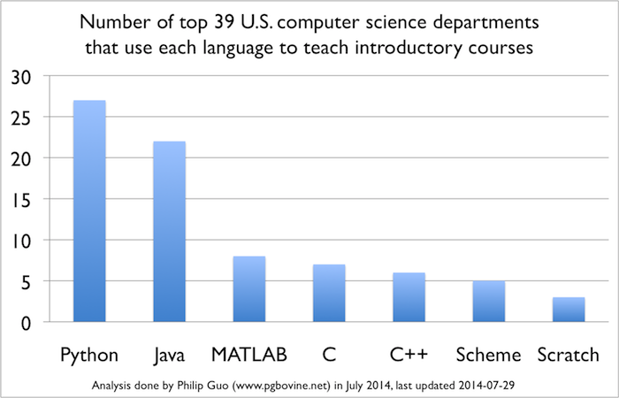
Text:
Anzahl der Informatikinstitute, die die angegebenen Sprachen im Rahmen ihrer Einführungskurse lehren
Python | 00
Java | 00
MATLAB | 00
C | 00
C++ | 00
Scheme | 00
Scratch | 00

Abbildung 2:
TIOBE-Index, August 2019
TIOBE Index for August 2019
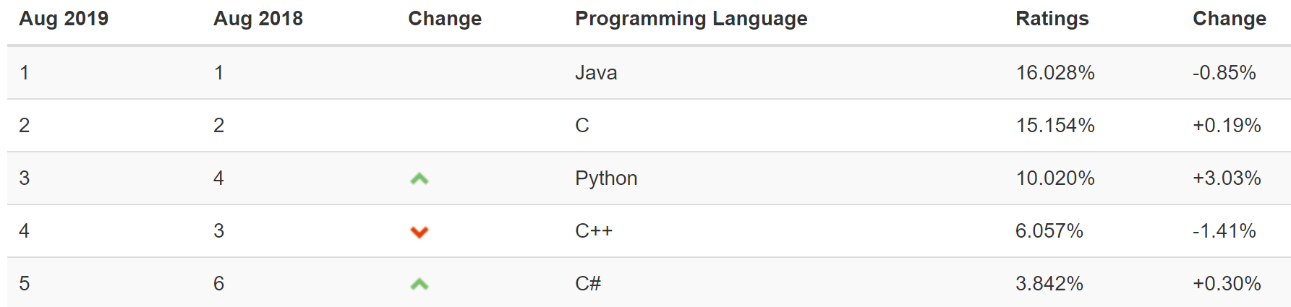
Text:
TIOBE Index for August 2019 | TIOBE-Index, August 2019
–0.85% | –0,85 %
+0.19% | +0,19 %
+3.03% | +3,03 %
–1.41% | –1,41 %
+0.30% | +0,30 %
16.028% | 16,028 %
15.154% | 15,154 %
10.20% | 10,20 %
6.057% | 6,057 %
3.842% | 3,842 %
Java | 00
C | 00
Python | 00
C++ | 00
C# | 00
Aug 2019 | Aug. 2019
Aug 2018 | Aug. 2018
Change | Trend
Programming Language | Programmiersprache
Ratings | Anteil
Change | Trend

Lektion 1.2
Abbildung 3:
Anaconda – Auswahl des Betriebssystems
Anaconda – Select Your Platform
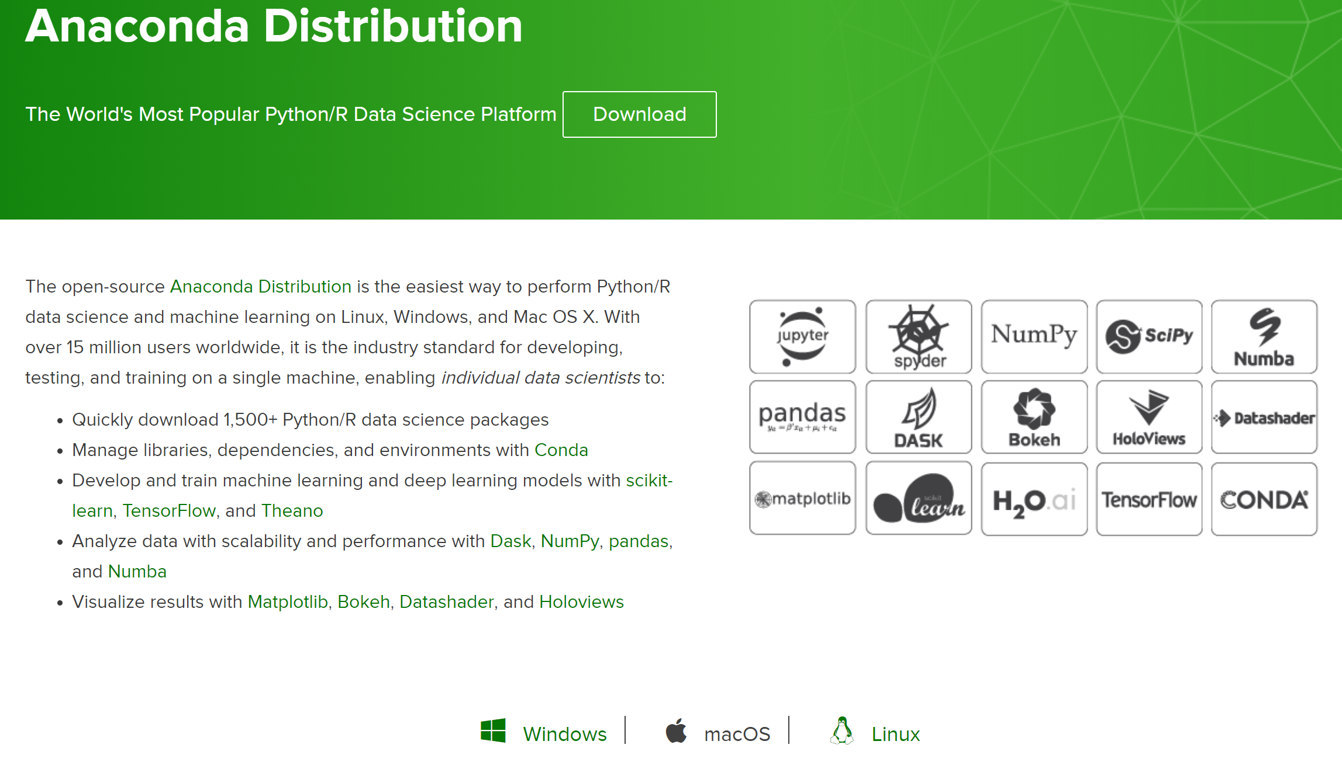

Abbildung 4:
Anaconda – Auswahl der Version
Anaconda – Select Version
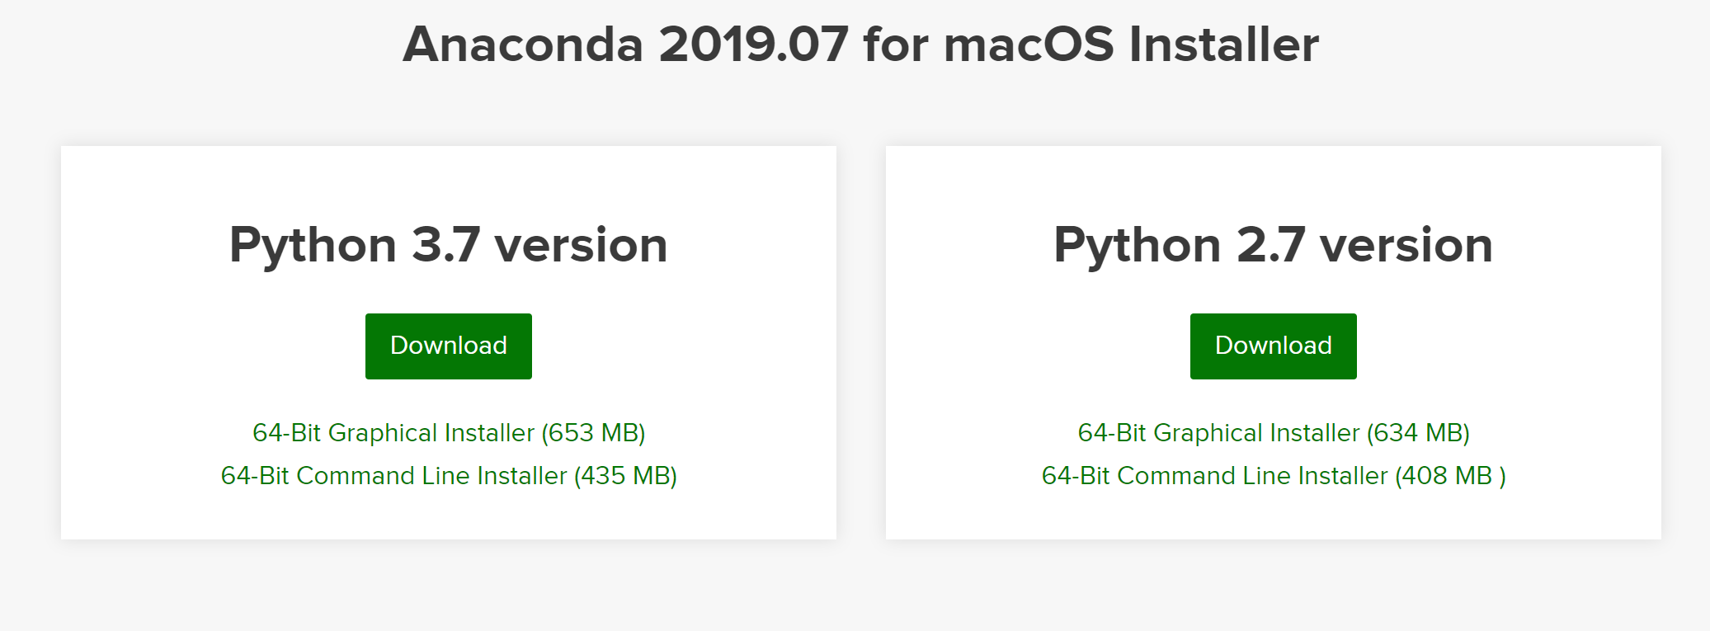

Abbildung 5:
Installation von Anaconda – Setup
Anaconda Install - Setup

Abbildung 6:
Installation von Anaconda – Lizenzvereinbarung
Anaconda Install – License Agreement

Abbildung 7:
Installation von Anaconda – Installationsart
Anaconda Install – Installation Type

Abbildung 8:
Installation von Anaconda – Installationspfad
Anaconda Install – Location

Abbildung 9:
Installation von Anaconda – Erweiterte Optionen
Anaconda Install – Advanced Options

