**Is there any compelling evidence that screen use causes autism spectrum disorder?**

Dr. Yaakov Ophir, Dr. Hananel Rosenberg and Raphael Tikochinski

**Abstract**

In a word, no. The current paper presents a critical review and meta-analysis of studies that (purportedly) support two hypotheses currently presented in the literature to explain the recent rise observed in the prevalence of autism spectrum disorder. The first hypothesis focuses on the parents’ use of cellular phones, while the second focuses on the children’s use of screens. Our review and meta-analysis reveal that the quality of the studies supporting these hypotheses is poor, and that the findings they present are insignificant, partial and unreliable. Before even addressing the question of causality (whether screen use **causes** the disorder), it appears there is only a negligible link between screen use and the disorder (0.05 ≤ *Cohen's d* ≤ 0.06), which even becomes insignificant (0.01 ≤ *Cohen's d* ≤ 0.03, 0.06 ≤ *p* ≤ 0.53) when taking into account the clear publication bias in the scientific literature (3.25 ≤ *Z Eggers test* ≤ 6.76, p < 0.001). Therefore, contrary to repeated reports appearing in newspaper headlines, the current paper demonstrates that no compelling scientific evidence has accrued that in any way demonstrates that screen use causes autism spectrum disorder. Moreover, the publication bias about this issue, as well as other gaps in the literature discussed in this paper reveal the intensity of the ethical-public panic surrounding the issue of screens. At the same time, the rising prevalence of autism spectrum disorder can be attributed to a broad range of causes, including increased awareness of parents and professionals on the one hand, and increased medicalization of otherwise normative childhood behaviors on the other.

**Introduction**

“[Is there a link between screen use and the rising prevalence of autism](https://www.themarker.com/blogs/liraz-margalit/BLOG-1.8502198)?” When reading this column in *TheMarker* in February 2020, the question mark at the end of the headline actually becomes an alarming exclamation mark! Despite the prevailing medical approach that treats autism spectrum disorder (ASD)[1] as a neurodevelopmental hereditary disorder, according to the column, there is a real possibility that environmental factors, and primarily the rising use of mobile phones and screen technologies, cause developmental delays in young children and explain the ongoing rise in the prevalence of the disorder.

**Two hypotheses, one (alarming) message**

The dramatic claim made by the column in *TheMarker*, along with many other newspaper articles in Israel and around the world, are based on two main hypotheses. The first was recently published by a team of Israeli researchers led by Dr. Michael Davidovitch, a pediatric neurology and child development specialist (Davidovitch et al., 2018). According to this hypothesis, the emergence of smartphones over the past decade has disrupted the delicate bond between parents and their infants. The parents’ attention is engrossed in their phones at the expense of critical moments of eye contact with their child. Thus, a parent surfing on a smartphone or responding to a text message “just for a moment” misses subtle cues the baby is sending while trying to create a positive mutual bond. This hypothesis claims that the disruption of the synchronization process that is meant to take place between parent and infant at such a critical developmental period increases the risk of ASD symptoms appearing among children who are vulnerable to the disorder (Davidovitch et al., 2018). The second hypothesis links the rising rates of ASD to children’s screen use. According to this hypothesis, which the literature refers to as “the displacement hypothesis,” extensive screen use by children comes at the expense of engaging in daily activities that are necessary for their healthy psychological development. Instead of playing with friends and family in “the real world,” internalizing the social norms and rules of the world in which they are operating, and then dealing with the emotional challenges these pose, young children spend their time passively watching screens. This does not present them with any challenges and teaches them nothing about life. Ultimately, this is a zero-sum game: children are awake 10–12 hours a day, and time “wasted” in front of screens is time that is not spent doing other activities, such as reading, physical activities, and participating in social interactions (Christakis, 2020).

When intuitively observing reality, both hypotheses sound quite reasonable. Unsurprisingly, they have made their way very quickly and in a somewhat one-dimensional way into newspaper headlines in Israel and around the world.[2] For example, a television interview with Dr. Davidovitch, the specialist mentioned above, was headlined as: “[Skyrocketing rates of autism diagnosed in children due to phone use](https://www.facebook.com/channel13israel/videos/467553550709980/)”*.* As we shall see below, while the existing studies did not examine the question of causality implied by the phrase “due to,” in response to the interviewer’s comment that “modern life and our phones take a toll on our lives,” Dr. Davidovitch replied: “In my opinion, unequivocally so. Because such a significant rise within a decade or 15 years can’t just be attributed to a change in awareness, and it can’t be attributed to a change in the genetics.” “Unequivocally, you say?” the interviewer adds, “So it’s the iPads, the iPhones, the tablets?” “I believe that’s absolutely the case,” Dr. Davidovitch responded. “Screens generally play a role in the children’s development. More and more evidence is emerging from studies throughout the world pointing to the damage that’s being caused by screens.”

And yet, despite the adamant tone heard in television studios and in the press, when reading Dr. Davidovitch’s studies, and those of others who have dealt with the subject, it appears we are still far from arriving at conclusive answers regarding the link between screen use and ASD. The current paper seeks to investigate whether the newspaper headlines and television items are indeed warranted. We ask whether there is currently compelling research evidence that the use of screen technologies increases the risk of developing ASD symptoms. We begin by discussing the empirical basis of the first hypothesis, which focuses on the use of mobile phones by *parents.* We then discuss the empirical basis for the second hypothesis, the “displacement assumption,” which deals with the rising use of screen technology among *children.* In this section on the second hypothesis, about which there is more abundant literature, we also conduct a meta-analysis to gauge the extent of the general impact of screens, and explore the possibility of the existence of a publication bias. Finally, we investigate a range of possible reasons for the rising rates of ASD diagnoses and examine the link between screen use and ASD within the broader context of the accumulated literature on the effects of technology on child development.

**The “phone use by parents” hypothesis**

As mentioned earlier, this hypothesis links the rising prevalence of ASD with smartphone use by the parents. Dr. Davidovitch and his colleagues recently published an article presenting this hypothesis in a journal that is unique within the so-called scientific landscape, *Medical Hypotheses* (Davidovitch et al., 2018). The aim of this journal, as stated on its [website](https://www.journals.elsevier.com/medical-hypotheses), is to serve as a forum for giving radical, novel ideas and speculations in the field of medicine open-minded consideration, even if these would be rejected by most conventional journals due to a lack of empirical evidence. Accordingly, in the paper’s introduction, which usually serves to justify the research hypothesis by reviewing existing scientific literature, no references are made to previous studies that have found a link or argued for the existence of a link between parents’ phone use and autistic symptoms in children. In the spirit of the journal, the justification for the new hypothesis is based on initial findings presented in a paper based on a pilot study conducted by the authors. Therefore, it is important to understand what exactly was done as part of the study, what its findings were and whether they do indeed support the new hypothesis.

The idea for the study was elegant and creative. 111 parents who came to see Dr. Michael Davidovitch or Dr. Nurit Asaf (another one of the collaborators on the study and a child neurology specialist) for a neurodevelopmental assessment of their child, were asked to agree to participate in a type of field study. The assessment lasted about an hour, after which some of the parents (those who had seen Dr. Davidovitch) were asked to wait for about 10 minutes before getting the doctor’s feedback. During the study two other researchers documented the parents’ interaction with their phone during two time periods: (1) during the assessment; (2) during the waiting period. The observation included three metrics: (1) a category metric tracking whether the parent focused on their phone during the assessment or waiting period (yes/no); two continuous metrics measuring (2) the minutes/seconds of phone use by the parent during the assessment/waiting period; (3) the total number of the parent’s interactions with their phone. It should be noted that these continuous metrics were only reported among parents who scored “yes” in the first category metric. The aim of the study was to examine whether there was a link between the parents’ phone use (using the three predictive metrics described above) and four developmental problems in children. Aside from (1) ASD, which was the core focus of the study, the researchers look at (4) language and /or motor delays, (3) attention deficit disorder and (4) congenital abnormalities (premature births and genetic problems). Thus, based on a calculation of the above we would expect 24 findings: two modes (assessment/waiting period), multiplied by three metrics, multiplied by four developmental issues.

The results section describes two distinct findings. The first (purportedly) supports the study’s hypothesis according to which the parents’ phone use is linked to language/motor delays, and the second goes against the hypothesis, pointing to a negative correlation between phone use and congenital issues. In other words, the prevalence of children with congenital problems was higher among parents who did not use their phone, as opposed to those who had.[3] The link between the parents’ phone use and attention disorders was nonsignificant, and here too the correlation went against the hypothesis, meaning the prevalence of children who received the diagnosis was higher among parents who did not use their phone. Finally, the link between parents’ phone use and the study’s principle metric, i.e. the one relating directly to ASD, was nonsignificant. In other words, the study **did not** find evidence of a direct correlation between the prevalence of ASD, but with a form of developmental delay. However, as we shall presently see, we believe this finding is also unreliable.

Out of 24 possible findings, only four were reported in the paper. These pertained to the link between the four developmental issues and the phone use (yes/no) category metric during the assessment period alone. In our opinion, the fact that the findings from the continuous metrics on the extent of the phone use were missing makes it difficult to draw conclusions based on the study, as they are much more appropriate tools for gauging the parents’ phone use compared to the category metric. The purpose of conducting the measurement was to try to reflect the parent’s actual phone use compared to other parents. Its purpose was certainly not to make a clear-cut distinction between parents who use a phone and those who do not, as a parent who completely avoids using a device would not have a device with them. Therefore, the continuous metrics would have been preferable, scoring parents who did not use their phone with zero on the continuous metrics. Furthermore, most of the parents who used their phone did so for less than 1% of the time during the assessment. In other words, the extent of these parents’ phone use was much closer to that of parents’ who did not use their phone at all, than to that of a certain group of parents (6.9.%) who used their phone for more than 10% of the time.

Similarly, the fact that findings from the waiting period were not reported makes it difficult to draw conclusions based on the study. This is especially true in light of the conceptual justification for the study, namely that the period spent waiting for the doctor’s feedback is a critical and stressful time that can tell us a lot about the quality of the parent-child relationship. In reality, the parents used their phones in a completely different way during the assessment period and the waiting period. During the assessment, most of the parents who used their phones did so for less than 1% of the time, while in the waiting room, nearly a third of the parents who used their phones (30.8%) did so for more than 50% of the time. In other words, the major drama at the focus of the research took place in the waiting room, which is precisely the situation that could serve to corroborate the study’s hypothesis. During a medical assessment, throughout which most of the interpersonal interaction takes place between the parent and the doctor, the behavior of a parent who glances at their phone for a second or two (e.g. when receiving a message) is not that different from a parent who does not look at it at all. On the other hand, the behavior pattern of a parent who spends most of the time in the waiting room focused on their phone instead of interacting with their child, is notably different than that of a parent who spends most of the time interacting with their child.

To gain an in-depth understating of what was done as part of the study, we conducted the missing analyses ourselves using the raw database we received from Dr. Davidovitch (and we are truly thankful for it). Specifically, we focused on the language/motor delay issue that was claimed to be significantly linked to parents’ phone use. When we used the continuous metric, which in our view is more accurate, to measure the duration of time the parents dealt with their phone during the assessment, we discovered that the effect of phone use on language/motor delays was statistically insignificant, *t*(110) = 1.45; *p* = 0.149. Likewise, we looked at the category metric in regards to the waiting period and found that its effect on language/motor delays was nonsignificant, *χ2* = 0.06, *p* = 0.80. Parenthetically, it should be noted that while going through the data we came across a coding error in the category metric that could potentially explain why it led to significant findings while the other metrics did not. Apparently, the coding of the category metric in the data file was derived from the continuous metric measuring the duration of time the parents spent on their phones. When the duration was very short (e.g. 0.01% of the assessment time) it was presented as zero, with no digits after the decimal point. Then that (inaccurate) zero was coded as “no cellular phone interaction” in the category metric. This error led to a discrepancy in the data file, where some parents were marked as not having used their phones in the category index while still scoring greater than zero on the second continuous metric, which tracked the number of times the parents used their phones. This error casts doubt on the finding reported in the paper.

These gaps join the study’s other, more general limitations. For example, the fact that there is no mention of the parents’ socio-demographic background considerably weakens the claim that the mere use of cellular phones increases the risk of developmental delay. Rather than the extent of the parents’ phone use, it is quite probable that developmental delays are rooted in much more basic socio-demographic variables, such as level of income, level of education or belonging to a minority group. A systematic literature review reveals that the extent of phone use was found to be linked to socio-demographic variables (Cillero & Jago, 2010). Therefore, focusing on the extent of phone use alone without addressing these variables may reflect a spurious correlation. Furthermore, the fact that that socio-demographical background was disregarded makes it difficult to evaluate the procedures that were taken as part of the study. For example, the researchers chose to remove from the sample three parents who did not have a phone with them during the assessment. But who are these parents and why did they not have a phone? Are they perhaps orthodox Jews who tend to only use simple phones (kosher phones)? Interaction with simple phones certainly differs from interaction with smartphones. And pursuantly, were all the parents’ phones smartphones?

To summarize, the combination of these limitations along with the lack of findings and series of methodological gaps reviewed above do not provide sufficient support for the hypothesis according to which parents’ phone use increases the risk of developmental delays in children, and certainly not that it increases the risk of ASD.

**The ‘cellular phone use by children’ hypothesis**

Contrary to the theory that focuses on the parents, displacement theory, which focuses on the children’s screen use, seems to be more empirically grounded at first glance. Quite a few studies have attempted to link children’s use of screen technologies with a variety of cognitive and emotional difficulties (Browne et al., 2020; Madigan et al., 2020), to the extent that the World Health Organization (WHO) issued a sweeping recommendation not to expose infants and toddlers up to the age of two to screens at all (WHO, 2019). The issue of how screen use affects young children is controversial in the literature (Ophir et al., 2019, 2020). In addition, the low quality of the studies on which the WHO based its recommendation, as well as the broader, more complex picture arising from those studies, do not allow for any unambiguous conclusions to be drawn (Ophir et al., 2021).[4] Nevertheless, perhaps sufficient evidence has accrued pertaining directly to the effects of screens on ASD? To answer this question let us review the current literature and as well as a recent longitudinal study dealing with the subject.

**Literature review**

In 2019, a comprehensive literature review was published on the connection between children’s screen use and ASD (Slobodin et al., 2019). To include as many studies in the literature review, the authors chose extremely lenient criteria for inclusion, according to which any comparative study that included a group of subjects with the diagnosis and a control group, and that related to the target variables (children’s screen use and an autism diagnosis) that had at least 20 participants would be considered appropriate for review. At the same time, no characteristic pertaining to the study sample (e.g. the child’s level of functioning or the presence of another co-morbid disorder), nor the time of publication would constitute grounds for rejection. The only studies that met these criteria and were not included in the review were those dealing with educational screen technologies such as educational computer games that could possibly help children who are vulnerable to ASD.

The systematic literature review was done using PRISMA, the accepted method for conducting literature reviews and meta-analysis,[5] with an initial search by title and abstract yielding 4,258 studies. However, despite the lenient criteria for inclusions described above, a large number of studies (4,222) were immediately removed upon examination of the content of the titles and abstracts. Of the remaining 36 studies, 20 were removed according to the following specifications: nine studies did not include a control group of children without ASD; three studies were not empirical studies; two studies did not meet the minimum requirement of 20 participants; two studies did not include an autism diagnosis; and one study dealt only with content analysis. In total, therefore, **16 studies** were included in the literature review.

Surprisingly, despite the leading narrative in the newspaper headlines, the central argument repeated throughout the review does not imply that screen use causes the appearance of autistic symptoms (screens 🡪 ASD) but rather the other way round: children on the autistic spectrum tend to use screens more. According to the review, there is evidence that children with ASD show increased interest in watching screens from a very young age (ASD 🡪 screens). This directionality is strengthened by studies tracking children’s daily activity in general that show that children with ASD spend more time doing screen-based activities compared to other leisure activities.

According to the researchers, there are several intuitive explanations for this directionality (ASD 🡪 screens). Looking at screens requires very little effort and therefore is especially appealing to children with ASD. To a certain extent, it also serves as a safe space for the child, separating them from (subjective) social and environmental threats and allowing them to temporarily disconnect from the daily activities that require so much cognitive or social effort. At the same time, parents of children with ASD allow their children a lot of screen time because they recognize the calming effect it has on their children. And indeed, some parents of children with ASD have positive views on screen use, particularly if they believe certain games are beneficial for their children (Slobodin et al., 2019). It is difficult to know whether these beliefs reflect “true” values or whether they are merely defensive justifications aimed at resolving the parents’ cognitive dissonance. However, even if this is a rationalization, we can easily understand these parents. Caring for children with ASD requires tremendous fortitude, especially if the child is low-functioning, and screen technologies provide a modicum of relief from the many challenges involved. Without supporting longitudinal studies it is difficult to determine the directionality of the link. However, evidence emerging from longitudinal studies of other childhood problems, such as regulation difficulties in early childhood, shows that parents of children with difficulties in early childhood allow their children to watch screens for longer amounts of time at later ages compared to children without regulation difficulties, apparently as a way of coping with those difficulties (Radesky et al., 2014).

**A longitudinal study to examine the directionality of the link**

If so, where does the assumption of the opposite directionality, according to which screen use causes autistic symptoms (screens 🡪 ASD) stem from? In April 2020, disturbing headlines published in various magazines throughout the world warned that exposing infants to screens increased the risk of developing ASD.[6] These headlines were based on a longitudinal study, unique of its kind, published in the important medial journal *JAMA Pediatrics,* aimed at investigating the directionality of the link between children’s screen use and autistic symptoms (Heffler et al., 2020).

In that study, the researchers tracked 2,152 infants between the ages of one and two years old, for an entire year. Throughout the study, the parents were asked to report whether the child had watched television or videos at the age of one (yes/no) and how many screen viewing hours the child had had by the age of one and a half. In addition, the parents filled out a questionnaire on ASD titled M-CHAT-R, from which two scores could be derived: (a) the main category score determining whether the child had ASD based on agreed criteria, and (b) a continuous score between zero and 20 for evaluating the degree to which the child was characterized by typical behaviors attributed to the disorder.

A review of the study’s results reveals that its alarming conclusion—the one that stimulated the public’s interest—was based on a single and rather unreliable finding. Purportedly, a (small) correlation was found between the television and video viewing at the age of one (yes/no) variable and the continuous score indicating the extent of behaviors attributed to the disorder at the age of two. However, that same behavioral score at the age of two was not found to be linked to the extent of screen viewing at the age of one and a half. Furthermore and even more importantly, the researchers did not find an effect of television and video viewing on the study’s principal result metric—the category score enabling the researchers to define whether the child was at risk for ASD. Finally, even the small and partial effect observed between screen viewing at the age of one and the continues score at the age of two, is very difficult to interpret, as the study provides no cut-off point on the continuous score for defining whether a certain child was at risk for the disorder, nor does it provide information on the average score children in the sample received. Based on the data presented in the study, it is possible to determine that the vast majority of children who watched television and videos at the age of one received a score of between zero and one, out of 20 possible points on the continuous scale of behaviors attributed to the disorder. In other words, even if we disregard the substantial gaps referred to previously, the study’s only finding does not truly shed light on the link between screen time and ASD.

**The intensity of the link between screens and autism**

Either way, whether the directionality of the link goes from screens to autism or from autism to screens, the question arises as to the intensity of the link discovered in the literature review presented above (Slobodin et al., 2019) and its clinical implications in the real world. But before we address this question, it is important that we note several reservations.

First, different studies included in the review investigated different types of screen time. Some studies investigated television viewing while others looked at video games, smartphones, computers, tablets, social media and more (some even examined several types of screen activity simultaneously). Moreover, some studies investigated the same screen activity under different conditions (e.g. video games during the week and video games on the weekend, or watching television alone versus watching television with a parent). This makes it difficult to unify the studies and assess the overall effect arising from them. Second, despite the conclusion presented in the review, a deep-dive into the studies it includes reveals that the overall picture arising from them is inconclusive. Some studies presented mixed findings, including nonsignificant findings as well as findings that went against the conclusion presented in the review. Finally, it is important to mention that some of the studies presented in the review did not include the participants’ social-demographic background as part of the result analysis. Generally, a meta-analysis seeking to gauge the intensity of the link between ASD and screen use would refer to simple effects while taking into account the variability between the different studies. However here the effects are not simple but partial, as they are stripped of socio-demographic influences, which also affect the variability between the studies reviewed, and thus this gap weakens the specific predictive validity of those studies.

**A consideration of the two studies presenting the strongest links in the review**

As an example of the last reservation, regarding the participants’ socio-demographic background, let us review the study that yielded the strongest finding in the literature review (*Cohen's d* = 1.67). The researchers compared the television viewing time of children with and without ASD but did not control for the socio-demographic variables measured in the study (Chonchaiya et al., 2011). Most of the socio-demographic differences between the children with ASD and the children without ASD were not found to be significant (the study used relatively small samples). However, when seeking to prove that a new factor (ASD) is related to screen use, researchers must verify that it is not concealing the influences of more basic factors such as socio-demographic factors or known medical factors. Thus for example, among the group of children with ASD 77.8% were boys, as opposed to 65.5% who were boys in the control group—a gender difference well documented in the literature on autism. Similarly, 13% of the children diagnosed with ASD had been born prematurely, as opposed to 7.3% among the children who were not diagnosed with the disorder (Chonchaiya et al., 2011). Lacking a single statistical model that takes all these factors into account, it is difficult to assess the extent to which there is in fact a link between ASD and viewing time and whether this link exists beyond the possible influences of other factors such as the child’s sex, or whether they were born prematurely.

As an example of the second reservation addressing the mixed findings, let us examine the study demonstrating the second largest effect out of all the studies appearing in the review (*Cohen's d* = 1.32). This study examined the use of mobile phones among teenagers diagnosed with Asperger’s (corresponding to the less severe section of the autistic spectrum, see Footnote 1) and its results included a series of mixed findings (Durkin et al., 2010). One of the findings can serve to support the conclusion presented in the literature review (i.e. that teenagers with Asperger’s spend more time playing games on their phones compared to typical teenagers), while other findings do not support and even contradict it. The researchers did not find significant differences between the groups in terms of the time devoted to phone contact with family, text messaging, taking photos and searching for content online. On the other hand, they did find significant differences in phone ownership and usage to communicate with friends. While “only” 60% of the teenagers with Asperger’s owned a mobile phone, a whopping 94% of typical teenagers owned one and they also spent a lot more time using it to communicate with friends (Durkin et al., 2010).

**Meta-analysis**

It is possible that these types of problems prevented the review’s authors from conducting a meta-analysis that would have aggregated the findings from all the studies reviewed and provided an assessment of the intensity of the link between screens and autism. In the discussion chapter, the authors note that the range of methodologies and findings they reviewed “limits our ability to harmonize the results and provide the magnitude and clinical significance of the association between screen use and ASD” (Slobodin et al., 2019. p.307). And yet, when seeking to make a general claim, as was made in that same literary review, according to which the overall picture arising from the studies reviewed was homogenous, i.e. that “Reviewing these 16 articles indicates that children with ASD are exposed to more screen time than typical peers” (Slobodin et al., 2019, p. 307) a general quantitative analysis (meta-analysis) must be conducted while taking measures to deal with its intrinsic limitations (Littell et al., 2008). We will now present two analyses we conducted in order to investigate the intensity of the link between screen use and ASD.

In order to deal with the variability of the various metrics collected (addressed in the first reservation presented above), we began by looking at the screen activities that were measured in each of the studies reviewed and conducted two separate meta-analyses of two activities that received the most research attention: television viewing and video games. The inclusion criteria for these analyses were studies from the review that directly compared between television viewing and/or video game habits of a group of subjects with ASD and those of a group of subjects with normal development. Studies lacking a control group of subjects with normal development were not included in the analyses. Likewise, one study was not included in the analyses (Must et al., 2015) because its database and reported findings regarding television and video games were identical to those appearing in a previous study already included in the analysis (Must et al., 2014).

In total, deducting the studies that did not meet the inclusion criteria, nine studies were entered into the meta-analysis examining the intensity of the link between autism and television viewing and eight studies were entered into the meta-analysis examining the link between autism and video games. In order to deal with the second and third reservations, pertaining to mixed findings and lack of control for socio-demographic variables, we chose the more severe route, referring in each study to the strongest effect size supporting the direction of the review’s hypothesis. In other words, the general effect expected to emerge from the meta-analysis is an overestimation of the true effect and constitutes the “worst case scenario”—an exaggeration of the intensity of the link if indeed our worst fears are proven true.

To conduct the meta-analysis we used version 3.5.0 of the R software ([www.r-project.org](http://www.r-project.org)). In studies where the findings were presented using a continuous metric, we calculated the effect size using *Cohen’s d* metric. In studies where the findings were presented using a category metric, we calculated the effect size using the *χ2* metric and then converted the result to *Cohen’s d* metric. We conducted the meta-analysis itself using the Metafor statistical evaluation software (version 2.1.0, [www.metafor-project.org](http://www.metafor-project.org)) using a fixed model analysis suitable for conducting analyses that include relatively few studies (Borenstein et al., 2011).

The overall picture emerging from the meta-analyses is presented in the forest plots (Figures 1 and 2). Seemingly, the results point to a correlation between screen viewing and ASD (*Cohen’s d* = 0.06, *p* = 0.001; 95% CI [0.03, 0.10]) as well as a correlation between video games and the disorder (*Cohen's d* = 0.05, *p* = 0.01; 95% CI [0.01, 0.09]). However, despite the significant correlations, the effect intensity (0.05 ≤ *Cohen's d* ≤ 0.06) and the confidence intervals nearing zero (0.01 and 0.03) indicate that the link between screen time and ASD is exceptionally weak and has very little, if any, clinical significance (Cohen, 2013).

**Publication bias and media panic**

Aside from the small effects, the funnel plots obtained from our meta-analysis demonstrate that the existing literature on the link between autism and screens suffers from publication bias (Figures 3 and 4). The funnel plots reveal how many findings pointing to results that were in line with the editors or authors’ a priori stance, were published in the scientific literature despite having relatively high standard errors rendering them statistically weak (Dickersin et al., 1987). At the same time, studies at the same level of statistical strength presenting findings that contradicted the editors or authors’ theoretical approach, or studies that presented statistically nonsignificant findings were almost not published at all (see the lower left section of the funnel plots). Such studies were only accepted for publication if they were “strong,” meaning with relatively small standard errors (see the top left corner of the funnel plot). Egger regression tests done on these data indicated that the publication biases observed in the funnels were statistically significant (*z* = 6.76 and 3.25 for TV and video games, respectively, p < 0.001).

Using the trim-and-fill method, we conducted a simulation to estimate the number and size of the effects that would have been published had there been no publication bias (Duval & Tweedie, 2000; Shi & Lin, 2019). This revealed, with quite a high probability, that the original (small) effects emerging from the meta-analysis on television viewing (*Cohen's d* = 0.03, *p* = 0.06; 95% CI [-0.005, 0.084]) and video games (*Cohen's d* = 0.01, *p* = 0.53; 95% CI [-0.031, 0.056]) would have been even smaller and more importantly, would have lost their statistical significance, were it not for the existence of a publication bias. Both meta-analysis findings, the insignificant intensity of the link and the existence of a publication bias, do not allow us to claim that there is empirical support linking screen use and autism.

The effect of the publication bias goes beyond weakening the validity of the link observed in the meta-analysis. It implies that the field of research dealing with the effects of technology, a field that should strive to be neutral and objective like any other scientific field, may be influenced by the public discourse and moral panic surrounding new technologies (Ingraham & Reeves, 2016). When new communication technologies enter our lives, it naturally raises concern whether the advantages they offer will be outweighed by the disadvantages the create. However, in the moral panic discourse, these concerns are amplified to the level of fear mongering, receiving headlines even while often being unsupported by scientific research (Ophir, Rosenberg and Tikochinski, 2020). Thus, in a type of closed infinity loop, the moral panic (unconsciously) spurs the publication bias to give prominence to studies that point to the dangers of screens, which in turn fuel the panic (Orben, 2020). Conversely, findings that are not in line with the panic discourse receive no research prominence. They get no flashy headlines in the press, and as the publication bias demonstrates, at times they are even denied entry to a scientific forum that purports to be concerned with what is true rather than what is alluring.

**Causes for the rising rates of ASD**

In light of the criticism presented in the current paper regarding the link between screens and autism, it is appropriate to inquire as to other possible causes that can explain the rising rates of ASD over the past 15 years, as was described in the television interview mentioned above. But before we tackle that question, it is important to put in within a more accurate context. The rising rates of ASD is not unique to recent years. A decade ago, in a paper published in July 2021, Dr. Davidovitch and his colleagues reported that “The dramatic rise *over the last several decades* in the diagnosis of autism spectrum disorders (ASD) has been documented extensively around the world” (Davidovitch et al., 2013, p. 785, italics added by the authors). In Israel for example, the rate of children diagnosed with the disorder rose at the end of the last century from 0.12% among children born in 1986 to 0.36% among children born in 2003 (Gal et al., 2012). In 2010, incidence of disorder nearly doubled to a rate of 0.65% (Davidovitch et al., 2013) and currently, according to data from the Maccabi healthcare provider, ASD rates have reached 1.30% (2.12% among boys) (Davidovitch et al., 2020). While these rates are indeed unprecedented, it is clear to see the rise itself is not a new phenomenon and it is difficult to attribute it specifically to the appearance of mobile phones.

Even in the fifth and most recent edition of the *Diagnostic and Statistical Manual of Mental Disorders* (the DSM-5), which was published in 2013, awareness of the rising diagnosis rates is evident. According to the manual, “the incidence of the diagnosis has approached 1% in the United States and outside of it” and it is difficult to know “whether these high rates reflect the broader criteria for the disorder compared to the manual’s previous version (DSM-IV) that includes sub-clinical cases XXX…” (American Psychiatric Association, 2013, p. 55).

That being the case, not only has the rising incidence of the diagnosis been well documented in recent decades, many causes have been suggested over the years to explain that rise. Thus for example, a known cause referred to briefly in the previous paragraph quoting the DSM, are the changes that were made to the definition of ASD. Changes in the definition of the disorder were linked with a rise in diagnosis rates even before the DSM-5 was published (Johnson & Myers, 2007), and the softer the criteria for diagnosis became the more rising diagnosis rates were observed. In the DSM-5, the diagnosis criteria were actually made more strict, however the second of the two main criteria for diagnosing the disorder,[7] the one pertaining to restricted or repetitive behavioral patterns, was expanded to include a range of behaviors related to sensory modulation. Examples of such behaviors, according to the DSM, include indifference to pain/temperature, negative reactions to movements or textures, excessive touching or smelling of objects an and increased interest in lights or movement. Another softening of the criteria in the current DSM allows the diagnostician to determine that the child suffers from ASD even if symptoms of the disorder did not appear in full before the age of three, as was required according to the previous edition. The changes made to the criteria may explain why the majority of the rise in diagnosis rates was observed in regards to high functioning rather than low functioning ASD, as children expressing clear and severe difficulties in early childhood would have apparently received the diagnosis also in the past.

Aside from this explanation, there are many other environmental factors that have previously been linked to ASD to potentially explain the rising rates of diagnosis. A partial list of these include exposure to air pollution (Lam et al., 2016), complications at birth and caesarian sections, risk factors among mothers such as advanced age, obesity and diabetes, and lack of vitamin D (Modabbernia et al., 2017). Alternatively, it is possible to focus on the sociological and practical aspects appearing in Dr. Davidovitch’s most recent paper, which include higher awareness of the disorder, increased use of initial screening tools, the limited specificity of those screen tools, unclear and ambiguous guidelines for assessing the symptoms, and the subjectivity characteristic of that assessment (Davidovitch et al., 2020). Another well-known explanation has to do with the concessions and benefits enjoyed by parents and children diagnosed with the disorder. The more the healthcare system accommodates those diagnosed with the disorder, the greater the incentive for parents and teachers to “get” the diagnosis. It is interesting to note that the hypothesis that screen use may also contribute its share to rising diagnosis rates appears only after these other familiar explanations are mentioned, and that is immediately followed by a reservation: “Despite many efforts, a single, simple explanation has not been found for the rise in ASD incidence” (Davidovitch et al., 2020, p. 1898).

Here it is apt to note that the difficulty in finding “a single, simple explanation” is not only relevant to solving the mystery behind the rise in ASD incidence. Over the past decades we have been witnessing a rise in the incidence of a range of neuropsychiatric disorders, and particularly developmental disorders in childhood such as attention deficit disorder, the incidence of which has risen from 3–5% to recently crossing the 20% mark, in only four decades (Ophir, 2020a; Ophir, 2020b). At the same time, we are witnessing attempts to propose new neuropsychiatric disorders, such as “sluggish cognitive tempo” (Becker & Barkley, 2018) and phones, social media and video games addiction (Billieux et al., 2015; Panova & Carbonell, 2018). If we rise above the relatively narrow spectrum of ASD, it is possible that the rising incidence of psychiatric disorders in children does not reflect a true increase in objective medical problems but an increasing social-cultural tendency towards medicalization—the labeling and definition of children’s everyday behavior as medical problems requiring medical intervention (Conrad, 2007; Conrad & Slodden, 2013).

It is important to note that medicalization is not necessarily a negative phenomenon. Labeling a child with a neuropsychiatric diagnosis may provide them and their parents with concessions and benefits (such as tutoring or equine therapy) that will contribute greatly to their social development, academic success and self-image. However, it is equally important to recognize the problematic aspects of medicalization. Beyond internalizing the message that the child suffers from a brain defect and the stigma this entails, medicalization is fueled by pharmaceutical companies and their representatives, who artificially exaggerate the incidence, severity and risk of a particular medical condition (Blasco-Fontecilla, 2014; Wolinsky, 2005) in the aim of increasing their sales (Schwarz, 2017; Whitaker & Cosgrove, 2015). Therefore, it is our duty to try to clarify precisely which causes are the most probable to explain rising rates of psychiatric disorders, especially when they are “harmful” to young children.

In the current paper, we are not claiming that the rising rates of ASD are necessarily caused by increased medicalization, and we are particularly making no such claim in regards to low functioning autism (which was already perceived as a medical problem in the past). We refer to medicalization as part of a series of possible and well-known explanations for the rising diagnosis rates, as an alternative, parsimonious and more probable explanation compared to that linking them with smartphone use. The rise in diagnosis rates, as the current paper demonstrates, did not begin in the past decade and in our view there is no sufficient empirical evidence causally linking it to the parents’ phone use or children’s screen use (screens 🡪 ASD).

**Final words**

In conclusion, let us return to the influential journal mentioned above, *JAMA Pediatrics*. In the an recently published paper by the editor addressing the precise topic at the core of the current paper, the journal’s editor recognizes the many limitations that make it difficult to draw conclusions (causality) regarding the link between screens and autism. At the same time, he estimates it will take quite a few more years before more valid findings are obtained, and therefore recommends that parents follow Hippocrates’ mantra to “first do no harm.” He suggests they follow the guidelines of the American Academy of Pediatrics prohibiting screen time before 18 months of age (Christakis, 2020). We understand and respect this position, however we would like to call attention to another one of the fundamental values of medical ethics—one we believe is no less important than the one noted by the journal’s editor, which is preserving patient autonomy. The well-known concept of “informed consent” is based on the tenet that all relevant information is fully disclosed by the doctor to the patient with integrity and in a transparent, reasonable and balance way.

In this context, we believe that the cautious delivery of information to parents of children suffering with ASD is even more important. Beyond transparency, objectivity and the need for accuracy in reporting scientific findings of any type, the link made between the parents’ behavior and the problem from which their child is suffering may be experienced as hurtful and offensive. Obviously, if the scientific findings are conclusive (e.g. if there is clear-cut evidence that parents’ phone use **causes** autism), then “first do no harm” probably supersedes patient autonomy. However, when the findings are inconclusive and the proposed hypotheses do not garner sufficient scientific support, as demonstrated in the current paper, we must be all the more cautious. While some parents may react positively to a link being made between their behavior and their child’s problems (some may even try to use their phone less as a result), others may be deeply hurt and feel intense guilt. Examples of this can be found in the comments made by the upset parents of autistic children in response to the column in *TheMarker* mentioned at the start of this paper.

On a personal note, as parents of young children ourselves, we admit that despite the criticism brought forth in the current paper we identify with Dr. Davidovitch’s general stance, which emphasizes the importance of mutual and attentive interaction between parent and child, free of screens. We also share the concern that the ubiquitous presence of screens disrupts the traditional boundaries between the home environment and the outside world, between family time and work time, and we too, are worried that phones are damaging the quality of our interaction with our children. Quite a few articles have accumulated in recent years, demonstrating that parents use their phones in a variety of family activities and situations (including museums, amusement parks and even during intimate situations such as breastfeeding) in a way that damages the eye contact and quality of the interaction between parent and child, and increases the parent’s impatient responses (e.g. Kushlev & Dunn, 2019; Lemish et al., 2020; Tomfohrde & Reinke, 2016). We also recognize the intense allure of screen technologies and accept the argument that in too many cases, the child’s screen time comes at the expense of other constructive and positive activities (the displacement hypothesis).

At the same time, in our professional capacity, when analyzing the scientific findings, we repeatedly come to the same conclusion, which is that the frightening news headlines regarding the damage caused by screens are exaggerated and very often false. Even when there are significant and reliable scientific findings, in most cases the psychological implications attributed to screens is not a result of screen time in and of itself, but rather of other factors such as dependent/pathological screen use or watching inappropriate content, lack of sleep, physical activity and social activities, and a critical lack of close beneficial interaction between parent and child. Therefore we suggest that parents focus less on the exact amount of minutes/hours they should allow their children to watch screens, and invest their educational resources in more important parental activities such as: (1) monitoring problematic and abnormal screen use, e.g. screen use that creates extreme dependence and disrupts daily conduct; (2) instilling rules for when to stop using screens and cultivating the habit of watching healthy and appropriate content; (3) maintaining a physically, emotionally and socially balanced and healthy lifestyle; and (4) establishing units of family time such as dinner, taking trips, playing board games and reading books, where telephones and screens “go to sleep” and our entire parental attention is devoted to our children.

We are aware that this partial list of recommendations for parents is more complex than the conclusive restrictions appearing in some of the medical position papers published from time to time (and we aim to expand our recommendations in our next paper). However, we believe that this partial list is more balanced and accurate, and mainly less intimidating, than those same conclusive restrictions. In regards to ASD specifically, we seek to ease the worries of our fellow parents and let them know that the findings accumulated to date do not support the hypotheses linking screen use and ASD symptoms. By making this statement we do not purport to claim that we possess all the relevant information, and we assume that in the near future new studies will emerge that may alter our stance. However, in writing the current paper we tried out best to deliver the information we currently hold in a transparent and balanced way, so that parents of children with ASD are able to judge it for themselves and reevaluate to what extent (if any) there is solid evidence supporting the hypotheses that screen use increases the risk of the disorder. It is our hope that this will help them let go of some of the heartache and guilt they have been living with.

Figure 1: Forest plot - television viewing and ASD

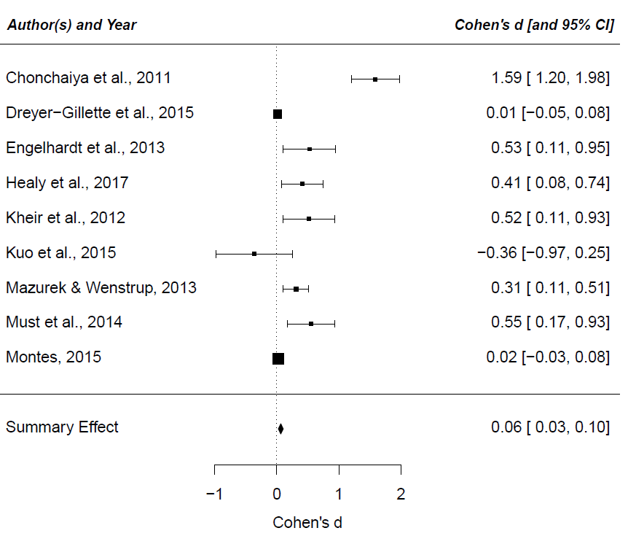

Figure 2: Forest plot – video games and ASD

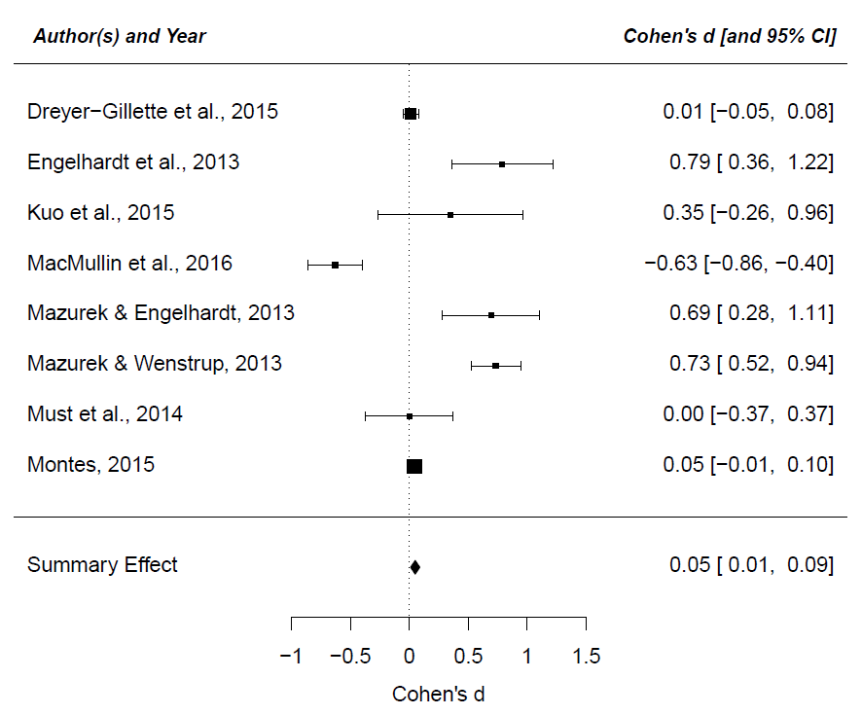

Figure 3: Funnel plot - television viewing and ASD funnel plot

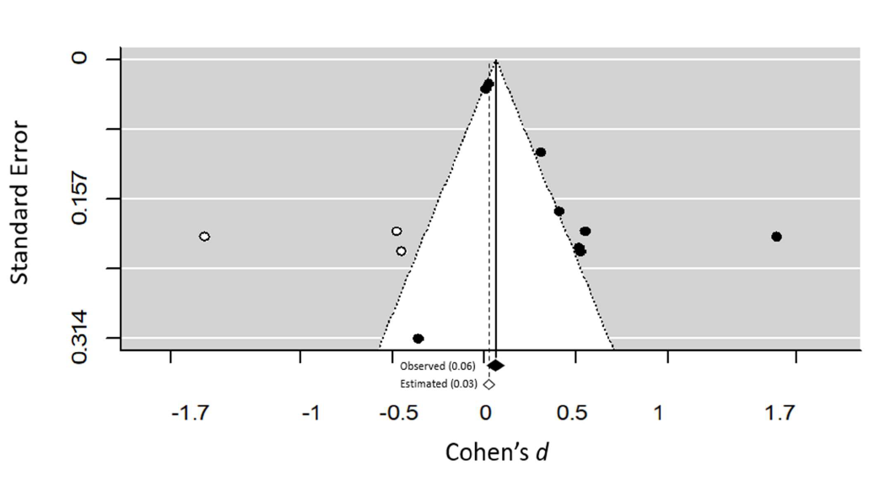

Figure 4: Funnel plot - video games and ASD funnel plot

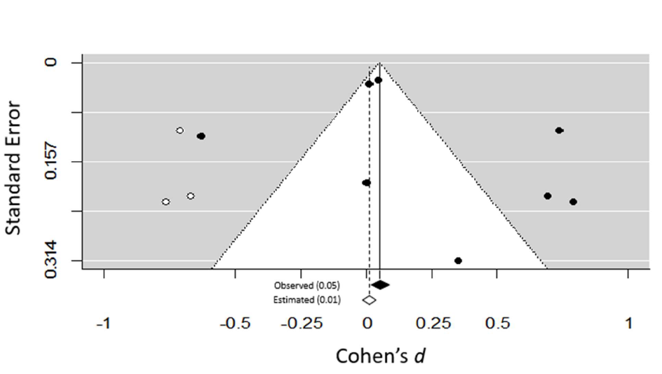

**Hebrew Bibliography**

Ophir, Y. (2020a). “30 Reasons why”: Attention deficit disorder should be removed from the DSM in light of its reliability and validity problems. Hebrew Psychology. Retrieved from

<https://www.hebpsy.net/articles.asp?id=3909>

Ophir, Y. (2020b). Let the public know and beware: The medication for attention deficit disorder is ineffective, unsafe and unethical. Hebrew Psychology. Retrieved from <https://www.hebpsy.net/articles.asp?id=4026>

Ophir, Y., Rosenberg, H., & Tikochinski, R. (2020). “Don’t rely on the general impression, my boy, focus on the details”: Does screen use damage children’s brain development?. Hebrew Psychology. Retrieved from <https://www.hebpsy.net/articles.asp?id=3992>

Ophir, Y., Rosenberg, H., & Tikochinski, R. (2021). Screen panic: A critical analysis and meta-analysis of the World Health Organization’s restrictions on children’s screen use. Misgarot Media, 20.

**Bibliography**

American Psychiatric Association. (2013). *Diagnostic and Statistical Manual of Mental Disorders (DSM-5®)*. American Psychiatric Pub.

Becker, S. P., & Barkley, R. A. (2018). Sluggish cognitive tempo. *Oxford textbook of attention deficit hyperactivity disorder*, 147-153.

Billieux, J., Schimmenti, A., Khazaal, Y., Maurage, P., & Heeren, A. (2015). Are we overpathologizing everyday life? A tenable blueprint for behavioral addiction research. *Journal of behavioral addictions*, *4*(3), 119-123.

Blasco-Fontecilla, H. (2014). Medicalization, wish-fulfilling medicine, and disease mongering: toward a brave new world? *Revista clinica espanola*, *214*(2), 104-107.

Borenstein, M., Hedges, L. V., Higgins, J. P. T., & Rothstein, H. R. (2011). *Introduction to meta-analysis*. John Wiley & Sons.

Browne, D., Thompson, D. A., & Madigan, S. (2020). Digital Media Use in Children: Clinical vs Scientific Responsibilities. *JAMA Pediatrics*, *174*(2), 111-112. <https://doi.org/10.1001/jamapediatrics.2019.4559>

Chonchaiya, W., Nuntnarumit, P., & Pruksananonda, C. (2011). Comparison of television viewing between children with autism spectrum disorder and controls. *Acta Paediatrica*, *100*(7), 1033-1037.

Christakis, D. A. (2020). Early Media Exposure and Autism Spectrum Disorder: Heat and Light. *JAMA Pediatrics*. <https://doi.org/10.1001/jamapediatrics.2020.0659>

Cillero, I. H., & Jago, R. (2010). Systematic review of correlates of screen-viewing among young children. *Preventive medicine*, *51*(1), 3-10.

Cohen, J. (2013). *Statistical power analysis for the behavioral sciences*. Routledge.

Conrad, P. (2007). *The medicalization of society: On the transformation of human conditions into treatable disorders*. JHU Press.

Conrad, P., & Slodden, C. (2013). The medicalization of mental disorder. In *Handbook of the sociology of mental health* (pp. 61-73). Springer.

Davidovitch, M., Hemo, B., Manning-Courtney, P., & Fombonne, E. (2013). Prevalence and incidence of autism spectrum disorder in an Israeli population. *Journal of autism and developmental disorders*, *43*(4), 785-793.

Davidovitch, M., Shrem, M., Golovaty, N., Assaf, N., & Koren, G. (2018). The role of cellular phone usage by parents in the increase in ASD occurrence: A hypothetical framework. *Medical hypotheses*, *117*, 33-36.

Davidovitch, M., Slobodin, O., Weisskopf, M. G., & Rotem, R. S. (2020). Age‐Specific Time Trends in Incidence Rates of Autism Spectrum Disorder Following Adaptation of DSM‐5 and Other ASD‐Related Regulatory Changes in Israel. *Autism Research*, *13*(11), 1893-1901.

Dickersin, K., Chan, S., Chalmersx, T. C., Sacks, H. S., & Smith, H. (1987). Publication bias and clinical trials. *Controlled Clinical Trials*, *8*(4), 343-353. <https://doi.org/https://doi.org/10.1016/0197-2456(87)90155-3>

Durkin, K., Whitehouse, A., Jaquet, E., Ziatas, K., & Walker, A. J. (2010). Cell phone use by adolescents with Asperger Syndrome. *Research in Autism Spectrum Disorders*, *4*(2), 314-318.

Duval, S., & Tweedie, R. (2000). Trim and fill: a simple funnel‐plot–based method of testing and adjusting for publication bias in meta‐analysis. *Biometrics*, *56*(2), 455-463.

Gal, G., Abiri, L., Reichenberg, A., Gabis, L., & Gross, R. (2012). Time trends in reported autism spectrum disorders in Israel, 1986–2005. *Journal of autism and developmental disorders*, *42*(3), 428-431.

Heffler, K. F., Sienko, D. M., Subedi, K., McCann, K. A., & Bennett, D. S. (2020). Association of Early-Life Social and Digital Media Experiences With Development of Autism Spectrum Disorder–Like Symptoms. *JAMA Pediatrics*. <https://doi.org/10.1001/jamapediatrics.2020.0230>

Ingraham, C., & Reeves, J. (2016). New media, new panics. *Critical Studies in Media Communication*, *33*(5), 455-467.

Johnson, C. P., & Myers, S. M. (2007). Identification and Evaluation of Children With Autism Spectrum Disorders. *Pediatrics*, *120*(5), 1183. <https://doi.org/10.1542/peds.2007-2361>

Kushlev, K., & Dunn, E. W. (2019). Smartphones distract parents from cultivating feelings of connection when spending time with their children. *Journal of Social and Personal Relationships*, *36*(6), 1619-1639. .

Lam, J., Sutton, P., Kalkbrenner, A., Windham, G., Halladay, A., Koustas, E., Lawler, C., Davidson, L., Daniels, N., & Newschaffer, C. (2016). A systematic review and meta-analysis of multiple airborne pollutants and autism spectrum disorder. *PloS one*, *11*(9), e0161851.

Lemish, D., Elias, N., & Floegel, D. (2020). “Look at me!” Parental use of mobile phones at the playground. *Mobile Media & Communication*, *8*(2), 170-187.

Littell, J. H., Corcoran, J., & Pillai, V. (2008). *Systematic reviews and meta-analysis*. Oxford University Press.

Madigan, S., McArthur, B. A., Anhorn, C., Eirich, R., & Christakis, D. A. (2020). Associations Between Screen Use and Child Language Skills: A Systematic Review and Meta-analysis. *JAMA Pediatrics*. <https://doi.org/10.1001/jamapediatrics.2020.0327>

Modabbernia, A., Velthorst, E., & Reichenberg, A. (2017). Environmental risk factors for autism: an evidence-based review of systematic reviews and meta-analyses. *Molecular Autism*, *8*(1), 13. <https://doi.org/10.1186/s13229-017-0121-4>

Must, A., Phillips, S., Curtin, C., & Bandini, L. G. (2015). Barriers to physical activity in children with autism spectrum disorders: relationship to physical activity and screen time. *Journal of Physical Activity and Health*, *12*(4), 529-534

Must, A., Phillips, S. M., Curtin, C., Anderson, S. E., Maslin, M., Lividini, K., & Bandini, L. G. (2014). Comparison of sedentary behaviors between children with autism spectrum disorders and typically developing children. *Autism*, *18*(4), 376-384.

Ophir, Y., Rosenberg, H., & Tikochinski, R. (2021). What are the Psychological Impacts of Children's Screen Use? A Critical Review and Meta-analysis of the Literature Underlying the World Health Organization Guidelines. *Computers in Human Behavior*, *Accepted Manuscript*.

Ophir, Y., Tikochinski, R., & Rosenberg, H. (2019). Challenging the Association Between Screen Time and Cognitive Development. *JAMA Pediatrics*, *173*(9), 890-890. <https://doi.org/10.1001/jamapediatrics.2019.2246>

Ophir, Y., Tikochinski, R., & Rosenberg, H. (2020). Science Has Not Proven That Screen Use Impacts Children's Brain Development. *JAMA Pediatrics*, *174*(8), 805-805. <https://doi.org/10.1001/jamapediatrics.2020.0635>

Orben, A. (2020). The Sisyphean Cycle of Technology Panics. *Perspectives on Psychological Science*, *15*(5), 1143-1157. <https://doi.org/10.1177/1745691620919372>

Panova, T., & Carbonell, X. (2018). Is smartphone addiction really an addiction? *Journal of behavioral addictions*, *7*(2), 252-259.

Radesky, J. S., Silverstein, M., Zuckerman, B., & Christakis, D. A. (2014). Infant self-regulation and early childhood media exposure. *Pediatrics*, *133*(5), e1172-e1178.

Schwarz, A. (2017). *ADHD nation: Children, doctors, big pharma, and the making of an American epidemic*. Simon and Schuster.

Shi, L., & Lin, L. (2019). The trim-and-fill method for publication bias: practical guidelines and recommendations based on a large database of meta-analyses. *Medicine*, *98*(23), e15987-e15987. <https://doi.org/10.1097/MD.0000000000015987>

Slobodin, O., Heffler, K. F., & Davidovitch, M. (2019). Screen Media and Autism Spectrum Disorder: A Systematic Literature Review. *Journal of Developmental & Behavioral Pediatrics*, *40*(4).

Tomfohrde, O. J., & Reinke, J. S. (2016). Breastfeeding mothers' use of technology while breastfeeding. *Computers in Human Behavior*, *64*, 556-561.

Whitaker, R., & Cosgrove, L. (2015). *Psychiatry under the influence: Institutional corruption, social injury, and prescriptions for reform*. Springer.

WHO. (2019). *Guidelines on physical activity, sedentary behaviour and sleep for children under 5 years of age*. World Health Organization. <https://apps.who.int/iris/rest/bitstreams/1213838/retrieve>

Wolinsky, H. (2005). Disease mongering and drug marketing. *EMBO reports*, *6*(7), 612-614. <https://doi.org/10.1038/sj.embor.7400476>

1. ASD was added to the latest edition of the Diagnostic and Statistical Manual of Mental Disorders (DSM-5). The diagnosis includes both the autism diagnosis (low functioning) and Asperger’s (high functioning) which appeared in previous versions of the manual.
2. Examples can be seen in the following links:  
   <https://drexel.edu/now/archive/2020/April/Screen-time-for-babies-linked-with-autism-like-symptoms/>

   <https://www.practiceupdate.com/content/more-screen-time-for-babies-tied-to-autism-like-symptoms/99535>

   <https://www.businessdailyafrica.com/bd/lifestyle/health-fitness/increased-exposure-to-electronic-devices-harms-child-growth-2288758>
3. It should be noted that in reading the paper it is difficult to fully understand the rationale behind the claim that there is any link at all, be it positive or negative, between parents’ phone use and their children’s congenital issues.
4. For a Hebrew version of the paper, see: Ophir, Rosenberg and Tikochinski, 2021.
5. PRISMA is an acronym for Preferred Reporting Items for Systematic Reviews and Mata-Analysis.
6. Examples of such headlines can be seen through the following links:  
   <https://drexel.edu/now/archive/2020/April/Screen-time-for-babies-linked-with-autism-like-symptoms/>

   <https://www.practiceupdate.com/content/more-screen-time-for-babies-tied-to-autism-like-symptoms/99535>

   <https://www.businessdailyafrica.com/bd/lifestyle/health-fitness/increased-exposure-to-electronic-devices-harms-child-growth-2288758>
7. The two main criteria for ASD diagnosis according to the DSM are (a) ongoing communication impairments and (b) restricted or repetitive behavioral patterns.