Deciphering the cellular and molecular mechanisms in the brain underlying the interaction between high-fat diet consumption and social isolation

1. **Scientific background**

Loneliness is increasingly recognized as a serious threat to mental health (1, 2). During the COVID-19 pandemic, social isolation has emerged as an important risk factor related to the onset of several psychiatric and emotional disorders, with the associated quarantine having led to increased domestic violence, fears of job loss, decreased physical activity, altered sleep, and higher levels of anxiety [Reviewed in (3)]. **However, current research has primarily focused on adults, failing to examine the outsized impact of social isolation and loneliness on children and adolescents, whose reactions to COVID-19-related isolation were severe and are thought to be long-lasting**(4). Social isolation is one of the most prominent stressors in animal models (5). One widely used rodent model of social isolation is the post-weaning isolation approach, which involves separating animals during a very early stage of development (postnatal day [PND] 20-28) without handling, and rearing them in isolation for several weeks or months(6). The social isolation of juveniles for 2 weeks from PND 21-35 has been linked to decreased sociability in adulthood and hypomyelination in the deep layers of the medial prefrontal cortex (mPFC), a critical node for social behaviors (7, 8). Re-socialization of these isolated mice failed to rescue their impaired sociability or mPFC hypomyelination(7). Similarly, post-weaning isolation exacerbated inhibitory synaptic activity and decreased intrinsic excitability in pyramidal cells of the mPFC in adult mice (9). Efforts to restore the sociability of the isolated animals via regrouping, chemogenetic, or optogenetic manipulations failed to achieve more than transient reversal effects (10).

The post-weaning period is a critical developmental window for the maturation of the mPFC, which is required for lifelong emotional and social memory (11). This suggests that environmental factors like exposure to adverse stressors in the juvenile stage can affect the developmental trajectory not only of the mPFC but also of its projections to other parts of the brain. Developing approaches to reverse the deficits caused by social isolation and loneliness in children and adolescents is thus critical, as these deficits develop during a period that sets the stage for lifelong mental health (12).

Several studies support the hypothesis that an “unhealthy” but palatable diet can mitigate the impact of stress exposure. Indeed, elevated consumption of calorie-rich palatable foods has been shown to engage certain coping mechanisms, thereby reducing stress in humans and rodents (13, 14). Consistently, long-term high-fat diet (HFD) consumption can selectively protect against some of the behavioral sequelae of chronic unpredictable social stressors (15), while also protecting offspring from the consequences of maternal separation stress (16). These prior studies have mainly focused on addressing the long-term consequences of social isolation or exposure to HFD after animals reach adulthood. In comparison, very few studies have addressed the effects of these manipulations in young animals. In our published work, we focused on addressing the immediate effects of exposure to either acute stress or acute HFD intake, revealing distinct effects in juvenile and adult animals that are brain region-dependent (17–21). In preliminary experiments, we applied social isolation stress, HFD, or both to **juvenile male rats** for one week starting from PND21. Social isolation or HFD alone impaired both short-term and long-term social recognition memory as respectively tested with habituation/dishabituation and social recognition memory paradigms (Figure 1), while also impairing mPFC synaptic plasticity as measured based on NMDA-dependent long-term potentiation (LTP), reaffirming our previous reports regarding the effects of HFD intake (22, 23). Interestingly, when we presented HFD during isolation, social recognition memory (SRM) and LTP deficits were rescued (Figures 1-2). Notably, this behavioral and electrophysiological rescue persisted **one month later**, whereas previously socially isolated animals fed a control diet still exhibited SRM and LTP deficits (Figure 3). In **adult animals**, HFD alone did not affect SRM (22) and had mixed effects on LTP, with HFD enhancing hippocampal CA1 LTP (21, 24) while impairing LTP in the mPFC (18), thus revealing brain region-dependent changes that were distinct from those in juveniles.

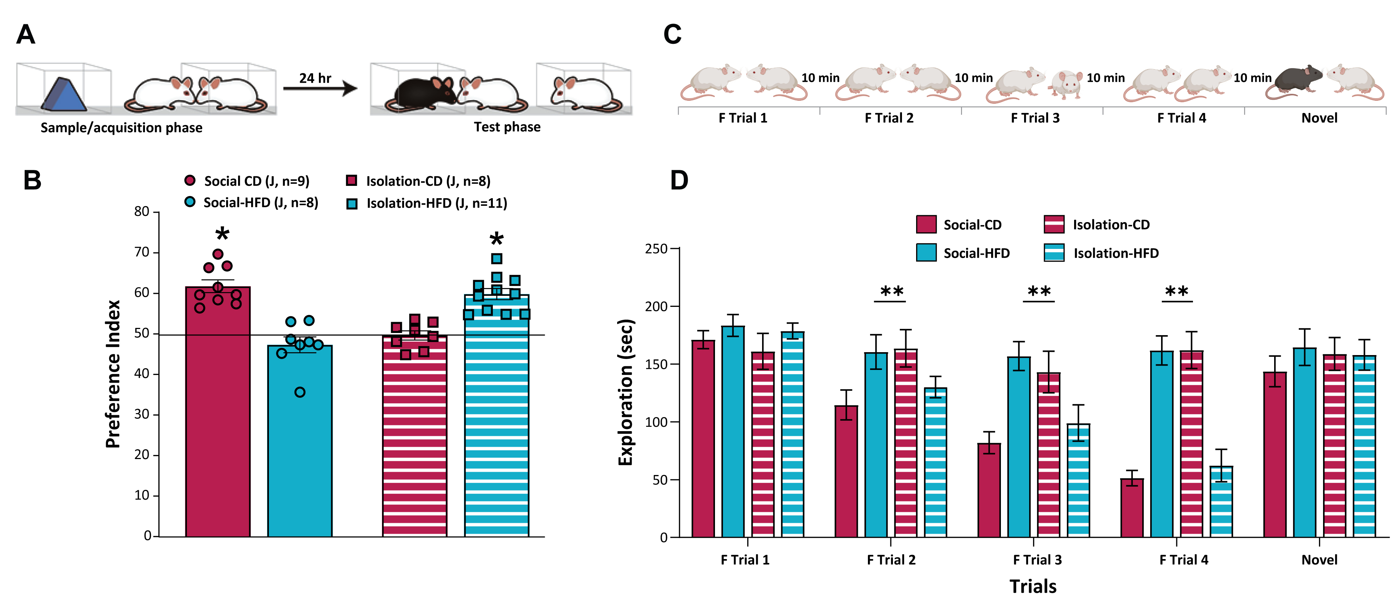

**Figure 1: The acute effects of HFD intake and social isolation for one week on SRM (left) and habituation and dishabituation (right) in juvenile rats.**

**A+C:** Schematic overview of the social recognition memory tests. (A) Animals were exposed for 1 h to an object or another animal in corrals. After 24 h they are exposed to both the familiar animal and a novel one. For details, see (22, 25). (C) In habituation dishabituation assays, rats were repeatedly presented with the same conspecific for 4 trials (F1 x 4) separated by 10 min intervals. On the fifth trial, rats were presented with a novel conspecific. For details, see (22, 25)

**B****:** Animals at PND21 (juveniles: J) were weaned and divided into 4 groups: control diet (CD) + group housing (Social-CD), CD + isolation (Isolation-CD), HFD + group housing (Social-HFD), and HFD + isolation (Isolation-HFD). {CD refers to a control standard chew diet providing 3 kcal/g [consisting of 4% fat and 60% carbohydrate (35% kcal); ENVIGO, Israel]. The utilized HFD provided 5.2 kcal/g [consisting of 35% fat, mostly saturated fat from lard (60% kcal), and 26% carbohydrate (20% kcal); D12492, Research Diets, New Brunswick, NJ]}. After 7 days of these treatments, animals were subjected to a social recognition memory test. The Isolation-CD and Isolation-HFD groups did not differ from each other, but did differ significantly from the other groups [P<0.001]. The Social-CD and Isolation-HFD groups exhibited intact social recognition memory.

(D) While gradual reductions in exploration of the familiar conspecific over repeated trials were observed in the Social-CD and Isolation-HFD groups, the Isolation-CD and the Social-HFD groups maintained enhanced exploration. Upon exposure to a novel conspecific, animals in the Social-CD and Isolation-HFD groups exhibited the recovery of exploration (*P<0.001).

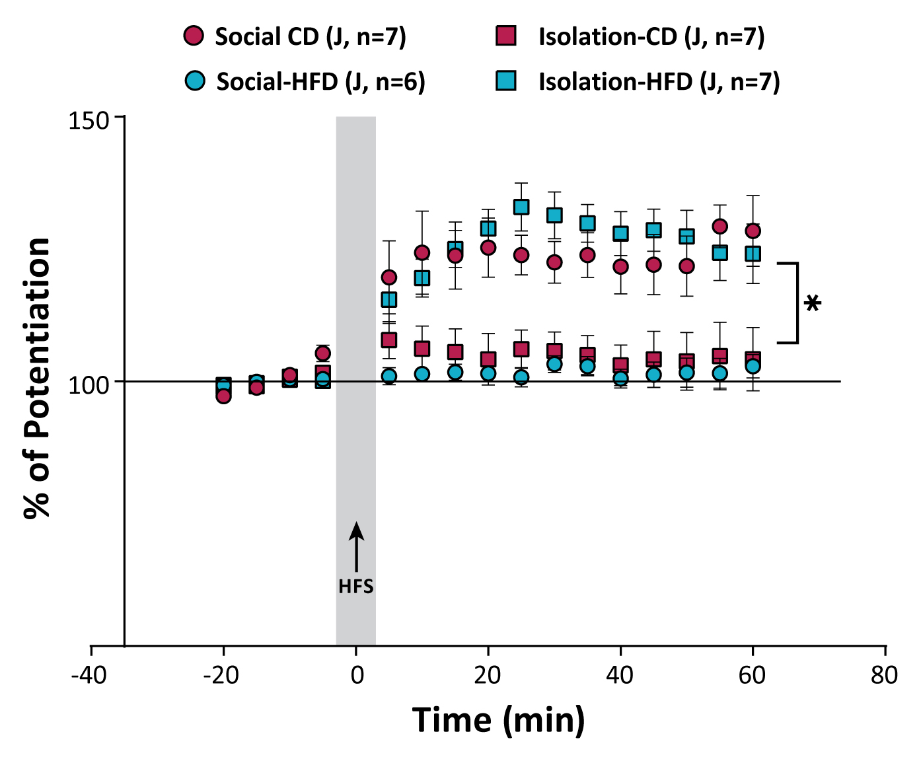

**Figure 2: The acute effects of one week of HFD intake and social isolation on LTP in the mPFC.** (A) LTP in the indicated groups. (B) Average LTP. Isolation-HFD animals exhibited intact LTP similar to Social-CD animals, while Social-HFD and Isolation-CD exhibited impaired LTP (*P<0.05).

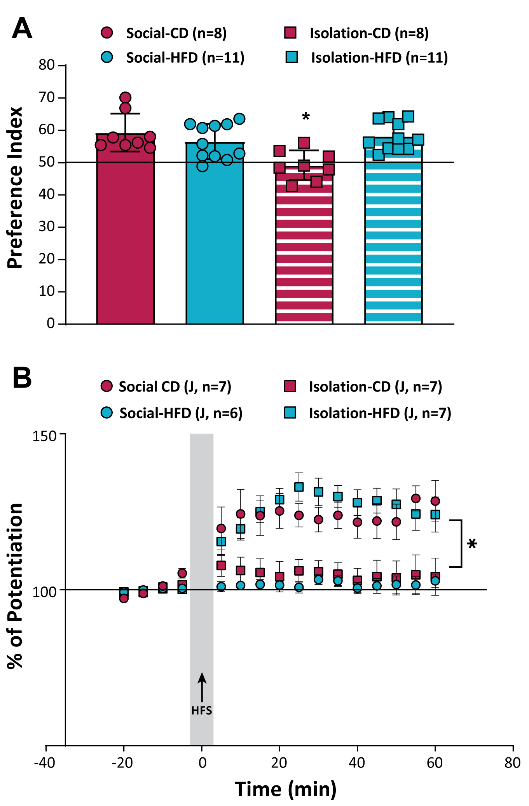**Figure 3:** **The long-term effects of one week of HFD intake and social isolation during the juvenile stage on SRM and LTP tested during adulthood.** After the 7-day treatment period, rats were returned to group housing and CD conditions. Testing was performed on PND60. (A) Only the Isolation-CD group exhibited impaired SRM at this time point, whereas all the other groups exhibited intact memory. *P<0.05. (B) LTP was intact in Isolation-HFD animals, much as in the Social-CD animals. Interestingly, the Isolation-CD group exhibited impaired LTP (100±3.6%) and differed significantly from the Social-HFD group, which showed attenuated levels of potentiation (117.9±2.4%; #P<0.05 vs. Isolation-CD).

Social isolation in adults resulted in the impairment of both SRM (25) and mPFC-LTP (Figure 4), suggesting that social isolation, unlike HFD, is detrimental in adulthood. Exposure to HFD in isolated adult animals rescued SRM impairment, but only partially reversed mPFC LTP deficits, suggesting that the protective benefits of this combination of stimuli are more potent in juveniles. These findings are consistent with a previous study demonstrating that chronic exposure to HFD after isolation improved isolation-induced deficits in object recognition memory and decreased brain-derived neurotrophic factor (BDNF) levels in mPFC (26). Mice fed either high-fat or high-sucrose diets also reportedly exhibit increased rearing behavior in an elevated zero maze 30 days post-exposure to stress and diet conditions, suggesting that even short-term dietary changes can contribute to long-term changes in risk behavior (27). These reports suggest that consuming a palatable diet (high in fat or sugar) under stress conditions can limit the consequent stress response. We have recently reported reductions in BDNF levels in the medial amygdala, another important node of social behavior, and impairments in SRM following social isolation for one week in adult animals, while both effects were reversed by the regrouping of the isolated animals (25). Interestingly, HFD intake for 72 h in adult animals elevated hippocampal BDNF levels and improved spatial memory (24). Together, these studies support our hypothesis that HFD and/or isolation can affect the reprogramming of neural networks in the mPFC and potentially the amygdalar and hippocampal circuits, thereby resulting in long-term consequences.

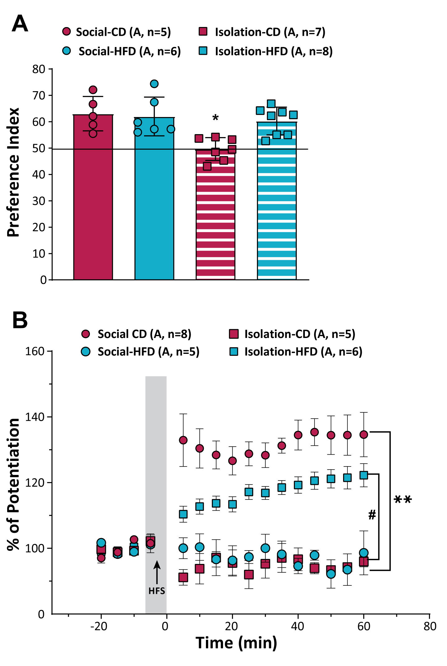

**Figure 4: The acute effects of one week of HFD intake and social isolation on SRM and prefrontal LTP in adult animals.** On PND50, animals were divided into the same four groups detailed in Figure 1. After the 7-day diet and housing treatment period was complete, animals were subjected to SRM (A) or LTP (B) testing. (A) Only the SRM of animals in the Isolation-CD group differed significantly from that of animals in the other groups (*P<0.05). SRM was intact in the Isolation-HFD group. (B) The Isolation-HFD group exhibited LTP that was attenuated compared to the Social-CD group (**P<0.01), although LTP in this group still differed significantly from the Isolation-CD and Social-HFD groups (# P<0.05).

With respect to the molecular underpinning of the effects of social isolation on brain circuitry, social isolation in rodents has been shown to affect the expression of non-coding RNAs such as microRNAs (miRNAs) (28, 29). miRNAs are a class of ~22 nucleotide short non-coding RNAs that play key roles in fundamental cellular processes, including how cells respond to various stressors (30). miRNAs function in the post-transcriptional regulation of gene expression by forming complexes with their target mRNAs that interfere with translation. In the brain, miRNAs impact cellular and subcellular functions and modify cognitive performance (31, 32), including in the context of HFD-induced deficits (33). One recent study addressed the effects of social isolation in adult and aged mice and identified relevant changes in miR-140-5p and miR-181a-5p levels in the mPFC and found that these alterations were reversible, returning to basal levels following social enrichment (34). Moreover, the prolonged postnatal isolation of rats resulted in differential miRNA profiles in brain regions involved in anxiety (35). For example, some miRNAs were differentially regulated in both male and female socially isolated rodents, with the majority being downregulated (reviewed in (3)). Other studies have attributed the contribution of altered miRNA profiles in the PFC to PFC-dependent tasks (31, 36). Specifically, miRNA-135a and miRNA-16 were noted as being important contributors to the mechanisms by which stressful early-life experiences increase post-traumatic disorder (PTSD) vulnerability (37). Thus, it is likely that specific miRNAs and their target genes are key mediators underlying the deficits caused by HFD or isolation and the rescue of these deficits achieved by HFD intake during social isolation.

Given the above evidence, ***we hypothesize that HFD intake under conditions of social isolation causes significant cellular and molecular reprogramming that can persistently affect neuronal plasticity and social memory***, with this reprogramming being age, sex, and brain region-dependent.

1. **Objectives and significance of the research**

Our preliminary data suggest that when HFD or social isolation are presented separately, they induce behavioral and plasticity deficits in the mPFC. However, when presented together, they are able to negate these effects. The resultant protected phenotypes are robust and long-lasting. This unexpected and novel finding is the focus of the present application**.** We thus aim to explore in-depth the behavioral (readout), cellular (circuit), and molecular (mechanism) changes in a specific social memory-related neural circuit comprised of the mPFC, hippocampus, and amygdala in order to reveal the signatures associated with HFD and isolation, with the ultimate goal of understanding how they interact to mediate the reprogramming that occurs at each of these nodes of the circuit.

Stress and HFD result in different effects in the hippocampus and the PFC as compared to the amygdala in an age-dependent manner (17, 38, 39). Social and anxiety disorders are more common in women than in men, yet most animal model studies focus on adult males. As such, the detailed comparisons proposed herein will allow us to examine whether these modifications are differently regulated in the three target brain structures as a function of age and/or sex.

As miRNAs have the potential to influence the expression of multiple mRNA targets via complex miRNA-mRNA interactions, we will examine miRNA expression profiles and associated changes in levels of protein expression. We will seek to identify miRNA targets with the ultimate goal of enhancing or inhibiting relevant miRNAs (using agomirs and antagomirs, respectively), to establish a causal link.

To address our experimental objectives, **we propose the following specific aims:**

**Aim 1:** Profile age- and sex-dependent differences in behavioral changes in response to social isolation and/or HFD intake.

**Aim 2:** Profile age- and sex-dependent activation and electrophysiological signatures in the mPFC-amygdala-CA1 circuit under conditions of social isolation and/or HFD intake.

**Aim 3**: Explore transcriptomic and proteomic changes to identify and establish the causal roles of miRNA-regulated genes and pathways underlying the phenotypic effects of social isolation and/or HFD intake.

To the best of our knowledge, this proposal is the first to attempt to unravel the molecular effects of social isolation, HFD intake, and the combination thereof at the molecular and circuit levels while assessing two developmental phases (juvenile and adult) in both males and females.

**Significance:**

Social isolation, especially during childhood, is detrimental to adult brain function and behavior across mammalian species (7). While the majority of research performed to date has focused on extended periods of isolation initiated in young mammals followed by the monitoring of the resultant effects in adults, here we propose a different approach that uses a short period of acute isolation which is more relevant to real life, whereafter we assess the immediate impact of these conditions in juvenile animals as well as their long-term effects. While a growing body of preliminary data pertaining to overweight and obesity rates among children during the COVID-19 pandemic is becoming available, there remains a pressing need to better understand the potential impact of the pandemic on children's health. School closures, strained household finances, and the marketing of fast foods have increased exposure for many children during the pandemic to environmental drivers of weight gain (The Lancet Public Health 2021). Understanding the effects of unhealthy diets on social and cognitive behaviors is thus especially timely in light of these recent increases in social distancing. It is important to note that our acute exposure to HFD was not associated with any metabolic disturbances or weight gain (18, 22, 23, 40), suggesting that fatty food intake can have context-specific benefits without the negative effects of obesity (41). While our HFD contains carbohydrates and is not ketogenic, a growing number of studies have shown that ketogenic diets can improve autistic behaviors characterized by social deficits (42), confirming the relevance of behavior-focused dietary research. While the application of a HFD to combat social disturbances in children may be controversial, our proposal is based on a strong foundation of published and preliminary data and is in line with the literature. These findings may thus open an avenue for future characterization of the micronutrients that can overcome social disturbances in children without any associated harmful diet-related effects. This may, in turn, enable the professional design of personalized dietary regimens that can buffer the detrimental effects of social isolation.

1. **Research Plan**

**Aim 1: Profile age- and sex-dependent differences in behavioral changes in response to social isolation and/or HFD intake.**

**Rationale:** Even in 2022, preclinical animal models focused on pathological conditions with a high prevalence among females such as anxiety disorders primarily utilize adult male rodents, with many researchers failing to consider sex as an experimental variable (43). Although males and females may be similar at the behavioral level, they often use different mechanisms to respond to social and emotional challenges and opportunities [reviewed in (44)]. Notably, our knowledge regarding the mechanisms of pre-pubertal females remains very sparse.

Thus, here in Aim 1 we propose to address:

1. The short-term and long-term age- and sex-dependent effects of HFD, social isolation, and the combination of the two.
2. Whether social isolation induces only social memory deficits or more generalized cognitive and emotional impairments, and whether these impairments are also rescued by HFD intake.

**Aim 1a: Conduct age- and sex-specific behavioral profiling.**

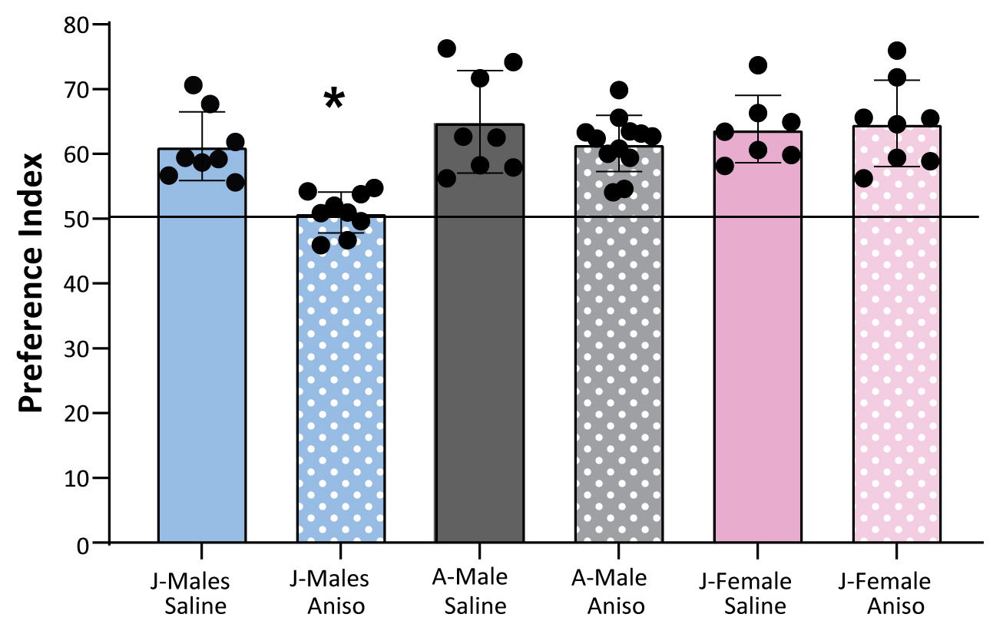**Rationale:** We have recently demonstrated that in the social-induced facilitation of extinction, the oxytocin system in juvenile females functions similarly to that of adult males but strikingly different from that of juvenile males (20). In preliminary analyses (Figure 5), we found that the engagement of the mPFC in SRM in juvenile females differs from that in juvenile males, more closely resembling that in adult males.

**Figure 5: The effects of the anisomycin-mediated blockade of protein synthesis on the infralimbic subregion of the mPFC (IL-mPFC).** Effects were analyzed in juvenile males (J), adult males (A), and juvenile females (J). Anisomycin microinjection into the IL-mPFC only blocked long-term SRM in juvenile males [*P<0.05]

When examining the role of the CA1 subregion of the hippocampus in social memory and spatial memory, we found that whereas it similarly mediates SRM in both juvenile males and females, it is differentially engaged in spatial memory. Manipulations of the CA1 of juvenile females did not affect spatial memory, whereas in juvenile males such manipulation had a significant effect. These distinct roles were reflected by the differential activation of the neuronal activation marker c-Fos (Shehadeh and Maroun, *Submitted*). This suggests substantial differences between males and females at the pre-pubertal phase. We thus aim to profile the behavioral phenotypes of juvenile and adult females and to compare them to those of males under the three conditions (Isolation, HFD, both) while testing both immediate and long-term effects.

**Aim 1b: Profile the cognitive and emotional effects of social isolation, HFD, and the combination of the two in juvenile and adult males and females.**

Social isolation has detrimental effects on human and animal cognitive functions (45, 46), and HFD is similarly associated with impaired cognition (47). In our preliminary research, we only focused on social memory. In this aim, we will also evaluate the hippocampal-dependent object location memory (OLM), and emotional behavior (anxiety-like behaviors) to address whether the observed rescue effect is restricted to social memory. As it was previously reported that exposure to chronic HFD following the termination of one week of social isolation resulted in a slight improvement in observed deficits (26), we will also assess whether there is a critical window for the combination of both conditions by testing whether 1 week of HFD intake immediately after isolation will yield similar rescue phenotypes.

**Working hypothesis:** Based on our published and preliminary data, we hypothesize that sex is a significant factor with the potential to impact behavioral profiles in this model system. It will be interesting to address whether HFD and isolation will exert similar effects in juvenile and adult females as compared to males. Our prior work suggests that it is plausible that juvenile females may exhibit profiles more similar to those of adult males and will be susceptible to social isolation but not to HFD.

**Research design and methods:** Our experimental approach is outlined in Figure 6. All experiments and protocols proposed herein will be conducted according to the regulations of the ethical committee at the University of Haifa for animal experimentation and welfare. We have experience with all proposed behavioral protocols proposed (22, 23, 38, 40, 48). We will use the OLM paradigm that is dependent on the CA1 and is similar to the SRM paradigm (Figure 1A), with animals being presented with two objects and 24 h later one of these objects is relocated (23). Emotional measures will include the open field and plus maze tests, all of which we have experience wth. We will test the effects of Age (Juveniles, Adults), Sex (Males, Females), Housing (Isolation, Group), and Diet (HFD, CD) at 7 or 30 days after manipulations. Based on our experience, we will require 7-10 animals per group for these behavioral analyses. We will employ the three R policy to reduce the number of animals utilized. To test the temporal contingencies between social isolation and HFD, animals (juveniles and adults of both sexes) will be presented with HFD after the termination of isolation.

**Expected results and pitfalls for Aim 1**: We expect juvenile and adult animals under the combined influence of isolation and HFD to exhibit the restoration of SRM, OLM, and anxiety markers relative to animals exposed to HFD or isolation alone. We expect to observe differences between males and females, although it is possible that no such sex-dependent phenotypes will be observed. If we find that HFD-fed adult female rats exhibit impaired SRM, this will indicate greater vulnerability to HFD in adult females. As to the contingency analyses in which we vary the temporal presentation of HFD and social isolation, we predict that optimal rescue will be observed when isolation and HFD are presented together (rather than in succession). As my lab has expertise in all the required protocols, we do not expect to encounter any technical challenges. However, if we find that OLM and emotional measures do not show changes, we will consider looking at fear and extinction, which can show robust effects and are modulated by stress and age (19).

Theoretically, the rescue effect of the combination of HFD+isolation could also suggest that we can rescue the effects of HFD by isolation, however, experimentally the diet is more modifiable and thus our focus is rather on how to rescue the detrimental effects of social isolation.

**Aim 2:** **Profile age- and sex-dependent activation and electrophysiological signatures in the mPFC-amygdala-CA1 network under conditions of social isolation and/or HFD intake.**

**Rationale:** LTP has been described at synapses throughout the brain and remains one of the most attractive cellular models for learning and memory (reviewed in (49)). This classical method has yielded exciting results regarding the differential effects of stress on plasticity in juveniles and adults in our lab and others (17, 19, 39, 48). We have previously shown that in juvenile animals, exposure to HFD resulted in the impairment of LTP in both the PFC and the hippocampal CA1 region (18, 22, 23, 40). However, in adult animals, we found that whereas HFD is detrimental to prefrontal LTP, it enhances its induction in the CA1 region (18, 40). Furthermore, only partial rescue of LTP was observed in adult animals in the Isolation-HFD group, with significant differences persisting between these animals and the Social-CD group. Interestingly, exposure to HFD in isolated adult animals completely reversed this SRM impairment, suggesting that the mechanisms mediating SRM and LTP may be distinct. Further, the full HFD-mediated rescue of SRM and LTP by HFD in isolated juvenile animals suggests that this combination is more powerful in juveniles. We also have preliminary data demonstrating the differential recruitment of the mPFC, measured by c-Fos, in juvenile males but not in adults following SRM acquisition in animals fed a standard control diet (Yaseen and Maroun, *In Preparation*; Figure 7). It will be thus interesting to examine whether there will be differences in the recruitment of the mPFC, CA1, and BLA under conditions of isolation, HFD intake, or the combination of the two and whether these effects are age-dependent and/or sexually dimorphic.

In this Aim, we propose to examine (1) neuronal c-Fos activation that will be indicative of activated circuits under different conditions and (2) changes in LTP that represent a model of memory formation in the CA1-BLA and PFC circuit. Based on our previous work we hypothesize differential effects in LTP in age and brain-dependent manners.

**Aim 2a: Define the brain regions and circuits activated following exposure to social isolation, HFD intake, or the combination thereof in juvenile and adult males and females.**

To pursue age- and sex-dependent activities that may contribute to the effects of isolation, HFD, or the combination of the two on SRM, we will profile c-Fos expression patterns under different conditions. We will identify the recruitment of the mPFC, CA1, and amygdala (medial and basolateral nuclei) upon social exposure in groups exposed to different conditions (Age, Sex, Diet, and Housing).

**Aim 2b: Explore the electrophysiological signatures associated with isolation and/or HFD intake.**

Our data regarding the differential effects of HFD on LTP in the CA1 and the prefrontal cortex in adult animals(18, 40), as well as the partial rescue of prefrontal LTP by the HFD intake, highlight the need to examine the effects of these manipulations in the CA1 or the basolateral amygdala (BLA). For this purpose, we will use high-frequency-induced LTP to identify deficits and rescue phenotypes in this network under our different experimental conditions in juvenile and adult males and females.

**Working hypotheses:** Based on our previous publications, we hypothesize that the rescue of memory deficits in Aim 1a will be accompanied by the normalization of LTP changes in the CA1 and the mPFC, but not in the BLA. This rescue may also be reflected by differential activation, as monitored by c-Fos levels, when comparing the HFD and isolation groups. As with SRM, we predict optimal rescue when isolation and HFD are presented together (rather than successively) during the juvenile period.

**Research design and methods:** Our experimental approach for this Aim is depicted in Figure 6. We have experience with all of the protocols proposed herein, with behavioral testing techniques and LTP analyses being performed as described previously (18, 19, 22, 23, 38, 40, 48). The c-Fos immunostaining protocols are also described in our published work (50). We will test Age (Juveniles, Adults), Sex (Males and Females), Housing (Isolation, Group), and Diet (HFD, CD) at 7 or 30 days after these experimental manipulations. Behavioral analyses will be performed after 7 or 30 days, and some animals will be used for electrophysiology analyses or will be euthanized 90 min after the last behavioral manipulation for c-Fos staining. Naïve animals will also undergo electrophysiology and c-Fos analyses as additional controls For each region, we will quantify the number of c-Fos+ neurons from the left and right hemispheres and the average within each animal. We will use 6-8 animals/group for electrophysiology analyses, and 4-5/group for c-Fos staining.

**Expected results and pitfalls for Aim 2**: We expect to detect differences in juveniles and adults, with more robust changes being evident in juveniles relative to adults. If we find that social isolation also impairs cognitive tasks and that HFD intake under isolation can rescue cognitive deficits, this may indicate that isolation and HFD under isolation may have more generalized effects that are not only restricted to social behavior. If we detect overlap in c-Fos activation after HFD and isolation, this may be indicative of shared neural networks. For the mPFC, we will be able to differentiate between the different subregions as we have preliminary data to show that the prelimibic and infralimbic areas are differentially engaged in SRM (Yaseen and Maroun, *In Preparation*).

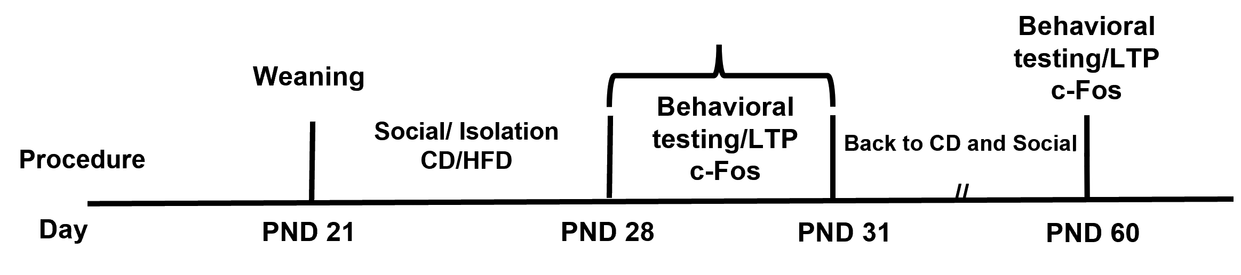

**Figure 6**: Experimental procedures for Aims 1 and 2. Animals will be weaned at postnatal day (PND) 21 and divided into are divided into four groups. Two animals will be taken from each litter to avoid litter effects. Animals will be caged either in groups (social) or alone (isolation) and fed either HFD or CD. On day 7 they will undergo behavioral testing, and at the end of testing, they will be returned to their experimental conditions. Other animals will be anesthetized for electrophysiological analyses or taken after testing is complete to analyze c-Fos expression. In different groups of animals, after exposure to social isolation and/or HFD for 7-9 days, animals will be returned to social ground housing conditions and fed CD, with testing (behavior, LTP, cFos) then being performed after 30 days. Adult animals will undergo similar procedures, but social isolation/HFD will be initiated at PND60. For these experiments, we will test males and females, 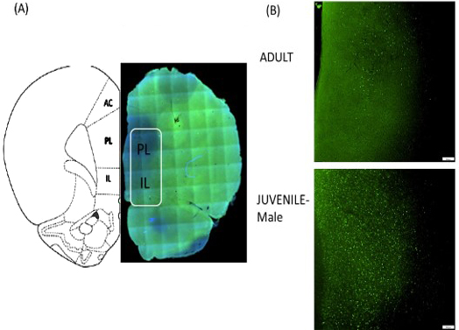juveniles and adults.

**Figure 7**. (A) Representative schematic overlays of c-Fos expression in the PL and IL. (B) Representative images of c-Fos immunohistochemistry staining in the PL and IL following long-term SRM in adult (Top) and juvenile (Bottom) male rats. These show that following the test phase (24 h after the sample phase), juvenile animals exhibited more activation of the IL and PL than did adult animals.

**Aim 3:** **Explore transcriptomic and proteomic changes to identify and establish the causal roles of miRNA-regulated genes and pathways underlying the phenotypic effects of social isolation and/or HFD intake.**

**Rationale:** Our data show that the combination of both social isolation and HFD prevents the defects caused by either of these factors applied separately. This provides a unique opportunity to reveal the molecular mechanisms underlying these and to understand whether the rescue of these deficits corresponds to a unique molecular signature. Many studies have explored the effects of social isolation, stressors, and HFD intake on miRNA expression profiles in different brain regions, including the mPFC (33, 36, 51–53). Our preliminary study conducted in collaboration with Prof. Irit Akirav (Psychology Dept. of the University of Haifa) highlighted the influence of early life stress on the expression of miR-16 (Figure 8), revealing that antagonizing miR-16 reduced its expression in the mPFC. We further demonstrated that early-life stress downregulated the expression of miR-16 and that chronic treatment with URB, a relatively selective and irreversible inhibitor of the enzyme fatty acid amide hydrolase (FAAH, the primary degradative enzyme for the endocannabinoid anandamide) normalized this effect.

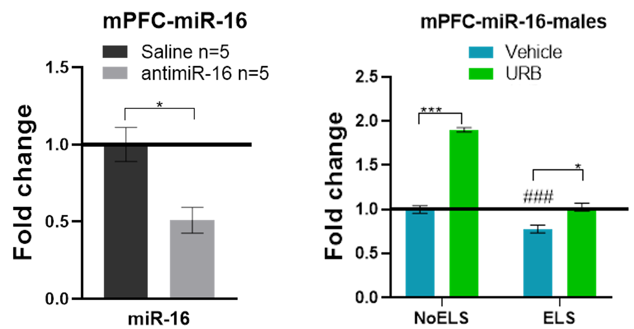

**Figure 8: The expression of miR-16 in the mPFC following the microinfusion of anti-miR-16.**

(A)Rats were microinjected with antagomir-16 (anti-mir, 20 nm; Creative Biiogene) in the right ventricle and were decapitated after 7 weeks. A significant decrease in miR-16 expression was observed in the PFC (n=5 in all groups) (*P<0.05). (B) The effects of early life stress (ELS) and chronic treatment with URB597 during late adolescence on the expression of miR-16 in adult male rats in the mPFC (*P<0.05; ***P<0.001; #P<0.05 vs. NoELS-Vehicle) (n=5-10/group).

Therefore, the involvement of miRNAs in the reprogramming of gene expression following dual exposure to social isolation and HFD is highly plausible. Furthermore, as miRNAs regulate protein expression both directly and indirectly, concurrent proteomic analyses are required to fully understand such reprogramming. Indeed, studies have reported changes in proteomic profiles in different brain regions following social isolation (51), as did our study of the medial amygdala following social isolation in adult animals (25). Here, we aim to conduct genome-wide analyses of both miRNA and proteomic profiles in order to assess how they are affected by social isolation, HFD, and the combination of the two. By integrating the resultant miRNA and proteomic profiles, we will be able to identify uniquepatterns of miRNA expression and complementary alterations in molecular pathways, allowing us to generate robust hypotheses regarding the molecular mechanisms underlying deficiencies caused by HFD or social isolation and their rescue when the two are presented together. After identifying candidate miRNAs that constitute a key signature associated with the rescue effect, we will seek to establish a mechanistic link by directly manipulating the expression of these miRNAs via the infusion of antagomir/agomir constructs and the monitoring of behavioral outcomes.

**Aim 3a**: **Explore transcriptomic and proteomic changes to identify putative miRNA-regulated genes and pathways underlying diet- and/or isolation-related phenotypes.**

The rescue of SRM and plasticity by two factors that separately cause deficits strongly suggests that distinctive molecular signatures underlie HFD/isolation and the combination of the two.

**Working hypotheses**: We predict that different patterns of miRNA and protein expression will be observed in the brain under the three tested conditions (isolation, diet, and isolation+HFD). In accordance with the assumption that we will observe differential miRNA expression patterns in different brain regions, a previous study reported that the central amygdala and the hippocampal CA1 exhibit distinct clusters of miRNA expression changes following either acute or chronic stress exposure(54). It is also plausible that the three tested conditions may exhibit different molecular signatures.

**Research design and methods:** In order to identifythe molecular mechanisms involved in the deficits observed following either social isolation or HFD exposure and the rescue thereof in response to the combined treatment, integrated miRNA and proteomic analyses will be performed. Due to the high costs of such analyses, we will focus on the brain region that shows the clearest phenotypes in c-Fos and LTP analyses defined in Aim 2 and that may exhibit differential involvement in juveniles and adults. We will sample both males and females in case sex-dependent patterns are observed. For each group, eight animals will be sampled after the termination of the 7-day exposure period. We will extract protein and total RNA, including miRNAs, from the same sample as described previously(25), and we will additionally collect samples from the other components of the circuit to enable future studies as appropriate. miRNA-Seq library construction and sequencing will be performed at the Technion Genome Center (Technion, Israel). For miRNA-Seq, pre-processing, identification, and quantification of miRNA expression will follow the workflow proposed by Yao et al (55). Briefly, following quality control, high-quality reads will be mapped to several small RNA debases (including miRBase, piRBase, and GtRNAdb) as well as to the latest NCBI versions of the *Rattus norvegicus* transcriptome and genome (GenBank assembly mRatBN7.2; accession: GCA_015227675.2). Novel miRNA discovery will be conducted using the miRDeep2 algorithm (56). Following quantification of miRNA expression, differential expression analysis will be performed (DESeq2 pipleline (57)) which will provide us with the sets of miRNA upregulated and downregulated under each experimental condition. We will then predict the putative mRNA targets of these identified miRNAs using appropriate databases (*e*.*g*., miRDB (58)) and calculate and compare potential miRNA-mRNA regulatory networks under each experimental condition (using miRNet, (59)). Then, we will examine functional pathway enrichment (e.g., gene ontology and KEGG pathways; DIANA-miRPath ref), based on putative mRNA targets identities. Label-free LC-MS/MS analysis and determination of proteomic profiles will be conducted at The Smoler Protein Research Center (Technion, Israel). The database for the retrieval of secondary mass spectrometry data will be the Uniprot rat reference proteome, and label-free Quantitation (LFQ) values will be assigned. The resultant proteomic dataset will be analyzed following our previous workflow (25) to identify differentially expressed proteins and functional pathway enrichment. Next, the two datasets will be integrated using graph convolutional networks, as implemented in MOGONET (60) via a supervised integrative multi-omics analytical approach. This approach will enable the identification of linkages between miRNAs and proteins co-regulated under specific experimental conditions. This strategy will highlight unique biomarkers (both miRNAs and proteins) specific to groups and/or phenotypes. Furthermore, the analyses will enable us to present robust hypotheses regarding specific pathways that may be regulated by specific miRNAs and to list candidate miRNAs related to the reprograming of the circut. The University of Haifa Bioinformatics Services Unit, will conduct these bioinformatics analyses (See letter of collaboration).

**Aim 3b: Establish the causal role of specific miRNA candidates by manipulating their expression and assessing whether they can reverse the social deficits caused by social isolation or HFD.**

The list of miRNAs identified in Aim 3a will be cross-referenced with a list of candidate miRNAs specifically associated with social isolation, HFD, and/or stress in the literature (such as miR-218 or miR-16). After identifying the candidate miRNAs, in this sub-aim, we will explore their mechanistic functions by directly manipulating their expression through the infusion of antagomirs/agomirs into the mPFC, CA1, or BLA based on the region profiled above. We will focus on the highest-ranked miRNAs.

**Working hypothesis**: Based on the predictions from Aim 3a and the literature, we hypothesize that activating specific miRNAs that were differentially upregulated in the Isolation+HFD condition will rescue observed deficits in SRM and LTP under the tested conditions. We further expect that these effects will persist 1 month later and that the effects of these manipulations will not only be region-specific (mPFC vs BLA) but also age-dependent, with juvenile animals showing the most robust effect. It is possible that sex-dependent differences will also be observed.

**Research design:** We will rank different miRNAs based on the available evidence and select 20 for validation by reverse-transcription quantitative PCR (RT-qPCR). For these RT-qPCR-confirmed miRNAs, we will microinfuse appropriate antagomirs/agomirs in the selected brain region. For those miRNAs exhibiting a high degree of rescue efficiency for either social isolation, HFD, or social isolation+HFD we will further examine the expression of predicted protein targets, based on the findings in Aim 3a, via Western blotting. Additionally, for the infusion-confirmed miRNAs, we will examine their expression in the other structures sampled in the previous aim. We have extensive experience performing mircoinfusion procedures in different brain structures in both adults and juveniles, enabling us to effectively complete this aim.

**Validation of miRNA expression results by RT-qPCR**: The expression of target miRNAs will be analyzed under different conditions (social isolation vs. no isolation, juveniles vs. adults, males vs. females, HFD vs. CD, 1 week vs. 1 month) in samples of mPFC, BLA, MeA, and CA1 tissue. Briefly, bilateral samples from the punched area will be harvested, and RNA extraction and cDNA synthesis will be performed as per Zaidan et al. (61) (see support letter). The expression of candidate miRNAs will be assessed via SYBR Green-based RT-qPCR amplification. Fold-change values will be calculated using the 2 ΔΔCt method (62) relative to the housekeeping genes RNU6 and RNU66.

**Western blot analysis:** Western blotting analyses will be performed as per our previous work (50)

**Expected results and pitfalls for Aim 3**: We expect to gain insight into the molecular mechanisms underlying social memory impairment in the selected brain area under conditions of social isolation and HFD intake, identifying miRNA and protein biomarkers associated therewith. Importantly, we will identify the molecular pathways that govern the observed rescue phenotypes in response to the combination of social isolation and HFD that occurs in juveniles but not in adults. At the conclusion of this aim, we will propose a list of miRNAs putatively governing the observed reprogramming under different conditions. While they can be effective, bulk tissue analyses have been criticized in brain research for the masking of effects that may only be evident in a small subset of cells within the tissue. As such, our efforts to identify molecular elements may be somewhat incomplete. Nevertheless, our previous experience indicates that the impact of social isolation on transcriptomic and proteomic profiles is readily accessible through bulk RNA- and protein-based analyses(25). Additionally, we may find that co-isolation of total RNA and total protein from the same sample may affect the quality or quantity of the sample. In that case, we will extract these different components separately using the left and right hemispheres (counterbalanced).

When establishing a mechanistic link in Aim 3b, we expect that blocking these miRNAs in the Isolation-HFD condition will impair SRM and LTP. In contrast, mimicking their activity will prevent the deficits caused by social isolation or HFD. As the mPFC and amygdala present opposing effects, we predict that we will observe differential effects of activation and inhibition in these compartments. With respect to the long-term effect of miRNA manipulation, we may address the durability of the effects of these agomirs and antagomirs last. If the changes in the expression of the specific miRNAs following microinjection do not last for 1 month, we may consider examining animals at 1 or 2 weeks after the termination. However, in our preliminary results, we found that antagonizing miR-16 resulted in its persistent downregulation for 7 weeks. As a control, we may also incorporate additional groups and we will perform microinfusion into the lateral ventricles to compare the resultant phenotypes with those that arise following intra-regional microinfusion.

**Available resources**: Animal facilities for breeding and housing are available at the University of Haifa, with 4 personnel including veterinary services. Prof. Maroun's lab is equipped with all of the necessary equipment for the proposed behavioral, pharmacological, immunohistochemical, and electrophysiological studies, with three fully equipped electrophysiological rigs for acute and chronic recordings. Behavioral paradigms include social interaction connected to software for offline behavioral analysis. Systems for microinjections, a virus injection room, and facilities for immunohistochemistry and perfusion are available in the lab. Our exciting preliminary data require that we step out of our scientific comfort zone to better explore the mechanisms mediating these effects. While my lab has not published on miRNAs, we have attained in-house technical support for miRNA-focused experiments through the laboratory of Prof Irit Akirav with whom we have joint projects focused on the effects of early life stress on the mPFC (preliminary data #8). We have published data with Prof. Shlomo Wagner on transcriptomics (25) as have worked with Profs. Kobi Rosenblum and Inna Gaisler-Solomon. We also have a support letter from the head of the Unit of Bioinformatics at Haifa University

**References:**

1. Miller G (2011): Why Loneliness Is Hazardous to Your Health. *Science (80- )*. 331: 138–140.

2. Pitman A, Mann F, Johnson S (2018): Advancing our understanding of loneliness and mental health problems in young people. *The Lancet Psychiatry*. 5: 955–956.

3. Arzate-Mejía RG, Lottenbach Z, Schindler V, Jawaid A, Mansuy IM (2020): Long-Term Impact of Social Isolation and Molecular Underpinnings. *Front Genet*. 1285.

4. Wang S, Chen L, Ran H, Che Y, Fang D, Sun H, Peng J, Liang X, Xiao Y (2022): Depression and anxiety among children and adolescents pre and post COVID-19: A comparative meta-analysis. *Front Psychiatry*. 13: 1752.

5. Mumtaz F, Khan MI, Zubair M, Dehpour AR (2018): Neurobiology and consequences of social isolation stress in animal model—A comprehensive review. *Biomed Pharmacother*. 105: 1205–1222.

6. Heidbreder CA, Weiss IC, Domeney AM, Pryce C, Homberg J, Hedou G, Feldon J, Moran MC, Nelson P (2000): Behavioral, neurochemical and endocrinological characterization of the early social isolation syndrome. *Neuroscience*. 100: 749–68.

7. Makinodan M, Rosen KM, Ito S, Corfas G (2012): A Critical Period for Social Experience-Dependent Oligodendrocyte Maturation and Myelination. *Science (80- )*. 337: 1357–1360.

8. Liu J, Dietz K, Deloyht JM, Pedre X, Kelkar D, Kaur J, Vialou V, Lobo MK, Dietz DM, Nestler EJ, Dupree J, Casaccia P (2012): Impaired adult myelination in the prefrontal cortex of socially isolated mice. *Nat Neurosci*. 15: 1621.

9. Yamamuro K, Bicks LK, Leventhal MB, Kato D, Im S, Flanigan ME, Garkun Y, Norman KJ, Caro K, Sadahiro M, Kullander K, Akbarian S, Russo SJ, Morishita H (2020): A prefrontal–paraventricular thalamus circuit requires juvenile social experience to regulate adult sociability in mice. *Nat Neurosci 2020 2310*. 23: 1240–1252.

10. Yamamuro K, Yoshino H, Ogawa Y, Makinodan M, Toritsuka M, Yamashita M, Corfas G, Kishimoto T (2018): Social Isolation During the Critical Period Reduces Synaptic and Intrinsic Excitability of a Subtype of Pyramidal Cell in Mouse Prefrontal Cortex. *Cereb Cortex*. 28: 998–1010.

11. Lupien SJ, McEwen BS, Gunnar MR, Heim C (2009): Effects of stress throughout the lifespan on the brain, behaviour and cognition. *Nat Rev Neurosci*. 10: 434–45.

12. Marín O (2016): Developmental timing and critical windows for the treatment of psychiatric disorders. *Nat Med 2016 2211*. 22: 1229–1238.

13. Dallman MF, Pecoraro N, Akana SF, La Fleur SE, Gomez F, Houshyar H, Bell ME, Bhatnagar S, Laugero KD, Manalo S (2003): Chronic stress and obesity: A new view of “comfort food.” *Proc Natl Acad Sci U S A*. 100: 11696–11701.

14. la Fleur SE, Houshyar H, Roy M, Dallman MF (2005): Choice of lard, but not total lard calories, damps adrenocorticotropin responses to restraint. *Endocrinology*. 146: 2193–9.

15. Finger BC, Dinan TG, Cryan JF (2011): High-fat diet selectively protects against the effects of chronic social stress in the mouse. *Neuroscience*. 192: 351–360.

16. Rincel M, Lépinay AL, Delage P, Fioramonti J, Théodorou VS, Layé S, Darnaudéry M (2016): Maternal high-fat diet prevents developmental programming by early-life stress. *Transl Psychiatry*. 6: e966.

17. Schayek R, Maroun M (2017): Dissociation in the effects of stress and D1 receptors activation on basolateral amygdalar LTP in juvenile and adult animals. *Neuropharmacology*. 113: 511–518.

18. Shrivastava K, Rosenberg T, Meiri N, Maroun M (2021): Age-Specific Modulation of Prefrontal Cortex LTP by Glucocorticoid Receptors Following Brief Exposure to HFD. *Front Synaptic Neurosci*. 13: 722827.

19. Schayek R, Maroun M (2015): Differences in Stress-Induced Changes in Extinction and Prefrontal Plasticity in Postweanling and Adult Animals. *Biol Psychiatry*. 78: 159–66.

20. Maroun M, Sarussi-Elyahu A, Yaseen A, A. Hatoum O, Kritman M (2020): Sex-dimorphic role of prefrontal oxytocin receptors in social-induced facilitation of extinction in juvenile rats. *Transl Psychiatry*. 10. doi: 10.1038/s41398-020-01040-9.

21. Khazen T, Hatoum OAOA, Ferreira G, Maroun M (2019): Acute exposure to a high-fat diet in juvenile male rats disrupts hippocampal-dependent memory and plasticity through glucocorticoids. *Sci Rep*. 9: 12270.

22. Yaseen A, Shrivastava K, Zuri Z, Hatoum OA, Maroun M (2018): Prefrontal Oxytocin is Involved in Impairments in Prefrontal Plasticity and Social Memory Following Acute Exposure to High Fat Diet in Juvenile Animals. *Cereb Cortex*. doi: 10.1093/cercor/bhy070.

23. Khazen T, Narattil NR, Ferreira G, Maroun M (2022): Hippocampal oxytocin is involved in spatial memory and synaptic plasticity deficits following acute high-fat diet intake in juvenile rats. *Cereb Cortex*. doi: 10.1093/CERCOR/BHAC317.

24. Gan L, England E, Yang J-YY, Toulme N, Ambati S, Hartzell DL, Meagher RB, Baile CA, Ogden C, Carroll M, Kit B, Flegal K, Bray G, Popkin B, Pasinetti G, Eberstein J, Grant W, Campbell A, Itzhaki R, *et al.* (2015): A 72-hour high fat diet increases transcript levels of the neuropeptide galanin in the dorsal hippocampus of the rat. *BMC Neurosci*. 16: 51.

25. Lavenda-Grosberg D, Lalzar M, Leser N, Yaseen A, Malik A, Maroun M, Barki-Harrington L, Wagner S (2021): Acute social isolation and regrouping cause short- and long-term molecular changes in the rat medial amygdala. *Mol Psychiatry 2021*. 1–10.

26. Arcego DM, Krolow R, Lampert C, Toniazzo AP, Berlitz C, Lazzaretti C, Schmitz F, Rodrigues AF, Wyse ATS, Dalmaz C, DM A, R K, C LL, AP T, C B, C LL, F S, AF R, AT W, *et al.* (2016): Early life adversities or high fat diet intake reduce cognitive function and alter BDNF signaling in adult rats: Interplay of these factors changes these effects. *Int J Dev Neurosci*. 50: 16–25.

27. Eudave DM, BeLow MN, Flandreau EI (2018): Effects of high fat or high sucrose diet on behavioral-response to social defeat stress in mice. *Neurobiol Stress*. 9: 1–8.

28. Kumari A, Singh P, Baghel MS, Thakur MK (2016): Social isolation mediated anxiety like behavior is associated with enhanced expression and regulation of BDNF in the female mouse brain. *Physiol Behav*. 158: 34–42.

29. Antony M, Scranton V, Srivastava P, Letters RV-N, 2020 U (n.d.): Micro RNA 181c-5p: a promising target for post-stroke recovery in socially isolated mice. *Elsevier*.

30. Moshitzky G, Shoham S, Madrer N, Husain AM, Greenberg DS, Yirmiya R, Ben-Shaul Y, Soreq H (2020): Cholinergic Stress Signals Accompany MicroRNA-Associated Stereotypic Behavior and Glutamatergic Neuromodulation in the Prefrontal Cortex. *Biomol 2020, Vol 10, Page 848*. 10: 848.

31. Darcq E, Warnault V, Phamluong K, Besserer GM, Liu F, Ron D (2015): MicroRNA-30a-5p in the prefrontal cortex controls the transition from moderate to excessive alcohol consumption. *Mol Psychiatry*. 20: 1240–1250.

32. Lin Q, Wei W, Coelho CM, Li X, Baker-Andresen D, Dudley K, Ratnu VS, Boskovic Z, Kobor MS, Sun YE, Bredy TW (2011): The brain-specific microRNA miR-128b regulates the formation of fear-extinction memory. *Nat Neurosci*. 14: 1115–1117.

33. Labouesse MA, Polesel M, Clementi E, Müller F, Markkanen E, Mouttet F, Cattaneo A, Richetto J (2018): MicroRNA expression profiling in the prefrontal cortex: Putative mechanisms for the cognitive effects of adolescent high fat feeding. *Sci Rep*. 8. doi: 10.1038/s41598-018-26631-x.

34. Popa N, Boyer F, Jaouen F, Belzeaux R, Gascon E (2020): Social Isolation and Enrichment Induce Unique miRNA Signatures in the Prefrontal Cortex and Behavioral Changes in Mice. *iScience*. 23. doi: 10.1016/J.ISCI.2020.101790.

35. Mavrikaki M, Pantano L, Potter D, Rogers-Grazado MA, Anastasiadou E, Slack FJ, Amr SS, Ressler KJ, Daskalakis NP, Chartoff E (2019): Sex-Dependent Changes in miRNA Expression in the Bed Nucleus of the Stria Terminalis Following Stress. *Front Mol Neurosci*. 12.

36. Lin Q, Wei W, Coelho CM, Li X, Baker-Andresen D, Dudley K, Ratnu VS, Boskovic Z, Kobor MS, Sun YE, Bredy TW (2011): The brain-specific microRNA miR-128b regulates the formation of fear-extinction memory. *Nat Neurosci*. 14: 1115–1117.

37. Liu Y, Liu D, Xu J, Jiang H, Pan F (2017): Early adolescent stress-induced changes in prefrontal cortex miRNA-135a and hippocampal miRNA-16 in male rats. *Dev Psychobiol*. 59: 958–969.

38. Boitard C, Maroun M, Tantot F, Cavaroc A, Sauvant J, Marchand A, Layé S, Capuron L, Darnaudery M, Castanon N, Coutureau E, Vouimba R-MRMR-MR-MR-M, Ferreira G (2015): Juvenile obesity enhances emotional memory and amygdala plasticity through glucocorticoids. *J Neurosci*. 35: 4092–103.

39. Boitard C, Etchamendy N, Sauvant J, Aubert A, Tronel S, Marighetto A, Layé S, Ferreira G (2012): Juvenile, but not adult exposure to high-fat diet impairs relational memory and hippocampal neurogenesis in mice. *Hippocampus*. 22: 2095–2100.

40. Khazen T, Hatoum OA, Ferreira G, Maroun M (2019): Acute exposure to a high-fat diet in juvenile male rats disrupts hippocampal-dependent memory and plasticity through glucocorticoids. *Sci Rep*. 9. doi: 10.1038/s41598-019-48800-2.

41. Ali EF, MacKay JC, Graitson S, James JS, Cayer C, Audet M-C, Kent P, Abizaid A, Merali Z (2018): Palatable Food Dampens the Long-Term Behavioral and Endocrine Effects of Juvenile Stressor Exposure but May Also Provoke Metabolic Syndrome in Rats. *Front Behav Neurosci*. 0: 216.

42. Li Q, Liang J, Fu N, Han Y, Qin J (2021): A Ketogenic Diet and the Treatment of Autism Spectrum Disorder. *Front Pediatr*. 9: 341.

43. Palanza P, Parmigiani S (2017, May 1): How does sex matter? Behavior, stress and animal models of neurobehavioral disorders. *Neurosci Biobehav Rev*. 76.

44. Bredewold R, Veenema AH (2018, April): Sex differences in the regulation of social and anxiety-related behaviors: insights from vasopressin and oxytocin brain systems. *Curr Opin Neurobiol*. 49.

45. Liu Y, Lv L, Wang L, Zhong Correspondence Y (2018): Social Isolation Induces Rac1-Dependent Forgetting of Social Memory In Brief. *CellReports*. 25: 288-295.e3.

46. Lara E, Caballero FF, Rico-Uribe LA, Olaya B, Haro JM, Ayuso-Mateos JL, Miret M (2019): Are loneliness and social isolation associated with cognitive decline? *Int J Geriatr Psychiatry*. 34: 1613–1622.

47. Kanoski SE, Meisel RL, Mullins AJ, Davidson TL (2007): The effects of energy-rich diets on discrimination reversal learning and on BDNF in the hippocampus and prefrontal cortex of the rat. *Behav Brain Res*. 182: 57–66.

48. Khazen T, Shrivastava K, Jada R, Hatoum OA, Maroun M (2018): Different mechanisms underlie stress-induced changes in plasticity and metaplasticity in the prefrontal cortex of juvenile and adult animals: Emotional-induced metaplasticity in the prefrontal cortex. *Neurobiol Learn Mem*. doi: 10.1016/j.nlm.2018.02.011.

49. Nicoll RA (2017): A Brief History of Long-Term Potentiation. *Neuron*. 93: 281–290.

50. Awad W, Ferreira G, Maroun M (2015): Dissociation of the Role of Infralimbic Cortex in Learning and Consolidation of Extinction of Recent and Remote Aversion Memory. *Neuropsychopharmacology*. 40: 2566–75.

51. Perić I, Costina V, Gass P, Findeisen P, Filipović D (2021): Hippocampal synaptoproteomic changes of susceptibility and resilience of male rats to chronic social isolation. *Brain Res Bull*. 166: 128–141.

52. Torres-Berrío A, Lopez JP, Bagot RC, Nouel D, Dal Bo G, Cuesta S, Zhu L, Manitt C, Eng C, Cooper HM, Storch KF, Turecki G, Nestler EJ, Flores C (2017): DCC Confers Susceptibility to Depression-like Behaviors in Humans and Mice and Is Regulated by miR-218. *Biol Psychiatry*. 81: 306–315.

53. Torres-Berrío A, Nouel D, Cuesta S, Parise EM, Restrepo-Lozano JM, Larochelle P, Nestler EJ, Flores C (2020): MiR-218: a molecular switch and potential biomarker of susceptibility to stress. *Mol Psychiatry*. 25: 951–964.

54. Meerson A, Cacheaux L, Goosens KA, Sapolsky RM, Soreq H, Kaufer D (2010): Changes in brain MicroRNAs contribute to cholinergic stress reactions. *J Mol Neurosci*. 40: 47–55.

55. Yao X, Sun S, Zi Y, Liu Y, Yang J, Ren L, Chen G, Cao Z, Hou W, Song Y, Shang J, Jiang H, Li Z, Wang H, Zhang P, Shi L, Li QZ, Yu Y, Zheng Y (2022): Comprehensive microRNA-seq transcriptomic profiling across 11 organs, 4 ages, and 2 sexes of Fischer 344 rats. *Sci Data 2022 91*. 9: 1–10.

56. Friedländer MR, MacKowiak SD, Li N, Chen W, Rajewsky N (2012): miRDeep2 accurately identifies known and hundreds of novel microRNA genes in seven animal clades. *Nucleic Acids Res*. 40: 37–52.

57. Love MI, Huber W, Anders S (2014): Moderated estimation of fold change and dispersion for RNA-seq data with DESeq2. *Genome Biol*. 15: 1–21.

58. Chen Y, Wang X (2020): miRDB: an online database for prediction of functional microRNA targets. *Nucleic Acids Res*. 48: D127–D131.

59. Chang L, Zhou G, Soufan O, Xia J (2020): miRNet 2.0: network-based visual analytics for miRNA functional analysis and systems biology. *Nucleic Acids Res*. 48: W244–W251.

60. Wang T, Shao W, Huang Z, Tang H, Zhang J, Ding Z, Huang K (2021): MOGONET integrates multi-omics data using graph convolutional networks allowing patient classification and biomarker identification. *Nat Commun 2021 121*. 12: 1–13.

61. Zaidan H, Ramaswami G, Golumbic YN, Sher N, Malik A, Barak M, Galiani D, Dekel N, Li JB, Gaisler-Salomon I (2018): A-to-I RNA editing in the rat brain is age-dependent, region-specific and sensitive to environmental stress across generations. *BMC Genomics*. 19: 28.

62. Livak KJ, Schmittgen TD (2001): Analysis of relative gene expression data using real-time quantitative PCR and the 2(-Delta Delta C(T)) Method. *Methods*. 25: 402–408.