**Research Proposal - Application No. 1106/25**

**The Eyes as a Reflection of Systems Thinking: Using Eye-Tracking to Assess Systems Thinking Skills**

1. **Scientific Background**

**Systems thinking**

Many researchers have defined systems thinking. Lamb and Rhodes (2007) formulated this definition : "Analysis, coupling, and understanding of internal relationships, technical, social, and temporal interactions." Frank (2002) emphasized the importance of understanding the entire system and how each part operates within it. Consequently, it is essential to view the system as a unified whole rather than as isolated components. Bertalanffy (1973) stated that different systems can be based on similar principles. Senge (1991) outlined five key areas for developing a learning organization, with the fifth being systems thinking—a holistic approach that avoids overemphasizing details and allows for recognizing the interconnections between components and their effects on one another and the system as a whole. According to Senge (1990), a skilled systems thinker is someone who can perceive four simultaneous levels: events, patterns, structures, and underlying forces. This insight unifies the fields of mental models, shared vision, personal mastery and team learning. Researchers commonly believe that applying systems thinking can optimize performance improvement in organizations (Neil, 1997). Researchers view systems thinking as a concept that involves considering an issue in its entirety, focusing on the interrelationships between its components rather than the individual components themselves (Richmond & Peterson, 2001; Arnold & Wade, 2015). Richmond (1994) formalized this concept as: “Systems Thinking is the art and science of making reliable inferences about behavior by developing an increasingly deep understanding of underlying structure.” Richmond (2000) coined the paraphrase “forest thinking” to clarify the concept of systems thinking. According to his approach, forest thinking involves a “view from 10,000 meters rather than focusing on local trees” and “considering how the system influences systems on the other side of the line and how these latter systems influence the former system. Richmond (1991) highlights the importance of promoting systems thinking within organizations and noted that efforts to implement it must be targeted and deliberate.

Since systems thinking is an interdisciplinary framework applied across a broad range of fields rather than a single discipline, numerous studies illustrate its potential applications in various global domains. These include for example: healthcare (Kenett & Lavi, 2016; Leshno & Menachem, 2016), education (Goldstein, 2016; Koral Kordova, Frank, & Nissel Miller, 2018), and systems engineering (Davidz & Nightingale, 2008; McDermott & Freeman, 2016; Zhang, 2016).‎ These studies help us gain a deeper understanding of the importance of incorporating a systematic perspective into the work environments of global organizations. In addition to explaining the conceptual foundations of systems thinking, they also introduce its terminology and tools, along with guidelines for their effective use. A better grasp of these tools and the newly proposed terminology will enhance our ability to identify problems and design solutions in environments increasingly defined by the complexity and chaos typical of global organizations.

**Tools for assessing systems thinking capability**

Systems thinking is a valuable skill that may be required for an individual to be promoted in the business arena. The systems thinking trait is not dichotomic and may be graded with a continuous, or at least a multi-level, scale. In order to make a decision regarding promoting/recruiting an employee to a position that requires systems thinking (or better systems thinking), a validated and reliable systems thinking measurement tool is required. When reviewing candidates for systems engineering positions, the evaluation of systems thinking skills is a central parameter (Frank, 2010). Assessing systems thinking skills is highly important in the education field, and is considered a necessary tool for implementing a productive teaching program for this subject (Plate & Monroe, 2014). An effective systems thinking assessment tool is important not only for recruitment/promotion decisions, but also for evaluating and enhancing training programs (Grohs et al., 2018). In order to evaluate the individual’s capabilities in general and to assess their preference for dealing with positions that require systems thinking skills in particular, we need a validated and reliable tool. The literature describes several tools aimed at evaluating systems thinking skills, mainly in the domain of education. Assaraf and Orion (2005) applied customized quandaries to test the ability of school students studying an earth-systems-based curriculum dealing with complex systems. Hooper and Stave (2008) suggested an assessment of systems thinking skills based on different levels, for example, the ability to list the system parts as predictors for recognizing interconnection levels, or the ability to justify why a given action is expected to solve a problem as a predictor for using conceptual model levels. Another approach seeks to define the complete set of skills required for systems thinking, e.g., the use of mental modeling and abstraction, and by quantitative assessment of these skills the systems thinking trait may be evaluated (Arnold, 2017). Lavi et al. (2019) classified systems thinking attributes into system function, structure, and behavior, and by scoring proposed system models based on object-process methodology they evaluated systems thinking skills. Buckle (2018) examined the utilization of a maturity model to assess the competence of a person to handle complex systems, i.e., systems thinking skills (coined as MMSTC—Maturity Model of Systems Thinking Competence). Frank (2010) developed a tool for assessing systems thinking skills: a questionnaire aimed at assessing the individual’s interest for positions requiring systems thinking. Frank proposed four different aspects of systems thinking: knowledge, individual traits, cognitive characteristics, and capabilities.

**Picture-based tests**

Picture-based tests have long been used in psychology to assess cognitive and emotional processes. These tools provide insights into how individuals think, process information, and react to visual stimuli. For example, tests like the *Thematic Apperception Test (TAT)* (Lilienfeld, Wood, & Garb, 2000) and the *Rorschach Inkblot Method* (Alexy, 2018; Hughes, Gacono, & Owen, 2007) have been employed to evaluate emotional content and thought patterns based on ambiguous visual prompts. Similarly, the *Picture Frustration Test* (Rosenzweig, 1976) assesses responses to everyday frustrating scenarios by having participants complete speech bubbles in cartoon images. These tests demonstrate the power of images in revealing deeper cognitive processes. Modern techniques, such as computer-based image analysis, have been applied to counselling and personality assessment (Cao & Wan, 2020). Visual Thinking Strategies (VTS) have been used to enhance observational skills, particularly in educational settings, as demonstrated by Poirier, Newman, and Ronald (2020). Additionally, Sang, Zhang, and Xu (2016) explored the use of image-based assessments for personality testing, showing that image-based tools can be as accurate as text-based methods. In the context of this research, picture-based tests will serve as a novel tool to explore systems thinking abilities. By presenting participants with complex images and tracking their eye movements, we aim to measure how individuals process these visual stimuli and identify patterns that correlate with systems thinking. This approach builds on the long-established use of pictorial stimuli in psychology, but applies it to the domain of systems thinking, using eye-tracking technology to provide objective, quantifiable data.

**Eye tracking**

Picture-based tests can indicate ways of thinking. Tracking eye movements gives a physiological basis for describing the way people look at pictures. The technology of eye tracking has become increasingly popular, affordable, and accessible, making it a popular tool for many types of research (Matzen, Stites & Gastelum, 2021). It is applied in various fields, including psychology, human factors, computer graphics, marketing, and virtual reality (Carter & Luke, 2020; Duchowski, 2017). Eye-tracking studies have been used to examine relationships between intelligence, personality, cognitive processes, and learning outcomes. For example, Peterson, Deary, and Austin (2005) researched the correlation between eye-tracking patterns and holistic-analytical cognitive styles. Eye tracking can be used as a tool for studying human cognition and patterns of attention. Eye movements are a reasonable proxy for patterns of attention in most cases, and recordings of eye movements can be a useful tool for studying human cognition. Eye-tracking is a set of research techniques and methods used to measure, analyse, and interpret data on the position and movement of eyeballs: where the subject’s eyesight falls at a given moment, how long the eyesight focuses on a particular point, what path it follows, and pupil size. It is a tool that enables obtaining an accurate representation and understanding of eye motion. The four types of eye movements that can be distinguished in eye-tracking research are fixations, saccades, smooth pursuits, and blinks (Zagermann, Pfeil, & Reiterer, 2016) . Fixations are brief pauses in the movement of the eye when the retina stabilizes at a particular point in the field of vision. Saccades are rapid eye movements that occur when the eye moves from one fixation point to another. Smooth pursuits are slow eye movements that occur when the eye follows a moving object. Blinks are when the eyelid closes and then reopens, which can be detected and analyzed in eye-tracking research (Białowąset al. 2021). Scientists hold a keen interest in studying eye movements because they are intrinsically linked to what individuals observe and, in turn, what they are thinking about.

**Using eye movement tracking**

Eye-tracking technology finds applications in numerous areas and diverse fields including neuroscience and psychology research, attentional neuroscience, the investigation of illusory contours, reading studies, human factors, marketing, human-computer interaction, collaborative systems, computer graphics, and virtual reality. (Duchowski, 2017). Bayliss et al. (2013) investigated how altering the way individuals' eyes are guided can influence our exploration and evaluation of the social environment. Reingold and Sheridan (2011) discerned that expertise is linked to the ability to process visual information within one's domain of expertise, particularly in terms of broader patterns rather than isolated components. Carter and Luke (2020) conducted a comprehensive review on employing eye tracking technology for emotion recognition. Notably, mental fatigue in construction equipment operators plays a pivotal role in accidents. Klaib et al. (2021) showcased the potential of wearable eye-tracking technology in detecting and classifying such mental fatigue among these operators.The connection between intelligence and personality concerning verbal imagery and holistic-analytical cognitive styles was explored by Peterson, Deary, and Austin (2005). Their study utilized two performance-based cognitive style assessments: the Verbal-Imagery Cognitive Style (VICS) test and the Extended Cognitive Style Analysis Wholistic-Analytic (Extended CSA-WA) test. They unveiled key psychometric properties of these tests and suggested their potential to contribute valuable insights beyond cognitive ability and personality traits in understanding individual differences. Eye-tracking technology offers a valuable window into the allocation of visual attention and can furnish crucial information about cognitive processes. Its applications span reading research, text and picture comprehension, and problem-solving. By monitoring students' eye movements, educators can gain insights into how students process information and distribute their attention, thereby enhancing instructional design and learning outcomes. Van Gog et al. (2009) propose leveraging eye tracking to guide students' attention during learning process by capturing and replaying a model's eye movements during performance. Through this approach, educators can effectively direct students' attention and improve their learning outcomes.Vakil et al. (2011) suggest that eye-tracking technology may be a useful tool for assessing cognitive processes in individuals with intellectual disability. Therefore, educators and researchers may want to consider incorporating eye-tracking technology into their assessments and interventions. Bendall and Thompson (2015) demonstrate how eye tracking can be used to investigate the impact of emotion on attentional allocation in a specific task

**Eye movement and cognitive processes**

Eye-tracking allows for direct measurements of cognitive processing, such as the duration of eye fixation, the number of fixations, and saccade velocity. These measurements can provide detailed information about the allocation of visual attention and cognitive activity in the process and integration of learning information presented in text or image. Eye movements have the capacity to reveal cognitive processes by mirroring internal cognitive activities driven by personal goals rather than external stimuli. By employing eye tracking, one can effectively observe intricate cognitive processes as they transpire within a mere few hundred milliseconds. These eye movements offer a valuable insight into the tempo and pertinent factors of multi-step actions, which would otherwise be quite challenging to decipher (König et al, 2016). Recent studies have unveiled a mutual relationship between eye movements and cognitive processes, where cognitive activities can exert an influence on eye movements. For example, an individual's attentional concentration can dictate their gaze direction, and their anticipations regarding the scene can shape their manner of looking at it (Thomas & Llaras, 2007). Eye movements during visual perception are guided by various factors, and these guiding elements can be subject to influence from cognitive processes such as attention, memory, and decision-making, which are closely tied to one's thought processes (Kollmorgen et al, 2016). According to Nitzan-Tamar, Kramarski, and Vakil (2016), eye movement can be used to identify individuals with different thinking styles based on their eye movement patterns during cognitive tasks. By analyzing the eye movements of participants while they engage in tasks, researchers can distinguish between wholistic and analytic learners. Wholistic learners are characterized by fewer eye movements and transitions, reflecting a tendency towards processing information as a whole. In contrast, analytic learners exhibit more eye movements and are influenced by the components of stimuli, indicating a step-by-step processing approach. Therefore, by monitoring eye movement patterns, researchers can infer the cognitive style of individuals and differentiate between wholistic and analytic thinking styles. Nitzan-Tamar, Kramarski, and Vakil (2023), conducted a study that explored the correlation between thinking flexibility and various cognitive styles. To categorize cognitive styles and establish links with cognitive flexibility, they suggested that the combination of eye movement monitoring and other classification tests be employed. Monitoring eye movements is recognized as a valuable tool for investigating learning strategies. The study incorporated two assessments: the E-CSA-W/A test, which categorizes individuals based on behavioural metrics, and real-time eye movement analysis, which characterizes how information is processed. The inclusion of eye movement analysis significantly enriched the insights gleaned from the behavioural questionnaire. According to Wilming et al. (2017), the analysis of eye movements serves as a valuable means to comprehend cognitive processes by shedding light on the decision-making process behind eye movements and its connection to the activity of individual neurons and brain networks. They suggest that it is feasible to construct behaviour-based models capable of characterizing specific behaviours or modes of thought. The researchers delve into the use of computational modelling of gaze behaviour, aiming to establish a benchmark for assessing and contrasting computational models of overt attention. Through the scrutiny of eye movements, researchers can extract insights into the spatial and temporal attributes of eye movement patterns, which, in turn, can be harnessed to create and enhance models depicting gaze behaviour. The primary focus lies in deciphering the neural foundations of saccade target selection and investigating alterations in viewing behaviour within different patient groups. Onat, Açık, Schumann, and König (2014) propose that eye movements can offer valuable glimpses into the cognitive processes that underpin visual perception and attention. These researchers delve into the interplay of cognitive functions, like attention and perception, with eye movements when individuals freely view natural scenes. The manner in which we conceptualize and interpret visual information within a scene significantly influences our gaze. For instance, when we are actively seeking a particular object in a scene, our attention becomes oriented towards areas where it is most probable for it to be located.

Finally, reaction time is the duration it takes for an individual to respond to a stimulus, such as a visual or auditory signal. It is commonly used as an indicator of cognitive processing speed and can be analyzed to provide insights into cognitive functions and styles (Lacko et al., 2023). Eye-tracking technology can be employed to measure reaction time effectively. To conclude, the scientific background underscores the importance of systems thinking in addressing complex challenges across disciplines and points to eye-tracking technology as a promising method for objectively evaluating and enhancing systems thinking skills in a variety of contexts.

1. **Research objective & expected significance**

The aim of this research proposal is to examine the potential of eye-tracking technology as a novel tool for identifying and assessing systems thinking ability. This study seeks to explore the relationship between specific eye movement patterns and systems thinking, which could lead to a deeper understanding of the cognitive mechanisms underlying this skill. The theoretical significance of this research is multifaceted:

First, the study contributes to cognitive science by advancing our knowledge of how systems thinking is processed at the cognitive level. By identifying eye movement patterns associated with systems thinking, this research could uncover new insights into the cognitive architecture of complex problem-solving and holistic thinking.

Second, it adds to the literature on visual cognition, providing a fresh perspective on how attention and visual processing are linked to higher-order cognitive functions. Eye-tracking data could offer an empirical basis for theorizing about the role of visual perception in complex cognitive tasks, such as systems thinking, which have traditionally been difficult to quantify through behavioural measures alone.

Third, the findings could bridge gaps between the fields of psychology and neuroscience by offering a measurable, physiological basis for systems thinking. Understanding the cognitive processes involved in systems thinking could shed light on broader questions regarding human cognition, such as how individuals integrate information across different domains and timeframes.

In summary, this research promises to extend the theoretical understanding of systems thinking and its cognitive foundations, paving the way for future interdisciplinary research at the intersection of engineering, cognitive science, and neuroscience.

The research question is as follows:

1. Can eye-tracking technology be used as a reliable tool to identify systems thinking ability in individuals who require a holistic perspective in their work, such as engineers, managers, and interdisciplinary professionals?
   1. Is there a correlation between specific eye movement patterns and systems thinking capabilities across various professions that necessitate an integrated, systems-oriented approach?

The research question is important for several reasons:

1. **Need for Reliable Tools for Assessing Systems Thinking**: Systems thinking is key to effective decision-making, yet reliable tools to measure it are lacking. Eye-tracking offers an objective alternative that may better capture its cognitive processes.
2. **Interdisciplinary Contribution**: This research spans engineering, cognitive science, psychology, and educational technology, potentially advancing tools for understanding cognitive processes in psychology and neuroscience.
3. **Methodological Innovation**: While eye-tracking is widely used in marketing and human-computer interaction, its application to systems thinking is novel, paving the way for innovative assessment methodologies.
4. **Detailed description of the proposed research**
   1. **Working hypothesis**

There is a significant correlation between specific eye movement patterns and the level of systems thinking, and eye-tracking data can accurately differentiate between individuals with high and low systems thinking abilities. Individuals classified as having stronger systems thinking abilities—through traditional assessments, such as Frank’s (2010) questionnaire—are expected to show longer fixations on key components within complex systems and smoother transitions between related elements, compared to those with lower systems thinking abilities. E Similarly, Niztzan-Tamar, Kramarski, and Vakil (2016) found that individuals with holistic cognitive styles, closely related to systems thinking, exhibited fewer transitions and longer fixations, reflecting a more integrated approach to information processing.

.

* 1. **Research Innovation**

This study is pioneering in its use of eye-tracking to assess systems thinking abilities—a novel application in this field. While eye-tracking is common in marketing and psychology, its use for research into systems thinking remains unexplored. Building on previous research using an image-based tool to identify systems thinking traits, this study will analyze participants' eye movements across 12 images to investigate correlations between eye movement patterns and systems thinking. As noted in the literature, eye-tracking is a valuable method for examining cognitive abilities, and this research introduces it as a new approach to understanding systems thinking.

* 1. **Research design & methods**

We will assess systems thinking abilities through both self-reported data and objective eye-tracking measures. Systems thinking is evaluated by analyzing participants' interactions with complex visual stimuli, using eye movement metrics—such as fixation duration, saccades, and transitions between areas of interest (AOIs)—as indicators of cognitive processing.

* + 1. **Tools for Assessing Systems Thinking**

Two primary tools will be used to evaluate systems thinking:

1. **Verbal Questionnaire for assessing systems thinking**: Based on Frank’s (2010) systems thinking assessment, this self-report tool evaluates tendencies toward systems thinking. Although it does not directly measure ability, it serves as a reliable indicator of systems thinking tendencies. This original questionnaire was developed by Frank (2010) as a tool for assessing systems thinking skills, mainly for systems engineers, in four different aspects of systems thinking: knowledge, individual traits, cognitive characteristics and capabilities. A model for describing the systems thinking aspects according to Frank’s suggestion was presented by Koral-Kordova and Frank (2016). According to this model, systems thinking is a theoretical latent value that cannot be predicted directly. Thus, to measure systems thinking, predictive indicators that match the relevant latent variables of systems thinking are applied. The model illustrates the systems thinking skills regarding each aspect, how these skills interrelate with each other, and how they relate to systems thinking. Examples of predictive indicators for each aspect are: (a) Knowledge—interdisciplinary and multidisciplinary knowledge; (b) Individual traits—managerial skills, group leadership, good interpersonal skills; (c) Cognitive characteristics—understanding the overall system, getting the big picture, understanding the synergy between different systems, considering non-engineering factors; (d) Capabilities—abstract thinking, seeing the future, vision of the future. This framework relies on the concept of high-order thinking skills. According to this taxonomy, the simplest thinking skills are learning facts and recall. Higher-order skills include critical thinking, creative thinking, analysis, and problem solving. Systems thinking may be one of the high-order thinking skills. Frank’s tool is a questionnaire aimed at assessing the individual’s interest for positions requiring systems thinking. This questionnaire reflects the four aspects of this model and presents the conceptual framework for systems thinking skills. Such a tool is essential in the screening and decision-making processes regarding the placing of employees. The main reason for choosing Frank’s tool was the fact that it had been tested and implemented in previous studies to examine its reliability and validity. These tests included two types of reliability (inter-rater reliability and inter-item consistency reliability) and three types of validity (content validity, contrasted group validity, and construct validity; Koral Kordova, Frank, & Nissel Miller, 2018). In the proposed research, as well as in the pilot study, we made several adaptations to Frank’s questionnaire (2010) in order to extend its use to a broader audience beyond systems engineers. The questionnaire presented below is the adapted version and, in light of the adjustments we made, several types of validity and reliability of the adapted tool were re-examined as following: The construct validity of the questionnaire was assessed through factor analysis, including both exploratory factor analysis (EFA) and confirmatory factor analysis (CFA). The CFA identified five factors that represent systems thinking. The content validity of the questionnaire was evaluated by three experts in the field of systems thinking. They reviewed the questionnaire to ensure its alignment with the research questions. Internal consistency was tested using Cronbach’s alpha, the most widely used measure of reliability. It is often described as the average of all possible split-half coefficients, where a high correlation indicates that all items measure the same underlying variable (Miller et al., 2023). The adapted verbal questionnaire for assessing systems thinking consisted of 28 statements. Respondents were asked to indicate their degree of agreement with each statement on a scale of 1-5 ( 1 indicates a lack of systems thinking, 5 indicates systems thinking. Some of the statements were presented in reverse, such that a lower level of agreement indicates a higher level of systems thinking). Each statement refers to one of the characteristics of systems thinking. After answering the verbal questionnaire, a systems thinking grade will be calculated for each participant (with a possible range of 28-140). Here is an example from the adapted verbal questionnaire:

Please indicate how much you agree with the following statement:

|  |  |  |  |  |
| --- | --- | --- | --- | --- |
| 5 -Very Much | 4 -Much | 3 -Moderately | 2 -Slightly | 1 -Very Slightly |
|  |  |  |  |  |

**When working in a team, one important thing is for each team member to perform his/her role as well as possible, regardless of his/her teammates’ work.**

1. **Pictorial (Visual) Questionnaire**: This questionnaire consists of images validated in previous studies (Miller et al., 2023) to reflect systems thinking characteristics. The pictures for the visual questionnaire were chosen by four researchers with expertise in systems thinking. The selected images represent various characteristics of systems thinking. After comparing answers between the verbal questionnaire and the visual questionnaire, 12 pictures were selected for the continuation of the study. Figure 1 outlines the stages involved in developing the visual questionnaire, while Figure 2 displays the final version.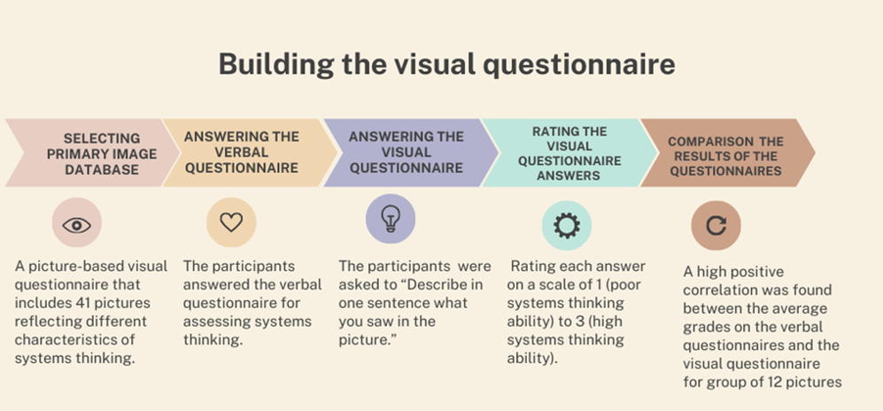

Figure 1: Building the visual questionnaire

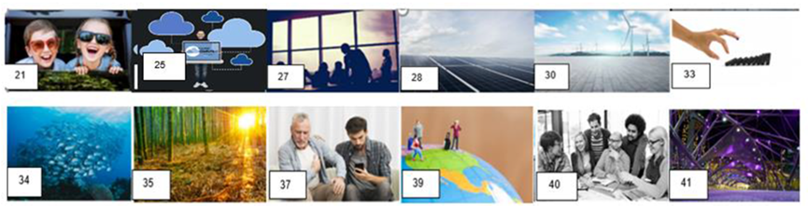

Figure 2: The final version of the visual questionnaire

As participants view the 12 images, their eye movements will be recorded using Tobi Pro eye-tracking devices, capturing key metrics such as **fixation duration** (the length of time spent fixating on specific visual elements), **saccades** (rapid eye movements between fixation points), **transitions between Areas Of Interest - AOI** (the movement of a participant's gaze between predefined regions on a visual stimulus. An expansion on how we selected AOI in the images will be given later in Section 4), and **pupil size** (an indicator of cognitive load). These metrics will provide insights into participants' visual processing and cognitive strategies.

* + 1. **Research Population**

We will recruit 100 to 150 participants with varying systems thinking abilities, focusing on engineers and professionals in complex, interdisciplinary roles. Recruitment will target diverse industries, academic institutions, and professional networks, including senior undergraduates and graduate students with relevant experience. Participants will complete a verbal questionnaire to assess systems thinking on a continuum, ensuring sample diversity for robust analysis of the relationship between eye-tracking patterns and systems thinking

* + 1. **Research stages**

The systems thinking abilities of the participants will be tested using the verbal questionnaire. Using Tobii Pro Lab, the eye movements of the participants will be tracked while viewing the images from the visual questionnaire. The results of the verbal questionnaire and the eye movements will be examined to identify patterns of observation in accordance with systems thinking abilities. Figure 3 presents the research stages.

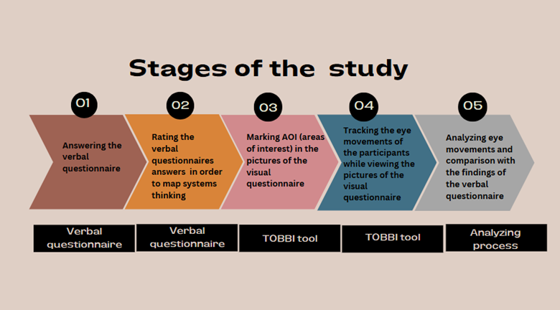

Figure 3: The research stages

* + 1. **Data Analysis**

Systems thinking will be treated as a continuous variable, allowing for a nuanced analysis without arbitrary group divisions. Two main methods will be applied: Correlation Analysis to examine relationships between systems thinking scores and eye-tracking metrics, such as fixation duration and AOI transitions, and Multivariate Regression to predict systems thinking scores from eye-tracking patterns. Regression types include **Linear** (to assess continuous relationships), **Multiple** (for multiple variables, e.g., fixation duration, task completion time, education level), **Non-linear** (for complex patterns), and **Hierarchical** (to gauge incremental variable impact). These analyses aim to identify key eye-tracking indicators of systems thinking and support a predictive model.

* + 1. **Ethical Considerations**

The study will follow ethical guidelines for research involving human subjects. All participants will be informed about the purpose of the research and will provide informed consent prior to participating. Participants will have the right to withdraw from the study at any time without penalty. Given that the study is not clinical, it was submitted for ethical approval by the Institutional Ethics Committee of Ariel University for Non-Clinical Human Research to ensure compliance with ethical standards.

1. **Preliminary studies**

A pilot study was conducted to test the research design using a Tobii eye tracker, which analyzed participants’ eye movements on specific images and compared the results with a verbal systems thinking questionnaire. The study, which included 17 participants from diverse backgrounds, showed significant correlations between eye-tracking metrics and systems thinking scores, supporting the feasibility of the proposed methodology. This pilot demonstrated the potential of eye-tracking as an innovative tool for assessing systems thinking and provided a foundation for the full study.

4.1 **The Pilot Study Planning**

An experiment was designed in Tobii Pro Lab, incorporating a set of 12 images and tracking participants' eye movements as they viewed the images. Areas of interest (AOI) were predefined by the researchers, based on criteria related to systems thinking (As shown in Figure 4 and Figure 5). Elements indicating system thinking were marked, such as tangible connections indicating connections between items **[1]**, connections indicating mutual effects between components **[2]** and areas indicating an activity that has a wider effect on other elements in the image **[3]**. Other AOI that were marked are elements in the picture that have no effects on other elements **[4]**. The focus on these elements can indicate a focus on the small details instead of the big picture. The viewing time for each image was standardized.

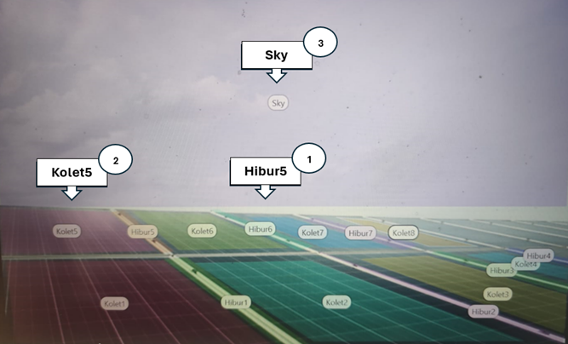

Figure 4: picture 28- Examples of AOI marking and their classification

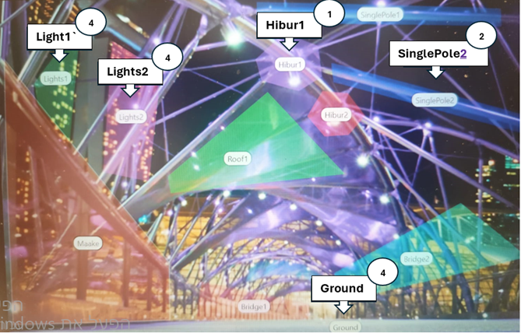

Figure 5: picture 41- Examples of AOI marking and their classification

* 1. **The Pilot Study Procedure**

**Verbal Questionnaire**: All participants completed the verbal questionnaire.  
**Tobii Eye Tracking**: Participants were instructed to focus on the screen and minimize head movements. Each participant viewed a sequence of 12 images, with each image displayed for 10 seconds. During the presentation, participants' eye movements were tracked, focusing on fixation concentration and scanning patterns.

* 1. **The Pilot Study Results**

**The results from the verbal questionnaire**: Analysis of the answers to the verbal questionnaire to identify systems thinkers (score ≥ 0.6) and non-systems thinkers (score ≤ 0.5). A score above 0.6 was selected to indicate a sufficiently high level of systems thinking, distinguishing individuals with stronger systems thinking abilities from those scoring closer to the midpoint or lower.

In the proposed research, systems thinking scores will be treated as a continuous variable, unlike in the pilot study where a binary cutoff of 0.6 was used. This shift allows for a more nuanced analysis of the relationship between parameters from the visual questionnaire and systems thinking abilities. By moving beyond a binary classification, the proposed study will capture subtle variations in systems thinking, enabling a richer and more detailed understanding of how eye-tracking measures correlate with systems thinking abilities.

**The results from the eye movements**: Using a cutoff value of 0.6 to distinguish between systems thinkers and non-systems thinkers, we analyzed eye movement patterns and found group differences, For example, for the AOI labelled “Lights2” in picture 41 (see Figure 5), non-systems thinkers had a higher total duration of fixations (479ms) than systems thinkers (70.3ms; p < 0.01), and a larger number of fixations (1.9 vs .025, p = 0.01).

Table 1: AOI labelled “Lights2”

|  |  |  |  |
| --- | --- | --- | --- |
|  | Systems thinkers (N=8)  x̄(std) | Non systems thinkers (N=9)  x̄(std) | T-test p value |
| Total duration of fixations in AOI (ms) | 70.3 (133) | 479 (360) | p<0.01 |
| Number of fixations in AOI | 0.25 (0.5) | 1.9 (1.5) | p=0.01 |

When the correlation between eye movement patterns and systems thinking grade was studied, we found significant negative correlations (Pearson) between systems thinking and total duration of fixations for the AOIs labelled “Lights2” (r = -0.7, p < 0.05) and “Ground” (r = -0.58, p < 0.05), and between systems thinking and the number of fixations on “Light2” (r = -0.79, p < 0.01) and “Ground” (r = -0.58, p < 0.05)

Table 2: Correlations

|  |  |  |  |  |
| --- | --- | --- | --- | --- |
|  | Total duration of Fixations | | Number of Fixations | |
|  | AOI “Lights2” | AOI “Ground” | AOI “Lights2” | AOI “Ground” |
| Systems Thinking Grade | -0.7 (p<0.005) | -0.58 (p<0.05) | -0.79 (p<0.001) | -0.58 (p<0.05) |

4.4 **Primary Conclusions**

All participants successfully completed the experiment, demonstrating full comprehension of the task at hand. Continuous data on gaze positions were collected without issues, and Areas of Interest (AOIs) were assigned appropriately. All relevant eye movement parameters were accurately extracted using the software.

Despite the small sample size, the findings suggest a notable difference in eye movement patterns between systems thinkers and non-systems thinkers. Specifically, the AOI labelled "Lights2" did not provide information regarding the individual components or their synergistic interactions, a result further supported by the observed negative correlation.

1. **Research conditions**

Dr. Sigal Kordova, an expert in systems thinking with over a decade of experience, leads this study, drawing on her extensive research and numerous publications. Dr. Shimon Friedkin, a co-leader and specialist in advanced statistical analysis, ensures methodological rigor. Dr. Anat Nissel Miller, a research fellow at Ariel University, oversees experimental design with a team of assistants, while Dr. Dario Geisinger supports technical aspects with his expertise in eye-tracking technology. Dr. Ganit Eshel Kedmi, a cognitive assessment specialist, and Dr. Simon Leibovich, an expert in cognitive skills for systems thinking, contribute valuable insights into questionnaire development and cognitive data analysis. Together, this multidisciplinary team’s expertise, experience, and access to advanced resources provide a strong foundation for conducting the study with academic rigor.

In the pilot study, we used an eye-tracking device on a one-time loan from a colleague. To ensure access for the full experimental phase of the current study, we are requesting funds in this budget to purchase our own device.

## **Expected results and potential pitfalls**

We expect to find significant correlations between specific eye movement patterns (e.g., fixation duration, saccade frequency, AOI transitions) and systems thinking abilities. Participants with stronger systems thinking are likely to have longer fixations on key system components and smoother transitions between interconnected elements, suggesting deeper cognitive processing. We expect the results to reveal that eye-tracking data can successfully differentiate between individuals with high and low systems thinking abilities, providing a more objective tool for assessing systems thinking beyond traditional self-report questionnaires. The study also aims to validate eye-tracking as an innovative, objective method for evaluating systems thinking. By correlating eye-tracking metrics with traditional questionnaire data, this research is expected to offer new insights into how visual attention relates to cognitive processing in complex problem-solving.

**Potential Pitfalls:**

1. **Technical Limitations:** The precision of the eye-tracking equipment might be impacted by participants' ability to remain still during the experiment, with movement or calibration issues potentially skewing results. To address these limitations, we will conduct a pre-experiment calibration and provide clear instructions to minimize movement. Additionally, inaccurate data and outliers will be screened and excluded to ensure the reliability of our results.
2. **Data Complexity**: Interpreting saccades, fixations, and transitions may be challenging. If needed, we will use advanced methods (e.g., machine learning) and consult cognitive data analysis experts to ensure robust interpretation.

**References**

Alexy, W. (2018). The analyst’s Rorschach: Gateway to opening the dialectical field. Journal of Analytical Psychology, 63(1), 26-46.

Arnold, R.D. (2017). A complete set of systems thinking skills. Insight, 20, 9–17, doi:10.1002/inst.12159.

Arnold, R. D., & Wade, J. P. (2015). A definition of systems thinking: A systems approach. Procedia Computer Science, 44, 669-678. doi:http://dx.doi.org/10.1016/j.procs.2015.03.050

Assaraf, O., Orion, N. (2005). Development of system thinking skills in the context of earth system education. J. Natl. Assoc. Res. Sci. Teach. 42, 518–560, doi:10.1002/tea.20061.

Bayliss, A. P., Murphy, E., Naughtin, C. K., Kritikos, A., Schilbach, L., & Becker, S. I. (2013). “Gaze leading”: Initiating simulated joint attention influences eye movements and choice behavior. Journal of Experimental Psychology: General, 142(1), 76.

‏Bendall, R. C., & Thompson, C. (2015). Emotion has no impact on attention in a change detection flicker task. Frontiers in Psychology, 6, 1592.‏

Białowąs, S., Pieranski, B., Szyszka, A., & Reshetkova, A. (2021). Experimental design and biometric research. Toward innovations. Poznań University of Economics and Business Press.‏

Bloom, B., Engelhart, M., Furst, E., Hill, W., Krathwohl, D. (1956). Taxonomy of Educational Objectives: The Classification of Educational Goals. Handbook I: Cognitive Domain; David McKay Company: New York, NY, USA.

Buckle, P. (2018). Maturity models for systems thinking. Systems, 6, 23, doi:10.3390/systems6020023.

Cao, M., & Wan, Z. (2020). Psychological counseling and character analysis algorithm based on image emotion. IEEE Access.‏

Carter, B. T., & Luke, S. G. (2020). Best practices in eye tracking research. International Journal of Psychophysiology, 155, 49-62.‏

Davidz, H. L., & Nightingale, D. J. (2008). Enabling systems thinking to accelerate the development of senior systems engineers. Systems Engineering, 11(1), 1-14. doi:http://dx.doi.org/10.1002/sys.20081

Duchowski, T. A. (2017). Eye tracking: methodology theory and practice. Springer International Publishing AG.‏

Frank, M. (2002). What is “engineering systems thinking”? Kybernetes, 31(9/10), 1350-1360.‏

Frank, M. (2010). Assessing the interest for systems engineering positions and other engineering positions’ required capacity for engineering systems thinking (CEST). Syst. Eng. 13, 161–174, doi:10.1002/sys.20140.

Goldstein, E. (2016). Identity Economics, System Thinking, and Education. In F. Moti, S. Haim, & K.-K. Sigal, Systems Thinking: Foundation, Uses and Challenges. Nova Science Publishers.

Grohs, J.R., Kirk, G.R., Soledad, M.M., Knight, D.B. (2018). Assessing systems thinking: A tool to measure complex reasoning through ill-structured problems. Think. Skills Creat. 28, 110–130, doi:10.1016/j.tsc.2018.03.003.

Hooper, M., Stave, K. (2008). Assessing the effectiveness of systems thinking interventions in the classroom. In Proceedings of the 26th International Conference of the System Dynamics Society, Athens, Greece, 20–24 July 2008.

Hughes, T. L., Gacono, C. B., & Owen, P. F. (2007). Current status of Rorschach assessment: Implications for the school psychologist. Psychology in the Schools, 44(3), 281-291.

Kenett, R. S., & Lavi, Y. (2016). Integrated models in healthcare systems. In F. Moti, S. Haim, & K.-K. Sigal, Systems Thinking: Foundation, Uses and Challenges. Nova Science Publisher.

Klaib, A. F., Alsrehin, N. O., Melhem, W. Y., Bashtawi, H. O., & Magableh, A. A. (2021). Eye tracking algorithms, techniques, tools, and applications with an emphasis on machine learning and Internet of Things technologies. Expert Systems with Applications, 166, 114037.‏

Kollmorgen, S., Nortmann, N., Schröder, S., & König, P. (2010). Influence of low-level stimulus features, task dependent factors, and spatial biases on overt visual attention. PLoS computational biology, 6(5), e1000791.‏

König, P., Wilming, N., Kietzmann, T. C., Ossandón, J. P., Onat, S., Ehinger, B. V, & Kaspar, K. (2016). Eye movements as a window to cognitive processes. Journal of eye movement research, 9(5), 1-16.‏

Koral-Kordova, S., Frank, M. (2016). Model for describing the systems thinking factors. In Systems Thinking: Foundation, Uses, and Challenges; Moti, F., Shaked, H., Sigal, K.-K., Eds.; Nova Science Publishers: Hauppauge, NY, USA, 2016.

Koral Kordova, S., Frank, M., & Nissel Miller, A. (2018). Systems thinking education—Seeing the forest through the trees. Systems, 6(3), 29. doi:http://dx.doi.org/10.3390/systems6030029

Lacko, D., Prošek, T., Čeněk, J., Helísková, M., Ugwitz, P., Svoboda, V., & Šašinka, Č. (2023). Analytic and holistic cognitive style as a set of independent manifests: Evidence from a validation study of six measurement instruments. Plos one, 18(6), e0287057.

Lamb, C. T., & Rhodes, D. H. (2007), Standardized Process as a Tool for Higher Level Systems Thinking. In INCOSE International Symposium, 17(1), 1492-1502.‏

Lavi, R., Dori, Y.J., Wengrowicz, N., Dori, D. (2019). Model-based systems thinking: Assessing engineering student teams. IEEE Trans. Educ. 63, 39–47, doi:10.1109/TE.2019.2948807.

Leshno, M., & Menachem, Y. (2016). A System Thinking in Medicine and Health Care: Multidisciplinary Team (MDT) approach for Hepatocellular carcinoma (HCC). In F. Moti, H. Shaked, & K.-K. Sigal, Systems Thinking: Foundation, Uses and Challenges. Nova Science Publishers.

Likforman-Sulem, L., Esposito, A., Faundez-Zanuy, M., Clémençon, S., & Cordasco, G. (2017). EMOTHAW: A novel database for emotional state recognition from handwriting and drawing. IEEE Transactions on Human-Machine Systems, 47(2), 273-284.‏

Lilienfeld, S. O., Wood, J. M., & Garb, H. N. (2000). The scientific status of projective techniques. Psychological science in the public interest, 1(2), 27-66

Matzen, L. E., Stites, M. C., & Gastelum, Z. N. (2021). Studying visual search without an eye tracker: An assessment of artificial foveation. Cognitive Research: Principles and Implications, 6(1), 45.‏

McDermott, T., & Freeman, D. (2016). Systems Thinking in the Systems Engineering Process: New Methods and Tools. In F. Moti, H. Shaked, & K.-K. Sigal, Systems Thinking: Foundation, Uses and Challenges. Nova Science Publishers.

Miller, A. N., Kordova, S., Grinshpoun, T., & Shoval, S. (2023). Worth 1000 words: Using pictures to identify systems thinkers. *Thinking Skills and Creativity*, *50*, 101401.‏

Miller, A. N., Kordova, S., Grinshpoun, T., & Shoval, S. (2022). Identifying a Systems Thinker: Matching a Candidate’s Systems Thinking Abilities with the Job. *Applied/*

Miller, A. N., Kordova, S., Grinshpoun, T., & Shoval, S. (2023, February). To be or not to be a systems thinker: Do professional characteristics influence how students acquire systems-thinking skills?. *Frontiers in Education* (Vol. 8, p. 1026488).

Neil, D. (1997). Managing With Systems Thinking: Making Dynamics Work For You in Business Decision-Making. Journal of the Market Research Society, 39(4), 628-630.

Nitzan-Tamar, O., Kramarski, B., & Vakil, E. (2016). Eye movement patterns characteristic of cognitive style. Experimental psychology.‏

‏Nitzan-Tamar, O., Kramarski, B., & Vakil, E. (2023). The flexibility of the intermediate vs. wholistic/analytic styles–an eye tracking study. Journal of Cognitive Psychology, 35(2), 205-216.‏

Onat, S., Açık, A., Schumann, F., & König, P. (2014). The contributions of image content and behavioral relevancy to overt attention. PLoS One, 9(4), e93254.‏

Plate, R., Monroe, M. (2014). A structure for assessing systems thinking. Creat. Learn. Exch. 23, 1–3.

Peterson, E. R., Deary, I. J., & Austin, E. J. (2005). Are intelligence and personality related to verbal-imagery and wholistic-analytic cognitive styles?. Personality and Individual Differences, 39(1), 201-213.‏

Poirier, T. I., Newman, K., & Ronald, K. (2020). The arts in health professions education: An exploratory study using Visual Thinking Strategies to improve undergraduate students’ observational skills. American Journal of Pharmaceutical Education, 84(4), 451-458.‏

Reingold, E. M., & Sheridan, H. (2011). Eye movements and visual expertise in chess and medicine.‏

Richmond, B. (1991). Systems Thinking: Four Key Questions. High Performance Systems (HPS).

Richmond, B. (1994). System dynamics/systems thinking: Let’s just get on with it. System Dynamics Review, 10, 165-157. doi:https://doi.org/10.1002/sdr.4260100204

Richmond, B. (2000). The" thinking" in systems thinking: Seven essential skills. Pegasus Communications.

Richmond, B., & Peterson, S. (2001). An introduction to systems thinking. High Performance Systems., Incorporated Lebanon, NH.

Rosenzweig, S. (1976). Aggressive behavior and the Rosenzweig Picture‐Frustration (P‐F) study. Journal of Clinical psychology, 32(4), 885-891.

Sang, J., Zhang, H., & Xu, C. (2016). Visual BFI: An exploratory study for image-based personality test. In Advances in Multimedia Information Processing-PCM 2016: 17th Pacific-Rim Conference on Multimedia, Xi´ an, China, September 15-16, 2016, Proceedings, Part I (pp. 95-106). Springer International Publishing.‏

Senge, P.M. (1990). The Art and Practice of the Learning Organization; Doubleday: New York, NY, USA, 1990; doi:10.1002/pfi.4170300510.

Senge, P. M. (1991). The Fifth Discipline, The Art and Practice of The Learning Organization. Doubleday.‏

Thomas, L. E., & Lleras, A. (2007). Moving eyes and moving thought: On the spatial compatibility between eye movements and cognition. Psychonomic bulletin & review, 14, 663-668.‏

Vakil, E., Lifshitz, H., Tzuriel, D., Weiss, I., & Arzuoan, Y. (2011). Analogies solving by individuals with and without intellectual disability: Different cognitive patterns as indicated by eye movements. Research in Developmental Disabilities, 32(2), 846-856.‏

Van Gog, T., Jarodzka, H., Scheiter, K., Gerjets, P., & Paas, F. (2009). Attention guidance during example study via the model’s eye movements. Computers in Human Behavior, 25(3), 785-791.‏

von Bertalanffy, L. (1973), The meaning of general system theory. General system theory: Foundations, Development, Applications, 30-53.

Wilming, N., Onat, S., Ossandón, J. P., Açık, A., Kietzmann, T. C., Kaspar, K., & König, P. (2017). An extensive dataset of eye movements during viewing of complex images. Scientific data, 4(1), 1-11.‏

Zagermann, J., Pfeil, U., & Reiterer, H. (2016). Measuring cognitive load using eye tracking technology in visual computing. In Proceedings of the sixth workshop on beyond time and errors on novel evaluation methods for visualization (pp. 78-85).‏

Zhang, Y. (2016). Dynamic Systems with Multiple Elements. In Systems Thinking: Foundation, Uses, and Challenges; Moti, F., Shaked, H., Sigal, K.-K., Eds.; Nova Science Publishers: Hauppauge, NY, USA, 2016.