**A. Scientific Background**

An understanding of the origins of different body plans requires knowledge of how the genes and genetic pathways that control embryonic development have evolved. The anteroposterior (AP) axis in chordates is regulated by the spatio-temporal expression of a common set of genes early in development, although extreme variation in adult morphology is observed. The initial events determining AP patterning occur during gastrulation stages in specific embryonic structures such as the primitive streak (PS) in amniotes and the blastopore in fish and amphibians. Several gene families and morphogens are involved in this orchestrated process. Among them are *Hox* genes and Retinoic Acid (RA) which provide excellent starting points for understanding the control of regionalization because they play well-understood causal roles in AP patterning and body plan organization in all bilaterians.

The amniote kidney is an example of an organ that develops in a specific position along the AP axis. All vertebrate kidney tissue is derived from a strip of tissue called the intermediate mesoderm (IM) which is located between the somites and the lateral plate mesoderm of the embryo4. As development proceeds, the IM differentiates sequentially from anterior to posterior into several types of kidney tissues known as the pronephros, the mesonephros and the metanephros. In birds and mammals the definitive adult kidney is the metanephros, whereas the pronephros and mesonephros largely degenerate or are incorporated into the reproductive system. Despite its subsequent degeneration, the pronephros is an essential structure because it is the source of the nephric duct which induces formation of the mesonephros and metanephros5.

A morphogenetic field is a group of cells competent to respond to biochemical influences of surrounding tissues, subsequently differentiating into specific morphological structures. A morphogenetic field has definitive boundaries that determine the eventual position of molecular events that lead to its derivatives. In vertebrate embryos, the kidney morphogenetic field within the IM is characterized by the expression profile of specific genes, including *Pax2, Pax8, Lim1,* *Wilms’ Tumor 1* (*WT1*), *c-ret*, *Wnt4*5-10, and *Osr1*11. The major patterning events specifying the kidney lineage take place during and shortly after gastrulation1;2;12-15. In chick embryos having a PS, the prospective IM is committed to its kidney fate but requires extrinsic signals to become specified1. The initial specification toward IM fate occurs at stages HH 5-716 shortly after prospective IM cells leave the PS and migrate anteriorly. By stage 8, IM cells are located at their final position and start to express *Lim1* and *Pax2*. Expression is restricted to the IM located posterior to the 6th somite level17-19;6, consistent with a specific structure that gives rise to the pronephric duct primordium20. However, examination of early chordate groups such as amphioxus reveals expression of these gene homologs in Hatschek’s nephridium, an excretory, kidney-like structure positioned in anterior segments of the head region and significantly more anterior to the location of the pronephros in amniotes21;22. Adding to the complexity, this organ is an ectoendodermal derivative provoking a long-lasting debate regarding the homology of this kidney structure to the vertebrate pronephros23;24. Knowledge regarding the signals governing IM specification is still incomplete. Several studies demonstrate the role of neighboring tissues in IM specification, mainly with respect to the mediolateral axis25-27;19;15;1. Considerable evidence from studies in zebrafish, Xenopus, mice and avian embryos have shown a role for bone morphogenetic protein (BMP), Activin and RA signaling in early events of mesoderm and pronephros induction28-36;26;27;14;2.

We previously showed that specification of the chick IM along the AP axis depends on the competence of cells to respond to kidney inductive signals emanating from midline tissues along the entire axis1. In Preger-Ben-Noon et al. (2009)2, we developed a model in which TGF-β signaling molecules secreted from the dorsal neural tube and BMP4 secreted from lateral plate mesoderm30 induce kidney genes. The competence of IM cells to respond to these signals is driven by RA and mediated by *Hoxb4*. Moreover, both of our studies and others point to decision-making processes at early stages in the PS and the potential role of RA and *Hoxb4* in these processes.

Our lab recently compared formation of the pronephros among early vertebrate model organisms *(Amphioxus, Lamprey and catshark)* with that of chick embryos representing amniotes. The cephalochordate Amphioxus represents an invertebrate chordate with basal chordate traits that can reflect basal vertebrate traits (Holland, 2018). Lamprey represents the most ancient vertebrate group, cyclostomes, and the catshark represents a group of organisms that are positioned at the early Gnathostomata. Our results reveal a conserved, yet unknown, control mechanism for defining the position of the pronephros along the AP axis, in particular with respect to its anterior boundary, in association with the 6th somite axial level. This mechanism is conserved between lampreys, chondrichthyans and birds and therefore evolved very early in the vertebrate lineage. RA signaling and *Hox4* genes do not contribute to this ancient pronephros positioning mechanism. However, during early Gnathostome diversification, the RA-dependent regulation of *Hox4* genes and the *Hox4*-dependent control of pronephros development (Preger Ben-Noon, 2009) were incorporated concomitantly into the nephric gene regulatory network. Thus, the association of RA and Hox4 with pronephros development appears to have evolved simultaneously in the vertebrate lineage with the coordinated actions of both components. A vertebrate pronephros can form only if both RA and *Hox4* are involved in regulatory control (like in Gnathostomes) or if neither are involved (like in cyclostomes) (Schmidt et al., submitted). Therefore, understanding the differences between the gene regulatory networks controlling the patterning and formation of a functional kidney in Gnathostomes and cyclostomes holds the key to understanding the evolution of vertebrate nephric development.

Analyses in other vertebrate models, including zebrafish and frogs have focused on pronephros development58-60. The results have allowed insights into mechanisms controlling pronephros specification along the AP and dorsoventral (DV) body axes and subsequent subdivision into specialized segments. While many genes characterized in these species are also involved in mammalian nephric development, cross-species comparisons highlight differences in segmental organization59;61. Despite such progress detailed descriptions of the developmental trajectories and molecular signatures of specific cell populations from mesoderm to pronephric territories are lacking in these species which hampers comprehensive comparisons. In summary, data accumulated in model organisms point to the existence of a conserved core of nephrogenic regulatory programs; however, the degree of conservation, the identity of nodes prone to variations and the constraints shaping their evolution remain largely unknown.

**B. Research Objectives and Expected Significance**

This proposal aims to understand the evolution of IM and pronephros formation. This will provide a deep understanding about the sequence by which the nephric field evolved and, hence, on tissue origin and the basics of nephric system molecular control. To achieve this goal, we will take a developmental evolutionary approach using three animal models that are taxonomically positioned at key branch points in the early chordate/vertebrate evolutionary tree. The rationale is to elucidate basal traits, gene expression and gene regulatory networks involved in formation of the IM and the pronephros, establishing an evo-devo reference for pronephros formation.

Two complementary aims will guide this research. The first focuses on positional information determining the origin of the IM and the molecular regulation establishing the pronephros morphogenetic field (PMF) and nephric duct. This will be carried out by using existing knowledge and a candidate gene approach. The second aim will complement the first to discover the progenitors of the nephric system and their molecular regulation by using RNA-seq and TomoSeq techniques. These expression screens will provide new genes and molecular pathways involved in IM, PMF and nephric duct formation.

**Specific Research Aims:**

**B1. The origin of the intermediate mesoderm**

**B1a.** **Positioning and developmental relationships between nephric genes and somitic markers**

Detailed analysis of the expression of several somitic markers (mainly *Pax1*, *Pax3 and MyoD*) in parallel with the expression of nephric genes will be performed on early and late developmental stages in the Catshark (partially done, see section C1) and Lamprey models. These analyses will be followed by gain and loss-of-function experiments using *Hox4* paralogues and signaling molecules known for their effect on somite compartmentalization and nephric gene regulation.

**B1b. The formation of the pronephros in catshark and lamprey**

**B1b1**. To reconstruct the formation of the pronephros whole mount 3D confocal microscopy analysis of nephric markers at relevant developmental stages will be performed .

**B1b2**. Fluorescent dye labeling experiments will be performed in catshark embryos to elucidate the cell source of the nephric duct. The motivation is to reveal whether the duct source is derived from only the pronephric somites (6-10) or from along the entire axis including the mesonephric somitic level.

**B1b3**. Based on earlier study in our lab (Schmidt et al., 2021), we will interfere with RA signaling that controls pronephros formation in catshark. This will elucidate RA effects on mesonephros formation.

**B1b4.** Budding from the somite; epithelial mesenchymal transition (EMT) and mesenchymal epithelial transition (MET) or evagination by proliferation?Following our preliminary results (C1), the detailed expression patterns of various markers for these three cell processes will be determined using a candidate gene approach in the two model organisms.

**B2. Discovering nephric progenitor cells and characterizing their differentiation**

We aim to discover novel genes, gene combinations and/or molecular pathways for early IM cell specification and PMF formation using the catshark model. According to our preliminary results this organism reveals an unexpected origin for the IM from a specific ventrolateral domain within the epithelial somite. We hypothesize that this particular domain includes the progenitors of the IM and the PMF. Discovering the molecular profile of this domain is of prime importance to understand the molecular control and origin of the IM and pronephros. Two complementary methodologies are in use to reveal the RNA expression in these early developmental stage domains.

**B2a**. The first is RNA-seq of anterior versus posterior regions along the AP axis at four developmental stages. This work is partially done (see Preliminary Results for comparison of domains and stages).

**B2b**. Based on the results of the first RNA-seq experiments (**B2a**), a second RNA-seq method will be used at developmental stage 19-20. This method named TomoSeq can detect *in situ* expression of RNA along the AP axis, including anterior and posterior domains as will be specified later in development.

**B2c**. Based on the results obtained in the two RNASeq approaches (B2a, B2b), validation and analyses of selected candidate pronephros patterning genes will be done by *in situ* hybridization followed by immunostaining. These selected genes will be cloned and analyzed in the other model organisms serving in this project, Amphioxus, Lamprey and chick embryos.

**B2d**. Gain and loss-of-function experiments will be performed to assess the role of the selected genes in the initiation, regulation and morphogenesis of the IM and pronephric duct.

**Expected Significance and Rational**

The evolutionary approach in this proposal should reveal new insights into the molecular basis of current developmental processes involved in AP patterning in general and the establishment of the nephric field in particular. Discovering the molecular mechanisms that control nephric genes in early chordate groups will point to basic requirements for this process that are poorly understood in late vertebrate groups. The use of an advanced, well established amniote model system in this proposal including the large background of molecular studies in the field of mesoderm patterning will provide new data on molecular cascades and mechanisms to be investigated in the early chordate/vertebrate models. This cross-species approach, although conceptually not new, in particular studies is not often followed, if at all. The collaboration of three labs that expert in their model systems should provide significant advantages in understanding evolutionary transitions and in particular the early events in the formation of the nephric field.

**C. Preliminary Results**

**C1. The origin of the IM and evolutionary development of the nephric duct**

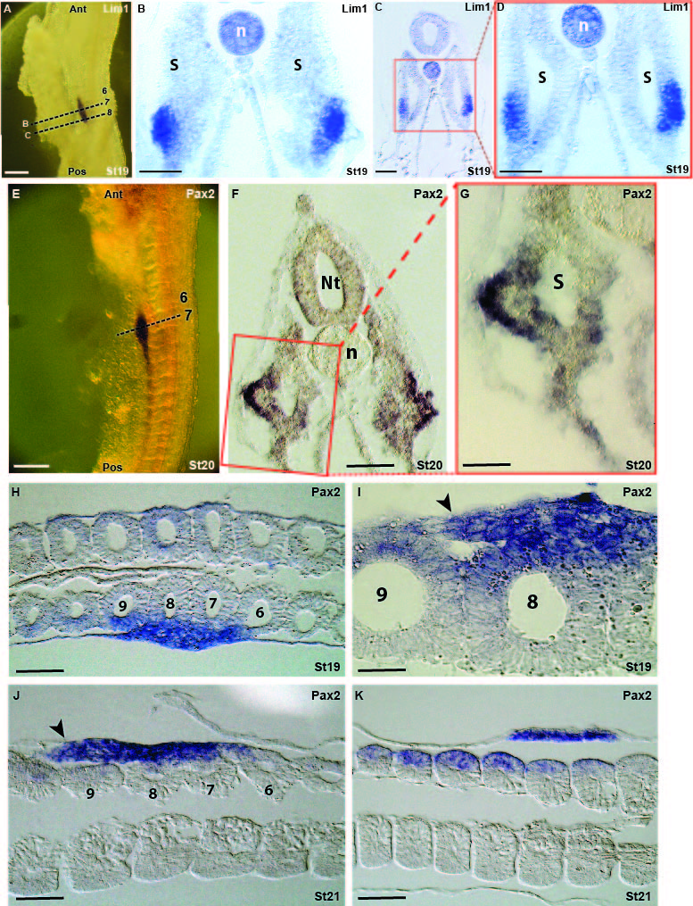**C1a. Expression pattern of pronephros genes in the somitic domain in catshark**

From the whole mount in situ hybridization (WMISH) of *Lim1* and *Pax2* it is clear that at early stages or in relatively young somites at later stages the expression has a segmented mode (Fig, 1E, posterior somites and Schmidt et al., 2021). Cross sections of these embryos reveal an unexpectedly specific expression domain of these two genes in the ventrolateral part of the epithelial somite (Fig. 1A?). At early somitic developmental stages there is no discernible domain of IM as exhibited in Aves and Mammals. The expression of *Lim1* and *Pax2* is within the epithelial somite (Fig. 1C,D, the level of somites 8 or 9, level of cross section is indicated in panel A) and as the somite matures this specific domain starts to evaginate in a process that remains to be elucidated (Fig. 1B, somite 7). A stage later this somitic level of somite 7 reveals an advanced stage of this evagination which starts to create a duct-like structure lateral to the somite (Fig. 1E-G). Furthermore, frontal sections at stages 19 and 21 (Fig. 1H-K) exhibit somitic origin and posterior extension of the nephric duct (Fig. 1I-J, arrowheads).Note, at stage 21 the expression of Pax2 in posterior somites (10-12) is clearly observed on the lateral somitic domains (Fig. 1K), leaving their contribution to the nephric duct an open question.

**Fig.1. Expression pattern of pronephros genes in somitic domains in catshark. (A-D)** Expression of *Lim1* in two axial (A, dashed lines) levels at the pronephros region of stage 19 embryo. (B) Cross sections at somite 7 level and the level of somite 8 (C and enlargement in D). **(E-G)** Expression of *Pax2* at the 7th somite level (E, dashed line) of stage 20 embryo. Cross section in F and enlargement in G. **(H-K)** Frontal sections at the level of somites 6-12. Scale bars in A and E represent 200µ and 100µ in B,C,D,F,H,J,K. Scale bar in G and I represents 50µ.

**C1b. Expression pattern of pronephros genes in relation to somitic markers in catshark**

The expression of the nephric genes within the somite raises the question of their relationship with known somitic markers such as *Pax3* (dermomyotome) and *Pax1* (sclerotome). To understand these relationships we first cloned *Pax3* and *Pax1* and analyzed their expression patterns of the catshark. WMISH of *Pax3* reveals strong expression in the nervous system including head regions (not shown) and the neural tube (Fig. 2B?). Within the somites expression is in the dorsal part and strengthens in more posterior somites (Fig. 2B).The WMISH of *Pax1* shows a strong expression in the pharyngeal arches and somites along the entire trunk (Fig. 2C, red arrow indicates first anterior somite). From a comparison of these two TFs with the nephric gene *Pax2* (Fig. 2A) it is clear that these genes share different expression patterns in both the AP and DV axes.

Double immunostaining of Pax2 and Pax3 in cross sections reveal clear separate expression domains. Whereas Pax3 is expressed in the dorsal neural tube and dermomyotome, Pax2 is expressed ventrolateral to Pax3 and shares a clear border (Fig. 2D-F, arrows). In the more mature somite 7 (Fig. 2D), Pax2 is expressed in the evaginating tissue which starts to organize into a duct-like shape. In the less mature somite 9 (Fig. 2F) Pax2 is still within the epithelial somitic domain. Interestingly, somite 8 (Fig 2E) of a later stage (St. 20) reveals an advanced phase in which a small duct-like tissue expressing Pax2 (black arrowheads) appears lateral to the epithelial somitic domain of the gene (yellow arrowheads). Does the duct-like Pax2 expression of somite 8 represent a posterior extension of a Pax2 expression in the more anterior somite 7? The dynamics (space and timing) of *Pax2* and *Lim1* expression during nephric duct formation will have to be elucidated in future experiments. Cross sections of *Pax1* WMISH embryos show a relatively small expression domain in the medial part of the somite close to the notochord and probably not overlapping with the 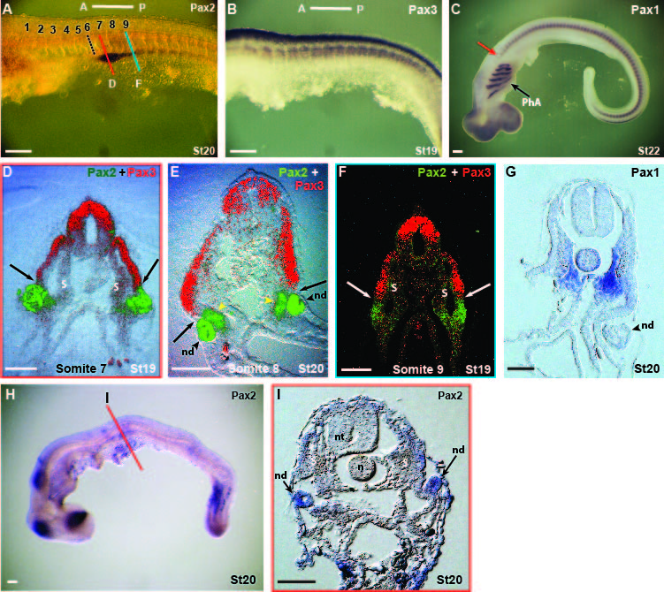expression of Pax3 and Pax2. What is the regulation of these three separate domains and especially in our context what regulates the expression of the nephric genes within the paraxial mesoderm? Moreover, what regulates the budding of the nephric duct and by what cell arrangement processes does this structure form?

**Fig.2. Expression pattern of pronephros genes in relation to somitic markers in catshark. (A-C)** WMISH of *Pax2* (A), *Pax3* (B) and *Pax1* (C). **(D-F)** Cross sections with double immunostaining of Pax2 and Pax3 at different axial levels (color lines in A) of the pronephros domain. **(G)** Cross section of the *Pax1* WHISH embryo. **(H-I)** Inhibition of canonical Wnt signaling by the chemical anatagonist IWR 1. N, notochord, nd, nephric duct, nt, neural tube, PhA, pharyngeal arches, S, somite. Scale bar in A-C, H represents 200µ and 100µ in D-G,I.

Several Wnt family members are involved in somitic compartmentalization and regulation of somitic genes including *Pax3* and *Pax1* (Reshef et al., 1998; Munstenberg et al., 1995; Capdevila et al., 1998; Piran et al., 2009; Sela-Donenfeld and Kalcheim 2002; Geetha-Loganathan et al., 2007). Preliminary experiments using the canonical Wnt signaling antagonist IWR 1 at a concentration of 1mM (the higher limit before embryos die) administrated to catshark embryos at stage 15 (before onset of pronephros markers at stage 17-18) result in morphological defects such as a curved axis (Fig. 2H) and deformed dorsal neural tube and somites (Fig. 2I). Despite the expression of pronephros genes in the somitic domain (Fig. 2D-F), analysis of stage 20 embryos reveals expression of *Pax2* in almost normal formed pronephros (Fig. 2I, arrows). These results suggest that Wnt signaling does not affect the somitic expression of Pax2 and the formation of the pronephros and nephric duct.

**C1c. Expression pattern of pronephros genes in lamprey cross sections**

Analyzing *Pax2* in cross sections of lamprey embryosreveals strong expression ventral to the myotome (St. 25) (Fig. 3D-F, red arrowheads?). This expression, which appears at early embryo stage 24, appears to be ventral to the somitic region, although this must to be confirmed by double or triple staining with other somitic markers such as *MyoD, Pax3* and *Pax1*. Interestingly, this strong ventral expression is connected to a short tubule (Fig. 3D,E, black arrowheads) which seems to be connected to the nephric duct (Fig. 3A, yellow arrows). The expression pattern of the nephric genes and the development of the pronephros is different from that observed in the catshark. Reasons for these differences were recently suggested in an article based on this project (Schmidt et al., 2021, submitted) in which catshark pronephros is RA dependent, whereas lamprey pronephros is RA independent and differentially regulated by other molecular mechanisms to be elucidated in this project. Adding to this evolutionary and developmental complexity, the initial expression of lamprey *Pax2* at stage 22 is within a clear large domain (Fig. 3C, black line) that medially contains the future somitic domain. This structure resembles the clear separation between paraxial and IM domains in chick embryos. However, whereas in chick *Pax2* expression in the IM is continuous along the entire axis, in lamprey it is segmented like in the catshark (Fig.3B, arrows). These observed differences in the appearance of the nephric system from an evolutionary perspective will be subjected to a deeper analysis during this project.

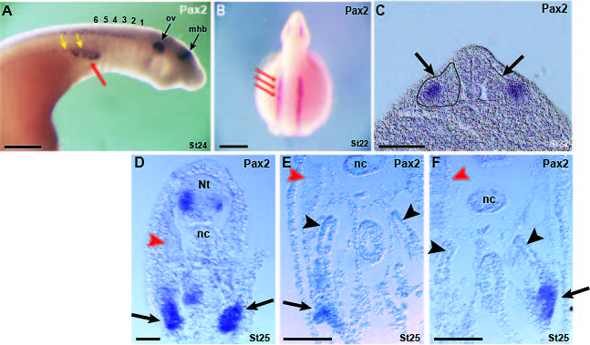

**Fig. 3. Expression pattern of the Lamprey nephric genes.** (**A-B**) Expression of *Pax2* at stage 24 and 22. Numbers in A represent the somite from anterior to posterior. Red arrows mark the segmented pattern of *Pax2* expression. Yellow arrows mark the pronephric duct. (**C**) Expression of *Pax2* in cross section of a 22 stage embryo. Black line marks a clear paraxial domain. **(D-F**) Cross sections of stage 25 embryo expressing *Pax2* in three AP levels from posterior (D) to anterior (F). Arrows mark developing glomeruli and black arrowheads mark the tubules connecting these glomeruli to the nephric duct. Red arrowheads mark myofibers within the myotome. mbh, mid-hindbrain boundary, nc, notochord, Nt, neural tube, ov, otic vesicle. Scale bar in panels A-B represent 200µ and 100µ in panels C-F.

**C1d. Cell tracing using Dye methodologies**

As shown previously (C1a and C1b.), catshark IM originates from the ventrolateral part of the somites starting in mid-somite 6 posteriorly. Despite the great contribution of cross and frontal sections of *Pax2* or *Lim1* WMISH (Fig. 1) to our understanding of nephric duct formation it is difficult to reconstruct the precise somitic source of the nephric duct and the way somitic cells are assembled into the tube form. Moreover, is the nephric duct a result of pronephric somitic level and further posterior elongation (as in chick embryos) or the result of the contribution of somites along the entire AP axis including the mesonephros level? To address these issues in nephric duct formation, we sought a cell lineage methodology that will allow us to detect cell movements and structure formation. To achieve this goal we started to develop a dye staining methodology for catshark, a Dye methods have rarely been used in this model.

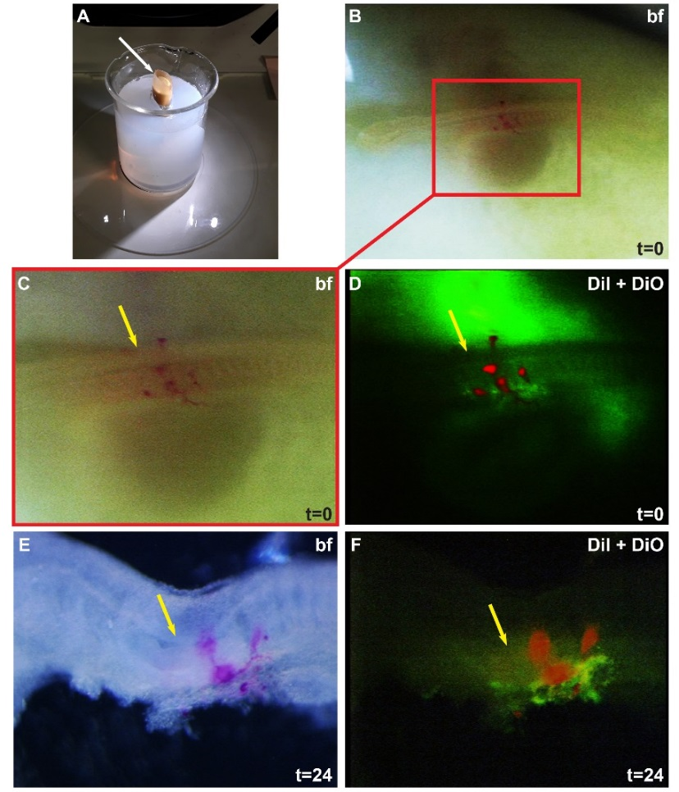Cm-DiI (red) and DiO (green) (Invitrogen) were injected into stages 18–20 catshark embryos *in ovo*. The egg was placed in a vertical position under a binocular scope (Fig. 4A), and the top of the egg shell was removed (Fig. 4A, arrow). The two dyes were injected into somites 6 and posteriorly in an alternating manner as shown in Fig. 4B-D to elucidate the somitic cell origin of the pronephric duct. Alternately injected dyes along the entire axis indicate different somitic origins of the nephric duct, and one color provides evidence of one somitic source and a posterior elongation as it is known from Aves (Fig. 4C-F?; arrow marks the 6th somite level). Following 24h the two dyes start to rearrange along the pronephric duct as separate entities suggesting different somitic origins (Fig. 4E-F). Elaboration of these experiments will extend dye injection into more posterior somites, and time lapse up to 96h plus analyses of all orientation sections should reveal the formation of the fully developed duct.

**Fig.4. Cell tracing by DiI methodology.** (A) The method of opening and placing the egg shell. **(B-D)** Injection of two different dyes (D) into the somitic ventrolateral domain. **(E-F)** 24h following the injection the Dyes seem to arrange in a segmented mode along the forming nephric duct. Yellow arrows mark the 6th somite level.

**C2. Discovering and characterizing nephric cells and their differentiation pathways**

**C2a. RNA-seq analysis**

As shown (Fig. 2A) the anterior border of pronephros gene expression is at mid-somite 6. The pronephros extends posteriorly and from somite 11-12 then turns into the mesonephros. To discover new genes and molecular pathways involved in the regulation, coordination and formation of the PMF and the nephric duct, we designed a RNASeq screen comparing the first anterior five somites, non-generating PMF, IM or nephric duct with the next 5-6 somite level that includes the PMF and the duct (Fig. 5A, compare yellow and red rectangles, respectively). Tissue collection was at four developmental stages; 15-16, prior to the first appearance of nephric markers in somite 6 and posteriorly, 17-18, the onset of nephric gene expression in somite 6 and posteriorly, 19-20, the budding stage in which ventrolateral somitic cells leave the somite to create the nephric duct, and stage 21 in which the duct differentiates into epithelial structure and elongates posteriorly. These four developmental stages supposedly cover all developmental events of interest for this project.

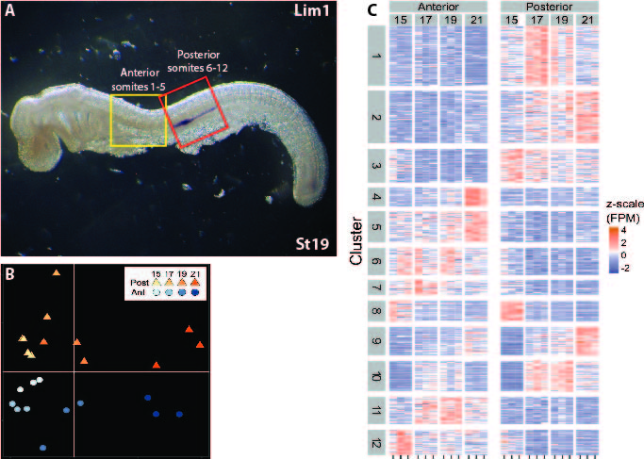Following tissue collection, RNA extraction, construction of libraries, and Illumina sequencing, differential expression was analyzed by mapping to a draft genome of catshark (*Scyliorhinus caninula*) available from Prof. Sylvie Mazan’s laboratory (Laboratoire Arago - Observatoire Océanologique de Banyuls sur Mer CNRS, Sorbonne University, see letter of collaboration) and gene expression quantification. The analysis was done by the University of Haifa Bioinformatic Service Unit. Overall, transcription patterns varied among developmental stages and between somite level positions as illustrated in non-metric multidimensional scaling (NMDS) ordination (Fig. 5B). These trends were tested by permutational analysis of variance (PERMANOVA). Significant differences in overall gene transcription patterns were found for both developmental stages (R2=0.65, *P*<0.001) and anterior vs. posterior somites (R2=0.07, *P*<0.01). Differential transcriptional analysis for interactions between developmental stages and somite position identified 172 genes significant at adjusted *P* value <0.05. An additional 350 genes were differentially transcribed between anterior and posterior somite positions. To understand the expression dynamics of this set of 522 genes, we applied clustering using the Kmeans method and extracted twelve clusters, each representing unique dynamic contrast (Fig. 5C). Gene set enrichment analysis identified, among others, highly significant enrichment of the gene ontology term ‘regulation of transcription, DNA-templated’ (GO:0006355). This set included 73 differentially transcribed genes, 43 associated with the posterior domain characterizing different developmental stages.

**Fig. 5. Differential expression of genes following RNA-seq. (A)** Anterior (yellow) versus posterior (red) regions of embryo trunk were collected for RNA-seq at four developmental stages. **(B)** Heatmap presenting 12 clusters demonstrating differential expression according to stage and position along the AP axis (anterior vs. posterior). **(C)**

**C2b. Analysis and validation of selected genes**

Following gene transcriptional analyses and literature searches, several genes were selected for further analysis and validation (Fig. 6). Among the selected genes, Wt1, a known kidney developmental gene expressed in the nephric mesenchyme that regulates glomeruli differentiation in vertebrates (Hwei-Jan et al, 2003; Kreidberg, 2010; Hastie, 2017) was a validation control for expression in nephric tissues, assuming a conserved role in catshark (Fig. 6.A-C). Other genes in this preliminary survey appear in the literature to be connected with kidney development (mostly metanephros) in one or two model organisms with or without an apparent role in the process or relation to the pronephros or mesonephros. Some reveal no known connection to the subjected process. The selected genes from our survey are as follows.

***Wt1*** at catshark stage 19 is expressed from the 6th somite level posteriorly similar to the expression of Pax2 and Lim1 (Fig. 6A,B). Cross sections through the expression domain reveal that this gene, in contrast to Lim1 that is expressed only within the evaginating tissue and later on in the nephric duct, is expressed only in the nephric mesenchyme that will give rise to the glomeruli and tubules (Fig. 6C, compare the expression in the nephric duct (nd) to the nephric mesenchyme (nm)). In this sense Wt1 expression pattern is conserved among vertebrates (Ishii et al., 2007).

***Emx2*** is a TF expressed at catshark stage 19 from the 7th somite posteriorly (Fig. 6D, E). Cross section through the expression domain demonstrates gene expression in the budding nephric duct (Fig. 6F, arrows). Emx2 is important for metanephros development (Miamoto et al., 1997; Pellegrini et al., 1997), and its expression in catshark pronephros was observed previously (Derobert et al., 2002). However, besides these observations and reports its role in pronephros and nephric duct development is unknown.

***MECOM*** or *Mds1/Evi1* COMplex was previously associated with kidney diseases and metanephros malformation (Bartholomew and Clark, 1994). *Evi1* was also reported to be expressed in the pro-and mesonephros of chick and Xenopus, but its role in forming the nephric duct or other pronephros tissues in these species remain unknown (Mead et al., 2005; Cela et al., 2013). Mecom was identified in Zebrafish in association with the pronephros and found to serve a dynamic role in regulating Notch signaling and antagonizing RA in the formation of renal tubules (Li et al., 2014). This gene appeared in the transcriptome in clear association with the pronephros markers, and its levels increased at stage 21 (the later stage examined). WMISH of stage 20 catshark embryos demonstrates expression in the neural tube, somites and the pronephros (Fig. 6G,H). Indeed, cross sections of these embryos confirmed the WMISH (Fig. 6I). Clear expression can be seen in the dorsal neural tube, dermomyotome (especially in the ventrolateral region), sclerotome, and the nephric duct (Fig. 6I, nd). The nephric mesenchyme revealed no expression at this particular stage (Fig. 6I, nm). Cloning and expression analysis in chick embryos of approximately the same developmental stage exhibited specific expression in the IM similar to the known expression of chick *Lim1*. Cross sections of these embryos demonstrated specific expression in the nephric duct (Fig. 6I', nd) in anterior regions (advanced differentiation) and specific expression in the nephric cord (Fig. 6I'', nc) in posterior regions which later develops into the nephric duct.

***Nynrin*** is one of several Wilms Tumor (WT) predisposition genes (Mahamdallie et al., 2019). Little is known about the Nynrin gene, but it is believed to play a role in microRNA processing and endoribonuclease activity (Turner et al., 2021; Peng and Yi Luo., 2018). This gene was differentially transcribed in our transcriptome dataset associated with cluster 1 (Fig. 5C). WMISH analysis revealed high expression levels in ventral domains in the anterior region of the trunk which extends to more dorsal regions (from somite 11) in posterior domains of the trunk (Fig. 6J, K) Cross sections demonstrate high levels of expression (confirmed in the transcriptome dataset) in the lateral plate mesoderm in both the somatopleura and the splanchnopleura along the entire axis (Fig. 6L,M). No expression was observed in the budding nephric duct (nd) or the nephric mesenchyme at the level of the pronephros (Fig. 6L) from somite 11 and posteriorly, the mesonephros region. But *Nynri*n was expressed in the ventral part of the somite and in a robust manner in the venrto-lateral domain. This expression pattern raises the question of its role in the regulation and formation of the mesonephros and the distinction between the two embryonic kidneys and the somitic contribution to the nephric duct.

**CDH6** is a member of the cadherin family of cell surface proteins that play a role in cell-cell interactions. CDH6 was shown in zebrafish to be expressed and to have a role in pronephros development in both glomeruli/tubules and nephric duct formation (Kubota et al., 2007). In our transcriptome dataset this gene was differentially transcribed at high levels in anterior and posterior regions and was associated with cluster 2 (Fig. 5C). WMISH revealed strong expression in the dorsal neural tube and ventral domains (Fig. 6N,O). Cross sections through the pronephros territory demonstrated expression in the dorsal neural tube and both the nephric duct and the nephric mesenchyme (Fig. 6P). This is particularly interesting because this is the only gene examined so far in this validation analysis that exhibits expression in both domains, the nephric duct and the nephric mesenchyme, which will give rise to the glomeruli and tubules.

***Uncx*** is a paired-type homeodomain TF expressed in many type of embryonic tissues including the somites, first branchial arch, forelimb digits, central nervous system, and meso-and metanephros (Neidhardt et al., 1997). In our transcriptome dataset this gene revealed transcription in the posterior domain which increased in levels from stage 17-18, resembled the pattern of Pax2 and Lim1, and was associated with cluster 2 (Fig. 5C). WMISH showed expression at stage 19 embryos that was exactly like that observed for Lim1 in the pronephros (Fig. 6Q,R). Cross sections of these embryos clearly demonstrate exclusive expression in the budding nephric duct (Fig. 6S, nd). The reported relationships between Uncx and various somitic TFs in mouse, Xenopus and zebrafish (Neidhardt et al., 1997; Sanchez and Sanchez 2013; Nittoli et al., 2019) suggest a role for *Uncx* in the gene regulatory network (GRN) that controls the compartmentalization and differentiation of somitic properties. Furthermore, these TFs activities are under the influence and effect of surrounding signaling factors, raising questions regarding the origin of the pronephros and the role of Uncx in this developmental process. Interestingly, pronephros was not detected and mentioned in any of the publications regarding expression and activity of Uncx. Cloning and expression analysis of chick *Uncx* in embryos of approximately the same developmental stage reveal expression similar to Pax2 and Lim1 (Fig. 6Q'). However, whereas Pax2 is expressed in both domains of the IM, Lim1 and Uncx shown here are expressed only in the nephric cord (Fig. 6S'), similar to the expression of chick *Mecom* (Fig. 6I',I'').

Taken together, these preliminary analyses of several genes out of 43 selected demonstrate dynamic expression patterns that varied between stages, position along the AP axis and mainly between the apparently two distinct pronephros domains, the nephric duct and the nephric mesenchyme which will give rise to the glomeruli and the tubules. Further investigation into the relationships and activity of these genes in an evolutionary oriented context will enhance our understanding of the PMF and nephric duct formation.

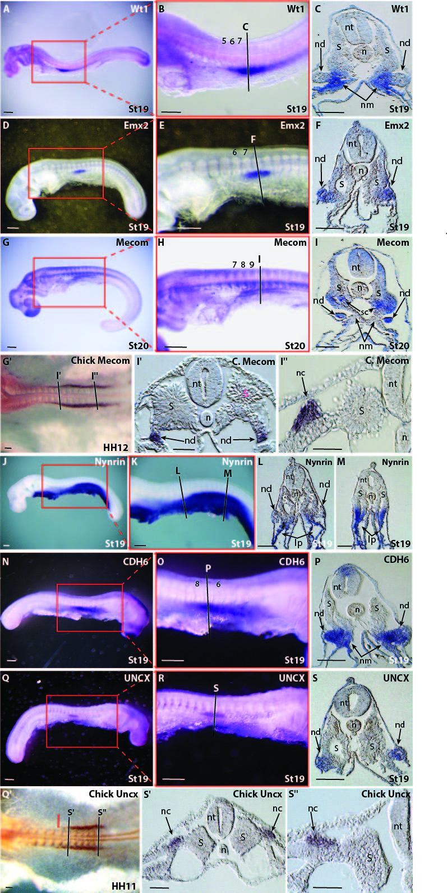**Fig. 6.** WMISH of selected genes that emerged from the RNA-seq screen. **(A-C)** *Wt1* expression at stage 19 embryos. **(D-F)** *Emx2* expression at stage 19 embryos. Note, staging is determined by several criteria such as the development of the pharyngeal arches. Differences in size and shape of same stage embryos may occur. **(G-I)** *Mecom* expression at stage 20 embryos. **(G'-I'')** Chick *Mecom* expression at HH12. I' and I'' are cross sections through the corresponding regions indicated in G'. **(J-M)** *Nynrin* expression at stage 19 embryos. **(N-P)** *CDH6* expression at stage 19 embryos. **(Q-S)** *UNCX* expression at stage 19 embryos. **(Q'-S")** Chick *Uncx* expression at HH11. S' and S'' are cross sections through the corresponding regions indicated in Q'. lp, lateral plate mesoderm, n, notochord, nc, nephric cord, nd nephric duct, nm, nephric mesenchyme, nt, neural tube, S, somite, sc, sclerotome. Scale bars represent 100µ.