**SCIENTIFIC BACKGROUND AND STATE OF THE ART**

The overall activity of the immune system has long been known to decline with age such that this progressive immunosenescence is a key hallmark of aging, affected by and impacting almost all pillars of aging (1-3). Older adults are much more prone to chronic inflammatory disorders, reduced vaccine efficacy, and infection-related morbidity and mortality (4-7). The mechanisms underlying this age-related deterioration of the immune system are not fully understood, and their elucidation may aid efforts to improve longevity and quality of life in the elderly (8-12). Of the many dysregulated inflammatory processes involved in aging, neuroinflammation characterized by glial activation (primarily microglia and astrocytes) and senescence (12-14), blood-brain barrier dysregulation (15-19), and leukocyte infiltration (20-22) has drawn increasing attention due to its strong impact on neurodegenerative diseases, psychiatric disorders, and dementia (23-33). Age-related inflammation may thus play a key role in tissue pathogenesis (14, 34-37) and degeneration (36, 38, 39). As the prevalence of Alzheimer’s disease (AD), the most common form of dementia, sharply increases alongside longevity, the identification of immune biomarkers that can enable the early diagnosis and treatment of patients exhibiting mild cognitive impairment (MCI), and thus a higher risk of progression to dementia, is extremely important (40).

One of the most remarkable changes that characterizes immunological aging relates to the maintenance and function of CD4 T cells, which are key orchestrators of the immune system (41-44). At younger ages, CD4 T cells comprise a large repertoire of naïve cells, reflecting the capacity of the immune system to encounter new antigens, respond to them effectively, and generate memory T cells (45). With age, however, central and effector memory cells accumulate and both the naïve and effector populations exhibit dysregulated properties (3, 43, 44, 46-48). The complexity of the immune system and its various cell populations have complicated systematic investigatory efforts focused on the immunological aging process. To address changes in CD4 T cells over the course of aging and to better understand their functional properties, we applied single-cell RNA sequencing (scRNA-seq) to analyze CD4 T cell populations isolated from young and old mice (49). As expected, we found that the proportions and absolute numbers of naïve CD4 T cells declined with age, whereas effector memory (EM) cells and exhausted cells tended to accumulate (Scheme 1). However, we also identified two intriguing cellular subsets that accumulated in mice with age: a subset of cells with an activated regulatory T cell phenotype (aTregs) and a subset with a cytotoxic and pro-inflammatory expression profile (cytotoxic CD4 T lymphocytes, CTLs). In addition, we found that the most prominent accumulation of EM, exhausted, and CD81+ Tregs occurred between the ages of 6 and 12 months, whereas CD4 CTLs accumulated primarily after 16 months of age [Scheme 1, (49, 50)]. Furthermore, the transcription factors (TFs) required for the CD8 CTL lineage were found to be active in these CD4 CTLs, and the *in vitro* stimulation of these cells elicits significantly higher levels of pro-inflammatory and cytotoxic protein expression as compared with EM and exhausted T cells [Scheme 2, (49-51)]. These CD4 CTLs have previously been therapeutically implicated in mouse models of colitis (52, 53), cancer (54), neuroinflammation (55, 56), and infectious diseases, and in human samples in the context of viral infection (57-61), secondary progressive multiple sclerosis (27), and cellular senescence (62) (Scheme 2). *Strikingly, a recent study of a Japanese cohort of supercentenarian individuals also demonstrated high frequencies of CD4 CTLs (up to about 50% of all T cell compartments) (63), similar to those we observed in old mice [Fig. 1 and (49)]*. Our preliminary results further show that transferring splenocytes or CD4 T cells from young to old mice resulted in the accumulation of CD4 CTLs at frequencies similar to those of endogenous cells, a phenomenon that was abolished by senolytic treatment [Figs. 1, and manuscript under revision (51)]. Intriguingly, using a Cre-Lox mouse model which allows for the depletion of EOMES - a key TF required the differentiation of effector cells into CD4 CTLs - we found that mice lacking this TF exhibit enhanced senescent cell (SC) load, accelerated aging, and a shorter lifespan [Fig. 2, (51)]. In addition, using a CCl4-induced mouse model of liver cirrhosis, we demonstrated that much as in the context of tissue aging, CD4 CTLs accumulate in the tissue and impact SC load and liver fibrosis [Fig. 3, (51)]. These results suggest that EOMES+ CD4 T cells may attenuate the aging process, at least in part, via differentiation to CTLs and the targeting of senescent cells. Our preliminary study in human subjects revealed changes in the CD4 T cell landscape across the lifespan along with the accumulation of CD4 CTLs, primarily EM cells and EM cells reexpressing CD45RA (TEMRA) (Fig. 5). Notably, a small cohort of individuals with MCI appeared to exhibit more robust changes in the age-related CD4 T cell landscape. This was further confirmed using machine learning (ML) approaches that, primarily based on absolute numbers and frequencies of CD4 T cell subsets, could identify individuals with MCI with area under the curve (AUC) of 77% (Fig. 6). scRNA-seq analyses of human CD4 T cells further demonstrated the accumulation of CD4 CTLs with age, including several clusters of cells exhibiting distinct molecular properties between young, healthy older, and MCI individuals (Fig. 7). Taken together, it is clear that the fate of CD4 T helper (Th) cells can change in a manner that contributes to the post-thymic differentiation of MHCII-restricted cytotoxic CD4 T cells with cytolytic activity much as is observed for the CD8 CTL lineage. *Overall, changes in the CD4 T cell landscape with age along with the accumulation of CD4 CTLs appear to be critical to the biology of aging, age-related diseases, and longevity. Critical questions related to the differentiation and accumulation of the cells and their mode of action, however, remain open.* *Intriguingly, in addition to coinciding with the timeline of aging, the appropriate regulation of CD4 CTL populations may play a protective role in the healthy aging process in certain individuals and thus represent a heretofore unexplored aspect of the biology of immune aging.*



**Scheme 1:** Illustration of the major changes that occur in the population of CD4 T cells during aging, demonstrating the shift from naïve dominancy in young mice to diverse and extreme effector and regulatory phenotypes in old mice.

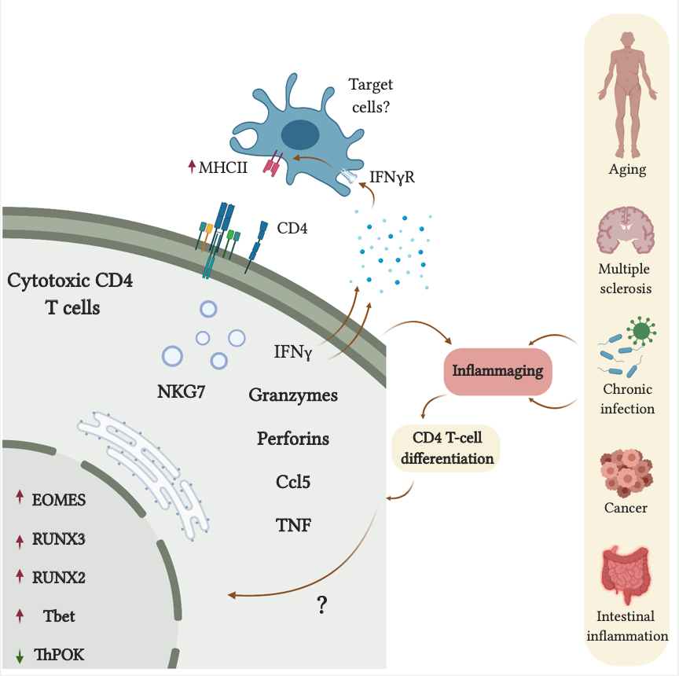

**Scheme 2:** Chronic inflammation promotes the accumulation of cytotoxic CD4 T cells.

**RESEARCH OBJECTIVES AND SIGNIFICANCE**

Our recent studies have aimed to comprehensively describe how aging reshapes the CD4 T cell compartment (49, 64). Our scRNA-seq data and functional assays have enabled the identification and characterization of CD4 T cell subsets, along with their specific transcriptional and functional regulation, in aging mice and humans. Given their key roles in chronic inflammation, tissue repair, and age-related diseases (57, 65, 66), ***we hypothesize that age-related CD4 T-cell subsets can provide a platform to unveil the mechanisms of immunological aging and cellular trajectories associated with chronic inflammation, cellular senescence, immunity, and tissue repair***. Here, we aim to characterize age-related changes in the human CD4 T cell landscape, which may enable efforts to predict the pace of aging, immune competence, and cognitive impairment. As CD4 CTLs may serve as an aging-related biomarker and functional regulators that directly impact longevity, we plan to focus on the molecular characterization and functional roles of these cells in both mice and older individuals. We will achieve these goals through two complementary specific aims:

Objectives

***Aim 1: Characterize the molecular and functional properties of CD4 CTLs in mouse models of liver cirrhosis and aging.*** Based on our previous studies, we will characterize the differentiation and dynamic accumulation of CD4 CTLs and assess their molecular and functional properties in aged mice and mice subjected to CCl4-induced liver cirrhosis. The roles of these CD4 CTLs will be explored using a Cre-Lox mouse model that enables EOMES depletion in CD4 T cells and EOMES reporter mice.

***Aim 2: Assess the capacity of CD4 CTL frequencies and molecular properties to predict aging-related chronic inflammation, cognitive decline, and frailty.*** We will study primarily samples from healthy males and females ≥70 years of age including healthy individuals, patients with MCI, and patients with dementia. We will use advanced cellular, molecular, and multivariate statistical approaches to explore aging-related changes in the population structure of CD4 T cells, with a particular focus on subpopulations of CD4 CTLs that coincide with biomarkers of aging and cognitive decline.

Expected Outcomes & Significance:

Our goal in this proposal is to conduct a detailed characterization of lymphocyte aging and its impacts on immune functionality, cellular senescence, and cognitive decline. The direct outcomes of the successful completion of this work will include the identification of immune-related biomarkers and mechanisms that should help facilitate the development of immune screening strategies that predict age-related cellular trajectories linked to systemic inflammation, tissue senescence, and cognitive decline. *Perhaps the most intriguing implication of these studies is the possibility that lymphocyte aging is tightly linked to the biology of aging by virtue of changes in lymphocyte functional properties and hence their capacity to orchestrate tissue repair.* *In addition, healthy aging at ages ≥70 years may not be associated with immune rejuvenation, but rather an adjusted immunity such as in the form of increased frequencies of CD4 CTLs.* The dynamics of lymphocyte aging can thus serve as a viable target not only to predict and understand other hallmarks of aging such as metabolic disorders, stem cell exhaustion, and cellular senescence (2, 3), but also to treat age-related diseases such as cancer, cardiovascular diseases, and type II diabetes.

**DETAILED RESEARCH PLAN:**

**Aim 1: Characterize the molecular and functional properties of CD4 CTLs in mouse models of liver cirrhosis and aging.**

Rationale: Our findings in mice and humans suggest that while the frequency of CD4 CTL population can serve as a biomarker of the aging timeline, they also exhibit beneficial properties through their ability to modulate tissue senescence, chronic inflammation, and antiviral and antitumor immunity (27, 55-57, 63). These results raise critical questions related to the underlying biology of CD4 CTLs and their roles in aging, including 1) the signaling cues that promote their terminal differentiation in tissues subjected to chronic inflammation and increased senescent cell load, 2) their molecular properties and mode of action that lead to the clearance of senescent cells, and 3) their overall impact on aging processes such as systemic inflammation, frailty, neuroinflammation, and cognitive decline. Addressing these questions may elucidate the individual aging trajectories that culminate in healthy or accelerated aging, while also having novel diagnostic and therapeutic implications for the aging process.

Specific Tasks & Experimental Systems:

1.1. *Use EOMES reporter mice to follow the dynamic accumulation and function of CD4 CTLs.* Efforts to functionally characterize CD4 CTLs in detail are currently limited by a lack of sufficient extracellular markers to enable their isolation. In addition, the frequency of CD4 CTLs is very low other than in the context of their accumulation at advanced ages (49, 51). Using a mouse model of CCl4-induced liver cirrhosis, we demonstrated that much as these CD4 CTLs accumulate over the course of aging, and they also accumulate locally in the liver in a manner that can be abolished by senolytic treatment [Fig. 3, (51)]. Furthermore, the depletion of EOMES in CD4 T cells using the CD4CreER+/-Eomeslox/lox mice resulted in increased frequencies of SCs and enhanced tissue pathology [Fig. 2, (51)]. This mouse model of CCl4-induced liver cirrhosis is thus an elegant and robust system for the further interrogation of the dynamic accumulation and molecular properties of EOMES+CD4+ cells. Notably, CD4 T cells expressing EOMES were recently demonstrated to exhibit enhanced metabolic fitness that allows them to survive and facilitate effector functions in tissues subjected to chronic inflammation (67). EOMES+ CD4 T cells may therefore not only represent CTLs but also serve as a population with enhanced effector functions that facilitates the clearance of SCs. As our scRNA-seq analyses of older humans revealed distinct populations of GzmK+ and GzmB+ CD4 CTLs (Fig. 7), both populations will be analyzed to detect the possible transition from more proliferative and/or inflammatory GzmK+EOMES+ to more cytotoxic GzmB+EOMES+ CD4 T cells, as was recently shown for a unique age-related population of CD8 T cells (ref). To detect the dynamic accumulation of EOMES+ CD4 T cells and the proportion of these cells that differentiate into CD4 CTLs, we will use EOMES reporter mice expressing both membrane-bound tdTomato (mT) and a nuclear GFP (nG) (EomesmTnG; kindly provided by Prof. Sebastian Arnold, Freiburg, Germany) (ref). Mice aged 3 months (n=6-8 mice/group) will be treated with CCl4 [intraperitoneal (IP) injection of a 1.0 ml/kg dose of CCl4 diluted 1:4 in corn oil twice per week for six weeks; Catalog: 289116-100ml, Sigma] or vehicle as detailed below (Fig. 3, (51)), and 3, 7, 14, and 28 days later livers and spleens will be resected and CD4 T cells expressing GFP and tdTomato+ cells will be analyzed by flow cytometry to detect CD3, CD4, CD8, CD44, CD62L, and a series of cytotoxic markers (GzmB, GzmK, EOMES, CCL5, CD107, and perforin) to define the dynamic accumulation of the hepatic EOMES+ CD4 T cell landscape and their cytotoxic properties. In addition, immunofluorescent confocal microscopy analyses of liver sections will be used to detect GFP+tdTomato+ CD4+ T cells, CD11c, CD11b, b-Gal, P16, P21, or caspase 3, to assess the tissue distribution EOMES+ CD4 T cells, their interactions with SCs or antigen-presenting cells (APCs), and their cytotoxic activity as we have previously shown (Methods, ref). Overall, we anticipate observing the dynamic accumulation of EOMES+ CD4 T cells that gradually transition to become CTLs, relative to CD8 CTLs, as reflected by differential expression of GzmK and GzmB.

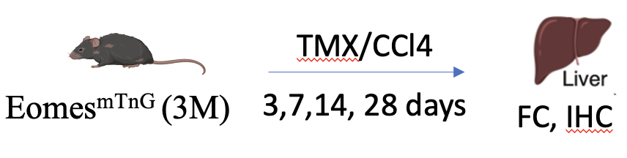

*1.2. Characterize the differentiation, molecular characteristics, and cellular properties of CD4 CTLs in a mouse model of liver cirrhosis.* To further determine the population structure of CD4 T cells in the liver following cirrhosis and the impact of EOMES depletion on the CD4 T cell landscape, we will apply scRNA-seq analyses of liver-derived CD45+ cells. CreERT2+/-CD4CreEREomeslox/lox mice and littermate controls (3 months old; n=4 mice/group) will be treated with tamoxifen (TMX; 100 µl of TMX diluted in corn oil (0.01 g/ml) delivered IP on three consecutive days followed by a three-day rest interval and then two weekly IP injections of TMX and CCl4 for six weeks (Fig. 3). As a negative control group, littermate controls will be administered TMX and vehicle. Depending on the results from Aim 1.1, livers will be dissected after 7, 14, or 28 days and analyzed for 1) CD4 T cell subsets (exhausted, regulatory, EOMES+ effectors, and EOMES+ CTLs) by flow cytometry; 2) in collaboration with Prof. Esti Yeger-Lotem (see letter of support) we will analyze the molecular and metabolic properties of CD4 T cell subsets and their T cell receptor (TCR) repertoire through scRNA-seq analyses of CD45+ leukocytes using the methodology described in Fig. 7 and Methods. By combining our flow cytometry and scRNA-seq results, we anticipate uncovering those EOMES+ CD4 T cell subsets exhibiting effector and cytotoxic properties that accumulate in the liver following CCl4 administration and clarifying how the effective depletion of EOMES in CD4+ T cells impacts CD4 T cell subset phenotypes and repertoires in the liver. Cellular trajectory analyses will be performed to infer transitions from effector CD4 T cells to EOMES+ cells, and to EOMES+ CTLs expressing GzmK+ and/or GzmB+. TCR analysis will allow us to assess the clonal expansion of CD4 CTLs in the presence or absence of EOMES and to ascertain CTL TCRs that can be further analyzed for antigen specificity, which is beyond the scope of the current proposal.

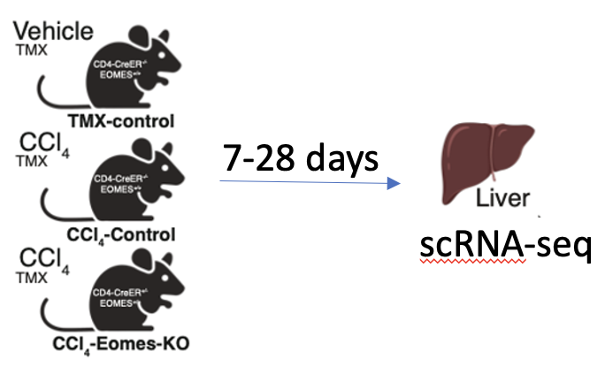

1.3. *Characterize the accumulation and function of CD4 CTLs in old mice.* Transferring splenocytes or CD4 T cells from young to old, but not from young to young, mice resulted primarily in differentiation and proliferation of EOMES+ CD4 T cells and their accumulation as CD4 CTLs at frequencies similar to those of endogenous cells while other subsets such as naïve and Tregs did not change [Fig. 1, (51)]. Given that primarily EOMES+ CD4 T cells expanded following transfer, in this Aim we will thus leverage this cell transfer system to follow the migration of EOMES+ CD4 T cells to various tissues in old mice following the depletion of endogenous EOMES+ CD4 T cells and determine the dynamic accumulation of GzmK+ and GzmB+ CD4 CTLs and their impacts on the immune compartment, SC load, and frailty. CD4CreER+/-Eomeslox/lox and littermate control mice aged 16 months (n=6-10 mice/group) will be treated with TMX (Fig. 2) to deplete the EOMES+ CD4 T cells followed 4 weeks later by the intravenous (IV) injection of vehicle control or 10 x106 CD4 T cells sorted from adult EomesmTnG reporter mice. Mice will be sacrificed at 1, 2, 4, and 6 weeks after cell transfer and analyzed for 1) the frequency of tdTomato (EOMES+) CD4 T cells expressing GzmK, GzmB, CCL5, and perforin along with the frequencies of CD4 T cell subsets (exhausted, regulatory, effector) in the spleen, blood, bone marrow, gut, adipose tissue, liver, lungs, and brain via flow cytometry, and 2) immunological synapse formation between GFP+tdTomato+CD4+ CTLs (GzmB+) and senescent cells (p16Ink4a+ and/or P21+) and/or APCs (CD11b+ and/or CD11c+) in the liver via confocal imaging. The groups analyzed at 4 and 6 weeks will remain on a weekly alternating TMX/normal chow diet regimen [ensuring the effective and continuous depletion of endogenous EOMES+ CD4 T cells (Fig. 2)] and monitored for weight, food and water intake, and frailty using the hanging and wheel tests while the frequencies of GzmK+ and GzmB+ CD4 CTLs in blood will be quantified before initial TMX administration and at the end of the experiment (Fig. 2, Methods). SC load will be assessed in livers and lungs by flow cytometry and confocal imaging (Fig. 2, Methods). We anticipate that this experiment will reveal the tissue-specific dynamic accumulation of CD4 CTLs in old mice and the proportions of GzmK+ and GzmB+ GFP+tdTomato+ CD4 cells relative to the endogenous CD4 CTL populations. Although we cannot exclude the possibility that other CD4 subsets impact the SC load and other aging-related biomarkers, our observation that primarily EOMES+ CD4 T cells expand following CD4 T cell transfer depending on the SC load (Fig. 1) strongly suggests that this effect is mediated primarily by the newly differentiating EOMES+ CD4 cells. As we progress with the analyses performed in Aim 1&2, a more defined population of CD4 CTLs will be used to carry out the efficacy experiment.

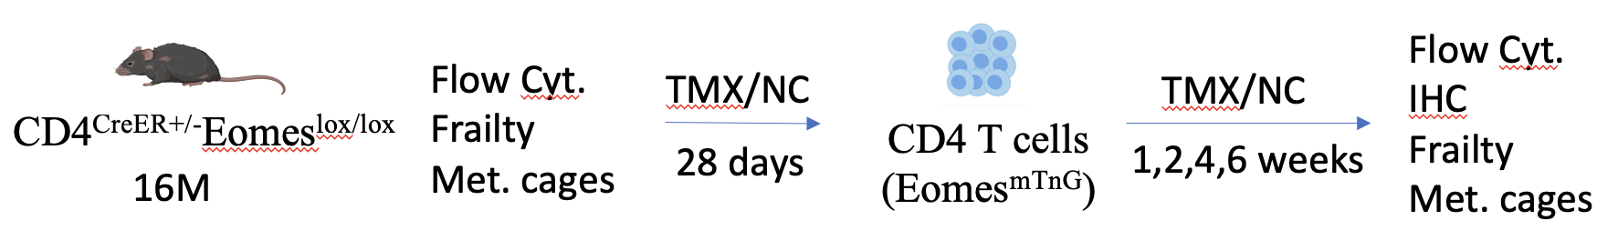

*1.4. Determine the cytotoxic properties of CD4 CTLs.* Activation of CD4 CTLs with anti-CD3/CD28 Dynabeads resulted in increased expression of IFN-γ, GzmB, and perforin, suggesting that the cells can exert cytotoxic functions following MHCII-TCR interactions (49, 62). However, it is critical to establish an *in vitro* system to determine whether the CD4 CTLs are directly involved in the elimination of SCs via direct MHCII-TCR interactions or their local stimulation by APCs and subsequent secretion of cytotoxic granules (ref). While the main barrier to achieving this goal is the isolation of CD4 CTLs and maintaining their cytotoxic properties, our preliminary results show that senescent primary fibroblasts cocultured with spleen-derived CD4 T cells can promote increased frequencies of CTLs [Fig. 4, (51)]. To obtain cytotoxic and potentially SC-derived antigen-specific CD4 T cells, CD4+GFP+tdTomato+ cells observed in the EomesmTnG reporter mice in Aim 1.1 will be sorted from the livers of mice subjected to CCl4 treatment at the timepoint when most EOMES+CD4+ cells exhibit cytotoxic properties. The cells will be activated *in vitro* for 24 hours using anti-CD3CD28 Dynabeads, and cocultured with primary fibroblasts or senescent primary fibroblasts for 3 and 7 days (Fig. 4, Methods). T cells will then be purified and subjected to flow cytometry analyses to determine the impact of cellular senescence on the cytotoxic profile of these cells (EOMES+CCL5+GzmB+perforin+CD107+) and SCs undergoing cell death (AnnexinV). In addition, cells will be fixed and immunolabeled with antibodies for CD4, GzmB, ICAM1, MHCII, CD90, b-Gal, and caspase-3 and analyzed by confocal microscopy to detect CD4 CTL-SC interactions and cell-mediated cytotoxicity. ICAM1 and MHCII blocking antibodies will be used to determine whether the differentiation and/or function of CD4 CTLs is contact-dependent. Cytokines associated with senescence (primarily IL-6, IL-1, and TNF-a) and other targets revealed by RNA-seq will be neutralized in the coculture system with blocking antibodies followed by analyses of the frequency and function of CD4 CTLs. To determine whether cytotoxicity is induced by secreted molecules and/or vesicles in a cell contact-independent manner, the liver-derived CD4+ tdTomato+ cells will be cultured for 24, 48, and 72 hours and conditioned media (CM) will be collected. Primary senescent and non-senescent fibroblasts will be then cultured with CM and evaluated for apoptosis at 24 and 48 hours post-treatment by flow cytometry. Overall, we find this system highly useful as a means of exploring the signaling pathways that promote the differentiation of CD4 CTLs and their cytotoxic mode of action.

**Aim 2: Assess the relationships of CD4 CTL frequencies and molecular properties with aging-related chronic inflammation, cognitive decline, and frailty.**

Rationale: Longitudinal brain imaging studies indicate that brain inflammation is one of the earliest signs of dementia developing 10-20 years later (14), and more attention is now focused on systemic inflammation as a key driver of brain inflammation (21, 68-73). Based on our earlier findings (49, 50) and preliminary results (Figs. 2-3), we hypothesize that immunological aging (as reflected by age-related CD4 T cells) and circulating inflammatory molecules can not only enhance aging but also disrupt the brain-immune ecosystem, a process that exacerbates neuroinflammation and neural damage. The accumulation of CD4 CTLs with age and their association with SC load, frailty, and longevity [Figs. 5, 7, (49-51, 62)], may, however, suggest a newly emerging concept of protective T cell-mediated cytotoxicity. More specifically, rather than rejuvenation, healthy aging may be achieved by the modulation of immunity such as the accumulation of CD4 CTLs. Our preliminary results in human cohorts not only show that the frequency of the CD4 CTL subset is increased with age (Fig. 5, 7), but that additional clusters of CD4 CTLs with different molecular properties develop in older individuals and may differ between healthy individuals and patients with MCI (Fig. 7). ML approaches (in collaboration with Dr. Dan Vilenchick) demonstrated that among all CD4 T cell subsets, cytotoxic and exhausted markers were able to effectively distinguish patients with MCI from healthy age- and sex-matched controls (Fig. 6). *Together, our preliminary results suggest that while CD4 CTLs can support healthy aging, both the frequency and functional properties of these cells may play a role in this process.* To further characterize the accumulation of CD4 CTLs, their differential molecular properties, and their functional roles in healthy individuals and patients experiencing cognitive decline, we will analyze the changes in CD4 T cell subsets, particularly within cytotoxic clusters, among male and female healthy adults, healthy older individuals, older individuals with MCI, assessing their associations with circulating biomarkers of aging, inflammation, and neurodegeneration (43, 44, 74).

Specific aims and experimental approaches:

*2.1. Characterize the changes in CD4 CTLs associated with aging and the progression of cognitive decline and their relationships with systemic inflammation and neuroinflammation.* To further reveal the role of CD4 CTLs in aging and their distinct phenotypes in patients experiencing cognitive decline, we will recruit individuals aged 70 and older with or without MCI. We anticipate that these analyses will not only reinforce the differences we observed between older individuals and patients with MCI but will also unveil CD4 CTL patterns and their association with other CD4 subsets at older ages (90-100 years). In addition, since only a subset of MCI patients will progress to dementia (about 40% in 4-5 years REF), we will recruit patients with established AD who may exhibit more advanced trajectories of CD4 T cell phenotypes as compared to those observed in the MCI cohort. The subject recruitment procedure, inclusion/exclusion criteria, and clinical assessments (cognitive decline and frailty) will be conducted in collaboration with Prof. Yan Press and Dr. Boris Punchik (*Clalit Health Services, Beer Sheva, Israel), Dr. xx (Psychiatry medical center),* and the Siaal center (see letters of support), as detailed in the Methods section below. As shown in Figure 6, recruiting healthy older (n=60) and MCI patients (n=60) to achieve 200 participants may be sufficient to distinguish individuals with cognitive decline with an AUC greater than 95%. Blood samples will be thus obtained from healthy males and females 70-100 years of age (n = 60, 20 individuals for each decade) and age-and sex-matched individuals with MCI (n = 60) as shown in Fig. 5. Based on our scRNA-seq analysis in collaboration with Prof. Esti Yeger-Lotem (Fig. 7), CD4 CTLs will be analyzed at higher resolution using flow cytometry panels including EOMES, GzmK, GzmB, CCL5, perforin, CD81, and Klrd1. A range of cytokines and chemokines including C-reactive protein (CRP), CX3CL1, CXCL9-10, IFN-g, interleukin 2 (IL-2), IL-6, TNF-a, and TNF receptor superfamily 1A (TNFRSF1A), as well as biomarkers of neuronal damage including glial fibrillary acidic protein (GFAP), neurofilament-light (NF-light), phosphorylated tau (pTau-181), and amyloid-beta peptides (Ab40 and Ab42), will be measured in serum samples using Luminex and Simoa approaches (Methods). Overall, together with the continuous analysis of the scRNA-seq dataset, we anticipate further clarifying the frequencies and phenotypes of CD4 CTLs at various stages of aging and cognitive decline and their associations with 1) other CD4 (naïve, regulatory, exhausted, effector) and CD8 (naïve, exhausted, effector) T cell subsets in each of the study groups, serum biomarkers of chronic inflammation and neuronal damage, age-related epigenetic changes in PBMCs REF (in collaboration with Prof. Gil Atzmon; see letter of support), frailty scores, and cognitive decline. To validate risk factors for the development of frailty and/or cognitive decline among the healthy control and MCI groups, the recruited individuals in these two groups will be reevaluated, as described above, in an additional visit (1st visit in years 1-2 and 2nd visit in years 3-4). We anticipate that around 17% of healthy older individuals and around 40% of MCI patients will exhibit progressive cognitive decline over the 4-5 years study period (40, 75, 76). Throughout the recruitment process, we will continue to re-train the ML models based on further analyses of age-related CD4 T cell subsets and additional inflammatory markers identified in Aim 2.1 such that testing new samples will allow us to better infer immune trajectories of cognitive decline and the underlying biological features.

*2.2. Clarify whether T cell subset functionality differs among older individuals at risk for cognitive decline.* Our scRNA-seq analyses revealed CD4 CTL subsets that differ in older individuals and/or in patients with MCI such that further interrogation of their functional properties is warranted. Intriguingly, in contrast with the homogeneous population of CD4 CTLs in young individuals, older individuals exhibited several clusters, that differed in expression of markers including GzmK and GzmB (Fig. 7). Patients with MCI had decreased frequencies of GzmK- and increased frequencies of GzmB-expressing cells, which also showed reduced metabolic fitness (Fig. 7). These results suggest that patients with MCI may exhibit a defect in the differentiation and/or function of CD4 CTLs that may reflect a more advanced stage of aging. We will thus conduct the functional characterization of the GzmB- and GzmK-expressing CD4 CTL subsets to assess the functional properties of these subsets in healthy young, older individuals, patients with MCI, and patients with AD. To that end, PBMCs from the healthy young (20-30 years), healthy older (≥70 years), MCI (≥70 years), and AD (≥70 years) groups (n=10-15/group) will be thawed and cultured in the absence or presence of a cell activation cocktail containing an optimized concentration of PMA (phorbol 12-myristate-13-acetate), ionomycin, and a protein transport inhibitor (Brefeldin A) for 4 hours, after which these cells will be analyzed via flow cytometry to assess EOMES-expressing GzmK+ and GzmB+ CD4 T cells for their inflammatory (IL-2, IL-17, IL-10, and IFN-g), cytotoxic (CCL5, perforin, CD107), and metabolic (mitochondrial mass with anti-TOMM20; membrane potential with 40 nM MitoSpy™ Red CMXRos) properties. We will also determine functional differences associated with exhaustion markers (PD-1, Lag3, and TIGIT) and cytokine expression (e.g., IL-17, IL-10, and TNF-a) profiles among the effector subsets. To measure the proliferative capacity of these T cell subsets, the cells will be incubated with 5 mM CFSE (carboxyfluorescein succinimidyl ester), washed, and activated with anti-CD28/anti-CD3 for 5 days, after which they will be harvested and analyzed by flow cytometry (49). These analyses of effector and cytotoxic properties will ultimately clarify key functional differences beyond cell frequencies that distinguish healthy older individuals from patients with MCI.

**Potential pitfalls and alternative approaches:**

*1. Splenic CD4 T cells in EOMEStdTomato mice may not be sufficient to show efficacy (Aim 1.3).* Based on our T cell transfer experiments, EOMES+ CD4 T cells rapidly propagate to achieve the frequency of endogenous CD4 CTLs (Fig. 1). However, if we do not observe sufficient CD4 CTLs in analyzed tissues, we will consider generating EOMES-GFP-overexpressing CD4 T cells, as we have previously shown (ref), evaluating their cytotoxic profile *in vivo* and *in vitro* when co-cultured with senescent fibroblasts as an alternative approach.

*2. CD4 CTL frequency and/or function may not be associated with cognitive decline (Aim 2.1).* In this case, we will examine two alternatives: 1) explore how other lymphocyte subsets and/or circulating inflammatory molecules contribute to cognitive decline using the ML approaches described in Fig. 6; and 2) further assess the relationships between CD4 CTLs and other biomarkers of aging to detect possible indirect links with cognitive decline, as may be revealed by epigenetics, proteomics and metabolomics analyses of serum samples.

*3. Differential functionality of GzmK+ and GzmB+ CD4 CTLs (Aim 2.2).* The differential roles of these subsets will be observed following short-term PMA-mediated activation. However, in the absence of a sufficiently detailed understanding of their dynamics following activation and their molecular properties, we will consider sorting these cells based on markers identified in the scRNA-seq data followed by activation and bulk RNA sequencing at different time points after activation.

**METHODS**

A. Human samples and clinical assessments. All recruitment will be performed in collaboration with Prof. Yan Press (Soroka Medical Center), Dr. Boris Punchik (*Clalit Health Services, Beer Sheva, Israel), Dr. Svetlana xx (Psychiatry medical unit),* and the Siaal Research Center at The Faculty of Health Sciences, Ben-Gurion University (support letters attached). Blood samples and questionnaires will be collected in community healthcare clinics in the south of Israel. Only subjects that signed consent forms will be included. *Exclusion criteria:* We will not recruit patients with known immunodeficiencies. This includes patients who received immunosuppressive treatments and/or over 5 days of steroid treatment within the three months preceding recruitment; oncology patients (not including squamous cell carcinoma and basal cell carcinoma); patients treated with chemotherapy or biological agents that might affect the immune system; patients with autoimmune diseases; immunosuppressed patients; patients with severe leukopenia (< 3000 leukocytes/µl) and/or neutropenia (< 1,500 neutrophils/µl); patients who suffered from a fever of 38.5°C or above in the two weeks preceding recruitment. Blood samples (50-70 ml) will be collected while taking a routine blood test, using 10 ml EDTA test tubes and one 5 ml serum tube. We will collect the following information from each participant: age; sex; gender; background diseases (including diabetes, chronic renal failure, ischemic heart disease, heart failure, liver dysfunction, hypertension, dementia, depression, and Parkinson's disease); vaccination status; marital status, and with whom they live; height and weight; and changes in weight during the past year. For these patients, we will calculate two comorbidity indexes: Charlson's Comorbidity Index and CIRS. All participants will undergo the following tests:

*Cognitive evaluation*:We will use a computerized-based platform (NeuroTrax) and the Montreal Cognitive Assessment test (MoCA) to determine MCI and dementia status. *NeuroTrax:* The Mindstreams computerized cognitive assessment battery has been well-validated for the assessment of cognitive function and MCI in older populations (77). The test lasts for 45–50 min and evaluates several cognitive components, including verbal memory, non-verbal memory, the Go-No Go test, the Stroop index, visuospatial perception, concentration, and reaction time. In the final report, these components are incorporated into categories with indices for memory, attention, visual-spatial perception, and executive function, together with a global score comprising all indices. The scores are based on a performance index in each cognitive domain that weighs the number of correct answers and response times, calculated as correct answers divided by the response time and multiplied by 100. Normative data are provided corrected for age and education level. There is no need for previous computer experience, as the program provides training before the initiation of the actual testing procedures. The data are automatically uploaded to a central server where the final score is calculated. *MoCA:* This instrument is a paper-based screening instrument that takes about 10 minutes to complete. The test iscomposed of 8 parts and has a maximum possible score of 30 points. A score of 26 or more is considered normal in the English version of the test (78). The tasks evaluate visuospatial perception, organizational skills, recognition and naming, short-term memory, attention, verbal ability, abstraction, and orientation. The Hebrew version of the MoCA was found to distinguish between cognitively asymptomatic older individuals and those with MCI with a sensitivity of 94.6% and a specificity of 76.3%, using a cutoff of 26/30 points (79, 80).

*Functional assessment*: For functional assessments, we will use the Barthel Index (Basic Activities of Daily Living) (81) and the OARS _IADL (Instrumental Activity of Daily Living) (82). For frailty measurements, we will use two indexes: Fried's frailty phenotype (FFP) (83) and the Study of Osteoporotic Fractures (SOF) index (84). According to the FFP index, "frailty" is defined by the presence of 3 or more of the following 5 components: (1) unintentional weight loss (4.5 kg in the past year), (2) self-reported exhaustion, (3) weakness (grip strength), (4) slow walking speed, and (5) low physical activity. According to the SOF index, “frailty” is defined by the presence of 2 or more of the following 3 components: (1) weight loss (irrespective of intent to lose weight) of 5% or more; (2) the subject’s inability to rise from a chair 5 times without using their arms; and (3) reduced energy levels, as identified by an answer of “no” to the question “Do you feel full of energy?”. Patients exhibiting none of these components will be considered to be robust, while those exhibiting one component will be considered to be in an intermediate or prefrail state. To evaluate muscle weakness participants, will undergo hand grip strength testing with a hand dynamometer. Individuals will be considered frail if they meet one of the frailty criteria (FFP and/or SOF).

B. Lymphocyte analyses. *Cell isolation:*We used standard operating procedures for Ficoll density gradient centrifugation for PBMC isolation, cryopreservation, storage, and thawing (85). Human CD4 T cells will be isolated from total PBMCs with a negative selection kit (StemCell Technologies, Canada) followed by the EasySep human CD4 T-cell positive enrichment kit, thus allowing us to achieve >95% purity. Spleens will be harvested from mice and mashed through a 70-μm cell strainer (49). Red blood cell lysis will be performed using 300 μl of Ammonium-Chloride-Potassium (ACK) buffer for 1.5 minutes (Lonza, Basel Switzerland).

*Flow cytometry:*We will use a multicolor labeling technique to detect cell-surface and intracellular molecules in PBMC, splenocyte, or mouse tissue samples, as we have recently described (49). Briefly, viable cells will be washed with FACS staining buffer and incubated with the Fc receptor blocker (TrueStain fcX; BioLegend) for 5 minutes at 4℃. To differentiate between live and dead cells, the eFluor780-Fixable Viability Dye (eBioscience) will be used according to the manufacturer’s instructions. Cells will be incubated with primary antibodies for 25 minutes at 4℃ and then washed twice with FACS staining buffer. After staining for surface markers, cells will be fixed and permeabilized using the FOXP3/Transcription Factor Staining Kit (eBioscience), blocked with rat serum (1 μl per 50 μl of staining buffer), and stained. For Sbeta-gal staining, we will use the CellEvent™ Senescence Green Flow Cytometry Assay Kit (eBioscience) according to the manufacturer's instructions. Flow cytometry experiments will be conducted using the CytoFLEX instrument (Beckman Coulter). Data analysis will be performed with the FlowJo (v10.5.3) software. Gating strategies will rely on fluorescence-minus-one controls, unstained samples, and unstimulated samples (when applicable).

C. Serum cytokine measurements. Red-topped tubes will be used to isolate serum from 5 ml blood samples. Blood tubes will be incubated at room temperature for coagulation (30 minutes) and then centrifuged at 450 x g. Serum will be then isolated and kept frozen. For measurements of circulating inflammatory mediators (described in Aim 2.1), we will use a Luminex human inflammation panel in accordance with the provided instructions. Data will be acquired on the Luminex instrument and analyzed by American Medical Laboratories (AML, Israel). The Simoa technology will be used for ultra-sensitive detection of serum biomarkers of neurodegeneration including GFAP, NF-light, pTau, and Ab (Quanterix; Merkel Technologies Ltd., Israel).

D. Confocal microscopy. Tissues will be immersed in a 4% paraformaldehyde solution at 4℃ overnight, then transferred to a 30% sucrose solution at 4℃ for 2 days and fixed in O.C.T Compound (Tissue-Tek). Sections (20-30 µm) will be produced with a cryostat and kept at -20℃. Sections will be rinsed in a washing solution (0.05% Tween 20 in PBS) and then permeabilized for 30 minutes in 0.5% Triton X-100 in PBS. Prior to staining, the sections will be incubated for 1 hour with a blocking solution containing 0.5% Triton X-100 and 10% Donkey serum in Antibody Diluting Buffer (Biomeda). Sections will be then incubated for 48 hours with primary antibodies in blocking solution at a 1:100 dilution. Following the incubation, the sections will be rinsed 3 times in a washing solution and then incubated for 1 hour with secondary antibodies conjugated to Alexa Fluor 488, 546, or 633 (Invitrogen) diluted 1:250 - 1:500 in PBS. Sections will be then rinsed in a washing solution twice more before nuclear staining and then mounted on slides for confocal imaging using an Olympus FV1000 laser-scanning 4-channel confocal microscope, as we recently described (86, 87).

F. Hanging test.Mice use their forelimbs to suspend their body weight on a wire stretched between two posts 50 cm above the ground, and a pillow is used to prevent fall injuries. We will evaluate grip strength and endurance in each mouse with the wire-hanging test before and after the tamoxifen feeding regime. Mice will be allowed to hang on a wire three times, and the average hanging time will be normalized to body weight as hanging duration (sec) × body weight (g).

G. Metabolic cages. For metabolic data acquisition, we will use the 8-cage Promethion High-Definition Behavioral Phenotyping System (Sable Instruments, Inc., Las Vegas, NV, USA). Before experiments, mice will be housed in a metabolic cage facility for 7 days. Data will be collected at 30-minute intervals for 84 hours of recording. Mice will be maintained under a 12/12 h light/dark cycle (07:00–19:00) at an ambient temperature of ≈ 23°C. The following parameters will be analyzed: temperature, body mass, water and food consumption, ped meter, ped speed, and x and y breaks. Overall activity will be the sum of all distances traveled within the beam break system (x and y). This includes fine movement (such as grooming and scratching) as well as direct locomotion. For analyses, we will record each mouse before and after 45 days of tamoxifen treatment and calculate the "performance ratio" = post-treatment parameter / pre-treatment parameter.

I. Senescence of primary fibroblasts and co-culture with CD4 T cells: To establish primary cultures of lung fibroblasts, lung tissue from young C57BL/6 mice (3 months old) will be chopped by gentleMACS and incubated at 37ºC with Liberase™ for 1 hour, then the tissue will be washed and transferred into T175 flasks. Tissue samples will be then incubated in Dulbecco’s Modified Eagle’s Medium (DMEM) (Gibco), supplemented with 10% (v/v) fetal bovine serum (Invitrogen) and 1% Penicillin-Streptomycin at 37°C in air containing 5% CO2. Cells will allowed to migrate out from the tissue and to grow to full confluence. Adherent cells will be passaged by digestion with 0.025% Trypsin-EDTA solution when ~90% confluent. Experiments will be performed with fibroblasts from individual cryovials of cells that were rapidly thawed in a 37°C water bath (1–2 min of agitation) and resuspended in culture media. Cells (105) will be seeded into wells (48-well plate) for a 48-hour incubation at 37°C. Senescence will be induced by treatment with Etoposide (Santa Cruz Biotechnology) dissolved in DMSO (3 mg/ml) and added to cell medium (final concentration: 30 μM) for 48 hours, after which cells will be washed with fresh medium and incubated for another six days.

J. Statistics. Statistical analyses will be carried out in collaboration with Dr. Vered Chalifa-Caspi, from the bioinformatics core facility at Ben-Gurion University (BGU, letter of support attached). ML tools will be used in collaboration with Dr. Dan Vilenchick; see letter of support). For routine statistical analysis, Student’s t-test or ANOVA will be used. We will identify and remove confounding sources of variation including batch effects (each experiment will be designed to balance the analyzed samples for age and sex; within each group, the samples will be randomly selected), background diseases, time of hospitalization, and additional parameters that will be collected from patients. We will use multivariable regression analysis to assess an association between clinical parameters and immunological states, adjusting for any confounding factors. Since clinical parameters may not be distributed normally, we will apply transformations or use non-linear regression approaches using Poisson or other distributions.

**Available resources:**

The laboratory employs a lab manager, research associate, 2 technicians, 2 postdoctoral researchers, 5 trainees, 4 MSc students, and 7 PhD students. The lab possesses the space and equipment required to perform the proposed study, including two tissue culture hoods, refrigerators and -20˚C freezers, -70˚C freezers, CO2 incubators, regular PCR instruments, an ELISA plate reader, an ELISA plate washer, a confocal microscopy station, and a 21-channel FACS analyzer. Available institutional services include a specific pathogen-free (SPF) animal facility with MRI, surgery, and behavioral stations and metabolic cages, Imagestream FACS instruments, cell sorters, cryostats, Taq-Man Real-time PCR instruments, ultracentrifuges, and a bioinformatics unit.

**PRELIMINARY RESULTS**

**Figure 1. CD4 T cells differentiate into CD4 CTLs in an aged environment. A**. Experimental setup: splenocytes were harvested from CD45.1+ C57BL/6 mice and then 20 million cells were injected into either young (2-3 months) or old (24-26 months) CD45.2+ C57BL/6 mice. After 30 days, spleens were harvested for analysis. **B**. Left: representative flow cytometry plots showing CD4 CTL (EOMES+CCL5+) frequencies out of transferred CD45.1+ CD4 T cells (CD3+CD4+CD8-) in young or old CD45.2+ mice. Right: quantitative analysis of CD4 CTL frequencies out of the transferred cells in young (n=6) or old (n=4) WT mice (CD45.2+). **C.** Quantitative analysis of effector (CD3+CD4+CD62L-CD44+PD1-LAG3-). **(D)** Percentages of CD4 CTLs out of CD4 T cells comparing CD45.1+ (young-transferred cells) and CD45.2+ (old-endogenous cells) in the old group. **E.** Experimental setup: CD4 T cells were isolated from young (2-3 month-old) CD45.1 mice and labeled with Carboxyfluorescein succinimidyl ester (CFSE). Five million labeled cells were transferred into young (2-3 months) or old (22-24 months) CD45.2 recipient mice. Spleens were harvested 7 days post-transfer for analysis. Graph showing the percentages of CFSE negative transferred cells out of EOMES-CCL5- cells or EOMES+CCL5+ cells in old mice. **F.** Experimental setup: splenocytes were harvested from young CD45.1 mice, and then 20 million of these cells were injected into old mice treated with vehicle (10% ethanol, 30% PEG 400, 60% Phosal50) or Navitoclax (ABT-263, 50 mg/kg,) for 30 days, after which spleens were harvested for analysis. The percentages of CD4-EOMES originating from CD45.2 (old-endogenous) and CD45.1 (young-transferred) cells in control (n=11, Left) and senolytic drug-treated mice (n=10; Right). Bars indicate means ± SEM from two (**B-E**) or three **(F)** independent experiments. Data were analyzed using a two-tailed Student’s t-test (unpaired: **B-C, E;** paired **D, F**).

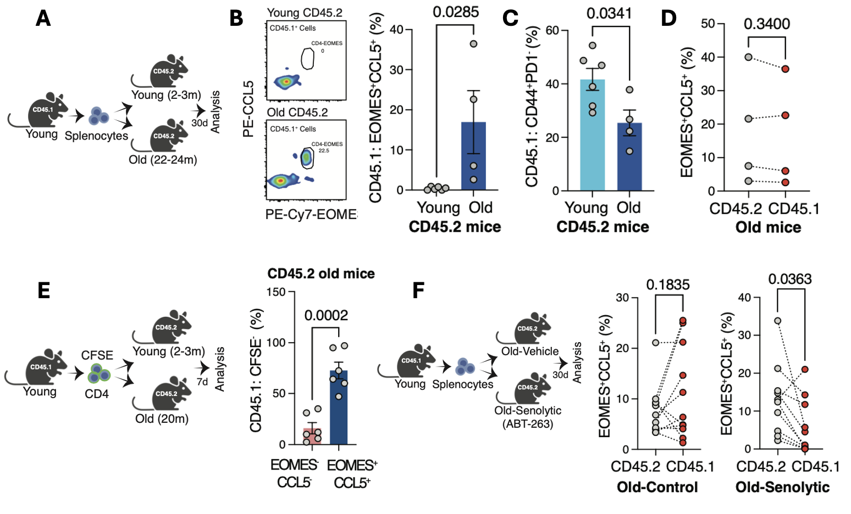

**Figure 2. Decreased physical performance and survival in aging are associated with lower frequencies of CD4 CTLs. A.** Experimental setup: physical performance of aged (20 months) control (CreERT2-/-Eomesfl/fl) and CD4 CTL KO mice (CreERT2+/-Eomesfl/fl) was evaluated using the hanging test and metabolic cages. Additionally, 100-200 µl of blood was collected from the tail vein of each mouse for flow cytometry analysis. Subsequently, the mice were subjected to a TMX regimen, which included intraperitoneal injections of 100 µl of TMX for 3 days, followed by an alternating dietary regimen of two weeks on TMX chow and two weeks on regular chow. After the TMX exposure period, each mouse was reevaluated for physical performance. Finally, the mice were sacrificed, and blood, spleen, and liver samples were collected for further analysis. **B.** CD4 CTL (CD3+CD4+EOMES+CCL5+) frequencies in the blood before and after TMX treatment in the control group (left, n=6) and in the CD4 CTL-depleted group (right, n=7). **C.** Representative flow cytometry plots showing CD4 CTLs in the blood of control mice (left) or CD4 CTL-depleted mice (right) before (upper plots) and after (lower plots) TMX treatment. The X-axis represents EOMES expression, and the Y-axis represents CCL5 expression. **D.** Hanging test results are shown as a ratio between the score after TMX and the score before TMX for each control (n=13) and CD4 CTL-depleted (n=15) mouse. Each dot represents one mouse. Scores were normalized to weight for each mouse. **E-F.** The ratio between post-treatment and pre-treatment performance in metabolic cages for each mouse in control (n=12) and CD4 CTL-depleted (n=14) groups. Each dot represents the ratio for one mouse. **E.** Activity ratio, which represents the sum of fine motor movement and intentional movements, in the control and CD4 CTL-depleted groups. **F.** Food consumption ratio (left) and water consumption ratio (right) in the control and CD4 CTL-depleted groups. **G.** Percentages of CD4 CTLs in the liver of control (n=12) and CD4 CTL-depleted (n=14) mice. **H.** Flow cytometry analysis of the percentage of Granzyme B+ cells among CD45+CD3+CD4+ cells in livers. **I.** Percentage of senescence β-Galactosidase+ (S-β-Gal+) cells among liver cells (CD45-) from control (n=12) and CD4 CTL-depleted (n=14) mice. **J.** Percentage of p16Ink4a+ and P21+ cells among liver cells (CD45-) from control (n=6) and CD4 CTL-depleted (n=7) mice. **K.** Kaplan-Mayer survival curve for control (n=9) and CD4 CTL-depleted (n=9) mice. Censoring is indicated by the black line (|) mark.Bars indicate mean ± SEM from two (**D-J**) or one (**J**) independent experiments. Data were analyzed using a two-tailed Student’s t-test, paired (**B**), unpaired (**D-J**), or log-rank (Mental-Cox) (**K**). Exact P-values are presented in the graphs.

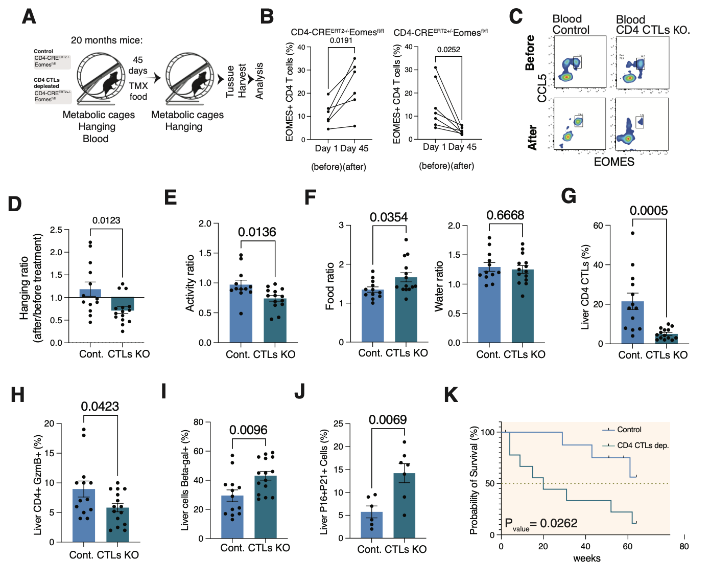

**Figure 3. Depletion of CD4-EOMES is linked to increased fibrosis and senescent cell accumulation in a mouse model of CCl4-induced liver cirrhosis. A.** Experimental setup: CreERT2+/-Eomesfl/fl (CCl4-Eomes-KO) and CreERT2-/-Eomesfl/fl (CCl4-Control) mice were subjected to a 45-day treatment with CCL4 + TMX to induce liver cirrhosis. Another group of CreERT2-/-Eomesfl/fl mice (TMX-Control) that received corn oil + TMX served as vehicle control. Livers were collected for further analysis after this treatment period. **B.** The percentages of CD4-EOMES in the livers from TMX-Control (n=12), CCl4-Control (n=12), and CCl4-Eomes-KO (n=15) mice. **C.** Quantitative analysis of senescence load in the area of the lobular hepatic vein in the CCl4-Control group (n=5) and the CCl4-Eomes-KO group (n=5), calculated as the ratio between the number of senescent cells (P21+) and hepatic vein circumference. **D.** Quantitative analysis of Sirus Red staining area calculated as the percentage of liver tissue area strained with Sirus Red out of all tissue area (ROI) for TMX-Control (n=9), CCl4-Control (n=11), and CCl4-Eomes-KO (n=15) mice. Each dot represents the average of at least two liver sections from one mouse. Bars indicate means ± SEM. Data were analyzed using one-way ANOVAs with Tukey’s correction for multiple comparisons (**B, D**) or unpaired two-tailed Student’s t-tests (**C**). Exact P-values are presented in the figures.

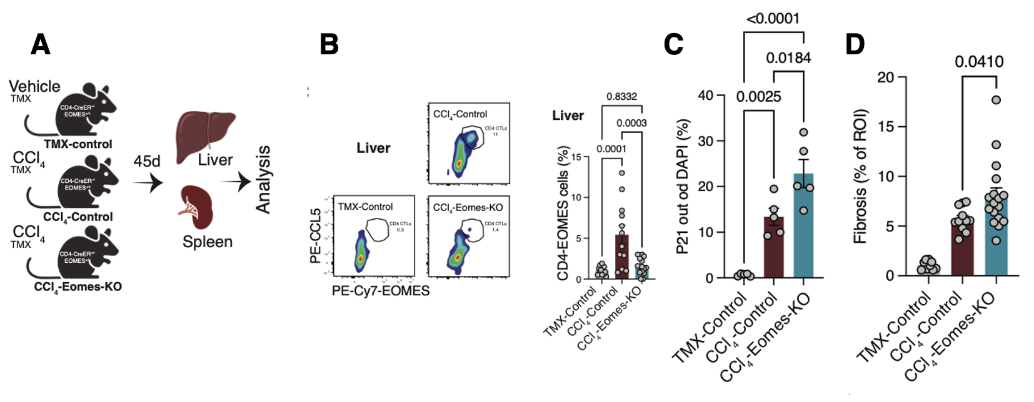

**Figure 4. CD4 CTL differentiation is induced by senescent fibroblasts *in vitro*. A.** Experimental setup: primary lung-derived fibroblasts underwent senescence induction with Etoposide (Methods). Next, CD4 T cells were purified, activated with anti-CD3/anti-CD28 beads, and co-cultured with either control or senescent fibroblasts for 7 days. Data were then analyzed via flow cytometry. **B.** A representative image displaying β-gal staining of cultured lung fibroblasts for control (upper panel) and etoposide-treated (lower panel) conditions. **C.** Percentages of CD4 CTLs (CD3+CD4+CCL5+EOMES+) (left) and median fluorescence intensity for EOMES (right) among CD4 T cells co-cultured with either control or etoposide-treated fibroblasts. **D.** Percentage of granzyme B positivity in CD4 T cells co-cultured with either control or etoposide-treated fibroblasts.Data are from one representative experiment analyzed using two-tailed Student’s t-tests (**C-D**). Exact P-values are presented in the graphs.

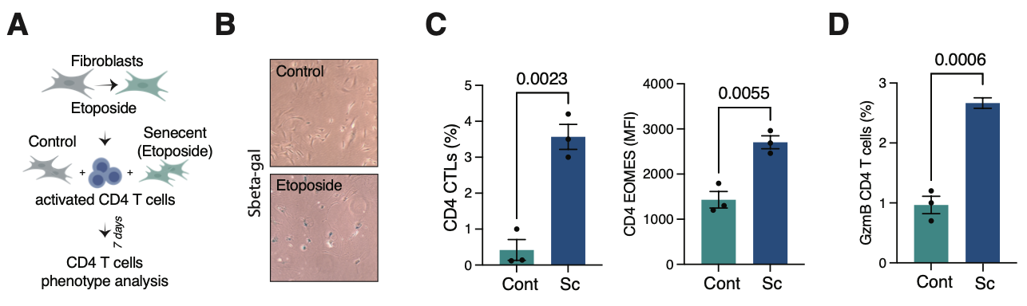

**Figure 5. Flow cytometry analyses of CD+ T cell subsets across the lifespan.** PBMCs were purified from the whole blood of healthy individuals of various ages and elderly individuals with mild cognitive impairment (MCI) and analyzed via flow cytometry. **A.** An overview of the selected flow cytometry gating strategy with different subpopulations identified by distinct colors (based on CD45RA/CCR7 labeling for effector memory [EM], central memory [CM], naïve, and TEMRA cells, and CD25/CD127 labeling for Tregs). **B.** Flow cytometry analysis showing alterations in CD4 subpopulations observed in healthy individuals across a range of ages (20-30, n=12; 61-70, n=8; and 71-90, n=19) and in elderly individuals with MCI (age 71-90, n=8). **C.** Flow cytometry results showing alterations in exhausted (PD1+, LAG3+) and cytotoxic (Granzyme B+, EOMES+) CD4 T cells across age groups (20 to 71+ years old) and in individuals with MCI. **D.** Percentages of EOMES+ cells within TEMRA, EM, CM, and naïve CD4 T cell populations in elderly individuals. *p<0.05, **p<0.01, ****p<0.0001, one way ANOVA with Tukey correction.

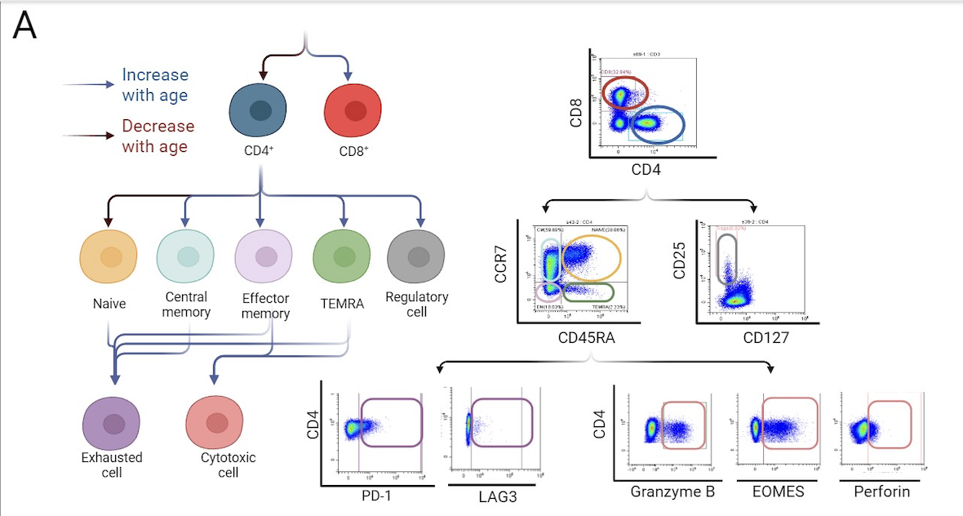

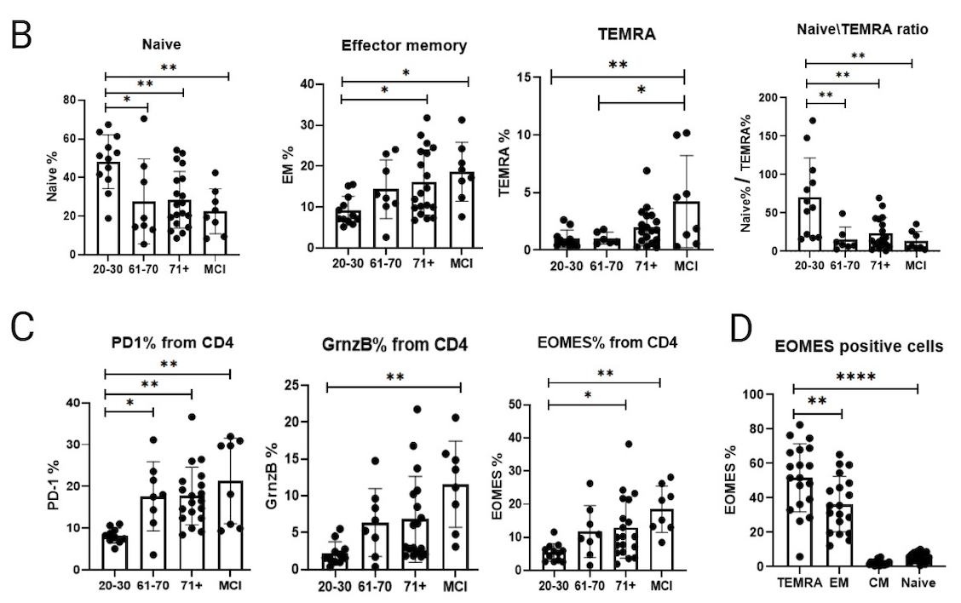

**Figure 6: Training a Random Forest classifier (Extra Trees, E-tree) with and without feature selection.** A Random Forest classifier (E-tree) with and without feature selection (FS) using 13 different feature selection algorithms (here we report the results of the Laplican Score (LS) FS algorithm) which was trained on a dataset that includes frequencies and absolute numbers of CD4 T cell subsets (n=34 features based on the flow cytometry panel shown in Fig. 5), cytokines (n=6 features), age, and sex from a cohort of healthy human individuals (N=58) and patients with MCI (N=22) to predict MCI status as a binary label. The average AUC (area under the curve) was computed using a 3-cross-validation (3CV) test. The graphs show the AUC as a function of sample size, comparing two approaches, one with feature selection (left panel) and the other without (right panel). Both graphs show two fits, a linear fit (blue line) and a logarithmic fit (red line), and mark the 85%, 90%, and 95% MCI performance thresholds. The black dots represent the performance with N=40, 50, 60, 70, and 80 samples, over which the line was fitted. Two conclusions are evident from the figures: 1) the performance with N=80 was 77% with FS, as compared to 65% without FS. The top selected features were related to cytotoxic (e.g., EOMES, GzmB) and exhausted (e.g., PD1, Lag3) CD4 T cell subsets (data not shown). The second conclusion lies in extrapolating the AUC performance as the sample size increases. A linear fit (blue) presents an optimistic estimate, and a logarithmic fit (yellow) assumes more rapid saturation. Feature selection significantly reduces the number of samples needed to reach high AUC thresholds above 90% or 95%, demonstrating the importance of ML techniques for improving model efficiency and accuracy.

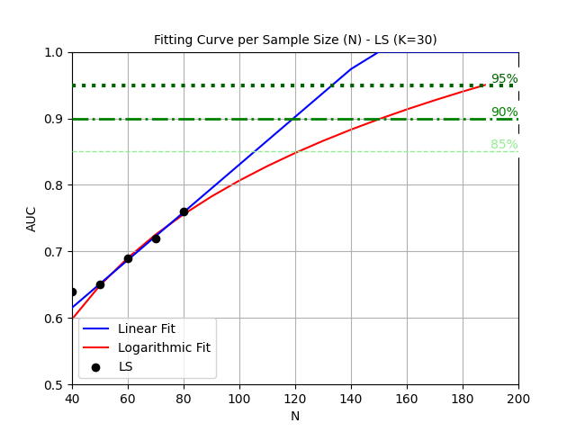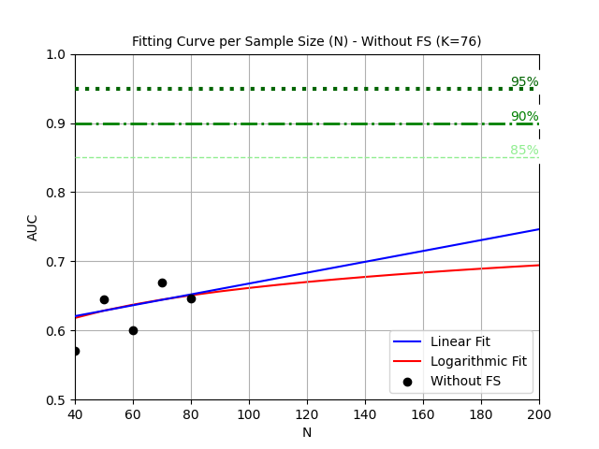

**Figure 7. Expansion and functional changes of CD4 CTLs in human older individuals and patients with MCI.** Blood samples were collected from young (21–28 years, n = 6), old (75–86 years, n = 6), and MCI (73–87 years, n = 8) individuals. Highly pure (96%) CD4 T cells were isolated and subjected to scRNA-seq using the 10X Genomics Chromium platform as we previously described (49, 88). The reads were processed into a raw counts matrix using CellRanger v6.0.1 (89) and cleaned with CellBender (90) to remove ambient RNA. Analysis was performed using Seurat v3.0 (91, 92), generating expression profiles for 38,308, 46,902, and 70,537 CD4 T cells from young, old, and MCI samples, respectively. **A.** CD4 T cell subsets were identified through principal component analysis (PCA)-based dimensionality reduction and k-nearest-neighbors (KNN, k=20) clustering. Doublets were removed using DoubletFinder (93), and samples from similar conditions were integrated using Harmony. Clusters were annotated based on differentially expressed markers identified with the Seurat FindAllMarkers function and CellTypist. Five main clusters of CD4 T cells emerged: (i) naïve, (ii) effector, (iii) regulatory (Tregs), (iv) naïve/effector intermediates, and (v) CTLs expressing the GNLY cytotoxic marker, shown in a UMAP plot as a distinct cluster. **B.** Representative bar plots showing the percentage of cells belonging to the CTL subset in young, old, and MCI individuals. **C.** The CTL subset exhibited distinct markers such as NKG7, CCL5, PRF1, CST7, KLRG1, and GzmB. Notably, GzmK was expressed only in CTL clusters from old or effector samples from MCI samples. In addition, CX3CR1 was expressed in both old and MCI CTLs and may indicate clusters homing to certain inflammatory sites. **D.** Differential expression analysis between CTLs from MCI vs old individuals using the Seurat FindMarkers function, identified increased expression of cytotoxic markers like GZMB, PRF1, and GNLY in MCI CTLs, while GZMK was elevated in old CTLs. The generated volcano plot displays genes with significant changes (avg_log2FC > 0.54, adjusted p < 0.05). **E.** To further characterize functional differences, gene set enrichment analysis (GSEA) with clusterProfiler (94) was conducted using upregulated genes from (**D**) against GO reference gene sets. The analysis revealed enrichment of protein synthesis processes in old CTLs, illustrated in a bar plot sorted by normalized enrichment score (NES) and including only significant processes (p.adjust < 0.05).

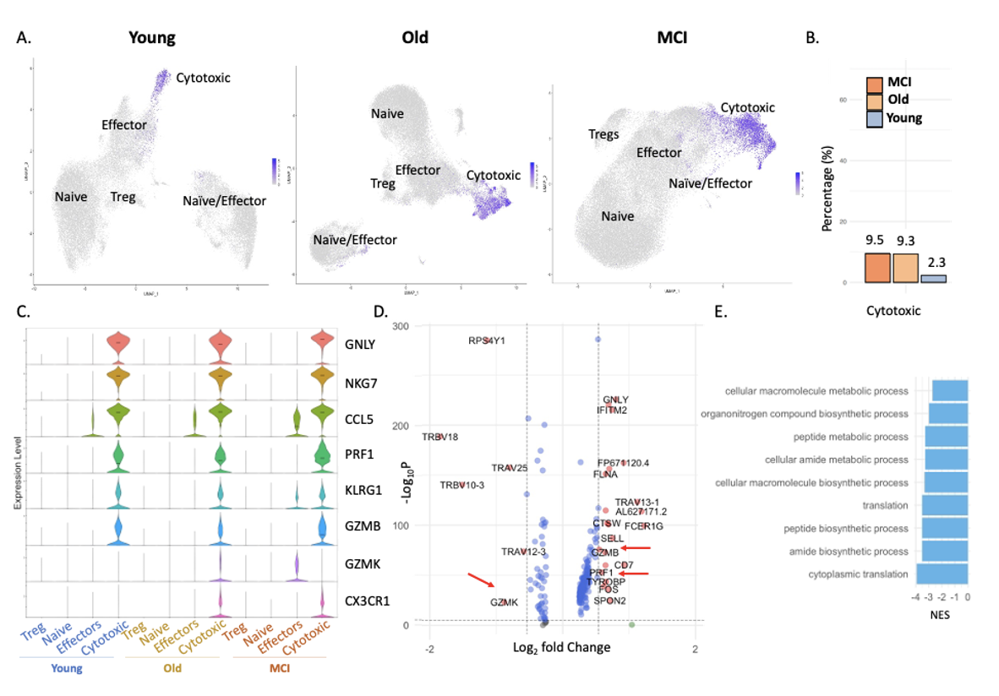

**REFERENCES:**

1. Lopez-Otin, C., M. A. Blasco, L. Partridge, M. Serrano, and G. Kroemer. 2013. The hallmarks of aging. *Cell* 153: 1194-1217.

2. Franceschi, C., P. Garagnani, P. Parini, C. Giuliani, and A. Santoro. 2018. Inflammaging: a new immune-metabolic viewpoint for age-related diseases. *Nat Rev Endocrinol* 14: 576-590.

3. Mittelbrunn, M., and G. Kroemer. 2021. Hallmarks of T cell aging. *Nat Immunol* 22: 687-698.

4. Lal, H., A. L. Cunningham, O. Godeaux, R. Chlibek, J. Diez-Domingo, S. J. Hwang, M. J. Levin, J. E. McElhaney, A. Poder, J. Puig-Barbera, T. Vesikari, D. Watanabe, L. Weckx, T. Zahaf, T. C. Heineman, and Z. O. E. S. Group. 2015. Efficacy of an adjuvanted herpes zoster subunit vaccine in older adults. *N Engl J Med* 372: 2087-2096.

5. Thompson, W. W., D. K. Shay, E. Weintraub, L. Brammer, N. Cox, L. J. Anderson, and K. Fukuda. 2003. Mortality associated with influenza and respiratory syncytial virus in the United States. *JAMA* 289: 179-186.

6. Furman, D., V. Jojic, B. Kidd, S. Shen-Orr, J. Price, J. Jarrell, T. Tse, H. Huang, P. Lund, H. T. Maecker, P. J. Utz, C. L. Dekker, D. Koller, and M. M. Davis. 2013. Apoptosis and other immune biomarkers predict influenza vaccine responsiveness. *Mol Syst Biol* 9: 659.

7. Shen-Orr, S. S., D. Furman, B. A. Kidd, F. Hadad, P. Lovelace, Y. W. Huang, Y. Rosenberg-Hasson, S. Mackey, F. A. Grisar, Y. Pickman, H. T. Maecker, Y. H. Chien, C. L. Dekker, J. C. Wu, A. J. Butte, and M. M. Davis. 2016. Defective Signaling in the JAK-STAT Pathway Tracks with Chronic Inflammation and Cardiovascular Risk in Aging Humans. *Cell Syst* 3: 374-384 e374.

8. Goronzy, J. J., and C. M. Weyand. 2013. Understanding immunosenescence to improve responses to vaccines. *Nat Immunol* 14: 428-436.

9. Montecino-Rodriguez, E., B. Berent-Maoz, and K. Dorshkind. 2013. Causes, consequences, and reversal of immune system aging. *J Clin Invest* 123: 958-965.

10. Pinti, M., V. Appay, J. Campisi, D. Frasca, T. Fulop, D. Sauce, A. Larbi, B. Weinberger, and A. Cossarizza. 2016. Aging of the immune system: Focus on inflammation and vaccination. *Eur J Immunol* 46: 2286-2301.

11. Alpert, A., Y. Pickman, M. Leipold, Y. Rosenberg-Hasson, X. Ji, R. Gaujoux, H. Rabani, E. Starosvetsky, K. Kveler, S. Schaffert, D. Furman, O. Caspi, U. Rosenschein, P. Khatri, C. L. Dekker, H. T. Maecker, M. M. Davis, and S. S. Shen-Orr. 2019. A clinically meaningful metric of immune age derived from high-dimensional longitudinal monitoring. *Nat Med* 25: 487-495.

12. Xu, W., J. Rustenhoven, C. A. Nelson, T. Dykstra, A. Ferreiro, Z. Papadopoulos, C. D. Burnham, G. Dantas, D. H. Fremont, and J. Kipnis. 2023. A novel immune modulator IM33 mediates a glia-gut-neuronal axis that controls lifespan. *Neuron* 111: 3244-3254 e3248.

13. Muraleedharan, A., N. Rotem-Dai, I. Strominger, N. P. Anto, N. Isakov, A. Monsonego, and E. Livneh. 2021. Protein kinase C eta is activated in reactive astrocytes of an Alzheimer's disease mouse model: Evidence for its immunoregulatory function in primary astrocytes. *Glia* 69: 697-714.

14. Leng, F., and P. Edison. 2021. Neuroinflammation and microglial activation in Alzheimer disease: where do we go from here? *Nat Rev Neurol* 17: 157-172.

15. Chen, M. B., A. C. Yang, H. Yousef, D. Lee, W. Chen, N. Schaum, B. Lehallier, S. R. Quake, and T. Wyss-Coray. 2020. Brain Endothelial Cells Are Exquisite Sensors of Age-Related Circulatory Cues. *Cell Rep* 30: 4418-4432 e4414.

16. Yang, A. C., R. T. Vest, F. Kern, D. P. Lee, M. Agam, C. A. Maat, P. M. Losada, M. B. Chen, N. Schaum, N. Khoury, A. Toland, K. Calcuttawala, H. Shin, R. Palovics, A. Shin, E. Y. Wang, J. Luo, D. Gate, W. J. Schulz-Schaeffer, P. Chu, J. A. Siegenthaler, M. W. McNerney, A. Keller, and T. Wyss-Coray. 2022. A human brain vascular atlas reveals diverse mediators of Alzheimer's risk. *Nature* 603: 885-892.

17. Senatorov, V. V., Jr., A. R. Friedman, D. Z. Milikovsky, J. Ofer, R. Saar-Ashkenazy, A. Charbash, N. Jahan, G. Chin, E. Mihaly, J. M. Lin, H. J. Ramsay, A. Moghbel, M. K. Preininger, C. R. Eddings, H. V. Harrison, R. Patel, Y. Shen, H. Ghanim, H. Sheng, R. Veksler, P. H. Sudmant, A. Becker, B. Hart, M. A. Rogawski, A. Dillin, A. Friedman, and D. Kaufer. 2019. Blood-brain barrier dysfunction in aging induces hyperactivation of TGFbeta signaling and chronic yet reversible neural dysfunction. *Sci Transl Med* 11.

18. Loscher, W., and A. Friedman. 2020. Structural, Molecular, and Functional Alterations of the Blood-Brain Barrier during Epileptogenesis and Epilepsy: A Cause, Consequence, or Both? *Int J Mol Sci* 21.

19. Delaney, C., M. Farrell, C. P. Doherty, K. Brennan, E. O'Keeffe, C. Greene, K. Byrne, E. Kelly, N. Birmingham, P. Hickey, S. Cronin, S. N. Savvides, S. L. Doyle, and M. Campbell. 2021. Attenuated CSF-1R signalling drives cerebrovascular pathology. *EMBO Mol Med* 13: e12889.

20. Gate, D., N. Saligrama, O. Leventhal, A. C. Yang, M. S. Unger, J. Middeldorp, K. Chen, B. Lehallier, D. Channappa, M. B. De Los Santos, A. McBride, J. Pluvinage, F. Elahi, G. K. Tam, Y. Kim, M. Greicius, A. D. Wagner, L. Aigner, D. R. Galasko, M. M. Davis, and T. Wyss-Coray. 2020. Clonally expanded CD8 T cells patrol the cerebrospinal fluid in Alzheimer's disease. *Nature* 577: 399-404.

21. Bettcher, B. M., M. G. Tansey, G. Dorothee, and M. T. Heneka. 2021. Peripheral and central immune system crosstalk in Alzheimer disease - a research prospectus. *Nat Rev Neurol* 17: 689-701.

22. Stym-Popper, G., K. Matta, T. Chaigneau, R. Rupra, A. Demetriou, S. Fouquet, C. Dansokho, C. Toly-Ndour, and G. Dorothee. 2023. Regulatory T cells decrease C3-positive reactive astrocytes in Alzheimer-like pathology. *J Neuroinflammation* 20: 64.

23. Ardura-Fabregat, A., E. Boddeke, A. Boza-Serrano, S. Brioschi, S. Castro-Gomez, K. Ceyzeriat, C. Dansokho, T. Dierkes, G. Gelders, M. T. Heneka, L. Hoeijmakers, A. Hoffmann, L. Iaccarino, S. Jahnert, K. Kuhbandner, G. Landreth, N. Lonnemann, P. A. Loschmann, R. M. McManus, A. Paulus, K. Reemst, J. M. Sanchez-Caro, A. Tiberi, A. Van der Perren, A. Vautheny, C. Venegas, A. Webers, P. Weydt, T. S. Wijasa, X. Xiang, and Y. Yang. 2017. Targeting Neuroinflammation to Treat Alzheimer's Disease. *CNS Drugs* 31: 1057-1082.

24. Pascoal, T. A., A. L. Benedet, N. J. Ashton, M. S. Kang, J. Therriault, M. Chamoun, M. Savard, F. Z. Lussier, C. Tissot, T. K. Karikari, J. Ottoy, S. Mathotaarachchi, J. Stevenson, G. Massarweh, M. Scholl, M. J. de Leon, J. P. Soucy, P. Edison, K. Blennow, H. Zetterberg, S. Gauthier, and P. Rosa-Neto. 2021. Microglial activation and tau propagate jointly across Braak stages. *Nat Med* 27: 1592-1599.

25. Ising, C., C. Venegas, S. Zhang, H. Scheiblich, S. V. Schmidt, A. Vieira-Saecker, S. Schwartz, S. Albasset, R. M. McManus, D. Tejera, A. Griep, F. Santarelli, F. Brosseron, S. Opitz, J. Stunden, M. Merten, R. Kayed, D. T. Golenbock, D. Blum, E. Latz, L. Buee, and M. T. Heneka. 2019. NLRP3 inflammasome activation drives tau pathology. *Nature* 575: 669-673.

26. Puntener, U., S. G. Booth, V. H. Perry, and J. L. Teeling. 2012. Long-term impact of systemic bacterial infection on the cerebral vasculature and microglia. *J Neuroinflammation* 9: 146.

27. Oki, S. 2019. Eomes-expressing T-helper cells as potential target of therapy in chronic neuroinflammation. *Neurochem Int* 130: 104348.

28. Heneka, M. T., M. J. Carson, J. El Khoury, G. E. Landreth, F. Brosseron, D. L. Feinstein, A. H. Jacobs, T. Wyss-Coray, J. Vitorica, R. M. Ransohoff, K. Herrup, S. A. Frautschy, B. Finsen, G. C. Brown, A. Verkhratsky, K. Yamanaka, J. Koistinaho, E. Latz, A. Halle, G. C. Petzold, T. Town, D. Morgan, M. L. Shinohara, V. H. Perry, C. Holmes, N. G. Bazan, D. J. Brooks, S. Hunot, B. Joseph, N. Deigendesch, O. Garaschuk, E. Boddeke, C. A. Dinarello, J. C. Breitner, G. M. Cole, D. T. Golenbock, and M. P. Kummer. 2015. Neuroinflammation in Alzheimer's disease. *Lancet Neurol* 14: 388-405.

29. Perry, V. H., and C. Holmes. 2014. Microglial priming in neurodegenerative disease. *Nat Rev Neurol* 10: 217-224.

30. Wohleb, E. S., T. Franklin, M. Iwata, and R. S. Duman. 2016. Integrating neuroimmune systems in the neurobiology of depression. *Nat Rev Neurosci* 17: 497-511.

31. Croese, T., G. Castellani, and M. Schwartz. 2021. Immune cell compartmentalization for brain surveillance and protection. *Nat Immunol* 22: 1083-1092.

32. Keren-Shaul, H., A. Spinrad, A. Weiner, O. Matcovitch-Natan, R. Dvir-Szternfeld, T. K. Ulland, E. David, K. Baruch, D. Lara-Astaiso, B. Toth, S. Itzkovitz, M. Colonna, M. Schwartz, and I. Amit. 2017. A Unique Microglia Type Associated with Restricting Development of Alzheimer's Disease. *Cell* 169: 1276-1290 e1217.

33. Bussian, T. J., A. Aziz, C. F. Meyer, B. L. Swenson, J. M. van Deursen, and D. J. Baker. 2018. Clearance of senescent glial cells prevents tau-dependent pathology and cognitive decline. *Nature* 562: 578-582.

34. Franceschi, C., M. Bonafe, S. Valensin, F. Olivieri, M. De Luca, E. Ottaviani, and G. De Benedictis. 2000. Inflamm-aging. An evolutionary perspective on immunosenescence. *Ann N Y Acad Sci* 908: 244-254.

35. Pawelec, G., D. Goldeck, and E. Derhovanessian. 2014. Inflammation, ageing and chronic disease. *Curr Opin Immunol* 29: 23-28.

36. Sarkar, D., and P. B. Fisher. 2006. Molecular mechanisms of aging-associated inflammation. *Cancer Lett* 236: 13-23.

37. Biran, A., L. Zada, P. Abou Karam, E. Vadai, L. Roitman, Y. Ovadya, Z. Porat, and V. Krizhanovsky. 2017. Quantitative identification of senescent cells in aging and disease. *Aging Cell* 16: 661-671.

38. Straub, R. H., and C. Schradin. 2016. Chronic inflammatory systemic diseases: An evolutionary trade-off between acutely beneficial but chronically harmful programs. *Evol Med Public Health* 2016: 37-51.

39. de Souza, R. G., C. S. de Paiva, and M. R. Alves. 2019. Age-related Autoimmune Changes in Lacrimal Glands. *Immune Netw* 19: e3.

40. Bai, W., P. Chen, H. Cai, Q. Zhang, Z. Su, T. Cheung, T. Jackson, S. Sha, and Y. T. Xiang. 2022. Worldwide prevalence of mild cognitive impairment among community dwellers aged 50 years and older: a meta-analysis and systematic review of epidemiology studies. *Age Ageing* 51.

41. Moro-Garcia, M. A., R. Alonso-Arias, and C. Lopez-Larrea. 2013. When Aging Reaches CD4+ T-Cells: Phenotypic and Functional Changes. *Front Immunol* 4: 107.

42. Linton, P. J., and K. Dorshkind. 2004. Age-related changes in lymphocyte development and function. *Nat Immunol* 5: 133-139.

43. Terekhova, M., A. Swain, P. Bohacova, E. Aladyeva, L. Arthur, A. Laha, D. A. Mogilenko, S. Burdess, V. Sukhov, D. Kleverov, B. Echalar, P. Tsurinov, R. Chernyatchik, K. Husarcikova, and M. N. Artyomov. 2023. Single-cell atlas of healthy human blood unveils age-related loss of NKG2C(+)GZMB(-)CD8(+) memory T cells and accumulation of type 2 memory T cells. *Immunity*.

44. Thomson, Z., Z. He, E. Swanson, K. Henderson, C. Phalen, S. R. Zaim, M. P. Pebworth, L. Y. Okada, A. T. Heubeck, C. R. Roll, V. Hernandez, M. Weiss, P. C. Genge, J. Reading, J. R. Giles, S. Manne, J. Dougherty, C. J. Jasen, A. R. Greenplate, L. A. Becker, L. T. Graybuck, S. V. Vasaikar, G. L. Szeto, A. K. Savage, C. Speake, J. H. Buckner, X. J. Li, T. F. Bumol, E. J. Wherry, T. R. Torgerson, L. A. Vella, S. E. Henrickson, P. J. Skene, and C. E. Gustafson. 2023. Trimodal single-cell profiling reveals a novel pediatric CD8alphaalpha(+) T cell subset and broad age-related molecular reprogramming across the T cell compartment. *Nat Immunol* 24: 1947-1959.

45. Nikolich-Zugich, J. 2018. The twilight of immunity: emerging concepts in aging of the immune system. *Nat Immunol* 19: 10-19.

46. Rodier, F., J. P. Coppe, C. K. Patil, W. A. Hoeijmakers, D. P. Munoz, S. R. Raza, A. Freund, E. Campeau, A. R. Davalos, and J. Campisi. 2009. Persistent DNA damage signalling triggers senescence-associated inflammatory cytokine secretion. *Nat Cell Biol* 11: 973-979.

47. Sage, P. T., C. L. Tan, G. J. Freeman, M. Haigis, and A. H. Sharpe. 2015. Defective TFH Cell Function and Increased TFR Cells Contribute to Defective Antibody Production in Aging. *Cell Rep* 12: 163-171.

48. Desdin-Mico, G., G. Soto-Heredero, J. F. Aranda, J. Oller, E. Carrasco, E. Gabande-Rodriguez, E. M. Blanco, A. Alfranca, L. Cusso, M. Desco, B. Ibanez, A. R. Gortazar, P. Fernandez-Marcos, M. N. Navarro, B. Hernaez, A. Alcami, F. Baixauli, and M. Mittelbrunn. 2020. T cells with dysfunctional mitochondria induce multimorbidity and premature senescence. *Science* 368: 1371-1376.

49. Elyahu, Y., I. Hekselman, I. Eizenberg-Magar, O. Berner, I. Strominger, M. Schiller, K. Mittal, A. Nemirovsky, E. Eremenko, A. Vital, E. Simonovsky, V. Chalifa-Caspi, N. Friedman, E. Yeger-Lotem, and A. Monsonego. 2019. Aging promotes reorganization of the CD4 T cell landscape toward extreme regulatory and effector phenotypes. *Sci Adv* 5: eaaw8330.

50. Elyahu, Y., and A. Monsonego. 2021. Thymus involution sets the clock of the aging T-cell landscape: Implications for declined immunity and tissue repair. *Ageing Res Rev* 65: 101231.

51. Elyahu Y. et al., a. A. M. 2024. CD4 T Cells Acquire Cytotoxic Properties to Modulate Cellular Senescence and Aging. *BioRxiv*.

52. Mucida, D., M. M. Husain, S. Muroi, F. van Wijk, R. Shinnakasu, Y. Naoe, B. S. Reis, Y. Huang, F. Lambolez, M. Docherty, A. Attinger, J. W. Shui, G. Kim, C. J. Lena, S. Sakaguchi, C. Miyamoto, P. Wang, K. Atarashi, Y. Park, T. Nakayama, K. Honda, W. Ellmeier, M. Kronenberg, I. Taniuchi, and H. Cheroutre. 2013. Transcriptional reprogramming of mature CD4(+) helper T cells generates distinct MHC class II-restricted cytotoxic T lymphocytes. *Nat Immunol* 14: 281-289.

53. Reis, B. S., A. Rogoz, F. A. Costa-Pinto, I. Taniuchi, and D. Mucida. 2013. Mutual expression of the transcription factors Runx3 and ThPOK regulates intestinal CD4(+) T cell immunity. *Nat Immunol* 14: 271-280.

54. Quezada, S. A., T. R. Simpson, K. S. Peggs, T. Merghoub, J. Vider, X. Fan, R. Blasberg, H. Yagita, P. Muranski, P. A. Antony, N. P. Restifo, and J. P. Allison. 2010. Tumor-reactive CD4(+) T cells develop cytotoxic activity and eradicate large established melanoma after transfer into lymphopenic hosts. *J Exp Med* 207: 637-650.

55. Raveney, B. J., S. Oki, H. Hohjoh, M. Nakamura, W. Sato, M. Murata, and T. Yamamura. 2015. Eomesodermin-expressing T-helper cells are essential for chronic neuroinflammation. *Nat Commun* 6: 8437.

56. Zhang, C., B. J. E. Raveney, H. Hohjoh, C. Tomi, S. Oki, and T. Yamamura. 2019. Extrapituitary prolactin promotes generation of Eomes-positive helper T cells mediating neuroinflammation. *Proc Natl Acad Sci U S A* 116: 21131-21139.

57. Patil, V. S., A. Madrigal, B. J. Schmiedel, J. Clarke, P. O'Rourke, A. D. de Silva, E. Harris, B. Peters, G. Seumois, D. Weiskopf, A. Sette, and P. Vijayanand. 2018. Precursors of human CD4(+) cytotoxic T lymphocytes identified by single-cell transcriptome analysis. *Sci Immunol* 3.

58. Juno, J. A., D. van Bockel, S. J. Kent, A. D. Kelleher, J. J. Zaunders, and C. M. Munier. 2017. Cytotoxic CD4 T Cells-Friend or Foe during Viral Infection? *Front Immunol* 8: 19.

59. Takeuchi, A., S. Badr Mel, K. Miyauchi, C. Ishihara, R. Onishi, Z. Guo, Y. Sasaki, H. Ike, A. Takumi, N. M. Tsuji, Y. Murakami, T. Katakai, M. Kubo, and T. Saito. 2016. CRTAM determines the CD4+ cytotoxic T lymphocyte lineage. *J Exp Med* 213: 123-138.

60. Levin, M. J. 2012. Immune senescence and vaccines to prevent herpes zoster in older persons. *Curr Opin Immunol* 24: 494-500.

61. Kaneko, N., J. Boucau, H. H. Kuo, C. Perugino, V. S. Mahajan, J. R. Farmer, H. Liu, T. J. Diefenbach, A. Piechocka-Trocha, K. Lefteri, M. T. Waring, K. R. Premo, B. D. Walker, J. Z. Li, G. Gaiha, X. G. Yu, M. Lichterfeld, R. F. Padera, Jr., and S. Pillai. 2022. Temporal changes in T cell subsets and expansion of cytotoxic CD4+ T cells in the lungs in severe COVID-19. *Clin Immunol* 237: 108991.

62. Hasegawa, T., T. Oka, H. G. Son, V. S. Oliver-Garcia, M. Azin, T. M. Eisenhaure, D. J. Lieb, N. Hacohen, and S. Demehri. 2023. Cytotoxic CD4(+) T cells eliminate senescent cells by targeting cytomegalovirus antigen. *Cell* 186: 1417-1431 e1420.

63. Hashimoto, K., T. Kouno, T. Ikawa, N. Hayatsu, Y. Miyajima, H. Yabukami, T. Terooatea, T. Sasaki, T. Suzuki, M. Valentine, G. Pascarella, Y. Okazaki, H. Suzuki, J. W. Shin, A. Minoda, I. Taniuchi, H. Okano, Y. Arai, N. Hirose, and P. Carninci. 2019. Single-cell transcriptomics reveals expansion of cytotoxic CD4 T cells in supercentenarians. *Proc Natl Acad Sci U S A*.

64. Harpaz, I., U. Bhattacharya, Y. Elyahu, I. Strominger, and A. Monsonego. 2017. Old Mice Accumulate Activated Effector CD4 T Cells Refractory to Regulatory T Cell-Induced Immunosuppression. *Front Immunol* 8: 283.

65. Zheng, C., L. Zheng, J. K. Yoo, H. Guo, Y. Zhang, X. Guo, B. Kang, R. Hu, J. Y. Huang, Q. Zhang, Z. Liu, M. Dong, X. Hu, W. Ouyang, J. Peng, and Z. Zhang. 2017. Landscape of Infiltrating T Cells in Liver Cancer Revealed by Single-Cell Sequencing. *Cell* 169: 1342-1356 e1316.

66. Carrasco, E., M. M. Gomez de Las Heras, E. Gabande-Rodriguez, G. Desdin-Mico, J. F. Aranda, and M. Mittelbrunn. 2022. The role of T cells in age-related diseases. *Nat Rev Immunol* 22: 97-111.

67. Joulia, E., M. F. Michieletto, A. Agesta, C. Peillex, V. Girault, A. L. Le Dorze, R. Peroceschi, F. Bucciarelli, M. Szelechowski, A. Chaubet, N. Hakim, R. Marrocco, E. Lhuillier, M. Lebeurrier, R. J. Arguello, A. Saoudi, H. El Costa, V. Adoue, T. Walzer, J. E. Sarry, and A. S. Dejean. 2024. Eomes-dependent mitochondrial regulation promotes survival of pathogenic CD4+ T cells during inflammation. *J Exp Med* 221.

68. Baruch, K., A. Deczkowska, N. Rosenzweig, A. Tsitsou-Kampeli, A. M. Sharif, O. Matcovitch-Natan, A. Kertser, E. David, I. Amit, and M. Schwartz. 2016. PD-1 immune checkpoint blockade reduces pathology and improves memory in mouse models of Alzheimer's disease. *Nat Med* 22: 135-137.

69. Goldeck, D., J. M. Witkowski, T. Fulop, and G. Pawelec. 2016. Peripheral Immune Signatures in Alzheimer Disease. *Curr Alzheimer Res* 13: 739-749.

70. Chen, X., M. Firulyova, M. Manis, J. Herz, I. Smirnov, E. Aladyeva, C. Wang, X. Bao, M. B. Finn, H. Hu, I. Shchukina, M. W. Kim, C. M. Yuede, J. Kipnis, M. N. Artyomov, J. D. Ulrich, and D. M. Holtzman. 2023. Microglia-mediated T cell infiltration drives neurodegeneration in tauopathy. *Nature* 615: 668-677.

71. Grabrucker, S., M. Marizzoni, E. Silajdzic, N. Lopizzo, E. Mombelli, S. Nicolas, S. Dohm-Hansen, C. Scassellati, D. V. Moretti, M. Rosa, K. Hoffmann, J. F. Cryan, O. F. O'Leary, J. A. English, A. Lavelle, C. O'Neill, S. Thuret, A. Cattaneo, and Y. M. Nolan. 2023. Microbiota from Alzheimer's patients induce deficits in cognition and hippocampal neurogenesis. *Brain*.

72. Piehl, N., L. van Olst, A. Ramakrishnan, V. Teregulova, B. Simonton, Z. Zhang, E. Tapp, D. Channappa, H. Oh, P. M. Losada, J. Rutledge, A. N. Trelle, E. C. Mormino, F. Elahi, D. R. Galasko, V. W. Henderson, A. D. Wagner, T. Wyss-Coray, and D. Gate. 2022. Cerebrospinal fluid immune dysregulation during healthy brain aging and cognitive impairment. *Cell* 185: 5028-5039 e5013.

73. Su, W., J. Saravia, I. Risch, S. Rankin, C. Guy, N. M. Chapman, H. Shi, Y. Sun, A. Kc, W. Li, H. Huang, S. A. Lim, H. Hu, Y. Wang, D. Liu, Y. Jiao, P. C. Chen, H. Soliman, K. K. Yan, J. Zhang, P. Vogel, X. Liu, G. E. Serrano, T. G. Beach, J. Yu, J. Peng, and H. Chi. 2023. CXCR6 orchestrates brain CD8(+) T cell residency and limits mouse Alzheimer's disease pathology. *Nat Immunol* 24: 1735-1747.

74. Zhang, H., R. R. Jadhav, W. Cao, I. N. Goronzy, T. V. Zhao, J. Jin, S. Ohtsuki, Z. Hu, J. Morales, W. J. Greenleaf, C. M. Weyand, and J. J. Goronzy. 2023. Aging-associated HELIOS deficiency in naive CD4(+) T cells alters chromatin remodeling and promotes effector cell responses. *Nat Immunol* 24: 96-109.

75. Mitchell, A. J., and M. Shiri-Feshki. 2009. Rate of progression of mild cognitive impairment to dementia--meta-analysis of 41 robust inception cohort studies. *Acta Psychiatr Scand* 119: 252-265.

76. Lin, S. Y., P. C. Lin, Y. C. Lin, Y. J. Lee, C. Y. Wang, S. W. Peng, and P. N. Wang. 2022. The Clinical Course of Early and Late Mild Cognitive Impairment. *Front Neurol* 13: 685636.

77. Dwolatzky, T., V. Whitehead, G. M. Doniger, E. S. Simon, A. Schweiger, D. Jaffe, and H. Chertkow. 2003. Validity of a novel computerized cognitive battery for mild cognitive impairment. *BMC Geriatr* 3: 4.

78. Nasreddine, Z. S., N. A. Phillips, V. Bedirian, S. Charbonneau, V. Whitehead, I. Collin, J. L. Cummings, and H. Chertkow. 2005. The Montreal Cognitive Assessment, MoCA: a brief screening tool for mild cognitive impairment. *J Am Geriatr Soc* 53: 695-699.

79. Lifshitz, M., T. Dwolatzky, and Y. Press. 2012. Validation of the Hebrew version of the MoCA test as a screening instrument for the early detection of mild cognitive impairment in elderly individuals. *J Geriatr Psychiatry Neurol* 25: 155-161.

80. Freud, T., A. Vostrikov, T. Dwolatzky, B. Punchik, and Y. Press. 2020. Validation of the Russian Version of the MoCA Test as a Cognitive Screening Instrument in Cognitively Asymptomatic Older Individuals and Those With Mild Cognitive Impairment. *Front Med (Lausanne)* 7: 447.

81. Mahoney, F. I., and D. W. Barthel. 1965. Functional Evaluation: The Barthel Index. *Md State Med J* 14: 61-65.

82. Doble, P., M. Macka, and P. R. Haddad. 1998. Factors influencing the choice of buffer in background electrolytes for indirect detection of fast anions by capillary electrophoresis. *Electrophoresis* 19: 2257-2261.

83. Fried, L. P., C. M. Tangen, J. Walston, A. B. Newman, C. Hirsch, J. Gottdiener, T. Seeman, R. Tracy, W. J. Kop, G. Burke, M. A. McBurnie, and G. Cardiovascular Health Study Collaborative Research. 2001. Frailty in older adults: evidence for a phenotype. *J Gerontol A Biol Sci Med Sci* 56: M146-156.

84. Ensrud, K. E., S. K. Ewing, B. C. Taylor, H. A. Fink, P. M. Cawthon, K. L. Stone, T. A. Hillier, J. A. Cauley, M. C. Hochberg, N. Rodondi, J. K. Tracy, and S. R. Cummings. 2008. Comparison of 2 frailty indexes for prediction of falls, disability, fractures, and death in older women. *Arch Intern Med* 168: 382-389.

85. Mexhitaj, I., M. H. Nyirenda, R. Li, J. O'Mahony, A. Rezk, A. Rozenberg, C. S. Moore, T. Johnson, D. Sadovnick, D. L. Collins, D. L. Arnold, B. Gran, E. A. Yeh, R. A. Marrie, B. Banwell, and A. Bar-Or. 2019. Abnormal effector and regulatory T cell subsets in paediatric-onset multiple sclerosis. *Brain* 142: 617-632.

86. Eremenko, E., K. Mittal, O. Berner, N. Kamenetsky, A. Nemirovsky, Y. Elyahu, and A. Monsonego. 2019. BDNF-producing, amyloid beta-specific CD4 T cells as targeted drug-delivery vehicles in Alzheimer's disease. *EBioMedicine* 43: 424-434.

87. Mittal, K., E. Eremenko, O. Berner, Y. Elyahu, I. Strominger, D. Apelblat, A. Nemirovsky, I. Spiegel, and A. Monsonego. 2019. CD4 T Cells Induce A Subset of MHCII-Expressing Microglia that Attenuates Alzheimer Pathology. *iScience* 16: 298-311.

88. Or Lazarescu, M. Z.-A., Yulia Haim, Idan Hekselman, Juman Jubran, Ariel Shneyour, Danny Kitsberg, Liron Levin, Idit F Liberty, Uri Yoel, Oleg Dukhno, Miriam Adam, Antje Körner, Rinki Murphy, Matthias Blüher, Naomi Habib, Assaf Rudich, Esti Yeger-Lotem. 2023. Human subcutaneous and visceral adipocyte atlases uncover classical and specialized adipocytes and depot-specific patterns. *BioRxiv*.

89. Zheng, G. X., J. M. Terry, P. Belgrader, P. Ryvkin, Z. W. Bent, R. Wilson, S. B. Ziraldo, T. D. Wheeler, G. P. McDermott, J. Zhu, M. T. Gregory, J. Shuga, L. Montesclaros, J. G. Underwood, D. A. Masquelier, S. Y. Nishimura, M. Schnall-Levin, P. W. Wyatt, C. M. Hindson, R. Bharadwaj, A. Wong, K. D. Ness, L. W. Beppu, H. J. Deeg, C. McFarland, K. R. Loeb, W. J. Valente, N. G. Ericson, E. A. Stevens, J. P. Radich, T. S. Mikkelsen, B. J. Hindson, and J. H. Bielas. 2017. Massively parallel digital transcriptional profiling of single cells. *Nat Commun* 8: 14049.

90. Fleming, S. J., M. D. Chaffin, A. Arduini, A. D. Akkad, E. Banks, J. C. Marioni, A. A. Philippakis, P. T. Ellinor, and M. Babadi. 2023. Unsupervised removal of systematic background noise from droplet-based single-cell experiments using CellBender. *Nat Methods* 20: 1323-1335.

91. Butler, A., P. Hoffman, P. Smibert, E. Papalexi, and R. Satija. 2018. Integrating single-cell transcriptomic data across different conditions, technologies, and species. *Nat Biotechnol* 36: 411-420.

92. Stuart, T., A. Butler, P. Hoffman, C. Hafemeister, E. Papalexi, W. M. Mauck, 3rd, Y. Hao, M. Stoeckius, P. Smibert, and R. Satija. 2019. Comprehensive Integration of Single-Cell Data. *Cell* 177: 1888-1902 e1821.

93. McGinnis, C. S., L. M. Murrow, and Z. J. Gartner. 2019. DoubletFinder: Doublet Detection in Single-Cell RNA Sequencing Data Using Artificial Nearest Neighbors. *Cell Syst* 8: 329-337 e324.

94. Wu, T., E. Hu, S. Xu, M. Chen, P. Guo, Z. Dai, T. Feng, L. Zhou, W. Tang, L. Zhan, X. Fu, S. Liu, X. Bo, and G. Yu. 2021. clusterProfiler 4.0: A universal enrichment tool for interpreting omics data. *Innovation (Camb)* 2: 100141.