**Mind your body: Attention as a regulator of biological-metabolic processes**

Our minds can exert a powerful influence over our bodies’ physiology. Research on placebo effects demonstrates that people’s beliefs about treatment trigger measurable neurobiological responses, which lead to relief in symptoms and improved health. Despite findings indicating the striking ability of the mind to regulate concurrent biological processes, studies rarely explore mind-body interactions as they influence daily human functioning. This proposed project offers a paradigm shift by: (i) studying influences of mind on bodily processes in daily situations, without sham drugs or treatments, and (ii) elucidating the biological mechanisms underlying these influences, in real-time and longitudinally. Specifically, it builds on evidence pointing to attention as a key mediator of the influence of mind over body, and tests whether attention regulates biological responses to everyday actions, such as eating and exercising. Our overarching hypothesis is that eating or exercising distractedly (or *mindlessly*) versus attentively (or *mindfully*) interferes with biological-metabolic processes and influences the brain regions that govern them. To test this hypothesis, we will conduct both cross-over and intervention studies, assessing behavioral, physiological, hormonal and metabolic measures. Our specific aims are as follows:

* **Aim** **1** tests potential differences in real-time biological-metabolic processes driven by attention. Employing a within-participants cross-over study design, participants will eat the same food (Aim 1.1) or perform the same physical effort (Aim 1.2) while their attention is being manipulated. They will either be attentive to their body and the action it performs (*mindful* condition), distracted by TV viewing (*mindless* condition), or asked to act as usual (*neutral* condition). Outcome measures include levels of appetite-regulating hormones, energy devoted to food digestion, self-reported hunger and satiety (Aim 1.1), and oxygen consumption by the muscles, energy expenditure, and self-reported effort (Aim 1.2).
* **Aim** **2** seeks to understand the longitudinal mechanisms governing mind-body influence. Two interventional randomized-controlled studies will be conducted (Aim 2.1, eating; Aim 2.2, exercising) with participants assigned to practice *mindful* or *mindless* eating or exercising for a period of four weeks. Outcome measures include assessments of changes in functional connectivity of related brain regions (i.e., hypothalamus and insula), body composition (fat and muscle mass), and the relationship between them.

Our proposed project will provide, for the first time, a systematic examination of the biological mechanisms underlying mind-body interactions in everyday situations. The results have the potential to elucidate underlying attention-induced biological mechanisms and to expand our understanding of the human brain and mind as it contributes to physical health.

**Mind your body: attention as a regulator of biological-metabolic processes**

**Scientific Background**

Research extending from at least 19331 has demonstrated that our minds can exert a powerful influence over our bodies’ physiology. Much of this understanding emerges from studies of the placebo effect. However, despite accumulating evidence regarding the influence of mind on body, research into the biological mechanisms of mind-body influences has remained largely limited to classic placebo research, where the focus is on the relief of negative symptoms using a sham treatment. Below we integrate evidence suggesting that such mind-body influences exist in daily situations as well. This project sets out to apply principles from placebo research outside classic placebo settings, and examine the influence of the mind, operationalized by attention, on the body in daily situations, and its biological underpinnings.

Research on the placebo effect has demonstrated robust mind-body interactions. For example, the mere expectation of pain relief following a drug’s administration, even when the drug is inert, can lead to a genuine physiological reduction in pain. One underlying mechanism for this response is the release of endogenous opioids in the brain, which then block spinal pain-transmitting neurons, thus mimicking the effect of real painkillers2,3. This potent effect has been observed in various conditions, such as acute postoperative pain4, chronic low back pain5 and irritable bowel syndrome6. Placebo effects have also been demonstrated in various disorders and conditions, with different downstream placebo-induced mechanisms underlying different placebo effects7,8. Examples range from psychiatric disorders such as depression9 and anxiety10, to neurologic disorders such as Parkinson’s disease11, to physical conditions such as coronary artery disease12, nausea13, and inflammatory skin reactions14, including itch15. **Together, these studies indicate that expectations and beliefs regarding treatment can induce concurrent neurobiological responses, leading to physiological improvement in symptoms.**

The placebo effect has also clearly been documented when an *active* drug is administered. For example, when opiates were administered to post-operative patients without their attention (via an existing intravenous line), they needed up to 50% higher dosage and for a longer period of time than when they were told it was being administered4. The same effect was observed in healthy participants in whom acute pain had been induced4,16. Similar effects of reduced treatment efficacy when it was performed covertly versus overtly were demonstrated in anti-anxiety drugs4,17 and deep-brain stimulation for Parkinson’s patients17,18. Underlying mechanisms include the release of endogenous opioids16, and activation of the autonomic nervous system18. **These findings, indicating that attention can substantially influence a drug's efficacy, provide further evidence not only that attention plays a key role in activating the placebo effect, but that attention – hereafter referred to as a mental state ranging from “mindful” to “mindless” – may more generally be a key facilitator of mind-body influences.**

The notion that attention may facilitate mind-body influences is further supported by studies exploring mind-body interventions focusing on eating and exercising. Several longitudinal studies show that performing daily physiological activities while being mindful of them leads to advantageous results over the course of several weeks relative to performing the same activities mindlessly. For example, mindful eating - an increasingly popular intervention that encourages people to eat while being more attentive to the food and to their bodily sensations - has repeatedly been found, over a period of several weeks to months, to effectively reduce binge eating and cravings, to reduce body weight, or to prevent weight gain in both normal weight19,20 and obese individuals21,22. While several behavioral explanations have been suggested, such as eating more when distracted, other studies show that mindful eating induces more satiety than mindless eating even when meal size was kept constant23,24, suggesting the involvement of biological mechanisms influencing satiety. Similarly, routinely performing physical activity as part of one’s occupation (e.g., hotel housekeeping) when mindful of the activity’s potential positive influences on physical health and body weight was found to significantly improve objective physiological measures such as body-mass index (BMI), fat percentage and blood pressure over the course of several weeks, relative to performing the very same activity mindlessly25. **These studies suggest that attention may inform biological-metabolic processes revolving around food consumption and energy expenditure, which may in turn affect physical health and well-being.**

**Critically, the possibility that attention may influence *concurrent, real-time* biological-metabolic processes that regulate satiety or performance has not been studied, to the best of our knowledge, outside placebo studies described above.** Nevertheless, studies that manipulate beliefs and expectations about food and exercise reveal that real-time effects of such manipulations on satiety and performance, respectively, are feasible. For example, several studies that manipulated participants’ expectations about the caloric value of the food they consumed found that consuming a food labeled as lower in fat or calories reduced participants’ reported satiety (compared to the same food under a different label), and led to increased meal size in the subsequent meal26–29. Another study investigating the biological underpinning of this effect, found that consuming the same food when believing it is low in fat and calories versus high, resulted in a higher secretion of the hunger-regulating hormone Ghrelin following consumption30, indicating a top-down effect on the brain-gut axis. Among professional athletes, administration of placebo, for example through the ingestion of an inert substance said to be an ergogenic aid, has been shown to have multiple, well-documented beneficial effects on both subjective and objective performance, from weightlifting to endurance cycling31. For example, administration of placebo when expecting to receive caffeine, which is known for its ergogenic effect, induces a dose-dependent improvement in power produced during cycling32, and increase of power and reduction in muscle fatigue during quadriceps muscle performance33. While little is known about the underlying mechanisms of placebo in sports34, two suggested mechanism include the release of dopamine following placebo-caffeine administration35, hypothesized to reduce muscle fatigue34, and increased pain endurance during exercise due to an opioid-mediated conditioned placebo responses36.

**Finally, the hypothesis that attention regulates biological-metabolic processes has theoretical foundations in predictive frameworks of brain function.** Such frameworks generally pose that the brain actively generates predictions of the input it is likely to encounter, and these predictions then guide perception and inform behavior37,38. At first, these frameworks are mostly applied in the sensory domain, but extensions soon followed. One extension argued that metabolic processes are regulated by the brain’s predictions of expected input39. In my postdoc I suggested that *high-order predictions* generated by the mind (e.g., beliefs, mindsets) also act to influence perception (i.e., information processing40–42 and symptom perception43,44), and ultimately affect our health. As attention is suggested to regulate the balance between sensory predictions and input45, our hypothesis extends this predictive line by testing whether attention to bodily actions influences the formation of metabolic predictions which then act to guide metabolic and ingestive processes.

Together, studies from placebo research converge with evidence from mind-body interventions of eating and exercising and with theoretical frameworks of brain-body crosstalk to suggest that attention could play a role in the biological-metabolic processes underlying energy intake and expenditure. **Attention is known to regulate the degree of the brain’s engagement in the processing of incoming sensory information, including visual46, auditory47 and tactile48 information. Here we ask, could attention regulate the degree of the brain’s engagement in the processing of bodily input, and subsequently influence biological-metabolic processes?** To address this critical question, we build on previous literature to examine the potential role of attention in the regulation of both real-time and longitudinal biological-metabolic processes following eating and exercising.

**Research Objectives and Expected Significance**

Our overarching aim is to explore the role of attention in the regulation of brain-body interactions in everyday life. In particular, we will test whether performing the basic physiological activities of eating and exercising while attentive versus distracted induces real-time (Aim 1) and longitudinal (Aim 2) differences in biological-metabolic processes (e.g., food metabolism, energy expenditure), and the brain regions governing them (e.g., hypothalamus). We hypothesize that attention to bodily actions improves engagement of biological-metabolic processes, resulting in more effective outcomes. We will test this aim by employing a series of cross-over and intervention studies together with objective measures of appetite-regulation, food digestion, muscle metabolic capacity and caloric expenditure, as well as self-reports of satiety and effort.

Expected significance: This project will be the first to assess how attention informs biological-metabolic processes. As such, it will have basic-science, theoretical and translational impact. In terms of basic science, if our hypothesis is confirmed, we will demonstrate that the mind routinely regulates the communication between the brain and body, and inattention to bodily actions attenuates optimal biological function. These results are expected to expand our understanding of the regulatory mechanisms of the brain over the body. Moreover, acknowledging the mind as a regulator of biological processes will extend the theoretical framework of mind-brain-body interactions and the role attention plays in these. Finally, this project is likely to have critical translational implications. Today, 65-88% of young adults eat most of their meals while watching TV or on their smartphones49, as do 20% of children ages 2-550. Similarly, most gyms have treadmills positioned across from personal TV screens. If inattention impedes metabolism, it could have critical, yet preventable, health consequences. Such results could suggest that healthy lifestyle recommendations should focus not only on *what or how much* we eat or exercise, but also on *how* to do both most effectively. With rising incidence of obesity51, especially among children52, in parallel to the unprecedented amount of screen exposure children have53, results of this project could have a potentially important public health impact.

**Detailed description of proposed research**

**Aim 1: Comparing real-time biological-metabolic processing following food consumption and during exercise, under different levels of attention.**

Our **working hypothesis** in Aim 1 is that concurrent biological-metabolic processes following a meal or during exercise will be influenced by one’s attentional state while performing these actions. Specifically, we hypothesize that all else kept equal (amount of food and eating duration, degree of exercise difficulty), attention to these actions (eating or exercising) will increase biological-metabolic engagement, such as the amount of energy invested in food digestion and in physical exercise, and the levels of hormones regulating hunger and satiety. Biological-metabolic engagement is hypothesized to be associated with self-reported increased satiety (and reduce hunger) and effort, respectively. **Research design and methods:** To probe concurrent effects of attention on biological-metabolic engagement, Aim 1 includes two experiments (Exp 1.1 eating, Exp 1.2 exercising) which apply a similar within-subject crossover study design. In both, participants’ performance will be tested as they perform the exact same action (namely eating or exercising, as detailed below) during three separate visits to the lab, each under a different attentional state: (1) when instructed to be fully attentive to one’s body and the action performed (*mindful)*, (2) when distracted by a series of short videoclips (*mindless*), and (3) when asked to act neutrally (**Fig 1**). These three conditions will be counter-balanced across sessions. Therefore, any individual differences in body mass, baseline physical activity or other related differences will be accounted for by the within-subjects design of the study. Methods: Both eating and exercising are well-studied physiological activities with measurable outcomes. Eating results in the regulation of hunger and satiety by hormones such as Ghrelin, Leptin and Insulin, secreted by the stomach, adipose and pancreas, respectively, and delivered to the brain (hypothalamus). In addition, food is digested in a process which requires energy over and above the basic energetic needs of the body. Moderate exercise, as will be used in this study, involves the use of oxygen (O2) by the muscles to produce energy, and a release of carbon dioxide (CO2) as a by-product. Energy is utilized in the presence of oxygen from fat and carbohydrate oxidation, in different proportions which indicate muscle effort. We will measure these biological-metabolic outcomes using two main methods: (1) Analysis of energy utilization through the measure of O2 uptake and CO2 release on a breath-by-breath resolution using a state-of-the-art metabolic-respiratory mask. Through this careful quantification, we can extract the metabolic function following eating (i.e., amount of energy devoted to food digestion), and during exercise (amount of oxygen consumed by the muscles, amount of CO2 released, energy (calories) utilized and the source of such energy). (2) Analysis of blood samples for the presence of appetite-regulating hormones, such as Ghrelin, Leptin and Insulin, using designated enzyme-linked immunosorbent assay (ELISA). **We will use these measures, together with self-reports of satiety, hunger and effort, to gauge eating and exercising effectiveness while manipulating attention.** Study participants: Participants will be recruited through social media and ads posted on and off campus. Our experience in prior collection of data from healthy controls shows that this is an effective strategy. Participants will be 18-45 years old, with normal BMI (18.5-25). They will be prescreened for medical conditions (e.g., diabetes, pregnancy, chronic medical and psychiatric conditions) and eating restrictions (e.g., vegan diet, kosher certification). The sample size in each experiment will be N=30 based on power analyses detailed below. Both experiments have been approved by the ethics committee of the Faculty of Medicine at Bar-Ilan University.

**Experiment 1.1 – comparing real-time metabolic and appetite regulation following food consumption:** After overnight fasting, participants will receive a standard meal (350 Kcal, 50% carbohydrate, 15% fat and 35% protein), and will be instructed to consume it within 15 minutes to control for eating duration. The meal will be given in the form of a shake, as was done in a previous study30, to account for any potential differences due to chewing (e.g., number of chews29). Outcome measures include: (1) Energy devoted to digestion: the amount of energy generated to digest and metabolize the food will be assessed following eating, by measuring oxygen uptake and carbon dioxide production over the basic metabolic rate, using a respiratory mask. (2) Appetite regulation: we will draw blood before, and then 30, 60 and 90 minutes after eating to measure changes in hunger and satiety-regulating hormones, Ghrelin and Leptin. (3) Subjective satiety: Participants will be asked to self-report their hunger and satiety levels at baseline, immediately after eating, and 30, 60 and 90 minutes after eating. We will also assess participants’ attention during the meal using the mindful eating scale54 and assess related traits, such as general attention to bodily signals55, in order to account for individual differences. Analyses: Energy devoted to food digestion will be calculated as the energy expenditure in the 2 hours following consuming the shake subtracted by the resting metabolic rate (RMR), namely the energy used by the body at rest. (While the duration of food digestion is longer, studies find that 2 hours is sufficient to capture meaningful effects56,57). For each outcome variable (1-3), we will conduct a repeated-measures ANOVA to compare between the different conditions (Mindful, Mindless, Neutral), adding a factor of time for variables measured before and after each session.

Our **Preliminary Results** support the hypothesis that attention during a meal is associated with sensations of satiety and hunger. In a pilot experiment, we asked 122 participants (ages 18-64, 35 men and 87 women) to indicate their levels of hunger and satiety, time of last meal consumption, and activity during that meal, in that order. A linear regression analysis revealed that whether participants were mindful (n=59) or mindless (n=63) while eating significantly influenced sensations of hunger (β=-0.18, *p*=0.04) and satiety (β=0.17, *p*=0.042, **Fig 2**), even after considering how long had passed since their last meal. These behavioral findings strongly suggest that physiological factors such as levels of appetite-regulating hormones may differ when people eat mindfully versus mindlessly. Critically, these differences were observed as fast as within 30 minutes after consuming the meal, indicating real-time regulation of satiation. Of note, most mindless eating was while participants watched TV or were on their phones, which strengthens our operationalization of screen viewing for the mindless condition.

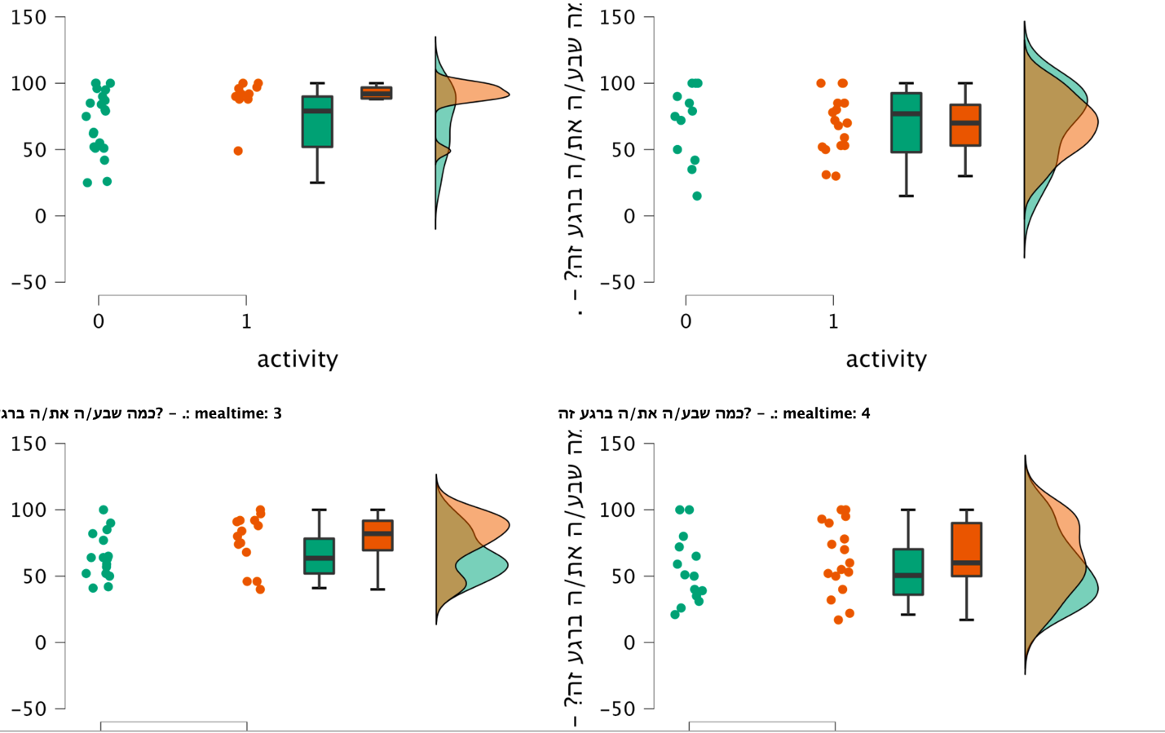

Mindless Mindful

Mindless Mindful

**0-30 minutes after eating**

**30-60 minutes after eating**

**60-120 minutes after eating**

**120+ minutes after eating**

Satiety (higher 🡪)

Satiety (higher 🡪)

Satiety (higher 🡪)

Satiety (higher 🡪)

*

*

Mindless Mindful

Mindless Mindful

**Figure 2. Preliminary results: satiety is higher when eating mindfully versus mindlessly.** Differences in satiety between groups who reported being mindful during their meal versus mindless (on their phone/ watching TV). The effect emerges almost immediately after a meal, and lasts for up to 2 hours, with an intriguing non-significant difference at 30-60 minutes.

**Expected results:** We expect to find that, all else kept equal, eating the same standard meal attentively versus distractedly will induce a gradual increase (mindful>neutral>mindless) in satiety and a decrease in hunger, as will be measured using both self-reports and respective hormonal levels (reduced Ghrelin, and increased Leptin and Insulin levels) after consuming the meal compared to beforehand. We expect a gradual increase in food metabolism, namely that more energy will be devoted to food digestion, the more mindful one is during eating. We also expect the above measures to correlate: higher satiety and lower hunger will be associated with higher levels Leptin and Insulin and lower levels of Ghrelin, and with more energy devoted to food digestion. **Alternative outcomes:** An alternative outcome, which is just as interesting, is that attentional state may influence hormonal regulation of appetite, but not food metabolism. This would suggest that attention during a meal influences the pre-absorptive phase, namely the sensory and cognitive aspects of satiation, which in turn influence hormone secretion and subjective satiety, but do not affect the metabolic phase of food digestion. Potential pitfalls are addressed after Experiment 1.2.

**Experiment 1.2 – comparing real-time energy expenditure during exercise:** Participants will complete a structured 20-minute exercise run of moderate intensity (75% of their individual maximal aerobic endurance) on a treadmill. Outcome measures include: (1) Muscle metabolism assessed during the exercise by O2 uptake and CO2 release using a respiratory mask. (2) Macronutrient utilization assessed by comparing the proportion of energy utilized from fat oxidation versus carbohydrate oxidation. (3) Objective effort assessed by the caloric expenditure. (4) Subjective effort: Participants will be asked to rate their subjective effort. We will also measure cardiopulmonary performance, namely heart rate and respiratory rate using a chest belt and a respiratory mask respectively. We will assess participants’ attention during the exercise using the state mindfulness scale for physical activity58 and assess related traits, such as general attention to bodily signals55, to account for individual differences. Analyses: For each outcome variable (1-4), we will compare the different conditions (Mindful, Mindless, Neutral) by employing a repeated-measures ANOVA, with a factor of time for variables measured before and after each session.

Our **Preliminary Results** support our working hypothesis, and provide proof of concept that performingan exercise while mindful versus mindless triggers more engagement in the exercise, as well as provide initial evidence for a successful manipulation check.We collected data from three participants; each completed both mindful and mindless exercise (20 minutes running at 75% of their maximal predicted heart rate) in a counterbalanced order, one week apart, while we collected their physiological-metabolic measurements using a respiration mask (**Fig 3**). During the mindful exercise, all participants showed higher muscle metabolic engagement, as was evident by higher O2 consumption and CO2 release. In addition, all participants showed higher caloric expenditure during exercise, and self-reported more effort. Furthermore, differences in O2 consumption, CO2 release and caloric expenditure between conditions were strongly associated with differences in attention to bodily actions between conditions, namely the more mindful one was, the more metabolic engagement was observed (**Fig 4**). These preliminary findings provide a proof of concept both for the feasibility of the study and attention manipulation, and for our hypothesis of more metabolic engagement when mindful. **Expected results:** we expect to find that, all else kept equal, performing the same physical activity attentively versus distractedly will induce a gradual increase (mindful>neutral>mindless) in biological-metabolic engagement, as will be evident by higher metabolic muscle activity (namely more oxygen consumed by the muscles), and higher caloric expenditure. We also expect participants to self-report higher perceived effort, 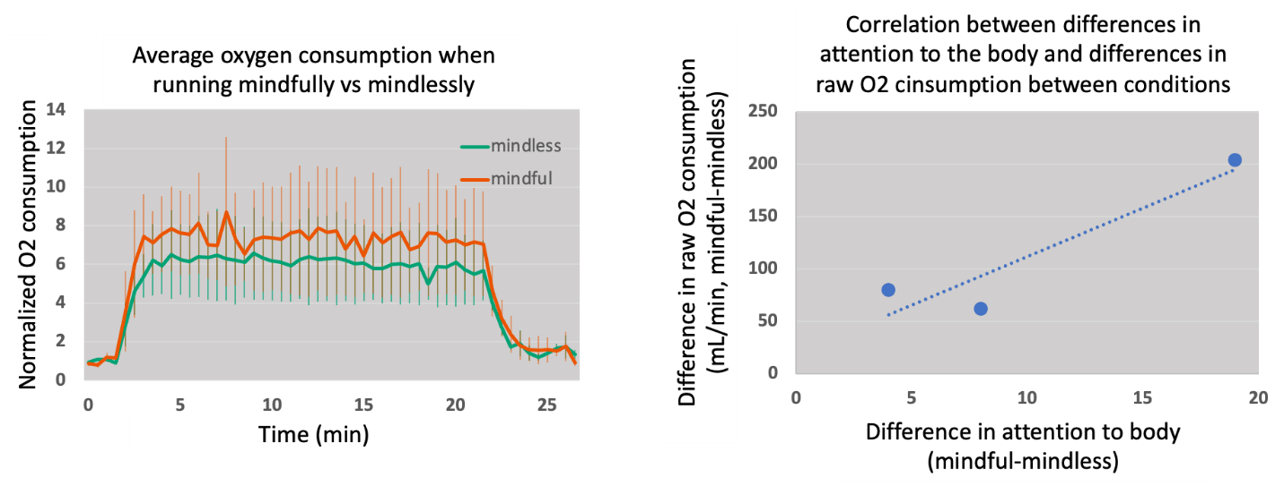and that the latter will be correlated with the increased engagement observed.

**Figure 4. Preliminary findings provide proof of concept for the study hypothesis.** Left panel depicts average O2 consumption of all 3 participants when running mindfully (orange) versus mindlessly (green). Levels were normalized to the mean O2 consumption during rest (first 2 minutes) to allow averaging across participants. Last 5 minutes are recovery. Right panel shows a striking correlation (R=0.93) between differences in attention to body’s actions and differences in raw O2 consumption between conditions. Each dot is a participant’s mindful minus mindless values.

**Figure 3. Study settings - Experiment 1.2.**  Participants run for 20 minutes on a custom designed treadmill while wearing a respiratory mask (see middle panel) which measures O2 consumption and CO2 release for every breath. In the left-most panel is participant 1 under the mindless condition (the blue arrow points to the screen presenting short, captivating videoclips). In the right-most panel is participant 2 under the mindful condition, directed to focus on the actions of her body (no screen). Critically, participants completed both conditions, a week apart, in a counter-balanced order, to allow a within-participants comparison of conditions.

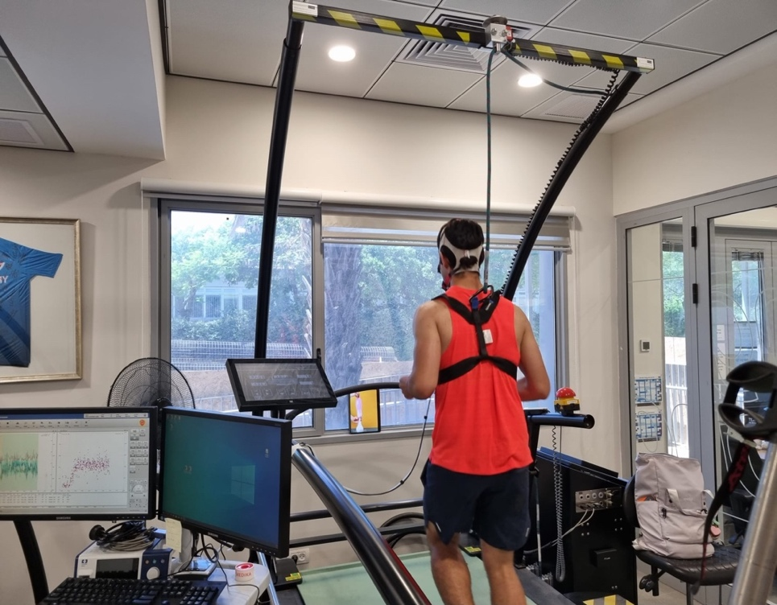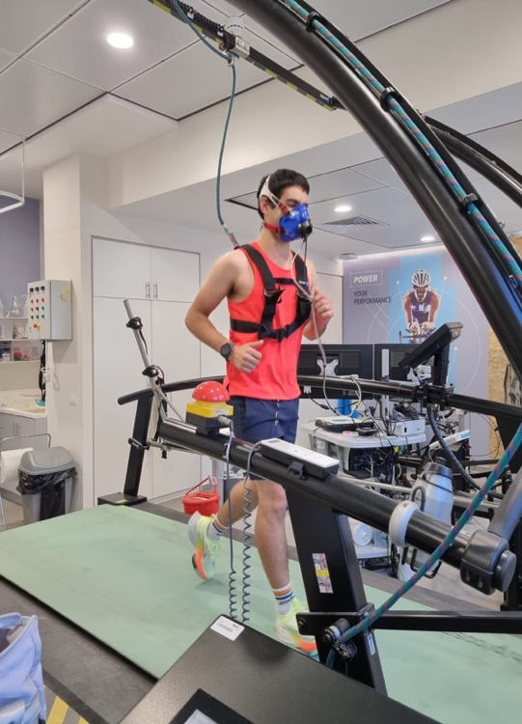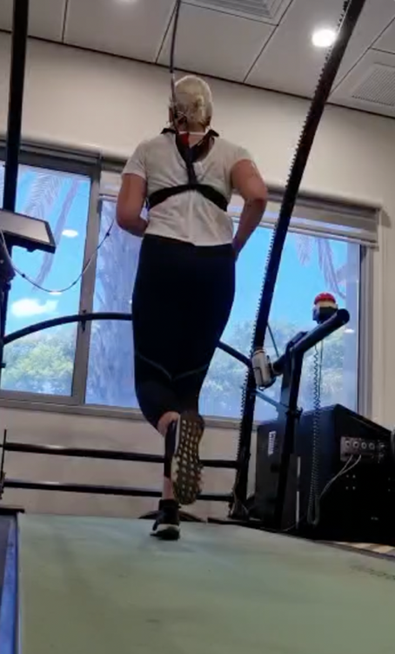

**Alternative outcomes:** An interesting alternative outcome will be that the increased engagement is not gradual but rather that exercising mindfully increases engagement compared to the other two conditions. Given the human tendency to mind-wander59, this would imply that various sources of distraction, and not just TV-viewing, affect engagement.

**Aim 1 – potential pitfalls:** One potential pitfall shared by both studies in Aim 1 is the concern that no differences will be found between different attentional states. This could result from a null effect of attention on the outcome measures (hypothesis rejection) or from unsuccessful attention manipulation. Regarding the former, studies discussed above23,24 and a pilot study in Exp 1.1 strongly suggest a significant difference in subjective self-reports when attending the body’s actions versus when distracted, which implies underlying physiological mechanisms. While our encouraging preliminary results in Exp 1.2 support this hypothesis, it is yet to be fully demonstrated and, therefore, a null result is possible. A related concern is that we will unsuccessfully manipulate attention. However, not only do prior studies demonstrate significant behavioral effects of attention on satiety using similar instructions23,24, but also our preliminary results in Exp 1.2 provide encouraging support that attention manipulation can be successfully achieved. Nevertheless, we intend to run additional pilot studies to validate our manipulation. Another possible pitfall is that individual differences in attentional abilities, fitness and/or body mass may affect the way food is metabolized or energy is produced and utilized during effort. We plan to overcome this challenge by the within-participants study design, in which participants are compared against themselves and not against others. In addition, to account for within-person changes in mood or motivation, we will collect this data from participants at each visit. Finally, in Exp 1.1, number of chews or meal duration could potentially differ when eating mindfully versus mindlessly20,29. We thus chose a meal in the form of a shake, with limited consumption time, and will record and account for actual time of consumption. Finally, it may be argued that mindful conditions comprise a larger cognitive load compared to mindless conditions, and that any difference in energy uptake between conditions could be explained by the brain. To address this concern, we introduced the neutral condition. Given the human tendency to mind-wander59, the neutral condition is expected to engage people in a thought-driven cognitive load similar to the mindful condition, yet different in content (we will verify this further using pilot studies). In this way, irrelevant thoughts are also expected to induce a distraction, yet lesser than TV-viewing. Thus, it will allow us to dissociate the effects of attention (wherein being mindful is expected to yield higher energy uptake, due to body engagement, than the distracting mindless and neutral conditions) from those of cognitive load (wherein TV-viewing is expected to yield a lower cognitive load, and thus less energy used by the brain, than the cognitively-engaging mindful and neutral conditions).

**Aim 2 – neurobiological correlates and associated physiological changes following practicing mindful versus mindless eating and exercising for several weeks**

Changing one’s thinking patterns or the target of one’s attention over several weeks has measurable neurobiological outcome. Studies documenting neurobiological changes following psychotherapy demonstrate that such changes occur both in activation and functional connectivity of related brain regions60,61. Additionally, numerous studies demonstrate that practicing mindfulness for several weeks, which requires repeatedly focusing one’s attention on the present moment, induces meaningful neurobiological changes62,63. My postdoctoral research was the first to demonstrate a causal relationship between mindfulness training and both changes in resting-state functional brain connectivity and associated improvements in sustained attention64. Resting-state functional connectivity (rsFC) is a particularly interesting neurobiological measure, as it reflects the brain’s spontaneous activity, regardless of a particular task65. We thus demonstrated that changing the target of attention for several weeks has the capacity to alter the spontaneous crosstalk between brain regions, leading to improvements in cognitive performance. Mindful eating and exercising interventions show significant physiological benefits19,20,22,25. Our **working hypothesis** is that beyond real-time effects of attention on biological-metabolic engagement, in the longer run (i.e., over the course of several weeks of training), rsFC between related brain regions will be altered as reflected in the mental practice, and these alterations will contribute to changes in the engagement of biological-metabolic systems, which result in the physiological benefits observed. Relevant brain regions include the hypothalamus, which is responsible for homeostasis regulation including of appetite and energy expenditure66 (although additional brain regions are also involved67), the insula, which is thought to play a key role in brain-body communication68, and motor cortex, in relation to exercise.

**Research design and methods:** To understand the mechanisms governing mind-body crosstalk, and measure its longitudinal impact, **Aim 2** includes two interventional randomized-controlled studies (Exp 2.1 eating; Exp 2.2 exercising), in which participants will be instructed to eat/exercise either attentively (*Mindful group*) or distractedly (*Mindless group*) for a duration of four weeks. We will compare changes in resting-state functional connectivity between brain regions such as the hypothalamus, the insula and motor cortex between the two groups following the intervention and correlate them with physiological changes in body composition, namely amount and distribution of fat and muscle mass (**Fig 5**). Study participants: As before, participants (ages 18-45, BMI 18.5-25, prescreened for medical conditions) will be recruited through social media and ads posted on and off campus. The sample size in each experiment will be N=60 based on power analyses detailed below.

Detailed design: First, prior to the intervention, participants will complete a daily online diary for two weeks, where they will report their eating/exercising routine (frequency, duration) and their actions while performing those actions, as baseline mindful/mindless tendencies. During the 2-week baseline period, participants will arrive at the lab to record their body composition using a body composition analyzer, and to record their rsFC patterns using magnetic resonance imaging (MRI). Next, in each experiment, participants will be pseudo-randomized to practice either *mindful* or *mindless* eating/exercising for a period of four weeks, simulating the longitudinal interventions that were shown to lead to beneficial physiological outcome in body weight and fat mass19,20,22,25. Participants will be pseudo-randomized such that both groups will have participants who at baseline showed similar profiles of high mindful or mindless eating/exercising tendencies. Specific instructions will guide participants to either focus on their bodies and the activity they are performing (i.e., eating or exercising) during the meal/exercise (Mindful groups), or to focus on any television or smartphone content they find interesting during the meal/exercise (Mindless groups). During the intervention, participants will continue to complete the daily online diary report regarding meal/exercise frequency, duration and attentional state. Weekly online meetings with participants to emphasize the intervention instructions and discuss any challenges will be conducted by the study team. Post-intervention, participants will return to the lab to record their body composition and rsFC. Analysis: We will use CONN to analyze rsFC (detailed in resources section) and employ repeated-measures ANOVA to compare outcome measures between the two intervention groups in each experiment before and after the intervention. **Expected outcome:** We expect that following the intervention, being mindful over mindless of bodily actions will lead to stronger hypothalamic rsFC with cortical areas (reflecting improved mind-body regulation) and will lead to improved body composition (namely less fat and more muscle mass) and reduced weight (as been reported in previous mindful eating and exercising interventions20,22,25). We further expect the two measures to correlate such that we can demonstrate a causal link between the intervention and associated brain and bodily changes following it. **Alternative outcome and potential pitfalls:** One interesting alternative outcome could be that rather than increased rsFC in the mindful group, we will observe reduced rsFC in the mindless group rather than in the mindful group, which will demonstrate the detrimental effects of commonly distracting the mind from the body’s activity. Another potential outcome is that we will find no changes in functional connectivity in the regions specified. While prior research strongly suggests that altering thinking patterns is reflected in spontaneous brain activity, making the possibility of null results less likely, we still plan on collecting additional neurobiological measures, such as task-specific activation of related brain regions, employing tasks from studies probing the same brain regions [REFS]. Potential pitfalls include the feasibility of the intervention, which we plan to mitigate with data from an independent dataset of participants to verify the successful manipulation of attention over time, and the optimal frequency of meetings with participants to verify their engagement in the task. Another potential pitfall is the number of practice hours a week as compared to standard mindfulness interventions, which include approximately 20-30 training hours over 4-8 weeks69. In the mindful eating intervention, it is assumed that people eat for at least 1 hour a day, every day, so a 4-week practice should result in ~28 hours of training. Since exercise is less frequent than meals, in the exercising condition participants will be asked to apply the mindful/mindless instructions on every physical activity (walking to places, climbing stairs). Similar methods were shown successful in inducing physical benefits in a previous study25, and we will test this again in our pilot experiment. **Significance:** Mindful eating and exercising interventions have already demonstrated benefits over the course of several weeks. This study will be the first to test their relationship with neurobiological mechanisms related to brain-body communication and probe the causal link between the two. Evidence already exists that thinking patterns can affect brain connectivity. Here, we will test whether they can also affect the engagement of the brain in regulating bodily metabolic processes. Furthermore, the study design will allow examining a potential detrimental effect of performing these daily activities while distracted by screen viewing, which is very common nowadays.

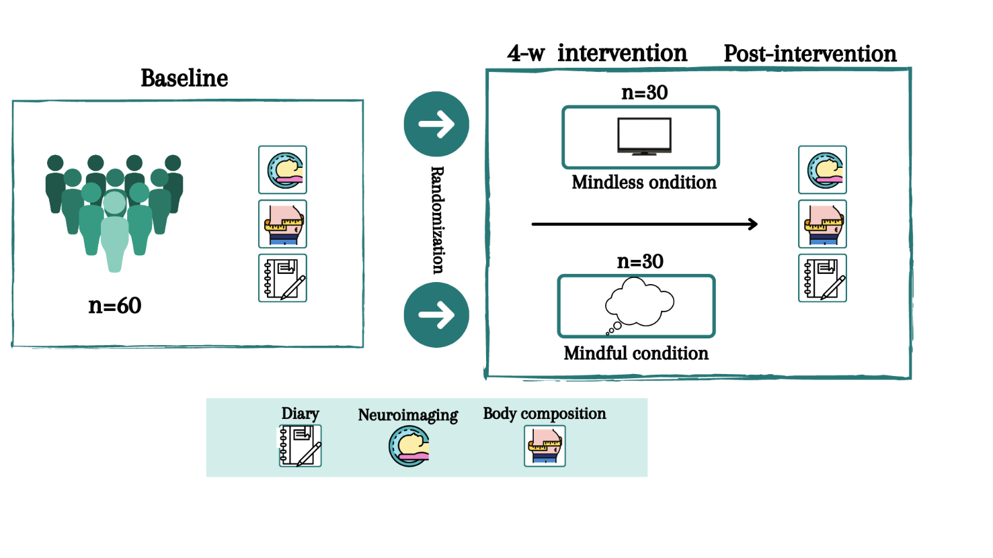

**Figure 5. Study design – Aim 2.** In order to elucidate the longitudinal mechanisms of attention-induced physiological benefits of mindful eating/exercising interventions, we will probe changes in functional connectivity of related brain regions following a 4-week mindful/mindless eating (N=60) and exercising (N=60) interventions.

**Available resources and feasibility**

The feasibility of the proposed project is supported by the expertise of the research team and its experience in conducting related studies that have employed similar methodologies. I have fourteen years of experience in recording and analyzing respiratory signals from human participants70–73, in analyzing hormonal levels using ELISAs74,75, and in conducting and analyzing fMRI studies to compare both task-based activations and resting-state functional connectivity patterns between two populations64,75. My training includes designing, executing and analyzing complex multi-level studies incorporating physiological measures (such as heart rate, respiration and skin conductance), hormonal measures and functional and anatomical MRI – all similar to the studies suggested in this proposal. I also have specific experience in conducting longitudinal mindfulness interventions and probing their neural mechanisms76, and in analyzing functional connectivity between subcortical regions such as the hypothalamus and the insula75. In order to strengthen my expertise in the fields of exercise and eating metabolism, I am conducting these studies in collaboration with Dr. Yftach Gepner, an expert in human physiology of exercise and nutrition, who widely uses these measures in his research and has advised me on the design and execution of this proposed project (a letter of endorsement is attached).

The proposed research will include two within-participants cross-over studies (Aim 1) and two intervention studies (Aim 2) conducted over a period of five years. Prior to each study, we will conduct behavioral pilot studies to verify that we can succeed in manipulating attention (a pilot study for Aim 1.2 has shown great success), and to inform the specific design of the study. Experiments will be conducted at my lab at the Azrieli Faculty of Medicine of Bar-Ilan University in Safed. The needed infrastructure will soon be in place to allow the first phase of data collection to commence. I received an initial support of $400,000 from my institution to purchase equipment, hire staff and pay participants. My lab currently includes well-trained PhD students with prior knowledge in fMRI analyses, a lab manager (PhD) with vast experience in ELISAs and the required equipment to conduct the proposed studies (detailed below).

Metabolic analysis system: The respiratory mask and metabolic cart are part of the COSMED Quark CPET (Cardio Pulmonary Exercise Test) system. The lab already purchased the system and is working with the Gepner Lab at Tel-Aviv University to run pilot data, and provide training on data collection and analysis so that as soon as the system arrives (expected October 2022), our research team will be experienced and ready to use it. Blood drawing and ELISA: Each lab member will be trained by MADA to perform blood draws. The PI and lab manager are trained in processing blood and preparing it for immunoassays. The lab will purchase ELISA kits, plate readers and additional required equipment by December 2022. MRI: MRI scans will be conducted either in Tel-Aviv University or Rambam Health Care Campus in Haifa, and I have active ongoing collaborations for fMRI studies in both places. Both scanners are 3T MRI scanners (Siemens) with a 64-channel head coil. Functional data will be acquired using a T2*-weighted echo planar imaging sequence (repetition time (TR) = 1500 ms). Slices will be positioned 30° off the anterior commissure-posterior commissure line to reduce ventromedial frontal signal dropout. Slices will be acquired using a multiband sequence. Data preprocessing will be done using SPM1277, which will include motion correction, slice timing correction, normalization with respect to the EPI template provided by SPM, and 8-mm Gaussian smoothing. Functional connectivity analyses: Functional connectivity analysis will be performed using CONN toolbox78. We will examine functional connectivity between a-priori regions of interest (ROIs) as specified above. Regions will be defined by the CONN software package and derived from an independent component analysis on 497 healthy control participants (293 females) as part of the Human Connectome Project. First-level functional connectivity analysis will include generating Pearson's correlation coefficients by computing correlations between the ROIs’ time series and time series of all other voxels in the brain. These ROI-to-voxel r maps will then be transformed to z maps using Fisher's r-to-z transformation and brought up to a general linear model analysis at the second level for within-group and between-group comparisons. Sample size calculations: All power analyses were conducted using G*Power version 3.1.9.679 for sample size estimation based on data from previous studies showing similar effects, with a significance threshold of alpha = 0.05 and power = 0.80. For the two studies composing Aim 1, we will choose a sample size of N=30 (per study). For Aim 1.1, we considered a study demonstrating effects of food labeling on Ghrelin response30. Its effect size was 0.33, yielding a minimal sample size of N=22 for a repeated-measures ANOVA. Thus, a sample size of 30 should be more than sufficient to capture the effect. Of note, a similar result is achieved by considering a study testing the effects of eating distractedly versus attentively on subjective satiety24 (effect size 0.32). For Aim 1.2, sample size calculations based on sports-placebo studies33 yielded a higher effect size of 0.48, and thus a lower minimal sample size of N=12. Assuming a smaller effect size as seen in Aim 1.1, we kept the sample size at N=30. For the two studies composing Aim 2, we will choose a sample size of N=60 per study, namely 30 participants per condition. An RCT we conducted testing the effects of mindfulness intervention on resting-state functional connectivity64 yielded a minimal sample size of N=17 per condition (with an effect size of 0.56). Assuming a smaller effect size, we found that a sample of N=30 per condition (N=60 in total) could reveal effects as small as 0.19.

**Bibliography**

1. Evans W, Hoyle C. The comparative value of drugs used in the continuous treatment of angina pectoris. *QJM Int J Med*. 1933;2(3):311-338.

2. Benedetti F, Mayberg HS, Wager TD, Stohler CS, Zubieta JK. Neurobiological Mechanisms of the Placebo Effect. *J Neurosci*. 2005;25(45):10390-10402. doi:10.1523/JNEUROSCI.3458-05.2005

3. Amanzio M, Benedetti F. Neuropharmacological Dissection of Placebo Analgesia: Expectation-Activated Opioid Systems versus Conditioning-Activated Specific Subsystems. *J Neurosci*. 1999;19(1):484-494. doi:10.1523/JNEUROSCI.19-01-00484.1999

4. Benedetti F, Maggi G, Lopiano L, et al. Open versus hidden medical treatments: The patient’s knowledge about a therapy affects the therapy outcome. *Prev Treat*. 2003;6(1):No Pagination Specified-No Pagination Specified. doi:10.1037/1522-3736.6.1.61a

5. Chaparro LE, Furlan AD, Deshpande A, Mailis‐Gagnon A, Atlas S, Turk DC. Opioids compared to placebo or other treatments for chronic low‐back pain. *Cochrane Database Syst Rev*. 2013;(8). doi:10.1002/14651858.CD004959.pub4

6. Kaptchuk TJ, Kelley JM, Conboy LA, et al. Components of placebo effect: randomised controlled trial in patients with irritable bowel syndrome. *BMJ*. 2008;336(7651):999-1003. doi:10.1136/bmj.39524.439618.25

7. Pollo A, Carlino E, Benedetti F. Placebo mechanisms across different conditions: from the clinical setting to physical performance. *Philos Trans R Soc B Biol Sci*. 2011;366(1572):1790-1798. doi:10.1098/rstb.2010.0381

8. Meissner K, Kohls N, Colloca L. Introduction to placebo effects in medicine: mechanisms and clinical implications. *Philos Trans R Soc B Biol Sci*. 2011;366(1572):1783-1789. doi:10.1098/rstb.2010.0414

9. Kirsch I, Deacon BJ, Huedo-Medina TB, Scoboria A, Moore TJ, Johnson BT. Initial Severity and Antidepressant Benefits: A Meta-Analysis of Data Submitted to the Food and Drug Administration. *PLoS Med*. 2008;5(2):e45. doi:10.1371/journal.pmed.0050045

10. Kirsch I. Placebo Effect in the Treatment of Depression and Anxiety. *Front Psychiatry*. 2019;10. Accessed October 1, 2022. https://www.frontiersin.org/articles/10.3389/fpsyt.2019.00407

11. de la Fuente-Fernández R, Ruth TJ, Sossi V, Schulzer M, Calne DB, Stoessl AJ. Expectation and Dopamine Release: Mechanism of the Placebo Effect in Parkinson’s Disease. *Science*. 2001;293(5532):1164-1166. doi:10.1126/science.1060937

12. Al-Lamee R, Thompson D, Dehbi HM, et al. Percutaneous coronary intervention in stable angina (ORBITA): a double-blind, randomised controlled trial. *The Lancet*. 2018;391(10115):31-40. doi:10.1016/S0140-6736(17)32714-9

13. Quinn VF, Colagiuri B. Placebo Interventions for Nausea: a Systematic Review. *Ann Behav Med*. 2015;49(3):449-462. doi:10.1007/s12160-014-9670-3

14. Darragh M, Chang JWH, Booth RJ, Consedine NS. The placebo effect in inflammatory skin reactions: The influence of verbal suggestion on itch and weal size. *J Psychosom Res*. 2015;78(5):489-494. doi:10.1016/j.jpsychores.2015.01.011

15. van Laarhoven AIM, van der Sman-Mauriks IM, Donders ART, Pronk MC, van de Kerkhof PCM, Evers AWM. Placebo Effects on Itch: A Meta-Analysis of Clinical Trials of Patients with Dermatological Conditions. *J Invest Dermatol*. 2015;135(5):1234-1243. doi:10.1038/jid.2014.522

16. Amanzio M, Pollo A, Maggi G, Benedetti F. Response variability to analgesics: a role for non-specific activation of endogenous opioids. *Pain*. 2001;90(3):205-215. doi:10.1016/S0304-3959(00)00486-3

17. Colloca L, Lopiano L, Lanotte M, Benedetti F. Overt versus covert treatment for pain, anxiety, and Parkinson’s disease. *Lancet Neurol*. 2004;3(11):679-684. doi:10.1016/S1474-4422(04)00908-1

18. Lanotte M, Lopiano L, Torre E, Bergamasco B, Colloca L, Benedetti F. Expectation enhances autonomic responses to stimulation of the human subthalamic limbic region. *Brain Behav Immun*. 2005;19(6):500-509. doi:10.1016/j.bbi.2005.06.004

19. Kristeller JL, Epel E. Mindful eating and mindless eating: The science and the practice. In: *The Wiley Blackwell Handbook of Mindfulness, Vols. I and II*. Wiley Blackwell; 2014:913-933. doi:10.1002/9781118294895.ch47

20. Warren JM, Smith N, Ashwell M. A structured literature review on the role of mindfulness, mindful eating and intuitive eating in changing eating behaviours: effectiveness and associated potential mechanisms. *Nutr Res Rev*. 2017;30(2):272-283. doi:10.1017/S0954422417000154

21. Mason AE, Jhaveri K, Cohn M, Brewer JA. Testing a mobile mindful eating intervention targeting craving-related eating: feasibility and proof of concept. *J Behav Med*. 2018;41(2):160-173. doi:10.1007/s10865-017-9884-5

22. Dalen J, Smith BW, Shelley BM, Sloan AL, Leahigh L, Begay D. Pilot study: Mindful Eating and Living (MEAL): Weight, eating behavior, and psychological outcomes associated with a mindfulness-based intervention for people with obesity. *Complement Ther Med*. 2010;18(6):260-264. doi:10.1016/j.ctim.2010.09.008

23. Ding F, Hamid N, Shepherd D, Kantono K. How is Satiety Affected When Consuming Food While Working on A Computer? *Nutrients*. 2019;11(7):1545. doi:10.3390/nu11071545

24. Oldham-Cooper RE, Hardman CA, Nicoll CE, Rogers PJ, Brunstrom JM. Playing a computer game during lunch affects fullness, memory for lunch, and later snack intake. *Am J Clin Nutr*. 2011;93(2):308-313. doi:10.3945/ajcn.110.004580

25. Crum AJ, Langer EJ. Mind-set matters: Exercise and the placebo effect. *Psychol Sci*. 2007;18(2):165-171.

26. Vadiveloo M, Morwitz V, Chandon P. The interplay of health claims and taste importance on food consumption and self-reported satiety. *Appetite*. 2013;71:349-356. doi:10.1016/j.appet.2013.09.005

27. Finkelstein SR, Fishbach A. When Healthy Food Makes You Hungry. *J Consum Res*. 2010;37(3):357-367. doi:10.1086/652248

28. Caputo FA, Mattes RD. Human dietary responses to perceived manipulation of fat content in a midday meal. *Int J Obes Relat Metab Disord*. 1993;17(4):237-240.

29. Cornil Y. Mind Over Stomach: A Review of the Cognitive Drivers of Food Satiation. *J Assoc Consum Res*. 2017;2(4):419-429. doi:10.1086/693111

30. Crum AJ, Corbin WR, Brownell KD, Salovey P. Mind over milkshakes: mindsets, not just nutrients, determine ghrelin response. *Health Psychol Off J Div Health Psychol Am Psychol Assoc*. 2011;30(4):424-431. doi:10.1037/a0023467

31. Beedie CJ, Foad AJ. The Placebo Effect in Sports Performance. *Sports Med*. 2009;39(4):313-329. doi:10.2165/00007256-200939040-00004

32. Beedie CJ, Stuart EM, Coleman DA, Foad AJ. Placebo effects of caffeine on cycling performance. *Med Sci Sports Exerc*. 2006;38(12):2159-2164. doi:10.1249/01.mss.0000233805.56315.a9

33. Pollo A, Carlino E, Benedetti F. The top-down influence of ergogenic placebos on muscle work and fatigue. *Eur J Neurosci*. 2008;28(2):379-388. doi:10.1111/j.1460-9568.2008.06344.x

34. Beedie C, Benedetti F, Barbiani D, Camerone E, Lindheimer J, Roelands B. Incorporating methods and findings from neuroscience to better understand placebo and nocebo effects in sport. *Eur J Sport Sci*. 2020;20(3):313-325. doi:10.1080/17461391.2019.1675765

35. Kaasinen V, Aalto S, Någren K, Rinne JO. Expectation of caffeine induces dopaminergic responses in humans. *Eur J Neurosci*. 2004;19(8):2352-2356. doi:10.1111/j.1460-9568.2004.03310.x

36. Benedetti F, Pollo A, Colloca L. Opioid-Mediated Placebo Responses Boost Pain Endurance and Physical Performance: Is It Doping in Sport Competitions? *J Neurosci*. 2007;27(44):11934-11939. doi:10.1523/JNEUROSCI.3330-07.2007

37. Friston K. Does predictive coding have a future? *Nat Neurosci*. 2018;21(8):1019-1021. doi:10.1038/s41593-018-0200-7

38. Friston K. The free-energy principle: a unified brain theory? *Nat Rev Neurosci*. 2010;11(2):127-138. doi:10.1038/nrn2787

39. Barrett LF, Simmons WK. Interoceptive predictions in the brain. *Nat Rev Neurosci*. 2015;16(7):419-429. doi:10.1038/nrn3950

40. Kube T, Schwarting R, Rozenkrantz L, Glombiewski JA, Rief W. Distorted cognitive processes in major depression: a predictive processing perspective. *Biol Psychiatry*. 2020;87(5):388-398.

41. Kube T, Rozenkrantz L. When beliefs face reality: an integrative review of belief updating in mental health and illness. *Perspect Psychol Sci*. 2021;16(2):247-274.

42. Rozenkrantz L, D’Mello AM, Gabrieli JD. Enhanced rationality in autism spectrum disorder. *Trends Cogn Sci*. 2021;25(8):685-696.

43. Rozenkrantz L, Kube T, Bernstein MH, Gabrieli JDE. How beliefs about coronavirus disease (COVID) influence COVID-like symptoms? – A longitudinal study. *Health Psychol*. 2022;41:519-526. doi:10.1037/hea0001219

44. Kube T, Rozenkrantz L, Rief W, Barsky A. Understanding persistent physical symptoms: Conceptual integration of psychological expectation models and predictive processing accounts. *Clin Psychol Rev*. 2020;76:101829.

45. Clark A. Attention alters predictive processing. *Behav Brain Sci*. 2016;39. doi:10.1017/S0140525X15002472

46. Treue S. Visual attention: the where, what, how and why of saliency. *Curr Opin Neurobiol*. 2003;13(4):428-432. doi:10.1016/S0959-4388(03)00105-3

47. Snyder J, Gregg M, Weintraub D, Alain C. Attention, Awareness, and the Perception of Auditory Scenes. *Front Psychol*. 2012;3. Accessed October 1, 2022. https://www.frontiersin.org/articles/10.3389/fpsyg.2012.00015

48. Johansen-Berg H, Lloyd DM. The physiology and psychology of selective attention to touch. *Front Biosci-Landmark*. 2000;5(3):894-904.

49. Anderer J. “Zombie Eating”: 88% Of Adults Dine While Staring At A Screen, Survey Finds. Study Finds. Published July 24, 2019. Accessed July 31, 2022. https://www.studyfinds.org/zombie-eating-88-percent-adults-dine-while-staring-at-screen-survey-finds/

50. Jusienė R, Urbonas V, Laurinaitytė I, et al. Screen Use During Meals Among Young Children: Exploration of Associated Variables. *Medicina (Mex)*. 2019;55(10):688. doi:10.3390/medicina55100688

51. Adult Obesity Rates. The State of Childhood Obesity. Accessed July 31, 2022. https://stateofchildhoodobesity.org/adult-obesity/

52. Childhood Obesity Facts | Overweight & Obesity | CDC. Published July 27, 2022. Accessed July 31, 2022. https://www.cdc.gov/obesity/data/childhood.html

53. McArthur BA, Volkova V, Tomopoulos S, Madigan S. Global Prevalence of Meeting Screen Time Guidelines Among Children 5 Years and Younger: A Systematic Review and Meta-analysis. *JAMA Pediatr*. 2022;176(4):373-383. doi:10.1001/jamapediatrics.2021.6386

54. Hulbert-Williams L, Nicholls W, Joy J, Hulbert-Williams N. Initial Validation of the Mindful Eating Scale. *Mindfulness*. 2014;5(6):719-729. doi:10.1007/s12671-013-0227-5

55. Mehling WE, Acree M, Stewart A, Silas J, Jones A. The Multidimensional Assessment of Interoceptive Awareness, Version 2 (MAIA-2). *PLoS ONE*. 2018;13(12):e0208034. doi:10.1371/journal.pone.0208034

56. Gepner Y, Bril N, Shelef I, et al. Higher visceral adiposity is associated with an enhanced early thermogenic response to carbohydrate-rich food. *Clin Nutr*. 2016;35(2):422-427. doi:10.1016/j.clnu.2015.03.004

57. Morris CJ, Garcia JI, Myers S, Yang JN, Trienekens N, Scheer FAJL. The human circadian system has a dominating role in causing the morning/evening difference in early diet-induced thermogenesis. *Obes Silver Spring Md*. 2015;23(10):2053-2058. doi:10.1002/oby.21189

58. Cox AE, Ullrich-French S, French BF. Validity evidence for the state mindfulness scale for physical activity. *Meas Phys Educ Exerc Sci*. 2016;20(1):38-49.

59. Killingsworth MA, Gilbert DT. A Wandering Mind Is an Unhappy Mind. *Science*. 2010;330(6006):932-932. doi:10.1126/science.1192439

60. Barsaglini A, Sartori G, Benetti S, Pettersson-Yeo W, Mechelli A. The effects of psychotherapy on brain function: A systematic and critical review. *Prog Neurobiol*. 2014;114:1-14. doi:10.1016/j.pneurobio.2013.10.006

61. Linden DEJ. How psychotherapy changes the brain – the contribution of functional neuroimaging. *Mol Psychiatry*. 2006;11(6):528-538. doi:10.1038/sj.mp.4001816

62. Young KS, van der Velden AM, Craske MG, et al. The impact of mindfulness-based interventions on brain activity: A systematic review of functional magnetic resonance imaging studies. *Neurosci Biobehav Rev*. 2018;84:424-433. doi:10.1016/j.neubiorev.2017.08.003

63. Wheeler MS, Arnkoff DB, Glass CR. The Neuroscience of Mindfulness: How Mindfulness Alters the Brain and Facilitates Emotion Regulation. *Mindfulness*. 2017;8(6):1471-1487. doi:10.1007/s12671-017-0742-x

64. Bauer CCC, Rozenkrantz L, Caballero C, et al. Mindfulness training preserves sustained attention and resting state anticorrelation between default‐mode network and dorsolateral prefrontal cortex: A randomized controlled trial. *Hum Brain Mapp*. 2020;41(18):5356-5369. doi:10.1002/hbm.25197

65. Fox MD, Raichle ME. Spontaneous fluctuations in brain activity observed with functional magnetic resonance imaging. *Nat Rev Neurosci*. 2007;8(9):700-711. doi:10.1038/nrn2201

66. Morton GJ, Cummings DE, Baskin DG, Barsh GS, Schwartz MW. Central nervous system control of food intake and body weight. *Nature*. 2006;443(7109):289-295. doi:10.1038/nature05026

67. Grill HJ. Distributed Neural Control of Energy Balance: Contributions from Hindbrain and Hypothalamus. *Obesity*. 2006;14(S8):216S-221S. doi:10.1038/oby.2006.312

68. Livneh Y, Andermann ML. Cellular activity in insular cortex across seconds to hours: Sensations and predictions of bodily states. *Neuron*. 2021;109(22):3576-3593. doi:10.1016/j.neuron.2021.08.036

69. Carmody J, Baer RA. How long does a mindfulness-based stress reduction program need to be? A review of class contact hours and effect sizes for psychological distress. *J Clin Psychol*. 2009;65(6):627-638. doi:10.1002/jclp.20555

70. Rozenkrantz L, Zachor D, Heller I, et al. A mechanistic link between olfaction and autism spectrum disorder. *Curr Biol*. 2015;25(14):1904-1910.

71. Arzi A, Rozenkrantz L, Gorodisky L, et al. Olfactory sniffing signals consciousness in unresponsive patients with brain injuries. *Nature*. 2020;581(7809):428-433.

72. Arzi A, Rozenkrantz L, Holtzman Y, Secundo L, Sobel N. Sniffing patterns uncover implicit memory for undetected odors. *Curr Biol*. 2014;24(7):R263-R264.

73. Mishor E, Amir D, Weiss T, et al. Sniffing the human body volatile hexadecanal blocks aggression in men but triggers aggression in women. *Sci Adv*. 2021;7(47):eabg1530.

74. Gelstein S, Yeshurun Y, Rozenkrantz L, et al. Human tears contain a chemosignal. *Science*. 2011;331(6014):226-230.

75. Rozenkrantz L, Weissgross R, Weiss T, et al. Unexplained repeated pregnancy loss is associated with altered perceptual and brain responses to men’s body-odor. *Elife*. 2020;9:e55305.

76. Bauer CC, Rozenkrantz L, Caballero C, et al. Mindfulness training preserves sustained attention and resting state anticorrelation between default‐mode network and dorsolateral prefrontal cortex: A randomized controlled trial. *Wiley*. Published online 2020. Accessed September 17, 2022. https://dspace.mit.edu/handle/1721.1/134562

77. Friston K. A short history of SPM. *Stat Parametr Mapp Anal Funct Brain Images*. Published online 2007:3-9.

78. Whitfield-Gabrieli S, Nieto-Castanon A. Conn: a functional connectivity toolbox for correlated and anticorrelated brain networks. *Brain Connect*. 2012;2(3):125-141.

79. Faul F, Erdfelder E, Lang AG, Buchner A. G* Power 3: A flexible statistical power analysis program for the social, behavioral, and biomedical sciences. *Behav Res Methods*. 2007;39(2):175-191.

Add YY Tang? Taren?

**Time Schedule**

|  |  |  |
| --- | --- | --- |
| **Objective** | **Beginning** | **End** |
| Piloting the induction of attentional states for Aim 1 | July 2023 | September 2023 |
| Running experiment 1.1 | October 2023 | February 2024 |
| Analyses and manuscript preparation (1.1) | March 2024 | August 2024 |
| Running experiment 1.2 | September 2024 | January 2025 |
| Analyses and manuscript preparation (1.2) | February 2025 | July 2025 |
| Piloting the instructions for Aim 2 | August 2025 | January 2026 |
| Running experiment 2.1 | February 2026 | September 2026 |
| Analyses and manuscript preparation (2.1) | October 2026 | April 2027 |
| Running experiment 2.2 | May 2027 | December 2027 |
| Analyses and manuscript preparation (2.2) | December 2027 | June 2028 |

**add time to pilot aim 1, reduce time from analyses,,, add pilot mind-wandering

**Explanatory notes:**

Piloting Aim 1: To verify that the instructions and stimuli used for Aim 1 indeed induce the desired attentional states (namely, that attention to bodily actions is highest in the mindful conditions, lowest in the mindless condition and the neutral condition is in between), we will conduct two pilot studies. For each, an independent cohort of participants will be asked to eat (N=30) or exercise (N=30) under each of the experimental conditions, and then self-report their attention during the activity, using the mindful eating and mindful exercising questionnaires, as well as their hunger/effort. This will ensure successful manipulation of attention in the experiments.

Conducting experiments 1.1, 1.2 is expected to take 5 months (for each experiment), considering a recruitment rate of 5 participants a week (1/day), with each participant returning 3 times (i.e., 5 completed participants every 3 weeks). Based on this calculation, reaching 30 participants will take 18 weeks, which when accounting for holidays, cancelations etc. will amount to 5 months.

Piloting Aim 2: Two pilot studies will be conducted to obtain several goals: to test the instructions planned for Aim 2, verify that they can be maintain for the duration of the intervention (4 weeks) and quantify number of training hours per experiment. In each study, an independent cohort of N=16 participants will be asked to practice either mindful (N=8) or mindless (N=8) eating/exercising, using instructions used in Aim 1 (the small sample size is due to the goal of feasibility assessments only). We will track their progress daily using online reporting, weekly by zoom/phone calls, and collect feedback at the end of the intervention.

Conducting experiments 2.1, 2.2 is expected to take 8 months (for each experiment). We plan to run the intervention in batches of 10 eligible participants. The intervention includes 2 weeks baseline reports including a lab visit (body measures, fMRI scan), 4 weeks intervention, and 2 additional weeks to complete the post-intervention body measures and fMRI scans, a total of 8 weeks per each 10 participants, and 24 weeks overall. During this time, recruitment for the next batch will be conducted, recruitment for the first batch is estimated to take 3 weeks, amounting to 6 months. Possible drop-offs may require a fourth batch, therefore we estimate 8 months.

**Budget**

"The budget (including for equipment) will be submitted in shekels (NIS). ● The required budget items should be specified and explained in as much detail as possible. If the proposal is approved, this specification will constitute the budget proposal and financial reporting will be according to the items it includes. The ISF does not commit to granting the full sum requested. ● The items specified in Section 4.3 above may not be included in the budget."

Section 4.3 contains list of expenses that are NOT allowed

The evaluation process includes an examination of the appropriateness of the requested budget to the submitted work plan. 4.2. The researchers must request a realistic sum for conducting the research and explain the sections of the requested budget."

Aim 1: piloting of Aim 1 experiments, running of Exp 1.1, 1.2.

Pilots include 2 studies of N=30 participants each. Compensation at a rate of 40 NIS/hour is expected for purely behavioral studies, with each participants completing 1 hour at each experimental condition. Together: 30 participants x 3 hours each x 40 NIS/hour = 3,600 NIS per experiment x 2 pilots = 7,200 NIS.

Running experiments 1.1, 1.2 includes N=30 participants per experiment, each arriving at the lab on 3 separate visits. Estimated duration is 2 hrs/visit for exp 1.1 and 1.5 hrs/visit for exp 1.2, with compensation rate of 50 NIS/hour for a study including biological-metabolic measures. Therefore, estimated compensation is 30 participants x 3 visits x 2 hours/visit x 50 NIS/hour = 9000 NIS for exp 1.1, and 30 participants x 3 visits x 1.5 hours/visit x 50 NIS/hour = 6,750 NIS for experiment 1.2 = 15,750 for Exps 1.1, 1.2 and 22,950 total for Aim 1.

Year 1 = pilots + Exp 1.1 = 16,200 NIS

Year 2 = 6,750 NIS

Aim 2: piloting of Aim 2 experiments, running of Exp 2.1, 2.2.

Pilots include 2 studies of N=16 participants each. Since this is a longitudinal intervention, in order to increase engagement and minimize attrition, completion of each part of the intervention will be compensated. In total, each pilot participant could get up to 450 NIS, 75 NIS for completing 2-week baseline surveys, 75 NIS for each of the four intervention weeks (practice, daily online surveys and a weekly phone call with research team), with additional 75 NIS as study completion and feedback bonus. In total, 16 participants x 450 NIS x 2 pilots = 14,400 NIS.

Running experiments 2.1, 2.2 includes N=60 participants per experiment, with the above compensation logic plus 2 lab visits (baseline, post-intervention) which include body composition measures (0.5 hr, 40 NIS/hour) and fMRI scan (1.5 hrs, 70 NIS/hour). With this addition of 125 NIS*2 per participant, the total compensation per experiment is 60 participants x (450+250) NIS = 42,000 x 2 experiments = 84,000 NIS.

Year 3: piloting aim 2 + (2/3) exp 2.1 = 14,400 + 28,000 = 42,400

Year 4: (1/3) exp 2.1 + (1/3) exp 2.2 = 14,000 *2 = 28,000

Year 5: (2/3) exp 2.2 = 28,000

MRI scanning costs: Each scanning hour costs 400 NIS including insurance. Experiments 2.1,2.2 include 60 participants per experiment, each scanned twice (per-post), for 1.5 hours each scan. Together, 2 studies x 60 participants/study x 2 scans each x 1.5 = 144,000 NIS scanning fees for years 3-5.