**Application number: 324/24**

**PI: David Deutsch**

**Neural control of social decisions in a naturalistic social environment**

**Scientific Abstract**

Social decisions are critical to human prosperity, and suboptimal social decision-making is associated with varied psychiatric and neurological disorders. While significant progress has been made in deciphering the neural basis of social decision-making in animal models and simplified lab tasks, social decisions in natural environments are typically more complex. From behavioral responses to social cues to selecting a mating partner, social decisions in the wild are context-dependent, relying on multiple factors such as group size and heterogeneity, animal density, the level of competition, and the effect of other recent social encounters.

Here, we propose to better understand the neural basis of naturalistic social decisions using the vinegar fly, *Drosophila melanogaster*, as a model system. We have two hypotheses. First, that social decisions in both sexes depends on social context, including decisions directly involving two flies (e.g., male choosing the next song note or females responding to a copulation attempt) and decisions involving more flies (e.g., male switching from one to another female target). Second, that these decisions, within the social context, are modulated by a specific set of sexually dimorphic cells in the central brains of male and female flies.

To test this, we first aim to reveal how immediate multisensory sensory cues (visual, auditory, and tactile), social context (specifically, male-female ratio) and recent social experiences (e.g., recent rejections or fights) determine male decisions including song choice, initiating/terminating courtship, or target switching and female decisions to accept or reject copulation. Second, we aim to determine how the activity of sexually dimorphic cells in male and female central brains modulate these social decisions.

We will take advantage of new tools for the fine quantification of social behavior and the optogenetic stimulation of well-defined neural populations in intact, freely moving flies. Using modern recording methods, we will measure visual, auditory, and tactile stimuli in our environments, as flies behave, and we will computationally estimate how these stimuli are experienced by individuals from their own perspective. We will analyze the data to assess whether complex social decisions can be predicted by a combination of the immediate sensory inputs, group dynamics, and recent experience of the deciding fly. To assess how the activity of central neurons modulates social decisions we will use both open- and closed-loop optogenetic experiments, measuring the effects of tonic and phasic activation of neurons during social behaviors. Overall, this work should allow us to develop a new and more comprehensive framework for understanding the neural basis of social decision-making in a tractable species. Our goal is to make the behavior of individuals in complex social environments increasingly sensible, building on the more reductionistic experiments of the past alongside the modern recording and analysis methods of the present.

**Detailed Description of the Research Program**

1. **Scientific background**

Social decisions are complex and state-dependent: they rely on the integration of dynamically changing multisensory cues, as well as on the needs and the physiological state of the participants. Accordingly, many brain disorders are characterized by deficits in social integration 1. Studying the neural basis of social decisions in animal model systems has been beneficial for the understanding of the processing and production of social cues 2–4.

*Drosophila* has been widely used as a model system for studying how males and females make social decisions, mostly in the context of aggression and mating. Mating in *Drosophila* is a dynamic process which involves multiple decisions both on the male and the female side. Males need to decide when to initiate courtship and with which female partner, which actions to take during courtship (e.g., initiating song or switching between song types, attempting to copulate, fighting a competing male), when to terminate copulation and move to another target, and once copulation was achieved, when to terminate it. Females are considered to mostly be ‘responders’, yet *Drosophila* females ultimately make the choice to mate (accept a copulation attempt) or not to mate (reject an attempt). Moreover, though less explored, the female’s choice of where to be relative to other potential mates (at the extreme - flying away or in the middle of a dense fly cohort) - very likely impacts her probability to be courted, and therefore her mating options and likelihood to mate. Mated females also remate, but are more ‘picky’ compared to adult virgins, reflecting a difference in the cost-benefit between first mating and remating [].

**Ethologically-oriented** studies in various *Drosophila* species have revealed theories about the principles underlying social decisions such as mate choice in both sexes [xx]. However, these studies have largely not explored the neural mechanisms underlying such decisions. Moreover, lab experiments, and particularly **neurobiology-oriented** experiments that take advantage of the genetic toolkit available in *Drosophila*, are often conducted in highly simplified settings. However, these settings are unlikely to reflect the conditions under which the underlying neural circuits evolved. There is thus a major gap in our knowledge of the neural bases of social behaviors in naturalistic conditions. **Here we aim to close some of this gap**.

**1.1 Social decisions in *Drosophila***

*Drosophila melanogaster* exhibit a variety of social behaviors, including mating and aggression5. Using the available toolkit in this model system, neurobiologists revealed much of the neural circuitry controlling mating and aggression in these flies6,7. While most neurobiology-oriented studies characterize mating behaviors in isolated male-female pairs on homogenous, food-free backgrounds 8–11, in their natural habitat flies aggregate densely on food patches, where they feed, fight, and mate 12–14. Groups of flies exhibit non-random group structures and social interactions, which depend on multiple factors such as genetic heterogeneity 14–16, group size and density 17, the existence of rivals 18, and sex ratio 19–21. Competition over a female partner depends not only on the male:female ratio, but also on the fraction of receptive females at any given moment, and the higher the ratio of motivated males to receptive females, the more competition there is for a female partner 12,20. Social dynamics influence the timing of various behaviors in flies, from locomotor activity bouts to circadian patterns of mating 14,15,22,23. Social decisions also depend on social experiences such as social isolation 24, previous aggressive encounters 25, and recent mating encounters 26. Taken together, these findings support the notion that **group living is a fundamental component of *Drosophila* behavior** 14,17. Social decisions such as choosing a mate or engaging in a fight depend on incoming sensory information about the prospective partner 6,27,28, but also on accumulated information regarding social environment and experience 16,29. Context-dependent social decisions are possible through spatial integration of sensory cues (e.g., olfactory cues about the density or heterogeneity of the group), and through temporal integration of previous events (such as recent mating or fighting), through their effect on the animals’ internal state (e.g., motivation or arousal), memory (e.g., a previous aggressive encounter), or direct changes in physiology (e.g., the injection of sex-peptide during mating 30,31).

A common framework for predicting and interpreting animal decisions, both social and non-social, is the ‘cost-benefit’ [xxx] analysis. This framework is based on the assumption that nervous systems evolved to be somewhat optimized to the environment the organism evolved in [xxx]. For example, remating in insects was shown to cause increased lifetime offspring production (benefit), while having a negative effect on female longevity (cost) 20. A male’s decision to terminate courtship or switch to another female target and a female’s decision to reject a copulation attempt both have the cost of the missed copulation opportunity, and the potential benefit of finding a better mate. When multiple females are available, males spend 80% of their time engaged in mating behaviors (courtship and copulation), but this percentage gradually declines to 10% over 4 hr, reflecting a lower benefit of remating 32. Males also become more sensitive to sensory cues as a function of time from copulation initiation 33, possibly reflecting a change in the cost/benefit ratio in terminating the current copulation event and potentially remating with another female. Consistent with this idea, males were found to alter their ejaculate investment, measured as mating duration, according to the level of sperm competition 34. We expect that all of these decisions will be biased by external factors such as the male-to-female ratio [xx], hence the importance of controlling this factor. While social context is important for social decisions, some behaviors involve more than two flies such that they cannot be studied in fly dyads at all. For example, in our preliminary data, we have found many instances of males interacting with a copulating pair, a male singing to a courting male in a male-male-female triplet, and a male switching a female target (**Figs. 1, 2; Table 1**).

Therefore, **the importance of studying social decisions in a complex social environment is two-fold: First, social decisions, even when involving only two flies, are potentially modulated by the social context, and second, many social interactions involve more than two individual flies.**

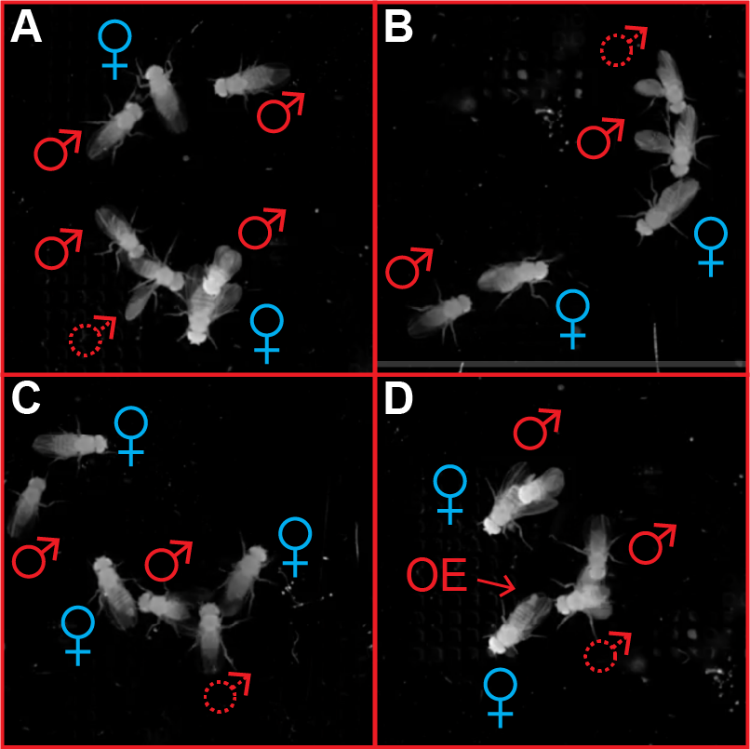

**Figure 1:** **Preliminary data, Deutsch lab** - Examples of behaviors that involve more than two flies. **A.** A male (marked with a dashed male symbol) circling around and singing to a copulating pair. **B.** A male (marked with a dashed symbol) singing behind a competitor male. **C.** A male switching from competing over one female to courting a different female (to his right). **D. A** female extruding her ovipositor while being courted by a male (marked by a dashed symbol) who is being chased and contacted by another male.

**Table 1** Social behaviors in *Drosophila melanogaster.*

|  |  |  |
| --- | --- | --- |
| **Flies used for detecting the behavior** | **Reported behaviors** | **Selected references** |
| male | Singing (wing vibrations) | 10,35,36 |
| female | Ovipositor extrusion, vaginal plate opening, pausing, singing copulation song | 11,31,37–39 |
| male, female | Chasing, tapping, licking, copulating, circling  shoving (/fending), kicking, flicking, decamping, copulation initiation and termination | 6,9,40–42 |
| male-male | chasing, singing, fighting (lunging, fencing, flicking) | 43–45 |
| female-female | fighting (shoving, head-butting..) | 43,46 |
| male-male-female | Male-male competition over a female  Male switching a female target*  Male interacting with a mating pair* | 47 * not characterized |
| female-female-male | Female interacting with a mating pair | 48 |
| 2 males, 2 females | Two males competing over a female, one male switching to an alternative female | Observed in our preliminary data |

**Table 2. Recent studies that have used machine learning tools to quantify group interactions in *Drosophila melanogaster***

| No. of individuals | Duration | Mixed sex | Food patch | Body parts tracked? | Year | Reference |
| --- | --- | --- | --- | --- | --- | --- |
| 12 | 30 min | No | No | No | 2012 | [16] |
| Up to 24 | 2–5 min | No | No* | No | 2015 | [29] |
| Up to 100 | Various | Yes | No | No | 2019 | [49] |
| 7, 16 | 3-5 h | Yes | No | No | 2020 | [50] |
| 10 | 15 min | No | No | No | 2021 | [24] |
| **16** | **4 h** | **Yes** | **Yes** | **Yes** | **This proposal** | |

**\*** No food, except for the measuring of aggregation density.

**1.2 Quantifying social decisions in complex environments**

Motion capture technology enables the precise quantification of complex phenotypes from high-resolution videography of freely behaving animals 51. Leveraging deep learning, the investigators’ previous work in developing these methods has recently been demonstrated to be feasible for tracking the motion of individual body parts of socially interacting animals, implemented using the SLEAP software framework 52. SLEAP works by using deep neural networks that take video frames as inputs and then predicting the locations of body parts, grouping them into animals, and linking them across time to generate a continuous trajectory of poses for each animal. SLEAP has been found to be successful in tracking the poses of two animals for short periods of time (<1 h), with up to 99.9995% identity tracking accuracy (62 incorrect frames out of 11.7 million frames).

Reliable pose tracking allows us to extract features useful for inferring social behaviors. For example, we have found that wing angles/extensions can be used as a proxy for male singing (using a simple classifier we obtained 91% correct classification as to whether frames included part of a singing epoch), an important part of the male courtship ritual. The measurement of wing extension is also important for scoring aggressive behaviors, such as same-sex fights in males and females 43 and rejection behaviors in unreceptive females 53,54. Finally, based on precise estimation of fly pose it is possible to estimate the sensory information (e.g., visual, auditory) that is available to the fly from the point of view of the animal (**Fig. 2**). Past work has shown that network models that consider the visual information accessible to each individual can be more predictive of behavior in collectives than those that do not incorporate this information 55.

Recent studies have adapted machine learning-based tools for automatic detection of group behaviors in *Drosophila*, offering new insights into collective behavior 29 and social networks (See **Table 2**; 14,16,24,29,49,50). For example, it has been shown that the internal dynamics in same-sex fly groups depend both on the genetic heterogeneity of the group 16 and on previous social experience 24. Both supervised and unsupervised learning methods have been developed for the automatic quantification of mating and fighting in *Drosophila* 56–58.

Given these opportunities for the tracking of individual animals and the detection of specific behaviors, we have the opportunity to leverage three complementary approaches to study group dynamics and individual decisions, including: (1) predictive models (e.g., 10,59), (2) the quantification of network properties 16,60,61, including *Clustering coefficient*, *Assortativity*, *Betweenness centrality* and *Global efficiency*, and (3) the use of a layered social network analysis 62, as in prior behavioral studies (e.g., 63). For example, different networks can be extracted for a given dataset based only on mating behaviors, aggressive behaviors, or general activity, after which the interactions among these networks can be quantified.

**1.3 Central control of social decisions in males and females**

Mating behavior in *Drosophila melanogaster* has been the subject of intense research for over a century 64. These studies have relied on multiple modalities, including visual, olfactory, auditory, and gustatory 6. During courtship, males and females display their qualities while analyzing the value of a potential mate. The male initiates courtship and the female decides whether or not she wishes to mate 53. Upon encountering a potential courtship partner, based on visual and chemosensory cues, the male taps the female’s abdomen to assess her desirability 65,66. The male then follows the female, extending a wing and vibrating it to generate the courtship song 35 and licking the female before attempting to copulate 65,67. Virgin females slow down and open their vagital plate in response to courtship song 31,68, and ultimately allow copulation. The female’s mating behavior is dependent on her sexual maturity 69 and on previous mating events, through both the immediate effect of a mating plug 70 and the slower effect of sex-peptide, which is injected by the male during copulation 71. Mated females respond to male courtship song by accelerating in response to song 10, ovipositor extrusion 38, and performing a range of rejection behaviors that include decamping (running, jumping, or flying away), wing flicking, and shoving/fencing 53,54,72.  
Aggressive behaviors of flies have been studied mainly in the context of fighting over food resources, and it has been shown that while some aggressive phenotypes are sex-specific, others are not 43,73,74. For example, while hierarchical relationships were seen to form between losing and winning males, hierarchy was not observed in females 43. Aggressive behaviors were also documented in the context of mating such that males fight with other males when competing over a female 64, while an unreceptive female shows aggressive rejection behaviors toward courting males 53,54. The neural basis of aggressive behavior has been the target of intensive research in males 44,75,76 and recently also in females 9,46,77. As in the case of mating behavior, laboratory studies of aggressive behavior have tended to focus on single, isolated pairs of flies.

Much of the progress in understanding the neural basis of social behaviors in *Drosophila* is due to the fact that many of the cells that participate in the control of social behaviors, from sensory integration to motor control, express the sex determination genes *doublesex* (dsx) and *fruitless* (fru) 27,78,79. In particular, **the dsx*-*expressing pC1 neurons regulate multiple aspects of mating and aggressive behaviors in both sexes** 9,32,80. pC1 neurons in both sexes have persistent effects on mating and aggression 9,44,80–82, meaning that their activation affects fly behavior minutes after stimulation offset **(Fig. 3B**; traces taken from 9). pC1 subsets are also involved in driving persistent mating and aggressive behaviors in both sexes 9,31,44,46,83, at least in part by driving an arousal state and by gating the transformation from sensory inputs to mating and aggressive behaviors 9,46,84. pC1 neurons were also shown to regulate the interactions between sex and other behaviors such as sleeping and feeding 85,86, possibly driving different behaviors in a threshold-dependent manner 87.

Using the complete female connectome, pC1 subtypes were in females have been designated pC1a-e 9,31. pC1a neurons receive the strongest inputs from SAG neurons activated by the male sex pheromone during copulation 11,71, driving the female to be less receptive to future copulation attempts.   
Activation of female pC1d/e cells drives aggression towards both males and females 9,46,88,89. The role of pC1b and pC1c neurons remains unknown.

In males, pC1 neurons include two subsets: the dsx(+)fru(-) and the male-only dsx(+)fru(+) subset often referred to as ‘P1’ 78. Activating different pC1 subtypes drives different phenotypes. In males, activating dsx(+)fru(-)pC1 and dsx(+)fru(+)pC1 (often referred as P1) neurons drives aggression and mating behaviors, respectively 83. At present, the more specific subgrouping of pC1 cells in males has yet to be completed, but it is expected in the near future with the anticipated release of the first male connectome.

1. **Research Objectives**

In this project, we aim to quantify how social decisions are made by males and females in a naturalistic environment based on sensory cues, group dynamics, and recent social experience. Utilizing advanced computational tools to monitor and quantify social behavior together with the genetic tools available in *Drosophila melanogaster*, our proposed project has two specific objectives:

1. Develop a novel framework for studying how complex social decisions are made in naturalistic conditions, and how these decisions are modulated by a critical factor: the level of competition over a sexual partner.
2. Examine how sexually dimorphic central neurons impact social decisions in males and females in a naturalistic environment.

In completing these objectives, we will test the following concrete hypotheses:

1. An increase in the male-to-female ratio will lead to higher aggression between males, more persistent courtship, reduced target switching by courting males, increased probability of females rejecting a courting male (more ‘choosy’ females), longer copulation duration, and higher female remating rates.
2. Subsets of the sexually dimorphic ‘pC1’ neurons bias social decisions in both males (courtship persistence, the probability of switching a female target, and the ratio of time spent courting a female versus communicating with a competing male) and females (the acceptance rate in both virgin and recently mated females, as well as responses to visual cues such as the presence of flies in the field of view, auditory cues such as changes in speed and turning in response to male song, and tactile cues.

The first hypothesis draws from theories of sexual selection and previous studies of flies, while the second is based on previous experiments on male-female and male-male dyads. **We will combine hypothesis-driven approaches that will ensure rapid progress with exploratory analyses that will yield a comprehensive description of social decisions in naturalistic social environments and potentially unexpected findings that will generate new hypotheses.** Our experiments will inform and constrain models, and theory will be used to interpret data and refine hypotheses. Overall, this research effort will expand our understanding of how social decisions are made in more natural scenarios.

***Aim 1. Determine how sensory cues, social context, and recent social experience contribute to social decisions in naturalistic social environments***

In this Aim we will quantify how social decisions in males and females depend on the immediate sensory environment, group dynamics, and the recent experience of the deciding fly. We will perform our studies in sex-mixed environments, manipulating the male-female ratio. Social decisions include both categorical and continuous ones. Examples of categorical decisions include the male’s choice to initiate or terminate courtship or to switch between song types, as well as the female's acceptance or rejection of a courtship attempt. Examples of continuous decisions include male song amplitude and the female change-in-speed in response to male song. Some of these decisions have already been modeled successfully in male-female dyads, including the choice of song type and amplitude by a singing male. We will extend these analyses to a more complex social environment, testing how the existence of other flies and recent social interactions impact these decisions. Other decisions have not been rigorously described to date, including the decision of a male to switch from courting a specific female to courting another female who crossed his field of view (as often observed in our preliminary data), or the male’s decision to terminate competition with another male over a single female in the presence of alternative female targets.

For this Aim will use two experimental settings. In one we will use videography and sound recordings of 8 flies for 60 minutes/session; in the other we will record 16 flies for 4 hours on a food patch, using high-speed videography. We will develop a pipeline for the automated quantification of social behaviors (**Table 1**). Specifically, we will quantify how male and female decisions depend on the degree of competition (varying the male-to-female ratio). The 4-hr experiment will also enable the quantification of remating and history-dependent choices in both sexes over longer timescales. The successful completion of Aim 1 will yield an automated pipeline for collecting, analyzing, and quantitatively describing social decisions in a naturalistic environment as a function of (1) ongoing sensory (visual, auditory, and tactile) inputs in egocentric coordinates (projected on the fly retinas, aristas, and body), (2) sensory-grounded social interaction network features, and (3) previous experience (e.g., recent mating, fighting or rejection).

***Aim 2. Reveal the role of sexually dimorphic central neurons in controlling social decisions in naturalistic social environments in males and females***

In this Aim, we will determine the role of known central, sexually-dimorphic neurons (‘pC1’) in the male and female brains in biasing social decisions in naturalistic social environments. We will characterize how the models developed in Aim 1 are modified by the neural activation of pC1 subgroups in both sexes. Specifically, we aim to reveal how tonic activation (optogenetic activation in ‘open-loop’ experiments) and phasic activation (optogenetic activation in ‘closed-loop’ experiments dependent on specific behavioral measures) impact the social decision described in aim 1.

Different subsets of pC1 neurons were shown to drive mating and aggressive behaviors in males and females. In particular, the fru(+)P1 and fru(-)P1 subsets of the male pC1 neurons were shown to promote persistent mating and aggression, respectively. We hypothesize that tonic activation of fru(+)P1 nurons will increase courtship persistence and reduce target switching, while tonic activation of the fru(-)pC1 subset will enhance male-male aggression, including male-male competition over target females. It is less clear if fru(-)pC1 activation will also affect copulation duration or courtship behavior in recently mated males.

In females, pC1a cells are associated with female receptivity, while pC1d/e drive both female-female and female-male aggression. We hypothesize that tonic activation of pC1a cells will increase acceptance rates in virgin females, while it is less clear how pC1a activation will affect the remating rate. It is also unclear how the tonic activation of pC1d/e cells will affect the behavior of virgin and recently mated females in a mixed-sex environment.

In Aim 1 we also intend to measure the effect of local spatiotemporal group dynamics on male and female decisions. In Aim 2 we will quantify how the activation of specific pC1 subsets interacts with the effects of group dynamics and recent social encounters, focusing on the context-dependent role of pC1 neurons.

**3. Experimental Design and Methods**

***3.1 Rationale and general design***

We will develop a computational pipeline for quantifying social decision-making in a socially complex and enriched environment, and will quantify how social decisions are modulated by social context (**Aim 1**) and neural modulations (**Aim 2**). As detailed below, our first technical challenges will be to keep track of each of multiple individual flies for the extended duration of the experiment (up to 4 hours) and to train classifiers for automated detection of multiple social behaviors (**Table 2**). Then, we will use existing frameworks for predicting these behaviors (onset and offset, when relevant) based on the egocentric projection of sensory information (**Fig. 2**), group dynamics, and recent social encounters. In Aim 2 we will measure the impact of the open- and closed-loop optogenetic activation of pC1 subsets on social decisions, based on the “baseline” description of the wild-type behaviors achieved in Aim 1. By the end of Aim 1, we will have a full pipeline for data collection and analysis of social decisions in a complex environment and a quantitative description of how a critical, ethologically relevant factor (male:female ratio) modulates social decisions. By the end of Aim 2, we will have a deeper understanding on the role of decision-making neurons in flies, in controlling social decisions in complex social environments.

**3.2 Experimental procedures**

***Aim 1: Determine how sensory cues, social context, and recent social experience contribute to social decisions in naturalistic social environments***

***Behavioral setups***

For this Aim, we will use two behavioral setups: **Setup 1**: Six identical setups with a top camera and 9 pressure microphones for the recording of male song, similar to that used previously 9,90 **Setup 2**: A novel setup with food substrate and a high-resolution camera for recording multiple flies for an extended period.

The advantage of Setup 1 is the ability to record male songs. However, its utility will be restricted to fewer flies and a shorter experimental duration for three reasons: (1) assigning songs to a specific male becomes harder as the number of male flies rises, (2) the inhomogeneous background makes it harder to track fly identity, therefore resulting in more identity flips, and (3) there is no food-substrate in this setup as there is a microphone array under the flies, such that flies will become increasingly hungry and thirsty over longer experiments. The recording durations for Setup 1 and Setup 2 will be 1 hr and 4 hr, respectively.

Setup 2 relies on the use of a food substrate to mimic a natural habitat, based on previous observations that the presence of food enhances social interactions 74. A curved dome minimizes side walking 24,56,91, and coating the dome with Sigmacoate minimizes walking on the ceiling 10,92. Under laboratory conditions, flies have been shown to aggregate on food at densities of ~1-2 flies/cm2 29. At a density of 1 fly/cm2  for an experiment with 16 flies, we will require a circular arena ~4.5 cm in diameter. We previously observed that a resolution of 30 pixels/mm is the minimum sufficient for leg tracking 52. To also allow for the fine tracking of subtler events such as vaginal plate opening and ovipositor extrusion, tapping, and licking, as well as to reduce the probability of identity flips, we will acquire videos at 100 pixels/mm. We therefore plan to use a camera with a resolution of 5120 x 5120 pixels. We will use a far-IR sensor and filter to avoid data loss during optogenetic activation (**Aim 2**), with the IR sensor being less sensitive to reflections of ambient room light. Given these requirements, we will use the Ximea camera model CB262RG-GP-X8G3 and a Gpixel GMAX0505RF Red Fox CMOS sensor with a quantum efficiency (QExFF) of 30% at 850 nm.

We will use real-time, hardware-accelerated video compression (~100×) of the high-resolution and high frame-rate videos. At 8 bits per pixel and 100 fps, this should yield ~350GB of compressed data for each 4-hr experiment.

***Collecting behavioral data***

Flies will be isolated individually to minimize social experience prior to the experiment. Four-day-old males and females will be inserted into the behavioral arena 1-2 hours after the incubator lights switch on to optimize for peak fly activity.

In Aim 1, we will collect the following datasets:

Setup 1: 1-hr experiments; 60 experiments/condition; 3 conditions: 1M:3F, 2M:2F, 3M:1F.

The 1M:3F condition will allow the quantification of ‘target switching’ and the exploration of the idea that females also have an active role in attracting courting males. The 2M:2M and 3M:1F conditions will enable a comparison of male and female social decisions in less/more competitive environments.

Setup 2: 4-hr experiments; 40 experiments/condition; 4 conditions (always 16 flies): 14M:2F, 12M:4F, 8M:8F, 4M:12F.

In total, we will collect 640 hrs of experimental data in both setups. Preliminary data (Fig. 1) show a few examples of social behaviors involving multiple male and female flies.

***Tracking, proofreading, and feature extraction***

Our preliminary data, collected in Setup 1, suggests that by using SLEAP 92, we are able to estimate the pose of multiple individuals for an extended period, and to project the audio-visual scene from the point of view of each individual fly (**Fig. 2**).

Currently, the expected rate of identity flips in isolated male-female pairs is 4.9 flips/hour 92 . Our preliminary data suggests that in a group of 8 flies (4 males, 4 females) identity flips remain rare. Despite this good performance, in the more challenging setting involving larger groups of flies (16) recorded over long sessions (4 h), we expect to encounter exponentially more frequent errors, as the potential for identity swaps increases combinatorially with the number of interacting animals and session duration. To address this, we suggest three technological improvements: (1) using a higher spatial resolution (100 pixels per mm, instead of 30 pixels/mm that we are using now), such that each fly is more separable even at close interactions, (2) improving the robustness of SLEAP in identifying identity flips, (3) building a tool for enhanced detection of predicted identity switches. (2) and (3) will be achieved via an active collaboration with the Pereira lab (see letter of support).

In short, we will improve the robustness of SLEAP in identifying errors by leveraging state-of-the-art techniques for appearance and trajectory modeling employed for multi-object tracking in the field of computer vision, and build a graphical user interface (GUI) with the capability to jump to predicted instances of identity switches and mark, in the relevant frames, the specific flies for which identity flip is most probable. To do this, we will leverage a sizable existing dataset of 11.7 million frames 92 that has identity switches manually proofread to train a deep neural network classifier to predict whether a switch has occurred. With this tool, we expect the time it takes to manually proofread a movie to scale with the number of interacting individuals.

Processing will be done on a new GPU cluster at the Haifa University, that we are currently already using. We will make pose tracks available in NeurodataWithoutBorders (NWB) format through the DANDI repository. Trained models and labeled data will be made available on OSF with publications. All analysis code will be made publicly available through GitHub throughout development.  
Based on the pose tracking and song segmentation (in the case of Setup 1) we will extract behavioral features such as male-female distance, female absolute velocity, female angle with respect to male centroid, pulse/sine song. In total, we will extract 22 features for each frame (see 9,59).

***Behavioral analysis pipeline***

In order to link sensory and social experience to social decisions, we need to extract 4 pieces of information:

1. **Frame-by-frame sensory experience** from the point of view of each fly (**Fig. 2**). Extracting the angle and size of a female on the eyes of a male fly is derived from her angular position on his eyes, their relative body direction and the fly’s field of view (see **Figs. 1, 2**). Inferring song production will be achieved either based using the microphone recording (e.g. 10,93) with the camera being used for assigning song to a specific male in Setup 1, or from the video alone (by detecting wing angle) in Setup 2. Inferring song onset/offset and song type from the video alone is possible, though less accurate compared to inferring it from audio recordings.
2. **Local group dynamics**: A few measures based on network theory have been used in the past to quantify group dynamics, including *Clustering coefficient*, *Assortativity*, *Betweenness centrality,* *Global efficiency,* and others 61,94*.* Previous studies have demonstrated that these group dynamics in *Drosophila* are non-random, and depend both on fly genotype and previous experience 16,24. However, how these group dynamics influence moment-by-moment social decisions of individual flies has not been quantified to date.
3. **Discrete behavioral events**, including courtship initiation or song bout initiation, target switching, male-male aggression epoch initiation/termination, male copulation attempts, female rejection or acceptance of a copulation attempt, and female vaginal plate opening. These events are used both as social decisions (e.g., a decision to reject a copulation attempt) and as predictor variables (e.g., rejections of copulation attempts may affect future decisions of the rejected male).
4. **Continuous variables** such as female speed and her angle with respect to a courting male. These are relevant for measuring continuous responses (such as female slowing or turning in response to male song) and are used for detecting discrete behaviors (3) and sensory experience (1).

We aim to reveal how sensory cues (1), local group dynamics (2), and previous social events (3) trigger social decisions, both discrete (3) and continuous (4).

We will use supervised techniques to automatically extract specific behaviors (**Table 1**) using the 22 collected behavioral features (some examples are shown in **Fig. 2**). Some behaviors are detected directly from the features associated with a single fly (e.g., singing and ovipositor extrusion 71,95), some involve two flies (e.g., chasing, tapping or shoving 9,81) and others involve more than 2 flies (e.g., partner switching and aggressive interactions between males who are competing over a female). Some of these behaviors have already been detected automatically by us and others 9 using available techniques for supervised classification 56,96,97. In our preliminary data (**Fig. 1**), we have already observed some behaviors that were not reported as of when our preliminary data was collected, including both males and females interacting with a copulating pair (female aggressiveness towards a copulating pair was recently reported by 48).

**While we aim to quantify and predict all the known social decisions (Table 1), we will focus on two:**

1. **Male courtship initiation and termination (end of courting or target switch)**
2. **Female responses to copulation attempts (accept/reject)**

Once (1-4) are extracted from the raw data, we will use an existing framework for predicting discrete events predictor variables (see e.g., 10,59). We will also apply statistical tools to test if accounting for past events contributes to the power of GLM or HMM-GLM models to predict male and female decisions. For example, we will test how visual cues from a courted female and a passing target in the background trigger a male to switch to a different female target, and how such a switching decision is modulated by the fly’s recent history (e.g., previous rejections or fights, and in Aim 2 - also by stimulating pC1 subgroups - see below).

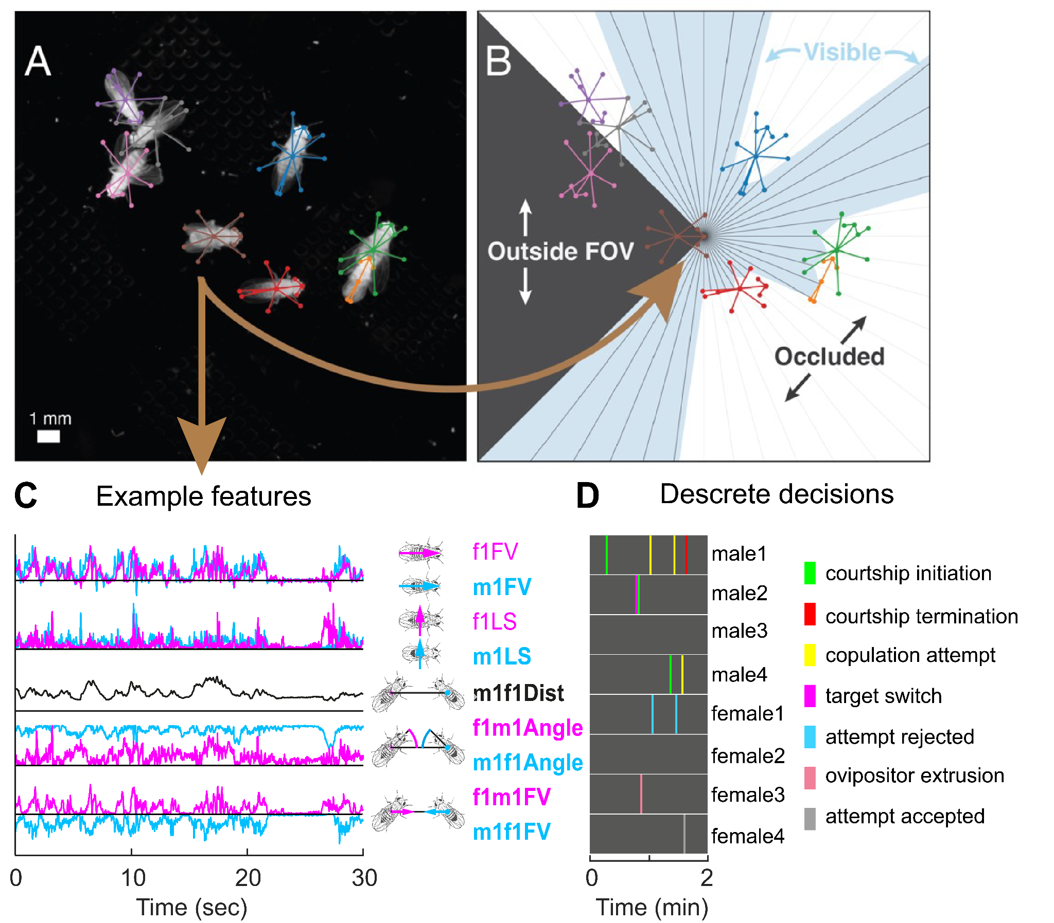  
**Figure 2** Tracking of individual flies in Setup 1, and projecting to an egocentric view. **A.** Pose tracking multiple files using SLEAP. **B.** Egocentric visualization of central fly with visible regions of field-of-view (FOV) shaded blue. Visual experience is extracted from this scheme. **C.** Example features. e.g., m1f2Angle - the angle between the heading of male1 and his direction to female2. **D.** Examples of discrete male and female decisions.

**Aim 2 - *Reveal the role of sexually dimorphic central neurons in controlling social decisions in naturalistic social environments in males and females***

In this Aim, we will test how the activation of pC1 subsets persistently modulates social decisions in both sexes in a complex environment. These analyses will focus on questions such as: when two males court a single female, will the activation of specific pC1 subsets drive more male-male aggression or more male-female courtship? Will pC1 activation modulate group dynamics or the probability of target switching? Is the aggressiveness of females towards a mating pair 48 modulated by the activity of pC1 cells? Specifically, we will test two pC1 subpopulations in males [dsx(+)fru(-)pC1 and dsx(+)fru(+)pC1 83] and two in females (pC1a and pC1d+e 9,89).

Currently, there is no line that labels only pC1a cells in females. We are now in the process of testing candidate genetic lines, based on the detection of pC1a cells in FlyWire. If this approach is not successful, we will use the pC1-SS1 37 which labels pC1a, pC1c, and pC1e neurons. Tonic photoactivation of this line in mated females has been shown to restore their receptivity 37, likely through the activation of pC1a cells.

For these experiments, will use two activation protocols (Fig. 3):

1. **Open-loop**: periodic activation (2 minutes ON, 6 minutes OFF repeatedly for the duration of the experiment). We will compare behavior during the ON and OFF periods, and measure the dynamics over the OFF period.
2. **Closed-loop**: photoactivation during specific behaviors, based on our hypotheses and behavioral observations from Aim 1. For example, as dsx(+)fru(-)pC1 and dsx(+)fru(+)pC1 cells drive aggression and mating in males, we expect that the activation of each group will bias male-male aggression versus male-female courtship in the case of two males competing over a female. This hypothesis will be tested by activating each one of these subsets specifically during male-male-female interactions. For a given behavior, we will activate in 50% of the instances, using the other half as a control.

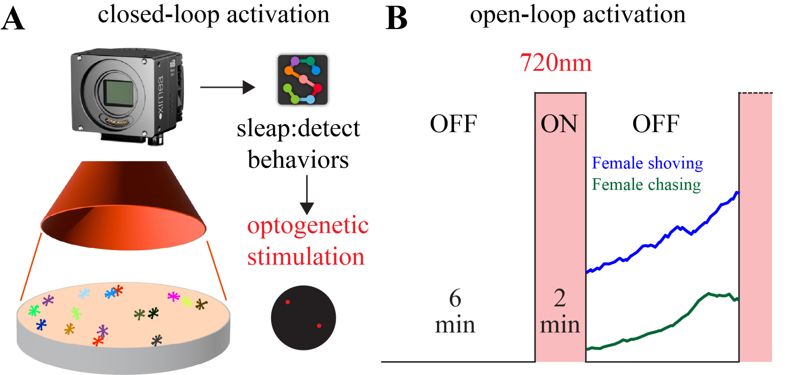

**Figure 3** Experimental setup. **A.** In closed-loop experiments, photoactivation (red circles) is locked to specific behaviors. Accordingly, it is focused on relevant spots. **B.** In open-loop experiments light is turned ON/OFF periodically, covering the whole arena. Examples of persistent female shoving/chasing following pC1d+e activation are taken from Deutsch et al., 2020 9.

The red-shifted channelrhodopsin csChrimson will be expressed in the relevant cells in males or females (but never both). Flies will be ATR-fed to allow the csChrimson expression. A 720 nm deep red light will be used for activation. A previous study suggests that while flies have a saddle response to a flash of deep red light (720 nm) in the dark, having light in the background (as we do in our experimental setup), eliminates this behavioral response. As in Aim 1, 850 nm light will be used as light for the camera sensors, with a narrow 850 nm bandpass filter at the camera entrance, ensuring that the 720 nm light will not be detected by the camera. Closed loop experiments will be done using SLEAP as demonstrated before 92. There, we estimated that the system exhibits a 70-ms latency from the time when the frame is captured to when an output signal can be generated based on predicted poses, and only about 3 ms are taken up by SLEAP model inference. We expect to cut this delay to around half with more optimized hardware and software. A DLP projector, with a shifted red light and a bandpass filter, will be calibrated to the arena and project 720 nm light spots at the relevant times and locations.

**3. Potential problems and alternative strategies**

***3.1 Identity tracking.*** As explained in Aim 1, we plan to use a very high-resolution camera (100 pixels/mm) to minimize identity during SLEAP-based pose estimation, and will develop tools to reduce the manual labor involved in manual proofreading with the aim of ensuring zero identity flips after proofreading. While our tracking of preliminary movies indicates that this approach is likely to prove successful, an alternative approach is suggested: as a last option, we can tag the flies (using an approach similar to 50), but using dots on the back of the fly that can be detected by the IR camera with 24 options (i.e., 1 or 0 dots in 4 separated areas along the fly back) for identifying 16 flies. A similar approach has been used by us and others before, for tracking the identity of the male in male-female dyads 10,98.

***3.2 Complexity.*** Due to the large space of possible behaviors, it is possible that we will need a larger dataset in order to have enough statistical power. In this case we will collect more data, potentially focusing only on more restricted conditions (e.g., smaller M:F ratios, focusing on fewer pC1 subgroups). We may also need to modulate the fly number or density. We have collected preliminary datasets in both setups and are now analyzing these data in order to make a better estimation. The opposite is also possible - if data analyses turn out to be faster than expected, we will consider testing more manipulations in Aim 2 - including the addition of optogenetic inactivation experiments.

**Expected Significance and Broader Impact**

Social decisions are critical to our daily lives, and are closely tied to the pathogenesis of various neuropsychiatric disorders. This work is expected to advance our understanding of the neural basis underlying social decisions in naturalistic scenarios. Reductionistic experiments with pairs or triplets of flies have contributed significantly to our understanding of social decisions in flies, particularly in the context of mating and aggression. Here we aim to use modern recording and analysis methods to extend our understanding to more naturalistic scenarios. We expect this work to reveal new hypotheses regarding how flies make social decisions in naturalistic environments and how these decisions are controlled by the activation of specific cell types. This work will pave the road for future studies by us and others that are focused on specific observations, the testing of additional experimental conditions, and, most importantly manipulating other cell types. These efforts will reveal how the nervous system ultimately makes social decisions in nervous systems make social decisions in the contexts in which they evolved.

**References**

1. Association, A. P. & Others. DSM 5 diagnostic and statistical manual of mental disorders. in *DSM 5 Diagnostic and statistical manual of mental disorders* 947-p (2013).

2. Haxby, J. V., Hoffman, E. A. & Gobbini, M. I. Human neural systems for face recognition and social communication. *Biol. Psychiatry* **51**, 59–67 (2002).

3. Kuhl, P. K. Human speech and birdsong: communication and the social brain. *Proceedings of the National Academy of Sciences of the United States of America* vol. 100 9645–9646 (2003).

4. Kohl, J., Huoviala, P. & Jefferis, G. S. Pheromone processing in Drosophila. *Curr. Opin. Neurobiol.* **34**, 149–157 (2015).

5. Dukas, R. Natural history of social and sexual behavior in fruit flies. *Sci. Rep.* **10**, 21932 (2020).

6. Dickson, B. J. Wired for sex: the neurobiology of Drosophila mating decisions. *Science* **322**, 904–909 (2008).

7. Hoopfer, E. D. Neural control of aggression in Drosophila. *Curr. Opin. Neurobiol.* **38**, 109–118 (2016).

8. Zhou, C., Pan, Y., Robinett, C. C., Meissner, G. W. & Baker, B. S. Central brain neurons expressing doublesex regulate female receptivity in Drosophila. *Neuron* **83**, 149–163 (2014).

9. Deutsch, D. *et al.* The neural basis for a persistent internal state in Drosophila females. *eLife* vol. 9 Preprint at https://doi.org/10.7554/elife.59502 (2020).

10. Coen, P. *et al.* Dynamic sensory cues shape song structure in Drosophila. *Nature* **507**, 233–237 (2014).

11. Feng, K., Palfreyman, M. T., Häsemeyer, M., Talsma, A. & Dickson, B. J. Ascending SAG neurons control sexual receptivity of Drosophila females. *Neuron* **83**, 135–148 (2014).

12. Markow, T. A. The natural history of model organisms: the secret lives of Drosophila flies. *Elife* **4**, e06793 (2015).

13. Soto-Yéber, L., Soto-Ortiz, J., Godoy, P. & Godoy-Herrera, R. The behavior of adult Drosophila in the wild. *PLoS One* **13**, e0209917 (2018).

14. Schneider, J., Atallah, J. & Levine, J. D. Chapter 3 - One, Two, and Many—A Perspective on What Groups of Drosophila melanogaster Can Tell Us About Social Dynamics. in *Advances in Genetics* (eds. Sokolowski, M. B. & Goodwin, S. F.) vol. 77 59–78 (Academic Press, 2012).

15. Billeter, J.-C., Jagadeesh, S., Stepek, N., Azanchi, R. & Levine, J. D. Drosophila melanogaster females change mating behaviour and offspring production based on social context. *Proc. Biol. Sci.* **279**, 2417–2425 (2012).

16. Schneider, J., Dickinson, M. H. & Levine, J. D. Social structures depend on innate determinants and chemosensory processing in Drosophila. *Proc. Natl. Acad. Sci. U. S. A.* **109 Suppl 2**, 17174–17179 (2012).

17. Rooke, R., Rasool, A., Schneider, J. & Levine, J. D. Drosophila melanogaster behaviour changes in different social environments based on group size and density. *Commun Biol* **3**, 304 (2020).

18. Setoguchi, S., Kudo, A., Takanashi, T., Ishikawa, Y. & Matsuo, T. Social context-dependent modification of courtship behaviour in Drosophila prolongata. *Proc. Biol. Sci.* **282**, 20151377 (2015).

19. Sharp, P. M. Competitive mating in Drosophila melanogaster. *Genet. Res.*  **40**, 201–205 (1982).

20. Markow, T. A. Perspective: female remating, operational sex ratio, and the arena of sexual selection in Drosophila species. *Evolution* **56**, 1725–1734 (2002).

21. Bath, E. *et al.* Sex ratio and the evolution of aggression in fruit flies. *Proc. Biol. Sci.* **288**, 20203053 (2021).

22. Fujii, S., Krishnan, P., Hardin, P. & Amrein, H. Nocturnal male sex drive in Drosophila. *Curr. Biol.* **17**, 244–251 (2007).

23. Krupp, J. J. *et al.* Social experience modifies pheromone expression and mating behavior in male Drosophila melanogaster. *Curr. Biol.* **18**, 1373–1383 (2008).

24. Bentzur, A. *et al.* Early Life Experience Shapes Male Behavior and Social Networks in Drosophila. *Curr. Biol.* **31**, 670 (2021).

25. Kravitz, E. A. & Fernandez, M. de la P. Aggression in Drosophila. *Behav. Neurosci.* **129**, 549–563 (2015).

26. Gromko, M. H. & Markow, T. A. Courtship and remating in field populations of Drosophila. *Anim. Behav.* **45**, 253–262 (1993).

27. Auer, T. O. & Benton, R. Sexual circuitry in Drosophila. *Curr. Opin. Neurobiol.* **38**, 18–26 (2016).

28. Fernández, M. de la P. *et al.* Pheromonal and behavioral cues trigger male-to-female aggression in Drosophila. *PLoS Biol.* **8**, e1000541 (2010).

29. Ramdya, P. *et al.* Mechanosensory interactions drive collective behaviour in Drosophila. *Nature* **519**, 233–236 (2015).

30. Liu, H. & Kubli, E. Sex-peptide is the molecular basis of the sperm effect in Drosophila melanogaster. *Proc. Natl. Acad. Sci. U. S. A.* **100**, 9929–9933 (2003).

31. Wang, K. *et al.* Neural circuit mechanisms of sexual receptivity in Drosophila females. *Nature* **589**, 577–581 (2021).

32. Zhang, S. X., Rogulja, D. & Crickmore, M. A. Dopaminergic Circuitry Underlying Mating Drive. *Neuron* **91**, 168–181 (2016).

33. Crickmore, M. A. & Vosshall, L. B. Opposing dopaminergic and GABAergic neurons control the duration and persistence of copulation in Drosophila. *Cell* **155**, 881–893 (2013).

34. Bretman, A., Fricke, C. & Chapman, T. Plastic responses of male Drosophila melanogaster to the level of sperm competition increase male reproductive fitness. *Proc. Biol. Sci.* **276**, 1705–1711 (2009).

35. von Philipsborn, A. C. *et al.* Neuronal control of Drosophila courtship song. *Neuron* **69**, 509–522 (2011).

36. Clyne, J. D. & Miesenböck, G. Sex-specific control and tuning of the pattern generator for courtship song in Drosophila. *Cell* **133**, 354–363 (2008).

37. Wang, F. *et al.* Neural circuitry linking mating and egg laying in Drosophila females. *Nature* (2020) doi:10.1038/s41586-020-2055-9.

38. Mezzera, C. *et al.* Ovipositor Extrusion Promotes the Transition from Courtship to Copulation and Signals Female Acceptance in Drosophila melanogaster. *Curr. Biol.* **30**, 3736-3748.e5 (2020).

39. Kerwin, P., Yuan, J. & von Philipsborn, A. C. Female copulation song is modulated by seminal fluid. *Nat. Commun.* **11**, 1430 (2020).

40. Ning, J. *et al.* Behavioral signatures of structured feature detection during courtship in Drosophila. *Curr. Biol.* **32**, 1211-1231.e7 (2022).

41. Jonsson, T., Kravitz, E. A. & Heinrich, R. Sound production during agonistic behavior of male Drosophila melanogaster. *Fly*  **5**, 29–38 (2011).

42. Pavlou, H. J. *et al.* Neural circuitry coordinating male copulation. *Elife* **5**, (2016).

43. Nilsen, S. P., Chan, Y.-B., Huber, R. & Kravitz, E. A. Gender-selective patterns of aggressive behavior in Drosophila melanogaster. *Proc. Natl. Acad. Sci. U. S. A.* **101**, 12342–12347 (2004).

44. Hoopfer, E. D., Jung, Y., Inagaki, H. K., Rubin, G. M. & Anderson, D. J. P1 interneurons promote a persistent internal state that enhances inter-male aggression in Drosophila. *Elife* **4**, (2015).

45. Zhou, C. *et al.* Central neural circuitry mediating courtship song perception in male Drosophila. *eLife Sciences* **4**, e08477 (2015).

46. Schretter, C. E. *et al.* Cell types and neuronal circuitry underlying female aggression in Drosophila. *Elife* **9**, (2020).

47. Tauber, E. & Eberl, D. F. The Effect of Male Competition on the Courtship Song of Drosophila melanogaster. *J. Insect Behav.* **15**, 109–120 (2002).

48. Gaspar, M., Dias, S. & Vasconcelos, M. L. Mating pair drives aggressive behavior in female Drosophila. *Curr. Biol.* (2022) doi:10.1016/j.cub.2022.09.009.

49. Romero-Ferrero, F., Bergomi, M. G., Hinz, R. C., Heras, F. J. H. & de Polavieja, G. G. idtracker.ai: tracking all individuals in small or large collectives of unmarked animals. *Nature Methods* vol. 16 179–182 Preprint at https://doi.org/10.1038/s41592-018-0295-5 (2019).

50. Gal, A., Saragosti, J. & Kronauer, D. J. anTraX, a software package for high-throughput video tracking of color-tagged insects. *Elife* **9**, (2020).

51. Pereira, T. D., Shaevitz, J. W. & Murthy, M. Quantifying behavior to understand the brain. *Nat. Neurosci.* 1–13 (2020).

52. Pereira, T. D., Tabris, N., Li, J. & Ravindranath, S. SLEAP: Multi-animal pose tracking. *bioRxiv* (2020).

53. Aranha, M. M. & Vasconcelos, M. L. Deciphering Drosophila female innate behaviors. *Curr. Opin. Neurobiol.* **52**, 139–148 (2018).

54. Connolly, K. & Cook, R. Rejection Responses by Female Drosophila melanogaster: Their Ontogeny, Causality and Effects upon the Behaviour of the Courting Male. *Behaviour* **44**, 142–166 (1973).

55. Strandburg-Peshkin, A. *et al.* Visual sensory networks and effective information transfer in animal groups. *Curr. Biol.* **23**, R709-11 (2013).

56. Kabra, M., Robie, A. A., Rivera-Alba, M., Branson, S. & Branson, K. JAABA: interactive machine learning for automatic annotation of animal behavior. *Nat. Methods* **10**, 64–67 (2013).

57. Berman, G. J. Measuring behavior across scales. *BMC Biol.* **16**, 23 (2018).

58. Anderson, D. J. & Perona, P. Toward a science of computational ethology. *Neuron* **84**, 18–31 (2014).

59. Calhoun, A. J., Pillow, J. W. & Murthy, M. Unsupervised identification of the internal states that shape natural behavior. *Nat. Neurosci.* **22**, 2040–2049 (2019).

60. Latora, V. & Marchiori, M. Efficient behavior of small-world networks. *Phys. Rev. Lett.* **87**, 198701 (2001).

61. Newman, M. *Networks*. (Oxford University Press, 2018).

62. Milo, R. *et al.* Network motifs: simple building blocks of complex networks. *Science* **298**, 824–827 (2002).

63. Golemiec, M. *et al.* Layered Social Network Analysis Reveals Complex Relationships in Kindergarteners. *Front. Psychol.* **7**, 276 (2016).

64. Sturtevant, A. H. Experiments on sex recognition and the problem of sexual selection in Drosoophilia. *J. Exp. Psychol. Anim. Behav. Process.* **5**, 351 (1915).

65. Bastock, M. & Manning, A. The Courtship of Drosophila melanogaster. *Behaviour* **8**, 85–111 (1955).

66. Spieth, H. T. Courtship behavior in Drosophila. *Annu. Rev. Entomol.* **19**, 385–405 (1974).

67. Hall, J. C. The mating of a fly. *Science* **264**, 1702–1714 (1994).

68. Clemens, J. *et al.* Connecting Neural Codes with Behavior in the Auditory System of Drosophila. *Neuron* **87**, 1332–1343 (2015).

69. Manning, A. Corpus allatum and sexual receptivity in female Drosophila melanogaster. *Nature* **211**, 1321–1322 (1966).

70. Bretman, A., Lawniczak, M. K. N., Boone, J. & Chapman, T. A mating plug protein reduces early female remating in Drosophila melanogaster. *J. Insect Physiol.* **56**, 107–113 (2010).

71. Wang, F., Wang, K., Forknall, N., Parekh, R. & Dickson, B. J. Circuit and Behavioral Mechanisms of Sexual Rejection by Drosophila Females. *Curr. Biol.* **30**, 3749-3760.e3 (2020).

72. Lasbleiz, C., Ferveur, J.-F. & Everaerts, C. Courtship behaviour of Drosophila melanogaster revisited. *Anim. Behav.* **72**, 1001–1012 (2006).

73. Chen, S., Lee, A. Y., Bowens, N. M., Huber, R. & Kravitz, E. A. Fighting fruit flies: a model system for the study of aggression. *Proc. Natl. Acad. Sci. U. S. A.* **99**, 5664–5668 (2002).

74. Lim, R. S., Eyjólfsdóttir, E., Shin, E., Perona, P. & Anderson, D. J. How food controls aggression in Drosophila. *PLoS One* **9**, e105626 (2014).

75. Asahina, K. *et al.* Tachykinin-expressing neurons control male-specific aggressive arousal in Drosophila. *Cell* **156**, 221–235 (2014).

76. Certel, S. J. *et al.* Octopamine Neuromodulatory Effects on a Social Behavior Decision-Making Network in Drosophila Males. *PLoS ONE* vol. 5 e13248 Preprint at https://doi.org/10.1371/journal.pone.0013248 (2010).

77. Palavicino-Maggio, C. B., Chan, Y.-B., McKellar, C. & Kravitz, E. A. A small number of cholinergic neurons mediate hyperaggression in female Drosophila. *Proc. Natl. Acad. Sci. U. S. A.* **116**, 17029–17038 (2019).

78. Kimura, K.-I., Hachiya, T., Koganezawa, M., Tazawa, T. & Yamamoto, D. Fruitless and doublesex coordinate to generate male-specific neurons that can initiate courtship. *Neuron* **59**, 759–769 (2008).

79. Yamamoto, D. & Koganezawa, M. Genes and circuits of courtship behaviour in Drosophila males. *Nat. Rev. Neurosci.* **14**, 681–692 (2013).

80. Jung, Y. *et al.* Neurons that Function within an Integrator to Promote a Persistent Behavioral State in Drosophila. *Neuron* **105**, 322-333.e5 (2020).

81. Zhang, S. X., Miner, L. E., Boutros, C. L., Rogulja, D. & Crickmore, M. A. Motivation, Perception, and Chance Converge to Make a Binary Decision. *Neuron* **99**, 376-388.e6 (2018).

82. Kohatsu, S. & Yamamoto, D. Visually induced initiation of Drosophila innate courtship-like following pursuit is mediated by central excitatory state. *Nat. Commun.* **6**, 6457 (2015).

83. Koganezawa, M., Kimura, K.-I. & Yamamoto, D. The Neural Circuitry that Functions as a Switch for Courtship versus Aggression in Drosophila Males. *Curr. Biol.* **26**, 1395–1403 (2016).

84. Hindmarsh Sten, T., Li, R., Otopalik, A. & Ruta, V. Sexual arousal gates visual processing during Drosophila courtship. *Nature* **595**, 549–553 (2021).

85. Chen, D. *et al.* Genetic and neuronal mechanisms governing the sex-specific interaction between sleep and sexual behaviors in Drosophila. *Nat. Commun.* **8**, 154 (2017).

86. Cheriyamkunnel, S. J. *et al.* A neuronal mechanism controlling the choice between feeding and sexual behaviors in Drosophila. *Curr. Biol.* (2021) doi:10.1016/j.cub.2021.07.029.

87. Zhang, W., Guo, C., Chen, D., Peng, Q. & Pan, Y. Hierarchical Control of Drosophila Sleep, Courtship, and Feeding Behaviors by Male-Specific P1 Neurons. *Neurosci. Bull.* **34**, 1105–1110 (2018).

88. Chiu, H. *et al.* Cell type-specific contributions to a persistent aggressive internal state in female Drosophila. *bioRxiv* 2023.06.07.543722 (2023) doi:10.1101/2023.06.07.543722.

89. Wu, Y., Bidaye, S. S. & Mahringer, D. Drosophila female-specific brain neuron elicits persistent position-and direction-selective male-like social behaviors. *bioRxiv* (2019).

90. Deutsch, D., Clemens, J., Thiberge, S. Y., Guan, G. & Murthy, M. Shared Song Detector Neurons in Drosophila Male and Female Brains Drive Sex-Specific Behaviors. *Curr. Biol.* **29**, 3200-3215.e5 (2019).

91. Simon, J. C. & Dickinson, M. H. A new chamber for studying the behavior of Drosophila. *PLoS One* **5**, e8793 (2010).

92. Pereira, T. D. *et al.* SLEAP: A deep learning system for multi-animal pose tracking. *Nat. Methods* **19**, 486–495 (2022).

93. Arthur, B. J., Sunayama-Morita, T., Coen, P., Murthy, M. & Stern, D. L. Multi-channel acoustic recording and automated analysis of Drosophila courtship songs. *BMC Biol.* **11**, 11 (2013).

94. Farine, D. R. & Whitehead, H. Constructing, conducting and interpreting animal social network analysis. *J. Anim. Ecol.* **84**, 1144–1163 (2015).

95. Coen, P., Xie, M., Clemens, J. & Murthy, M. Sensorimotor Transformations Underlying Variability in Song Intensity during Drosophila Courtship. *Neuron* **89**, 629–644 (2016).

96. Schweihoff, J. F., Hsu, A. I., Schwarz, M. K. & Yttri, E. A. A-SOiD, an active learning platform for expert-guided, data efficient discovery of behavior. *bioRxiv* 2022.11.04.515138 (2022) doi:10.1101/2022.11.04.515138.

97. Weinreb, C. *et al.* Keypoint-MoSeq: parsing behavior by linking point tracking to pose dynamics. *bioRxiv* (2023) doi:10.1101/2023.03.16.532307.

98. Clemens, J., Deutsch, D., Thiberge, S. Y. & Murthy, M. Shared song object detector neurons in Drosophila male and female brains drive divergent, sex-specific behaviors. *bioRxiv* 366765 (2018).