ABSTRACT
This study explores limited evidence of a 12th century BC occupation of Tell es-Sultan (Jericho) in the light of the biblical account of the town’s destruction by the Israelites. The discovery of Iron I pottery and a pre-Iron II collapsed defensive wall may contain clues to the historical accuracy of the Bible’s account of the fall of Jericho and its subsequent abandonment until the 9th century BC. A brief survey of evidence consistent with a 12th century BC exodus/conquest at other biblical sites provides a context for a fresh interpretation of the findings at Jericho. The uniform harmonization of the biblical account of Israel’s appearance in Canaan in the 12th century BCE with the archaeological facts at biblical sites, as well as and the possibility of an assault on Jericho in this period, suggests that the biblical account of the conquest may have a historical basis.

KEY WORDS
Jericho, Joshua, conquest, exodus, Canaan, Ramesses II, Merenptah Stele, Ramesses III, Tell es-Sultan, Gilgal, Kathleen Kenyon, Ai, Heshbon, Judges, Gibeon, Hebron, Hazor, Shiloh, Transjordan

THE ISRAELITE CONQUEST OF JERICHO IN THE 12TH CENTURY BC
This study examines evidence of a 12th century BC occupation at Tell es-Sultan (Jericho) in the light of the Bible’s account of the destruction of the town. The book of Joshua provides a vivid picture of the Israelite assault, highlighted by the collapse of its outer wall. As Joshua surveyed the smoking ruins, he pronounced a divine curse on anyone who would rebuild this town that God had devoted to destruction (Josh 6:26).
According to 1 Kgs 16:34, Hiel of Bethel defied this curse in the early 9th century BC. He rebuilt the walls and gates and paid for his temerity with the death of two sons.
This study tests whether this biblical sequence can be accommodated by limited archaeological data at Jericho. A brief survey of findings at other conquest sites provides a context for interpretation of the Jericho material.
One of the major reasons for dismissing the historicity of the biblical account of the origins of Israel in Canaan has been the absence of an archaeological window of time at Jericho when the biblical event could have occurred. The 12th century BC may be such a window. The gatekeepers for this and all reconstructions of Israel’s origins in Canaan are the archaeologists.

A BRIEF CASE FOR A 12TH CENTURY BC EXODUS/CONQUEST:
A CONTEXT FOR THE BIBLICAL FALL OF JERICHO
The present author has argued elsewhere that a chronology of Israel’s origins in Canaan, keyed to an exodus from Egypt ca. 1175 BC, results in uniform coherence between biblical events and available archaeological findings at biblical sites. This coherence occurs across an arc of time from Abraham (Gen 12) to the time of Saul (1 Sam 10). Biblical events associated with identified biblical sites are compatible with the archaeological or other extrabiblical evidence at 88 sites or periods. These embrace every presently known site/event correlation. Of these, more than 50 represent synchronisms that fit only within a 12th century BC exodus/conquest chronology.
The term “synchronism” (as used here) refers to a narrow window of time when a biblical event could have occurred, consistent with the archaeological dating. To illustrate, the town of Hebron provides three synchronisms that derive from a 12th century BC exodus/conquest chronology.
According to this chronology, Abraham sojourned near Hebron in the latter late 18th century BC. A synchronism occurs if Abraham’s presence at Hebron is narrowly restricted by the archaeological findings. And it is.
The excavators have determined that occupants of Hebron abandoned the site at the end of the Early Bronze Age III (ca. 2300 BC). It lay fallow for 500 years until reoccupied ca. 1800 BC. Therefore, Abraham could not have sojourned near Hebron before ca. 1800 BC. (This is a “no-earlier-than” (terminus post quem) condition imposed by the archaeological data, that which fits the proposed chronology.) Any chronology that dates Abraham at this site earlier than this period is contradicted by the evidence.
Hebron’s occupation history provides a second and third synchronism. The excavators of Hebron identified a destruction level dated to ca. 1550 BC. Thereafter the site lay abandoned until the Iron I period (beginning ca. 1200 BC). New settlers arrived and rebuilt the town’s massive walls at that time.
According to the Bible, Israelite spies dispatched from Kadesh-Barnea came upon these fortifications at Hebron in the time of Moses (early in the Sinai wandering period); forty years later the invading Israelites encountered the Hebron population again. Neither of these encounters could have occurred before ca. 1200 BC. These are examples of a “no-earlier-than” (terminus post quem) and a “no-later-than” (terminus ante quem) synchronism between the biblical events (based on a 12th century BC exodus/conquest chronology) and the archaeological dating.
The existence of at least 50 such interlocking synchronisms is a reason for arguing that the biblical account of Israel’s appearance in Canaan (correctly dated) is historically accurate. And yet this chronology has not received serious consideration by the academic community for reasons that trace back to the time of William F. Albright (d. 1971).
Albright’s reconstruction of Israel’s appearance in Canaan in the 13th century BC (a conquest model) held great promise in his lifetime. He and many others were persuaded that the biblical conquest would be validated at archaeological sites across Canaan dating to the latter 13th century BC. However, unfolding discoveries at key sites proved inconsistent with his expectations. Confidence in the conquest model and the Bible’s account of Israel’s appearance in Canaan rapidly faded into skepticism, since no other acceptable timeframe could be reconciled with the evidence coming out of the ground.
With the demise of Albright’s brand of biblical archaeology, the disciplines of archaeology and biblical studies progressively diverged. Presently, most biblical scholars have opted out of the historicity debate in favor of literary approaches to the text. And Furthermore, most archaeologists have now dismissed the Bible’s account of Israel’s origins in Canaan as an invention of late authorship.
However, a retro view of the biblical witness as history should be reconsidered if it can be shown that a 12th century BC biblical exodus/conquest aligns with the archaeological facts. Such an obvious solution to the origins of Israel debate would require a reappraisal of the nature of the biblical text and a number of deeply entrenched assumptions. Moreover, this solution to the origins of Israel in Canaan controversy poses a threat to the heritage of many published scholars.
1. Selected synchronisms between biblical events of the exodus/conquest era and the archaeological evidence. Several examples of synchronisms between the 12th century BC chronology events and the extrabiblical evidence are mentioned here to provide a credibility context for an interpretation of the findings at Jericho. Since these examples (and more) have been presented elsewhere by the author, they are listed with limited documentation and discussion. For purposes of the present discussion, the timeline should begin in Egypt just before the exodus.
Ramesses II (1279–1213 BC) was likely the pharaoh of the oppression, since he was the builder of the biblical store cities of Raamses and Pithom (Exod 1:11). Exodus 2:23 specifies, however, that he was not the pharaoh of the exodus. For several reasons, Ramesses III (1184–1153 BC) is the best candidate for the pharaoh who defied Yahweh (see Exod 13:17). The likely date for the exodus was ca. 1175 BC, shortly after Ramesses III had repulsed the Sea Peoples in the eastern delta. From that time the Philistines settled on the southern coastal plain of Canaan.
During the wandering period in the Sinai, the Israelites were hemmed in on the north (the Negev) by the Amalekites who became the dominant tribal polity in that region in the early 12th century BC. To the east, the Israelites were constrained by the newly established Lowland Edomite polity, a tribal enterprise that had begun exploitation of the vast copper resources in the Wadi Faynan by the late 13th century BC. Source?
The Israelites could not have encountered these entrenched polities before the 12th century BC. Their emergence was coincident with the withdrawal of the Egyptian presence in the region and a new demand for copper in the light of developments in Cyprus, following the collapse of the Late Bronze Age hegemons of the northern Levant.
Having bypassed the Edomite kingdom, the Israelites encountered further opposition on the highlands east of the Dead Sea and the Lower Jordan Valley. The archaeological dates at biblical sites in the Transjordan allow for an Israelite appearance no earlier than the mid-12th century BC. There was no occupation at biblical sites such as Heshbon earlier than this period. The evidence at Heshbon and other sites date the founding of the biblical kingdom of Sihon in the 12th century BC, at the earliest.
In Canaan, the site of Ai (assuming et-Tell) was reoccupied in the early 12th century BC after lying fallow for a thousand years. The excavator attributed the destruction of the site to the Israelites ca. 1150–1125 BC. The Israelites bypassed the adjacent allied site of Bethel for one reason: its impressive walls that were constructed in the late 13th or early 12th century BC. Later, in the judges period, the town was captured by stealth since the Israelites were not capable of assaulting walled cities (Jericho being the exception).
The impressive walls and water system of the Hivite town of Gibeon (el-Jib) date to the early Iron Age. This fortified town came under siege by the kings of the southern coalition (Josh 10:2–10) for making peace with the Israelites. This event could have happened no earlier than the mid-12th century BC.
An altar discovered on Mt. Ebal (dated to ca. 1140 BC) has been attributed to Joshua by the excavator (referencing Deut 27:4–7 and Josh 8:30). Further north, several sites listed in the account of Joshua’s northern campaign could not have been a factor in the Israelite war before the 12th century BC. Sites with key dating evidence include Taanach (T. Ti’innik), Jokneam (T. Yoqneam), and Tirzah (T. el-Farah, N.). Who were the people who built these new fortifications and reoccupied ancient sites? They appear to have been newly arrived immigrants to Canaan.
The “Settlement” is defined here as a late-13th/early-12th century BC refugee influx into Canaan that tripled the population of the highlands in the aftermath of the collapse of the Late Bronze Age powers of the northern Levant. This demographic movement of unaligned people groups had apparently ceased by the time of the Israelite arrival ca. 1135 BC.
The Settlement people built new sites, destroyed some, and rehabilitated others. And they heavily fortified certain sites, testifying to security concerns of these newcomers. Among the Settlement people (it is argued here) were those who rebuilt Jericho’s walls that Joshua encountered ca. 1135 BC
A 12th century BC conquest explains why the Bible records no Israelite encounter with the Egyptians after departing Egypt. The Egyptians had withdrawn from Beth-Shean in the last third of the 12th century BC (by 1136 BC at the latest). This was a decade or more before the Israelites arrived in Canaan. There is evidence the Egyptians occupied Jaffa (on the coast) until ca. 1125 BC, or later.
The reoccupation of Shiloh by the Israelites marks the beginning of the period of the judges. The Israelite reconstruction of this abandoned site is dated by Israel Finkelstein to the latter 12th century BC.
2. Chief arguments against a 12th century BC exodus/conquest. While a case can be made for consistent alignment between a 12th century BC dating of the exodus/conquest events and the archaeological evidence at known biblical sites, there remain several firmly held objections to this chronology. These objections are the principal reasons why this chronology has been dismissed by the academic community and why it does not qualify for equal billing with the 15th and 13th century BC reconstructions that continue to appear in study Bibles and commentaries.

a. The Merenptah Stele places Israel in Canaan at the end of the 13th century BC. The most influential argument against a 12th century chronology has been the long-entrenched belief that the Merenptah Stele’s reference to Israel places them in Canaan in the time of Pharaoh Merenptah (ca. 1213–1203 BC, the son and successor of Ramesses II). This view has been addressed elsewhere in detail by the author. The finding of that study demonstrates that the Stele could be referencing the Israelite presence east of the Pelusiac Nile in the area of Goshen (a region designated as a “foreign land” in the time of Merenptah). The unassimilated population of the Israelites would have been correctly identified by Merenptah’s scribes as a “foreign landless people,” as the Stele says.
b. The Israelites destroyed Greater Hazor ca. 1230 BC. A second major objection to a 12th century BC Israelite conquest is the widely accepted notion that the Israelites destroyed Greater Hazor ca. 1230 BC, although there is no evidence to support this interpretation. If the Israelite destruction of the site occurred in the latter 12th century BC (consistent with the present chronology), the archaeological evidence in this period disappoints expectations. Footers of flimsy and insecurely dated structures and many random stone-lined-storage pits are all that has been discovered that might date to the 12th century BC. Nevertheless, this could be the physical presence Joshua encountered.
A careful reading of the Joshua narrative (Josh 11:10–11) shows that the account of the attack on Hazor lacks the hyperbole one might expect of a victory hard-won over a strategic target. The text does not mention fortifications; nor is there is any indication that the defenders of Hazor offered notable resistance.
The most important word in the narrative is the description of Hazor as “formerly the head of all those kingdoms” (i.e. those kingdoms represented in the coalition of kings mentioned in Joshua 11:1–5; and 12).
Far from the sprawling city of the 13th century BC, the Hazor Joshua destroyed may have represented little more than an assembly point (as in the case of the Amalekites in the Negev and the Israelites at Kadesh-Barnea and Gilgal) to which the hereditary king of Hazor held the deed. In the time of Hazor’s glory (a city vastly larger than any other in Canaan), the king of Greater Hazor held power and prestige that must have far exceeded that of any of the cities of the coalition. On this basis, the towns of the coalition in the 12th century BC would likely have deferred to the call for mobilization by the hereditary king of Hazor—who may not have actually lived on the derelict site.
While this scenario falls short of traditional imagery, it seems more likely than the alternative, given the presence of the Egyptians in the region. An Israelite assault on Greater Hazor in the 13th century BC would have occurred during the reign of Ramesses II (1279–1213 BC). Egypt maintained interests in the produce of the fertile Jezreel Valley just south of Hazor. The muster of a significant Canaanite military coalition (as described in Joshua 11 and 12) in this period seems improbable; such an action would surely signal rebellion and likely would have triggered a military response, despite the fact that Ramesses’s foreign policy may have stagnated in his later years.
Had there been such a development in the northern province one might expect to have found records of it, And yet none have been found. Merenptah’s presumed expedition into Canaan several years before ca. 1209 BC dealt only with restive vassals in the south and at Yenoam, suggesting all was well in the Jezreel and Jordan Valleys.
c. The period of judges cannot fit in the available time. A third major argument against a 12th century BC Israelite conquest is the necessary compression of the period of the judges. If the conquest was essentially complete by ca. 1130 BC (as proposed here) and Saul was anointed king (arguably) ca. 1032 BC, the period of the judges must have lasted no more than a century.
Recent scholarship on the book of Judges views the text not as historical narrative, but as a theological or ideological treatise in which the author has arbitrarily rearranged historical events to illustrate a theme. Literary analysis now suggests the three sections of the book are not chronologically arranged, nor are the judges’ episodes necessarily sequential.
Problematic for the modern reader is the fact that the author has styled the transitions between the judges events to suggest they are contingent and sequential. However, they are not. These segues between the episodes are evidently literary devices that would have been accepted and understood by the original audience.
Though the events are likely historical, the stories of the twelve judges are regionally focused, involving only one or several adjacent tribes in common cause. Some of these episodes were probably occurring simultaneously with no necessary relationship with one another. “All Israel” was not involved in any of the twelve judges’ conflicts.
Archaeological evidence supports this interpretation of the book of Judges as an interlude lasting about one hundred years. For the several years required to neutralize unified military opposition in the highlands, the combined Israelite forces lived on the plains of Jericho where they continued to irrigate the fertile fields surrounding Gilgal and the ruins of the Jericho mound.
The beginning of the move into the allotted lands is marked by the rebuilding of the abandoned religious temenos at Shiloh (Josh 18:1). Early excavations at Shiloh indicate that the Israelites reoccupied the fallow site in the latter 12th century BC. The dating of this construction and the transport of the ark of the covenant up from Gilgal marks the beginning of the period of the judges.
The rise of the Philistine hegemony on the coastal plain provides a synchronism for the time of Joshua’s residence in the highlands and the period of the judges. Though the Philistines likely appeared on the southern coast ca. 1177 BC (after being repulsed in the eastern Nile delta by Ramesses III), they had not established dominance over the Amorites in that area by the time of the Israelite arrival in the highlands ca. 1135 BC. In the following years, when Judah launched early forays onto the coast, the Philistines were not mentioned (Judg 1:18).
Later, in the early years of the Judges, when the tribes of Judah and Dan attempted to descend to their allotted coastal land, they were driven back by Amorites, not by Philistines (Judg 1:18–19, 34). By the time Joshua was an old man (before the inauguration of Saul), the Philistines dominated the southern coast. Their rising ambitions created the singular threat that caused the Israelites to demand a king “like the other nations.” These developments are bounded by the time of Joshua’s assault on Jericho and the rise of the Philistine menace. These biblical events could have occurred only in the century of the judges that lasted from ca. 1130 BC to ca. 1030 BC.
d. There is no archaeological evidence in the Late Bronze Age (ca. 1550–1200 BC) at Jericho that accommodates a biblical conquest. A remaining argument against a biblical conquest in any period has been the absence of an archaeological window of time when the destruction of Jericho could have occurred. The 12th century BC window has never been considered because of the three reasons above.
The first three major excavations of the Jericho mound (from 1907 to the 1950s) shared a hope of discovering evidence of the Joshua event. The earliest proposals favoring a 15th century BC conquest (Sellin-Watzinger and Garstang) have not withstood scrutiny. And the third major excavation (Kenyon’s in the 1950s) found no occupation level that could accommodate the biblical event through the end of the Late Bronze Age (ca. 1200 BC).
Lorenzo Nigro, director of the most recent work at Jericho, does not recognize any archaeological correlation with the biblical account of the conquest. He dismisses W. F. Albright’s “13th–12th century BC” [sic] conquest since this dating, he says, “exactly correspond[s] to a major occupation gap at the site.” He agrees with Kenyon that the site was not inhabited in Late Bronze Age IIB (1300–1200 BC).
Nigro and others in the archaeological community accept as fact that the biblical text was written in the 6th century BC or later. Some allow that the Joshua account may be based upon oral traditions and garbled fact, but mostly the narrative is thought to be invention. Nigro evidently accepts this explanation for the Bible’s origins, persuaded that the biblical author exploited the famous ruins of Jericho perhaps to lend a patina of historical authenticity to the Joshua narrative.
Yet to be considered is the possibility that the biblical fall of Jericho occurred in the latter 12th century BC. The question of whether the archaeological evidence allows such a possibility is the purpose of this study.

THE DESTRUCTION OF JERICHO
There is no more complex archaeological site than Jericho. The periods of occupation between the Middle Bronze Age (1550 BC) and the beginning of the Iron IIC (700 BC) have been especially difficult to assess stratigraphically because these occupation levels have been largely destroyed by the forces of man and nature while deeper (older) occupation levels have been less vulnerable to these effects. There are a number of explanations why these levels of particular interest to biblical students have disappeared from the mound of Jericho.
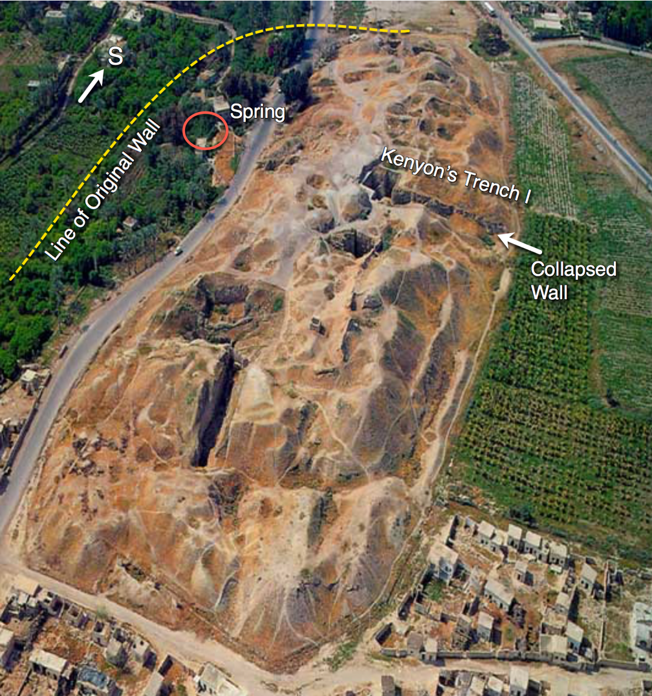
Tell es-Sultan (looking south). The circle shows the location of the spring; the dotted line shows the approximate extent of the lower wall that enclosed the spring beginning in the Early Bronze Age. Photo courtesy of Rohr Publications.
1. Destruction of the mound: Occupation Gaps, Erosion, and Mining. Though rainfall is seasonal and limited in this area of the Jordan Valley, it can be heavy on rare occasions. Over the millennia rain has scoured the mound when it was uninhabited, washing much of the upper levels of archaeological remains down the slopes to the base where the nitrogen-bearing mudbrick soil has been harvested by farmers through the ages to fertilize the surrounding fields. They have also, no doubt, extracted much volume from the upper levels of the mound.
Kathleen Kenyon found multiple gaps in occupation spanning nearly ten thousand years on the Jericho mound. Severe erosion of the mound occurred during these periods of abandonment, which she believed occurred when the spring at the eastern base of the mound dried up—perhaps blocked by earthquake. Because of the aridity of the area the only means of sustaining crops in the fertile fields was by irrigation from the spring. When the spring dried up, crops withered, the people moved away, and the mound eroded.
Only during periods of occupation was it possible to protect the structural integrity of the buildings and the defensive structures against rain and wind. This is why the ancients continuously plastered exposed mudbrick and rampart surfaces.
2. Destruction of the mound: subsequent occupation. New settlers often destroyed earlier structures in the process of clearing for new construction. They dug up and reused stone foundations of destroyed and abandoned buildings. They also recycled the mudbrick debris of collapsed buildings to form new brick. Sometimes this brick material contained datable fragments of broken pottery.
Broken pottery sherds found their way into the narrow lanes and streets contributing to an accumulation of life debris. This steady accretion required the occupants of houses to raise their floor levels successively to match or exceed the level of the streets to prevent rainwater from flowing into the home. Sometimes walls and mudbrick structures collapsed and had to be rebuilt at ever-higher levels, thus continually elevating the mound with time.
The steady accumulation of this debris explains why diagnostic pottery sherds are so abundant within the soil matrix of a tell. Sherds were incorporated into the material of mudbrick structures in subsequent occupations while much of it washed down from above into layers of erosion debris at the foot of the mound.
The longer the occupation in any period the greater the concentration of sherds from that period. This is an obvious and important point: short-lived occupations contributed significantly fewer diagnostic sherds to the soil matrix than long-lived occupations.
3. Destruction of the mound: excavations. Another cause of destruction of occupational strata at Jericho has been the work of successive excavators. When the overburden of a target stratum is removed to the dump site the strata above are gone and can no longer be assessed by later investigators (unless balks are preserved).
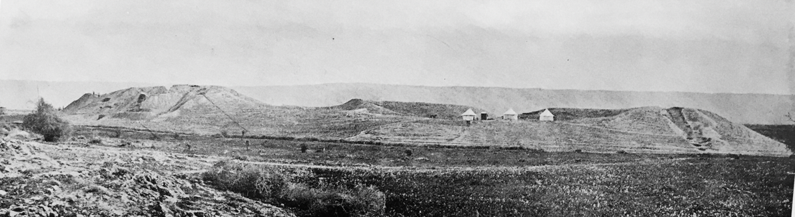
The mound of Jericho (looking east ca. 1908). The Transjordan Plateau is in the distance. (Note the natural desolation of the unirrigated landscape)

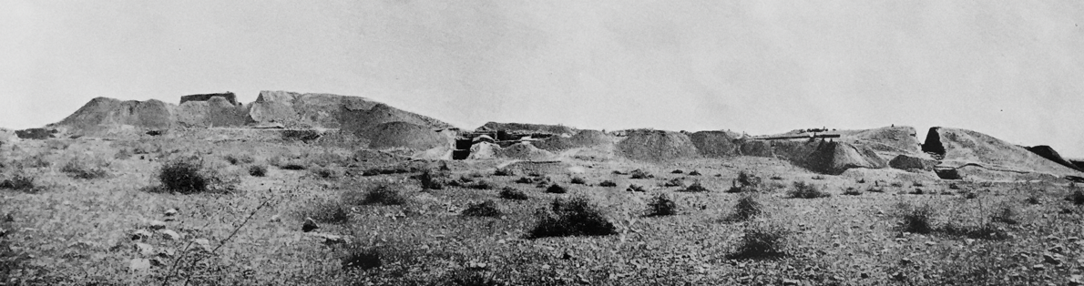
The same view at the end of the 1909 Sellin/Watzinger excavation season. Compare the extensive excavation on the north end of the site (left) and the deep trench to the right.

Kenyon’s composite drawing of previous excavations show how much of the mound was cut away by the three major expeditions (including her own). Ernst Sellin and Carl Watzinger (1907–1909) exposed large areas on the northern and central parts of the tell. The combined removal of material by Sellin/Watzinger (1907–1909), John Garstang (1930–1936), and Kathleen Kenyon (1950s) has very little of the mound undisturbed by investigators.
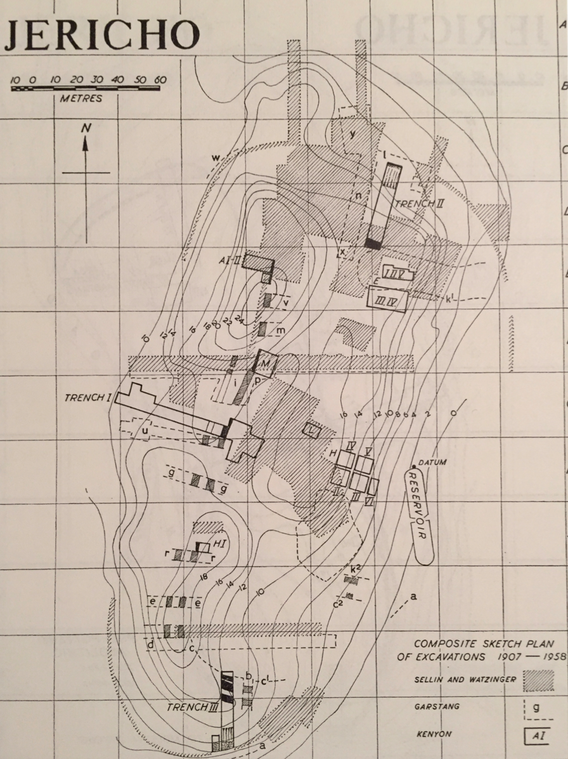
Composite of excavations 1907–1958 (Kenyon 1981, fig. 1). Reproduced by the permission of the Council for British Research in the Levant, London—pending.

GLEANINGS FROM THE EARLY EXCAVATIONS
The first large-scale excavation at Jericho was undertaken by Ernst Sellin and Carl Watzinger, who led an Austro-German excavation at Tell es-Sultan between 1907–1909. The excavation discipline (control of stratigraphy and typology) was rudimentary at that time but the participants were highly competent in their fields, particularly Felix Langenegger (a government master builder from Dresden who had experience in the excavations of Babylon).
The usefulness of this early effort was limited since the excavators had no basis for dating the strata they exposed, nor did they grasp the vital importance of associating artifacts with corresponding occupational strata. However, their records have since permitted a reassessment of some of their finds. Little noted in most studies of the mound’s history (but highly significant), are Iron I pottery forms depicted in their reports—discussed below.
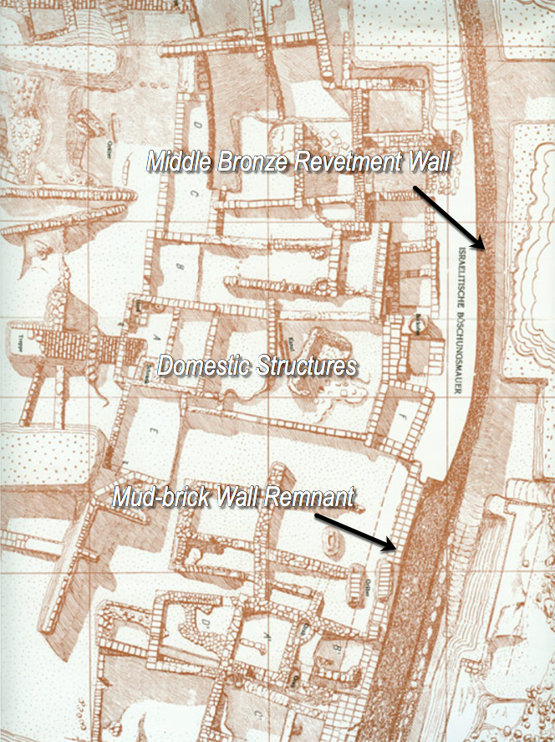
Sellin’s and Watzinger’s drawing shows the outer Cyclopean Wall and domestic structures built upon the rampart. (View looking southwest)

British archaeologist John Garstang excavated the site from 1930 to 1936. The pottery typology database had evolved considerably by his time, but his stratigraphic control was poor, resulting in much guesswork. Garstang’s conclusions supportive of a ca. 1400 BC conquest stratum have been rejected by most scholars.
The work of Kathleen Kenyon of the British School of Archaeology in Jerusalem in the 1950s was comprehensive and acclaimed for her stratigraphic and typological control. She found that the earliest remains at the lowest levels of the mound were about 12,000 years old. She attested very long occupation phases during Neolithic and Chalcolithic eras. Though the present mound occupies only several acres, the total inhabited area surrounding the mound may have extended out to about ten acres in the Bronze Ages.
Kenyon’s work consisted primarily of soundings designed to establish the “history” of the site in vertical cross-section. Her method contrasted with earlier approaches that focused on uncovering large lateral areas in specific periods of interest.
One of Kenyon’s major objectives in undertaking the excavation of Jericho was to determine if there was evidence to support the Joshua account. This was of particular interest since her predecessor, John Garstang, had dated an upper double wall on the summit to ca. 1400 BC, seemingly in agreement with the early exodus/conquest theory based on 1 Kgs 6:1. Kenyon, however, could find no evidence to support this dating. (This wall actually dates to the Early Bronze Age.)
Archaeologists are gratified to find evidence of destruction on a mound. Indications of fire and collapsed walls that typically seal datable artifacts on the floors of destroyed buildings can allow for a narrow dating of the destruction event. Kenyon found evidence of one fiery destruction dating to ca. 1550 BC. The only other dating context she described was a floor datable by a single Late Bronze Age juglet.
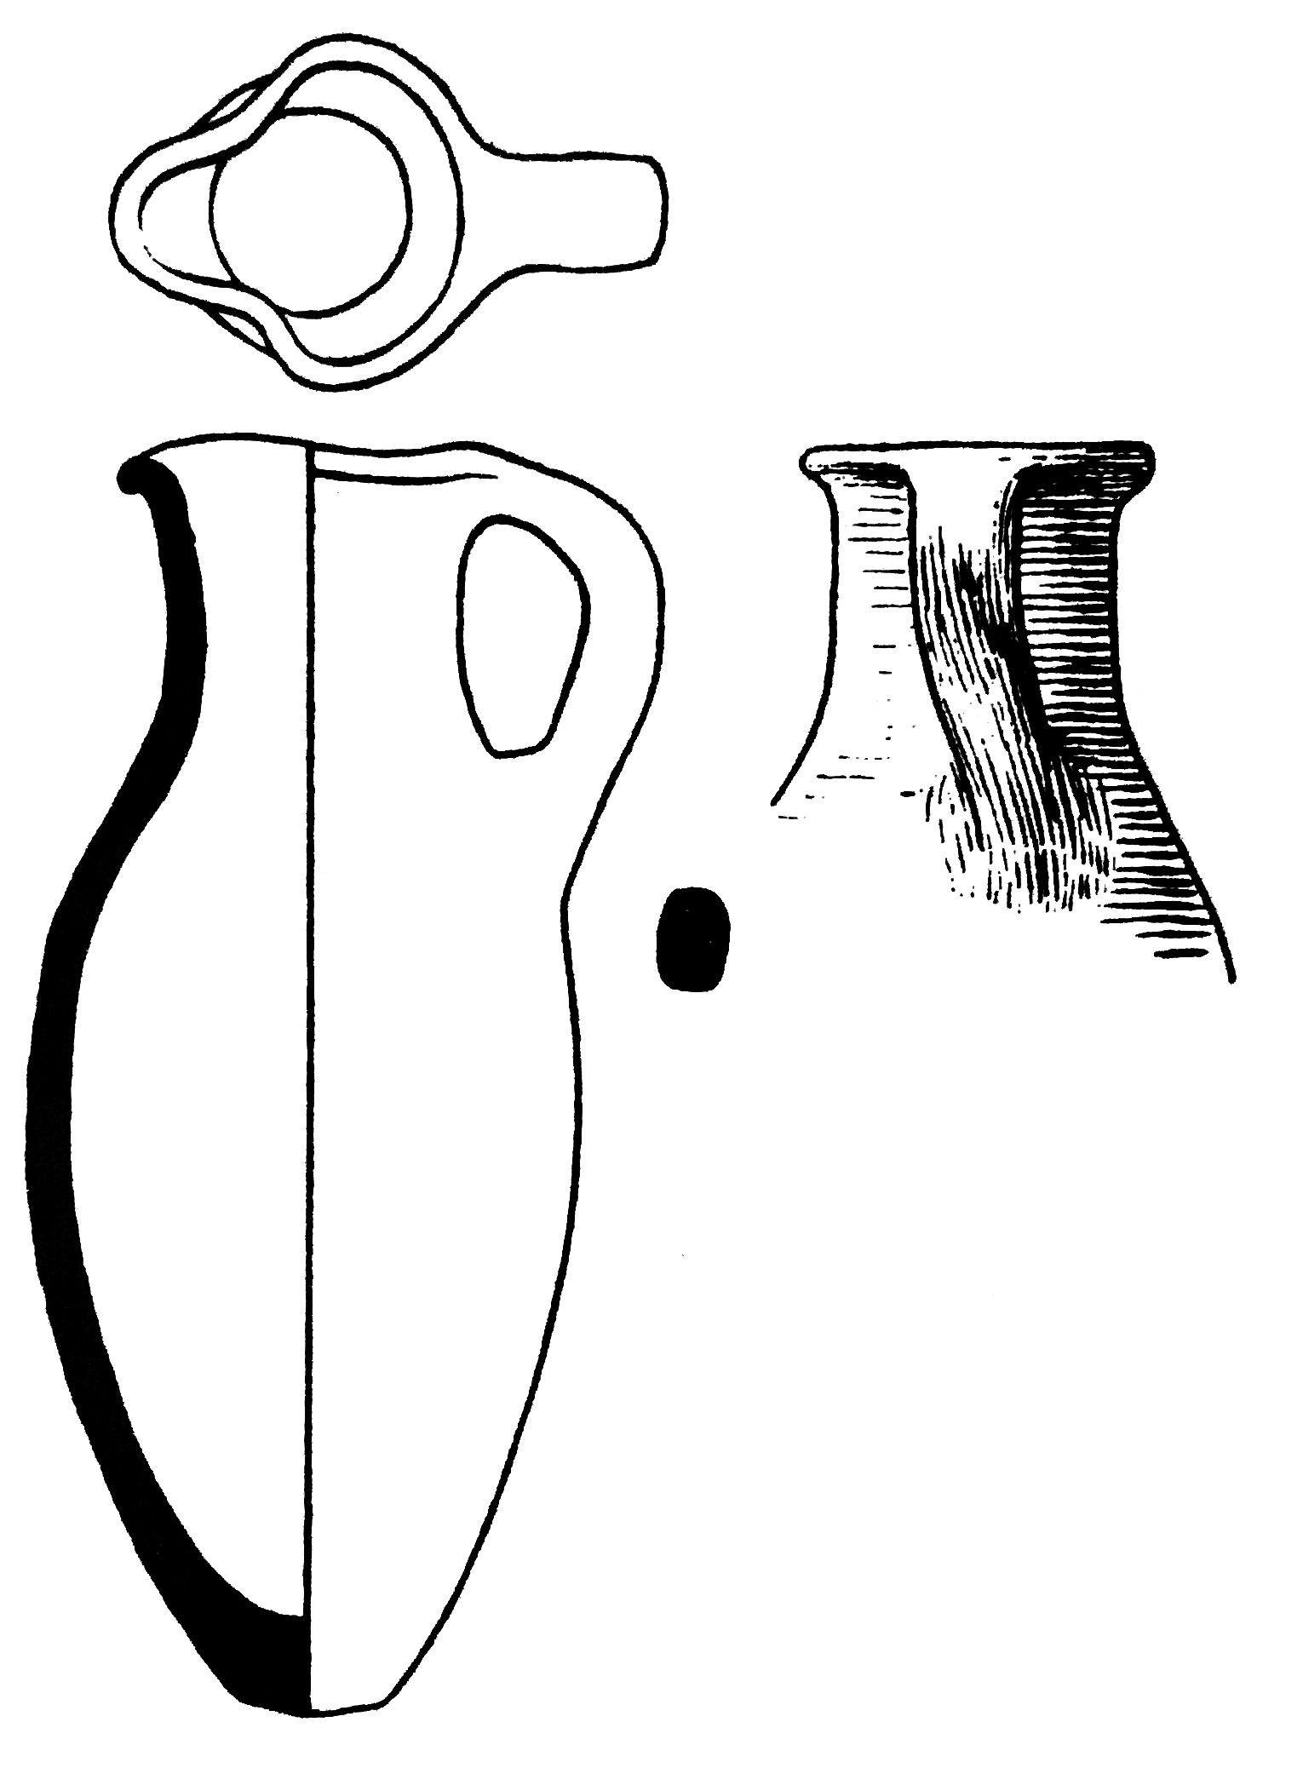
Kenyon’s Late Bronze Age Juglet found in situ. Reproduced by the permission of the Council for British Research in the Levant, London—pending.

Complementing limited dating contexts on the mound was Kenyon’s discovery of cemeteries a short distance from the tell (mainly to the north). She investigated 507 tombs (mostly shaft type) containing datable grave goods that illuminated some but not all periods when the tell was presumably inhabited or periodically visited.
Earlier, in the 1930s, Garstang also discovered a number of tombs. Some contained Middle Bronze and Late Bronze Age materials in the same burial chamber. These few Late Bronze materials supported his deduction that the site was occupied during this period. Whether there was continuous occupation on the site during this period or whether people only brought their dead for burial cannot be determined.
No burials dating to the Iron I have been found. And only three multiple-interment tombs of the Iron II period (1000–586 BC) were found in the vicinity of the tell with contents dating to between the 10th and 7th centuries BC.
This limited evidence of occupational periods is supplemented by drawings of Iron Age pottery discovered by Sellin and Watzinger (1907–1909). These materials were not critically examined until 1976 when Helga and Manfred Weippert reassessed the reports of Sellin and Watzigner and discovered renderings of Iron I and II pottery forms found in the vicinity of an Iron II structure called the Hilani on Spring Hill.
Nicolò Marchetti, co-director of the Joint Italian-Palestinian expedition (1997–2000), confirmed the findings of the Weippert study and agreed that the Iron II material dated to the 10th–9th centuries BC. He also confirmed that the Iron II material was preceded by an Iron I occupation level. Lorenzo Nigro concurs, suggesting the Iron I material detected at a few places on Spring Hill dates to the 11th century BC.
The speculation of the Weipperts that the site was continuously occupied from the Iron I to the time of the Babylonian period is not consistent with the biblical sequence. The question is whether the pottery forms can be parsed into two discrete Iron Age occupations. If the Iron I pottery forms date to the Iron IA (1200–1140 BC) and the remaining Iron II forms are dated to the 9th century, or later, the biblical sequence can be accommodated. There is no other explanation that would permit the biblical account to be historically accurate.
In the light of evidence at other exodus/conquest sites, the present study hypothesizes that the Iron IA occupation was short lived; and that it was destroyed by the Israelites. If the fallen wall depicted by Kenyon in Trench I dates to this period it potentially supports the biblical event of Joshua’s destruction of the site.

INTERPRETIVE CHALLENGES
It should be evident from this brief survey of the results of successive excavations at Tell es-Sultan that very little stratified evidence is available to document successive occupation levels from the end of the Middle Bronze Age to the Iron IIC. The duration of occupation periods can only be assumed based on what has been found (relying on material usually out of context). Determining when the site was not occupied has been based on what has not been found.
Because of the poor stratigraphic mapping of the early excavations and the extensive damage subsequently, projecting periods and durations of occupation is less secure than at other archaeological sites. Taken together, an assemblage of different types of artifacts in a single spot can narrow the possible range of dates for that locus. However, finding assemblages in context at Tell es-Sultan has been rare, when compared with other sites.
Certain date-specific aspects of an artifact can narrow the range of dates for the object. Garstang found datable scarabs in two tombs. The names of Thutmose III (1479–1425 BC), Hatshepsut (1479–1457 BC), and Amenhotep III (1391–1353 BC) have been attested. These finds provide relatively narrow dating of extramural burials in the 14th century BC and later. And yet, of the more than 400 scarabs found at the site, only a few are datable by reference to Egyptian titles or names.
The most prominent feature of Tell es-Sultan is the fortification system defined by layered earthen ramparts. A final addition to the earlier Middle Bronze Age fortifications occurred in the period ca. 1650–1550 BC. In that period an additional layer of rampart was added resulting in a vast mound of upward-sloping earth interleaved with crushed limestone and engineered features to provide drainage. The purpose of this structure was to prevent the close approach of battering rams and siege engines.
To contain the weight of the rampart a stone wall, referred to as the Cyclopean Wall, was built upon bedrock with limestone boulders tapering upward against the face of the earthen rampart to provide a supporting girdle for the mound. The Cyclopean Wall leaned inward against the mass of earthen fill reaching a maximum height of 8 m (26 feet). On its crest successive builders from the Middle Bronze Age to the Iron II presumably built and maintained mudbrick walls. Evidence of a second (upper wall) dating to the Early Bronze Age appears near the summit and an upper casemate wall existed in the Iron II period, according to Lorenzo Nigro.
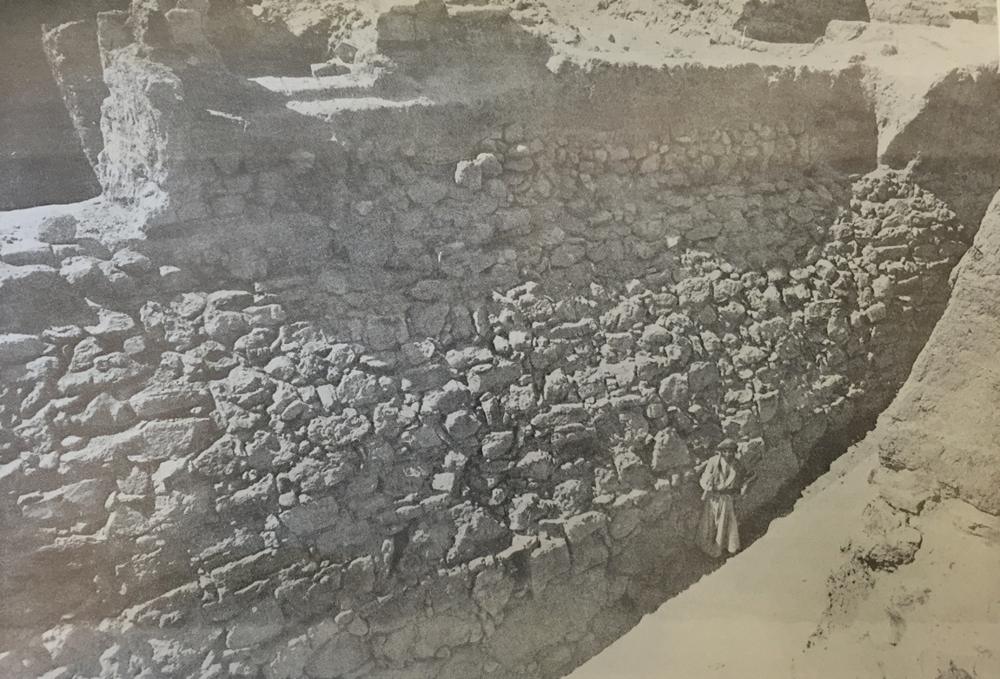
Outer face of the Cyclopean Wall exposed to its base by Sellin and Watzinger (ca. 1909). Notice the remnant of a mudbrick wall on top of the Cyclopean Wall. In this section of the wall, the excavators obviously removed Kenyon’s collapsed wall debris without noting its significance. Compare Kenyon’s cross section of Trench I below to appreciate the scale.

The work of the Italian-Palestinian Expedition to Jericho (1997–2016) has built upon the findings of earlier excavators to produce successive city plans and to synthesize the history of occupation at Tell es-Sultan. The excavators now seem more certain than Kenyon that Late Bronze Age and Iron II occupants constructed mudbrick walls on top of the Cyclopean Wall. On his city plans Nigro (apparently) depicts a mudbrick wall atop the Cyclopean Wall in the Middle Bronze II and Iron II periods. (He does not offer a proposed city plan for the Late Bronze Age.)
Nigro and his colleagues have found evidence of Late Bronze Age layers at locations around the tell but not on the top of the mound; and no architectural evidence has been specifically identified as Iron I. The only Iron II structures found by Kenyon and Nigro have been found outside the lower wall. Roman, Hellenistic, and Byzantine occupations with datable foundations have been found in only a few places.
With this limited evidence, occupational periods and duration remain inferential in the period of the 13th through the 9th centuries BC. Nigro says it is impossible to reconstruct the history of the city during the Iron II period (1000–586 BC).
Lacking any further information, the Bible may provide the only clue as to what was happening at Jericho in the period of the 12th through 9th centuries BC.

JERICHO: THE “BIBLICAL STRATIGRAPHY” AND THE EVIDENCE
According the book of Joshua, the Israelites marched silently around the city for each of six days as priests blew rams’ horns. On the seventh day they marched seven times around the city. At the sound of a long blast on the rams’ horns the troops shouted and “the wall fell down flat.”
The troops went up over the collapsed wall-debris, onto the rampart, and into the town destroying all in their path. (Evidently, the wall that was toppled by an earthquake was a lower mudbrick wall that stood upon the Cyclopean Wall.)
Surveying the smoking ruins, Joshua cursed any man who would rebuild Jericho:
Joshua laid an oath on them at that time, saying, “Cursed before the Lord be the man who rises up and rebuilds this city, Jericho. At the cost of his firstborn shall he lay its foundation, and at the cost of his youngest son shall he set up its gates” (Josh 6:26, ESV).

The ruins of Jericho, now under a divine ban, was to be left as a perpetual sign of God’s judgment of the wickedness of the Canaanite culture. However, Hiel of Bethel defied the curse and rebuilt Jericho.
In Ahab’s time [ca. 871–852 BC], Hiel of Bethel rebuilt Jericho. He laid its foundation at the cost of his firstborn son, Abiram, and he set up its gates at the cost of his youngest son, Segub, in accordance with the word of the LORD spoken by Joshua son of Nun” (1 Kgs 16:34, NIV 1984).

If this sequence is correct, the only occupation prior to the 9th century BC should be the town Joshua destroyed. And yet some scholars have inferred from Judges 3:12–26 that Eglon, king of Moab in the time of the judges, built a palace at Jericho. This is based on Deut 34:3, that which appears to associate an anachronistic reference to “the city of palms” with Jericho. The Judges text does not necessarily mean Eglon built on the ruins of the Jericho mound.
1. An Iron IA Occupation: The Pottery. Helga and Manfred Weippert identified 55 pottery forms in the Sellin-Watzinger publications, which they dated to the Iron I and II periods. They concluded that after a short-lived Late Bronze Age occupation, Tell es-Sultan was reoccupied in the 12th/11th century BC. They believe the main mass of the Iron Age settlement on the upper mound was exposed by Sellin and Watzinger and that the area of Spring Hill was populated in the Iron I and II periods.
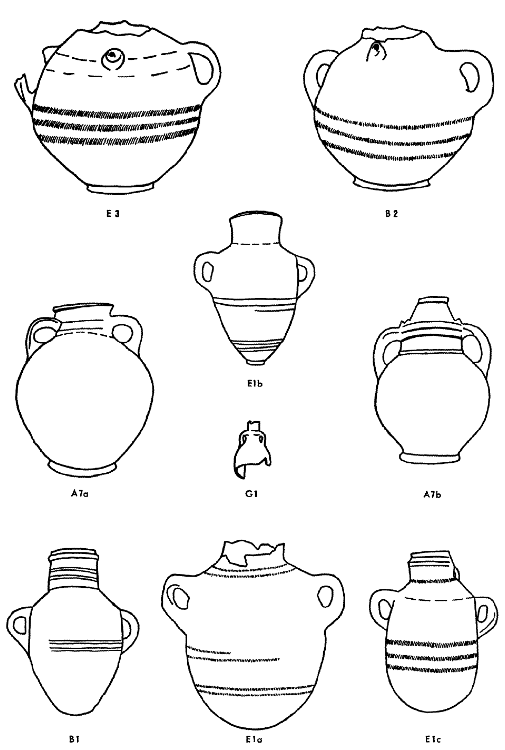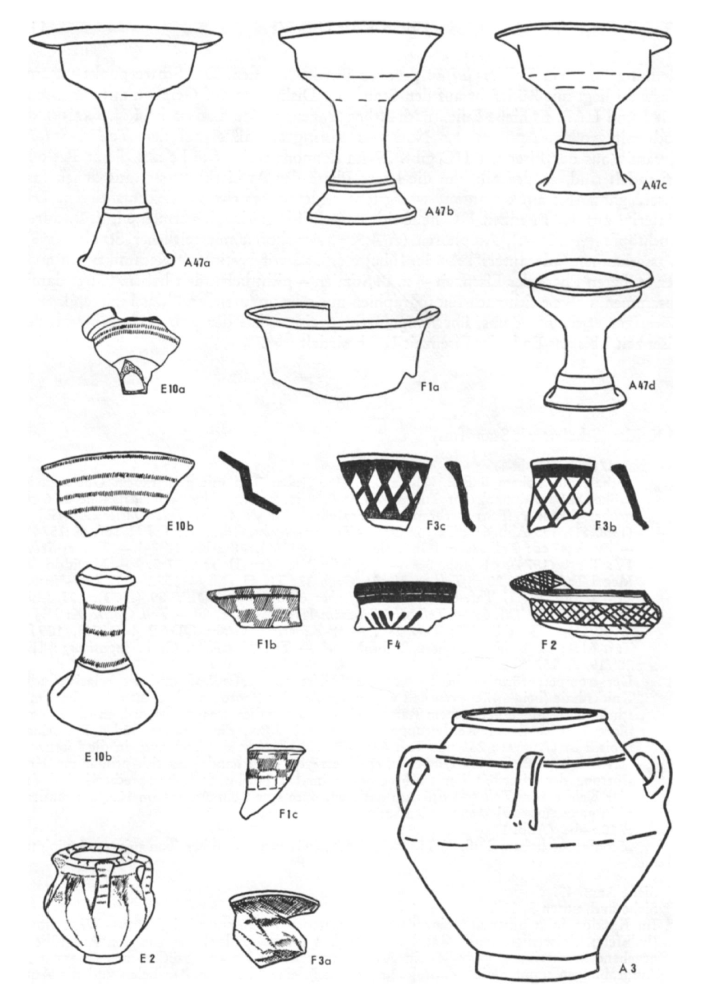
Representative Iron I and II vessels (Iron I examples include E1b, B1, E1c, E10a & b, E2).
Used with permission. (An additional plate is not depicted here.)

Robert Mullins dates the pottery forms above to the Iron I (meaning the 12th–11th centuries BC) and the Iron IIA (10th–9th centuries BC). In personal communications with this author, Mullins concludes that “the biggest takeaway might be that there is pottery here that would agree with an Iron I conquest under Joshua and an Iron IIA city rebuilt by Hiel the Bethelite.”
Nigro is confident Jericho was occupied by the 9th century BC. In that period the city was once again surrounded by a mudbrick wall built upon the Middle Bronze Age Cyclopean Wall. This period of reoccupation agrees with 1 Kgs 16:34.
From the 9th century BC the city was intensively inhabited, spreading to the lower western, northern, and southern slopes of the mound. Nigro mentions the construction of slab-paved stairs built to allow ascent to the 15-m-high summit.
It is important to note that the Iron II wall builders did not expose the outer face of the Cyclopean Wall, but left it buried by the natural erosion material that incorporated the earlier wall collapse identified by Kenyon in Trench I. If this is the case, Kenyon’s collapsed wall pre-dates the Iron II mudbrick wall.
2. “The wall fell down flat” (Josh 6:20). There is a striking archaeological feature discovered by Kathleen Kenyon toward the western end of her Trench I. It is a collapsed mudbrick wall identifiable as a mass of red brick debris lying at the base of the Cyclopean Wall. Within the decomposed brick Kenyon found embedded fragments of datable pottery.
Her cross-section drawing (below) brings to mind the Joshua account of how the walls collapsed outward and how the Israelites advanced up the slope of the collapsed wall debris into the city (Josh 6).
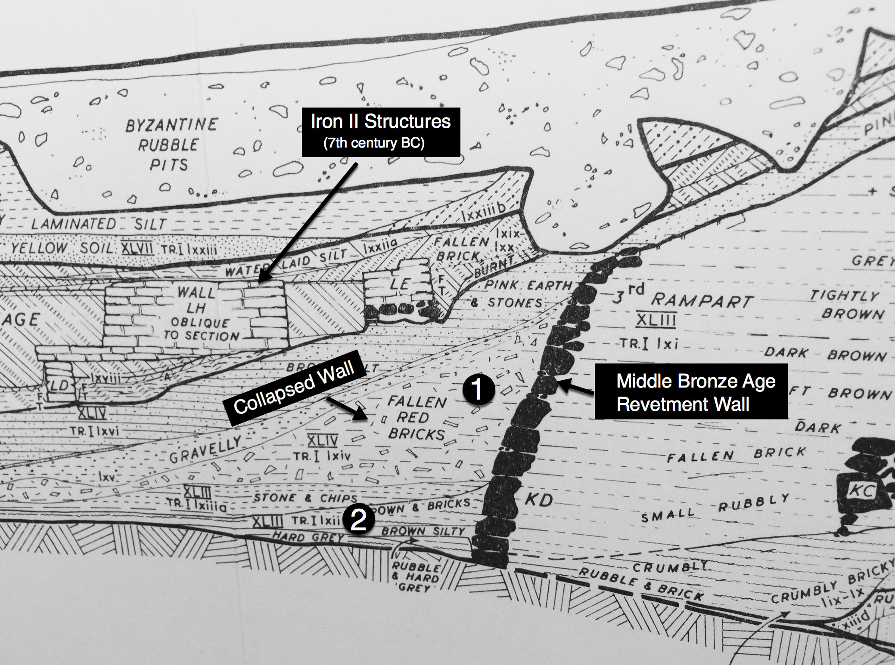
Outer/western end of Trench I excavated by Kenyon (annotations mine). Looking north.
Reproduced by the permission of the Council for British Research in the Levant, London—PENDING.

3. Dating markers. Kenyon speculated that this collapsed wall dated to the Middle Bronze Age destruction ca. 1560 BC. However, she offered no supporting evidence for this opinion. Bryant Wood dated the wall collapse to ca. 1400 BC. And Lorenzo Nigro allows that the collapsed wall may date to the Iron II.
The material identified in the graphic above as #1 is the collapsed brick wall material that Kenyon designates as Stage XLIV, Phase lxiv. Pottery sherds beneath this phase (#2, Stage XLIII) date to the Early/Middle Bronze Age; this latter material lies near the foundation of the Cyclopean Wall.
The dates of the diagnostic pottery sherds found in the strata below and above the fallen brick sandwich the possible range of dates for the construction of the collapsed wall.
It is necessary to study closely Kenyon’s drawings to detect the successive strata and to discriminate between the fallen brick locus and those loci immediately above and below it.
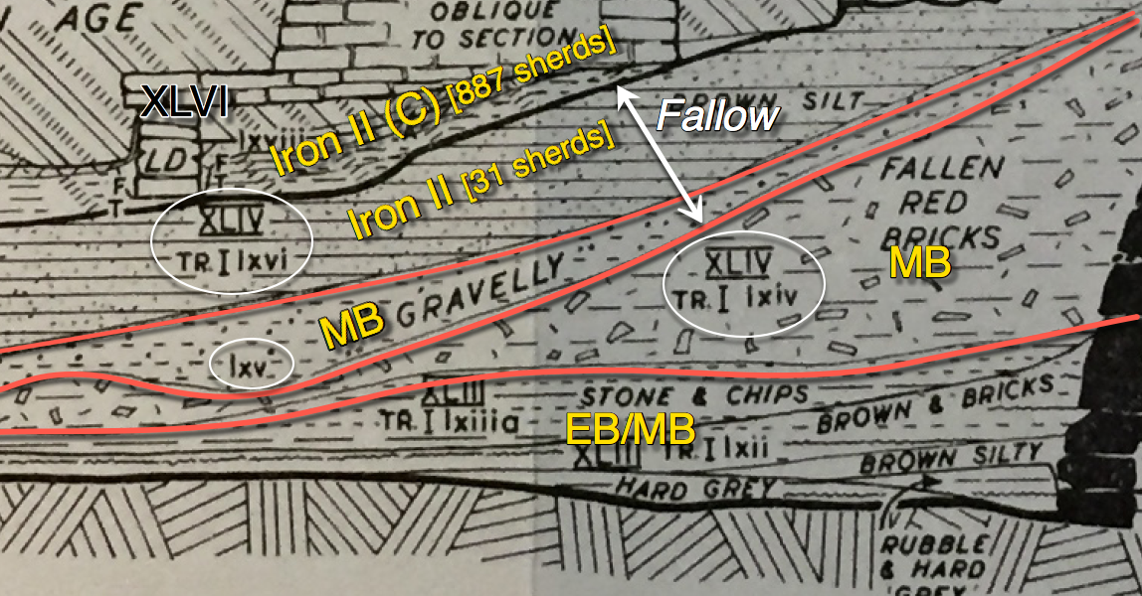
Dates of latest pottery sherds found in successive strata in the western end of Kenyon’s Trench I. Capital letters (e.g. XLIV) designate Stages; lower case letters (e.g. lxiv) specify Phases (distinctive strata). Kenyon (1981, pl. 236). (Annotations are mine.) The specific Iron IIC annotation in Stage XLVI (887 sherds) is based on Kenyon’s dating of the earliest Iron Age material to the 7th century BC. The latest material in the fallow stratum (lxvi) contained 31 sherds broadly identified as Iron II. (Reproduced by the permission of the Council for British Research in the Levant, London—PENDING.)

Kenyon’s method of designating “Stages” suggests that Phases within each Stage all date to the same period. But they do not. In the above graphic the most important Stage for present consideration is Stage XLIV. This stage includes three strata or phases: Phase lxiv (the fallen brick locus—i.e. “Tr. I lxiv”, designating Trench I, locus lxiv), the “gravelly” Phase lxv, and the “brown silt” Phase lxvi. These are distinctive strata laid down in successive periods. A total of only ten diagnostic sherds are illustrated in the drawings in Jericho V (figs. 22 and 23) for these three strata. However, 76 (or 77) total datable vessel sherds were actually identified in these three strata.
Representative sherds of only four datable vessels appear within the fallen brick (all Middle Bronze Age). In the immediately overlying gravelly stratum only one sherd was found (Middle Bronze Age). In the next overlying Phase (Tr.I lxv) there appears to be a mix of sherds from three periods. They include sherds from 39 Middle Bronze vessels, one or two from the Late Bronze Age, and 31 from the Iron II.
4. The collapsed wall: Dating it to the 12th century BC. Archaeologists commonly date a stratum by the latest diagnostic sherds (or whole vessels) that can be associated confidently with the stratum. However, the context here does not allow a definitive date of the fallen brick wall. The actual date of the brick could be significantly later than the latest datable diagnostic artifact associated with it.
The fallen brick matrix contains four Middle Bronze Age sherds, and no Late Bronze nor Iron I/II material. The absence of Late Bronze or Iron I sherds in the brick material is not statistically significant, given the relative abundance of Middle Bronze material within the soil. Late Bronze material is rare, lending support to the belief that the mound was not inhabited in the 13th century BC.
Almost 7,000 datable pottery sherds were logged for Trench I. Of this number Kenyon/Holland counted more than 500 Early/Middle Bronze sherds compared with 18 dating to the Late Bronze Age (and only one or two in a locus above the collapsed wall). There appears to be no Iron I material identified in Trench I.
If the wall was constructed in the Iron IA, the builders would have used soil for brick containing a far higher statistical concentration of Middle Bronze vessel fragments than Late Bronze. No accumulation of Iron I material would have developed if the first task of the newly arrived Settlement people was to construct a defensive wall. Therefore, one should not expect to find Iron I sherds within the brick matrix.
Considering the extended fallow period immediately above the fallen wall, it seems unlikely the wall could date to the Iron II. Nearly 2,000 Iron II sherds were found in Trench I. Given the presumed lateral extent of the occupation and its duration (arguably commencing with the 9th century), one might expect to find some 9th century or later Iron II material in the brick or the erosion layer above if it dated to the Iron II period. Also, if the fallen wall dates to the Iron II, one might expect the erosion layer at the base of the Cyclopean Wall to contain some Iron II material (i.e. Stage XLIII beneath the fallen wall represents material accumulating during the life of the wall). However, the latest material found there is Middle Bronze Age. It seems likely the fallen wall and the fallow period of erosion immediately above it both pre-date the Iron II.
It also seems unlikely that the fallen wall dates to the end of the Middle Bronze Age. The erosion layer immediately above the wall seems too thin to represent deposition of almost 700 years (1550 BC to the 9th century BC) before an Iron II wall was constructed. Nor does it seem likely that the fallen wall dates to the Late Bronze Age, given the limited evidence of Late Bronze Age occupation.
For several reasons, the date of this wall best fits the Iron IA. The biblical account and the evidence agree that the wall collapsed as the result of an earthquake. There is no other biblical reference to an earthquake before ca. 750 BC. The collapsed material formed a ramp to the top of the 25-foot-high Cyclopean Wall for the Israelite warriors to gain the rampart and enter the town, as described in the Joshua account.
The Bible specifies a subsequent period of abandonment; this is attested by the erosion layer above the wall material, accounting for the passage of perhaps 300 years. It seems more than irony that this picture of the biblical account has been undisturbed until the 20th century.
After Jericho, the Israelite army proceed to Ai, which they destroyed ca. 1135 BC. Here the relevancy of evidence of a biblical conquest at other biblical sites dating to this time lends support to a date for the collapsed wall at Jericho.

THE FALL OF JERICHO: A RECONSTRUCTION
Given the dramatic influx of new people into the highlands of Canaan in the early 12th century BC it is reasonable to assume new settlers would have found their way to the ruins of Jericho (which may have lain fallow for one hundred years or more). The site had a copious water source; there were extensive alluvial fields capable of feeding a large population; it was strategically located at the nexus of commercial roads; and it had an elevated mound with exposed foundations of ancient walls and ramparts requiring minimal effort to construct nearly impregnable defenses. The construction of a lower mudbrick wall was likely the first order of business.
The Bible records that Joshua sent spies from Abel-Shittim across the Jordan River to Jericho—14 miles west. The spies lodged in the inn of Rahab who assisted in their escape after their presence had been discovered by the king of Jericho. Rahab provided some vital intelligence to the spies: the people of the land west of the Jordan were in great fear of the Israelites, having heard what Yahweh had done to bring the Israelites out of Egypt to their present circumstances as masters of the Transjordan.
Encouraged by this information, Joshua and the Israelites moved their encampment from Abel-Shittim to the shore of the Jordan River, then in flood stage. As they prepared to cross, the waters were cut off by an earthquake that likely collapsed the bluffs lining the river 18 miles upstream near Adam. Israel crossed the bed of the river on dry ground.
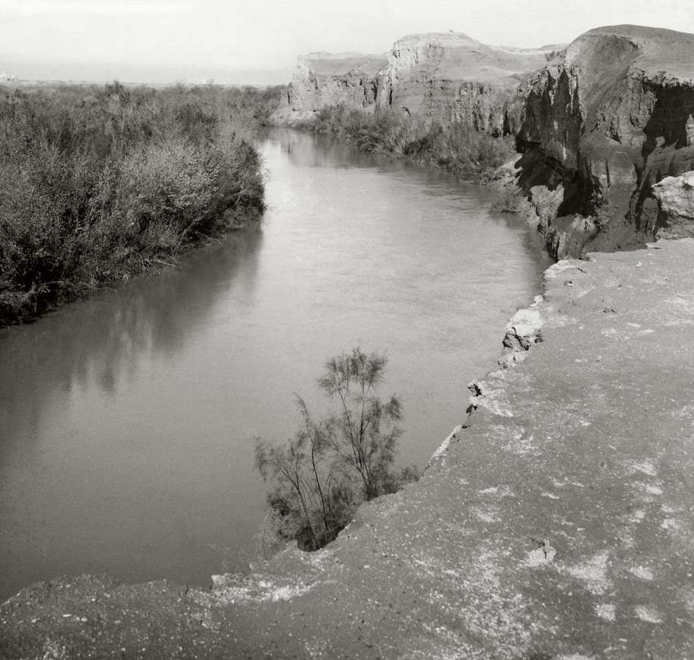
Bluffs along the Jordan, view to the north, 1910–1920 (photo by G. Eric Matson,
Library of Congress). In Road to Jericho, Jordan, etc. Looking up the River Jordan. LC-matpc-01017.

The Israelites encamped on the plains of Jericho centered on the assembly point of Gilgal. They kept the Passover on the evening of the fourteenth day of the first month and harvested ripe grain from Jericho’s fields. (They would live within this sea of grain for several years during the conquest of the highlands.)
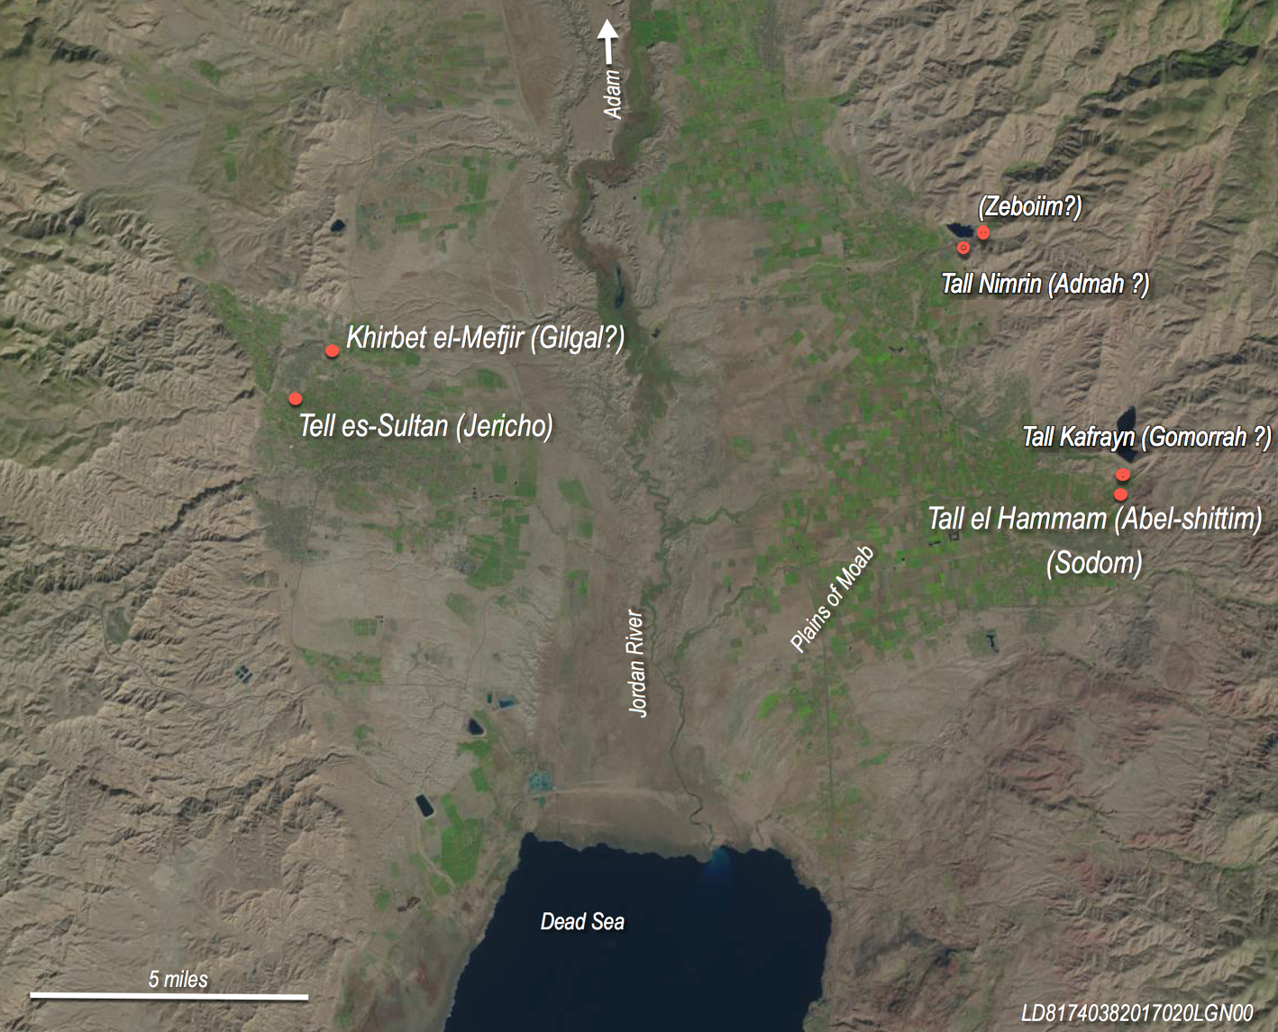
Disposition of Jericho, Gilgal, Adam, and the Israelite encampment on the Plains of Moab.
Software courtesy of the U.S. Geological Survey.
Not many days after crossing the Jordan the Israelites marched around Jericho. On the seventh day the high walls collapsed outward in a tectonic event evidently related to that which blocked the Jordan River days earlier. The Israelites climbed up the fallen wall material onto the rampart and proceeded to destroy the inhabitants and set the town on fire.
The total population of the Israelites probably numbered 20,000 to 25,000. A population of this size could be fed from the fields as long as they maintained the irrigation system.
From the encampment they continued to launch military forays up into the highlands for several years until they had neutralized any unified threat capable of driving them out of the land (many indigenous peoples continued to live in the land). When they had achieved this, the Israelites began to occupy their allotted lands as the period of the judges began.
In conclusion, there is no definitive evidence at Tell es-Sultan that can corroborate this reconstruction of the Joshua account dated to the latter 12th century BC. The supporting evidence is inferential. It is accommodated by the discovery of pottery forms dating to the Iron I, a collapsed wall that may date to this period, and an erosion layer above this wall that may suggest abandonment of the site for a period of time.
This limited basis for visualizing a biblical conquest at Jericho in this period would be far-fetched were it not for widespread evidence supportive of this chronology at other biblical sites like the Wadi Faynan (Lowland Edom), Heshbon, Dibon, Aroer, Ai, Bethel, Gibeon, Hebron, the Mt. Ebal altar, Shiloh, Taanach, and others. Every biblical site with datable evidence either accommodates or establishes a synchronism between the biblical events of the exodus/conquest and judges and the archaeological evidence of the 12th and 11th centuries BC.

Review:
The article is a bit too long to be considered by most journals. Most will not even entertain a submission of over 8,000 words (this word-count includes footnotes).
Above and beyond the word-count, you seem to be trying to do too much with this article. Your title indicates you will be discussing the timing of the conquest of Jericho, and the abstract says “this article explores limited evidence of a 12th century occupation at Jericho.” You do much more than this, however. The article should be fairly substantially revised/shortened before it can be published. It seems you are trying to publish a chapter of a book, rather than a focused study (which is what a journal article must be). I understand that you need to provide some background/context, but certainly not 20 pages (you don’t even mention Jericho until p. 20). I would recommend removing the section entitled: A BRIEF CASE FOR A 12TH CENTURY BC EXODUS/CONQUEST: A CONTEXT FOR THE BIBLICAL FALL OF JERICHO. You can cover *some* of this information in a footnote, or simply cite your article (or future work).
Another potential issue is the apologetic flavour of the article. Rather than try to defend the historicity of every word in the Bible, it would be wise to admit there is no easy way to reconcile certain passages. For example, now and again you might admit that “the Hebrew Bible contains conflicting information with regards to *blank*.” This would also gain you some sincerity points from potential readers.
There is no doubt that you are dealing with interesting and significant material and that you present a rather intriguing argument. There is a strong foundation to work with and with some revision it would likely be welcomed in numerous journals.

Potential Journals (in order of likelihood to accept):
If you choose to retain the apologetic nature:
-Journal of the Evangelical Theological Society (JETS)
-Bulletin for Biblical Research (BBR)
-Journal of Theological Studies (JTS)
If you change the overall tone / nuance the apologetic material:
-The Biblical Archaeology Review (BAR)
-Catholic Biblical Quarterly (CBQ)
-Journal of Near Eastern Studies (JNES)

Larry D. Bruce, “The Merenptah Stele and the Biblical Origins of Israel,” JETS 62.3 (2019): 463–93. Also available on Academia.edu.
This claim is based upon an as-yet-unpublished study by the author.
Avi Ofer, “Hebron,” NEAEHL, 2: 606–9.
Dates for the archaeological periods used here are those of the NEAEHL, 5: 2126.
Avi Ofer, “Hebron.” Compare Jeffrey Chadwick, “Discovering Hebron: The City of the Patriarchs Slowly Yields Its Secrets,” BAR 31:5 (Sept/Oct, 2005). See also Nadav Na’aman, “Hebron Was Built Seven Years before Zoan in Egypt (Numbers XII:22),” VT 31 (1981): 172–85.
See Barry Webb, The Book of Judges, NICOT (Grand Rapids: Wm. B. Eerdmans, 2012), 16. Efforts to establish a historical basis for the text have been stymied by the facts; nothing new and meaningful could be said that has not been rehearsed ad nauseum. (The problem in every case has been the chronology.)
Archaeologist and Jewish historian Nadav Na’aman (“Memories in the Old Testament” Ugarit-Forschungen, Internationales Jahrbuch für die Altertumskunde Syrien-Palästinas, Band 47 [Münster: Ugarit-Verlag, 2016], 135) observes that the conquest stories of Josh 6–11 are alien to the reality of Late Bronze Age Canaan (since most of the towns encountered by Joshua were not inhabited in that period); likewise, he says, the list of 31 kings of Josh 12 is alien to the 13thcentury BC and earlier. Most scholars assume that the conquest is a work of fiction framed by the biblical writers to have occurred in the Late Bronze Age, and therefore it must be fictional (since the facts don't agree with the events). To account for the existence of the narratives, many have concluded that the text is some sort of patchwork of later writers who were utterly ignorant of their true origins, were unwilling to record their origins accurately, or invented a story to undergird some political agenda. Scholarly literature commonly contains elaborate and imaginative reconstructions of how the biblical narrative arose. (Na’aman’s article is an example.) However, these convoluted speculations are entirely unnecessary if the conquest occurred in the Iron I, when the evidence aligns with the biblical account. It seems far simpler (using the Occam’s razor principle) to at least consider dates for the exodus/conquest events that align with the archaeological facts in the 12th century BC.
An observation Robert Bergen shared with this author in a personal communication.
James K. Hoffmeier, Ancient Israel in Sinai: The Evidence for the Authenticity of the Wilderness Tradition (New York: Oxford University Press, 2005), 53.
Israel Finkelstein, “Arabian Trade and Socio-Political Conditions in the Negev in the Twelfth-Eleventh Centuries B.C.E,” JNES 47, 4 [Oct, 1988]: 241–52). See also Amihai Mazar, “Archaeology and the Biblical Narrative: The Case of the United Monarchy,” in One God - One Cult - One Nation: Archaeological and Biblical Perspectives, ed. R. G. Kratz, (New York: Spieckermann. Beihefte Zur Zeitschrift Für die Alttestamentliche Wissenschaft, 2010), 31, n. 7.
Lawrence T. Geraty, “Hesbon”, NEAEHL 2: 626. Other biblical sites date no earlier than the 12th century BC (except perhaps Medeba which may date as early as the 13th century BC).
Joseph A. Callaway, “New Evidence on the Conquest of ‘Ai,” JBL 87, 3 (Sep 1968): 316.
Oded Lipschits, “Bethel Revisited,” in Rethinking Israel: Studies in the History and Archaeology of Ancient Israel in Honor of Israel Finkelstein, ed. Oded Lipschits, Yuval Gado, and Matthew J. Adams (Winona Lake: Eisenbrauns, 2017), 233. See also Israel Finkelstein and L. Singer-Avitz, “Reevaluating Bethel,” ZDPV 125 1 (2009): 33–8.
James B. Pritchard, “Gibeon,” NEAEHL, 2: 513.
Adam Zertal, “Has Joshua’s Altar Been Found on Mt. Ebal?” BAR 11, 1 (1985): 26–35, 38–41, 43; and Ralph K. Hawkins, “The Iron Age I Structure on Mt. Ebal: Excavation and Interpretation,” BBR Sup. 6 (Winona Lake, IN: Eisenbrauns, 2012), 221.
Albert E. Glock, “Taanach (Place)” ABD. Amnon Ben-Tor, “Jokeam (Place),” ABD. Dale Manor, “Tirzah (Place),” ABD.
There is no mention in Joshua/Judges of the Israelites contending with newly arriving people groups. What about the Philistines?
Amihai Mazar, “Beth-Shean: An update to Vol. 1, 214–35,” NEAEHL, 5:1620. Mazar says, “The circumstances of the violent destruction of stratum S3 [at Beth-Shean] and its exact date remain unknown, but it may have occurred sometime during the days of Rameses IV, V or VI.” (Ramesses VI reigned ca. 1143–1136 BC.)
Aaron A. Burke, “Left Behind: New Kingdom Specialists at the End of Egyptian Empire and the Emergence of Israelite Scribalism,” in “An Excellent Fortress for His Armies, a Refuge for the People,” ed. Richard E. Averbeck and K. Lawson Younger, Jr., 51 (University Park, PA: Eisenbrauns, 2020).
Israel Finkelstein, “The History and Archaeology of Shiloh from the Middle Bronze Age II to the Iron Age II,” in Shiloh: The Archaeology of a Biblical Site, by Israel Finkelstein, Shlomo Bunimovitz, and Zvi Lederman, ed. Israel Finkelstein (Tel Aviv University, 1993), 381–3; and Shlomo Bunimovitz and Israel Finkelstein, “Pottery,” in Shiloh: The Archaeology of a Biblical Site, 135.
Bruce, “The Merenptah Stele.”
Yigael Yadin, “Hazor,” NEAEHL 2: 603. A. Ben-Tor, “Hazor: An update to Vol. 2,” NEAEHL, 5:1769–76. Some claim the mutilation of statues of deities and kings in the ruins of Greater Hazor indicates a unique Israelite practice. However, that is not the case. K. Lawson Younger (Judges and Ruth, [Grand Rapids: Zondervan, 2002], 28–9, 47) points out that other conquering forces mutilated the statues of idols which they did not or could not carry off. The ancients believed that desecration of an idol forced the god to abandon its image, thus withdrawing its patronage of the conquered town.
Itamar Singer, “Merneptah’s Campaign to Canaan and the Egyptian Occupation of the Southern Coastal Plain of Palestine in the Ramesside Period,” BASOR 269 (Feb 1988), 3.
Monumental stone inscriptions found mainly in upper Egypt do not reference this development. And the archives of papyrus records (presumably vast in number) have not survived in the wet soil of the delta. Decades of excavations have found no papyri. In any case, the fall of Hazor may not have been a significant military/economic issue for the Egyptians. The strategic and economic importance of Greater Hazor was waning by the time the city was destroyed in the latter 13th century BC. Several lines of evidence suggest this, including the fact that the main commercial highway north and east to Damascus was rerouted well south of Hazor before the city was destroyed (Piotr Bienkowski, “The Role of Hazor in the Late Bronze Age,” PEQ [Jan-June 1987]: 50–61). The Egyptians may have been indifferent to the fate of Hazor in Ramesses’s advanced years (or it may have been outside the arc of his effective control, being some 30 miles north of the Jezreel Valley). Warlords from Amurru to the north may have sacked Hazor, an early sign, perhaps, of a growing restiveness that would lead to the end of the Late Bronze Age not many decades later. In any case, the destruction of Greater Hazor probably had no particular effect on the Egyptians; its fall may have strengthened their position. However, the rise of an indigenous Canaanite army and the appearance of the Israelites engaged in running battles across the Jezreel Valley would have been a matter of vital concern to the Egyptians since the Jezreel was a breadbasket for the Egyptians.
??
The date of Saul’s inauguration and the duration of his reign remains controversial [In other words: “The Hebrew Bible contains conflicting evidence about Saul’s inauguration and the duration of his reign”]. The dating of Diana Edelman (“Saul [Person],” ABD) is adopted here [perhaps explain which biblical passage you are accepting/rejecting]. See Robert D. Bergen, 1, 2 Samuel, NAC (Nashville: Broadman & Holman, 1996), 147–8.
There are a number of important studies of Judges that reflect insights from a literary perspective. For a review of recent scholarly works on Judges see Barry J. Webb, The Book of Judges, NICOT (Grand Rapids: Wm. B. Eerdmans, 2012), 35–53. He concludes that Judges is a prophetic book whereas Daniel Block, Isaac, Judges, Ruth, NAC (Nashville: Broadman & Holman Publishers, 1999], 51–4, believes the book of Judges is an extended sermon (or a series of sermons) in which the preacher selects his material to illustrate his thesis. By recognizing this thematic emphasis, Block says, the reader is prepared to “resist the fallacy of misplaced literalism” which would incline the reader to expect an accurate historical narrative in Judges when that was not the objective of the writer. K. Lawson Younger (Judges and Ruth, NIV Application Commentary [Grand Rapids: Zondervan, 2002], 22) believes each judge may symbolize an aspect of Israel’s experience. Thus, he says, the text illustrates the relevance of local events as though they were applicable to all of Israel. See also Trent Butler, Judges, WBC, rev. ed. (Grand Rapids: Zondervan, 2014).
The expression “all Israel” is best understood as a synecdoche (a figure of speech in which a part is made to represent the whole; e.g. Atlanta won by a touchdown).
Israel Finkelstein, “The History and Archaeology of Shiloh,” 381–2. In a personal communication with the author (Aug 14, 2019), he reaffirmed confidence in his original findings. He says there was limited activity at Shiloh in the Late Bronze IIA (which he dates to 1300–1200 BC) followed by a gap until the late 12th century. Scott Stripling of Associates of Biblical Research (ABR), who has renewed excavations at Shiloh, proposes a continuous occupation of the site from ca. 1485 BC to ca. 1050 BC. (ABR is committed to a ca. 1400 BC conquest in agreement with a literal reading of 1 Kgs 6:1.) The claim of continuous occupation of Shiloh from the 15th century BC to the Iron I is not substantiated. See the website abr@biblearchaeology.org (“The Shiloh Excavations, Archaeological Claims about Shiloh” and “The Israelite Tabernacle at Shiloh”). In a brief summary of a 2012–2013 excavation of the northern platform at Tel Shiloh, Reut Livyatan-ben Arie and Hananya Hizmi mention finds in the platform area dating only to the Middle Bronze and the Iron I with later Iron IIA/B materials. They found no structural remains of the Late Bronze period. (“The Excavations at the Northern Platform of Tel Shiloh for the 2012–2013 Seasons,” NEASB 62 [2017], 36–53.)
Joshua 13:1–3 contains the first mention of the Philistines in the conquest account (not counting Exod 13:17 and the anachronous references to Abimelech as the Philistine king of Gerar in Gen 26:1, 8, 15). When Joshua was very old, the LORD said to him, “This is the land that remains: all the regions of the Philistines and Geshurites, from the Shihor River on the east of Egypt to the territory of Ekron on the north, all of it counted as Canaanite though held by the five Philistine rulers in Gaza, Ashdod, Ashkelon, Gath and Ekron; the territory of the Avvites on the south” (NIV).
Kathleen Kenyon’s dating of a destruction level at Jericho at the end of the Middle Bronze Age (ca. 1550 BC) appears to be the most reliably dated termination of any stratum. The argument advanced by Bryant Wood (“Did the Israelites Conquer Jericho? A New Look at the Archaeological Evidence,” BAR 16, 2 [Mar/Apr 1990]) re-dates this destruction level to ca. 1400 BC (to harmonize with the 1 Kgs 6:1 chronology). However, this argument has been rejected in mainstream scholarship. Critical pottery forms that Wood dates to the Late Bronze Age others date to the Middle Bronze Age.
Kathleen M. Kenyon, Archaeology in the Holy Land, 4th ed. (New York: W. Norton, 1979), 208. Lorenzo Nigro, “Jericho and the Dead Sea. Life and Resilience,” in Life at the Dead Sea. Proceedings of the international Conference held at the State Museum of Archaeology Chemnitz (smac), February 21–24, 2018, ed. Martin Peilstöcker and Sabine Wilfram, Ägypten unde Altes Testament 96 (Münster: Zaphon, 2019), 150. And, “The Italian-Palestinian Expedition to Tell es-Sultan, Ancient Jericho (1997–2015): Archaeology and Valorisation of Material and Immaterial Heritage,” in Digging Up Jericho: Past, present and future, ed. Rachael Thyrza Sparks, Bill Finlayson, Bart Wagemakers, and Josef Marion Briffa , (Summertown, Oxford: Archaeopress Publishing Ltd, 2020), 204. The decline in Late Bronze Age population in Canaan is evident in the 12-year survey of Adam Zertal in Manasseh (800 sq. miles) (“Israel Enters Canaan—Following the Pottery Trail, BAR 17, no. 5 (1991). He found 116 sites dating to the Middle Bronze Age IIB (1750–1550 BC), 39 dating to the Late Bronze Age (1550–1200 BC), and 136 dating to the Iron I (1200–1000 BC).
L. Nigro, “The Italian-Palestinian Expedition,” 204.
Charles Warren arrived at the Jericho mound on 23 February 1868. His objective was to cross the Jordan to the east during the time of the inundation (an annual event caused by rain and snow melt from Mt. Hermon). Unable to cross the Jordan at Jericho, he traveled north to the ford at Damieh (23 miles north of Jericho). He described a night of violent wind and rain in the vicinity of the ford and subsequent efforts to find a way across the Jordan that was 60 yards wide and “running like a mill race.” See Col. Sir Charles Warren and Captain Claude Reignier Conder, The Survey of Western Palestine. Jerusalem (London: Committee of the Palestine Exploration Fund, 1884), Kindle edition (loc.11063–11203).
Organic temper added to clay to form mudbrick serves as a binder preventing bricks from cracking and disintegrating. In time, the organic material (straw, even food) decays to nitrogen. Disintegrated mudbrick has been mined by farmers since ancient times to fertilize agricultural fields. The ongoing practice remains one of the principal reasons for the destruction of archaeological sites in the Middle East.
Ernst Sellin and Carl Watzinger, Jericho: Die Ergebnisse der Ausgrabungen, neudruck der ausgabe von 1913 (Osnabrück: Otto Zeller Verlag, 1973), blatt 1.
See David Ussishkin, “Notes on the Fortifications of the Middle Bronze II Period at Jericho and Shechem” BASOR 276 (Nov 1989): 30.
These excavators were expecting to find occupations dating to two main biblical events/periods, the destruction of the Canaanite fortress by Joshua and the re-establishment of occupation by Hiel in the reign of Ahab (ca. 871–852 BC). They dated exposed occupation levels based on what they were expecting to find. See Helga Weippert and Manfred Weippert, “Jericho in der Eisenzeit,” ZDPV 92 (1976):107; see also Carl Watzinger, “Zur Chronologie der Schichten von Jericho,” ZDMG 80 (1926): 132
Ernst Sellin and Carl Watzinger, Jericho, Tafel III.
Kathleen M. Kenyon, Excavations at Jericho. Vol 3, The Architecture and Stratigraphy of the Tell, Text, ed. Thomas A. Holland (Jerusalem: British School of Archaeology, 1981), 1–2.
Lorenzo Nigro, “Tell Es-Sultan—a Pilot Project for Archaeology in Palestine” NEA 79, 1 (March 2016): 4–17.
Kathleen Kenyon and T. A. Holland, Excavations at Jericho. Vol. 5: The Pottery Phases of the Tell and Other Finds (British School of Archaeology in Jerusalem, 1983), 467, figure 208.
Robert Mullins (personal communication) dates it to LB II (with parallels at Megiddo Stratum VIII [LB IIA] and VII [LB IIB). See Robert A. Mullins, and Eli Yannai, “Late Bronze Age I–II,” in The Ancient Pottery of Israel and Its Neighbors: From the Middle Bronze Age through the Late Bronze Age, Vol. 3, ed. Seymour Gitin (Jerusalem: Israel Exploration Society, 2019), 151–258.
Kathleen Kenyon, Digging up Jericho (London: Ernest Benn, Ltd, 1957), 48, 95. And Excavations at Jericho. Vol. 2, The Tombs excavated in 1955–1958 (Jerusalem: British School of Archaeology, 1965), 1.
A. D. Tushingham, The Tombs, 482. L. Nigro believes Garstang’s “Cremation Pit” can be dated to the Iron I (“Aside the Spring: Tell es-Sultan/Ancient Jericho: The Tale of an early City and Water Control in Ancient Palestine,” in A History of Water: Series III. Vol 1: Water and Urbanization, ed. Terje Tveldt and Terje Oestigaard [New York: I. B. Taurus, 2014], 41). David Ilan (“Iron Age mortuary practices and beliefs in the Southern Levant,” in Engaging with the Dead: Exploring Changing Human Beliefs about Death, Mortality and the Human Body, ed. Jennie Bradbury and Chris Scarre [Philadelphia: Oxbow Books, 2017], 52–3) says newly established Iron I settlements were never accompanied by detectable contemporaneous burials. These people [including the Israelites] apparently buried their dead in the ground with no durable grave goods (as suggested in Gen 3:19). In the Iron II, discernable burial assemblages made a comeback—mainly in rock-carved tombs.
A. D. Tushingham, “Chapter 4 [sic]: Tombs of the Early Iron Age,” in Excavations at Jericho. Vol. 2, The Tombs excavated in 1955–1958, by Kathleen Kenyon (Jerusalem: British School of Archaeology, 1965), 479–82, 491, 513.
Marchetti, Nicolò, “A Century of Excavations on the Spring Hill at Tell es-Sultan, Ancient Jericho: A Reconstruction of Its Stratigraphy,” in The Synchronisation of Civilisations in the Eastern Mediterranean in the Second Millennium B.C. II. Proceedings of the SCIEM 2000 EuroConference Haindorf, 2nd of May – 7th of May 2001, ed. Manfred Bietak (Vienna: Austrian Academy of Sciences Press, 2003), 317.
L. Nigro, “Italian-Palestinian Expedition,” 204–6.
By way of contrast, there are eight clearly defined Late Bronze Age levels at Tel Batash (biblical Timnah, 32 miles WSW of Jericho in the western Judean foothills). These strata date to the late 16th through 13th centuries BC. Of the five occupations and three sub-phases, three suffered violent conflagration sealing an abundance of restorable pottery vessels and other artifacts. These materials provide one of the best anchors for the typological development of material culture of the Late Bronze Age in southern Canaan. The pottery assemblage, Egyptian scarabs, seals, and radiocarbon dates provide the basis for an absolute chronology of the Late Bronze Age strata at that site and provide a typological reference for other Late Bronze Age sites. (See Amihai Mazar and Nava Panitz-Cohen, “Tel Batash in the Late Bronze Age—a retrospect,” 2019, https://doi.org/10.1515/9783110628371-005, pp. 89–91, 113.) Such clarity does not exist at Jericho.
See L. Nigro, “Italian-Palestinian Expedition,” 199. (Dates of the pharaohs here are those of NEAEHL 5: 2127.)
See Chiara Fiaccavento, Daria Montanari, and Gaia Ripepi, “MB III Rampart & Cyclopean Wall of Tell es-Sultan/Jericho, Scienze dell’Antichità 19.2–3 (2013): 58–61. (Compare the traditional dates for the Middle Bronze Age IIB are 1750–1550 BC [NEAEHL 5: 2126]).
L. Nigro, Italian-Palestinian Expedition,” 206.
Sellin and Watzinger (1913/1973), Blatt 10.
Nigro appears to accept Garstang’s dating of a remnant mudbrick wall standing on the Cyclopean Wall (in John Garstang, “The Walls of Jericho,” PEFQS 63 [1931], pl. II). See L. Nigro (“Italian-Palestinian Expedition,” figure 25, p. 202).
L. Nigro, “Jericho and the Dead Sea,” figures 5, 8, 10, 17, 19, 28.
Kenyon found the foundations of buildings dating to the Iron IIC (700–586 BC) west of the outer wall in Trench I (see her profile of Trench I). L. Nigro (Italian-Palestinian Expedition,” 202–4) found Iron IIC installations in Area A (lying just outside the southern wall)—see his “Jericho and the Dead Sea,” Plate 6.
L. Nigro, “Italian-Palestinian Expedition,” 206.
See the discussion of Paul House, 1, 2 Kings, NAC (Nashville: Broadman & Holman, 1995), 204; and Simon DeVries, 1 Kings, 2nd ed. WBC (Nashville: Thomas Nelson, 2004), 205. While the death of two sons may have been a consequence of his defiance of the curse, it is possible Hiel offered his sons as foundation sacrifices. One interpretation of this text is that this “building/rebuilding” refers specifically to the construction of fortifications, including walls and gates. This possibility, however, is at odds with the assumed efficacy/intent of the curse and Hiel’s actions.
In Deut 34, Moses surveyed the promised land from the summit of Mt. Nebo. Verse 3 mentions the “Valley of Jericho the city of palm trees.” Most of the references in this text are anachronistic since they describe geographic regions and boundaries visible to Moses from Mt. Nebo which had yet to be defined. Second Chronicles 28:15 also associates Jericho with the city of palm trees in the latter 8th century BC (in the time of Ahaz). Again, the city of palm trees (probably an 8th century BC toponym) should not necessarily be associated with the physical mound of Tell es-Sultan.
H. and M. Weippert (“Jericho in der Eisenzeit,” 117–30) specify that no statistical deductions can be drawn from the pottery examples. Most of the material is Iron II. Of particular note are the Iron I forms similar to materials found at a number of sites including T. Masos, Megiddo, and Transjordan locations.
Ibid., pp. 112, 131–6. Iron I and II occupation is supported by certain finds by Garstang which acquire more weight in the light of the reassessment of the Sellin/Watzinger evidence. The most important Iron I materials were found on Spring Hill (Nigro, “Jericho and the Dead Sea”, 150–1). He cautiously suggests there was an Iron IB occupation; but this conjecture is based only on Garstang’s discovery of some Iron IB pottery in a pit grave.
H. and M. Weippert,“Jericho in der Eisenzeit,” Abb.[figs.] 1, 2. R. Mullins concurs.
Robert Mullins, personal communication 8/24/20.
L. Nigro, “Jericho and the Dead Sea,” 150–1.
Kathleen M. Kenyon, Excavations at Jericho, vol 3, The Architecture and Stratigraphy of the Tell, Text, ed. Thomas A. Holland (Jerusalem: British School of Archaeology, 1981), plate 236.
Bryant Wood, “Did the Israelites Conquer Jericho? A New Look at the Archaeological Evidence,” BAR 16, 2 (Mar/Apr 1990).
This is an impression gained from an unpublished ASOR conference presentation (Nov 2017) cited by S. Collins in a newsletter (Nov 20, 2017) published by the Tall el-Hammam Excavation Project: tallelhammam.com.
Diagnostic sherds consist of rims, handles, bases, and (in some cases) body sherds. The multitude of indeterminate body sherds are generally of no value in dating unless they are distinctive in some way; they are typically discarded and not recorded.
A total of 44 Middle Bronze Age, 1 or 2 Late Bronze Age, and 31 Iron Age sherds were identified in these three phases comprising Stage XLIV. The Late Bronze Age and Iron Age material lies only in the uppermost erosion layer (Phase Tr.I lxvi). These numbers can be determined from Chart I (p. xli) and figures 22 and 23 (pp. 55–8) of Jericho V.
Ibid.
Chart I of Jericho V (p. xli) tallies 6,860 diagnostic and datable body sherds in Trench I. These are tabulated according to stages that date from the PNA (Pottery Neolithic) to the Roman period. The distribution of diagnostic (plus datable body sherds) representing distinctive vessels is: Early Bronze/Middle Bronze Ages 336; Middle Bronze Age 188; Late Bronze Age 18; and the Iron (II) 1,898. (Statistical considerations have been restricted here to Trench I, though Jericho V also details finds in two other trenches and several excavation squares.) Trench II contained 3 Late Bronze Age sherds and 55 dating to the Iron Age; no Late Bronze Age /Iron Age sherds were found in Trench III; only in squares HII, III, VI was Late Bronze Age material found (a total of 17 sherds)—no Iron I/II was found in these squares. No other squares recorded Late Bronze Age or Iron Age material. Kenyon recorded more than 25,000 total vessels and fragments from the tell (ibid., xxix).
Chart I, Kenyon/Hollard (1983: xli). Resettlement of the mound in the early 9th century BC (the first biblical reoccupation after the Joshua attack) allows for several hundred years of Iron II habitation before the 7th century construction Kenyon depicted above the wall collapse outside the western wall.
See Adam Zertal’s documentation of the radical decline of Late Bronze Age population in Manasseh compared with the Middle Bronze Age IIB and the Iron I (“Israel Enters Canaan”)—referenced above.
There is widespread archaeological evidence of a major earthquake in Israel ca. 750 BC, mentioned by the prophet Amos. See Steven A. Austin, Gordon W. Franz & Eric G. Frost “Amos's Earthquake: An Extraordinary Middle East Seismic Event of 750 B.C.,” International Geology Review 42:7 (2000), 657–71. DOI: 10.1080/00206810009465104.
A possible location for Gilgal is in the vicinity of Khirbet el-Mefjir (Mafjar), just under a mile northeast of Tell es-Sultan (Jericho). Archaeological soundings have yielded Iron Age pottery unassociated with any excavated ruins of that period.
According to D. H. K. Amiran, Jericho lies at one of several earthquake epicenters in Palestine (“A Revised Earthquake-Catalogue of Palestine,” IEJ 2, 1 [1952]:48–65). How can you be sure the biblical account isn’t a legend based on witnessing the ruins of the city or based on the knowledge that there are occasionally earthquakes in Jericho?
The problem of the vast numbers of the Israelites (Num 1, 26) evidently does not derive from the text but from the evolution an original Hebrew term ’eleph (אֶלֶף) that (judging from context and early usage) referred to a small military unit of perhaps 8–15 men. In time, ’eleph came to refer to a literal one thousand in a military context. It seems reasonable to conclude that a later copyist went to some lengths to incorporate the “thousand” meaning and to reconcile associated passages to make the usage consistent.
Gilgal would continue to have significance through the period of the judges. It was here that Saul was confirmed as king (1 Sam 11:15).

