**CHARACTERIZATION OF THE GASSY SEDIMENT LAYER IN SHALLOW WATER USING AN ACOUSTICAL METHOD: LAKE KINNERET AS A CASE STUDY**

Katsnelson B.1, Lunkov A.2, Ostrovsky I.3, Uzhansky E.1

1 L. Charney School of Marine Sciences, University of Haifa, Israel, 3498838 Haifa,

2 Prokhorov General Physics Institute of the Russian Academy of Sciences,

38 Vavilova Str. Moscow, 119991, Russia,

3 Israel Oceanographic & Limnological Research, Yigal Alon Kinneret Limnological Lab., P.O. Box 447, Migdal 1495001, Israel

*Keywords: gassy sediment, geoacoustic inversion, frequency dependence of reflection coefficient*

**ABSTRACT**

Remote characterization and parametrization of gassy sediments have significant ecological importance. Acoustic techniques that have been developed hold advantages over direct methods (pressurized or frozen cores), as they are cost-effective and permit comparatively quick mapping of large areas. We propose an acoustical method to allow simultaneous estimate of the free gas content (*Θ*) and the thickness (*d*) of a gassy layer. The method is based on measuring and analyzing the reflection coefficient for wideband sound signals, including their frequency dependence. We studied the spatial variability of *Θ* and *d* in the freshwater Lake Kinneret (Israel), where the upper sediment layer is characterized by a high content of organic material, high methaneproduction rates, and a large *Θ*. Wideband chirp signals (of 300 – 3500 Hz) were emitted from a transducer deployed at 6 to 11 m of depth from a research vessel. Sound signals were recorded at the same depth with a single hydrophone positioned 1 m away from the source. In various lake locations, the sound speed in the gassy layer varied from 150 to 325 m s-1 for a *Θ* of 0.6% to 0.1%, and a *d* of 20 to 40 cm, respectively. These findings show reasonable agreement with gas void fractions measured directly in frozen sediment cores during previous investigations. Our study reveals a remarkable spatial variability of gassy layer characteristics. The methodology developed to estimate both *Θ* and *d* should have considerable practical application for noninvasive spatiotemporal monitoring of shallow gassy sediments in aquatic ecosystems.

**INTRODUCTION**

Gaseous methane (CH4) is a common occurrence in organic-rich aquatic and terrestrial sediments (Mechalas, 1974; Whiticar, 1982, Judd and Hovland, 1992; Fleischer et al. 2001; Ostrovsky, 2003; Walter et al., 2006, 2007; Tegowski et al., 2010; Boudreau, 2012). Methane is the most abundant hydrocarbon and one of the most important greenhouse gases in the atmosphere. It is a powerful heat-trapping gas (Cicerone and Oremland 1988; Harries et al. 2001), with a warming potential that is approximately 25-fold larger than that of carbon dioxide (Meredith et al., 2019). Methane concentrations have been rising in the athmosphere by 1% per year over the last century (Rowland, 1985, Pandey et al., 2015). Natural lakes contribute significantly to the global CH4 budget of 40 - 200 Tg of CH4 annually (DelSontro et al., 2018), while bottom sediments are a hotspot of CH4 production, accumulation, and release in shallow waters and the atmosphere (Anderson & Martinez, 2015). Methane bubbles form in soft, shallow organic-rich sediment as a result of *in situ* CH4 production from microbial organic matter decomposition — that is, *methanogenesis* (Martens & Berner, 1974). When the CH4 concentration exceeds its solubility in pore water, CH4 bubbles form and accumulate within bottom sediments, migrating upward (Rothfuss & Conrad, 1988; Boudreau, 2012; Katsman et al., 2013). The gas releases to the overlying water and can reach the atmosphere (Ostrovsky et al., 2008; Anderson & Martinez, 2015; Schmid et al., 2017; Lohrberg et al., 2020). The sub-bottom methanotrophs in upper sediment can prevent CH4 escape to the water column, which would result in formation of a well-defined gas horizon at some distance from the seafloor (Whiticar, 2002).

Various approaches exist for estimating the amount of gas in upper sediments. The direct methods include pressure-preserved and unpressurized sediment sampling. Pressure-preserved or frozen cores with subsequent X-ray computed tomography (CT) are used to quantify CH4 bubbles in sediment samples (Abegg & Anderson, 1997; Anderson et al., 1998; Wilkens & Richardson, 1998; Abegg et al. 2008; Barry, 2010; Choi et al., 2011; Liu et al., 2018). However, direct sampling methods are time- and labor-consuming, expensive, and provide results only at a specific distance from the seafloor, and thus, cannot represent large-scale variations in space and time. This can become an issue for studying gases in sediments in large water bodies such as Lake Kinneret, where a huge spatial heterogeneity of gas concentrations in sediments has been reported (Ostrovsky, 2003; Ostrovsky & Tegowski, 2010; Lazar et al., 2019). Furthermore, despite concerted efforts, the invasiveness of direct methods is unavoidable. Corers inevitably damage sediment during testing, violating its structural integrity (e.g., Fig. 6 in Dück et al., 2019). This significantly affects the free gas content and its quantitative estimates. Also, the high spatial heterogeneity of bubble distribution in soft sediments makes it technically unfeasible to implement conventional sampling methods for representative quantification of a gassy layer over large areas. Thus, development of remote sensing techniques has considerable ecological importance for the quantification and mapping of gassy sediments.

The occurrence of free gas, even in small quantities (0.1% – 1%), dramatically decreases the speed of sound in sediment (Wilkens & Richardson, 1998). For instance, the compressional sound speed decreases tenfold when the concentration of free gas (void fraction) in sediment reaches 1%. As a result, the presence of gas in sediments causes a change in their elastic properties, which can be studied by measuring changes in sound attenuation, acoustic wave velocity, and reflective features of the upper sediment layer (Anderson & Hampton, 1980). Acoustical methods for gassy sediment characterization are noninvasive and cost-effective (Tegowski, 2005). They allow rapid, synoptic scanning of large areas of bottom sediments to specify and map sediment parameters (Weinberg & Bartholoma, 2005; van Warlee & Tegowski, 2005) and thus present a good practical alternative to direct methods. At the same time, acoustical methods require more sophisticated data collection, processing, and interpretation.

One of the methods to evaluate bottom sediment properties is measurement and analysis of the reflection coefficient of the sound signal. The first measurements of the reflection coefficient to estimate bottom properties (mainly sound speed) occurred between the late 1940s to 1960s. The idea of bottom characterization using acoustics came from studying the relationships between the sound reflection coefficient and sediment properties (Liebermann, 1948). The goal was to solve the inverse problem of investigating bottom properties (Jones et al., 1958). Of particular interest were studies in aquatic sediments on the amplitude-frequency characteristics of the sound field as a function of sound speed (Grubnik, 1961; Goncharenko et al., 1976). The method for determining the reflection coefficient in these studies (the standing wave method) is based on analyzing the interference field structure, formed by direct and bottom-reflected tonal signals on the receiving system. In this case, the reflection coefficient is based on the ratio of the maximum and minimum field amplitudes that can be obtained by changing the receiver’s position in some spatial area (or by using a set of receivers), as well as by observing changes in the frequency domain. However, in the theoretical analysis of the interference structure considered in these works, multiple reflections from the bottom and surface were neglected, which gives a noticeable error for the reflection coefficient. A more detailed analysis of the reflection coefficient in natural sediment, including of the layered structure, was carried out by Goncharenko et al. (1976) and Goncharenko & Gordienko (2006). These authors also considered the angular dependence of the reflection coefficient. In addition, they noted the marked difficulty of simultaneously determining the sound speed and thickness of the layer, using only on the frequency and angular dependencies, when analyzing a tonal signal.

Studies of the acoustic properties of gassy sediment have also been conducted in recent decades using different methodologies, including analyzing the resonance and nonlinear properties of bubbles in water/sediment, and in their aggregations (Abegg et al., 1997, 2008; Anderson et al., 1998, 2015; Wilkens et al.,1998; Toth et al., 2015; Best et al.; Gardner, 2003). Recently, the analysis of the sound field formed by multiple reflections (reverberation) of mid-frequency (~1  kHz) pulses from gassy sediment was developed and implemented to estimate the CH4 void fraction in gassy sediment (Katsnelson et al., 2017). Lunkov & Katsnelson (2020) used the analysis of low-frequency (<100 Hz) shipping noise based on normal mode decomposition to evaluate the effective gaseous CH4 fraction in the upper sediments along the research vessel track. Both mid-frequency and low-frequency methods provided similar results.

In this paper, we suggest a noninvasive acoustical methodology for estimating the free gas content (*Θ)* and gassy layer thickness (*d*) while investigating these parameters in Lake Kinneret (Israel).

The key feature of the proposed method is the ability to independently determine two characteristics of the gassy layer: the sound speed in the gas-bearing layer and its thickness. In the first stage, we determine the speed of sound in the layer, using a theoretical model with a low-speed bottom in the form of a liquid homogeneous half-space (Katsnelson et al. 2017). At this stage, analyzing of the entire reverberation signal, consisting of a sequence of multiple signal arrivals (i.e., direct and reflected signals), should be carried out. The matching procedure of experimental and modeled sequences gives an effective frequency-independent reflection coefficient, which is equal to the frequency-averaged reflection coefficient from the layered bottom, and thus provides, with good accuracy, the speed of sound in the layer (see below). In the second stage, the thickness of the layer (*d)* is estimated by selecting a one-time bottom-reflected signal and its corresponding spectral analysis.

**MATERIALS AND METHODS**

***Study site***

Subtropical Lake Kinneret (in the Sea of Galilee, Fig.1b) is a large freshwater body in which biological, sedimentological, and biogeochemical processes cause accumulation of organic-rich sediment with a high free gas content (*Θ)* in the upper sedimentary layer (Ostrovsky et al., 2014; Ostrovsky et al. 2008). This is a warm monomictic lake, where the holomixis occurs from January to March, while a stratification period typically lasts from April to December (Lewis 1983). The *epilimnion* (the surface layer of the lake during the period of summer stratification) shows an annual temperature range of 15 to 30 °C, while the *hypolimnion* (the deep-water region in a lake below the thermocline) temperature stays at between 15 and 16 °C throughout the year (Boehrer & Schultze, 2008; Sobek et al., 2011; Ostrovsky et al., 2013). The maximal depth of the lake is about 44 m, and the thermocline depth is about 10-20 m. The sediment is composed mainly of clays (20%) and carbonate (40% – 50%; Hadas & Pinkas, 1995). Sandy sediments dominate in the littoral zone, while soft mud (silty-clay) prevails at depth (Ostrovsky et al., 1999, 2010).

The presence of gas bubbles in the upper sediment layer makes the lake acoustically impenetrable for seismic survey, as was first suggested by Ben-Avraham et al. (1986). Further, the occurrence of a gas-bearing layer was confirmed by chemical analyses and observed directly in regular and freeze cores using X-ray CT (Ostrovsky & Tegowski, 2010; Dück et al., 2019; Liu et al., 2020). Data obtained from hydroacoustic surveys showed that gaseous CH4 is being emitted from randomly dispersed sediment sources (Ostrovsky et al. 2008). Such sources occur predominantly in organic-rich sediments that have accumulated in deep areas. In shallow areas, which are characteristic for organic-poor sediments, CH4 emission is not detected or occurs negligibly (Ostrovsky & Tegowski, 2010). Recent research has also revealed distinct changes in the concentration of dissolved and gaseous CH4 in Lake Kinneret sediments with bottom depth (Liu et al., 2020).

***Acquisition of acoustic data***

Acoustic measurements were carried out using the research vessel (R/V) Hermona in November 2017 at Station F (Sta. F; water layer depth ~18 m). The measurements were repeated with water layer depths of 17 m and , respectively. The source-receiver system, which consisted of a single hydrophone and the Lubell LL-9162 sound transducer, was deployed at the same depth for all measurements. The horizontal distance between the transducer and hydrophone was 1 m (Fig. 1a). Deployment depths were 6.4 m at Sta. F, and 11 m at Sta. S17 and at Sta. S22. Linearly frequency modulated pulses (chirp) with a frequency band of 300 to 3500 Hz and 1 sec duration were radiated with 1-sec intervals at Sta. F, and 5-sec intervals at Sta. S17 and Sta. S22.

**Figure 1.** Acoustic measurement logistics. **a)** Geometrical configuration for the experiment, showing distance between sound source and receiver, D, SR, BR represent direct arrival, surface reflection, and bottom reflection, respectively.

**b)** Bathymetric map of Lake Kinneret, depicting locations of acoustic measurements (green dots for Stations F, S17, and S22) and sampling point of sediment cores (white dot, Station A). Adapted from Ben-Avraham et al. 1990.

The R/V was not anchored while harvesting the acoustic data and drifted due to currents with a speed of 1 to 2 m/s over about 100 to 200 m. Vertical oscillations of the R/V due to surface waves reached up to 1 m.

The sampling rate was set to 20 kHz, and the geometrical configuration (source-receiver depth) was specifically selected for each point of acoustic data acquisition to avoid destructive interference of bottom reflection data from other signals.

***Acoustical method***

In this study, we estimated the parameters of sediment within the framework of a model (Fig. 2) consisting of a thin gassy sedimentary layer with a sound speed ($c_{s}$) that was much less than that of water (*cw*). The thickness of the gassy layer, is much less than bottom depth,: $d≪h$. The gassy layer overlays the gas-free sediments (basement), in which sound speed is *cb* and $c_{b}>c_{w}≫c_{s}$. Strictly speaking, between the water and gassy layer exists a few-centimeter-thick, gas-free, fluffy sediment layer that consists mostly of water (~95%) and silts (Ostrovsky & Yacobi, 1999). In our model, this thin layer has a density and compressibility similar to those of water and was considered part of the overlying water layer. Note that the typical bubble size (effective diameter) is about 2-5 mm, and their corresponding resonance (Minneaer) frequency of about 3 to 3.5 kHz should be higher than acoustic frequencies used in our experiments.

The approach used considered sound propagation in shallow water that had cylindrical coordinates $(r,φ,z)$, from a point sound source (S) placed at the point $(0,0,z_{s})$, and an emitting signal $s\left(t\right)$ with the spectrum $S(f)$. A receiving hydrophone (R) had coordinates of $(r,0,z)$. An axial symmetry was assumed in the problem, thus the dependence on $φ$ was omitted. The water layer is characterized by constant sound speed $c_{w}$ and density and is bounded by a free release surface at the top, where *z* = 0, and by the flat seafloor at *z* = *h*. The bottom has a layered structure (Fig. 2).

The sound field received in this situation constituted a sequence of pulses undergoing multiple reflections from the bottom and the surface (Fig.2a):

$p\left(t\right)=\sum_{j,l}{p_{lj}\left(t\right)}$ (1)

For the broadband emitted signal, $p\left(t\right)$ can be presented using the transfer function, $G\left(f\right)$:

$$p\left(t\right)=\int_{Ω}{S\left(f\right)G\left(f\right)e^{-i2πft}df} , (2)$$

where $f$ is the sound frequency and $Ω$ is the frequency band. For mid-frequencies, the transfer function $G\left(f\right)$ between the sound source and receiver can be represented in the form of a double sum, using ray approximation:

$$G\left(f\right)=\sum_{l=0}^{L}{\sum_{j=1}^{4}{A_{lj}\left(f\right)e^{i\frac{R_{lj}}{c_{3}}2πf}}}, \left(3\right)$$

where groups of four arrival (denoted by *j*) are separated. Here $A_{lj}\left(f\right)$ are the ray amplitudes, which can be denoted for different *j* as:

$$A_{l1}\left(f\right)=\frac{{\left(-V_{l1}\left(f\right)\right)}^{l}}{R_{l1}}; A_{l2}\left(f\right)=\frac{{-\left(-V_{l2}\left(f\right)\right)}^{l+1}}{R_{l2}}; A_{l3}\left(f\right)=\frac{{-\left(-V_{l3}\left(f\right)\right)}^{l}}{R_{l3}};$$

$$A_{l4}\left(f\right)=\frac{{\left(-V_{l4}\left(f\right)\right)}^{l+1}}{R_{l4}} , (4)$$

where $R_{lj}={\left(r^{2}+z_{lj}^{2}\right)}^{\frac{1}{2}}$ is the distance traveled along a ray defined by indices *l* and *j*,

, $z_{l2}=2h\left(l+1\right)-z_{s}-z$, $z_{l3}=2hl+z_{s}+z$, and $z_{l4}=2h\left(l+1\right)-z_{s}+z$ are the depth differences between image sources and a receiver, and $V_{lj}(f)$ is the reflection coefficient for the corresponding rays. The reflection coefficient depends on both the angle of incidence/reflection and also on frequency, due to the layered bottom. The negative sign (--) in (4) corresponds to a reflection coefficient of -1 from free release surface.

In Fig. 2a, the first five rays are indicated by the following pairs: ($l,j$) = (0,1), (0,2), (0,3), (0,4) and (1,1), in which pairs (0,3), (0,4) and (1,1) incorporate a one-time reflection from the bottom.

In our study, we used a sound source and a receiver that were close enough to each other such that $r≪h$. Because the reflection coefficient is independent of the incident angle, the following approximations were valid:

$$R_{lj}≈z_{lj}, (5a)$$

$$V_{l1}\left(f\right)≈V_{l2}\left(f\right)≈V_{l3}\left(f\right)≈V_{l4}\left(f\right)≈V\left(f\right), (5b)$$

where $V(f)$ is the reflection coefficient at normal incidence.

In the case of the layered structure shown in Fig. 2, the seabed reflection coefficient of a plane wave $V\left(f\right)$ from the bottom can be depicted in terms of the “partial” frequency-independent reflection coefficients $V_{sw}$ and $V_{bs}$ at the sediment-water and basement-sediment interface, respectively (Brekhovskikh & Lysanov, 1991), as follows:

$$V\left(f\right)=\frac{V_{sw}+V_{bs}e^{i\frac{2d}{c_{2}}2πf}}{1+V_{sw}V_{bs}e^{i\frac{2d}{c_{2}}2πf}}, (6a)$$

$$V_{sw}=\frac{1-{c_{w}ρ_{w}}/{c_{s}ρ_{s}}}{1+{c_{w}ρ_{w}}/{c_{s}ρ_{s}}}, \left(6b\right)$$

$$V_{bs}=\frac{1-{c_{s}ρ_{s}}/{c_{b}ρ_{b}}}{1+{c_{s}ρ_{s}}/{c_{b}ρ_{b}}}, (6c)$$

In these equations, $ρ_{w}$, $ρ_{s}$, $ρ_{b}$, $c_{w},c_{s},c_{b}$ are the densities and sound speeds of water, the gassy layer and gas-free half-space (basement), respectively, with *d* representing the thickness of the layer.

Note that the key feature of current situation is $c_{s}$ << $c_{w}<c_{b}$.

It is well known that the frequency dependence $V(f)$ obtained from (6a) has an oscillating character, with minima at “resonance” frequencies $f_{n}$, determined by the following equation (Brekhovskikh & Lysanov, 1991):

$$\frac{2d}{c_{s}}2πf_{n}=2πn , \left(7\right)$$

or

$$f_{n}=n\frac{c_{s}}{2d} , \left(8\right)$$

where *n* = 1, 2, 3, … are the numbers of the corresponding minima (the so-called half-wavelength resonance:). At these frequencies, the reflection coefficient from the layered bottom is equal to the reflection coefficient straight from the half-space $V_{bw}$, as if the gassy layer was not present. Note that if, then Eq. (8) stays approximately valid even if the angle of incident, $ϑ_{w}$, is not very small due to the smallness of refraction angle $ϑ_{s}$ (e.g., if = 300 m s-1, and , then $ϑ_{s}= 10°)$. Thus, the condition of resonance can be defined by Eq. (8) for a rather wide range of angles of incidence. For the gassy layer and the water-saturated half-space, | and the minima of reflection coefficients are rather sharp. $V\left(f\right)$ has a periodical character with a period in a frequency domain that can be depicted as:

$${{Δf=c}_{s}}/2d, (9)$$

Eq. (8) allows us to find *d*, if the sound speed $c_{s}$ and resonance frequency $f_{n}$ (or period $Δf$) are known.

The idea of utilizing the measurement of the reflection coefficient and Eqs. (6a) and (6b) to determine the bottom parameters is based on the usage of short broadband pulses in the geometry shown in Fig. 1a.

***Figure 2.*** *Schematic representation of sound rays between source (S), and receiver (R).* ***a)*** *The group of arriving signals reflecting from the surface and bottom, parameters l and j, are shown;* ***b)*** *The ray paths in the layered media. Here are the densities, sound speeds, and propagating angles for the water, gassy layer, and gas-free bottom, respectively.*

If the source radiates short sound pulses of a wide spectrum, then the received sound signal will contain a sequence of pulses with arrival times of $τ_{lj}=R_{lj}/c_{w}$ determined by the corresponding ray paths, and with pulse amplitudes, decreasing with the distance/number of reflections due to geometrical spreading and the loss of reflected energy. In the case of the gassy sediment, due to a rather high reflection coefficient, the entire received reverberation signal has been found capable of containing 10 or more groups of pulses (Katsnelson et al., 2017).

Note that in the first approximation, with neglecting the layered structure, the sediment can be considered as an effective half-space, which can be described by its effective sound speed and density. In such an approximation, the frequency-independent reflection coefficient (which is equal to $V_{sw}$, as in Eq. (5b)) can be estimated using $V_{sw}$ as a fitting parameter in the matching of the experimentally measured entire reverberation signal and the reverberation signal calculated based on modeling of the half-space for the sediment. Next, by connecting the reflection coefficient with the bottom parameters (using Fresnel formula 5b), the effective sound speed can be determined and, in turn, the corresponding effective gas void fraction in the sediment computed (Katsnelson et al., 2017; Uzhanskii, 2018; Uzhansky et al., 2020).

We consider the frequency dependent reflection coefficient $V(f)$ within the framework of the model presented in Fig. 2. Two examples of $\left|V(f)\right|$ that were calculated with a normal incidence ($θ_{w}=0°$) are shown in Fig. 3 using parameters resembling those in Lake Kinneret: $ρ_{w}=1000 kg/m$, $ρ_{s}=1435 kg/m$, $ρ_{b}=1459 kg/m$ represent the densities of the water, sediment layer, and basement, respectively; $c_{b}=1537 m/s$ and ${ c}_{w}=1470 m/s$ are the sound speeds in the basement and water layers, respectively; and, for the two pairs of such gassy layer parameters as the thickness and sound speed: $d=0.43 m$, $c_{s}=260 m/s$ and $d=1.3 m$, $c_{s}=780m/s$, which produce one and the same frequency period of $Δf$. The dashed lines represent the reflection coefficient from the bottom, consisting of a layer of thickness *d* with the sound speed $c_{s}$ lying above a gas-free half-space. The solid line represents the reflection coefficient $|V_{sw}|$ from an infinite gassy half-space, having a density and sound speed of $ρ_{s}, c_{s}$. The dotted line denotes the reflection coefficients $\overline{\left|V\right|}$ averaged over frequency.

One can see that the $\left|V(f)\right|$ modeled in the figure undergoes distinct variations within the period $Δf$ of about 430 Hz, and an amplitude varying from about 0.2 to about 0.9 for the first case (in which $c_{s}=260 m/s$), and with a lesser amplitude varying from about 0.2 to about 0.4 for the second case (when $c_{s}=780m/s$). Note that the maximal value of |*|* is higher than that of the gassy half-space (which has a value of $|V_{sw}|$) due to the constructive interference of waves reflected from the upper and lower boundary of the gassy layer (Fig. 3).

In both cases, the frequency-averaged reflection coefficient $\overline{\left|V\right|}$ is close to the Fresnel reflection coefficient $|V_{sw}|$ from the effective homogeneous gassy half-space that has the same parameters. Note that the resonance frequency $f_{n}$ and the period $Δf$ are determined by the pair of values *d* and $c_{s}$. This means that, to estimate the layer’s thickness it is necessary to have independent estimation of $c_{s}$, which can be done using the measurement of.

Thus, the acoustic estimation of the parameters of the gassy layer can be carried out in two steps within the model framework presented in Fig. 2b, as follows:

* To find the reflection coefficient we use the matching procedure for the entire reverberation signal with $\overline{\left|V\right|}$ as a fitting parameter (Katsnelson et al., 2017). As mentioned above, one can take $\left|V_{sw}\right|≈\overline{\left|V\right|}$, and then the sound speed $c_{s}$ can be computed from Eq. (6b).
* To determine the resonance frequency $Δf$, we use the frequency dependence of the one-time reflected sound signal, and subsequently estimate *d*. It should be noted that the accurate quantification of the frequency dependence of $V(f)$ requires proper separation of the one-time bottom-reflected signal from the sequence of reflected pulses, i.e., the signal propagating along the ray denoted as (0,2) in Fig. 2a.

**Figure 3.** Frequency dependencies of the modulus of the reflection coefficients from half-space (solid line) and layered bottom (dashed and dash-dot lines are plotted for various values of cs and d). Dotted line depicts the value of averaged over frequency.

***Processing of acoustic data***

We then consider processing and analysis of the data obtained in experiment at three positions in Lake Kinneret (Sta.17, Sta. F, and Sta. 22) to find the frequency dependence of the bottom reflection coefficient $V(f)$. The signal $p(t)$ received at a hydrophone was correlated with the radiated signal $s(t)$ to obtain a waveguide pulse response as follows:

$$b\left(τ\right)=\int_{0}^{T}{p\left(t\right)s(t-τ)dt} (10)$$

Because the pulse response constituted a sequence of pulses (corresponding to Eq. (1) and Fig. 2a), it was possible to select the intervals for the first (direct) arrival $τ_{01}$ signal and the first bottom-reflected arrival $τ_{02}$. We denoted the corresponding intervals as [$τ_{1}^{'};τ_{1}^{''}$] and [$τ_{2}^{'};τ_{2}^{''}$], respectively. Note that to correctly implement a reflection coefficient analysis, one needs to arrange the sound source and receiver geometry in such a way that the first (direct) arrival and the first bottom-reflected arrival would not interfere with other arrivals. To check if the experimental geometry is appropriate, numerical simulation should be done.

Next, the finite-time Fourier transform of $b\left(τ\right)$ was used in the selected intervals to estimate the radiated spectrum $S_{1}\left(f\right)$ and the spectrum after first bottom reflection $S_{2}\left(f\right)$:

$$S_{1}\left(f\right)=\int_{0}^{T}{b\left(τ\right)w_{1}\left(τ\right)e^{i2πfτ}dτ} , (11a)$$

$$S_{2}\left(f\right)=\int_{0}^{T}{b\left(τ\right)w_{2}\left(τ\right)e^{i2πfτ}dτ , (11b)}$$

The rectangular window functions $w_{1}\left(τ\right)$ and $w_{2}\left(τ\right)$ are nonzero in the interval of [$τ_{1}^{'};τ_{1}^{''}$] and [$τ_{2}^{'};τ_{2}^{''}$], respectively.

The amplitude of the reflection coefficient as a function of frequency then can be defined by the normalized ratio of two spectra, as follows:

$$\left|V\left(f\right)\right|=\frac{\left|S_{2}\left(f\right)\right|R_{01}}{\left|S_{1}\left(f\right)\right|R_{02}}, (12)$$

where $R_{01}$ and $R_{02}$ are the travel distances along the paths of the first arrival and first bottom-reflected arrival, respectively (Fig. 2a).

**RESULTS**

The parameters of a gassy sediment were estimated at Stations F, S17, and. S22 (Fig. 1b). To display the logic of parameter calculations, we present below a detailed example of how the parameters of the gassy sediment layer were calculated and analyzed based on our measurements at S17. As was mentioned in p.2.1, linear frequency modulated signals (of 300-3500 Hz) with a duration of 1 sec were emitted every 5 sec by the source deployed at 11 m of depth and recorded by a single hydrophone R (Fig. 1a). Signals received by that hydrophone constituted a temporal sequence of pulses (Fig. 4a.)

In the first stage, simulation of the entire sequence of received pulses was carried out in supposition of the gassy half-space (Katsnelson et al., 2017, Uzhanskii, 2018, Uzhansky et al., 2020) with the sound speed $c_{s}$ as the fitting parameter. By minimizing the mismatch between the experimental and modeled pulse responses, we obtained an optimal value of $c_{s}=200$ m/s. The effective sediment density used in this study was estimated based on water content and dry sediment density, as presented in Sobek et al. (2011). The sound speed in a gas-free bottom layer was calculated using the Akal empirical formula for a two-component bottom (Akal, 1972). The corresponding theoretical temporal sequence of reflected pulses using optimal parameters is shown in Fig. 4b.

Further, we evaluated the reflection coefficient $\left|V\left(f\right)\right|$ as a function of the frequency at Sta. S17. To do so, we identified peaks in the pulse response function at the stations (Fig. 4a) using a calculation of arrival times for different ray paths shown in Fig. 2 and the actual experimental positions of the source and receiver. The first peak (whose arrival time is marked by a vertical solid line in Fig. 2a) corresponds to the direct signal (ray path). For the depth of the source-receiver system of 11 m (whose distance to the bottom is 6 m), the length of the bottom-reflected ray ( $R_{02}$ in Fig. 1a) was remarkably less than the surface-reflected ray ($R_{03}$), and the second peak on Fig. 4a corresponds to the one-time reflected signal from the bottom. After selection of the intervals [$τ_{1}^{'};τ_{1}^{''}$] and [$τ_{2}^{'};τ_{2}^{''}$], we calculated the spectra $S_{1}\left(f\right)$ and $S_{2}\left(f\right)$ in accordance with Eq. (10 a, b); they are shown in Fig. 5d and 5g in a normalized form (in which max $\left|S_{1,2}\left(f\right)\right|=1)$. Then, we obtained the $\left|V\left(f\right)\right|$ using Eq. (11).

The experimental curve of spectra of received signals (Fig. 5g), radiated signals (Fig. 5d), and reflection coefficient (Fig. 5a) represent averaged curves and confidence intervals for the results, which were based on analysis of 30 acoustic measurements carried out at this station.Our calculations show that the experimentally measured frequency dependence of $\left|V\left(f\right)\right|$ (Fig. 5a) has rather pronounced minima and maxima, repeating at a constant period of 350 ± 55 Hz.

Modeling of the reflection coefficient as a function of frequency was carried out at Sta. S17 for the layered bottom (Fig. 5b, e, h) and for the half-space (Fig. 5c, f, i). For simulation within the framework of the layered bottom-only thickness of the layer, $d$ was the fitting parameter. Densities of all the layers and the sound speed in water and the lower half-space were derived from the literature. The sound speed in the gassy layer was calculated at the first stage and, in the given case, was 200 ± 25 m/s. The thickness, providing the best fit with experimental data, was 0.31 ± 0.07 m (see Fig. 5f for the corresponding behavior of $\left|V\left(f\right)\right|$). The values of all parameters for the three stations are shown in the Table. 1a. Note that the $\left|V\left(f\right)\right|$ calculated for the liquid half-space bottom (denoted as $\left|V_{sw}\right|$), did not show pronounced and repeating oscillations, but had some chaotic oscillations that were apparently associated with the interference of direct and multiple reflections (Fig. 5i).

Using the same series of calculations, the parameters of the gassy sediment (c2, Θ , and d) were calculated at Stations F and S22, as well. All results are represented in Table 3.

The geometry of the experimental design was critical for the analysis of the signal arrival time. The interval of arrival times between the direct and reflected signal ($R_{02}/c_{2}$) was about 0.01-0.015 sec. The corresponding data processing of the received signal gave an approximate duration of the received signals of $τ\sim 1/f$ and, in our case, τ $\sim$ 1/2500 = 0.0004 sec, which was enough to isolate the reflected signals.

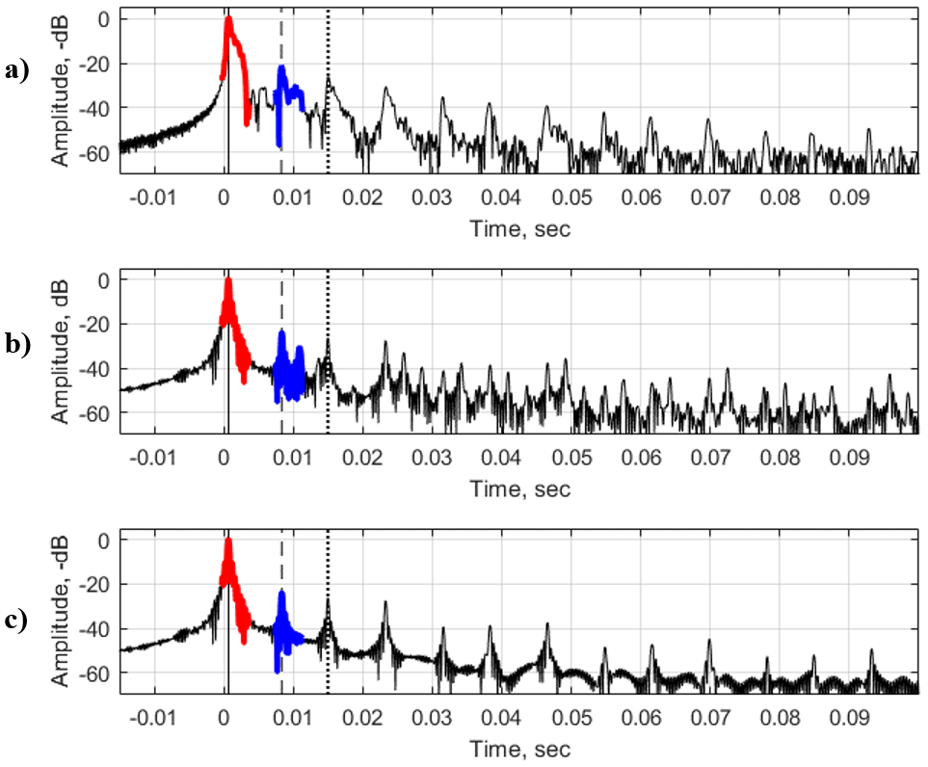

**Figure 4.** Pulse response functions at Station S17 (17 m depth). **a)** experimental; **b)** modeled with layered bottom; **c)** modeled with half-space bottom. Arrival times of the direct signal, single surface reflection, and single bottom reflection are represented as solid, dashed and dotted vertical lines, respectively. The direct signal is highlighted in red; the single reflection from the bottom , in blue. The source and receiver were located at 11 m of depth.

In addition to the changes in the amplitude at the interfaces, the phase of the reflection coefficient changed as well. Sound speed in the gassy layer was less than the sound speed in the water, and the phase of the sound field changed by *π* for bothafter reflection. In addition to the high reflection coefficients from the bottom (*V* ~ -0.8 for water-layer interface) and the very small arrival times (of tens of milliseconds), accurate separation of the reflection from the seabed becomes especially important to not confuse the seafloor with the surface.

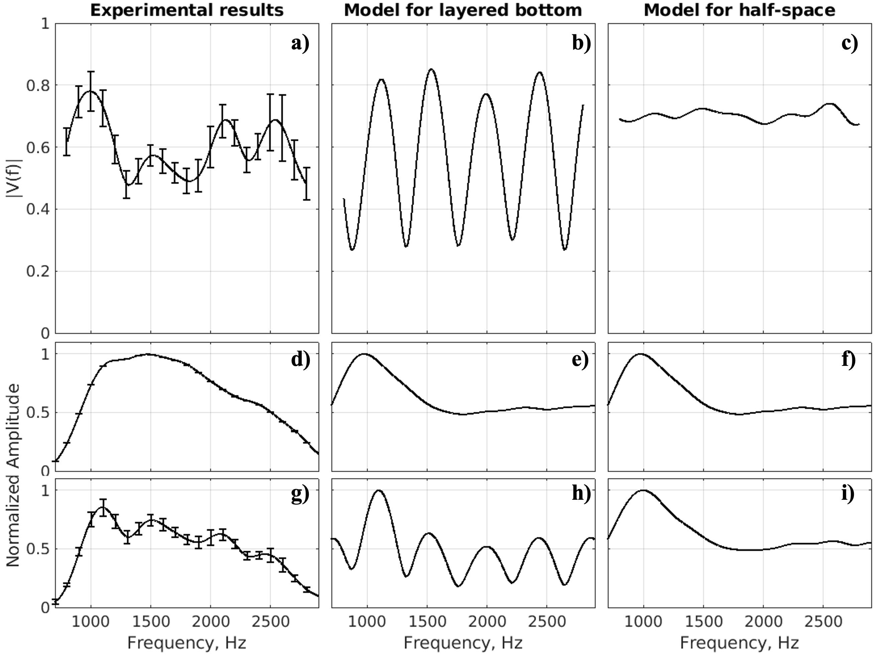

***Figure 5.*** *Experimental and modeled spectra (with normalized amplitude) of received signals (direct and reflected), and frequency dependence of the modulus of the reflection coefficient, $\left|V\left(f\right)\right|$* , at Station S17*.* ***a) – c)*** *The frequency-dependent reflection coefficient;* ***d) – f)*** *Spectrum of direct arrival signal;* ***g) – i)*** *— Spectrum of the one-time reflection from the bottom. Here, Δf = 380 Hz, c2 = 200 m s-1, and d = 0.26 m.* Vertical bars denote 0.95 confidence intervals.

Table 1. Parameter estimates of the gassy layer in the seabed at three stations

|  |  |  |  |  |  |  |  |  |
| --- | --- | --- | --- | --- | --- | --- | --- | --- |
| **Sta.** | **Depth,**  **m** | ***c*s *,**  **m/s** |  | **m/s** | **Kg/m3** | *Θ*  ***\*\*,***  ***%*** | ***Resonance frequency,***  ***Hz\*\*\**** | ***d ***,***  ***m*** |
| S17 | 17.1 | 200 ± 25 |  | $$1537$$ | $$1459$$ | 0.18 – 0.30 | 350 ± 55 | 0.31 ± 0.07 |
| S22 | 35 | 325 ± 25 |  | $$1537$$ | $$1459$$ | 0.07 – 0.10 | 400 ± 50 | 0.40 ± 0.06 |
| F | 18.6 | 150 ± 50 |  | $$1537$$ | $$1459$$ | 0.23 – 0.93 | 510 ± 60 | 0.20 ± 0.12 |

*\* Sound speed,cs, is given as mean* ± *0.95 confidence intervals (CI).*

*\*\* Free gas content,* Θ*, is presented as a range calculated for c2-CI and c2+CI using the power-law dependence of gas fraction on sound speed in gassy sediment (Eq. 3 in Katsnelson et al., 2017).*

*\*\*\* Resonance frequency, and thickness of gassy layer, d, are presented as mean* ± *standard deviation*.

**DISCUSSION**

Direct sediment sampling using pressurized or freeze cores with subsequent CT analysis provides high-resolution images (up to 250 μm in linear scale) and allows discernment of the bubble shapes, size, and volume concentration in natural environments (Barry, 2010; Choi et al., 2011). However, this sampling approach is very complex, requiring specific equipment and staff, while being time consuming and expensive, and producing few data points of local sediment parameters. For large water bodies such as Lake Kinneret, where the gas content in the bottom is characterized by immense horizontal variability, conducting sediment sampling can be enormous for examining large lake areas (Ostrovsky, 2003; Ostrovsky & Tegowski, 2010; Lazar et al., 2019). Another issue with direct sampling is the degree of invasiveness, and discrepancies that can occur between the length of the retrieved sediment column and the penetration depth of the corer. For example, X-ray CT scans of freeze cores obtained in Lake Kinneret in December 2016 revealed bending of the originally horizontal sediment layers (Dück et al., 2019). This bending distorted the pattern of the vertically distributed gas bubbles within the sediment core. For chemical analysis, another challenge is the use of conventional (unpressurized) sediment gravity corers, in which bubbles existing in sediment can burst and new bubbles may form due to a large drop in hydrostatic pressure during the core retrieval to the air (Wilkens & Richardson, 1998).

In contrast to sediment sampling, acoustic methods using different physical mechanisms can provide cost-effective, flexible, noninvasive tools for rapid monitoring of large areas synoptically to specify and map sediment parameters (Tegowski, 2005; Tegowski et al., 2006). In this paper, the methodology presented has some specific features concerned with highly reflective seabed in which multiple strong reflections from the boundaries occur. Our approach provides robust results from a simple geoacoustic model, with a bottom considered to be a liquid homogeneous half-space (citation). However, estimations of the free gas content, *Θ,* may have rather significant errors due to the nonlinear relationship between *Θ* and sound speed. At low sound speed values (< 100 m/s) even small errors in sound speed measurements may result in notable errors in estimation of the free gas content (Uzhansky et al., 2020).

In this study, we found that the gassy sediment layer in Lake Kinneret has rather high concentration of CH4 bubbles (calculated based on an assessed sound speed of 150-300 m/s in the layer) and a gassy layer thickness, *d,* of 20- to 40 cm depending on location (citation). The estimated parameters corresponded well to the selected sounding frequency band (*f*) of about 300 to 3000 Hz, as the wavelength in the layer is approximately 0.03-0.6 m (i.e., on the order of *d* or less). Compared with direct measurements from frozen and unfrozen cores obtained in December 2016 (Dück et al., 2019) and November 2017 (Liu et al., 2020), the approximate total thickness of the layer with bubbles is about 40 to 45 cm. Still, the most concentrated bubbles were found at the narrower depth range of about 30 to 50 cm, resulting in a gassy layer thickness of about 20 cm. Thus, the acoustic assessments in this paper fit the direct observations well.

The depth-averaged gas content on 50-cm-long freeze cores collected on December 8, 2016 at Sta. F was 0.5% (Dück et al., 2019). Our estimations at the same station indicated a *Θ* of 0.23% to 0.93 %, which is also in good agreement with the direct measurements. The *Θ* estimates obtained at other stations (Uzhansky et al., 2020) come close to the direct measurements, but displayed slightly lower values. In contrast to direct sampling of sediment cores, the acoustic remote sensing approach provided an averaged assessment of *Θ* over a defined but rather large bottom area, relative to sediment cores. In our case, the acoustically sampled areas varied from 50 to 200 m2 for bottom depths of 10 to 40 m, respectively. Moreover, the R/V used in this study was not anchored during acoustic data acquisition and slowly drifted of ~ 1-2 m s-1 by wind and surface currents. Such boat motion could 1) inadvertently increase the area of insonification and 2) increase errors due to small vertical displacements of the sound source and the receiver. Still, these influences were compensated for by recording a rather long set of pulses (tens to hundreds) to decrease statistical errors. Thus, in contrast to direct sampling methods, the acoustic remote sensing approach assesses *Θ* over larger bottom areas, minimizing the issue of small-scale variability of gas concentrations in the bottom sediment.

Because the arrival times of both straight and reflected signals are small (tens of milliseconds), interference between a direct signal and its reflections can occur at specific source-receiver dispositions, making it difficult or even impossible to separate the one-time bottom reflection signal from other arrivals. Therefore, the geometrical configuration of the system being deployed is crucial (depth of the sound source, depth of the receiver, and distance between them), and configurations should be carefully analyzed for each bottom depth to avoid unnecessary interference.

In providing just one integral parameter of the effective *Θ* for each acoustically measured location, the suggested method does not consider the small-scale (below tens of meters) heterogeneity of *Θ*. Rather, it allows investigating the large-scale spatiotemporal variability of *Θ* (Uzhansky et al., 2020). Our results also suggest that more efforts are needed to study the variability of the gassy layer thickness in sediment.

The way that the methodology was developed was concerned with taking into account some specific effects at higher frequencies (which in our case, was considered to be > 3-4 kHz):

* The manifestation of Minnaert frequencies (resonance oscillation of bubbles), whose expression should be modified for essentially nonspherical bubbles. These frequencies lead to increases in attenuation, sound speed, and the appearance of remarkable dispersion at high and midfrequencies (> 3-4 kHz);
* The increased occurrence of scattering, including back scattering, which changes the effective reflection coefficient at the frequencies mentioned above;
* The manifestation of nonlinear effects, for example, the appearance of harmonics and combination frequencies.

**CONCLUSION**

This research demonstrates that geoacoustic inversion is an efficient, noninvasive technique for assessment of the free gas content (*Θ)* and thickness of the gassy layer (*d*) in water reservoirs based on accurate estimations of the sediment sound speed and resonance frequency (half-wavelength resonance) of the reflection coefficient. The presented method allows for the rapid scanning of large areas and can be suitable for long-term monitoring of the *Θ* distribution in a lake. The method provides an integral assessment of *Θ* and the corresponding *d* for surface areas that are orders of magnitude larger than those that can be analyzed by traditional coring procedures.

With the new method, the parameters of a gassy layer can be evaluated in two steps:

* Estimation of the sound speed in a gassy layer using the fitting procedure for the average reflection coefficient (Katsnelson et al., 2017), and subsequent estimation of sound speed;
* Analysis of the frequency dependence of the reflection coefficient using the one-time reflected sound signal, to determine the resonance frequency and thickness of the gassy layer.

Acoustic estimations were performed in Israel’s Lake Kinneret at Stations S17, F, and S22, located at depths of 17.1, 18.6, and 35 m, respectively. The corresponding sound speeds, *Θ,* and *d* were 200 ± 25 m s-1, 0.18% to 0.30 %, and 0.31 ± 0.07 m at Sta. S17, 150 ± 50 m s-1, 0.23% to 0.93 %, and 0.20 ± 0.12 m at Sta. F, and 325 ± 25 m s-1, 0.07% to 0.10 %, and 0.40 ± 0.06 m at Sta. S22.

In addition, the acoustical method allows researchers to efficiently scan large areas, providing a technology for studying spatiotemporal variability of gassy layer thickness in natural water reservoirs.