**CHARACTERIZATION OF GASSY SEDIMENT LAYER IN SHALLOW WATER USING ACOUSTICAL METHOD: LAKE KINNERET AS A CASE STUDY**

Katsnelson B.1, Lunkov A.2, Ostrovsky I.3, Uzhansky E.1

1 L. Charney School of Marine Sciences, University of Haifa, Israel, 3498838 Haifa,

2 Prokhorov General Physics Institute of the Russian Academy of Sciences,

38 Vavilova str. Moscow, 119991, Russia,

3 Israel Oceanographic & Limnological Research, Yigal Alon Kinneret Limnological Lab., P.O. Box 447, Migdal 1495001, Israel

*Keywords: gassy sediment, geoacoustic inversion, frequency dependence of reflection coefficient*

**ABSTRACT**

Remote characterization and parametrization of gassy sediments has significant ecological importance. Acoustic techniques that have been developed have advantages over direct methods (pressurized or freeze cores), as they are cost-effective and permit comparatively quick mapping of large areas. An acoustic method is suggested to allowsimultaneous estimate of the free gas content (*Θ*) and the thickness (*d*) of a gassy layer. The method is based on measuring and analyzing the reflection coefficient for wideband sound signals, including their frequency dependence. We studied the spatial variability of *Θ* and *d* in the freshwater Lake Kinneret (Israel), where the upper sediment layer is characterized by a high content of organic material, high methaneproduction rates, and a large *Θ*. Wideband chirp signals (of 300 – 3500 Hz) were emitted from a transducer deployed at 6 to 11 m of depth from a research vessel. Sound signals were recorded at the same depth with a single hydrophone positioned 1 m away from the source. In various lake locations, the sound speed in the gassy layer varied from 150 to 325 m/s for a *Θ* of 0.6% to 0.1%, and a *d* of 20 to 40 cm, respectively. These findings show reasonable agreement with gas void fractions measured directly in frozen sediment cores during previous investigations. Our study reveals a remarkable spatial variability of gassy layer characteristics. The methodology developed to estimate both *Θ* and *d* should have considerable practical implementation for noninvasive spatiotemporal monitoring of shallow gassy sediments in aquatic ecosystems.

**INTRODUCTION**

Gaseous methane (CH4) is a common occurrence in organic-rich aquatic and terrestrial sediments (Mechalas 1974; Whiticar, 1982, Judd and Hovland 1992; Fleischer et al. 2001; Ostrovsky 2003; Walter et al. 2006, 2007; Tegowski et al. 2010; Boudreau 2012). Methane is the most abundant hydrocarbon and one of the most important greenhouse gases in the atmosphere. It is a powerful heat-trapping gas (Cicerone and Oremland 1988; Harries et al. 2001), with a warming potential that is approximately 25-fold larger than that of carbon dioxide (Meredith et al. 2019). Methane concentrations have been rising in the athmosphere by 1% per year over the last century (Rowland 1985, Pandey et al, 2015). Natural lakes contribute significantly to the global CH4 budget (40 - 200 Tg of CH4 annually, DelSontro et al. 2018), while bottom sediments are a hotspot of CH4 production, accumulation, and release in shallow waters and the atmosphere (Anderson and Martinez 2015). Methane bubbles form in soft, shallow organic-rich sediment as a result of *in situ* CH4 production from microbial organic matter decomposition — that is, *methanogenesis* (Martens and Berner 1974). When the CH4 concentration exceeds its solubility in pore water, CH4 bubbles form and accumulate within bottom sediments, migrating upward (Rothfuss and Conrad 1988; Boudreau 2012; Katsman et al. 2013). The gas releases to the overlying water and can reach the atmosphere (Ostrovsky et al. 2008; Anderson and Martinez 2015; Schmid at al. 2017; Lohrberg et al. 2020). The sub-bottom methanotrophy in upper sediment can prevent CH4 escape to the water column; this escape results in formation of a well-defined gas horizon at some distance from the seafloor (Whiticar 2002).

Various approaches exist for estimating the amount of gas in upper sediments. The direct methods include pressure-preserved and unpressurized sediment sampling. Pressure-preserved or frozen cores with subsequent X-ray computed tomography (CT) are used to quantify CH4 bubbles in sediment samples (Abegg and Anderson 1997; Anderson et al. 1998; Wilkens and Richardson 1998; Abegg et al. 2008; Barry, 2010; Choi et al. 2011; Liu et al. 2018). However, direct sampling methods are time- and labor-consuming, expensive, and provide results only at a specific distance from the seafloor, and thus, cannot represent large-scale variations in space and time. This can become an issue for studying gases in sediments in large water bodies such as Lake Kinneret, where a huge spatial heterogeneity of gas concentrations in sediments has been reported (Ostrovsky 2003; Ostrovsky and Tegowski 2010; Lazar et al, 2019). Despite concerted efforts, the invasiveness of direct methods cannot be avoided. Corers inevitably damage sediment during testing, violating its structural integrity (e.g., Fig. 6 in Dück et al. 2019). This significantly affects the free gas content and its quantitative estimates. Also, the high spatial heterogeneity of bubble distribution in soft sediments makes it technically unfeasible to implement conventional sampling methods for representative quantification of a gassy layer over large areas. Thus, development of remote sensing techniques has considerable ecological importance for the quantification and mapping of gassy sediments.

The occurrence of free gas, even in small quantities (0.1% – 1%), dramatically decreases the speed of sound in sediment (Wilkens and Richardson 1998). For instance, the compressional sound speed decreases tenfold when the concentration of free gas (void fraction) in sediment reaches 1%. As a result, the presence of gas in sediments causes a change of their elastic properties, which can be studied by measuring changes in sound attenuation, acoustic wave velocity, and reflective features of the upper sediment layer (Anderson and Hampton 1980). Acoustical methods for gassy sediment characterization are noninvasive and cost effective (Tegowski 2005). They allow rapid, synotpic scanning of large areas of bottom sediments to specify and map sediment parameters (Weinberg and Bartholoma 2005; van Warlee and Tegowski 2005); thus, they present a good practical alternative to direct methods. At the same time, acoustical methods require more sophisticated data collection, processing, and interpretation.

One of the methods to evaluate bottom sediment properties is measurement and analysis of the reflection coefficient of the sound signal. The first measurements of the reflection coefficient to estimate bottom properties (mainly sound speed) occurred by the late 1940s to 1960s. The idea of bottom characterization using acoustics began from studying the relationships between the sound refection coefficient and sediment properties (Liebermann 1948). The goal was to solve the inverse problem of finding the properties of the bottom (Jones et al. 1958). Of particular interest was studies in aquatic sediments on the amplitude-frequency characteristics of the sound field as a function of sound speed (Grubnik 1961; Goncharenko et al. 1976). The method for determining the reflection coefficient in these studies (the standing wave method) is based on the analyzing the interference field structure formed by direct and bottom-reflected tonal signals on the receiving system. In this case, the reflection coefficient is based on the ratio of the maximum and minimum field amplitudes that can be obtained by changing the receiver’s position in some spatial area (or by using a set of receivers), as well as by observing changes in the frequency domain. However, in the theoretical analysis of the interference structure considered in these works, multiple reflections from the bottom and surface were neglected, which gives a noticeable error for the reflection coefficient. A more detailed analysis of the reflection coefficient in natural sediment, including lof the ayered structure, was carried out by Goncharenko et al. (1976) and Goncharenko and Gordienko (2006). These authors also considered the angular dependence of the reflection coefficient. In addition, they noted the marked difficulty of determining the sound speed and thickness of the layer simultaneously based only on the frequency and angular dependencies, when analyzing a tonal signal.

Studies of the acoustical properties of gassy sediment have also been conducted in recent decades using different methodologies, including analyzing the resonance and nonlinear properties of bubbles in water/sediment, and in their aggregations (Abegg et al. 1997, 2008; Anderson et al. 1998, 2015; Wilkens et al. 1998; Toth et al. 2015; Best et al.; Gardner 2003). Recently, the analysis of the sound field formed by multiple reflections (reverberation) of mid-frequency (~1  kHz) pulses from gassy sediment was developed and implemented to estimate the CH4 void fraction in gassy sediment (Katsnelson et al. 2017). Lunkov and Katsnelson (2020) used the analysis of low-frequency (<100 Hz) shipping noise based on normal mode decomposition to evaluate the effective gaseous CH4 fraction in the upper sediments along the research vessel track. Both mid-frequency and low-frequency methods provided similar results.

In this paper, we suggest a noninvasive acoustic methodology for estimating the free gas content (*Θ)* and gassy layer thickness (*d*) while investigating these parameters in Lake Kinneret (Israel).

The key feature of the proposed method is independent determination of two characteristics of the gassy layer: the sound speed in the gas-bearing layer and its thickness. In the first stage, we determined the speed of sound in the layer, using a theoretical model with a low-speed bottom in the form of a liquid homogeneous half-space (Katsnelson et al. 2017). At this stage, analyzing of entire reverberation signal, consisting of a sequence of multiple signal arrivals (i.e., direct and reflected signals), should be carried out. The matching procedure of experimental and modeled sequences gives an effective frequency-independent reflection coefficient, which is equal to the frequency-averaged reflection coefficient from the layered bottom, and thus, provides, with good accuracy, the speed of sound in the layer (see below). In the second stage, the thickness of the layer (*d)* is estimated using selection of a one-time bottom-reflected signal and its corresponding spectral analysis.

**MATERIALS AND METHODS**

***Study site***

Subtropical Lake Kinneret (in the Sea of Galilee, Fig.1b) is a large freshwater body in which biological, sedimentological, and biogeochemical processes cause accumulation of organic-rich sediment with a high free gas content, *Θ,* in the upper sedimentary layer (Ostrovsky et al. 2014; Ostrovsky et al. 2008). This is a warm monomictic lake. The holomixis occurs from January to March, while a stratification period typically lasts from April to December (Lewis 1983). The *epilimnion* (the surface layer of the lake during the period of summer stratification) shows an annual temperature range of 15 to 30 °C, while the *hypolimnion* (the deep-water region in a lake below the thermocline) temperature stays at between 15 to 16 °C throughout the year (Boehrer and Schultze 2008; Sobek et al. 2011; Ostrovsky et al. 2013). The maximal depth of the lake is about 44 m, and depth of the thermocline, about 10-20 m. The sediment is composed mainly of clays (20%) and carbonate (40% – 50%; Hadas and Pinkas 1995). Sandy sediments dominate in the littoral zone, while soft mud (silty-clay) prevails at depth (Ostrovsky et al., 1999, 2010).

The presence of gas bubbles in the upper sediment layer makes the lake acoustically impenetrable for seismic survey, as was first suggested by Ben-Avraham et al. (1986). Further, the occurrence of a gas-bearing layer was confirmed by chemical analyses and observed directly in regular and freeze cores using X-ray CT (Ostrovsky and Tegowski 2010; Dück et al. 2019; Liu et al. 2020). Data obtained from hydroacoustic surveys showed that gaseous CH4 is being emitted from randomly dispersed sediment sources (Ostrovsky et al. 2008). Such sources occur predominantly in organic-rich sediments that have accumulated in deep areas. In shallow areas, which are characteristic for organic-poor sediments, CH4 emission is not detected or occurs negligibly (Ostrovsky and Tegowski 2010). Recent research has also revealed distinct changes in the concentration of dissolved and gaseous CH4 in Lake Kinneret sediments with bottom depth (Liu et al. 2020).

***Acquisition of acoustic data***

Acoustical measurements were carried out using the research vessel (R/V) Hermona in November 2017 at Station F (Sta F; depth of water layer of ~18 m), . The measurements were repeated with water layer depths of 17 m and , respectively. The source-receiver system, which consisted of a single hydrophone and the Lubell LL-9162 sound transducer, was deployed at the same depth for all measurements. The horizontal distance between the transducer and hydrophone was 1 m (Fig. 1a). Deployment depths were: 6.4 m at Sta. F, and 11 m at Sta. S17 and at Sta. S22. Linearly frequency modulated pulses (chirp) with a frequency band of 300 to 3500 Hz and 1 sduration were radiated with 1-s intervals at Sta. F, and 5-s intervals at Sta. S17 and Sta. S22.

**Figure 1.** Geometrical configuration for the experiment, showing distance between sound source and receiver, D, SR, BR represent direct arrival, surface reflection, and bottom reflection, respectively.

**Figure 2.** Bathymetric map of Lake Kinneret, depicting locations of acoustic measurements (green dots for Sta. F, Sta. S17, Sta. S22) and sampling point of sediment cores (white dot, Sta. A). Adapted from Ben-Avraham et al. 1990.

The R/V was not anchored while harvesting the acoustic data and drifted due to currents with a speed of 1 to2 m/s for about 100 to 200 m. Vertical oscillations of the R/V due to surface waves reached up to 1 m.

The sampling rate was set to 20 kHz, and the geometrical configuration (source-receiver depth) was specifically selected for each point of acoustic data acquisition to avoid destructive interference of bottom reflection data with the arrival of other signals.

***Acoustical method***

In this study, we estimated the parameters of sediment within the framework of a model (Fig. 2) consisting of a thin gassy sedimentary layer with a sound speed ($c_{s}$) that was much less than that of water (*cw*). The thickness of the gassy layer, is much less than bottom depth,: $d≪h$. The gassy layer overlays the gas-free sediments (basement), which has a sound speed of *cb*: . Strictly speaking, between the water and gassy layer exists a few-centimeter-thick, gas-free fluffy sediment layer that consists mostly of water (~95%) and silts (Ostrovsky and Yacobi 1999). In our model, this thin layer with a similar density and compressibility as water was considered part of the overlying water layer. Note that the typical size (effective diameter) of the bubbles are about 2-5 mm, and their corresponding resonance (Minneaer) frequency of about 3-3.5 kHz should be higher than acoustic frequencies used in our experiments.

The approach used considered sound propagation in shallow water that had cylindrical coordinates $(r,φ,z)$, from a point sound source (S) placed at the point $(0,0,z_{s})$, and an emitting signal $s\left(t\right)$ with the spectrum $S(f)$. A receiving hydrophone (R) had coordinates of $(r,0,z)$. An axial symmetry was assumed in the problem, thus the dependence on $φ$ was omitted. The water layer was characterized by its constant sound speed $c_{w}$ and density and is bounded by a free release surface at *z* = 0 at the top and by the flat seafloor at *z* = *h*. The bottom has the layered structure ( Fig. 2).

The sound field received in this situation constituted a sequence of pulses undergoing multiple reflections from the bottom and the surface (Fig.2a):

$p\left(t\right)=\sum_{j,l}{p_{lj}\left(t\right)}$ (1)

For the broadband emitted signal, $p\left(t\right)$ can be presented using the transfer function, $G\left(f\right)$:

$$p\left(t\right)=\int_{Ω}{S\left(f\right)G\left(f\right)e^{-i2πft}df} , (2)$$

where $f$ is the sound frequency and $Ω$ is the frequency band. For mid-frequencies, the transfer function $G\left(f\right)$ between sound source and receiver can be represented in the form of a double sum, using ray approximation:

$$G\left(f\right)=\sum_{l=0}^{L}{\sum_{j=1}^{4}{A_{lj}\left(f\right)e^{i\frac{R_{lj}}{c_{3}}2πf}}}, \left(3\right)$$

where groups of four arrival (denoted by *j*) are separated. Here $A_{lj}\left(f\right)$ are the ray amplitudes, which can be denoted for different *j* as

$$A_{l1}\left(f\right)=\frac{{\left(-V_{l1}\left(f\right)\right)}^{l}}{R_{l1}}; A_{l2}\left(f\right)=\frac{{-\left(-V_{l2}\left(f\right)\right)}^{l+1}}{R_{l2}}; A_{l3}\left(f\right)=\frac{{-\left(-V_{l3}\left(f\right)\right)}^{l}}{R_{l3}};$$

$$A_{l4}\left(f\right)=\frac{{\left(-V_{l4}\left(f\right)\right)}^{l+1}}{R_{l4}} , (4)$$

where $R_{lj}={\left(r^{2}+z_{lj}^{2}\right)}^{\frac{1}{2}}$ is the travel distance along a ray defined by indices *l* and *j*,

$z_{l1}=2hl+z_{s}-z$, $z_{l2}=2h\left(l+1\right)-z_{s}-z$, $z_{l3}=2hl+z_{s}+z$, and $z_{l4}=2h\left(l+1\right)-z_{s}+z$ are the depth differences between image sources and a receiver, $V_{lj}(f)$ is the reflection coefficient for the corresponding rays, depending on the angle of incidence/reflection, and also on frequency due to the layered bottom. Sign “ - “ in (4) corresponds to a reflection coefficient of -1 from free release surface.

In Fig. 2a, the first five rays are indicated by the following pairs: ($l,j$) = (0,1), (0,2), (0,3), (0,4) and (1,1), in which pairs (0,3), (0,4) and (1,1) contain a one-time reflection from the bottom.

In our study, we used a sound source and a receiver that were close enough to each otherthat. So, in the absence of an incident angle dependence of the reflection coefficient, the following approximations were valid:

$$R_{lj}≈z_{lj}, (5a)$$

$$V_{l1}\left(f\right)≈V_{l2}\left(f\right)≈V_{l3}\left(f\right)≈V_{l4}\left(f\right)≈V\left(f\right), (5b)$$

where $V(f)$ is the reflection coefficient at normal incidence.

In the case of the layered structure shown in Fig. 2, the seabed reflection coefficient of a plane wave $V\left(f\right)$ from the bottom can be depicted in terms of the “partial” frequency-independent reflection coefficients $V_{sw}$ and $V_{bs}$ at the sediment-water and basement-sediment interface, respectively (Brekhovskikh and Lysanov 1991), as follows:

$$V\left(f\right)=\frac{V_{sw}+V_{bs}e^{i\frac{2d}{c_{2}}2πf}}{1+V_{sw}V_{bs}e^{i\frac{2d}{c_{2}}2πf}}, (6a)$$

$$V_{sw}=\frac{1-{c_{w}ρ_{w}}/{c_{s}ρ_{s}}}{1+{c_{w}ρ_{w}}/{c_{s}ρ_{s}}}, \left(6b\right)$$

$$V_{bs}=\frac{1-{c_{s}ρ_{s}}/{c_{b}ρ_{b}}}{1+{c_{s}ρ_{s}}/{c_{b}ρ_{b}}}, (6c)$$

here $ρ_{w}$, $ρ_{s}$, $ρ_{b}$, $c_{w},c_{s},c_{b}$ are the densities, sound speeds of water, gassy layer and gas-free half-space (basement), respectively, and *d* is the thickness of the layer.

Remark, that key feature of current situation is $c_{s}$ << $c_{w}<c_{b}$.

It is well known that the frequency dependence $V(f)$ obtained from (6a) has oscillating character, having minima at “resonance” frequencies $f_{n}$, determined by the following equation (Brekhovskikh and Lysanov 1991):

$$\frac{2d}{c_{s}}2πf_{n}=2πn , \left(7\right)$$

or

$$f_{n}=n\frac{c_{s}}{2d} , \left(8\right)$$

where *n* = 1, 2, 3, … is the numbers of the corresponding minima (the, so-called, half-wavelength resonance: $d=nλ/2$). At these frequencies, the reflection coefficient from the layered bottom is equal to the reflection coefficient straight from the half-space $V_{bw}$, as if gassy layer was not present. Remark that if ${c_{b }>c}_{w}≫c_{s}$, then Eq. (8) stays approximately valid even if the angle of incident, $ϑ_{w}$, is not very small due to the smallness of refraction angle $ϑ_{s}$ (for example if = 300 m s-1, and , then $ϑ_{s}= 10°)$. Thus, the condition of resonance can be defined by Eq. (8) for rather wide range of angle of incidence. For gassy layer and water saturated half-space | and minima of reflection coefficient are rather sharp. $V\left(f\right)$ has periodical character with period in frequency domain

$${{Δf=c}_{s}}/2d, (9)$$

Eq. (8) allows us to find *d*, if the sound speed $c_{s}$ and resonance frequency $f_{n}$ (or period $Δf$) are known.

The idea of utilization the measurement of the reflection coefficient and Eqs. (6a) and (6b) to determine the bottom parameters is based on the usage of short broadband pulses in the geometry shown on Fig. 1a.

***Figure 2.*** *Schematic representation of sound rays between source S, and receiver R.* ***a)*** *the group of arriving signals reflecting from the surface and bottom, parameters (l,j) are shown;* ***b)*** *ray paths in the layered media. Here $ρ_{w}, c_{w}, ϑ_{w}, ρ_{s}, c_{s}, ϑ_{s}, ρ_{b}, c_{b}, ϑ_{b}$ are the densities, sound speeds and propagating angles for water, gassy layer and gas-free bottom, respectively.*

If the source radiates short sound pulse of wide spectrum, then the received sound signal contains sequence of pulses with arrival times $τ_{lj}=R_{lj}/c_{w}$ determined by the corresponding ray paths, and with pulse amplitudes, decreasing with the distance/number of reflections due to geometrical spreading and reflection energy loss. In the case of gassy sediment, due to rather high reflection coefficient, entire received reverberation signal can contain up to 10 or more groups of pulses (Katsnelson et al., 2017).

Remark, that in the first approximation, neglecting the layered structure, the sediment can be considered as effective half-space, described by effective sound speed and density. In such an approximation, the frequency-independent reflection coefficient (equals to $V_{sw}$, see Eq. (5b)) can be estimated using $V_{sw}$ as fitting parameter in the matching of experimentally measured entire reverberation signal and reverberation signal calculated based on model of the half-space for sediment. Next, connection of reflection coefficient with bottom parameters (Fresnel formula 5b) allows us to get the effective sound speed and, in turn, to compute the corresponding effective gas void fraction in sediment (see Katsnelson et al. 2017; Uzhanskii, 2018; Uzhansky et al., 2020).

Let’s consider frequency dependent reflection coefficient $V(f)$ within the framework of model presented in Fig. 2. Two examples of $\left|V(f)\right|$ calculated for normal incidence ($θ_{w}=0°$) are shown in Fig. 3 for the parameters, close to that in Lake Kinneret: $ρ_{w}=1000 kg/m$, $ρ_{s}=1435 kg/m$, $ρ_{b}=1459 kg/m$ are the densities of water, sediment layer and basement, respectively; $c_{b}=1537 m/s$ and ${ c}_{w}=1470 m/s$ are the sound speeds in the basement and water, respectively; and for two pairs of such gassy layer parameters as its thickness and sound speed: $d=0.43 m$, $c_{s}=260 m/s$ and $d=1.3 m$, $c_{s}=780m/s$ giving one and the same frequency period of $Δf$. Dashed lines represent the reflection coefficient from the bottom, consisting of a layer of thickness *d* with the sound speed $c_{s}$ lying above a gas-free half-space. Solid line represents reflection coefficient $|V_{sw}|$ from an infinite gassy half-space, having density and sound speed $ρ_{s}, c_{s}$. Dotted line denotes reflection coefficients $\overline{\left|V\right|}$ averaged over frequency.

One can see that modeled $\left|V(f)\right|$ undergoes distinct variations with the period, $Δf$ of about 430 Hz, and amplitude varying from about 0.2 to about 0.9 for the first case ($c_{s}=260 m/s$), and with lesser amplitude varying from about 0.2 to about 0.4 for the second case ($c_{s}=780m/s$). Note, that maximal value of |*|* is higher than that from the gassy half-space $|V_{sw}|$ due to constructive interference of waves reflected from the upper and lower boundary of the gassy layer (Fig. 3).

In both cases, the frequency-averaged reflection coefficient $\overline{\left|V\right|}$ is close to the Fresnel reflection coefficient $|V_{sw}|$ from the effective homogeneous gassy half-space with the same parameters. Remark, that the resonance frequency $f_{n}$ and the period $Δf$ are determined by the pair of values *d* and $c_{s}$. It means that for the estimation of the layer thickness it is necessary to have independent estimation of $c_{s}$, which can be done using the measurement of.

Thus, the acoustic estimation of the parameters of gassy layer can be carried out in two steps within the framework of the model presented in Fig. 2b, as follows:

* To find the reflection coefficient $\overline{\left|V\right|}$ using the matching procedure for the entire reverberation signal using $\overline{\left|V\right|}$ as a fitting parameter (Katsnelson et al., 2017). As mentioned above, one can take $\left|V_{sw}\right|≈\overline{\left|V\right|}$, then, the sound speed $c_{s}$ can be computed from Eq. (6b).
* To determine the resonance frequency $Δf$ using the frequency dependence of the one-time reflected sound signal, and subsequently to estimate *d*. It should be noted that the accurate quantification of the frequency dependence of $V(f)$ requires proper separation of the one-time bottom-reflected signal from the sequence of reflected pulses, i.e., signal propagating along ray, denoted as (0,2) in Fig. 2a.

**Figure 3.** Frequency dependences of modulus of the reflection coefficients from half-space (solid line) and layered bottom (dashed and dash-dot lines are plotted for various cs and d). Dotted line depicts $\left|\overline{V} \right|$ averaged over frequency.

***Processing of acoustic data***

Let’s consider processing and analysis of data, obtained in experiment at three positions in Lake Kinneret (Sta.17, Sta. F, and Sta. 22) to find frequency dependence of the bottom reflection coefficient $V(f)$. The signal $p(t)$ received at a hydrophone is correlated with the radiated signal $s(t)$ to obtain a waveguide pulse response

$$b\left(τ\right)=\int_{0}^{T}{p\left(t\right)s(t-τ)dt} (10)$$

Because the pulse response constitutes sequence of pulses, corresponding to Eq. (1) and Fig. 2a, it is possible to select the intervals for the first (direct) arrival $τ_{01}$ and the first bottom-reflected arrival $τ_{02}$. We denote the corresponding intervals [$τ_{1}^{'};τ_{1}^{''}$] and [$τ_{2}^{'};τ_{2}^{''}$], respectively. Note that for correct implementation of reflection coefficient analysis, one needs to arrange sound source and receiver geometry in such a way that the first (direct) arrival and the first bottom-reflected arrival would not interfere with other arrivals. To check if the experimental geometry is appropriate, numerical simulation should be done.

Next, finite-time Fourier transform of $b\left(τ\right)$ is used in the selected intervals to estimate the radiated spectrum $S_{1}\left(f\right)$ and the spectrum after first bottom reflection $S_{2}\left(f\right)$:

$$S_{1}\left(f\right)=\int_{0}^{T}{b\left(τ\right)w_{1}\left(τ\right)e^{i2πfτ}dτ} , (11a)$$

$$S_{2}\left(f\right)=\int_{0}^{T}{b\left(τ\right)w_{2}\left(τ\right)e^{i2πfτ}dτ , (11b)}$$

The rectangular window function $w_{1}\left(τ\right)$ and $w_{2}\left(τ\right)$ is nonzero on the interval of [$τ_{1}^{'};τ_{1}^{''}$] and [$τ_{2}^{'};τ_{2}^{''}$], respectively.

The amplitude of the reflection coefficient as a function of frequency is then can be defined by normalized ratio of two spectra

$$\left|V\left(f\right)\right|=\frac{\left|S_{2}\left(f\right)\right|R_{01}}{\left|S_{1}\left(f\right)\right|R_{02}}, (12)$$

where $R_{01}$ and $R_{02}$ are the travel distances along the paths of the first arrival and first bottom-reflected arrival, respectively (Fig. 2a).

**RESULTS**

Parameters of gassy sediment were estimated at three following stations: Sta. F, Sta. S17, and Sta. S22 (Fig. 1b). To display the logic of parameter calculations, below we present a detailed example to display how the parameters of gassy sediment layer were calculated and analyzed based on our measurements at Sta. S17. As it was mentioned in p.2.1, linear frequency modulated signals (300-3500 Hz) with duration of 1 sec were emitted every 5 sec by the source deployed at 11 m of depth and recorded by single hydrophone R (Fig. 1a). Signals received by single hydrophone constitute temporal sequence of pulses (Fig. 4a.)

At the first stage, simulation of the entire sequence of received pulses was carried out in supposition of the gassy half-space (Katsnelson et al., 2017, Uzhanskii, 2018, Uzhansky et al., 2020) with the sound speed $c_{s}$, as the fitting parameters. By minimizing the mismatch between the experimental and modeled pulse responses, we obtained the optimal value of $c_{s}=200$ m/s. The effective sediment density used in this study was estimated based on water content and dry sediment density presented in Sobek et al. (2011). Sound speed in gas-free bottom layer was calculated using the Akal empirical formula for a two-component bottom (Akal, 1972). The corresponding theoretical temporal sequence of reflected pulses using optimal parameters is shown in Fig. 4b.

Further, we evaluate the reflection coefficient $\left|V\left(f\right)\right|$ as a function of frequency at Sta. S17. For this goal we identify peaks in the Fig. 4a using calculation of arrival times for different ray paths shown in Fig. 2, at actual experimental positions of the source and receiver. The first peak (arrival time is marked by vertical solid line) corresponds to the direct signal (ray path $R_{01}$ in Fig. 2a). For the depth of the source-receiver system of 11 m (distance to the bottom is 6 m), the length of the bottom-reflected ray ( $R_{02}$ in Fig. 1a) is remarkably less than the surface reflected ray ($R_{03}$) and the second peak on Fig. 4a corresponds to one-time reflected signal from the bottom. After selection of intervals [$τ_{1}^{'};τ_{1}^{''}$] and [$τ_{2}^{'};τ_{2}^{''}$] we calculate of spectra $S_{1}\left(f\right)$ and $S_{2}\left(f\right)$ in accordance with Eq. (10 a, b), they are shown in the Fig. 5 d, g. in normalized form (max $\left|S_{1,2}\left(f\right)\right|=1)$. Then, we obtained the $\left|V\left(f\right)\right|$ using Eq. (11).

Experimental curve of spectra of received signals (Fig. 5g), radiated signals (Fig. 5d) and reflection coefficient (Fig. 5a) represent averaged curves and confidence intervals for the results based on analysis of 30 acoustical measurements carried out at this station.Our calculations show that the experimentally measured frequency dependence of $\left|V\left(f\right)\right|$ (Fig. 5a) has rather pronounced minima and maxima, repeating at a constant period of 350 ± 55 Hz.

Modeling of reflection coefficient as a function of frequency was carried out at Sta. S17 for layered bottom (Fig. 5b, e, h) and for half-space (Fig. 5c, f, i). For simulation within the framework of layered bottom only thickness of layer, $d$, is the fitting parameter. Densities of all the layers and sound speed in water and lower half-space are taken from literature. The sound speed in gassy layer was calculated at the first stage and in the given case it is 200 ± 25 m/s. The thickness, providing the best fit with experimental data is 0.31 ± 0.07 m (see Fig. 5f for corresponding behavior of $\left|V\left(f\right)\right|$). The values of all parameters for three stations are shown in the Table. 1a. Remark, that the $\left|V\left(f\right)\right|$ calculated for liquid half-space bottom (denoted as $\left|V_{sw}\right|$), did not show pronounced and repeating oscillations, but some chaotic oscillations that were apparently associated with interference of direct and multiple reflections (Fig. 5i).

Following the same way of calculations, the parameters of gassy sediment (c2, Θ , and d) were calculated at Sta. F, and Sta. S22, as well. All results are represented in Table 3.

The geometry of the experimental design is critical for the analysis of the signal arrival time. The arrival time interval between the direct and reflected signal ($R_{02}/c_{2}$) is about 0.01-0.015 sec. The corresponding data processing of the received signal gives an approximate duration of the received signals of about $τ\sim 1/f$ and, in our case, τ 1/2500 = 0.0004 sec, which is enough to isolate the reflected signals.

.

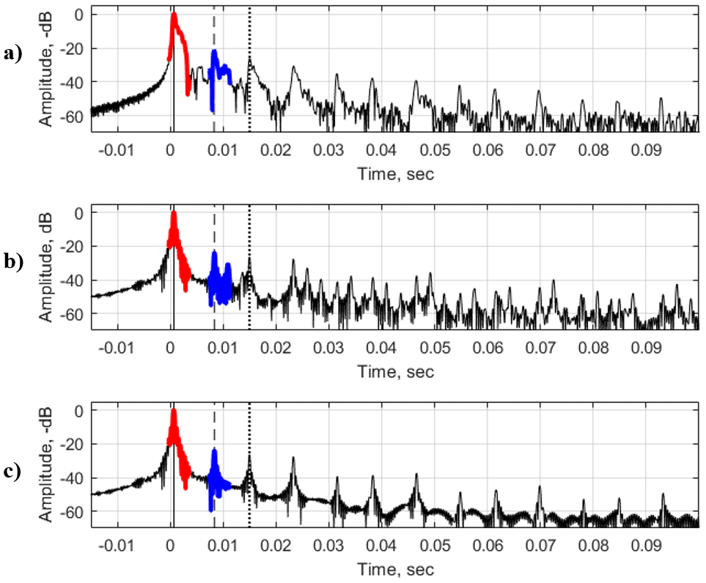

**Figure 4.** Pulse response functions at Sta. S17 (17 m depth). **a)** experiment; **b)** model with layered bottom; **c)** model with half-space bottom. Arrival times of direct signal, single surface reflection and single bottom reflection are represented as solid, dashed and dotted lines respectively. Direct signal is highlighted in red, single reflection from the bottom is highlighted in blue. The source and receiver are located at 11 m depth.

In addition to the changes in the amplitude at the interfaces, the phase of the reflection coefficient changes as well. Sound speed in the gassy layer is less than sound speed in the water and the phase of the sound field changes by *π* bothafter reflection. In addition to the high reflection coefficients from the bottom (*V* ~ -0.8 for water-layer interface) and very small arrival times (tens of milliseconds), the accurate separation of the reflection from the seabed becomes of a high importance so as not to confuse the seafloor with the surface.

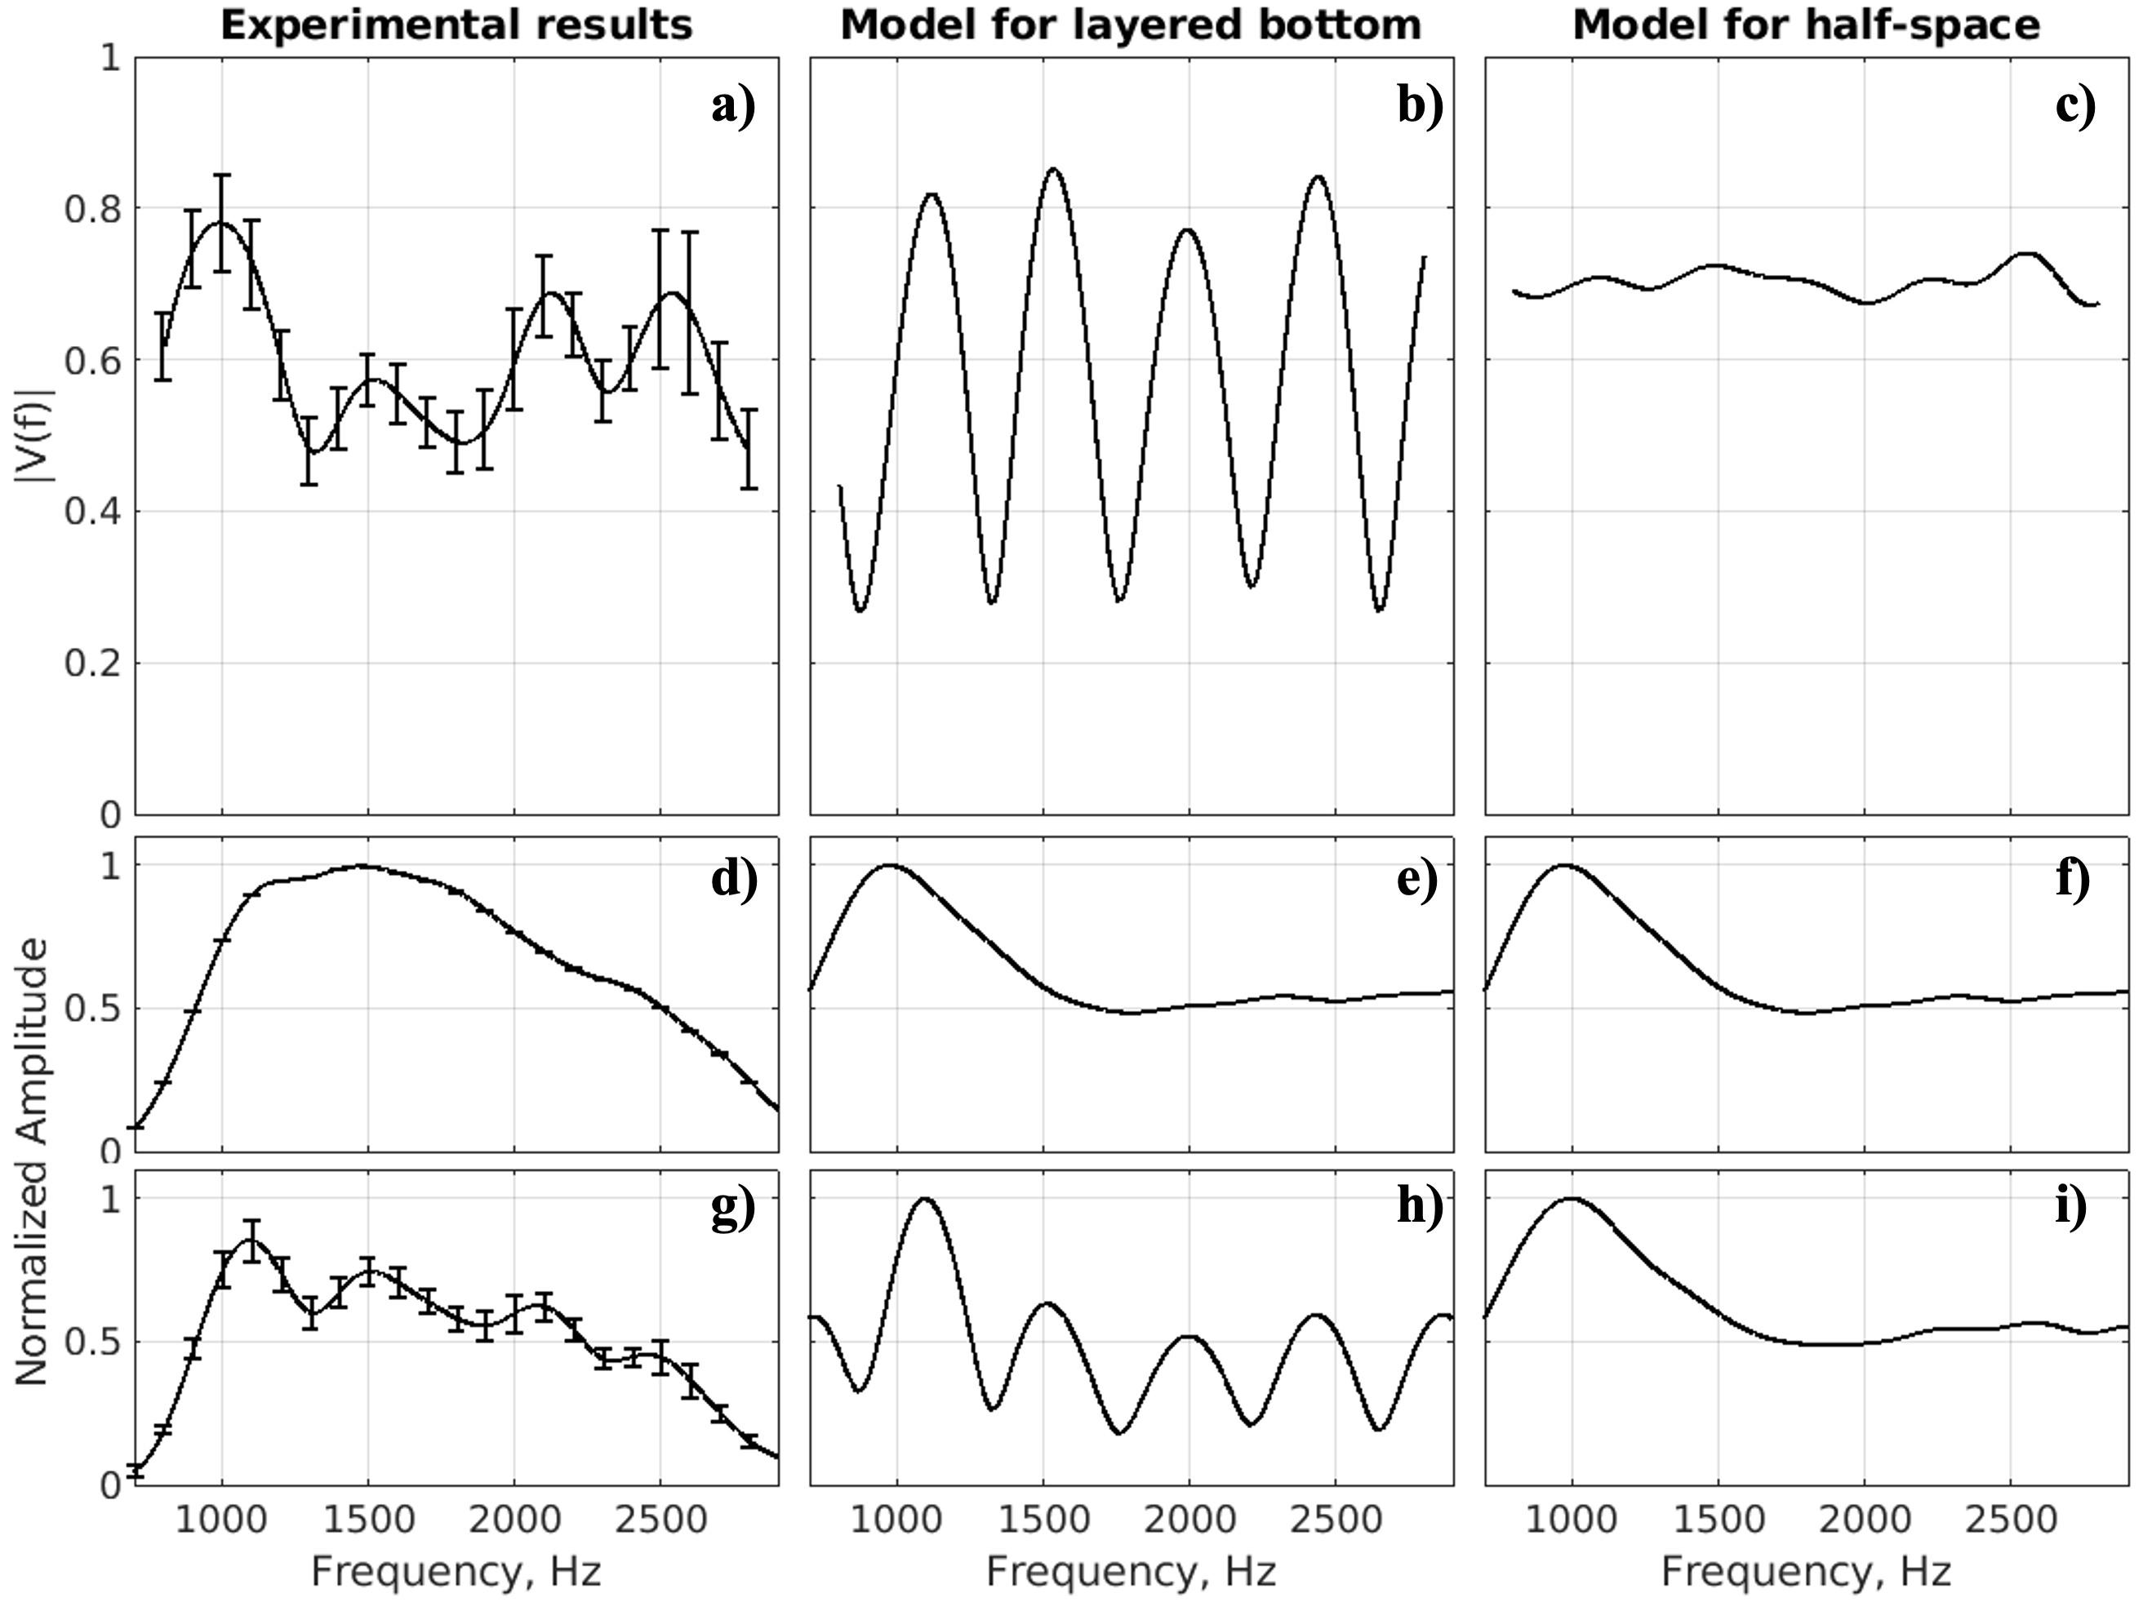

***Figure 5.*** *Experimental and modeled spectra (normalized amplitude) of received signals (direct and reflected), and frequency dependence of the modulus of the reflection coefficient, $\left|V\left(f\right)\right|$* , at Sta. S17*.* ***a) – c)*** *frequency-dependent reflection coefficient;* ***d) – f)*** *spectrum of direct arrival;* ***g) – i)*** *— spectrum of one-time reflection from the bottom. Here Δf = 380 Hz, c2 = 200 m s-1, d = 0.26 m.* Vertical bars denote 0.95 confidence intervals.

Table 1. Parameter estimates of the gassy layer in the seabed at three stations

|  |  |  |  |  |  |  |  |  |
| --- | --- | --- | --- | --- | --- | --- | --- | --- |
| **Sta.** | **Depth,**  **m** | ***c*s *,**  **m/s** |  | **m/s** | **Kg/m3** | *Θ*  ***\*\*,***  ***%*** | ***Resonance frequency,***  ***Hz\*\*\**** | ***d ***,***  ***m*** |
| S17 | 17.1 | 200 ± 25 |  | $$1537$$ | $$1459$$ | 0.18 – 0.30 | 350 ± 55 | 0.31 ± 0.07 |
| S22 | 35 | 325 ± 25 |  | $$1537$$ | $$1459$$ | 0.07 – 0.10 | 400 ± 50 | 0.40 ± 0.06 |
| F | 18.6 | 150 ± 50 |  | $$1537$$ | $$1459$$ | 0.23 – 0.93 | 510 ± 60 | 0.20 ± 0.12 |

*\* cs is given as mean* ±*0.95 confidence intervals (CI).*

*\*\* free gas content,* Θ*, is presented as a range calculated for c2-CI and c2+CI using the power-law dependence of gas fraction on sound speed in gassy sediment (Eq. 3 in Katsnelson et al., 2017).*

*\*\*\* Resonance frequency and thickness of gassy layer, d, are presented as mean* ± *standard deviation*.

**DISCUSSION**

Direct sediment sampling using pressurized or freeze cores with subsequent CT analysis provides high-resolution images (up to 250 μm in linear scale) and allows revealing the bubble shapes, size and volume concentration in natural environment (Barry, 2010; Choi et al., 2011). However, this sampling approach is very complex, required specific equipment, manpower, time consuming and expensive. Also it can provide only very few points of measurements, giving local sediment parameters. For large water bodies, such as Lake Kinneret, where the gas content in the bottom is characterized by immense horizontal variability, such a sediment sampling effort should be enormous when large areas of the lake should be examined (Ostrovsky, 2003; Ostrovsky and Tegowski, 2010; Lazar et al., 2019). Another issue is degree of corer invasiveness, for example, the discrepancy between the length of the retrieved sediment column and penetration depth of the corer. For example, the X-ray CT scans of the freeze cores obtained in Lake Kinneret in December 2016 revealed bending of originally horizontal sediment layers (Dück et al., 2019), which distort the pattern of the vertical distribution of gas bubbles within the sediment core. For chemical analysis it is possible to use conventional (unpressurized) sediment gravity corers, in this case the bubbles existing in the sediment can burst and new bubbles may be formed due to large drop of hydrostatic pressure during the core retrieval to the air (Wilkens and Richardson, 1998).

In contrast to the sediment sampling, the acoustic methods using different physical mechanisms can provide cost-effective, flexible, and noninvasive tools for rapid monitoring of large areas synoptically to specify and map parameters of the sediment (Tegowski, 2005; Tegowski et al., 2006). In this paper the methodology presented has some specific features concerned with highly reflective seabed, at which multiple strong reflections from the boundaries occur. Our approach provides robust results from a simple geoacoustic model, where bottom is considered as a liquid homogeneous half-space (citation). However, estimations of *Θ* may have rather significant errors due to the nonlinear relationship between *Θ* and sound speed. At low sound speed values (< 100 m s−1) even small errors in sound speed measurements may result in notable errors in estimation of the free gas content (Uzhansky et al., 2020).

In this study we found that the gassy sediment layer in Lake Kinneret has rather high concentration of CH4 bubbles (calculated based on assessed sound speed of 150-300 m/s in the layer) and *d* of 20-40 cm depending on location (citation). The estimated parameters were well corresponded to the selected sounding frequency band (*f*) of about 300 - 3000 Hz, as wavelength in the layer is approximately 0.03-0.6 m, i.e., the order of *d* or less. Comparing with the results of direct measurements from frozen and unfrozen cores obtained in December 2016 (Dück et al., 2019) and November 2017 (Liu et al., 2020), respectively, the approximate total thickness of the layer with bubbles is about 40 to 45 cm. Still, the highest amount of bubbles was concentrated at the nerrower depth range of about 30 to 50 cm, resulting in the gassy layer thickness of about 20 cm. Thus, our acoustic assessments provided in this work are well fit the direct observations.

The depth-averaged gas content on 50-cm long freeze cores collected on December 8, 2016 at Sta. F was 0.5% (Dück et al., 2019). Our estimations at the same station show *Θ* of 0.23% to 0.93 %, which is also in a good agreement with direct measurements. The *Θ* estimates obtained at other stations (Uzhansky et al., 2020) are close to the direct measurements, but still displayed a bit lower values. In contrast to direct sampling, the acoustic remote sensing approach provides an averaged assessment of *Θ* over a certain but rather large bottom area, comparatively to sediment cores. In our case, the acoustically sampled areas varied from 50 to 200 m2 for the bottom depths of 10 to 40 m, respectively. Moreover, the R/V used in this study was not anchored during the acoustic data acquisition and slowly drifted of about 1-2 m s-1 by wind and surface currents. Such a boat motion could 1) increase the area of insonification and 2) could lead to extra errors due to small vertical displacements of the sound source and the receiver. Still, these influences were compensated by recording a rather long set of pulses (tens to a hundreds) that decreased statistical errors. Thus, in contrast to direct sampling methods, the acoustic remote sensing provides assessment of *Θ* over much large bottom area that allow neglecting small-scale variability of gas in bottom sediment.

Taking that the arrival times of both straight and reflected signals are small (tens of milliseconds), interference between direct signal and its reflections can occur at specific source-receiver dispositions, making it difficult or even impossible to separate the one-time bottom reflection signal from other arrivals. Therefore, the geometrical configuration of the system deployment (depth of sound source, depth of receiver and distance between them) is crucial and it should be analyzed for each bottom depth to avoid unnecessary interference.

Providing just one integral parameter of the effective *Θ* for each acoustic measured location, the suggested method does not consider the small-scale (below tens of meters) heterogeneity of *Θ*, but rather allows investigating the large-scale spatiotemporal variability of *Θ* (Uzhansky et al., 2020). Our results also suggest that more efforts are needed to study the variability of gassy layer thickness in sediment.

The following development of methodology presented is concerned with taking into account some specific effects at higher frequencies (in our case > 3-4 kHz):

* manifestation of Minnaert frequencies (resonance oscillation of bubbles), expression for which should be modified for essentially nonspherical bubbles. It leads to increasing of attenuation, sound speed and appearance of remarkable dispersion at high and midfrequencies (> 3-4 kHz);
* increasing of scattering, including back scattering, changing effective reflection coefficient at frequencies mentioned above;
* manifestation of nonlinear effects, for example appearance of harmonics and combination frequencies.

**CONCLUSION**

Geoacoustic inversion is a noninvasive and efficient technique for assessment of free gas content (*Θ)* and thickness of gassy layer (*d*) based on accurate estimations of the sediment sound speed and resonance frequency (half-wavelength resonance) of the reflection coefficient. The presented method allows us to scan rapid the large areas and can be suitable for long-term monitoring of *Θ* distribution in the lake. The method provides an integral assessment of *Θ* and the corresponding *d* over surface areas over orders of magnitude larger area that can be provided by traditional coring procedures.

Parameters of gassy layer were evaluated in two steps:

* Estimation of the sound speed in gassy layer using the fitting procedure for average reflection coefficient (Katsnelson et al., 2017) and subsequent estimation of sound speed;
* Analysis of the frequency dependence of the reflection coefficient using one-time reflected sound signal, to determine the resonance frequency and *d*.

Acoustic estimations were performed at three Sta. S17, Sta. F, and Sta. S22 located at the depths of 17.1, 18.6, and 35 m, respectively. The corresponding sound speeds, *Θ* and *d* were 200±25 m s-1, 0.18% to 0.30 %, and 0.31±0.07 m at Sta. S17, 150±50 m s-1, 0.23% to 0.93 %, and 0.20±0.12 m at Sta. F, and 325±25 m s-1, 0.07% to 0.10 %, and 0.40±0.06 m at Sta. S22.

In addition, it allows us to carry out fast scanning over large areas, providing a technology to study spatiotemporal variability of gassy layer thickness in natural water reservoirs.