Scientific Abstract: INS/DVL Fusion with Complete, Partial or Lack of DVL Beam Measurements

The continuous operation of the navigation system of an autonomous underwater vehicle (AUV) is critical to the successful completion of the AUV’s tasks, which include scientific, industrial, military, and search and rescue missions. Fusion between the inertial navigation systems (INS) and the Doppler velocity log (DVL) ensures this continuous operation. In many different AUV scansions, the DVL fails to provide measurements, and the consequent navigation solution time drift results in the immediate termination of a mission. Here, we aim to develop a comprehensive framework for INS/DVL fusion to address three possible scenarios regarding DVL measurement availability: 1) complete measurements (normal conditions); 2) partial measurements; and 3) no measurements (DVL outages).

The research is divided into three tracks, in order to examine each type of DVL measurement availability. Although complete and partial DVL outage situations commonly occur during AUV missions, they are rarely discussed in the literature, most of which focuses on normal operating conditions, i.e., complete DVL measurements. In a recent and pioneering theoretical analysis, we showed that accurate navigation levels can be preserved even during partial DVL measurements. Later, we proposed a solution for complete DVL outage situations over short time periods. However, a lack of comprehensive solutions for partial and complete DVL outages remains.

The goal of the current research is to achieve research results with substantial effect that can provide the foundation for important developments in the field that are supported by both theory and sea experiments. Currently, core solutions are needed which would represent major advances relative to the current state-of-the-art in the field, and which could act as a basis for future work on and implementations of INS/DVL fusion with all three types of DVL measurement availability.

Applying these new approaches can either mitigate or completely stop the problem of navigation solution drift. This issue is critical, particularly in partial or complete DVL outage situations. Using the new approach advanced here, the AUV would be allowed a longer time to complete its mission, rather than having to issue an immediate command to surface when the DVL is not available. Also, from a practical cost-effective point of view, improving the performance of INS/DVL fusion may result in the use of lower grades of INS or DVL. As a consequence, new possibilities will become available for INS/DVL in micro AUVs, in bio-inspired marine platforms, or in other low-cost and small-sized platforms which currently cannot use such fusion due to sensor cost and size.

Detailed Description of the Research Program

1 Scientific Background

Covering about two-thirds of the earth’s surface, oceans have a great impact on mankind, both now and for the future [1]. Today, the use of manned submarines and tethered and remotely operated underwater robots is currently limited to only a few applications, because of very high operational costs and safety issues. In the 1970s, the demand for advanced multi-purpose underwater vehicle technologies led to the development of autonomous underwater vehicles (AUVs) [2]. Since then, advances in the efficiency and size of sonar, computers, and navigation sensors have enhanced AUVs’ potential, and today, concomitantly with ongoing research in the field, AUVs are commonly used in many applications [3]. In scientific missions, AUVs are used for seafloor mapping [4], environmental monitoring [5], marine biology studies [6], and more. In industrial applications, AUVs assist in monitoring underwater construction work and the health of underwater infrastructures [7]. AUVs also have military applications [8], such as payload delivery to the ocean floor [9], and search and rescue missions [10].

The accuracy of the AUV’s navigation solution is critical to the successful accomplishment of its tasks. In order to achieve a reliable and accurate navigation solution, an inertial navigation system (INS) and a Doppler velocity log (DVL) are commonly employed [11]-[15]. The INS is frequently used because it provides a full navigation solution, indicating position, velocity, and attitude. Also contributing to the prevalence of is use is that the INS it is a stand-alone system capable of working in any environment, and that it is available in many different systems grades, from low-cost low to high-cost high performance. The INS contains inertial sensors that are capable of measuring specific force and angular velocity vectors. By utilizing those measurements, the INS navigation solution can be calculated at each epoch. The inertial sensor measurements contain noises and biases which penetrate to the navigation solution during the integration process; therefore, regardless of INS quality, the navigation solution will drift with time.

A DVL calculates a vehicle’s velocity with respect to the sea bottom or water column, by observing the frequency shift as a result of the Doppler effect. The calculated velocity is bounded, and is usually provided to a high degree of accuracy. However, the sampling rate is low compared to that of the inertial sensors.

DVl/INS fusion aims to utilize the advantages of the two individual systems, and to overcome their weaknesses. When combined, both systems can provide a complete bounded navigation solution, including position, velocity and attitude, over long time periods. The fusion between the two systems under normal operating conditions is addressed extensively in the literature, in terms of the fusion type (loosely or tightly) [16]-[19], nonlinear filter type [20]-[24], observability analysis [25-27], and alignment [28-32].

Under normal conditions, the INS/DVL navigation solution provided is satisfactory for achieving mission goals. However, some or all of the DVL beams may experience outages if the AUV is operating in complex environments, such as extreme roll/pitch angles, passing over fish and other sea creatures, sound scattering, and passing over trenches in the seafloor. Using a tightly coupled approach, even partial beam measurements may be used to aid the INS, but this comes at the cost of reduced accuracy. In contrast, when using a loosely coupled approach, all four beams are required to obtain the AUV velocity, meaning that the AUV velocity cannot be estimated if fewer beams are available.

To address the issue of partial DVL measurements, we undertook a theoretical analysis that indicates that external information, combined with partial DVL measurements, can be used to estimate the DVL-based AUV solution [33]. Until now, such an approach, which enables the use of a loosely coupled INS/DVL integration, has not yet been applied. Later, our pioneering approach was extended in [34] for “+” and “x” DVL configurations, but only for the tightly coupled approach in simulation, and without sea experiments. Since many AUVs operate in a loosely coupled approach, more effort is required to strengthen the framework presented in [33].

We seek to continue this line of analysis, extending it to include the incorporation of additional information, while taking into account the analytical process measurement noise covariance, using deep learning to estimate missing beam velocities, and validating it in thorough experiments.

To cope with complete DVL outage situations over short time periods, the most recent AUV velocity estimation, or an average of some previous estimates, is usually used to update the navigation filter. However, if the AUV changes its velocity, turns, or experiences perturbations (winds, currents, etc.), this method will fail. Drawing on our recent work on land vehicle heading estimation [35], we derived an analytical closed-form solution to enable estimation of the AUV velocity and acceleration, thereby helping it cope better in varying trajectories [36]. Our goal is to elaborate this analysis, examining the possibility of using the accelerations to estimate the accelerometer biases, in particular for the x and y axes, which are not observable. To that end, linear and nonlinear observability analyses will be conducted. Moreover, by using the estimated velocity approach, we aim to calculate both the AUV’s heading angle and its side-slip angle, in order to bound the heading drift in straight line trajectories. In addition, we aim to use deep learning and the inertial sensor measurements to estimate the velocity and acceleration of the DVL model, as derived in [36].

With the help of such methods, the AUV will have more time to complete its mission in situations of partial or complete DVL outage, instead of issuing an immediate command to surface when the DVL is not available.

2 Research Objectives and Expected Significance

**Research Objectives**

1. Develop an enhanced DVL/INS nonlinear adaptive filter using deep learning approaches.

2. Derive algorithms to enable the use of partial DVL measurements in a loosely coupled integration, including the analytical process measurement covariance matrix.

3. Derive a framework to cope with complete DVL outage situations over short time periods.

**Expected Significance**

The expected significance lies in a novel theoretical understanding of partial and complete DVL outage scenarios, and in deriving the means to mitigate immediate INS navigation solution drift. We also expect to contribute to the theoretical knowledge of the implementation of deep learning based algorithms in the nonlinear navigation filter under normal INS/DVL fusion conditions. While most INS/DVL literature assumes normal operating conditions, it is our intention to tackle the fusion process in practical real-life scenarios, where this assumption does not hold, and thus fill a gap in the literature.

Our goal is to address three possibilities regarding DVL measurement availability during INS/DLV fusion: 1) complete DVL outage over short time periods; 2) partial DVL measurements over short time periods; and 3) deep learning nonlinear filtering in normal INS/DVL operating scenarios.

We are seeking to present research results with substantial signficance by laying foundations, showing major directions, and defining new and important problems in the field, all supported by theory and sea experiments. Currently, there is room for core solutions which constitute major leaps relative to the state-of-the-art, and which could act as a basis for future work on and implementations of INS/DVL fusion.

The outcome of our algorithms will enable the continuous operation of AUVs during their planned missions. Today, in situations of partial or complete DVL outage, the AUV navigation solution is allowed to rely on the INS solution for a very limited time only, due to the INS solution drift. Therefore, in such scenarios, the autonomous functioning of the AUV will order it to surface, leading to cancellation of the mission. In addition, failure to complete the task (resulting in wasted effort, money and operational delays) in search and rescue missions could also cost people their lives.

The proposed approaches offer a much greater buffer, allowing the AUV to operate with partial or complete DVL measurements, and ensuring the continuation of the AUV mission. Also, from a practical, cost-effective point of view, improving the INS/DVL fusion performance may result in the use of lower grades of INS or DVL. In addition to the savings resulting from such an outcome, improved INS/DVL fusion performance could present new possibilities for INS/DVL in micro AUVs, bio-inspired marine platforms, or other low-cost and small-sized platforms which currently cannot use such fusion due to sensor cost and size.

3 Detailed Description of the Proposed Research

3.1 Formulation of INS/DVL Fusion

The INS motion equations are nonlinear. Thus, when it is fused with DVL, a nonlinear filter is required. In most cases, an error state Extended Kalman Filter (EKF) implementation is used with $δx∈R^{12}$ [37-38]. The error state vector consists of the velocity error vector $δv^{n}$ expressed in the navigation frame, and misalignment errors $ε^{n}$, accelerometer bias residuals $b_{a}$ and gyro bias residuals, $b_{g}$ expressed in the body frame, such that:

$δx={\left[\begin{matrix}\begin{matrix}δv^{n} & ε^{n}\end{matrix} & \begin{matrix}b_{a} & b_{g}\end{matrix}\end{matrix}\right]}^{T}$ (1)

The linearized error-state model is

$δ\dot{x}=δxF+Gw$ (2)

where $F$ is the system matrix, $G$ is the shaping matrix and $w$ is a zero mean white Gaussian noise. The accelerometers and gyros residuals are modeled as random walk processes. The system matrix is given by

$F=\left[\begin{matrix}\begin{matrix}F_{vv} & F_{vε} \\ F_{εv} & F_{εε}\end{matrix} & \begin{matrix}T_{b}^{n} & 0_{3×3} \\ 0_{3×3} & T_{b}^{n}\end{matrix} \\ \begin{matrix}0_{3×3} & 0_{3×3} \\ 0_{3×3} & 0_{3×3}\end{matrix} & \begin{matrix}0_{3×3} & 0_{3×3} \\ 0_{3×3} & 0_{3×3}\end{matrix}\end{matrix}\right]$ (3)

where $T_{b}^{n}$ is the transformation matrix from body to navigation frame, and $F_{ij}$ are submatrices corresponding to the linearization of the nonlinear equation of motion (further details on the internalization process can be found in navigation textbooks, such as [39-40]). The shaping matrix is given by

$G=\left[\begin{matrix}\begin{matrix}T_{b}^{n} & 0_{3×3} \\ 0_{3×3} & T_{b}^{n}\end{matrix} & \begin{matrix}0_{3×3} & 0_{3×3} \\ 0_{3×3} & 0_{3×3}\end{matrix} \\ \begin{matrix}0_{3×3} & 0_{3×3} \\ 0_{3×3} & 0_{3×3}\end{matrix} & \begin{matrix}I_{3} & 0_{3×3} \\ 0_{3×3} & I_{3}\end{matrix}\end{matrix}\right]$ (4)

and the noise vector is

$w={\left[\begin{matrix}\begin{matrix}w_{a} & w_{g}\end{matrix} & \begin{matrix}w_{ab} & w_{gb}\end{matrix}\end{matrix}\right]}^{T}$ (5)

where $w_{a}$ and $w_{g}$ are zero mean white Gaussian noise, assumed to be constant for all samples of the accelerometers and gyros respectively, and $w_{ab}$ and $w_{gb}$ are zero-mean white Gaussian noise, assumed to be constant for all accelerometer and gyro biases samples, respectively. The EKF error-state closed loop implementation algorithm following [37,41] is

$δ{\hat{x}}_{k}^{-}=0$ (6)

$P_{k}^{-}=Φ_{k-1}P_{k-1}^{+}Φ_{k-1}^{T}+Q_{k-1}$ (7)

$δ{\hat{x}}_{k}^{+}=K_{k}δz_{k}^{}$ (8)

$P_{k}^{+}=\left[I-K_{k}H_{k}\right]P_{k}^{-}$ (9)

$K_{k}^{}=P_{k}^{-}H_{k}^{T}{\left[H_{k}P_{k}^{-}H_{k}^{T}+R_{k}\right]}^{-1}$ (10)

where k is the time step index, $δ{\hat{x}}_{k}^{-}$ is the a priori estimate of the error-state, $δ{\hat{x}}_{k}^{+}$ is the a posteriori estimate of the error-state, $z_{k}^{}$ is the measurement residual vector, $P_{k}^{-}$ is the covariance of the a priori estimation error, $P_{k}^{+}$ is the covariance of the posteriori estimation error, $K_{k}^{}$ is the Kalman gain, $Q_{k}^{}$ is the process-noise covariance assumed to be constant for all samples, $R_{k}^{}$ is the measurement noise covariance assumed to be constant for all samples, $Φ_{k}$ is the state transition matrix, and $H_{k}^{}$ is the measurement matrix.

The process-noise covariance is determined based on inertial sensor quality, while the measurement noise covariance, measurement and measurement matrix are determined based on the DVL’s fusion type, either loosely coupled (LC), or tightly coupled (TC). To explain the difference between the two, the DVL measurement model needs to be described.

Commonly, a four-beam DVL contains four transducers; each transducer emits an acoustic beam to the seafloor and receives the reflected signal. Figure 1(a) shows a four-beam DVL in the Janus “x” configuration. The velocity for each of the DVL beams, ${\tilde{y}}_{j}$, can be modeled by [33]:

${\tilde{y}}_{j}=d_{k}^{T}\left[v^{b}\left(1+s_{j}\right)+ω^{b}×l_{j}^{b}\right]+b_{j}+v_{j}$ (11)

where $v^{b}$ is the platform velocity vector expressed in the body frame, $ω^{b}$ is the angular velocity vector expressed in the body frame, $l_{j}^{b}$ is the lever-arm vector of transducer *j* expressed in the body frame, and $d_{j}$ is the unit vector in the beam *j* direction. The DVL error terms of each transducer *j* are scale-factor, $s_{j}$, bias, $b_{j}$, and zero mean white Gaussian noise, $v_{j}$.

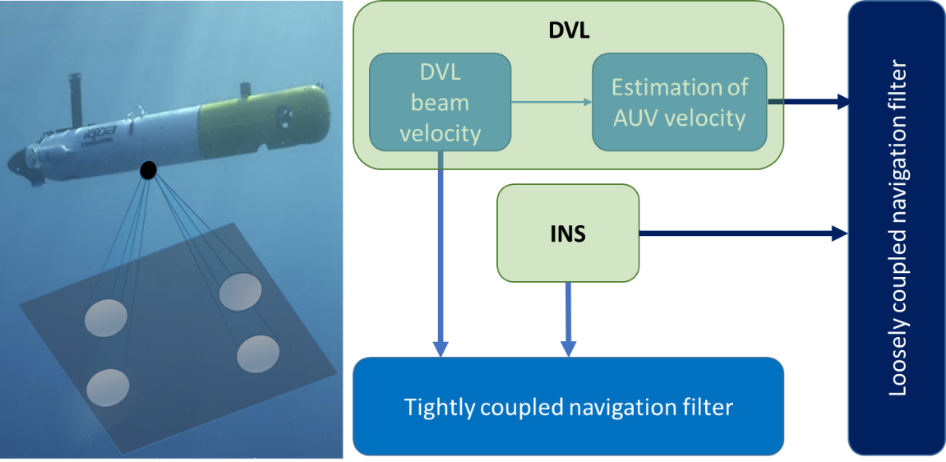

(a) (b)

Figure 1: (a) AUV with a Janus “x” DVL configuration; (b) INS/DVL fusion types: loosely coupled (body velocity) and tightly coupled (beam velocities)

The relation between the four DVL measurements

$y={\left[\begin{matrix}\begin{matrix}{\tilde{y}}_{1} & {\tilde{y}}_{2}\end{matrix} & \begin{matrix}{\tilde{y}}_{3} & {\tilde{y}}_{4}\end{matrix}\end{matrix}\right]}^{T}$ (12)

and the platform velocity is defined by

$y=Mv^{b}$ (13)

where

$M={\left[\begin{matrix}\begin{matrix}d_{1}^{} & d_{2}^{}\end{matrix} & \begin{matrix}d_{3}^{} & d_{4}^{}\end{matrix}\end{matrix}\right]}^{T}$ (14)

Finally, the platform velocity can be estimated as:

${\hat{v}}_{DVL}^{b}={\left(M^{T}M\right)}^{-1}M^{T}\tilde{y}$ (15)

When using the DVL’s beam velocity measurements (12) in the navigation filter, the fusion is called a “TC integration.” DVL raw data is used in the navigation filter directly, along with the calculated INS counterpart. Therefore, there is no need for a bottom lock stage, and aiding may be applied, even with a single beam measurement. In contrast hand, the LC integration approach uses the DVL’s estimation of the platform’s velocity (15). The advantage of this method is the simplicity of integration and the ability to combine any off-the-shelf INS with any DVL. However, in order for the DVL to calculate vehicle velocity, it must operate in bottom lock: a situation in which a sufficient number of beam measurements (at least three) are available. Both the LC and TC integration approaches are illustrated in Figure 1(b).

3.2 Fusion with Partial DVL Measurements

In the loosely coupled INS/DVL approach, the DVL estimated velocity (15) is employed in the navigation filter. To that end, three (the fourth is for redundancy) DVL beam measurements (12) are needed. In some situations during AUV operations, such as passing over trenches or operating in extreme roll/pitch angles, only one or two DVL beams are available and, as a consequence, the DVL estimated velocity (15) cannot be calculated.

3.2.1 Preliminary Work

Our pioneering preliminary work [33] proposed the extended loosely coupled (ELC) INS/DVL fusion approach, which enables the application of the loosely-coupled approach, with partial DVL beam measurements. Four different approaches to coping with partial measurements were suggested:

* “Virtual Beam” — the most recent velocity estimate from the navigating filter is used as the current velocity of the AUV, and by utilizing the known beam geometry (14), the missing beam velocity can be found using (11)

${\tilde{y}}_{j}=d_{k}^{T}v^{b}$ (16)

* “Nullifying Sway Velocity” — an assumption of zero sway velocity is made. The motivation for this lies in the fact that, in practice, most AUV trajectories are straight lines (although the AUV might be influenced by disturbances that alter the straight line). Thus, the unknown velocity vector now has only two components and, by using the measured velocity of two (instead of three) DVL beams, the components can be determined utilizing (13).
* “Partial Loosely Coupled Fusion” — this method utilizes the DVL setup configuration, in order to calculate one component of the AUV velocity components (in either the surge or the heave direction), depending on the active transducer order. For example, in the “x” configuration, the surge velocity component is estimated, but it is only used in the navigation filter.
* “Virtual Heave Velocity” — to further elaborate the previous approach, the most recent estimated velocity from the navigation filter is used to calculate, and then to heave, the velocity component.

3.2.2 Proposed Research

The proposed research goals and the current ELC approach are presented in Figure 2. The blue rounded rectangles show the ELC approach, which is based on providing more DVL measurements to enable the LC method. The orange rectangles provide the current state-of-the art in the field (as described in Section 3.1.1), while the green rectangles present the proposed research directions.

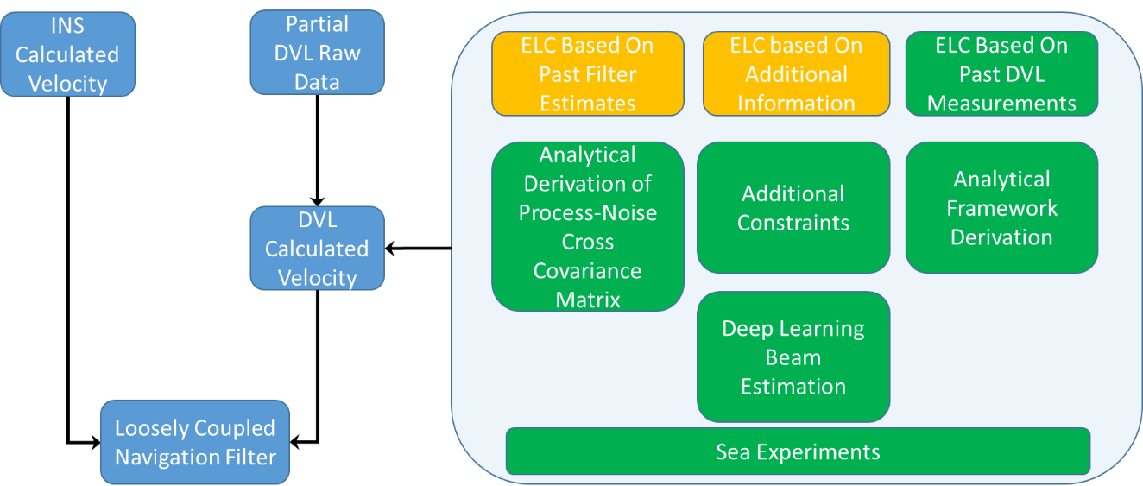

Figure 2: INS/DVL fusion with partial DVL measurements. The blue rounded rectangles show the ELC approach, the orange rectangles provide the current state-of-the art, and the green rectangles provide the proposed research directions topics

The proposed research topics include:

1) Analytical derivation of the process-noise cross covariance matrix in the navigation filter

Usually, when deriving the navigation filter (6)-(10), one of the underlying assumptions is that the process and measurement are not corralled. In fact, this is the case in INS/DVL fusion, since the process-noise depends on the INS inertial sensors, while the measurement noise depends on the DVL. Yet, when using past filter estimates in the ELC approach, the process-noise cross covariance matrix is no longer zero, since the filter solution depends both on the INS and the DVL. This covariance matrix, **N**, is defined by [42]

$E\left[w,v_{}^{T}\right]=N$ (17)

where ***w*** is the process-noise and ***v*** is the measurement noise. As a consequence of the non-zero process-noise cross covariance matrix, the navigation filter error covariance and gain calculations (9)-(10) are modified to

$P_{k}^{+}=P_{k}^{-}-K_{k}\left[H_{k}P_{k}^{-}+N_{k}^{T}\right]$ (18)

$K_{k}^{}=\left[P_{k}^{-}H_{k}^{T}+N_{k}\right]{\left[H_{k}P_{k}^{-}H_{k}^{T}+{H_{k}N}_{k}{+H_{k}^{T}N_{k}^{T}+R}_{k}\right]}^{-1}$ (19)

In [21], using a numerical value for N, the influence of the process-noise cross covariance matrix on navigation accuracy is shown. Here, the aim is to calculate a closed form analytical solution for the cross covariance matrix, using (17). When this analytically derived matrix in (18)-(19) is used, the accuracy of the navigation filter is expected to improve.

2) Additional constraints to enable calculation of the velocity vector

In [33], it was assumed that only one beam velocity is unavailable, while in [34], two beams might be unavailable for the tightly coupled approach. Here, the aim is to elaborate the ELC approach with respect to several aspects, including:

* Addressing the case of only one available DVL beam measurement, and using motion constraint assumptions and/or past DVL measurements to construct the velocity vector necessary for INS/DVL fusion.
* Adding more motion constraint approaches to the ELC framework, for situations when two beam DVL velocities are available.
* Making a clear distinction between ELC, for both “+” and “x” DVL configurations, and deriving the proposed framework for both configurations.

3) Deep-learning-based beam velocity estimation

Machine and deep learning approaches have recently been employed in applications related to navigation. For example, in pedestrian dead reckoning, a commonly used approach for smartphone based indoor navigation, deep learning approaches are used to classify user dynamics (walking/escalator, etc.) [43-44] or smartphone locations (texting/talking, etc.) [45-47], as well as to estimate user step length and heading angle [48-52]. Following the great success of deep learning indoor navigation approaches, we aim to apply deep learning to INS/DVL fusion to achieve equally meaningful results. Our objective is to use partial beam measurements and additional information as input to a neural network in order to estimate the velocities of missing beams. We can then calculate the AUV velocity (15), using the measured and estimated beam velocities, and apply the loosely coupled approach.

4) Analytical derivation of the ELC framework using past DVL measurements

Both [33] and [34] use the most recent velocity estimation from the navigation filter, and neither uses the noise-process cross covariance matrix, as required by the Kalman filter theory. To overcome this problem, instead of using the filter estimated velocity, we propose using past DVL based velocity in order to calculate the velocity of missing DVL beams. This is, we aim to derive the ELC framework from DVL measurements only in order to avoid cross-covariance coupling.

3.3 Fusion with Complete DVL Outages

As in partial DVL measurement availability, in some situations, none of the DVL beams are available during AUV operations. As a result, the DVL velocity update (15) is not available, and the navigation solution must then rely solely on the INS velocity update, which will drift in time.

3.3.1 Preliminary Work

In [36], we derived an algorithm to enable the estimation of the velocity vector in situations of complete DVL outage, based on past DVL measurements. To that end, it was assumed that past DVL-measured velocities from a segment of the AUV trajectory, $v\left(t\right)$, can be modeled as

$v\left(t\right)=v_{0}+a_{0}{\left(t-t_{0}\right)}^{}$ (20)

with constant but unknown vectors of the velocity, $v_{0}$, and acceleration, $a_{0}$. To solve for the unknown vectors, a minimization problem was solved analytically, to yield close-form expressions as a function of past DVL measurements. Using those estimated values for the velocity, ${\hat{v}}_{0}$, and acceleration, ${\hat{a}}_{0}$, the current velocity vector at time *j* of the AUV is found by:

${\hat{v}}_{j}={\hat{v}}_{0}+{\hat{a}}_{0}{\left(t_{j}-t_{0}\right)}^{}$ (21)

Note that since $v_{0}$ and $a_{0}$ in (20) have six unknown parameters, the number of past velocity measurements used should be equal to or greater than two.

3.3.2 Proposed Research

The proposed research goals and our preliminary work in the field are presented in Figure 3 below:

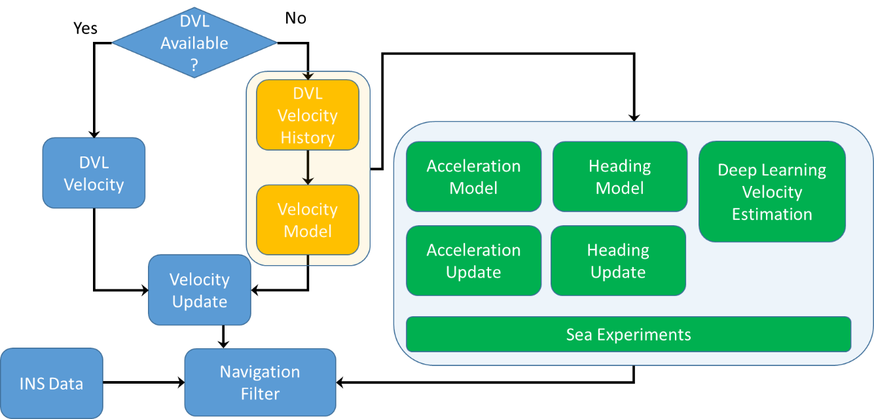

Figure 3: INS/DVL fusion, with or without DVL measurements. The blue rounded rectangles and diamond present the fusion process, the orange rectangles show the current state-of-the-art as described in Section 3.2.1, and the green rectangles provide the proposed research directions

The proposed research directions are:

1) Acceleration model to enable accelerometer bias estimation

When using DVL velocity measurements to update the navigation filter, the system is only partially observable, meaning that not all states in the state vector (1) can be estimated. Two of those states are the accelerometer *x* and *y* axis biases [25].

Now, if the analytical close form solution of the acceleration ${\hat{a}}_{0}$ (obtained from solving (20) using past DVL velocity measurements) is available, it could be used as an additional update to the navigation filter. With such an update, we believe that not only will the accelerometer *x* and *y* axis biases be observable, but there will also be an improvement in the accuracy of roll and pitch angle estimation. As a consequence, the overall estimation performance is expected to improve in situations with no DVL updates.

2) Heading model to enable heading estimation

In global navigation satellite system (GNSS) position and velocity updates (as well as in DVL velocity updates), the heading angle is not observable [35, 53]. To facilitate heading estimation, a geometric constraint is employed, using the measured GNSS velocity vector [54-56]

$ψ_{GNSS}=arctan\left({v_{E}^{GNSS}}/{v_{N}^{GNSS}}\right)$ (22)

where $v_{E}^{GNSS}$ and $v_{N}^{GNSS}$ are the GNSS measured velocity components in directions east and north. However, the measured DVL velocity vector is given in the body frame, so it cannot be utilized (22), even if measurements are available.

Since most AUVs operate at low velocities and have mainly straight line trajectories, we propose leveraging from this behavior and using past estimated AUV velocity vectors from the navigation filter to estimate the heading angle, as in (22). Assuming that the underlying assumptions are valid, the calculated heading angle will also help to estimate the gyro *z* axis bias. When using this proposed approach, the process measurement cross covariance matrix (17) should be taken into account. We aim to calculate it analytically, and employ it in the navigation filter.

3) Deep-learning based velocity estimation

In this part, our goal is employ deep-learning based algorithms to estimate the AUV velocity vector, which in turn will be used in the navigation filter. To that end, we propose two different directions:

* In [36] we showed that our theoretical model (20), used to estimate the current velocity vector expressed in the body frame, is valid for sea experiments. We presented means to calculate the initial velocity and acceleration vectors, based on past DVL measurements. Here, we aim to use deep learning approaches and leverage their noise reduction ability to estimate the initial velocity and acceleration vectors and to obtain the current velocity vector in the body frame by applying them to (21).
* Instead of using past DVL measurements, we propose using the AUV’s inertial sensor readings to directly estimate the AUV velocity vector in the navigation frame.

3.4 Enhanced DVL/INS Fusion Using Machine and Deep Learning Approaches

Our goal is to employ machine and deep learning approaches to improve the performance of INS/DVL fusion in situations where all DVL measurements are available. To that end, we suggest that the regression of four different quantities (presented in Figure 4) should be estimated.

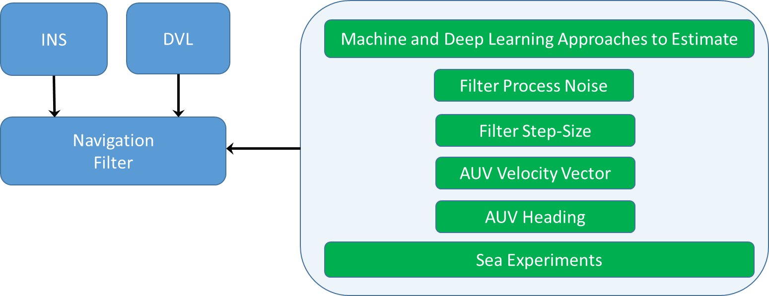

Figure 4: INS/DVL fusion. The blue rounded rectangles present a top-view of the fusion process, while the green rectangles show the proposed research direction topics

The quantities include:

* Filter Process Noise — The navigation filter requires knowledge of the inertial sensor noise statistics in order to accurately determine the process-noise covariance [37-38]. Together with the noise covariance measurement, the statistics determine the filter accuracy and bandwidth [41-42]. Although commonly assumed to be known, in practice, noise covariances are generally unknown, and vary during operation. Using deep learning, we aim to estimate the time varying process noise covariance, taking into account real-time conditions and thereby improving the ability of the filter to change its bandwidth and improve overall navigation accuracy.
* Filter Step Size — The step size (or the difference between two successive time steps) is selected according to the scenario type and computational constraints. Generally, reducing the step size improves estimation error accuracy along with the cost of a high computational load. This trade-off raises the issue of choosing an appropriate step size. To avoid this conflict, our objective is to propose a criterion to act as a guideline for a reasonable choice of step size, then to use machine and deep learning approaches to estimate the actual step size.
* AUV Velocity Vector — Two different inputs to a neural network architecture to regress the AUV velocity are considered. The first input is the four beam velocity measurements, which yield the AUV velocity vectors in both the body frame and the navigation frame. In the former, deep learning will be used instead of using (15); in the latter, the velocity will be regressed directly in the navigation frame, instead of using a body-to-navigation transformation. The second input is the inertial sensor readings, with or without DVL beam velocities, to output the velocity vector in the navigation frame. Regardless of the input type, we aim to achieve improved accuracy in the velocity estimate before it is introduced to the navigation filter.
* AUV heading — We extend the methodology proposed in Section 3.2.2 further by proposing the use of current and past DVL beam velocities as input to a neural network in order to regress the AUV heading angle.

3.5 Sea Experiments and Datasets

We are currently negotiating with several AUV manufactures to purchase a one-man portable micro-AUV which is equipped with an INS and a DVL in order to conduct sea experiments. We estimate that at least five sea days will be required each year, amounting to a total of 20 days over four years. Our goal in conducting the sea experiments is twofold:

1. Algorithm validation: Collecting inertial sensor recordings and DVL data to validate the proposed methods and algorithms.
2. Dataset generation: In addition to theoretical contributions, a major goal of this research is to create extensive datasets of underwater navigation with ground truth and to publish it online.

3.5 Personnel and Facilities

The study’s PI has a strong background in inertial sensors, navigation, estimation theory, Doppler velocity logs, machine learning and deep learning, in theory and in practice. In addition, the PI, with 15 years of extensive experience in the industry, working at leading companies in Israel, brings both academic and industry perspectives to the project. The PI also has extensive experience in the core methodologies of inertial navigation systems, including building some systems to conduct experiments in the field.

Some relevant examples include more than 30 papers about inertial navigation, estimation and tracking, attitude deamination and alignment, multiple navigation systems, INS/DVL and INS/GPS fusion, and machine and deep learning approaches for navigation applications.

His group consists of a full-time research assistant, two PhD candidates, and ten MSc students (one PhD and one MSc student are already working on related topics).

The PI’s Autonomous Navigation and Sensor Fusion Lab (<http://marsci.haifa.ac.il/labs/ansf/>) includes a high-end INS/GNSS system with real-time kinematic (RTK) capabilities, and two massive multi-inertial measurement unit array modules, each with 192 inertial sensors. In addition, we are currently negotiating with several AUV manufactures to purchase a one-man portable micro-AUV, which is equipped with an INS and a DVL, and one underwater drone.

The lab is located in the Helmsley Mediterranean Sea Research Center at the University of Haifa, which comprises an advanced underwater vehicle maintenance workshop, a salt water test pool, and fully equipped electronic and mechanical workshops. Underwater experiments will take place in the Mediterranean Sea.

Time Schedule and Work Plan

|  |  |  |
| --- | --- | --- |
| Objective | Beginning | End |
| Develop the ELC approach based on past filter measurements | Oct 2021 | Oct 2021 |
| Develop the ELC approach based on additional information |  |  |
| Derive the ELC framework based on past DVL measurements |  |  |
| Develop an acceleration model to aid in situations of complete DVL outage |  |  |
| Develop a heading model to aid in situations of complete DVL outage |  |  |
| Drive deep learning framework for velocity estimation in situations of complete DVL outage |  |  |
| Generate datasets of INS and DVL measurements, including ground truth obtained from sea experiments |  |  |
| Filter analytical and regression based process noise covariance approaches |  |  |
| Derive filter step size approaches |  |  |
| Develop a velocity vector regression framework, using both INS and DVL outputs |  |  |
| Derive approaches to estimate the AUV heading angle |  |  |

Explanatory Notes:

All the objectives require both theoretical and experimental work, and some of the experiments may be used to meet several objectives.

Two full-time PhD students will work on the project, with a part-time engineer assisting with all technical and experimental aspects.

We will embark on experiments as soon as possible to strengthen the theoretical development with real data and to provide data for developing and testing the methods. The experimental activity will run concomitantly with the theoretical activity, and will last throughout the four-year duration of the grant, with the first half of the year devoted to purchasing equipment and establishing a web server to post the datasets online. The engineer will be responsible for this activity, and will conduct it jointly with the PhD students.

The theoretical and algorithm development will be carried out by two PhD students, with the following general division of topics:

PhD #1 will work on INS/DVL fusion with partial DVL measurements (roughly, in years 1-2), and fusion with complete DVL outages (roughly, in years 3-4).

PhD #2 will work on analytical and deep learning methods for estimating an adaptive process-noise covariance and appropriate filter step size (roughly, in years 1-2), and various approaches for estimating the AUV velocity and heading angles using deep learning methods (roughly, in years 3-4).