|  |
| --- |
| Comparison of Simple Manual Aspiration and Chest Tube Drainage in the First Occurrence of a Primary Spontaneous Pneumothorax |
| Department of Emergency Medicine and Department of Thoracic & Cardiovascular Surgery, Gil Medical Center, Gachon Medical School |
| Sang Woo Oh, Sung Youl Hyun1, Hyuk Jun Yang, Yong Su Lim, Jae Kwang Kim, Gun Lee |

**Comparison of Simple Manual Aspiration and Chest Tube Drainage in the First Occurrence of a Primary Spontaneous Pneumothorax**

**Sang Woo Oh, M.D., Sung Youl Hyun, M.D.,1 Hyuk Jun Yang, M.D., Yong Su Lim, M.D., Jae Kwang Kim, M.D., Gun Lee, M.D.**

**Purpose:** The aim of this prospective study was to determine the safety and the efficacy of simple manual aspiration, as an initial treatment for the first occurrence of a primary spontaneous pneumothorax, as opposed to chest tube drainage.

**Methods:** From January 2002 to December 2002, 98 patients were admitted for the first occurrence of a primary spontaneous pneumothorax. They were divided into 3 groups according to sizes of the pneumothoraces and the treatment modalities: (1) size<25% (n=21; rest and oxygen therapy), (2) 25<size<80% (n=57), (3) size>80% (n=20; chest tube drainage). Fifty-seven patients with pneumothorax size of 25 to 80% were randomly treated with simple manual aspiration (SMA; n=30) or with chest tube drainage (CTD; n=27).

**Results:** The therapy was successful in 24 out of 30 patients (80.0%) in the SMA group and in 22 out of 27 patients (81.5%) in the CTD group (*p*=0.89). The recurrence rates at 3 months for the two groups were similar (6.7% and 11.1%, respectively; *p*=0.55). The hospital stay was significantly shorter in the SMA group than in the CTD group (4.2 ±3.27 and 7.5 ±2.77 days, respectively; *p*<0.01). Most of the treatment failures in the SMA group involved pneumothorax sizes greater than 50% (5 out of 6).

**Conclusion:** This study indicates that simple manual aspiration seems to be as effective and safe as chest tube drainage. Especially, simple manual aspiration may be proposed as a first-line treatment in the first occurrence of a primary spontaneous pneumothorax with a size smaller than 50%.

|  |  |  |
| --- | --- | --- |
| Manager: | Yong Su Im | |
|  | Department of Emergency Medicine | |
|  | Gachon University Gil Medical Center | |
|  | 1147-16 Guweol-dong, Namdong-gu, Incheon | |
|  | Tel: 032) 460-3015, | Fax: 032) 460-3019 |
|  | E-mail: yongem@netian.com | |
| Date Received: 23 Jul 2003, Publication Approval Date: 6 Sep 2003 | | |

**Key Words:** Pneumothorax, Treatment, Aspiration

Department of Emergency Medicine, Department of Thoracic & Cardiovascular Surgery,1 Gil Medical Center, Gachon Medical School, Incheon, Korea

Introduction

Spontaneous pneumothorax is a disease that is often seen in emergency rooms and is defined as a condition in which air leaks into the pleural cavity, increasing pressure in the thoracic cavity and causing the lung to collapse.1) It is generally classified as primary spontaneous pneumothorax with no clinically obvious pulmonary lesions and secondary spontaneous pneumothorax based on an existing disease such as pulmonary tuberculosis or chronic obstructive pulmonary disease.1) The principle of treating spontaneous pneumothorax is to re-expand the collapsed lung by removing air in the pleural cavity and to prevent further complications and recurrences by doing this, and non-invasive methods such as follow-up and high-concentration oxygen therapy, invasive methods such as simple puncture suction, catheter insertion, and obstructive chest tube drainage, as well as video thoracotomy and thoracoscopic surgery may be performed for this, taking into account such things as the patient’s condition and the size of the pneumothorax.1)-3) Although most cases of incipient primary spontaneous pneumothorax can be resolved by closed chest tube drainage, inpatient treatment is essential for closed chest tube drainage. The resulting extended period of hospitalisation, the possibility of pain and deep infection due to chest tube drainage, scarring and infection of the skin incision, and being inconvenienced during the period of chest tube insertion can interfere with the financial and academic activities of patients who are in their late teens to early twenties at the age of initial onset of primary spontaneous pneumothorax. And the burden of not knowing when there might be a recurrence can also be a source of great stress for both the patient and the family.4) Bullectomy by video thoracotomy and thoracoscopic surgery have excellent outcomes with recurrence prevention rates of more than 95% and 99%, respectively. However, the rate of recurrence after treatment of primary spontaneous pneumothorax with closed chest tube drainage is generally reported to be about 30%, and, in light of this, it is not appropriate as an initial treatment because the remainder of patients can be viewed as undergoing unnecessary surgery.5),6) Therefore, the authors conducted this study to compare simple manual aspiration, which is much easier to perform and almost non-invasive, with closed chest tube drainage for success rate, recurrence rate, and duration of hospitalisation and analyse its usefulness and safety.

Subjects and Methods

1. Subjects

We performed a prospective study to randomly perform simple manual aspiration or closed chest tube drainage using as patients whose vital signs were not unstable and whose pneumothorax size was at least 25% to at most 80% among primary spontaneous pneumothorax patients with no previous history of pneumothorax who visited the Emergency Center of Gil Medical Center, Gachon Medical School during the 12-month period from January 2002 to December 2002. Patients were excluded as subjects if they were suffering respiratory distress or chest pain that they could not tolerate, or if pleural effusion was observed in chest radiography. Patients with unstable vital signs who did not meet all of the following conditions were also excluded as subjects and all underwent closed chest tube drainage: respiration rate 30 breaths/minute or less, pulse rate 60 to 120 beats/minute, systolic blood pressure 90 mmHg or higher, and arterial oxygen concentration 90% or higher.

2. Methods

For the size of the pneumothorax, posterior and anterior chest radiography was taken immediately after admission, and, with this, we used the formula devised by Collins et al.,7) to measure the size of the pneumothorax using the sum of the interpleural distances between the three sites devised by Collins et al.7): Pneumothorax size (%) = 4.2 + 4.7 × (the sum of interpleural distances measured from each central part dividing the upper and lower thorax and the apex of the lung, cm).

Subject patients were randomly selected to undergo simple manual aspiration or chest tube drainage. For simple manual aspiration, the patients were put in a semi-supine position, then underwent local anaesthesia with 2% lidocaine after skin disinfection, and an 18-gauge intravenous needle catheter was slowly inserted into the 2nd or 3rd intercostal space on the midclavicular line. When the catheter was confirmed to be located in the pleural cavity by air leakage, the catheter was pushed approximately 5 to 10 cm further into the pleural cavity as the needle was removed. After securing the catheter to the skin and attaching a three-way valve, aspiration was performed through it with a 50-cc syringe until resistance was felt or it could not be further aspirated. After aspiration, the catheter was removed, and chest radiography was performed. Closed chest tube drainage was performed using the 28 Fr thoracic duct and the 4th or 5th intercostal space on the anterior axillary line, then applying negative pressure (-20 cmH2O) using a three-bottle system and similarly taking chest radiography after insertion. All patients were admitted for follow-up, and chest radiography was performed every morning. In patients who underwent simple manual aspiration, manual aspiration was performed again if lung collapse was observed again after admission, and, if lung collapse proceeded further, it was defined as treatment failure, and chest tube drainage was performed. In patients who had already undergone chest tube drainage, treatment failure was define as lungs not re-inflating when 72 hours had elapsed after insertion of the chest tube or a large volume of air leakage was observed, and a thoracotomy was performed.6),8) Treatment success was defined as being able to be discharged without any other invasive procedures after undergoing simple manual aspiration or closed chest tube drainage, and follow-up was performed by performing outpatient chest radiography when symptoms such as chest pain or dyspnea occurred at 1 week, 1 month, 3 months after discharge or during the observation period. Patients with a pneumothorax size of less than 25% underwent observation and oxygen therapy with 3 L of oxygen per minute by nasal cannula, and closed chest tube drainage was performed in more than 80% of the patients. Statistical comparisons between the two groups were made using SPSS 11.0 for Windows, and analysis was done with Student’s t-test for quantitative variables and the Χ2-test or Fisher’s exact test for nominal variables. Using a 95% confidence interval, *p*<0.05 was considered to be significant.

Results

A total of 98 patients with spontaneous pneumothorax visited the Emergency Center of Gil Medical Center, Gachon University during the 12-month period from January 2002 to December 2002. There were 21 patients with a pneumothorax size of less than 25% who underwent observation and highly-concentrated oxygen therapy, and 20 patients with a pneumothorax size of 80% or greater who underwent closed chest tube drainage immediately after admission. There were 50 primary pneumothorax patients with sizes 25 to 80% who were subjects of this study, and 30 were in the simple manual aspiration (SMA) group and 27 in the chest tube drainage (CTD) group. There were no differences in age, gender, or size or location of the pneumothorax between the two groups (Table 1). No statistically significant differences were seen between the SMA group and the CTD group in treatment failure rate (20% (6/30) and 18.5% (5/27), respectively) or 3-month recurrence rate (6.7% (2/30) and 11.1% (3/27), respectively) (*p*=0.89 and *p*=0.55, respectively). However, a statistically significant difference (*p*<0.01) was seen in the hospitalisation period at 4.2 ±3.27 days and 7.5 ±2.77 days, respectively (Table 2). In the SMA 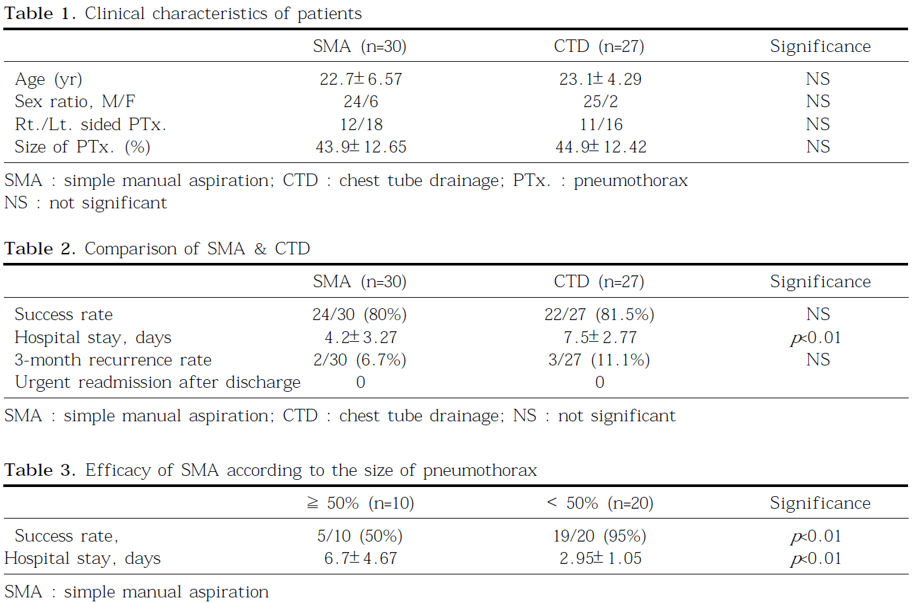group, two of six patients who underwent closed chest tube drainage after treatment with simple manual aspiration failed had reduced air leakage and were extubated and discharged 5 days after intubation, and the remaining four underwent thoracotomy with persistent air leakage 72 hours after intubation. Of the total of 27 patients in the CTD group, 22 were able to be discharged after extubation, but the remaining 5 patients underwent thoracotomy with pneumothorax persistently observed in chest radiography or persistent air leakage even 3 to 4 days after intubation. There were no complications such as empyema, haemothorax, or wound infection in either the SMA group or CTD group, and there were no cases of readmission due to emergencies such as pneumothorax-related complete lung collapse or tension pneumothorax during the 3-month follow-up period after discharge (Table 2). In patients whose pneumothorax size was 50% or greater, simple manual aspiration showed a success rate of 50% (5/10), but a success rate of 95% (19/20) was seen in patients whose pneumothorax size was 50% or less (Table 3). From the perspective of hospitalisation period, dividing them into cases of pneumothorax size of 50% or less and 50% or greater, a significant difference (*p*<0.01) was seen with 2.95 ±1.05 days for 50% or less and 6.7 ±4.67 days for 50% or greater. Twenty-one patients whose pneumothorax size was 25% or less were all able to be discharged with no other procedures except for follow-up and oxygen therapy, and only one of those cases had a spontaneous pneumothorax on the opposite side 4 weeks after discharge and underwent a thoracotomy. Of the 20 patients whose pneumothorax size was 80% or greater, 12 were discharged after extubation, and 8 underwent thoracotomy with persistent air leakage for 3 or more days after intubation.

Discussion

According to recent reports, primary spontaneous pneumothorax is a relatively common disease with 6 to 7 cases per 100,000 population annually, and, although recurrence rates may differ according to treatment method, cases in which non-invasive methods such as follow-up and highly-concentrated oxygen therapy, simple manual aspiration, catheter insertion, or chest tube drainage were used without undergoing pleurodesis are reported to be about 30% of the results, ranging from 16% to 52%.1-3,9) Primary spontaneous pneumothorax is not a life-threatening condition or a serious condition that leaves aftereffects; however, because it can be a major stress factor for patients and their families, and the primary purpose of the treatment of spontaneous pneumothorax is to remove the air in the pleural space and re-inflate the collapsed lung, discussion continues of treatment methods that are simpler and less invasive and can reduce hospitalisation rates and hospitalisation periods, depending on the patient’s condition and the size of the pneumothorax.1,2,4)

In many reports, the size of the pneumothorax was 15% or less, and the lung was re-inflated with only simple observation or oxygen therapy.5,10-14) When indoor air is aspirated, approximately 1.25% of the air in the pleural space is absorbed per day, and when additional oxygen is supplied, absorption of the air in the pleural space increase by about three to five times.10-12) According to American College of 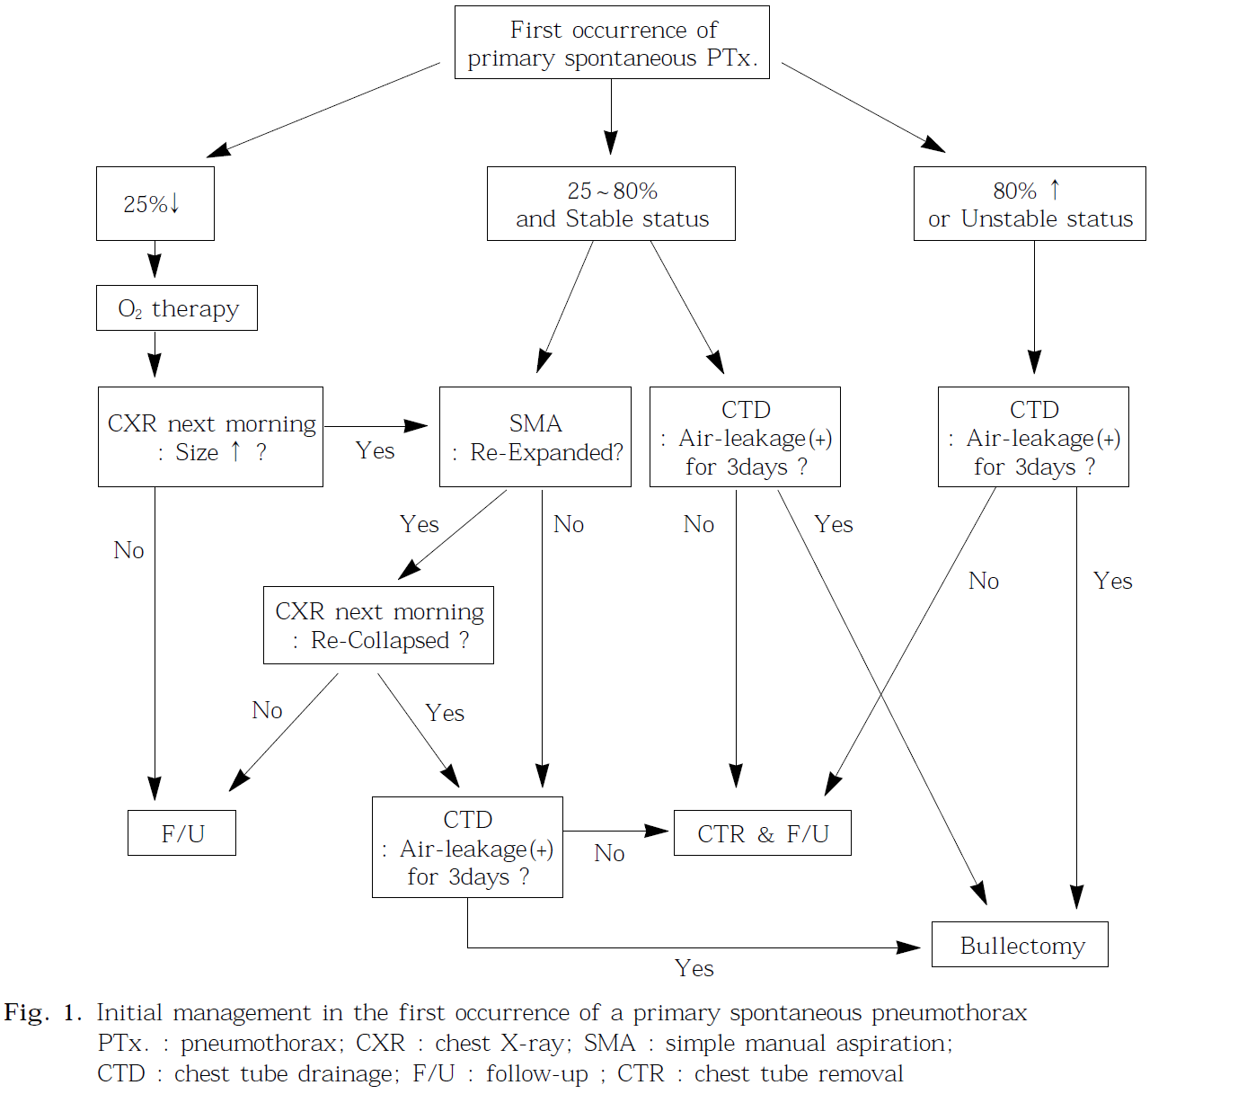Chest Physicians (ACCP) guidelines, patients whose pneumothorax size is small in chest radiography are observed for 3 to 6 hours in the emergency room if they are clinically stable, then undergo chest radiography again and can be sent home if it has not progressed assuming follow-up within 2 days.14) Even when symptoms have been present for 24 hours or more, simple aspiration or closed chest tube drainage is not necessary in most patients if the size of the pneumothorax does not increase.14) In the results of this study as well, discharge was possible without other invasive procedures for small pneumothoraxes with a size of 25% or less that did not progress further, and there were no cases of readmission with pneumothorax-related emergencies.

Several studies of simple manual aspiration of been conducted. Harvey and Prescott15) reported that as a result of randomly selecting 73 primary spontaneous pneumothorax patients to undergo either simple manual aspiration or closed chest tube drainage, simple manual aspiration showed a success rate of 66% (23/35). According to a report by Andrivet et al.,8) simple manual aspiration showed a lower success rate than chest tube drainage (67% (22/33) and 93% (26/28), respectively; *p*=0.01), and the differences between hospitalisation periods and 3-month recurrence rates were not significant. Noppen et al.,3) compared simple manual aspiration with chest tube drainage and stated that there was almost no difference in the success rate (59.2% (16/27) and 63.6% (21/33), respectively; *p*=0.90) and 1-year recurrence rate, and the difference in hospitalisation periods was not significant, but simple manual aspiration had the advantage of reducing unnecessary hospitalisation by almost half (52%). As seen in the results of these studies, there was not a great difference in the success rate or recurrence rate between simple manual aspiration and chest tube drainage.

From the perspective of recurrence, pleural adhesion is induced to some extent due to the irritating effect of the chest tube when chest tube drainage is performed, but, in light of the fact that a rate of recurrence of 23 to 52% is seen when treatment is only with simple chest tube drainage without pleurodesis; the irritating effect of the chest tube itself does not seem sufficient to prevent recurrence of primary spontaneous pneumothorax .8,9) Injection of sclerosing agents such as talc or tetracycline through the chest tube has not generally been accepted up to the present in patients with primary spontaneous pneumothorax, and the recurrence prevention rate is reported to be around 80%.5) Furthermore, when chemical pleurodesis was performed in spontaneous pneumothorax, the effect of the resulting pleural adhesions on subsequent surgical procedures has not yet been elucidated.8,17)

The occurrence of a collapsed lung after undergoing simple manual aspiration means that there is a persistent air leak, and repeating it is ineffective.5,18) In the results of this study as well, lung collapse recurred in four patients after the first attempt and underwent a second simple manual aspiration, but all four cases ultimately underwent chest tube drainage, and three of those cases underwent thoracotomy with persistent air leaks even after chest tube intubation.

The success of simple manual aspiration appears to be related to the size of the pneumothorax. Miller and Harvey13) recommended discontinuing further aspiration in the British Thoracic Society (BTS) guidelines if the volume of aspirated air is 2,500 ml or greater, and, according to Kiely et al.,16) a success rate of 60% (54/90) was seen when 2,500 ml or less of air was aspirated, but a success rate of only 21% (6/29) was seen when 2,500 ml or more of air was aspirated. In the six cases in which treatment with simple manual aspiration failed in this study, treatment failed with pneumothorax sizes, respectively of 58, 62, 70, 45, 67, and 57% at the time of their visits, and it was confirmed that the size of the pneumothorax was 50% or greater at the time of their visits in the approximately 83.3% (5/6) of patients who underwent closed chest tube drainage. The results of comparing the treatment success rate of simple manual aspiration to this and hospitalisation period with pneumothorax sizes divided into a group of 50% or greater and a group of less than 50% showed that there is a significant difference between the two groups (Table 3). Of the 57 patients who were subjects of this study, all 24 (2 in the SMA group and 22 in the CTD group) in whom air leakage did not persist after closed chest tube drainage were discharged after extubation, and their average period of chest tube placement was 5.5 ±1.64 days.

Discussion

The results of this study suggest that simple manual aspiration may be useful as an initial treatment for incipient primary spontaneous pneumothorax because its success rate and 3-month recurrence rate did not show a great difference from that of closed chest tube drainage, and the period of hospitalisation can be shortened. In addition, its success is related to the size of the pneumothorax, and simple manual aspiration is considered to be more useful in patients whose pneumothorax size is 50% or less in particular.

References

1. Lee J, Kim J, Seo G, Yun Y. A Clinical Evaluation of Spontaneous Pneumothorax. JKSEM 1997;8:42-51

2. Oh T, Jang U, Bae S. The Management of Spontaneous Pneumothorax - Clinical Review in 451 Cases. The Korean Journal of Thoracic and Cardiovascular Surgery 1998;31:374-9

3. Noppen M, Alexander P, Driesen P, Slabbynck H, Verstraeten A. Manual aspiration versus chest tube drainage in first episodes of primary spontaneous pneumothorax: a multicenter, prospective, randomized pilot study. Am J Respir Crit Care Med 2002;165:1240-4.

4. Jeon S, Lee E, Jo J, Jang B, Lee J, Kim G, et al. Treatment Guidelines for Primary Pneumothorax. The Korean Journal of Thoracic and Cardiovascular Surgery 2002;35:43-7.

5. Baumann MH, Strange C. Treatment of spontaneous pneumothorax: A more aggressive approach? Chest 1997;112:789-804.

6. Shoenenberger RA, Haefeli WE, Weiss P, Ritz RF: Timing of invasive procedure in therapy for primary and secondary spontaneous pneumothorax. Arch Surg 1991;126:764-6.

7. Collins CD, Lopez A, Mathie A, Wood V, Jackson JE, Roddie ME. Quantification of pneumothorax in chest radiographs using interpleural distance: Regression analysis based on volume measurement from helical CT. Am J Roentgenol 1995;165:1127-30.

8. Andrivet P, Djedaini K, Teboul JL, Brochard L, Dreyfuss D. Spontaneous pneumothorax: comparison of thoracic drainage vs immediate or delayed needle aspiration. Chest 1995;108:335-40.

9. Schramel F, Postmus P, Vanderschueren R. Current aspects of spontaneous pneumothorax. Eur Respir J 1997;10:1372-9.

10. Kircher LT, Swartzel RL. Spontaneous pneumothorax and its treatment. JAMA 1954;155:24-9.

11. Northfield TC. Oxygen therapy for spontaneous pneumothorax. BMJ 1971;4:86-8.

12. Chadha TS, Cohn MA. Noninvasive treatment of pneumothorax with oxygen inhalation. Respiration 1983;44:147-52.

13. Miller AC, Harvey JE. Guidelines for the management of spontaneous pneumothorax. BMJ 1993;307:114-6.

14. Baumann MH, Strange C, Heffner JE, Light RW, Kirby TJ, Klein J, et al. Management of spontaneous pneumothorax: an American College of Chest Physicians Delphi Consensus Statement. Chest 2001;119:590-602.

15. Harvey J, Prescott RJ. Simple aspiration versus intercostal tube drainage for spontaneous pneumothorax in patients with normal lungs. BMJ 1994;309:1338-9.

16) Kiely DG, Mahadevan V, Davey WA, Tayor G, Seaton D. Volume aspirated is an indicator of the success of manual aspiration in the treatment of spontaneous pneumothorax. Thorax 2000;55 supplement 3:A74.

17. Light RW. Management of spontaneous pneumothorax. Am Rev Respir Dis 1993;148:245-8.

18. Hamilton AAD, Archer GJ. Treatment of pneumothorax by simple aspiration. Thorax 1983;38:934-6.