**LANDSCAPE ARCHITECTURE AS A CATALYST FOR IMPROVING THE QUALITY OF LIFE FOR PATIENTS IN MENTAL HEALTH INSTITUTIONS**

**Kanonich, Z1**

1corresponding university, institute,…

Email of the Presenting Author

**ABSTRACT**

How should we plan outdoor environments that will contribute to the quality of life of patients in mental health institutions? This research question, based on the paradigm of nature as rehabilitative, arose from encounters with outdoor environments in mental health institutions throughout the country. The understanding that spending time in nature or an environment that resembles nature improves humans’ health and mental state was prevalent thousands of years ago, but only in 1984 was the first empirical study published proving that exposure to a garden environment has a real effect on physiological parameters (Ulrich, 1984). The current research study is based on a combination of three schools of thought: the healing garden school, the horticultural therapy school and the cognitive school. Within the framework of these three schools, diverse theories have been developed to connect the physical and mental state of humans to the environment, from those that assume the connection is based on ‘evolutionary memory’, psychological theories that consider the garden to be an inclusive environment, and theories that place importance on physical activities in the garden.

**Keywords:** 4-5 keywords

**INTRODUCTION**

“Flowers are restful to look at. They have neither emotions nor conflicts.” (Sigmund Freud)

**

“Loneliness under hospitalization is difficult: there is no connection to the outside world, only the memory remains, but with time it also fades and disappears. The patient loses track of time, each day is like the one before. The sounds and noises coming from outside and the smells that encompass his environment add to the pressure that he already finds himself in. He is in a foreign environment, in which his status, relationships and the power relationships between him and the medical staff members are unclear. A feeling of boredom and the long-term inactivity cause his thoughts to wander, and he sinks into an imaginary world and cuts himself off from the real world” (David, R, 2011).

Mentally-ill people must deal with difficulties arising from mental disorders – a general name for a group of disorders that cause disruptions in thought processes, emotions and communication, and make it difficult for sufferers to deal with routine life situations. There are dozens of mental diseases and disorders, each with its own severity and symptoms. They may appear in people of every age, regardless of gender, race, religion or socio-economic status, but the common denominator for all mental disorders is the subjective mental distress of the mentally ill, resulting in objective damage to their ability to function, at least on one life level – social, occupational, educational or interpersonal.

So how can we design outdoor environments to ensure they contribute to the quality of life of patients in mental health institutions? I asked this question, which is based on the notion of nature as rehabilitative, after encounters with outdoor environments in mental health institutions throughout the country. They left me with the harsh impression of deficient planning vision and an understanding that a well-planned outdoor environment can improve the quality of life of the mentally ill patients in these institutions.

In order to plan an outdoor environment that will contribute to the quality of life of the patients in a mental health institution, we must study their life under hospitalization. For this purpose I reviewed both research literature as well as theoretical and historical literature, conducted interviews and discussions with the target audience – mental health workers, patients and their families – and conducted observations, planned a case study and had it evaluated by experts. Based on all of these I proposed ways to bring nature into outdoor environments in mental health institutions and to strengthen the connection to nature, including increasing the amount of vegetation, encouraging patients to spend time in outdoor environments and natural areas, creating visual and functional diversity, encouraging a feeling of vitality and a connection to reality, creating sensory stimuli and ensuring security and safety.

But the question remains: how does the environment affect the physical and mental condition of the patient?

**RESEARCH METHOD**

This research study is based on the Research by Design (Deming & Swaffield, 2011) method in which planning is an essential stage in the research process, as described below (Table 1).

**Table 1.** Stages in the research methodology

**THE EFFECT OF THE ENVIRONMENT ON THE MENTAL AND PHYSICAL STATE OF THE PATIENT**

A person’s natural attraction to nature, particularly during times of sickness and stress, is explained by different theories that connect his physical and mental state to the environment. Some theories explain this connection on the basis of evolutionary memory, some via psychological theories that consider the garden environment to be inclusive, while others assign importance to actual physical activity in the garden (Ulrich, 1984). Three schools of thought try to answer the question: the healing garden school of thought, the horticultural therapy school of thought and the cognitive school of thought. All three consider the influence of the environment on human health in general and do not focus necessarily on the mentally ill; they differ in the way they perceive the involvement of humans in the environment.

**Healing Garden school of thought**

This school of thought assigns importance to the experience of spending time in the garden space, while considering garden design and components, and the ability of this environment to be healing, stemming from its capacity to reduce stress and rehabilitate (Cooper-Marcus & Barnes 1995). It proposes a few theories that describe how the environment influences a patient’s physical and mental state: The Biophilia Theory – “biophilia, if it exists, and I believe that it does exist, is the congenital emotional connection between man and the animal world” (Kellert & Wilson, 1995); The Stress Reduction Theory – the garden environment is known to relieve feelings of stress in both patients and the attending staff and to encourage a feeling of control, social support, an opportunity for movement and activity, and leisure in a natural environment; The Inclusion Theory – the garden provides an environment that considers the capabilities of a patient in a state of despair or poor state of mind; The Relaxation Response Theory – certain diseases become more severe when a patient is in a state of pressure or stress (Carpman & Grant, 1986).

**Horticultural Therapy school of thought**

This school of thought assumes that physical work in the garden is safe, enjoyable and provides meaning. A working person feels compensated, particularly when there is harmony and a good match between the challenge facing him and his abilities (Simon & Straus, 1998). Work in the garden creates a feeling of physical and mental well-being, commitment, and disregard for time and identity. It has been proven that there is a human response to plants – *phyto-resonance* (Neuberger, 2007) (phyto=plant-related). Plants are very similar to humans and reflect processes taking place in humans.

**Cognitive school of thought**

This school of thought developed among researchers in environmental psychology, landscape architecture, medicine and horticultural therapy. According to the cognitive school of thought, a garden or wild nature provide the patient with shapes, colors, smells and activities that remind him of his active life, particularly the periods of childhood and youth, which are usually connected to these stimuli. These experiences strengthen the patient’s feeling of self-identity and his self-concept as part of a meaningful world (Garlach-Spriggs et al., 1998). This school of thought includes the Attention Restoration Theory, which claims that the human brain has been endowed with two types of attention: spontaneous attention that is unconscious, does not require classification or filtering, and thus is not tiring, and attention that requires direct concentration (Kaplan & Kaplan, 1989); the Dermo-Optic Perception Theory, according to which our skin contains sensors that sense the energy of color, and more.

**ENCOUNTERS IN THE OUTDOOR ENVIRONMENT**

The three round table discussion I held at Maale Hacarmel Hospital with three groups of stakeholders – mentally ill patients, attending staff, and family members – produced interesting results that reveal their needs. It appears that patients sometimes prefer to be alone, and other times to spend time in a group, according to their mood. In a group they prefer to meet up in accessible places, near the ward, with comfortable furniture. The choice of sitting in a group may be planned or spontaneous when there is a gathering in a meeting-place. Their preferred places to spend time alone are diverse. In general they prefer to be alone in places where nature is present, far from buildings, meeting places and primary movement routes.

Families prefer to conduct their meetings outside the building, in a place that offers privacy, and a feeling of security, without interactions with other families. The meeting place should be shady on hot days and protected on rainy days, with comfortable furniture and a pleasant, respectful atmosphere. Staff members themselves also need places to spend time in the outdoor environment, away from their patients (and possibly also from other staff members), in order to refresh themselves and replenish their energy during their work day.

**CONVERTING THE FINDINGS TO PLANNING INSIGHTS**

**The functional level**

*Creating order and boundaries*: some patients tend to lose track of time, thus the seasons of the year and hours of the day must be emphasized using vegetation and inanimate objects.

*Personal security*: the hospital environment of the mentally ill necessitates caution when planning for safety issues. It is necessary to create spaces bordered by vegetation, use soft materials, and avoid harmful vegetation.

*Comfort and accessibility*: the arrangement of hospital spaces and activity areas on different levels harms the quality of treatment and negatively affects the patients’ condition. Operating on one level has a significant and positive effect. Similarly, accessibility to all hospital spaces and activity areas must be ensured.

*Movement*: patients tend to stay near the ward due to fatigue, weakness, a lack of self-confidence and indifference. Therefore their confidence must be strengthened by a system of paths: a hierarchy and clear identity must be defined for different movement routes; movement routes must never lead to a dead end; the main route must be wide and clearly visible.

*Maintenance and service buildings*: maintenance buildings may be used by patients as part of their occupational therapy, on condition that the work environment is hygienic and safe.Therefore, maintenance buildings must be accessible to patients and well-designed.

**Therapeutic level**

*Strengthening the feeling of closeness to nature*: exposure to the natural environment must be provided in leisure areas within the buildings, in terms of both gazing at nature and accessibility. Nature must be brought into the outdoor environment in a range of ways (distance landscape, close vegetation).

*Encouraging a feeling of vitality and a connection to reality*: the cognitive school of thought attaches high rehabilitative value to encouraging a feeling of vitality and connection to reality. For employment, it is very important to dissipate the atmosphere of boredom, reduce levels of smoking, rehabilitate patients, prepare them for their return to community life and improve the institution’s reputation. Due the patients’ tendency to stay close to the word and to lose track of time, the outdoor environment must offer a range of places and means that encourage and allow employment, in both central, exposed places and at different distances from the ward, in order to encourage movement and a feeling of been busy. Seasons of the year and hours of the day should be emphasized using vegetation and inanimate objects.

*Strengthening personal identity and self-confidence*: both the horticultural therapy and cognitive schools of thought consider strengthening of self-confidence to be an important component of the rehabilitative process. Losing personal identity is part of the unbalanced state in which the mentally-ill patient finds himself. Clarifying personal identity is part of the treatment process. Both patients and staff members place great importance on personal space and a feeling of personal identity in the hospital. The outdoor environment must offer a range of places and means that encourage and allow different types of employment, including horticultural therapy. Places and means must be provided for self-expression, including spatial creation such as graffiti, corners for displaying patients’ creations, temporary exhibitions, etc.

*Diversity*: The need for diversity in the outdoor environment arose from both the theoretical background and public discussions. Visual and functional diversity is critical for encouraging a feeling of vitality and a connection to reality. According to the relaxation response theory, functional diversity encourages rehabilitation by strengthening the ability for personal choice and control. According to the cognitive school of thought, sensory diversity encourages rehabilitation by honing the senses and cognitive abilities. The outdoor environment needs to offer a range of places and means that encourage and allow different types of employment. A design balance should be maintained between diversity and uniformity, for example, by maintaining a common denominator among different elements and by avoiding excess amounts of materials, shapes and colors. Diversity must be expressed mainly by distinct design of each different area and movement route, such that the choice itself will be meaningful. Intelligent use should be made of color; there is a need to soften ‘freedom’ and the multiple stimuli offered by the outdoor environment by deterministic design and by creating an outdoor environment with order and boundaries.

*Creating a place for assistance and diagnosis*: although this issue is not connected directly to the theoretical background, proven experience has been reported in the literature (Marcus, 1999, P 336-341). Within the framework of the public discussion, staff members reinforced the claim that the outdoor environment may be used as a diagnosis space by observing patients’ behavior in different challenging environments, as is done from time to time in the dining room or as part of occupational therapy. It is reasonable to assume that the outdoor environment may be used as a diagnostic environment since it invites social gatherings and environments that simulate reality. The outdoor environment needs to offer a range of places and means that encourage social gatherings and experiences at different coping levels.

*Providing solutions for different clinical needs*: patients prefer to be alone in places where nature is present, far from buildings, meeting places and main movement routes. According to the cognitive school, a garden environment helps patients to overcome different cognitive deficiencies by honing the senses and offering diverse activities that improve cognitive abilities.

*A feeling of protection and security*: it is difficult to prevent suicide attempts. The term ‘security’ in the context of the patients’ feelings includes providing solutions, treatment and protection from fears associated with the disease, such as suicidal thoughts, paranoia and conflicts related to daily coping with reality. Closeness to the ward gives patients a feeling of homeliness, which is identified with feeling secure. The feeling of homeliness is important for creating a feeling of security and comfort; however it must be spatially and quantitatively limited. A feeling of homeliness should be provided on a gradation with distance, from the intimate environment of the bed, through the patient’s room, the lobby, and the ward’s courtyard, to the entire hospital environment. To provide a feeling of homeliness it is necessary to use spaces with boundaries, comfortable, homely furniture, flowering vegetation, beneficial plants and soft materials.

*Preparation for returning to the community*: the main purpose of hospitalization is rehabilitation, i.e., preparation for community life. The outdoor environment should offer a range of places and means that encourage social meetings and experiences at different coping levels. In sanatoriums of the 1950s-1970s lawns played an important role as meeting areas that combine spending time in group conversation with exposure to the sun, fresh air and natural landscape. A wide range of spaces designed for groups should be created; these should differ from each other in terms of the experience they provide, be close to the ward and be visible from the main movement routes. A lawn should also be planned as a main meeting area.

*Meetings with family members*:family visits provide satisfaction to both patients and staff members. Therefore, appropriate meeting places for small groups of two to four people should be created near the ward, distanced or separated from each other to allow privacy, and some should be protected from the rain.

*Meetings between patients and staff members in the outdoor environment*: maintaining privacy is a necessary condition for the likelihood of meetings between patients and staff members. These meeting places should be bounded and isolated from background noise. Some of them need to be suitable for group therapy while others for one-on-one conversations. A few one-on-one meeting places should be planned as ‘way stations’ along walking trails, and should include the presence of nature. The close landscape is more meaningful for treatment in comparison to the distant landscape. The outdoor environment needs to offer a range of places and means that encourage and allow employment, both central, visible places, and at different distances from the ward, in order to encourage movement and a feeling of being busy.

**IMPLEMENTING PLANNING PRINCIPLES AT MAALE HACARMEL HOSPITAL AS A CASE STUDY**

Maale Hacarmel in Tirat Hacarmel is a government-run psychiatric hospital affiliated with the Faculty of Medicine at the Technion. It provides treatment for a range of mental disorders to youth, adults and the elderly, and serves a population of approximately half a million people living in Haifa and its surroundings. Ward 6A includes a closed wing with 16 beds and is designed for patients in an acute state that require a protective framework. In addition to this wing there is an open wing with 18 beds that is designed for continuing treatment.

The plan for the Ward 6A courtyard (Figure 1A-B) implements the principle of expanding the view to Mt. Carmel by removing the concrete shelters along the nearby main walking route, as well as setting up a new movement route from west to east that ascends the stairs and turns one’s gaze toward the mountain. The plan creates a separate bordered space for staff members, and two distinctly different spaces for patients that allow choice (Figure 1B). The first space, in the lower courtyard, is designed with soft lines and offers a wide, accessible wooden space with a range of sitting corners, deciduous trees that mark the seasons, and an artificial watercourse that culminates in an ecological pond (Figure 1C-E). The second space, in the upper courtyard, designed with clear geometric lines, offers a bustan (agricultural garden) rich in aromatic and beneficial plants that allows horticultural therapy, and provides an intimate sitting corner. The plan creates diverse leisure and activity spaces, significantly increases the amount of vegetation, integrates water elements, and provides a stage for patients’ creativity, including niches sunken into the wall that supports the stairs. A narrow, meandering circular path made from small pebbles allows meditative walking, barefoot, throughout the courtyard (Figure 1B).

**Figure 1.** Master plan (A), Ward 6 courtyard plan (B), impressions of lower courtyard (C-D), lower courtyard cross-section (E)

**PLANNING PRINCIPLES AND THEIR IMPLEMENTATION**

One of the central guiding principles in writing the master plan for Maale Hacarmel Hospital is emphasizing the presence of nature; this principle generates and facilitates other important principles, such as creating a range of leisure spaces for different needs and communities, activity and strolling in the outdoor environment. The aim of planning is to correct the current situation in which the magnificent nature surrounding the location is hardly noticed, and to strengthen the feeling of closeness to the sea and to Mt. Carmel. Emphasizing the presence of nature was also done by increasing the amount of vegetation by establishing green walls along the entrance path to the ground-floor wards; installing spacious windows for viewing the outdoor environment, as well as wide doors, attracting birds and other animals. Another aim related to this principle is strengthening the connection with the nearby outdoor environment by creating a range of leisure spaces in natural areas and encouraging their use for leisure and activity, for example, by using water elements and setting up nearby sitting corners; installing shading in some of the leisure areas using deciduous trees and airy pergolas combined with vegetation; and an automatic misting system. Strengthening the perception of time is done using vegetation that emphasizes seasonality, elements that create unique shade patterns that change throughout the day and more (Figure 2).

**Figure 2.** Use of vegetation and shade elements

The other central guiding principles included a range of planning tools for encouraging a feeling of vitality and connection to reality, including: encouraging a feeling of vitality and a connection to reality and strengthening the relationship with the community and the city; encouraging regular daily activities, strengthening spatial orientation (Figure 3) and creating a feeling of ownership and belonging (Figure 4).

**Figure 3.** Elements that strengthen spatial orientation

**Figure 4.** Elements that create a feeling of ownership and belonging

In addition a range of leisure spaces allow seclusion at different levels of intimacy (Figure 5).

**Figure 5.** Leisure spaces that allow seclusion at different levels of intimacy

**CONCLUSIONS**

It is necessary and possible to bring about change.In this study I propose tools for examining and planning outdoor environments for psychiatric hospitals, so that they can help patients reach the most stable mental state possible, and prepare them for integration into community life. Landscape architecture is not a replacement for medical treatment, but can certainly be a catalyst for improving the quality of life of mentally ill patients.

**REFERENCES**

10 pt.

**Table 1.**

|  |  |  |  |
| --- | --- | --- | --- |
| **Description of stage** | **Sources of information** | **Work method** | **Product** |
| **1. Theoretical background:**  - the history of planning outdoor areas in recovery environments  - review of theories that explain the connection between the environment and physical and mental health | Research literature | Comprehensive literature review | Summary |
| **2. Public participation:**  - initial familiarization  - public participation with staff members, patients and family members | Interviews with:  8 staff members1  A round table with:  10 staff members  5 patients  5 family members | A round table discussion:  - documentation by filming and transcription  Formulating insights classified in a table according to the subjects that arose | Planning guidelines |
| **3. Observations:** | Behavioral observations of patients, visitors and staff members in defined outdoor areas at Maale Hacarmel | In three selected observation areas. Each observation is divided into a morning observation and an evening observation on two separate days | Written formulation of insights |
| **4. Initial planning principles document** | Based on all the insights |  | A written document |
| **5. Case study planning** | Master plan and detailed plan for the patio and entrance to Ward 6A based on the initial planning principles document | Planning | A 1:1000 scale plan, a 1:250 plan of a selected section, 1:250 and 1:100 scale cross-sections, typical details at various scales, simulations |
| **6. Planning assessment and evaluation** | Architectural experts and representatives of the Maale Hacarmel staff (total of 10 participants) | Presenting the planning products, discussion and completion of evaluation questionnaires | Feedback pages |
| **7. Creating a planning tool for a designated planning principles document** | Updating the original document based on the planning evaluation |  | Written document |

1Including the Ward 6A Director, head nurse, deputy head nurse, medical secretary, occupational therapist, horticultural therapist, Maale Hacarmel economist, Maale Hacarmel maintenance manager

**Figure 1.**

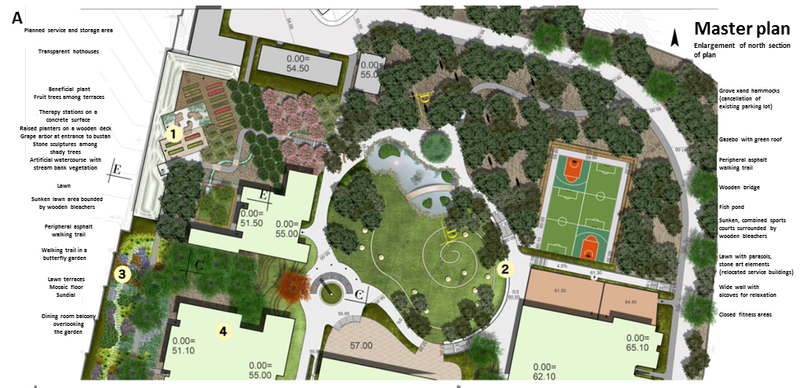

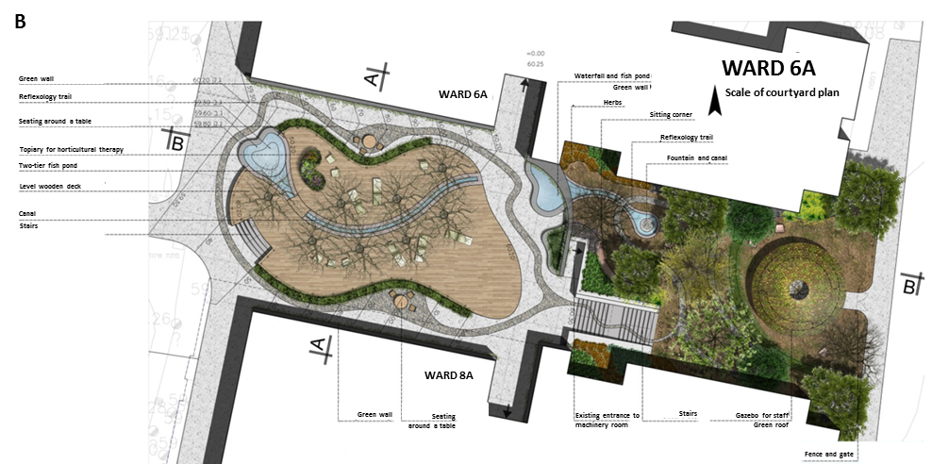

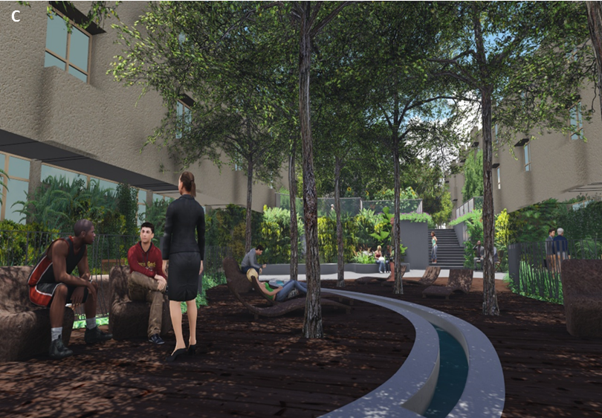

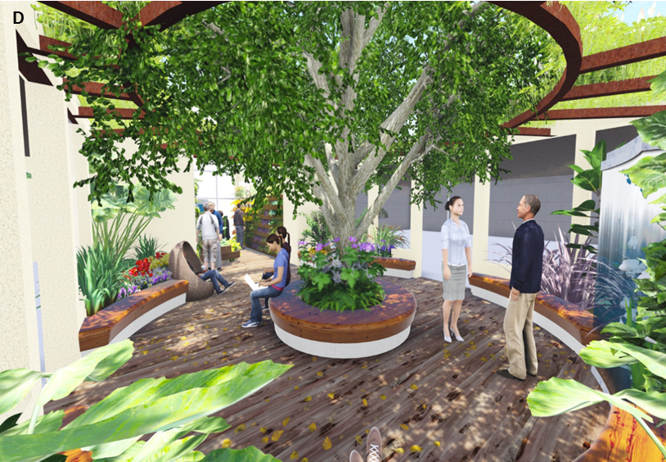

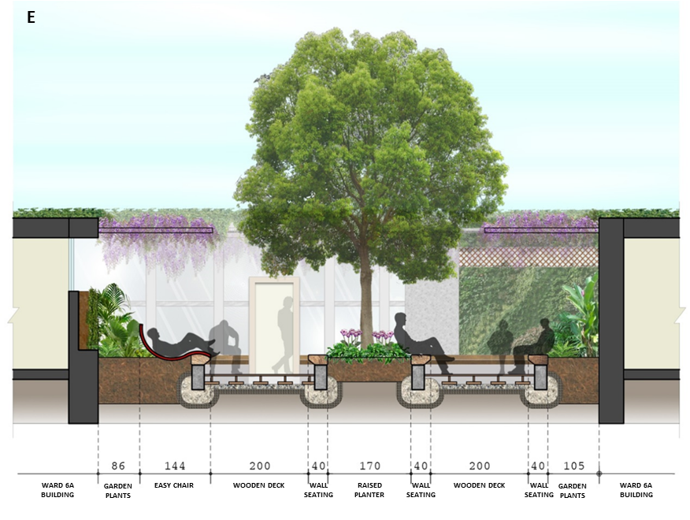

**Figure 2.**

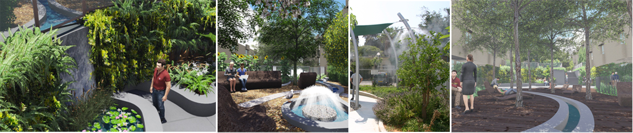

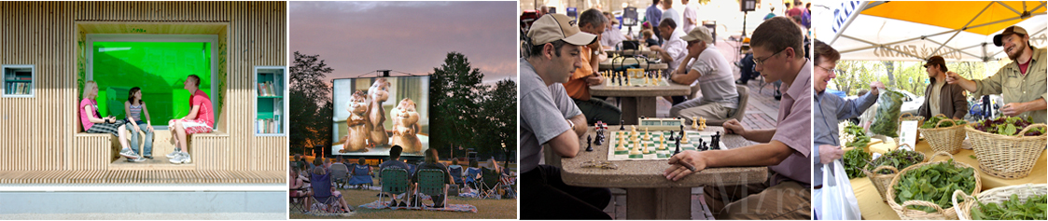

**Figure 3.**

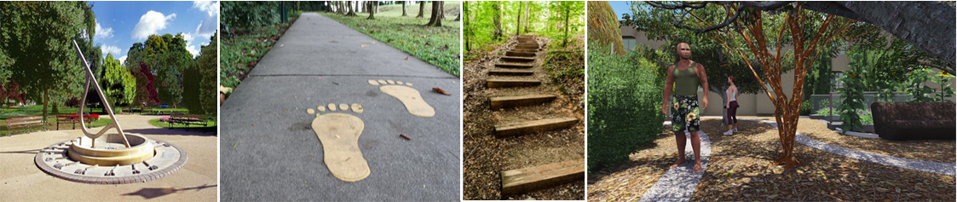

**Figure 4.**

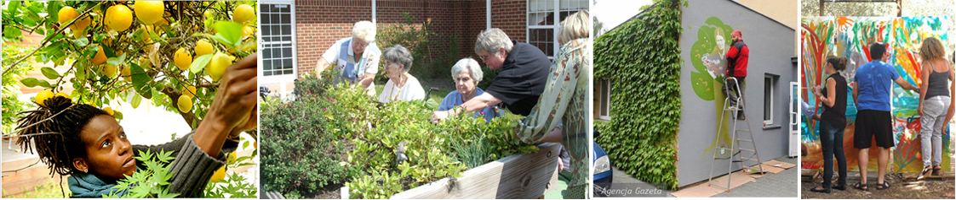

**Figure 5.**

