Raymond C. Russ, Ph.D., Editor  
The Journal of Mind and Behavior  
Department of Psychology  
University of Maine  
5742 Little Hall  
Orono, Maine 04469-5742

Dear Professor Russ,

Please find below my responses to the suggestions included in your letter, as well as the revised manuscript. Thank you to you and the reviewers for the comments. I greatly appreciate the time and effort that you and the other reviewers have invested in providing the reviews. To make it as simple as possible for you to review the corrections I made to the article, I marked the main edits in bold and underlined them. If it is possible, I would like to add a note that reads: I would like to thank the anonymous reviewers and the journal editor, Raymond Russ, for their insightful comments, which greatly improved the paper.

Best wishes,

Sam Rakover

**Responses to the reviewers’ comments and the changes made to the manuscript (MS):**

1. MS. p. 2: I eliminated the italics.
2. MS. p. 4; Letter p. 4: I deleted the three sentences and added a dash, as suggested.
3. MS. p. 5; Letter p. 5: I added the following sentence to explain the use of operational definitions: Note that operational definitions are applied also to the independent variables; for example, the method section of an experimental paper includes a description of the stimuli and the conditions of its presentation.

I deleted the website address that appeared in note 4.

1. MS. p. 7: I clarified note 6.
2. MS. p. 9; Letter p. 9: I italicized the sub-title and deleted the comma. I decided to include all the references since there are about six cases to discuss, and the majority of the references deal with most of these cases. If I separated the references, I would end up citing each of them about 6 times, and I wanted to avoid repeating the citations.
3. Confirmed-Supported: When describing results that validate a hypothesis, it is customary to use the word “confirm”; however, the word “support” may also be used in relation to a hypothesis. The reason for the usage of these terms is that hypotheses cannot be proved or validated by empirical observations because of the issue of inductive reasoning. As such, I believe that using the word “confirmation” works well in this context. Additionally, the use of the word “disconfirmed” may be used as well, but it was not relevant to use the word “unsupported” in the current manuscript.
4. MS. p. 11-12; Letter p. 11: I replaced the word “reinforce” with the word “promote.”

Additionally, in regard to point 6 (above), I used the word “support” on p. 11, line 2.

1. MS. p. 13-15: I made the corrections that were suggested and clarified the conclusion of the short review on p. 13 (in bold and underlined).
2. MS. p. 16; Letter p. 16: I made edits to clarify the sentence.
3. MS. p. 17: I made the corrections that were suggested.
4. MS. p. 18; Letter p. 18: I deleted the sentence.
5. MS. p. 19; Letter p. 19:

**Quotation** -I changed the order of the sentences so that the section will not end with a quotation.

**Muller-Lyer Illusion** -Perhaps the difference in measurements is where one should place the ruler. The depiction below is the way I think one should objectively measure the lines. As you can see, the length of A = the length of B. Below this visual depiction, there is a description of how one creates the ML-illusion. First, one divides the line into two equal parts. Second, one adds the arrows to the line in the appropriate places. These two steps lead to two lines that are objectively equal in length, but do not appear to be equal subjectively.

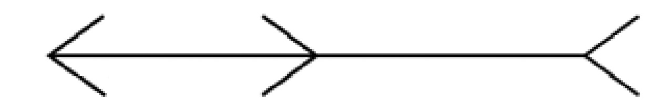

A B

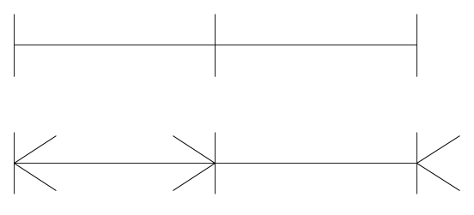

1. MS. p. 20-23: I have made all the suggested corrections.
2. MS. p. 25: I deleted the sentence, as it does not add anything new.
3. MS. p. 26-28: I have made all the suggested corrections.
4. MS. p. 29; Letter p. 29: I re-wrote the sub-section of the conclusion. I hope that it is reads better now.
5. **References and Figure:** I have made all the suggested corrections. Please note that the Berezow, Henriques, and Jogalekar papers and comments appear on the internet. As such, I have included the website links to the reference section.