To whom it may concern,

We confirm that the remainder of the text on the pages that we did not translate is standard contractual legal boilerplate language and not unique to any particular property.

Sincerely,

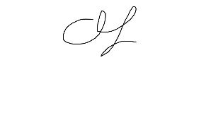

Avi Staiman

CEO, Academic Language Experts