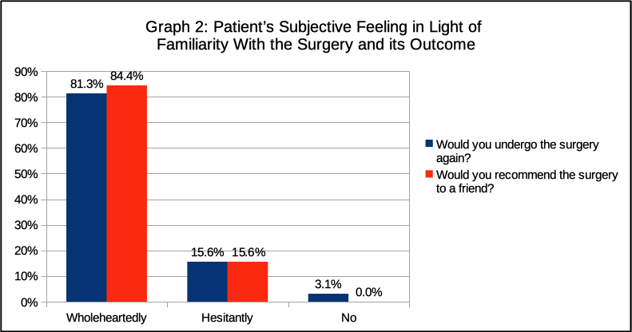**Figure 2.** Patient’s Subjective Feeling in Light of Familiarity with the Surgery and Its Outcome