Ni-WSe2 Nanostructures as Efficient Catalysts for Electrochemical Hydrogen Evolution Reaction (HER) in Acidic and Alkaline Media

Sunil R. Kadam1,2, Andrey N. Enyashin3,4, Lothar Houben5, Ronen Bar-Ziv6 and Maya Bar-Sadan1,2*

1 Ben-Gurion University of the Negev, Department of Chemistry, Beer-Sheva, Israel

2 Ilse Katz Institute for Nanoscale Science and Technology, Ben-Gurion University of the Negev, Beer-Sheva, Israel

*3 Institute of Solid State Chemistry UB RAS, 620990 Ekaterinburg, Russian Federation*

*4 Ural Federal University, Institute of Natural Sciences and Mathematics, 620083 Ekaterinburg, Russian Federation*

*5 Department of Chemical Research Support, Weizmann Institute of Science, Rehovot, Israel*

6 Chemistry Department, Nuclear Research Center-Negev (NRCN), Beer-Sheva 84190, Israel

E-mail: barsadan@bgu.ac.il

**Abstract**

Layered transition metal dichalcogenides (TMDCs) are an emerging materials family of catalysts. W is abundant and affordable, as WSe2 attracted attention for electro-optical applications, although it is relatively unexplored as a catalyst. We report the synthesis of WSe2 doped with various transition metals (Fe, Co, Nb, Ni and Zr). Among the doped catalysts, Ni-WSe2 is the most promising electrocatalyst for the hydrogen evolution reaction (HER), as it possesses the smallest charge transfer resistance, which contributes to the facilitated faster catalytic reaction. The analysis shows that, upon doping with Ni, the catalytic enhancement originates from improved hydrogen adsorption (Hads). Beyond this threshold of Ni loading, the improved activity in alkaline medium results from optimized interaction of the OH/surface active sites. Using density functional theory calculations, we identified that the catalytic sites are Se atoms either bound to a substitutional Ni dopant or constituting a small patch of NiSe grafted on the WSe2 surface.

**Introduction**

The electrochemically driven water-splitting process depends mostly on the availability of efficient and robust catalysts. Hydrogen production through water splitting is among the most promising methods for this challenge.1 In order to adopt water electrolyzers as a main hydrogen production source, it is necessary to develop highly efficient, inexpensive and abundantly available electrocatalysts in both half reactions of water splitting. Currently, Pt-based electrocatalysts demonstrate the best catalytic performance for the hydrogen evolution reaction (HER) in acid (2H + 2e ⟶H2) and alkaline (2H2O + 2e ⟶ H2 + 2OH-) media. However, considering the scarcity and cost of the noble metal Pt, its large-scale utilization as a cathode in H2 production cells is limited.2 Among the nonprecious catalysts that drive HER at low overpotential are transition metal dichalcogenides (TMDCs), such as MoS2, which has been reported as a promising electrocatalyst due to its layered structure, unique electronic configuration and electrochemical stability. Following the successful implementation of transition metal sulfides in various applications, transition metal selenides are now recognized as having enormous potential; heavier chalcogens provide better electrical conductivity, which is critically important for energy storage and optoelectronic and magnetic applications.3, 4 Although the overall structure is similar for all TMDCs, the material properties can be significantly different depending on the size, polarizability and charge of both constituting elements.5

Tungsten is the heaviest transition metal in the TMDC family, and provides a better opportunity to alter the structure and control the materials’ properties.6 WS2 and WSe2 have recently attracted considerable attention because of the abundancy of W in the Earth’s crust, their affordable price and their more benign nature in comparison with their Mo counterparts.7 In particular, WSe2 is one of the most promising in this sub-family, and has been widely utilized for various applications including photodetectors and field-effect transistors.3, 8, 9 Its lattice structure is typical for TMDCs with W atoms confined in a trigonal prismatic coordination sphere neighbored to Se atoms.6 Each layer of W is sandwiched between two layers of hexagonally close-packed Se atoms, and the atomic layers are stacked by weak van der Waals interactions.10 The electrocatalytic HER activity is governed by active sites, intrinsic activity and conductivity between the active sites and the catalyst substrate.11 TMDCs typically adopt a 2H crystal structure where the catalytic active sites are mostly absent on the basal planes but are present at the edges.12 Density functional theory (DFT) calculations by Nørskov et al. show that the Mo edge of MoSe2 and the Se edges of both WSe2 and MoSe2 are major sites for the catalytic activity of the HER, with activity that is predicted to be comparable to or better than MoS2.13 Edge-oriented structures of WSe2 are being envisaged as promising catalysts for HER,14, 15 not only theoretically but practically, similarly to other TMDC materials with such a morphology.16-18

In addition to creating edge-rich morphology, another common strategy to create active catalytic sites is doping of the TMDC with other transition metals,14, 16, 17, 19-21 which is also a means to enhance the electrical conductance within the WSe2 nanosheets.22, 23 The formation of solid solutions with *d*-elements such as Zr and Nb to form W1-xNbxSe2 and W1-xZrxSe2 in a wide range of x is highly probable since both Zr and Nb have the ability to form molecular-like 2D layers similar to WSe2.24 High affinity of Co to the saturation of the edges of layered *d*-metal dichalcogenides is also well established and is extensively applied in catalysis.25-27 Other works have used Fe and Ni as dopants in other TMDCs,28 but focused only on HER in acidic environments.27, 29, 30 A limited number of previous publications presented the catalytic performance towards HER of WSe2 structures such as monolayer nanosheets,31 WSe2 nanotubes supported on carbon fibers,32 WSe2 nanosheets supported on carbon fibers,33 exfoliated WSe2 nanosheets,34 Nb-doped WSe2,11 V-doped WSe2,11 Ta-doped WSe2,11 WSe2/rGO composite,35 Co0.85Se-WSe2 composite36 and WSe2 nanomesh.37 To date, the number of efficient and inexpensive HER catalysts for alkaline medium is much lower than that of acidic medium, although there is promising commercial viability for the design of efficient and stable catalysts for alkaline conditions.

In the present study, a comparative analysis for transition metal doping (Fe, Co, Nb, Ni and Zr) in WSe2 was carried out, using colloidal chemistry as the synthesis route. Doping with Ni leads to the best catalytic performance within this set of samples in terms of the overpotential (η) at 10 mA cm-2 and with a lower Tafel slope. We therefore continued to study only Ni-doped samples in both acidic and alkaline media. The 10% Ni-doped WSe2 exhibits a significantly improved HER performance with a lower Tafel slope and overpotential at 10 mA cm-2 of 259 mV in acid and 215 mV in alkaline medium, much better than reported for pristine and other doped WSe2 samples. Herein, we demonstrate that the sluggish HER kinetics and catalytic activity of WSe2 are improved by Ni doping. Using density functional theory calculations, we propose two possible structures as the catalytic active sites—either the Se bound to a substitutional Ni dopant or the Se in a small patch of NiSe grafted on the WSe2 surface. Electronic properties and charge transfer dynamics of these structures are also discussed.

**Experimental Section**

Pristine WSe2 was synthesized by colloidal chemistry.1-Octadecene (ODE)-Se precursor was prepared by adding 1 mmol selenium powder in 20 mL ODE. Further, 0.2 mmol of ammonium metatungstate hydrate ((NH4)6H2W12O40·xH2O) was mixed with 20 mL of oleylamine. Then, the flask was backfilled with N2 gas, and 0.4 mmol of Se-ODE precursor solution (8 mL) was added dropwise using a syringe pump with constant stirring. The reaction temperature was slowly increased to 300oC and maintained for the next 3 hours. Doped WSe2 samples, with varying compositions, were synthesized by the same procedure except for substitution of some of the W precursor with the precursor of the doping element in the set ratio. The dried powder samples were annealed under a N2 atmosphere at 250oC for 3 hours to remove residuals attached to the surface (ligand stripping). Working electrodes were prepared by dispersing 2 mg of the catalyst and 1 mg Vulcan carbon black in 550 μl of Nafion solution, and the homogeneous ink (20 µl) was drop-casted onto a 3-mm glassy carbon electrode (i.e., final loading of ∼1 mg cm-2). A standard three-electrode system was used for all the electrochemical measurements. The electrochemical HER measurements were performed in Ar-saturated 0.5 M H2SO4 or 0.5 M KOH aqueous solution at room temperature.Detailed experimental procedures are provided in the Supporting Information.

Results and Discussion

The synthesized pristine WSe2 nanostructures comprised small, randomly assembled nanosheets anchored together, forming 3D hierarchical flower-like or petalled structures (**Figure 1a-b**). The nanopetals constituted sheets with edge lengths of 200–500 nm, approximately 10 nm thick. Such a morphology offers many additional active edge sites through the rough surface and promotes the HER performance.38 In addition, doped samples with a feed ratio of 3% (i.e., substituting 3% of the W precursor) were prepared with various transition metals—Ni, Fe, Co, Nb and Zr—all exhibiting similar structural morphology (**Figure 1c-f**). The doping percent provided here is the percent in the feed ratio; the actual doping level within the samples is probably different, as will be discussed below for the Ni-doped samples. In the case of 3% Zr-WSe2, agglomerated particles of 200 nm on average have been observed (**Figure 1f**).



**Figure 1.** SEM images of: (a) pristine WSe2, (b) 3% Ni-WSe2, (c) 3% Fe-WSe2, (d) 3% Co-WSe2, (e) 3% Nb-WSe2 and (f) 3% Zr-WSe2.

According to the X-ray diffraction (XRD) powder diffractions, the crystallographic phase of the synthesized nanostructures (i.e., Fe, Co, Nb and Zr-doped WSe2) is the bulk hexagonal phase, with P63/mmc symmetry matching the JCPDS Data card No. 00-038-1388 (**Figure 2**).

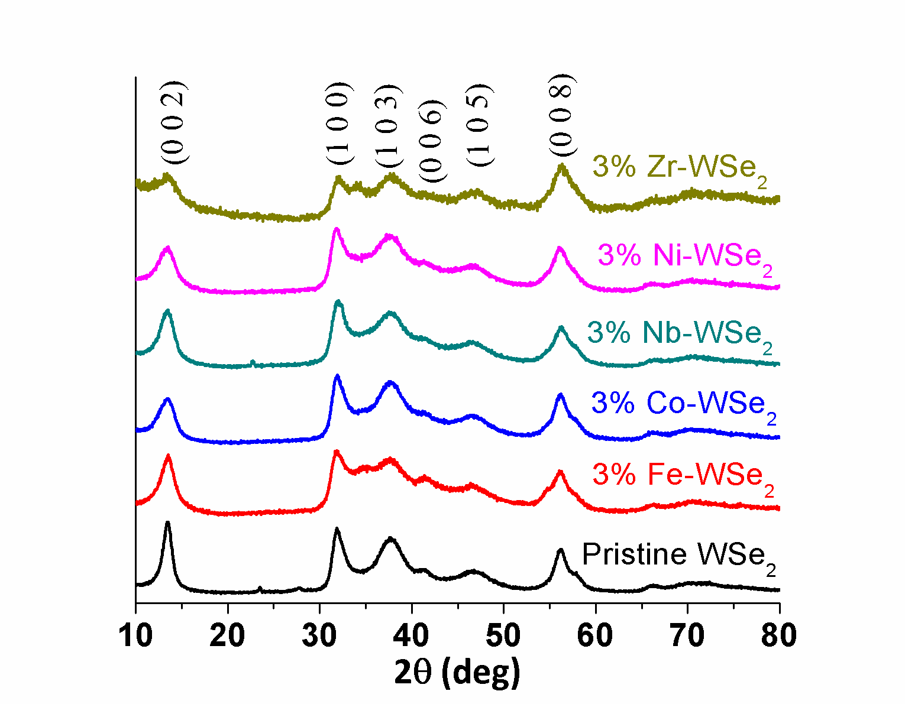

Figure 2. XRD pattern of the pristine WSe2 along with the patterns for 3% Fe, Co, Nb, Ni and Zr-doped WSe2 samples.

Hydrogen evolution electrocatalysis was probed by linear sweep voltammetry (LSV) between 0.1 and -0.5 V versus a reversible hydrogen electrode (RHE) in 0.5 M H2SO4 in a three-electrode configuration (see the Experimental Section of the Supporting Information for details). **Figure 3** shows the polarization curves with their corresponding Tafel plots for pristine WSe2 and 3% Fe, Co, Nb, Ni and Zr-doped WSe2. The 3% Ni-WSe2 catalyst demonstrates the best catalytic performance, displaying the lowest overpotential (η) of 280 mV at 10 mA cm-2, an improvement of about 100 mV from the pristine WSe2.The HER kinetics of the catalysts mentioned above was analyzed by corresponding Tafel plots (η vs log j) (**Figure 3b**). The 3% Ni-doped WSe2 catalyst also shows the lowest Tafel slope within the sample set (79 mV/dec), indicating a faster rate of the HER. Therefore, we focused further on investigating the Ni-doped WSe2 samples.

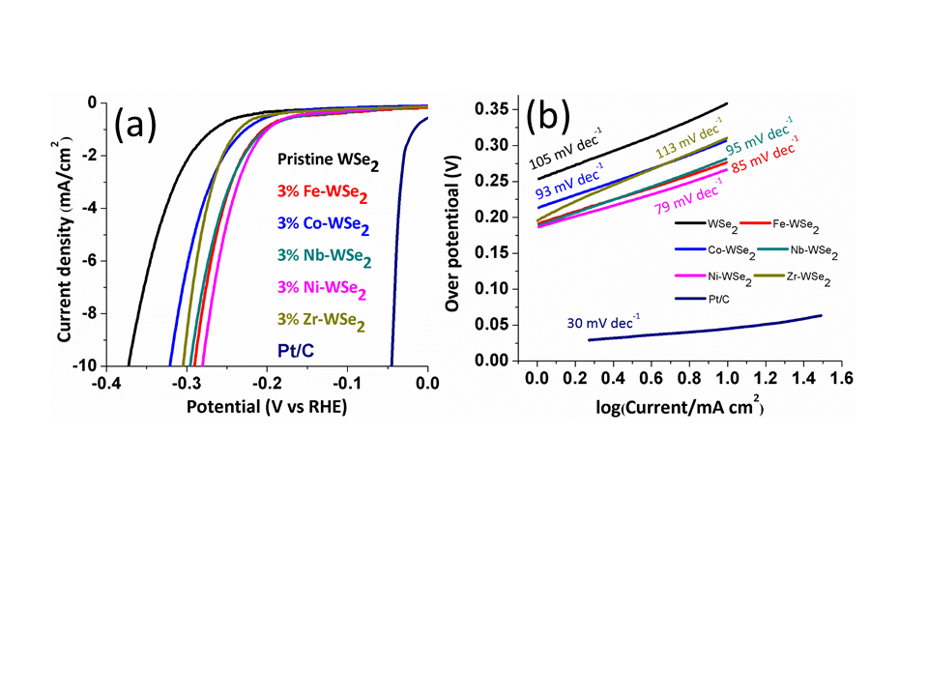

**Figure 3.** (a) HER polarization curves of the pristine WSe2 along with 3% Fe, Co, Nb, Zr and Ni-doped WSe2 samples in 0.5 M H2SO4. (b) Corresponding Tafel plots obtained from the polarization curves.

A controlled synthesis of Ni-doped nanostructures, with feed ratios of 3%, 5% and 10% Ni, was carried out. Scanning electron microscope (SEM) images show that the typical morphology was maintained upon Ni doping (**Figure 4a-c**; see **Figure S1** for additional transmission electron microscope [TEM] images), offering an opportunity to study the specific effect of Ni doping on the catalytic activity. As a control experiment, only Ni and Se precursors were used to prepare pure NiSe structures under the same conditions as the Ni-doped WSe2, resulting in a mixed morphology containing both sheet-like structures of 250 nm in size and rod-like structures of 10 nm in diameter and 400 nm in length (**Figure 4d**). The elemental composition in the samples was confirmed by SEM EDS (energy-dispersive X-ray spectroscopy) analysis (**Table S4**).

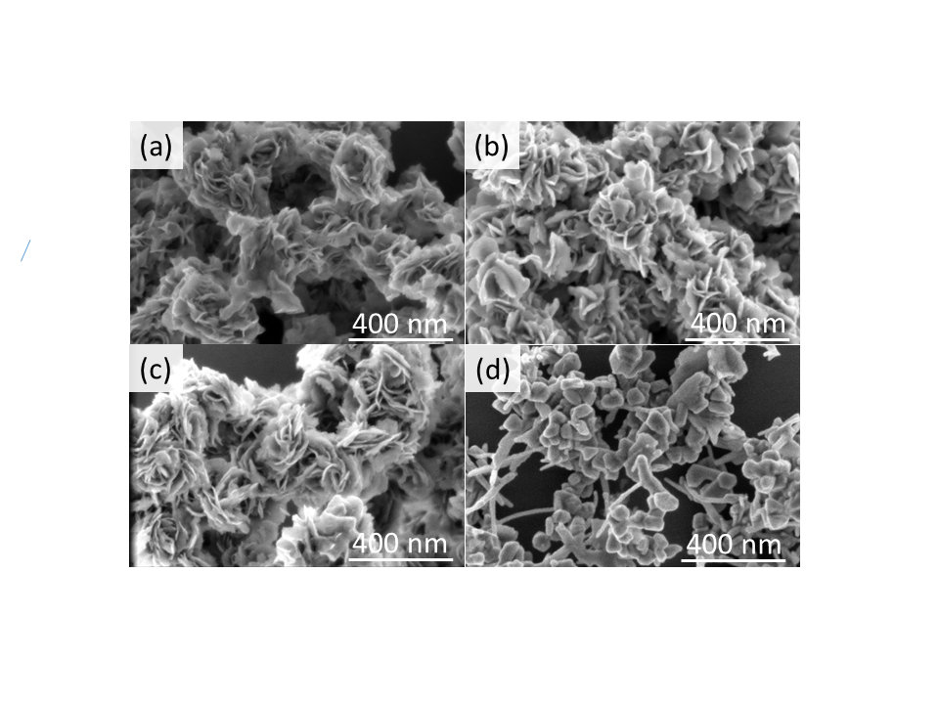

**Figure 4.** SEM images of: (a) 3% Ni-doped WSe2, (b) 5% Ni-doped WSe2, (c) 10% Ni-doped WSe2 and (d) pristine nickel selenide (Ni3Se2-NiSe) structures of the control sample.

The crystallographic phase of the synthesized Ni-doped nanostructures also matched the bulk hexagonal phase of WSe2 (**Figure 5a**). The (002) peak at 2θ = 13.5° shows broadening with higher Ni content, demonstrating thinning of the petals typically seen in the growth of ternary materials,17 and formation of plentiful edges for enhanced HER activity. At higher Ni loading (10% in the feed ratio relative to the W), a shoulder peak at 2θ = 33.14° indicated the formation of a hexagonal NiSe impurity (**Figure 5a**). The control sample of only NiSe showed that under these conditions, a mixed phase comprising 83% rhombohedral Ni3Se2 and 17% hexagonal NiSe was produced (See **Figure S2** for XRD patterns). Raman spectroscopy, using an excitation laser wavelength of 532 nm, showed only one broad peak located at 250 cm-1for the A1g (out-of-plane) and E12g (in-plane) mode due to the small energy difference between them (**Figure 5b**).39The increase in the A1g and E12g peaks with higher Ni content and the characteristic shoulder peak located at 310 cm-1 both indicate thinning and the presence of few-layered WSe2.1, 40, 41

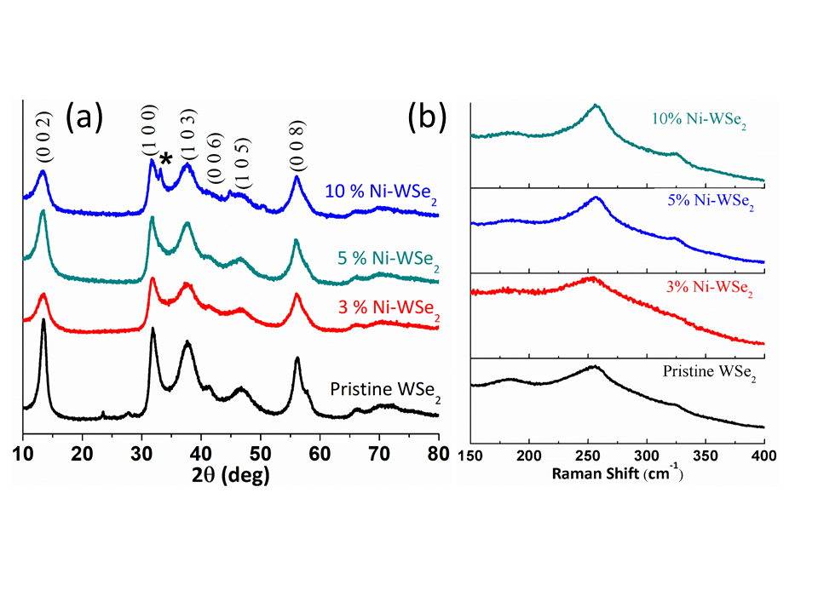

**Figure 5.** (a) XRD pattern of the pristine WSe2 along with 3%, 5% and 10% Ni-doped WSe2 samples. (b) Raman spectrum of the pristine WSe2, 3%, 5% and 10% Ni-doped WSe2 samples.

The chemical composition and atomic valence state of pristine and doped WSe2 were investigated by X-ray photoelectron spectroscopy (XPS) (**Figure 6a-c**). The spectra show two sets of peaks corresponding to both W+4 and W+6..42 For the W+4, the W 4f spectrum of pristine WSe2 contains two signals located at 32.05 eV and 34.15 eV, assigned to 4f7/2 and 4f5/2, respectively.43 With higher Ni doping, both peaks gradually shift towards higher binding energies, 32.34 eV and 34.44 eV for the 10% Ni-doped WSe2 (**Figure 6a**). The second set of peaks, located at 35.76 eV and 37.86 eV for pristine WSe2, is assigned to 4f7/2 and4f5/2 of W6+ and W5+,showing minor traces of the precursoror WO3, although the latter was not detected in the high-resolution TEM studies (shown below).23, 43 **Figure 6b** shows the Se signal, composed of two lines for Se 3d5/2 and Se 3d3/2 located at 54.33 and 55.13 eV for the pristine WSe2 (deconvoluted images shown in **Figure S3**). With higher Ni doping, a shift towards the higher energy was observed, reaching 54.59 and 55.39 eV for 10% Ni-doped WSe2, confirming successful doping of Ni into the WSe2.23 The peak position for the W 4f and Se 3d for the pristine and Ni-doped WSe2 sample is given in **Table S1**. The shift observed in the binding energy of W and Se when Ni atoms are introduced into the WSe2 lattice suggests that the electronic structure is modified by Ni doping. **Figure 6c** presents the Ni 2p spectrum of the 5% and 10% Ni-doped WSe2 sample. The 2p3/2 peak located at 854.6 eV reveals that the Ni is in the Ni2+ oxidation state, similar to NiSe44 and Ni(OH)2 that possibly exit at the surface.29, 45 The XPS survey spectrum for oxygen is presented in **Figure** **S4**, showing that ­­the O 1s peak appears at ~531.0 and 533.0, and therefore can be associated with O-W and not with oxidized Ni.43 It indicates that in the outer surface, a certain fraction of the W is oxidized, although the reaction was carried out under nitrogen.

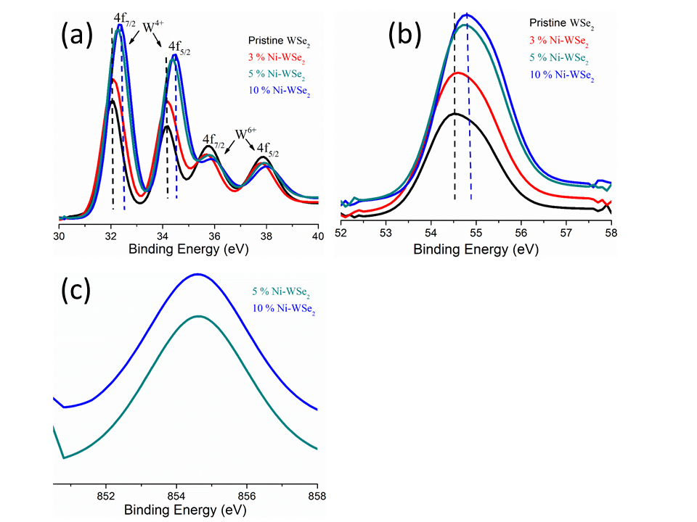

**Figure 6**. X-ray photoelectron spectra of (a) W 4f for pristine WSe2 along with 3%, 5% and 10% Ni-doped WSe2; (b) Se 3d for pristine WSe2 along with 3%, 5% and 10% Ni-doped WSe2; and (c) Ni 2p for 5% and 10% Ni-doped WSe2 samples.

Theoretical and experimental studies have shown that the activity trends in acidic solution are concluded on the basis of hydrogen adsorption (Hads) at the active sites. However, the kinetic barrier for the primary step of the water dissociation, H--OH, govern the overall reaction rate in alkaline medium in addition to the thermodynamic ΔGH*.46-48 Obviously, a low water dissociation barrier requires favorable H/OH adsorption on the surface. In this respect, Ni2+ promotes the dissociation of water by a favorable interaction of hydroxyl with Ni.49-51 The dissociation step is then followed by H adsorption on the nearby active sites of WSe2 and by adsorption of OH- on Ni. In addition, the observation that Ni alters the electronic structure and the binding energy of both W and Se (derived from XPS) suggests that the electronic structure can be modified to more favorable interaction with the intermediates.

The HER performance of the Ni-WSe2 catalysts with different amounts of Ni in both acidic (0.5 M H2SO4) and alkaline (0.5 M KOH) media is presented in **Figure 7** and **Table 1** along with pristine WSe2 and as-obtained Ni3Se2-NiSe. In acidic solution, increasing the Ni content above 3% led to negligible changes in both the overpotential and the Tafel values (**Figure 7**), while a pronounced improvement of the HER performance in alkaline was observed. Therefore, it can be concluded that up to 3% Ni doping improves the hydrogen adsorption (Hads) and is responsible for the enhanced activity. Above this threshold of Ni loading, the improved activity in alkaline originates mainly from optimization of the OH/surface active site interactions, and therefore no further improvement was observed in acidic media. The results for the 10% Ni-WSe2 catalyst showed improved performance in both media (η = 259 mV in acid and η = 215 mV in alkaline at 10 mA cm-2), which exceeds the reported values in the literature for various structures such as WSe2 monolayer nanosheets,31 WSe2 nanotubes supported on carbon fibers,32 WSe2 nanosheets supported on carbon fibers,33 exfoliated WSe2 nanosheets,34 Nb-doped WSe2,11 V-doped WSe2,11 Ta-doped WSe2,11 WSe2/rGO composite35 and Co0.85Se-WSe2 composite36 (**Table S2** in the Supporting Information).The use of additional Ni in the feed ratio did not further improve the catalytic performance in alkaline conditions (Figure S6).

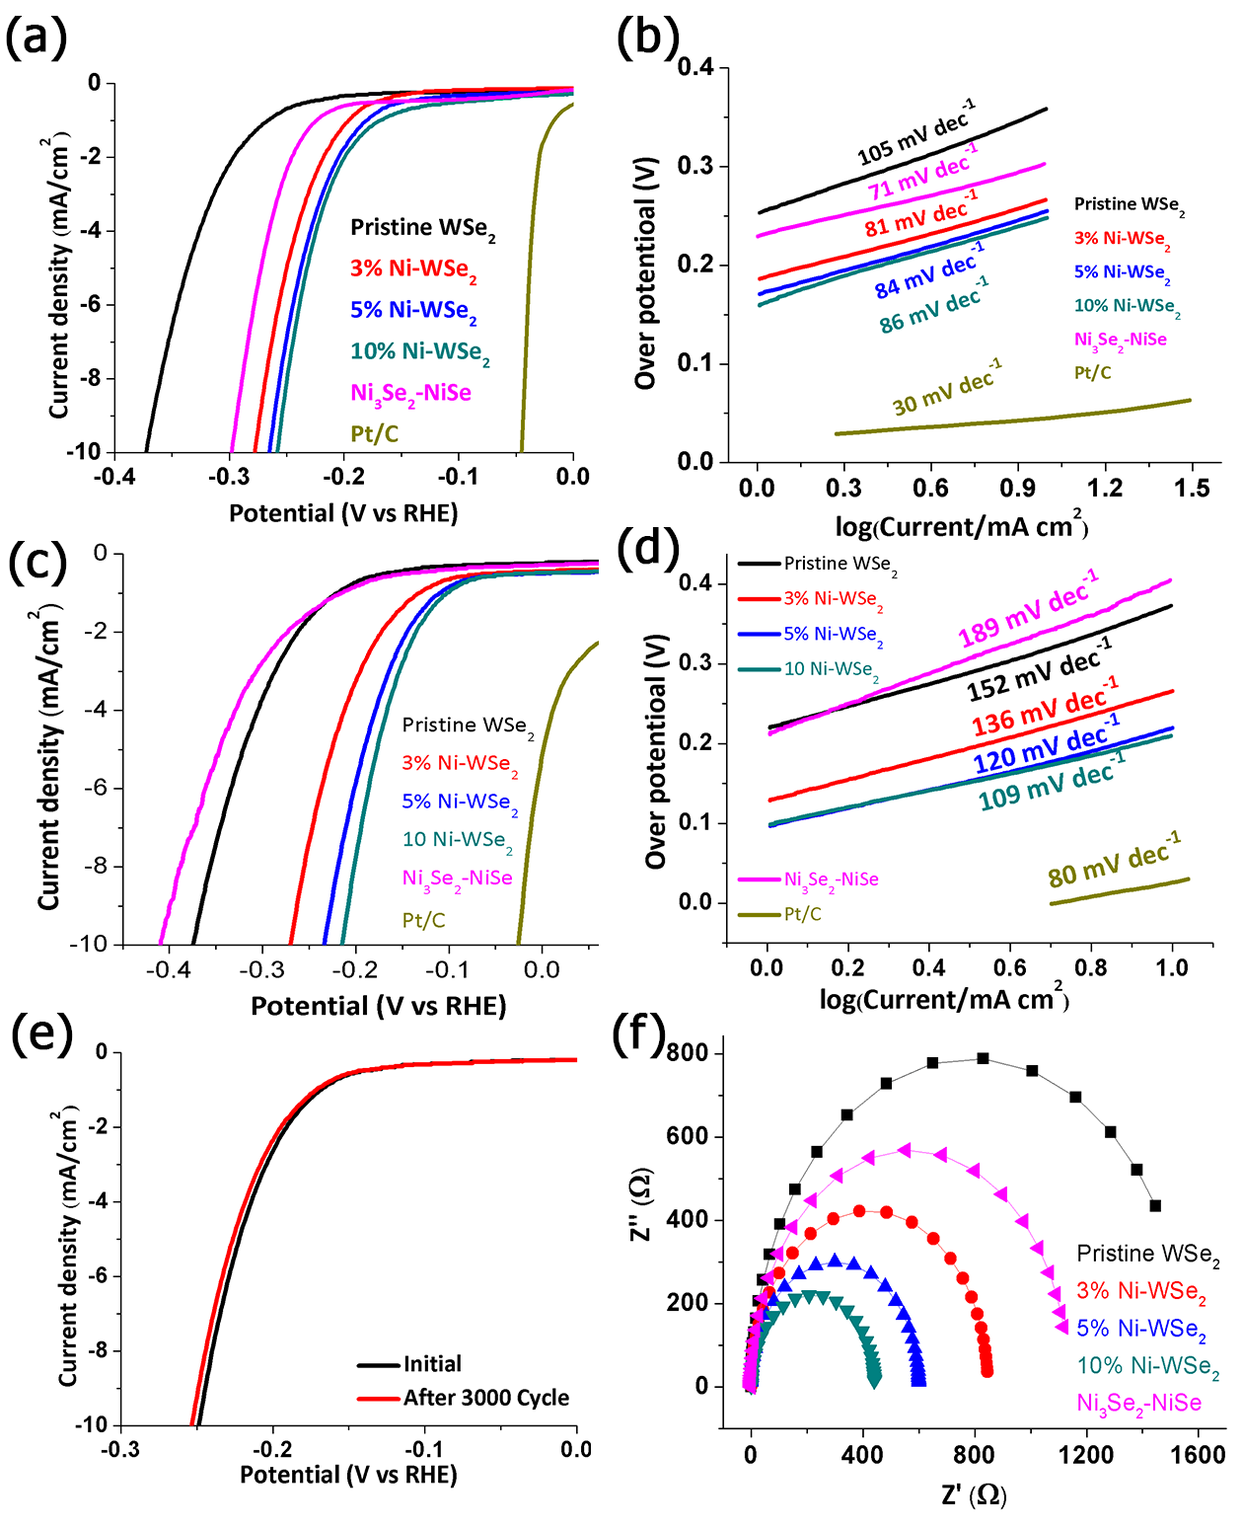

**Figure 7.** (a)HER polarization curves of the pristine WSe2 and Ni3Se2 along with 3%, 5% and 10% Ni-doped WSe2 in 0.5 M H2SO4. (b) Corresponding Tafel plots obtained from the polarization curves. (c) HER polarization curves of the pristine WSe2 and Ni3Se2 along with 3%, 5% and 10% Ni-doped WSe2 in 0.5 M KOH. (d) Corresponding Tafel plots obtained from the polarization curves. (e) Stability test of 10% Ni-doped WSe2 sample in 0.5 M H2SO4. Polarization curves before (black) and after (red) continuous 3000 CV cycles. (f) Nyquist plots showing the electrode kinetics of WSe2 along with 3%, 5% and 10% Ni-doped WSe2 samples.

Table 1: Electrochemical HER results for various Ni-doped WSe2 compared with pristine WSe2 and Ni3Se2-NiSe in acidic and alkaline media

|  |  |  |  |  |  |  |  |
| --- | --- | --- | --- | --- | --- | --- | --- |
| ECSA (cm2) | Rct from impedance at 200 mV  (Ω) | | Tafel slope (mV/dec) | | Overpotential at 10 mA/cm2  (mV) | | Catalyst |
|  | Base | Acid | Base | Acid | Base | Acid |  |
| 25 | 1500 | 1450 | 152 | 105 | 375 | 372 | Pristine WSe2 |
| 35 | 460 | 850 | 136 | 81 | 271 | 278 | 3% Ni-WSe2 |
| 50 | 190 | 600 | 120 | 84 | 235 | 266 | 5% Ni-WSe2 |
| 73 | 160 | 440 | 109 | 86 | 215 | 259 | 10% Ni-WSe2 |
|  | 2900 | 1120 | 189 | 71 | 410 | 298 | Pristine Ni3Se2-NiSe |

In addition, the results showed that the 10% Ni-WSe2 catalyst had very good electrocatalytic stability after 3000 cyclic voltammetry (CV) cycles in 0.5 M H2SO4 (**Figure 7e**) and 0.5 M KOH (**Figure S7**). To characterize the materials directly before and after the catalytic reaction, we prepared another set of electrodes without carbon black (which complicates the analysis). The new set of electrodes was prepared by dispersing 3 mg of 10% Ni-WSe2 in 300 µl of the following solution: 2000 μl water, 500 μl ethanol and 150 μl Nafion solution (5%). The stability study was performed by CV measurement in both acidic and alkaline media. The surface morphology of the catalyst before and after the stability study was investigated by SEM (**Figure S8**), showing that the surface morphology of the catalyst before and after the stability study is quite similar. XPS analysis of the catalyst before and after the stability study showed minor changes in the XPS spectra (**Figures S8** and **S9**). Electrochemical impedance spectroscopy was further used to explore the HER electrode kinetics of the pristine WSe2,Ni3Se2-NiSeand Ni-doped WSe2 catalysts at 200 mV potential. **Figure 7f** depicts the associated Nyquist plots at the overpotential of 200 mV. The interfacial charge transfer resistance (Rct) can be represented by the semicircle fit in a Nyquist plot. The 10% Ni-WSe2 possesses the smallest electron transfer resistance, which contributed to the preferred catalytic reaction. The plot of log(1/Rct) versus the overpotential (ɳ) gives the Tafel slope from the impedance data for the HER. The results (**Figure S10d)** prove that 10% Ni-WSe2 exhibits the lowest Tafel slope (81 mV dec-1), much better than pristine WSe2 (120 mV dec-1). The Tafel slope derived in this way better reflects the electrode kinetics compared to those obtained from polarization curves. Additionally, electrochemical active surface area (ECSA) has been evaluated from the double-layer capacitance (Cdl) measurements. As shown in **Figure S11**, the 10% Ni-doped WSe2 exhibits ECSA that is threefold higher than that of WSe2, indicating the large fraction of exposed effective active sites, which is responsible for the excellent HER activity (the electrochemical measurements are summarized in **Table 1**).

In order to gain insight into the possible catalytic sites within the Ni-doped WSe2, we employed DFT calculations (see the Supporting Information for calculation details). We calculated the formation energy, ΔE, as the difference between the total energies of a system and its relevant predecessors—the bulks of NiSe and WSe2 and molecular Se8—in the ratios corresponding to the stoichiometry of a Ni-WSe2 nanostructure (**Table S3**). Possible locations for the Ni atoms within the WSe2 lattice include intercalated Ni atoms between the molecular layers of WSe2. Our calculations show that intercalation of single Ni atoms into the WSe2 lattice is extremely endothermic (**Table S3**). Intercalation of Ni atoms as octahedral or tetrahedral interstitials in the WSe2 van der Waals gap would require energies of ~11 eV/Ni atom. Alternative structures with W vacancies or Ni clustering exhibited ΔE ~5 eV/Ni atom, which is too high to be a realistic option. The experimental results refute intercalation since the layer spacing, as measured by XRD, remains close to the pristine material. In addition, considering the exposure of intercalated Ni atoms to a solvent medium, leaching of Ni is plausible.

Substitutional doping of WSe2 layers by single Ni atoms was also highly endothermic with ΔE ~7.5 eV/Ni atom. These calculations are in accordance with EDS elemental maps that show an actual 0.5% Ni substitution for the samples prepared using 10% Ni in the feed ratio (**Figure 9**), although such substitution occurs according to the shift in the XPS binding (**Figure 6**). Se deficiency and distortion of the prismatic coordination of Ni only adds to thermodynamic instability. The formation of W1-xNixSe2 solid solutions may be promoted by a clustering of the dopant Ni atoms, since ΔE ~2.9 eV/Ni atom is found for a Ni triplet and ΔE ~0.9 eV/Ni atom for a complete 1H-NiSe2 layer. However, a mosaic of WSe2 and very large 1H-NiSe2 fragments cannot be expected, since Ni2+ ions disfavor the prismatic coordination and NiSe2 should rather crystallize in a pyrite-like structure. Obviously, only small islands of Ni dopants might be expected, whose detection would be beyond the limits of XRD characterization.

In the highest Ni content, 10% in the feed ratio, an impurity phase of NiSe was detected (**Figure 5a**). Our calculations also unveiled possible thermodynamic competition between the formation of alloyed W1-xNixSe2 layers and grafted NiSe patches on WSe2 layers (**Table S4**). The formation energies of several island-like NiSex fragments deposited on pristine WSe2 layers have been estimated. The formation of a grafted NiSe phase on the WSe2 surface would require the endothermic formation of Se-deficient seed-like Ni3Se with ΔE ~5 eV/Ni atom. Consequent saturation of the seeds by Se atoms would decrease ΔE to ~4 eV/Ni atom. We can surmise that the growth of large-area NiSe-WSe2 heterostructures may be feasible, since the basal surface of a rapidly forming perfect WSe2 nanoparticle is more available than the lateral surface of a slowly organizing, imperfect W1-xNixSe2 nanoparticle.

The complete saturation of WSe2 surface by a single layer of NiSe could yield the hexagonal NiSe-WSe2 heterostructure with ΔE to ~1.0 eV/Ni atom. Once such a structure is formed, possible reconstructions into a distorted tetrahedral Ni coordination with zigzag-like or triangular-like arrangements of the Ni atoms may follow, with ΔE smaller by ~0.1-0.2 eV/Ni atom than for the perfect tetrahedral Ni coordination. A deposition of a second NiSe layer on the first NiSe layer will lower the formation energy further to ~0.7 eV/Ni atom.

**Table 2.** Formation energies (ΔE) for selected different models of Ni-WSe2 nanostructures and single H atom adsorption energies (ΔGH) (according to equation 1). DFT calculations. (For the full table, see the Supporting Information.)

|  |  |  |  |
| --- | --- | --- | --- |
| Description of the model | DFT-optimized structure | Formation energy (ΔE), eV/Ni atom | Corrected hydrogen adsorption energy (ΔGH), eV/H atom |
| Single-layer WSe2 | vmdscene | +0.33 (per WSe2)  +34.9 meV/Å2 | +2.49 |
| Doping by single Ni atom | vmdscene | +7.48 | +0.09 (onto Se-Ni)  +1.28 (onto Se-W) |
| NiSe2 layer (complete substitution of W in WSe2 layer) |  | +0.87 | - |
| Chemisorption of Ni3Se cluster | vmdscene | +5.10 | +1.29 (onto Se-Ni)  +1.91 (onto Se-W) |
| NiSe single layer grafted onto WSe2 single layer (2a×2a reconstruction) | vmdscene | +0.99 | +0.24 (onto Se-Ni)  +0.21 (onto Se-Ni)  +2.09 (onto Se-W) |
| NiSe single layer grafted onto WSe2 single layer (3a×2a reconstruction) | vmdscene | +0.96 | +1.66 (onto Se-Ni)  +0.21 (onto Se-Ni)  +0.72 (onto Se-Ni)  +2.04 (onto Se-W) |
| NiSe double layer grafted onto WSe2 single layer | vmdscene | +0.69 | +0.91 (onto Se-Ni)  +2.10 (onto Se-W) |
| Slab(001) Se(NiSe)2  nonpolar Se saturated | vmdscene | -0.36  -31.9 meV/Å2 | +0.17 |
| Slab(001) Se(NiSe)3  nonpolar Se saturated | vmdscene | -0.33  -43.8 meV/Å2 | +0.08 |

The catalytic activity towards HER of an electrode material depends on the number of catalytic sites with favorable hydrogen adsorption energy (∆GH) and on the electron transfer kinetics at the electrode/electrolyte interface. As mentioned, the ΔGH* is one of the key descriptors in theoretical prediction of the activity for HER on solid electrodes and was calculated via:

$$\left(1\right) ∆G_{H}=E_{SL+H}-E_{SL}-\frac{E_{H_{2}}}{2}+∆E_{ZPE}-T∆S_{H}$$

where ESL+H, ESL, and EH2 are the DFT total energies of a single layer (SL) of WSe2 (pristine or Ni doped) with adsorbed H*, the single layer alone and a H2 molecule in the gas phase, respectively; ΔEZPE and ΔS are the differences in the zero-point energies and entropies between an adsorbed hydrogen atom and its reference state in the separated H2 molecule. ΔEZPE -TΔSH is about +0.24 eV.36, 52 According to the Sabatier principle, (∆GH*) should be zero; under this condition, the overall reaction has the maximum rate (expressed in terms of HER exchange current density, j0). The computed ΔGH values for catalytic sites of various Ni-WSe2 nanostructures are given in **Table 2** for selected structures and in **Table S3** for all the calculated structures.

The Se atoms bound to a Ni dopant within alloyed W1-xNixSe2 layers seem to be promising catalytic sites with ΔGH = +0.09 eV/H atom. Other Se atoms of the basal plane of the W1-xNixSe2 layers (those bound to W) still demonstrate a higher ΔGH = +1.28 eV/H atom relative to ΔGH = +2.49 eV/H atom of a Se atom in a pristine WSe2 (**Table 2**). Therefore, once Ni dopants overcome the thermodynamic barrier and substitute W, they produce optimized catalytic sites. Most of the adsorbed clusters of various NiSe structures showed high ΔGH values. As the adsorbed layer widened and was allowed to reconstruct (into the distorted tetrahedral Ni coordination with zigzag-like or triangular-like arrangements of the Ni atoms, as explained above), some of the Se exhibited ΔGH = +0.21 eV/H atom or ΔGH = -0.22 eV/H atom (see **Table 2 and Table S3**). Although thermodynamically favorable, deposition of a second NiSe layer on the NiSe-WSe2 heterostructure should lead to the total suppression of its HER activity. Alternatively, if thin slabs of Se-rich NiSe nanoparticles are formed, then the Se atoms at the NiSe(001) surface show ΔGH = +0.08 eV/H atom and should be good HER catalysts. Hereby, the DFT calculations suggest two possible Ni-WSe2 combinations with similar thermodynamics of formation and slightly different hydrogen adsorption energies: Ni-doped structures of the form W1-xNixSe2 and a heterostructure of NiSe-WSe2 single layers. The intercalation case has been extensively researched for Mo-based systems,20,17, 21, 24, 28, 53-55 and the heterostructure has recently been presented for the system of NiSe-MoSe2.56 The available structural data and our DFT calculations confirm similar values of the in-plane lattice parameter of molecular-like WSe2 layer (calc. *a* = 3.32 Å) and of NiSe(001) plane in NiSe bulk (calc. *a* = 3.61 Å), suggesting a tolerable lattice match at interface NiSe||WSe2.

A comparative analysis of the electronic densities of states (DOS) revealed that the alternative structures differ in their electronic properties such that they exhibit different charge transfer dynamics (**Figure 8**). The pristine WSe2 monolayer is a semiconductor with a calculated fundamental band gap of ~1.6 eV and a direct K-K transition. The valence band was formed by dominant Se4*p*-states, but the top of this band was contributed mostly by W5*dz2*-states. Other W5*d*-states were unoccupied and formed the bottom of the conduction band. The substitutional Ni doping of WSe2 substantially reshaped the DOS profile of WSe2 (**Figure 8a**; the DOS of pristine WSe2 is shown in **Figure S12**); the main DOS change for the Ni-doped WSe2 is related to the splitting of several levels from the valence band into the band gap of WSe2, inducing *p*-type conductivity. Notably, Ni3*d* states and Se4*p* states of the atoms near the dopant contributed the unoccupied part of these levels, making them a possible depot for entrant electrons during the first elementary reaction of the HER. The electron deficiency located only near the Ni and its Se neighbors can be confirmed by mapping the redistribution of electron density Δρ upon substitution of a W atom with Ni (**Figure 8a**). The electronic structure for the heterostructure of NiSe-WSe2 became significantly modified, compared with pristine WSe2 (**Figure 8b**). The heterostructure is expected to demonstrate high electron conductivity, since the band gap of WSe2 is fully populated by the Ni3*d* and Se4*p* states of NiSe and with a negligible propagation of the W5*d*- and Se4*p* states of WSe2. The edges of the former valence and conduction bands of WSe2 can be found at -1.0 and +0.7 eV, respectively, relative to the Fermi level. According to the calculated crystal orbitals’ overlap populations, the bonding strength between Ni and Se bound in the WSe2 lattice should be comparable to that of W-Se bonding (~0.24-0.29 e). The map of Δρ confirms that the interaction between NiSe and WSe2 is realized via covalent-like bonding, while the amount of charge transfer from WSe2 to NiSe is small, on the order of 0.06 e/WSe2 (**Figure 8b**).

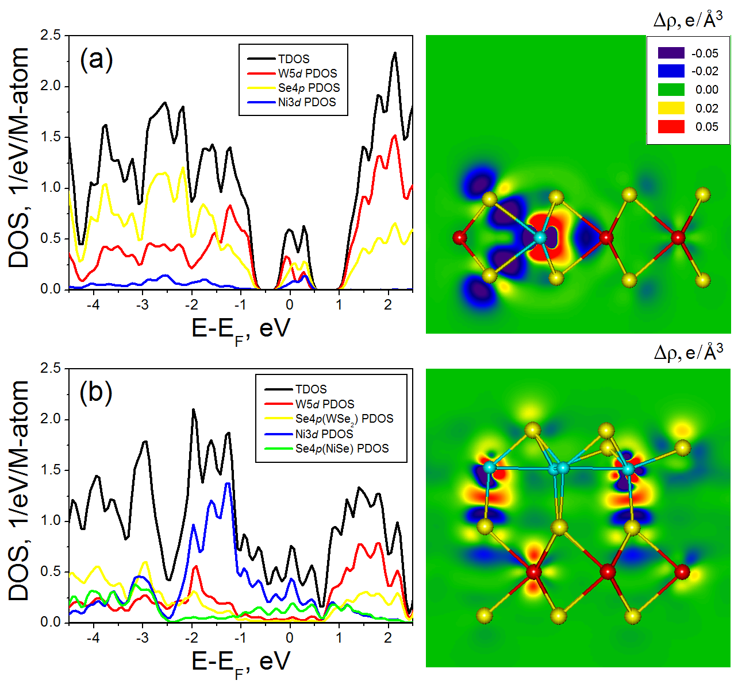

**Figure 8**. DOS for different Ni-WSe2 nanostructures: (a) WSe2 monolayer with single substitutional NiW atom and (b) WSe2 monolayer with grafted NiSe single layer (2a×2a superstructure). Ball-and-stick models of corresponding nanostructures are depicted nearby and overlaid on the maps of the electron density redistribution (Δρ) caused by Ni modification. W, Ni and Se atoms are shown in red, cyan and yellow, respectively. DFT calculations. The DOS of pristine WSe2 is presented in **Figure S12**.

In order to confirm the existence of segregated, Ni-rich phases, we used high-resolution electron microscopy. The proposed grafted Ni patches have a matching hexagonal structure as the WSe2 lattice, preventing direct imaging of attached grafted layers from a top view. The edge structure of the nanostructures in **Figure 9a** is presented in **Figure 9b**, showing an atomic-scale resolution of the WSe2 hexagonal lattice. The edge clearly contains multiple domains of a few nanometers each, but they are aligned such that the fast Fourier transform (FFT), in the inset of **Figure 9b** shows one hexagonal pattern. The high-angle annular dark-field-scanning electron microscope (HAADF-STEM) image of such a nanostructure agglomerate is shown in **Figure 9c**. HAADF-STEM imaging is based on mass contrast, such that thicker sample parts have higher intensity in the image. For the frame in **Figure 9c**, a scan of the electron energy loss (EEL) was performed, allowing identification and mapping of the location of the Ni atoms using the Ni L32 edge. Unlike Ni, detecting W by EELS is more complex, and therefore the image in **Figure 9d** contains an overlay of the Ni signal (in green) over the HAADF signal, which is the combined signal of all the constituting elements within the sample, in red. The green Ni signal is mainly located in two distinct patches within the field of view, showing the segregation of the Ni-rich phase. Uniquely identifying the nature and structure of the Ni-rich patch was not possible with the available data. Moreover, we expect a plethora of possible structures and different structural variations to be found across the sample.

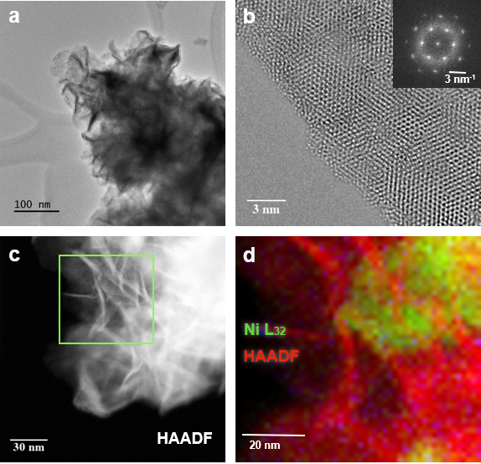

**Figure 9**. TEM images and STEM-EELS elemental maps of Ni-doped WSe2 nanostructures with 10% Ni in the feed ratio. (a) TEM bright-field image of a nanostructure agglomerate. (b) High-resolution TEM phase contrast image, showing the edges of a nanoflower. The inset shows an FFT of the lattice image with its hexagonal symmetry and is indicative of aligned stacking of layers. (c) HAADF image and (d) elemental Ni map of the marked area in (c) obtained with STEM-EELS. In (d), the red color corresponds to the mass density represented by the HAADF signal and the green color to the signal of the Ni L32 absorption edge. The image in (d) confirms the existence of segregated Ni-rich patches, in addition to detecting a small concentration of Ni (<0.5%) from the WSe2 structure.

**Conclusions**

Transition metal doping (Fe, Co, Nb, Ni and Zr) of WSe2 nanostructures was obtained via a simple colloidal synthesis technique. After successful metal doping, a similar morphology was maintained, offering an opportunity to study the effect of doping on the catalytic HER activity. Among the doped catalysts, Ni-WSe2 is the most promising electrocatalyst to build a high-performance and low-cost electrochemical hydrogen evolution reaction. The 10% Ni-doped WSe2 exhibits significantly improved HER performance with overpotential at 10 mA cm-2 of 259 mV in acid with a Tafel slope of 86 mV dec-1 and 215 mV in alkaline solutions with a Tafel slope of 109 mV dec-1, much better than reported for the pristine and doped WSe2 sample. Moreover, Ni-WSe2 exhibits a reduction in the charge transfer resistance, which contributed to the facilitated faster catalytic reaction. The analysis shows that up to 3% Ni doping, the catalytic enhancement originates from improved hydrogen adsorption (Hads). Beyond this threshold of Ni loading, the improved activity in alkaline environment results from optimized interaction of the OH/surface active sites.

Two optimized Ni-WSe2 nanostructures for HER were identified using DFT calculations: first, a substitutionally doped W1-xNixSe2 layer preserving the prismatic coordination of the Ni atoms, and second, a NiSe single layer grafted onto a WSe2 layer with distorted tetrahedral Ni coordination. The doped structures have a lower hydrogen adsorption energy (ΔGH), and their HER activity is localized only on the Se atoms bound to a Ni dopant atom. The charge transfer kinetics at the electrode/electrolyte interface of the doped structures was favorably affected by the unoccupied levels induced by doping, making them a possible pool for entrant electrons during the first elementary step of the HER. The NiSe-WSe2 heterostructure demonstrated a tolerable energy of hydrogen adsorption, with a metal-like single layer of NiSe that possesses catalytically active Se atoms, potentially providing improved electron migration along and across the solid-electrolyte interface. WSe2 is therefore an additional building block in the TMDC family, serving as a platform to build hybrid structures with promising catalytic properties.

**Acknowledgements**

S.K. thanks the financial support of the Kreitman Post-Doctoral fellowship at the BGU. This centre of excellence was supported by The Israel Science Foundation (grant No. 1212/21). A.E. acknowledges the support by Act 211 Government of the Russian Federation, contract No. 02.A03.21.0006.

**References**

1. H. Zhang, L. Yu, T. Chen, W. Zhou and X. W. Lou, *Adv. Funct. Mater.*, 2018, **0**, 1807086.

2. L. Zhang, K. Doyle-Davis and X. Sun, *Energy Environ. Sci.*, 2019, **12**, 492-517.

3. Z. Zheng, T. Zhang, J. Yao, Y. Zhang, J. Xu and G. Yang, *Nanotechnology*, 2016, **27**, 225501.

4. H. Kim, G. H. Ahn, J. Cho, M. Amani, J. P. Mastandrea, C. K. Groschner, D.-H. Lien, Y. Zhao, J. W. Ager, M. C. Scott, D. C. Chrzan and A. Javey, *Sci. Adv.*, 2019, **5**, eaau4728.

5. S. R. Kadam, R. S. Kalubarme, S. P. Deshmukh, R. P. Panmand, U. V. Kawade, M. V. Kulkarni, S. S. Deo, S. W. Gosavi and B. B. Kale, *ChemistrySelect*, 2018, **3**, 11020-11026.

6. A. Eftekhari, *J. Mater. Chem. A*, 2017, **5**, 18299-18325.

7. S. R. Taylor, *Geochim Cosmochim Acta.*, 1964, **28**, 1273-1285.

8. H. Sung Ju, P. Min, K. Hojin, L. Minwoo, J. Dae Hong and P. Yung Woo, *AIP Adv.*, 2016, **6**, 085320.

9. S.-H. Jo, D.-H. Kang, J. Shim, J. Jeon, M. H. Jeon, G. Yoo, J. Kim, J. Lee, G. Y. Yeom, S. Lee, H.-Y. Yu, C. Choi and J.-H. Park, *Adv. Mater.*, 2016, **28**, 4824-4831.

10. W. Zhao, Z. Ghorannevis, L. Chu, M. Toh, C. Kloc, P.-H. Tan and G. Eda, *ACS Nano*, 2013, **7**, 791-797.

11. X. Chia, N. A. A. Sutrisnoh, Z. Sofer, J. Luxa and M. Pumera, *Chem. Eur. J.*, 2018, **24**, 3199-3208.

12. M. Chhowalla, H. S. Shin, G. Eda, L.-J. Li, K. P. Loh and H. Zhang, *Nat Chem*, 2013, **5**, 263-275.

13. C. Tsai, K. Chan, F. Abild-Pedersen and J. K. Nֳ¸rskov, *Physical Chemistry Chemical Physics*, 2014, **16**, 13156-13164.

14. H. Liu, X. Chen, L. Deng, M. Ding, J. Li and X. He, *Journal of Materials Chemistry A*, 2016, **4**, 17764-17772.

15. D. A. Henckel, O. M. Lenz, K. M. Krishnan and B. M. Cossairt, *Nano Lett.*, 2018, **18**, 2329-2335.

16. R. Bar-Ziv, O. E. Meiron and M. Bar-Sadan, *Nanoscale*, 2018, **10**, 16211-16216.

17. O. E. Meiron, V. Kuraganti, I. Hod, R. Bar-Ziv and M. Bar-Sadan, *Nanoscale*, 2017, **9**, 13998-14005.

18. J. Yin, J. Wei, J. Guo, S. Shi, N. Chai, K. Zhang, W. Xu, C. Yuan, T. Liu, W. Lin, Q. Zhang, H. Zhou, Y. Zhang, B. Chen, X. Pu, W. Li and X. Zhang, *ChemSusChem*, 2019, **12**, 795-800.

19. T. F. Jaramillo, K. P. Jørgensen, J. Bonde, J. H. Nielsen, S. Horch and I. Chorkendorff, *Science*, 2007, **317**, 100-102.

20. K. Vasu, O. E. Meiron, A. N. Enyashin, R. Bar-Ziv and M. Bar-Sadan, *J. Phys. Chem. C*, 2019, **123**, 1987-1994.

21. V. Kuraganti, A. Jain, R. Bar-Ziv, A. Ramasubramaniam and M. Bar-Sadan, *ACS Appl. Mater. Interfaces*, 2019, **11**, 25155-25162.

22. G. Yang, Y. Yang, H. Ma, X. Mao, C. Li, J. Li, Q. Zhang, Z. Zhang, F. Yin and J. Li, *Nanotechnology*, 2018, **29**, 115201.

23. G. Zhang, X. Zheng, Q. Xu, J. Zhang, W. Liu and J. Chen, *J. Mater. Chem. A*, 2018, **6**, 4793-4800.

24. M. Chhetri, U. Gupta, L. Yadgarov, R. Rosentsveig, R. Tenne and C. N. R. Rao, *ChemElectroChem*, 2016, **3**, 1937-1943.

25. L. Xianqing and N. Jun, *J. Appl. Phys*, 2014, **116**, 044311.

26. H. Wang, C. Tsai, D. Kong, K. Chan, F. Abild-Pedersen, J. K. Norskov and Y. Cui, *Nano Res.*, 2015, **8**, 566-575.

27. T. H. M. Lau, X. Lu, J. Kulhavy, S. Wu, L. Lu, T.-S. Wu, R. Kato, J. S. Foord, Y.-L. Soo, K. Suenaga and S. C. E. Tsang, *Chem. Sci.*, 2018, **9**, 4769-4776.

28. H. Shu, P. Luo, P. Liang, D. Cao and X. Chen, *ACS Appl. Mater. Interfaces*, 2015, **7**, 7534-7541.

29. D. Escalera-Lopez, Y. Niu, J. Yin, K. Cooke, N. V. Rees and R. E. Palmer, *ACS Catal.*, 2016, **6**, 6008-6017.

30. X.-Y. Yu, Y. Feng, Y. Jeon, B. Guan, X. W. Lou and U. Paik, *Adv. Mater.*, 2016, **28**, 9006-9011.

31. Y. Sun, X. Zhang, B. Mao and M. Cao, *Chem. Commun.*, 2016, **52**, 14266-14269.

32. K. Xu, F. Wang, Z. Wang, X. Zhan, Q. Wang, Z. Cheng, M. Safdar and J. He, *ACS Nano*, 2014, **8**, 8468-8476.

33. H. Wang, D. Kong, P. Johanes, J. J. Cha, G. Zheng, K. Yan, N. Liu and Y. Cui, *Nano Lett.*, 2013, **13**, 3426-3433.

34. A. Y. S. Eng, A. Ambrosi, Z. Sofer, P. Šimek and M. Pumera, *ACS Nano*, 2014, **8**, 12185-12198.

35. Z. Liu, H. Zhao, N. Li, Y. Zhang, X. Zhang and Y. Du, *Inorg. Chem. Front.*, 2016, **3**, 313-319.

36. J. Deng, H. Li, J. Xiao, Y. Tu, D. Deng, H. Yang, H. Tian, J. Li, P. Ren and X. Bao, *Energy Environ. Sci.*, 2015, **8**, 1594-1601.

37. W. Xu, K. Chai, Y.-w. Jiang, J. Mao, J. Wang, P. Zhang and Y. Shi, *ACS Appl. Mater. Interfaces*, 2019, **11**, 17670-17677.

38. Z. Lu, W. Zhu, X. Yu, H. Zhang, Y. Li, X. Sun, X. Wang, H. Wang, J. Wang, J. Luo, X. Lei and L. Jiang, *Adv. Mater.*, 2014, **26**, 2683-2687.

39. M. Zou, J. Chen, L. Xiao, H. Zhu, T. Yang, M. Zhang and M. Du, *J. Mater. Chem. A*, 2015, **3**, 18090-18097.

40. H. Li, G. Lu, Y. Wang, Z. Yin, C. Cong, Q. He, L. Wang, F. Ding, T. Yu and H. Zhang, *Small*, 2012, **9**, 1974-1981.

41. M. O'Brien, N. McEvoy, D. Hanlon, T. Hallam, J. N. Coleman and G. S. Duesberg, *Sci. Rep.*, 2016, **6**, 19476.

42. R. D. Engelken, T. P. Van Doren, J. L. Boone, A. K. Berry and A. Shahnazary, *Mater. Res. Bull.*, 1985, **20**, 1173-1179.

43. R. Zhang, D. Drysdale, V. Koutsos and R. Cheung, *Adv. Funct. Mater.*, 2017, **27**, 1702455.

44. I. H. Kwak, H. S. Im, D. M. Jang, Y. W. Kim, K. Park, Y. R. Lim, E. H. Cha and J. Park, *ACS Appl. Mater. Interfaces*, 2016, **8**, 5327-5334.

45. X. Kong, N. Wang, Q. Zhang, J. Liang, M. Wang, C. Wei, X. Chen, Y. Zhao and X. Zhang, *ChemistrySelect*, 2018, **3**, 9493-9498.

46. Y. Zheng, Y. Jiao, A. Vasileff and S.-Z. Qiao, *Angew. Chem. Int. Ed.*, 2018, **57**, 7568-7579.

47. R. Subbaraman, D. Tripkovic, D. Strmcnik, K.-C. Chang, M. Uchimura, A. P. Paulikas, V. Stamenkovic and N. M. Markovic, *Science*, 2011, **334**, 1256.

48. N. Mahmood, Y. Yao, J.-W. Zhang, L. Pan, X. Zhang and J.-J. Zou, *Adv. Sci.*, 2018, **5**, 1700464.

49. M. Gong, W. Zhou, M.-C. Tsai, J. Zhou, M. Guan, M.-C. Lin, B. Zhang, Y. Hu, D.-Y. Wang, J. Yang, S. J. Pennycook, B.-J. Hwang and H. Dai, *Nat. Commun.*, 2014, **5**, 4695.

50. T. An, Y. Wang, J. Tang, W. Wei, X. Cui, A. M. Alenizi, L. Zhang and G. Zheng, *Journal of Materials Chemistry A*, 2016, **4**, 13439-13443.

51. J. Hu, C. Zhang, L. Jiang, H. Lin, Y. An, D. Zhou, M. K. H. Leung and S. Yang, *Joule*, 2017, **1**, 383-393.

52. P. C. K. Vesborg, B. Seger and I. Chorkendorff, *The Journal of Physical Chemistry Letters*, 2015, **6**, 951-957.

53. Y. Shi, Y. Zhou, D.-R. Yang, W.-X. Xu, C. Wang, F.-B. Wang, J.-J. Xu, X.-H. Xia and H.-Y. Chen, *J. Am. Chem. Soc.* , 2017, **139**, 15479-15485.

54. X. Hong, K. Chan, C. Tsai and J. K. Norskov, *ACS Catal.*, 2016, **6**, 4428-4437.

55. M. Chhetri, U. Gupta, L. Yadgarov, R. Rosentsveig, R. Tenne and C. N. R. Rao, *Dalton Trans.*, 2015, **44**, 16399-16404.

56. X. Zhou, Y. Liu, H. Ju, B. Pan, J. Zhu, T. Ding, C. Wang and Q. Yang, *Chemistry of Materials*, 2016, **28**, 1838-1846.