**Tri-functional Nickel Phosphide Catalysts for Hydrogen Generation through Water Reduction, Aminoborane, and Borohydride Hydrolysis**

Sirshendu Ghosh1, Sunil R. Kadam1, Lothar Houben,2 Ronen Bar-Ziv,3 and Maya Bar-Sadan1,4*

1 Department of Chemistry, Ben-Gurion University, Beer-Sheva, 8410501, Israel

2 Chemical Research Support, Weizmann Institute of Science, Rehovot, Israel

3 Nuclear Research Center Negev (NRCN), Beer-Sheva, Israel

4 Ilse Katz Institute for Nanoscale Science & Technology, Ben-Gurion University, Beer-Sheva, 8410501, Israel

**Abstract**

The use of hydrogen as fuel requires its efficient production and retrieval from energy carriers. Nickel phosphides are established catalysts for hydrogen evolution, but different phases are rich in nitrogen and phosphorus, and understanding the fundamental properties of these phases is challenging. In this work, we describe the synthesis of various pure phases of nickel phosphide (Ni5P4, Ni2P, and Ni12P5) producing nanostructures. The conditions used to obtain each phase and its growth mechanism are described. A comparative study illustrates the phases’ catalytic activity towards hydrogen production through electrochemical water reduction as well as hydrogen retrieval by hydrolysis of chemical hydrogen storage materials (aminoborane and NaBH4). The results show that charge separation between the Niδ+ and Pδ sites in the various Ni–P phases plays a key role in achieving the desired efficacy of the catalytic reaction. Ni2P nanoparticles exhibited the highest performance for electrocatalytic hydrogen evolution, with low overpotential (126 mV and 180 mV at J = 10 mA·cm-2 for acid and base, respectively). For the hydrolysis of boron–hydride compounds, a high positive charge on the metal center acts as a hydride acceptor to accelerate the catalytic reaction and the release of H2. Ni12P5 was the most efficient catalyst, with a turnover frequency (TOF) = 23.0 min-1 and activation energy (Ea) = 50.4 kJ·mol-1 for hydrogen retrieval from aminoborane, and TOF = 17.3 min-1 and Ea = 52.7 kJ·mol-1 for hydrogen retrieval from NaBH4, which is comparable to noble metal nanoparticles. Our work provides new insights into this system and offers a deeper understanding of the structure–activity relationship to facilitate the design of promising multi-functional noble metal-free catalysts for hydrogen evolution from water and hydrogen storage materials.

**Keywords**: Electrochemistry, growth mechanism, hydrogen storage, charge separation, hydrogen retrieval, high-resolution electron microscopy

1. **Introduction**

The development of clean and sustainable energy sources is a global goal. Hydrogen has a zero carbon footprint upon combustion and a high gravimetric energy density (120 MJ kg-1).[1] While it is considered a clean fuel, most hydrogen is still produced from fossil fuels—a process that results in the emission of pollutants and, further, is not economical. Moreover, storage of H2 in the gas phase for transport and refueling presents safety issues, and costly resources are required for hydrogenliquefaction and compression.

Hydrogen may be produced electrocatalytically via the hydrogen evolution reaction (HER) or from hydrogen-rich molecules: metal organic frameworks,[2] metal hydrides,[3] and borane compounds.[4] The advantage of this type of catalysis is that no thermal or electrical energy source is required. Chemical boron hydrides such as metal borohydrides and aminoborane (NH3BH3, denoted as AB) have high gravimetric hydrogen density (19.6 wt% for AB; 10.8 wt% for NaBH4), providing the high rate of hydrogen production required for fuel cells, etc. That, and the fact that these materials are inflammable, non-toxic, environmentally safe, and highly stable, make them promising candidates for energy storage.

In the presence of a suitable catalyst in alkaline medium, hydrolysis of aminoborane or borohydride to release H2 can occur under ambient conditions via the following reactions:

$NH_{3}BH_{3}+2H_{2}O →NH_{4}BO_{2}+3H_{2}$

$NaBH_{4}+2H_{2}O→NaBO_{2}+4H_{2}$

In these reactions, hydrogen atoms bound to boron atoms react with water to generate 3–4 equivalents of H2 atoms. The hydrolysis provides another important advantage: half of the H2 produced originates from water (unlike other methods, in which boron–hydride cleavage is achieved by thermolysis, a process that requires high temperatures and high energy).[5]

Although more expensive, NH3BH3 has a low molecular weight and a high H2content with long-term stability in aqueous solutions and air. However, issues such as improving the efficiency of by-products recycling, reducing the release of NH3, and preventing the poisoning of currently available metal-based catalysts need to be resolved.[6]

Near-optimal performance for electrocatalytic HER has been demonstrated by Pt or Pt-group metal catalysts.[7] Other noble metal-based catalysts—such as Pt, Pd, Rh, and Ru[6, 8]—are also effective for retrieving H2 from aminoborane, but their high cost and limited availability hinder widespread application. Therefore, it is imperative to design low-cost bi-functional catalysts that are able to generate hydrogen and retrieve it from hydrogen storage molecules.

Transition metal phosphides exhibit unique activity for simultaneous adsorption and activation of the reactants. This is due to the co-existence of a positive charge on the transition metal and negative charge on the phosphorus, which provides them with hydrogenase-like catalytic activity. Pure Ni2P, doped Ni2P, and heterostructures have been employed for electrocatalytic HER in acid medium,[9-11] showing that manipulation of their local structure and electronic properties is a pathway to alter or improve the catalytic process. Transition metal phosphides have also been employed for aminoborane hydrolysis.[12], [13], [14] The nickel phosphide system comprises several phases (Ni3P, Ni12P5, Ni2P, Ni5P4, NiP, and NiP2), and various forms of Ni and P may be realized and used to enhance catalytic activity. Specifically, the binding properties of active sites and the extent of charge separation between Ni and P impact the activation process, allowing H2 to be retrieved from aminoborane or NaBH4 and improve electrocatalytic HER performance.

Herein, we report the simple colloidal synthesis of three different nickel phosphide phases (Ni2P, Ni12P5, and Ni5P4) using the thermal decomposition technique. Nickel acetylacetonate was the Ni source, trioctylphosphine (TOP) was the P source, and oleylamine (OLAM) was the capping agent. Aliquot collection and characterization were used to establish the growth mechanism. The catalysts were utilized for electrocatalytic HER in acid and alkaline media and for H2 generation from hydrogen storage materials such as NH3BH3 and NaBH4.To the best of our knowledge, this is the first report ofcatalytic hydrogen production from NaBH4 by nickel phosphide nanostructures. Ni2P showed the best activity towards HER at a current density of 10 mA cm-2 with an overpotential of 126 mV in 0.5 M H2SO4 and 180 mV in 0.5 M KOH, respectively. The highest turnover frequency for H2 formation from aminoborane hydrolysis (~23 min-1) and NaBH4 hydrolysis (~17.3 min-1) was achieved by the Ni12P5 catalyst. It was found that the extent of electron transfer between Ni and P in the various nickel phosphide phases plays a crucial role in initiating a specific catalytic reaction.

1. **Materials and Methods**

Three different phases of nickel phosphide—Ni2P, Ni12P5, and Ni5P4—were synthesized by colloidal thermal decomposition. For all the syntheses, oleylamine (OLAM) and trioctylphosphine (TOP) were used as capping agents, with the latter also used as a phosphorus source. Extended synthesis protocols are available in the Supplementary Information.

***2.1 Synthesis of Ni2P and Ni12P5 nanocrystals***

In a typical synthesis, 1 mmol Ni(acac)2, 2 ml OLAM, 3 ml octadecene (ODE), and 0.2–4.0 ml TOP were mixed in a 50-ml two-necked round-bottom flask. The mixture was heated to 120 °C for 30 min in vacuum in a Schlenk line apparatus. The flask was back-filled with dry nitrogen gas and heated to 300 °C at a ramp rate of 15 °C/min, after which the temperature was maintained for 40 min at 300 °C*.* The product was left to cool to 40 °C by removing the heating mantle. It was then washed with chloroform as the solvent and ethanol as the non-solvent, and was centrifuged for 8 min at 8000 rpm. To ensure complete removal of excess ligands and organic solvent, the washing procedure was repeated at least two times. The nanocrystals were stored in dry chloroform.

***2.2 Synthesis of Ni5P4 nanocrystals***

Monodispersed Ni5P4 nanocrystals were synthesized using a hot injection process. In a two-necked round-bottom flask, 2.5 ml TOP was heated to 340 °C in a dry N2 atmosphere. In another two-necked flask, a mixture of 1 mmol Ni(acac)2, 4 ml OLAM, and 2 ml ODE was heated to 120 °C and maintained for 30 min in constant evacuation mode to produce the Ni precursor. The Ni precursor was rapidly injected into the hot TOP solution at 340 °C. This mixture was heated to 350 °C and was maintained for 20–25 min in a dry N2 atmosphere. The washing procedure was similar to that used for the Ni2P nanocrystals.

***2.3 Electrochemical measurements for hydrogen evolution***

The long-chain OLAM was replaced by a needle-like thiocyanide (SCN) ligand prior to the catalytic experiments. Details of the ligand-stripping process and analysis are provided in the Supporting Information (**Figure S1**). For the electrochemical experiments, catalyst ink was produced by blending the SCN-capped nanocrystals, Vulcan carbon black, and Nafion solution. Typically, 1 mg SCN-capped nanocrystals, 1 mg carbon black, and 410 µL Nafion solution (from a mixture of 200 µL DI H2O, 200 µL isopropanol, and 10 µL 5% Nafion solution) were combined and sonicated for 30 min to form the catalyst ink. The ink was further homogenized by ultrasonication using a QSONICA probe sonicator (125 W) at 40% amplitude at an interval mode of 15:5 seconds on:off for 5 min. The glassy carbon electrodes (3 mm in diameter) were cleaned with alumina micropolishing powder (0.05 micron) followed by ultrasonication in ethanol and water for 30 s. The homogeneous ink (20 μL) was drop-cast onto a mirror-polished 3-mm glassy carbon electrode to form a final loading of ∼0.7 mg/cm2 and was left overnight to dry under ambient conditions.

All the electrochemical measurements were performed in a standard three-electrode system in which a graphite rod, Ag/AgCl, and glassy carbon electrode coated with the catalyst were used as the counter, reference, and working electrode, respectively. Polarization curves were recorded on an Ivium Technologies Vertex potentiostat/galvanostat (V74606) and analyzed using the IviumSoft program. Electrochemical HER measurements were performed in argon-saturated 0.5 M H2SO4 or 0.5 M KOH solution at room temperature. The electrolyte was bubbled with Ar gas for 15 min prior to the measurements in order to remove dissolved gases from the solution. Each electrode was pretreated with 12 cyclic voltammetry (CV) cycles between 0 V and -0.7 V (vs. RHE, reversible hydrogen electrode) at a scan rate of 100 mV/s. Polarization curves were recorded at a scan rate of 10 mV/s over the same potential range. During the electrochemical measurements, the reactor headspace was continuously purged with Ar gas. All measurements were introduced to the RHE using the relationship: E(RHE) = E(Ag/AgCl) + E0(Ag/AgCl) + 0.059V × pH. Polarization curves were obtained in the potential region -0.5 V to -1.5 V (vs. Ag/AgCl) with a scan rate of 10 mV/s. CV tests were also performed in the same potential window.

***2.4 Catalytic hydrogen production from hydrolysis of aminoborane***

Catalytic activity for hydrolytic cleavage of aminoborane to generate H2 was conducted in a 25-ml two-neck reactor in an Ar atmosphere. One neck was sealed with rubber septa and the other was connected to a water-filled burette system to quantify the amount of gas evolving. A heating mantle and thermocouple were used to control and maintain the temperature of the reaction bath. In a typical experiment, 10 mg catalyst was dispersed in 2 ml H2O in the reactor and purged with Ar. Using a syringe, NH3BH3 (0.5 mmol dissolved in 2 ml H2O) was quickly injected into the reactor. The hydrogen generated was identified by an Agilent 7820 GC with thermal conductivity detector (TCD). An inverted 50-ml graduated cylinder was used to collect and quantify the amount of H2 released over time. The rate of reaction was obtained from the slope of evolved gas with time at the linear part of the plot. Activation energy was measured by performing the catalytic reaction at five different temperatures (298 K, 303 K, 308 K, 318 K, and 328 K). The initial TOF was calculated using the following equation:

$$TOF=\frac{P_{atm }V_{H_{2}}}{RT}/(n_{catalyst}.t)$$

Where *Patm* is the atmospheric pressure, $V_{H_{2}}$ is the volume of gas formed at 50% completion of the reaction, *T* is the room temperature, R is the universal gas constant, $n_{catalyst}$ is the amount of the catalyst in moles, and *t* is the reaction time.

***2.5 Catalytic hydrogen production from hydrolysis of NaBH4***

Catalytic hydrogen evolution from NaBH4 was done similarly to that for AB catalysis. For each catalytic reaction, 5 mg catalyst was dissolved in 1 ml H2O and was injected into 2 ml of a solution containing 0.1 M NaBH4 and1 M KOH. The activation energy of the catalyst and the TOF were calculated as described above.

1. **Results and Discussion**

***3.1 Structural analysis***

Different phases of Ni–P nanocrystals were obtained by tuning the Ni:P ratio, that is, changing the reaction temperature and the surfactant. First, a series of reactions was performed by varying the amount of TOP. The addition of up to 0.3 ml TOP (0.67 mmol) produced Ni12P5. Above that amount, Ni2P was obtained (**Figure 1**). For the synthesis of Ni5P4, a reverse reaction sequence was used, where the Ni precursor was injected into the TOP solution at high temperature.

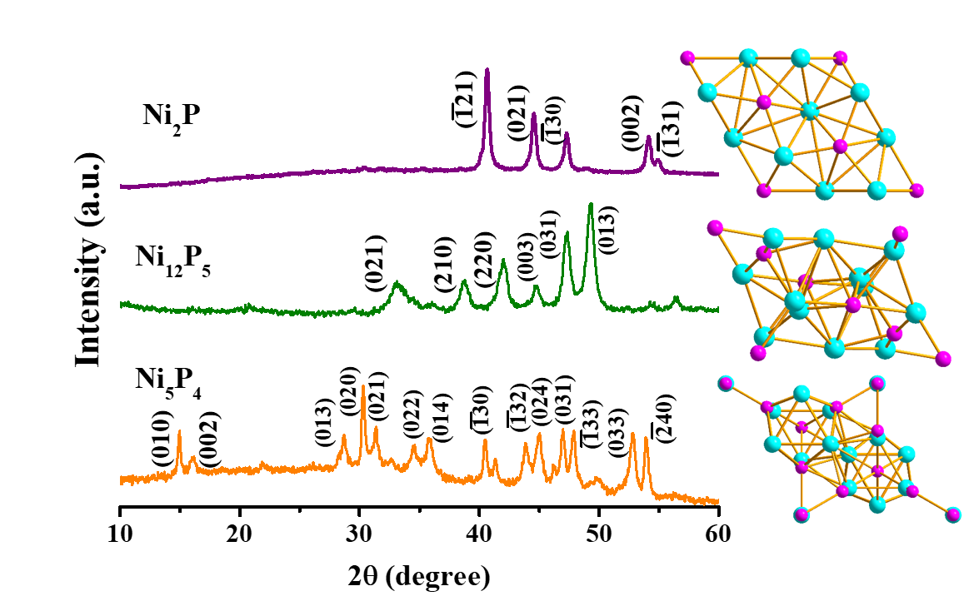

**Figure 1.** X-ray diffraction (XRD) patterns of as-synthesized Ni2P (produced with 0.4 ml TOP), Ni12P5 (produced with 0.3 ml TOP), and Ni5P4. At right are the unit cells of the corresponding phases (purple: P, cyan: Ni).

Transmission electron microscopy (TEM) was used to characterize the morphologies of the as-synthesized nanostructures. The Ni2P structures were polygonal with a single void, monodispersed, in the size range of 28 ± 4 nm (**Figure 2A**), and single crystalline (**Figure 2B**). Elemental mapping (**Figure 2C**) shows a homogeneous distribution of Ni and P in the Ni2P structures, and the atomic ratio of Ni:P corresponding to the stoichiometric ratio.

**Figure 2.** Electron microscopy images of Ni2P structures. (A) High-angle annular dark-field imaging-scanning electron microscopy (HAADF-STEM), (B) high-resolution transmission electron microscopy (HRTEM), and (C) scanning electron microscopy-energy-dispersive X-ray spectroscopy (STEM-EDS) elemental maps (red: P, blue: Ni).

The Ni12P5 structures were truncated polyhedra, showing a single void, with a size distribution of 58 ± 6 nm (**Figure 3A**). **Figure 3B** confirms the presence of domain boundaries, which may improve catalytic activity. Elemental mapping (**Figure 3C**) shows homogeneous distribution and the atomic ratio of Ni:P corresponding to the stoichiometric ratio.



**Figure 3.** Electron microscopy images of Ni12P5 structures. (A) HAADF-STEM, (B) HRTEM, and (C) STEM-EDS elemental maps (red: P, blue: Ni).

**Figure 4A** shows a HAADF-STEM image of Ni5P4 nanocrystals. The Ni5P4 was spheroidal in shape and highly monodispersed, with a size distribution of 25 ± 3 nm without voids. **Figure 4B** shows the single-crystalline nature of the as-synthesized Ni5P4. Elemental mapping (**Figure 4C**) shows that the atomic ratio of Ni:P is in accordance with the stoichiometric ratio.

**Figure 4**. Electron microscopy images of Ni5P4 structures. (A) HAADF-STEM, (B) HRTEM, and (C) TEM-EDS elemental maps (red: P, blue: Ni).

***3.2 Growth mechanism***

Analysis of aliquots taken at different stages of the synthesis showed that the Ni2P phase was formed from an amorphous Ni−P phase, producing pure Ni2P when the annealing time was longer than 10 min, or a mixture of Ni2P and Ni12P5 when the annealing time was 10 min (see **Figure 5** where the TOP amount was 0.4 ml). When the reaction was carried out using 0.3 ml TOP, Ni12P5 was formed, starting with Ni(0) particles that phosphorized in 10–20 min (**Figure S6**). Metallic Ni(0) can be synthesized at lower temperatures (220 °C), but at higher temperatures, TOP decomposes and serves as the source for phosphorus,[15] which diffuses inwards into the Ni(0) particles. A faster inward diffusion of P into Ni(0) produced hollow structures, in a Kirkendall mechanism, confirmed by the size increase from Ni(0) to Ni12P5 (**Figure S7**). The formation of Ni5P4 progressed through initial Ni2P structures that converted gradually to the P-rich Ni5P4 phase upon annealing at 350 °C at high TOP concentration (**Figure S8**). **Figure 5** depicts the formation process of different nickel phosphide phases.

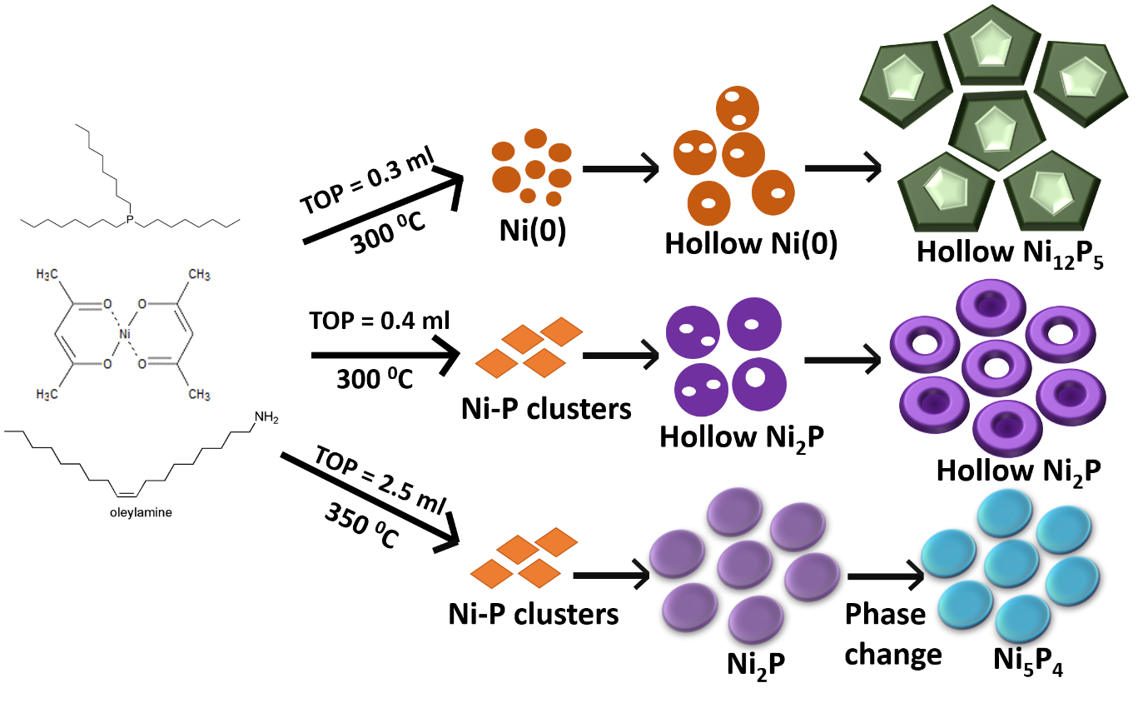

**Figure 5.** Schematic representation of the growth mechanism.

**3.3 *XPS studies***

The HER activity of the catalyst is highly dependent on the oxidation states and the chemical environment of the catalytic sites. This was studied by X-ray photoelectron spectroscopy (XPS) (**Figure 6**; the positions of the relative peaks and their ratio are provided in **Table 1**). Analysis was performed after ligand stripping, the technique later used for the catalytic measurements. Peaks related to oxygen species (oxide, phosphate layer, or hydroxide) were observed for all three catalysts, and it was concluded that the outer surface of all the nanostructures was oxidized (NiPO phase) or that surface-absorbed hydroxyl groups were present (**Figure S9**). A few Ni oxidation states were resolved by the XPS: Niδ+ with a slight positive charge, and Ni species with higher oxidation states (Ni2+ or Ni3+).[16, 17] Ni2P and Ni5P4 had a large proportion of Ni in its low oxidation state, producing a ratio of Niδ+/(Ni2+or Ni3+) of 3.0 and above. With Ni12P5, both species were equally distributed with a ratio of Niδ+/(Ni2+or Ni3+) of 1.0. The XPS spectra of P (**Figure 6B**) reveal peaks at 129.5, 129.0, and 129.1 eV for Ni2P, Ni12P5, and Ni5P4, respectively—all lower binding energies than elemental P (130.2 eV)—indicating a negatively charged Pδ-. These findings suggest that there is an electron transfer from Ni to P in all nickel phosphide phases. Additionally, around 133 eV, the peaks observed in the P 2P energy region are likely due to surface-oxidized P species because the samples were exposed to air.[18] To summarize, we conclude that Ni12P5 has the highest degree of charge transfer between Ni and P within the sample set.

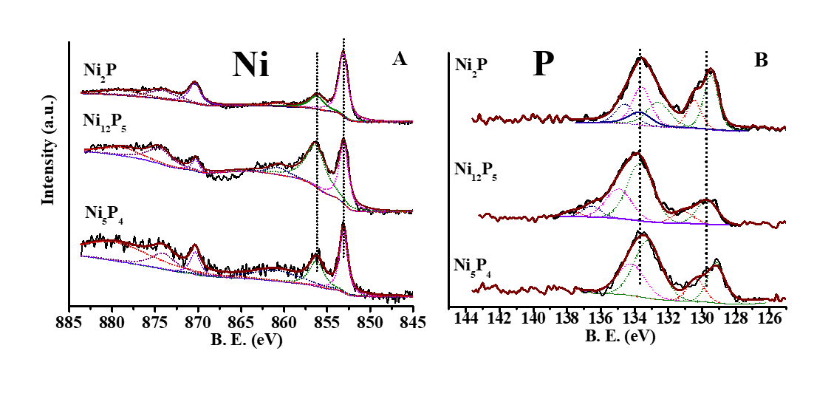**F****igure 6.** XPS spectra of Ni (A) and P (B) for Ni2P, Ni12P5, and Ni5P4.

**Table 1**: Peak position of Ni and P in different nickel phosphide nanocrystals and ratio of Niδ+ and Ni2+

|  |  |  |  |
| --- | --- | --- | --- |
|  | **Ni2P** | **Ni12P5** | **Ni5P4** |
| **Ni 2P**  **(eV)** | 853.1 | 852.9 | 853.2 |
| 856.0 | 856.3 | 856.3 |
| **P 2P3/2**  **(eV)** | 129.5 | 129.0 | 129.1 |
| 132.6 | 133.8 | 133.2 |
| 133.5 | 135.0 |  |
| **Niδ+/Ni2+** | 3.6 | 1.0 | 3.0 |

In the literature, improved catalytic activity has been attributed to the formation of acid-base pairs in close proximity within the crystal lattice, facilitating similar activity to hydrogenase, where negatively charged non-metal sites act as H+ acceptors and metal sites act as hydride acceptors.[19] Such acid-base pairs are potentially formed by charge transfer between Ni and P, comparable to charge transfer in other transition metal phosphides.[18, 20, 21] Here, the XPS results confirm mild electron transfer between Ni and P in Ni2P and strong electron transfer between Ni and P in Ni12P5, which was found to affect the catalytic activity in previous studies.[9]

***3.4 Electrocatalytic HER***

Electrocatalytic activity of the various nanostructures toward the HER was evaluated under both acidic and alkaline conditions. The onset potential, which is the starting point of catalytic activity—defined as the overpotential at the current density of J = 1 mA cm−2 and the overpotential to produce a current density of 10 mA cm−2—was low for all of the samples (see **Figure 7A** and **Table 2**). The reaction kinetics and mechanism at the surface of the electrode were estimated from the Tafel slope, which is calculated by plotting the overpotential vs. the logarithm of the current density (**Figure 7B)**. The lowest Tafel slope was 60 mV/dec (for Ni2P), indicating a similar mechanism for all the catalysts—a fast Volmer step followed by a rate-determining Heyrovský reaction.[22] Catalytic activity of Ni5P4 in this study is better than or comparable to that shown in recently published research,[23] and Ni12P5 demonstrated superior performance to Ni12P5-based catalysts (for detailed comparison with the state-of-the-art, see **Table S3** in the Supporting Information).[24, 25] Ni2P structures showed significantly higher catalytic activity than both Ni5P4 and Ni12P5, exhibiting an overpotential of 126 mV (at 10 mA cm−2), much higher than Ni2P systems.[25-28]

Further, we calculated the electrochemical surface area (ECSA) of the as-synthesized catalysts, estimated from their double-layer capacitance (Cdl). The results indicate a large number of available surface sites (see **Table 2** and **Figure S10** in the Supporting Information for details of the measurements and calculations). Notably, the ECSA of Ni2P was the lowest in the set. We therefore ascribe the higher activity of Ni2P to its desirable binding properties, rather than an active surface area.

The ideal way to compare catalyst activity is to use the turnover frequency (TOF) of the electrocatalytic reaction, which is independent of the active surface. TOF is the ratio of the number of H2 molecules produced to the number of sites present in the catalyst surface. The TOF plot was calculated from the current density plot, by normalizing with respect to the surface sites and the ECSA (details of the calculation for the surface sites and the TOF are provided in the Supporting Information, **Figure S11**). The best TOF value obtained was 0.59 s-1 for Ni2P, comparable with recent reporting.[27]

~~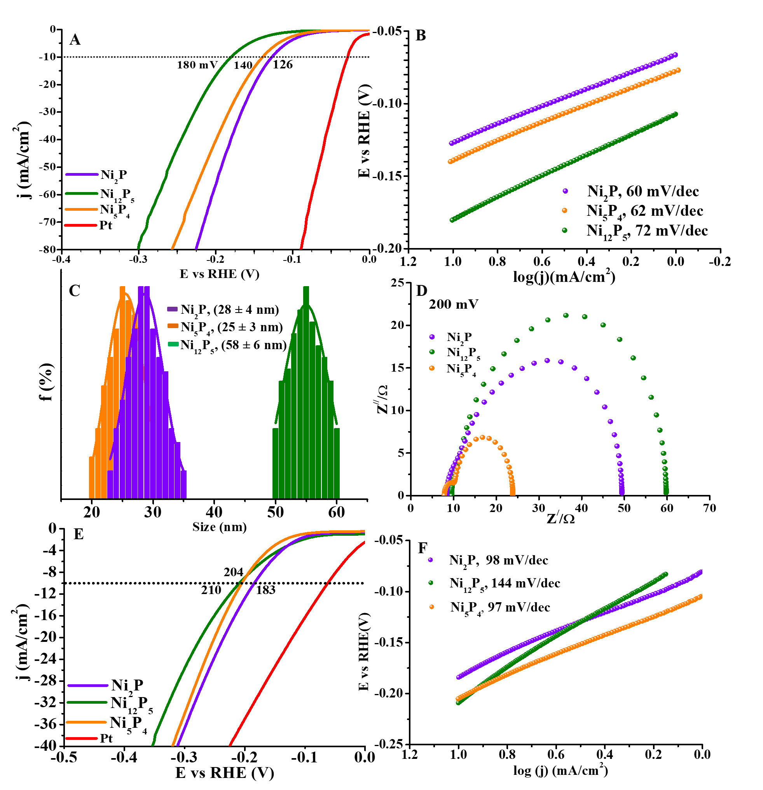~~

**Figure 7.** (A) HER polarization curves of various nickel phosphide catalysts in 0.5 M H2SO4 and (B) corresponding Tafel slopes. (C) Size distribution histograms. (D) Nyquist plots at a bias of 200 mV. E) HER polarization curves in 0.5 M KOH and (F) corresponding Tafel slopes.

**Table 2**: Summary of the electrochemical performance of the various nickel phosphide catalysts

|  |  |  |  |  |  |  |  |
| --- | --- | --- | --- | --- | --- | --- | --- |
| **Catalyst** | **Acid (0.5 M H2SO4)** | | | | | **Base (0.5 M KOH)** | |
| **Ƞ10 mA cm-2**  **(mV)** | **Tafel slope**  **(mVdec-1)** | **Rct at  200 mV**  **(Ω)** | **ECSA**  **(cm2)** | **TOF200**  **(min-1)** | **Ƞ10 mA cm-2**  **(mV)** | **Tafel slope**  **(mVdec-1)** |
| Ni2P | 126 | 60 | 49.4 | 155 | 0.59 | 183 | 98 |
| Ni12P5 | 180 | 72 | 59.7 | 284 | 0.1 | 210 | 144 |
| Ni5P4 | 140 | 62 | 23.5 | 195 | 0.35 | 204 | 97 |

Electrochemical impedance spectroscopy (EIS) was used to investigate the electrode kinetics. **Figure S12** shows the Nyquist plots of different catalysts at various potentials within the frequency range 100 kHz–0.05 Hz with an amplitude of 15 mV. The diameter of the semicircle in the Nyquist plots represents the charge transfer resistance (Rct) of the catalyst. **Figure 7D** shows the Rct values determined from the diameter of the semicircles at 200 mV; these are summarized in **Table 2**. Fast electron transfer from the catalyst surface to the solution was confirmed by the low charge transfer resistance for Ni5P4. The Rct value can be used to derive the Tafel slope by plotting log(1/Rct) vs. the overpotential, as depicted in **Figure S12**. The Tafel slope values were in accordance with those obtained from the linear sweep voltammetry (LSV) measurements, showing that the contribution of electron transport resistance is minor.[29] Continuous cyclic voltammetry (CV) sweeps at a scan rate of 100 mV/s for 3000 CV cycles showed the durability of the various catalysts for electrocatalytic HER (**Figure S13A-C**).

**Figure 7E** depicts HER performance in alkaline. The overpotentials required for a current density of 10 mA cm-2 and the derived Tafel slopes (**Figure 7F**) are provided in **Table 2**. Electrocatalytic performance of Ni2P in alkaline medium (considering both the overpotential and the Tafel slope) was comparable to [30] or better than [31-33] that shown in recently reported studies. It is widely accepted that in alkaline medium HER activity is also affected by the water dissociation step and the poisoning of active sites by OH-, in addition to the ΔGH*, a prominent parameter in acidic conditions. The performance of Ni12P5 and Ni5P4 in alkaline is comparable in terms of the overpotential at 10 mA cm-2 (the former even exhibits the lowest onset potential), while in acidic medium Ni5P4 is significantly better. We attribute this observation to the high oxidation state of Ni species within Ni12P5, which decreases the energy barrier for water dissociation, H--OH.[34, 35]

In contrast, the higher oxidation number of nickel will also bind OH- more strongly—a negative effect[36] that may lead to the poisoning of active sites.[35] This is clearly observable at high current densities (**Figure 5E**), where Ni12P5 performance was the worst. Ni5P4, on the other hand,showed gradual relative improvement and approached the Ni2P activity. At high current densities, more H2 is generated, and the desorption of OH- to refresh the surface sites is a vital step that facilitates the readsorption of water. This is an important consideration in the design of catalysts for alkaline conditions. In this respect, the Ni5P4, with its mild oxidation state of Ni, exhibited the optimum balance: facilitating water dissociation while preventing poisoning with -OHads. Ni2P showed the highest activity, both in acid and alkaline, which is a result of its abundant active sites combined with significantly favorable hydrogen adsorption energy.[37]

***3.5 Catalytic HER from hydrolysis of AB and NaBH4***

The catalysts were also employed for catalytic dehydrogenation from hydrolysis of AB and NaBH4. The hydrogen-generating reaction was performed with a fixed ratio of the catalyst to AB or NaBH4. **Figure 8** shows the catalytic activity of the phases at 298 K under ambient conditions. Experiments in the temperature range 288K–318K were used to derive the activation energy (Ea) of the catalytic hydrolysis (**Figure S14 and S19**). For both catalytic processes, the performance of Ni12P5 was better than Ni2P and Ni5P4 in terms of the TOF and Ea. The TOF and Ea values of Ni5P4 and Ni12P5 for AB hydrolysis are better than Pd, Ru, and other noble metal-based catalysts, and are comparable to the recently reported state-of-the-art (Supporting Information, **Table S4**). For NaBH4 hydrolysis, all three catalysts showed activity on par with that of noble metal-based catalysts or other recently reported transition metal-based structures.[5] The reaction followed zero-order kinetics with respect to NaBH4 for all three catalysts, as no change in catalysis rate was found when the NaBH4 concentration was varied (**Figure S20**).



**Figure 8.** (A and B) Kinetics of hydrolysis of NH3BH3 by Ni12P5 at various temperatures and corresponding Arrhenius plot for the activation energy. (C and D) Kinetics of hydrolysis of NaBH4 by Ni12P5 at various temperatures and corresponding Arrhenius plot for the activation energy. (E) and (F) Csomparative plots for activation energy and TOF of Ni–P nanoparticles for NH3BH3 and NaBH4 hydrolysis, respectively.

Stability tests for AB hydrolysis showed that the least stable catalyst was Ni2P, whereas Ni5P4 and Ni12P5 were both highly stable for up to five catalytic cycles (**Figure S15–S18**). Ni12P5 even showed an improved TOF value after five cycles. A plausible explanation for this improvement may be the reduction of Niδ+ to Ni(0) by BH4-, which increases the electron density on Ni sites.[38] The change in the Ni oxidation state is also evident in the XPS measurements as a shift of the binding energy of Niδ+ to a lower value (from 852.9 eV to 852.5 eV) (**Figure S18)**. Exposed Ni(0) on the surface of Ni12P5 reportedly boosted the hydrogen evolution rate.[14]

The difference in the hydrolysis activity of the three catalysts may be correlated with the extent of the charge separation between Ni and P. For aminoborane, the hydrogen atoms of the molecules interact with both Ni and P. According to calculations, the rate-determining step is SN2,where activated water absorbed on the surface attacks the BH3 group of NH3BH3 and accelerates the B–N bond breakage.[5] Ni acts as a hydride acceptor due to its inherent positive charge, making the charge density on the Ni sites a significant parameter. A higher positive charge density may promote the initial binding of aminoborane to the Ni–P surface and thereby effectively activates the B–N bond and enhances hydrogen release. In accordance with these observations, Ni12P5 has a substantial charge on the Ni sites (as per the XPS data) that results in lower activation energy and faster kinetics of hydrolytic cleavage. For NaBH4 and other hydride transfer reagents, the starting point is (NP-H)n- followed by the hydrolysis that occurs via the following mechanism:[39]

{(Ni-P-NP)-Hm}n-+ H+⟶ {(Ni-P-NP)-Hm-1}(n-1)-+ H2 (“Heyrovský”)

{(Ni-P-NP)-Hm}n-⟶ {(Ni-P-NP)-Hm-2}n-+ H2 (“Tafel”)

Therefore, cations or electropositive elements such as Ni promote the first step at which the M–H bond is formed. The charge separation between Ni (Ni**δ**+/Ni2+) and P (P**δ**-) was confirmed from the XPS studies for all three phases of Ni–P, which enabled them to exhibit good catalytic activity. Ni12P5 had a high positive charge on the Ni center and high density of these sites (Ni**δ**+/Ni2+ = 0.98), allowing it to act as a hybrid acceptor that reduces the activation energy for the catalytic reaction. Similar logic may explain the high TOF as well.

1. **Conclusions**

In summary, we successfully synthesized various pure phase nanostructures of nickel phosphide (Ni5P4, Ni2P, and Ni12P5). The conditions used to obtain each phase and its growth mechanism were described. Catalytic activity towards electrochemical hydrogen production was measured by water reduction, and towards hydrogen retrieval by hydrolysis of chemical hydrogen storage materials (aminoborane and NaBH4). The results show that charge separation between the Niδ+–Pδ- sites in the various Ni–P phases plays a pivotal role in achieving the desired efficacy of the catalytic reaction. Ni2P nanoparticles exhibited the highest performance for the electrocatalytic hydrogen evolution reaction, with low overpotential (126 mV and 180 mV at J = 10 mA·cm-2 for acid and base, respectively). For the hydrolysis of boron-hydride compounds, the high positive charge on the metal center acts as a hydride acceptor to accelerate the catalytic reaction and the release of H2. Ni12P5 was the most efficient catalyst, with TOF = 23.0 min-1 and Ea = 50.4 kJ·mol-1 for hydrogen retrieval from aminoborane, and TOF = 17.3 min-1 and Ea = 52.7 kJ·mol-1 for hydrogen retrieval from NaBH4, which is comparable to noble metal nanoparticles. Our work provides new insights into this system and provides a more comprehensive understanding of the structure–activity relationship to facilitate the design of promising multi-functional noble metal-free catalysts for hydrogen evolution from water and hydrogen storage materials.

**Author contributions**

S. G. designed the project, synthesized the samples and measured their catalytic properties, carried out the characterization measurements except for the HRTEM and wrote the majority of the manuscript. S. R. K. measured the electrochemical properties of the samples with S. G. Aberration-corrected electron microscopy was performed by L. H. The work was supervised by M. B. S. and R. B. Z. who were also involved with the writing of the manuscript. All authors have given their feedback on the paper and approved the final version of the manuscript before its submission.

**Conflict of interests**

The authors declare no competing financial interests.

**Acknowledgements**

S. K. and S. G. thank the financial support of the Kreitman Post-Doctoral fellowship at the BGU. This center of excellence was supported by The Israel Science foundation (grant No. 1212/21).

**Appendix A. Supplementary data**

Supplementary data to this article can be found online.

**References**

[1] L. Schlapbach and A. Züttel, Nature, 414 (2001) 353.

[2] L.J. Murray, M. Dincă and J.R. Long, Chem. Soc. Rev., 38 (2009) 1294.

[3] B. Sakintuna, F. Lamari-Darkrim and M. Hirscher, Int. J. Hydrog. Energy, 32 (2007) 1121.

[4] U.B. Demirci and P. Miele, Energy Environ Sci, 4 (2011) 3334.

[5] N. Patel and A. Miotello, Int. J. Hydrog. Energy, 40 (2015) 1429.

[6] W.-W. Zhan, Q.-L. Zhu and Q. Xu, ACS Catal., 6 (2016) 6892.

[7] K. Li, Y. Li, Y. Wang, J. Ge, C. Liu and W. Xing, Energy Environ Sci, 11 (2018) 1232.

[8] E.K. Abo-Hamed, T. Pennycook, Y. Vaynzof, C. Toprakcioglu, A. Koutsioubas and O.A. Scherman, Small, 10 (2014) 3145.

[9] Y. Pan, Y. Liu, J. Zhao, K. Yang, J. Liang, D. Liu, W. Hu, D. Liu, Y. Liu and C. Liu, J. Mater. Chem. A, 3 (2015) 1656.

[10] H. Li, S. Lu, J. Sun, J. Pei, D. Liu, Y. Xue, J. Mao, W. Zhu and Z. Zhuang, Chem. Eur. J., 24 (2018) 11748.

[11] M. Das, N. Jena, T. Purkait, N. Kamboj, A. De Sarkar and R.S. Dey, J. Mater. Chem. A, 7 (2019) 23989.

[12] C.-Y. Peng, L. Kang, S. Cao, Y. Chen, Z.-S. Lin and W.-F. Fu, Angew. Chem. Int. Ed., 54 (2015) 15725.

[13] C.-C. Hou, Q. Li, C.-J. Wang, C.-Y. Peng, Q.-Q. Chen, H.-F. Ye, W.-F. Fu, C.-M. Che, N. López and Y. Chen, Energy Environ Sci, 10 (2017) 1770.

[14] Y. Lin, L. Yang, H. Jiang, Y. Zhang, D. Cao, C. Wu, G. Zhang, J. Jiang and L. Song, J. Phys. Chem. Lett., 10 (2019) 1048.

[15] L.M. Moreau, D.-H. Ha, C.R. Bealing, H. Zhang, R.G. Hennig and R.D. Robinson, Nano Lett., 12 (2012) 4530.

[16] L. Cai, B. Qiu, Z. Lin, Y. Wang, S. Ma, M. Wang, Y.H. Tsang and Y. Chai, J. Mater. Chem. A, 6 (2018) 21445.

[17] H. Zhang, Y. Lu, C.-D. Gu, X.-L. Wang and J.-P. Tu, CrystEngComm, 14 (2012) 7942.

[18] P. Jiang, Q. Liu, Y. Liang, J. Tian, A.M. Asiri and X. Sun, Angew. Chem. Int. Ed., 53 (2014) 12855.

[19] P. Liu and J.A. Rodriguez, J. Am. Chem. Soc., 127 (2005) 14871.

[20] J. Tian, Q. Liu, N. Cheng, A.M. Asiri and X. Sun, Angew. Chem. Int. Ed., 53 (2014) 9577.

[21] P. Jiang, Q. Liu and X. Sun, Nanoscale, 6 (2014) 13440.

[22] Y.-F. Xu, M.-R. Gao, Y.-R. Zheng, J. Jiang and S.-H. Yu, Angew. Chem. Int. Ed., 52 (2013) 8546.

[23] M. Ledendecker, S. Krick Calderón, C. Papp, H.-P. Steinrück, M. Antonietti and M. Shalom, Angew. Chem. Int. Ed., 54 (2015) 12361.

[24] Y. Pan, W. Hu, D. Liu, Y. Liu and C. Liu, J. Mater. Chem. A, 3 (2015) 13087.

[25] Y. Pan, N. Yang, Y. Chen, Y. Lin, Y. Li, Y. Liu and C. Liu, J. Power Sources, 297 (2015) 45.

[26] Y. Du, C. Liu, G. Cheng and W. Luo, Chem. Asian J., 12 (2017) 2967.

[27] B. Seo, D.S. Baek, Y.J. Sa and S.H. Joo, CrystEngComm, 18 (2016) 6083.

[28] L. Mora-Tamez, G. Barim, C. Downes, E.M. Williamson, S.E. Habas and R.L. Brutchey, Chem. Mater., 31 (2019) 1552.

[29] H. Vrubel, T. Moehl, M. Grätzel and X. Hu, Chem Commun 49 (2013) 8985.

[30] J. Xia, K. Dhaka, M. Volokh, G. Peng, Z. Wu, Y. Fu, M. Caspary Toroker, X. Wang and M. Shalom, Sustain Energ Fuels, 3 (2019) 2006.

[31] Y. Zhang, Y. Liu, M. Ma, X. Ren, Z. Liu, G. Du, A.M. Asiri and X. Sun, Chem Commun 53 (2017) 11048.

[32] L. Yan, P. Dai, Y. Wang, X. Gu, L. Li, L. Cao and X. Zhao, ACS Appl. Mater. Interfaces., 9 (2017) 11642.

[33] T. Ma, Y. Qiu, Y. Zhang, X. Ji and P.-A. Hu, ACS Appl. Nano Mater., 2 (2019) 3091.

[34] Y. Zheng, Y. Jiao, A. Vasileff and S.-Z. Qiao, Angew. Chem. Int. Ed., 57 (2018) 7568.

[35] D. Strmcnik, P.P. Lopes, B. Genorio, V.R. Stamenkovic and N.M. Markovic, Nano Energy, 29 (2016) 29.

[36] R. Bar-Ziv, O.E. Meiron and M. Bar-Sadan, Nanoscale, 10 (2018) 16211.

[37] M.H. Hansen, L.-A. Stern, L. Feng, J. Rossmeisl and X. Hu, Phys. Chem. Chem. Phys., 17 (2015) 10823.

[38] Z.-C. Fu, Y. Xu, S.L.-F. Chan, W.-W. Wang, F. Li, F. Liang, Y. Chen, Z.-S. Lin, W.-F. Fu and C.-M. Che, Chem Commun 53 (2017) 705.

[39] A. Sermiagin, D. Meyerstein, R. Bar-Ziv and T. Zidki, Angew. Chem. Int. Ed., 57 (2018) 16525.