**Abstract**

This study examines expressions of political opinions on Facebook following politically charged events in the context of the Israeli-Palestinian conflict. Using content analysis, we compared 539 randomly selected Facebook comments written by both Jewish and Palestinians Israelis responding to three political incidents that sparked heated discussions and exchanges of ethno-political insults between the two groups on social networks. For each incident, comments were categorized as either offensive or friendly. After analyzing the comments, the percentages of comments posted by Jewish Israelis and Palestinian Israelis in each category were compared. Sixty-six percent of all comments were categorized as offensive, of which 44% were posted by Jewish Israelis and 25% were posted by Palestinian Israelis. These findings reflect the tense and fragile relationship between Jewish and Palestinian citizens of Israel, and highlight the role of social network platforms such as Facebook in unleashing extreme political opinions, which may not surface otherwise.

Keywords: Political expression, Facebook, expected outcomes, Israeli-Palestinian conflict, political crisis, Jewish-Palestinian relations in Israel.

**War of Words: Virtualizing the Israeli–Palestinian Conflict on Facebook in Times of Crisis[1]**

**Introduction**

The increasing popularity of social media sites such as Facebook as platforms for expressing political content and opinions has been attracting increased research attention in recent years.[2] The easy and affordable access to Facebook, together with the heterogeneous and largely unknowable audience associated with it, provide rich ground for political disagreement and the exchange of heated and fiery online posts between users with differing political views.[3] The growing expression of political disagreements on social media sites is attributed to the sites’ structures, which weaken social boundaries and facilitate contact among users holding conflicting political views.[4] These factors are particularly pertinent in conflict-ridden countries such as Israel, whose citizens, Jewish and Palestinian, have been embroiled in the ongoing, long-standing, and still irresolvable Israeli–Palestinian conflict.[5]

In the Israeli context of heightened political conflict, discussing highly divisive political issues or events on social media platforms such as Facebook will most certainly result in confrontations and personal repercussions.[6] These consequences are likely to be even more acute when the political issue under discussion is situated along the ethno-political demarcation line between Arabs and Jews. In this context, an individual’s willingness to express candid political opinion on Facebook, particularly in highly charged political times, may depend on whether the person belongs to Israel’s majority Jewish population, or to its minority Arab population. Parties to interethnic conflicts, such as the Israeli-Palestinian conflict, frequently have unequal levels of power and do not exhibit the same sense of threat or security.[7] As a result, those belonging to a majority or more powerful group are more likely to express their genuine opinions, whereas individuals in the minority may be less likely to express their true political opinions in order to avoid potential repercussions.

This study aims to explore and compare Jewish and Palestinian Israelis’ willingness to express political opinions on Facebook in the context of the Israeli-Palestinian conflict, particularly following highly charged political events. The comparison is based on content analysis of 539 randomly selected Facebook comments written by both Jewish and Palestinian Israelis in response to three news items about politically motivated incidents that sparked heated discussions and exchanges of ethno-political insults between Jewish and Palestinian Israelis on social media. The incidents under investigation include the killing of Nash'at Milhim, the shooting of Israa Abed, both Palestinian Israelis, and the support by Knesset Member Bezalel Smotrich of the *Bayit HaYehudi* (Jewish Home) Party for segregated Jewish-Arab maternity wards in Israeli hospitals. Before examining these incidents in more depth, some historical and political background on the Palestinian minority in Israel is needed in order to clarify the context of this study.

**Background**

Palestinian Israelis

After the Arab–Israeli war of 1948, only 156,000 Palestinians remained in that part of Palestine which had become the State of Israel. Cut off from the rest of the Palestinian people and physically, socially and culturally isolated from the rest of the Arab world, the remaining Palestinians formed a socially and politically weakened group in Israel.[8] Although they were granted Israeli citizenship and received full legal rights, as a minority, Palestinian Israelis have chronically suffered from limited political representation and a debilitated social, economic and educational infrastructure.[9] Referring to their political and social marginalization, the Israeli novelist David Grossman,[10] used the oxymoron “present absentees” to describe Palestinians in Israel.

Israel’s formal policy towards its Palestinian citizens has been determined by three main factors: the democratic character of the state; the Jewish-Zionist nature of the state; and security considerations. In the event of any conflict among these factors, the latter two prevail.[11] Because of the state’s democratic character, Palestinians in Israel have nonetheless enjoyed opportunities for political organization and activity, through which they have sought to improve their status and negotiate to advance the Palestinian case.[12]

However, the status and conditions of the Palestinians in Israel have been linked to and deeply affected by the Israeli-Palestinian conflict and the wider Arab-Israeli conflicts. These conflicts have profoundly influenced relations between Jews and Palestinians in Israel and have shaped the political identities of both groups. The conflicting and competing narratives regarding the conflict adopted by these groups continue to feed the perpetual tensions, animosity, suspicion and distrust between them.[13] Furthermore, Jewish Israelis tend to perceive Palestinian Israelis as a “hostile minority” and a “security risk” because of their links with the Palestinians in the West Bank and the Gaza Strip, as well as with Arabs in neighboring Arab countries. These perceptions further deepen the schism between Jews and Palestinians in Israel, and have had a major impact on Israel's policies regarding surveillance and control of its Palestinian citizens.[14] The status of Palestinians in Israel has become even more vulnerable since the Al-Aqsa Intifada (*uprising*), which erupted in 2000 within the context of a serious crisis in the peace process.[15]

**Palestinian Israelis and Political Expression in the Public Sphere**

Despite Israel’s democratic character, Palestinian Israelis were for long reluctant to publicly display symbols of their Palestinian identity or express their political views towards the state of Israel for fear of security related repercussions. This apprehension may be a reaction to Israel’s effective employment of strategies of political control and surveillance on the Palestinian minority living within its borders since the founding of the state, despite having been granted Israeli citizenship.[16] Cohen[17] demonstrates that Israel was able to exercise tight surveillance with the help of the many collaborators and informers that it recruited to spy on and relay information about their colleagues, neighbors and friends to the authorities.

This situation has changed in recent years with the growth of social media. Now, expressing ones' identity and political views, traditionally done in private, has become mediatized through social networks sites such as Facebook.[18] Indeed, there has been a significant amount of research exploring the role of social media, and Facebook in particular, as an avenue for political expression and speech.[19] Furthermore, scholars have stressed the importance of studying the unique nature of the Facebook context for expressing political content and conducting political discussion.[20]

Facebook as a Platform for Political Discussion

Facebook’s unique qualities render it a distinct format for political expression. The platform’s accessibility, combined with the ease of interacting with hundreds of people simultaneously, enable users to convey information to vast audiences,[21] including those with differing opinions, which rarely happens in most face-to-face social situations.[22] Consequently, incendiary political posts on Facebook can result in heated debates, offended audiences, and even damaged relationships.[23] During times of political crisis, controversies and disagreements on Facebook can escalate to an extreme level, with tolerance and acceptance declining at the same time.[24] This is particularly true in Israel, a nation with the highest level of Facebook users in the world.[25]

John and Dvir-Gvirsman found that in the Israeli context of heightened conflict, discussing politics on Facebook could prove risky, resulting in confrontation and adverse repercussions.[26] For example, John and Dvir-Gvirsman reported that during the 2014 Gaza War, Jewish Israelis judged other users harshly on the basis of their political statements, and sometimes blocked those users’ contents or unfriended them. Similarly, Mor, Kliger-Vilenchik, and Maoz found that Jewish Israeli Facebook users were aware that posting political content, both in times of heightened political conflict and in calmer times, entailed risks such as disappointing family members, ending friendships and even damaging future career opportunities.[27] However, despite the accompanying risks, they found that the majority of Israeli Facebook users were highly motivated to express their opinions on sensitive political issues. Mor, Kliger-Vilenchik, and Maoz contend that because these users value open discussion, they are willing to pay the price.

For Palestinian Israelis, however, discussing politically sensitive issues on Facebook during times of heightened political tension can involve higher political risks. The consequences can be far more serious and extend beyond heated exchanges of racial slurs with fellow Jewish Facebook users. Posting an inappropriate comment can lead to the loss of employment or even arrest. In one case, during the 2014 Gaza War, a Palestinian Israeli educational psychologist was fired from her job at the Lod municipality after posting on Facebook that she was pleased about the death of Israeli soldiers. The mayor of the Lod municipality, Ya'ir Rivivo, took to Facebook to announce her dismissal from her job and to launch into an angry tirade against her:[28]

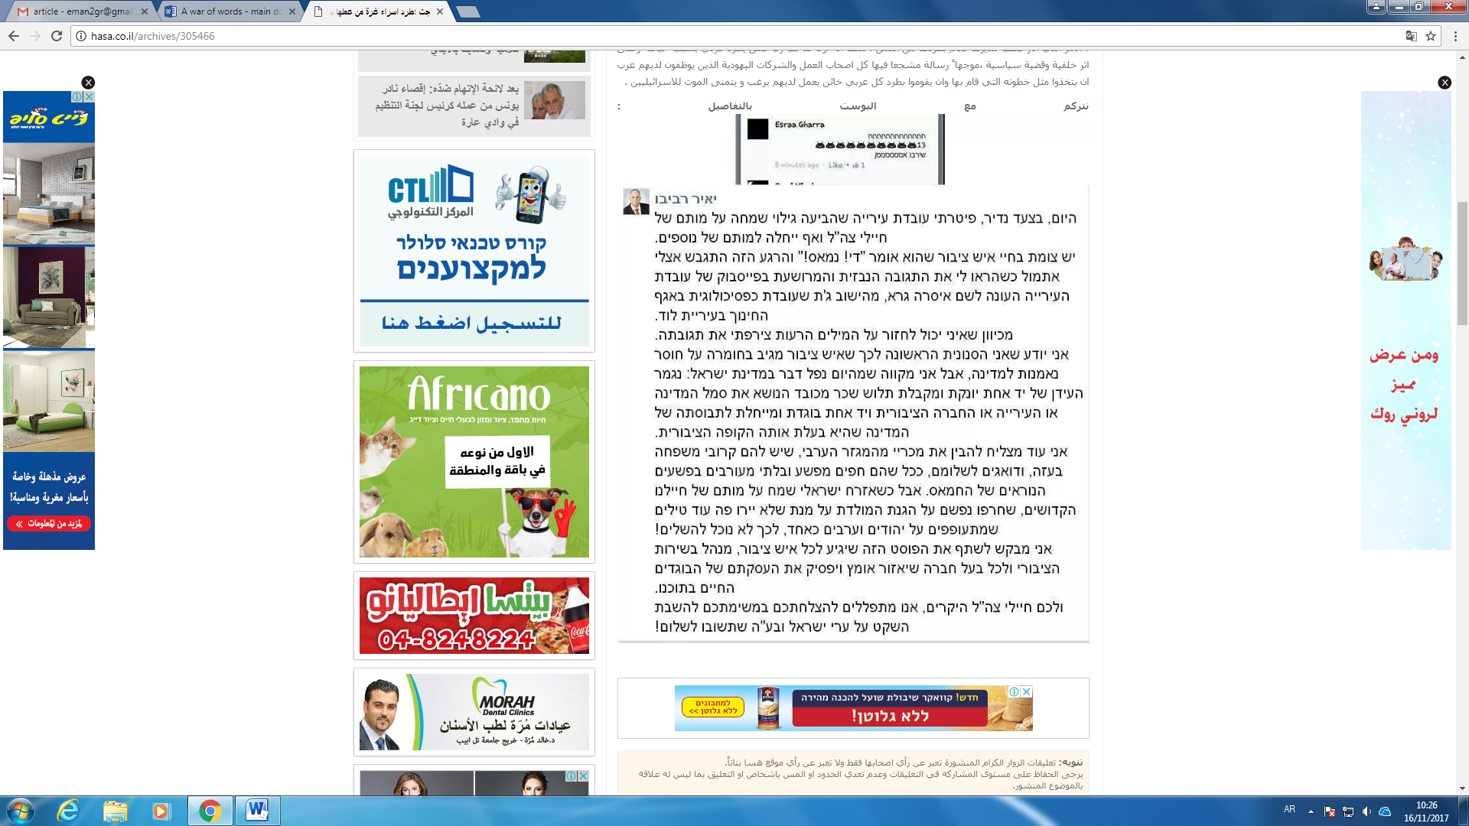

**Translation:** *“Today, in an unprecedented step, I have sacked a municipality employee who expressed joy at the death of IDF soldiers and even wished for the death of more”*

Another incident that was widely shared on Facebook and received extensive coverage on major Israeli and international news outlets was the arrest of Anas Abu Da’abes, a well-known Palestinian Israeli blogger and social activist. Abu Da’abes had posted a comment in Arabic on Facebook satirizing Palestinians who had expressed their delight on social media about the wildfires that blazed through Israel in November 2016. However, the police, having relied on automatic translation software to translate his post, misinterpreted his comments and mistakenly accused him of inciting Palestinian Israelis to commit further arson attacks. Incidents like these can make Palestinian Israelis reluctant to express their political opinions, particularly during times of heightened political tension. Furthermore, such incidents send a clear message to Palestinian Israelis that their Facebook posts are taken more seriously by the Israeli security apparatuses than are those of their Jewish counterparts. To support this claim, following the arrest of Abu Da’abes, many Palestinian Israeli Facebook users posted screenshots of similar comments made by Jewish Israeli Facebook users that contained actual direct incitement to commit arson in Arab areas as illustrated in the following comments.

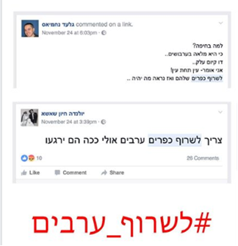

**Translation**: *“Why in Haifa? Because it is full of Arabs…and they call it co-existence, I say - eye for an eye! Let’s burn their villages and then see what happens…”*



**Translation:** *“We have to burn Arab villages, maybe this way they will calm down”.*



Translation: *“#Let’s_burn_Arabs*”

The Events under Examination

The first incident studied was the shooting of Israa Abed, 29, who was shot multiple times in the bus station in the city of Afula in October 2015. A video of the shooting shows Abed, a Nazareth resident, standing alone, surrounded by heavily armed Israeli police, before she was shot and badly wounded. She was suspected of planning to carry out a stabbing attack. The Israeli press reported that she had been holding a knife, a claim that was refuted by her father, who insisted that the police mistook her sunglasses for a knife.[29]

The second incident was that of Nashat Milhim, the gunman who killed three Israelis in a shooting rampage in Tel Aviv in January 2016. Milhim, a Palestinian Israeli from the village of Arara, escaped the shooting scene and remained at large for a week before he was tracked down in his hometown by Israeli security forces and killed in an ensuing gunfight.[30]

The third incident examined was the controversy surrounding a proposal made in April 2016 by Betzalel Smotrich, a member of Knesset (MK) from the ultra-nationalist *Bayit Yehudi* (Jewish Home) party, which is part of Prime Minister Netanyahu's coalition, calling for segregation between Jewish and Arab mothers in maternity wards in Israeli hospitals. His statement sparked an outrage from both left and right wing politicians and set social media ablaze with reactions.[31]

**Methodology**

Krippendorff defines content analysis as a research technique whereby contextual inferences can be made from the text for the purpose of attaining replicable and valid results.[32] Using this technique, researchers can address the consequences of communication enabling them to locate the cause and effect of communication throughout its explicit content.[33] "It provides new insights, increases a researchers' understanding of particular phenomena, or informs practical actions".[34]

Holsti (1969) offers a broad definition of content analysis as: "any technique for making inferences by objectively and systematically identifying specified characteristics of messages".[35] In order to allow for replication, however, the technique can only be applied to data that are durable in nature. Content analysis enables researchers to sift through large volumes of data with relative ease in a systematic fashion.[36] It can be a useful technique for enabling investigators to detect and describe the focus of individual, group, institutional, or social attention.[37] Using content analysis, inferences can be made and then be corroborated using other methods of data collection. Krippendorff notes that "[m]uch content analysis research is motivated by the search for techniques to infer from symbolic data what would be either too costly, no longer possible, or too obtrusive by the use of other techniques".[38]

Facebook has become a global documenting arena wherein anybody can express and chronicle whatever content they wish through posts, comments, links, and even screenshots. Before the advent of Facebook and other social media outlets, it was extremely difficult for individuals to document their attitudes and real-time reactions and discourse about current events. Today, the task of reporting and chronicling public attitudes is much easier given the pervasive use of social media.

In order to understand public reactions to politically charged events in the context of the Israeli-Palestinian conflict, the study applied content analysis to 539 randomly selected Facebook comments. Screenshots were taken of comments, chosen at random from different Israeli Facebook pages and included comments of both Jews and Palestinians living in Israel that were made in response to controversial news items arising from the conflict between Jews and Palestinians.

In total, 296 comments by Jewish Israelis and 243 comments by Palestinians living in Israel were collected. The nature of the comments was then categorized. Comments including obscene, anti-social, or inflammatory language were categorized as comments with “offensive reactions.” Comments with clearly positive language or reactions were categorized as “friendly reactions.”

**Findings**

As stated previously, this study examined reactions of Israeli Jews and Palestinians towards controversial events as expressed on Facebook and divided these reactions into two groups of offensive and friendly comments. This section presents a sample of the comments posted in response to the three incidents under study, together with their translations. A table summarizing the findings for each incident is also provided.

Incident I: The Shooting of Israa Abed

The following are samples of the comments posted by Jewish and Palestinian Israeli Facebook users following this incident:

**Sample Comments by Jewish Israelis**

Comment 1 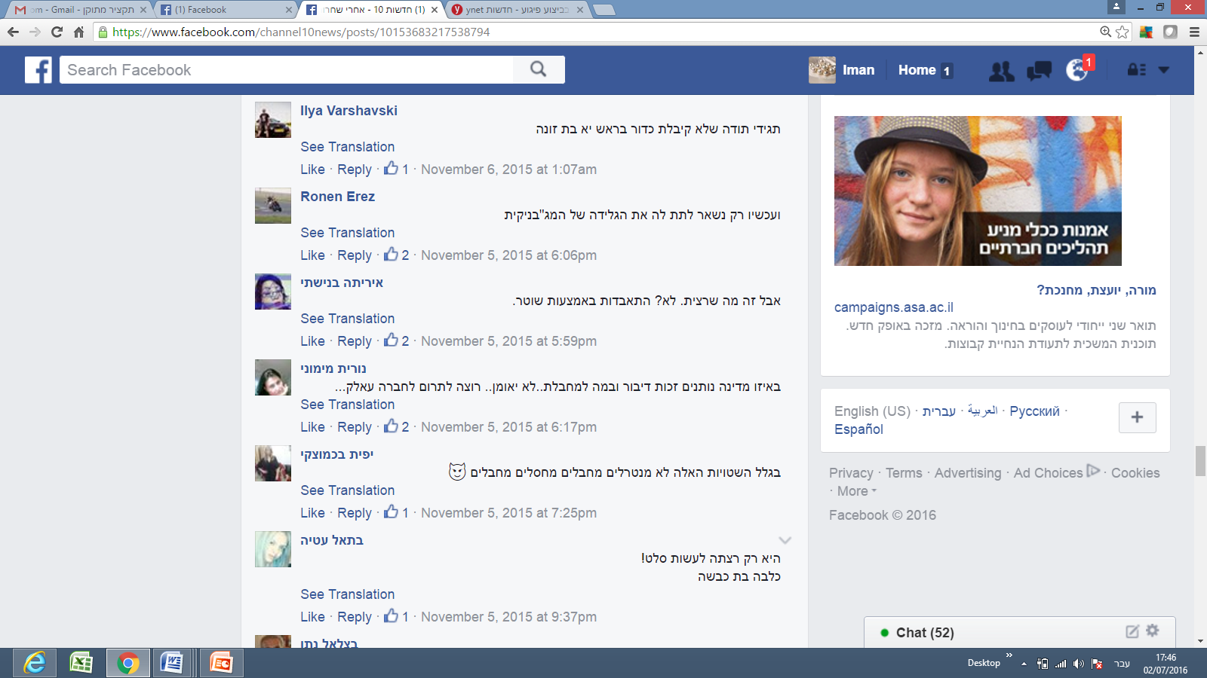

*Translation*: *“Just be grateful that you didn’t get a bullet in the head, you bitch.”*

Comment 2

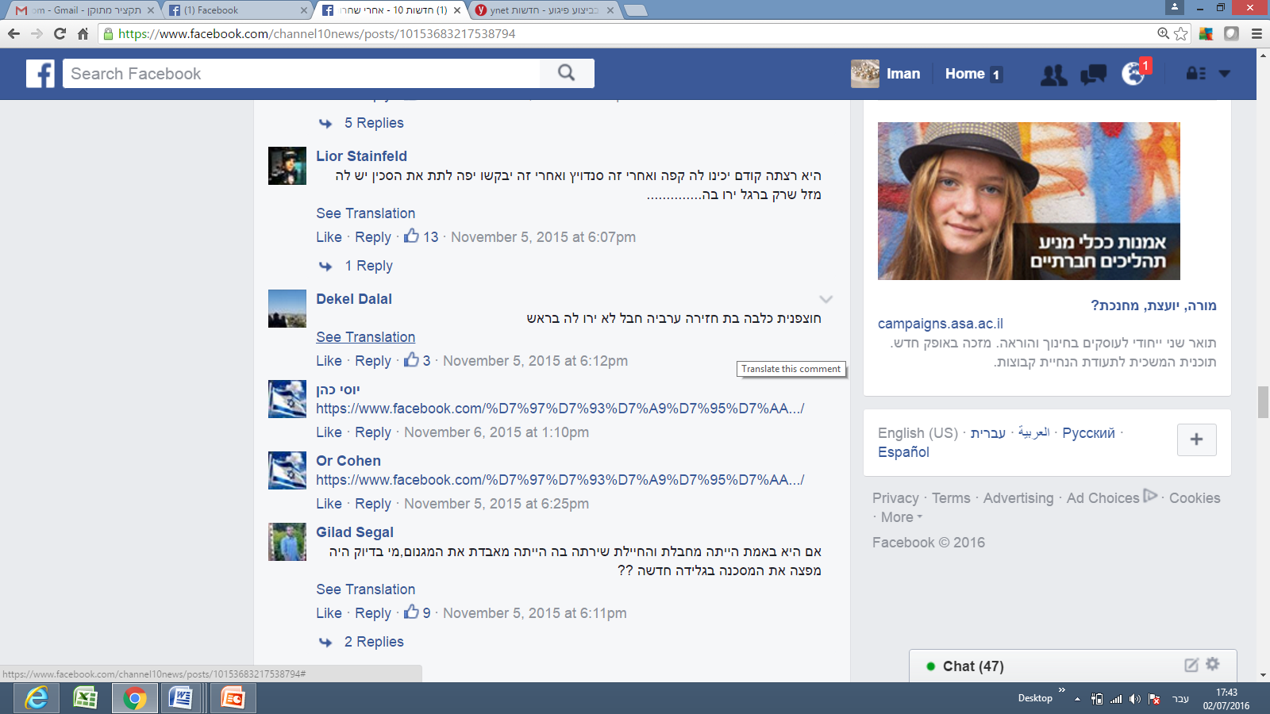

*Translation:* “*You’re an Arab pig; it’s too bad you weren’t shot in the head*.”

Comment 3

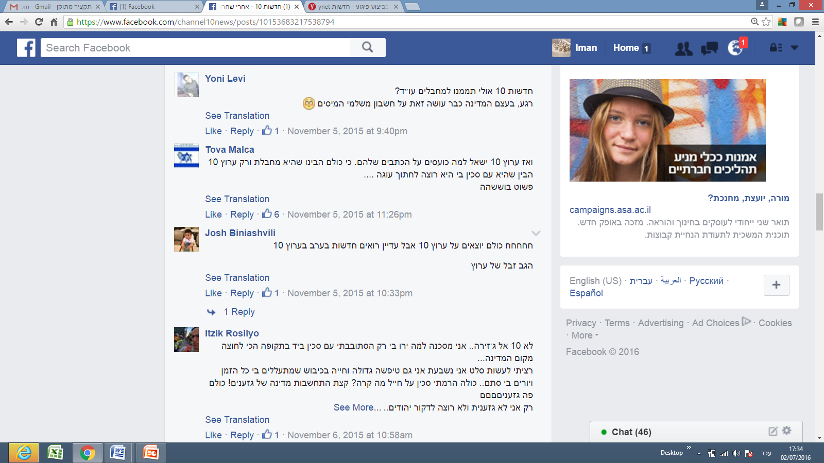

*Translation*: “*Not Channel 10, but Al Jazeera*. [the following was written sarcastically, but as if quoting Israa Abed]: ‘*I’m an unfortunate victim. Why did they shoot me? I was only wandering in the street with a knife in my hand during one of the most stressful times since the establishment of the state…* *I only wanted to prepare salad. I swear. I am a big idiot living under occupation. They abuse me all the time, and shoot at me for no reason... All I did was raise a knife towards a soldier! So, what?! Just show a bit of consideration, you country of racists! You are all racists! I am the only one who is not racist, and I don’t want to stab Jews....*”

**Sample comments by Palestinian Israelis**

Comment 1

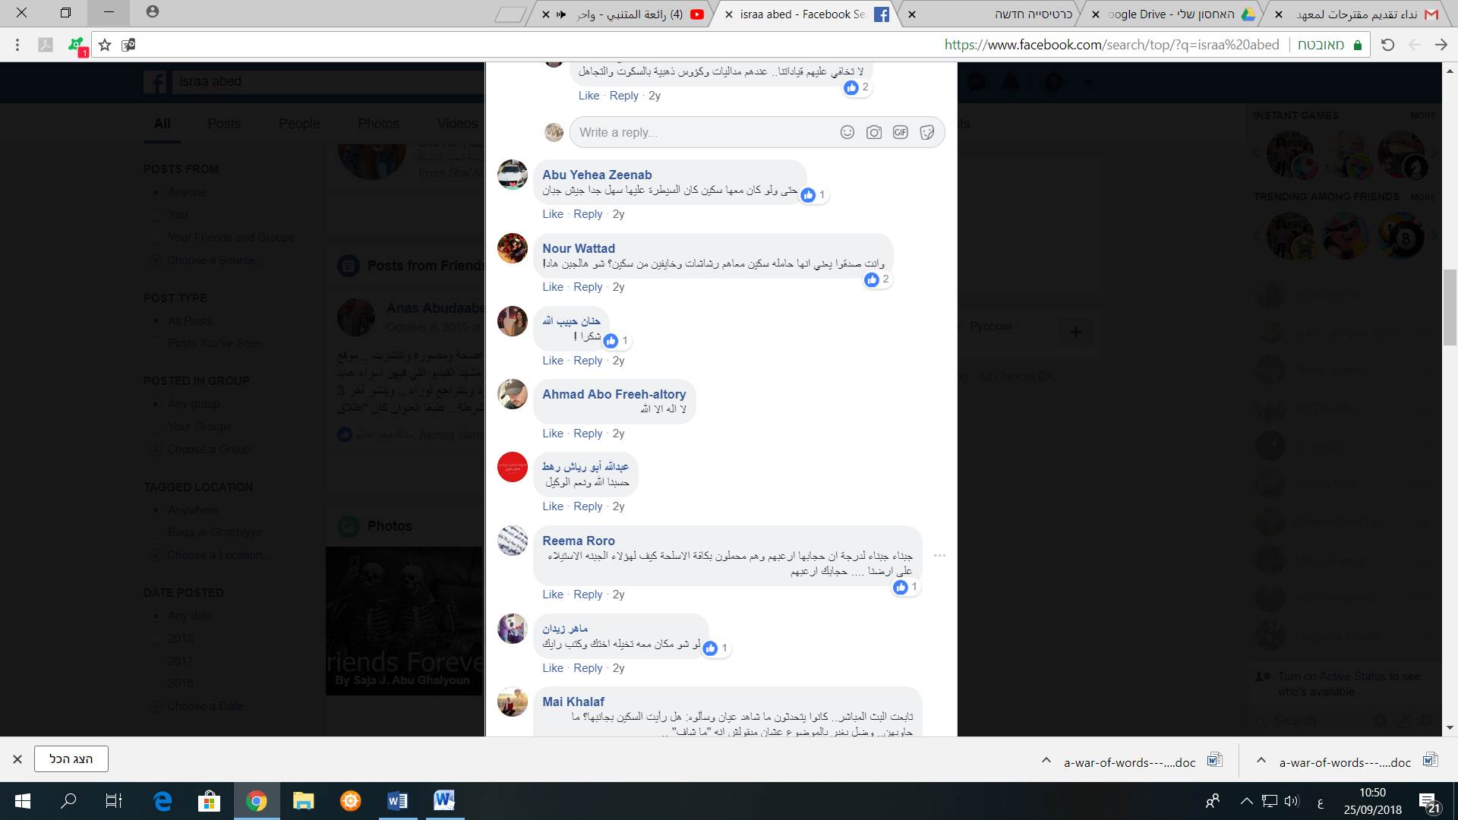

*Translation:* *“Cowards, cowards [referring to Israeli soldiers] to the extent that her [Israa Abed] headscarf frightened them despite being armed to the teeth. How did these cowards manage to occupy our land [if] your headscarf frightened them”.*

Comment 2

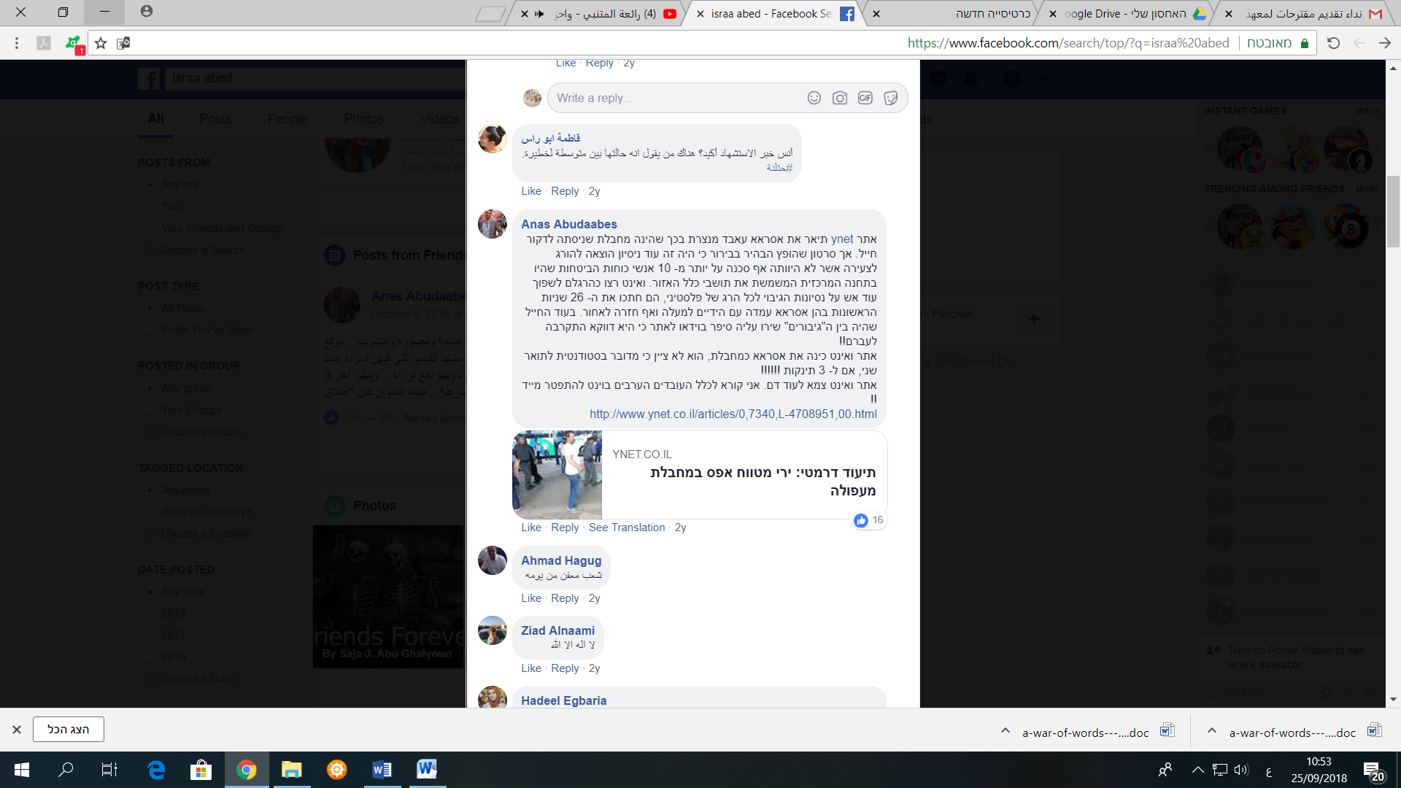

*Translation:* “*Rotten people* [referring to Jews] *ever since”*

[Table 1 here]

Incident II: The Shooting of Nashat Milhim

The following are samples of the comments posted by Jewish Israeli Facebook users following this incident.

**Sample Comments by Jewish Israelis**

Comment 1

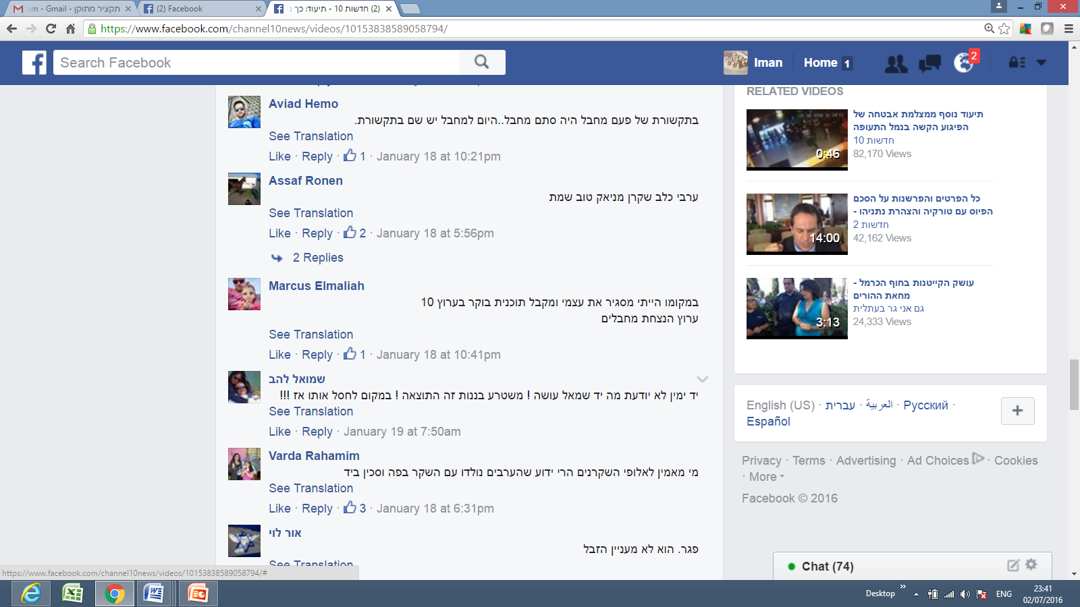

*Translation:* *“An Arab dog, liar, maniac; good that he’s dead.”*

Comment 2

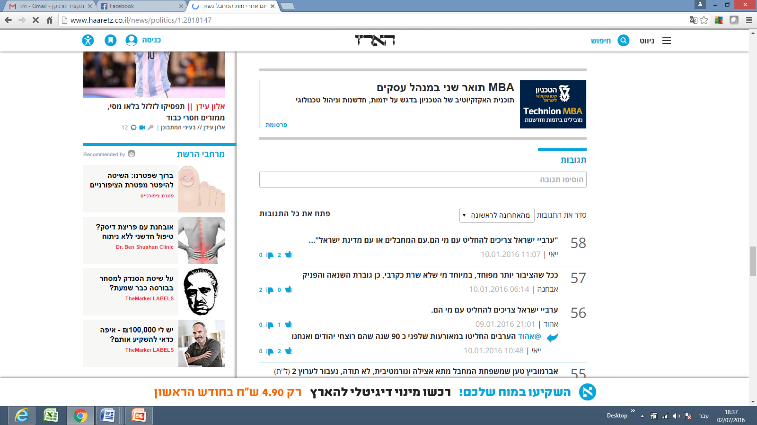

*Translation:* “*Israeli Arabs should decide with whom they stand. With the terrorists or the State of Israel?”*

Comment 3



*Translation:* “*Who would believe the champions of lying* [referring to Arabs]*? Everyone knows that Arabs are born with a lie in their mouths and a knife in their hands.”*

[Table 2 here]

IncidentIII: MK Bezalel Smotrich’s Call for Segregating Arab and Jewish Mothers in Israeli Hospital Maternity Wards

**Sample Comments by Jewish Israelis**

The following are samples of the comments posted by Jewish Israeli Facebook users following this incident.

Comment 1

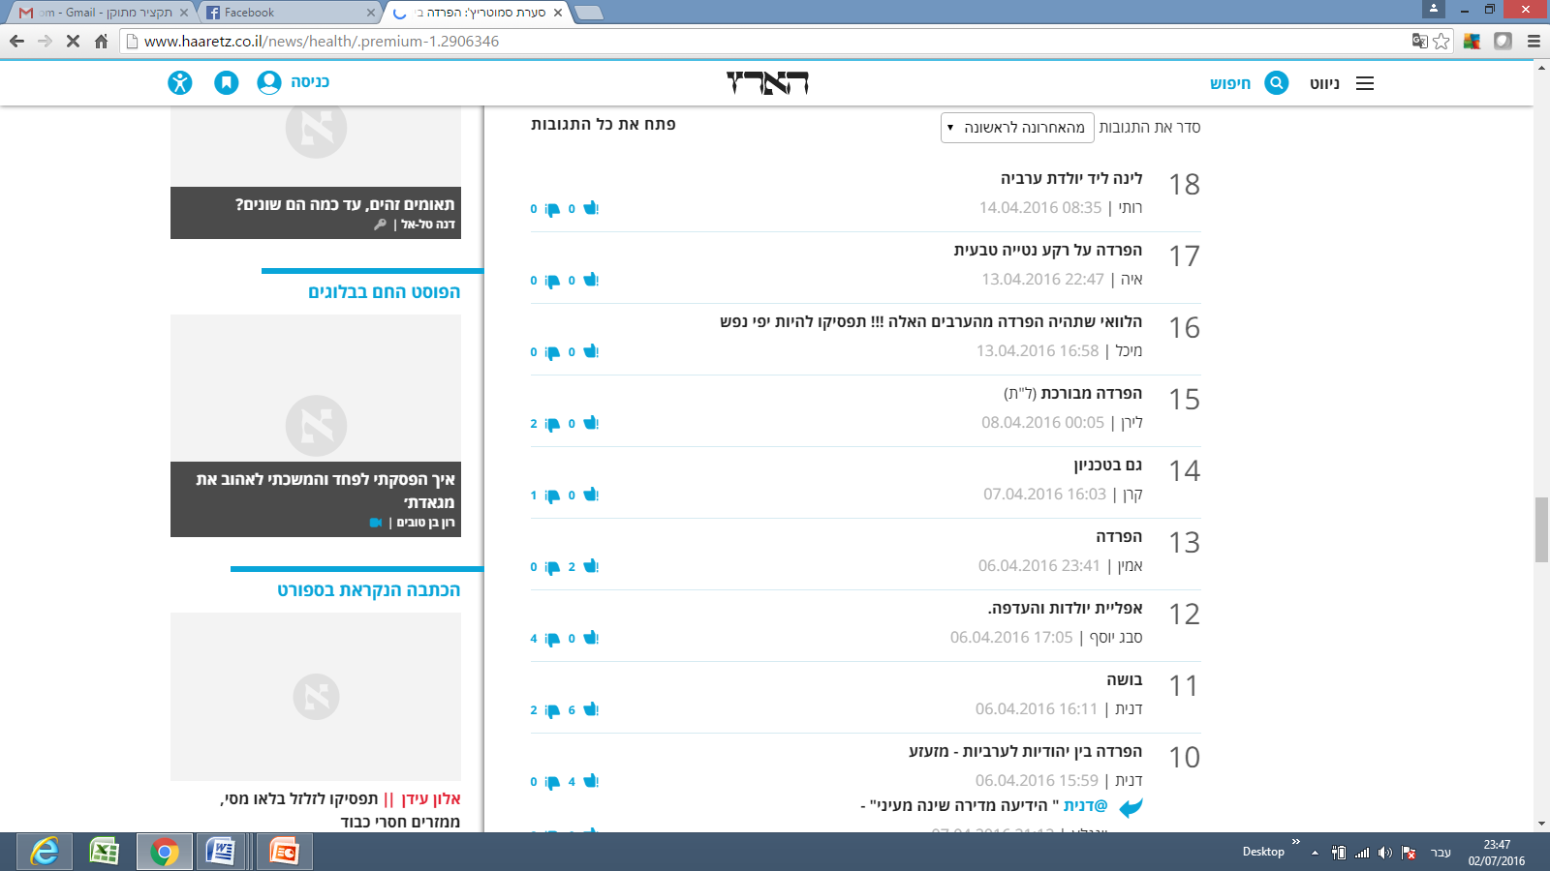

*Translation:* *“I wish there would be segregation from those Arabs!!! Stop being so overly-sensitive!”*

Comment 2

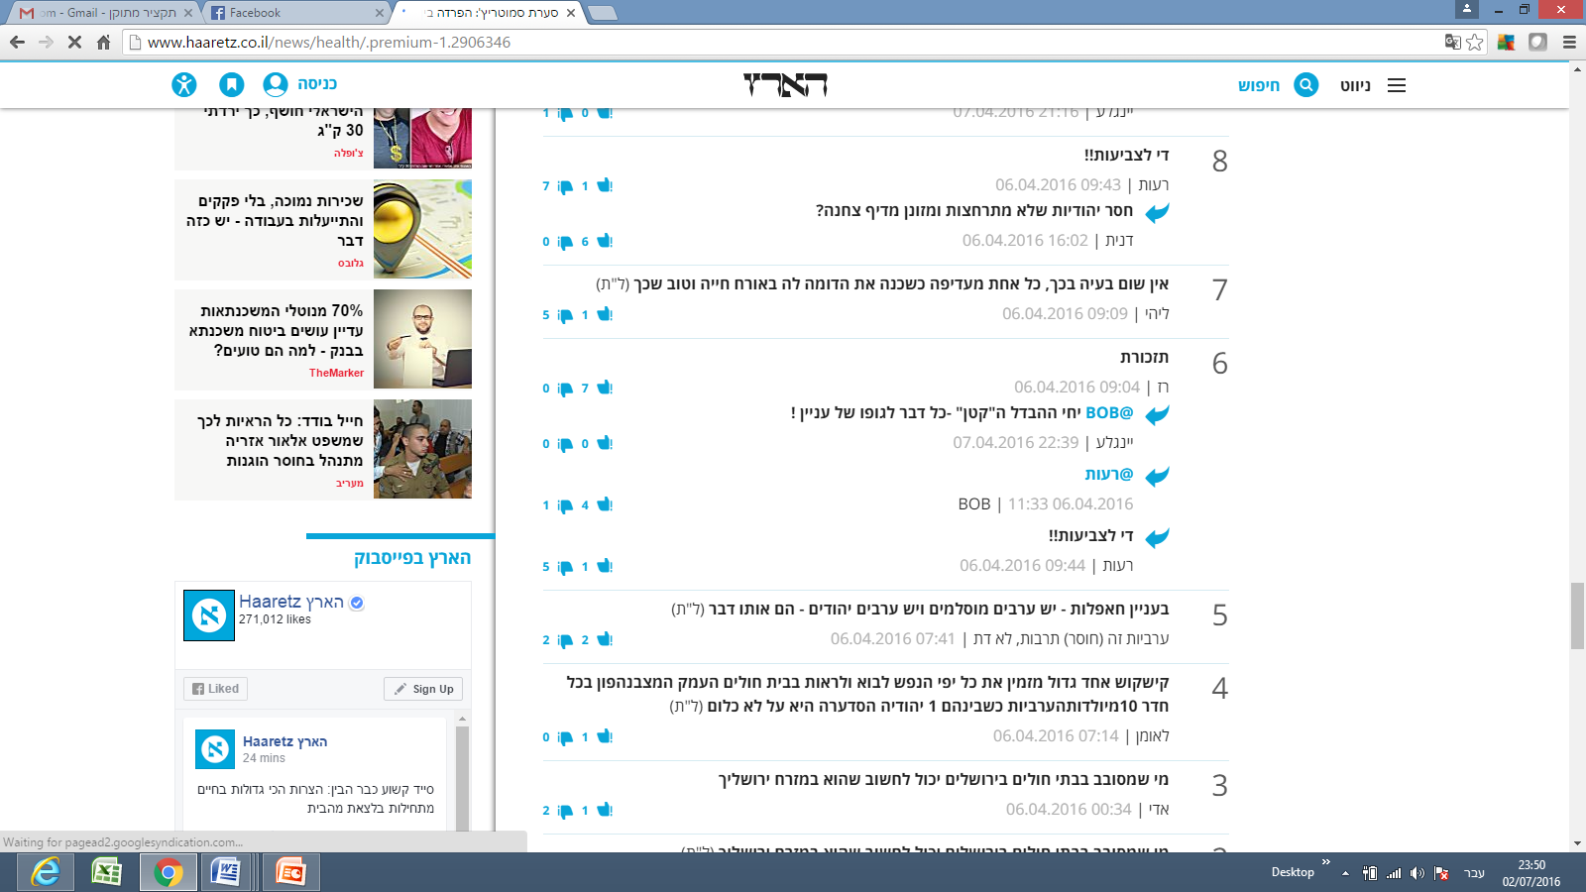

*Translation:* *“Regarding get-togethers: there are Arab Muslims and there are Arab Jews* [referring to the Jews who oppose the segregation] *─ they are both the same."*

*“Arabness is a (lack) of culture, not a religion.”*

Comment 3

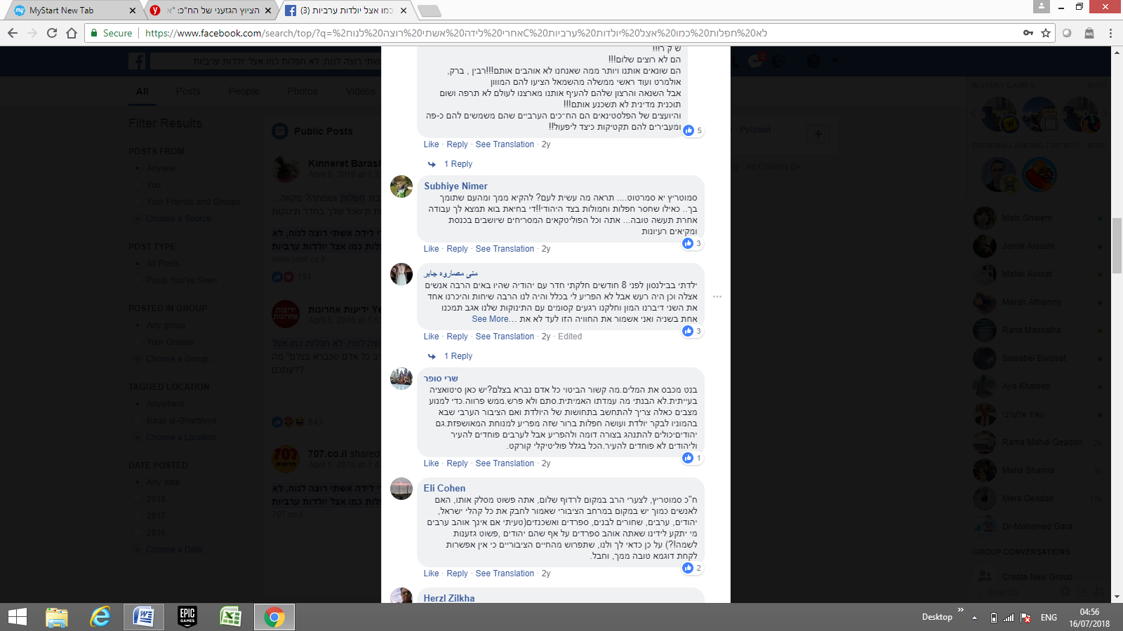

*Translation:* “*Smotrich, you dirty rag... what have you done to the people? We will vomit from you and from people supporting you. As if we lack celebrations and clans from the Jewish side! Stop it for God's sake. Do us a favor and go find yourself some other job... you and all the disgusting Knesset Members who sit in the Knesset vomiting their ideas*.”

Comment 4 (written by a Jewish Israeli).

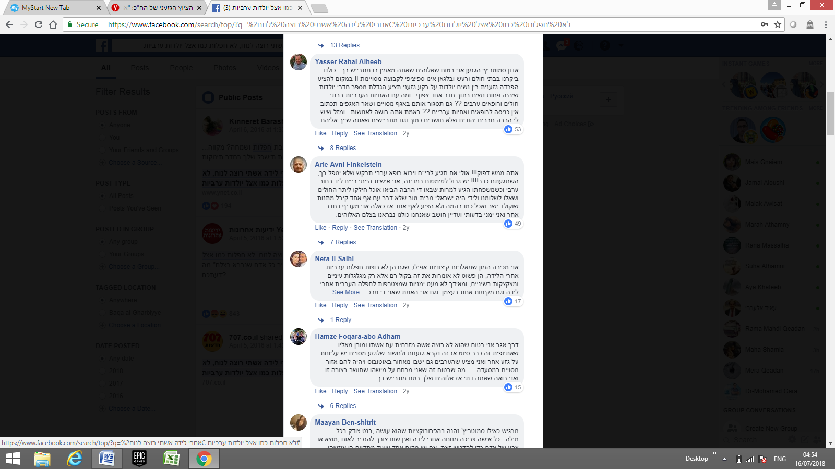

*Translation:* “*You* [addressing Smotrich] *must be crazy! Maybe if you go to a hospital and an Arab doctor comes to treat you, you will ask him not to take care of you! Are you all crazy!* [...] *Even though my political opinions are right-wing, I still believe that we are all created alike in God’s image”.*

[Table 3 here]

These findings point to a high percentage of negative reactions expressed by both parties under study following controversial incidents. Of the 296 comments made by Jewish Israelis, 220 (74%), were categorized as negative reactions, and 137 of the 243 comments made by Palestinian Israelis (56%), expressed negative reactions towards Jews. The total negative comments from both parties amounted to 66% of the total number of comments gathered for the study, with 357 of the 539 comments expressing negative attitudes.

**Discussion**

This study aimed to explore and compare Jewish and Palestinian Israelis’ willingness to express political opinions on Facebook in the context of the ongoing Israeli-Palestinian conflict. In highly divisive societies, such as the Israeli society, politics plays a significant role in peoples’ lives and political topics are hotly debated.[39] The findings of the current study echoed this reality and showed that the frequency with which both Jewish Israelis and Palestinian Israelis used offensive language about the other group, as well as their strong negative attitudes toward the other regarding the incidents under examination, reveal a fragmented and polarized political and social landscape vulnerable to significant inflammation or incitement. Jewish Israelis commenting on Facebook were far more likely to use offensive language than their Palestinian Israeli counterparts. One possible explanation for this result is that Jewish Israelis, believing that they are less likely to face legal or security-related consequences, feel more secure about expressing their true opinions; regardless of how offensive they are. In contrast, Palestinian Israeli commentators are more reluctant to express their views freely, as they feel more vulnerable to facing pressure from or even arrest by Israel’s security apparatuses than do their Jewish counterparts.

In addition, in many cases in the past, Palestinian Israelis experienced adverse consequences when they revealed negative attitudes towards the Jewish community. For example, a Palestinian Israeli woman was fired from her job at a Jewish Israeli municipality after writing on her Facebook wall that she wished more Israeli soldiers had been killed following the death of some Israeli soldiers.[40]

Another well-known incident, which was frequently discussed and shared on Facebook pages and other media platforms, including Al Jazeera and all Israeli mainstream media, such as Channels 2 and 10, was that of the popular Arab journalist Anas Abu Da’abes, who had written a satirical Facebook post during a time when wildfires were raging in Israel. The post, after having been translated using Google Translate, lost its satirical meaning and was interpreted as an incitement for Arab/Palestinian Israelis to commit arson, leading to Abu Da’abes’ arrest.[41] This is in line with previous findings that showed that political expression in the divisive Israeli society could bear serious risks.[42] For instance, in the context of the 2014 Gaza war, John and Dvir-Gvirsman found strong personal repercussions to political expression on social media such as people being publicly denounced, reprimanded by their supervisors, and even fired from their jobs.[43]

These incidents likely dissuaded Palestinians Israelis from revealing their true attitudes towards Jewish citizens, especially during times of crisis or regarding controversial issues. Many Palestinian Israelis using Facebook are convinced that their Facebook posts are scrutinized more closely by Israel’s security apparatuses than are those of their Jewish counterparts. In the case of Abu Da’abes, for example, many Palestinian Israeli Facebook users shared screenshots on their walls of other comments by Jewish Facebook users which clearly called for arson.[44]

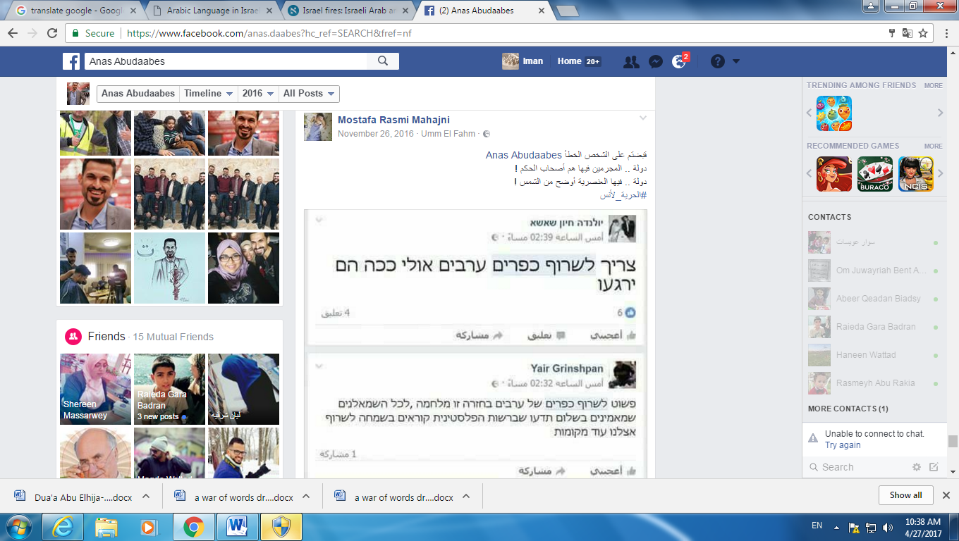

*Translation of the Arabic text: “You’ve arrested the wrong person, Anas Abu Da’abes. In this country the criminals are the governors! In this country racism is as clear as the light of the sun!*

*#Freedom to Anas!”*

**Translation of the Hebrew Texts**

Comment 1

*“We have to burn all Arab villages; maybe this way they’ll calm down.”*

Comment 2

*“We simply need to burn Arab villages in return. This is a war, and all the leftists who believe in peace should know that in the Palestinian Authority, they are happily calling for more fires in our country.”*

The findings also demonstrate a difference between Jewish Israelis’ reactions to controversies involving physical threats or confrontations and to controversies involving ideological or ethical issues, such as that of segregating Arab and Jewish women in maternity wards. The latter case evoked far fewer offensive comments from Jewish Israelis than did the Abu Da’abes incident. However, even these friendlier comments revealed a sub-category of attitudes, with Jewish Israelis criticizing Jews who sympathized or affiliated with Palestinian Israelis. Palestinian Israelis were also much more confident about expressing their opinions about the segregation controversy, as the issue clearly involved racism rather than a threat of physical harm.

A further examination of these findings also raises the question of the relative absence of left-wing views expressed. Mass communication theories, specifically Noelle-Neumann’s spiral of silence theory (1979), which posits that some people are not willing to state their real opinions due to fear of isolation from the overwhelming majority opinion, may help clarify this phenomenon.[45] According to Noelle-Neumann, public opinion amounts to “pressure to conform.” In essence, public opinion is a general social climate, a prevailing moral and aesthetic trend in society that monitors human activity much like a “public eye” from which nobody can remain unseen.[46] Furthermore, she argues that the essential meaning of the term lies in “the interaction between the inclinations, abilities, and convictions of the individual and the agreement of the many, to which the individual has to subordinate himself if he does not want to place himself in isolation outside society”.[47] According to Noelle-Neumann, it is through the media of mass communication that people in modern societies come to learn about public opinion. This is certainly the case in the context of social media networks and can help explain why the overwhelming majority of the posts by Jewish Israelis examined expressed anti-Arab sentiments. Despite our findings’ contribution to the understanding of online political expression of Facebook users in times of political crisis in the Israeli context, this study also has a number of limitations. Information were missing regarding religious affiliation, political orientation, educational background, ethnicity, age and locality. Such information could provide in-depth analysis of the political expression on Facebook and offer a clearer picture of the political landscape in Israel on social media. Further research would benefit from the consideration of these factors to examine the specific influence of respondents’ demographic factors on their choice of political expression on Facebook at times of political crisis. This also allows conducting in-group comparisons (e.g. Palestinian Israelis of different demographic characteristics). Furthermore, this research selected cases at times of political crisis in the context of the Israeli Palestinian conflict. Future research could elaborate on the issue of political expression on social media also at times of relative calmness, and at times of harmony and in circumstances of co-existence between Jewish and Palestinian Israelis.

In this research, we have explored the reactions of Israeli Jewish and Palestinian Facebook users’ to politically charged events. As far as the researchers are concerned, this is the first research study that compares Israeli Jewish and Palestinian Facebook users’ reactions to political events in Israel and by doing so we hope to contribute the growing body of research on political expression on social networks.

**Endnotes**

1. The names of all private individuals have been redacted from all Facebook materials cited herein to protect individuals’ privacy.
2. See for example: S. Mo Jang, Hoon Lee, and Yong Jin Park, “The More Friends, The Less Political Talk? Predictors of Facebook Discussions among College Students,” *Cyberpsychology, Behavior, and Social Networking* 17, no. 5 (2014): 271–275; Emily K. Vraga, Kjerstin Thorson, Neta Kligler-Vilenchik, and Emily Gee, “How individual sensitivities to disagreement shape youth political expression on Facebook,” *Computers in Human Behavior* 45 (2015): 281–289.
3. Kevin Coe, Kate Kenski, Stephen A. Rains, “Online and Uncivil? Patterns and Determinants of Incivility in Newspaper Website Comments,” *Journal of Communication* 64, no. 4 (2014): 658–679.
4. Jennifer Brundidge, “Political Discussion and News Use in the Contemporary Public Sphere: The ‘Accessibility’ and ‘Traversability’ of the Internet,” *Javnost-The Public: Journal of the European Institute for Communication and Culture* 17 no. 2 (2010): 63–81.
5. Eran Halperin and Daniel Bar-Tal, “Socio-psychological Barriers to Peace Making: An Empirical Examination within the Israeli Jewish society,” *Journal of Peace Research*48, no. 5 (2011): 637–651.
6. Nicholas A. John and Shira Dvir-Gvirsman, “‘I Don't Like You Any More’: Facebook Unfriending by Israelis during the Israel–Gaza Conflict of 2014,” *Journal of Communication* 65, no. 6 (2015): 953–974.
7. Nadim N. Rouhana and Susan T. Fiske, “Perception of Power, Threat, and Conflict Intensity in Asymmetric Intergroup Conflict: Arab and Jewish Citizens of Israel,” *Journal of Conflict Resolution* 39, no. 1 (1995): 49–81.
8. Majid Al-Haj and Henry Rosenfeld, *Arab Local Government in Israel* (Boulder, CO: Westview Press, 1990); Yair Bäuml, *Tzel Kakhol Lavan Mediniyut Hamimasad Hayisraeli u'Peulotav Bekerev Haezrakhim Ha'aravim b'Yisrael: Hashanim Hamatzvot: 1958-1968 [Blue and White Shadow–the Policy of the Israeli Establishment and Its Activities among the Arab Citizens: The Formative Years: 1958–1968]* (Haifa, Israel: Pardes, 2007).
9. Zvi Bekerman and Ifat Maoz, “Troubles with Identity: Obstacles to Coexistence Education in Conflict Ridden Societies,” *Identity* 5, no. 4 (2005): 341–357.
10. David Grossman, *Nochechim Nifkadim [Present Absentees]* (Tel Aviv: Hakibutz HaMeuhad Publishers, 1992).
11. Majid Al-Haj, “The Political Culture of the 1990s Immigrants from the Former Soviet Union in Israel and their Views toward the Indigenous Arab Minority: A Case of Ethnocratic Multiculturalism,” *Journal of Ethnic and Migration Studies* 30, no. 4 2004): 681–696; Al-Haj & Yaniv, 1983 NOT IN ORIGINAL REFERENCE LIST; Sammy Smooha, “Minority Status in an Ethnic Democracy: The status of the Arab Minority in Israel,” *Ethnic and Racial Studies* 13, no. 3 (1990): 389–413.
12. Al-Haj, “Political Culture of 1990s Immigrants.”
13. Muhammad Amara, *Arabic in Israel: Language, Identity and Conflict* (London, UK: Routledge, 2017).
14. Majid Al-Haj, *Education among the Arabs in Israel: Control and Social Change* (Jerusalem, Israel: Magnus Press, 1996); Al-Haj, “Political Culture of 1990s Immigrants”; Sammy Smooha, *Arabs and Jews in Israel*, vol. 1 (Boulder, CO: Westview Press, 1989), 2-3.
15. Al-Haj, “Political Culture of 1990s Immigrants.”
16. Ahmad H. Sa’di, *Thorough Surveillance: The Genesis of Israeli Policies of Population Management, Surveillance and Political Control towards the Palestinian Minority* (Manchester, UK: Manchester University Press, 2013).
17. Hillel Cohen, *Aravim Tovim: Hamodi'in Hayisraeli v'Ha'aravim B'yisrael [Good Arabs: The Israeli Security Services and the Arabs in Israel]* (Jerusalem, Israel: Keter, 2006)
18. Gunn Sara Enli and Nancy Thumim, Socializing and Self-representation Online: Exploring Facebook, *Observatorio* 6, no. 1 (2012): 87–105.
19. See for example: Robert M. Bond et al., “A 61-Million-Person Experiment in Social Influence and Political Mobilization,” *Nature* 489, no. 7415 (2012): 295-298; Jang, Lee, and Park, “The More Friends.”
20. Jang, Lee, and Park, “The More Friends”; Vraga “Individual Sensitivities.”
21. Feng-Yang Kuo et al., “A Study of Social Information Control Affordances and Gender Difference in Facebook Self-Presentation,” *Cyberpsychology, Behavior, and Social Networking* 16, no. 9 (2013): 635–644.
22. Diana C. Mutz, “How the Mass Media Divide Us,” in *Red and Blue Nation*, ed. Pietro S. Nivola and David W. Brady (Washington, DC: Brookings Institution Press, 2006), 223-248
23. Shira Dvir-Gvirsman, Yariv Tsfati, and Ericka Menchen-Trevino, “The Extent and Nature of Ideological Selective Exposure Online: Combining Survey Responses with Actual Web Log Data from the 2013 Israeli Elections,” *New Media & Society* 18 (2014): 857–877; John and Dvir-Gvirsman, “I Don’t Like You.”
24. Robert Huckfeldt, Paul E. Johnson, and John Sprague, *Political Disagreement: The Survival of Diverse Opinions within Communication Networks* (Cambridge, UK: Cambridge University Press, 2004).
25. Yuval Karniel and Amit Lavie-Dinur, “Privacy in New Media in Israel: How Social Networks are Helping to Shape the Perception of Privacy in Israeli Society,” *Journal of Information, Communication and Ethics in Society* 10, no. 4 (2012): 288-304; Yifat Mor, Neta Kligler-Vilenchik, and Ifat Maoz Political Expression on Facebook in a Context of Conflict: Dilemmas and Coping Strategies of Jewish-Israeli Youth," *Social Media + Society* 1, no. 2 (2015): 1-10.
26. John and Dvir-Gvirsman, "I Don't Like You"
27. Mor, Kligler-Vilenchik, and Ifat Maoz, “Political Expression on Facebook.”
28. Or Kashti, Eli Ashkenazi, and Nir Hasson “Workplaces Discipline Israeli Arabs for Facebook Posts Against Gaza Incursion,” *Ha’aretz*. July 23, 2014. Retrieved from: <https://www.haaretz.com/4-israeli-arabs-disciplined-over-anti-war-facebook-posts-1.5256408>
29. See: Jack Khoury, “Israeli Arab Woman Shot in Bus Station Not a Terrorist, Conclude Security Forces,” *Ha’aretz*. October 28, 2015. <http://www.haaretz.com/israel-news/1.682928>; versus: Jonathon Cook, “Israel is a Terrorist State,” *Al Jazeera.* October 12, 2015. Retrieved from: <http://www.aljazeera.com/news/2015/10/terrorist-state-151011084548356.html>
30. Yaniv Kubovich and Noa Spigel, “Police Kill Suspected Tel Aviv Gunman in Northern Israel After Week-long Manhunt,” *Ha’aretz.* January 8, 2016. Retrieved from: <http://www.haaretz.com/israel-news/1.696321>
31. Judy Siegel-Itzkovich and Ariel Ben Solomon, “Smotrich Supports Hospital Room Segregation between Jews and Arabs,” *The Jerusalem Post*. April 5, 2016. Retrieved from: <http://www.jpost.com/Israel-News/Report-Various-Israeli-hospitals-separate-pregnant-Jewish-Arab-on-request-450271>
32. Klaus Krippendorff, *Content Analysis. An Introduction to Its Methodology*, 3rd ed. (Beverly Hills, CA: Sage Publications, 2013).
33. Drikson & Maschi, 2015 NOT IN REFERENCE LIST
34. Krippendorff, *Content Analysis*, 24.
35. Ole R. Holsti, *Content Analysis for the Social Sciences and Humanities*. (Reading, MA: Addison-Wesley, 1969), 14.
36. Klaus Krippendorff, *Content Analysis. An Introduction to Its Methodology*, (Beverly Hills, CA: Sage Publications, 1980). IS THERE A REASON NOT TO USE THE PREVIOUSLY CITED 2013 EDITION?
37. Robert P. Weber, *Basic Content Analysis*, 2nd ed. (Newbury Park, CA: Sage, 1990).
38. Krippendorff, *Content Analysis*, 1980, 51. CAN THE PAGE NUMBER FOR THE 2013 EDITION BE USED FOR THIS QUOTE?
39. See for example: Rosenberg & Maoz, 2012 NOT IN REFERENCE LIST; Mor, Kligler-Vilenchik, and Maoz, “Political Expression on Facebook.”
40. HASA, “Sacking Israa Ghara from Her Work because of a Post on Facebook,” *HASA.* July 22, 2014. Retrieved from: <http://hasa.co.il/?p=305466> THIS LINK DOES NOT WORK
41. The Facebook post in question ended with the tag: [#satire_not_serious](https://www.facebook.com/hashtag/satire_not_serious?source=feed_text&story_id=10210042404830148) and  [#the_smoke_is_blinding_the_eyes_and_heart](https://www.facebook.com/hashtag/the_smoke_is_blinding_the_eyes_and_heart?source=feed_text&story_id=10210042404830148). See the link to the original Facebook post, which was mistranslated: Anas Abudaabes, November 24, 2016. Retrieved from: <https://www.facebook.com/anas.daabes/posts/10209996280477068>. See also the comment on the story in: Jack Khoury, “Satirical Facebook Post Criticizing Celebration of Israel Fires Lands Arab in Jail,” *Haaretz*. November 25 2016. Retrieved from: <http://www.haaretz.com/israel-news/.premium-1.755367>
42. Mor, Kligler-Vilenchik, and Maoz “Political Expression on Facebook.”
43. John and Dvir-Gvirsman, “I Don’t Like You.”
44. THIS LINK DOES NOT WORK See: <https://www.facebook.com/permalink.php?story_fbid=1248838305139564&id=100000402186492>
45. Elisabeth Noelle-Neumann, “Public Opinion and the Classical Tradition: A Re-evaluation,” *Public Opinion Quarterly* 43, no. 2 (1979): 143–156.
46. Noelle-Neumann, 1985, p. 84 NOT IN REFERENCE LIST
47. Noelle-Neumann, “Public Opinion and Classical Tradition,” 151.