**Isomerization of Hydrogen Cyanide and Hydrogen Isocyanide in a Cluster Environment: Quantum Chemical Study**

Alon Zamir1 and Tamar Stein1

1Fritz Haber Research Center for Molecular Dynamics, The Hebrew University of Jerusalem, Jerusalem, Israel, 9190401

*Corresponding author: tamar.stein@mail.huji.ac.il, Tel: +972-2-658-6108

**Abstract**

Hydrogen cyanide (HCN) and its isomer hydrogen isocyanide (HNC) are omnipresent in the interstellar medium (ISM). The ratio between the two isomers serves as an indicator of the physical conditions in different areas of the ISM. As such, the isomerization process between the two isomers has been extensively studied on the neutral potential energy surface. Moreover, HCN and HNC are thought to be precursors of important organic molecules such as adenine. Here, we use quantum chemistry calculations and *ab-initio* molecular dynamics (AIMD) simulations to focus on the chemistry that occurs upon ionization of pure HNC clusters. We demonstrate that upon ionization of HNC clusters, a distonic ion $HCNH^{+}⋯CN$ is formed, and this formation is accompanied by HNC-to-HCN isomerization. Moreover, we show that the cluster environment and the network of hydrogen bonds are crucial for the isomerization process to occur and for stabilization of the clusters. We demonstrate that in contrast to HNC clusters, isomerization of ionized HCN clusters can occur only for the larger clusters. Additionally, we discuss the formation of aminonitrile cation in the clusters and propose a barrierless route for diaminonitrile, a known precursor of amino acids and nucleobases.

# **Introduction**

The isomers hydrogen cyanide (HCN) and hydrogen isocyanide (HNC) are pervasive in different areas of the interstellar medium (ISM) such as diffuse clouds,1, 2 dense clouds,3, 4 protoplanetary disks,5 and star-forming regions6, 7 among other areas of the ISM.8-10 Additionally, HCN and HNC were identified in comets,11 and HNC was identified in the atmosphere of Titan.12 The abundance of these two isomers and the difference in their thermodynamic stability are such that the ratio between them serves as an indicator of different chemical and physical environments. For example, the intensity of the I(HCN)/I(HNC) ratio of the transition J = 1-0 is used to probe the gas kinetic temperature in the ISM.13

Chemically, hydrogen cyanide and hydrogen isocyanide can play an important role in reactions, leading to more complex organic molecules such as amino acids and nucleobases, which are important from an astrobiological point of view.14, 15 Specifically, the formation of the nucleobase adenine (formally an HCN pentamer) from HCN and HNC has garnered much attention.16-18

The HCN isomerization process has been studied extensively in order to explain the different ratios obtained at different areas.19 Several mechanisms have been proposed for the isomerization process. It has been suggested that a water-catalyzed mechanism lowers the barrier for the isomerization,20 demonstrating a low barrier for HNC-to-HCN isomerization, but a high barrier for the reverse reaction, which makes this mechanism an unlikely candidate.21 Moreover, the mechanism for the reaction was studied using the first and second derivatives of the energy, and two stages were identified for the reaction. The first is C-H bond breakage, and the second is formation of the N-H bond. The intermediate structure is a transitory state identified as a state in which the H atom is situated above the C-N bond.22 Direct and reverse isomerization have been demonstrated to occur via radiative relaxation processes from a highly excited vibronic state.23 The production of the two isomers can also occur via dissociative recombination.24

While the isomerization reaction has been studied extensively on the neutral potential energy surface (PES), to our knowledge, the isomerization reaction has not been investigated on the cationic surface.

Cotton et al. performed *ab-initio* calculations with HCN and HNC to study the complexes of HCNH+. They speculated that isomerization between HCN and HNC can occur via the bound complex.25 In a previous work, we studied the growth upon ionization of pure HCN van der Waals clusters of different sizes. The result indicated formation of a distonic structure HCNH+ cation and a CN radical. $HCN→HNC$ isomerization was not detected in the majority of the clusters, and was only detected in one instance in the larger clusters (pentamer cluster).26

Here we report the isomerization reaction that takes place in ionized HNC clusters by means of *ab-initio* calculations and *ab-initio* molecular dynamics (AIMD) simulations to study the evolution of the system over time. We show that, when the starting clusters contain HNC, isomerization occurs upon ionization of the clusters in contrast to pure HCN clusters. We analyze the energy of the cluster due to the additional bonds, and shed light on the conditions that enable isomerization. Additionally, we analyze possible routes for molecular growth upon ionization of the clusters to form complex organic molecules of astrological interest, and show that growth that occurs from pure HNC clusters can result in the formation of important molecules such as aminonitrile. We demonstrate that this can lead to a barrierless pathway to diaminonitrile (DAMN), a known precursor of amino acids and nucleobases.27, 28

# Computational details

All calculations were performed with the Q-Chem 5 software package.29 Neutral and cation clusters were optimized using 30 with a cc-pVTZ basis set. Frequency calculations were performed to verify that all of the structures found were indeed a minimum on the PES.

Potential energy scans were performed to analyze possible isomerization routes in order to locate transition states if they exist. The scans were run using a $ωB97X-V$ functional and cc-pVTZ basis set. During the scans, the location of the protons changed systematically while the rest of the system remained frozen. In some cases, additional relaxed scans were performed; after each step, full relaxation of the system was performed. In addition, constrained optimizations were performed in the search for the transition states; in these optimizations, the systems were relaxed under a structural constraint either at a specific distance or an angle that remained constant during the optimization.

For the AIMD calculations, we ran the structures of the neutral clusters on the cationic surface to model an ionization event. To sample over different initial conditions, each structure was run 30 times, with temperatures in the range of 30K–80K. Each trajectory was run for 1000 ps in the trimer, tetramer, and pentamer case, and for 2000 ps in the hexamer case, with a time step of 1.21 fs (50 a.u.).

# Results

1. HCN/HNC isomerization process.

In order to understand the binding trends taking place in the HNC clusters, we started by exploring the smallest possible cluster, a dimer cluster. Figure 1 (left panel) shows the structure of a neutral HNC dimer.

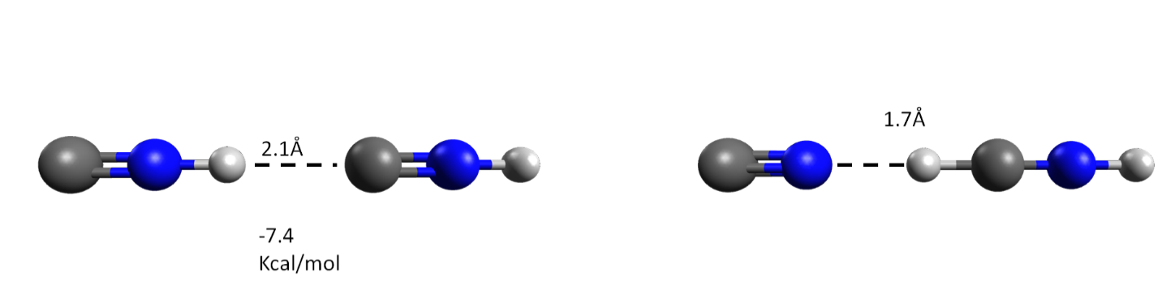

Figure : Left panel: neutral HNC dimer cluster. Right panel: ionized HNC dimer cluster.

The distance between the two units is 2. 1, which is slightly smaller than the distance in the HCN dimer, and the dipole moment of HNC is slightly larger than that for HCN (calculated as 3.07 D and 3.02 D for HNC and HCN, respectively). The calculated binding energy (BE) is –7.4 kcal/mol, which is larger than the value calculated for the HCN dimer (5.0 kcal/mol).26 The BE difference between HCN and HNC can be explained by the hydrogen bonds that are forming in the HNC case, which are stronger then the hydrogen bonds between the two HCN units.31

The right panel of Figure 1 shows the optimized cationic structure. We observed a distonic structure that was previously reported in the case of pure HCN clusters; the cationic structure obtained by ionization of HCN and HNC dimers is identical. However, critical differences were observed upon ionization of the larger clusters. We report the structures of neutral (trimer, tetramer, pentamer, and hexamer) HNC clusters in the supporting information (SI) (Figures SI1 and SI2). The trends in the neutral structures are similar to those observed in the HCN clusters. A comparison of the BE of the structures with those of previously studied pure HCN26 demonstrates that here the clusters bind more strongly due to stronger hydrogen bonds, as was demonstrated for the dimer case.

The previous study26 showed that upon ionization of pure trimer and tetramer HCN clusters, the products are either a distonic structure complexed to the remaining HCN units or a bonded ionic structure, C2N2H2+, complexed to the remaining HCN molecules. For the pentamer clusters, the same products were observed, except for the linear case, where the formation of the distonic structure was accompanied by isomerization of one of the HCN units to an HNC unit. Figure 2 presents the ionized structure of the HNC clusters. Similar trends can be observed here: We identify the formation of the distonic structure in addition to a bonded C2N2H2+ structure, albeit here the bond is formed between the two carbons. A major difference is observed for the HNC case in contrast to the HCN clusters. Unlike with the HCN cluster, here the formation of the distonic structure is accompanied by an isomerization $HNC→HCN$ process, even in the case of the trimer clusters; in general the isomerization processes are more frequent starting from ionized HNC clusters than ionized HCN clusters.

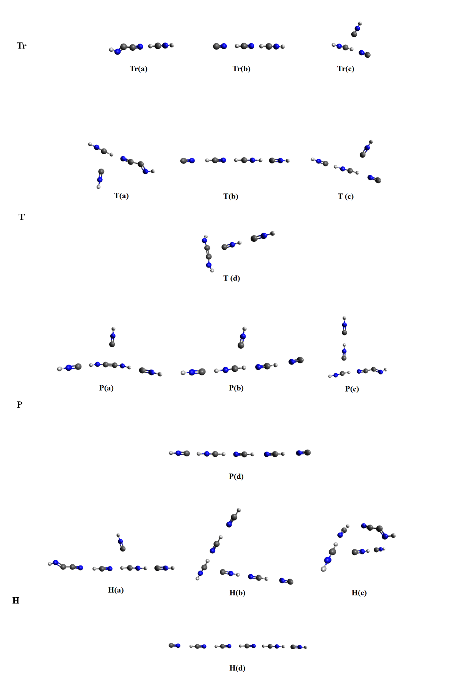

Figure : Optimized structure of trimer (Tr), tetramer (T), pentamer (P), and hexamer (H) clusters following ionization.

To understand why isomerization did not occur in the ionized HCN trimer clusters, we analyzed possible routes for the process to occur. We can hypothesize such an isomerization in the following route stated in equation 1. We started with a neutral trimer cluster that underwent ionization. In the first step, a proton can transfer to form the distonic product complexed to an HCN unit. In the second stage, a second proton transfer occurs during which isomerization takes place and results in a change in the location of HNCH+.

To study this route, we scanned the potential energy surface for the proton transitions (while the rest of the atoms in the system were frozen). The results are shown in Figure 3. We can see from the figure that there are barriers for the transitions of the protons. Evaluation of relative energies of the structures and the barrier for their formation requires full optimization.

Figure : Potential energy surface scan; at each stage only the positions of the proton have changed.

Figure 4 presents the fully optimized structures, with respect to the energy of the ionized linear trimer structure (Figure 4, structure 1). After ionization of the cluster, the distonic ion is formed and is complexed to an HCN unit (Figure 4, structure 3). This state corresponds to the minimum energy and the transition to it is barrierless, achieved directly from optimization of structure 1. To further demonstrate that the transition is barrierless, we performed an FSM calculation (see Figure S3 of the SI). During the transition from structure 1 to structure 3, structure 2 can be identified. For this structure to further stabilize, the CN rotates such that the nitrogen points toward the hydrogen of the [HNCH]+ structure. Structure 2 is only a minimum when we consider the system to be in a $C_{∞v}$ symmetry point group. Elevation of the symmetry constraint results in a direct barrierless transition into structure 3. To evaluate the energy of the hypothetical route suggested in equation 1, we calculated the additional structures (Figure 4, structures 3’ and 4).

Figure : Optimized structures. Structures shown in black (1 and 3) are minimum on the PES. Structures shown in dark gray (structure 2) were optimized under symmetry, and structures shown in light gray (3’ and 4) are not optimal structures on the full potential energy surface and were optimized under a constraint.

We were able to obtain structures 3’ and 4 only under constraint optimization. To obtain structure 3’ we applied the constraints that the distance between the hydrogen and the nitrogen of HCNH+ is fixed, and that the angle between the hydrogen on HNC and the CN molecule is 180° (to avoid rotation of the CN). To obtain structure 4 we applied the constraint that the distance between the hydrogen and the nitrogen of HCNH+ is fixed. In this hypothetical route, we observed barriers, and any lifting of this constraint will result in the system reverting to the true minimum, structure 3. It is thus clear why we do not observe any isomerization upon ionization of trimer clusters, that is, the system reverts to structure 3, as reported in the literature.26

Next, we examined ionized tetramer clusters. Results are shown in Figure 5. As in the case of the trimer structure, direct optimization of the cluster (Figure 5, structure 1) on the cationic structure results in an [+ structure (Figure 5, structure 3). Forcing the system to belong to the $C_{∞v}$ symmetry point group does not allow the CN group to rotate such that the nitrogen of the NC would point toward the hydrogen of [HNCH]+ as is the case in structure 3. As a result, the CN moves away from the rest of the cluster, as shown in Figure 5, structure 2. Despite the unfavorable orientation, CN departure was not observed in the trimer case (Figure 4, structure 2). We attribute this difference between the trimer and the larger clusters to the dipole moments. The CN total dipole is 1.46 D; for the trimer case it is complexed to HNCH+∙∙∙NCH, which has a total dipole of 3.48 D. Adding to HNCH+∙∙∙NCH, supplementary HCN units, as in the tetramer and pentamer clusters, significantly enlarge the dipole moment (calculated as 6.69 D for HNCH+∙∙∙NCH∙∙∙NCH and 15.72 D for HNCH+∙∙∙NCH∙∙∙NCH∙∙∙NCH), resulting in CN departure. Breaking the symmetry and reoptimizing the structure will lead back to structure 3.

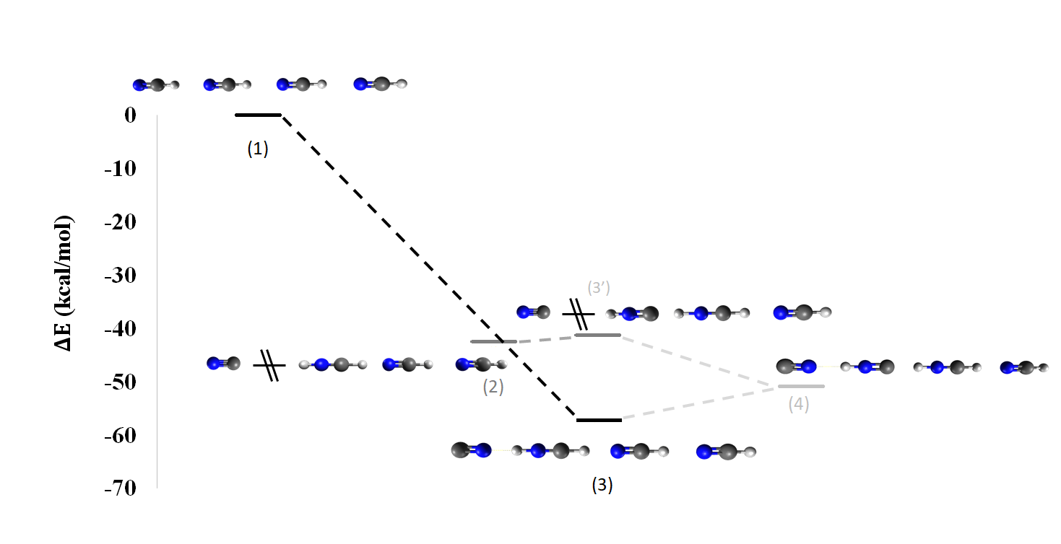

Figure : Optimized structures. Structures shown in black (1 and 3) are minimum on the PES. Structures shown in dark gray (structure 2) were optimized under symmetry, and structures marked in light gray (3’ and 4) are not optimal structures on the full potential energy surface and were optimized under constraint.

To obtain Figure 5, structure 4, we had to optimize under the constraint that the distance of the hydrogen and nitrogen in HNCH+ is fixed. As this structure is only obtained under constraint minimization, it is not a minimum on the PES, and for this cluster as well, isomerization process cannot take place.

In contrast to the trimer and tetramer results, we see that isomerization occurs in an ionized cluster containing five HCN units, as demonstrated in Figure 6. Optimization of the ionized cluster results in ${\left[HNC⋯HNCH⋯NCH⋯NCH\right]}^{+}$ (Figure 6, structure 2). A second minimum, in which an isomerization process did not take place, was also found (Figure 6, structure 3). The two minima are very close in energy, with structure 3 being 0.8 kcal/mol lower in energy.

In both structures (Figure 6, structures 2 and 3) the carbon atom in the CN radical is pointed towards an H atom (of either an HCNH molecule [structure 3] or an HNC molecule [structure 2]), and in both structures the CN radical departed from the cluster. The global minimum is achieved when the nitrogen atom of the CN radical is pointed towards the hydrogen of HCNH, as shown in Figure 6, structure 4.

Figure : Optimized structures. Structures shown in black (1 and 3) are minimum on the PES.

In order to understand why isomerization of the HCN can take place in the pentamer cluster but not in smaller clusters, we will look at the energy of the systems. The HCN isomer is lower in energy then the HNC isomer; however, due to the strong hydrogen bonds in the HNC clusters (as demonstrated above for the dimer case), additional stability is obtained, as is manifested in the BEs of the clusters.

To compare the different clusters, we removed the CN radical from the systems as it departs in clusters larger than trimer, and then compared the energies of the rest of the systems. Removal of the CN radical resulted in a system with a positive charge and a singlet multiplicity. The results are shown in Table 1

Table 1: Possible conformers obtained from the trimer, tetramer, and pentamer clusters after CN removal.

|  |  |  |  |
| --- | --- | --- | --- |
|  | Structure | Energy [Eh] | BE [kcal/mol] |
| Trimer | (1) HNCH+∙∙∙NCH | -187.169 | -23.3 |
| (2) HNCH+∙∙∙CNH | -187.149 | -23.7 |
| Tetramer | (3) HNC∙∙∙HNCH+∙∙∙NCH | -280.614 | -49.1 |
| (4) HNCH+∙∙∙NCH∙∙∙NCH | -280.615 | -36.2 |
| Pentamer | (5) HNC∙∙∙HNCH+∙∙∙NCH∙∙∙NCH | -374.056 | -60.0 |
| (6) HNCH+∙∙∙NCH∙∙∙NCH∙∙∙NCH | -374.055 | -46.0 |

We began by comparing two distinct possible conformers of the trimers; results are presented in Table 1. In both cases, the HNCH+ is complexed to either an HNC or HCN molecule.

Complex (2), which contains the HCN molecule, is lower in energy. However, the BE is larger when HNCH+ is complexed to HNC due to the stronger hydrogen bonds between the HNCH+ hydrogen and the carbon lone pair. Despite the stabilization added from the hydrogen bond, structure 1 is still lower in energy—by 12.55 kcal/mol.

For the tetramer clusters, we compered a cluster containing HCNH+ complexed to an HCN and to an additional molecule, either HCN or HNC. We observed a very small energetic preference (0.6 kcal/mol) towards complex (4), which contains two HCN molecules. The reason for this preference lies in the stronger hydrogen bonds, and can be seen from the BE. In case (3), where the HNCH+ is complexed to the HNC molecule, the BE is much larger (12.9 kcal/mol difference).

In the case of the pentamer clusters, HNCH+ is complexed to three HCN molecules (6), or two HCN molecules and one HNC molecule. In this instance, due to the strong hydrogen bonds in complex (5) (BE of 60 kcal/mol), it is lower in energy than complex (6), even though $HCN→HNC$ isomerization occurred. These trends explain why the isomerization process in the HCN ionized cluster were only observed for the pentamer clusters.

1. Growth of HNC clusters upon ionization.

We performed AIMD simulations to further analyze the processes that take place upon ionization of the clusters. As expected, according to the results presented above, isomerization processes are omnipresent in ionized HNC clusters. Figure 7 shows the number of $HNC→HCN$ isomerizations that took place during the trajectories (as seen at the end of the trajectory; this included both cases where growth occurred or did not occur) from different cluster sizes. In all instances, regardless of the cluster size, the majority of the trajectories resulted in the occurrence of at least one isomerization process. In most cases, we observed more than one isomerization process; for the trimer case, a single isomerization occurred in 52% of the cases; 48% of the time no isomerization occurred.

Figure 7: Number of isomerization processes observed at the end of the AIMD simulations in trimer, tetramer, pentamer, and hexamer clusters.

As demonstrated above, the stability of the complexes depends both on the isomers that are present and the hydrogen bond network. The isomerization that takes place is dictated by the balance between the stability of the isomers in the cluster and the stability of the cluster due to the hydrogen bonds, as demonstrated above.

For the linear clusters, we observed either *N-3* or *N-4* isomerizations ( $HNC→HCN$ transitions), where *N* is the number of molecules in the cluster. In accordance with the trends demonstrated above, protons are transferred to form a structure in which isomerization takes place until, at the edge of the cluster, we either have $HNC∙∙∙{HNCH}^{+}∙∙∙NCH∙∙∙$ or ${HNCH}^{+}∙∙∙NCH∙∙∙NCH∙∙∙$. After the formation of the structure, in the rest of the simulations the protons go back and forth between the above-mentioned structure:, and thus the number of isomerization is either *N-3* or *N-4*,depending on the point at which the simulation ended.

In addition to isomerization, growth processes were observed. Figure 8 presents the distribution of structures at the end of the trajectories for different cluster sizes. Except for the pentamer clusters, the majority of the trajectories resulted in proton transfer, forming the distonic ion discussed above (76%, 69%, 37%, and 47% for the trimer, tetramer, pentamer, and hexamer, respectively).

Figure : Distribution of structures at the end of the AIMD simulations for trimer, tetramer, pentamer, and hexamer clusters.

As we can see from Figure 8, the larger the cluster, the higher the tendency for the cluster to grow (34%, 41%, 63%, and 53% for the trimer, tetramer, pentamer, and hexamer, respectively), which is in agreement with previous studies.26, 32-34 The pentamer clusters seem to lean towards growth more than the hexamer clusters. This may be the result of the limited number of distinct clusters we used when modeling the neutral structures, and may indicate that we did not sample a sufficient number of starting structures, as the results of the trajectories are highly dependent on the initial structure. However, it is not the aim of this study to fully sample neutral clusters upon ionization, but rather to understand the possible routes and processes taking place in the clusters.

As in the case of the HCN clusters, here as well we observed growth mainly by forming a bond between two heavy atoms. We observed the formation of C2N2H2+and C2N2H•. The C2N2H molecule frequently formed in a cationic system by binding CN• with an HNC or HCN molecule. In a few instances, the formation occurred as a result of dimerization of HNC to form HNC-CNH+ followed by proton transfer.

The C2N2H2+ molecule was obtained from either C2N2H• followed by proton transfer or from dimerization, as shown above.

The last group, the occurrence of which was rare (1–2%), consists of the C3N3H3+ and C2N2H3+ molecules.

Formation of the C2N2H3+ molecule requires dimerization of two neutral HNC molecules, followed by proton transfer This scenario was observed only in the pentamer and hexamer clusters in 1% of the trajectories.

Figure 9: C3N3H3 structures obtained in the AIMD simulations, after optimization.

The formation of C3N3H3+ isomers, presented in Figure 9, occurred as a result of bonding between C2N2H2+ with either HCN or HNC molecules. We observed one trajectory in which C3N3H3+ formed within one step; in this case HNC+ bonded simultaneously to two other HNC units. Such molecules are not likely to form rings (such as triazine) since their longest chains may form five-membered rings at most. Under the conditions of the system, additional growth is not a likely scenario, due to the inability of the positive charged cation to form an additional bond.

Previous work studied growth upon ionization of HCN clusters.26 Some similarities can be found between HCN and HNC pure cluster systems. From the trajectories, we can learn that HNC+ may either bind to another HNC or, in turn, may initiate proton transfer with another HNC for HNCH+ and CN formation.

(2) $HNC^{+}+CNH→HNCCNH^{+}$

(3) $CNH^{+}+CNH→CN+HCNH^{+}$

These reactions compete and, as discussed earlier, the latter reaction occurs more often. Once HCNH+ is available, isomerization processes will occur, generating a mixed cluster or even clusters similar to ionized pure HCN clusters (complexed to additional HCNH+ and CN) in significant amounts, as demonstrated in Figure 7.

The major difference between the HCN and HNC clusters is the availability of HNC in the system. As shown previously, ionized HCN clusters are capable of isomerization to HNC if the cluster is large enough. Yet, such systems depend on the removal of the CN and specific intramolecular bonds enabling stability. In the case of ionized pure HNC clusters, isomerization processes occur frequently; however, the systems still contain HNC molecules as well. The mixed composition of the cluster is crucial for the formation of important products such as aminonitrile cation, NCCNH2+, which will be discussed in the next section.

1. Formation of DAMN molecule.

The growth of the HNC monomers is of great interest from an astrobiological point of view due to the abundance of HCN and HNC in the interstellar medium and the fact that they contain the three main elements needed for the formation of nucleobases. It has been suggested that HCN and CN• growth leads to the formation of DAMN, an important precursor to the formation of amino acids such as adenine under prebiotic conditions.27, 28, 35, 36 The suggested route formation for DAMN is via formamide and $CN^{}$ in high-energy chemistry,27 or pentamerization of HCN under different conditions.28

We suggest a simple route for the formation of aminonitrile cation based on our AIMD results.

We observed the formation of aminonitrile cation, presented in Figure 10 (although in <1% of the simulations). The possibility of binding two aminonitriles to receive the DAMN molecule in its cationic or neutral form is a promising route for DAMN formation.

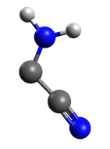

Figure 10: Aminonitrile cation obtained during the AIMD simulation, after optimization.

Interestingly, the formation of the DAMN cation (trans isomer, as seen in Figure 11(a)) from aminonitrile cation and neutral aminonitrile occurred directly upon optimization of the system, which indicates the formation is barrierless.

Optimization of two neutral aminonitriles also resulted in the formation of a DAMN molecule (cis isomer, as shown in Figure 11(b)). The fact that the DAMN molecule was formed upon optimization demonstrates that in the neutral case as well the reaction is barrierless, which makes it feasible in cold regions.

To further demonstrate that the transition is barrierless, we performed an FSM calculation (see Figures S5, S6 of the SI).

Thus, the formation of DAMN can be simply achieved via a direct combination of aminonitrile units, either cationic or neutral, without the need for a complex multistage mechanism.

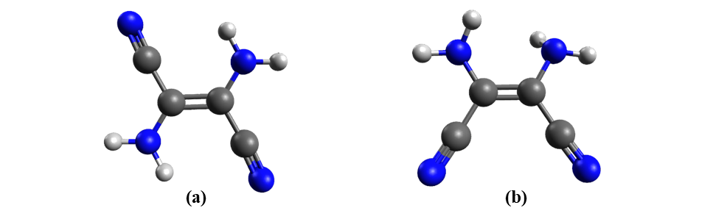

Figure 11: DAMN molecule: (a) trans DAMN, (b) cis DAMN.

# Conclusions

In this manuscript, we present processes that occur within pure HNC clusters upon ionization. We demonstrated that a large number of isomerization processes, can take place upon ionization of pure HNC clusters. We explain the reason why the reverse ionization cannot occur from small HCN clusters, and is observed only in the pentamer clusters. The stability of the clusters (either HCN or HNC) depends on the identity of the isomers (HCN or HNC; HCN isomer is lower in energy) and the hydrogen bonds that form in the clusters. These two factors will determine whether isomerization can occur. In the HCN pentamer cluster, the stability obtained from the hydrogen bonds enabled the isomerization $HCN→HNC$ to take place.

By means of AIMD, we demonstrated that, similar to the HCN clusters, ionization of HNC clusters results in the formation of distonic ion $HCNH^{+}+CN^{}$ or in growth that results from the bond between the two units. Among the structures formed is aminonitrile, which we show can form the DAMN molecule barrierlessly. This is significant from an astrobiological point of view as the DAMN molecule is a major precursor for nucleobase formation.

# **Acknowledgements**

This research was funded by the Israel Science Foundation, grant number 1941/20.

# **References**

1. Liszt, H.; Lucas, R., Comparative chemistry of diffuse clouds. *A&A* **2001,** *370* (2), 576-585.

2. Turner, B. E.; Pirogov, L.; Minh, Y. C., The Physics and Chemistry of Small Translucent Molecular Clouds. VIII. HCN and HNC. *The Astrophysical Journal* **1997,** *483* (1), 235-261.

3. Pratap, P.; Dickens, J. E.; Snell, R. L.; Miralles, M. P.; Bergin, E. A.; Irvine, W. M.; Schloerb, F. P., A Study of the Physics and Chemistry of TMC‐1. *The Astrophysical Journal* **1997,** *486* (2), 862-885.

4. Hirota, T.; Yamamoto, S.; Mikami, H.; Ohishi, M., Abundances of HCN and HNC in Dark Cloud Cores. *The Astrophysical Journal* **1998,** *503* (2), 717-728.

5. Graninger, D.; Öberg, K. I.; Qi, C.; Kastner, J., HNC IN PROTOPLANETARY DISKS. *The Astrophysical Journal* **2015,** *807* (1), L15.

6. Jin, M.; Lee, J.-E.; Kim, K.-T., THE HCN/HNC ABUNDANCE RATIO TOWARD DIFFERENT EVOLUTIONARY PHASES OF MASSIVE STAR FORMATION. *The Astrophysical Journal Supplement Series* **2015,** *219* (1), 2.

7. Graninger, D. M.; Herbst, E.; Öberg, K. I.; Vasyunin, A. I., THE HNC/HCN RATIO IN STAR-FORMING REGIONS. *The Astrophysical Journal* **2014,** *787* (1), 74.

8. Aalto, S.; Garcia-Burillo, S.; Muller, S.; Winters, J. M.; van der Werf, P.; Henkel, C.; Costagliola, F.; Neri, R., Detection of HCN, HCO+, and HNC in the Mrk 231 molecular outflow⋆. *A&A* **2012,** *537*, A44.

9. Gao, Y.; Solomon, P. M., HCN Survey of Normal Spiral, Infrared‐luminous, and Ultraluminous Galaxies. *The Astrophysical Journal Supplement Series* **2004,** *152* (1), 63-80.

10. Guélin, M.; Salomé, P.; Neri, R.; García-Burillo, S.; Graciá-Carpio, J.; Cernicharo, J.; Cox, P.; Planesas, P.; Solomon, P. M.; Tacconi, L. J.; Vanden Bout, P., Detection of HNC and tentative detection of CN at z = 3.9. *A&A* **2007,** *462* (3), L45-L48.

11. Lis, D. C.; Bockelée‐Morvan, D.; Boissier, J.; Crovisier, J.; Biver, N.; Charnley, S. B., Hydrogen Isocyanide in Comet 73P/Schwassmann‐Wachmann (Fragment B). *The Astrophysical Journal* **2008,** *675* (1), 931-936.

12. Moreno, R.; Lellouch, E.; Lara, L. M.; Courtin, R.; Bockelée-Morvan, D.; Hartogh, P.; Rengel, M.; Biver, N.; Banaszkiewicz, M.; González, A., First detection of hydrogen isocyanide (HNC) in Titan’s atmosphere. *A&A* **2011,** *536*, L12.

13. Hacar, A.; Bosman, A. D.; van Dishoeck, E. F., HCN-to-HNC intensity ratio: a new chemical thermometer for the molecular ISM★★★. *A&A* **2020,** *635*, A4.

14. Danger, G.; Borget, F.; Chomat, M.; Duvernay, F.; Theulé, P.; Guillemin, J.-C.; Le Sergeant d’Hendecourt, L.; Chiavassa, T., Experimental investigation of aminoacetonitrile formation through the Strecker synthesis in astrophysical-like conditions: reactivity of methanimine (CH2NH), ammonia (NH3), and hydrogen cyanide (HCN). *A&A* **2011,** *535*, A47.

15. Hamid, A. M.; Bera, P. P.; Lee, T. J.; Aziz, S. G.; Alyoubi, A. O.; El-Shall, M. S., Evidence for the Formation of Pyrimidine Cations from the Sequential Reactions of Hydrogen Cyanide with the Acetylene Radical Cation. *The Journal of Physical Chemistry Letters* **2014,** *5* (19), 3392-3398.

16. Mechanisms of Prebiotic Adenine Synthesis from HCN by Oligomerization in the Gas Phase. *Astrobiology* **2013,** *13* (5), 465-475.

17. OrÓ, J., Mechanism of Synthesis of Adenine from Hydrogen Cyanide under Possible Primitive Earth Conditions. *Nature* **1961,** *191* (4794), 1193-1194.

18. Adenine Synthesis in Interstellar Space: Mechanisms of Prebiotic Pyrimidine-Ring Formation of Monocyclic HCN-Pentamers. *Astrobiology* **2007,** *7* (3), 455-470.

19. Bowman, J. M.; Gazdy, B., A New Perspective on Isomerization Dynamics Illustrated by HCN → HNC. *The Journal of Physical Chemistry A* **1997,** *101* (36), 6384-6388.

20. Gardebien, F.; Sevin, A., Catalytic Model Reactions for the HCN Isomerization. I. Theoretical Characterization of Some Water-Catalyzed Mechanisms. *The Journal of Physical Chemistry A* **2003,** *107* (19), 3925-3934.

21. Koch, D. M.; Toubin, C.; Xu, S.; Peslherbe, G. H.; Hynes, J. T., Concerted Proton-Transfer Mechanism and Solvation Effects in the HNC/HCN Isomerization on the Surface of Icy Grain Mantles in the Interstellar Medium. *The Journal of Physical Chemistry C* **2007,** *111* (41), 15026-15033.

22. Gutiérrez-Oliva, S.; Díaz, S.; Toro-Labbé, A.; Lane, P.; Murray, J. S.; Politzer, P., Revisiting the seemingly straightforward hydrogen cyanide/hydrogen isocyanide isomerisation. *Molecular Physics* **2014,** *112* (3-4), 349-354.

23. Barger, T.; Wodtke, A. M.; Bowman, J. M., Radiative Relaxation and Isomeric Branching of Highly Excited H/C/N: The Importance of Delocalized Vibrational States. *The Astrophysical Journal* **2003,** *587* (2), 841-846.

24. Herbst, E., What are the products of polyatomic ion-electron dissociative recombination reactions? *The Astrophysical Journal* **1978,** *222*, 508.

25. Cotton, C. E.; Francisco, J. S.; Klemperer, W., Computational study of the linear proton bound ion–molecule complexes of HCNH+ with HCN and HNC. *The Journal of Chemical Physics* **2013,** *139* (1), 014304.

26. Stein, T.; Bera, P. P.; Lee, T. J.; Head-Gordon, M., Molecular growth upon ionization of van der Waals clusters containing HCCH and HCN is a pathway to prebiotic molecules. *Physical Chemistry Chemical Physics* **2020,** *22* (36), 20337-20348.

27. Ferus, M.; Nesvorný, D.; Šponer, J.; Kubelík, P.; Michalčíková, R.; Shestivská, V.; Šponer, J. E.; Civiš, S., High-energy chemistry of formamide: A unified mechanism of nucleobase formation. *Proceedings of the National Academy of Sciences* **2015,** *112* (3), 657.

28. Glaser, R.; Hodgen, B.; Farrelly, D.; McKee, E., Adenine Synthesis in Interstellar Space: Mechanisms of Prebiotic Pyrimidine-Ring Formation of Monocyclic HCN-Pentamers. *Astrobiology* **2007,** *7* (3), 455-470.

29. Shao, Y.; Gan, Z.; Epifanovsky, E.; Gilbert, A. T. B.; Wormit, M.; Kussmann, J.; Lange, A. W.; Behn, A.; Deng, J.; Feng, X.; Ghosh, D.; Goldey, M.; Horn, P. R.; Jacobson, L. D.; Kaliman, I.; Khaliullin, R. Z.; Kuś, T.; Landau, A.; Liu, J.; Proynov, E. I.; Rhee, Y. M.; Richard, R. M.; Rohrdanz, M. A.; Steele, R. P.; Sundstrom, E. J.; Woodcock, H. L.; Zimmerman, P. M.; Zuev, D.; Albrecht, B.; Alguire, E.; Austin, B.; Beran, G. J. O.; Bernard, Y. A.; Berquist, E.; Brandhorst, K.; Bravaya, K. B.; Brown, S. T.; Casanova, D.; Chang, C.-M.; Chen, Y.; Chien, S. H.; Closser, K. D.; Crittenden, D. L.; Diedenhofen, M.; DiStasio, R. A.; Do, H.; Dutoi, A. D.; Edgar, R. G.; Fatehi, S.; Fusti-Molnar, L.; Ghysels, A.; Golubeva-Zadorozhnaya, A.; Gomes, J.; Hanson-Heine, M. W. D.; Harbach, P. H. P.; Hauser, A. W.; Hohenstein, E. G.; Holden, Z. C.; Jagau, T.-C.; Ji, H.; Kaduk, B.; Khistyaev, K.; Kim, J.; Kim, J.; King, R. A.; Klunzinger, P.; Kosenkov, D.; Kowalczyk, T.; Krauter, C. M.; Lao, K. U.; Laurent, A. D.; Lawler, K. V.; Levchenko, S. V.; Lin, C. Y.; Liu, F.; Livshits, E.; Lochan, R. C.; Luenser, A.; Manohar, P.; Manzer, S. F.; Mao, S.-P.; Mardirossian, N.; Marenich, A. V.; Maurer, S. A.; Mayhall, N. J.; Neuscamman, E.; Oana, C. M.; Olivares-Amaya, R.; O’Neill, D. P.; Parkhill, J. A.; Perrine, T. M.; Peverati, R.; Prociuk, A.; Rehn, D. R.; Rosta, E.; Russ, N. J.; Sharada, S. M.; Sharma, S.; Small, D. W.; Sodt, A.; Stein, T.; Stück, D.; Su, Y.-C.; Thom, A. J. W.; Tsuchimochi, T.; Vanovschi, V.; Vogt, L.; Vydrov, O.; Wang, T.; Watson, M. A.; Wenzel, J.; White, A.; Williams, C. F.; Yang, J.; Yeganeh, S.; Yost, S. R.; You, Z.-Q.; Zhang, I. Y.; Zhang, X.; Zhao, Y.; Brooks, B. R.; Chan, G. K. L.; Chipman, D. M.; Cramer, C. J.; Goddard, W. A.; Gordon, M. S.; Hehre, W. J.; Klamt, A.; Schaefer, H. F.; Schmidt, M. W.; Sherrill, C. D.; Truhlar, D. G.; Warshel, A.; Xu, X.; Aspuru-Guzik, A.; Baer, R.; Bell, A. T.; Besley, N. A.; Chai, J.-D.; Dreuw, A.; Dunietz, B. D.; Furlani, T. R.; Gwaltney, S. R.; Hsu, C.-P.; Jung, Y.; Kong, J.; Lambrecht, D. S.; Liang, W.; Ochsenfeld, C.; Rassolov, V. A.; Slipchenko, L. V.; Subotnik, J. E.; Van Voorhis, T.; Herbert, J. M.; Krylov, A. I.; Gill, P. M. W.; Head-Gordon, M., Advances in molecular quantum chemistry contained in the Q-Chem 4 program package. *Molecular Physics* **2015,** *113* (2), 184-215.

30. Mardirossian, N.; Head-Gordon, M., [small omega]B97X-V: A 10-parameter, range-separated hybrid, generalized gradient approximation density functional with nonlocal correlation, designed by a survival-of-the-fittest strategy. *Physical Chemistry Chemical Physics* **2014,** *16* (21), 9904-9924.

31. Bautista-Renedo, Joanatan M.; Reyes-Pérez, H.; Cuevas-Yáñez, E.; Barrera-Díaz, C.; González-Rivas, N.; Ireta, J., Hydrogen bonding capabilities of group 14 homologues of HCN and HNC. *RSC Advances* **2019,** *9* (11), 5937-5941.

32. Stein, T.; Bandyopadhyay, B.; Troy, T. P.; Fang, Y.; Kostko, O.; Ahmed, M.; Head-Gordon, M., Ab initio dynamics and photoionization mass spectrometry reveal ion-molecule pathways from ionized acetylene clusters to benzene cation. *Proc Natl Acad Sci U S A* **2017,** *114* (21), E4125-E4133.

33. Stein, T.; Jose, J., Molecular Formation upon Ionization of van der Waals Clusters and Implication to Astrochemistry. *Israel Journal of Chemistry* **2020,** *60*, 1-9.

34. Jose, J.; Zamir, A.; Stein, T., Molecular dynamics reveals formation path of benzonitrile and other molecules in conditions relevant to the interstellar medium. *Proceedings of the National Academy of Sciences* **2021,** *118* (19), e2101371118.

35. Hudson, J. S.; Eberle, J. F.; Vachhani, R. H.; Rogers, L. C.; Wade, J. H.; Krishnamurthy, R.; Springsteen, G., A Unified Mechanism for Abiotic Adenine and Purine Synthesis in Formamide. *Angewandte Chemie International Edition* **2012,** *51* (21), 5134-5137.

36. Jeilani, Y. A.; Williams, P. N.; Walton, S.; Nguyen, M. T., Unified reaction pathways for the prebiotic formation of RNA and DNA nucleobases. *Physical Chemistry Chemical Physics* **2016,** *18* (30), 20177-20188.