**Optical Changes in a Patient with a Subtle Peripheral Unilateral Lens Coloboma**

Elishai Assayag MD, David Zadok MD, David Smadja MD, Eduardo Roditi MD, Yishay Weill MD

Department of Ophthalmology, Shaare Zedek Medical Center, Jerusalem, Israel, affiliated to the Hebrew University, Jerusalem, Israel

**Word count:** 982

**Corresponding author:** Elishai Assayag MD, Department of Ophthalmology, Shaare Zedek Medical Center, Shmuel Bait St 12, Jerusalem, Israel, 9103102. Telephone: +972-2-6555246.

E-mail: elishai.assayag@gmail.com

**Conflicts of interest:** All authors declare they have no conflicts of interest to disclose.

**Funding:** This work received no funding.

**Informed consent:** Informed consent was waived because no identifiable information is presented in the report.

**Key Words:** Lens coloboma; emmetropization; advanced wavefront aberrometer; corneal astigmatism

# Abstract

PURPOSE: To describe the optical changes caused by a subtle, peripheral isolated lens coloboma and their possible impact on emmetropization.

METHODS: We report the case of a 20-year-old man who was referred for evaluation with an amblyopic right eye, and describe his clinical examination and work-up.

RESULTS: Manifest refraction was −2.25+3.00 × 35° and −0.25+0.25 × 120° and corrected distance visual acuity was 20/50 and 20/20 in the right and left eye, respectively. Corneal tomography demonstrated regular astigmatism of +2.46 diopters (D) at 124° in the right eye and +0.55 D at 93° in the left eye. Wavefront aberrometry revealed an irregular internal astigmatism of +6.27 D at 35° in the right eye. After full pupillary dilation only, a subtle peripheral lens coloboma was observed in the right eye.

CONCLUSION: Even minor lens colobomata can lead to amblyopia if left untreated. Developmental ipsilateral corneal alterations may occur to compensate for lens deformities.

# Introduction

Lens coloboma (plural: *colobomata*( is a developmental defect resulting from abnormalities of the zonules and ciliary body. It may present as an isolated pathology or be accompanied by anomalies in different ocular structures.1 The extent and location of the lens distortion can vary from large colobomata that involve the visual axis to small and peripheral deformities located beyond the physiologic pupil margin.2 Large defects may cause significant refractive disturbances, anisometropia, and amblyopia.3

Nowadays, advanced wavefront aberrometers facilitate a better understanding of the contribution of each component to the eye’s optical system and assist the evaluation process of different ocular entities.4 Here, we report a unique case of a peripheral isolated lens coloboma, its effect on the visual quality as measured with internal wavefront aberrometry, and its possible developmental impact on emmetropization.

# Case Report

A 20-year-old man who was known to suffer from amblyopia of unknown cause in his right eye was referred for evaluation. Systemic disease, use of medications, past ocular trauma, and relevant family history were ruled out. Uncorrected distance visual acuity on presentation was 20/60 and 20/20 in the right and left eye, respectively. Manifest refraction was −2.25+3.00 × 35° in the right eye and −0.25+0.25 × 120° in the left eye. Right eye corrected distance visual acuity was 20/50 and did not improve with pinhole. Slit lamp biomicroscopy, before the administration of pupillary dilating drops, was unremarkable.

Corneal tomography was performed (GALILEI G6, Ziemer, Port, Switzerland) showing regular astigmatism of +2.46 diopters (D) at 124° and +0.55 D at 93° in the right and left eye, respectively (Figure 1A, 1B). Owing to the marked discrepancy of the astigmatism axis between the patient’s corneal tomography and manifest refraction in the right eye, an advanced wavefront aberrometer (OPD-Scan-III, NIDEK, Gamagori, Japan) was used. Internal refraction revealed an irregular lenticular astigmatism of +6.27 D at 35° in the right eye and +0.13 D at 17° in the left eye (Figure 1C, 1D).

Slit lamp biomicroscopy was completed after pharmacologic pupillary dilation. When the pupils were fully dilated (10 mm), a subtle, peripheral, superonasal lens coloboma of two clock hours was evident on retro-illumination in the right eye (Figure 1E), corresponding to the steep axis of the measured lenticular astigmatism. The lens itself was clear and centrally positioned, with no signs of phacodonesis (Figure 1F). Posterior segment evaluation was completed by fundus biomicroscopy, with no other pathological findings in either eye.

# Discussion

Ocular coloboma refers mainly to embryologic absence of tissue in any structure of the eye. Coloboma of the lens is a misnomer because there is no genuine deficiency of lenticular tissue but rather a zonular developmental defect that occurs in the first few weeks of fetal life and changes the shape and hence the power of the lens at the equator.1 Previous studies have shown that anisometropia and amblyopia are occasionally evident, with high lenticular astigmatism being a major contributing factor.3

In cases of an isolated lens coloboma, early diagnosis and surgical management may improve long-term visual outcomes.3 However, most studies have described the diagnosis and management of large, isolated colobomata with cataractous changes and/or subluxated lenses. Detection and management of isolated, small, and peripheral lens indentations can be challenging. To the best of our knowledge, the optical changes caused by an isolated lens coloboma, which clinically does not involve the visual axis, and its impact on the visual quality have not been previously reported.

In this case, we have demonstrated that a subtle, peripheral, and isolated lens coloboma can account for significant optical changes and reduced visual acuity, even if clinically the coloboma margins do not involve the visual axis and the lens is clear and well positioned. It is most probable that these changes have caused our patient to develop amblyopia, which theoretically could have been prevented, at least partially, by early detection and surgical repair, as previously described in a case of a far more extensive lens coloboma.5 Nevertheless, the expected visual and refractive benefits in such cases must be weighed against potential complications of cataract surgery in pediatric patients.6

Unlike the cornea of the uninvolved left eye, the right cornea exhibited high astigmatism (2.50 D). Interestingly, the axes of the corneal and lenticular astigmatisms of the right eye were perfectly perpendicular to each other, as if the cornea underwent a compensating process for the congenital lens anomaly. The process of human emmetropization is not completely understood and is probably mainly influenced by axial length modulations in early life.7 It is also known that corneal and lenticular aberrations are constantly balanced by the eye, as a part of this process. Natural or artificial ocular changes such as accommodation, aging, cataract surgery, and refractive surgery may disrupt this balance.8 Children with unilateral congenital cataract have been shown to have significantly higher corneal astigmatism in the cataractous eye than in the healthy eye.9 Similar findings were observed in a cohort of 400 congenital cataract patients, where unilateral cataract was significantly associated with higher corneal astigmatism, central corneal thickness, and anterior chamber depth compared with the fellow eye.10 We postulate that in this case, the observed asymmetric corneal astigmatism in the involved eye, which was perfectly perpendicular to the induced astigmatism of the lens coloboma, may not be a mere coincidence but rather a developmental attempt to compensation for the high internal astigmatism caused by the lens coloboma.

In conclusion, even subtle, peripheral, and isolated colobomata of clear and non-subluxated lenses can have an extensive influence on the visual quality and, if left untreated, can be a cause of refractive amblyopia. Diagnosis of such abnormalities can sometimes be difficult, but when diagnosed they must not be underestimated. Advanced wavefront aberrometers may be helpful in detection and evaluation of the optical changes in such eyes. Lastly, it is possible that ipsilateral corneal changes develop in response to lens colobomata in order to achieve emmetropization; this hypothesis needs to be further evaluated.

# References

1. Onwochei BC, Simon JW, Bateman JB, Couture KC, Mir E. Ocular colobomata. *Surv Ophthalmol*. 2000;45(3):175-194. doi:10.1016/S0039-6257(00)00151-X.

2. Bavbek T, Ōgūt MS, Kazokoglu H. Congenital lens coloboma and associated pathologies. *Doc Ophthalmol*. 1993;83:313-322.

3. Gurler B, Coskun E, Okumus S, Pinero DP, Ozcan E, Erbagci I. Surgical outcomes of isolated lens coloboma with or without cataract among young adults. *Can J Ophthalmol*. 2014;49(2):145-151. doi:10.1016/j.jcjo.2013.12.004.

4. Gatinel D, Hoang-Xuan T. Measurement of combined corneal, internal, and total ocular optical quality analysis in anterior segment pathology with the OPD-Scan and OPD-Station. *J Refract Surg*. 2006;22(9 SUPPL.). doi:10.3928/1081-597x-20061102-01.

5. Singh S, Yangzes S, Gupta R, Ram J. Surgical technique for management of isolated lenticular coloboma with high corneal astigmatism. *Indian J Ophthalmol*. 2018;66(4):562-564. doi:10.4103/ijo.IJO_1026_17.

6. Nordlund ML, Sugar A, Moroi SE. Phacoemulsification and intraocular lens placement in eyes with cataract and congenital coloboma: Visual acuity and complications. *J Cataract Refract Surg*. 2000;26(7):1035-1040. doi:10.1016/S0886-3350(00)00433-8.

7. Mutti DO, Mitchell GL, Jones LA, et al. Axial growth and changes in lenticular and corneal power during emmetropization in infants. *Investig Ophthalmol Vis Sci*. 2005;46(9):3074-3080. doi:10.1167/iovs.04-1040.

8. Tabernero J, Berrio E, Artal P. Modeling the mechanism of compensation of aberrations in the human eye for accommodation and aging. *J Opt Soc Am A*. 2011;28(9):1889. doi:10.1364/josaa.28.001889.

9. Watanabe T, Matsuki N, Yaginuma S, Nagamoto T. Corneal astigmatism in children with congenital cataract. *Nihon Ganka Gakkai Zasshi*. 2014;118(2):98-103.

10. Lin D, Chen J, Liu Z, et al. Prevalence of corneal astigmatism and anterior segmental biometry characteristics before surgery in Chinese congenital cataract patients. *Sci Rep*. 2016;6(December 2015):1-9. doi:10.1038/srep22092.

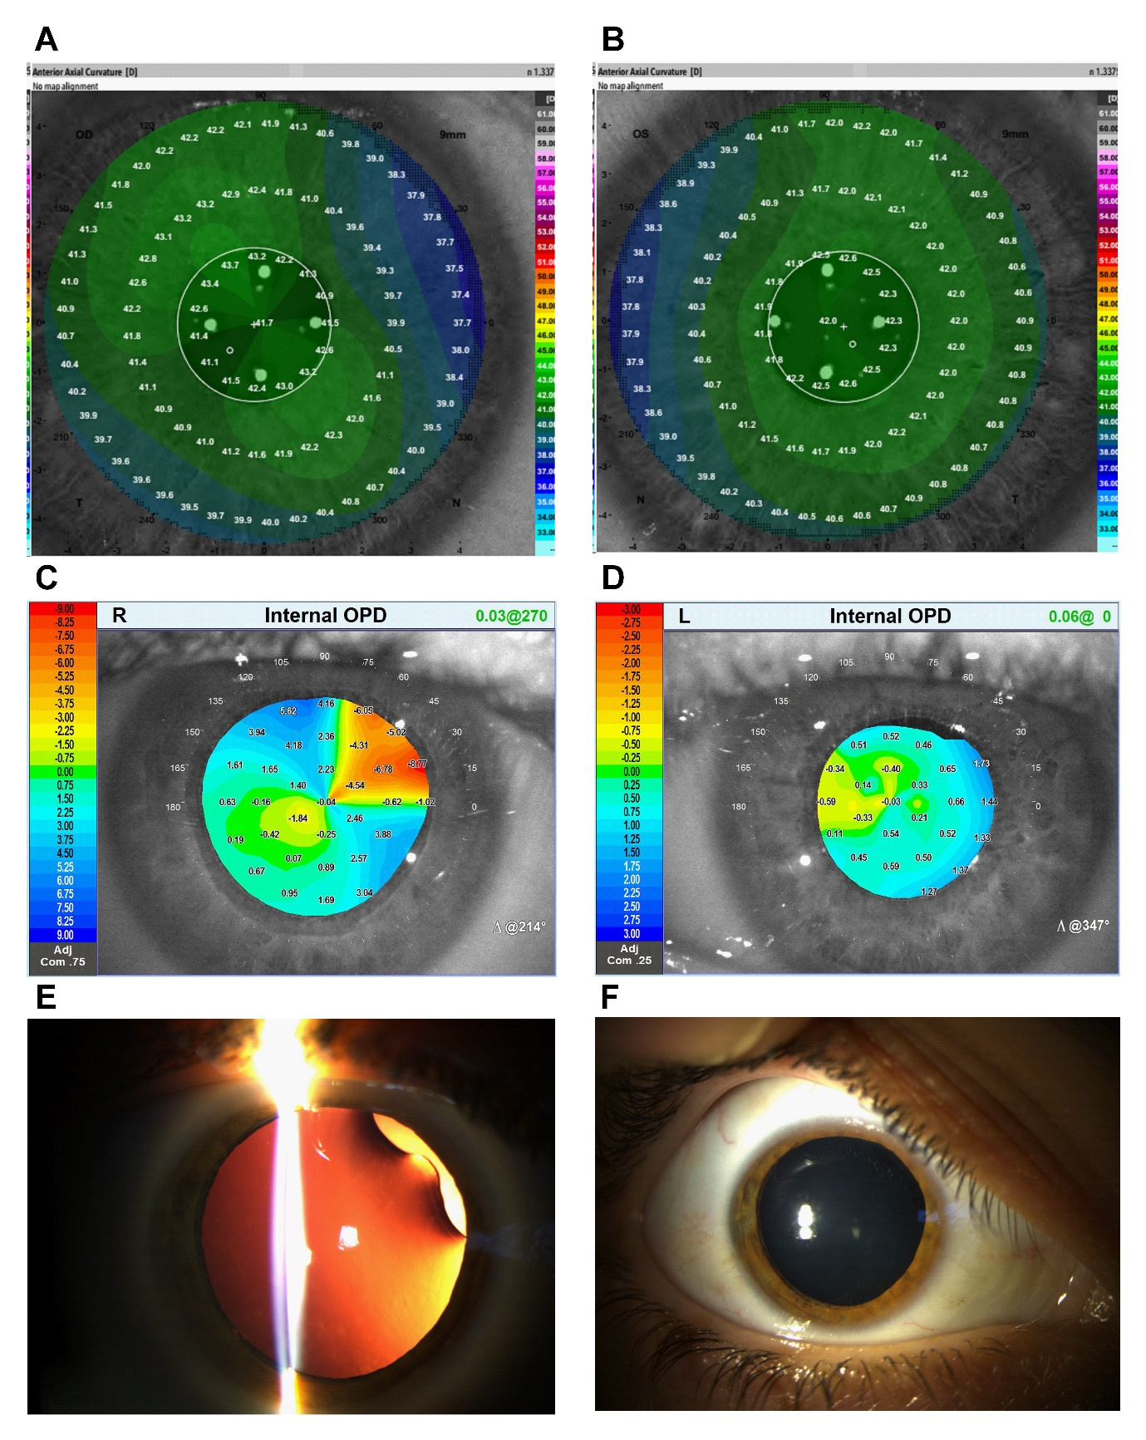**Figure 1. Optical Changes Caused by a Subtle Isolated Unilateral Lens Coloboma**

Anterior axial curvature maps of the right (A) and left (B) corneas showed regular astigmatism of +2.46 diopters at 124° and +0.55 diopters at 93°, respectively. Internal aberrometry of the right (C) and left (D) eyes revealed an irregular lenticular astigmatism of +6.27 diopters at 35° and +0.13 diopters at 17°, respectively. A subtle, superonasal, isolated lens coloboma was noticed in slit lamp biomicroscopy of the right eye only with retro-illumination (E), while the lens itself appeared clear and well-positioned (E, F).