**Efficacy of Topical Treatment with Hyaluronate without Preservatives, Trehalose, and Steroids in the Management of Ocular Surface Disease Affecting Patients Under Treatment with Glaucoma Medications**

Luz A. Giorgi-Sandoval,1,2 José A. Paczka,2,3,4 Miguel A. Ibáñez-Sandoval,5 Carlos D. Ortiz-Moreno,1,2 Fabiola M. Guerrero-Cuevas,1,2 Luz A. Paczka-Giorgi6

1Research Department, Clínica para el Ojo Seco, Guadalajara, Jalisco, Mexico.

2Research & Development, Unidad de Diagnóstico Temprano del Glaucoma, Guadalajara, Jalisco, Mexico.

3Instituto de Oftalmología y Ciencias Visuales, Universidad de Guadalajara, Guadalajara, Jalisco, Mexico.

4Asistencia e Investigación en Glaucoma, Guadalajara, Jalisco, Mexico.

5School of Medicine, Universidad Guadalajara LAMAR, Guadalajara, Jal., México.

6Research Department, Telemedicine LATAM, Toronto, ON, Canada.

Correspondence should be addressed to: Dr. Luz A. Giorgi-Sandoval; dra.lags@gmail.com

**Abstract**

Aim: To study the efficacy of mixed topical regimens with hyaluronate, trehalose, and steroidal anti-inflammatory drugs in the treatment of intense ocular surface disease (OSD) in patients under topical antiglaucoma agents. Methods: A retrospective evaluation was conducted of 7415 medical records of consecutive patients visiting a glaucoma center throughout a 2-year period. The analysis included cases with complete information for patients under preserved topical antiglaucoma treatment who were diagnosed with ocular surface disease (OSD), the severity of which was determined using the OSD Index (OSDI) score. Variables investigated were signs and symptoms related to OSD and the type and duration of topical treatment. The efficacy of two mixed-treatment regimens containing a tear substitute without preservatives and a topical steroid were compared in patients with moderate/severe OSD. Treatments differed in the administration of trehalose (T+) or not (T-). Results: Of 5158 cases under topical antiglaucoma treatment, 2634 (51.06%) showed some signs of OSD, with 725 cases showing moderate/severe OSD. Of these 725 cases, 396 and 329 cases were placed in the T+ and T- groups, respectively. In the T+ group, a global clinical improvement of 76.47% (299/391) was found, versus 58.38% (188/322; *p* = 0.024) in the T- group. The outcome variables (OSDI, TRL, and corneal fluorescein staining) improved significantly in both groups between their initial and final visits (at least two months apart). The mean of these variables was significantly better in the T+ group during the final visit (*p* ≤ 0.01). Conclusion: An improvement in OSD variables associated with antiglaucoma drugs was observed, particularly in the group that used trehalose. Therefore, this agent should be considered for routine use in patients with OSD, especially for cases of moderate to severe intensity; it is most useful when associated with non-preserved artificial tears and topical steroids.

**Keywords**

Glaucoma, hyaluronate, ocular surface disease, preservatives, steroids, trehalose.

**Introduction**

Glaucoma continues to be one of the main causes of blindness in the world (1-5), mainly due to its silent nature and consequent late diagnosis. Although there are multiple treatments available to control the disease (6,7), medical treatment to reduce intraocular pressure (IOP) has been shown to be effective in slowing or even stopping the progression of the disease (6-9). However, therapeutic modalities can also cause significant side effects (10,11), such as ocular surface disease (OSD) (12). In fact, the ocular surface has been widely studied as an area of interest for various deleterious effects induced by most of the pharmacological interventions used to reduce IOP (12). Research has shown that chemical preservatives in antiglaucoma drugs may be linked to the development of OSD (13-15). Consequently, this condition can induce important changes at the cellular and clinical levels, frequently affecting the intensity of the disease (16-20). Since OSD symptoms can also have an impact on a patient’s quality of life (21- 23), treatment is aimed not only at improving symptoms in the most efficient way possible but also at making changes toward the use of more appropriate antiglaucoma drugs (24,25) and treating other underlying conditions that can cause or exacerbate inflammation (12,26). To treat OSD associated with the use of ocular hypotensive drugs, patients may migrate to medications without preservatives (12); increase the use of artificial tears without preservatives (27); use topical steroids (28) or other agents that have different applications, such as immunomodulators (29,30); or use substances that act as restoratives of the ocular surface, such as the glucose-reducing disaccharide, trehalose (31-35).

The aim of this study was to investigate the efficacy of using mixed topical regimens with hyaluronate (as artificial tears), trehalose, and steroidal anti-inflammatory drugs to treat higher intensity OSD among glaucoma patients under topical ocular hypotensive treatment.

**Materials and Methods**

A detailed retrospective evaluation of clinical information obtained from the electronic medical records of all patients (n = 7415) who visited a specialized glaucoma center in western Mexico during a two-year period (from January 2018 to December 2019) was carried out. This study had ethics approval from the local Institutional Review Board and was conducted in accordance with the Declaration of Helsinki. The cases included were identified as having OSD based on the presence of at least two out of six clinical signs, as well as at least one of four OSD symptoms, and/or their Ocular Surface Disease Index (OSDI) score was greater than 12 (Table 1). Subsequently, the severity of each case was determined according to their OSDI result (36). Furthermore, the records of these cases had complete and consistent information and were from patients who used topical antiglaucoma drugs in both eyes (n = 5158). Cases were excluded (n = 2257) if they were glaucoma cases who had undergone surgical treatment in which hypotensive eye drops were not applied, if their record lacked complete information, or if they had a concomitant special surface condition (e.g., chemical burns, pemphigoid reactions, recent use of topical steroids in relation to the time of identification of OSD).

The variables investigated included ocular surface data (corneal or conjunctival staining with fluorescein), tear breakup time (TBUT), OSDI score, modified type 2 Schirmer test (using topical anesthetic before placing a paper strip), and the presence of meibomian gland dysfunction, as well as the type and duration of topical treatment (either related to glaucoma or any other type of topical treatment). The retrospective evaluation of all cases was carried out by two of the investigators (MAIS, LAPG). If a clinical situation was identified that was difficult to interpret, the most experienced researchers (LAGS, JAP) clarified the interpretation.

The data were stored in an electronic database (Excel, Microsoft; Redmond, WA, U.S.A.) and analyzed using the biostatistical program MedCalc (version 19.3; MedCalc Software Ltd; Belgium). Demographic variables, OSDI score, TBUT, and fluorescein staining were compared between the two treatment groups that included artificial tears (at least one of them hyaluronate without preservatives, for at least two months), topical steroids (for at least 5 days), and the presence of trehalose (T+) for at least two months. In the “T- group”, trehalose was never used. Continuous variables were analyzed using the Student’s *t*-test, while categorical variables were analyzed using the chi-square test and Fisher’s exact test. All statistical tests were two-tailed, and a *p*-value <0.05 was considered statistically significant.

**Results**

A total of 2634 cases had OSD, of which 725 (27.5%) were classified as moderate to severe OSD. Cases with mild OSD were significantly younger and comprised more males than the group with moderate/severe OSD (Table 2). The number of medications used and the application time were significantly different between those who had mild OSD and moderate/severe OSD.

In the mild OSD group, the use of artificial tears was identified in 97.5% (n = 1861), topical steroids in 12.47% (n = 238), and trehalose in 15.03% (n = 287) of cases. In the moderate/severe OSD group (Table 3), all cases were treated with at least one type of artificial tear, of which hyaluronate without preservative was at least one of them, and a topical steroid scheme lasting 5–24 days (average 11.23 ± 6.75 days). More specifically, the group with moderate/severe OSD under treatment with the mixed T+ regimen (n = 396) applied 0.15% hyaluronate without preservative (Hyabak, Théa Laboratories; average frequency one drop every 2.38 ± 1.39 hours), 3% trehalose (Thealoz, Théa Laboratories; average frequency one drop every 7.84 ± 2.62 hours), and topical steroids (average frequency one drop every 4.20 ± 1.39 hours). The group with moderate/severe OSD under the T- regimen (n = 329) applied 0.15% hyaluronate without preservative (Hyabak, Théa Laboratories; average frequency one drop every 2.17 ± 1.61 hours) and topical steroids (average frequency one drop every 4.04 ± 1.57 hours; see Table 2). The number of antiglaucoma medications used (2.23 ± 1.14 medications vs. 2.25 ± 1.15 medications) and their duration of use (2.06 ± 1.21 years vs. 2.01 ± 1.18 years) were not significantly different between the two treatment groups. Overall, after approximately two months of treatment, a clinical improvement was seen in 76.47% (n = 299/391) of cases in the T+ group and in 58.38% (n = 188/322; *p* = 0.024) in the T- group, as well as in 3 out of 4 of the analyzed variables for both groups (Table 4). Furthermore, most of the variables analyzed improved significantly in both groups, but the OSDI score was noticeably better in the T+ compared with the T- group (32.55 ± 5.19 vs. 33.87 ± 5.27, *p* = 0.0008), respectively), as were the TBUT (6.30± 2.58 vs. 6.78 ± 25.9 seconds, *p* = 0.017) and corneal staining with fluorescein results (20.43% ± 6.73% vs. 22.49% ± 6.56%, *p* = 0.0001).

Although modified type 2 Schirmer test results were recorded for fewer than 50% of the cases in both groups, a marginal non-significant improvement (*p* = 0.45) was observed in the T+ treatment group (baseline, 7.58 ± 2.41; post-treatment, 7.89 ± 2.45 mm, *p* = 0.073) compared with the T- group (baseline, 7.95 ± 2.56; post-treatment, 7.75 ± 2.48 mm, *p* = 0.30). Similarly, there was no difference in the frequency of meibomian gland dysfunction in either group (25.06% vs. 24.84%, *p* = 0.95).

**Discussion**

It has been established that the quality of vision, surgical outcome, and quality of life of individuals is highly dependent on the health of the ocular surface. The complexity of the ocular surface is maintained by a delicate homeostasis; therefore, any destabilization in this balance can have serious structural and functional consequences (37). Among the various risk factors for the development of OSD, there is robust scientific and empirical evidence regarding the impact of long-term use of ocular hypotensive medications, especially those containing chemical preservatives (12). In fact, the prevalence of OSD among individuals with glaucoma can be as high as between 48% and 75% (38-40). Remarkably, evidence has demonstrated that the use of antiglaucoma drugs preserved with benzalkonium chloride can cause as much as twice the risk of ocular surface abnormalities (38). In the current study, involving a Latino population, 2634 out of 5158 cases (51.06%) under topical antiglaucoma treatment showed some signs of OSD. Those individuals with more severe cases were older and had been using more antiglaucoma medications, and for a longer time, compared with individuals with mild OSD.

To expand on the ethnicity factor, some studies have indicated that ethnicity is a major determinant of a predisposition that contributes to the development of OSD or dry eye disease (DED). For instance, it has been recognized that there is a greater proclivity to develop DED among individuals of Asian ethnicity than among individuals of Caucasian ethnicity (41,42). However, there is scarce information regarding the development of OSD or DED in people of Latin American ethnicity, in particular from the Mexican population, which constituted the sample analyzed in our study. Of the research that has been conducted, Graue-Hernandez et al (43) identified a DED prevalence of 41.1% among a sample of 1508 adults in the central region of Mexico. Garza-Leon et al (44) found an unusually high prevalence (70.4%) of DED among a university population in northern Mexico, where being of the female sex, smoking, and the use of eye drops represented risk factors. Additionally, Martinez and colleagues (45) found that in an eye care center in Mexico City, of 338 consecutive first-time adult patients, 43% had OSDI scores classified as severe. Rodriguez-Garcia et al (46) noted that, in a prospective cohort of an open population study in the two main cities of Mexico, more than 70% of 2725 patients had a positive fluorescein test and the presence of DED. They also identified Sjogren’s syndrome and glaucoma as being important risk factors for significant damage to the ocular surface. More specifically, in the context of OSD in Mexican patients with glaucoma, Orozco-Garcia et al (47) found a global prevalence of 51.07%; this increased almost exponentially from 17.9% in patients <40 years of age to >70% in patients aged more than 70 years. In another preliminary report about Mexican patients with glaucoma, by Giorgi-Sandoval and colleagues (48), it was reported that 76.7% of 438 patients had OSDI scores indicating the presence of mild to severe OSD, with 40% classified as severe. They also showed a correlation between the severity of symptoms, the number of ocular hypotensive medications, and the duration of antiglaucoma treatment. Therefore, this study contributes to the OSD literature focused on the Latino population.

In terms of treatment, it is crucial to mention that the TFOS DEWS II (49) reviewed contemporary options for the treatment and management of DED, which included anti-inflammatory medications, surgical approaches, dietary modifications, environmental considerations, and complementary therapies. It has been established that tear replacement using artificial tears (tear substitutes) is the traditional cornerstone of OSD, especially when there is a DED component. These agents, in a variety of formulations, such as drops, gels, ointments, and lubricants, can prevent ocular complications by reducing evaporation and stabilizing the tear film (50). Pucker and colleagues (51) evaluated the effect of over-the-counter (OTC) tear substitutes through 43 randomized clinical trials that compared artificial tear formulations with no treatment or placebo. In this review, the authors reported that the overall quality of the evidence was low and, although artificial tears could be effective in treating DED, there was a need for more extensive research to support any conclusions regarding the effectiveness of specific formulations. It is important to note that preservative-free hyaluronate, which was used as the main tear substitute in the current report, is widely distributed at the ocular surface and the anterior segment, therefore binding to ocular surface cells and contributing to the repair of tissues (52-57). There is a wide range of commercial products available that contain hyaluronate, and scientific research has demonstrated that these treatments can improve the symptoms of dry eye (58).

With regard to treatment for OSD in patients who are using antiglaucoma drugs, it is essential to identify the intensity of the inflammatory process at the ocular surface and to determine whether the use of anti-inflammatory agents could inactivate some of the cascade of events that often result in OSD symptoms. Despite the existing variety of topical steroids used to slow the inflammatory process (28), certain treatments are preferred due to their efficacious and safe results on the ocular surface, such as loteprednol, fluorometholone, and prednisolone (59-61), all of which were used in this study. In this report, fluorometholone and loteprednol were the most commonly chosen topical steroids in both treatment groups (T+ and T) due to the empirical and scientific evidence showing their usefulness in the management of the most intense cases of OSD (28,49,59-61). Nevertheless, the use of steroids should be personalized to each individual patient, using a careful and meticulous approach to seek the best risk/benefit balance for them. No relevant structural side-effects or IOP loss of control were found in the current study (data not shown) because of the short-term use of topical steroids.

In other therapeutic approaches, as has been demonstrated in both clinical and experimental studies (31-35), trehalose participates in the promotion of the survival of cells and tissues exposed to desiccation stress. This suggests that trehalose could facilitate better clinical outcomes in a potentially synergistic way to hyaluronate and topical steroids. Thus, trehalose can be considered an appropriate complement to traditional treatment regimens to help manage the harmful effect of antiglaucoma agents containing chemical preservatives and other concomitant conditions that can damage the ocular surface.

It is important to point out that the current study had some limitations, in that it was retrospective in nature and lacked randomization. Nevertheless, the abundant information in the medical records and the sample size are advantages that should be taken into consideration.

Finally, it is essential to emphasize that due to the adverse effects that OSD can have on the visual function and quality of life of patients using ocular hypotensive drugs (16,21-23), the involvement of ocular surface experts and the performance of early glaucoma surgery should be kept in mind, particularly in young people or those with a greater predisposition toward the development of the more advanced stages of OSD. Furthermore, the findings obtained from the current study strongly suggest that a reduction in ocular discomfort and an improvement in the signs of surface damage in patients with glaucoma who developed OSD due to ocular hypotensive agents can be attributed to the use of a multiple therapeutic regimen. It is important to emphasize that a regimen including a preservative-free artificial tear based on hyaluronate, steroid drops, and topical trehalose treatment as well as an indication of preservative-free ocular hypotensive agents can be appropriate to treat moderate to severe cases of OSD associated with the use of preserved topical glaucoma treatment.

**Conclusions**

1. OSD can be caused or aggravated by the effect of topical glaucoma medications, chemical preservatives, or both.
2. Treatment of OSD might require the use of multiple medications, which suggests that a scheme including a preservative-free hyaluronate-based tear substitute, the short-term administration of topical steroids, and the sustained use of threalose can be of substantial benefit for patients with moderate/severe OSD.
3. Future longitudinal, prospective, long-term studies to investigate multiple treatment regimens are warranted to establish the best approach to managing OSD in patients under topical glaucoma eyedrops.

**Data availability**

The data used to support the findings of this study are available from the corresponding author upon request.

**Disclosure**

There are no competing interests for any author.

**Acknowledgments**

The authors wish to acknowledge the financial support of the Unidad de Diagnóstico Temprano del Glaucoma, made in the research program year of 2019.

**References**

1. Kingman S. Glaucoma is second leading cause of blindness globally. *Bull World Health Organ*. 2004;82:887-888.
2. Bourne RR, Jonas JB, Flaxman SR, et al. Prevalence and causes of visión loss in high-income countries and in Eastern and Central Europe: 1990-2010. *Br J Ophthalmol.* 2014;98:629-638. doi: 10.1136/bjophthalmol-2013-304033
3. Jonas JB, George R, Asokan R, et al. Prevalence and causes of vision los in Central and South Asia: 1990-2010. *Br J Ophthalmol*. 2014;98:592-598. doi: 10.1136/bjophthalmol-2013-303998
4. Quigley HA, Broman AT. The number of people with glaucoma worldwide in 2010 and 2020. *Br J Ophthalmol.* 2006;90:262-67. doi: 10.1136/bjo.2005.081224
5. Tham YC, Li X, Wong TY, Quigley HA, Aung T, et al. Global prevalence of glaucoma and projections of glaucoma burden through 2040: a systematic review and meta-analysis. *Ophthalmology.* 2014;121:2081-2090. doi: 10.1016/j.ophtha.2014.05.013
6. Cvenkel B, Kolko M. Current medical therapy and future trends in the management of glaucoma treatment. *J Ophthalmol.* 2020;2020:6138132. doi: 10.1155/2020/6138132
7. Kolko M. Present and new treatment strategies in the management of glaucoma. *Open Ophthalmology J.* 2015;9:89-100. doi: [10.2174/1874364101509010089](https://dx.doi.org/10.2174%252F1874364101509010089)
8. Heijl A, Bengtsson B, Hyman L, Leske MC, Early Manifest Glaucoma Trial Group. Natural history of open-angle glaucoma. *Ophthalmology.* 2009;116:2271-2276. doi: 10.1016/j.ophtha.2009.06.042
9. Quigley HA. Glaucoma. *Lancet.* 2011;377:1367-77. doi: 10.1016/S0140-6736(10)61423-7
10. Harasymowycz P, Birt C, Gooi P, Heckler L, et al. Medical management of glaucoma in the 21st century from a Canadian perspective. *J Ophthalmol.* 2016; 2016: 6509809. doi: 10.1155/2016/6509809
11. Inoue K. Managing adverse effects of glaucoma medications. *Clin Ophthalmol.* 2014;8:903-913. doi: [10.2147/OPTH.S44708](https://dx.doi.org/10.2147%252FOPTH.S44708)
12. Zhang X, Vadoothker S, Munir WM, Saeedi O. Ocular surface disease and glaucoma medication: A clinical approach. *Eye Contact Lens.* 2020;45:11-18. doi: 10.1097/ICL.0000000000000544
13. Ramli N, Supramaniam G, Samsudin A, Juana A, Zahari M, Choo MM. Ocular surface disease in glaucoma: Effect of polypharmacy and preservatives. *Optom Vis Sci.* 2015;92:e222-226. doi: 10.1097/OPX.0000000000000542
14. Rossi GC, Scudeller L, Rolle T, Pasinetti GM, Bianchi PE. From benzalkonium chloride-preserved latanoprost to polyquad-preserved travoprost: A 6-month study on ocular surface safety and tolerability. *Expert Opin Drug Saf.* 2015;14:619-623. doi: 10.1517/14740338.2015.1017467
15. Baudouin C, Renard JP, Nordmann JP, Denis P, et al. Prevalence and risk factors for ocular surface disease among patients treated over the long term for glaucoma or ocular hypertension. *Eur J Ophthalmol.* 2013:23:47-54. doi: 10.5301/ejo.5000181
16. Skalicky SE, Goldberg I, McCluskey P. Ocular surface disease and quality of life in patients with glaucoma. *Am J Ophthalmol.* 2012;153:1.9. doi: 10.1016/j.ajo.2011.05.033
17. Baudouin C, Labbe A, Liang H, Pauly A, Brignole-Baudouin F. Preservatives in eyedrops: The good, the bad and the ugly. *Prog Retin Eye Res.* 2010;29:312-334. doi: 10.1016/j.preteyeres.2010.03.001
18. Arici MK, Arici DS, Topalkara A, Guler C. Adverse effects of topicalantiglaucoma drugs on the ocular surface. *Clin Experiment Ophthalmol.* 2000; 28:113-117. doi: 10.1046/j.1442-9071.2000.00237.x
19. Broadway D, Hitchings R, Grierson I. Topical antiglaucomatous therapy: Adverse effects on the conjunctiva and implications for filtration surgery. *J Glaucoma.* 1995;4:136.
20. Johnson DH, Yoshikawa K, Brubaker RF, Hodge DO. The effect of long-term medical therapy on the outcome of filtration surgery. *Am J Ophthalmol.* 1994;117:139-148.
21. Rossi GCM, Tinelli C, Pasinetti GM, Milano G, et al. Dry eye syndrome related quality of life in glaucoma patients. *Eur J Ophthalmol.* 2009;19:572-579. doi: 10.1177/112067210901900409
22. Camp A, Wellik SR, Tzu JH, Feuer W et al. Dry eye specific quality of life in veterans using glaucoma drops. *Cont Lens Anterior Eye.* 2015;38:220-225. doi: [10.1016/j.clae.2015.02.001](https://dx.doi.org/10.1016%252Fj.clae.2015.02.001)
23. Rossi GCM, Pasinetti GM, Scudeller L, Bianchi PE. Ocular surface disease and glaucoma: how to evaluate impact on quality of life. *J Ocul Pharmacol Ther.* 2013;29:390-394. doi: 10.1089/jop.2011.0159
24. Steven DW, Alaghband P, Lim KS. Preservatives in glaucoma medication. *Br J Ophthalmol.* 2018;102:1497-1503. doi: 10.1136/bjophthalmol-2017-311544
25. Goldberg I, Graham SL, Crowston JG, d’Mellow G, et al. Clinical Audit examining the impact of benzalkonium chloride-free anti-glaucoma medications on patients with symptoms of ocular surface disease. *Clin Exp Ophthalmol. 2015*;43:214-220. doi: 10.1111/ceo.12431.
26. Ong HS, Dart JKG. Managing ocular surface disease: a common-sense approach. *Community Eye Health.* 2016;29:44-46.
27. Walsh K, Jones T. The use of preservatives in dry eye drops. *Clin Ophthalmol.* 2019;13:1409-1425. doi: 10.2147/OPTH.S211611
28. Fung AT, Lim LL, Samarawickrama C, Gillies M, et al. Local delivery of corticosteroids in clinical ophthalmology: A review. *Clin Experiment Ophthalmol.* 2020;48:366-401. doi: 10.1111/ceo.13702
29. Ambroziak AM, Szaflik J, Szaflik JP, Ambroziak M, et al. Immunomodulation on the ocular surface: A review. *Cent Eur J Immunol.* 2016;41:195-208. doi: 10.5114/ceji.2016.60995
30. Periman LM, Perez VL, Saban DR, Lin MC, et al. The Immunological basis of dry eye Disease and current topical treatment options. *J Ocul Pharmacol Ther.* 2020;36:137-146. doi: 10.1089/jop.2019.0060
31. Matsuo T, Tsuchida Y, Morimoto N. Trehalose eye drops in the treatment of dry eye syndrome. *Ophthalmology.* 2002;109:2024-2029. doi: 10.1016/s0161-6420(02)01219-8
32. Matsuo T. Trehalose versus hyaluronan or cellulose in eyedrops for the treatment of dry eye. *Jpn J Ophthalmol.* 2004;48:321-327. doi: 10.1007/s10384-004-0085-8
33. Chiambaretta F, Doan S, Labetoulle M, Rocher N, et al. A randomized, controlled study of the efficacy and safety of a new eyedrop formulation for moderate to severe dry eye syndrome. *Eur J Ophthalmol.* 2017;27:1-9. doi: 10.5301/ejo.5000836
34. Fariselli C, Giannaccare G, Fresina M, Versura P. Trehalose/hyaluronate eyedrop effects on ocular surface inflammatory markers and mucin expression in dry eye patients. *Clin Ophthalmol.* 2018;12:1293-1300. doi: [10.2147/OPTH.S174290](https://dx.doi.org/10.2147%252FOPTH.S174290)
35. Li J, Roubeix C, Wang Y, Shi S, et al. Therapeutic efficacy of trehalose eye drops for treatment of murine dry eye by an intelligently controlled environmental system. *Mol Vis.* 2012;18:317-329.
36. Miller KL, Walt JG, Mink DR, Satram-Hoang S, et al. Minimal clinically important difference for the Ocular Surface Disease Index. *Arch Ophthalmol.* 2010;128:94-101. doi: 10.1001/archophthalmol.2009.356
37. Yiu SC. Dry eye and ocular surface disease. Saudi J Ophthalmol 2014;28:163. doi: [10.1016/j.sjopt.2014.09.003](https://dx.doi.org/10.1016%252Fj.sjopt.2014.09.003)
38. Leung EW, Medeiros FA, Weinreb RN. Prevalence of ocular surface disease in glaucoma patients. *J Glaucoma.* 2008;17:350-355. doi: 10.1097/IJG.0b013e31815c5f4f
39. Fechtner RD, Godfrey DG, Budenz D, Stewart JA, et al. Prevalence of ocular surface complaints in patients with glaucoma using topical intraocular pressure-lowering medications. *Cornea.* 2010;29:618-621. doi: 10.1097/ICO.0b013e3181c325b2
40. Barisic F, Krolo I, Popovic- Suic S, Sesar I, et al. Prevalence of ocular surface disease in patients with glaucoma using topical antiglaucoma medications. *J Clin Exp Ophthalmol.* 2014;5:1-5. doi: 10.4172/2155-9570.1000334
41. Wang MTM, Craig JP. Natural history of dry eye disease: Perspectives from

inter-ethnic comparison studies. *Ocul Surf.* 2019;17:424-433. doi: [10.1016/j.jtos.2019.03.004](https://doi.org/10.1016/j.jtos.2019.03.004)

1. Craig JP, Lim J, Han A, Tien L, et al. Ethnic differences between the Asian and Caucasian ocular surface: A co-located adult migrant population cohort study. *Ocul Surf.* 2019;17:83-88. doi: 10.1016/j.jtos.2018.09.005
2. Graue-Hernandez EO, Serna-Ojeda JC, Estrada-Reyes C, Navas A, et al. Dry eye symptoms and Associated risk factors among adults aged 50 or more years in Central Mexico. *Sal Pub Mex.* 2018;60:520-527. doi: 10.21149/9024
3. Garza-Leon M, Valencia-Garza M, Martinez-Leal B, Villarreal-Peña P, et al. Prevalence of ocular surface disease symptoms and risk factors in group of university students in Monterrey, Mexico. *J Ophthalmic Inflamm Infect.* 2016 Dec 6:44. doi: 10.1186/s12348-016-0114-z
4. Martinez JD, Galor A, Ramos-Betancourt N, Lisker-Cervantes A, et al. Frequency and risk factors associated with dry eye in patients attending a tertiary care ophthalmology center in Mexico City. *Clin Ophthalmol.* 2016:10:1335-1342. doi: [10.2147/OPTH.S106451](https://dx.doi.org/10.2147%252FOPTH.S106451)
5. Rodriguez-Garcia A, Loya-Garcia D, Hernandez-Quintela E, Navas A. Risk factors for ocular surface damage in Mexican patients with dry eye disease: a population-based study. *Clin Ophthalmol.* 2019;13:53-62. doi: [10.2147/OPTH.S190803](https://dx.doi.org/10.2147%252FOPTH.S190803)
6. Orozco-Garcia A, Giorgi-Sandoval LA, Paczka JA, Garcia-y-Otero SA, et al. Dry eye disease prevalence exponentially increases with age in patients under topical glaucoma treatment. *Invest Ophthalmol Vis Sci.* 2020;61:e335 (abstract). doi: 10.13140/RG.2.2.10240.05121
7. Giorgi-Sandoval LA, Paczka JA, Tornero-Jimenez A, Rodriguez-Lopez J, et al. High Prevalence of dry eye disease in Mexican patients visiting a glaucoma referral center. *Invest Ophthalmol Vis Sci.* 2020;61:e334 (abstract). doi: 10.13140/RG.2.2.11708.05761
8. Jones L, Downie LE , Korb D, Benitez-Del-Castillo JM, et al. TFOS DEWS II Management and therapy report. *Ocul Surf.* 2017;15:575-628. doi: 10.1016/j.jtos.2017.05.006
9. Barabino S, Benitez-Del-Castillo JM, Fuchsluger T, Labetoulle M, et al. Dry eye disease treatment: the role of tear substitutes, their future, and an updated classification. *Eur Rev Med Pharmacol Sci.* 2020;24:8642-8652. doi: [10.26355/eurrev_202009_22801](https://doi.org/10.26355/eurrev_202009_22801)
10. Pucker AD, Ng SM, Nichols JJ. Over the counter (OTC) artificial tear drops for dry eye syndrome. *Cochrane Database Syst Rev.* 2016;2:CD009729. doi: 10.1002/14651858.CD009729.pub2
11. Rah MJ. A review of hyaluronan and its ophthalmic applications. *Optometry.* 2011;82:38-43. doi: 10.1016/j.optm.2010.08.003
12. Stiebel-Kalish H, Gaton DD, Weinberger D, Loya N, et al. A comparison of the effect of hyaluronic acid versus gentamicin on corneal epithelial healing. *Eye (Lond).* 1998;2:829-833. doi: 10.1038/eye.1998.213
13. Gomes JA, Amankwah R, Powell-Richards A, Dua HS. Sodium hyaluronate (hyaluronic acid) promotes migration of human corneal epithelial cells in vitro. *Br J Ophthalmol.* 2004;88:821-825. doi: [10.1136/bjo.2003.027573](https://dx.doi.org/10.1136%252Fbjo.2003.027573)
14. Camillieri G, Bucolo C, Rossi S, Drago F. Hyaluronan-induced stimulation of corneal wound healing is a pure pharmacological effect. *J Ocul Pharmacol Ther.* 2004;20:548-853. doi: 10.1089/jop.2004.20.548
15. Yang G, Espandar L, Mamalis N, Prestwich GD. A cross-linked hyaluronan gel accelerates healing of corneal epithelial abrasion and alkali burn injuries in rabbits. *Vet Ophthalmol.* 2010;13:144-1450. doi: 10.1111/j.1463-5224.2010.00771.x
16. Ho WT, Chiang TH, Chang SW, Chen YH, Hu FR, Wang IJ. Enhanced corneal wound healing with hyaluronic acid and high-potassium artificial tears. *Clin Exp Optom.* 2013;96:536-541. doi: 10.1111/cxo.12073
17. Ang BCH, Sng JJ, Wang PXH, Htoon HM, at al. Sodium hyaluronate in the treatment of dry eye syndrome: a systematic review and meta-analysis. *Sci Rep.* 2017;7:9013. doi: 10.1038/s41598-017-08534-5
18. Comstock TL, Sheppard JD. Loteprednol etabonate for inflammatory conditions of the anterior segment of the eye: Twenty years of clinical experience with a retrometabolically designed corticosteroid. *Expert Opin Pharmacother.* 2018;19:337-353. doi: 10.1080/14656566.2018.1439920
19. Beckman K, Katz J, Majmudar P, Rostov A. Loteprednol etabonate for the treatment of dry eye disease. *J Ocul Pharmacol Ther.* 2020; 36: 497-511. doi: [10.1089/jop.2020.0014](https://dx.doi.org/10.1089%252Fjop.2020.0014)
20. Pinto-Fraga J, López-Miguel A, González-García MJ, Fernández I, et al.

Topical fluorometholone protects the ocular surface of dry eye patients from

desiccating stress: a randomized controlled clinical trial. Ophthalmology

2016; 123: 141-153. doi: 10.1016/j.ophtha.2015.09.029

Table 1.

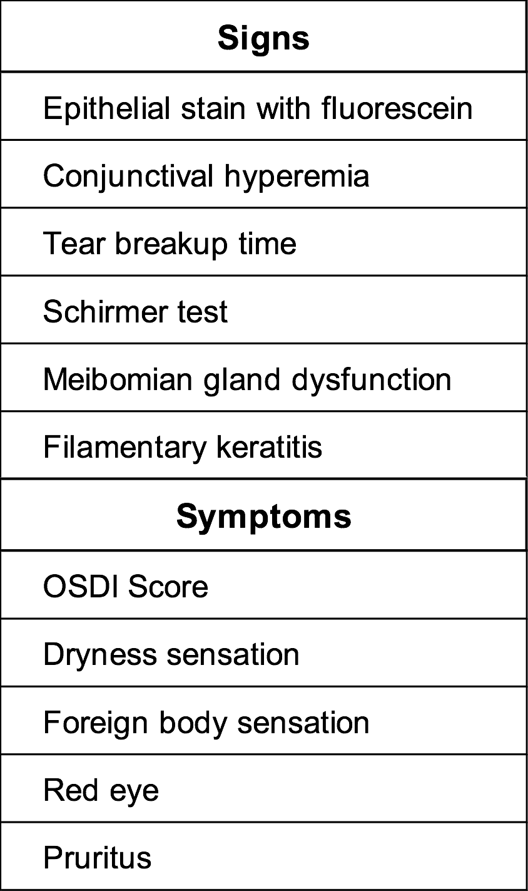

Table 2.

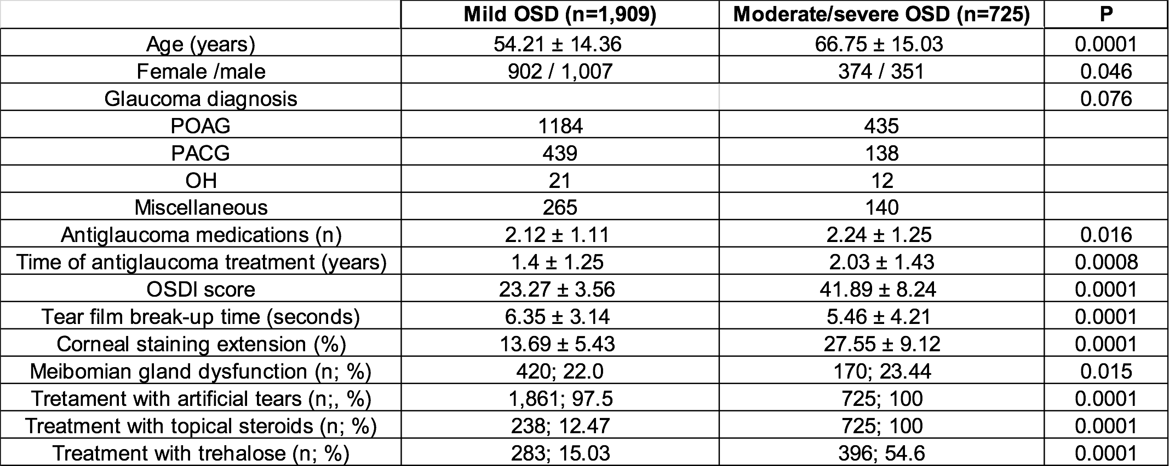

Table 3.

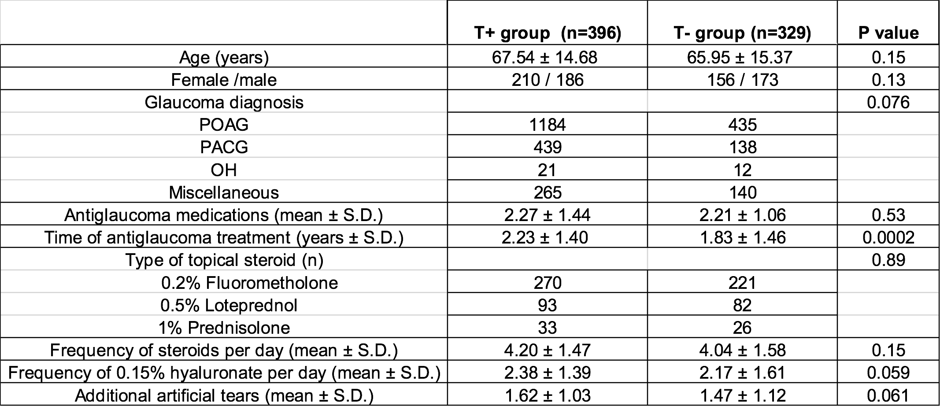

Table 4.



**Legends**

Table 1.

Signs and symptoms used as criteria for ocular surface disease (OSD). OSDI: Ocular Surface Disease Index.

Table 2.

Demographic and general data comparing mild OSD with moderate/severe OSD cases. OSD, ocular surface disease; POAG, primary open-angle glaucoma; PACG, primary angle-closure glaucoma; OH, ocular hypertension; OSDI, Ocular Surface Disease Index.

Table 3.

Demographic and therapy data associated with the two treatment groups. T+, with trehalose; T-, without trehalose; S.D., standard deviation.

Table 4

Treatment results associated with the two study groups. T+, with trehalose; T-, without trehalose; S.D., standard deviation.