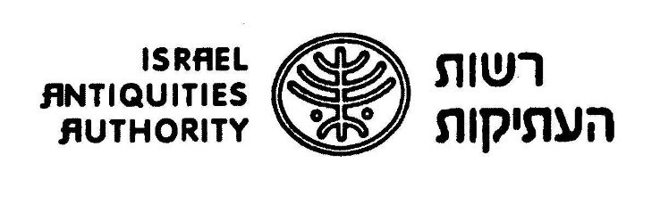

**9,000-year-old Rare Stone Mask Uncovered**

**Researchers: discovery of the mask in the Pnei Hever region reinforces the theory of a stone-mask production center in southern Har Hevron during the New Stone age**

This fascinating and rare stone mask dates from the Neolithic (new stone) period. It was discovered several months ago and is currently being studied by experts of the Israel Antiquities Authority and the Geological Survey of Israel. Results of the initial study of the mask will be presented tomorrow (Thursday) at the Israel Prehistoric Society conference.

Information received by the IAA’s Robbery Prevention Unit at the beginning of 2018 led to the recovery of the impressive stone mask. An investigation revealed the probable archaeological site in which the mask was originally found, in the Pnei Hever region of southern Har Hevron. Its characteristics, in addition to other findings from the region in which it was discovered, testify that the mask is 9,000 years old – dating from the Pre-Pottery Neolithic B period.

According to Ronit Lupo of the IAA Robbery Prevention Unit, “The mask is a unique finding in the archaeological world. It is even more unusual that we know which site it came from. The fact that we have information regarding the specific place it was discovered makes this mask more important than most other masks from this period that we currently know of.” The mask is made of pinkish-yellow limestone, carefully shaped with stone tools to resemble a human face. Four holes were drilled along the edge of the mask, probably in order to tie it – possibly to the face of a living person, or maybe to a pole or other designated artifact in order to display it. According to Lupo, “Discovering a mask made of stone, at such a high level of finish, is very exciting. The stone has been completely smoothed over and the features are perfect and symmetrical, even delineating cheek bones. The nose is impressive and there is a mouth with teeth.”

Dr. Omry Barzilai, director of the IAA research department, said that, “Stone masks are linked to the agricultural revolution. The transition from an economy based on hunting and gathering to ancient agriculture and domestication of plants and animals was accompanied by a change in social structure and a sharp increase in ritual-religious activity. Ritual findings from that period include human shaped figurines, plastered skulls, and stone masks.”

Ancestor worship was practiced during this period. “It was part of the ritual and retention of family heritage that was accepted at the time,” says Ronit Lupo. “For example, we find skulls buried under the floors of houses, as well as various methods of shaping and caring for the skulls of the dead. This led to plastering skulls, shaping facial features, and even inserting shells for eyes. Stone masks, such as the one from Pnei Hever, are similar in size to the human face, which is why scholars tend to connect them with such worship.”

There are currently fifteen known masks in the world that date from this period, of which only two were discovered in a clear archaeological context – meaning: we know which site they came from. The remaining masks are in private collections throughout the world, which makes it more difficult to study them. The importance of this new mask stems from the fact that it has been traced to an archaeological site that can be studied. The site can help us understand the material, everyday world in which the mask was produced, probably for purposes of worship.

The mask from Pnei Hever joins other masks attributed to the Pre-Pottery Neolithic B period discovered in the southern Har Hevron – Judean Desert area. Discovering the mask from Pnei Hever strengthens the assumption that the southern Har Hevron area was a center for producing stone masks, and most likely also for ritual activities in the Pre-Pottery Neolithic B period.

Dr. Omry Barzilai and Ronit Lupo of the IAA will present the initial research of the mask tomorrow (Thursday) at the Israel Prehistoric Society conference to be held at the Israel Museum.

[Click here to download good quality pictures](https://www.dropbox.com/sh/yx64v3tr4sfladl/AADLamLMs8HsPuniLAvPwSGfa?dl=0):

1 – 3. The Ancient Mask. Photography: Clara Amit, IAA

4 – 7. The Mask. Photography: The Robbery Prevention Unit, IAA

8. Video clip in Hebrew. Photography: IAA

For additional details: Yuli Schwartz, IAA, 052-5991888