**Ab Initio Molecular Dynamics Reveals Formation Path of Benzonitrile and Other Molecules in Conditions Relevant to the Interstellar Medium**

Jeeno Jose, Alon Zamir, Tamar Stein

Fritz Haber Research Center for Molecular Dynamics, The Hebrew University of Jerusalem, Jerusalem Israel, 9190401

**Abstract**

Polycyclic aromatic hydrocarbons and polycyclic aromatic nitrogen heterocycles are believed to be widespread in different areas of the interstellar medium. However, the astronomical detection of specific aromatic molecules is extremely challenging. As a result, no specific aromatic molecules have yet been identified, and very little is known about how they are formed in different areas of the interstellar medium. Only recently, McGuire et al. detected the simple aromatic molecule benzonitrile in Taurus Molecular Cloud-1. Applying quantum chemistry and ab initio molecular dynamics, we suggest a mechanism that elucidates the formation of small aromatic molecules from the ionization of van der Waals clusters in conditions prevalent in molecular clouds, such as Taurus Molecular Cloud 1. This mechanism predicts benzonitrile formation in acetylene and cyanoacetylene mixed clusters; additional aromatic molecules may also form in a similar manner. The results presented make an essential contribution to a better understanding of the formation mechanism of benzonitrile at the molecular level. These results also offer new insights that can guide astronomers in their search for aromatic molecules.

**Significance Statement**

Understanding how aromatic molecules are formed in the harsh environment of the interstellar medium has long been a puzzle to scientists. This paper investigates how small aromatic molecules and aromatic nitrogen heterocycles (as well as non-aromatic molecules) are formed from ionized van der Waals clusters. Applying ab initio molecular dynamics, we demonstrate that when the clusters contain acetylene and cyanoacetylene — some of the building blocks found in Taurus Molecular Cloud-1 — the model predicts the formation of benzonitrile cation. Our results predict the formation of other important compounds, including a bicyclic structure, and can help facilitate astronomy’s search for additional aromatic molecules.

1. **Introduction**

Despite the harsh conditions in space, such as low density, extreme temperatures, shock waves, and radiation, radio astronomy measurements are able to reveal the universe’s rich molecular nature [1]. To date, approximately 175 molecules have been identified in the gas phase [2]. Additionally, different organic molecules have been identified in meteorites and comets, including carboxylic and amino acids, purine and pyrimidine bases, sugars, and hydrocarbons [3-6], with demonstrated interstellar origins. While only relatively small molecules of up to 12 atoms have been identified in the gas phase, it is commonly believed that much more complex molecules are present in the interstellar medium (ISM). Included among these are polycyclic aromatic hydrocarbons (PAHs), which are considered widely prevalent in the ISM, and which constitute 20% of the carbon in the ISM [7–13]. The well-accepted PAH hypothesis [9, 10] suggests that PAHs, including their derivatives and ionic form, are responsible for the unidentified infrared bands (UIBs), or observed emission bands that appear at 3.3, 3.4, 6.2, 7.7, 8.6, and 11.3 $μm$ in the infrared (IR) spectra [14, 15]. The presence of the UIBs, also referred to as aromatic infrared bands (AIBs), demonstrate the generality of the PAH hypothesis [16].

Polycyclic aromatic nitrogen heterocycles (PANHs), the ring structures of which include a nitrogen atom, are also believed to contribute to the observed IR spectra, with a shift in the 6.2- $μm$ peaks having been suggested as an indicator of their presence [17-19]. In order to understand the chemical evolution of prebiotic molecules, and to obtain enhanced insights in the field of astrophysics, astrobiology, and astrochemistry, it is essential to clarify PANHs’ possible formation routes [20].

Although the presence of complex organic molecules such as PAHs and PANHs in different areas of the ISM is generally accepted, the mechanisms of their formation from smaller precursor molecules in areas such as dense molecular clouds remain elusive, and continue to be the subject of much study and debate. Moreover, while PAH and PANHs are relatively ubiquitous, their low rotational constant makes the detection of a specific PAH or PANH molecule challenging. In fact, only recently was the aromatic molecule benzonitrile identified in the cold-core Taurus Molecular Cloud-1 (TMC-1) via its hyperfine structure [21].

It is known that dense molecular clouds possess rich chemical compositions, as they are inhomogeneous, contain high-density cores (relative to the ISM), and have low temperatures of 10–100K [16, 22]. Moreover, while the cloud’s surface is exposed to a large amount of radiation from its surroundings, internally, it is shielded from most of that radiation. This protection prevents the destruction of molecules from radiation, but some ionizing radiation can still penetrate the cloud’s internal areas and lead to the formation of ionized species [23]. Spectral measurements reveal that a number of different molecules (mostly small molecules with fewer than 12 atoms) can be found in dense molecular clouds. For example, in TMC-1, over 60 molecules have been identified, including cyanopolyynes (HCnN; n=odd) [24, 25]. Due to the fact that molecular collisions are rare under the prevailing cloud conditions, and given that the reaction of two neutral species is likely to require activation energy, most such collisions will not be reactive. Consequently, to date, the astrochemistry field has focused on reactions between ions and neutral molecules, as well as on radical reactions, as these do not have activation energies, and are therefore far more likely to occur and lead to chemical growth.

While most encounters between neutral species are not reactive, they can result in the formation of molecular clusters, especially in the low temperatures of the cloud environment [26, 27], and because the rare occurrence of ionizing radiation enables the growth of clusters. When the cluster finally encounters ionizing radiation, it can lead to intra-cluster polymerization, a process that, in our opinion, despite possibly playing an essential role in the chemistry of molecular clouds, is often overlooked.

Intra-cluster ionic polymerization has been shown to generate molecular growth. For example, acetylene is the basic building block of complex organic molecules, such as PAHs, that are formed in a number of processes, including those leading to soot formation during combustion, or the creation of interstellar dust. Thus, many experimental studies have focused on clusters of acetylene molecules, and have demonstrated that radical ions of the form (C2H2)n+ resulted from the ionization of these clusters. Covalently bonded cyclic structures, such as cyclobutadiene cation and benzene cation, have been identified among the resulting structures [28–40]. Recently, Momoh et al. showed that ionization of van der Waals clusters of ethynylbenzene (C8H6)n formed by supersonic beam expansion led to molecular growth into larger structures, and resulted in radical cations of (C8H6)n+. Based on mass-selected ion dissociation and ion mobility measurements, they further demonstrated that the larger structures are covalently bonded [41]. Zhen et al. studied the photodissociation processes of pyrene clusters, and found that small PAHs can convert into larger ones when undergoing laser irradiation [42].

Recently, using ab initio molecular dynamics (AIMD) to model ionization of small neutral acetylene clusters, we demonstrated the potential of this conversion mechanism for forming aromatic molecules [26, 39, 43]. This process can lead to molecular growth, whereby structures are formed on the C4 and C6 potential energy surfaces, among them the benzene cation [39]. In addition, upon ionization of mixed HCCH and HCN clusters, growth can occur between three and four units, forming new C–C and C–N bonds. We showed that cyclic structures can be formed through this mechanism, including the pyridine radical cation [44], which is particularly important due to its prebiotic nature.

In this paper, we establish the strong relevance of the intra-cluster growth mechanism to the molecular formation in molecular cloud environments. By applying this mechanism to acetylene and cyanoacetylene mixed clusters, we were able to successfully predict benzonitrile radical cation formation. This result is significant, as the benzonitrile molecule was recently identified experimentally in TMC-1. Moreover, the intra-cluster growth mechanism perceives the formation of a fused double-ring structure, 2 azabicyclo[4.2.0]octa-1,3,5,7-tetraene cation, emphasizing its importance for astrochemical systems. Moreover, our results show the formation of additional nitrogenous organic molecules, which can serve as the basis of future astrophysical research studies.

This paper is organized as follows: Section II.a introduces the subject of neutral van der Waals structures of pure cyanoacetylene clusters, and includes a discussion of their stability and the stability of the ionized clusters. AIMD simulations were performed to study the resulting condition of the clusters upon ionization. The AIMD results of pure and mixed clusters are presented in Sections II.b.i and II.b.ii, respectively. Section II.c reviews the mechanism for benzonitrile formation from a mixed trimer cluster. Details of our calculations are presented in Section III, followed by the Conclusion in Section IV.

1. **Results and Discussion**

We speculate that the growth process begins with a gradual build-up of neutral van der Waals clusters and so we begin our discussion by presenting the relevant structures.

1. **Cyanoacetylene Dimer and Cluster Structures**

The neutral structures of pure cyanoacetylene dimers are presented in Figure 1, showing different orientations of cyanoacetylene molecules with respect to one another. The most stable structure is the D3 structure, in which the hydrogen atom of one molecule is pointed toward the nitrogen atom of the other molecule. The next most stable structure is D2, where two molecules are positioned on top of each other, and each nitrogen atom is closest to its paired molecule’s hydrogen atom. Due to the large dipole moment of cyanoacetylene (calculated as 3.84 D), the dimer structures exhibit large binding energies (BEs) with respect to acetylene dimers (which have no dipole moments and a BE of 1.4–1.6 kcal/mol, depending on the molecular orientation) [45]. The BEs are similar in magnitude to the BE of the hydrogen cyanide (HCN) dimer, which is −4.97 kcal/mol for the linear orientation [44]. The smallest structure present is a T-shape-like structure, in which the nitrogen atom of one molecule points toward the second molecules, as shown in structure D1.

Figures 2 and 3 present the structures of larger pure cyanoacetylene clusters.

The trends exhibited by the larger clusters are similar to the patterns of the dimer clusters. The interaction between a hydrogen atom in one cyanoacetylene molecule and a nitrogen atom in the paired cyanoacetylene molecule is favorable.

Upon ionization, the structures are no longer stable on the neutral surface and contain a large amount of excess energy, which leads to relaxation processes, as demonstrated schematically in Figure 4 (before ionization, the structures are at equilibrium on the neutral surface). After ionization, the structures are no longer at equilibrium and possess a large amount of energy. To understand what the optimal structures on the ionic surface are, we re-optimized the structures on the surface, as shown in Figure 4. In examining the resulting structures, we uncovered several interesting features.

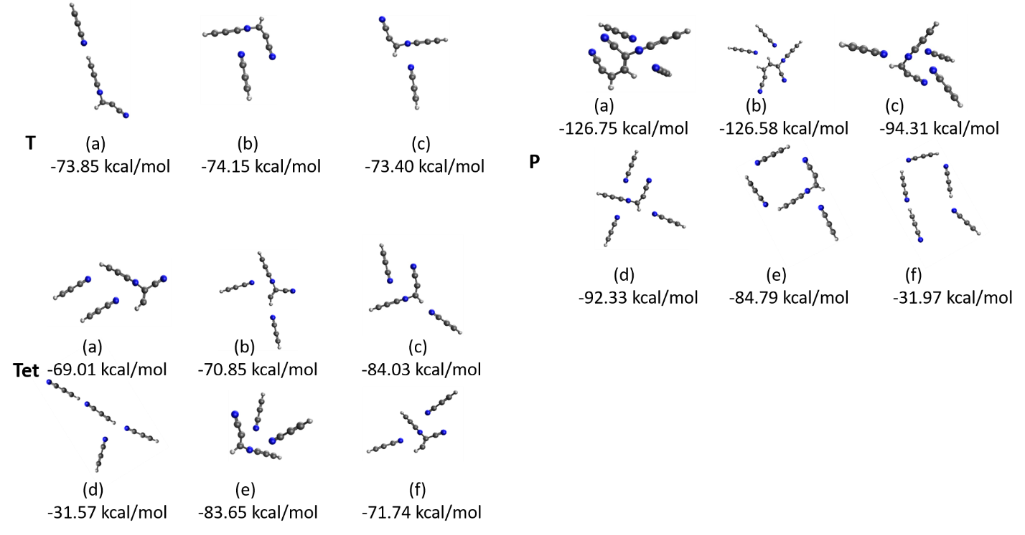

Figure 1: Optimized structures obtained from the starting geometries of the structures shown in Figure 2, presented on a cationic surface. T, Tet, and P represent trimer, tetramer and pentamer clusters, respectively. BEs are presented in kcal/mol.

First, we did not observe any proton transfer after optimization (in contrast to the case of pure HCN clusters [44], to be discussed below.) Secondly, in most clusters, we observed the formation of a bond after ionization. In the trimer and tetramer clusters, the bond was formed between two cyanoacetylene units. In the pentamer clusters, we observed bond formation between three cyanoacetylene units (Figure 4, P(a) and P(b)). Because the structures were obtained as a result of optimization, we can thereby conclude that there was no barrier to their formation. However, after ionization, the system does possess a large amount of energy that can be utilized to form additional structures. To study the evolution of the systems over time, we performed ab initio molecular dynamics (AIMD) simulations. The results are presented in the next section.

1. **Ab Initio Molecular Dynamics**
2. **Pure Cyanoacetylene Clusters**

Figure 6 presents the distribution of structures resulting from molecular dynamics (MD) simulations of pure cyanoacetylene clusters. We present the core structures formed during the dynamic process that can be complexed to an additional cyanoacetylene molecule or molecules, depending on the size of the starting cluster. As shown in the figure, most trajectories result in bonded pair structures (79%, 86%, and 58% for the trimer, tetramer, and pentamer, respectively). The C6H2N2+ isomers mostly form structures in which nitrogen is bonded to carbon 1 or 2 in the paired cyanoacetylene, as shown in the top panel of Figure 7. There is a small percentage of isomers in which the nitrogen is connected to the cyano carbon, and isomers in which carbon 1 and 2 from each structure are bonded to each other, forming a cyclic structure. In a recent study, we investigated growth processes upon ionization of pure HCN clusters [44]. The study revealed that growth is quenched at the level of pairwise condensation. In contrast, here we find growth that occurs beyond the dimers; fifteen percent of the pentamer’s trajectories (a total of 31 trajectories) result in C9H3N3+ structures. The C9H3N+ isomer formation is mostly a result of nitrogen’s attack on carbons 1 and 2 of the neighboring cyanoacetylene, and on an additional carbon–carbon bond, as shown in the bottom panel of Figure 7. TheC9H3N3+ isomers contain long chains with cyano groups, as well as four-member ring structures. These structures are already quite complex and can serve as the basis for additional growth. Interestingly, C9H3N3+ isomers result only from ionization of the pentamer clusters, thus demonstrating the cluster’s vital role in the growth process.

Additional isomers obtained from the pentamer simulations are C6H1N2+ structures, as shown in Figure 7. The C6H1N2+ structures originate from C6H2N2+, in which a proton is transferred from the carbon to form a new bond with a neighboring nitrogen. In cases of more than one cyanoacetylene spectator molecule, the proton can hop between nitrogen atoms of the spectator cyanoacetylene molecules.

1. **Mixed Cyanoacetylene and Acetylene Clusters**

In the case of HCN clusters, it has been demonstrated that doping of the clusters with acetylene molecules can enhance the growth process, and lead to the formation of larger molecules [44]. We thus studied the effect of doping cyanoacetylene clusters with acetylene, at varying ratios of cyanoacetylene/acetylene. The starting neutral clusters are presented in SI Fig XX.

Figures 8–11 present the distribution of structures obtained at the end of the AIMD simulations of mixed clusters doped with one acetylene molecule (Figure 8), two acetylene molecules (Figure 9), three acetylene molecules (Figure 10), and four acetylene molecules (Figure 11).

The figures demonstrate the effect of doping with acetylene on the growth process. In the presence of acetylene, growth beyond three units can occur. Although growth beyond three units is only observed in small percentages, we anticipate that this might change in an environment containing larger clusters. For the pure clusters, we observed only minor bonding beyond two units in the trimer and tetramer clusters, and for the pentamer clusters, <20% of the trajectories resulted in bonds of more than two units. However, when the cluster was doped with one acetylene unit, we observed growth beyond two units in tetramer clusters. For the pentamer clusters, >20% of the trajectories resulted in three units bonding (C8H4N2+). Doping with two acetylene units (Figure 9) resulted in bonding between three units in about 15% of the tetramer and >40% of the pentamer clusters. When proceeding to doping with three units (Figure 10), we found that approximately 40% of the pentamer trajectories formed structures via bonding between three units. Doping with four acetylene units resulted in a pentamer cluster containing four acetylene units and one cyanoacetylene unit. As can be seen in Figure 11, this scenario was less effective for cluster growth. These results further demonstrate the crucial role of the clusters, which provide the environment for growth processes to occur.

Figure 8 presents the results of clusters doped with one acetylene unit. As can be seen from the figure, in the case of the trimer structures, the resulting structures are C6H2N2+ (76% of the trimer trajectories), and C5H3N+ (24% of the trimer trajectories), which were formed from bonding between two cyanoacetylene units (C6H2N2+), or bonding between cyanoacetylene and acetylene (C5H3N+). Those were also the main structures in the case of the tetramer, where 42% of the trajectories resulted in C5H3N+ isomers, and 14% resulted in C6H2N2+. In the case of tetramer clusters, we also observed bonding between three molecules. In about 12% of the tetramer trajectories, three cyanoacetylene molecules bonded together to form C9H3N3+.In an additional 13% of the trajectories, C8H4N2+ isomers were obtained; those isomers resulted from the bonding between two cyanoacetylene molecules and one acetylene molecule. Interestingly, we also observed (although in small percentages) C11H5N3+, which contains three cyanoacetylene molecules and one acetylene molecule. Evidently, by doping with an acetylene molecule, a growth of four units was achieved, with C5H3N+ as the main structure (68%) for the pentamer trajectories, followed by C8H4N2+ (26%). We also observed small percentages of C5H2N+ and C6H2N2+.

C5H3N+ structures are generated upon bond formation between one acetylene and one cyanoacetylene unit. C5H3N+ isomers are presented in the top panel of Figure 10, where, among the various structures, we can see structures that resemble those obtained from pure acetylene clusters [39]; a cyclobutadiene cation (Figure 10, top panel a), and a methylenecyclopropane cation (Figure 10, top panel c), with one of the hydrogen atoms substituted by a cyano group. C5H2N+ isomers are presented at the bottom of the figure. In these structures, the proton left the core structure and proceeded to bond to one of the neighboring nitrogen atoms. At the bottom of the figure, structure (a) shows a complex of the core structure and an additional cyanoacetylene molecule. In the orientation presented in the figure, the proton can hop between the neighboring nitrogen atoms. Structure (b) shows a complex of the C5H2N+ core structure with an additional cyanoacetylene unit. In this case, no proton hopping occurs, as no proton is situated between two nitrogen atoms.

C8H4N2+ isomers are also produced in the simulations of the tetramer and pentamer clusters. Among those isomers, we observed many linear isomers, or isomers that formed small cyclic structures among three or four carbons. The structures are presented in the supplementary materials in Figure X1.

C8H4N2+ also formed cyclic structures containing six-membered rings, such as substituted benzene and pyridine. Those structures are fundamental from the perspectives of astrobiology and astrochemistry, as they can serve as a bridge for additional growth of carbon-containing rings. Figure 11 presents the cyclic isomers of C8H4N2+.As can be seen from the figure, three structures (a–c) containing nitrogen within the ring are pyridine based, substituted by an acetylene and cyano group (a, b), or a cyanoacetylene group (c). Structures (d) and (e) represent benzene-based groups substituted by cyano groups.

Additional structures that arise from the trajectories are the C11H5N3+ and C4H2N+ compounds; the C11H5N3+ structure results from bonds between three cyanoacetylene molecules and one acetylene molecule, and is presented in the supplementary material Figure X2(b). C4H2N+ structures originate from C7H5N+, where a C3H3 group is detached from the system, as demonstrated in Figure X2(a).

Figures 10–12 present the distribution of structures obtained when the cluster is doped with acetylene molecules (two, three, and four, respectively). Doping with acetylene resulted in an extensive variety of structures. In addition to the structures already found, additional structures formed upon bonding with acetylene units were identified [39]. Moreover, we detected C7H5N+ and C10H6N2+ structures (see Figure X2(c) in the supplementary material), formed by binding between two acetylene units and one cyanoacetylene unit, and from binding between two cyanoacetylene units and two acetylene units, respectively.

Figure 12 presents the different six-membered ring isomers obtained for the C7H5N+ structures; additional noncyclic or cyclic isomers with smaller rings were also obtained for C7H5N+ and are presented in the supplementary material (Figures X3–X5). Figure 12(a–c) shows Dewar benzene and benzvalene isomers with substituent cyano groups at different locations on the ring. Figure 12(d) shows a benzene molecule substituted with a cyano group, namely cyanobenzene. This structure is the most stable structure among those presented, with a BE of −204.9 kcal/mol. Figure 12(e) is a five-membered ring structure with BE of −192.25 kcal/mol. The rest of the structures contain nitrogen in the ring, and thus can serve as bases for prebiotic molecules. It is evident from Figure 12(i) that a bicyclic structure is also formed. This result is significant, as it emphasizes the fact that the mechanism presented in this work can lead to complex structures that contain more than one ring.

**Formation of Cyanobenzene**

One of the structures predicted by our model simulations is cyanobenzene. Cyanobenzene was recently detected in TMC-1 [21], which highlights the importance of understanding its formation mechanism, and provides experimental support for our model predictions. Among a list of molecules that McGuire et al. [21] searched for, cyanobenzene was the only one to be detected. None of the other molecules predicted in this current work was the subject of research in the study of McGuire et al. [21], and we hope that the predictions here will help guide astronomers in future research.

Figure 13 presents the formation path of cyanobenzene, starting from the trimer cluster containing two acetylene molecules and one cyanoacetylene molecule. It is evident that the route for the formation of the cyanoacetylene molecule involves the formation of three and four-ring structures, followed by the generation of a Dewar benzene structure substituted with a cyano group. It is important to note that while there are barriers to the reaction, they are submerged, and as such, the systems can go over them smoothly.

1. **Methods**

All calculations in this manuscript were performed with Q-Chem 5.1 software [46], and all the structures presented here (neutral and cationic systems) were optimized using a wB97X-V functional [47] with a cc-pVTZ basis set [48]. Each structure was identified as a minimum or a saddle point on the potential energy surface by performing vibrational frequency calculations at the same level of theory (wb97X-V and cc-pVTZ basis set). For the potential energy surface, single-point calculations were performed with the aug-cc-pVTZ basis set [49].

To model ionization events, we performed AIMD using the ωB97 functional [50] and 6-31G* basis set [51]. The geometrical structure of each neutral trimer, tetramer, and pentamer cluster served as a starting point for the simulations. For each structure, we ran 30 trajectories, where the temperature was randomly chosen between 30–80°K in each trajectory. The time step taken in the simulations was 1.21 fs (50 a.u.), and the total time of the simulations was 2.4 ps (2000 time steps).

1. **Conclusions**

In this manuscript, we demonstrate the importance of the inter-cluster growth mechanism as a path for molecular growth in different environments, such as dense molecular clouds. We applied the mechanism on van der Waals clusters containing cyanoacetylene molecules, and a combination of cyanoacetylene and acetylene molecules; both are expected to be found in dense molecular clouds such as TMC-1. Our results demonstrate the rich chemistry that can occur upon ionization of the clusters. We detected formation of a large variety of molecules and isomers, among them aromatic and nonaromatic molecules, and aromatic molecules containing nitrogen within their rings. Aromatic molecules that contain nitrogen in their rings are highly significant, as they can lead to the formation of DNA and RNA nucleobases. We also observed the formation of a bicyclic structure, which demonstrates that the inter-cluster growth mechanism can lead to the formation of more complex molecular structures.

## 

**References**

1. Tielens, A.G.G.M., *The molecular universe.* Reviews of Modern Physics, 2013. **85**(3): p. 1021-1081.

2. Agúndez, M. and V. Wakelam, *Chemistry of Dark Clouds: Databases, Networks, and Models.* Chemical Reviews, 2013. **113**(12): p. 8710-8737.

3. Kvenvolden, K., J. Lawless, K. Pering, E. Peterson, J. Flores, C. Ponnamperuma, I.R. Kaplan, and C. Moore, *Evidence for Extraterrestrial Amino-acids and Hydrocarbons in the Murchison Meteorite.* Nature, 1970. **228**(5275): p. 923-926.

4. Mullie, F. and J. Reisse. *Organic matter in carbonaceous chondrites*. 1987. Berlin, Heidelberg: Springer Berlin Heidelberg.

5. Cooper, G., N. Kimmich, W. Belisle, J. Sarinana, K. Brabham, and L. Garrel, *Carbonaceous meteorites as a source of sugar-related organic compounds for the early Earth.* Nature, 2001. **414**(6866): p. 879-883.

6. Irvine, W.M., *Extraterrestrial Organic Matter: A review.* Origins of life and evolution of the biosphere, 1998. **28**(4): p. 365-383.

7. Sellgrem, K., *The near-infrared continuum emission of visual reflection nebulae.* Astrophysical Journal, Part 1 1984. **277**: p. 623-633.

8. Tielens, A.G.G.M., *Interstellar Polycyclic Aromatic Hydrocarbon Molecules.* Annual Review of Astronomy and Astrophysics, 2008. **46**(1): p. 289-337.

9. Allamandola, L.J., A.G.G.M. Tielens, and J.R. Barker, *Interstellar polycyclic aromatic hydrocarbons - The infrared emission bands, the excitation/emission mechanism, and the astrophysical implications.* Astrophysical Journal Supplement Series, 1989. **71**: p. 733-775.

10. Leger, A. and J.L. Puget, *Identification of the 'unidentified' IR emission features of interstellar dust?* Astronomy and Astrophysics, 1984. **137**(1): p. L5 - L8.

11. Joblin, C. and G. Mulas, *Interstellar polycylic aromatic hydrocarbons: from space to the laboratory.* Interstellar Dust from Astronomical Observations to Fundamental Studies, 2009. **35**: p. 133-152.

12. Rhee, Y.M., T.J. Lee, M.S. Gudipati, L.J. Allamandola, and M. Head-Gordon, *Charged polycyclic aromatic hydrocarbon clusters and the galactic extended red emission.* Proceedings of the National Academy of Sciences of the United States of America, 2007. **104**(13): p. 5274-5278.

13. Ehrenfreund, P. and M.A. Sephton, *Carbon molecules in space: from astrochemistry to astrobiology.* Faraday Discussions, 2006. **133**(0): p. 277-288.

14. Allamandola, L.J., A.G.G.M. Tielens, and J.R. Barker, *Polycyclic aromatic hydrocarbons and the unidentified infrared emission bands: auto exhaust along the milky way.* The Astrophysical Journal, 1985. **290**: p. L25.

15. Russell, R.W., B.T. Soifer, and S.P. Willner, *The 4 to 8 micron spectrum of NGC 7027.* The Astrophysical Journal, 1977. **217**: p. L149.

16. Sandford, S.A., M. Nuevo, P.P. Bera, and T.J. Lee, *Prebiotic Astrochemistry and the Formation of Molecules of Astrobiological Interest in Interstellar Clouds and Protostellar Disks.* Chemical Reviews, 2020.

17. Mattioda, A.L., L. Rutter, J. Parkhill, M. Head‐Gordon, T.J. Lee, and L.J. Allamandola, *Near‐Infrared Spectroscopy of Nitrogenated Polycyclic Aromatic Hydrocarbon Cations from 0.7 to 2.5 μm.* The Astrophysical Journal, 2008. **680**(2): p. 1243-1255.

18. Peeters, E., S. Hony, C. Van Kerckhoven, A.G.G.M. Tielens, L.J. Allamandola, D.M. Hudgins, and C.W. Bauschlicher, *The rich 6 to 9 $\vec\mu$m spectrum of interstellar PAHs*.* A&A, 2002. **390**(3): p. 1089-1113.

19. Hudgins, D.M., C.W. Bauschlicher, Jr., and L.J. Allamandola, *Variations in the Peak Position of the 6.2 μm Interstellar Emission Feature: A Tracer of N in the Interstellar Polycyclic Aromatic Hydrocarbon Population.* The Astrophysical Journal, 2005. **632**: p. 316.

20. Bera, P.P., T. Stein, M. Head-Gordon, and T.J. Lee, *Mechanisms of the Formation of Adenine, Guanine, and Their Analogues in UV-Irradiated Mixed NH3:H2O Molecular Ices Containing Purine.* Astrobiology, 2017. **17**(8): p. 771-785.

21. McGuire, B.A., A.M. Burkhardt, S. Kalenskii, C.N. Shingledecker, A.J. Remijan, E. Herbst, and M.C. McCarthy, *Detection of the aromatic molecule benzonitrile (&lt;em&gt;c&lt;/em&gt;-C&lt;sub&gt;6&lt;/sub&gt;H&lt;sub&gt;5&lt;/sub&gt;CN) in the interstellar medium.* Science, 2018. **359**(6372): p. 202.

22. Benson, P.J. and P.C. Myers, *A Survey for Dense Cores in Dark Clouds.* The Astrophysical Journal Supplement Series, 1989. **71**: p. 89.

23. Prasad, S.S. and S.P. Tarafdar, *UV radiation field inside dense clouds - Its possible existence and chemical implications.* The Astrophysical Journal, 1983. **267**: p. 603-609.

24. McGuire, B.A., A.M. Burkhardt, C.N. Shingledecker, S.V. Kalenskii, E. Herbst, A.J. Remijan, and M.C. McCarthy, *Detection of Interstellar HC 5 O in TMC-1 with the Green Bank Telescope.* The Astrophysical Journal, 2017. **843**(2): p. L28.

25. Gratier, P., L. Majumdar, M. Ohishi, E. Roueff, J.C. Loison, K.M. Hickson, and V. Wakelam, *A NEW REFERENCE CHEMICAL COMPOSITION FOR TMC-1.* The Astrophysical Journal Supplement Series, 2016. **225**(2): p. 25.

26. Stein, T. and J. Jose, *Molecular Formation upon Ionization of van der Waals Clusters and Implication to Astrochemistry.* Israel Journal of Chemistry, 2020. **60**: p. 1-9.

27. Klemperer, W. and V. Vaida, *Molecular complexes in close and far away.* Proceedings of the National Academy of Sciences, 2006. **103**(28): p. 10584-10588.

28. Ono, Y. and C.Y. Ng, *A study of the unimolecular decomposition of the (C2H2)3+ complex.* Journal of the American Chemical Society, 1982. **104**(18): p. 4752-4758.

29. Shinohara, H., H. Sato, and N. Washida, *Photoionization mass spectroscopic studies of ethylene and acetylene clusters: intracluster excess energy dissipation.* The Journal of Physical Chemistry, 1990. **94**(17): p. 6718-6723.

30. Booze, J.A. and T. Baer, *The photoionization and dissociation dynamics of energy‐selected acetylene dimers, trimers, and tetramers.* The Journal of Chemical Physics, 1993. **98**(1): p. 186-200.

31. Coolbaugh, M.T., S.G. Whitney, G. Vaidyanathan, and J.F. Garvey, *Intracluster polymerization reactions within acetylene and methylacetylene clusters ions.* The Journal of Physical Chemistry, 1992. **96**(23): p. 9139-9144.

32. Hrouda, V., M. Roeselová, and T. Bally, *The C4H4•+ potential energy surface. 3. The reaction of acetylene with its radical cation.* The Journal of Physical Chemistry A, 1997. **101**(21): p. 3925-3935.

33. Momoh, P.O., S.A. Abrash, R. Mabrouki, and M.S. El-Shall, *Polymerization of ionized acetylene clusters into covalent bonded ions:  evidence for the formation of benzene radical cation.* Journal of the American Chemical Society, 2006. **128**(38): p. 12408-12409.

34. Momoh, P.O. and M.S. El-Shall, *Stepwise hydration of ionized acetylene trimer. Further evidence for the formation of benzene radical cation.* Chemical Physics Letters, 2007. **436**(1–3): p. 25-29.

35. Momoh, P.O., A.-R. Soliman, M. Meot-Ner, A. Ricca, and M.S. El-Shall, *Formation of Complex Organics from Acetylene Catalyzed by Ionized Benzene.* Journal of the American Chemical Society, 2008. **130**(39): p. 12848-12849.

36. Momoh, P.O., A.M. Hamid, A.-R. Soliman, S.A. Abrash, and M.S. El-Shall, *Structure of the C8H8•+ radical cation formed by electron impact ionization of acetylene clusters. Evidence for a (Benzene•+·Acetylene) complex.* The Journal of Physical Chemistry Letters, 2011. **2**(19): p. 2412-2419.

37. Momoh, P.O., A.M. Hamid, S.A. Abrash, and M. Samy El-Shall, *Structure and hydration of the C4H4•+ ion formed by electron impact ionization of acetylene clusters.* The Journal of Chemical Physics, 2011. **134**(20): p. 204315.

38. Relph, R.A., J.C. Bopp, J.R. Roscioli, and M.A. Johnson, *Structural characterization of (C2H2)1–6+ cluster ions by vibrational predissociation spectroscopy.* The Journal of Chemical Physics, 2009. **131**(11): p. 114305.

39. Stein, T., B. Bandyopadhyay, T.P. Troy, Y. Fang, O. Kostko, M. Ahmed, and M. Head-Gordon, *Ab initio dynamics and photoionization mass spectrometry reveal ion-molecule pathways from ionized acetylene clusters to benzene cation.* Proc Natl Acad Sci U S A, 2017. **114**(21): p. E4125-E4133.

40. Ahmed, M. and O. Kostko, *From atoms to aerosols: probing clusters and nanoparticles with synchrotron based mass spectrometry and X-ray spectroscopy.* Physical Chemistry Chemical Physics, 2020. **22**(5): p. 2713-2737.

41. Momoh, P.O., I.K. Attah, M.S. El-Shall, R.P.F. Kanters, J.M. Pinski, and S.A. Abrash, *Formation of covalently bonded polycyclic hydrocarbon ions by Intracluster polymerization of ionized ethynylbenzene clusters.* The Journal of Physical Chemistry A, 2014. **118**(37): p. 8251-8263.

42. Junfeng, Z., C. Tao, and G.G.M.T. Alexander, *Laboratory Photochemistry of Pyrene Clusters: An Efficient Way to Form Large PAHs.* The Astrophysical Journal, 2018. **863**(2): p. 128.

43. Tamar, S., B. Partha P., L. Timothy J., and H.-G. Martin, *Molecular Growth upon Ionization of Van Der Waals Clusters Containing HCCH and HCN is a Pathway to Prebiotic Molecules*. 2020.

44. Stein, T., P.P. Bera, T.J. Lee, and M. Head-Gordon, *Molecular growth upon ionization of van der Waals clusters containing HCCH and HCN is a pathway to prebiotic molecules.* Physical Chemistry Chemical Physics, 2020. **22**(36): p. 20337-20348.

45. Bandyopadhyay, B., T. Stein, Y. Fang, O. Kostko, A. White, M. Head-Gordon, and M. Ahmed, *Probing ionic complexes of ethylene and acetylene with vacuum-ultraviolet radiation.* The Journal of Physical Chemistry A, 2016. **120**(27): p. 5053-5064.

46. Shao, Y., Z. Gan, E. Epifanovsky, A.T.B. Gilbert, M. Wormit, J. Kussmann, A.W. Lange, A. Behn, J. Deng, X. Feng, D. Ghosh, M. Goldey, P.R. Horn, L.D. Jacobson, I. Kaliman, R.Z. Khaliullin, T. Kuś, A. Landau, J. Liu, E.I. Proynov, Y.M. Rhee, R.M. Richard, M.A. Rohrdanz, R.P. Steele, E.J. Sundstrom, H.L. Woodcock, P.M. Zimmerman, D. Zuev, B. Albrecht, E. Alguire, B. Austin, G.J.O. Beran, Y.A. Bernard, E. Berquist, K. Brandhorst, K.B. Bravaya, S.T. Brown, D. Casanova, C.-M. Chang, Y. Chen, S.H. Chien, K.D. Closser, D.L. Crittenden, M. Diedenhofen, R.A. DiStasio, H. Do, A.D. Dutoi, R.G. Edgar, S. Fatehi, L. Fusti-Molnar, A. Ghysels, A. Golubeva-Zadorozhnaya, J. Gomes, M.W.D. Hanson-Heine, P.H.P. Harbach, A.W. Hauser, E.G. Hohenstein, Z.C. Holden, T.-C. Jagau, H. Ji, B. Kaduk, K. Khistyaev, J. Kim, J. Kim, R.A. King, P. Klunzinger, D. Kosenkov, T. Kowalczyk, C.M. Krauter, K.U. Lao, A.D. Laurent, K.V. Lawler, S.V. Levchenko, C.Y. Lin, F. Liu, E. Livshits, R.C. Lochan, A. Luenser, P. Manohar, S.F. Manzer, S.-P. Mao, N. Mardirossian, A.V. Marenich, S.A. Maurer, N.J. Mayhall, E. Neuscamman, C.M. Oana, R. Olivares-Amaya, D.P. O’Neill, J.A. Parkhill, T.M. Perrine, R. Peverati, A. Prociuk, D.R. Rehn, E. Rosta, N.J. Russ, S.M. Sharada, S. Sharma, D.W. Small, A. Sodt, T. Stein, D. Stück, Y.-C. Su, A.J.W. Thom, T. Tsuchimochi, V. Vanovschi, L. Vogt, O. Vydrov, T. Wang, M.A. Watson, J. Wenzel, A. White, C.F. Williams, J. Yang, S. Yeganeh, S.R. Yost, Z.-Q. You, I.Y. Zhang, X. Zhang, Y. Zhao, B.R. Brooks, G.K.L. Chan, D.M. Chipman, C.J. Cramer, W.A. Goddard, M.S. Gordon, W.J. Hehre, A. Klamt, H.F. Schaefer, M.W. Schmidt, C.D. Sherrill, D.G. Truhlar, A. Warshel, X. Xu, A. Aspuru-Guzik, R. Baer, A.T. Bell, N.A. Besley, J.-D. Chai, A. Dreuw, B.D. Dunietz, T.R. Furlani, S.R. Gwaltney, C.-P. Hsu, Y. Jung, J. Kong, D.S. Lambrecht, W. Liang, C. Ochsenfeld, V.A. Rassolov, L.V. Slipchenko, J.E. Subotnik, T. Van Voorhis, J.M. Herbert, A.I. Krylov, P.M.W. Gill and M. Head-Gordon, *Advances in molecular quantum chemistry contained in the Q-Chem 4 program package.* Molecular Physics, 2015. **113**(2): p. 184-215.

47. Mardirossian, N. and M. Head-Gordon, *[small omega]B97X-V: A 10-parameter, range-separated hybrid, generalized gradient approximation density functional with nonlocal correlation, designed by a survival-of-the-fittest strategy.* Physical Chemistry Chemical Physics, 2014. **16**(21): p. 9904-9924.

48. Dunning , T.H., Jr, *Gaussian basis sets for use in correlated molecular calculations. I. The atoms boron through neon and hydrogen.* The Journal of Chemical Physics, 1989. **90**(2): p. 1007-1023.

49. Kendall, R.A., T.H.D. Jr., and R.J. Harrison, *Electron affinities of the first‐row atoms revisited. Systematic basis sets and wave functions.* The Journal of Chemical Physics, 1992. **96**(9): p. 6796-6806.

50. Chai, J.-D. and M. Head-Gordon, *Systematic optimization of long-range corrected hybrid density functionals.* The Journal of Chemical Physics, 2008. **128**(8): p. 084106.

51. Rassolov, V.A., J.A. Pople, M.A. Ratner, and T.L. Windus, *6-31G* basis set for atoms K through Zn.* The Journal of Chemical Physics, 1998. **109**(4): p. 1223-1229.

**Figures**

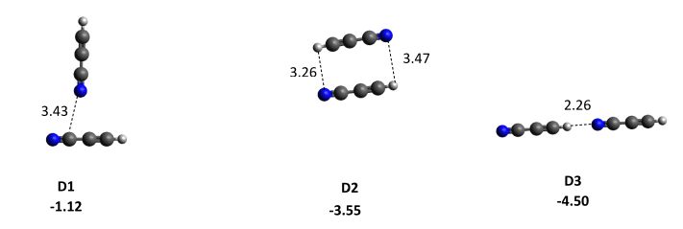

Figure 1: Optimized structures of pure cyanoacetylene dimer clusters (D1–D3). Binding energies (BEs) are presented in kcal/mol (in bold font), and distances in Å.

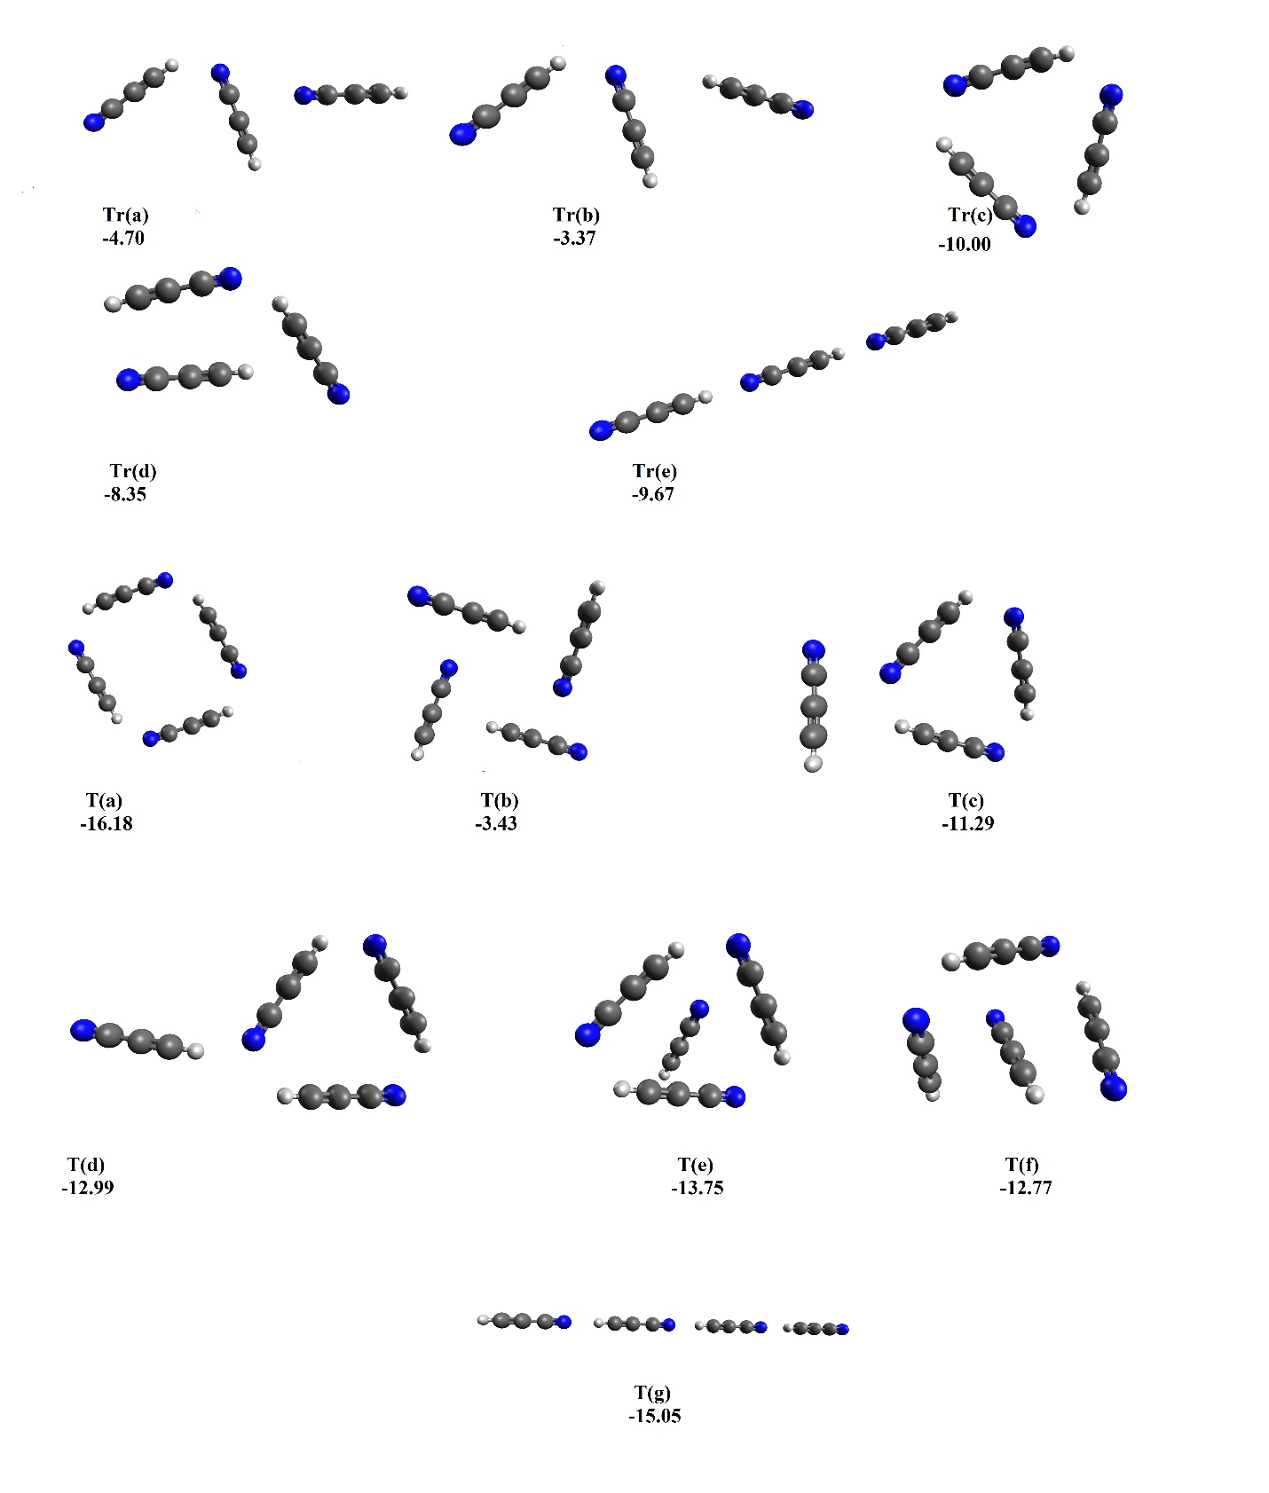

Figure 2: Optimized structures of pure cyanoacetylene clusters. Trimer structures (Tr) and tetramer structures (T) are presented. BEs are presented in kcal/mol.

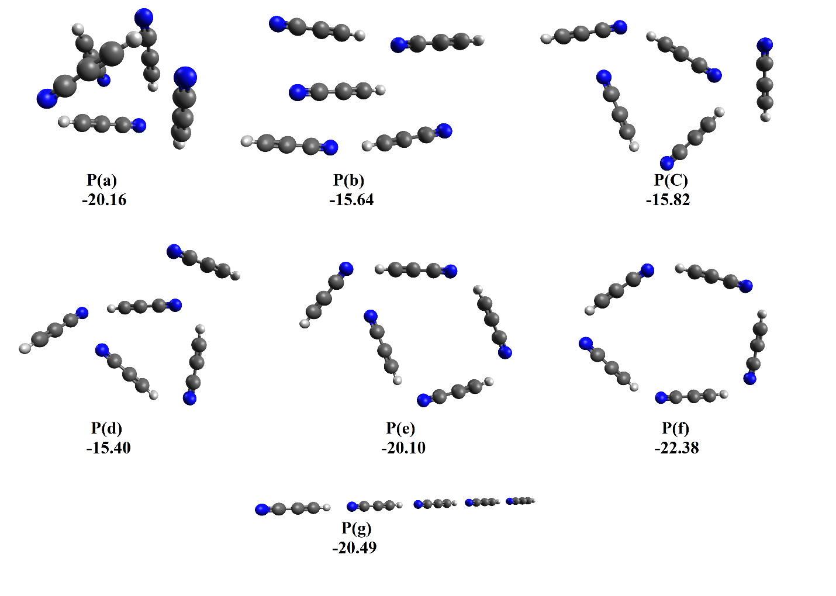

Figure 3: Optimized structures of pure cyanoacetylene pentamer clusters (P) are presented. BEs are presented in kcal/mol.

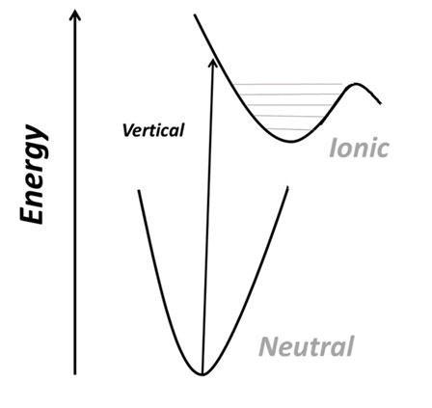

Figure 4: Schematic representation of the ionization process. The minimum energy corresponding to the neutral cluster is not a minimum in the cationic surface, and the system undergoes relaxation. The figure is based on Figure 1 in Stein and Jose [26].

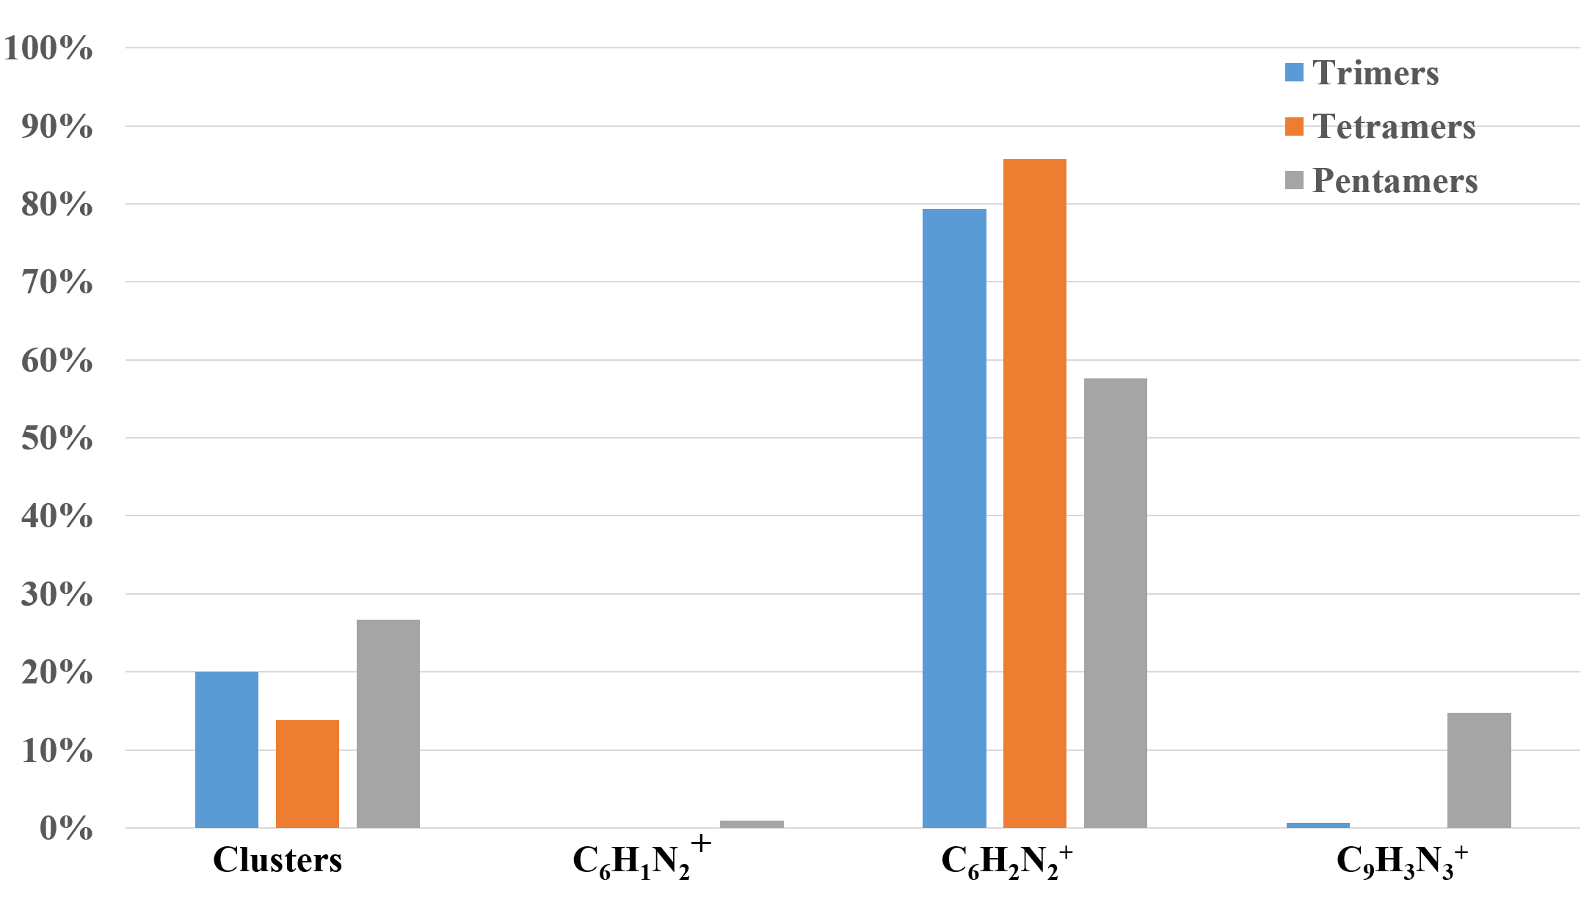

Figure 2: Distribution of the pentamer, tetramer, and trimer structures of pure cyanoacetylene clusters (in percentages) at the end of the AIMD trajectories.

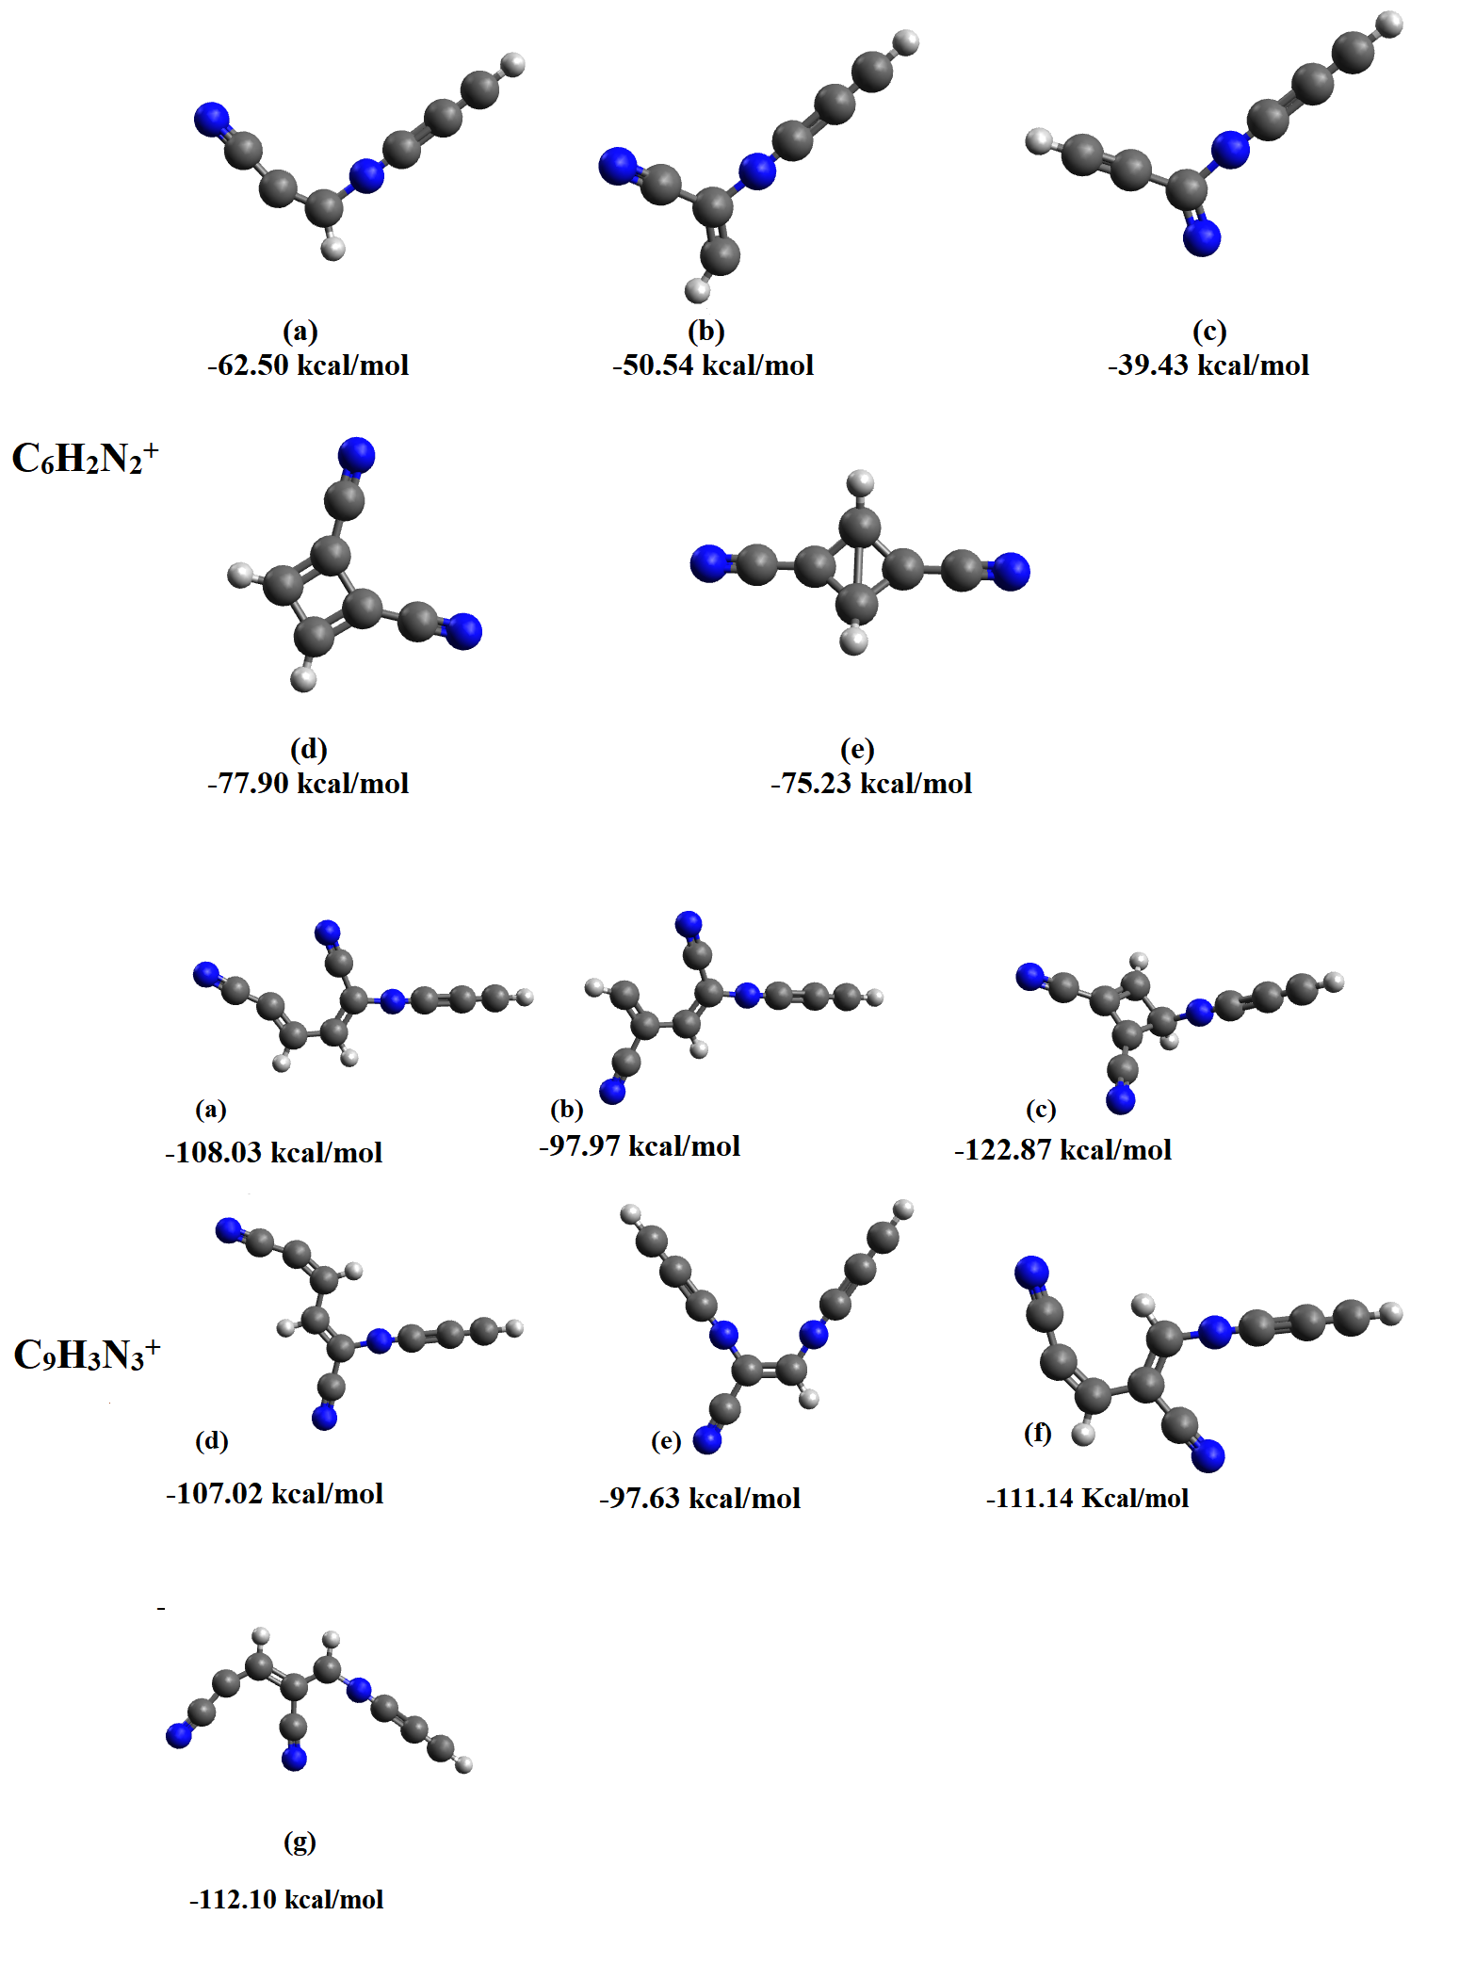

Figure 3: C6H2N2+ and C9H3N3+ structures obtained from molecular dynamics simulations after optimization. BEs are given in kcal/mol.

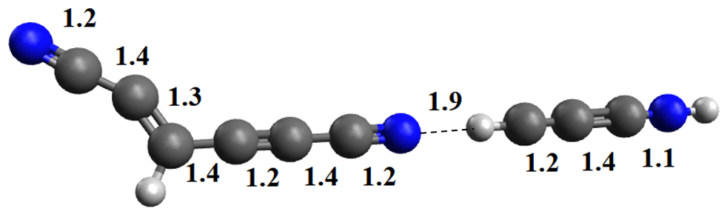

Figure 4: C6H1N2+ distonic ion after optimization of the geometry. Distances are presented in Å.

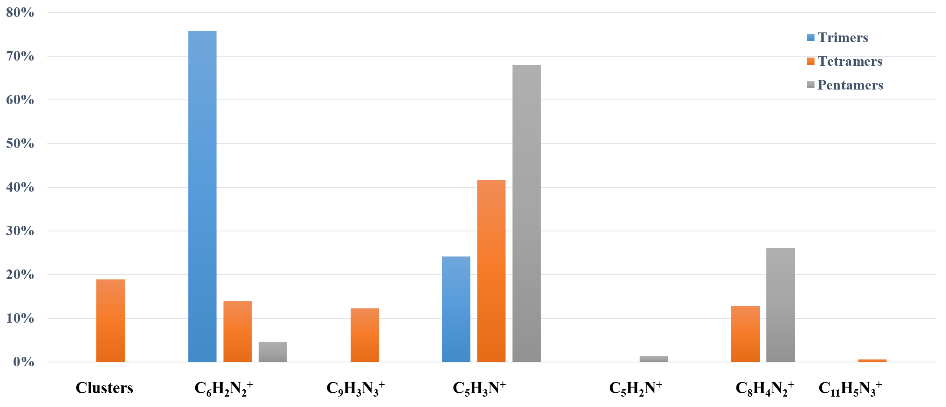

Figure 5: Distribution of the pentamer, tetramer, and trimer structures (in percentages), of mixed clusters containing both acetylene and cyanoacetylene, at the end of the molecular dynamics simulations of clusters containing one unit of acetylene.

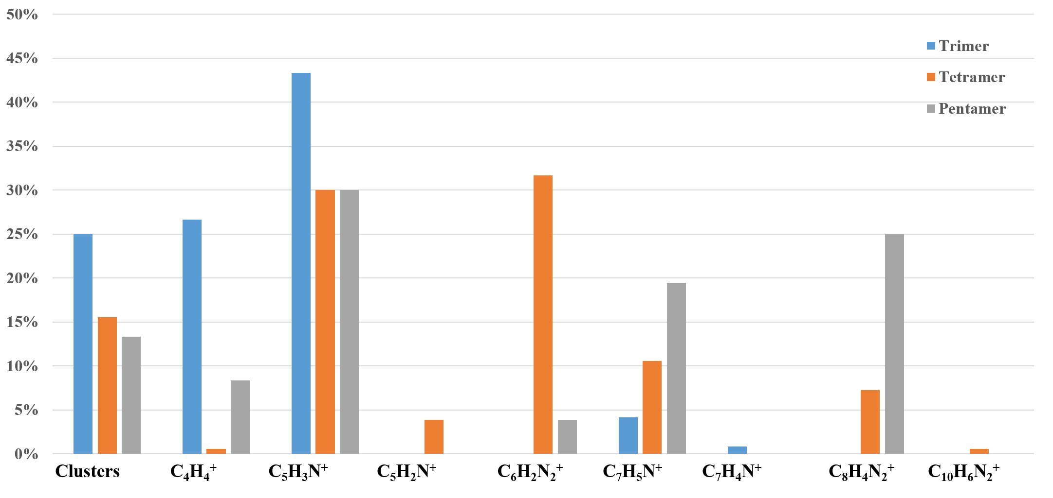

Figure 6: Distribution of the pentamer, tetramer, and trimer structures (in percentages), of mixed clusters containing both acetylene and cyanoacetylene, at the end of the molecular dynamics simulations of clusters containing two acetylene units.

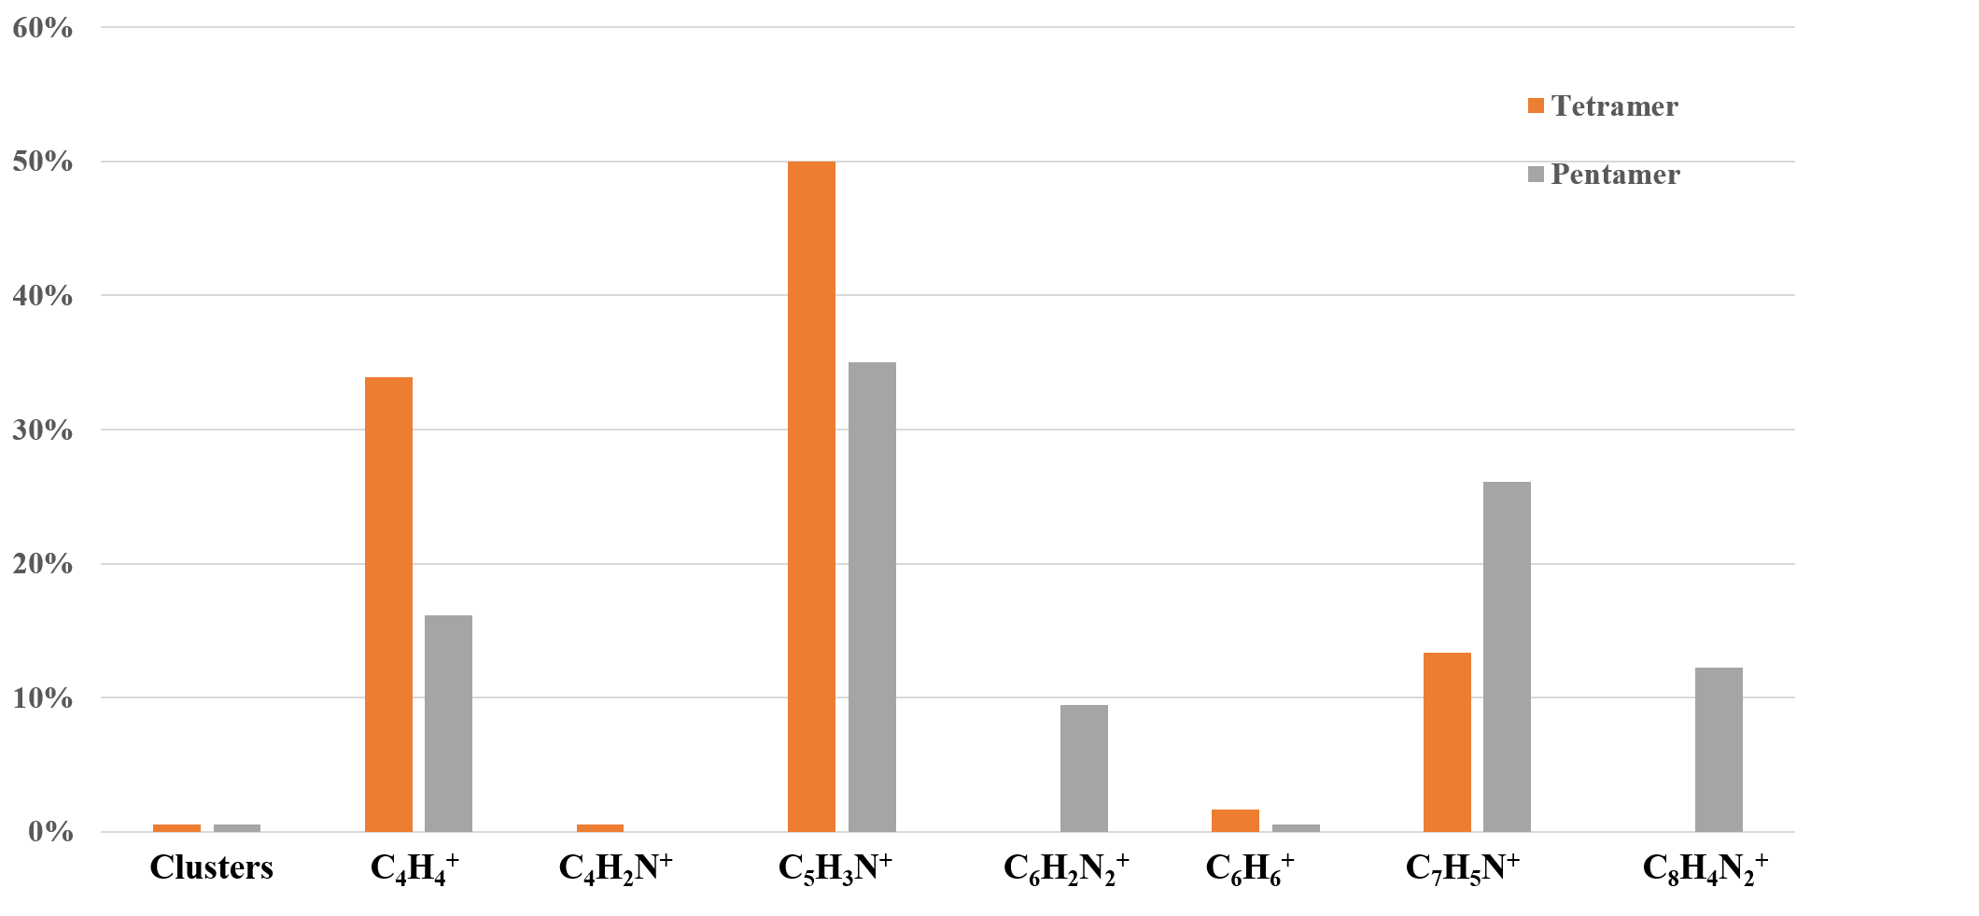

Figure 7: Distribution of the pentamer, tetramer, and trimer structures (in percentages), of mixed clusters containing both acetylene and cyanoacetylene, at the end of the molecular dynamics simulations of clusters containing three acetylene units.

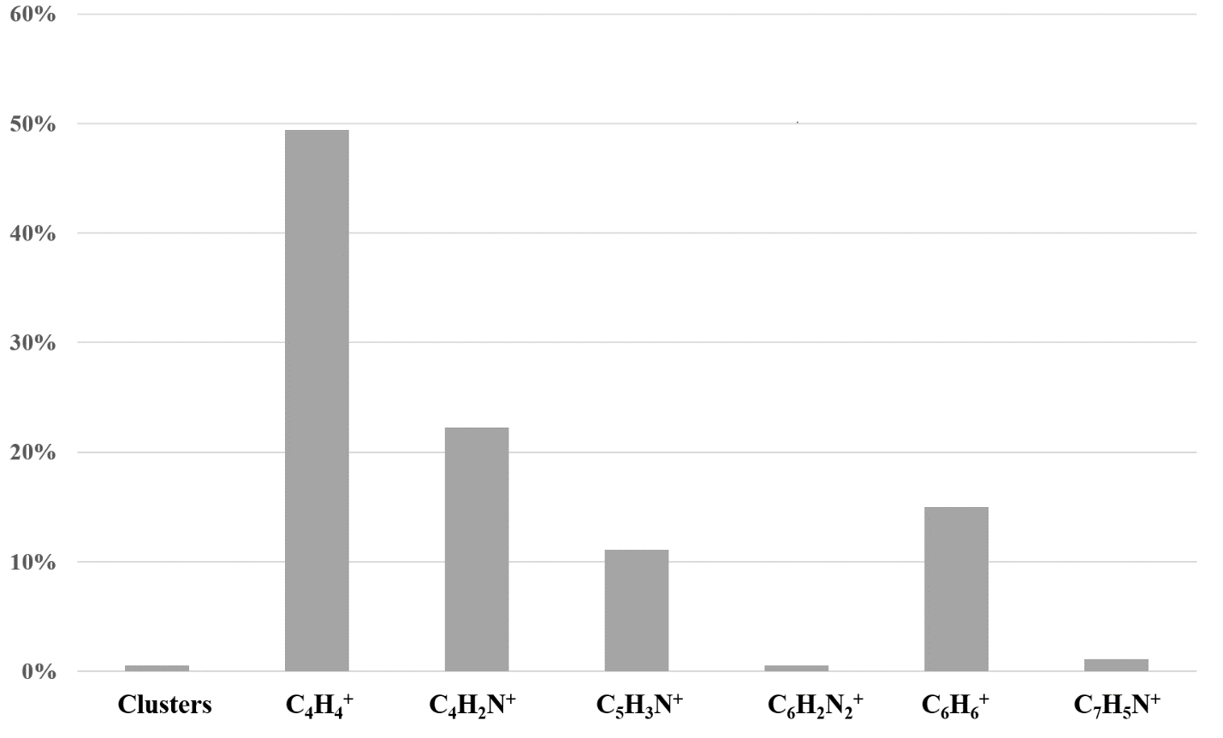

Figure 8: Distribution of the pentamer, tetramer, and trimer structures (in percentages), of mixed clusters containing both acetylene and cyanoacetylene, at the end of the molecular dynamics simulations of clusters containing four acetylene units.

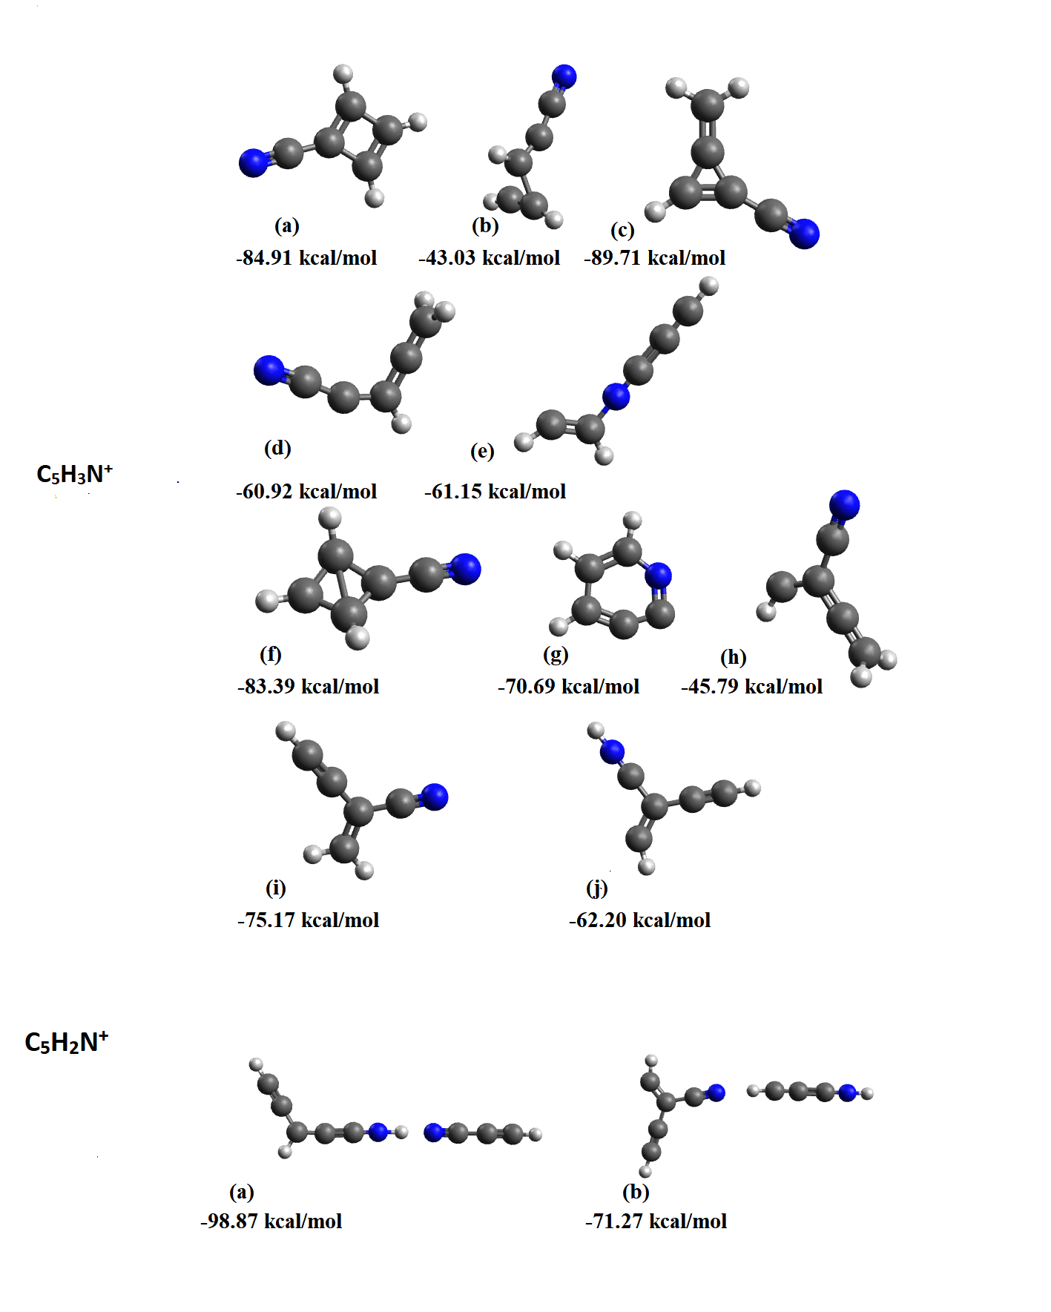

Figure 9: C5H3N+ and C5H2N+ structures obtained from molecular dynamics simulations after optimization. Top: Optimized C5H3N+ structures. Bottom: Optimized C5H2N+ structures. BEs are presented in kcal/mol.

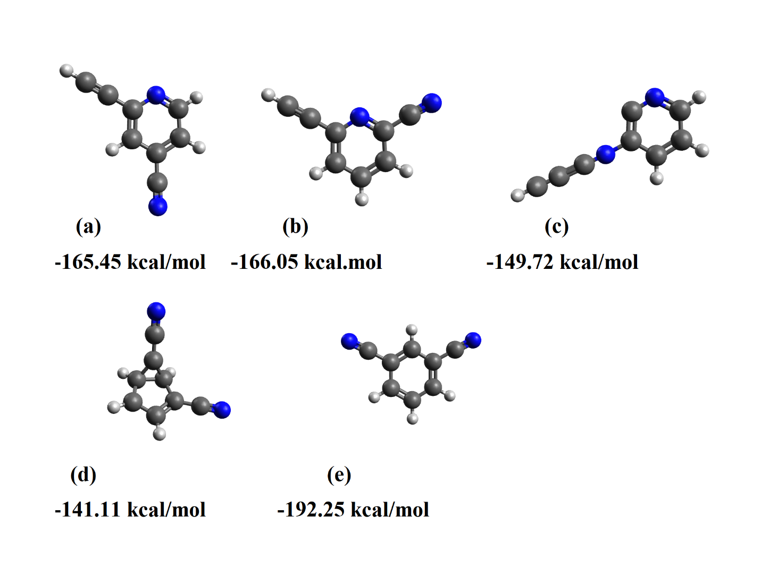

Figure 10: C8H4N2+ cyclic isomers obtained from molecular dynamics simulations after optimization, and their corresponding BEs, presented in kcal/mol.

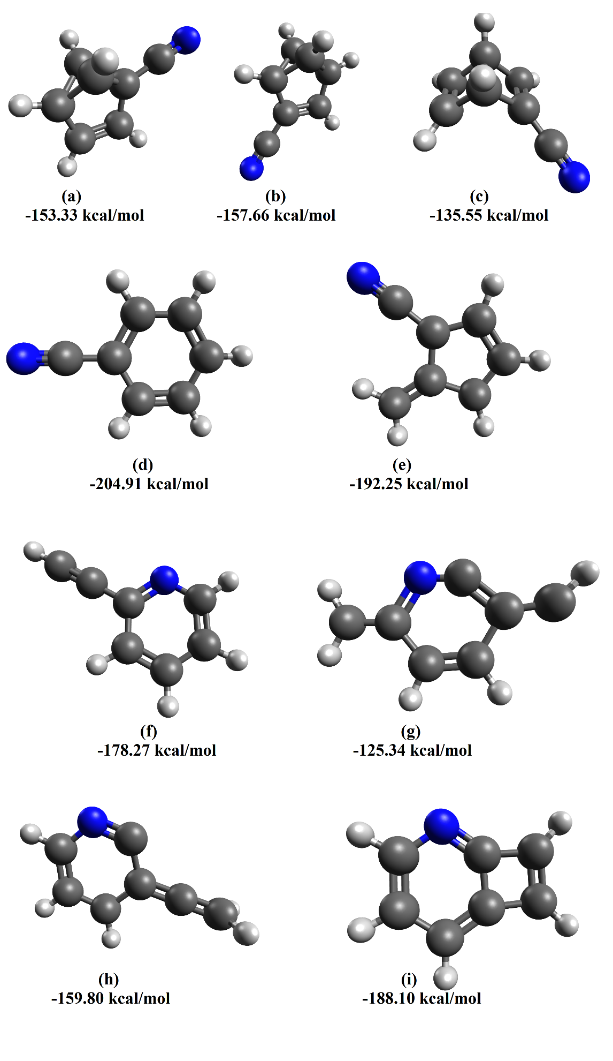

Figure 11: Optimized C7H5N+ structures obtained from AIMD simulations. BEs are presented in kcal/mol.

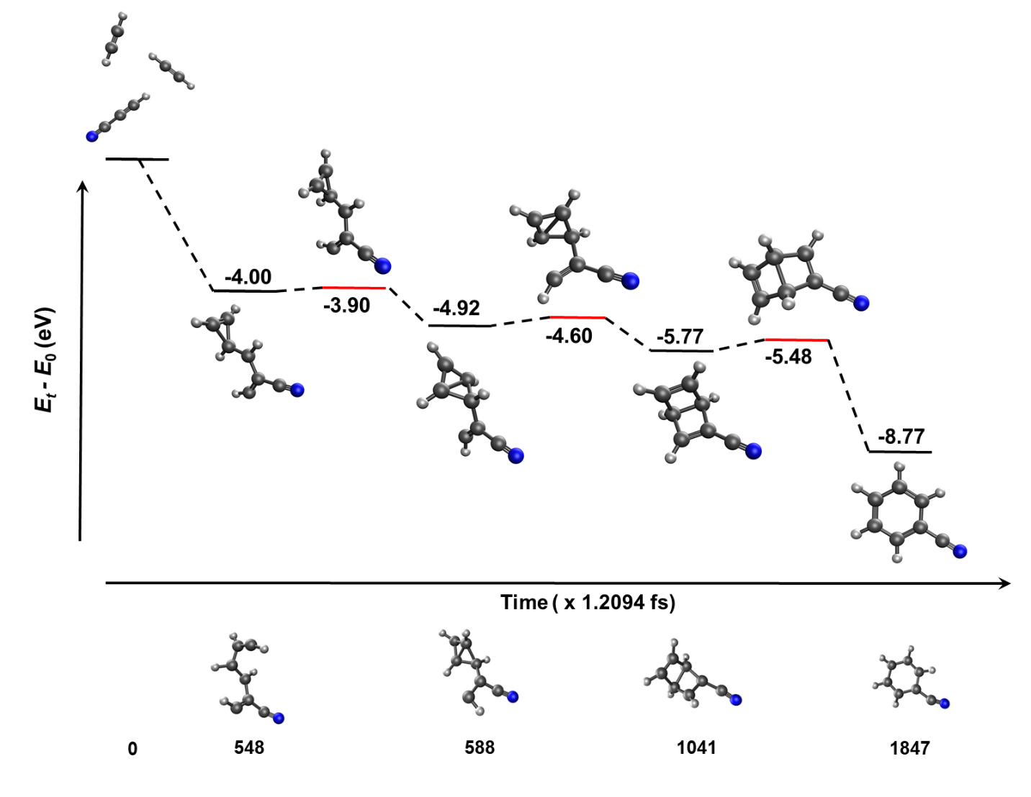

Figure 12: Formation of cyanobenzene upon ionization of trimer clusters containing one cyanoacetylene group. The x-axis presents the change in molecular structure through time (presented in fs), and the y-axis shows the energy of the structure relative to the cluster (in eV). Data were obtained from AIMD simulations.