Analysis and Synthesis of Multiple Input Buck-Boost Converter Topology Implementation by Digital Signal Processor

Eli Flaxer

AFEKA - Tel-Aviv Academic College of Engineering, 69107 Tel-Aviv, Israel

Abstract

This paper analyzes and shows how to synthesize the trigger control for a multiple-input buck-boost (MIBB) converter topology with different voltages at each input source, while an arbitrary value determines the energy diversiﬁcation between the sources in the range of 0%–100%. The full-range linearity of the controller transfer function makes the closed-loop MIBB system behave as a linear single input buck-boost converter. The intelligent switching strategy with a ﬁxed frequency ensures that the system avoids limitations when multiple-input converters operate based on switching period sharing. The analysis is verified by simulations and an experimental setup with two inputs.

Keywords: Buck-Boost Converter; Energy Sharing; Multiple Input Converter.

Introduction
Multiple-Input (MI) converter is a topology that accommodates more than one energy source input and provides at least one output. Although most converters are supplied by one energy source, two power sources or more are needed in some instances, such as uninterruptible power supplies (UPS). Therefore, MI converters are required to enable multiple-source technology. MI energy sources can consume different energy from each source and increase the system's ability, reliability, and performance. Several research studies have analyzed, modeled, and utilized MI converters in applications such as grid-connected integrated hybrid generation systems, fuel cells, micro-grid-based telecom power systems, uninterruptible power supplies, and electric and hybrid electric vehicles [1]–[15]. Some of those works produced a negative reference output, others used a magnetic coupling in the inputs, etc.
The buck-boost converter is a type of converter that has an output voltage magnitude that is either greater than or less than the input voltage magnitude. Actually, it is a converter with a circuit topology similar to both buck and boost converters. The output voltage of this converter can be adjusted by controlling the duty cycle of four switching power transistors.
Multiple-Input Buck-Boost (MIBB) converters have been presented in several works [16]–[25]. In this work, we present a full-bridge topology of MIBB that produces a positive output voltage without magnetic coupling, while the energy diversiﬁcation between the sources is controlled continuously by arbitrary values in the range of 0%–100%. In addition, we show that this model can be linearized and implemented by a digital signal processor (DSP) with pulse width modulation (PWM) units. The linearization of the model to one input parameter allows us to use this converter in open-loop and closed-loop feedback mechanisms.

Circuit Topology
The principal topology of the converter is shown in Figure 1. Each of the five switches S1–S5 is bi-directional and made of an ultra-fast metal-oxide-semiconductor field-effect transistor (MOSFET). A circuit in such a configuration can work in buck or boost mode for each source, V₁ and V₂, independently. The active switches in each mode described above are summarized in Table 1. When there are constraints, the S₄ switch is in the opposite position to the S₅ switch, and the S₃ switch is in the opposite position to both S₁ and S₂ switches (S₄ = !S₅, S₃ = !S₁• !S₂).

Mode | S₁ | S₂ | S₃ | S₄ | S₅
Buck V₁ | P_{H} | Off | P_{L} | On | Off
Buck V₂ | Off | P_{H} | P_{L} | On | Off
Boost V₁ | On | Off | Off | P_{L} | P_{H}
Boost V₂ | Off | On | Off | P_{L} | P_{H}
Table 1: The active switches in each mode of the converter.

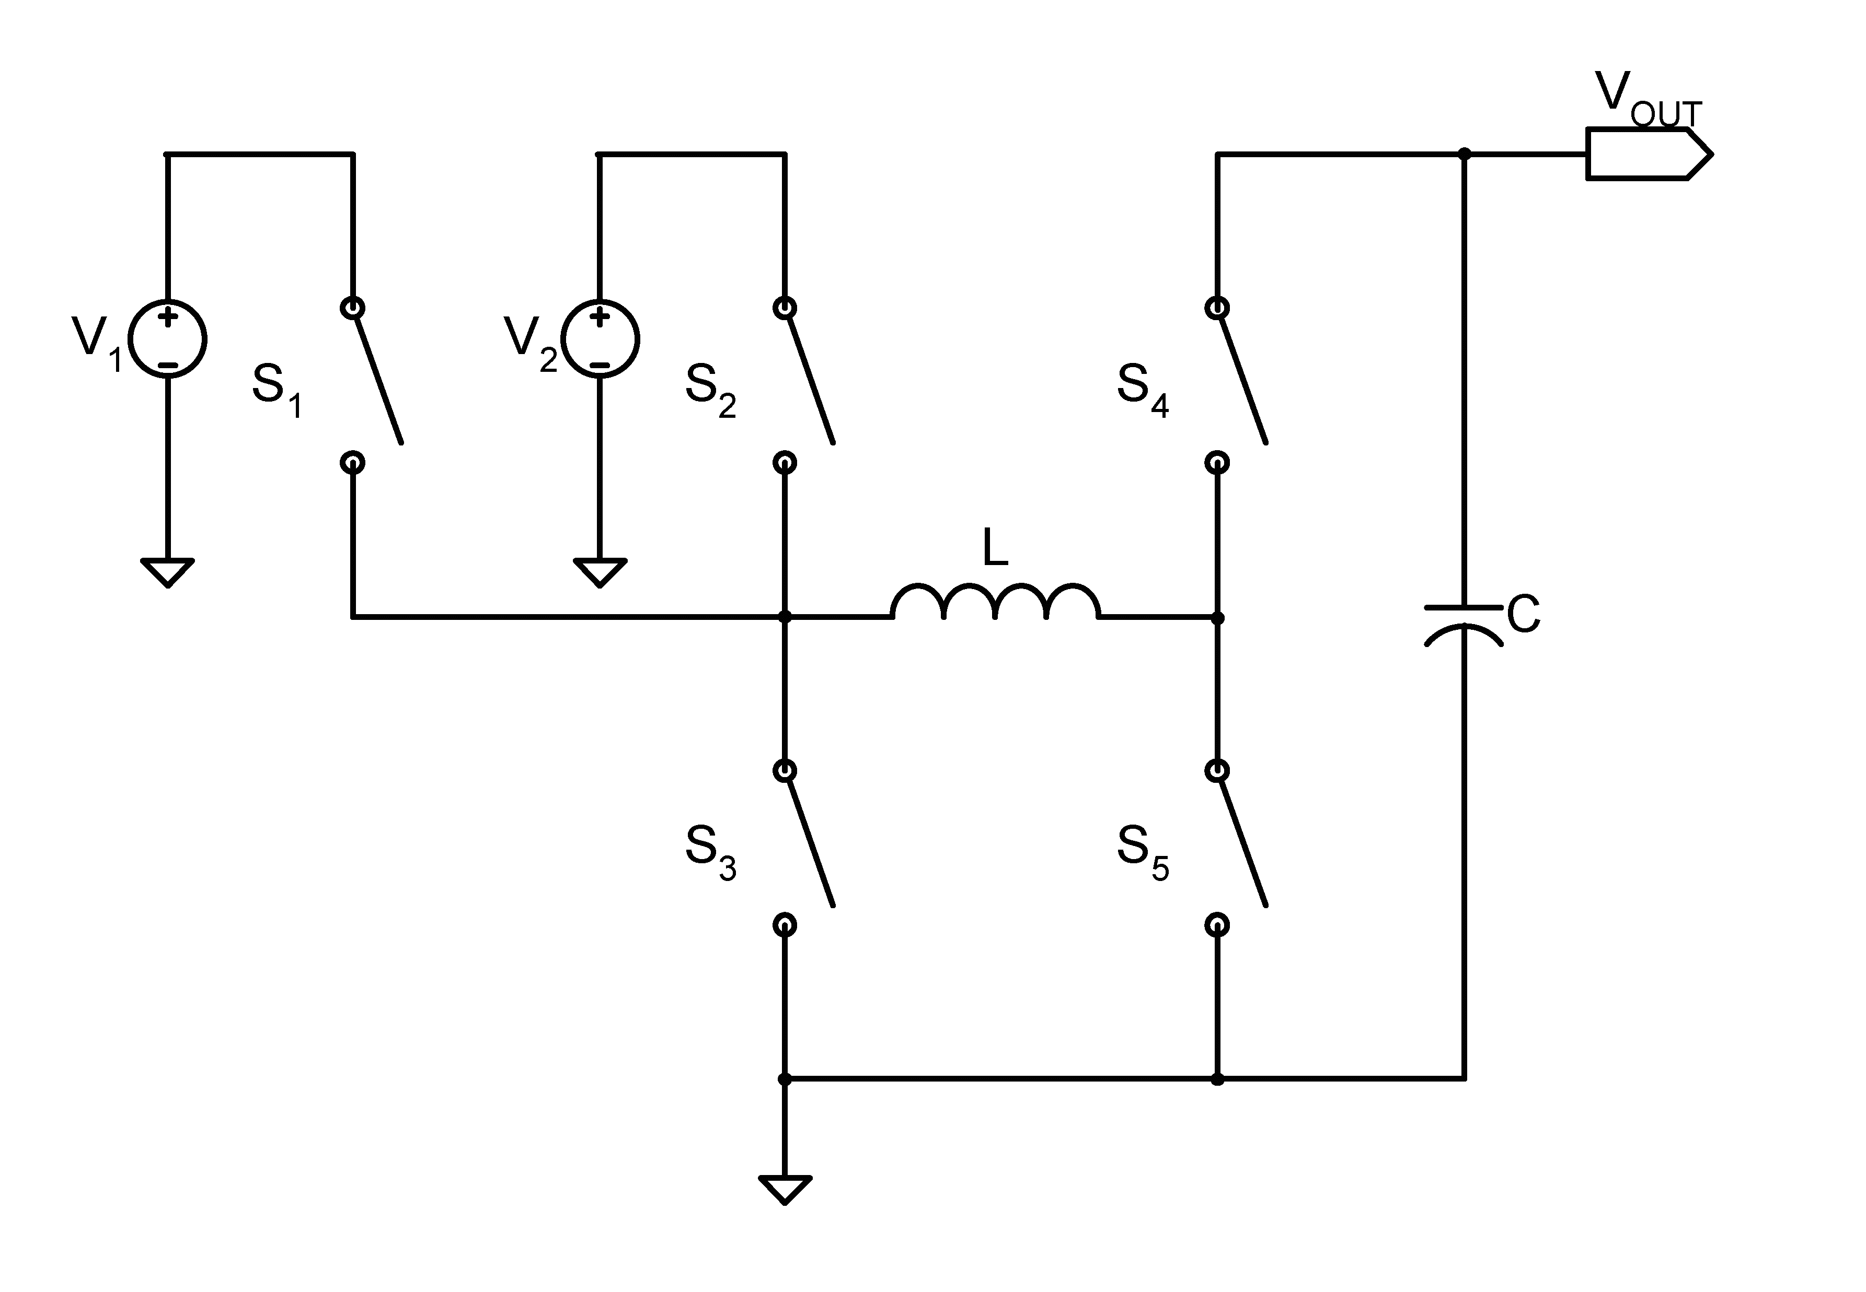
Figure 1: The multiple-input full bridge architecture.
V_{OUT} will calculate from the steady-state condition of the current. Suppose that the inductor induction L is 1 in an arbitrary unit. The charging and discharging currents in the inductor are:

Mode | Charge | Discharge
Buck | (V_{IN} - V_{OUT}) • T_{H} | V_{OUT} • T_{L}
Boost | V_{IN} • T_{H} | (V_{OUT} - V_{IN}) • T_{L}

In the steady-state I_{CHARGE} = I_{DISCHARGE}. In this condition, we get the equations
Mode | Steady State Equation
Buck | (V_{IN} - V_{OUT}) • T_{H} = V_{OUT} • T_{L}
Boost | V_{IN} • T_{H} = (V_{OUT}- V_{IN}) • T_{L}

Suppose that the inductor average current is 1 in arbitrary units. The energy derived from the source per cycle is: in buck mode V_{IN} • T_{H}; in boost mode V_{IN} • T_{T}. Using the above expressions for two sources leads to the following expressions:
Mode (V₁, V₂) | Vout | E₁ | E₂
Buck-Buck | V₁•T_{H1}/T_{T} + V₂•T_{H2}/T_{T} | V₁ • T_{H1} | V₂ • T_{H2}
Boost-Boost | V₁•T₁/T_{L} + V₂•T₂/T_{L} | V₁ • T₁ | V₂ • T₂
Buck-Boost | V₁•T_{H1}/(T₁+T_{L2}) + V₂•T₂/(T₁+T_{L2}) | V₁ • T_{H1} | V₂ • T₂
Boost-Buck | V₁•T₁/(T₂+T_{L1}) + V₂•T_{H2}/(T₂+T_{L1}) | V₁ • T₁ | V₂ • T_{H2}

Where: T_{T} ≡ T₁+T₂, T₁ ≡ T_{H1}+T_{L1}, T₂ ≡ T_{H2}+T_{L2}, T_{L} ≡ T_{L1}+T_{L2}, T_{H} ≡ T_{H1}+T_{H2}

We require that the energy distribution from the two sources be in the ratio of P to (1-P), where P is a real number between 0 and 1. In the limits we get:
P = 0 => E₁ = 100% and E₂ = 0%; P = 1 => E₁ = 0% and E₂ = 100%.
For the above expressions, let us define T_{T} = 1 and calculate the switching times T_{JI}^{MN} by the following function, where all the times are relative to the total periodic time T_{T} of the PWM. Solving the above expressions for T_{H1}, T_{H2}, T_{L1,} and T_{L2} as a function of V_{O}, V₁, V₂, and P gives us all times required for the switching as described in Table 2:

Buck-Buck | V_{O}/V₁ ≤ 1 | V_{O}/V₂ ≤ 1
T_{H1} ^{KK} | (1-P) • (V_{O}/V₁)
T_{H2} ^{KK} | P • (V_{O}/V₂)
T₁ ^{KK} | (1-P)
T₂ ^{KK} | P
Boost-Boost | 1 < V_{O}/V₁ | 1 < V_{O}/V₂
T_{L1} ^{TT} | (1-P) / [P•(V_{O}/V₂) + (1-P)•(V_{O}/V₁)]
T_{L2} ^{TT} | P / [P•(V_{O}/V₂) + (1-P)•(V_{O}/V₁)]
T₁ ^{TT} | (1-P) / [P•(V₁/V₂) + (1-P)]
T₂ ^{TT} | P / [P + (1-P)•(V₂/V₁)]
Buck -Boost | V_{O}/V₁ ≤ 1 | 1 < V_{O}/V₂
T_{H1} ^{KT} | (1-P) / [P•(V₁/V₂) + (1-P)•(V₁/V_{O})]
T_{L2} ^{KT} | P / [P•(V_{O}/V₂) + (1-P)]
T₁ ^{KT} | (1-P) / [P•(V_{O}/V₂) + (1-P)]
T₂ ^{KT} | P / [P + (1-P)• (V₂/V_{O})]
Boost -Buck | 1 < V_{O}/V₁ | V_{O}/V₂ ≤ 1
T_{L1} ^{TK} | (1-P) / [P + (1-P) •(V_{O}/V₁)]
T_{H2} ^{TK} | P / [P•(V₂/V_{O}) + (1-P)•(V₂/V₁)]
T₁ ^{TK} | (1-P) / [P•(V₁/V_{O}) + (1-P)]
T₂ ^{TK} | P / [P + (1-P)• (V_{O}/V₁)]
Table 2: The switching times summary.

Three or four complementary PWM channels can be used to implement the system. We examined the two possibilities and found no significant differences between them except for symmetry differences in switching times. We used three complementary PWM channels to drive the switches (solid-state switches): PWM1A, PWM1B, PWM2A, PWM2B, PWM3A, and PWM3B. The switches are connected to the PWM channels as follows: PWM1A → S₁, PWM2A → S_{2,} PWM3A → S_{5,} (PWM1B & PWM2B) → S_{3,} PWM3B → S₄, where PWMnB = !PWMnA for n = (1,2,3). For each of the three PWM channels, we assigned two values (times): T_{DELAY}, the delay of the pulse and T_{PULSE}, the pulse width, as shown in Figure 2A. The three PWM channels have a common counter and equal periodic time (i.e., the same frequency), so the separation of the pulses within a cycle is determined by T_{DELAY}. The complete time separation and pulse width for all channels for all operation modes are summarized in Table 3 and Figure 2B.
If we want to implement using four channels, the configuration will be as follows: PWM1–PWM4 are connected to the switches as follows: PWM1A → S₁, PWM2A → S_{2,} (PWM3A | PWM4A) → S₅, (PWM1B & PWM2B) → S,; (PWM3B & PWM4B) → S₄, where PWMnB = ! PWMnA for n = (1-4).
Figure 2: a) The pulse timing: T_{DELAY}, the delay of the pulse and T_{PULSE}, the pulse width. b) Summary of the delay time and pulse width for all channels for all operation modes.

Mode | Chan | 1 | 2 | 3 | 3’ | 4’
Buck-Buck  KK | T_{Delay} | 0 | T₁^{KK} | 0 | 0 | 0
Buck-Buck  KK | T_{Pulse} | T_{H1}^{KK} | T_{H2}^{KK} | 0 | 0 | 0
Boost-Boost  TT | T_{Delay} | 0 | T₁^{TT} | T_{L1}^{TT} | T_{L1}^{TT} | T₁^{TT} +T_{L2}^{TT}
Boost-Boost  TT | T_{Pulse} | T₁^{TT} | T₂^{TT} | 1 - (T_{L1}^{TT}+T_{L2}^{TT}) | T₁^{TT} - T_{L1}^{TT} | T₂-T_{L2}^{TT}
Buck-Boost  KT | T_{Delay} | 0 | T₁^{KT} | T₁^{KT} | T₁^{KT} | 0
Buck-Boost  KT | T_{Pulse} | T_{H1}^{KT} | T₂^{KT} | 1 - (T₁^{KT} +T_{L2}^{KT}) | 1 - (T₁^{KT} +T_{L2}^{KT}) | 0
Boost-Buck  TK | T_{Delay} | 0 | T₁^{TK} | 0 | 0 | 0
Boost-Buck  TK | T_{Pulse} | T₁^{TK} | T_{H2}^{TK} | 1 - (T₂^{TK} +T_{L1}^{TK}) | 1 - (T₂^{TK} +T_{L1}^{TK}) | 0
Table 3: The complete time separation and pulse width for all channels for all operation modes. When using 3 PWM channels, the actual columns are (1,2,3); when using 4 PWM channels, the actual columns are (1,2,3’,4’).

SPICE Simulation
After calculating the pulse switching and triggering times for each channel, we tested the model with a SPICE simulator. In the SPICE model, we have written scripts that calculate all the relevant times for each of the converter modes depending on V_{O}, V₁, V₂, and P. We used the calculation results to define 5 pulse sources (vpulse) that drive 5 controllable switches according to Figure 2, where L= 10 µH and C=100 µF. We determine V₁ = 100 V, V₂ = 60 V, and P = 0.5. Using the parametric sweep with a switching frequency of 150 kHz, we increase the output voltage Vo from 20 V to 150 V in increments of 10 V, while the converter switches from buck-buck mode to buck-boost mode to boost-boost mode automatically. Figure 3 shows the overall simulation result. It can be seen from the figure that the converter is stabilized at less than 1 ms at all voltages from 20 V to 150 V, while the transitions from mode to mode occur continuously and smoothly.
Figure 3: The SPICE simulation result. The converter stabilizes at all the voltages from 20 V to 150 V, while the transitions from mode to mode occur continuously.
Linearization of the System
After showing that the converter can operate continuously in the transition between all modes, we wanted to show that the system is completely linear in the transfer function. Since the converter calculates the switching times of the pulses to any required V_{O} and continuously produces output voltage for each required value, the voltage produced by the converter V_{OUT} is linear in the V_{O} parameter. Keeping V₁, V₂, and P constant, the output voltage is then - V_{OUT} = K• V_{AA}, where K is a single real number with a value between 0 and N, and V_{AA} = (1-P)•V₁ + P•V₂. To test the linearity of the model, we wrote a C program that calculates all the switching times for each desired output voltage. Using the expressions from the SPICE model (discussed above), we calculated the actual output voltage by the switching time values. We ran the model on 100 different K values between 0 and 2 with an increment of 0.02. Figure 4 shows the simulation results for V₁ = 100, V₂ = 60 V and P = 0.5. From the figure, it can be clearly seen that the output voltage increases from 0 V to 160 V linearly while passing through the various modes of work from buck-buck mode to buck-boost mode to boost-boost mode automatically. It can also be seen that the density of the dots on the line is uniform. Such a linear behavior of the transfer function allows the implementation of a simple and stable closed-loop control.

Figure 4: The linearity simulation results for V₁ = 100, V₂ = 60 V and P = 0.5. It can be seen that the output voltage increases from 0 V to 160 V linearly while passing through the various modes of work from buck-buck mode (red) to buck-boost mode (green) to boost-boost mode (blue) automatically.
Hardware and Embedded Software Design
In order to build the model in practice, we used a microcontroller to implement the gate pulses. The microcontroller we chose is a Texas Instruments [26] TMS320F28335 150 MHz DSC. This controller includes a floating-point unit (FPU). This unit is essential for real-time calculations of all parameters and contains 512 KB of Flash memory for programming and 68 KB of SRAM for the data. It has 16 fast analog to digital converter (ADC) channels and a wide range of peripheral units. In particular, this controller includes several channels of high-resolution pulse width modulation (HRPWM) with a pulse width resolution of 130 ps. The HRPWM unit has a trip zone (TZ) mechanism to give continual protection over the current and short circuit in the load.
In addition to the TZ, the microcontroller has a dad band (DB) mechanism designed to drive switches in the full bridge architecture. We used three (or four) complementary HRPWM channels of the DSC (PWM1, PWM2, PWM3, PWM4) to trigger the gate driver. To determine the pulse delay and its width, we used the COMPA and COMPB registers in the PWM unit of the microcontroller. All PWM outputs are routed to gates via Lattice [27] CPLD to allow flexibility in the circuit logic and change routing by the software. The Code Composer Studio 8.0 (CCS) environment and ANSI C were used to write the embedded program; Lattice Diamond and VHDL were used to write the CPLD code for simulation and synthesis. We also included voltage and current amplifiers in the circuit to sample the voltages and currents of the input and output by the controller ADC. In order to maintain flexibility in the selection of switching devices, we decided to split the electric circuit into two partial builds on two separate printed circuit boards (PCB). One PCB includes the digital control consisting of the CPU and CPLD, and the second PCB includes the analog switching devices, capacitors, coils, auxiliary power supply, and other devices. Figure 5 shows the PCB of the digital circuit with all its components.
The switching frequency of the PWM is set to 150 kHz, or in other words, to a period of 6.6 microseconds. The processor operates at a frequency of 150 MHz so that in each PWM period there are 1000 CPU clock cycles. Since our RISC processor executes each command in one clock cycle and floating-point commands in two cycles, hundreds of calculation and conditioning commands can be executed in each PWM period. In this way, the operation of the system can be updated in real-time without any restriction. If closed-loop control is used, the control mechanism can be updated at the PWM switching rate.
It is important to note that most DSPs do not contain division instructions but rather multiplication commands in addition to addition and subtraction. If a division command is used in writing the code, the command will be translated into a subroutine with tens or hundreds of machine instructions; and execution may take longer than a microsecond. To avoid this, one must replace the division commands with multiplication commands using the inverse (x/y → x*(1/y). The inverse command must be implemented using the intrinsic function, which is usually executed very fast.

Figure 5: The PCB of the control unit with all its components. The connector at the top connects to the analog power unit, which has all the switches, coil capacitors, etc.

To implement the switches, we used an SPP17N80C3 from Infineon.

Results
To communicate with the converter, a control application was written using the National Instrument [28] Lab Windows CVI environment, which has full compatibility with ANSI C. The program running on a PC connects to the microcontroller via the RS-232 port. It can determine the desired output voltage V_{O} and the division ratio P when the actual voltage values, V_{OUT}, V₁, and V₂ are measured by the microcontroller analog to digital converters after attenuation of 100. Figure 6 shows the GUI of the control software. The software enables scanning voltages from Start voltage to Stop voltage at Step volt, with a delay of 100 milliseconds between the setpoints.
We used 72 V (six 12 V batteries) for V₁ inputs and 48 V (four batteries of the same type) for V₂ inputs. Using the software mentioned above, we scan the desired output voltage from start voltage of 0 V to stop voltage of 100 V, in steps of 1 V and delay of 100 milliseconds, when the P factor is 0.5. The figure shows a consistent and linear increase in the measured output voltage.

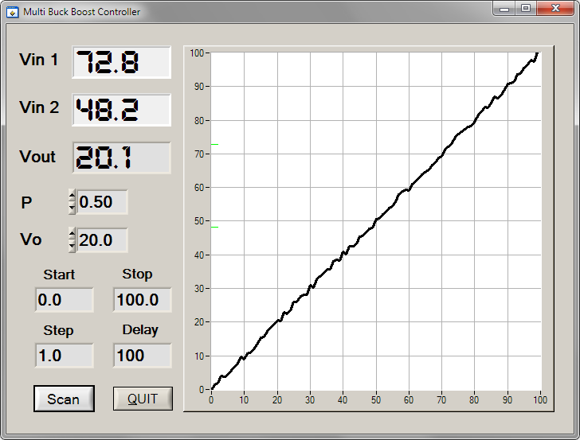
Figure 6: The GUI of the control software. The software enables scanning voltages from Start voltage to Stop voltage at Step volt, with a varied delay. When V₁=72 V and V₂=48 V, scan the desired output voltage from 0 V to 100 V in steps of 1 V, when the P factor is 0.5. The graph shows a consistent and linear increase in the measured output voltage.

Conclusion
This work showed how to use a microprocessor with PWM units to implement a Multiple Input Buck-Boost Converter. We have shown that it is possible to linearize the system and thus use the converter in an open-loop or closed-loop control. The response time of the controller is faster than microseconds and therefore allows high-speed real-time control.
References
[1] B. G. Dobbs and P. L. Chapman, "A multiple-input dc–dc converter", IEEE Power Electron Lett., vol. 1, p. 6, 2003.
[2] A. D. Napoli , F. Crescimbini , S. Rodo and L. Solero, "Multiple input DC–DC power converter for fuel-cell powered hybrid vehicles", Proc. IEEE 33rd Power Electron. Spec. Conf., vol. 4, p. 1685, 2002.
[3] L. Solero, A. Lidozzi and J. A. Pomilio, "Design of multiple-input power converter for hybrid vehicles", IEEE Trans. Power Electron., vol. 20, p. 1007, 2005.
[4] H. Matsuo, L. Wenzhong, F. Kurokawa, T. Shigemizu and N. Watanabe, "Characteristics of the multiple-input dc–dc converter", IEEE Trans. Ind. Electron., vol. 51, p. 625, 2004.
[5] H. Matsuo, T. Shigemizu, F. Kurokawa and N. Watanabe, "Characteristics of the multiple-input dc–dc converter", Proc. 24th IEEE Power Electron. Spec. Conf., p. 115, 1993.
[6] G. J. Su, F. Z. Peng and D. J. Adams, "Experimental evaluation of a soft-switching dc–dc converter for fuel cell applications", Proc. IEEE Conf. Power Electron. Transp., p. 39, 2002.
[7] L. Solero, "Performance of a 10 kW power electronic interface for combined wind/PV isolated generating systems", Proc. IEEE PESC 1996, p. 1027
[8] F. Caricchi, "Testing of a new dc–dc converter topology for integrated wind-photovoltaic generating systems", Proc. Eur. Conf. Power Electron. Appl., p. 83, 1993.
[9] D. Liu and H. Li, "A novel multiple-input ZVS bidirectional dc–dc converter", Proc. IEEE 32nd Annu. Conf. Ind. Electron. Soc., p. 579, 2005.
[10] Y. M. Chen, Y. C. Liu, and F. Y. Wu, "Multi-input dc/dc converter based on the multiwinding transformer for renewable energy applications", IEEE Trans. Ind. Appl., vol. 38, p. 1096, 2002.
[11] N. Benavides and P. L. Chapman "Power budgeting of a multiple-input buck–boost converter", IEEE Trans. Power Electron., vol. 20, p. 1303, 2005.
[12] A. Kwasinski and P. T. Krein, "A microgrid-based telecom power system using modular multiple-input dc–dc converters", Proc. IEEE 27th Int. Telecommun. Conf., p. 515, 2005.
[13] M. Marchesoni and C. Vacca, "New dc–dc converter for energy storage system interfacing in fuel cell hybrid electric vehicles", IEEE Trans. Power Electron., vol. 22, p. 301, 2007.
[14] Y. Chen, C. Cheng, and H. Wu, "Grid-connected hybrid PV/wind power generation system with improved dc bus voltage regulation strategy", Proc. IEEE 21st Annu. Appl. Power Electron. Conf. Expo., p. 1088, 2006.
[15] F. Caricchi, F. Crescimbini, C. Giulii and L. Solero, "Study of bi-directional buck-boost converter topologies for application in electrical vehicle motor drives", Proc. IEEE 13th Appl. Power Electron. Conf., p. 287, 1998.
[16] Khaligh, J. Cao and Y. Lee, "A Multiple-Input DC-DC Converter Topology”, IEEE Trans. Power Electronics, vol. 24, pp. 862–868, March 2009.
[17] Onwchekwa, Chimaobi and Kwasinski Alexis, "Analysis of boundary control for a multiple-input DC-DC converter topology" Applied Power Electronics Conference and Exposition (APEC), 2011 Twenty-Sixth Annual IEEE.

[18] Nguyen Son, Yuk Kelvin, Amirtharajahl Rajccvan, “Pulse Skipping Modulation Method for Multiple Input Buck-Boost Converter”, IEEE 19th Wireless and Microwave Technology Conference 2018.
[19] Kim, Jeongtae; Bae, Sungwoo, “High Efficient Multiple-Input Positive Buck-Boost Converter”, 9th Annual IEEE Energy Conversion Congress & Exposition (ECCE), Cincinnati, OH, OCT 01–05, 2017.
[20] Bae, Sungwoo; Yun, Jae-Jung, “High Efficient Multiple-input Buck-Boost Converter for Energy Harvesting Systems”, IEEE International Conference on Consumer Electronics (ICCE), Las Vegas, NV, JAN 07–11, 2016.
[21] Hashiguchi Takuto, Abe Seiya, Matsumoto Satoshi, “A fully digitally controlled multiple input and output voltage buck-boost POL for power supply on chip”, IEEE International Telecommunications Energy Conference (INTELEC), Namba, Peoples R China, OCT 18–22, 2015.
[22] Ding Guanyu, Kwasinski Alexis, “Digital constant on-time controlled Multiple-input buck and buck-boost converters”, 28th Annual IEEE Applied Power Electronics Conference and Exposition (APEC), Long Beach, CA, MAR 17–21, 2013
[23] Onar Omer Caglar, Shirazi Omid Hajiamin, Khaligh Alireza, “Grid Interaction Operation of a Telecommunications Power System With a Novel Topology for Multiple-Input Buck-Boost Converter”, IEEE Transactions On Power Delivery, vol. 25, no. 4, pp: 2633–2645, 2010.
[24] Khaligh Alireza, “A multiple-input dc-dc positive buck-boost converter topology”, 23rd Annual IEEE Applied Power Electronics Conference (APEC 2008), Austin, TX, FEB 24–28, 2008.
[25] Benavides N D, Chapman P L, “Power budgeting of a multiple-input buck-boost converter”, IEEE Transactions On Power Electronics vol. 20, no. 6, pp. 1303–1309, 2005.
[26] Texas Instruments: http://www.ti.com.
[27] Lattice Semiconductor: https://www.latticesemi.com
[28] National Instrument: http://www.ni.com

