Principal Investigator Names:  Illana Gozes; Shani Stern; Shlomo Wagner; Assaf Zinger | Principal Investigator Institutions:  Tel Aviv University; University of Haifa; Technion, Israel Institue of Technology | Principal Investigator Emails:  igozes@tauex.tau.ac.il; sstern@univ.haifa.ac.il; shlomow@research.haifa.ac.il; assafzinger@gmail.com;
Project Title  Treating ASD with mRNA Biomimetic Nanoparticles: ADNP-Syndrome Case Study |  | Proposal Type:  2022 Genomics of ASD: Pathways to Biological Convergence and Genetic Therapies
Are biospecimens, data or patient recruitment from a Simons Collection (i.e., SSC, Simons Searchlight, SPARK, AIC) being requested in this application? No
(already available).

PROPOSAL NARRATIVE
Scientific Background: ASD is a group of neurodevelopmental conditions characterized by persistent deficits in social behavior and the manifestation of repetitive and stereotypic patterns of behaviors with no pharmacological treatments available to treat these core symptoms (Lord et al., 2018). ASD is considered to be highly affected by genetic factors (Woodbury-Smith and Scherer, 2018); About 5-10% of the ASD diagnoses can be identified with a specific etiology in clinical genetics and they are termed syndromic ASD (Sztainberg and Zoghbi, 2016). Nevertheless, distinct mutations of the same gene may cause different etiologies and symptoms (Fernandez and Scherer, 2017). These may be related to the fact that many mutations not only lead to insufficient level of functional protein but also yield a truncated form of it, which may prevent appropriate activity of the functional form (dominant-negative effect). Therefore, it seems as if the most effective way to develop a treatment for syndromic ASD cases is through a personalized genetic approach, by targeting both the genetic haploinsufficiency and the possible dominant-negative effects. Coping with COVID19 pandemics demonstrated that mRNA holds the promise to transform clinical applications such as immunizations, therapy of genetic disorders, and protein replacement therapies (Pilishvili et al., 2021). The delivery of mRNA and its expression in the brain are the key factors in optimizing specific therapeutic applications (Magadum et al., 2019, Martini and Guey, 2019). Thus, syndromic ASD cases may benefit from the delivery of mRNA that encodes the functional protein as well as siRNA that inhibits the production of the truncated protein. Among the various strategies developed for efficient mRNA delivery to the brain in vivo, nanoparticles (NP) stand as the most frequently used non-viral means. The NP technology holds the merits of efficiently binding and condensing RNA, protecting it against degradation in the extracellular space, and localizing the payload to the membrane of the desired target cell, followed by cellular uptake and endosomal escape into the cytosol (Cullis and Hope, 2017). Zinger's research team recently designed neurons’ biomimetic NP to enhance selective targeting of nerve cells (Fig. 1). We hypothesize that such neurons’ biomimetic NP may provide an effective way to develop a tailored treatment for syndromic ASD patients, by delivering both mRNA and siRNA to the brain. This novel strategy may be tested by employing models that are directly related to the specific case under examination. Such models may be either patient-derived induced pluripotent stem cells (iPSCs) or animal models that mimic the specific mutation associated with the patient’s etiology. Here we plan to use both models in parallel.
Activity-dependent neuroprotective protein (ADNP) syndrome, also known as the Helsmoortel Van Der Aa syndrome, is a rare condition diagnosed in children exhibiting autistic traits, developmental delays and intellectual disabilities (Helsmoortel et al., 2014, Gozes et al., 2017a, Gozes et al., 2017b, Levine et al., 2019, Van Dijck et al., 2019, Grigg et al., 2020, Levine et al., 2022). The syndrome occurs when one of the two copies of the ADNP gene is de novo mutated (mostly STOP or frameshift mutation), resulting in loss of normal functions (Van Dijck et al., 2019, Gozes and Shazman, 2022). When the mutation is close to the ADNP start codon, the child will present a haploinsufficient loss-of-function phenotype. Indeed, Adnp^{+/−} mice (Vulih-Shultzman et al., 2007) suffer from slower axonal transport (Amram et al., 2016) and impaired dendritic spines, learning and memory deficiencies, muscle weakness, and communication problems, mimicking the human condition (Malishkevich et al., 2015, Hacohen-Kleiman et al., 2018, Hacohen-Kleiman et al., 2019, Sragovich et al., 2019, Kapitansky et al., 2020b) (Table 1). Similarly, heterozygous Adnp Tyr mice carrying p.Tyr718* mutation, the homolog of the most prevalent human pTyr719* mutation (almost halving the mutated protein) show delayed development, aberrant gait, and early brain tauopathy coupled to anomalous visual evoked potential (Karmon et al., 2022). The ADNP microtubule-interacting fragment NAP (davunetide, CP201) (Bassan et al., 1999, Gozes, 2020) resolves, in part, ADNP deficiencies and protects against ADNP pathogenic sequence variant abnormalities in mouse (above) and humanized cell models (Mollinedo et al., 2019, Grigg et al., 2020, Ivashko-Pachima et al., 2021) (with mouse ADNP presenting 90% identity to the human ADNP) (Zamostiano et al., 2001) (Tables 2 & 3). Having all the models at hand, we present an advantage for testing a direct gene-therapy strategy for treating ADNP syndrome cases by inhibiting the potential toxic allele expression by RNA silencing (using siRNA) while replenishing this pathogenic allele with healthy ADNP mRNA. A lead ASD gene (Larsen et al., 2016), essential for brain formation (Pinhasov et al., 2003), interacting/regulating key autism genes (Ivashko-Pachima et al., 2022), ADNP-directed therapy will serve as a prototype for ASD therapeutics, further compared to pharmacological intervention and paving the path for treatments directed to other syndromes.
Team: Our team includes four PIs with different and complementary expertise as follows. Professor Illana Gozes (IG, Tel Aviv University), the discoverer of ADNP and NAP, an expert translational neuroscientist. Professor Shlomo Wagner (SW, Haifa University), an expert for in vivo electrophysiology in social behavior and animal models of autism. Dr. Shani Stern (SS, Haifa University), an expert in differentiating patient-derived pluripotent stem cells to neurons and organoids and electrophysiology and Dr. Assaf Zinger (AZ, Technion), an expert in producing biomimetic nanoparticles and their translational use for RNA delivery into the brain. Importantly, NAP (dauvnetide) and related ADNP technologies are exclusively licensed to ATED Therapeutics Ltd (IG, Chief Scientific Officer), which is developing ADNP-based therapies, targeting first the ADNP syndrome. With the discovery of potential pipeline-therapeutics proposed here, ATED will be ready for direct clinical translation of the proposed study’s findings.
Aim: We propose a synergistic effort of our labs to develop, validate and test a cutting-edge, gene-therapy strategy for the ADNP syndrome, based on RNA-encapsulating biomimetic NP. This strategy will be tested on the most prevalent human de novo mutation of the ADNP gene (Tyr719*), as well as on haploinsufficiency cellular and animal models, and its results will be directly compared with pharmacological NAP treatment. We hypothesize that the deteriorating effects of ADNP mutations may arise from both a reduced dose of functional ADNP protein and dominant-negative effect of the mutated protein. Thus, delivering mRNA of functional protein may not be enough to correct all the effects of the mutation, and a complementary inhibitory RNA strategy should be employed as well. To challenge this hypothesis, we will examine the effects of using NP for delivering either siRNA against the mutated allele, mRNA of the functional allele, or both siRNA and functional RNA together, to each one of the models.
Preliminary results:
ADNP models and NAP treatment (IG): As stated in the Introduction, we (IG) are well positioned with cellular (Table 2) and unique animal models of the ADNP syndrome (Table 3) mimicking the human condition (Table 1) and responsive to pharmacological intranasal NAP treatment. We further have evidence that healthy ADNP overexpression is tolerated (Ivashko-Pachima et al., 2021), and that ADNP self-regulates its own promoter (Mandel et al., 2007, Aboonq et al., 2012). Using advanced RNA-seq, and gene expression profiling, we have shown that ADNP is a master regulator of critical gene expression, corrected, in part, by NAP treatment (Tables 2 & 3). While we have evidence of shared phenotype between distinct ADNP mutations, we also have indications of differences, given the size and multiple active sites on the ADNP molecule (Ivashko-Pachima et al., 2022). Most importantly, we see a gain of toxic function in the newly developed heterozygous Adnp p.Tyr718* (Tyr) mice (Karmon et al., 2022). These findings are extended to our novel CRISPR/Cas9 DNA-edited neuroblastoma cell lines expressing two different green fluorescent protein (GFP)–labeled mutated ADNP proteins (p.Tyr718* and p.Ser403*). These cells exhibit unique gain of toxic phenotypes, with p.Tyr718* (mutated at the nuclear localization motif) showing diffused cellular distribution (unclear nuclear boundaries) in comparison to the control GFP-labeled ADNP as well as p.Ser403*, even in DMSO-differentiated neuronal-like cells. However, NAP + DMSO corrected this abnormal phenotype (Figs. 2-3). Complementing these cell cultures, we (IG) have studied multiple patient-derived lymphoblatoid cells (LCLs, Tables 1-2), including, but not limited to the human homologue of p.Tyr718*, namely, p.Tyr719* e.g. (Karmon et al., 2022), these cells are available to us (IG) and SS through Simon Simplex Collection (SSC08311). Furthermore, p.Tyr719* iPSC cells (and relevant controls) are also available, if needed, through collaboration with a leading group in Spain (Mollinedo et al., 2019, Montes et al., 2019, Yan et al., 2022).
iPSCs (SS): Electrophysiological recordings were conducted at our (SS) lab from cortical and hippocampal neurons derived from patients with other ASD-associated mutations, such as the c.3679insG Shank3 and c.2065G>T GRIN2B (Fig. 4). Already at 2.5-wk post-differentiation, representing an early developmental stage, we observed neurophysiological irregularities. At this stage, control cells are immature, display a small sodium current and cannot evoke action potentials, while both Shank3 and GRIN2B mutant neurons develop faster, exhibiting more significant potassium and sodium currents and more evoked action potentials. We (SS) have reported a similar phenotype in IQSEC2 mutant hippocampal neurons (Brant et al., 2021) and in WWOX mutant cortical organoids (Steinberg et al., 2021), both compared to CRIPSR/Cas9 corrected-controls. These observations suggest a convergent phenotype of cortical and hippocampal neurons derived from ASD patients. Notably, IG has reported sex and age-dependent regulation of ion channels by ADNP, as specifically indicated in the hippocampus of the Adnp^{+/-} mouse (Amram et al., 2016).
Animal models - correlating electrophysiological with social activity in behaving mice (SW): We (SW) used chronically implanted electrode arrays to explore the activity of 18 social behavior-associated brain regions in ICR mice (background strain of the Adnp^{+/-} mice (Hacohen-Kleiman et al., 2018), now expanded by IG to the p.Tyr718* (Tyr) mice). Conducting three distinct social discrimination tasks: social preference (SP), emotional state preference (ESP) and sex preference (SXP), we (SW) found that each task elicited a distinct profile of local field potential (LFP), as analyzed using power spectral density (PSD) analysis (Fig. 5A-C). When separately analyzing the theta (4-12 Hz) and gamma (30-80 Hz) rhythms, we observed a different pattern of power change across the various regions for each task (Fig. 5D-G). By analyzing the power change in synchronization with the distinct investigation bouts, separately for each of the stimuli, we found that distinct brain regions showed different pattern of stimulus-specific responses at the various tasks (Fig. 6A-F). Furthermore, analysis of the coherence between the various brain regions demonstrated a distinct pattern of coherence change during each task, although no difference between the tasks was observed before stimulus insertion (Fig. 6G-K). Altogether, these results reveal a unique pattern of brain activity at the system level for each of the tasks. To further explore this possibility, we (SW) are now using Neuropixel probes to record single-unit activity from hundreds of neurons at a time in specific brain areas, during the various tasks (Fig. 7). Moreover, while conducting similar recordings from Cntnap2^{-/-} mice, a well-established mouse model of ASD which exhibit impaired ESP behavior (Fig. 8A), we found general changes in both theta and gamma rhythmicity in the mutant (MT) mice, as compared to wild-type (WT) littermates (Fig. 8B-D). Specifically, we observed changes in neural activity in the nucleus accumbens, medial amygdala and infralimbic prefrontal cortex (Fig. 8E-G). These data suggest that the neural activity associated with the impaired social behavior is differentially distributed in brain of MT and WT mice, specifically in these brain regions, which were previously implicated in ESP (Scheggia et al., 2020, Wu et al., 2021). Notably, IG reported that deficits in visual evoked potentials associated with the p.Tyr718* mutation, were corrected by NAP treatment (Karmon et al., 2022).
Biomimetic NPs and intranasal delivery (AZ): In preliminary studies, we (AZ) verified a method for incorporating membrane proteins extracted from GFP-expressing human neurons into lipid-based NP. Following the differentiation of the cells, their membrane proteins were extracted and quantified, as previously described (Zinger et al., 2021b). As a negative control, we fabricated liposomes (i.e., lipid NP only, without integrating membrane proteins). We utilized our current microfluidic assembly protocol to fabricate NP, adapting the NanoAssemblerTM benchtop system for combining neuron cell-derived membrane proteins with lipids (Neurosomes) (Fig. 1A). Neurosomes exhibited the same morphology as liposomes, as determined by cryo-transmission electron microscopy (TEM) (Fig. 1B). We next defined the Neurosomes' physical characteristics and assessed reproducibility within three non-dependent batches using Dynamic Light Scattering Zetasizer Nano ZS (for NP size distribution and zeta potential) (Fig. 1C). The decreased zeta potential of Neurosomes compared to liposomes verified the integration of the membrane proteins in the NP lipid membrane. Together, these studies confirmed our capacity to systematically incorporate membrane proteins into NP with dedicated formulation and characterize their physicochemical properties. To ensure the carry-over of unique proteins from neurons, we assessed the presence of neuronal markers by western blot (WB). NCAM1 and membranal GFP were exclusively detected in Neurosomes samples as evidence of the membrane protein carryover using WB (Fig. 1D) (Dou et al., 2020).
Next, we have verified our ability to reproducibly fabricate and characterize mRNA encapsulating NP, this time with distinct lipid formulation aimed to encapsulate mRNA (Fig. 9A). mRNA encapsulation efficiency was determined using Quant-iT™ RiboGreen® RNA Reagent assay. As an initial proof-of-concept, mRNA encoding EGFP was loaded into NP and added to human triple-negative breast cancer (TNBC) cell line. EGFP expression indicated functional mRNA delivery (Fig. 9B).
Finally, we assessed the ability of NP to accumulate in the brain, using either local brain injection or intranasal delivery. One day after administration, the mice and brains were imaged using in vivo imaging system (IVIS), and we successfully validated NP accumulation in the brain following both local and intranasal delivery (Fig. 10).
In vivo transcriptomic analysis (IG): Previously published hippocampal Adnp^{+/-} data is summarized in Tables 1-3 (Amram et al., 2016). Results of RNA-seq in heterozygous Tyr mice indicate a sex-specific gene expression changes in the spleen, with focus on female Foxo3, a gene associated with synapse formation, autophagy and healthy aging (Karmon et al., 2022). These finding are now extended to the hippocampus (under analysis), with Foxo1, a gene/protein regulated by Foxo3 (Zhou et al., 2012), in the female Tyr hippocampus (Fig. 11).
Specific aims: This study will be based mainly upon mouse models and human cells already existing in the IG laboratory. These include cells from ADNP-syndrome patients with the Tyr719* mutation and a paralog mouse model - heterozygous Tyr mice, as well as ADNP-haploinsufficient human cells and an Adnp^{+/-} mouse model (see preliminary results).
Specific aim 1: Electrophysiological and transcriptional characterization of the human cellular models (SS, IG).
Batches of patient-derived cells pTyr719*, and pGln40*, available at IG lab (Gozes et al., 2017b), will be reprogrammed to iPSCs, and the mutations will be corrected using CRISPR/Cas9 technology to create two pairs of isogenic lines with the patient and the control with the same genetic background. The mutant and the corrected control iPSC lines will then be differentiated into several types of hippocampal neurons (dentate gyrus (DG) granule cells as well as CA3 pyramidal cells) in monolayers and to 3D brain organoids at the SS lab. Using patch-clamp, calcium imaging, and multi-electrode arrays, each patient cellular intrinsic, and network properties will be measured and compared to the isogenic neurons and organoids at several time points throughout the differentiation. Specific receptor blockers will be applied to determine the types of possible synaptic transmission deficiencies. The cell composition of the monolayer and 3D organoids will be determined by immunostaining for different neuronal populations using cell-specific markers, including PROX1, ELAVL2, CALB1, GABA, and MAP2). Bulk RNA sequencing will be performed to determine differential gene expression in the monolayer cultures and brain organoids at three time points throughout the differentiation process, to better understand the dynamic gene regulation program in the patient cells and how it changed compared to the isogenic control cells. Following these experiments, similar experiments will be conducted with six more patient-derived cell lines of common ADNP mutations from IG lab (see Experimental Design for details), to assess the heterogeneity of their phenotype and to reveal common deficits. At the end of this aim, we expect to identify specific modifications in electrophysiological activity and gene expression, which will be used later (Aim 3) to assess the effects of the various treatments.
Specific aim 2: Electrophysiological and behavioral characterization of the mouse models (SW, IG).
IG lab will extend their behavioral characterizations of the mouse models (Table 3), including learning and memory, gait and open field (anxiety) behavior and aberrant activities in novel ICR-outbred Tyr mice comparable to the haploinsufficient model. In parallel, the SW lab will use a battery of social discrimination tasks to identify specific behavioral deficits in both mouse models adding and comparing to existing data. Then, we will apply chronic electrophysiological recordings from behaving mice, using chronically-implanted electrode arrays to characterize neuronal activity in multiple social-behavior associated brain regions, including various areas (CA1, CA3, and DG) of both dorsal and ventral hippocampus, medial prefrontal cortex, nucleus accumbens, and multiple amygdaloid areas. We will characterize the population neural activity at the system level in mutated animals during impaired social behavior, compared to WT littermates. We will then use Neurpixel probes to analyze the neural activity at specific brain areas showing modified activity in the electrode-array screen, at the single-cell level. Research deliverable will include characterization of a novel ADNP syndrome mouse encompassing unique deficits in social behavior with specific signatures of brain activity providing biomarkers for treatments' behavioral and electrophysiological effects.
Specific aim 3: Establishing and testing RNA-encapsulating biomimetic nanoparticles in human cellular models (AZ, IG, SS).
Three groups of nanoparticles (NP) will be fabricated by the AZ lab: one with functional Adnp mRNA, one with siRNA specifically designed for downregulating the truncated Adnp protein in the pTyr718*models and one with shuffled siRNA that will serve as a control. After fabricating and characterizing these NP physiochemical and biomimetic properties in AZ lab, they will be tested for toxicity, gene regulation, gene expression, association, uptake, and electrophysiology on the cellular and organoid models produced by the SS lab in collaboration with IG lab. The control and Adnp mRNA-encapsulating NP will be tested with all models, to examine the effect of adding functional protein to the mutant cells. The siRNA-encapsulating NP will be tested in pTyr718* models only, in order to examine the consequences of reducing possible dominant-negative effects of the truncated Adnp form. Finally, a forth treatment including a mixture of both siRNA- and mRNA-encapsulating NP will be tested on the pTyr718* models, to evaluate the joint influence of both RNA types. All models will also be tested with a pharmacological treatment using NAP, for comparison purposes. SS lab will examine whether any of the treatments yields a significant restoration of the electrophysiological deficits and transcriptomic changes observed in Aim 1. In parallel, IG lab will conduct biochemical analysis of microtubule – Tau association using coimmunoprecipitation techniques, thus further addressing potential pharmacological protection by NAP (davunetide) compared to NP treatments. At the end of this aim, we will compare the electrophysiological, transcriptomic and biochemical analyses of the different treatments and examine their efficacy regarding each of the cellular models.
Specific aim 4: Testing RNA-encapsulating biomimetic nanoparticles in animal models (AZ, IG, SW).
The two animal models will be chronically treated by AZ lab with ASD-NP mixed with luciferase mRNA-encapsulating NP, intranasally administered as previously described (Sragovich et al., 2019) three times a week during PN weeks 4-16. The NP whole body distribution will be tested once a week at pre-determined time intervals of 1, 3, 6, 24 and 48 hours following administration, using IVIS following IP luciferin administration. This stage will assess the long-term dynamics of chronic NP administration and, if needed, enable AZ to modify and optimize the administration protocol. Next, a similar protocol will be used by SW and IG to behaviorally examine if any of the NP treatments (mRNA, siRNA, mRNA+siRNA) alleviates the impaired behavior and the results will be compared to pharmacological NAP (davunetide) intervention (Sragovich et al., 2019). The IG lab will examine learning and memory, gait and motor deficits, while the SW lab will examine social behavior. For the treatments proven as efficient in these behavioral examinations, we will further use in vivo electrophysiology (both electrode microarrays and Neuropixel probes), to examine if the treatment also restored the modified neural activity signature during social behavior in the same brain regions identified in Aim 2, most specifically in hippocampal regions. In parallel, bulk transcriptomic analysis of in the brain region (s) showing the strongest electrophysiological change coupled to single-cell transcriptomic analysis, if deemed necessary, will be conducted by IG to examine the transcriptomic changes induced by the treatment. At the end of this study aim we plan to identify a specific treatment that restores typical behavior and normalizes electrophysiology and gene transcription in the brains of the Adnp mutant mice.
Experimental design:
Specific aim 1: Electrophysiological and transcriptional characterization of the human cellular models (SS, IG).
1.1 Reprogramming PBMC into iPSCs. SS lab will reprogram peripheral blood mononuclear cells (PBMCs)/lymphoblastoid cell lines (LCLs, Table 2) of one ADNP patient with the p.Tyr719* (SSC08311= p.Tyr719*) and one with p.Gln40* mutations (IG) (Gozes et al., 2017b). iPSCs will be derived from PBMCs using a CytoTune Sendai reprogramming kit (Invitrogen) or from LCLs using Episomal vectors, to a total of 8 patient lines (1.4, below). At least two independent, fully reprogrammed, pluripotent, and euploid iPSC clones will be established for each patient from which master and working cell banks will be generated and characterized, as previously described (Brennand et al., 2011). The best clones based on morphology that passed all the quality control will be genetically engineered to produce isogenic controls with corrected ADNP. We will confirm the mutation and its correction with Sanger Sequencing in the hiPSC clones, assessing expression of pluripotency markers with immunocytochemistry and checking for potential off-targets.
1.2 Hippocampal differentiation. Our hippocampal differentiation protocol is robust and produces over 50% DG granule neurons and over 80% CA3 pyramidal neurons (Sarkar et al., 2018, Stern et al., 2018). The neurons are functional with active synapses, and display network bursts. Briefly, starting from iPSC colonies, we will produce hippocampal neural progenitor cells (NPCs) and then differentiate them into DG granule neurons, as confirmed by immunocytochemistry. In these protocols, approximately 15% of the neurons are GABAergic and 40-50% are Prox1 positive, indicating DG granule neurons. To enhance the synaptic connectivity, the neurons will be dissociated at 2-3 weeks of age and re-plated. Experiments will be performed at approximately 8 weeks’ post-differentiation. At this age, the neurons exhibit mature firing patterns as well as synaptic connectivity that we measure in voltage-clamp mode as Excitatory Post Synaptic Currents (EPSCs). Electrophysiology, as well as bulk RNA sequencing, will be performed on the patient, gene-edited, and control neuronal cultures, as described (Brant et al., 2021). Differentiated cultures will be analyzed for neuronal morphology including soma size, neurite growth, branching, and relative numbers of differentiated cell types generated (glutamatergic neurons, GABAergic neurons, and astrocytes). In our experience, the ratios of differentiated cell types in the mixed cultures we generate can differ from line to line; however, significantly skewed ratios of glutamatergic and GABAergic neurons have been reported for iPSC derived neurons from ASD patients (Culotta and Penzes, 2020, Brant et al., 2021), supporting the idea that such a potential phenotype should be carefully examined.
1.3 Hippocampal organoids differentiation. We will differentiate hippocampal organoids using published protocols (Sakaguchi et al., 2015). Mature organoids will be fixed, cryosected, and immunostained to verify cell identities and distribution. Electrophysiology (SS) will be performed on the patient and control organoids. SS main expertise is functional assays of patient-derived neurons and organoids (Stern et al., 2018, Quraishi et al., 2019, Stern et al., 2020, Brant et al., 2021, Stern et al., 2022). Whole-cell patch-clamp provides the opportunity to find specific ionic currents that may be altered in the patient’s neurons. These may include changes in small currents that cannot otherwise be measured. Patch-clamp will also allow us to identify changes in neurotransmitter-specific receptors. For calcium imaging, we will incubate the neuronal cultures or organoids with Fluo-5AM for 45 minutes and then perform the recordings with aLeica K8 camera. We will also perform bulk RNA sequencing for the brain organoids at three time points during their development and maturation that will give us information on the affected pathways, which are common or specific for each patient. A comparison with known ADNP-related pathways, e.g. culminating on the AKT pathway (Hacohen-Kleiman et al., 2018, Karmon et al., 2022) (Tables 1-3) and currently proposed brain transcriptomics will validate our results.
1.4 Extending and generalizing the above with more cell lines. Following the above stages, iPSCs will be produced from one male child with p.Arg419Glufs*3 ADNP and a man with a p.Arg730* ADNP (PBMCs) (Levine et al., 2022). Another cohort, previously published by IG (Gozes et al., 2017b) will be reprogrammed with ADNP-mutated LCL (Simon Simplex Collection, SSC04121=ADNP p.Lys408Valfs*31) and p.Asn832Lysfs*81. CRISPR/Cas9 corrected isogenic controls will be generated for these iPSC lines. We will repeat stages 1.1-1.3 with these lines in order to examine their electrophysiological, morphological and gene-expression deficits, as compared to isogenic controls. This will enable us to determine (1) their heterogeneous deficits, which may be related to the unique dominant-negative effects of the specific truncated protein of each line, as well as (2) their common deficits, which are likely related to ADNP haploinsufficiency.
Specific aim 2: Behavioral and Electrophysiological characterization of the mouse models (SW, IG).
2.1 Behavioral characterization. The SW lab will use their experimental and analysis systems (Netser et al., 2019), that enable highly detailed automatic analysis of mouse behavior during social discrimination tasks (Netser et al., 2017) to thoroughly characterize the social behavior of male and female WT and heterozygous (MT) mice from both the mouse models. To that end, we will use a battery of social discrimination tasks (Jabarin et al., 2021) including: SP, SXP, ESP and social vs. food preference (Haskal de la Zerda et al., 2020). The behavioral analysis will characterize not only the investigation time for each stimulus but also how it changes across time, its distribution to short and long investigation bouts, reflecting curiosity and interactive behavior, respectively (Netser et al., 2017) and the transitions between stimuli (Haskal de la Zerda et al., 2020). At the end of this stage, we hope to identify specific deficits in the social behavior of each one of the mouse models, including sex-dependent differences. In parallel, IG lab will extend their behavioral characterizations of the same mouse models (Table 3) first characterizing the novel ICR-outbred Tyr model, including learning and memory, gait and open field (anxiety) behavior and aberrant activities, as described (Karmon et al., 2022).
2.2 Electrophysiological characterization at the system level. We will conduct mesoscale electrophysiological recordings from behaving mice (John et al., 2022, Mohapatra et al., 2022) and characterize the distributed neural activity in multiple (up to 32 at a time) social-behavior associated brain regions, including the various areas (CA1, CA3, and DG) of both dorsal and ventral hippocampus, medial prefrontal cortex, nucleus accumbens, and several amygdaloid areas. This will be done in male and female WT and MT mice from both mouse models, while they are performing the specific social discrimination tasks found to be impaired in each one of the models (2.1). We will analyze changes in multi-unit activity (MUA) rate and the power at various frequencies of local field potential (LFP) signals (e.g. theta, gamma) in the distinct brain areas, as well as in the coherence between them. For each session, we will first compare the 5-min session (test period) to the 5-min period before it (baseline period), and then analyze the measured variables in synchrony with the investigation bouts of the distinct stimuli and the transitions between them. We will look for brain areas (or couples of brain areas in the case of coherence) which show statistically significant changes between the WT and MT mice for each mouse model. At the end of this stage, we plan to define specific signatures of brain activity at the system level, which are modified in the two mouse models during impaired social behavior. We also hope to identify specific brain regions showing the most significant changes in neural activity in the mutated mice, as compared to their WT littermates.
2.3 Electrophysiological and molecular characterization at the single cell level. We will characterize WT and MT mouse neural activity during the impaired tasks (2.2) at the single-cell level. To that end, we will use Neuropixels 1.0 probes, which enable recordings of hundreds of single-units during behavior (Jun et al., 2017). Specifically, we will record activity from the various hippocampal areas, as well as from the specific brain regions showing the most significant changes in neural activity in the mutated mice. We will analyze the activity of the recorded units across the session, as well as in synchrony with specific behavioral events, such as investigation bouts and transitions between stimuli. This will be coupled to single cell-RNA-seq. Culminating this aim, we will have quantitative behavioral, electrophysiological and molecular signatures of the distinct Adnp mutations, which will allow us to examine the effects of the various treatments in Aim 4.
Specific aim 3: Establishing and testing RNA-encapsulating biomimetic nanoparticles in the cellular models (AZ, IG, SS).
3.1 ASD-NP fabrication. We will generate three distinct groups of NP: (1) Adnp mRNA, (2) Adnp siRNA (designed either for the p.Tyr719* human variant or for the p.Tyr718* mouse variant) (Karmon et al., 2022) and (3) shuffled siRNA that will serve as a control. Biomimetic nanoparticles (ASD-NP) will be produced using the NanoAssemblr™ Benchtop by applying our optimized expertise in synthesizing biomimetic NP using microfluidics (Zinger et al., 2021a, Zinger et al., 2021b). Next, we will optimize ASD-NP formulations by adjusting the NP lipid backbone for improved stability, mRNA encapsulation efficiency, mRNA release, and the NP membrane proteins composition to enhance ASD-NP neurons specific targeting.
3.2 Adjusting ASD-NP lipid formulation. Two combinations of lipid formulations capable of delivering mRNA will be tested. These formulations were chosen based on their known ability to load and deliver mRNA (Veiga et al., 2018, Lou et al., 2020), and our lab's previous experience with their ability to integrate membrane proteins and to support the loaded NP structure (Table 4). Moreover, these two NP formulations allow us to adjust the cholesterol content (0, 15, or 30 mol %) to test its effect on the mRNA release rate at a physiological temperature of 37°C.
3.3 Adjusting ASD-NP protein formulation. Three different membrane protein compositions will be tested to enhance specific ASD-NP neurons targeting based on homotypic cell-cell adhesion (i.e., the attachment of a cell to a second cell of the identical type via adhesion molecules): NCAM1-ASD-NP incorporating in their membrane only neural cell adhesion molecule 1 (NCAM1) human recombinant membrane protein; L1CAM-ASD-NP incorporating only L1 Cell Adhesion Molecule (L1CAM) human recombinant membrane protein and Neuro-ASD-NP integrating the whole neuron membranal proteins extract. NCAM1 and L1CAM were chosen based on their natural abundancy on neurons’ surfaces to increase ASD-NP probability to target neurons. In addition, using one type of membrane protein presented on the ASD-NP surface might shorten future food and drug administration (FDA) approval. The use of whole neurons’ membrane proteins extract for NP generation was chosen based on our previous published data, demonstrating specific neuron targeting field (Zinger et al., 2021b) and, together with liposomes (i.e., NP without membrane proteins), will be used as experimental controls to assess ASD-NP groups neurons’ targeting ability.
3.4 ASD-NP protein characterization. The ASD-NP groups will be thoroughly characterized and tested for homogeneity, stability, mRNA encapsulation efficiency and mRNA release tests, and the integration and orientation of the specific proteins on their surface. In addition, we will rigorously characterize each of the ASD-NP groups to address reproducibility (batch-to-batch and consistent protein presentation) and ability to retain surface proteins using the following approaches. We will assess the reproducibility of the physiochemical properties of NP by monitoring variations in size, polydispersity index (PDI), zeta potential, and concentration using a Zetasizer Ultra particle analyzer, and cryo-transmission electron microscopy (TEM). Protein consistency will be analyzed using micro-BCA assay, denaturing polyacrylamide gel electrophoresis (SDS-PAGE) mass spectrometry, Western blot (WB), and cryo-TEM using with specific fluorescent and metal-labeled antibodies, respectively. Stability will be tested by evaluating the changes in size, zeta potential, NP concentration, and the expression of particular biomarkers using WB for up to 21 days. We will assess the stability at two different temperatures: 4°C (storage temperature) and 37°C (physiological temperature). At the end of this stage, we expect to determine the optimal formulation of ASD-NP that yields a reproducible size, zeta potential, PDI, optimal mRNA encapsulation efficiency and release, and membrane protein consistency.
3.5 ASD-NP treatment for the human neurons and organoids. The four NP treatments, as described above, will be supplied at the SS lab to the human neuronal monolayer and 3D cultures three times a week starting at the initiation of differentiation, as transcriptional changes occur within days of differentiation initiation (Schafer et al., 2019). Early phenotypes such as electrophysiological, morphological, and transcriptional changes, as described in Aim 1, will be measured after the treatment to seek rescue. Specifically, we will use RNA sequencing data (Karmon et al., 2022), as well as WB analysis of protein levels (Fig. 3), to assess the abundance of functional and truncated ADNP mRNA and protein, respectively, to validate the efficiency of the ASD-NP treatment. Additionally, later stage phenotypes such as synaptic degradation, will be assessed to see if rescuing the neuronal changes at early stage will also stop the synaptic degradation that appears in many ASD-related patient-derived neurons.
Specific aim 4: Testing RNA-encapsulating biomimetic nanoparticles in animal models (AZ, IG, SW).
4.1 Assessing neuronal targeting, organs distribution, and mRNA functional delivery by ASD-NP in vivo. The two animal models will be chronically treated with intranasal NP administration as previously described (Sragovich et al., 2019) three times a week during PN weeks 4-16 by AZ lab. We will use the ASD-NP group that demonstrated the highest neuronal targeting and optimal mRNA expression in vitro (Aim 3). For examining ASD-NP distribution, we will mix them with similar NP, encapsulated with luciferase mRNA and will examine luciferase bioluminescence once a week at pre-determined time intervals of 1, 3, 6, 24 and 48 hours following administration, using IVIS following IP luciferin administration. At the end of the whole administration protocol, the mice will be euthanized perfused, and the major filtering organs: lungs, liver, spleen, and kidneys, along with the target organ (i.e., brain), will be harvested and imaged using in vivo imaging system (IVIS). Finally, the organs will be fixed using 4% neutral buffered formalin overnight and processed by paraffin-embedding and sectioning, except for the brains that will be sent to expressive neuroscience for assessing ASD-NP specific neurons targeting and desired protein expression (e.g., both luciferase and Adnp) in vivo (Table 5). ASD-NP effectiveness will be compared to liposomes (e.g., lipid NP without membrane proteins) that will serve as a negative control for the ASD-NP. If the results of the administration protocol will be disappointing, the AZ lab will modify and optimize it. At the end of this stage, we expect to validate the ASD-NP intranasal administration protocol in vivo.
4.2 Assessing the behavioral and electrophysiological effects of ASD-NO in the mouse models. We will use the same methodology as in 4.1 to compare the behavior of animals of both models between the various ASD-NP treatment groups, as well as for the pharmacological NAP treatment. Behavioral experiments will be conducted in both SW and IG labs, as described in Aim 2.1, to test if any of the treatments causes an improvement in the impaired behavior of the MT animals. For each of the treatment that will cause behavioral improvement we will test social behavior coupled to electrophysiological assessment (Aim 2.2) to examine if the behavioral improvement is also accompanied by restoration of normal signature of brain activity during behavior. In parallel, bulk and single-cell transcriptomic analyses of the hippocampus will be conducted by IG as described (Amram et al., 2016, Kapitansky et al., 2020a, Karmon et al., 2022), to comprehensively examine the transcriptomic changes (including the silencing of the mutant allele, induced by the treatment.
Pitfalls and alternative strategies:
Aim 1: If we fail to create a cellular model of ADNP haploinsufficiency using the pGln40* mutation, we will use CRIPSR/Cas9 knockout of the gene in human cell, as previously performed by IG (Kapitansky et al., 2020a). For pTyr719*, we also have an alternative established cell line (Mollinedo et al., 2019, Montes et al., 2019, Yan et al., 2022).
Aim 2: While the Adnp^{+/-} mice show social deficits (IG, Tables 1 & 3), handling of the Tyr mice results in loss of some social deficits (Karmon et al., 2022). In the proposed studies, we will use Tyr mice on ICR background complementing the same background strain of the Adnp^{+/-} mice and the available expertise (SS). Furthermore, IG will also perform gait, motor and learning and memory analyses as before (Tables 1 & 3), further establishing the models and the RNA efficacy.
Aim 3: Suppose the size of the different ASD-NP groups will cross the 250 nm diameter. In that case, we will assess the effect of increasing the polyethylene glycol (PEG) molar ratio in the NP formulation and use shorter PEG chains. In case the stability of ASD-NP at 4ºC is inadequate, i.e., ±40 nm size, ±5 mV zeta potential, and ±0.2 polydispersity index (PDI), we will explore (1) adjusting the formulation to incorporate longer lipid chains that will stabilize the formulation, (2) increase the molar concentration of saturated lipid chains, or (3) increase the concentration of cholesterol. Suppose encapsulated mRNA concentration is low, lower cationic lipid:mRNA amount (w/w) ratios will be tested, and longer phospholipid chains will also be used.
Aim 4: 4a - One major obstacle could be that NP would not be detected in the brain using IVIS due to either low fluorophore emission or poor NP concentration. In this case, we will increase the fluorescent molecule concentration during the fabrication process as demonstrated in our previous publication (Zinger et al., 2021b) or treat the mice with a higher concentration of NP followed by an IVIS distribution assessment. 4b - If we fail to efficiently deliver the NP to the brain using intranasal administration, we will use local administration to the lateral ventricles via a chronically implanted catheter and osmotic pump as an alternative. Of note, IG developed a highly accessible nose-brain formulation, easily tested before (Sragovich et al., 2019), which we will use. Lastly, ADNP is not only expressed in neurons, if needed, generic NP will aim to correct ADNP expression in other tissues.
Project significance and relevance to autism:
This is a proof of principal study, with ADNP being one of the most abundant genes de novo mutated in autism (Larsen et al., 2016). Most importantly, recent data suggests that ADNP interacts with other key autism genes, for example, SHANK3 (Ivashko-Pachima et al., 2022) and POGZ (Markenscoff-Papadimitriou et al., 2021, Conrow-Graham et al., 2022), with NAP being effective in treating Shank3-mutated mice (Ivashko-Pachima et al., 2022). Furthermore, with ADNP being part of the SWI/SNF chromatin remodeling complex (Mandel and Gozes, 2007), it is also associated with autism inflicted by mutations/dysregulation in these genes with multiple literature citations (https://pubmed.ncbi.nlm.nih.gov/?term=SWI%2FSNF+autism&sort=date). Thus, we will prove: 1] if Adnp mRNA treatment is viable for haploisufficiency, 2] if silencing of mutated Adnp mRNA expression is viable for the treatment of gain of toxic function, which will be applicable for the ADNP syndrome and serve of a prototype for other syndromes. Additionally, ADNP mRNA, may be unbalanced in the related syndromes, or idiopathic autism (which could be assessed in the future by serum/CSF evaluations) and could supplement directed treatment modalities. Finally, ATED Therapeutics focuses on ADNP and neurodevelopmental, neuropsychistric and neurodegenerative diseases, as such, developing NAP (davunetide) as the lead compound for the ADNP syndrome. Thus, ATED is well poised for further development, accelerating translational science for the benefit of autism, currently an unmet need.
Timeline and milestones:
Aim | 1.1 | 1.2 | 1.3 | 1.4 | 2.1 | 2.2 | 2.3 | 3.1 | 3.2 | 3.3 | 3.4 | 3.5 | 4.1 | 4.2
Location | SS+IG | SS | SS+IG | SS+IG | SW+IG | SW | SW+IG | AZ | AZ | AZ | AZ | SS+IG | AZ | SW+IG
Schedule  (Months of study) | 1-6 | 6-12 | 12-24 | 18-36 | 1-12 | 12-24 | 24-36 |  |  |  |  | 12-24 |  | 24-36

References

Aboonq MS, Vasiliou SA, Haddley K, Quinn JP, Bubb VJ (2012) Activity-dependent neuroprotective protein modulates its own gene expression. Journal of molecular neuroscience : MN 46:33-39.
Amram N, Hacohen-Kleiman G, Sragovich S, Malishkevich A, Katz J, Touloumi O, Lagoudaki R, Grigoriadis NC, Giladi E, Yeheskel A, Pasmanik-Chor M, Jouroukhin Y, Gozes I (2016) Sexual divergence in microtubule function: the novel intranasal microtubule targeting SKIP normalizes axonal transport and enhances memory. Molecular psychiatry 21:1467-1476.
Bassan M, Zamostiano R, Davidson A, Pinhasov A, Giladi E, Perl O, Bassan H, Blat C, Gibney G, Glazner G, Brenneman DE, Gozes I (1999) Complete sequence of a novel protein containing a femtomolar-activity-dependent neuroprotective peptide. Journal of neurochemistry 72:1283-1293.
Brant B, Stern T, Shekhidem HA, Mizrahi L, Rosh I, Stern Y, Ofer P, Asleh A, Umanah GKE, Jada R, Levy NS, Levy AP, Stern S (2021) IQSEC2 mutation associated with epilepsy, intellectual disability, and autism results in hyperexcitability of patient-derived neurons and deficient synaptic transmission. Molecular psychiatry 26:7498-7508.
Brennand KJ, Simone A, Jou J, Gelboin-Burkhart C, Tran N, Sangar S, Li Y, Mu Y, Chen G, Yu D, McCarthy S, Sebat J, Gage FH (2011) Modelling schizophrenia using human induced pluripotent stem cells. Nature 473:221-225.
Conrow-Graham M, Williams JB, Martin J, Zhong P, Cao Q, Rein B, Yan Z (2022) A convergent mechanism of high risk factors ADNP and POGZ in neurodevelopmental disorders. Brain : a journal of neurology.
Cullis PR, Hope MJ (2017) Lipid Nanoparticle Systems for Enabling Gene Therapies. Mol Ther 25:1467-1475.
Culotta L, Penzes P (2020) Exploring the mechanisms underlying excitation/inhibition imbalance in human iPSC-derived models of ASD. Molecular autism 11:32.
Dou X, Lee JY, Charness ME (2020) Neuroprotective Peptide NAPVSIPQ Antagonizes Ethanol Inhibition of L1 Adhesion by Promoting the Dissociation of L1 and Ankyrin-G. Biol Psychiatry 87:656-665.
Fernandez BA, Scherer SW (2017) Syndromic autism spectrum disorders: moving from a clinically defined to a molecularly defined approach. Dialogues Clin Neurosci 19:353-371.
Gozes I (2020) The ADNP Syndrome and CP201 (NAP) Potential and Hope. Frontiers in neurology 11:608444.
Gozes I, Patterson MC, Van Dijck A, Kooy RF, Peeden JN, Eichenberger JA, Zawacki-Downing A, Bedrosian-Sermone S (2017a) The Eight and a Half Year Journey of Undiagnosed AD: Gene Sequencing and Funding of Advanced Genetic Testing Has Led to Hope and New Beginnings. Frontiers in endocrinology 8:107.
Gozes I, Shazman S (2022) STOP Codon Mutations at Sites of Natural Caspase Cleavage Are Implicated in Autism and Alzheimer's Disease: The Case of ADNP. Frontiers in endocrinology 13:867442.
Gozes I, Van Dijck A, Hacohen-Kleiman G, Grigg I, Karmon G, Giladi E, Eger M, Gabet Y, Pasmanik-Chor M, Cappuyns E, Elpeleg O, Kooy RF, Bedrosian-Sermone S (2017b) Premature primary tooth eruption in cognitive/motor-delayed ADNP-mutated children. Transl Psychiatry 7:e1043.
Grigg I, Ivashko-Pachima Y, Hait TA, Korenkova V, Touloumi O, Lagoudaki R, Van Dijck A, Marusic Z, Anicic M, Vukovic J, Kooy RF, Grigoriadis N, Gozes I (2020) Tauopathy in the young autistic brain: novel biomarker and therapeutic target. Transl Psychiatry 10:228.
Hacohen-Kleiman G, Sragovich S, Karmon G, Gao AYL, Grigg I, Pasmanik-Chor M, Le A, Korenkova V, McKinney RA, Gozes I (2018) Activity-dependent neuroprotective protein deficiency models synaptic and developmental phenotypes of autism-like syndrome. The Journal of clinical investigation 128:4956-4969.
Hacohen-Kleiman G, Yizhar-Barnea O, Touloumi O, Lagoudaki R, Avraham KB, Grigoriadis N, Gozes I (2019) Atypical Auditory Brainstem Response and Protein Expression Aberrations Related to ASD and Hearing Loss in the Adnp Haploinsufficient Mouse Brain. Neurochemical research 44:1494-1507.
Haskal de la Zerda S, Netser S, Magalnik H, Wagner S (2020) Impaired sex preference, but not social and social novelty preferences, following systemic blockade of oxytocin receptors in adult male mice. Psychoneuroendocrinology 116:104676.
Helsmoortel C, Vulto-van Silfhout AT, Coe BP, Vandeweyer G, Rooms L, van den Ende J, Schuurs-Hoeijmakers JH, Marcelis CL, Willemsen MH, Vissers LE, Yntema HG, Bakshi M, Wilson M, Witherspoon KT, Malmgren H, Nordgren A, Anneren G, Fichera M, Bosco P, Romano C, de Vries BB, Kleefstra T, Kooy RF, Eichler EE, Van der Aa N (2014) A SWI/SNF-related autism syndrome caused by de novo mutations in ADNP. Nature genetics 46:380-384.
Ivashko-Pachima Y, Ganaiem M, Ben-Horin-Hazak I, Lobyntseva A, Bellaiche N, Fischer I, Levy G, Sragovich S, Karmon G, Giladi E, Shazman S, Barak B, Gozes I (2022) SH3- and actin-binding domains connect ADNP and SHANK3, revealing a fundamental shared mechanism underlying autism. Molecular psychiatry.
Ivashko-Pachima Y, Hadar A, Grigg I, Korenkova V, Kapitansky O, Karmon G, Gershovits M, Sayas CL, Kooy RF, Attems J, Gurwitz D, Gozes I (2021) Discovery of autism/intellectual disability somatic mutations in Alzheimer's brains: mutated ADNP cytoskeletal impairments and repair as a case study. Molecular psychiatry 26:1619-1633.
Jabarin R, Levy N, Abergel Y, Berman JH, Zag A, Netser S, Levy AP, Wagner S (2021) Pharmacological modulation of AMPA receptors rescues specific impairments in social behavior associated with the A350V Iqsec2 mutation. Transl Psychiatry 11:234.
John SR, Dagash W, Mohapatra AN, Netser S, Wagner S (2022) Distinct Dynamics of Theta and Gamma Rhythmicity during Social Interaction Suggest Differential Mode of Action in the Medial Amygdala of Sprague Dawley Rats and C57BL/6J Mice. Neuroscience 493:69-80.
Jun JJ, Steinmetz NA, Siegle JH, Denman DJ, Bauza M, Barbarits B, Lee AK, Anastassiou CA, Andrei A, Aydin C, Barbic M, Blanche TJ, Bonin V, Couto J, Dutta B, Gratiy SL, Gutnisky DA, Hausser M, Karsh B, Ledochowitsch P, Lopez CM, Mitelut C, Musa S, Okun M, Pachitariu M, Putzeys J, Rich PD, Rossant C, Sun WL, Svoboda K, Carandini M, Harris KD, Koch C, O'Keefe J, Harris TD (2017) Fully integrated silicon probes for high-density recording of neural activity. Nature 551:232-236.
Kapitansky O, Karmon G, Sragovich S, Hadar A, Shahoha M, Jaljuli I, Bikovski L, Giladi E, Palovics R, Iram T, Gozes I (2020a) Single Cell ADNP Predictive of Human Muscle Disorders: Mouse Knockdown Results in Muscle Wasting. Cells 9.
Kapitansky O, Sragovich S, Jaljuli I, Hadar A, Giladi E, Gozes I (2020b) Age and Sex-Dependent ADNP Regulation of Muscle Gene Expression Is Correlated with Motor Behavior: Possible Feedback Mechanism with PACAP. International journal of molecular sciences 21.
Karmon G, Sragovich S, Hacohen-Kleiman G, Ben-Horin-Hazak I, Kasparek P, Schuster B, Sedlacek R, Pasmanik-Chor M, Theotokis P, Touloumi O, Zoidou S, Huang L, Wu PY, Shi R, Kapitansky O, Lobyntseva A, Giladi E, Shapira G, Shomron N, Bereswill S, Heimesaat MM, Grigoriadis N, McKinney RA, Rubinstein M, Gozes I (2022) Novel ADNP Syndrome Mice Reveal Dramatic Sex-Specific Peripheral Gene Expression With Brain Synaptic and Tau Pathologies. Biol Psychiatry 92:81-95.
Larsen E, Menashe I, Ziats MN, Pereanu W, Packer A, Banerjee-Basu S (2016) A systematic variant annotation approach for ranking genes associated with autism spectrum disorders. Molecular autism 7:44.
Levine J, Cohen D, Herman C, Verloes A, Guinchat V, Diaz L, Cravero C, Mandel A, Gozes I (2019) Developmental Phenotype of the Rare Case of DJ Caused by a Unique ADNP Gene De Novo Mutation. Journal of molecular neuroscience : MN 68:321-330.
Levine J, Hakim F, Kooy RF, Gozes I (2022) Vineland Adaptive Behavior Scale in a Cohort of Four ADNP Syndrome Patients Implicates Age-Dependent Developmental Delays with Increased Impact of Activities of Daily Living. Journal of molecular neuroscience : MN.
Lord C, Elsabbagh M, Baird G, Veenstra-Vanderweele J (2018) Autism spectrum disorder. Lancet 392:508-520.
Lou G, Anderluzzi G, Schmidt ST, Woods S, Gallorini S, Brazzoli M, Giusti F, Ferlenghi I, Johnson RN, Roberts CW (2020) Delivery of self-amplifying mRNA vaccines by cationic lipid nanoparticles: The impact of cationic lipid selection. Journal of Controlled Release 325:370-379.
Magadum A, Kaur K, Zangi L (2019) mRNA-Based Protein Replacement Therapy for the Heart. Mol Ther 27:785-793.
Malishkevich A, Amram N, Hacohen-Kleiman G, Magen I, Giladi E, Gozes I (2015) Activity-dependent neuroprotective protein (ADNP) exhibits striking sexual dichotomy impacting on autistic and Alzheimer's pathologies. Transl Psychiatry 5:e501.
Mandel S, Gozes I (2007) Activity-dependent neuroprotective protein constitutes a novel element in the SWI/SNF chromatin remodeling complex. The Journal of biological chemistry 282:34448-34456.
Mandel S, Rechavi G, Gozes I (2007) Activity-dependent neuroprotective protein (ADNP) differentially interacts with chromatin to regulate genes essential for embryogenesis. Developmental biology 303:814-824.
Markenscoff-Papadimitriou E, Binyameen F, Whalen S, Price J, Lim K, Ypsilanti AR, Catta-Preta R, Pai EL, Mu X, Xu D, Pollard KS, Nord AS, State MW, Rubenstein JL (2021) Autism risk gene POGZ promotes chromatin accessibility and expression of clustered synaptic genes. Cell reports 37:110089.
Martini PGV, Guey LT (2019) A New Era for Rare Genetic Diseases: Messenger RNA Therapy. Hum Gene Ther 30:1180-1189.
Mohapatra AN, Netser S, Wagner S (2022) Modular Electrode Array for Multi-site Extracellular Recordings from Brains of Freely Moving Rodents. Curr Protoc 2:e399.
Mollinedo P, Kapitansky O, Gonzalez-Lamuno D, Zaslavsky A, Real P, Gozes I, Gandarillas A, Fernandez-Luna JL (2019) Cellular and animal models of skin alterations in the autism-related ADNP syndrome. Scientific reports 9:736.
Montes R, Mollinedo P, Perales S, Gonzalez-Lamuno D, Ramos-Mejia V, Fernandez-Luna JL, Real PJ (2019) GENYOi004-A: An induced pluripotent stem cells (iPSCs) line generated from a patient with autism-related ADNP syndrome carrying a pTyr719* mutation. Stem cell research 37:101446.
Netser S, Haskal S, Magalnik H, Bizer A, Wagner S (2019) A System for Tracking the Dynamics of Social Preference Behavior in Small Rodents. J Vis Exp.
Netser S, Haskal S, Magalnik H, Wagner S (2017) A novel system for tracking social preference dynamics in mice reveals sex- and strain-specific characteristics. Molecular autism 8:53.
Pilishvili T, Gierke R, Fleming-Dutra KE, Farrar JL, Mohr NM, Talan DA, Krishnadasan A, Harland KK, Smithline HA, Hou PC, Lee LC, Lim SC, Moran GJ, Krebs E, Steele MT, Beiser DG, Faine B, Haran JP, Nandi U, Schrading WA, Chinnock B, Henning DJ, Lovecchio F, Lee J, Barter D, Brackney M, Fridkin SK, Marceaux-Galli K, Lim S, Phipps EC, Dumyati G, Pierce R, Markus TM, Anderson DJ, Debes AK, Lin MY, Mayer J, Kwon JH, Safdar N, Fischer M, Singleton R, Chea N, Magill SS, Verani JR, Schrag SJ, P VEH (2021) Effectiveness of mRNA Covid-19 Vaccine among US Health Care Personnel. New Engl J Med 385.
Pinhasov A, Mandel S, Torchinsky A, Giladi E, Pittel Z, Goldsweig AM, Servoss SJ, Brenneman DE, Gozes I (2003) Activity-dependent neuroprotective protein: a novel gene essential for brain formation. Brain research Developmental brain research 144:83-90.
Quraishi IH, Stern S, Mangan KP, Zhang Y, Ali SR, Mercier MR, Marchetto MC, McLachlan MJ, Jones EM, Gage FH, Kaczmarek LK (2019) An Epilepsy-Associated KCNT1 Mutation Enhances Excitability of Human iPSC-Derived Neurons by Increasing Slack KNa Currents. The Journal of neuroscience : the official journal of the Society for Neuroscience 39:7438-7449.
Sakaguchi H, Kadoshima T, Soen M, Narii N, Ishida Y, Ohgushi M, Takahashi J, Eiraku M, Sasai Y (2015) Generation of functional hippocampal neurons from self-organizing human embryonic stem cell-derived dorsomedial telencephalic tissue. Nature communications 6:8896.
Sarkar A, Mei A, Paquola ACM, Stern S, Bardy C, Klug JR, Kim S, Neshat N, Kim HJ, Ku M, Shokhirev MN, Adamowicz DH, Marchetto MC, Jappelli R, Erwin JA, Padmanabhan K, Shtrahman M, Jin X, Gage FH (2018) Efficient Generation of CA3 Neurons from Human Pluripotent Stem Cells Enables Modeling of Hippocampal Connectivity In Vitro. Cell stem cell 22:684-697 e689.
Schafer ST, Paquola ACM, Stern S, Gosselin D, Ku M, Pena M, Kuret TJM, Liyanage M, Mansour AA, Jaeger BN, Marchetto MC, Glass CK, Mertens J, Gage FH (2019) Pathological priming causes developmental gene network heterochronicity in autistic subject-derived neurons. Nat Neurosci 22:243-255.
Scheggia D, Manago F, Maltese F, Bruni S, Nigro M, Dautan D, Latuske P, Contarini G, Gomez-Gonzalo M, Requie LM, Ferretti V, Castellani G, Mauro D, Bonavia A, Carmignoto G, Yizhar O, Papaleo F (2020) Somatostatin interneurons in the prefrontal cortex control affective state discrimination in mice. Nat Neurosci 23:47-60.
Sragovich S, Ziv Y, Vaisvaser S, Shomron N, Hendler T, Gozes I (2019) The autism-mutated ADNP plays a key role in stress response. Transl Psychiatry 9:235.
Steinberg DJ, Repudi S, Saleem A, Kustanovich I, Viukov S, Abudiab B, Banne E, Mahajnah M, Hanna JH, Stern S, Carlen PL, Aqeilan RI (2021) Modeling genetic epileptic encephalopathies using brain organoids. EMBO molecular medicine 13:e13610.
Stern S, Lau S, Manole A, Rosh I, Percia MM, Ben Ezer R, Shokhirev MN, Qiu F, Schafer S, Mansour AA, Mangan KP, Stern T, Ofer P, Stern Y, Diniz Mendes AP, Djamus J, Moore LR, Nayak R, Laufer SH, Aicher A, Rhee A, Wong TL, Nguyen T, Linker SB, Winner B, Freitas BC, Jones E, Sagi I, Bardy C, Brice A, Winkler J, Marchetto MC, Gage FH (2022) Reduced synaptic activity and dysregulated extracellular matrix pathways in midbrain neurons from Parkinson's disease patients. NPJ Parkinson's disease 8:103.
Stern S, Santos R, Marchetto MC, Mendes APD, Rouleau GA, Biesmans S, Wang QW, Yao J, Charnay P, Bang AG, Alda M, Gage FH (2018) Neurons derived from patients with bipolar disorder divide into intrinsically different sub-populations of neurons, predicting the patients' responsiveness to lithium. Molecular psychiatry 23:1453-1465.
Stern S, Sarkar A, Stern T, Mei A, Mendes APD, Stern Y, Goldberg G, Galor D, Nguyen T, Randolph-Moore L, Kim Y, Rouleau G, Bang A, Alda M, Santos R, Marchetto MC, Gage FH (2020) Mechanisms Underlying the Hyperexcitability of CA3 and Dentate Gyrus Hippocampal Neurons Derived From Patients With Bipolar Disorder. Biol Psychiatry 88:139-149.
Sztainberg Y, Zoghbi HY (2016) Lessons learned from studying syndromic autism spectrum disorders. Nat Neurosci 19:1408-1417.
Van Dijck A, Vulto-van Silfhout AT, Cappuyns E, van der Werf IM, Mancini GM, Tzschach A, Bernier R, Gozes I, Eichler EE, Romano C, Lindstrand A, Nordgren A, Consortium A, Kvarnung M, Kleefstra T, de Vries BBA, Kury S, Rosenfeld JA, Meuwissen ME, Vandeweyer G, Kooy RF (2019) Clinical Presentation of a Complex Neurodevelopmental Disorder Caused by Mutations in ADNP. Biol Psychiatry 85:287-297.
Veiga N, Goldsmith M, Granot Y, Rosenblum D, Dammes N, Kedmi R, Ramishetti S, Peer D (2018) Cell specific delivery of modified mRNA expressing therapeutic proteins to leukocytes. Nature communications 9:1-9.
Vulih-Shultzman I, Pinhasov A, Mandel S, Grigoriadis N, Touloumi O, Pittel Z, Gozes I (2007) Activity-dependent neuroprotective protein snippet NAP reduces tau hyperphosphorylation and enhances learning in a novel transgenic mouse model. The Journal of pharmacology and experimental therapeutics 323:438-449.
Woodbury-Smith M, Scherer SW (2018) Progress in the genetics of autism spectrum disorder. Dev Med Child Neurol 60:445-451.
Wu YE, Dang J, Kingsbury L, Zhang M, Sun F, Hu RK, Hong W (2021) Neural control of affiliative touch in prosocial interaction. Nature 599:262-267.
Yan Q, Wulfridge P, Doherty J, Fernandez-Luna JL, Real PJ, Tang HY, Sarma K (2022) Proximity labeling identifies a repertoire of site-specific R-loop modulators. Nature communications 13:53.
Zamostiano R, Pinhasov A, Gelber E, Steingart RA, Seroussi E, Giladi E, Bassan M, Wollman Y, Eyre HJ, Mulley JC, Brenneman DE, Gozes I (2001) Cloning and characterization of the human activity-dependent neuroprotective protein. The Journal of biological chemistry 276:708-714.
Zhou J, Liao W, Yang J, Ma K, Li X, Wang Y, Wang D, Wang L, Zhang Y, Yin Y, Zhao Y, Zhu WG (2012) FOXO3 induces FOXO1-dependent autophagy by activating the AKT1 signaling pathway. Autophagy 8:1712-1723.
Zinger A, Soriano S, Baudo G, De Rosa E, Taraballi F, Villapol S (2021a) Biomimetic nanoparticles as a theranostic tool for traumatic brain injury. Advanced Functional Materials 31:2100722.
Zinger A, Sushnitha M, Naoi T, Baudo G, De Rosa E, Chang J, Tasciotti E, Taraballi F (2021b) Enhancing Inflammation Targeting Using Tunable Leukocyte-Based Biomimetic Nanoparticles. ACS Nano 15:6326-6339.

Figures:

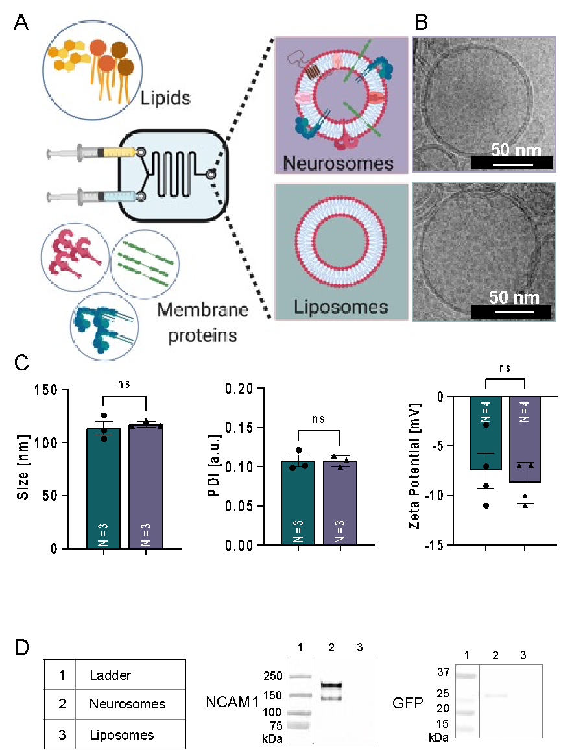
Figure 1. Generation and characterization of NP incorporating neurons’ membrane proteins (i.e., Neurosomes).
(A) Illustrative summary of the NP fabrication process. The lipid formulation is composed of neutral lipids 1,2-dipalmitoyl-sn-glycerol-3-phosphocholine (DPPC, Avanti), 1,2-dioleoyl-sn-glycerol-3-phosphocholine (DOPC, Avanti), and cholesterol (Sigma), was chosen to enable the encapsulation of either hydrophilic⁴¹ or hydrophobic⁴² therapeutic cargo.
(B) Cryo-TEM examples of NP groups (biomimetic NP- top, liposomes- bottom).
(C) Dynamic light scattering-based sizes (left), heterogeneity of sizes (arbitrary units, middle) and net surface charges of NP (right) are shown, averaged among four replicates each.
(D) WB listing adhesion proteins, extracted from neurons and uniquely identified on biomimetic NP.

A B

Figure 2. Confocal live imaging of full-length ADNP, or truncated ADNP proteins conjugated to GFP after 7 days in culture (N115 cells subjected to CRISPR/Cas9 genome editing, including N-terminal GFP fusion and mutation insertion).
(A) Images - Leica SP8, after 7 days of control or treatments (N=~34).
(B) Percentage of diffused protein in cells (number of cells that have diffused protein/total cell number in a field). Red arrows point at diffused GFP ADNP (Ganaeim, Ivashko-Pachima, Karmon and Gozes, in preparation). (DMSO = neuronal differentiation medium, as before, Table 2).

Figure 3. Cell Model Development with CRISPR/Cas9 (Preliminary, Ganaiem, Ivashko-Pachima, Karmon and Gozes, in preparation).
(A-B) Schematic representation of CRISPR/Cas9 DNA-editing system, which was used to created neuroblastoma cell lines (N115) expressing full-length ADNP conjugated to GFP, or truncated ADNP proteins as illustrated on the figure.
(C) Immunoblotting with GFP (left hand panel) and ADNP (right hand panel) antibodies was performed to test the expression of GFP-tagged proteins. α-GFP panel represents only GFP-conjugated proteins; α-ADNP represents all ADNP forms (specifically the ADNP antibody (F-9) is a mouse monoclonal IgG1 (sc-376674, Santa Cruz), dilution; 1:200 recognizing human ADNP N-terminal amino acids 1-138C) real-time PCR was performed as published (e.g. Kapitansky et al., 2020b).
Kapitansky O, Sragovich S, Jaljuli I, Hadar A, Giladi E, Gozes I (2020b) Age and Sex-Dependent ADNP Regulation of Muscle Gene Expression Is Correlated with Motor Behavior: Possible Feedback Mechanism with PACAP. International journal of molecular sciences 21.

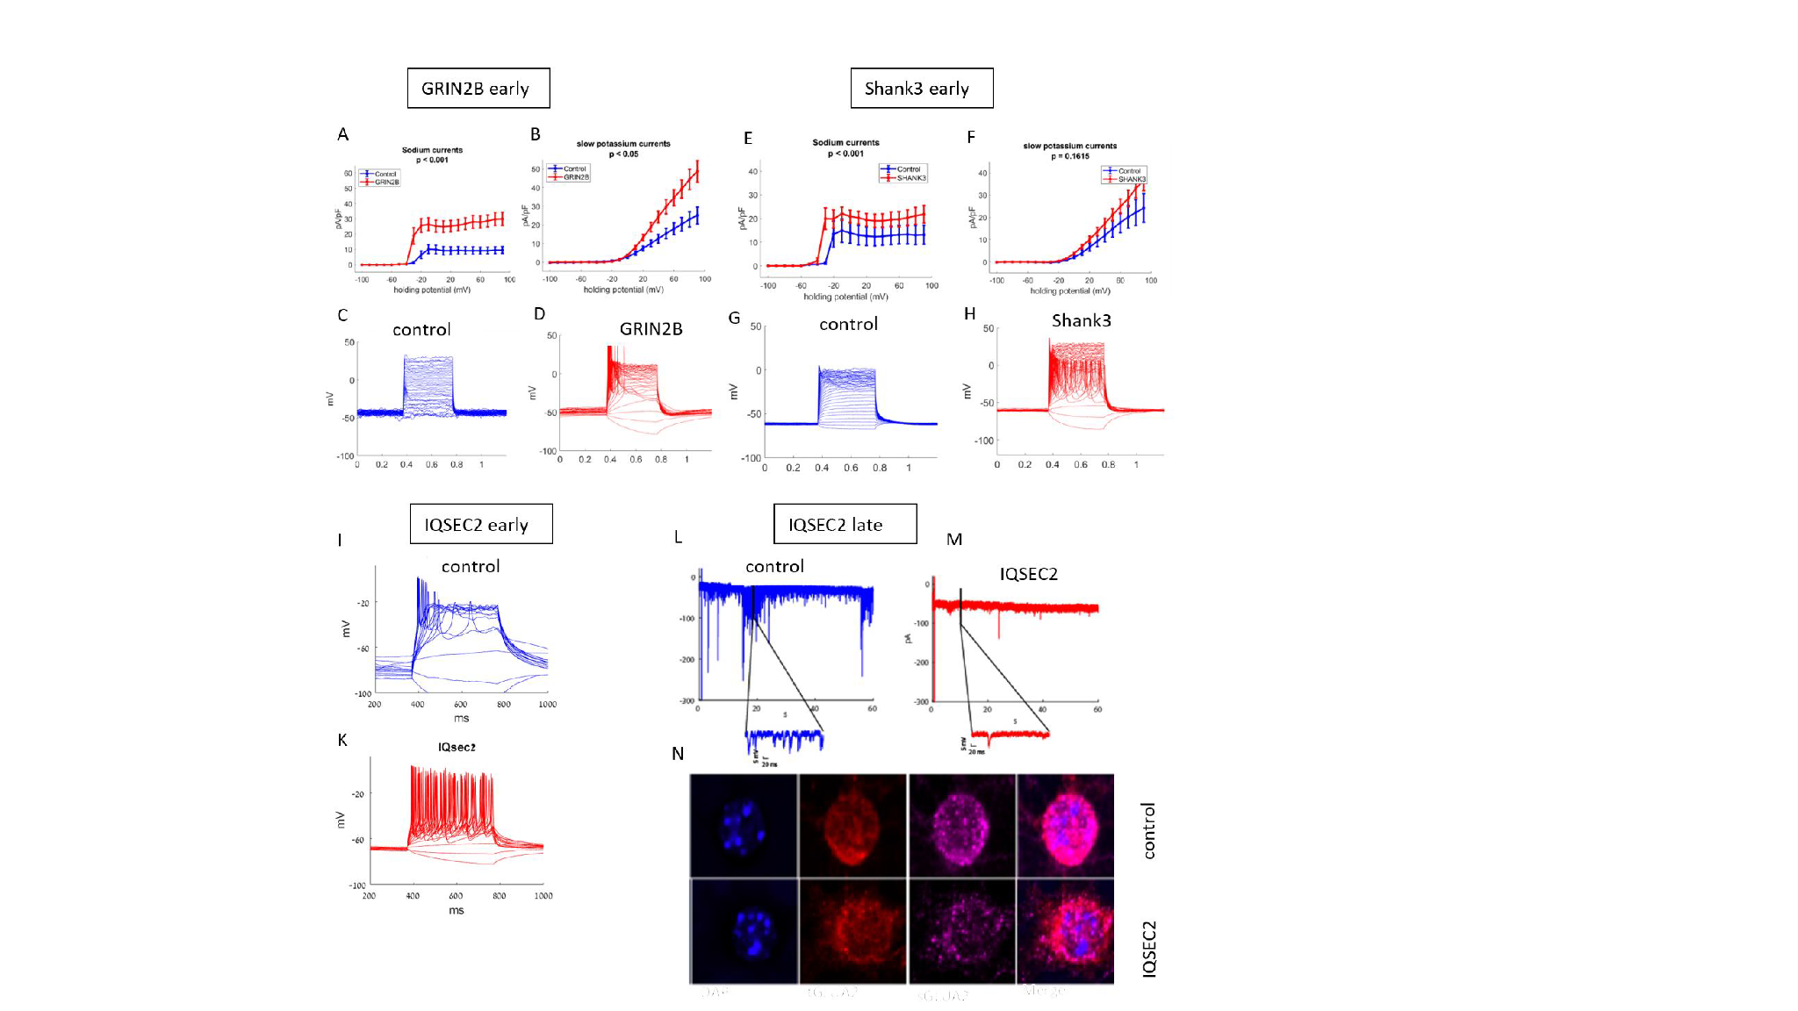

Figure 4. An early hyperexcitability results in synaptic degradation over multiple ASD patient derived neurons. (A-D) Early in the differentiation (~2.5 weeks), GRIN2B patient-derived cortical neurons exhibit early development (increased sodium and potassium currents) with hyperexcitability compared to neurons derived from first degree relative.
(E-H) Similarly, early in the differentiation (~2.5 weels), SHANK3 patient-derived cortical neurons exhibit early development (increased sodium and potassium currents) with hyperexcitability compared to neurons derived from first degree relative.
(I-K) At around 30 days in the differentiation, hippocampal neurons derived from a patient with a mutation in his IQSEC2 gene exhibit rapid maturation compared to a CRIPSR/Cas9 corrected controls.
(L-N) The IQSEC2 neurons that were hyperexcitable as young neurons, exhibit synaptic degradation 1.5 months later. Synaptic activity is reduced by patch-clamp experiments and surface GluA2 proteins are reduced.

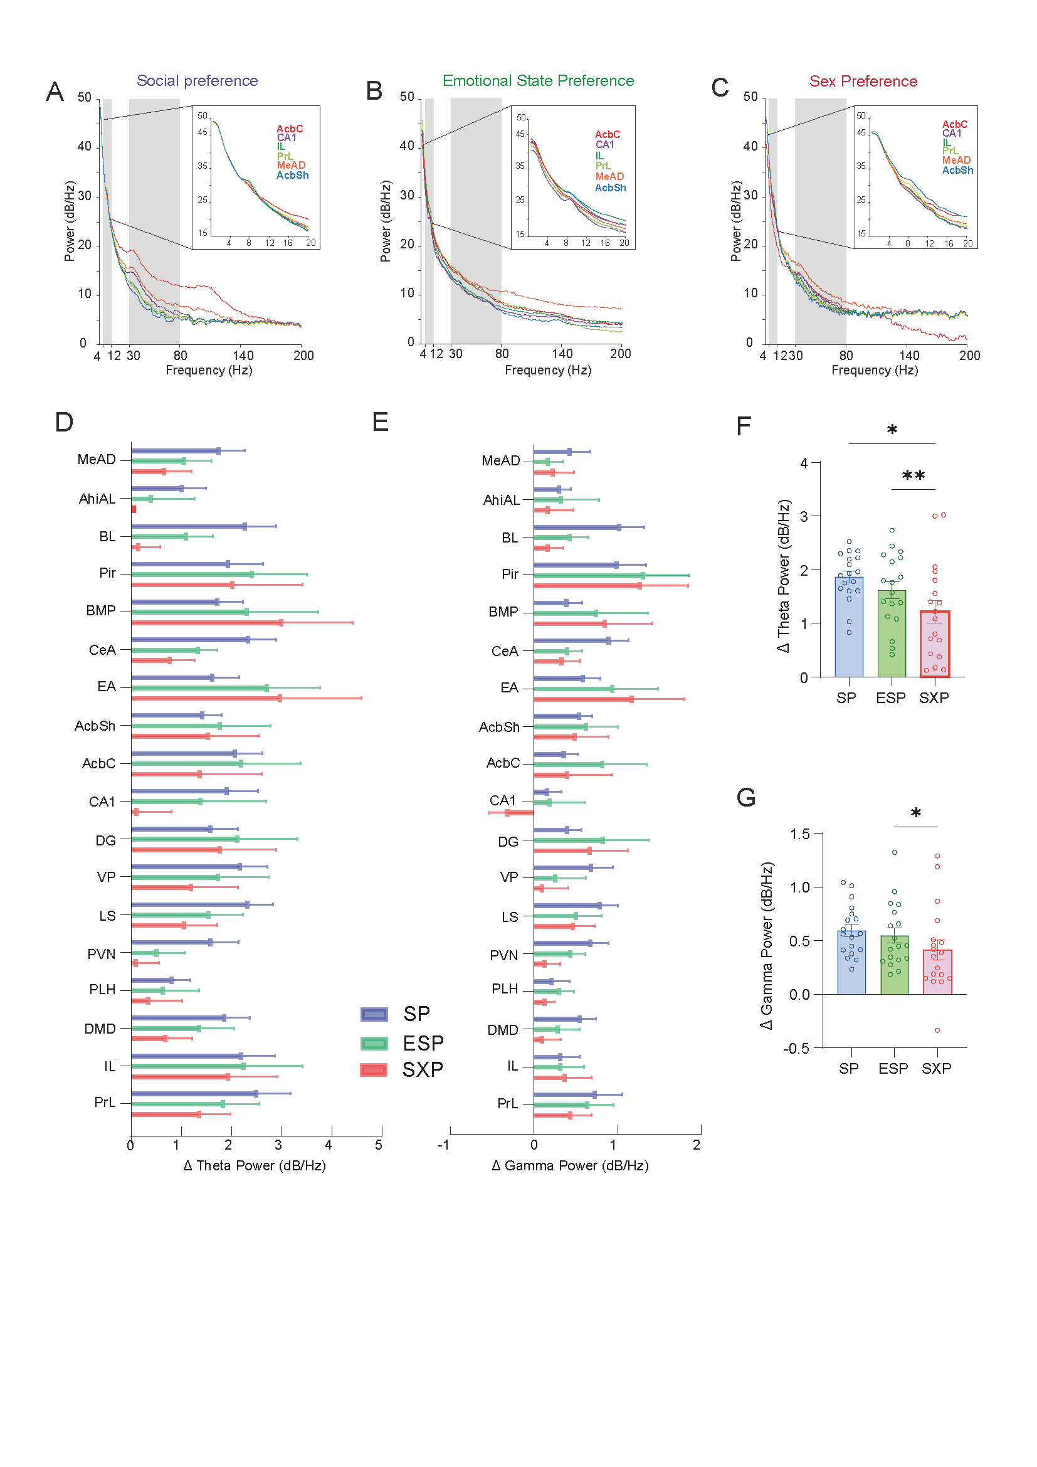

Figure 5: Characterizing brain activity during social behavior at the system level.
(A-C) Power spectral density (PSD) profiles of LFP potential signals recorded using chronically-implanted electrode arrays from six brain regions of the same ICR mouse while it was performing either the SP (A), ESP (B) or SXP (C) tasks. Note the marked differences between the tasks in the profiles of the same regions.
(D-E) Change in power (∆power) of either theta (C) or gamma (D) rhythmicity during each of the color-coded tasks. Note that in some brain regions, such as the BLA, there were marked differences between the tasks, while in others, such as the IL, we observed no difference between them.
(F-G) Mean changes in power across all brain regions, for each of the tasks. Note the significant higher change in theta power during the SP tasks as compared to the other two task. However, in some brain regions the SXP yielded the strongest response.
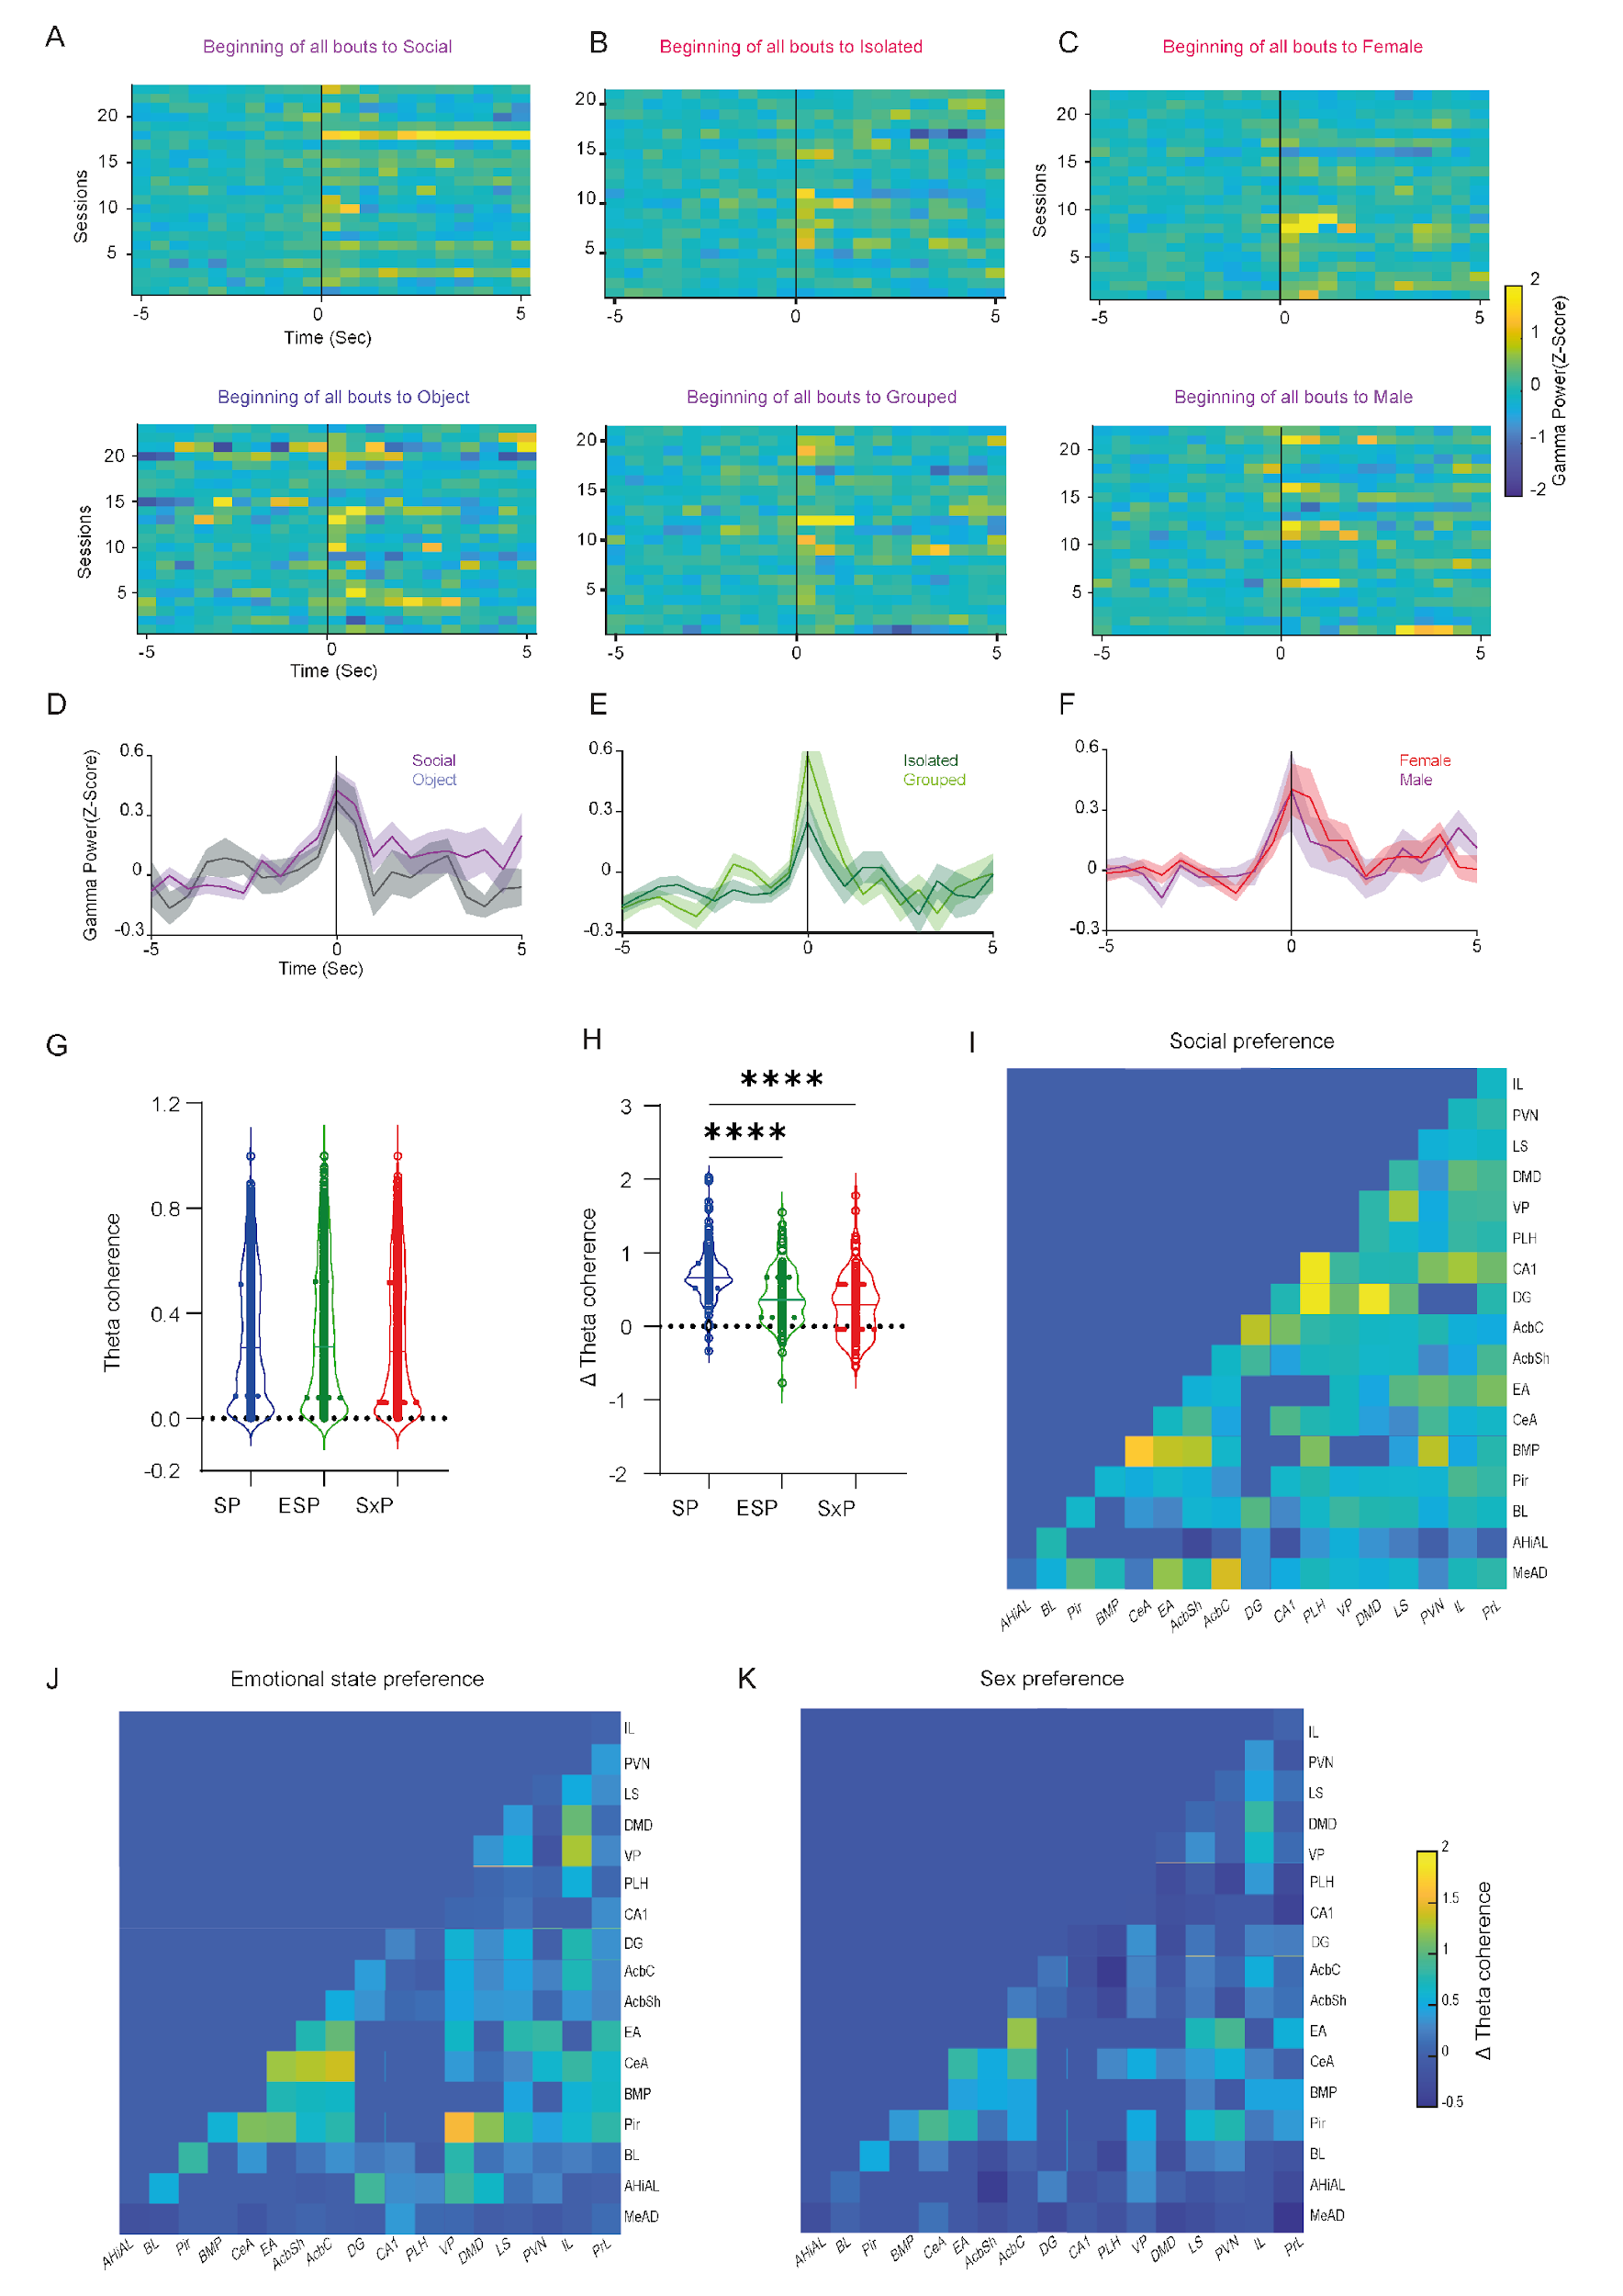
Figure 6. Neural activity during specific social investigation bouts
(A-C) Z-score analyses of the power change during investigation bouts of each one of the stimuli during the SP (A), ESP (B) and SXP (C) tasks, for the prelimbic prefrontal cotex. Each line is the average of all bouts towards the same stimulus in a single session. Upper panels present the bouts towards preferred stimuli while lower panels present the bouts towards non-preferred stimuli. Time 0 represent the beginning of the investigation bout. The five seconds before time 0 are considered as baseline for the Z-score analysis.
(D-F) The mean power change in the same brain region during the investigation bouts for each of the stimuli, superimposed separately for each of the tasks. Note the stronger response of this brain area from grouped, as compared to isolated social stimuli.
(G) Mean theta coherence between all brain regions during the 5 minutes before stimuli insertion (baseline), for each of the tasks. As expected, we found no difference in coherence between the tasks during this period.
(H) Mean change in theta coherence between all brain regions during the 5 minutes after stimuli insertion (test session), for each of the tasks. Note the significant difference in coherence between the various tasks.
(I-K) Matrix of color-coded theta coherence changes between all brain regions (same regions in the X and Y axes) for either the SP (I), ESP (J) or SXP (K) tasks. Note the distinct patterns of the coherence changes between the tasks, representing task-specific system level brain synchronization pattern.

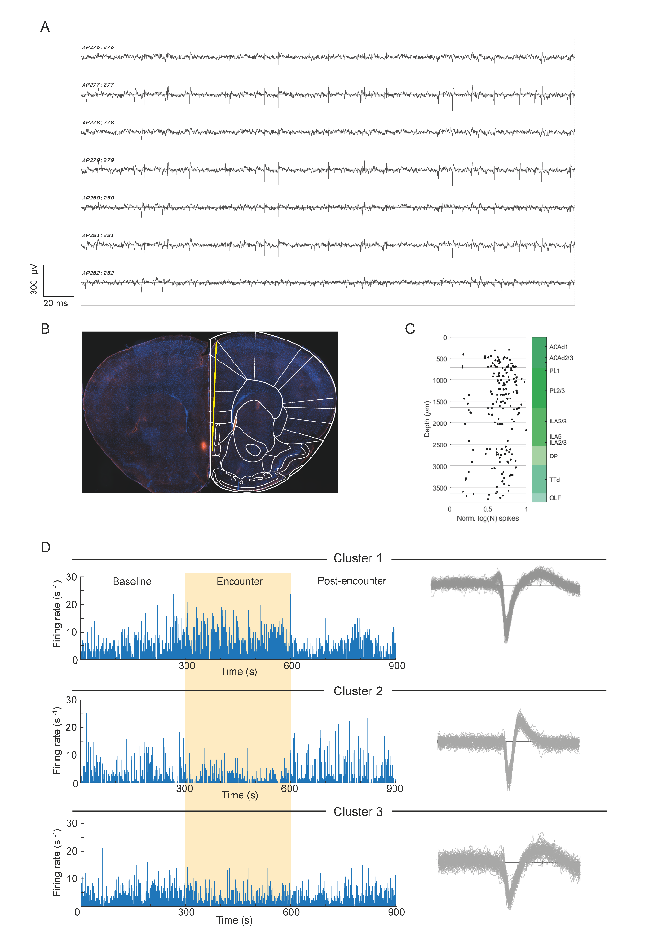
Figure 7. Single-unit recordings during social behavior using Neuropixel probes
- Example raw-data traces from four distinct single units recorded using Neuropixel 1.0 probe chronically implanted in the forebrain of an ICR male mouse, as described below.
- Picture of the probe-tip location in a slice taken post mortem from the implanted mouse. Superimposed brain-atlas picture is shown to the left. The electrode tip was coated with DiI, hence is marked by a red dot but the rest of the electrode-trace is not shown due to the angle of it.
- A scheme showing the normalized mean firing rate (X-axis, logarithmic scale), along the depth of the probe. The name of the various brain regions penetrated by the probe are marked to the right.
- The mean firing rate of three distinct single-units recorded from the prelimbic prefrontal cortex during the social preference task, across the time course of the task. The colored area marks the time of the social encounter. Note that the upper unit was excited during the encounter, the middle one was inhibited and the lower one did not respond.

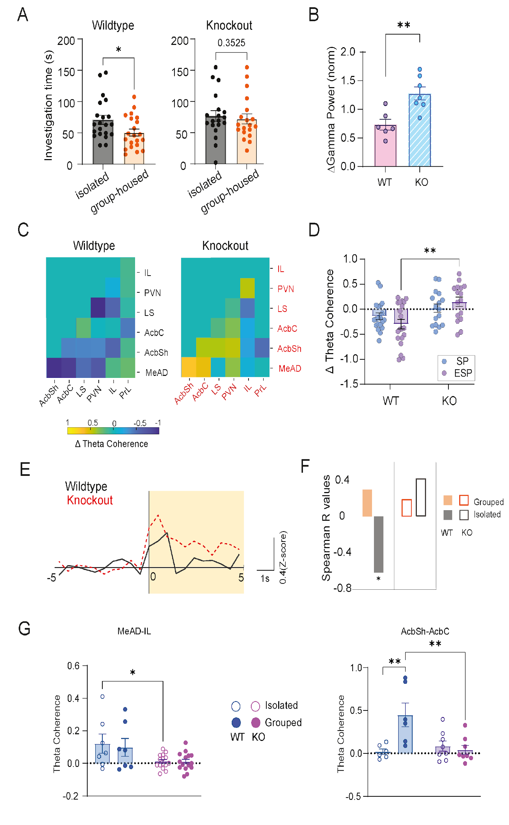
Figure 8. Modified neuronal activity in specific brain regions of Cntnap2-KO mice during ASR.
- Left: Total time of the WT mice to investigate the Isolated and the Group-housed stimulus (Wilcoxon matched-pairs signed rank test: n = 21 sessions, W= -127, p = 0.0263); Right: Total investigation time of each stimulus by the KO mice (n = 19 sessions, W= -48, p = 0.3525).
- Change in Gamma power (normalized) of all recorded brain regions during the encounter with stimuli (n = 7 regions, W= 28, p = 0.00156).
- Matrices of the color-coded change in theta coherence between six recorded brain region during the ESP task, for WT (left) and Cantnap2-KO mice (right). Note the higher general coherence in the mutant mice.
- Left: Change in Theta coherence between all couples of brain regions during SP and ASR test (2 way ANOVA: Test vs. Genotype - Test: F (1, 68) = 0.035, p = 0.852, Genotype: F (1, 68) = 12.93, p = 0.0006, Šídák's multiple comparisons test: WT: ASR vs. KO:ASR, p = 0.0024). Right: Change in Gamma Coherence between all brain regions during SP and ASR test (2-way ANOVA: Test vs. Genotype - Test: F (1, 68) = 6.542, p = 0.0128, Genotype: F (1, 68) = 0.7989, p = 0.3746).
- (I) Gamma power (Z-score) of IL mPFC during interaction bout with Isolated stimulus by WT (black) and KO (red) mice. (J) Spearman R values for the correlation of IL mPFC Gamma power (Z-score) during interaction bout with the investigation time of specific stimuli, for both genotypes. *p<0.05.
- Change in theta coherence between the anterior-dorsal medial amygdala (MeAD) and IL mPFC (left) and between the nucleus accumbens core (AcbC) and sell (AcbSh), for both genotypes. Note the statistically-significant differences between the genotypes in both cases.

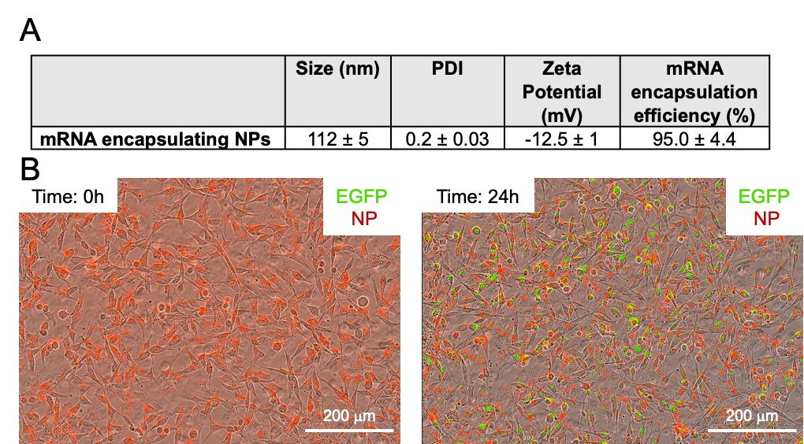
Figure 9. mRNA NPs Fabrication, physiochemical characterization and functional delivery of EGFP mRNA in vitro.
(A) The mRNA encapsulating NPs fabricated using D-Lin-MC3-DMA; 1,2-distearoyl-sn-glycero-3-phosphocholine, and 1,2-dimyristoyl-rac-glycero-3-methoxypolyethyleneglycol-2000 by NanoAssemblr, were characterized using DLS with average of 112±5 nm, polydispersity index (PDI) <0.2, pointing towards a homogenous population of nanoparticles and zeta potential of -12.5±5 nm. Notably, high encapsulation efficiency of mRNA in NPs was measured using Ribogreen assay >95%.
(B) Internalization of EGFP-mRNA loaded NPs (red) by human TNBC cells (MDA-MB-231, ATCC) and expression of EGFP protein (green) coded by successful functional mRNA delivery was assessed over 24h using using IncuCyte Live-Cell Systems.

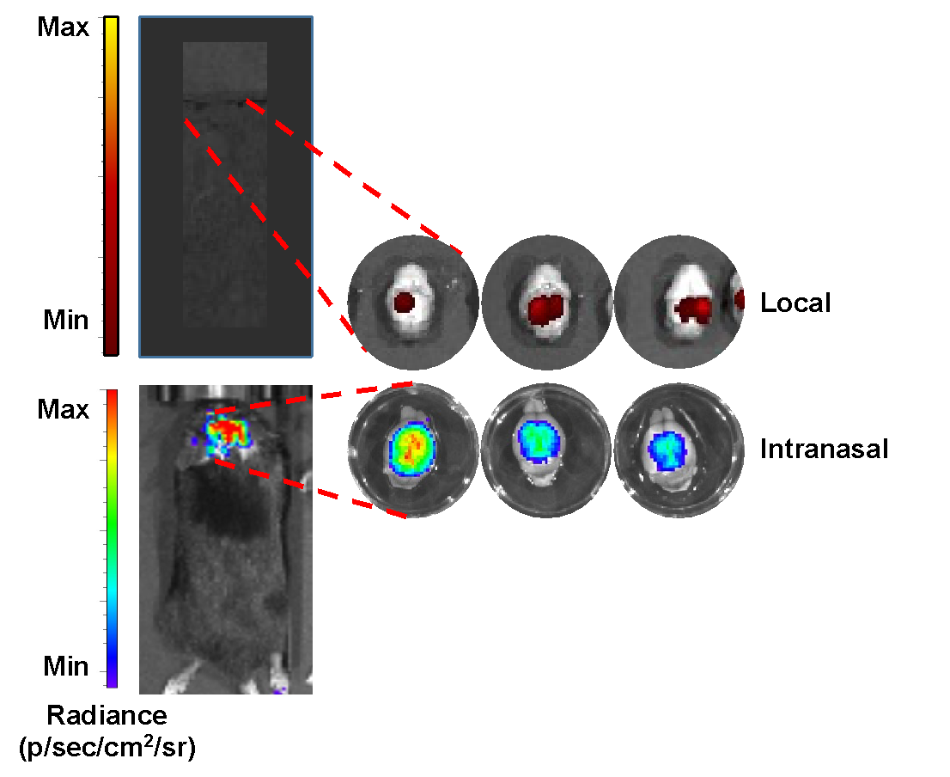

Figure 10. Validation of NP ability to accumulate in the brain, using either local brain injection or intranasal delivery. For the local NP administration, the mice were anesthetized with isoflurane and placed on a stereotaxic frame with a built-in heating bed that maintains body temperature at 37 °C. First, a 10-mm midline incision was made over the skull to allow a 4 mm craniotomy on the left parietal bone. Next, 2 ⎧l of cy5.5 labeled NP at a rate of 0.2 ⎧l/min were injected using a mounted Hamilton syringe and automatic syringe. After the injection, the incision was closed with staples, and the mice were allowed to fully recover from anesthesia before transferring it to their home cages. For the intranasal cy5.5 NP administration, the mice were held, inverted, and intranasally administrated repeatedly with 5 μl of NP into the left and right nostrils alternately until reaching a volume of 20 μl in each nostril, totally pf 40 μl. 24 h after administration, the mice and brains were imaged using in vivo imaging system (IVIS), and we successfully validated NP accumulation in the brain following local and intranasal delivery

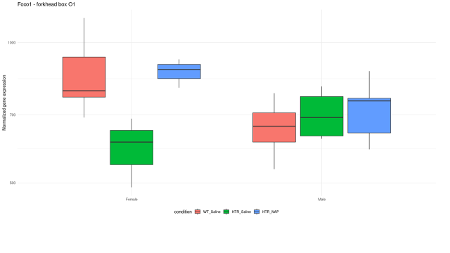

Figure 11. The Tyr mutation in mice (HTR here) regulates Foxo3 mRNA in a sex-dependent manner: correction by NAP treatment
Animals were treated as described in our (IG) 2022 paper (Karmon et al.). Similar to the published spleen RNA, hippocampal RNA was prepared and subjected to RNA-seq. Results (box plot) indicate a female significant reduction in Foxo3 expression, which is completely reversed by NAP treatment (Shapira, Karmon, Shomron and Gozes, in preparation).

