**הנחיות לכתיבת המאמר:**

**Special Article**

Reports scientific results of original research in such areas as economic policy, ethics, law, and health care delivery.

[**SEE EXAMPLE**](https://www.nejm.org/doi/full/10.1056/NEJMsa1600011#t=article)

**Maximum words:** 2,700

**Elements:**

* Abstract
* Maximum of five (5) tables and figures
* Up to 40 references

Study design, population and settings

Data collection and quality control  
General information  
Outcome measures

Statistical analysis + algorithm about population

**What do we know about contributing factors for 'Never Events' in the Operating Rooms? Machine learning analysis**

**Background:**

Adverse medical events can lead to significant morbidity and mortality and increase healthcare expenditures (Kjellberg et al, 2017). A Never Event (NE) is an unacceptable adverse event, both preventable and unjustified, and should be reduced to zero thorough quality improvement (Robert, Choi et al, 2015), (Flug, Ponce et al 2018). Major NEs in perioperative care include incorrect surgery sites and retained foreign bodies during surgery (NHS, 2018), (NHS Improvement, 2019).

Human error is a main contributor to perioperative NEs (Elbardissi & Sundt, 2012, Gawande et al, 1999, Weigmann et al, 2010). Error includes surgeon distraction (Jung et al, 2019), lack of situational awareness of the surgical team to possible error, and miscommunication among team members (Fann et al, 2016). Additionally, institutional factors, like increased workload and clinicians’ pressure, create a work climate inconsistent with standards required to maintain patient safety (Smith et al, 2009), (Green et al, 2016).

Two essential international standards were implemented in Israel to reduce NE occurrence. (Papadakis, 2019): the WHO Surgical Safety Checklist (Treadwell, Lucas, & Tsou, 2014) (Papadakis, 2019), (Rothman et al, 2016); and a strict counting of all surgical instruments used during the surgery (Lean, Page & Vincent, 2018), (Stawicki, et al., 2009), both prior to and after surgery.

Yet, only partial compliance with these standards[sources], and other possible unknown factors, contribute to an NE rate of X in Israel [source]. This study uses machine learning methods (Logan-Phellan, 2018), to identify as yet unknown possible contributors to NE occurrence. Machine learning is a proactive prediction of risk in relation to non-trivial possible factors (Feldman et al., 2018), such as the combination of different surgical specialties and staff characteristics. Previous studies leveraging machine learning methods in healthcare have demonstrated the benefits of analyzing and revealing non-trivial insights from diverse data types when compared to traditional methods (Doupe et al, 2019). To the best of our knowledge, this is the first study to use machine learning methods to identify potential contributing factors to the occurrence of NEs in ORs.

**Methods:**

**Study Design**

We utilized a supervised machine learning approach called Random Forest (RF) (Shalev-Schwartz and Ben-David, 2014), incorporating the popular Extra Tree classifier (Pierre et al., 2016).

RF is an ensemble learning method that trains multiple “simple” decision tree models and merges them together to achieve a more accurate and stable prediction. The use of RF results in several factors needed for properly conducting the analysis for this study: 1) RFs are used to rank the importance of features in a natural way. Specifically, the importance of features can be determined by looking at to what extent the tree nodes using a feature reduce the impurity (i.e., the uncertainty in classification) across all trees in the forest; 2) RFs are known to cope well with imbalanced datasets( as in this study), and avoid overfitting the data; and 3) empirically, RFs compared favorably with several other supervised machine learning algorithms we tested using our data, including deep neural networks, support vector machines, and others. It is worthwhile mentioning that RFs have been used extensively in the medical field for risk identification, as survival indicators for various diseases (e.g., Mohammaad et al., 2011; Wongvibulsin et al. 2020), and more.

**Data Collection and Annotation**

Data were collected from 29 Israeli-based hospitals and consisted of two types of data entries: *observations* of surgeries between January 2018 and February 2019 in which no NE occurred, and *root-cause analyses* (RCA) of NEs that occurred between January 2016 and February 2020.

*Observations*

Passive observations are routinely performed in ORs by medical students (third year and above) physicians, nursing students (fourth year) or nurses. The observers in this study underwent an eight-hour long designated training that included simulations. In each OR, at least two observers passively observed surgeries randomly selected, and annotated the surgery process using a pre-defined set of features. Observations were then transferred to a central database and routinely assessed for variability and reliability. Each observation was translated into a 93-feature long vector, corresponding to one of the issues annotated by the observers. To maintain reliability, entries with greater than 5% discordance among annotators in one OR are discarded.

We were able to obtain the full set of 9,234 observations conducted between January 2018 and April 2019.

*Root-Cause Analyses (RCA)*

RCAs performed between January 2016 to February 2020 identified 101 NEs that occurred during this observational period; 49 of Type A (incorrect surgery site and 52 of Type B (retained foreign body). The obtained RCAs were manually annotated by the authors using the same representation as that of the observations, resulting in 101 vectors of 98 features. Unlike the observations, RCAs were performed *retrospectively* and, thus, a significant portion of the features was missing and could not be obtained. Therefore, missing data for some features of the work protocols were gathered from insights from the RCAs. For all NEs, name of the hospital, length of surgery, patient’s gender and age, surgeon’s specialty, number of physicians, and nurses present during surgery were always provided. However, up to 40% of all other feature values were missing.

**Pre-Processing and Analysis Technique**

As some features were non-binary (e.g., age, length of surgery), we first discretized them (e.g., age was rounded to the closest multiplication of 10, length was rounded to the closest full hour), resulting in 250 binary features. This and subsequent steps were performed using a designated Python 3 program implemented by the authors that uses the standard scikit-learn machine learning package.

Examination of the 40% missing entries revealed that most missing feature values were strongly dependent on the NE type. Namely, for Type A, features that were assumed to be more related to NEs of Type B were not recorded and vice versa. For example, for an NE on which the wrong hand was operated, there is no record of whether the surgeon scanned the surgical cavity for retained surgical items before closure. To mitigate this artifact, we used a standard iterative data imputation approach predicting the value of each missing feature, and relying on the present features and available examples. Specifically, using the entire dataset, for each missing value we used a Decision-Tree Regressor to estimate the missing feature values.

In addition, balancing steps were taken to cope with the high imbalance of the dataset. Specifically, with over 9,000 observations and 101 NEs, we adopted a cost-sensitive training approach where our model was penalized for prediction mistakes on the minority class (NEs) by an amount proportional to how underrepresented it was (here, approximately 90 times under-represented).

We trained three RF models using the data: Model 1 distinguishing between observations and NEs; Model 2 distinguishing between observations and NEs-Type A; and Model 3 distinguishing between observations and NEs-Type B. We used a standard 10-cross validation technique to evaluate the model’s metrics and adopted the standard Gini impurity measure to estimate the importance of features and their combination in our models.

The study was approved by the University's ethics committee and the MOH's Helsinki committee. (reference number MOH 032-2019 at 27.12.19). There was no industry involvement in or support for the study. The authors vouch for the accuracy and completeness of the data.

**Results**

The majority of NEs (62.32%) occurred in six main departments (General Surgery, 19 (18.81%), Gynecology, 17 (16.83%), Orthopedics, 16 (15.84%), Cardiac and Cardiothoracic 15 (14.85%), Opthamology 8 (7.92%) and Urology, 7 (6.93%) (See Table 1). Therefore, our analysis focused on main factors influencing the occurrence of NEs in these six departments.

*Table 1: Characteristics of the data set*

|  |  |  |  |  |  |  |  |
| --- | --- | --- | --- | --- | --- | --- | --- |
| **Observations** | | | | | | | **Never Events** |
| Average age: 50.8 years (SD 20.4)  Gender: Male (n=388 (49.8%)), Female (n=391 (50.2%))  Length of surgery: up to 1 hour: 2124 (23%), 1-2 hours: 4340 (47%), 3-4 hours: 2031 (22%), more than 4 hours: 739 (8%) | | | | | | | n=101 average age: 46 Gender: Male (n=46 (45.5%))  Female n=55 (54.5%)  Length of surgery: up to 1 hour: 54 (53.5%), 1-2 hours: 13 (12.9%) 3-4 hours: 17 (16.8%), more than 4 hours: 17 (16.8%) |
| Phase  Specialty | *Pre procedure (n=1,539) (missing data on 760 cases) | Sign in  (n=1,504) | Time out (n=1,498) | First count (n=1,518) | Second count (n=1,501) | Third count  (n=1,498) |  |
| Urology | 72 | 156 | 148 | 124 | 118 | 124 | 7 (6.93%) |
| Orthopedics | 185 | 331 | 324 | 341 | 302 | 326 | 16 (15.84%) |
| ENT | 64 | 105 | 105 | 99 | 102 | 93 | 3 (2.97%) |
| Gynecology | 63 | 143 | 139 | 149 | 153 | 153 | 17 (16.83%) |
| General surgery | 313 | 537 | 558 | 576 | 623 | 604 | 19 (18.81%) |
| Plastic surgery | 22 | 39 | 37 | 40 | 36 | 42 | 2 (1.98%) |
| Vascular surgery | 18 | 45 | 42 | 45 | 42 | 43 | 5 (4.95%) |
| Neurosurgery | 7 | 25 | 19 | 22 | 19 | 19 | 5 (4.95%) |
| Dermatology | 7 | 16 | 26 | 21 | 22 | 24 | 2 (1.98%) |
| Opthamology | 12 | 41 | 34 | 33 | 19 | 18 | 8 (7.92%) |
| Maxillofacillary | 3 | 12 | 10 | 8 | 10 | 11 | 2 (1.98%) |
| Cardiac and Cardiothoracic | 13 | 54 | 56 | 60 | 55 | 41 | 15 (14.85%) |

**Feature Importance**

We performed a feature importance ranking using the trained RF model and for each identified feature, reporting the change in NE occurrence probability given the entire data set. We considered each identified feature separately and calculated the probability of NE occurrence when that feature assumed the value “True” as compared to the value “False.”

*Table 2: Top 5 contributing features for the six examined departments*



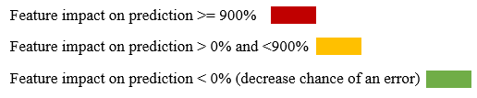

The top five features vary significantly across departments, and there is no single feature-set which is consistently more informative across all operations in predicting NEs (Table 2). For example, feature [C], **Discrepancy in second count,** varies significantly across departments (160% to 1950%). Feature [B], **Surgery is paused because of discrepancy in third count,** appears in four of the six departments, and its associated probability change varies dramatically as well, between 269% and 1,540%. There are 10 features that consistently decreased the chance of an NE, including [F], **Surgeon scans the cavity/fascia before closure during the second count**, which affected five out of six departments, and was consistent in its probability change of between 65% -100%. Features [I,] [J,][K,][L],[M], and [N] decreased the chances of NEs between 2%–100% in three departments. Three features, [A], **Discrepancy in absorbing materials**, [E], **Surgery time > 4 hours,** and [G], **Surgery time < 1 hour** appeared just once across departments with a medium impact on NE occurrence.

When analyzing the results per department, we saw a variation of contributing factors and probability. In Ophthalmology, the probability was consistently -100 in five features that decreased the chance of an error. In General Surgery, two features varied between 1168-1283% that increased probability of an error: features [B] **Surgery is paused because of discrepancy in third count,** and **[C] Discrepancy in second count.** Two features were found to decrease the probability of NE between -81% and -100%, both related to scanning the fascia before closure. In Orthopedics, those same two features increased the probability of error (1540-1950%) and three features decreased the probability: [F] **Surgeon scans the cavity/fascia before closure;** [H] **Second count is performed before closure of fascia/cavity; and** (I) **Procedure's type is compared to the one written in patient's file,** -65 to -87%. Similarly, in Urology, the same two features had an increased probability for occurrence of NE varying from 1125–1150%. One feature had a decreased probability of -100% for the occurrence of NEs: [D] **Length of surgery 1-2 hours**,100%. Two features had an increased probability for occurrence of NE of 11-577%: [A] **In case of discrepancy in the count of absorbable items, their package is taken out from the OR** and[E] **Length of surgery >4 hours.** In Cardiology, only two features were found to have increased probability of error with a smaller impact of 128-160%: [C] **Discrepancy in second count;** and **[**G] **Length of surgery <1 hour;** while three features had an impact of100% in decreasing the probability of NE. In the Gynecological department, three features decreased the probability for an error (-2.78 to -77%) and two features were found to increase the probability (269%), and were related to discrepancies in the second and third count (features [B] and [C]).

**Effects of Feature Combinations**

In the following analysis (Figure x) , the prediction rate of the top 15–20 pairs of features are shown for each department and an accumulated impact on increased probability is shown to an error of 2000–3150%. In Figure 1, we present the probability change of each of the identified feature combinations. Interestingly, in general surgery, there are 14 feature combinations that cause a probability change of 13,600% (Figure 1A). In comparison, the single feature analysis (Table 2) revealed a probability change of 1,287% and 1,168%, surprisingly by two features that were not part of the 14 feature combinations identified here.

In Figure 1B (gynecology), the effect of every identified feature combination is associated with a probability change of 1000–2000%. In the single feature analysis (Table 2), the effect of every single feature is <900%, specifically for only two features, and the rest lag behind with <150%.

In ENT surgery, results for the accumulated effect of two features together show that there are dozens of pairs with an effect of 3150–2000%, while the effect of a single feature has up to a 1350% impact on error for only two features, and the rest lag behind with <50% (Figure 1C).

In graph 1D (Urology), results show there are dozens of pairs with an effect of 1900–2500%, while the effect of a single feature has an <1150% indication of an error for only two features, and the rest lag behind.

In graph 1E (Orthopedics) the accumulated effect of two features together show a dozen pairs with an effect of 1900–4200%, while the effect of a single feature has an <1950% indication on error, and the rest lagbehind.

*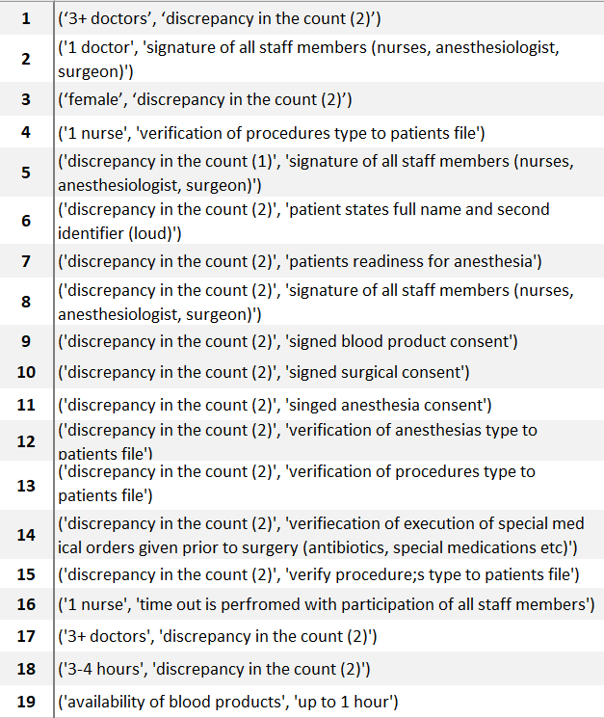Figure 1: Effect of two features’ combination on prediction by surgical departments*

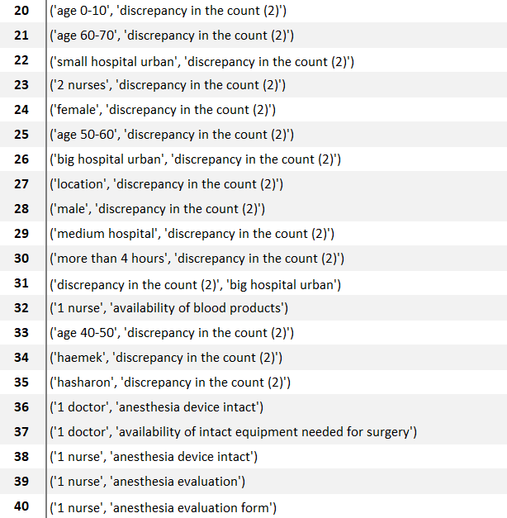

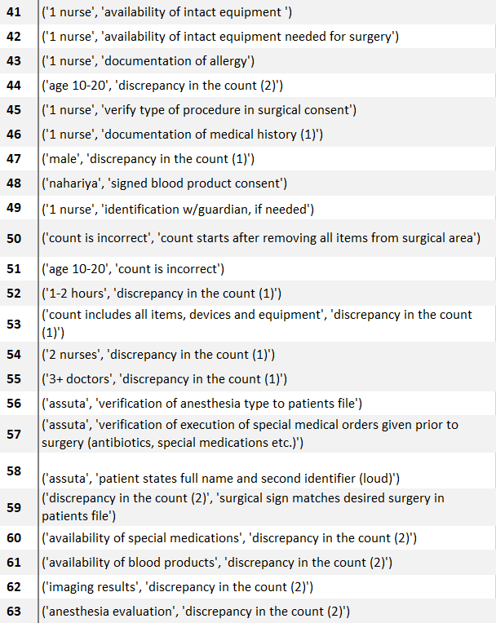

**Compare results in the 2 use cases**

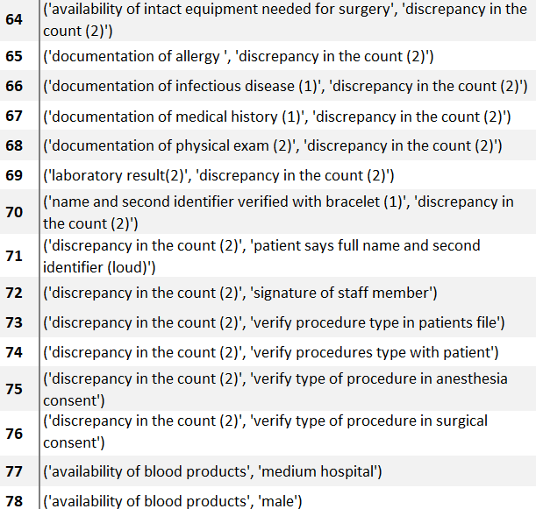

**Features affecting Types A and B**

The top five contributing features distinguishing between Types A and B overlap in three features are: 1) the presence of two nurses predicts greater occurrence of Type A (66%), and Type B (85%); 2) an operation < 1 hour had a greater occurrence of Type A (122%), and Type B (87%); and 3) when the operation lasted between one to two hours, both Types A and B were less frequent, decreasing by 60% and 74%, respectively.

The department was found to have a significant influence on the occurrence of Type A errors. Eye surgeries had greater NE prevalence of 504% and General Surgery was associated with a decrease of 63% in Type A (graph 2). For Type B, the two remaining features were staff driven; the feature “more than three surgeons” was associated with an increased prevalence of Type B (122%), and “two surgeons” was associated with a decreased prevalence of 52% (Figure 3).

***Figure 2 – Features affecting the wrong surgery site***

***Graph 3: Features affecting retained foreign items during surgery***

**Discussion**

Despite the widespread use of the surgical safety checklist and strict counts during the surgery, perioperative NEs still occur. Our results show that although the existing checklists supposedly address the main contributing factors to NE occurrence, their goal of “one custom fits all” may not consider potential risk factors that evolve from human aspects and work environments. Contributing factors, such as length of surgery and number of staff participating in the surgery consistently influenced NE occurrence.

Moreover, the results suggest that the risk for occurrence or prevention of NEs may be graded differently among surgical specialties. One of the possible explanations is the amount of equipment and dressings present in surgeries that complicates the count. A possible solution to improve the count process in these surgeries would be to use technological methods, such radio frequency identification (RFID) and data matrix code (DMC) (Teng et al, 2014).

Surgery duration alone can increase risk of NEs. A possible explanation is that in shorter surgeries, the staff is rushing and “skips” some phases of the checklists (Thomas et al, 2020).

The paired features analysis further predicts combinations of contributing factors that reveal additional risks related to the length of the surgery and number of staff members participating in the surgery. That, in combination of discrepancy in the count and failure to verify data required to the surgery.

In conclusion, the use of machine learning methods has surprisingly revealed further contributing factors to NEs that are not addressed in the standard checklists.

A possible limitation of our study is the small number of NEs analyzed when compared to the number of analyzed observations. Therefore, the feature impact for preventing NEs is relatively low. We overcame this problem using grounded statistical techniques and plan to further strengthen the results in the future given newly obtained data. In addition, the use of transfer learning in which NEs from other countries will be used to better inform our model will be considered as well.

**References:**

## Understanding Machine Learning: From Theory to Algorithms Shalev-Schwartz and Ben-David, 2014, Chapter 18.3),

## Geurts, Pierre, Damien Ernst, and Louis Wehenkel. "Extremely randomized trees." Machine learning 63.1 (2006): 3-42.

## Khalilia, Mohammed, Sounak Chakraborty, and Mihail Popescu. "Predicting disease risks from highly imbalanced data using random forest." BMC medical informatics and decision making 11.1 (2011): 51.

### Clinical risk prediction with random forests for survival, longitudinal, and multivariate (RF-SLAM) data analysis Wongvibulsin et al. 2020

Robert, M.A. Choi, C.J., Saphiro, F.E., Urman, R.D. & Samir, M. (2015). Avoidance of serious medical errors in refractive surgery using a custom preoperative checklist, Journal of Cataract and Refractive Surgery, 41 (10), 2171-2178. DOI: <https://doi.org/10.1016/j.jcrs.2015.10.060>

# The WHO safer surgery checklist time out procedure revisited: Strategies to optimise compliance and safety [RSS](https://cdn.clinicalkey.com/rss/issue/17439191.xml) [Download PDF](https://www-clinicalkey-com.moh-ez.medlcp.tau.ac.il/service/content/pdf/watermarked/1-s2.0-S174391911930158X.pdf?locale=en_US&searchIndex=)

* [Marios Papadakis](https://www-clinicalkey-com.moh-ez.medlcp.tau.ac.il/#!/search/Papadakis%20Marios/%7B%22type%22:%22author%22%7D)
* , [Abdulwares Meiwandi](https://www-clinicalkey-com.moh-ez.medlcp.tau.ac.il/#!/search/Meiwandi%20Abdulwares/%7B%22type%22:%22author%22%7D)
* and [Andrzej Grzybowski](https://www-clinicalkey-com.moh-ez.medlcp.tau.ac.il/#!/search/Grzybowski%20Andrzej/%7B%22type%22:%22author%22%7D)

International Journal of Surgery, 2019-09-01, Volume 69, Pages 19-22, Copyright © 2019 IJS Publishing Group Ltd

Kjellberg, J., Wolf, R. T., Kruse, M., Rasmussen, S. R., Vestergaard, J., Nielsen, K. J., & Rasmussen, K. (2017). Costs associated with adverse events among acute patients. *BMC health services research*, *17*(1), 651. https://doi.org/10.1186/s12913-017-2605-5

Recommended practices for sponge, sharp, and instrument counts.Perioperative Standards and Recommended Practices.2010.AORN, Inc Denver, CO:pp. 207-216

OECD ilibrary, Health at a Glance 2019 : OECD Indicators , Safe acute care – surgical complications and health care-associated infections <https://www.oecd-ilibrary.org/sites/4dd50c09-en/1/3/6/2/index.html?itemId=/content/publication/4dd50c09-en&_csp_=82587932df7c06a6a3f9dab95304095d&itemIGO=oecd&itemContentType=book>

Rosenfeld, Ariel, Benrimoh, David, Armstrong, Caitrin, Mirchi, Nykan, Langlois-Therrien, Timothe, Rollins, Colleen, Tanguay-Sela, Myriam, Mehltretter, Joseph, Fratila, Robert, Israel, Sonia, Snook, Emily, Perlman, Kelly, Kleinerman, Akiva, Saab, Bechara, Thoburn, Mark, Gabbay, Cheryl, & Yaniv-Rosenfeld, Amit (2019, March 12). Big Data Analytics and AI in Mental Healthcare.

Doupe, P., Faghmous, J., & Basu, S. (2019, July). Machine Learning for Health Services Researchers. *Value in Health*, *22*(7), 808-815. <https://doi-org.moh-ez.medlcp.tau.ac.il/10.1016/j.jval.2019.02.012>

NHS. (2018). *Provisional publication of Never Events reported as occurring between 1 February and 31 March 2018.* Retrieved from https://improvement.nhs.uk/documents/2613/Never_Events_1_February_to_31_March_2018_.pdf

NHS Improvement. (2019). *Provisional publication of Never Events reported as occurring between 1 April 2018 and 31 January 2019.* Retrieved from <https://improvement.nhs.uk/documents/4872/Provisional_publication_-__NE_1_April_to_31_Jan_FINAL.pdf>

Stawicki, S. P., Evans, D. C., Cipolla, J., Seamon, M. J., Lukaszczyk, J. J., Prosciak, M. O., . . . Steinberg, S. M. (2009). Retained surgical foreign bodies: a comprehensive review of risks and preventative strategies. *Scandanavian Journal of Surgery, 98*, 8-17. doi:10.1177/145749690909800103

Chan, B., & Cochrane, D. (2016). *Measuring Patient Harm in Canadian Hospitals.* CIHI, Ottawa. Retrieved from https://secure.cihi.ca/free_products/cihi_cpsi_hospital_harm_en.pdf

Cima, R. R., Kollengade, A., Garnatz, J., Storsveen, A., Weisbrod, C., & Deschamps, C. (2008). Incidence and Characteristics of Potential and Actual Retained Foreign Object Events in Surgical Patients. *Journal of the American College of Surgeons, 207*(1), 80-87. doi:10.1016/j.jamcollsurg.2007.12.047

de Vries, E. F., Prins, H. A., Crolla, R. M., den Outer, A. J., van Andel, G., van Helden, S. H., . . . BoerMeester, M. A. (2010). Effect of a Comprehensive Surgical Safety System on Patient Outcomes. *New England Journal of Medicine, 363*, 1928-1937. doi:10.1056/NEJMsa0911535

Hariharan, D., & Lobo, D. N. (2013). Retained surgical sponges, needles and instruments. *Annals of the royal college of surgeons in England, 95*(2), 87-92. doi:10.1308/003588413X13511609957218

Haynes, A. B., Weiser, T. G., Berry, W. R., Lipsitz, S. R., Breizat, A. H., Dellinger, E. P., . . . Gawande, A. A. (2009). A Surgical Safety Checklist to Reduce Morbidity and Mortality in a Global Population. *New England Journal of Medicine, 360*, 491-499. doi:10.1056/NEJMsa0810119

Hempel, S., Maggard-Gibbons, M., Nguyen, D. K., Dawes, A. J., Miake-Lye, I., Beroes, J. M., . . . Shekelle, P. G. (2015). Wrong-Site Surgery, Retained Surgical Items, and Surigcal Fires. *JAMA Surgery, 150*(8), 796-805. doi:10.1001/jamasurg.2015.0301

Kwaan, M. R., Studdert, D. M., Zinner, M. J., & Gawande, A. A. (2006). Incidence, Patterns, and Prevention of Wrong-Site Surgery. *Jama Surgery, 141*(4), 353-358. doi:10.1001/archsurg.141.4.353

Logan-Phelan, T. (2018). The Buzz around Learning Analytics – Enablers and Challenges Identified through the Ireland Project, *Irish Journal of Technology Enhanced Learning*, 3(2). DOI: 10.22554/ijtel.v3i2.46}

Mehtsun, W. T., Ibrahim, A. M., Diener-West, M., Pronovost, P. J., & Makary, M. A. (2013). Surgical never events in the United States. *Surgery, 153*(4), 465-472. doi:10.1016/j.surg.2012.10.005

Moppett, I. K., & Moppett, S. H. (2016). Surgical caseload and the risk of surgical Never Events in England. *Anaesthesia, 71*, 17-30. doi:10.1111/anae.13290

National Patient Safety Consortium. (2015). *Never Events for Hospital Care in Canada - Safer Care for Patients.* Ottawa. Retrieved from https://www.patientsafetyinstitute.ca/en/toolsResources/NeverEvents/Documents/Never%20Events%20for%20Hospital%20Care%20in%20Canada.pdf

NHS Improvement. (2018). *Never Events list 2018.* National Health Service, London. Retrieved from https://improvement.nhs.uk/documents/2266/Never_Events_list_2018_FINAL_v5.pdf

Patient Safety Network. (2019). *Never Events.* Patient Safety Primer. Retrieved from https://psnet.ahrq.gov/primers/primer/3/never-events

Stawicki, S. P., Evans, D. C., Cipolla, J., Seamon, M. J., Lukaszczyk, J. J., Prosciak, M. O., . . . Steinberg, S. M. (2009). Retained surgical foreign bodies: a comprehensive review of risks and preventative strategies. *Scandanavian Journal of Surgery, 98*, 8-17. doi:10.1177/145749690909800103

The Joint Commission. (2017). *Sentinel Events.* Oak Brook. Retrieved from https://www.jointcommission.org/assets/1/6/CAMH_SE_0717.pdf

The Joint Commission. (2019). *Most Commonly Reviewed Sentinel Event Types.* The Joint Commission, Oak Brook. Retrieved from https://www.jointcommission.org/assets/1/6/Event_type_4Q_2018.pdf

The World Health Organization. (2009, 1). *Surgical Safety Checklist.* Retrieved from World Health Organization: https://apps.who.int/iris/bitstream/handle/10665/44186/9789241598590_eng_Checklist.pdf;jsessionid=1908B5C90ED0DC4F1362F25B6DE63AEA?sequence=2

Teng, Y.C., Ward, J., Horberry, T., Patil, V. & Clarckson, P.J.(2014). Retained Surgical Instruments: Using Technology for Prevention and Detection, *ReasearchGate*, Conference Paper. https://www.researchgate.net/publication/315771425

Treadwell, J. R., Lucas, S., & Tsou, A. Y. (2014). Surgical checklists: a systematic review of impacts and implementation. *BMJ Quality and Safety, 23*(4), 299-318. doi:10.1136/bmjqs-2012-001797

Appendix A- Surgical safety standards checklist

**Appendix 1- Structure of Observations (based on MOH regulations)**

* 1. Surgical Checklist:

Phase 1. Pre-procedure

|  |  |  |  |
| --- | --- | --- | --- |
| **N/A** | **NO** | **Yes** | **Statement** |
|  |  |  | Patient states full name and second identifier |
|  |  |  | Name and second identifier verified |
|  |  |  | Identification w/guardian, if needed |
|  |  |  | Verify procedure type with patient |
|  |  |  | Verify procedure type to patient's file |
|  |  |  | Verify type of procedure in surgical consent |
|  |  |  | Verify type of procedure in anesthesia consent |
|  |  |  | Surgical sign matches the desired surgery |
|  |  |  | Documentation of medical history |
|  |  |  | Documentation of physical exam |
|  |  |  | Documentation of infectious disease |
|  |  |  | Anesthesia evaluation |
|  |  |  | Documentation of allergy |
|  |  |  | Laboratory results |
|  |  |  | Imaging results |
|  |  |  | Availability of blood |
|  |  |  | Availability of medications |
|  |  |  | Availability of equipment |
|  |  |  | Signature |

Phase 2. Sign-in:

|  |  |  |  |
| --- | --- | --- | --- |
| **N/A** | **NO** | **Yes** | **Statement** |
|  |  |  | Sign-in performed by surgeon, anesthesiologist and nurse |
|  |  |  | Patient states full name and second identifier |
|  |  |  | Name and second identifier verified |
|  |  |  | Verification procedure type to patient's file |
|  |  |  | Verification anesthesia type to patient's file |
|  |  |  | Surgical sign matches the patient's file |
|  |  |  | Readiness for anesthesia |
|  |  |  | Anesthesia device intact |
|  |  |  | Documentation of medical history |
|  |  |  | Documentation of physical exam |
|  |  |  | Documentation of infectious disease |
|  |  |  | Anesthesia evaluation |
|  |  |  | Signed surgical consent |
|  |  |  | Signed anesthesia consent |
|  |  |  | Signed blood product consent |
|  |  |  | Documentation of allergy |
|  |  |  | Laboratory results |
|  |  |  | Imaging results |
|  |  |  | Availability of blood |
|  |  |  | Availability of medications |
|  |  |  | Availability of equipment |
|  |  |  | Execution of medical orders |
|  |  |  | Signature (surgeon, anesthesiologist, nurse) |

Phase 3. Time Out:

|  |  |  |  |
| --- | --- | --- | --- |
| **N/A** | **NO** | **Yes** | **Statement** |
|  |  |  | Sign-in performed by all staff members |
|  |  |  | Time out is before surgical cut |
|  |  |  | Time out performed with the patient |
|  |  |  | All staff members stop and listen |
|  |  |  | Patient identified by 2 identifiers |
|  |  |  | Procedure compared to patient's file |
|  |  |  | Surgical sign matches the patient's file |
|  |  |  | Signed surgical consent |
|  |  |  | Signed anesthesia consent |
|  |  |  | Time out for each procedure |
|  |  |  | Verbal agreement of all staff members |
|  |  |  | Repeat time out in surgeon's exchange |
|  |  |  | Signature of all staff members |

* 1. Surgical Counts - Observations by surgical phase and type of count:

First Count - Prior to skin incision:

|  |  |  |  |
| --- | --- | --- | --- |
| **N/A** | **NO** | **Yes** | **Statement** |
|  |  |  | Count performs by scrubbed nurse or two nurses |
|  |  |  | Count is out loud before the beginning of surgery, with opening the sterile equipment |
|  |  |  | Equipment count is out loud compared to the list |
|  |  |  | Count of absorbable items is out loud while separating |
|  |  |  | In case of no matching in absorbable items it is removed out from the OR |
|  |  |  | Documentation of the count on a dedicated form |
|  |  |  | Items are not removed from the OR while counting |
|  |  |  | No match in the count |
|  |  |  | Nurses announce the non-match to surgeon |
|  |  |  | Surgery stops due to non-match |
|  |  |  | Searching the missing item |
|  |  |  | Ordering imaging test for finding the missing item |

Second count- closure of fascia/cavity is initiated:

|  |  |  |  |
| --- | --- | --- | --- |
| **N/A** | **NO** | **Yes** | **Statement** |
|  |  |  | Count performed by scrubbed nurse or two nurses |
|  |  |  | Count performed before closure of fascia/cavity |
|  |  |  | Equipment count is out loud with the participation of all staff members |
|  |  |  | Surgeon announces out loud about intention for closure before closure of fascia/cavity |
|  |  |  | Surgeon reviews the cavity before closure |
|  |  |  | Two nurses perform the count |
|  |  |  | Closure begins after verifying correct count |
|  |  |  | No match in the count |
|  |  |  | Nurses announce the non-match to surgeon |
|  |  |  | Surgery stops due to non-match |
|  |  |  | Searching the missing item |
|  |  |  | Ordering imaging test for finding the missing item |

Third count - After Skin Closure:

|  |  |  |  |
| --- | --- | --- | --- |
| **N/A** | **NO** | **Yes** | **Statement** |
|  |  |  | Count performed by scrubbed nurse or two nurses |
|  |  |  | Count is after removing items from surgical area |
|  |  |  | Count is made out loud with the participation of all staff members |
|  |  |  | Count includes all items, devices and equipment |
|  |  |  | Count is declared when there are no items left in the surgical field |
|  |  |  | Count is documented in a dedicated form |
|  |  |  | Sterile nurse declares out loud that count is correct |
|  |  |  | Nurses’ names and results of count are documented |
|  |  |  | Surgeon verifies out loud that count is correct |
|  |  |  | **Count does not match** |
|  |  |  | Nurses announce the non-match to surgeon |
|  |  |  | Surgery stops due to non-match |
|  |  |  | Search for the missing item |
|  |  |  | Order imaging test to find the missing item |