**New Horizons of Digital Literary Criticism**

**Abstract**

Digital literature has undoubtedly brought about many changes to the literary system and has reestablished our understanding of many concepts related therein, including how we conceptualize the reader, the author, and the text. Therefore, it is only natural for a change to also be brought about in our conceptualization of the critic who addresses this literature, and, consequently, the concept of literary criticism itself.

Based on the above, this study aims to shed light on the new perspectives presented by digital literature in the field of criticism by exploring the critical process and suggesting new terminologies that can describe this criticism. This study is based on a previous study written by myself and my colleague, which was published in a book entitled *Al-tafāʿil al-fannī al-adabī fī al-shiʿir al-raqamī: qaṣīdah “shajar al-Būghāz” namūdajan* (Artistic Literary Interaction in Digital Poetry: The Būghāz Tree, 2015). That said, the present study differs from the previous study in that the previous study aimed to uncover the digital aesthetics of the poem and therefore focuses on the end result of the criticism, while the present work aims to uncover digital criticism perspectives. Consequently, the present study focuses on the critical process itself, which shall be discussed below. The distinctiveness of our research lies in its focus on the interactive critical process in Arabic digital literature in order to delve into the horizons of digital criticism.

**Introduction**

The idea for this study came about after my colleague, Dr. ʿĀyīda Naṣrallah, and I published the aforementioned book(2015) in which we, relying on our different literary skills (I, a litterateur, and she, an artist), attempted to demonstrate the overlapping aesthetics between the literary elements in the interactive poem entitled “Shajar al-Būghāz (the Būghāz tree)” by the Moroccan poet Munʿam Al-Azraq.

In that work, our focus was principally centered on our previous research, which analyzed the literary elements and exposed the levels of interaction between them in order to understand their significance. However, we were not concerned with the critical process itself, as it was a complex process that required us to diverge to different levels of analysis and interpretation and the use of external parties. In other words, we focused on the outcome as opposed to the process. Thus, I see it is necessary to shed light on the critical process in all of its branches and offshoots in order to uncover the new possibilities and horizons that digital literature offers the critic. The presentation of the critical process in each research work is as important as the final product. Contemporary criticism has touched upon the importance of the presentation of the critical process, as stated in the book *One Thousand and One Plateaus* by Gil Doloz and Felix Guterri. The critics devoted a whole chapter of the book to explaining their work as critics from two different fields (Wardrip-Fruin and Montfort, 2003).

Before discussing the critical process we have undergone and the new horizons that have become clear to us as a result of exploring the digital poem, we must first take a brief glance at the poem itself to understand the reasons for adopting a critical, rather than traditional, process.

The poem talks about a series of earthquakes that struck the seaside region of Būghāz in the Strait of Gibraltar and the destructive humanitarian, social, and economic consequences that occurred as a result. It is worth noting that these earthquakes were not naturally-occurring, rather, they resulted from nearby works that aimed to extend channels for the Mediterranean port.

Through this poem, the poet attempts to describe the city and its residents in the aftermath of this horrible disaster. Dozens of houses were damaged, electricity polls collapsed, and many of the wells that the population relied on for water were drained. The unemployment rate soared and the economic situation deteriorated. Hundreds of people lost their homes, property, and livestock without any compensation and were forcibly displaced. Although the inhabitants surrendered much of their land for the construction of mega projects linked to the Mediterranean port, they were marginalized and excluded from the labor market. Additionally, their neighborhoods became subjected to very serious unnatural earthquakes (by the indiscriminate work of random contractors), which the population termed ‘development earthquakes’.

The poet described this disaster using references to Amazigh culture at times, and to historical events at others. He also sought to employ myth intensively. In addition, he used multimedia images, colors, and lines as expressive forms that gave rise to ambiguity and posed additional challenges in understanding and analyzing text, requiring active participation between the fields of artistic and literary knowledge.

Due to the references to Amazigh culture, combined with the intensity of its textual and meta-textual functions, any individual attempt to understand the poem and disassemble its elements would be doomed to failure. At first I tried to understand the poem on my own and analyze its various levels by drawing upon my knowledge of the theories of literary criticism. However, I found this poem puzzling on account of the cultural references (which were unfamiliar to me) and the density of its text and meta-text functions. In order to remedy this, I consulted Dr. Nasrallah in order to combine her knowledge of art and my knowledge of literary criticism when analyzing the poem. We went through a long process based on mutual dialogue between us and other parties, which resulted in a complex and multi-faceted reading of the work.

**Collaboration Between Critics from Different Fields of Study**

One of the most significant challenges a critic faces when exploring a digital literary text is how to deal with the hidden non-literary elements embedded therein. It is well known that digital literature can employ non-literary elements such as illustrations, music, and video clips. Therefore, the critic may find himself compelled to seek help and advice from specialists from other fields of study.

Returning to the poem under analysis, we find it is replete with artistic elements that cannot be understood in depth without consulting an art expert. To elucidate this further, I selected some models for specific facets of the poem that express the levels of literary interaction between elements in the poem and which necessitated similar cooperation between myself (as a specialist in literature) and my colleague (as a specialist in art).

***Integration and Literary Criticism Tools***

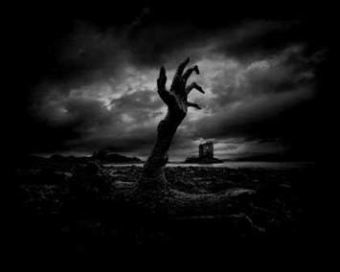

The image above depicts a branch of a collapsed tree with human fingers and sharp nails, suggesting ferocity. The diagonally-upward hand shows movement, growth, and extrusion. As is known in art, the diagonal structure is intended to provoke the recipient's eye with revolutionary connotations. In addition, placing the hand/tree in the foreground focuses on it as a theme. In the distant background we see the ruins of a village in a foggy atmosphere — the hand may be a sign of those who were buried under the earthquake, while the tree’s branches turning into human fingernails to penetrate the earth may symbolize the rejuvenation of the land.

If we look at the details of the tree, especially its cracked bark, it is clear that it is not a normal tree, but an exceptionally old tree with a vast history. Some perennial trees have acquired a certain sanctity in Arab culture and are found in the Holy Qurʾan, such as fig and olive trees. As the poem revolves around the Būghāz tree, it is possible to claim that the tree/hand in the image is a metaphor for the city, with the nails growing back to indicate the rejuvenation of the land. That the hand and tree are attached to one another draws reference to their similarity — they both possess the qualities of production and fruit (i.e., life), with the hand emanating from the human body and the tree emanating from the earth.

This type of image is known in art as a ‘grotesque image.’ Such images cannot be read unilaterally, but can be interpreted through different lenses (which Mitchell [1996] referred to as ‘multi-stability’). This image evokes ambiguity, allowing for infinite interpretations (in order to mislead the viewer). The lack of color from the picture is also significant. The different shades of black and white refer to several concepts related to the content of the text such as: destruction, mystery, fear, vanishing, absence, and so on.

One of the motifs that the poet used frequently is ‘the cat’ — the cat appeared in several sections of the poem in different shapes and forms. Sometimes it appears in black, sometimes in both black and white, and sometimes only its head or eyes appear (in proportion to the content of the accompanying text).

The cat has various connotations among different peoples and civilizations, especially the Amazigh, who believe it is linked to the world of ‘jinn’ (‘genies’) and demons, harming whoever touches it at night. Likewise, the black cat represents bad luck. The Amazigh believe the cat has ‘99 lives,’ allowing it to escape death time and time again, despite what deadly attacks or accidents it may endure (Naṣrallah and Yūnis, 2015).

The cat has other common connotations — it represents trickery, deception, and rudeness. It has often been employed in the arts as a woman (Clark, 1998), and in Arabic and Western literature it bears political and social connotations (Naṣrallah and Yūnis, 2015). The poet has been able to use the cat in the poem to employ rhetorical codes in a way that is compatible with its content, as in the following example:

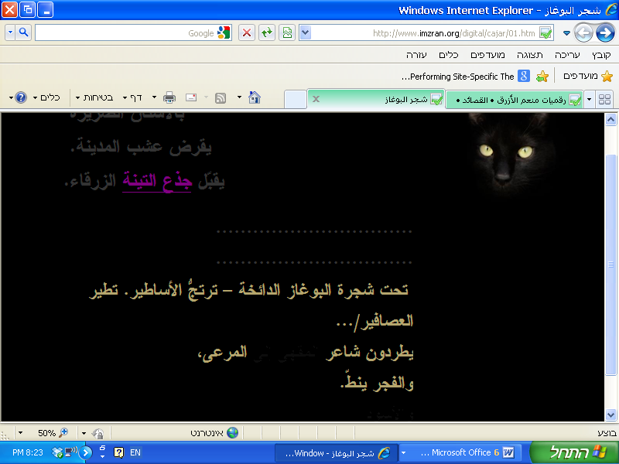

In the image above we see a black cat (with two yellow piercing eyes) that blends into the background. In the middle of the page we see two lines of dots (containing words written in the color of the cat’s eyes) representing a pause in time, a pause that calls for the reflection of, and anticipation of, the indescribably devastating event.

These two lines contain words written in the color of the cat’s ruthless eyes in the darkness. In this sense, the cat bands together with the poet — the poet becomes like an evil cat that triumphs over whomever harms him and is able to survive despite the harm he faces. The cat symbolizes all the poets who, despite being attacked, expelled, and marginalized, possessed the cruel stubbornness of the cat to survive and preserve their poetry. Thus, the image depicts tragedy, challenge, resistance, and survival.

The poet drew upon the cat's connection to the moon, as well. The moon has many connotations in legends, art, and literature. When the moon is red, it is related to femininity and symbolizes fertility. If it changes, or is depicted with an animal, it may symbolize the occurrence of a certain, possibly tragic, event, as the Almighty says (Surah Al-Qamar 1). The poet expressed this in the cover:

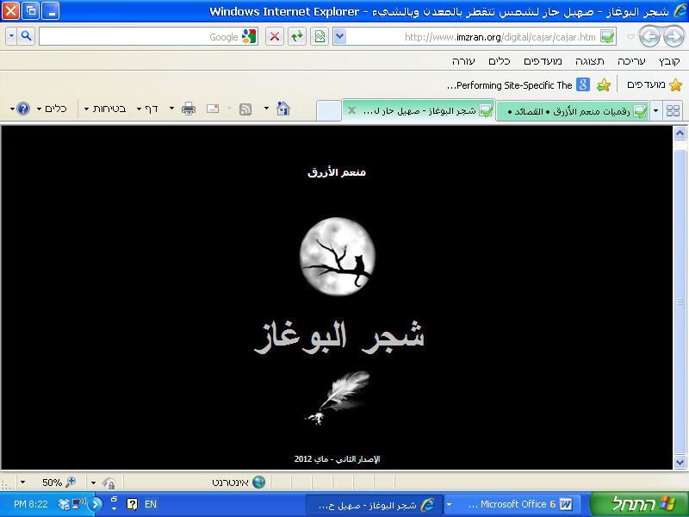

In this picture, the cat appears perched on a sparse tree branch as a metaphor for death, while the tree itself symbolizes the Būghāz tree. The cat is in a position corresponding to the full moon, in reference to a disaster. As the picture depicts nighttime (i.e., storytelling time in the Amazigh culture), it is as if the poet says to the reader, “it is time for me to tell you this tragic tale.” The poet has also been able to employ colors with their different gradients and insignia and symbolism, which we have tried to deduce based on common understanding from the perspective of artistic criticism with regards to colors, on the one hand, and from literature on the other.

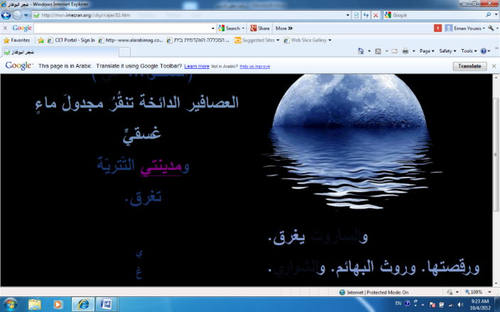

In this interface we see a picture of a moon sinking in water, and by moving the mouse, the text ‘my city’ appears. The text is written in blue gradients, the dominant color in this interface.

In Arab literature and the Qurʾan blue can symbolize misfortune, as the Almighty said,

“On the day the trumpet is blown we will assemble the guilty bleary-eyed (with terror)” (Surah Taha 102:6). All these connotations are consistent with the meaning contained in the text. The text describes the sinking of the city explicitly as a tragic situation after the earthquake. The act of sinking is not depicted only through meaning and color, but also through the topographical shape and the order of the words. The letters that spell the word ‘sinking’ are written separately (a digression from standard Arabic writing conventions) and arranged on top of each other, from top to bottom, to simulate the process of sinking.

***Interacting with Technology and Inventing New Aesthetic Values in Literary Criticism***

The employment of technology has led to the expansion of the new aesthetic values in literary text with which it has not had to contend in its paper format. Thus, it is imperative that the critic or critics involved in analyzing the work take into account such employment of technology as a new aesthetic value.

Before we examine our critical interaction with technology in order to highlight its role in adding new aesthetic dimensions to poetry, we will discuss the relationship between aesthetics and technology generally.

Aesthetics is connected to technology by the intermediate material that the artist uses, as aesthetics is concerned with resolving the qualitative nature of that material and its role in producing works of art. Indeed, since Heidegger wrote *On the Origin of the Work of Art*, he has touched on the importance of machines to art, claiming that technology is the basis of all innovation (Heidegger, 2003).

Heidegger’s claim applies to digital literature as an artistic genre. In the poem “Shajarat Būghāz,” for example, the poet takes the same (written) text and changes the medium thereof, radically altering the essence and method of reading the poem; making it richer and more fertile and granting it other aesthetic dimensions absent in the poem’s paper format.

Since Heidegger, some artistic movements connecting technology and art have emerged (such as the Bauhaus Movement that began in Germany) to produce beautiful, usable doctrines for modern life. This tendency manifests itself in many works of architecture and products used in daily life, such as furniture and textiles. There have been aesthetic elements within technology itself. The design of many emergent machines underscores careful attention to aesthetics. This artistic trend went as far as considering any industrial product that could be a work of art to be as valuable as the fine arts. It also declared that technology itself is a creative endeavor resembling the efforts of artists, musicians, and toolmakers, as indicated by the devices that people use.

Technology, through the design of machines, relies on imagination, innovation, perception, and proficiency. This school of thought regarded the machine as an artistic tool, like the painter’s brush and the potter’s clay. Consequently, the machine started to be viewed as an extension of the human hand, as the computer is viewed as an extension of human consciousness. This led to the appraisal of industrial products’ aesthetic values. It also led to the emergence of new branches within the field of aesthetics, such as *machine aesthetics*, which, as the name suggests, is concerned with studying the aesthetics of machines. Likewise, the use of machines led to the appearance of new aesthetic values within the arts. Aesthetic values connected to technology include *precision*, *flawlessness*, and *simplicity*.

The use of technology in writing in platforms such as hypertext and multimedia forces the writer to pay attention to several criteria that might affect the literary work’s aesthetic values. Among these criteria, which the writer would not have to heed on paper, are the following:

* **Balance**: The writer must not burden any part of the text with fundamental elements that are simultaneously absent in other parts of the text for risk of causing gaps in the text.
* **Unity**: Unity refers to the relationship between the visual elements. The images and texts that share common elements like color create the perception of a single meaning, unlike the incompatible elements that share no common denominator.
* **Movement**: There are two varieties of movement: the movement of the viewer’s eye as it follows the elements of the text on the screen and the movement of certain visual elements themselves. The lack of organized movement may confuse the reader and send them in multiple directions.
* **Contrast**: Contrasts refers to the interaction between the design elements, such as the contrast between light and dark, soft and coarse, cold and warm, and so on. All of these elements musts be considered through the viewer’s eye, lest they strain it.
* **Parallelism:** Parallelism refers to the way that the elements are arranged on the page.
* **Proportionality**: This refers to proportionality between three or more elements, such as the proportionality between the sizes and weights of the design.
* **Rhythm**: Rhythm is repetition of the design elements, such as lines, colors, and spaces, which give the design vibrancy and energy (Muhassib, 2007).

Any discord between the aforementioned design elements disfigures the text and affects the reception of the aesthetic values within it. This means that the writer must learn new methods for writing and expression. They must study these elements thoroughly and know how to utilize them in an effective, positive way. In exchange, the critic must be aware of these elements and understand the programs upon which these texts are built in order to assess their strengths and weaknesses. This is what is known as *software art* (Basṭāwisī, 2011).

Regarding the relevance of these standards to the poem, we have noticed that their fundamentals have been observed, whether consciously on the part of the writer himself or the programmers who assisted him in implementing the work. Awareness of the fundamentals of electronic design has contributed to the preservation of harmony between the visual elements and different aspects of parallelism, unity, and balance. The colors of the images resemble those of the text and flow with the meaning in every aspect of the poem. Similarly, the distribution of the visual cues on the screen works with each element to bring forth the meaning that the author wishes to convey. Sometimes the image occupies the center of the screen, while other times it retreats to the side. This pattern occurs, too, with the written text. As a result, the movement of the reader’s eye follows accordingly.

Judging the aesthetics of digital text requires the critic to fully grasp two fundamental elements, those being:

* **Data**: Data refers to attention to the elements that the text comprises, such as the images, colors, font, etc., as well as their distribution and design.
* **Process**: Process is the software with which the text is built (Wardrip-Fruin and Montfort, 2003). For example, the critic must observe the images that the writer edited using computer programs such as Photoshop.

Thus, we had to examine the poem from these two angles. In addition to the interpretive reading of the literary work, it was necessary for us to do a reading of the data and software. It is worth noting that we could have enlisted the assistance of a third critic, but we preferred to focus on the artistic and literary aspects. At the same time, we were aware of the importance of the role that technology plays and were content to immerse ourselves in it to the extent that our critical faculties allowed.

During our interaction with technology and our interpretative reading of it, we had to exchange our understanding of certain critical terms familiar to us with new understandings—for example, the concept of eloquence. Before the digital text, the stylistic eloquence of a text was gauged by the writer’s ability to employ diction to generate meanings, ideas, and artistic images; their use of literary devices like allegory, metaphor, allusion, assonance, and analogy; and their ability to convince and argue. However, with the advent of the digital text and the use of multimedia, the concept of eloquence has changed. It is now gauged by other standards and new devices. When a writer can master all technological capabilities in the service of a text, they use color as symbol, movement as meaning, music as suggestion, and image as allusion.[1]

Through our semiotic analysis of the different visual functions of the text, we endeavored to uncover the hidden eloquence by noting its new digital appearances and manifestations. We demonstrated the eloquence of expression in the image, color, and font, as well as the role of visual symbols in enriching the meaning. This confirms Simanowski’s hypothesis that the value of visual poetry is not latent in its presentation of new visual forms itself; rather, these new visual forms complement the semiotic meaning of the words (Simanowski, 2010).

Consequently, our preoccupation with reading the poem in its digital format (as opposed to reading in its paper format) was embedded in the search for internal relationships with the aesthetic medium used. This aesthetic medium finds visual expression in the relationship between the images and the utterances; between the colors, its tones, and its dimensions; between the words and their sizes; and in the ability of the visual functions to induce different feelings within us as critical viewers. This is what leads to the different aspects of reading and interpretation.

Accordingly, if the aesthetics of the traditional text are realized by the text’s deviation from the familiar through the eloquent styles used, then the digital text’s deviation from the familiar is achieved through the various media and techniques that it employs. Such digital eloquence opens the text to limitless readings.

The effect of hypertext on the aesthetics of the text can be traced to its importance in making the text a hybrid text, or a text combining multiple arts. All of the arts are interwoven within the text: drawing, film direction, photography, and calligraphy. This is what urged us to rethink multiple other terms such as ‘intertextuality’, ‘adaptation,’ ‘embedding,’ and others related to rhetoric that now require new definitions.

The employment of hypertext technology also led to the prominence of other forms of interaction with the text. Links that defined the way we view the text are employed in the poem to navigate from one interface to the other — this is known as ‘point of view’ (Rossario, 2011). Therefore, contrary to the case with paper text, it was not possible to view the entire poem at once, and thus we had to move from one link to the other in order to open the different interfaces and read their content. As we did this, we assumed the role of the exploratory reader who probes the nuances of ‘exploratory text’ (as Michael Joyce called it) in order to uncover its contents and significance (Rossario, 2011).

In addition to what was mentioned above, the links worked to both guide the reading process and to split it up. We had to move between the interfaces, guided by the links that either allowed us to move forward or backward. This technology did not lead to a linear reading of the poem, but to a multi-faceted reading with many internal intricacies, and we did not know where we would end up. The links enabled us to penetrate the body of the poem, or to traverse its outer surface, in an exploratory trip that took on a third dimension.

In the context of our reading, the hypertext technology is interactive critical reading, which can be said to have led to our physical interaction with the text through the click of the mouse (and to our mental interaction through our analysis of the links and their contents). This type of interaction is considered the simplest type of digital interaction (‘degree zero of interactivity’; Rossario, 2011, p. 90) or what is also known as ‘weak interactivity.’ All we could do was follow the trajectory by opening the links without the freedom of choosing the order in which we opened them (contrary to some Western digital works where hypertext technology is employed in a manner that stimulates the greatest possible interaction between the reader/critic and the text).

***Communication with the Author and the Reader***

Interactive digital criticism, according to our understanding of it, not only interacts with the elements of the text, rather it extends to the interaction with the author and the reader. These two parties cannot be ignored in a networked world in which we can communicate easily. It would seem illogical to not take advantage of this opportunity and benefit from it.

We interacted with the author via email, discussing different matters. We were able to urge him to document his poems digitally and to encourage him to write new digital poems. However, he did not refer us to the content to the same extent that he cooperated with us to decipher some of the symbols interchangeably (interactively). In this regard, it is important to note that we drew the attention of the poet to the importance of the chronological order of his poems and the factors that encouraged him to work and refine his poems.

Without a doubt, our email conversation with Al-Azraq confirms the direct influence of the digital critic on the author. Al-Azraq had to document the gaps in his research by drawing upon our notes to him, which highlighted areas which would not have been noticed through traditional paper criticism, as critics used to share their notes and ideas on paper, without the ability to know the authors’ reaction to the critics’ notes. We find that digital criticism opens the door wide for positive interactive cultural exchange between the author and critic.

Our communication with the author also revealed to us some information related to the Amazigh culture upon which the poem was built. The poet is of Amazigh descent, and drew upon his cultural symbols, necessitating us to unearth the different Amazigh legends and history by drawing upon the text and communication with the author.

For example, through the author’s statement “be a Berber without pronouncing the letter ‘r’ with a Western accent” he meant to reject the Western influence that looked upon Amazighs negatively. Therefore, the educated and cultured poets, writers, and artists imposed their Amazigh culture through art and literature by inserting Amazigh words in their literary texts (called ‘site of memory’ by Pierre Nora and others). These poets, writers, and artists (and others like them) have contributed to the enrichment of their culture and helped save it from extinction.

As we adopted the interactive critique with the author, we also adopted it with the readers, by analyzing and screening their comments, taking them into account in order to work in a manner that re-establishes lost boundaries. Ryan Gillespie claims that the main drawbacks brought by the internet and social networks are the dismantling and undermining of the functions of the author, the reader and the critic, and the demarcation of boundaries between them; as a result, there is a growing need for a systematic critical process that has a clear scientific basis that distinguishes between the commentator and the expert critic (Gillespie, 2012).

***Summary and Conclusion***

The changes that resulted from the employment of technology in the literary text also prompted changes in the methods of literary production and delivery, opening up new perspectives in the field of digital literature. We have attempted to reveal these perspectives by reviewing the critical process itself.

As long as digital work is operational, it requires procedural critique. Breaking into the text of “Shajarat Būghāz”requires a complex process, which falls within the context of theorization through experimentation, and falls within the scope of the aesthetic experience.

In our attempt to understand the poem in its social contexts and historical and cultural references, we had to conduct an in-depth reading and seek meaning beyond what was explicitly stated in the text. Therefore, we read about Amazigh history and popular Moroccan legends. We also reviewed news sources pertaining to the destructive earthquake that struck the Būghāz region many years ago. It was also necessary for us to communicate with the author to understand some Amazigh terminologies that were difficult to decipher from the context alone. Additionally, we looked at readers’ comments on the website of the digital form of the poem, enriching the critical vision of literary work through an exchange of views. This communication between us as readers and the writer, and between us and other readers, demonstrates that in this virtual space, barriers between the writer, reader, and critic are torn down; virtual communication is opened up and reduces the feeling of alienation and distance between them.

We strived to understand and analyze the technological literary interaction between the visual and textual functions in the poem through the integration of our critical tools borrowed from the fields of literature and art — two fields influencing and enriching one another. Naturally, we did not forget to interact with technology and the different levels of technological analysis in order to uncover their additional value in providing the text with new aesthetic dimensions.

Without a doubt, then, a text like “Shajarat Būghāz” and others like it, require an atypical critic — a critic that can read in diverse directions and permeate the text from all angles.

**References**

**Basṭāwisī, M.** (2011). Al-Naṣṣ al-Adabī Bayna al-Maʿlūmātīya wa-l-Tawẓīf. In Āfāq al-Ibdāʿ wa-Marjaʿīyatuhu fī ʿAṣr al-ʿUlūma. Dimashq: Dār al-Fikr.

**Clark, T.J.** (1998). The Painting of Modern Life: Paris in the Art of Manet and His Followers (revised ed). Princeton, NJ: Princeton University Press, p. 86.

**Gillespie, R.** (2012). The Art of Criticism in the Age of Interactive Technology: Critics, Participatory Culture, and the Avant-Garde. International Journal of Communication, 6:56–75.

**Heidegger, M.** (2003). Aṣl al-ʿAmal al-Fannī. Abū al-ʿĪd Dūdū (trans). Al-Jazāʾir: Manshūrāt al-Ikhtilāf, p. 77.

**Mitchell, W.J.T.** (1996). Word and Image. In Nelson, R. and Shiff, R. (eds),Critical Terms for Art History. Chicago, IL: University of Chicago Press, p. 50.

**Muhassib, H.** (2007). Ikhrāj al-Ṣuḥuf al-Iliktrūnīya ʿalā Shabkat al-Internet. Al-Qāhira: Dār al-ʿUlūm li-l-Nashr wa-l-Tawzīʿ, p. 285.

**Naṣrallah, A. and Yūnis, I.** (2015). Al-Tafāʿil al-Fannī al-Adabī fī al-Shiʿir al-Raqmī: Qaṣīdat Shajar al-Būghāz Namūdhajan.Kfār Sābā: Markaz Abḥāth al-Mujtamaʿ al-ʿArabī fī Isrāʾīl,Bayt Berl, pp. 102–5.

**Rossario, G.** (2011). Electronic Poetry: Understanding Poetry in the Digital Environment.Jyväskylä, Finland: University of Jyväskylä, p. 111.

**Simanowski, R.** (2010). Against the Embrace: The Recovery of Meaning Through the Reading of Digital Arts. Minneapolis, MN: University of Minnesota Press.

**Surah Al-Qamar** 1.

**Surah Taha** 102:6.

**Wardrip-Fruin, N. and Montfort, N.** (2003). The New Media Reader. Cambridge, MA, and London: MIT Press.

1. A number of critics have referred to the concept of ‘digital rhetoric’ and have used it in various studies. They have pointed to many other critical terms that have acquired new concepts because of changes made by technology. Arab criticism, however, still lacks a lexicon that redefines literary terms in the context of technological transformations.