**The comparison of pre- and post-operation diabetes in patients 4-7 post LAGB**

**Short title: Follow-up of diabetics after LGB**

**Manuscript type:** Original contribution

Shahar Atias a*, Uri Netz a*, Ofri Berar b, Solly Mizrah  a, Leonid Lantsberg, Eliezer Avinoach a, and Zvi H. Perry a,b

aSurgery Ward A, Soroka University Medical Center

bEpidemiology and Health Evaluation Department, Faculty of Health Sciences, Ben-Gurion University

*Equal contributors

Correspondence to:

Dr. Zvi Perry

Surgery Ward A

P.O.B. 651

Soroka University Medical Center

Beer-Sheva, Israel, 84101

Mobile: +972-50-489-3371

Fax: +972-8-647-7633

e-mail: [zperry@bgu.ac.il](mailto: zperry@bgu.ac.il)

sollymizrahi@gmail.com; avinoach@zahav.net.il; urinetz@gmail.com; atiassh@yahoo.com; [leolant@bgu.ac.il](mailto:leolant@bgu.ac.il); berar.ofri@gmail.com

ABSTRACT

**Background/Objective**: Laparoscopic gastric banding (LGB) is a common treatment for morbid obesity. Laparoscopic adjustable gastric banding (LAGB) has the potential to improve control of the comorbidities of morbid obesity, primarily diabetes mellitus (DM) and hypertension (HTN). Our hypothesis was that patients treated with LAGB would have long-term improvement in the control of DM and HTN.

**Methods:** This is a cohort study, based on patients who underwent LAGB surgery in our institution 4 to 7 years previously and had DM type 2 at the time of surgery. Data were collected from patients’ charts and a telephone interview–based questionnaire including demographics, health status, and quality-of-life assessment (Bariatric Analysis and Reporting Outcome System [BAROS]).

**Results:** Seventy patients participated in the current study. Average follow-up time was 5.128±0.85 years postsurgery. The average weight prior to surgery was 122.01±20.2 kg, and on the day of the interview it was 86.97±17.53 kg (*P* < .001). The average body mass index before surgery was 43.76±5.08, and on the day of the interview it was 31.16±4.83 (*P* < .001). On the day of the interview, 47.1% of the participants were cured of DM (not receiving treatment, dietary or pharmacologic). The sum of ranks for diabetes was lower after the surgery (*P* < .001), as was HTN and its treatment (*P* < .001).

**Conclusion**: We have shown in this study that LAGB is an effective treatment for morbid obesity, as well as two comorbidities that come with it—DM type 2 and HTN—in a longer period of time than previously shown. There is a need for further studies to consolidate our findings and characterize which patients are more prone to enjoy these remarkable surgical benefits.

Keywords

Laparoscopic gastric banding; Diabetes mellitus; Remission; Long-term follow-up

1. **Introduction**

Obesity, defined as a body mass index (BMI) of more than 35, is a worldwide epidemic, with numbers on the rise in the Western world.1,2 Obesity is strongly correlated with ischemic heart disease, diabetes mellitus (DM), and arterial hypertension (HTN), and it has been associated with increased morbidity and mortality. One of the major factors affecting this increase is comorbid diseases that are strongly associated with and dependent on the degree of obesity.3 DM type 2 and HTN are among the most important and dangerous of these.4 The risk of developing DM is strongly affected by the familial history and an elevated BMI; together, they nearly double the risk.4,5 In a cohort study comprising more than 80,000 patients, the strongest predictor for DM after a decade was obesity.6,7 DM affects close to 10% of the adult population in the US.8 Treatment can prevent some, but not all, of its lethal consequences.5 HTN is also commonly seen in obese patients. About 1 of 3 US adults, approximately 70 million people, have high blood pressure.7 HTN increases the risk for [heart disease](http://www.cdc.gov/heartdisease/index.htm) and [stroke](http://www.cdc.gov/stroke/index.htm), two of the leading causes of death in US adults. Bariatric surgery for the treatment of obesity has an important role. It has been shown to be the best long-term solution for weight reduction in the severe or morbidly obese.9 Laparoscopic adjustable gastric banding (LAGB), a restrictive type of surgery, is a common type of bariatric procedure. Worldwide utilization of LAGB as a bariatric procedure has varied, with its being used in 24.4% of all bariatric procedures in 2003, peaking at 42.3% in 2008, and decreasing to 17.8% in 2011.10 It is a relatively simple and safe operation that does not change gastrointestinal anatomy (allowing reversibility), has a very low mortality rate and short hospital stay, and results in good, stable long-term weight loss.5,11–16

In addition, and as a result of the weight reduction, bariatric surgery has the potential to affect the comorbidities. Schauer et al.12 demonstrated that surgical treatment by sleeve gastrectomy or Roux-en-Y gastric bypass on morbidly obese patients with DM was superior to medical treatment in a 1-year follow-up. Bariatric surgery has also been shown to be effective for improving control of DM even in patients who have a BMI less than 35,13,14 and different kinds of bariatric procedures have shown these improvements.15 Bariatric surgery has also been shown to improve the control of HTN in obese patients.16,17

An important question is what the long-term effects of bariatric surgery on obesity-related comorbidities are. A study done on LAGB patients diagnosed with DM showed that after 4 years, most of the patients showed a marked improvement both in their DM and in HTN.15,18,19

Alas, long-term follow-up on this subject is lacking. We hypothesized that LAGB would be proven to be an effective treatment for DM and HTN in a long-term follow-up of 4 to 6 years after the index operation.

**2. Materials and methods**

This is a retrospective cohort study based on patients with obesity and DM who underwent LAGB surgery in the Soroka University Medical Center (SUMC), a high-flow bariatric center. The study was approved by the SUMC IRB. Inclusion criteria incorporated patients who underwent LAGB (ICD-9 code 44.95) in Surgical Department A, SUMC, Beer-Sheva, Israel, during the years 2002 to 2012, had a concomitant diagnosis of DM type 2 known prior to surgery, and had their band for 4 to 7 years. Fig. 1 depicts the flow diagram for patient selection.

From the patients fitting these criteria, we selected a random sample of 70 patients to be included in the study. Consenting participants were interviewed by telephone.

Comorbidities and weight loss were assessed by a standardized questionnaire (see Supplement 1).20,21 Surgical outcome was assessed according to the Bariatric Analysis and Reporting Outcome System (BAROS) questionnaire, which is a standardized questionnaire for assessing weight loss and quality of life22,23 (Supplement 2). Additional data were collected from patient charts.

**2.1 Surgical technique**

The patient was placed on the table in the supine position with left tilt. All patients were administered a single dose of intravenous cefuroxime 750 mg preoperatively, unless there was a known allergy to it. End-tidal CO2 monitoring was performed in all patients during surgery. The pneumoperitoneum was achieved using Veress needle in all patients. The Veress needle was inserted in the left subcostal space in the middle clavicular line to avoid inadvertent injury of the uterus. Pneumoperitoneum of 12 mm Hg was obtained. The location of the first port was supra-umbilical and was moved cephalad according to prior operations. Subsequently, two working 10 mm trocars were placed under laparoscopic guidance, as well as two 5 mm ports to aid with retraction. Standard laparoscopic band technique was implemented with separation of the gastrophrenic ligament, followed by pars flaccida dissection. Insertion of the gastric band was performed in the usual manner through the 10 mm port in the left CVA. Once the band was placed and locked, the port was positioned near the sternum.

**2.2 Power analysis**

The power of the study was calculated using PEPI-for-Windows (WINPEPI) by comparing total BAROS score and the level of morbidity before and after the operation (pairs function). We used a power of 80%, α = .05, and an odds ratio (OR) of 2. Under these assumptions, the required sample size was at least 70 patients.

**2.3 Statistical analysis**

The data were analyzed with SPSS version 18.0. Descriptive statistics including mean values and standard deviations were used to describe the baseline characteristics of the 2 study groups. Intergroup comparison was done using the Pearson chi-square test for qualitative variables and the Fisher exact test for dichotomous variables. Comparison of quantitative variables was performed using parametric tests: a paired samples *t* test and a Wilcoxon nonparametric test. The level of significance was defined as *P* < .05.

**3. Results**

A total of 70 patients who fit the above criteria were enrolled. Twenty-three (33%) patients were males, and 53 (76%) of the patients were married. The average age at recruitment was 55±9.9 years. The average interview time after surgery was 5.1±0.9 years. None of the patients suffered from any complications during their index hospitalization. In 10 patients (15%), the band was open during the time of interview (an empty band does not contribute to weight loss as it does not press on the stomach). The average weight prior to surgery was 122±20 kg; the lowest weight attained was 78±16.4 kg, while the weight at the time of the interview was 87±17.5 kg. The average weight loss between surgery and the interview was 35±16.6 kg (*P* < .001).

The BMI immediately prior to the operation was 43.8±5, whereas at the time of the interview it was 31.2±4.8, with an average decrease of 12.6±5.7 (*P* < .001). No significant differences were found in weight loss or BMI between males and females (*P* = .946).

As mentioned, all patients had DM prior to the operation; 17 (24%) were treated by diet only, 41 (59%) needed oral medications, and 12 (17%) needed insulin (see Fig. 2).

After the operation, 33 (47%) of the patients had a remission from diabetes, 5 patients (7%) needed only diet as their treatment, 21 patients (30%) needed oral medications, and 11 patients (16%) needed insulin (see Fig. 3).

When patients were asked about their diabetes state, 3 patients (4%) said that they felt it had gotten worse, 8 (11%) declared no change in disease status, 8 (11%) declared a slight change in disease status as being more balanced, 18 (26%) reported a big improvement in their status, and the rest (32 patients, or 46%) reported a remission in their diabetes. When patients were asked about their use of diabetes and HTN medication before and after the operation, their responses showed a significant decline (*P* < .001).

The fasting glucose level of 47 patients who were tested in the month of the interview was 111.6±32. Forty-three patients (61%) had HbA1c levels taken before and after the operation—of them, the average HbA1c before operation was 8.6±2.1, and after the operation, the average was 6.6±1.1; this led to an average decrease of HbA1c of 2.1±2.1, which was a significant decrease in the HbA1c from before the operation (*P* < .001).

Of the 70 patients, 39% had lost less than 25% of their excess body weight, while other patients lost more than that. When looking at the group that had lost more than 25% of excess body weight, there was a higher utilization of the band (95% vs. 70% in the lower reduction of band utilization; *P* = .011). Age and number of years with the band had no significant effect on excess weight loss. An interesting result was that there was no difference between those who lost more than 25% of their excess weight and those who lost less than that in the reduction of HbA1c, which means this is unrelated to the magnitude of the weight loss. Also, we did not find any correlation between the HbA1c levels and the BMI decrease or the excess weight loss. Another interesting result was an improvement in other comorbidities such as HTN (50% did not need any HTN drugs 5 years after the operation), and OSA was clinically improved in 25% of the patients.

When considering the subjective level, 29% of the patients felt a significant improvement in their self-esteem, and 43% felt a dramatic improvement.

Forty-nine percent of the patients felt a significant improvement in their physical ability, and a significant correlation was found between the excess weight loss and the improvement in physical ability (*r* = 0.421, *P* < .001).

The BAROS score in total had an average of 2.7±1.43. The distribution of the BAROS scores is depicted in Fig. 4.

When considering weight on interview, we found an inverse correlation between the current weight and the BAROS score (*r* = –0.385, *P* = .001). A similar result was found between the BMI difference and the BAROS score (*r* = 0.604, *P* < .001). Similarly, a significant difference was found in the total BAROS score between the group who lost less than 25% of their excess body weight and those who lost more (1.6 vs. 3.3; *P* < .001).

**4. Discussion**

Obesity and its comorbidities, mainly diabetes and HTN, are a great challenge to physicians today. Surgical therapy for obesity and its comorbidities is well established.13,18,24 Research has shown the efficacy and safety of bariatric surgery for the treatment of obesity-related illness, mainly diabetes.18 However, these studies were for short periods of time, and their long-term efficacy is not well established, which led us to conduct the current study. In our study, we followed diabetic patients who had undergone LAGB for a range of 4 to 7 years after surgery, with a mean follow-up time of 5.130.9± years. When considering the long-term effect of LAGB on obesity, our study has shown that 5 years after the operation, our patients showed a steady and significant decrease in body weight (*P* < .001); the mean BMI previous to the operation was 43.8±5.1, and the mean BMI at the time of the study was 31.2±4.8, which reflects a mean BMI reduction of 12.5, or 35 kg lost on average. Sixty-two percent of the patients lost more than 25% of their excess body weight. Similar results have been shown in other studies, even though their follow-up period was shorter.25–27

Some studies have shown that the main bulk of the weight loss following bariatric surgery is attained in the first 2 years11,26; our results have shown that there is a decrease to a lower weight than seen upon the interview time, as indicated in the difference between weight attained until interview and lowest weight attained.

Forty-seven percent of our patients, who at the start of our study were all considered diabetic, no longer had elevated blood sugar, which meant that they needed no treatment. This is in accordance with prior studies18 that had shorter periods of follow-up or a smaller sample size. HbA1c levels decreased from 8.6 to 6.6, which means that on average, most of our patients have become balanced with regard to their diabetes. A study that randomized patients either to traditional diabetes treatment or LAGB showed that remission rates were 5 times more likely in LAGB patients 2 years after the operation. Our results have validated that and have shown that the remission rate stays higher 5 or more years after the operation. If we take into consideration the long-term damage caused by diabetes and the dangers of traditional treatment for it (mainly hypoglycemia), the LAGB patients on average have shown a normal HbA1c, which means a balanced sugar level not only on the day of the examination but at least 3 months prior to it; this means that the operation has succeeded in the long-term control and even “cure” of their diabetes. If we remember that one of the indications for bariatric surgery is alleviating comorbid illness, mainly diabetes, our results show that long-term relief is achieved using LAGB and that this remission is independent of the excess body-weight loss, which mitigates one of the main criticisms about LAGB, as it leads to a smaller reduction of weight than other bariatric procedures.

When considering subjective results of the LAGB, we have found (not surprisingly) that the larger reduction in weight (as portrayed in excess weight loss) was positively correlated with the elevation of self-esteem after the operation. Previous studies have shown that 1 year after surgery, the weight loss was not a predictor for the quality of life of bariatric patients,23,26 and we can conclude that the change in weight loss is significant only on larger time scales and that the main factor is not weight by itself but the loss of excess weight.

The BAROS is a validated questionnaire for the evaluation of subjective results of bariatric procedures,23,26 and as such, it was utilized in the current study to understand the long-term effect of LGB on our diabetic patients. We have seen that 5 years after the operation, the total BAROS score was on average 2.7, which is considered a fair result. This seems to be contradictory to the fact that remission and a clear improvement in diabetes are seen in most of our patients. We believe this stems from the fact that even though bariatric operations are lifesaving procedures in essence, they are perceived by the general public as an esthetic procedure, and due to that, the satisfaction from the operation is reliant mainly on weight loss and not on true objective measures such as HbA1c. Thus, it seems logical to have some kind of coordination of patients’ anticipation to aid them in their subjective evaluation of the operation.

**4.1 Study limitations**

First and foremost, the sample size is not very large, even if it is satisfactory based on sample-size calculations.

Secondly, our study is in part a retrospective cohort study, which is a design more prone to biases such as information and selection bias. It would be better if this study had been conducted in a prospective cohort study design, but time and financial issues prevented this.

Another limitation is the length and timing of the study. We did not see in the years of the study any trend of more band removals, but in the last 2 years, as the sleeve has become increasingly prevalent in Israel, we have seen a rise in the number of band removals. Based on these limitations, we advise that future studies should have a larger sample size, should include patients whose band has been removed, and should involve longer periods of follow-up.

**5. Conclusion**

Our study is unique in its length of follow-up on patients with diabetes who underwent an LAGB. We have found that LAGB is an efficient and safe procedure not only for weight loss but more importantly for the comorbid illnesses that are so prevalent among obese patients—mainly diabetes and HTN. Our study has shown that 5 years after the operation, half of our patients were in remission of their diabetes and most of the patients showed an improvement in their diabetes, in sharp contrast to patients with diabetes who were not operated on, a majority of whom showed deterioration in their medical status. Thus, we can conclude that in the long term, LAGB at least ceases the detrimental deterioration seen in diabetes, and it might even lead to a full remission of the disease.

Considering the fact that the public burden of diabetes worldwide is enormous, and today treatments for this disease are lacking, LAGB is a valid answer, both safe and efficient, and a big advancement in our battle against diabetes.

**Declaration of competing interest**

The journal requests a Competing Interests Statement to be included: *All authors must disclose any financial and personal relationships with other people or organizations that could inappropriately influence (bias) their work. … Authors must disclose any interests in two places: 1. A summary declaration of interest statement in the title page file (if double-blind) or the manuscript file (if single-blind).* ***If there are no interests to declare then please state this: “Declarations of interest: none.”*** (See journal guidelines at <https://www.elsevier.com/wps/find/journaldescription.cws_home/505770?generatepdf=true>)

**Funding**

The journal requests a Funding Statement to be included: *You are requested to identify who provided financial support for the conduct of the research and/or preparation of the article and to briefly describe the role of the sponsor(s), if any, in study design; in the collection, analysis and interpretation of data; in the writing of the report; and in the decision to submit the article for publication. If the funding source(s) had no such involvement then this should be stated.* (See journal guidelines at <https://www.elsevier.com/wps/find/journaldescription.cws_home/505770?generatepdf=true>)

**Author contributions**

The journal suggests including an Author Contribution statement: *For transparency, we encourage authors to submit an author statement file outlining their individual contributions to the paper using the relevant CRediT roles: Conceptualization; Data curation; Formal analysis; Funding acquisition; Investigation; Methodology; Project administration; Resources; Software; Supervision; Validation; Visualization; Roles/Writing - original draft; Writing - review & editing. Authorship statements should be formatted with the names of authors first and CRediT role(s) following.* (See example at <https://www.elsevier.com/authors/journal-authors/policies-and-ethics/credit-author-statement>)

References

1. Bour ES. Evidence supporting the need for bariatric surgery to address the obesity epidemic in the United States. *Curr Sports Med Rep*. 2015;14(2):100–103.
2. Dietz WH. The response of the US Centers for Disease Control and Prevention to the obesity epidemic. *Annu Rev Public Health*. 2015;36:575–596.
3. Baker JL, LW Olsen, TI Sorensen. Childhood body-mass index and the risk of coronary heart disease in adulthood*.* *N Engl J Med*. 2007;357(23):2329–2337.
4. Lyssenko V, Jonnson A, Almgren P, et al. Clinical risk factors, DNA variants, and the development of type 2 diabetes. *N Engl J Med*. 2008;359(21):2220–2232.
5. Knowler WC, Barrett-Connor E, Fowler SE, et al., Reduction in the incidence of type 2 diabetes with lifestyle intervention or metformin*.* *N Engl J Med*. 2002:346(6):393–403.
6. Hu FB, Manson JE, Stampfer MJ, et al. Diet, lifestyle, and the risk of type 2 diabetes mellitus in women*.* *N Engl J Med*. 2001;345(11):790–797.
7. Centers for Disease Control and Prevention. High blood pressure—CDC fact sheet. <http://www.cdc.gov/bloodpressure/>;2015.
8. Centers for Disease Control and Prevention. National diabetes statistic card. <http://www.cdc.gov/diabetes/data/statistics/2014statisticsreport.html>;2014.
9. Sjöström L, Lindroos AK, Peltonen M, et al. Lifestyle, diabetes, and cardiovascular risk factors 10 years after bariatric surgery. *N Engl J Med*. 2004:351(26):2683–2693.
10. Victorzon M, Tolonen P. Mean fourteen-year, 100% follow-up of laparoscopic adjustable gastric banding for morbid obesity. *Surg Obes Relat Dis*. 2013;9(5):753–757.
11. Alhamdani A, et al. Laparoscopic adjustable gastric banding: a 10-year single-centre experience of 575 cases with weight loss following surgery. *Obes Surg.* 2012;22(7):1029–1038.
12. Schauer PR, Kashyap SR, Wolski K, et al. Bariatric surgery versus intensive medical therapy in obese patients with diabetes. *N Engl J Med.* 2012;366(17):1567–1576.
13. Fried M, Ribaric G, Buchwald JN, Svacina S, Dolezalova K, Scopinaro N. Metabolic surgery for the treatment of type 2 diabetes in patients with BMI <35 kg/m2: an integrative review of early studies. *Obes Surg*. 2010;20(6):776–790.
14. Baskota A, Li S, Dhakal N, Liu G, Tian H. Bariatric surgery for type 2 diabetes mellitus in patients with BMI <30 kg/m2: a systematic review and meta-analysis. *PLoS One*. 2015;10(7):e0132335.
15. Dicker D, Yahalom R, Comaneshter DS, Vinker S. Long-term outcomes of three types of bariatric surgery on obesity and type 2 diabetes control and remission. *Obes Surg*. 2016:26(8):1814–1820.
16. Benaiges D, Sagué M, Flores-Le Roux JA, et al. Predictors of hypertension remission and recurrence after bariatric surgery. *Am J Hypertens*. 2016;29(5):653–659.
17. Ricci C, Gaeta M, Rausa E, Asti E, Bandera F, Bonavina L. Long-term effects of bariatric surgery on type II diabetes, hypertension and hyperlipidemia: a meta-analysis and meta-regression study with 5-year follow-up. *Obes Surg*. 2015;25(3):397–405.
18. Frigg A, Peterli R, Peters T, Ackermann C, Tondelli P. Reduction in co-morbidities 4 years after laparoscopic adjustable gastric banding. *Obes Surg*. 2004;14(2):216–223.
19. Ballantyne GH, Wasielewski A, Saunders JK. The surgical treatment of type II diabetes mellitus: changes in HOMA insulin resistance in the first year following laparoscopic Roux-en-Y gastric bypass (LRYGB) and laparoscopic adjustable gastric banding (LAGB). *Obes Surg*. 2009;19(9):1297–1303.
20. Atias S, Perry ZH, Netz U, Mizrahi S, Avinoach E. The effects of gastric banding in morbid obesity on eating behavior—a 3-phase model. *J Obes Bariatr*. 2015;2(2):5.
21. Perry ZH, Glazer Y, Teich N, et al. Why do patients who underwent laparoscopic adjustable gastric banding surgery, decide to remove their band, a retrospective cohort study. *J Obes Bariatr*. 2015;2(2):5.
22. Oria HE, Moorehead MK. Bariatric analysis and reporting outcome system (BAROS). *Obes Surg*. 1998;8(5):487–499.
23. Mamplekou E, Komesidou V, Bissias Ch, Papakonstantinou A, Melissas J. Psychological condition and quality of life in patients with morbid obesity before and after surgical weight loss. *Obes Surg*. 2005;15(8):1177–1184.
24. Fisher BL, Schauer P. Medical and surgical options in the treatment of severe obesity. *Am J Surg*. 2002;184(6B):9S–16S.
25. Blanco-Engert R, Weiner S, Pomhoff I, Matkowitz R, Weiner RA. Outcome after laparoscopic adjustable gastric banding, using the Lap-Band and the Heliogast band: a prospective randomized study. *Obes Surg*. 2003;13(5):776–779.
26. Weiner R, Blanco-Engert R, Weiner S, Matkowitz R, Schaefer L, Pomhoff I. Outcome after laparoscopic adjustable gastric banding—8 years experience. *Obes Surg*. 2003;13(3):427–434.
27. Dixon JB, O’Brien PE, Playfair J, et al. Adjustable gastric banding and conventional therapy for type 2 diabetes: a randomized controlled trial. *JAMA*. 2008;299(3):316–323.

**Figure captions**

Fig. 1. Study Population. *LAGB,* laparoscopic adjustable gastric banding.

Fig. 2. Diabetes mellitus (DM) status prior to the operation.

Fig. 3. Diabetes mellitus (DM) status after the operation.

Fig. 4. Bariatric Analysis and Reporting Outcome System (BAROS) scale distribution in the current study.

**Figure 1**

Patients who underwent an LAGB procedure during the study period – **10,824**

Patients who underwent an LAGB procedure that had concomitant Diabetes mellitus Type 2 at the time of surgery – 1046.

Patients who underwent an LAGB procedure who had concomitant diabetes mellitus type 2 at the time of surgery and had their band for more than 4 years but less than 7 – 430

Randomly sampled – 70 patients

**Figure 2**

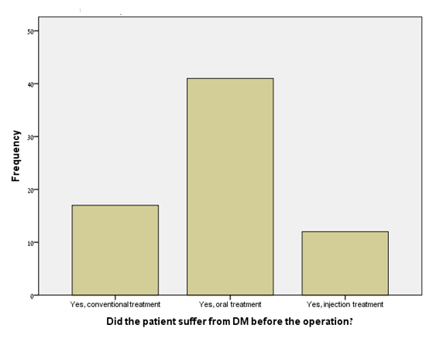

**Figure 3**

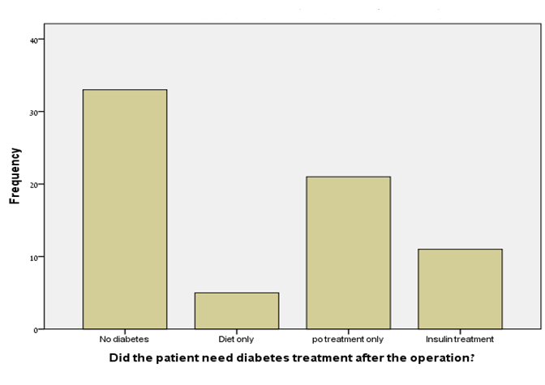

**Figure 4**

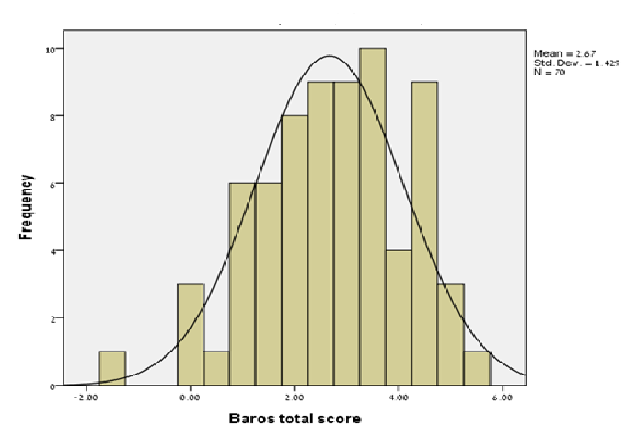

**Index**

**Supplement 1 – Result and Comorbidity Questionnaire**

Subject number: _________________ Name and Family: _________________

Date of birth: _________________ Gender: M\F

Height (cm): _________________ Current weight (kg): _________________

Lowest weight attained (kg): _______________ Year of band placement: _________________ Post op days: _________________

Were there any early post-op complications? Which: _________________

Any late post-op complications? Which: _________________

**Background illnesses:**

Did you suffer before the operation from HTN? _________________

Do you suffer today from HTN? _________________

How did the operation change this illness? It worsened/Did not change/Some improvement/A big improvement/Total remission

Did you suffer from DM before the operation? _________________

Do you suffer from DM today? _________________

How did the operation change this illness? It worsened/Did not change/Some improvement/A big improvement/Total remission

Did you suffer from OSA before the operation? _________________

Do you suffer from OSA today? _________________

How did the operation change this illness? It worsened/Did not change/Some improvement/A big improvement/Total remission

**Supplement 2 – Bariatric Analysis and Reporting Outcome System (BAROS) obesity scale**

