**Title of Seminar:**

“**Topics in Jewish Legal and Philosophical Thought, from the Geonim of Babylonia to Maimonides**” **–** Halakhic Codices of the Bodleian Library of Oxford as a Key to comprehension of the Jewish legal system

**Seminar leader or leaders**Neri Ariel (M.A., PhD anticipated in summer of 2018), Hebrew University, Talmud and Halakha Dept. [neri.ariel@mail.huji.ac.il](mailto:neri.ariel@mail.huji.ac.il)

I wish to join other scholars at Oxford who are working on similar topics in related research fields.

**Description of subject**

Maimonides received and continued a legal-halakhic and philosophical tradition established by the Babylonian Geonim. However, he also transcends their halakhic erudition and philosophical scope. Prior to Maimonides, Andalusian Rabbinic sages, such as R. Isaac Ben Yehuda ibn Ghiat (1038–1089 Lucen), already began to compile and organize Geonic texts. This literature can serve as a basis for the proper appraisal of materials from the Geonim and may provide insight into Maimonides’ evaluation of the traditional scholarship transmitted by his predecessors. This seminar will provide scholars with unique insight into Maimonides’ original understanding of these materials, many composed in Judaeo-Arabic, which he was immersed in while preparing and presenting his monumental Codex of Jewish Law. We will show that his interpretation of the Talmud and core Halakhic and philosophical literature at times differed from that of his predecessors. Moreover, the writings of the later Geonim, such as the school of Se’adiya Gaon, are critically examined and responded to later by Maimonides himself in his own legal and philosophical works.

This seminar will provide participants with a deeper view into the halakhic writings and legal codices of Jewish Law composed by the Geonim and by Maimonides’ contemporaries among the generations of the ‘Rishonim’. The course will include methodologies and helpful tools that will serve Judaic studies scholars dealing with manuscripts and will expose the scientific public to the enormously important treasures of the field housed in the Bodleian library. Among the questions that will be discussed in the seminar are the role of Maimonidian thought in the creation of the Jewish legal system, including inquiries into the halakhic traditions with which he was confronted. It is widely recognized that Maimonides comprehensively revolutionized Halakhic literature. However, to fully contextualize Maimonides’ innovation in the Halakhic tradition, one must recognize the work of his contemporaries and his sources, as well as his own most influential writings, especially Mishneh Torah, but also his works in Judeo-Arabic. The most impressive manuscript preserved at Oxford is an ‘autograph’ original, signed by Maimonides himself (Ms. Hunt. 80). Emerging significance of philosophical texts, such as כתאב אלאמאנאת ואלאעתקאדאת / *Emunoth ve-Deoth* – the book of Beliefs and Opinions by Se’adiya al-Fayyumi Gaon, and Halakhic-legal monographs of the late Geonim contributed significantly to the Maimonides’ sophisticated holistic thought. In his monumental work, Mishneh Torah, Maimonides not only corrected but completely revamped the entire Geonic system, rejected various concepts, and paved the way for a more complete and scientific understanding of the Jewish human being in toto.

**Methods for taking advantage of collaborative research**

The analytical methodology for collaborative research on materials found in the Oxford University library is to work with an interdisciplinary group of scholars to interpret texts and explore their "betweenness" via close readings of selected materials in weekly seminars and research groups. For example, we hope to examine Maimonides’ *Hilkhot Mamrim* in comparison with the remnants of *Kittāb adab AlQadā* by Rav Hai Ibn Shrira Gaon, also housed in The Bodleian Library, Oxford, (Ms. Marsh 509).

**Possibilities for innovation through the research project**

Various Geonic and Maimonidean texts will be compared in depth, with an eye to contrasting features. The consequences of their divergent approaches will be analyzed in the context of the contemporary issues they faced. Since this epoch has not yet been a focus of collaborative field research, due, in part, to a previous lack of technological tools only just now at the disposal of the research community (e.g. <http://bav.bodleian.ox.ac.uk/> and <http://web.nli.org.il/sites/NLIS/en/ManuScript/>; <https://fjms.genizah.org/>). The monumental Judaeo-Arabic works of these leading and authoritative authors demonstrate that Jews simultaneously wielded their own authority under Islam yet still generally maintained reciprocal learning relationships with their Arab neighbors and enjoyed periods of political peace.

**Reasons why Oxford is particularly appropriate as the venue for the seminar** Oxford provides scholars with unique libraries of textual materials and the best research facilities and scholars in Europe. In the past, it has hosted challenging seminars of interest to students and scholars of Jewish texts and history. Many of the rare codices under discussion are nowadays available online; however, the time I spent in Oxford previously as a Polonsky fellow demonstrated that actual physical accessibility of manuscript research subjects is not fully substitutable. Many details such as water marks and other material aspects of the manuscript can only be properly researched by direct exposure of the research subject to the real being of the object.

**Value of the Seminar for the development of Jewish Studies as an academic subject**The potential value of the proposed seminar includes deepening the level of scholarship into key epochs of diaspora Jewish life and its early sages and leaders. Their teachings, texts and thought on Judaism have contributed significantly to contemporary Jewish knowledge and to the evolution of its core concepts.

**Names of scholars who might be invited to participate in the project**

Prof. Robert Brody (Jerusalem, Hebrew University); Prof. Mark Cohen (Princeton University); Prof. Nahem Ilan (Independent scholar); Prof. Tal Ilan (Freie Universität, Berlin); Prof. Mordechai A. Friedman (Tel-Aviv University).

Thank you in advance, with my best regards,

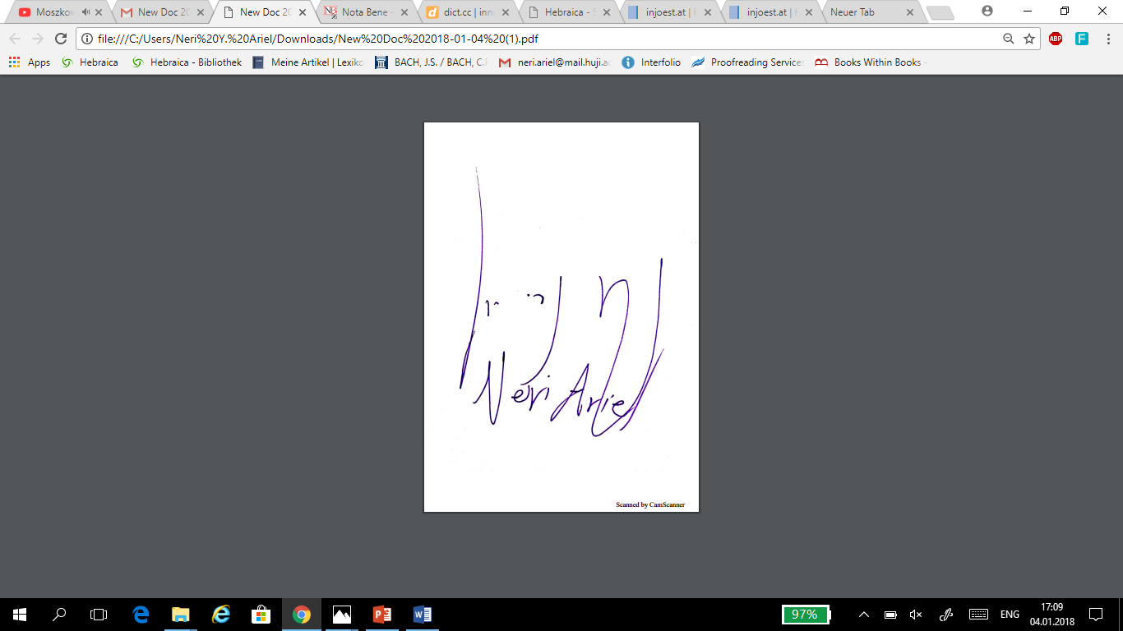

the body of my Application E-mail must be proofed as well>> [registrar@ochjs.ac.uk](mailto:registrar@ochjs.ac.uk)

To the Honored Committee, Dear Colleagues,

Attached is my CV and the requested proposal for the Seminar in Advanced Jewish Studies that I propose to coordinate at Oxford in 2020.

I hope that I correctly understood the call for applications: perhaps specification of Professorship is not required. However, it might refer to senior scholars and prestigious professors in the field of Judaic studies. If I have erred in my exaggerated aspirations, please forgive me and do not interpret it as arrogance or ignorance. If this is the case, perhaps you could generously help me by recommending another frame that this seminar proposal could fit into.

I hope that you will find this neglected field of research fascinating and worthy of extensive thought and inquiry. If there will be a need for addendum and corrigendum, i.e. documentation and declarations, it will be my pleasure to provide you with them or to resubmit an updated and revised proposal later, as per your instructions.

I am flexible and open to different types of collaboration with other scholars engaged in related topics and fields. I would be most grateful to you for providing me with the necessary tools and for advising me as to the most constructive ways of improving my work, so that I could have the distinct honor and privilege of working with you in the near future.

With my very best regards and wishes,

Neri Yeshayahu Ariel

Talmud and Halakha Dept.

Hebrew University of Jerusalem