Journal: Architectural Science Review

Stefanie Rückrich a, *, Galit Agranati a, Yasha J. Grobman a

*a Faculty of Architecture and Town Planning, Technion - Israel Institute of Technology, Haifa, 3200003, Israel.*

*\* Corresponding author. E-mail address: stefanie-ru@campus.technion.ac.il (S. Rückrich).*

Earth-based additive fabrication: evaluating materials printability

Abstract

The recent convergence of earth construction with technology focuses on additive manufacturing extrudable earth-based materials. Three main parameters define the material's printability: the aggregates' size, the mixture's fresh properties for pumpability, extrudability, and buildability, and the strength after drying.

The paper presents a field-oriented methodology to design local mixtures according to the printer. The material's fresh properties are evaluated and optimized for printability with three characterization tests investigating flowability, pumpability and extrudability, and buildability. The method showed that adjusting the water content for consistency and decreasing or increasing the plasticity for cohesiveness are vital parameters to tune printability. Adding only low amounts of vegetal fibers in cm-scale led to clogging, while cellulose microfibers can increase the material's flowability, plasticity, and compressive strength.

A future with extensive use of recallable earth-based 3D printing can facilitate its application into the building sector; the material is recyclable and provides passively indoor climate regulating qualities.

Keywords: 3D-printing earth-based materials, recycling, clay, adobe, printability, field-oriented test-methods

1. Introduction

Earth architecture developed according to the locally available materials as a craft, based on vernacular knowledge since thousands of years (Veliz Reyes et al. 2019). To date, earth-building practices are based on an open-ended process, where uncertainty and risk are embedded as core precepts. The necessary field-specific knowledge, the variety of the material, and the labor-intensive work hinder the implementation of earth construction into the building sector (Ben-alon 2020).

Today, the building sector is responsible for environmental problems such as air pollution, toxic waste, and land degradation. Cement production alone is responsible for about 8% of global CO2 emissions (Lavagna et al. 2020). At the same time, technology can facilitate new affordable and sustainable building methods while including and reviving traditional principles. To overcome the barriers, leading novel approaches industrialize earthen material construction by preprocessed materials: 'ready-to-use-mixtures' e.g., for plasters or rammed earth, prefabricated elements: such as adobe bricks, rammed earth elements, and earthen-fibrous boards (Claytec 2018; Rauch et al. 2020), or digital construction (DC) processes: such as additive fabrication (Rael and San Fratello 2011, Wasp 2021). These fabrication techniques are controlled and produce high-quality outcomes, though eliminating possible changes during construction (Veliz Reyes et al. 2019).

The convergence of additive manufacturing technology and earth-based materials appears promising to reduce production costs and advance mass-customized implementation strategies. At the same time, the construction method takes advantage of the materials' passive indoor climate regulating qualities and recyclability (WASP 2019).

The printability is a characteristic of the earthen mixture in its fresh state, including its pumpability, extrudability, and buildability, concerning the mechanics, and dimensions, of the printing system (Jacquet et al. 2020). The earthen material must provide a challenging thixotropic behavior to be printable (Thixotropy is defined as the decrease in viscosity when shear stress is applied, followed by increased viscosity when stress is removed). First, the printable mixture has to flow with a ‘moderate’ yield stress. In contrast, immediately after the extrusion, the strength and stability should increase through drying and enable the build-up of a layered structure. This requires a high material’s yield stress (Nerella and Mechtcherine 2019).

Our literature review has discovered a gap of information on how to evaluate and optimize the printability of earth-based materials with field-oriented methods, which are a common tool in earth building practice.

This research proposes a field-oriented methodology and derives a potential material index for generic guidance that enables designers and fabricators to define, evaluate and optimize the printability characteristics of earthen materials mixtures for additive fabrication. The first part of the paper gives a brief background on earth-based mixtures. The second part determines the mixture's design: the preparation method, the optimal ratio of sand and clay, and specifies the amount of water added to the mixture. The third part presents the printing technology used for this research. Following, the main part presents the characterization tests that define the suggested field-oriented 3D printing methodology. Exemplary, a case study investigates the influence of three vegetal fibrous additives on the mixture's printability. Finally, printing the developed mixtures demonstrates the method's relevance.

2. Materials and methods

2.1 Background on earth-based mixtures

The properties of earthen construction materials are defined by the clay (< 0.002mm), various aggregates such as silt (0.002 - 0.06mm), sand (0.06 - 2mm), and gravels (2 - 63mm, < 4% ), and additives. Aggregates are added to reduce shrinkage and cracking and to increase stability – they form the granular skeleton. Water and movement activate the binding characteristics of clay minerals. As opposed to cement-based materials that dry through a chemical hydration process, earthen materials harden by drying (Lagouin et al. 2021; Minke G. 2006). This inherent property is the main reason for its potential never-ending recyclability.

In vernacular techniques, the earthen building method relies on the properties of the local soil available. If necessary, the plasticity of the mixture can be increased by adding clay or can be reduced by adding sand. Moreover, the grain size distribution, the water content, the type of clay, the method of preparation, and additives influence the rheological and mechanical properties of the building material. This literature review found that current research in the field of earth construction primarily investigates additives. The additives can be grouped into three different approaches:

Traditionally, materials of vegetal or animal origin were added in small quantities. Their fermentation and chemical reactions within the earthen mixture and the fibers' physical shape improve mechanical properties and water resistance (Laborel-Preneron et al. 2016)(Lagouin et al. 2021). The second approach uses hydraulic and non-hydraulic binders, such as cement and lime, which have increased usage as stabilizers in the last decades. However, they are highly discussed regarding their environmental impact and actual effectiveness (Rauch et al. 2020; Minke G. 2006). The third approach is related to the recent development of self-compacting clay concrete (SCCC) with known chemical admixtures in soil mechanics and the ceramic industry. They cause a dispersion of the clay particles, followed by a flocculation process to the material (Landrou et al. 2018).

***2.2 Field oriented methodology***

The field-oriented methodology for developing printable material, relies on the existence of earthen material in the vicinity of the construction site and consists of the following main stages:

1. Excavating a sample of the base earth material from the ground.

2. Improving the excavated earth by filtering for predefined particle size.

To mimic a local sample, we compose a reference material of sand and kaolinite clay for this research.

3. Performing a set of characterization tests to determine the ingredients of a printable mixture.

*Based on the method’s results, this research proposes an earthen material index for 3D printing as a tool to turn local earth into printable mixtures.*

4. Examining the developed index: Preparing and adjusting a printable mixture’s cohesiveness and consistency using the suggested earth material index for 3D printing.

5. 3D printing tests.

The methodology's first two characterization tests evaluate the material's workability and particle size for flowability, pumpability and extrudability, and enable rechecking the material right before printing. In particular they measure the consistency (ease of flow), and the material’s cohesiveness – segregation characteristics and deformation properties, when force is applied (Tourtelot et al. 2021; P.Kuma Mehta 2006) .

The third characterization test investigates the buildability of a mixture by measuring the green strength development. The buildability refers to the ability of the material to retain its extruded shape and the buildup of a layered structure. The green strength defines the strength of the material in its fresh-state (Panda, Lim, and Tan 2019).

Together these three tests evaluate the printability of a mixture.

Given that previous studies suggest a link between the cellulose content and the mechanical characteristics of fibers for earthen materials; parallel to the development of the new methodology this research investigates the influence of three vegetal fibers on the reference mixture’s printability.

The methodology is assessed and verified by printing the developed mixtures into cylinders (Ø15cm, ten layers, each Ø1.5cm).

2.3 Printing equipment and setup

In this research, a ‘Delta WASP 3MT’ 3D printer commercially available for ceramic materials is used (Fig.1). A pressure of up to 8bar can be applied to a hanging 3L-container for piston extrusion (inner Ø1.8cm). The material is pressed throughout the container and a 15cm long pipe (inner Ø1.8cm) that connects to the extruder. The original WASP XL extruder includes an inner screw and is designed to ensure homogenous material’s deposition with clay. A printed connection part without a screw replaces the original extruder and enables extruding a mixture with the sand size of Dmax 1.18mm. This connection part joins the pipe to the printer and includes the nozzle’s design (inner Ø 1.5cm).

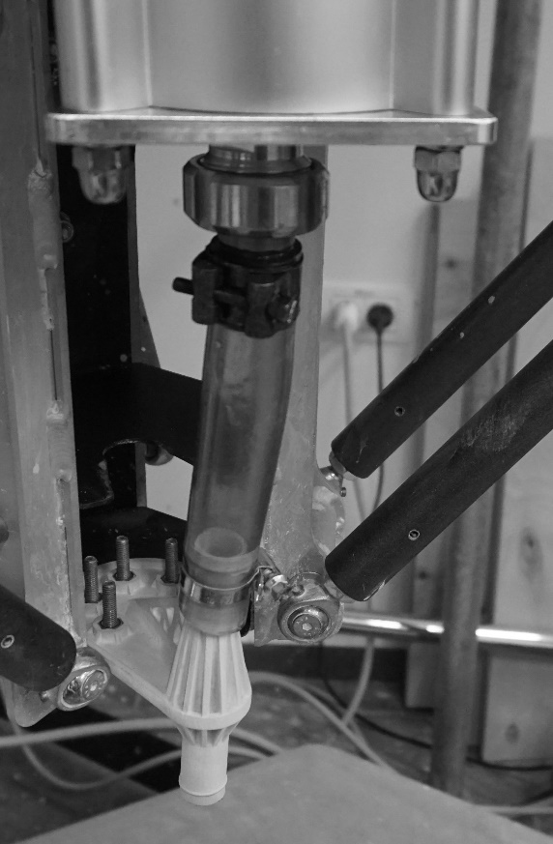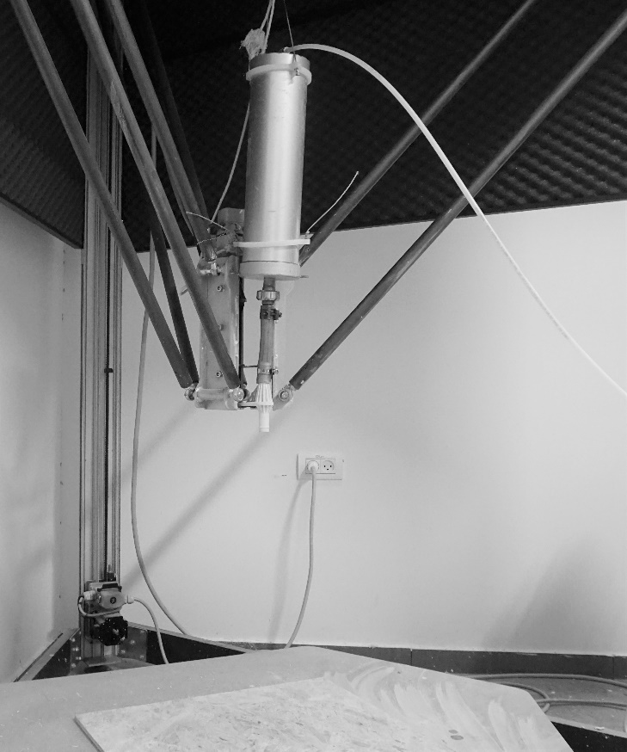

Fig.1: Printer’s setup.

The following section describes the research’s approach to create printable earthen material.

2.4 Mixture’s design

Recyclable earth building material consists of clay, sand, and water. Additionally, additives of vegetal or animal origin can improve the processing and mechanical properties of the material.

This research aligns the earthen materials’ mixture for extrusion-based additive fabrication to cob and adobe. According to Schroeder their mixtures are composed of: 10-25% clay, 10-30% silt, 75% sand, 0-4% organic material, 10-20% water (Schroeder 2010). The material facilitates shaping in its fresh state and stability when dried (Gomaa et al. 2019; Alhumayani et al. 2020). As a reference material, we compose a mixture of coarse sand, kaolinite clay, and tap water. Kaolinite clay has a moderate swelling capacity and shows less shrinkage than other types of clay (Schroeder 2017). Generally, a lower amount of clay reduces the risk of shrinkage, while adding more clay can facilitate pumpability (Perrot 2019). Given that vegetal fibers can modify the material’s mechanical and rheological properties and previous studies suggest a link between the cellulose content and the mechanical characteristics of fibers for earthen materials, we investigate the influence of three fibers with high cellulose content, that are differently processed and with different physical dimensions: hemp shiv plant fibers, fibers of horse manure, cellulose microfibers.

**2.4.1. Mixing / Preparation method**

Mixing procedure used in this research relies on the preparation methods described by Laborel et al. (2016) and Minke (2006). Clay and sand are stored at room temperature (21°C, 54% RH). The mixture is prepared according to the following stages:

1. According to the printing setup (cf. 2.3), the particle size of the sand is decreased by sieving with sieve number°16 (Dmax1.18mm). Mixture’s ratio of sand and clay is calculated in percentage per volume and converted to weight (sand 1.7g/ml, clay 0.7g/ml).

2. When adding fibers in cm-scale, their amount is calculated in % to the volume of sand and clay. Instead, fibers in micro-scale are calculated in % to the amount of added water and usually diluted for several hours. Only after resting, the suspension is ready to be added to the mixture of sand and clay (cf. 4.).

3. All aggregates are added into a bowl and mixed without water additions for one minute.

4. After dry mixing, the amount of water, respectively the suspension, containing the cellulose microfibers, is added. Everything is mixed by hand until a homogenous material is obtained.

5. The material was used immediately after the preparation, as we consider storage difficult when envisioning large material quantity on construction sites. This is a shift from the usual process in earth construction, where the mixture rests for a few hours up to days to increase the plastic qualities of the material.

**2.4.2. Addition of water**

A mixture's water content varies depending on the local temperature and relative humidity. Water can be chemically or electrostatically bound, absorbed inside the clay's microporous structure through capillary action, or trapped between the particles (Minke G. 2006). As earth-based materials harden through drying, only the two latter forms of water vary according to the climate. If not yet saturated, the addition of water activates the plastic performance of the clay minerals and influences the flow characteristics of the material when trapped between the particles. Thus the added water content is relevant for adjusting the workability of a mixture (Tourtelot et al. 2021). Tuning this parameter is necessary to achieve a good material’s consistency for pumpability and extrudability.

To prepare the starting samples for the proposed characterization tests in this research, the addition of the initial water content is determined according to sensual feeling. The added water content should be low, but enough to cause good plastic qualities to mold a sample, e.g. to a ball, cylindric, or cubic shape. In our case, 12% of water by total weight is added to the mixture of sand and clay. Alternatively, the initial necessary water content can be performed according to the stiffness test of the German standard DIN 18952 (Minke G. 2006). However, the test is laborious and not necessary for the following testing procedure.

When preparing a sample mixture in small quantities (< 1 liter), the final remaining amount of water is metered with the syringe, as the material properties react very sensitive to water additions.

**2.4.3 Dermining the optimal sand to clay ratio**

The first step in the optimization process is to determine the optimal clay / sand ratio concerning the final compressive strength of the mixture after drying. The compressive strength of various mixtures with different coarse sand to clay ratios are measured: 1/5, 1/4 , 1/3, 1/2, 2/3. 5cm x 5cm x 5cm cube speicmens are used. These are unmolded after 3 days and stored at 21°C, 54% RH conditions.

The mixture with a 1 clay / 2 sand ratio obtains the highest compressive strength with about 150kPa. Thus this ratio is chosen as a reference point to investigate printable material (Fig.2).

Fig.2: Investigating the optimal ratio of clay and sand for compressive strength after three days of drying.

2.5 Characterization tests for field-oriented methodology

In this research three field tests are used to evaluate the added additives and the amount of added water regarding their influence on the printability of earthen materials mixtures for additive fabrication:

The first test evaluates a mixture’s flowability and lables it by the spread. The second test evaluates its pumpability (the possibility to pump the material from the container through pipes to the nozzle exit) and extrudability (the possibility to extrude the material out of the nozzle to a stable line). Together these two tests appraise the necessary workability and particle size according to the dimensions of the printer’s setup. In this case, the mixture was evaluated in respect to the specific printer used, however, this methodology can be applied to different machines.

The third test determines the devlopment of green strength to estimate and compare the material’s buildability (the capability of the material to build up a layered structure after its extrusion).

These three tests capture the fresh-properties of earth-based materials' for their printability.

2.5.1 Characterization test for flowability

Objective is to describe the material’s workability through a modified flow test to enable fast rechecking before printing, which is not possible with a standaridzed test for mortar (e.g. ASTM C230 / C230M – 21).

A cylindric mold (⌀45mm, 45mm height) is filled with material, which is manually extruded to a cylindric sample. The sample is placed in the center of a wooden plate (20cm x 30cm). The plate is alternately lifted ten times with the long side of the board at the initial height of the sample (4.5cm) and released to hit the surface.

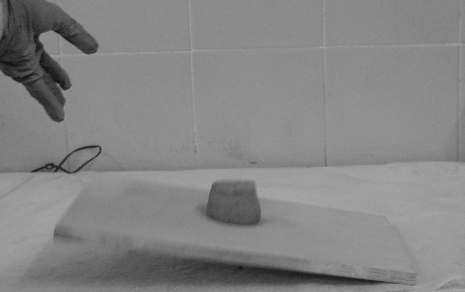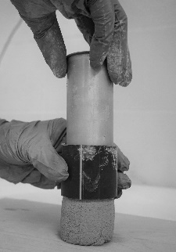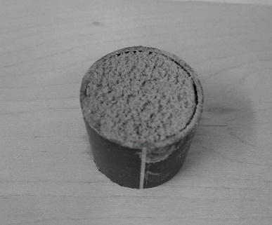

Fig.3: Preparation of sample, sample lifted on a plate and released to falling.

The spread of the material is measured with a caliper gauge or spacer (Fig.3). The value of L and Lo are recorded. As higher the Δ L value, as higher is the workability.

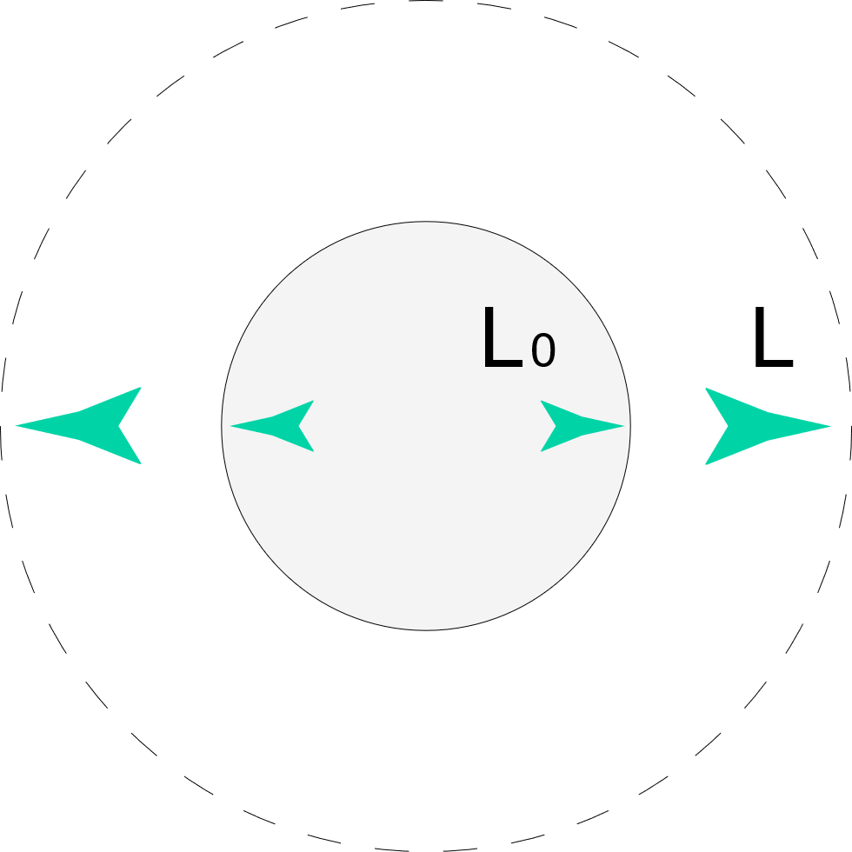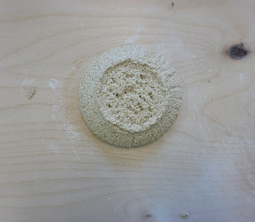

Fig.4: Cylindric sample while evaluating the workability, ∆L = (L – L0)

This test allows quantifying the material’s flowability by its spread and rechecking the required spread for pumpability and extrudability right before printing according to the machine. The mixture’s spead can be examined by decreasing or increasing the amount of water of the initial water content (cf. 2.4.2), in steps of 1%.

2.5.2 Characterization test for pumpability and extrudability

The test evaluates the ability of the material to pass through an opening, to reflect pumpability and extrudability. The test is performed using a triangular bag with an opening that simulates the opening of the machine’s nozzle. The test defines the necessary workability and, thus, the necessary minimum water content and plasticity of the mixture to pass the opening of the triangular bag by manual extrusion. A good extrusion is achieved when the material is easily homogeneously extrudable to a stable cylindric line without separating water (Fig.5). The extrudable mixture can then be characterized with the test for workability (cf. 2.5.1).

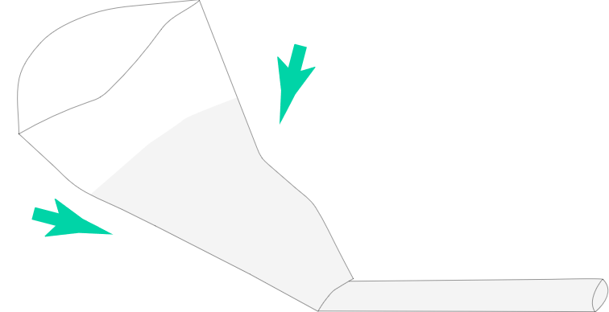

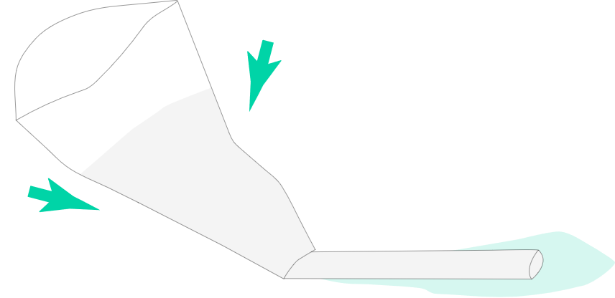

Fig.5: Testing the material’s extrudability and pumpability with a triangular bag through manual extrusion: incorrect material (separating water indicates low plasticity), vs correct material (no separation of water)

Together the two tests for evaluating and defining the ‘flowability’, and the ‘pumpability and extrudability’ can determine the necessary water and clay content for printing, which is concurrently necessary as a starting point to investigate the green strength.

2.5.3 Characterization test for evaluating the green strength development

The buildability of a material can be illustrated by measuring its green strength at different drying times. The green strength describes the strength of a mixture in its fresh state until it reaches its final ultimate strength (Panda, Lim, and Tan 2019). To define a material’s buildability, this characterization test investigates the material's capability to increase strength in its fresh state. Therefore, the green strength is measured at different drying times by the material's plastic deformation according to the applied stress σ. The examination method consists of the following stages:

For each mixture, six samples are prepared (cf. 2.5.1) with the water content according to the printer's setup, which was described earlier in this paper determined through the extrudability test (cf. 2.5.2). The samples are dried for 15min, 30min, 1h, 2h, 3h, and 6h. The green strength is evaluated using weight loads added in steps of 500g up to 4.0kg to each sample at the certain drying times (Fig.6).

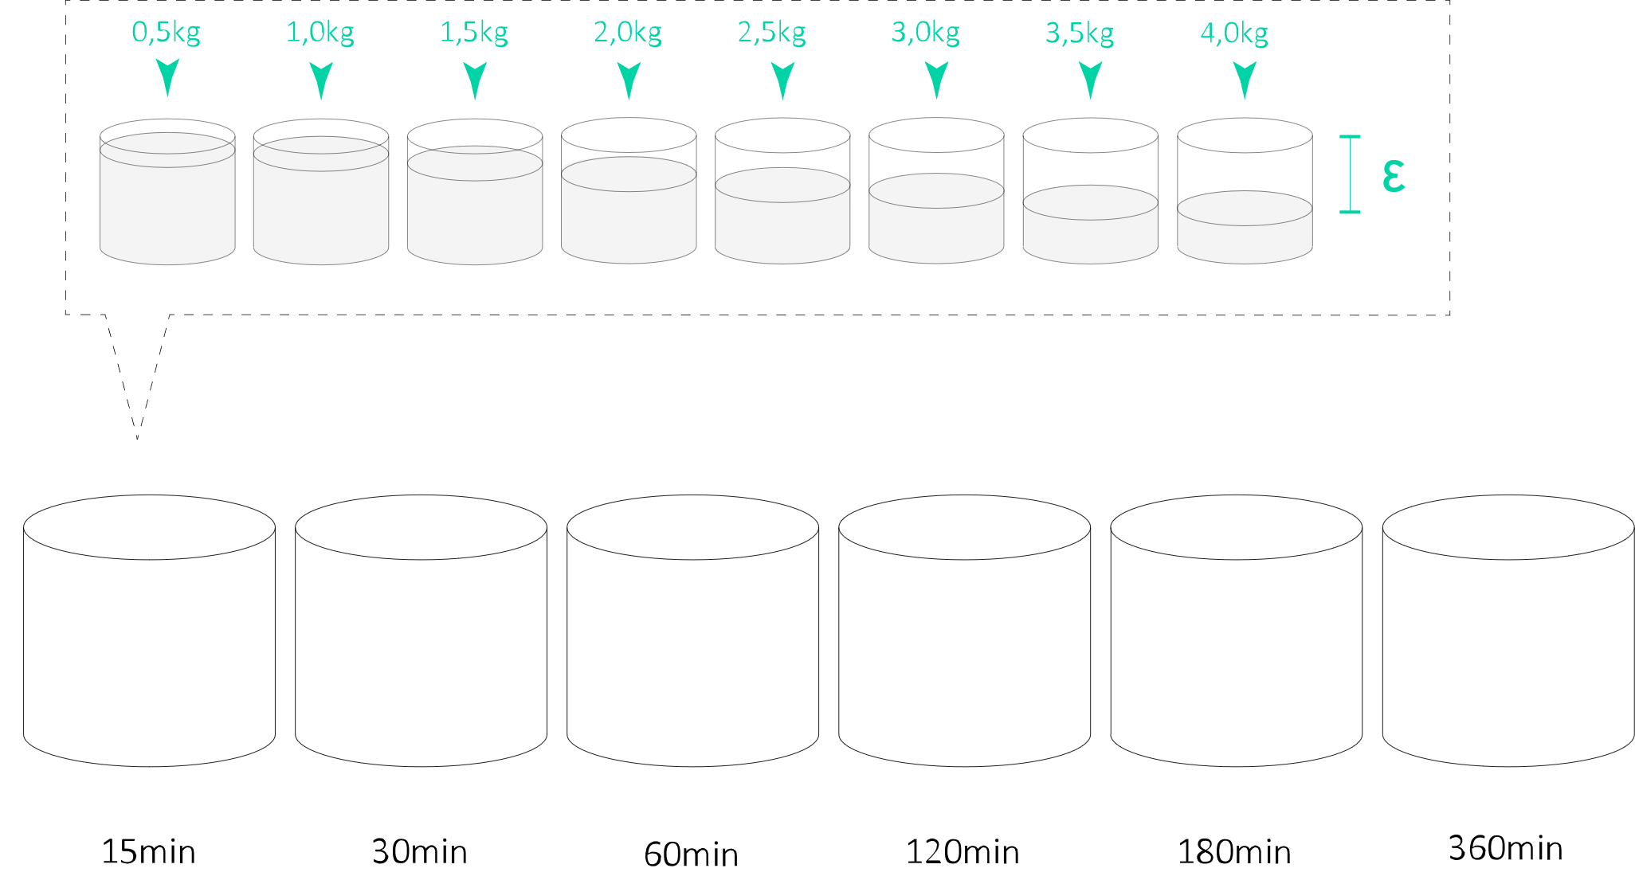

Fig.6: Illustration of the green strength measurement.

The weight rests positioned for at least ten seconds until the material’s deformation is measured. A small plastic sheet of 1.5mm thickness is placed between the sample and the weight to prevent sticking and uneven surface deformation. Each vertical deformation is measured with a ruler (Fig.7).

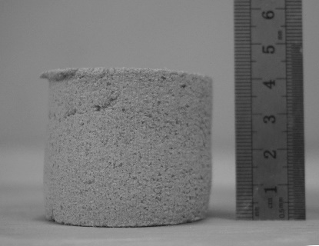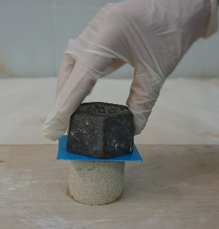

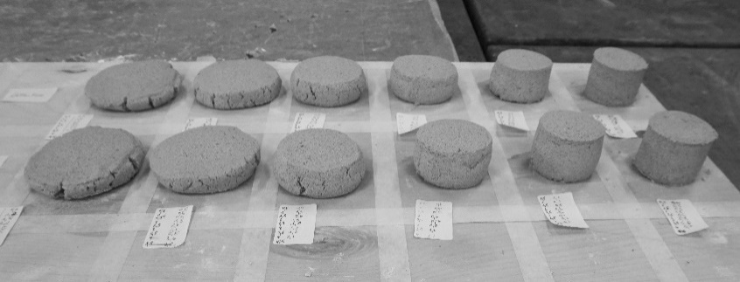

Fig.7 from l. to r.: Applying a weight of 500g to a sample, measuring the height of the tested sample after the weight was applied, overview measurements of green strength development M1*updated* and M5*updated*.

For each sample, the results are plotted for each drying time, of which the linear regression gradient is calculated. Thus, we obtain one regression gradient for each drying time and six differing linear regression gradients for one material. Plotting the regression gradients in a chart shows the development of strength of the material in its fresh state.

2.6 Fibers

The printability characterization tests are used to evaluate the effect of three different vegetal fibers on the reference mixture with a ratio of 1 clay / 2 sand (cf. 2.4.3): horse manure (1mm long, 0.5mm thick), industrially processed hemp shiv plant fibres (1-1.5cm long, 1-2mm thick), and cellulose microfibers (Abocel BE 600-30PU) (Fig.8)(Millogo et al. 2015). The fibers tested in this research do not disturb the possibility to reuse the earthen material in the future.

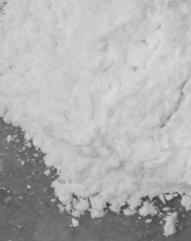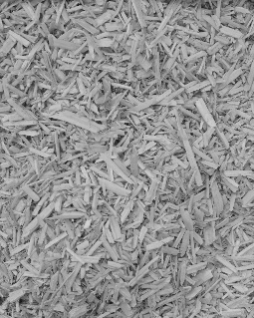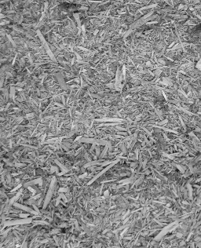

Fig.8, from l. to r.: Fibers of horse manure, hemp shiv plant fibers, cellulose microfibers. Fibers of horse manure are thin and flexible, while the threads of hemp are thicker and rigid.

The organic fibers and their proportion ratios are chosen according to literature (table 1, 2)(Schroeder 2017; Vissac et al. 2018).

***2.6.1 Characterization tests with fibers***

The ‘flowability’, ‘pumpability and extrudability’ for all six mixtures is examined when increasing the water content in steps of 1%, added to the initial water content (see table 1 for mixtures’ details). The initial water content of the mixtures can differ depending on the contained type and amount of fibers. Finally, the ‘green strength development’ of the extrudable mixtures is tested and compared.

Table 1: Mixtures design to examine the ‘flowability’ and ‘pumpability and extrudability’.

|  |  |  |  |  |
| --- | --- | --- | --- | --- |
| **Mixtures** | **Clay [g]** | **Sand [g]** | **Additives [g]** | **Initial water content [g]** |
| M1 | 980g | 4420g | - | 480g (12%) |
| M2 | 980g | 4420g | 12g hemp fibers (2.5%) | 560g (14%) |
| M3 | 980g | 4420g | 14g horse manure (1.5%) | 560g (14%) |
| M4 | 980g | 4420g | 10g hemp fibers (2%) + 9g horse manure (1%) | 560g (14%) |
| M5 | 980g | 4420g | 2.5g cellulose microfibers (1,7%) | 480g (12%) |
| M6 | 980g | 4420g | 10g hemp fibers (2%) + 9g horse manure (1%) + 2.5g cellulose microfibers (1.7%) | 600g (15%) |

*Table 2: Measured volume and water loss after drying in an oven for 24h at 105°C.*

|  |  |  |  |  |
| --- | --- | --- | --- | --- |
| **Material** | **Water [%]** | **Volume [g/ml]** | **Fiber length [cm]** | **Fibers thickness [cm]** |
| horse manure | 3.7 | 0.23 | 0.5-1cm | 0.05cm |
| hemp shiv plant fibers | 3.1 | 0.12 | 1-2.5cm | 0.1-0.15cm |
| cellulose microfibers | 2.5 | 0.30 | 40µm | 20µm |

***2.7 Cylindric test prints***

According to the characterization tests results, the as printable defined and adjusted mixtures are tested with the printer for their ability to build up a cylindric shape. The digital shape is designed as a spiral (Ø15.0cm) out of ten layers, with a layer’s distance set to 0.8cm, and layer’s diameter of Ø1.5cm.

3. Results

This section presents the results of the three proposed characterization tests, described in the previous section. All tests are carried out with the determined ratio of 1 clay / 2 sand and the chosen three types of fibers. The tests were repeated three times, and the average value was calculated.

3.1 Results: Flowability

The first test determined the material's flowability through a modified flow test. As a basic principle the flowability was examined by adding water. The difference in the material's spread was clearly measurable, considering that earth mixtures are highly sensitive to minor variations in water content. Furthermore, the spread (Δ L) differed depending on the amount and type of fiber. While mixtures that contain admixtures of fibers in cm-scale needed to be composed of more than 2% water to reach similar viscosities as materials without fibers, adding cellulose microfibers to the mix required more than 2% less water (Fig.9).

Fig.9: The influence of the water content on the spread of the mixtures.

The results show that additions of cellulose microfibers increased the flowability, thus decreased the yield stress (water content: 15%, deformation: M5 1.5cm / M1 0.7cm). In contrast the addition of fibers in cm-scale increased the yield stress: With higher water additions, the mixtures that contained hemp fibers and horse manure fibers (M2, M3, M4, M6) exhibited lower deformation. However, mixture M3, with horse manure textures, showed a slightly higher strain and behaved similarly to the mixture without additives (M1) but started with higher water content.

3.2 Results: Pumpabiltiy and extrudability

The extrudability test examined the way earthen material is extruded through an opening size of Ø1.5cm (Fig. 10). This size was chosen according to the nozzle’s inner diameter within the printer’s setup.

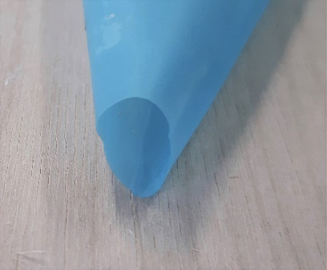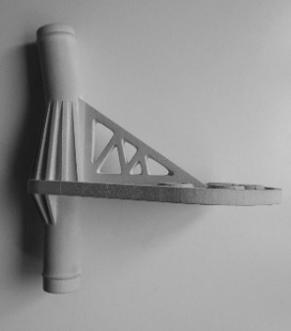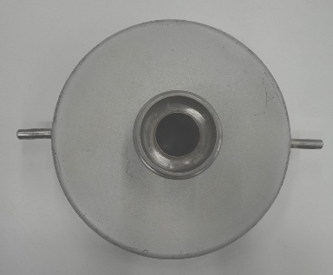

Fig.10 from l. to r.: Opening - container: Ø1.8cm, - connection part and nozzle: Ø1.5cm, - size triangle bag: Ø1.5cm.

The mixture without additives (M1) and the mixture with cellulose microfibers (M5) started to be extrudable when the spread was measured to 1.5-2.0cm. All other mixtures containing hemp fibers and/or fibers of horse manure were not extrudable to a stable line. The fibers jammed with each other and led to clogging inside the triangular bag. With too high water content, the yield stress was to low and the mixtures were not extrudable to a stable line. When extruding mixture M1 (19% of added water) and M5 (16% of added water), a small amount of water separated from the mixtures, which indicates low cohesiveness. Thus, the mixtures were tuned for pumpabiltiy and extrudabiltiy with a second parameter: the clay content was increased to a 2 clay / 1 sand ratio for mixture M1*updated* and a 1 clay / 1 sand ratio for mixture M5*updated*, which allowed extrusion without separating water.

3.3 Results: Green strength

To characterize the mixtures' buildability, the third characterization test measured the green strength when applying different weights and measuring the deformation of the samples at different drying times. The samples were performed with the mixtures M1*updated* and M5*updated*, which were extrudable with the triangular bag in the previously described extrudability test (see section 3.2). The samples preparation included the determined necessary water and clay content for extrudability (table 3).

Table 3: Mixtures’ design to examine the green strength.

|  |  |  |  |  |  |
| --- | --- | --- | --- | --- | --- |
| **Mixtures** | **Clay [g]** | **Sand [g]** | **Additives [g]** | **Water [g, (%)]** | **Spread [cm]** |
| M1*updated* | 1848g | 2244g | - | 840g (19%) | 1.8cm |
| M5*updated* | 1400g | 3400g | 2,5g | 640g (16%) | 1.5cm |

According to the applied stress (2 kPa – 18kPa) and the sample's drying time, the deformation is listed in a graph (Fig.11).

Fig.11: Sample graph of mixture M1*updated*, measurements of the vertical deformation at different drying times.

Linear regression was performed through each graph, and the slope values were derived. The different slopes were summarized into a new chart, which indicates the increase in strength of each material according to the drying time (Fig.12).

Fig.12: Determining the deformation of the material in its plastic state over different drying times illustrates the development of green strength.

When comparing mixture M1*updated* to mixture M5*updated*, the cellulose microfibers did not significantly influence the green strength. The green strength of both mixtures highly increased after three hours of drying. However, when comparing the compressive strength of M1 and M5 after three days of drying, the cellulose microfibers increased the strength of the material by 17%.

3.4 Printing

First, the printability of mixture M1 and M5 (3 liters each) was rechecked according to the proposed test methods by determining the added amount of water without adjusting the clay content. The materials were filled inside a cylindric hanging container and extruded through piston extrusion, passing the connecting pipe (Ø1.9cm) and nozzle (Ø1.5cm). During printing, with a 2cm/sec speed, the material's viscosity was uneven and required differing pressure. The pressure was manually adjusted and varied between 3-4bar. Therefore the print quality failed (Fig.13). Successful printing is controllable and optimized to accomplish a coherent buildup to the expected digital model's shape (Nerella and Mechtcherine 2019).

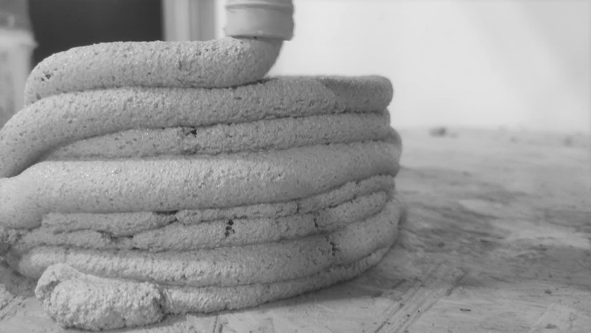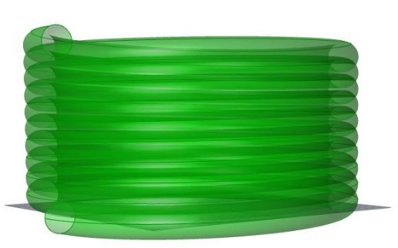

Fig.13, from l. to r.: Digital file cylinder (width Ø16.5cm, hight 8.4cm, 10 layers, computed layer distance 0.8cm, layer’s width Ø1.5cm), printed with M1 and M5.

Secondly, to test the influence of the materials' plasticity on the printability, the clay content was increased for both mixtures according to the extrudability test until no water separates from the mixture when extruding with a triangular bag (cf. 3.2, table 3). When printing the materials M1*updated* and M5*updated*, the printability was improved to a smooth homogenous extrusion with a constant pressure of 4bar.

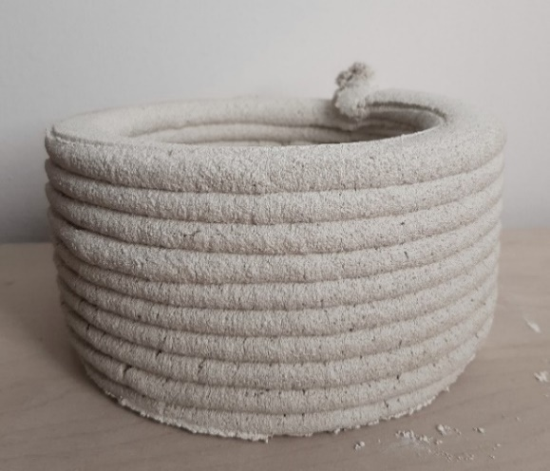

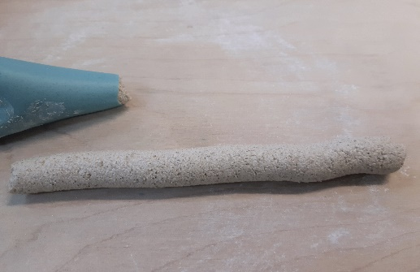

Fig.14, from l. to r.: Triangular bag extruding material without separating water, printed cylinders quality with mixture M1*updated* (2 clay / 1sand) and mixture M5*updated* (1 clay / 1 sand + 1.7% cellulose microfibers)

According to the test method of Jacquet, which investigates the mixture's tensile strength and informs about the plasticity for a good printability, we measured the material filament leaving the nozzle, of a vertical downward extruder, to a length of 30-40cm for both mixtures (Jacquet et al. 2020).

The higher clay content and thus the increased plasticity of mixture M1*updated* (Plastic Index: 6.66) and mixture M5*updated* (Plastic Index: 5.78), improved the cohesiveness and led to a smooth extrusion and a uniform cylindric shape. However, mixture M2*updated*, containing cellulose microfibers, was printable already with a lower clay content and plasticity index.

To detect the conformity of the digital model to the printed model, and to the dried printed model, the cylinders ’height, width, and layers’ width were measured. The dimensions of the printed models did not change by drying for three days. Compared to the dimensions of the digital model, the printed cylinders’ height and width barely differentiate. However, the printed layer width is increased by 25% (cf. table 4).

Table 4: Comparison of size, digital model vs printed model vs dried model.

|  |  |  |  |
| --- | --- | --- | --- |
|  | **Width [cm]** | **Height [cm]** | **Layer width[cm]** |
| **Digital cylinder** | 16.5cm | 8.4cm | 1.5cm |
| **Printed cylinder** | M1*updated* 16.6cm  M5*updated* 16.5cm | M1*updated* 8.5cm  M5*updated* 8.6cm | M1*updated* 2.0cm  M5*updated* 2.0cm |
| **Printed dried cylinder** | M1*updated* 16.6cm  M5*updated* 16.5cm | M1*updated* 8.5cm  M5*updated* 8.6cm | M1*updated* 2.0cm  M5*updated* 2.0cm |

4. Discussion

The suggested method evaluated and optimized the printability of an earthen mixture comprising the particle size, compressive strength, flowability, pumpability and extrudability, and the buildability – parameters which are relevant to compose earth-based materials to printable mixtures, according to the dimensions of the printer’s setup.

The research started with determining the compressive strength to indicate the ideal ratio of clay and sand in a mixture. However, experienced earth builders can already compose a good ratio through estimation and sensual feeling by common field tests (Minke G. 2012). Following, the modified flow test measured the flowability of an earthen mixture which can be primary modified by increasing the water content. The second characterization test, the triangular bag test for pumpability and extrudability, first evaluated the necessary water content and the size of the aggregates for consistency, and second, the material's cohesivness by observing segregation when water separates from the mixture. This research found that the extrusion diameter of 1.5cm required a 1.5-2.0cm spread. The simplicity of these two tests enabled rechecking the material’s printability right before printing, which is especially helpful when preparing large quantities of material in changing climatic conditions.

In this research it was shown, that even if the material is extrudable, too little plasticity leads to segregation and uneven uncontrollable print quality when adjusting the workability only by the water content. The material’s cohesiveness can be improved with additions of clay and/or vegetal fibers, that can act as rheological modifying agents and allow printing mixtures with a lower plasticity index.

Mixture M1*updated* was printable with a 2 clay / 1 sand ratio, thus a plasticity index of PI 6.7, while Mixture M5*updated* with 1.7% cellulose microfibers was already printable with a ratio of 1 clay / 1 sand and a lower plasticity index of PI 5.8. This finding conforms to the research of Lagouin et al.: Polysaccharides of vegetable origin provide a potential solution as a rheology modifying admixture (Lagouin et al. 2021).

In contrast to the first two characterization tests, the proposed field test for buildability that measures the development of green strength, was more laborious than previously assumed but enabled to display the increase in strength of a material. This test can instead be developed into a lab test.

As a general result, already minor additions of fibers influenced the material’s printability. When comparing them, their stiffness, size, components, time, and capability to absorb water are relevant to their performance. With the triangular bag's opening size of Ø1.5cm, it was possible to extrude only mixture M1, containing no admixture, and mixture M5, containing cellulose microfibers. Fiber’s in cm-scale lead rapidly to clogging. When testing the flowability, the fibers of horse manure and hemp shives instantly increased the viscosity. In contrast, the admixture of cellulose microfibers lowered the viscosity and improved the material's extrudability.

Despite the difference in the water amount of mixture M1 and mixture M5 to reach similar flow characteristics, compared to mixture M1, the admixture of cellulose microfibers did not increase the green strength during the first six hours of drying. However, they increased the compressive strength when testing the materials after three days of drying.

Based on our findings, we propose the development of a material index for printable earth-based mixtures that will inform designers and builders how to control printable parameters to design a mixture customized to the in-situ conditions of the printer's setup:

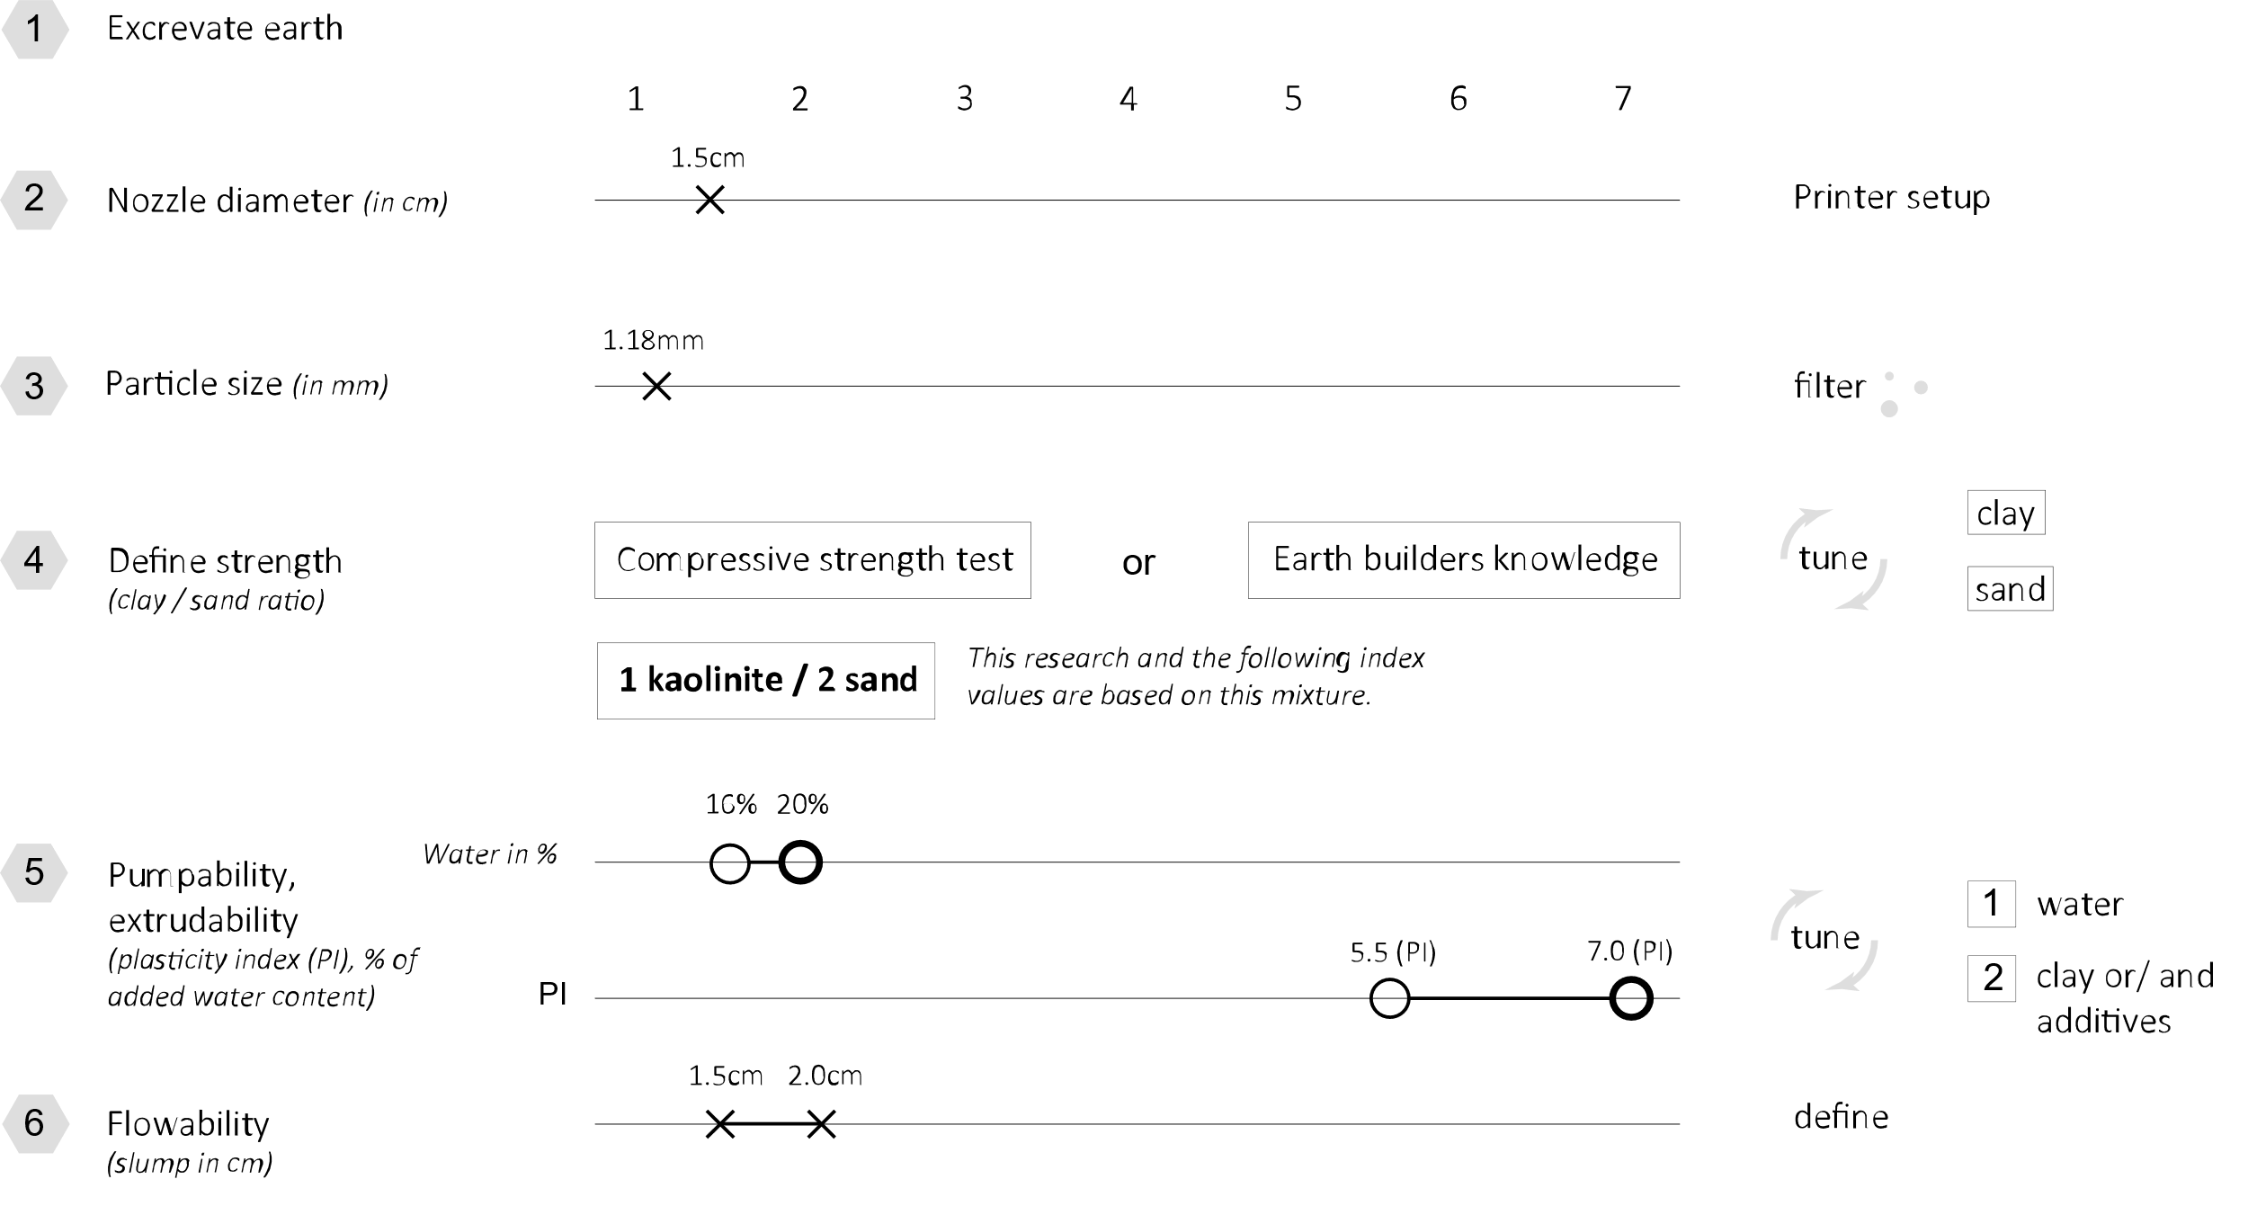

Fig.15: Parameters for printability according to the printer’s setup, here with piston extrusion (compressive strength, nozzle diameter, particle size, plasticity index, water content, flowability).

Further investigation can develop a schema similar to the consistency classes of fresh concrete specified in the European standard EN206. The required flow test values ​​can be sorted to the printer's extrusion dimensions as a reference (EN 206-1 2000).

5. Conclusion

This research illustrated that field-oriented test methods are not only a fundamental principle in traditional earth building, but also essential in the additive manufacturing of earth-based material. The suggested methodology showed that, after determining the size and ratio of sand and clay in a mixture to optimze the compressive strength, adjusting and controlling the water content and the cohesiveness of the material are key parameters to tune the printability of earth-based mixtures. A material index has the potential to guide builders and can serve for standardized industrially preprocessing of earth-based materials when preparing excavated earth to printable material, applicable to the in-situ printer’s setup.

Concerning fibers, the material’s printability is influenced first by their physical shape and second their chemical reaction within the mixture. The more significant the dimensional difference of the aggregates, the more the fibers' binding to the sand and clay is reduced, the lower is the mixture's flowability. As rheology modifiying admixtures, vegetal additives provide a potential solution to allow printing materials with a lower plasticity index.

This opens a field of research that investigates in depth the chemical and physical processes of vegetal and animal additives on the printability of earthen mixtures. Additionally, fibers in cm-scale can improve the tensile strength, isolation and decrease the cracking behavior of the dried material. A more diverse grain size distribution can increase the stability - properties that were not investigated in this research.

Further research with a printer set-up with bigger dimensions and more power, including rotating screws and cavity pumps, such as the Crane Wasp and 3D Potter Scara, will enlarge the preliminary index presented in this research and facilitate the extrusion of earth-based mixtures with admixtures of fibers in cm-scale and larger aggregate sizes.

This research only reveals the beginning of what is needed to turn earthen 3D printing into a common field practice in building construction. It calls for further research that will promote a more sustainable and vernacular building industry combined with technology.

*Aknowledgments:* This project was supported by the Israel Science Foundation grant no. 720/19.

*Declaration of competing interest*: The authors declare that they have no known competing financial interests or personal relationships that have influenced the work reported in this paper.

**Data availability statement.**

5. References

Alhumayani, Hashem, Mohamed Gomaa, Veronica Soebarto, and Wassim Jabi. 2020. “Environmental Assessment of Large-Scale 3D Printing in Construction: A Comparative Study between Cob and Concrete.” *Journal of Cleaner Production* 270: 122463. https://doi.org/10.1016/j.jclepro.2020.122463.

Ben-alon, Lola. 2020. “Natural Buildings: Integrating Earthen Building Materials and Methods into Mainstream Construction.” Carnegie Mellon University.

Claytec. 2018. “Claytec.” 2018. http://www.claytec.de.

Gomaa, Mohamed, Jim Carfrae, Steve Goodhew, Wassim Jabi, and Alejandro Veliz Reyes. 2019. “Thermal Performance Exploration of 3D Printed Cob.” *Architectural Science Review* 0 (0): 1–8. https://doi.org/10.1080/00038628.2019.1606776.

Jacquet, Yohan, Vincent Picandet, Damien Rangeard, and Arnaud Perrot. 2020. “Gravity Induced Flow to Characterize Rheological Properties of Printable Cement‐based Materials.” *RILEM Technical Letters* 5: 150–56. https://doi.org/10.21809/rilemtechlett.2020.128.

Laborel-Preneron, A, J E Aubert, C Magniont, C Tribout, and A Bertron. 2016. “Plant Aggregates and Fibers in Earth Construction Materials: A Review.” *Construction and Building Materials* 111: 719–34. http://dx.doi.org/10.1016/j.conbuildmat.2016.02.119.

Lagouin, Méryl, Aurélie Laborel-Préneron, Camille Magniont, Sandrine Geoffroy, and Jean Emmanuel Aubert. 2021. “Effects of Organic Admixtures on the Fresh and Mechanical Properties of Earth-Based Plasters.” *Journal of Building Engineering* 41 (March). https://doi.org/10.1016/j.jobe.2021.102379.

Landrou, Gnanli, Coralie Brumaud, Michael L. Plötze, Frank Winnefeld, and Guillaume Habert. 2018. “A Fresh Look at Dense Clay Paste: Deflocculation and Thixotropy Mechanisms.” *Colloids and Surfaces A: Physicochemical and Engineering Aspects* 539 (December 2017): 252–60. https://doi.org/10.1016/j.colsurfa.2017.12.029.

Lavagna, Giulia, Alessandro Ercolani, Francesca Lionetti, and Andrey Prigov. 2020. “THE SDG HOUSE RETHINKING BUILDING PRACTICES : INTERVENTIONS IN BUILDING DESIGN , CONSTRUCTIONS , COST EFFECTIVENESS AND RESOURCE EFFICIENCY.” *UN Habitat, SDG House*.

Lehm Ton Erde Baukunst GmbH. 2020. “Unstabilisierter Stampflehm – 100 % ERDE. Warum Ist Es so Schwer Auf Die 100 % Zu Vertrauen?,” 1–8. https://www.dachverband-lehm.de/lehm2020_online/pdf/lehm2020_b_rauch_de.pdf.

Millogo, Younoussa, Jean-Emmanuel Aubert, Erwan Hamard, and Jean-Claude Morel. 2015. “How Properties of Kenaf Fibers from Burkina Faso Contribute to the Reinforcement of Earth Blocks.” *Materials* 8 (5): 2332–45. https://doi.org/10.3390/ma8052332.

Minke G. 2006. *Building with Earth - Design and Technology of Sustainable Architecture*. Publishers. Basel.

———. 2012. *Handbuch Lehmbau - Baustoffkunde*. Ökobuchver. Staufen bei Freiburg.

Nerella, Venkatesh Naidu, and Viktor Mechtcherine. 2019. “Studying the Printability of Fresh Concrete for Formwork-Free Concrete Onsite 3D Printing Technology (CONPrint3D).” *3D Concrete Printing Technology*, 333–47. https://doi.org/10.1016/b978-0-12-815481-6.00016-6.

Panda, Biranchi, Jian Hui Lim, and Ming Jen Tan. 2019. “Mechanical Properties and Deformation Behaviour of Early Age Concrete in the Context of Digital Construction.” *Composites Part B: Engineering* 165 (December 2018): 563–71. https://doi.org/10.1016/j.compositesb.2019.02.040.

Perrot, Arnaud. 2019. *3D Printing of Concrete*. *3D Printing of Concrete,State of the Art and Challenges of the Digital Construction Revolution*. Great Britain and the United States by ISTE Ltd and John Wiley & Sons, Inc. https://doi.org/10.1002/9781119610755.

Rael, Ronald, and Virginia San Fratello. 2011. “Developing Concrete Polymer Building Components for 3D Printing.” *Integration Through Computation - Proceedings of the 31st Annual Conference of the Association for Computer Aided Design in Architecture, ACADIA 2011*, 152–57.

Schroeder, Horst. 2010. *Lehmbau - Mit Lehm Ökologisch Planen Und Bauen*. Edited by Vierweg+Teubner l GWV Fachverlag GmbH. Wiesbaden.

———. 2017. *Sustainable Building with SIPs*. https://doi.org/10.1007/978-3-319-19491-2_7.

Taylor, Donald W. 1948. *Fundamentals of Soil Mechanics*. *Geotechnical, Geological and Earthquake Engineering*. Vol. 36. Massachusetts Institute of Technology: New York John Wiley & Son, Inc. https://doi.org/10.1007/978-94-017-9460-2__4.

Tourtelot, Julia, Imen Ghattassi, Robert Le Roy, Ann Bourgès, and Emmanuel Keita. 2021. “Yield Stress Measurement for Earth-Based Building Materials: The Weighted Plunger Test.” *Materials and Structures* 54 (1). https://doi.org/10.1617/s11527-020-01588-4.

Veliz Reyes, Alejandro, Wassim Jabi, Mohamed Gomaa, Aikaterini Chatzivasileiadi, Lina Ahmad, and Nicholas Mario Wardhana. 2019. “Negotiated Matter: A Robotic Exploration of Craft-Driven Innovation.” *Architectural Science Review* 62 (5): 398–408. https://doi.org/10.1080/00038628.2019.1651688.

Wasp. 2021. “WASP-Tecla.” 2021. https://www.3dwasp.com/en/.

WASP. 2019. “WASP ’Gaia’-Project.” 2019. https://www.3dwasp.com/en/3d-printed-house-gaia/.