Journal: Architectural Science Review

WORD COUNT: 6472

Stefanie Rückricha,*, Galit Agranatia, & Yasha J. Grobmana

*a Faculty of Architecture and Town Planning, Technion – Israel Institute of Technology, Haifa, 3200003, Israel.*

*\* Corresponding author. E-mail address: stefanie-ru@campus.technion.ac.il (S. Rückrich).*

ORCID

Stefanie Rückrich http://orcid.org/ [0000-0001-7688-5683](https://orcid.org/0000-0001-7688-5683)

Galit Agranati http://orcid.org/ [0000-0001-8003-2878](https://orcid.org/0000-0001-8003-2878)

Yasha J. Grobman http://orcid.org/ [0000-0003-4683-4601](https://orcid.org/0000-0003-4683-4601)

Earth-based additive fabrication: a field-oriented methodology to evaluate material printability

Abstract

The recent convergence of earth construction with technology focuses on additive manufacturing using extrudable earth-based materials. Three main parameters define the printability of these materials: aggregate size, the pumpability and extrudability of a fresh material and its buildability; and strength after drying.

The paper presents a field-oriented methodology and suggests a material index to design local mixtures according to the printer. The fresh properties of the material are evaluated and optimized for printability with three characterization tests investigating flowability, pumpability and extrudability, and buildability. The method showed that adjusting water content for consistency and decreasing or increasing plasticity for cohesiveness are vital for tuning printability. Adding only low amounts of vegetal fibers at a centimeter scale led to clogging, while cellulose microfibers increased the flowability, plasticity, and compressive strength of the material.

Keywords: 3D printing, earth-based materials, recycling, clay, adobe, printability, field-oriented test methods

1. Introduction

Earth architecture using locally available materials developed as a craft, based on vernacular knowledge, over thousands of years (Veliz Reyes et al. 2019). Until today, earth-building practices are based on an open-ended process in which uncertainty and risk are embedded as core precepts. A lack of field-specific knowledge, the variety of materials, and the labor-intensive work hinder the implementation of earth construction in the building sector (Ben-alon 2020).

Present, the building sector is responsible for environmental problems such as air pollution, toxic waste, and land degradation. Cement production alone is responsible for about 8% of global CO2 emissions (Lavagna et al. 2020). At the same time, technology can facilitate new affordable and sustainable building methods while including and reviving traditional principles. To overcome the barriers, novel approaches industrialize earthen material construction by using preprocessed materials, such as “ready-to-use” mixtures for plasters or rammed earth; prefabricated elements, such as adobe bricks, rammed earth elements, and earthen fibrous boards (Claytec 2018; Rauch 2020); or digital construction processes, such as additive fabrication (Rael and San Fratello 2011; WASP 2021). These fabrication techniques are controlled and produce high-quality outcomes, although they eliminate the possibility of making changes during construction (Veliz Reyes et al. 2019).

The convergence of additive manufacturing technology and earth-based materials promises to reduce production costs and advance mass-customized implementation strategies. Other advantages are the ability of the materials to provide passive indoor climate regulation qualities and their recyclability (WASP 2019).

Printability is a characteristic of the earthen mixture in its fresh state, including its pumpability, extrudability, and buildability, depending on the mechanics and dimensions of the printing system (Jacquet et al. 2020). The earthen material must exhibit thixotropic behavior to be printable (*thixotropy* is defined as ‘the decrease in viscosity when shear stress is applied, followed by increased viscosity when stress is removed’)(Jiao et al. 2021). First, the printable mixture has to flow with ‘moderate’ yield stress. By contrast, immediately after extrusion, the strength and stability should increase through drying and enable the buildup of a layered structure. This requires the material to have a high yield stress (Nerella and Mechtcherine 2019).

Our literature review has discovered an information gap regarding the evalutation and optimization of the printability of earth-based materials with field-oriented methods—a common tool in earth building practices.

This study proposes a field-oriented methodology and derives a potential material index for generic guidance that will enable designers and manufacturers to define, evaluate, and optimize the printability characteristics of earthen mixtures for additive fabrication. The first part of the paper gives a brief background on earth-based mixtures. The second part determines the design of the mixture: the preparation method, the optimal ratio of clay to sand, and the amount of water to add to the mixture. The third part presents the printing technology used for this research. The main part of that section presents the characterization tests that define the suggested field-oriented 3D printing methodology. A case study investigates the influence of three vegetal fibrous additives on printability. Finally, printing the developed mixtures demonstrates the relevance of the method.

2. Materials and methods

2.1 Background on earth-based mixtures

The properties of earthen construction materials are defined by the quality and proportion of clay (<0.002 mm), various aggregates such as silt (0.002–0.06 mm), sand (0.06–2 mm), gravels (2–63 mm, <4%), and additives. Aggregates are added to reduce shrinkage and cracking and to increase stability; these form the granular skeleton. Water and movement activate the binding characteristics of the clay minerals. Unlike cement-based materials that dry through a chemical hydration process, earthen materials harden by air drying (Lagouin et al. 2021; Minke 2006). This inherent property is the main reason for its potentially infinite recyclability.

In vernacular techniques, the earthen building method relies on the properties of the local soil available. If necessary, the plasticity of the mixture can be increased by adding clay or can be reduced by adding sand. The grain size distribution, water content, type of clay, method of preparation, and additives all influence the rheological and mechanical properties of the building material.

Our literature review found that current research in the field of earth construction primarily investigates additives. The treatment with additives can be grouped into three approaches.

Traditionally, materials of vegetal or animal origin were added in small quantities. Their fermentation and chemical reactions within the earthen mixture, as well as the physical shape of the fibers, can improve mechanical properties and water resistance (Laborel-Préneron et al. 2016; Lagouin et al. 2021).

The second approach uses hydraulic and non-hydraulic binders, such as cement and lime, which have increased in use as stabilizers in the last few decades. Their environmental impact and actual effectiveness are of particular interest (Minke 2006; Rauch 2020).

The third approach is related to the recent development of self-compacting clay concrete with known chemical admixtures in soil mechanics and the ceramic industry. This method causes a dispersion of the clay particles, followed by a flocculation of the material (Landrou et al. 2018).

2.2 Field-oriented methodology

Field-oriented methodology for developing printable material relies on the existence of earthen materials in the vicinity of the construction site and consists of the following main stages:

1. Excavating a sample of the base earth material from the ground.
2. Improving the excavated earth by filtering for a predefined particle size.

To mimic a local sample for this research, we composed a reference material of sand and kaolinite clay.

1. Performing a set of characterization tests to determine the components of a printable mixture.

On the basis of the results of this method, this research proposes an earthen material index for 3D printing as a tool to turn local earth into printable mixtures.

4. Examining the developed index: preparing and adjusting the cohesiveness and consistency of the printable mixture using the suggested earth material index for 3D printing.

5. Running 3D printing tests.

The first two characterization tests of this methodology evaluate the workability and particle size of the material for flowability, pumpability, and extrudability, and allow for rechecking the material right before printing. In particular, the tests measure consistency (ease of flow) and cohesiveness—segregation characteristics and deformation properties when force is applied (Mehta 2006; Tourtelot et al. 2021).

The third characterization test investigates the buildability of a mixture by measuring green strength development. ‘Buildability’ refers to the ability of the material to retain its extruded shape and the buildup of a layered structure. ‘Green strength’ defines the strength of the material in its fresh state (Panda, Lim, and Tan 2019).

Together these three tests evaluate the printability of a mixture.

Given that previous studies suggest a link between cellulose content and the mechanical characteristics of fibers for earthen materials, our research investigates the influence of three vegetal fibers on the printability of the reference mixture.

The methodology is assessed and verified by printing the developed mixtures into cylinders (Ø = 15 cm; 10 layers, each of Ø 1.5 cm).

2.3 Printing equipment and setup

In this research, we used a Delta WASP 3MT 3D printer commercially available for ceramic materials (Figure 1). A pressure of up to 8 bar (1 bar = 100 kPa) can be applied to a hanging 3L container for piston extrusion (inner Ø 1.8 cm). The material is pressed through the container and a 15 cm long pipe (inner Ø 1.8 cm) that connects to the extruder. The original WASP XL extruder includes an inner screw and is designed to ensure homogeneous material deposition with clay. A printed screw-less connection part replaces the original extruder and enables the extrusion of a mixture with sand of *D*max = 1.18 mm. This connection part joins the pipe to the printer and includes the nozzle (inner Ø 1.5 cm).

The following section describes our approach to creating printable earthen materials.

[Figure 1 here]

2.4 Mixture design

Recyclable earth building materials consists of clay, sand, and water. Additives of vegetal or animal origin can improve the processing and mechanical properties of the material.

This research aligns the earthen material mixture for extrusion-based additive fabrication to cob and adobe. According to Schroeder (2010) and Minke (2006), their mixtures are 10%–25% clay, 10%–30% silt, 75% sand, and 0%–4% organic material. The added water content varies between 10%–20%. The material facilitates shaping in its fresh state and creates stability when dried (Alhumayani et al. 2020; Gomaa et al. 2019). As a reference material, we composed a mixture of coarse sand, kaolinite clay, and tap water. Kaolinite clay has a moderate swelling capacity and less shrinkage than other types of clay (Schroeder 2017). Generally, a lower amount of clay reduces the risk of shrinkage, while adding more clay can facilitate pumpability (Perrot 2019). Given that vegetal fibers can modify the mechanical and rheological properties of the material and previous studies suggest a link between cellulose content and the mechanical characteristics of fibers for earthen materials, we investigated the influence of three fibers with high cellulose content that are differently processed and with different physical dimensions: hemp shiv fibers, horse manure fibers, and cellulose microfibers.

2.4.1. Mixing / preparation method

The mixing procedure used in this research relied on the preparation methods described by Laborel-Préneron et al. (2016) and Minke (2006). Clay and sand were stored at room temperature (21°C, 54% RH). The mixture was prepared in the following stages:

1. According to the printing setup (see section 2.3), the particle size of the sand was decreased by sieving with a number 16 sieve (*D*max 1.18 mm). The ratio of clay to sand for the mixture was calculated as a percentage per volume and converted to weight (clay 0.7 g/mL; sand 1.7 g/mL).
2. When centimeter-scale fibers were added, the amount was calculated in percentage per volume of sand and clay. Microscale fibers, on the other hand, were calculated in percentage per amount of added water and were usually diluted for several hours. Only after resting was the suspension ready to be added to the mixture of sand and clay (see section 4).
3. All aggregates were put in a bowl and mixed without water for 1 min.
4. After dry mixing, the water—the suspension containing the cellulose microfibers—was added. Everything was mixed by hand until a homogeneous material was obtained.
5. The material was used immediately after preparation because storage in the amounts envisioned on construction sites would be difficult. This is a shift from the usual process in earth construction, where the mixture rests from a few hours up to a few days to increase the plastic qualities of the material.

2.4.2. Addition of water

The water content of a mixture depends on the local temperature and relative humidity. Water can be chemically or electrostatically bound, absorbed in the microporous structure of the clay through capillary action, or trapped between the particles (Minke 2006). As earth-based materials harden through drying, only the latter two forms of water addition vary according to climate. If the materials are not yet saturated, the addition of water activates the plastic performance of the clay minerals and influences the flow characteristics of the material when trapped between the particles. Thus, the added water content is relevant for adjusting the workability of a mixture (Tourtelot et al. 2021). Tuning this parameter is necessary to achieve a good consistency for pumpability and extrudability.

To prepare the starting samples for the proposed characterization tests in this research, we determined how much water to add initially by feel. The added water content should be low, but high enough so that the plasticity of the mixture allows for a sample to be molded (e.g., a ball, cylinder, or cube). In our case, 12% of water by total weight was added to the mixture of sand and clay. Alternatively, the initial necessary water content can be determined according to the German standard DIN 18952 stiffness test (Minke 2006). However, the test is laborious and not necessary for the following testing procedure.

When a sample mixture is prepared in small quantities (<1 L), the final remaining amount of water is metered with a syringe, as the reaction of the material properties is very sensitive to water addition.

2.4.3 Determining the optimal clay to sand ratio

The first step in the optimization process is to determine the optimal clay to sand ratio for the final compressive strength of the mixture after drying. The compressive strength is measured for mixtures with various coarse clay to sand ratios: 1:5, 1:4, 1:3, 1:2, and 2:3. Our specimens were 5 cm × 5 cm × 5 cm. These were unmolded after 3 days and stored at 21°C, 54% RH.

The mixture with a clay to sand ratio of 1:2 obtained the highest compressive strength, about 150 kPa. Thus, we chose this ratio as a reference point for investigating printable materials (Figure 2).

[Figure 2 here]

2.5 Characterization tests for field-oriented methodology

In this study three field tests were used to evaluate the impact of additives and amount of added water on the printability of earthen material mixtures for additive fabrication.

The first test evaluated the flowability of the mixture and labeled it by how it spread. The second test evaluated its pumpability (the ability of the material to be pumped from the container through pipes to the nozzle exit) and extrudability (the ability of the material to be extruded out of the nozzle to a stable line). Together these two tests appraised the necessary workability and particle size according to the dimensions of the printer setup. In this case, the mixture was evaluated with respect to the specific printer used; however, this methodology can be applied to different machines.

The third test determined the development of green strength to estimate and compare the material’s buildability (the capability of the material to build up a layered structure after its extrusion).

These three tests captured the fresh properties of earth-based materials for their printability.

2.5.1 Characterization test for flowability

The objective was to describe material workability through a modified flow test to enable fast rechecking before printing, which is not possible with a standardized test for mortar (e.g., ASTM C230 / C230M – 21).

A cylindrical mold (Ø 45 mm, height 45 mm) was filled with material, which was manually extruded for a cylindrical sample. The sample was placed in the center of a wooden plate (20 cm × 30 cm). The plate was alternately lifted 10 times with the long side of the board at the initial height of the sample (45 mm) and released to hit the surface (Figure 3).

[Figure 3 here]

The spread of the material was measured with a caliper gauge or spacer (Figure 4). The values of *L* and *L*o were recorded: the higher the Δ*L* value, the higher the flowability was.

[Figure 4 here]

This flow test allowed us to quantify the flowability of the material its spread and to recheck the required spread for pumpability and extrudability right before printing, in line with how we had set up the machine. We tested the spread by decreasing or increasing the initial water content (see section 2.4.2), in increments of 1%.

2.5.2 Characterization test for pumpability and extrudability

The pumpability and extrudability test evaluated the ability of the material to pass through an opening. The test was performed using a triangular bag with an opening that simulated the opening of the machine nozzle. The test defined the necessary workability and, thus, the necessary minimum water content and plasticity of the mixture to enable the mixture to pass through the opening of the triangular bag by manual extrusion. A good extrusion was achieved when the material could be easily and homogeneously extruded to a stable cylindrical line without the water separating (Figure 5). The extrudable mixture can then be characterized with the test for workability (see section 2.5.1).

[Figure 5 here]

Together the two tests for evaluating and defining the flowability and the pumpability and extrudability can determine the necessary water and clay content for printing, which is necessary as a starting point for investigating green strength.

2.5.3 Characterization test for evaluating the development of green strength

The buildability of a material can be estimated by measuring its green strength at different drying times. Green strength is a measure that describes the strength of a mixture in its fresh state until it reaches its final ultimate strength (Panda, Lim, and Tan 2019). To define the buildability of a material, this characterization test investigated the capability of the material to become stronger in its fresh state. Therefore, green strength was measured at different drying times by observing the plastic deformation of the material in response to the applied stress σ. The examination method consisted of the following stages:

For each mixture, six samples were prepared (see section 2.5.1) with the water content according to the printer setup, which was described earlier in this paper and determined by the extrudability test (see section 2.5.2). The samples were dried for 15 min, 30 min, 1 h, 2 h, 3 h, and 6 h. The green strength was evaluated by applying loads added in increments of 500 g up to 4.0 kg to each sample at those drying times.

The weight rested in position for at least 10 s, at which point the deformation of the material was measured. A small plastic sheet 1.5 mm in thickness was placed between the sample and the weight to prevent sticking and uneven surface deformation. Each vertical deformation was measured with a ruler (Figure 6).

[Figure 6 here]

For each sample, the results were plotted for each drying time and the linear regression gradient was calculated. Thus, we obtained one regression gradient for each drying time and six linear regression gradients for each material. Plotting the regression gradients in a chart shows the development of strength of the material in its fresh state.

2.6 Fibers

Printability characterization tests were used to evaluate the effect of three different vegetal fibers on the reference mixture with a clay to sand ratio of 1:2 (see section 2.4.3). These fibers were horse manure (1 mm long, 0.5 mm thick), industrially processed hemp shiv fibers (1–1.5 cm long, 1–2 mm thick), and cellulose microfibers (Abocel BE 600-30PU) (Figure 7) (Millogo et al. 2015). The types of fiber tested in this research will permit the earthen material to be reused in the future.

[Figure 7 here]

The organic fibers and their proportions were chosen according to literature (Tables 1, 2) (Schroeder 2017; Vissac et al. 2018).

[Tables 1 & 2 here]

2.6.1 Characterization tests with fibers

The flowability, pumpability, and extrudability of all six mixtures were examined while the initial water content was increased in increments of 1% (see Table 1 for mixture details). The initial water content of the mixtures differed depending on the type and amount of fibers used. Finally, the development of the extrudable mixtures’ green strength was tested and compared.

2.7 Cylindrical test prints

Given our characterization tests’ results, we used the printer to test the ability of the printable (based on the printer’s setup) and adjusted mixtures to build up a cylindrical shape. The digital shape was designed as a spiral (Ø 15.0 cm) of 10 layers, with layer distance set to 0.8 cm and diameter Ø of 1.5 cm.

3. Results

This section presents the results of the three proposed characterization tests described in the previous section. All tests were carried out with a clay to sand ratio of 1:2 and the chosen three types of fibers. The tests were repeated three times, and the average value was calculated.

3.1 Flowability

The first test, a modified flow test, determined the flowability of the material. As a basic principle, the flowability was examined by adding water. The difference in the spread of the material was clearly measurable, given that earth mixtures are highly sensitive to minor variations in water content. Furthermore, the spread (Δ*L*) depended on the amount and type of fiber contained in the mixture. While mixtures that contained additives of centimeter-scale fibers needed to be composed of more than 2% water to reach viscosities similar to those of materials without fibers, adding cellulose microfibers to the mix required over 2% less water (Figure 8).

[Figure 8 here]

The results show that the addition of cellulose microfibers increased flowability, thus decreasing the yield stress (water content: 15%; deformation: M5 1.5 cm / M1 0.7 cm). In contrast, the addition of centimeter-scale fibers increased the yield stress: with higher amounts of water added, the mixtures that contained hemp fibers and horse manure fibers (M2, M3, M4, M6) exhibited less deformation. However, mixture M3, with horse manure textures, showed slightly higher strain and behaved similarly to the mixture without additives (M1) but started with a higher water content.

3.2 Pumpability and extrudability

The extrudability test examined the way earthen materials were extruded through an opening with a diameter Ø of 1.5 cm (Figure 9). This size was chosen to match the inner diameter of the nozzle in the printer setup.

[Figure 9 here]

The mixture without additives (M1) and the mixture with cellulose microfibers (M5) started to be extrudable when the spread was measured at 1.5–2.0 cm. All other mixtures containing hemp fibers and/or fibers of horse manure were not extrudable to a stable line. The fibers jammed up against each other and led to clogging inside the triangular bag. With an excesively high water content, the yield stress was too low and the mixtures were not extrudable to a stable line. When mixtures M1 (19% of added water) and M5 (16% of added water) were extruded, a small amount of water separated from the mixtures, which indicates low cohesiveness. Thus, the mixtures were tuned for pumpability and extrudability with a second parameter: the clay to sand ratio was increased to 2:1 for mixture M1updated and to 1:1 for mixture M5updated, which allowed extrusion without the water separating.

3.3 Green strength

To characterize buildability, the third characterization test measured the green strength of mixtures when different weights were applied and measured the deformation of the samples at different drying times. The sample tests were performed with the mixtures M1updated and M5updated, which proved extrudable with the triangular bag in the previously described extrudability test (see section 3.2). The samples were prepared with the necessary water and clay contents for extrudability (Table 3).

[Table 3 here]

Deformation versus applied stress (2–18 kPa) and sample drying time is shown graphically in Figure 10.

[Figure 10 here]

Linear regression was performed for each graph, and the slope values were derived. The slopes were summarized in a new chart, which indicates the increase in strength of each material according to drying times (Figure 11).

[Figure 11 here]

When comparing mixture M1updated to mixture M5updated, we note that the cellulose microfibers had no significant influence on green strength. The green strength of both mixtures greatly increased after 6 h of drying. However, when comparing the compressive strength after 3 days of drying, we note that the cellulose microfibers increased the strength of the material by 17%.

3.4 Printing

First, we rechecked the printability of mixtures M1 and M5 (3 L each), according to the proposed test methods, by determining the added amount of water without adjusting the clay content. The materials filled a cylindrical hanging container and were extruded through a piston and then passed through the connecting pipe (Ø 1.9 cm) and nozzle (Ø 1.5 cm). During printing at a speed of 5 cm/s, the viscosity was uneven and required different pressures. The pressure was manually adjusted and varied between 3 and 4 bar. The print quality failed (Figure 12). Successful printing is controllable and optimized to accomplish a coherent buildup to the expected shape of the digital model (Nerella and Mechtcherine 2019).

[Figure 12 here]

Second, to test the influence of material plasticity on printability, we increased the clay content for both mixtures according to the extrudability test until no water separated from the mixture when extruded from a triangular bag (see section 3.2, Table 3). When materials M1updated and M5updated were printed, the printability was improved to a smooth homogeneous extrusion with a constant pressure of 4 bar (Figure 13).

[Figure 13 here]

Adhering to the test method of Jacquet et al. (2020), which investigates the tensile strength of a model and its plasticity for good printability, we measured the material filament leaving the nozzle of a vertically downward extruder. The filament of both mixtures was 30–40 cm in length.

The higher clay content and thus the increased plasticity of mixture M1updated (plasticity index 6.66) and mixture M5updated (plasticity index 5.78) improved cohesiveness and led to a smooth extrusion and a uniform cylindrical shape. However, mixture M5updated, containing cellulose microfibers, was printable already with a lower clay content and plasticity index.

To detect the conformity of the digital model to the printed model and to the dried printed model, we measured the height and width of the cylinders and the width of the layers. The dimensions of the printed models were not changed by drying for 3 days. Compared to the dimensions of the digital model, the height and width of the printed cylinders barely changed. However, the width of the printed layer increased by 25% (Table 4).

[Table 4 here]

4. Discussion and conclusion

The suggested method evaluated and optimized the printability of an earthen mixture by considering compressive strength, flowability, pumpability and extrudability, and buildability—parameters that are relevant to the composition of earth-based materials for printable mixtures, according to the dimensions of the printer setup.

The research started with determining the compressive strength to indicate the ideal ratio of clay to sand in a mixture. However, experienced earth builders can already compose a mixture with a good ratio of these components through estimation and sensory evaluation using common field tests (Minke 2012). Following this, we used a modified flow test to measure the flowability of an earthen mixture that could be primarily modified by increasing the water content. The second characterization test—the triangular bag test for pumpability and extrudability—evaluated the necessary water content and the size of the aggregates for consistency first and material cohesiveness second by observing segregation when water separated from the mixture. We found that the extrusion diameter of 1.5 cm required a 1.5–2.0 cm spread. The simplicity of these two tests enabled rechecking of material printability right before printing, which is especially helpful when preparing large quantities of material in fluctuating climate conditions.

In contrast to the first two characterization tests, the proposed field test for buildability that measures the development of green strength was more laborious than previously assumed but enabled us to study the material’s increase in strength. This test can be developed into a lab test. Despite the difference in the water content of mixture M1(updated) and mixture M5(updated) when they reached similar flow characteristics, the admixture of cellulose microfibers did not increase green strength during the first 6 hours of drying compared to mixture M1. However, the compressive strength of the mixture with cellulose microfibers was increased after 3 days of drying.

Based on our findings, we propose the development of a material index for printable earth-based mixtures that can be used to standardize industrially preprocessed earth-based materials and will inform designers and builders about how to control printable parameters and design a mixture customized to the *in-situ* conditions of the printer setup (Figure 14):

[Figure 14 here]

Further investigation could develop a schema similar to the consistency classes of fresh concrete specified in European Standard EN 206. The required flow test values ​​can be sorted by printer extrusion dimensions as a reference (EN 206-1 2000).

The suggested methodology showed that after determination of the aggregates’ size and ratio of clay to sand in a mixture to optimize compressive strength, the water content and the cohesiveness of the material were the main parameters to tune the printability of earth-based mixtures. Even if the material was extrudable, too little plasticity led to segregation and uneven, uncontrollable print quality when the workability was adjusted only by way of water content. The cohesiveness could be improved with the addition of clay and/or vegetal fibers.

In the case of added fibers, the material printability is influenced first by their physical shape and second by their chemical reaction within the mixture. When comparing mixtures, we found that stiffness, size, components, time, and capability to absorb water were relevant to their performance. Centimeter-scale fibers rapidly led to clogging. The more significant the dimensional difference of the aggregates, the more the binding of fibers to the sand and clay is reduced and the lower the mixture flowability becomes. By contrast, the admixture of cellulose microfibers lowered viscosity and improved extrudability. Thus, as rheological modifying admixtures, vegetal additives show potential to increase the material’s cohesiveness and produce printing materials with a lower plasticity index. This finding conforms to the research of Lagouin et al. (2021): ‘polysaccharides of vegetable origin provide a potential solution as a rheological modifying admixture’.

Further research with a printer setup with bigger dimensions and more power, including rotating screws and cavity pumps, such as the Crane WASP and 3D Potter Scara, will enlarge the preliminary index presented in this research and facilitate the extrusion of earth-based mixtures with the addition of centimeter-scale fibers and larger aggregates. Centimeter-scale fibers can improve the tensile strength and isolation of the material, while decreasing its cracking behavior when dried. A more diverse grain-size distribution can increase stability—a property that was not investigated in this research.

This research only reveals the beginning of the procedures that need to be put in place in order to turn earthen 3D printing into a common field practice in building construction. It calls for further research that will promote a more sustainable and vernacular building industry combined with technology. A future in which earth-based 3D printing is used extensively can facilitate its application in the building sector; the material is recyclable and has passive indoor climate-regulating qualities.

**Acknowledgments/ Funding details**

This research was supported by THE ISRAEL SCIENCE FOUNDATION (grant No. 720/19).

**Disclosure statement**

The authors declare that they have no known competing financial interests or personal relationships that influenced the work reported in this paper.

5. References

Alhumayani, Hashem, Mohamed Gomaa, Veronica Soebarto, and Wassim Jabi. 2020. “Environmental Assessment of Large-Scale 3D Printing in Construction: A Comparative Study between Cob and Concrete.” *Journal of Cleaner Production* 270: 122463. https://doi.org/10.1016/j.jclepro.2020.122463.

Ben-alon, Lola. 2020. “Natural Buildings: Integrating Earthen Building Materials and Methods into Mainstream Construction.” *Doctoral Dissertation*. Carnegie Mellon University.

Claytec. 2018. <http://www.claytec.de>.

Jiao, Dengwu, De Schryver, Robin, Shi, Caijun, De Schutter, Geert. 2021. “Thixotropic structural build-up of cement-based materials: A state-of-the art review.” *Cement and Conrete Composites* 122: 104152. https://doi.org/10.1016/j.cemconcomp.2021.104152.

European Standard EN 206. 2013. “Concrete – Specification, performance, production and conformity.” Ref. No. EN 206: 2013 (E)

Gomaa, Mohamed, Jim Carfrae, Steve Goodhew, Wassim Jabi, and Alejandro Veliz Reyes. 2019. “Thermal Performance Exploration of 3D Printed Cob.” *Architectural Science Review* 62 (3): 230–237. https://doi.org/10.1080/00038628.2019.1606776.

Jacquet, Yohan, Vincent Picandet, Damien Rangeard, and Arnaud Perrot. 2020. “Gravity Induced Flow to Characterize Rheological Properties of Printable Cement‐based Materials.” *RILEM Technical Letters* 5: 150–156. https://doi.org/10.21809/rilemtechlett.2020.128.

Laborel-Préneron, A., J. E. Aubert, C. Magniont, C. Tribout, and A. Bertron. 2016. “Plant Aggregates and Fibers in Earth Construction Materials: A Review.” *Construction and Building Materials* 111: 719–34. http://dx.doi.org/10.1016/j.conbuildmat.2016.02.119.

Lagouin, Méryl, Aurélie Laborel-Préneron, Camille Magniont, Sandrine Geoffroy, and Jean Emmanuel Aubert. 2021. “Effects of Organic Admixtures on the Fresh and Mechanical Properties of Earth-Based Plasters.” *Journal of Building Engineering* 41 (Sep.), 102379. https://doi.org/10.1016/j.jobe.2021.102379.

Landrou, Gnanli, Coralie Brumaud, Michael L. Plötze, Frank Winnefeld, and Guillaume Habert. 2018. “A Fresh Look at Dense Clay Paste: Deflocculation and Thixotropy Mechanisms.” *Colloids and Surfaces A: Physicochemical and Engineering Aspects* 539 (Feb.): 252–260. https://doi.org/10.1016/j.colsurfa.2017.12.029.

Lavagna, Giulia, Alessandro Ercolani, Francesca Lionetti, and Andrey Prigov. 2020. “The SDG House. Rethinking Building Practices: Interventions in Building Design, Constructions, Cost Effectiveness and Resource Efficiency.” *UN Habitat, SDG House*.

Mehta, Kumar P., Paulo, J.M. 2006. „Concrete Microstructure, Properties and Materials.“ (212): 904_4069. https://doi.org/10.1036/0071462899

Millogo, Younoussa, Jean-Emmanuel Aubert, Erwan Hamard, and Jean-Claude Morel. 2015. “How Properties of Kenaf Fibers from Burkina Faso Contribute to the Reinforcement of Earth Blocks.” *Materials* 8 (5): 2332–2345. https://doi.org/10.3390/ma8052332.

Minke, G. 2006. “Building with Earth: Design and Technology of Sustainable Architecture.” Basel: Birkhäuser.

Minke, G. 2012. “Handbuch Lehmbau: Baustoffkunde [Manual Earth Building: Building Material Science].“ Staufen bei Freiburg: Ökobuch Verlag.

Nerella, Venkatesh Naidu, and Viktor Mechtcherine. 2019. “Studying the Printability of Fresh Concrete for Formwork-Free Concrete Onsite 3D Printing Technology (CONPrint3D).” *3D Concrete Printing Technology*, 333–347. https://doi.org/10.1016/b978-0-12-815481-6.00016-6.

Panda, Biranchi, Jian Hui Lim, and Ming Jen Tan. 2019. “Mechanical Properties and Deformation Behaviour of Early Age Concrete in the Context of Digital Construction.” *Composites Part B: Engineering* 165 (15 May): 563–571. https://doi.org/10.1016/j.compositesb.2019.02.040.

Perrot, Arnaud, ed. 2019. “3D Printing of Concrete: State of the Art and Challenges of the Digital Construction Revolution.” London: ISTE Ltd. https://doi.org/10.1002/9781119610755.

Rael, Ronald, and Virginia San Fratello. 2011. “Developing Concrete Polymer Building Components for 3D Printing.” *Integration Through Computation: Proceedings of the 31st Annual Conference of the Association for Computer Aided Design in Architecture, ACADIA 2011*, 152–157.

Rauch, Martin. 2020. “Unstabilisierter Stampflehm – 100% ERDE. Warum ist es so schwer auf die 100% zu vertrauen? [Unstabilized rammed earth construction – 100% Earth: Why is it so difficult to trust the 100%].” 1–8. https://www.dachverband-lehm.de/lehm2020_online/pdf/lehm2020_b_rauch_de.pdf.

Schroeder, Horst. 2010. “Lehmbau: Mit Lehm Ökologisch Planen und Bauen [Earth Building: Ecological Planning and Building with Earth].” Wiesbaden: Teubner Verlag.

Schroeder, Horst. 2017. “Sustainable Building with Earth.” https://doi.org/10.1007/978-3-319-19491-2_7.

Tourtelot, Julia, Imen Ghattassi, Robert Le Roy, Ann Bourgès, and Emmanuel Keita. 2021. “Yield Stress Measurement for Earth-based Building Materials: The Weighted Plunger Test.” *Materials and Structures* 54 (1). https://doi.org/10.1617/s11527-020-01588-4.

Veliz Reyes, Alejandro, Wassim Jabi, Mohamed Gomaa, Aikaterini Chatzivasileiadi, Lina Ahmad, and Nicholas Mario Wardhana. 2019. “Negotiated Matter: A Robotic Exploration of Craft-Driven Innovation.” *Architectural Science Review* 62 (5): 398–408. <https://doi.org/10.1080/00038628.2019.1651688>.

Vissac, Aurélie, Bourgès, Ann, Gandreau, David, Anger, Romain, Fontaine, Laetitia. 2018. “Argiles biopolymères – les stabilisants naturels pour la construction en terre [Clay biopolymers – the natural stabilizers for earth construction].” HAL Id: hal-01682536. https://hal.archives-ouvertes.fr/hal-01682536.

WASP. 2019. “WASP ’Gaia’-Project.” 2019. https://www.3dwasp.com/en/3d-printed-house-gaia/.

WASP. 2021. “WASP-Tecla.” 2021. https://www.3dwasp.com/en/.

TABLES ON SEPARATE PAGES

**Table 1. Design of mixtures used for examining ‘flowability’ and ‘pumpability and extrudability’.**

|  |  |  |  |  |
| --- | --- | --- | --- | --- |
| **Mixture** | **Clay [g]** | **Sand [g]** | **Additives [g]** | **Initial water content [g]** |
| M1 | 980 | 4420 | — | 480 (12%) |
| M2 | 980 | 4420 | Hemp fiber, 12 (2.5%) | 560 (14%) |
| M3 | 980 | 4420 | Horse manure, 14 (1.5%) | 560 (14%) |
| M4 | 980 | 4420 | Hemp fiber, 10 (2%) + horse manure, 9 (1%) | 560 (14%) |
| M5 | 980 | 4420 | Cellulose microfiber, 2.5 (1.7%) | 480 (12%) |
| M6 | 980 | 4420 | Hemp fiber, 10 (2%) + horse manure, 9 (1%) + cellulose microfiber, 2.5 (1.7%) | 600 (15%) |

**Table 2. Volume and water loss after drying in an oven for 24 h at 105°C.**

|  |  |  |  |  |
| --- | --- | --- | --- | --- |
| **Material** | **Water [%]** | **Volume [g/mL]** | **Fiber length [cm]** | **Fiber thickness [cm]** |
| Horse manure | 3.7 | 0.23 | 0.5–1 | 0.05 |
| Hemp shiv fibers | 3.1 | 0.12 | 1–2.5 | 0.1–0.15 |
| Cellulose microfibers | 2.5 | 0.30 | 40*a* | 20*a* |

*a* µm instead.

**Table 3. Design of mixtures used for examining green strength.**

|  |  |  |  |  |  |
| --- | --- | --- | --- | --- | --- |
| **Mixture** | **Clay [g]** | **Sand [g]** | **Additives [g]** | **Water [g]** | **Spread [cm]** |
| M1updated | 1848 | 2244 | — | 840 (21%) | 1.8 |
| M5updated | 1400 | 3400 | 2.5 | 720 (18%) | 1.5 |

**Table 4. Comparison of size: digital model vs printed model vs printed dried model.**

|  |  |  |  |
| --- | --- | --- | --- |
|  | **Width [cm]** | **Height [cm]** | **Layer width [cm]** |
| **Digital cylinder** | 16.5 | 8.4 | 1.5 |
| **Printed cylinder** | M1updated16.6  M5updated16.5 | M1updated8.5  M5updated8.6 | M1updated2.0  M5updated2.0 |
| **Printed dried cylinder** | M1updated16.6  M5updated16.5 | M1updated8.5  M5updated8.6 | M1updated2.0  M5updated2.0 |

FIGURES ON SEPARATE PAGES (captions at end)

[1]

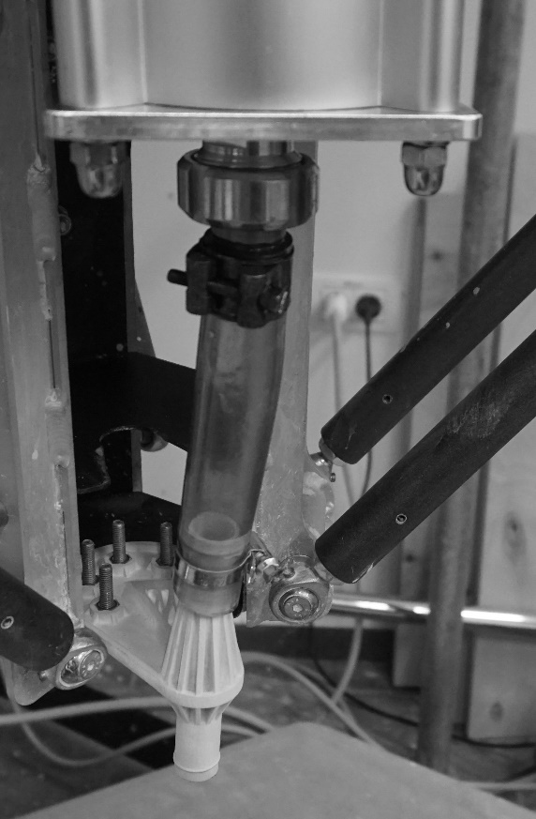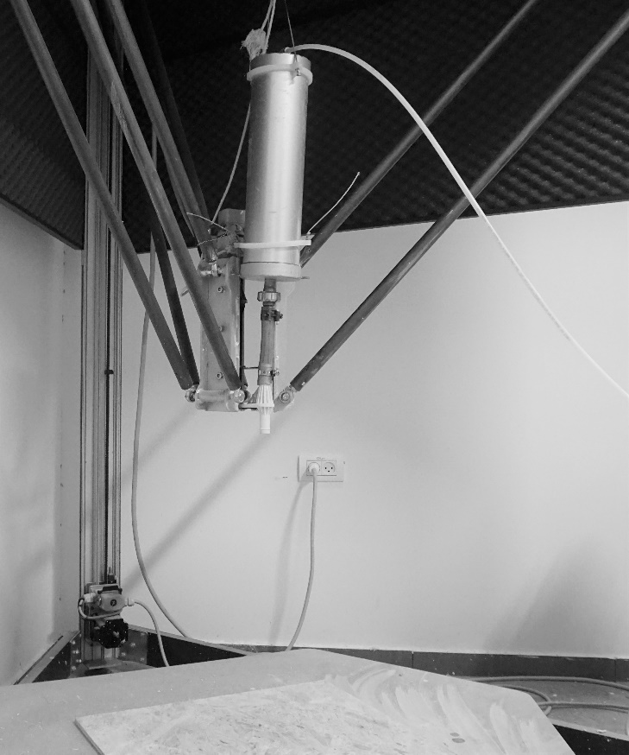

[2]

[3]

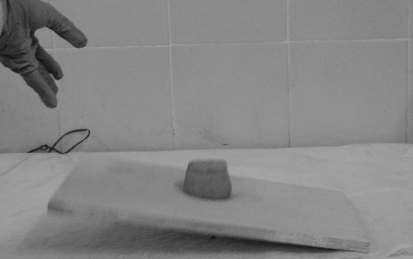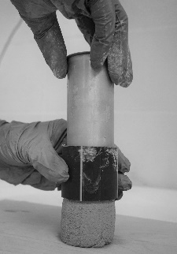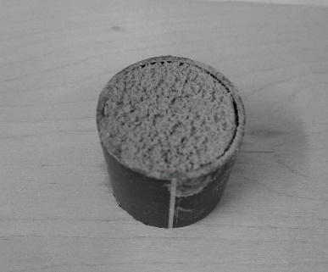

[4]

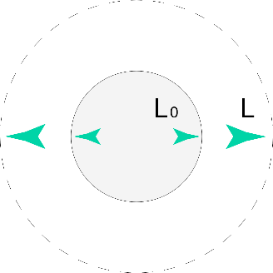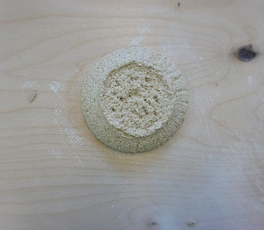

[5]

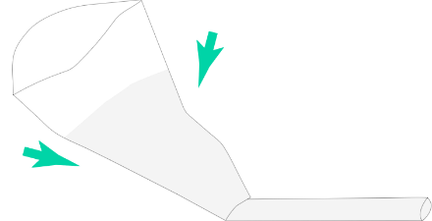

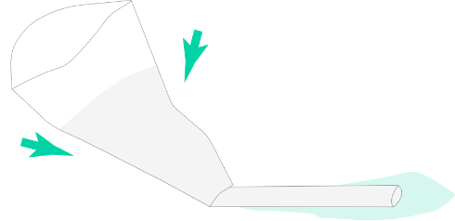

[6]

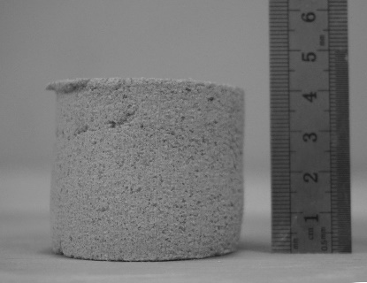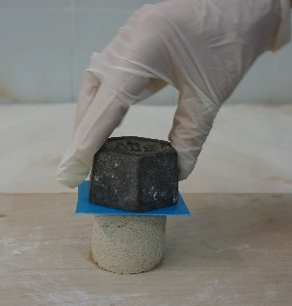

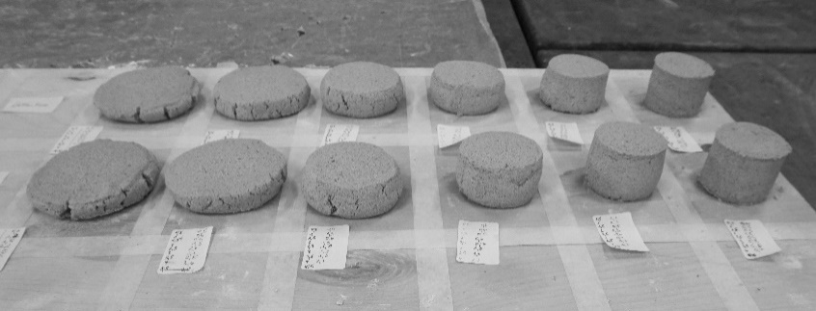

[7]

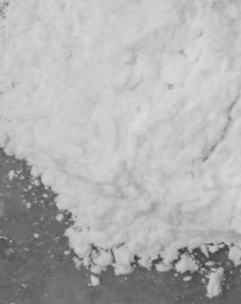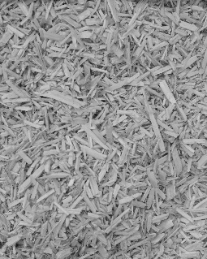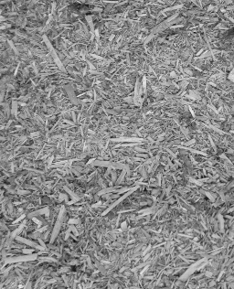

[8]

[9]

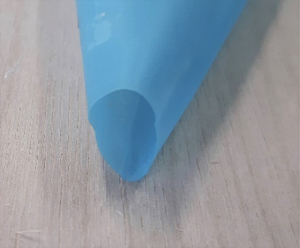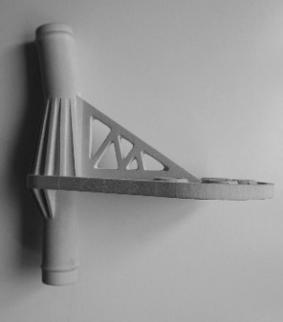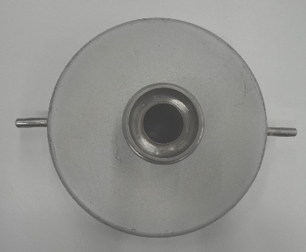

[10]

[11]

[12]

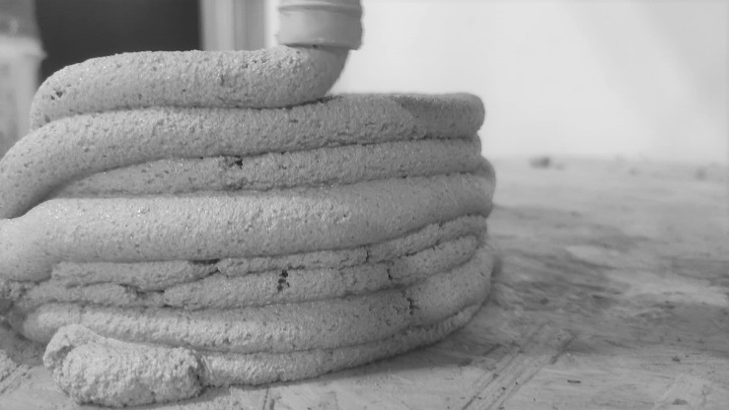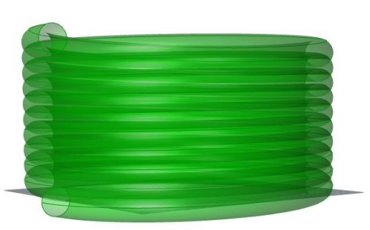

[13]

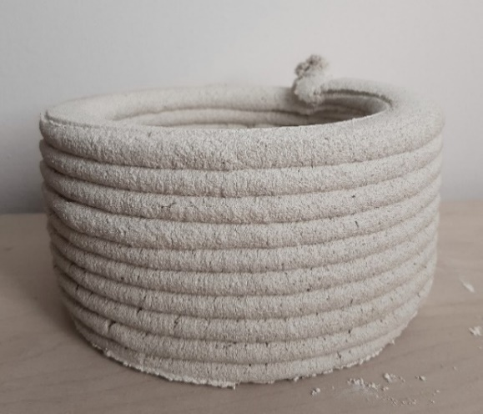

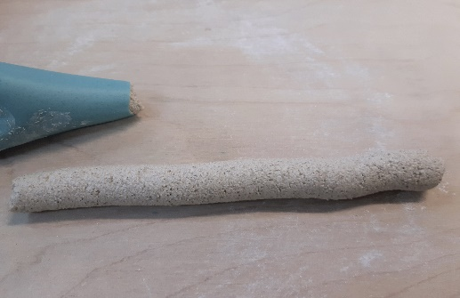

[14]

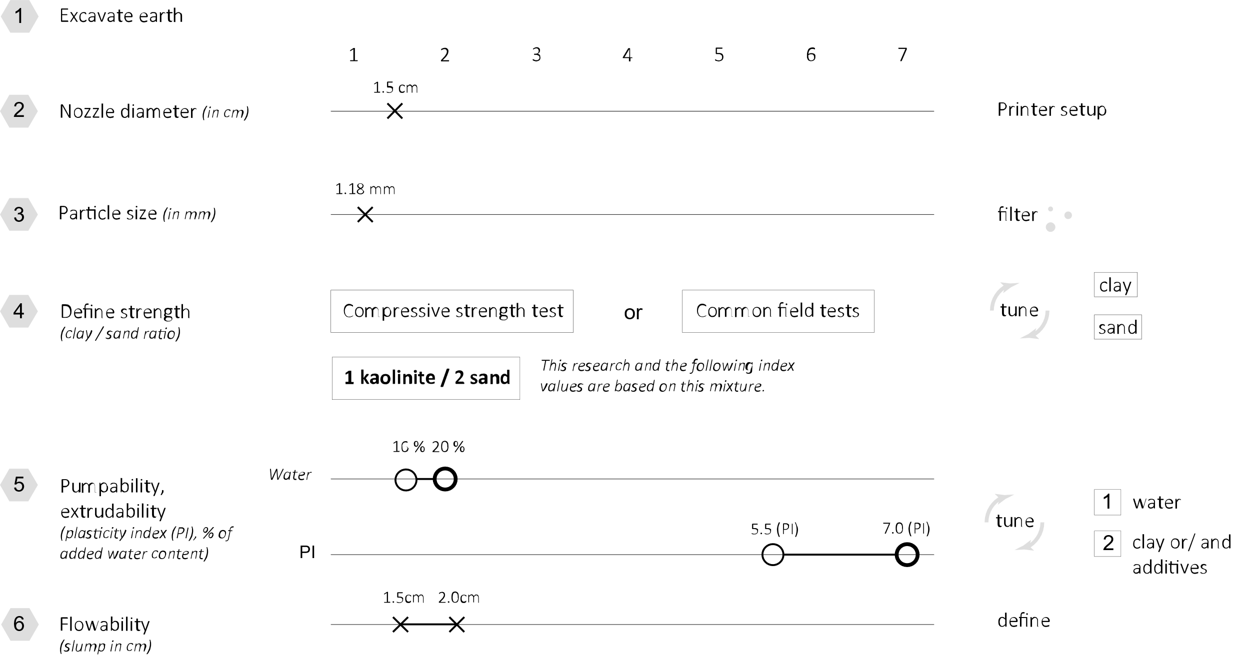

Figure 1. Printer setup.

Figure 2. Investigating the optimal ratio of clay to sand for compressive strength after 3 days of drying.

Figure 3. Preparation of sample; sample lifted on a plate and released to fall.

Figure 4. Cylindrical sample used for evaluating workability, ∆*L* = *L* − *L*0.

Figure 5. Testing the material’s extrudability and pumpability via manual extrusion through a triangular bag. Left: Incorrect material (separating water indicates low plasticity). Right: Correct material (no separation of water).

Figure 6. Top left: Applying a 500 g weight to a sample. Top right: Measuring the height of the tested sample after the weight was applied. Bottom: Overview measurements of green strength development for mixtures M1updated and M5updated.

Figure 7. Fibers of horse manure, hemp shiv fibers, and cellulose microfibers. The horse manure fibers are thin and flexible, while the hemp fibers are thicker and rigid.

Figure 8. Influence of water content on the spread of the mixtures.

Figure 9. Left to right: Opening of container (Ø = 1.8 cm); connection part and nozzle (Ø = 1.5 cm); triangular bag (Ø = 1.5 cm).

Figure 10. Sample graph for mixture M1updated showing measurements of vertical deformation at different drying times.

Figure 11. Determining deformation of the material in its plastic state over different drying times illustrates the development of green strength.

Figure 12. Left to right: Digital file cylinder (width Ø 16.5 cm, height 8.4 cm, 10 layers, computed layer distance 0.8 cm, layer’s width Ø 1.5cm); failed printed cylinder with mixtures M5.

Figure 13. Left to right: Triangular bag extruding material without the water separating; good-quality printed cylinder with mixture M5updated (clay to sand ratio = 1:1; + 1.7% cellulose microfibers).

Figure 14. Parameters for printability according to the printer setup, here with piston extrusion (compressive strength, nozzle diameter, particle size, plasticity index, water content, flowability).