Sam S. Rakover, Rani A. Bar-On, and Anna Gliklich

**How an inverted face is compared to upright face? Mental rotation or visual similarity?**

**A major interest of research in face recognition lies in explaining the Face Inversion Effect (FIE), in which the recognition of an inverted face is less successful than that of an upright face. However, prior research has devoted little effort in examining how the cognitive system handles comparison between upright and inverted faces. The present paper finds that such comparison is based on visual similarity rather than on mental rotation of the inverted face to upright. In two experiments, a similarity scale is constructed, tested, and used to create an instrument to measure how well similar and dissimilar faces will be matched when presented in various orientations.**

Research on face perception and recognition over the last 50 years has fo­cused on the Face Inversion Effect (FIE), according to which an upright face (with the hair on top and the chin below) is recognized much better than an inverted face (chin on top, hair below)1-7. The FIE is explained by two similar hypotheses, 1) the processing of configural information related to the space between facial features and 2) holistic perception of the face as a whole. Both hypotheses propose that the processing of configural and holistic information is impaired in an inverted face compared to an upright face1,3,4,5,8,9. Despite the vast amount of research on the FIE, the question of how the cognitive system compares an inverted face to an upright face has been largely neglected. We use a simple Yes/No procedure to test two hypotheses: visual similarity and mental rotation.

The **visual-similarity** hypothesis proposes that a person’s decision is based on the visual similarity between the perceived inverted face and the remembered upright face11,12. The **mental-rotation** hypothesis proposes that the inverted face as a whole is mentally rotated to the upright orientation and then compared to the remembered upright face13-16. The impact of the FIE on a person’s cognitive system results in their great difficulty at mentally rotating each of the facial features and correctly imagining their spatial relationships in the upright orientation14,15. FigureHowever, empirical evidence supports the hypothesis that a face is mentally rotated as a whole unit, in a way similar to the mental rotation of visual shapes16,17.

These two hypotheses do not overlap since they stem from two distinct mechanisms. While the visual-similarity hypothesis is based mainly on the estimation of the number of mutual elements that compound the two faces10,12 , the mental-rotation hypothesis is founded on a mechanism that rotates the representation of the inverted face to the upright orientation and then examines whether it overlaps with the remembered upright face13-16,18.

The main goal of the present paper is to examine these two hypotheses. To study this, we conducted a variation of the Yes/No experiment based on the following manipulations and rationale. In a preparatory experiment, we constructed two groups of faces. The *similar*groupcontained seven pairs, each composed of two different faces, one upright and one inverted, which ranked very high on our similarity scale. The *non-similar* group contains seven different pairs, each composed of two different faces, one upright, one inverted, which ranked quite low on the similarity scale.

In a *Study* stage, 14 upright faces, *similar* and *non-similar*, were presented to participants. In a subsequent *Testing* stage, 28 inverted faces were presented. They were composed of the 14 previously viewed faces (of the *Study* stage) and 14 new faces. The 14 new faces included seven inverted faces from the *similar* group and seven from the *non-similar* group. The participant’s task was to decide for each inverted face if it was old (familiar) or new.

If the **visual-similarity** hypothesis is correct, then we can predict that the false-alarm performance measure for the seven new, similar, inverted faces (FAs-faces) will be significantly greater than the false-alarm for the seven new, non-similar, inverted faces (FAns-faces). When the visual similarity between upright face and inverted face is high, there is a greater likelihood of believing that a new face is an old one; hence, FAs-faces > FAns-faces.

In contrast, if the **mental-rotation** hypothesis is correct, there should be no significant differences between FAs-faces and FAns-faces; when an inverted face is rotated to the upright position, it should be easy to decide whether or not it is congruent with the familiar upright face and to decide whether the inverted *Test* face is old or new.

To test these two predictions, we conducted two experiments. The preparatory Experiment 1 was to construct a similarity scale in order to create two groups of faces: *similar* and *non-similar*. The testing Experiment 2 had two parts. The first, *Similarity,* was to test the above two predictions empirically, and the second, *Orientation,*had two important goals. First, to give additional empirical support to the construction of the similarity scale, and second, to test whether the distinction between the *similar* and the *non-similar* groups was confined only to the UI orientation or if it could be generalized to the other orientations, UU, IU and II. In other words, Part B of Experiment 2 was to test whether this distinction has the quality of resisting inversion transformations.

Experiment 1 – Preparatory study

*Participants, Design, and Procedure*: Thirty participants (21 females and nine males, average age 24.7) were shown a series of pictures on a computer screen. In each trial, participants were presented with six oval shaped faces without hair or ears. One of the faces appeared in the upright orientation (hair on top, chin below) and the other five appeared in the inverted orientation (chin on top, hair below) and were arranged in a semi-circle below the upright face. Each oval face was a different unfamiliar, black-and-white image of a man. The hair and ears were cut omitted because external facial features would aid recognition19,20.

A total of 180 trials included 30 different faces appearing six times each in the upright orientation with five inverted faces below, one of which matched the upright face. Thus, each upright face was associated with all 30 faces in the inverted orientation (including itself). The faces, chosen randomly for each trial, were exposed for 20 seconds, in which time the participant had to choose among the five inverted faces the one most similar to the upright face. Each trial also featured two whistles, at 10 and 18 seconds, to expedite the participant’s responses.

Method

Similarity scale. The main purpose of the preparatory Experiment 1 was to construct two groups of face pairs: *similar*and *non-similar*. To do this, we constructed a table of 30 *upright* faces x 30 *inverted* faces. Figure 1 shows how well the 30 participants indicated that an inverted face was similar to the correct upright face. Based on this result, we built a *similar*group by selecting seven different pairs of faces for which participants had correctly matched the upright face to its inversion to a high degree (the range of similarity was between 27% to 67% of the participants.) The *non-similar*groupwas constructed in the same way: we selected seven different pairs of faces (upright and inverted) which were different from each other but had a low number of participants who indicated a similarity between the upright and inverted faces: the low range of similarity was between 3% to 17%. The pairs in these two groups were different from each other.

=========================

Insert Figure 1 about here

===========================

It was found that on average, 82% of participants indicated that an inverted face was similar to itself in the upright orientation. In comparison, an average of 23% of participants indicated that a certain inverted face was similar to a distinct upright face. This finding suggests that the number of elements mutual to upright face X and inverted face X is greater than the number of elements mutual to upright face X and inverted face Y.

Experiment 2 – Prediction testing

Part A – Similarity

*Participants, Design, and Procedure*: Twenty participants (15 females and five males, average age 24.75) were shown a series of pictures on a computer screen each consisting of one upright face at a time. The experiment consisted of two stages: *Study* and *Test* and was a variation of the common Yes/No recognition experiment. In the *Study* stage, participants were shown 14 upright faces, each exposed for 3s at intervals of 1s between faces. These upright faces were taken from both the *similar* and *non-similar* groups and presented in randomized order. In the *Test* stage, participants were shown 28 inverted faces including 14 *old* faces that appeared in the *Study* stage taken from both the *similar* and *non-similar* groups. The faces in this stage were also presented in randomized order.

The participants were informed that they would take part in two experiments in succession. The instructions for each experiment were read before the beginning of each experiment. For the *Study* stage, participants were told to concentrate on the upright oval-faces and attempt to remember them. In the *Test* stage, they were presented with *old* and *new* inverted faces, one at a time, and had to decide whether they were *old* or *new*. They had 10s to make their decision. After 5s, a whistle sounded to expedite their decision.

Part B – Orientation

*Participants, Design & Procedure*: The same 20 participants were shown a series of pair of faces, one at a time, on a computer screen. All the pairs were constructed of the14 pairs constructed in the preparatory study, Experiment 1. Each face pair was presented in four possible orientations: *upright/inverted* (UI), *upright/upright* (UU), *inverted/inverted* (II) and *inverted/upright* (IU). A total of 56 face pairs (4x14) were presented one at a time in randomized order. Each pair was presented for 10s to allow the participant to rank the degree of similarity between the faces on the screen. After 5s, a whistle sounded to indicate that half the time remained.

Figure 2 shows how face pair orientation relates to the similarity ratings.A score of 1 signifies that the faces were not viewed as similar at all, while a 5 signifies that the faces were perceived as very similar.

Results

*Part (a)* The main results appear in Figure 1: While there is no significant difference between Percent Hits in the *similar* groups (%Hs) and Percent Hits in the *non-similar* groups (%Hns), Percent Falls-Alarm in the similar-groups (%FAs) is significantly greater than Percent Falls-Alarm in the non-similar-groups (%FAns). A repeated measurement 2 (Hits, Falls-Alarm) x 2 (*similar* group, *non-similar* group) ANOVA supports this observation: F(1,19) = 9.56 p<.006 µ2=.34; An LSD test revealed a significant difference between %FAs=55.0% and %FAns=35.7% p<.007 but not between %Hs and %Hns.

=============================

Insert Figure 2 about here

=============================

*Part (b)* The main results appear in Figure 2: The similarity ranking of the pairs in the *similar* group (SRs) was higher than the similarity ranking in the non-*similar* group (SRns) in all the four groups: UI, UU, IU and II. A repeated measurement 4(UU, UI, IU, II) x 2(Similar group, Non-similar group) ANOVA supports this observation: F(3, 57) = 27.92 p< .0001 µ2=.595. A LSD test done within each of the four groups revealed that SRs was significantly higher than SRns at the level of p<.001.

Discussion

The main results of the present study are as follows: First, FAs is greater than FAns, while no significant difference was found between Hs and Hns. Second, the SRs was higher than the SRns in each of the four orientation. The first result supports the **visual similarity** hypothesis that the cognitive system compares an inverted face with an upright face by conducting a visual similarity between the perceived inverted face and the remembered upright face10,11. The result does not support the **mental rotation** hypothesis since it predicts no significant difference between FAs and FAns.

The second result supports the validity of the *similarity scale*; the SRs is greater than the SRns for the UI orientation and also in the other three orientations. Moreover, the finding that SRs > SRns for all four orientations suggests the following. The distinction between the similar and non-similar groups indicates that it is not confined only to the UI orientation. Rather, the distinction generalizes to all other orientations. This finding suggests that the similarity between different faces resists the transformation of inversion. If we assume that similarity is founded on mutual elements that resist transformation of inversion, inversion resisting elements (IRE), we may propose that IRE have the qualities of symmetry and saliency, for example, round or narrow eyes, fleshy lips, wide nose, and thick eyebrows. This explains well the above finding; the similarity of an upright, oval face with itself in the inversion orientation is much higher than the similarity between an upright face with a different inverted face. The reason for this could be that the number of mutual symmetrical and salient elements in an upright face X and an inverted face X is much higher than in an upright face X and an inverted face Y. Furthermore, the IRE may also explain whether recognition of inverted faces is based mainly on featural information2,3,12. Promising future research would discover which IREs are the most (or least) salient for successful face recognition.

References

1. Maurer, D., Le Grand, R., & Mondloch, C. J. (2002). The many faces of

Configural processing. *Trends in Cognitive Sciences*, **6**, 255–260.

1. Rakover, S. S. (2002). Featural vs. configurational informa­tion in faces: A

conceptual and empirical analysis. *British Journal of Psychology*, **93**, 1–30.

1. Rakover, S. S. (2013). Explaining the face-inversion effect: The face-scheme incompatibility (FSI) model. *Psycho­nomic Bulletin & Review*, **20**, 665–692.
2. Rossion, B. (2008). Picture-plane inversion leads to qualita­tive changes of face perception. *Acta Psychologica*, **128**, 274–289.
3. Rossion, B. (2009). Distinguishing the cause and conse­quence of face inversion: The perceptual field hypothesis. *Acta Psychologica*, **132**, 300–312.
4. Valentine, T. (1988). Upside-down faces: A review of the effect of inversion on face recognition. *British Journal of Psychology*, **79**, 471–491.
5. Yin, R. K. (1969). Looking at upside-down faces. *Journal of Experimental Psychology*, **81**, 141–145.
6. Piepers, W., & Robbins, R. A. (2012). A review and clarifica­tion of the terms “holistic,” “configural” and “relational” in face perception literature. *Frontiers in Psychology*, **3**, Article 559.
8. Rakover, S. S. & Cahlon, B. (1989). To catch a thief with a recognition model: The model and some empirical results. *Cognitive Psychology*, **21**, 423-468.
9. Rakover, S. S. & Cahlon, B. (2001). *Face Recognition: Cognitive and Computational Processes*. Amsterdam/Philadelphia: John Benjamins.
10. Rakover, Sam S. (2015). Cognitive processing of scrambled faces: Effects of instructions and tasks. *American Journal of Psychology*, **128**, 379-386.
11. Rock, I. (1973). *Orientation and form.* New York, NY: Aca­demic Press.
12. Rock, I. (1974). The perception of disoriented figures. *Scientific American*, **230**, 78-86.
13. Valentine, T. & Bruce, V. (1988). Mental rotation of faces. *Memory & Cognition*, **16**, 556-566.
14. Cooper, L. A. (1975). Mental rotation of random two-dimensional shapes. *Cognitive Psychology*, **7**, 20-43.
15. Bonner, L., Burton, A. M., & Bruce, V. (2003). Getting to know you: How we learn new faces. *Visual Cognition*, **10**, 527–536
16. Want, S. C., Pascalis, O., Coleman, M., & Blades, M. (2003). Recognizing people from the inner or outer parts of their faces: Developmental data concerning “unfamiliar” faces. *British Journal of Developmental Psychology*, **21**, 125–135.

**Figure 1:** PercentHits and False Alarm as function of similar and non-similar groups of pairs of different oval-faces.

**Figure 2:** Similarity ratings as a function of the face pair orientation and of similarity versus non-similarity.

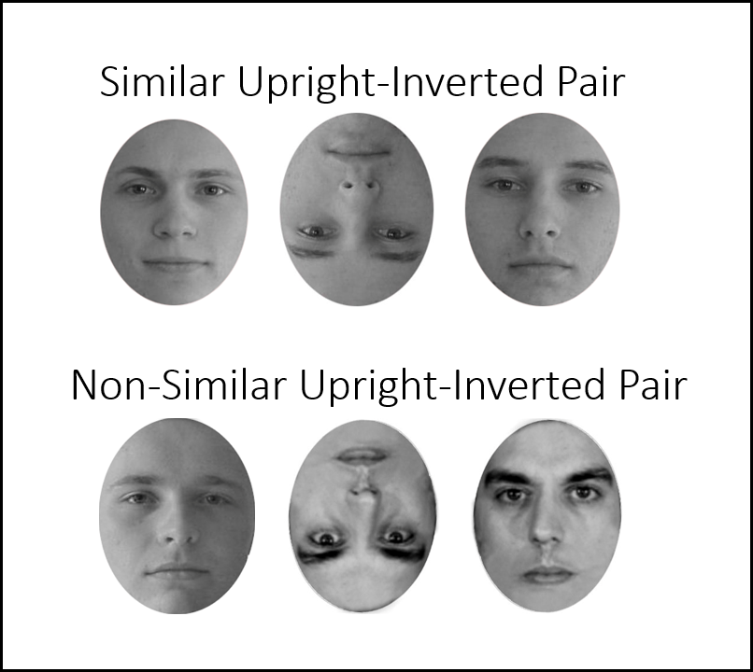

**Figure 3:** Examples of similar and non-similar pairs of oval-faces. The left face was presented in the upright orientation and the middle one in the inverted orientation. The upright face on the right is the same as the inverted one. It is presented here for the sake of comparison.