**Using discrete low-frequency components of shipping noise to characterize gassy sediment in shallow water**

**Andrey A. Lunkova)**

*Prokhorov General Physics Institute of the Russian Academy of Sciences, 38 Vavilov st., Moscow 119991, Russia*

**Boris G. Katsnelson**

*L.Charney School of Marine Sciences, University of Haifa, 199 Aba Khoushy Ave., Haifa 3498838, Israel*

**Abstract:** This work shows that normal-mode attenuation coefficients can be used to estimate the speed of sound in gas-saturated sediments, which is much less than the speed of sound in water. Deeper penetration into the bottom sediment and more effective mode filtering require a low-frequency sound source. In an experiment in the Sea of Galilee, the research vessel was used as a noise source approaching a vertical hydrophone array at a constant speed. Twelve narrow-band components of the vessel noise in the frequency band 20–100 Hz were identified and mode filtered to estimate the normal-mode attenuation coefficients. The inversion results indicate that the speed of sound in the sediment was approximately 170 m/s.

**PACS numbers:**

**Date Received: Date Accepted:**

**1. Introduction**

Gassy bottom sediments are typical of many freshwater lakes,1 reservoirs,2 and oil and gas fields on an ocean shelf.3 In lakes, the gas is primarily methane produced by microbial activity. Gas bubbles in sediment increase its compressibility, thereby decreasing the speed of sound in this medium. The speed of sound through sediment is very sensitive to the presence of gas; for example, given a volume gas fraction of 1% in muddy sediment, the speed of sound is about 100 m/s,2 which is much less than that in water. The sound-reflection coefficient from such acoustically soft sediment is −0.6 to −0.7, even at normal incidence. Using this speed of sound and a typical frequency of 300 Hz, the wavelength  ≈ 0.3 m, which means that even comparatively narrow gassy layers behave like a half space, so comparatively deep penetration into sediment requires the use of low-frequency sound (a few tens of Hz). Thus, low-frequency acoustic waves must be used to penetrate through the gassy layer.

Although pressurized or frozen cores may be collected from sediment to directly measure the gas fraction therein,4 this approach is not only complex and costly but also invasive, which reduces the reliability and accuracy of the results.4 A solution to this problem may be found in the use of noninvasive acoustic methods within the framework of geo-acoustic inversion to obtain the sediment parameters (speed of sound, density, etc.). Given the speed of sound in sediment, the volume gas fraction can be deduced unambiguously.5

A geo-acoustic inversion method of particular interest uses ambient noise or ship noise instead of active sound sources. For example, Chailloux *et al.*6 studied the possibility of using a shipping lane as a continuous acoustic source for passive detection of the Ushant thermal front. In other work, Battle *et al.*7 towed a horizontal array from a ship and geo-acoustically inverted the tow-ship noise by using near-field−matched-field processing. By using acoustic data collected by a bottom-moored AUV in very shallow water, Crocker *et al.*8 estimated the broadband noise spectrum of a passing ship in shallow water and the compression-wave speed in the seafloor sediment. In the 2006 Shallow Water Experiment, Stotts *et al.*9 extracted inversion solutions from noise measurements of a surface ship acquired by using an L-shaped array. Finally, Tollefsen and Dosso10 applied a Bayesian geo-acoustic inversion to low-frequency narrow-band acoustic noise from a quiet surface ship that was recorded by using a bottom-moored horizontal line array in shallow water.

The present work investigates how to extract normal-mode attenuation coefficients from research-vessel noise. The investigation is based on noise recorded by a fixed vertical line array (VLA) in the Sea of Galilee (also known as Lake Kinneret, Israel). Applying a matching procedure to the coefficients allows us to estimate the effective speed of sound in the gassy sediment. Earlier studies11,12 involving a mid-frequency (≈1 kHz) active sound source and a single nearby hydrophone revealed the spatiotemporal variability of the speed of sound in the lake, with values ranging from 180 to 730 m/s and spatial scales up to 4 km. The speed of sound was estimated from measurements of the reflection coefficient for the sound pulse and the corresponding matched-field processing of the impulse response in the time domain.

**2. Theory of modal attenuation**

In shallow water, modal attenuation depends strongly on the properties of the bottom sediment. According to a simplified theory of Katsnelson *et al.*,13 the mode attenuation coefficient, which is the imaginary part of the mode eigenvalue, can be written as

|  |  |
| --- | --- |
| | (1) |

where $D$ is the cycle distance of the ray corresponding to a normal mode, and $V$ is the bottom-reflection coefficient. Assuming a constant speed of sound *c* in water, then $D=2H\cot{χ}$, where $H$ is the water depth, and $χ$ is the grazing angle of the ray. Considering the bottom as a homogeneous liquid half space with speed of sound, the Rayleigh reflection coefficient *V* at the water-bottom interface is

|  |  |
| --- | --- |
| | (2) |

where $m_{b}=ρ_{b}/ρ$ is the density ratio, $n_{b}=c/c_{b}$ is the index of refraction, and $β_{b}$ is the bottom-absorption coefficient given by the imaginary part of the complex wave number in the sediment. If $c_{b}≪c$, the acoustic energy loss at the boundary is primarily governed by the contrast in speed of sound across the boundary, so the absorption coefficient $β_{b}≪1$ can be neglected. In this case, Eq. (1) takes the form

|  |  |
| --- | --- |
| | (3) |

For the *m*th normal mode in a waveguide with a constant speed of sound in water and with a soft bottom, the sine and cosine factors in Eq. (3) can be written as $\sin{χ_{m}}≈πm/kH$ and $\cos{χ_{m}}≈\sqrt{1-{\left({πm}/{kH}\right)}^{2}}$, where $k=2πf/c$ is the wave number. Substituting these expressions into Eq. (3) gives

|  |  |
| --- | --- |
| | (4) |

Equation (4) reveals the linear dependence between the speed of sound $c_{b}$ in the bottom sediment and the mode attenuation coefficient $α_{m}$. In this paper, the mode attenuation coefficients extracted from noise recordings are used as input data for geo-acoustic inversion. For a hard bottom where $c_{b}>c$, the relation between bottom properties and modal attenuation is more complicated because it includes bottom absorption.

**3. Experiment**

Acoustic noise data were obtained in the central part of the Sea of Galilee in late November 2017. Figure 1(a) shows the bathymetry at the experiment site, the track of the research vessel, and the location of the receiving VLA. The water depth $H$ along the track was approximately 37 m. Figure 1(b) shows the downward-refracting speed of sound profile $c(z)$ in the water column. The cutoff frequency for this shallow-water waveguide is about 20 Hz. A seven-element VLA was deployed from a stationary floating platform. The array spanned the water column from 4 to 34 m with hydrophones at intervals of 5 m. The red circles in Fig. 1(b) show the depth $z_{j}$ of each hydrophone. The acoustic acquisition system collected seven channels of digital data at a sampling rate of 20 kHz.

A 14-m-long research vessel served as a moving source of low-frequency sound. The vessel was equipped with two 400 hp diesel engines. For the experiment, the vessel approached the VLA at a constant speed of 4 m/s (8 knots) for approximately10 min. along a straight north-south line. The yellow arrow in Fig. 1(a) shows the vessel’s GPS track. The maximum (minimum) distance from the VLA that is considered is $r_{max}=$ 2500 m ($r_{0}=$ 100 m). Because the engine ran at a constant rate, the noise output of the vessel is assumed to be constant. Figure 2 shows the noise spectrogram and normalized power spectral density from one hydrophone of the VLA. For the spectrogram, the window length was set to 1 s with 50% overlap. The arrows in Fig. 2(b) indicate the twelve stable discrete frequency components, $f_{i}=$ 22, 24, 36, 44, 48, 66, 72, 76, 84, 87, 96, and 98 Hz. Presumably, these frequency components were produced by the propulsion machinery of the vessel; they were thus selected for extraction of the normal-mode attenuation coefficients. Note that, in water, the Doppler shift for a frequency of 100 Hz and sound-source speed of 4 m/s does not exceed 0.3 Hz.

The twelve frequency components were selected from the spectrograms acquired by each hydrophone of the VLA to obtain the time-dependent vertical acoustic-pressure profile $P(f_{i},t,z_{j})$. Figure 3 shows the variation over time of the vertical acoustic-pressure profile for three frequency components: 24, 48, and 72 Hz. Figures 3(a)–3(c) illustrate one-, two-, and three-mode propagation, respectively. Note that the observed interference patterns are symmetric with respect to the center of the waveguide and that the acoustic pressure is almost zero near the bottom. These results mean that the bottom is acoustically soft with a high reflection coefficient, even at a very low frequency. Recall that a pulse reflected from such a bottom is inverted (i.e., the phase shift of the reflection coefficient is ~), which is typical for reflections from an upper free release boundary.

**4. Data processing and results**

Based on the GPS data, the time $t$ in $P(f_{i},t,z_{j})$ is converted to range $r$ with the origin at the VLA location. To extract the normal modes, a standard spatial filtering technique is applied to $P(f_{i},r,z_{j})$. The resulting modal amplitudes are13

|  |  |
| --- | --- |
|  | (5) |

The effect of the non-uniform speed-of-sound profile [Fig. 1(b)] on the mode shapes $ψ_{m}(f_{i},z)$ produces small mode amplitudes for frequencies below 100 Hz [Fig. 1(c)]. Thus, for a bottom that is essentially acoustically soft, the mode functions can be approximated by perfect sinusoids $ψ_{m}\left(f_{i},z\right)≈\sqrt{2/H}\sin{(πmz/H)}$, which gives the modal amplitude as a function of range shown in Fig. 4(a) for the first three modes at 72 Hz. Note that the soft-bottom condition means that the modal orthogonality condition is satisfied rather precisely, even for integration only over the water column. This condition allows the modes to be extracted by using a vertical array.

The modal amplitude in a range-independent horizontal waveguide can be written as

|  |  |
| --- | --- |
| | (6) |
|  |  |

Hereinafter, the frequency dependence is omitted for brevity. Each $ψ_{m}\left(z\right)$ is an acoustic mode with associated horizontal wave number $q_{m}$ and attenuation coefficient $α_{m}$, and $z_{s}$ is the depth of the sound source. To isolate $α_{m}$, Eq. (6) is first divided by the modal amplitude $A_{m}\left(r_{0}\right)$ at the reference point $r_{0}$. Next, rearranging the terms and taking the natural logarithm of both sides gives

|  |  |
| --- | --- |
| | (7) |

Equation (7) has no dependence on source depth $z_{s}$ or horizontal wave number $q_{m}$. To find the attenuation coefficient $α_{m}$, the left-hand side is linearly interpolated from $r_{0}$ to the maximum range, where the *m*th mode can be identified. The slope of the line is associated with the attenuation coefficient. The maximum range for processing a given mode increases with frequency (see dashed rectangles in Fig. 3) because the modal attenuation decreases with frequency. Figure 4(b) gives the estimated attenuation coefficients and their 90% confidence intervals for the first four modes. The results show that the modal attenuation varies over a wide range from 10−4 to 10−2 m−1 (from 3 to 86 dB/km).

The inverse problem is now solved to determine the effective speed of sound $c_{b}$ in the sediment (assumed to be a liquid half space). The experimental dependencies of $α_{m}$ are compared with simulated values of $α_{m}$ for a set of values of $c_{b}$. The upper-sediment density of 1300 kg/m3 is known from geophysical core data. If the speed of sound $c_{b}$ in the bottom sediment is much less than the speed of sound $c$ in water, then the bottom absorption coefficient $β_{b}$ can be neglected. Thus, including bottom absorption does not affect the angular dependence of the bottom reflection coefficient because of the absence of total internal reflection at all angles. As a result, all normal modes are leaky.

In the proposed method, the speed of sound in sediment corresponds to the maximum of the following matching function that provides the best fit between the experimental () and calculated ($α_{m}^{theory}$) attenuation coefficients:

|  |  |
| --- | --- |
| | (8) |

where $M_{i}$ is the number of normal modes at frequency $f_{i}$.

The matching procedure gives the speed of sound in the bottom sediment of 170 ± 10 m/s. Figure 4(b) (dashed lines) shows simulated modal-attenuation curves for this value. T also produces very similar curves. The best agreement between theory and experiment occurs in the frequency range 22–96 Hz. However, the experimental attenuation coefficient is not monotonic in frequency, which is attributed to a non-uniform bottom structure. Usually, the gassy sediment layer may be a few meters thick, and its presence can lead to a resonant absorption at some frequencies, which increases the mode attenuation coefficients. The speed of sound obtained corresponds to a volume gas (methane) fraction of 0.2%, which is consistent with the results of previous studies11,12 that used a mid-frequency (~1 kHz) wideband noise source to estimate the speed of sound in sediment from measured reflection coefficients.

To further verify the present estimate of the speed of sound in the bottom sediment, Table 1 compares the calculated and experimental interference spacing for the first and second mode,. The results agree rather well.

Table 1

|  |  |  |  |  |  |  |  |  |  |
| --- | --- | --- | --- | --- | --- | --- | --- | --- | --- |
| Interference spacing for 1st and 2nd modes | | | | | | | | | |
| Frequency (Hz) | **44** | **48** | **66** | **72** | **76** | **84** | **87** | **96** | **98** |
| Experiment (m) | 64 | 96 | 132 | 156 | 168 | 180 | 194 | 230 | 236 |
| Theory (m) | 70 | 91 | 145 | 161 | 173 | 196 | 204 | 229 | 234 |

**5. Conclusion**

The paper proposes a method to estimate the modal attenuation at frequencies below 100 Hz by using the discrete components of noise from a research vessel recorded by a vertical line array of hydrophones. In a waveguide consisting of gassy sediment, the normal modes can be accurately extracted by using the orthogonality condition, even when only integrating over the water column. The frequency-dependent mode attenuation coefficients obtained for the central part of the Sea of Galilee are inverted to obtain the speed of sound in the bottom sediment. The estimated speed of sound in the sediment is 170 m/s. Even at such low frequencies, the gassy half-space model accurately describes the experimental acoustic data.

**Acknowledgments**

This work was supported by the Russian Foundation for Basic Research under Grants No. 20-05-00119 and No. 19-02-00127. The authors would like to thank E. Uzhansky and G. Zaslavsky for their help in collecting the acoustic data. The authors are also grateful to the crew of *R/V Hermona* for their professionalism.

**References**

1 Anderson, M. A., & Martinez, D. (2015). Methane gas in lake bottom sediments quantified using acoustic backscatter strength. Journal of Soils and Sediments, 15(5), 1246-1255.

2 Grigor’ev, V. A., Lun’kov, A. A., & Petnikov, V. G. (2015). Attenuation of sound in shallow-water areas with gas-saturated bottoms. Acoustical Physics, 61(1), 85-95.

3 Fleischer, P., Orsi, T., Richardson, M., & Anderson, A. (2001). Distribution of free gas in marine sediments: a global overview. Geo-Marine Letters, 21(2), 103-122.

4 Dück, Y., Liu, L., Lorke, A., Ostrovsky, I., Katsman, R., & Jokiel, C. (2019). A novel freeze corer for characterization of methane bubbles and assessment of coring disturbances. Limnology and Oceanography: Methods, 17(5), 305-319.

5 Tóth, Z., Spiess, V., Mogollón, J. M., & Jensen, J. B. (2014). Estimating the free gas content in Baltic Sea sediments using compressional wave velocity from marine seismic data. Journal of Geophysical Research: Solid Earth, 119(12), 8577-8593.

6 Chailloux, C., Kinda, B., Bonnel, J., Gervaise, C., Stephan, Y., Mars, J., & Hermand, J. P. (2011). Modelling of ambient noise created by a shipping lane to prepare passive inversion: application to Ushant. In Proceedings of the 4th Underwater Acoustics Measurements Conference (UAM 2011) (Vol. 26).

7 Battle, D. J., Gerstoft, P., Kuperman, W. A., Hodgkiss, W. S., & Siderius, M. (2003). Geoacoustic inversion of tow-ship noise via near-field-matched-field processing. IEEE journal of oceanic engineering, 28(3), 454-467.

8 Crocker, S. E., Nielsen, P. L., Miller, J. H., & Siderius, M. (2014). Geoacoustic inversion of ship radiated noise in shallow water using data from a single hydrophone. The Journal of the Acoustical Society of America, 136(5), EL362-EL368.

9 Stotts, S. A., Koch, R. A., Joshi, S. M., Nguyen, V. T., Ferreri, V. W., & Knobles, D. P. (2010). Geoacoustic inversions of horizontal and vertical line array acoustic data from a surface ship source of opportunity. IEEE Journal of Oceanic Engineering, 35(1), 79-102..

10 Tollefsen, D., & Dosso, S. E. (2008). Bayesian geoacoustic inversion of ship noise on a horizontal array. The Journal of the Acoustical Society of America, 124(2), 788-795.

11 Katsnelson, B., Katsman, R., Lunkov, A., & Ostrovsky, I. (2017). Acoustical methodology for determination of gas content in aquatic sediments, with application to Lake Kinneret, Israel, as a case study. Limnology and Oceanography: Methods, 15(6), 531-541.

12 Uzhansky, E., Katsnelson, B., Lunkov, A., & Ostrovsky, I. (2020). Spatial and temporal variability of free gas content in shallow sediments: Lake Kinneret as a case study. Geo-Mar Lett. https://doi.org/10.1007/s00367-019-00629-4

13 Katsnelson, B., Petnikov, V., & Lynch, J. (2012). Fundamentals of shallow water acoustics. Springer Science & Business Media.

**FIGURES**

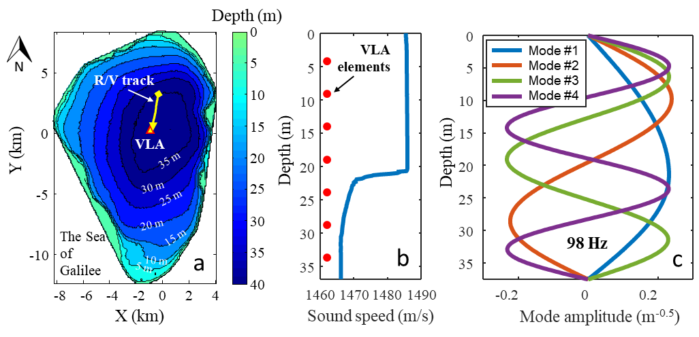

Fig. 1. (a) Bathymetric map of the Sea of Galilee, the VLA location (red triangle) and the research-vessel (R-V) track (yellow arrow), (b) depth profile of speed of sound at VLA location and depth of VLA elements (red circles), and (c) normal modes at a frequency of 98 Hz.

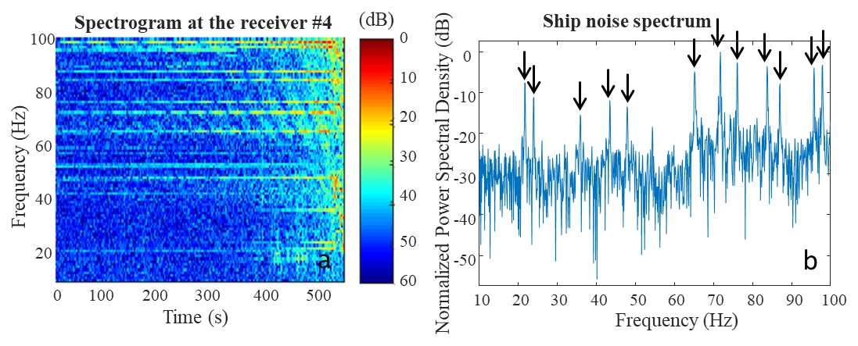

Fig. 2. (a) Spectrogram and (b) normalized power spectral density from fourth VLA element from the free surface. Black arrows indicate the twelve research-vessel noise lines used for inversion.

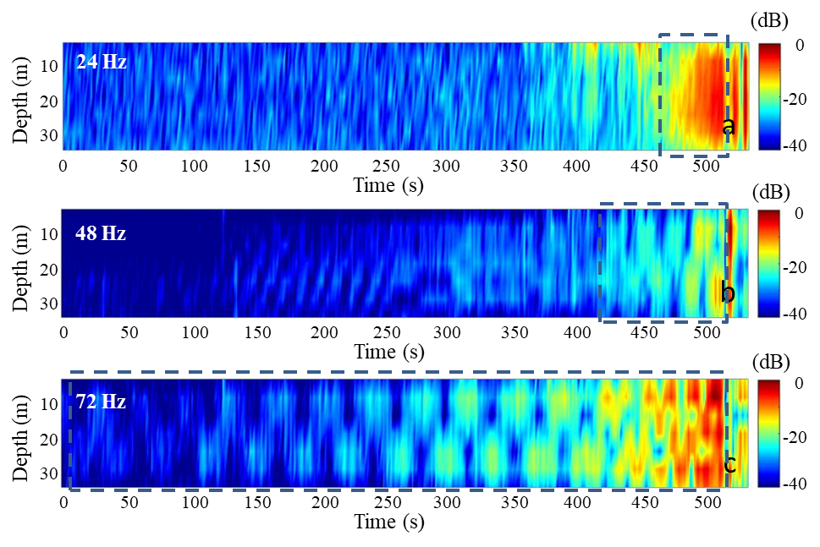

Fig. 3. Vertical profiles of acoustic pressure at VLA at a frequency of (a) 24 Hz, (b) 48 Hz, and (c) 72 Hz.

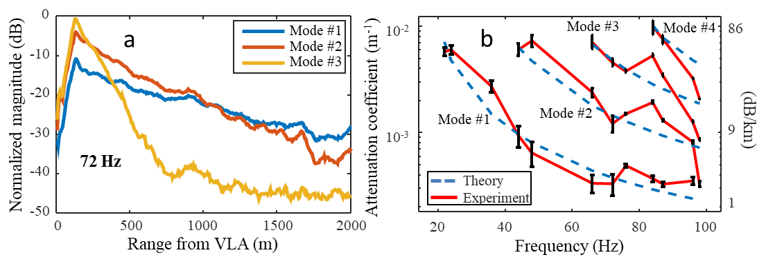

Fig. 4. (a) Modal amplitudes as a function of range from VLA at a frequency of 72 Hz, and (b) experimental (solid curves) and calculated (dashed curves) attenuation coefficients as a function of acoustic frequency.