# **Unit 2 – Career Development**

Study goals

After working through this unit, you will be able to ...

… Define career motivations and understand what drives people in their careers.

… Understand the differences between content and process motivation theories and apply them to your own career.

… Identify different career roles and classify the requirements for career roles and role conflicts.

... Describe professional accomplishment throughout the different career phases.

# 2. Career Development

### Introduction

Sophie's father works for a global corporation in Asia and has lots of contacts. Sophie is extremely motivated about her career, because she was immersed in the corporate world from an early age through her father and is familiar with the career opportunities in this field.

Her career motivation is therefore reflected in certain types of behavior, such as deliberately selecting a degree course (business administration with a focus on sales and logistics) with a view to a career in a multinational company and attending networking events to expand her contacts and career opportunities.

Sophie's career motivation highlights the importance of motivation for career development. Motivation can influence people's behavior and decisions and help shape and structure their career trajectories.

There are no such things as good or bad motivations. The important thing is to be able to recognize and address your own motivations and shape your career accordingly.

## 2.1 Career Motivations

Motivation helps to explain people’s behavior and "why" they act in a certain way. Von Rosenstiel defines motivation as a "psychological disposition that is comparatively long-lasting and specific in content" (2011, p. 238). Some motivations are innate and develop over time.

Career motivations explain why individuals opt for a particular career direction or strive for advancement. They are often personal and unique to each person and can vary according to their individual interests, needs and values. By being familiar with our own career motivations, we can make conscious career decisions and lead a fulfilled working life.

The concept of career motivations has been studied by several scientific disciplines including psychology, sociology and organizational research. Researchers found that individual career motivations are often influenced by an individual's personality, experience, and values.

In career theory, the term **career motivation** means the factors that influence our individual striving for professional success and advancement. Career motivations may include various needs or desires, such as financial security, prestige, professional development, autonomy, power, or social recognition.

**Career motivations**

Scientists use a range of techniques to research career motivations, including questionnaires, interviews and psychometric testing.

By identifying and analyzing the most common career motivations, we can gain insights into why people aspire to specific careers, which factors contribute to job satisfaction and success, and how employers can better promote and support their employees in their career development.

The analysis of career motivations is pivotal to understanding the behavior of individuals at work and helping organizations develop appropriate incentive systems and career development programs. Career motivations can also help individuals make the right career choices and build a meaningful and fulfilling career.

### Motivation Theories

Motivation theories describe how people become motivated and which factors influence their motivation. They aim to explain why people perform certain actions and how these actions are influenced by various factors such as needs, desires, goals, incentives, and rewards. They also help to understand how people's needs, desires, and goals can affect their actions and decisions, and identify the conditions needed to boost and maintain people's motivation.

Additionally, **motivation theories** can help explain why some people are successful in the pursuit of their goals. They can offer useful guidance when designing incentive systems in various fields such as education and work.

There are countless **motivation theories** focusing on different aspects of motivation, some of which are outlined below. Essentially, there are two types of motivation theory: content theories and process theories, each of which focuses on different aspects of motivation. Content-related theories focus on the factors that influence people's motivation, while process-related theories focus on processes that help to motivate people.

**Motivation Theories**

The scientific discourse on motivations dates back to antiquity with Epicurus and his philosophical theories (in around 300 BC). (Haag, 2020, S. 26).

### Content Theories

Content-related motivation theories (also known as need theories) address the factors influencing an individual’s motivation by exploring people’s needs and the conditions under which these needs are met. They examine effective motivators and what inspires someone to do something (e.g., work). They therefore center around the factors influencing people's needs, desires and goals and how these needs and desires influence motivation. Needs can vary greatly (such as the need to earn money, receive recognition, give back to society, use your skills, make your mark, continue the family business).

#### Motivation theory according to McClelland

Psychologist David McClelland developed his theory of human motivation in the 1950s and 1960s (McClelland, 1961). He postulates that people are driven by three basic motivations: Achievement, affiliation and power. A combination of all three motivations is also possible.

* **Achievement**: People with strong achievement motivation are motivated by a desire to improve their skills and knowledge to meet challenging goals and deliver outstanding performance. They strive for personal success and growth, are usually more willing to take risks, and seek feedback to improve their performance.
* **Affiliation:** People with strong affiliation motivation are motivated by a desire to build and maintain close interpersonal relationships. They appreciate harmony and collaboration and tend to be friendly, cooperative and empathetic.
* **Power:** People with strong power motivation are motivated by a desire to influence and control other people and situations. They want to assert their own goals and strive to influence and lead others. They may sometimes be perceived as authoritarian or manipulative.

**Motivation groups**

McClelland found that in nearly 98% of all cases, human behavior can be attributed to one of the three motivation groups (Haag, 2020, S. 31).

McClelland stresses that each person has a mix of these **motivations**, but one may be more dominant than the rest. These motivations are culturally driven and may change over the course of a person’s life.

Figure 4: Basic Motivations According to McClelland

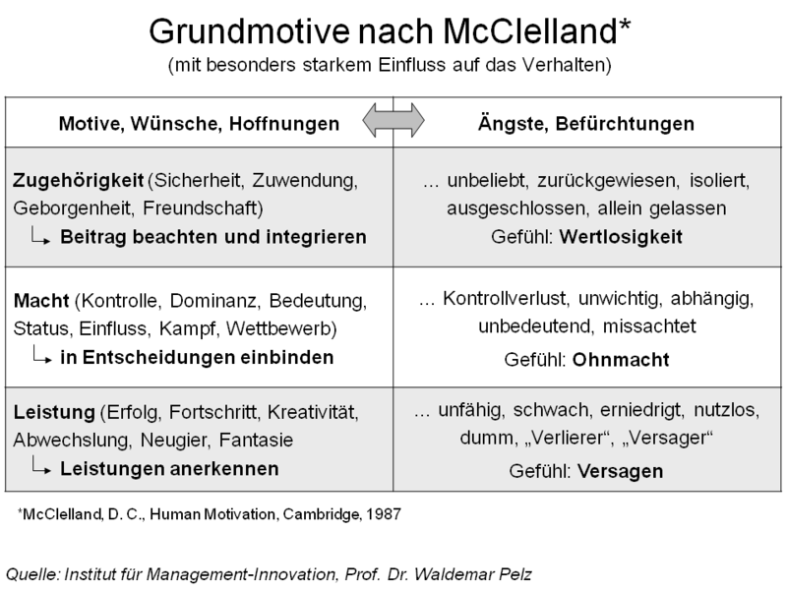

Source: <https://de.wikipedia.org/wiki/Datei:Grundmotive_nach_McClelland.png>

Within organizational psychology, McClelland's theory provides an important basis for HR development and employee motivation in particular. However, McClelland himself noted self-critically that his theory may in fact be guilty of oversimplifying people and their motivations (Haag, 2020, S. 123). We cannot simply pigeonhole individuals and label them based on a particular theory of motivation. Motivation profiles are useful for outlining individual characteristics and helping us to understand what drives people, but in reality, individual motivations are rarely the determining factor in personality. Rather, it is the interplay between combinations of motivations which affects our behavior in a complex way.

Knowing what drives a person can therefore help us make the best decision for them in critical situations: Depending on an individual’s dominant basic motivation, it may have a greater influence when deciding whether to work for large corporation or a small start-up. Should you prioritize training opportunities over job titles? How much performance pressure you can handle is another key consideration.

#### Intrinsic and extrinsic motivation (Barbuto & Scholl)

Intrinsic and extrinsic motivation is a well-known distinction in motivation theory developed by John Barbuto and Richard Scholl, which provided the basis for their concept of the "Five Sources of Motivation" (Barbuto & Scholl, 1998).

Intrinsic motivation comes from the inside – our inner drive, or in other words, joy and interest in the activity itself. Intrinsically motivated people perform an activity because they enjoy it and consider it valuable. Intrinsic motivation can be enhanced by various factors, such as setting challenging but achievable goals, creating opportunities for creativity and self-expression, or providing feedback that acknowledges performance and commitment.

By contrast, extrinsic motivation is determined by external factors, such as rewards, punishments, or social pressure. Extrinsically motivated people perform an activity to get a certain reward or avoid punishment. This form of motivation is also observed in the world of work, for example, when employees complete a task for financial reward or to keep their jobs.

Barbuto and Scholl classified intrinsic and extrinsic motivation into five sources of motivation in the workplace.

Intrinsic sources:

1. **Intrinsic process motivation:** This is a motivation derived from joy and interest in performing a task or activity. A person is intrinsically motivated because they like the activity itself and are not driven by an external reward or punishment. For example, an employee may be motivated to learn a new skill or plan a project because they enjoy the activity itself.

* Other examples: Musicians who make music from the heart or people who write articles for Wikipedia because they are passionate about it. It is about the pleasure of the activity itself rather than any particular benefits, rewards or forms of recognition.

1. **Internal self-concept:** Describes how a person derives their self-image and identity from internal factors. A person who has a strong internal self-image is more likely to identify with their work and feel fulfilled by it. For example, a factory worker who strongly identifies with their work and considers it part of their identity may be intrinsically motivated to work because they feel they are making an important contribution.

* Examples: Surgeons or journalists who believe that they can make things happen (high performance motivation, tends to be long-term and focused on the whole person).

Extrinsic sources:

1. **Instrumental motivation:** Motivation that is driven by external benefits, rewards, and avoidance of punishment. A person is motivated to perform a specific action to get a reward or avoid punishment. For example, an employee may be motivated to complete a certain task in order to earn a reward. This motivation tends to be short-term.

* Other examples: Authors who dream of writing a bestseller or real estate agents hoping to get rich (high form of power motivation).

1. **External self-concept:** When a person derives their self-image from external factors. A person may define themselves through feedback and evaluation from others. For example, an employee might base their self-image on having a close relationship with managers or colleagues.

* Other examples: Cello players as part of an orchestra, basketball players as part of a team (high form of affiliation motivation).

1. **Goal internalization:** This refers to the way goals are internalized to maintain long-term motivation. When a person internalizes a goal, it becomes an integral part of their identity and not just an external reward or goal. One example is an employee who sets themselves a goal to acquire a certain skill in order to advance their long-term career and improve their work.

* Other examples: Entrepreneurs who commit to the company’s values or an assistant whose decisions are almost identical to those of their manager (combination of affiliation and performance motivation).

Figure 5: The Five Sources of Motivation According to Barbuto & Scholl

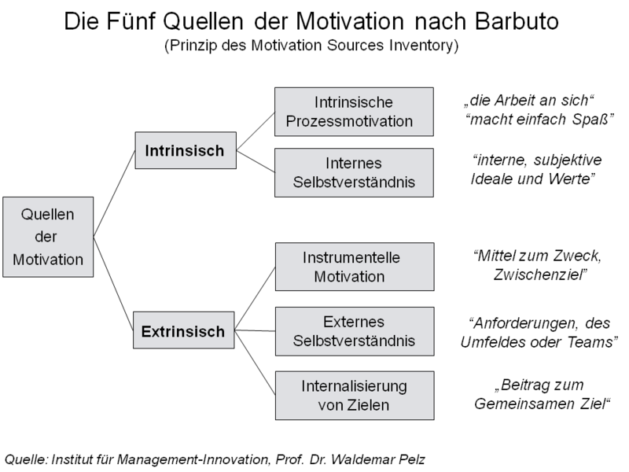

Source: <https://de.wikipedia.org/wiki/Datei:Quellen_der_Motivation.png>

The theory of intrinsic and extrinsic motivation is often used as a basis when designing working conditions and reward systems to boost employee engagement and performance. It is important to strike a good balance between intrinsic and extrinsic motivation to promote long-term engagement and well-being.

### Process Theories

Process-based motivation theories (also known as action theories) consider the origins of motivation and the processes that cause people to become motivated. They postulate that motivation is influenced not only by the needs and desires of individuals, but also by their evaluations and expectations. They describe the various steps involved in executing a particular action, such as assessing the situation, anticipating the outcome, and choosing the best option.

#### Expectancy / V-I-E theory (Vroom)

Victor Vroom's expectancy theory is an example of a process-based motivation theory (Work & Motivation, 1964). Expectancy theory examines the way in which a person's expectations about the consequences of their actions affects their motivation. The expectancy theory postulates that motivation depends on the expectation that a person’s efforts will produce certain performance, which in turn will lead to a certain reward. This theory was developed by psychologist Victor Vroom and is based on three main components: Valence, instrumentality and expectancy (V-I-E).

* **Valence:** The subjective value a person places on a reward. In other words, an individual is more motivated to perform a task when the reward is of high value to them.
* **Instrumentality:** A person’s belief that a successful performance will result in a reward. In other words, how likely does the individual believe it is that their action will result in a particular outcome, such as a reward or promotion? When someone believes that their performance will result in a reward, they will be more motivated to perform the task.
* **Expectancy:** A person’s belief that their efforts will lead to a successful performance. If someone believes that their efforts will result in a successful performance, they will be more motivated to perform the task.

In a corporate context, employees often wonder whether their work performance has a significant influence on their opportunities for promotion. If they conclude that it has no influence, or only a minimal influence, they may hold back from maximizing their full potential to achieve above-average work results, because their motivation is adversely affected by their negative expectation about the consequences.

The consequences of a promotion are even more relevant. Depending on the individual, the additional influence and creative freedom gained may be more or less significant than the loss of leisure time or additional traveling required. The weighting of each factor is highly individual, yet equally as important as their expectations.

One interesting aspect of the expectancy theory is that it incorporates the different values people ascribe to different consequences. For example, one person may consider a reward particularly valuable, while another may consider the same reward less important. The expectancy theory also allows for the possibility of disappointment and frustration about the lack of consequences if the anticipated rewards fail to materialize or their probability is assessed as low.

Figure 6: Vroom’s VIE Theory

Ein Bild, das Diagramm enthält.

Source: Tolimir, 2022, p. 91.

Expectancy theory is a useful tool for understanding what motivates people and how motivation is influenced by their perceptions, attitudes and values. Also interesting is the way it considers both extrinsic and intrinsic motivation and the interactions between them.

#### Locke’s Goal-Setting Theory

The goal-setting theory was devised by American psychologist Edwin A. Locke, considered one of the pioneers of motivation research. In the 1960s and 1970s, Locke conducted extensive research on motivation in the workplace and the importance of goals (Locke & Latham, 1990; 2002).

His goal-setting theory argues that it is possible to boost an individual’s motivation by setting specific, challenging goals. It is based on the assumption that people are more motivated when they have a clear understanding of what is expected of them and believe they are capable of achieving set goals.

The goal-setting theory comprises three core elements:

1. **Clarity:** The goals must be specific and clearly formulated so that the person understands what is expected of them.
2. **Challenge:** The goals should be challenging, but nevertheless realistic and achievable. If a goal is too easy or too difficult, it may cause dissatisfaction or frustration.
3. **Feedback:** The person should receive regular feedback on their performance in achieving the set goals. Feedback can also help to keep them motivated and improve their performance.

The goal-setting theory postulates that setting specific and challenging goals motivates people by giving them a clear idea of what is expected and a goal they can work toward. By tracking their progress and receiving feedback, people can improve their performance and stay motivated.

**Moderators**

Examples of moderators include: An individual's skills and experiences, and the support of others.

**Moderators** influence the relationship between goals and performance. A moderator can increase or decrease the strength of the relationship between goals and performance. In a career context, factors such as job satisfaction, confidence in your own skills or support from managers or colleagues can act as moderators.

**Mediators** explain the correlations between goals and performance. In a career context, mediators might include motivation, self-regulation and work commitment. These factors can help people achieve their goals by increasing their effort, endurance and persistence.

**Mediators**

Examples of mediators include:Motivation, effort and endurance.

The combination of moderators and mediators helps to explain how goals affect people's behavior and how they can be used to improve their performance.

Figure 7: Model of the Goal-Setting Theory According to Locke and Latham

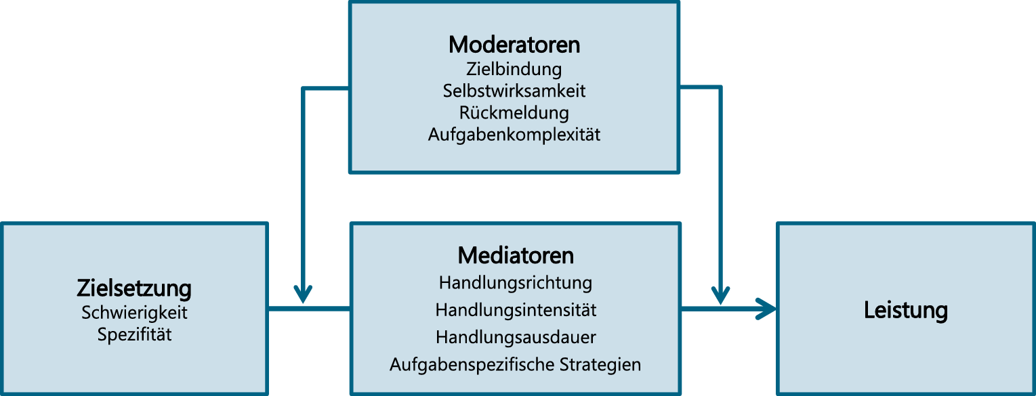

Source: Burkhardt-Waldherr & Kauffeld, 2020, p. 157.

While Locke's goal-setting theory is widely used in motivation research, it is not without its critics:

* **Overemphasis on goals:** Locke theorizes that setting specific and challenging goals will increase performance and motivation. However, some research suggests that an overemphasis on goals can actually increase stress and anxiety among employees, which in turn may adversely impact their performance and motivation.
* **Neglecting the long-term impacts:** Locke’s theory focuses mainly on short-term goals and their impact on performance and motivation. However, we should remember that long-term goals and their impact on employee job satisfaction and well-being are also important.

#### Rubicon model

The **Rubicon** model is a motivation theory developed by German psychologist Heinz Heckhausen. It describes the processes people undergo in order to achieve their goals. The model is based on the precept that different phases in life require different actions and decisions to achieve an aspired goal (Koch, 2018).

**Rubicon**

The name "Rubicon" refers to the Rubicon River, which Julius Caesar crossed in 49 BC, marking the start of a civil war. The river crossing symbolizes the transition from a state of indecision to a state of determination.

The Rubicon model divides the goal pursuit process into four phases:

1. **Pre-decision phase (preparation):** During this phase, goals are formulated and possible actions are weighed up. The individual is still undecided and seeking possible alternatives.
2. **Post-decision phase (decision):** The individual has decided on an action that best fits the goals.
3. **Action phase:** The individual translates their decision into reality and works actively toward their goal.
4. **Post-action phase:** The outcome of the action is evaluated and appropriate consequences are drawn.

The model also identifies a certain threshold, known as the "Rubicon." Once the individual has passed this threshold, their motivation changes from "possibility" to "commitment" (**volition**). In other words, once an individual has decided on and begun an action, they feel compelled to see it through. The Rubicon model also stresses the importance of positive expectations and goals for motivation and the need to set realistic and achievable goals in order to remain motivated.

**Volition**

Unlike motivation, which concerns a person’s willingness to pursue a goal, volition is the ability to actively and purposefully pursue a goal and translate it into action, despite potential difficulties or obstacles. Volition also includes other aspects such as endurance, willpower and self-management.

One example of the Rubicon process in a work-related context is applying for a new job. During the pre-decision phase, you consider your career goals and the opportunities for achieving them. You look for suitable job advertisements and find out about the requirements and expectations of potential employers.

The decision to apply for a particular job marks the Rubicon. At this point, you transition from considering to actively planning.

During the planning phase, you decide which steps to take in order to create a convincing application. You research the company and tailor your cover letter and résumé to the specific role. During the action phase, you execute your plan and submit the application.

During the post-action phase, you evaluate the success of your application and potential areas for improvement. If invited to an interview, the process enters a new round, during which you re-engage with the Rubicon process to achieve your goal of a successful job application.

Figure 8: Rubicon Model

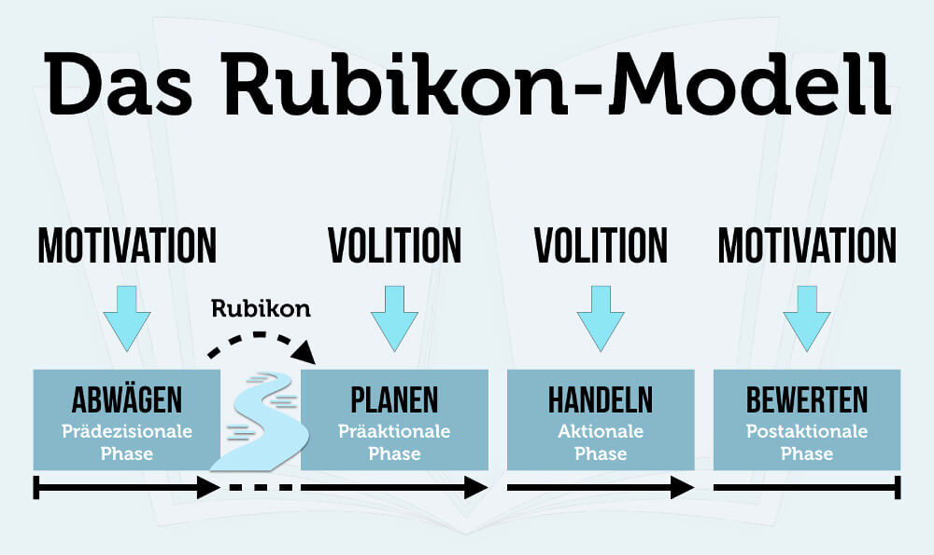

Source: Mai, 2023.

### Your Own Motivation Profile

Motivation theories scrutinize and explain various aspects of motivation and behavior, helping us to understand why it is so relevant to understand our own career motivations.

For example, intrinsic and extrinsic motivation theories can help us understand the factors which motivate us to perform certain activities and how this affects performance and satisfaction. This may help you to identify which activities and tasks you enjoy and which you would rather avoid.

Expectancy and goal-setting theories can help us understand how goal achievement affects our motivation and behavior. This, in turn, helps us to set realistic and challenging career goals that are incentivizing and motivating.

The Rubicon model can us help understand the goal implementation process and how we overcome obstacles. It describes the journey from planning to achieving career goals and how focusing on your own resources and skills can help you to overcome challenges.

Motivation theories can help you understand your career motivations and develop a strategy for achieving your goals. Applying different theories gives you a broader perspective of your own motivations, enabling you to embark on a successful and fulfilling career trajectory.

**Motivation profile**

While there are various online tools offering a broad assessment of your individual motivation profile, they are no substitute for a comprehensive, reliable analysis by a qualified professional.

There are various online platforms available to help create your motivation profile.

For example, a free **motivation profile** by Ahead (Haag, 2020, p. 3; 34) is currently being tested, offering quick multiple-choice options. The test is based on a refined version of the McClelland categories and takes around 20 minutes. It can be found on the Ahead Academy website (Ahead-Academy, 2023).

Further examples include:

* 16Personalities (16Personalities, 2023),
* Hogan Assessments (Hogan, 2023),
* Talentoday (taltoday, 2023),
* High5Test (High5Test, 2023) and
* Crystal Knows (Crystal, 2023) .

### Self-Check Questions

1. Please provide three examples of intrinsic and extrinsic motivation.

*Intrinsic motivation:*

* *A person who is passionate about making music and wants to continually improve because they enjoy it and see it as part of their identity.*
* *A person who enjoys exercising for their physical and mental health and because it makes them feel good.*
* *A student who is passionate about a particular subject and wants to learn more without seeking grades or external rewards.*

*Extrinsic motivation:*

* *A person who does a job just to earn money and does not enjoy it or feel motivated by it.*
* *A student who strives to achieve good grades purely in order to receive praise from teachers or parents.*
* *An employee who works overtime to get a salary increase or promotion, but does not enjoy their work or feel motivated by it.*

2. Please mark the statements which are correct.

¨ The theory of self-determination is based on the three basic needs: Autonomy, competence and relatedness. (T)

¨ In expectancy theory, V-I-E stands for valence, individuality and experience. (F)

¨ The goal-setting theory is based on the idea that setting specific, challenging and clear goals increases employee motivation and performance. (T)

¨ The Rubicon model describes the "Rubicon" as the phase of identifying your own motivations. (F)

## 2.2 Career Roles

Career development can be a complex and dynamic journey incorporating multiple roles and responsibilities. Being aware of and understanding that each individual performs different career roles over the course of their career development can help prepare more effectively for future challenges. Below, we outline some of the different career roles and perspectives to consider.

### Career Stages Model

Career development encompasses multiple different roles and responsibilities that can change over time. The "Career Stages Model of Careers" (Dalton et al., 1977) outlines a somewhat traditional career trajectory, from apprentice through to manager, and includes four stages.

In the first stage, a career entrant usually works under the guidance of a more senior colleague and performs routine tasks as part of a larger project and team. Following an induction period, they are expected to tackle increasing work volumes and complexities and to take on certain responsibilities.

In the second stage, the individual becomes more deeply involved in the projects and assumes responsibility for defined aspects. They work independently and achieve significant results, thereby gaining credibility and recognition. They are often responsible for managing a project or part of a project.

In the middle phase of their career, they forge links between different departments and influence project implementation with their own ideas. As team leaders, they assume responsibility for managing a team and coordinating its performance. The ability to motivate employees and promote their skills is crucial. They act as mentors or group leaders and influence the development of less experienced coworkers. As head of a section, unit or department, they have disciplinary responsibility for a significant number of employees and must be capable of developing and executing a strategy for the entire department.

In the final stage, the person has become an important part of the organization. This may mean taking responsibility for a division or the entire organization as a board member. They exercise formal and informal power, represent the organization and prepare other employees for key roles within the company.

At the time, this model was useful for describing a typical corporate career trajectory for talented and motivated employees. However, it is debatable whether this career path is still relevant or desirable today. Not every employee strives to lead others and share the corporate philosophy with them, and not all potential managers want to be on the board. We must consider critically whether this classic career progression model is still valid or desirable for current generations.

More recent developments in protean and postorganizational career development theories describe new career types in an evolving work context. Concepts such as "Empowerment" by Gretchen Spreitzer (1995) focus on the individual sense of self-efficacy, self-determination, meaningfulness and competency. One feature common to all modern career development models is the need to continually adopt new roles and embrace **different perspectives**. When we first embark on a career, we should be prepared to learn from experienced colleagues and gain valuable experience. As team or project managers, we should be able to motivate our own employees and promote their skills to boost the team’s performance. As departmental or section heads, we should be able to develop and implement a clear strategy for entire departments which incorporates the customers’ needs as well as the organization’s objectives.

**Different perspectives**

It is important to understand that over the course of a career, an employee’s roles are determined by their own skills, experience and performance.

### Katz and Kahn’s Role Theory

Katz and Kahn’s role model concept (1966) describes how people in organizations perform different roles and interact with one another.

**Roles**

Katz and Kahn argue that there are specific forms of behavior associated with certain tasks (standardized behavior patterns required within a functional network).

Katz & Kahn define **roles** as "standardized patterns of behavior required of all persons who participate in a given functional relationship, regardless of any personal wishes or interpersonal obligations irrelevant to the functional relationship" (Katz & Kahn, 1966, p. 37, quoted by Greif, 1983, p. 128).

Katz and Kahn's role model identifies the different roles held by an individual within an organization. Developed in the 1960s, the model works from the assumption that each person in an organization performs a variety of roles which mutually influence and interact with one another. It has since been widely applied in organizational and leadership research.

1. **Position:** An individual’s formal position within an organization, such as CEO, team leader or administrator.
2. **Person:** The person’s individual characteristics, such as personality, skills and experiences.
3. **Role:** The individual’s expectations of their position, such as their tasks, responsibilities and code of conduct.
4. **Group:** The people with whom the person works in an organization, such as colleagues, customers or managers.

Katz and Kahn's role model also impacts the behavior of people in organizations. When a person plays a certain role, it can influence their behavior. When a person takes on a role as a team member, they may become more cooperative and collaborative. When a person takes on a leadership role, they may become more confident and willing to make decisions.

Katz and Kahn's role model has also been applied to leadership research. Leaders must be skilled at playing different roles within an organization in order to succeed. They must be able to switch between positions and roles, while understanding and meeting the expectations and requirements of each role.

#### Sending and Receiving Roles

There are various ways to send and **receive** roles, either through verbal communication (such as verbal and written instructions), or through non-verbal signals (such as positive or negative consequences). Katz and Kahn elaborate on the different roles in their role model:

**Receiving a role**

The role is received by communicating the role expectations.

1. **Role expectation:** The expectations placed by others on a person who holds a certain position. These may be expectations of tasks, responsibilities, or behavior. Role expectation is important because it affects how a person perceives their role and how they behave in it.
2. **Sent Role:** The behavior exhibited by an individual in their position and perceived by others. The behavior may differ from or conform to expectations.
3. **Received role:** How the role is perceived and interpreted by others. It may differ from the sent role if other people’s perceptions differ from your intentions or actions.
4. **Role behavior:** The actual behavior exhibited by an individual in their role, regardless of whether it is perceived or expected by others.

These four aspects of roles are closely interrelated and mutually influence one another: Role expectation can affect others’ behavior and perceptions, while other people’s behavior and perceptions can affect role behavior and role expectation.

#### Role assignment context

The context in which roles are assigned includes several factors affecting the expectations of the role sender:

* **Organizational environment:** The external framework conditions and influences affecting work and role performance within an organization. This may include the corporate culture, organizational structure, working conditions and market development.
* **Personality traits:** Individual traits and characteristics that can affect a person's behavior and performance. Examples include performance orientation, conscientiousness, openness to experiences and emotional stability.
* **Interpersonal factors:** The interpersonal relationships and interactions that take place within an organization including collaboration with colleagues, relationships with managers, or interactions with customers.

Figure 9: Role Model According to Katz & Kahn 1966

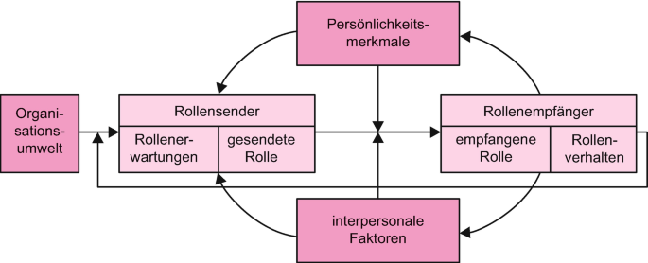

Source: Schreyögg & Koch, 2020, p. 491.

Katz and Kahn’s role model is an important concept within organizational and leadership research. It highlights the many different roles an individual may perform within an organization and illustrates how they interact with each other and affect people's behavior within organizations. By understanding the requirements and expectations of these roles, you will be able to respond to them more effectively and improve your performance in different areas.

Understanding the role model may also help people to identify and resolve potential conflicts between their different roles. For example, someone who works both as a team leader and as a member of a project team may find it difficult to reconcile their responsibilities in both roles. By understanding the requirements and expectations of these roles, they can develop strategies to minimize conflicts and become more effective in both roles.

Understanding the role model can also help develop career planning by identifying and understanding the different roles that are relevant to a particular career. This may help you to acquire the skills and experience needed to fulfill these roles and achieve your career goals.

### Requirements for the "Manager" Career Role

Katz and Kahn's role model stresses that each role influences the individual, and that different expectations and requirements must be met in each role. For example, when a person takes on a leadership role, they are expected to have a vision of their area of responsibility, motivate employees, and achieve goals. When taking on a technical role, on the other hand, they are expected to possess expertise and solve technical problems. Fulfilling each of these roles requires different skills and competencies.

Over the course of a career, people must meet a range of different tasks, responsibilities and expectations. They typically include:

1. **Functional responsibility:** The role a person plays based on their functional knowledge and skills. Functional responsibility means being responsible for fulfilling your assigned tasks and responsibilities and can apply equally to employees and managers. It includes responsibility for achieving goals and delivering results in a specific field or function. In other words, it means being functionally responsible for work results, checking work quality and ensuring compliance with specifications and processes.

An example of functional responsibility would be when an IT expert is responsible for maintaining a computer system and keeping it functioning correctly. The IT expert is responsible for ensuring that the system is functioning smoothly, that it meets user requirements, and that it is secure and well-protected.

1. **Leadership skills:** The role played by a manager in leading and controlling teams or departments. Leadership skills are the skills needed to lead and manage a group of employees or an organization. This includes skills such as planning, organization, leadership, and communication. Leadership skills are important for motivating employees to achieve their goals and collaborate effectively.

The ability to create and manage budgets is one example of leadership skills. A manager must be able to plan and monitor their team’s or department’s budget to ensure financial stability. Additionally, they must be sufficiently adept at applying these skills in the demonstrated practices.

1. **Disciplinary leadership skills:** Acting as a role model and decision-maker for other employees. Disciplinary responsibility refers to a manager’s responsibility for their employees and includes being responsible for adhering to company policies, reviewing employee performance, providing feedback and coaching, and taking action when employee performance falls short of expectations, or when behavioral or trust issues arise.

One example of disciplinary responsibility is when a manager takes disciplinary action against an employee by issuing a formal warning for inappropriate behavior. The manager is responsible for ensuring that the employee understands the reasons for the disciplinary action and that they behave appropriately in future.

1. **Networking skills:** Developing and maintaining work-related contacts and networks. Networking skills also include the skills needed to build and maintain effective relationships with others, including skills such as communication, collaboration, negotiation, and networking. A network of contacts can help achieve business goals, attract customers, and create new business opportunities.

One example of networking skills is the ability to build and cultivate relationships with other managers. A manager with a good network can draw on the contacts and resources of their business partners to meet their business goals and explore new business opportunities.

1. **Mentoring skills:** An individual acting as a mentor or coach for other employees or students. Mentoring skills are the ability to mentor others (typically employees or younger colleagues) to help them develop their careers and achieve their goals.

A mentor is usually an experienced manager who shares their experiences and knowledge with others to help them achieve their career goals. Their skills may include coaching, giving feedback, offering alternative perspectives and being empathetic. A successful mentor helps mentees to develop personally and professionally and reach their full potential.

One example of mentoring skills is helping a young coworker to define their career goals and draw up a plan for achieving them. A mentor can also provide feedback and advice to help employees improve their skills and performance.

1. **Entrepreneurial skills:** The role played by an individual when setting up or running their own business. Entrepreneurial skills are the skills required to set up, develop and lead a company including risk-taking, creativity, innovativeness and business development. An entrepreneur needs entrepreneurial skills to develop new products and services, tap into markets and win customers.

The ability to develop and implement new business ideas is one example of entrepreneurial skills. A successful entrepreneur must be capable of developing innovative ideas and transforming them into successful business models.

The different roles within a career may vary depending on the industry, company, position and individual career goals. One individual may play multiple roles simultaneously or switch between different roles over the course of their career. It is important to identify and understand your own career roles and development prospects if you want to set clear career goals.

### Role Conflicts

Kahn et al. (1964) and Kahn (1978) argue that discrepancies may arise between the sent and received role for various reasons e. g. if the sender is considered untrustworthy, the underlying role expectations are considered unimportant, penalties are thought to be unlikely, the sender and receiver cannot find a common language, or the demands are not clearly and unequivocally formulated.

Role conflicts are common in organizations and companies worldwide. They may take various formats and may impact employees and the organization as a whole. Kahn and Katz identify two particular types of role conflict: Inter-role and intra-role conflicts.

An inter-role conflict involves conflict between the expectations and requirements associated with different roles. For example, as a father, an employee may be responsible for picking up his children from school on time, but as an employee he may also be required to attend an important meeting on time. Another example of an inter-role conflict is when an employee is asked by their manager to perform tasks that conflict with their personal values and beliefs.

An intra-role conflict involves conflict between the different expectations and requirements associated with one specific role. For example, a teacher may expect to treat their students fairly, but may also expect to enforce discipline and strict rules. Another example is a manager balancing the need to meet stakeholder expectations with the need to uphold the company's ethical values.

Role conflicts can cause dissatisfaction and stress among employees, which in turn affects their performance and impacts the working environment. It is therefore important to identify and address role conflicts. One way to reduce inter-role conflicts is by promoting clear communication and flexibility in work planning. To address intra-role conflicts, employees could be trained to make decisions that reflect the company's ethical values, for example.

### Self-Check Questions

Please mark the statements which are correct.

¨ Functional responsibility primarily means being responsible for managing employees. (F)

¨ Disciplinary responsibility is mainly about accepting responsibility for work results and performance in a particular field or role. (F)

¨ The best managers are usually adept at balancing their different skills. (T)

¨ Role conflicts can have a significant impact on organizations, employees, and their performance. (T)

## 2.3 Professional Accomplishment

Accomplishment plays a vital role in your career, both for your success in your current role and for your future career opportunities. Accomplishment can be defined as the degree to which a person achieves their career goals and delivers the performance expected by their employer. It may also include a person's ability to continuously deliver high-quality work and improve their skills and abilities to advance their career.

### Performance Behavior (von Rosenstiel)

The concept of performance behavior is closely linked to the concept of professional accomplishment. In many cases, performance leads to faster achievement of career goals. Conversely, successful accomplishment can also help to strengthen a person's self-confidence and motivation, which can positively impact their performance.

Von Rosenstiel (1997) developed this approach to describe the performance behavior of employees in 1997, and it has since become very well-established in occupational psychology. Performance behavior includes an employee’s efforts to deliver a certain performance, the quality of the performance, and its duration. In other words, it considers how much effort an employee invests in a task, how well they perform it, and how long they are able to sustain that performance.

Von Rosenstiel defines performance behavior as a complex function determined by personal factors, situational factors and the requirements of the task. Personal factors (volition and ability) include personality traits, cognitive abilities and skills, as well as experience and motivation. Situational factors (situational enabling, empowerment and social obligations) relate to the environment in which the task is performed and include both physical and psychological aspects such as time pressures, workplace design and social interactions. The requirements of the task include the complexity of the task, the accuracy and speed required, and the resources available.

Figure 10: Performance Behavior According to von Rosenstiel 1997

Ein Bild, das Diagramm enthält.

Source: Sigg et al. 2020, p. 41

* **Volition (motivation, values):** Volition is a person’s desire to demonstrate a particular behavior and recognition that the associated goals are important.
* **Ability** **(knowledge, skills, abilities):** Abilities and skills are acquired or further improved under this heading.
* **Situational enabling (impeding or favorable external factors):** Individuals cannot exhibit performance behavior unless the necessary framework conditions (such as timing and spatial resources) are in place.
* **Empowerment and obligation** **(norms, regulations):** This includes the individual’s social environment and social system with the associated social and societal, explicit and implicit norms, regulations and environmental expectations.

Performance behavior can be measured in various ways, such as observing behavior while performing a task, by self-assessment, or by assessing others. Measuring performance behavior can help identify the cause of any underlying problems and initiate targeted action to improve performance behavior.

Von Rosenstiel stresses that performance behavior depends not only on personal factors, but also on the fit between personal factors, the requirements of the task and situational factors. For example, an individual may possess high cognitive abilities and skills, but nevertheless fail to complete a very time-consuming task requiring a high level of accuracy when faced with time pressures or distracted by disruptive factors.

The concept of performance behavior is pivotal to HR and organizational development, as it can help to improve employee performance and optimize the fit between individual skills and task requirements. It can also help improve working conditions and workplace design with a view to maximizing performance.

Overall, the concept of performance behavior has had a significant impact on occupational psychology as well as HR and organizational development since its introduction by von Rosenstiel in 1997. It provides a useful basis for measuring and optimizing employee performance and improving working conditions and workplace design.

### Performance Behavior at Different Career Stages

Von Rosenstiel’s research also examined how performance behavior changes over the course of the various career phases identified by Greenhaus et al. (2010): the early, mid and late career stages.

#### Early career

The early career stage tends to focus on becoming established in the industry, gaining experience and acquiring expertise. Greenhaus et al. (2010, p. 196) sub-divided this stage into the establishment phase and the achievement phase. During the early career stage, individuals focus primarily on acquiring and building skills, professional competencies and knowledge.

Performance behavior at this stage is determined by the individual's skills and experience, as well as the requirements of the task. At this stage, career achievement may be characterized by high motivation, a steep learning curve, and rapid adaptation to new challenges. As the individual is still quite inexperienced, their performance may fluctuate during this stage, especially when faced with demanding task requirements. It is therefore important to give individuals support and feedback at this stage in order to improve their performance.

#### Mid career

In the mid career phase, most people have already acquired a certain amount of work experience, a broader skillset and knowledge, and are established in their occupation.

During this stage, performance behavior is influenced by personal factors such as personality, motivation and experience, as well as situational factors such as working conditions and task requirements. Career performance at this stage may be characterized by high productivity, leadership, innovation, and the development of expertise and skills. The emphasis is on consolidating previous experience and developing leadership skills. Career planning also plays an important role at this stage, as the person often focuses on advancing their career. They may also review, confirm or modify previous career moves and career goals (Schmeisser et al., 2013, p. 221).

#### Late career

Individuals in the late career stage usually have extensive experience and may hold leadership roles based on their skills and experience. At this stage, performance behavior is often influenced by the requirements of the management task and by situational factors, such as organizational framework conditions and the corporate culture. Professional accomplishment at this phase may be characterized by prioritizing the transfer of knowledge and experience to younger employees, helping the company achieve strategic goals, and achieving a good work-life balance. It may also focus on succession planning and bringing their career to a successful conclusion.

To summarize von Rosenstiel's model, performance behavior at various different career stages is influenced by both personal factors (such as skills and experience) and situational factors (such as working conditions and requirements). Work experience and career planning are also of particular importance. We should consider performance behavior at different career stages in order to ensure optimal performance.

### Performance Behavior at Particular Career Phases

Performance behavior also plays an important role during particular phases of a career, such as during a career plateau, a career break or a consolidation / career realignment phase.

#### Career plateau

A career plateau is a (temporary) phase when there are no further advancement opportunities within the current company. This may be the case, for example, if a person has already achieved a senior position and is unlikely to climb further, if they have held their position for a very long time, or if there are no further opportunities for promotion or advancement (Möller & Volkmer, 2005).

In this situation, professional accomplishment may stagnate or even decline if there are no new challenges or growth opportunities. Motivation may diminish and job satisfaction may fall, leading to a decrease in productivity and work quality.

**Career plateau**

Regnet’s studies found that the average manager reaches their career plateau at around the age of 45 **Invalid source specified.**.

During a **career plateau** phase, performance behavior may help the employee to maintain their current position, change direction, or embark on new career steps, for example in a different industry. It is crucial at this stage to constantly improve your own skills and competences and take on new challenges, for example, by taking on additional responsibilities, participating in training, or accepting new projects and tasks.

**Career break**

Career breaks (sometimes known as career setbacks) may occur for a variety of reasons: Termination, time off due to illness or caregiving, part-time work, family time, etc.

A lack of motivation may cause people to remain on a career plateau and fail to seize development opportunities.

#### Career break

A **career break** is a sudden, unexpected, or unwanted interruption to a person's career development. During this period, professional accomplishment and success may stagnate or even decline.

A career break may be due to various causes, including personal factors, organizational changes, or external influences. Personal factors such as poor work performance, lack of commitment or lack of skills may also cause a career setback. Other causes may include organizational changes such as mergers, acquisitions, reorganization or restructuring. External influences such as economic turbulence, technological changes or political unrest can also lead to a career break. It may also be caused by a combination of factors. For example, if a person loses their job due to a merger, this can lead to a loss of job security and self-confidence, leading to a career break.

During a career break, performance behavior may be critical for getting back on track. It is important to analyze your strengths and weaknesses and reflect on your performance behavior when considering your next steps. A high level of willingness and motivation are crucial during this phase for overcoming the setback.

One option is to identify the causes of the career break and develop strategies for overcoming the obstacles, such as further training, changing direction or switching employers or industries.

#### Consolidation / reorientation phase

A consolidation / reorientation phase is a period for reflecting on your career, reconsidering your past performance behavior, and where necessary, setting new goals. This phase may be triggered by a variety of factors, such as personal considerations, job changes or external influences.

During this phase, the individual might critically assess their career development and seek ways to improve or broaden their skills and competencies, such as further training, a new direction or taking on new tasks in the current working environment.

During this phase, the individual might also rethink and adjust their career goals and priorities. A consolidation / reorientation phase might also be an opportunity to pursue personal or professional interests and passions that have become sidelined.

In a career consolidation / reorientation phase, performance behavior may help individuals to secure and develop a new role. It is important to adapt to the new requirements and acquire new skills and competencies where necessary. A high level of motivation and willingness to perform is also crucial.

This phase may also coincide with changes in the work environment or organization triggered, for example, by restructuring, mergers or acquisitions, which then force the individual to reassess their career development.

A consolidation / realignment phase often requires a high degree of self-reflection and self-management to develop a clear vision of your own career goals and priorities and take concrete steps to achieve those goals.

### Self-Check Questions

1. Please define professional accomplishment:

*Professional accomplishment can be defined as the degree to which a person achieves their career goals and delivers the performance their employer and the industry expects. It may also describe a individual's ability to continuously deliver high-quality work and improve their skills and abilities to advance their career. Maintaining performance depends on the personal aspects of volition and ability combined with the environmental aspects of empowerment and social obligations.*

2. Please mark the statements which are correct.

¨ A career plateau is phase when there are no further advancement opportunities within the current company. (T)

¨ A career break is an expected, planned interruption to a person's career development. (F)

¨ A consolidation and reorientation phase is a period for reflecting on your career, re-evaluating past performance behavior, and where necessary, setting new goals. (T)

Summary

Career motivations describe why people exhibit certain types of behavior, why they pursue certain career directions, and why they strive for career advancement. Motivation theories may be categorized into two main types: Content theories that focus on people's needs, desires, and goals; and process theories that focus on how motivation and behavior arise. Both are important for a comprehensive understanding of people's motivations. Content theories include McClelland's theory of motivation, the distinction between intrinsic and extrinsic motivation, and the theory of self-determination, while process theories include the expectancy theory, the goal-setting theory, and the Rubicon model.

Over the course of their career, most people will assume various career roles (career stages model), beginning with minimal responsibility, then acquiring project and team responsibility, and subsequently acquiring increasing responsibility through to management positions in an organization. This type of classic model has existed for decades but is now increasingly being questioned.

Professional accomplishment plays an important role throughout every career phase. It is crucial to continuously improve your own skills and competencies, tackle new challenges and remain highly motivated and enthusiastic if you want to successfully shape your own career trajectory.