Basic science research, towards fulfillment of the requirements for internal medicine specialty training

Topic:

# The influence of percutaneous cholecystostomy on the prognosis of patients with acute cholecystitis.

# Introduction

Acute cholecystitis (AC) is an infectious disorder, most commonly occurring in patients with gallstones (cholelithiasis) which obstruct the cystic duct. Less commonly, it is a result of other abdominal disorders.

In most patients, this obstruction blocks outflow through the cystic duct, leading to increased pressure within the gallbladder, which continues secreting mucus from epithelial cells of the gallbladder wall. The rising pressure leads to decreased blood flow, ischemia of the gallbladder wall, and even hydrops of the gallbladder. Stasis of obstructed bile allows bacteria to colonize the gallbladder, producing infection, usually due to *Escherichia coli*, *Klebsiella*, *Clostridium*, and *Streptococcus* Spp. Unchecked progression of this process can lead to gangrene of the gallbladder wall, in some cases even to perforation of the gallbladder and biliary peritonitis, which is a potentially fatal complication.

Gallstones, which underlie the root of the inflammatory process, are usually composed of cholesterol and calcium, or less commonly are pure cholesterol stones. The pathophysiology of gallstone formation involves a rise in cholesterol levels within the bile, rapid accumulation of cholesterol crystals into cholesterol stones, and decreased motility of the gallbladder further promoting crystallization of cholesterol. Risk factors for gallstones include, among others, obesity, pregnancy, high cholesterol intake, older age, and previous gastrointestinal surgeries. Gallstones are more commonly found in women than in men, and are a generally common disorder. Cholelithiasis affects approximately 10-20% of Americans, up to a third of which will develop acute calculous cholecystitis. Surgical removal of the gallbladder(cholecystectomy), the primary treatment for cholecystitis, is the most common surgical procedure performed in general surgery, with up to 500,000 operations annually in the US alone1.

Pathologically, acute cholecystitis is characterized by a dilated gallbladder, with a reddish-violet color and covered in a layer of fibrin, causing adhesion of the gallbladder to surrounding organs. The tissue surrounding the gallbladder is usually also inflamed and edematous. Spreading and progression of the inflammation may lead to ischemia, which if left untreated may allow for proliferation of gas-forming bacteria, and lead to gangrenous cholecystitis.

Prognosis of acute cholecystitis patients is generally favorable. Most patients (about 75%) will report reduced symptoms within days of initial treatment. However, a quarter of patients may develop complications despite conservative treatment measures. Complications include empyema of the gallbladder, necrosis, perforation, fistulization with the intestines, gallstone bowel obstruction, cholangitis, pancreatitis, and others.

Treatment for cholecystitis depends on the clinical state of the patient. In principle, the primary treatment for cholecystitis is laparoscopic surgical removal of the gallbladder (cholecystectomy)2. This procedure prevents disease recurrence as well as complications. However, prior to surgery, initial treatment includes antibiotic coverage of common gastrointestinal bacteria (e.g. with third-generation cephalosporins, or broad-spectrum penicillins), fluid administration, pain control, correction of electrolyte abnormalities, and complete fasting. Some patients can continue treatment as outpatients (after comprehensive risk assessment), though the vast majority will require hospitalization.

The timing of cholecystectomy also depends on patient’s clinical status. Ideally, patients with uncomplicated acute cholecystitis will undergo laparoscopic cholecystectomy within 72 hours of diagnosis3. Early timing of surgery has been shown to reduce hospital stays, duration of illness, and complications4,5,6. However, this treatment strategy is less commonly followed in older patients, with severe disease, who may be hemodynamically unstable and who suffer from various comorbidities. In such cases, early surgery has been associated with increased rates of post-operative complications, and it is the practice of many surgeons to first stabilize the patient under conservative treatment, referring the patients to delayed surgery up to 6 weeks or more after diagnosis3.

In high-risk surgical patients, an alternative option is to insert a drainage tube into the gallbladder – percutaneous cholecystostomy (PC) under ultrasound guidance. This procedure allows pressure within the gallbladder to decrease immediately, preventing progression of the disease. This drainage procedure is usually not associated with major complications, and effects in significant improvement in severe cholecystitis patients. In patients with acalculous cholecystitis, percutaneous drain insertion combined with antibiotic therapy may even be the definitive treatment7, but in most cases is used only as bridging therapy until cholecystectomy is feasible8. Cholecystostomy insertion is a relatively safe procedure, with few complications9, and is also useful for cases of post-operative traumatic (iatrogenic) gallbladder disease10.

In recent years, there has been debate in the literature on how essential is percutaneous drainage in severe cases of acute cholecystitis, and regarding the timing of the procedure. Some posit that prolonged waiting and delayed surgery, leads to higher rates of complications, as a result of fibrin accumulation leading to adhesion of the gallbladder to surrounding structures. In some medical centers, cholecystectomy is performed even in severely ill patients, reporting high measures of safety and effectiveness11, compared to the conservative approach advocating waiting for the patient to “cool down”, and postponement surgery.

The objective of this study was to examine outcomes of percutaneous gallbladder drainage in patients hospitalized for acute calculous cholecystitis.

Research question: Does percutaneous gallbladder drainage reduce hospitalization times and reduce complications in patients with acute calculous cholecystitis.

Specific questions:

1. Length of hospital stay in patients who underwent percutaneous gallbladder drainage, compared to patients who did not.
2. 30-day and 1-year mortality after acute cholecystitis hospitalization in patients who underwent percutaneous gallbladder drainage vs those who did not.
3. Number of recurrent hospitalizations of patients after cholecystitis in patients treated with or without percutaneous gallbladder drainage.

# Materials and Methods

Study type: Retrospective study of medical records

Inclusion criteria: All patients admitted to the Wolfson Medical Center between the years 2008-2014 with a diagnosis of acute calculous cholecystitis

Exclusion criteria:

1. Patients having undergone cholecystectomy during their initial hospitalization, whether because of mild disease or because of radiologic diagnosis of necrotic disease.
2. Patients hospitalized due to recurrent episodes of cholecystitis, with the first episode prior to 2008.

## Methods:

Patients were sorted into 2 groups based on whether they had undergone percutaneous gallbladder cholecystostomy. Demographic data of patients was gathered (age, sex, marital status), along with severity of disease (mild, moderate, and severe, based on established criteria3), ASA score at admission, laboratory test results, background comorbidity, duration of first hospitalization, date of cholecystectomy, number of hospitalizations following initial admission, recurrent hospitalizations due to cholecystitis, and date of death (where relevant). In patients who underwent PC, additional data was collected regarding complications of cholecystostomy tube including ___________.

## Statistical analysis:

All data was gathered from medical records and entered into an Excel spreadsheet. Statistical analyses were performed using SPSS software, version 23. Continuous variables were compared between the t'o groups using t-test. Non-continuous variables were compared using chi-squared test. P-values less than 0.05 were considered significant. In order to correct for selection bias towards severe patients in the PC group (vs those with milder disease, who received only antibiotic treatment without need for additional intervention), a linear regression model (of hospital stay duration and number of hospitalizations) and a logistic regression (for 30-day and 1-year mortality) were constructed PC patients with the controls. Each model included the respective study outcome as the dependent variable, with patient age, sex, disease severity, creatinine levels at admission, and ASA grade as independent variables. In light of the recognized association between obesity and mortality, a Cox survival model was used to include also obesity as an independent variable, in addition to the others.

# Results

Within the timeframe of the study, 683 patients were admitted to surgical departments with a diagnosis of acute cholecystitis. Out of these, 69 (10%) required additional hospitalizations, with a total of 764 hospitalizations for AC. The distribution of AC hospitalizations is presented in Figure 1. Demographic data of the 683 patients is listed in Table 1. Average age of study subjects was 62 years, with 336 patients over age 65.

**Figure 1**: Admissions for acute cholecystitis according to number of admissions per patient

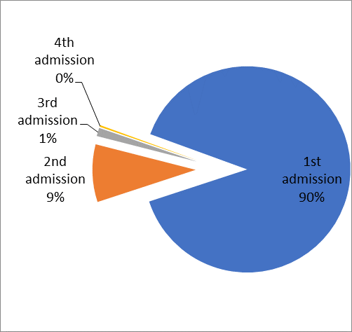

Table 2 details subject data regarding severity, average ASA score, comorbidities, and blood tests on admission. Figure 2 presents the distribution of ASA grades among the subjects. Most patients presented with mild disease (439 patients, 64.3%), and a minority suffered severe disease (39 patients, 5.7%). Most patients fell into ASA grades 2 and two (427, 62.5%), a few with grades 4 and 5 (23, 2.8%). The most prevalent comorbidity was diabetes mellitus (30.2%). Out of these, 50 patients (7.3%) underwent PC.

|  |  |  |
| --- | --- | --- |
| **Table 2**: Disease parameters, co-morbidities and laboratory values of study cohort | | |
| Disease severity | |  |
|  | Mild | 439 (64.3%) |
|  | Moderate | 205 (30.0%) |
|  | Severe | 39 (5.7%) |
| Average ASA score | | 2.12+0.87 |
| Co-morbidities | |  |
|  | Diabetes mellitus | 30.2% |
|  | Ischemic heart disease | 20.6% |
|  | COPD | 10.8% |
|  | Renal failure | 7.3% |
|  | Obesity | 7.3% |
|  | Biliary calculus | 4.8% |
|  | CVA | 1.6% |
|  | Cholecystostomy | 7.3% |
|  | Cholecystectomy* | 41.6% |
| Laboratory values | |  |
|  | Hemoglobin (g/dL) | 13.3+1.7 |
|  | WBC (cells per cmm3) | 12.7+4.8 |
|  | Creatinine (mg/dL) | 0.93+0.56 |
|  | Total bilirubin (mg/dL | 1.26+1.30 |
|  | ALP (IU/dL) | 110+101 |
|  | * -Number of patients undergoing elective cholecystectomy at the Wolfson Medical Center following admission. | |

**Figure 2:** Distribution of ASA score in study cohort

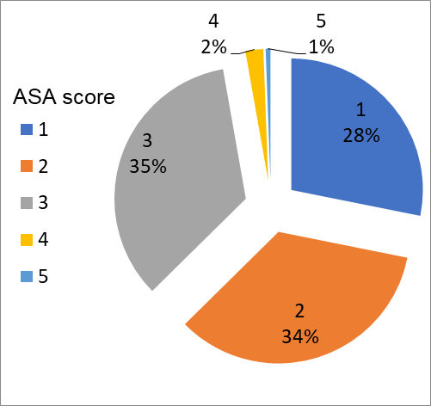

## Comparison of patients with and without cholecystostomy:

Subjects’ demographic data and comorbidities are presented in Table 3; laboratory data appears in Table 4. PC patients were older by about 15 years on average, the vast majority being over age 65. There was no significant difference in the presence of comorbidities except a higher prevalence of cerebrovascular disease (CVA) in PC patients (6.6% vs 1.1% in patients without PC).

|  |  |  |  |
| --- | --- | --- | --- |
| **Table 3**: Comparison of patient demographic data and co-morbidities across cholecystostomy status | | | |
|  | No  n=633 | Yes  n=50 | p Value |
| **Age (years)** | **60.8±19.2** | **76.0±12.4** | **<0.001** |
| **Age 65 and over (%)** | **46.4** | **84.0** | **<0.001** |
| Female sex (%) | 55.1 | 44.0 | 0.128 |
| Diabetes mellitus (%) | 29.5 | 36.7 | 0.414 |
| Renal failure (%) | 7.0 | 10.0 | 0.550 |
| Obesity (%) | 6.7 | 13.3 | 0.182 |
| IHD (%) | 19.3 | 33.3 | 0.071 |
| Biliary calculus (%) | 5.3 | 0 | 0.198 |
| **CVA** (%) | **1.1** | **6.7** | **0.019** |
| Cholangitis (%) | 0.7 | 0 | 0.645 |
| Cholecystectomy (%) | 41.4 | 44.0 | 0.719 |

A greater rate of laboratory test abnormalities was found in patients who underwent PC. These patients presented with hemoglobin levels lower by about 9.6 g/dL on average, higher percentage of patients with leukocytosis, and higher creatinine and urea levels. Likewise, they exhibited lower sodium levels and more abnormally low albumin levels. Additionally, patients who underwent cholecystostomy had higher ASA grades on average. Figure 3 displays the percentages of patients in each ASA class in patients treated with and without PC.

|  |  |  |  |
| --- | --- | --- | --- |
| **Table 4**: Comparison of patient laboratory data, in patients with and without cholecystostomy | | | |
|  | No  n=633 | Yes  n=50 | p Value |
| **Hemoglobin (g/dL)** | **13.3±1.6** | **12.7±1.5** | **0.010** |
| **WBC (per cmm3)** | **12.5±4.6** | **14.8±5.7** | **0.001** |
| Platelets (per cmm3) | 245±80 | 248±92 | 0.832 |
| **Creatinine (mg/dL)** | **0.9±0.5** | **1.0±0.4** | **0.033** |
| **UREA (mg/dL)** | **36.7±21.1** | **48.1±24.8** | **0.003** |
| **Sodium (meq/L)** | **137±3.2** | **135±3.9** | **<0.001** |
| **Albumin (g/dL)** | **3.4±0.5** | **3.1±0.7** | **0.005** |
| LDH (IU/dL) | 447±231 | 418±156 | 0.441 |
| Total bilirubin (mg/dL) | 1.2±1.3 | 1.2±0.9 | 0.943 |
| ALP (IU/dL) | 109±99 | 120±126 | 0.472 |

**Figure 3:** Distribution of ASA score and cholecystostomy

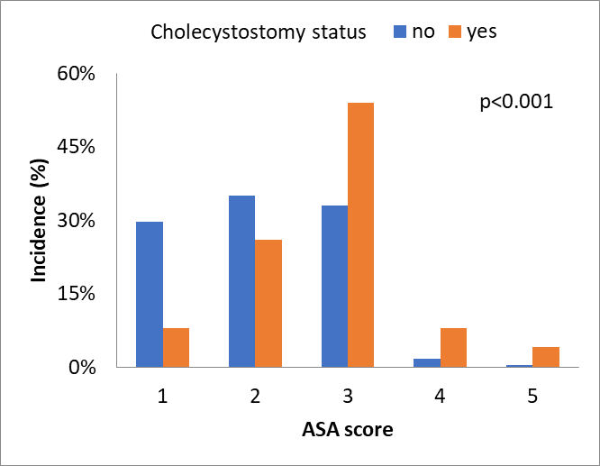

Figure 4 shows severity of disease with regard to PC treatment. Patients who were treated with this procedure had more severe disease than those who were not.

**Figure 4:** Disease severity and cholecystostomy

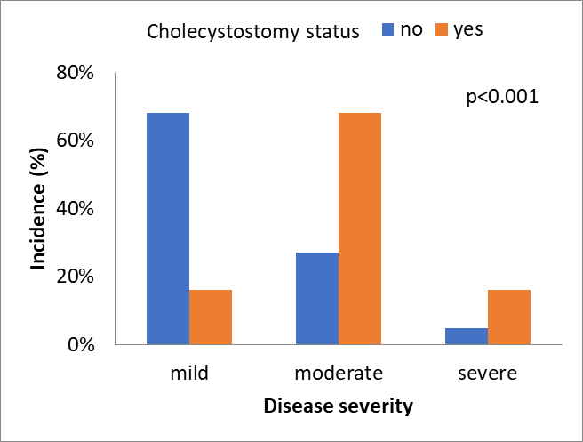

Prognosis was worse in patients in the PC group. Hospital stay was on average 12.8±9.7 days, vs 6.5±7.0 days in non-PC group, p<0.001). There were no differences in number of recurrent hospitalizations within a year in patients with and without PC, or in total hospital stay duration over the year following initial admission. 30-day mortality rates were 10%, vs 0.9% in patients without PC (p<0.001). At one year, mortality in PC patients was 20%, and 4.9% in the control group (p<0.001).

Among PC patients, those with ASA grades 3-5 were hospitalized longer than those with ASA grades 1-2. (Figure 5). Similarly, there was an increase in mortality at 30 days and at one year among the ASA groups (Figure 6), though this did not reach statistical significance.

**Figure 5:** Length of hospital stay among cholecystostomy patients according to ASA groups (1-2 vs. 3-5).

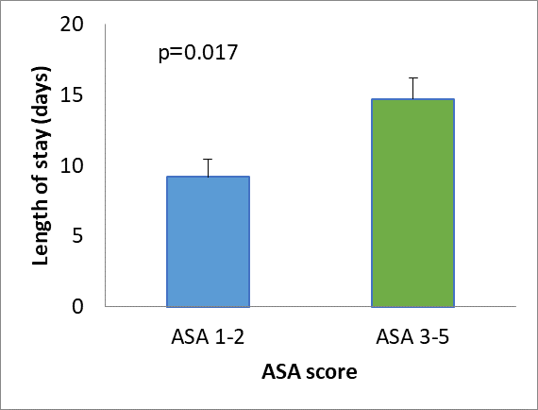

**Figure 6:** 30-day and 1-year mortality rates among cholecystostomy patients according to ASA groups (1-2 vs. 3-5).

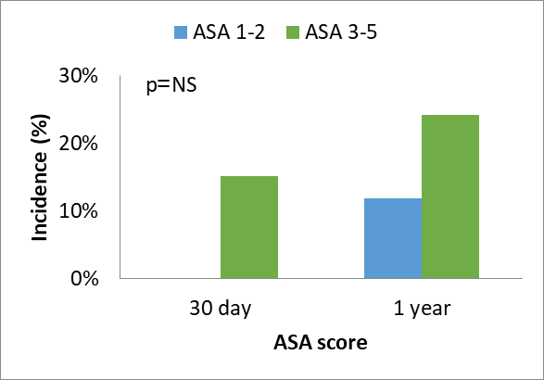

## Effect of PC in patients over age 65 years

Considering that most patients undergoing cholecystostomy were over age 65, we further analyzed these patients separately. Of note, analysis of patients under age 65 (data not presented here), revealed that cholecystostomy patients were on average 11 years older than those who were not treated with cholecystostomy (45.9+12.6 years vs 57.0+9.2, p=0.014), and there was significant disparity in sex of patients and comorbidities such as ischemic heart disease. Therefore, we did not further analyze data of patients under 65 years separately.

In patients age 5 and older, PC and control groups were comparable with regard to demographic data. There were somewhat increased rates of comorbid CVA in the PC patients, approaching statistical significance. Additionally, ASA score of PC patients was significant higher (mean ASA and distribution). This data is presented in Table 5 and Figure 5.

|  |  |  |  |
| --- | --- | --- | --- |
| **Table 5**: Comparison of patient data across cholecystostomy placement status | | | |
|  | No  n=294 | Yes  n=42 | p Value |
| Age (years) | 78.2±7.6 | 79.7±9.3 | 0.254 |
| Female sex (%) | 50.3 | 45.2 | 0.536 |
| **Mean ASA score** | **2.1±0.9** | **2.7±0.9** | **<0.001** |
| Diabetes mellitus (%) | 33.3 | 38.5 | 0.605 |
| Renal failure (%) | 9.3 | 11.5 | 0.715 |
| Obesity (%) | 2.7 | 15.4 | 0.003 |
| IHD (%) | 24.0 | 34.6 | 0.246 |
| CVA (%) | 1.6 | 7.7 | 0.059 |
| Cholangitis (%) | 1.6 | 3.8 | 0.406 |

Presented in Table 6 is a comparison of laboratory tests in PC and control patients over age 65. Results were similar in both groups

|  |  |  |  |
| --- | --- | --- | --- |
| **Table 6**: Comparison of admission laboratory data in PC and no PC groups | | | |
|  | No  n=294 | Yes  n=42 | p-value |
| Hemoglobin (g/dL) | 13.0±1.8 | 12.6±1.6 | 0.122 |
| WBC (per cmm3) | 13.4±5.2 | 14.6±6.1 | 0.164 |
| Platelets (per cmm3) | 236±89 | 231±85 | 0.745 |
| Creatinine (mg/dL) | 1.0±0.5 | 1.1±0.5 | 0.237 |
| UREA (mg/dL) | 46.2±24.8 | 52.0±25.0 | 0.159 |
| Sodium (meq/L) | 136±4 | 135±4 | 0.097 |
| Albumin (g/dL) | 3.3±0.6 | 3.2±0.8 | 0.409 |
| Total bilirubin (mg/dL) | 1.4±1.2 | 1.3±1.1 | 0.516 |
| ALP (IU/dL) | 123±110 | 116±113 | 0.718 |
| LDH (IU/dL) | 465±240 | 415±163 | 0.240 |

Distribution of ASA scores and disease severity in patients are presented in Figure 7 and Figure 8, respectively. ASA score and disease severity were higher in PC patients.

**Figure 7:** Distribution of ASA score among patients over 65 across cholecystostomy status groups

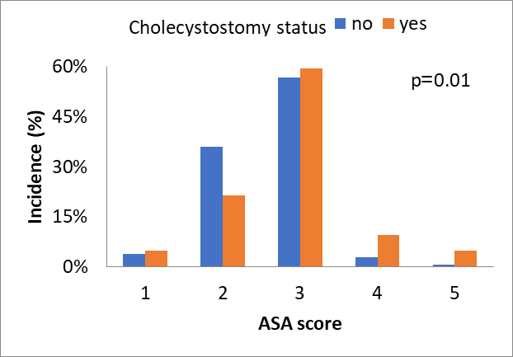

**Figure 8**: Disease severity of patients over 65 across cholecystostomy status groups

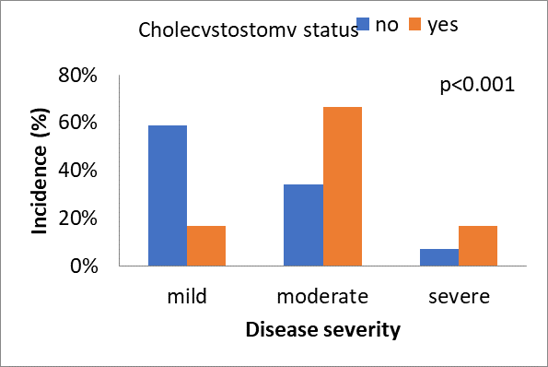

Analysis of PC in AC patients over age 65 revealed that longer hospital stays and higher mortality at 30 days and one year, like in the larger sample. There was no difference in recurrent hospitalization rates within a year after AC (Table 7).

|  |  |  |  |
| --- | --- | --- | --- |
| **Table 7**: Prognosis of patients across cholecystostomy placement status | | | |
|  | No  n=294 | Yes  n=42 | p Value |
| Hospital duration (days) | 8.1±9.2 | 13.5±10.4 | 0.002 |
| 1-year rate of admissions (%) | 15.0 | 14.3 | 0.908 |
| 30-day mortality (%) | 1.7 | 11.9 | <0.001 |
| 1-year mortality (%) | 9.9 | 23.8 | 0.008 |

Effect of cholecystostomy in patients over age 65 with AC was analyzed using logistic regression, with 30-day mortality as the dependent variable. Independent variables included age of patients, sex, ASA grade, disease severity, serum creatinine levels at admission and cholecystostomy procedure. Higher mortality was correlated with higher serum creatinine levels (OR 4.899, 95% confidence interval 1.447-16.580, p=0.011) and older age (OR 1.125, 95% confidence interval 1.001-1.264, p=0.048), and inversely correlated with female sex (OR 0.041, 95% confidence interval 0.002-0.764, p=0.032). Cholecystostomy patients trended towards higher 30-day mortality (OR 5.431, 95% confidence interval 0.885-33.338, p=0.068). There was no significant correlation between disease severity at admission and subsequent mortality. This model correctly predicted 97.3% of cases.

An additional model was constructed to analyze factors affecting mortality at one year from hospitalization. The model was constructed identically to the previous except the outcome variable which was set as mortality at 1 year (vs 30 days). Initial creatinine levels (OR 4.284, 95% confidence interval 2.189-8.383, p<0.001) and patient age (OR 1.073, 95% confidence interval 1.019-1.129, p=0.007) were associated with increased mortality at 30 days. PC was again associated with a statistically insignificant increase in mortality at on year (OR 2.448, 95% confidence interval 0.916-6.540, p=0.074), whereas ASA, disease severity, and sex, had no correlation with mortality. This model was correctly predicted of 90.1% of all (outcome)? events and 17.9% of mortality events.

Finally, we constructed a Cox model to describe patient survival throughout the full 6-year follow-up period. Like in the logistic regression models, the dependent variable was death within 6 years follow-up, and independent variables included age, sex, severity of disease, ASA scores, initial serum creatinine levels, comorbid obesity, and cholecystostomy procedure. We found increased mortality associated with initial creatinine levels (OR 2.316, 95% confidence interval 1.563-3.430, p<0.001), comorbid obesity (OR 4.063, 95% confidence interval 1.748-9.448, p=0.001), and age of patients (OR 1.101, 95% confidence interval 1.067-1.136, p<0.001). PC was associated with a statistically insignificant increase in mortality during follow-up (OR 1.861 95% confidence interval 0.951-3.648, p=0.070). Measure of ASA, disease severity, and patient sex were not associated with mortality. Graph 9 depicts the Cox analysis for cholecystostomy status and survival.

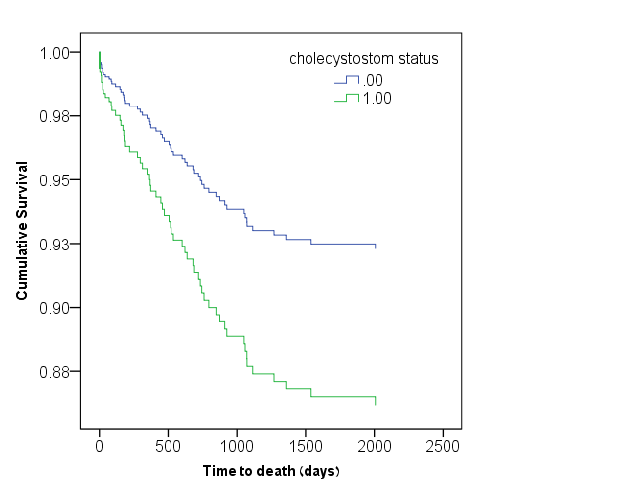

**Figure 9:** Cox regression analysis for 4-year survival rate according to cholecystostomy status

# Discussion

The significance and necessity of percutaneous cholecystostomy is under debate in the literature12. Our study revealed an association between PC and longer hospital stays, as well as higher 30-day and one-year mortality. Length of hospital stay in PC patients was longer by about 50% than the controls. This finding has been previously described in the literature13, and may be explained by two factors: one is the fact that procedures require longer post-procedure treatment and follow-up, leading to the longer hospital stays. A second possibility is that PC was performed only after patients were deemed unresponsive to antibiotic therapy, and not right after initial admission. This logically led to longer hospital stays when including the time waiting for clinical response to conservative treatment. It is important to observe that in our study, similar to other studies published, patients who underwent cholecystostomy were on average more severely ill, whether measured by ASA score, clinical status, or abnormal laboratory tests. Therefore, it is hard to deduce the actual effect of the cholecystostomy drainage procedure on hospital stay, a challenge that our study cannot resolve.

Additionally, we found that in the PC group, 30-day mortality versus the control group was 10 times greater across all age groups, and 8 times greater in patients older than 65 years. 1-year mortality was 5 times greater in all PC patients and 2.5 times greater in those older than 65 years, compared to patients without cholecystostomy. Multi-variate analysis revealed that serum creatinine levels at admission, age, and ASA score, were the highest predictors of mortality at 30 days and one year from initial cholecystitis, while PC status itself exhibited only insignificant associations with these measures. This may be due to the study sample size, since only 50 patients were treated with cholecystostomy during the 6-year study period, limiting the ability to reach statistically significant conclusions.

Creatinine level of patients at admission was found to be an independent predictor of mortality, independent of ASA score and patient age. A study by Hsieh also reported an association between creatinine and mortality during hospitalization13. Creatinine levels may indicate multiple organ system injury resulting from the infectious disease process, although interestingly, creatinine levels were inversely correlated with prognosis even within the normal reference ranges. There is a possibility that minor kidney injury may be related to the body’s ability to deal with infections, a topic which may be clarified by larger studies. Curiously, disease severity at admission was not correlated with prognosis throughout hospitalization, and in multi-variate analysis did not seem to have significant effects. Oמ the other hand, tests of kidney function had significant implications on prognosis in these patients during hospital stay.

Data from our study revealed a number of cases of cholecystostomy drainage in patients with mild disease and low ASA scores. Analysis showed that patients exhibited longer hospital stays even in patients with low ASA scores. On one hand, cholecystostomy insertion is generally intended for use specifically in patients with severe disease; however, though they may have been classified as “low severity patients”, their lack of improvement with conservative measures may have been the driving factor in the decision to treat with percutaneous drainage. Even after cholecystostomy ASA score had a profound effect on duration of hospital stay and possibly on 30-day mortality. Therefore, it is unclear whether cholecystostomy is beneficial in patients defined as “mild” at admission but unresponsive to conservative treatment.

In our study, we found that elective cholecystectomy after discharge was performed in less than 50% of patients; interestingly, there was no difference in rates between patients cholecystostomy group and the control group. These results are similar to those found in other studies14. There are a few explanations for this: one, patients may have chosen not to return for elective cholecystectomy; alternatively, patients may have undergone cholecystectomy in a different medical center, from which data could not be collected. It is a reasonable possibility that in fact patients underwent cholecystectomy in other hospitals, or perhaps through private insurance/funding____, leading to a misleadingly low rate of cholecystectomy in our sample. Since less than half of patients underwent the surgery at this hospital, we decided not to examine surgery duration and complications for this small sample size.

## Study limitations

As with any retrospective study, the possibility of selection bias is always present, and very difficult to accurately measure. Additionally, our sample size was relatively small, which may reduce the accuracy of our regression models – larger samples may better estimate the effect size and statistical significance of the intervention’s effect on prognosis. These difficulties may be remedied with a large-sample, prospective, randomized trial of the effects of the colostomy procedure.

# Conclusions

In our study, we found that percutaneous cholecystostomy and drainage for acute cholecystitis patients is associated with worse prognosis, longer hospitalization times, and increased 30-day and one-year mortality. Additionally, higher age and ASA score were associated with multiple measures of adverse outcomes in acute cholecystitis patients.

# References

1. http://emedicine.medscape.com/article/171886-overview#a0156 Accessed on 06.05.2015
2. Katz DS, Rosen MP, Blake MA, et al; and Expert Panel on Gastrointestinal Imaging. ACR Appropriateness Criteria® right upper quadrant pain. Reston (VA): American College of Radiology (ACR); 2010:
3. Takada T, Strasberg SM, Solomkin JS, et al. Tokyo Guidelines Revision Committee. TG13: Updated Tokyo Guidelines for the management of acute cholangitis and cholecystitis. J Hepatobiliary Pancreat Sci. 2013 ;20(1):1-7.
4. Lo CM, Liu CL, Fan ST, et al. Prospective randomized study of early versus delayed laparoscopic cholecystectomy for acute cholecystitis. Ann Surg. Apr 1998;227(4):461-7.
5. Cox MR, Wilson TG, Luck AJ, et al. Laparoscopic cholecystectomy for acute inflammation of the gallbladder. Ann Surg. Nov 1993;218(5):630-4.
6. Siddiqui T, MacDonald A, Chong PS, et al. Early versus delayed laparoscopic cholecystectomy for acute cholecystitis: a meta-analysis of randomized clinical trials. Am J Surg. Jan 2008;195(1):40-7.
7. Silberfein EJ, Zhou W, Kougias P, et al. Percutaneous cholecystostomy for acute cholecystitis in high-risk patients: experience of a surgeon-initiated interventional program. Am J Surg. Nov 2007;194(5):672-7.
8. Overby DW, Apelgren KN, Richardson W, Fanelli R. SAGES guidelines for the clinical application of laparoscopic biliary tract surgery. Surg Endosc. Oct 2010;24(10):2368-86. [Guideline]
9. Viste A, Jensen D, Angelsen J, Hoem D. Percutaneous cholecystostomy in acute cholecystitis; a retrospective analysis of a large series of 104 patients. BMC Surg. 2015 Mar 8;15(1):17.
10. Rahnemai-Azar AA, Rahnemaiazar AA, Naghshizadian R, Cohen JH, Naghshizadian I, Gilchrist BF, Farkas DT. Minimally invasive management of biliary tract injury following percutaneous nephrolithotomy. Nephrourol Mon. 2014 Sep 5;6(5):e19943
11. Kamalapurkar D, Pang TC, Siriwardhane M, Hollands M, Johnston E, Pleass H, Richardson A, Lam VW. Index cholecystectomy in grade II and III acute calculous cholecystitis is feasible and safe. ANZ J Surg. 2015 Feb 2.
12. Wang CH, Wu CY, Yang JC, Lien WC, Wang HP, Liu KL, Wu YM, Chen SC. Long-Term Outcomes of Patients with Acute Cholecystitis after Successful Percutaneous Cholecystostomy Treatment and the Risk Factors for Recurrence: A Decade Experience at a Single Center. PLoS One. 2016 Jan 28;11(1): Epub ahead of print
13. Hsieh YC, Chen CK, Su CW, Chan CC, Huo TI, Liu CJ, Fang WL, Lee KC, Lin HC. Outcome after percutaneous cholecystostomy for acute cholecystitis: a single-center experience. J Gastrointest Surg. 2012 Oct;16(10):1860-8.
14. Popowicz A, Lundell L, Gerber P, Gustafsson U, Pieniowski E, Sinabulya H, Sjödahl K, Tsekrekos A, Sandblom G. Cholecystostomy as Bridge to Surgery and as Definitive Treatment or Acute Cholecystectomy in Patients with Acute Cholecystitis. Gastroenterol Res Pract. 2016; Epub 2015 Dec 29.