**A Waveguide Imaging Method Based on Reflective Periscope Design**

**1. Scientific background**

Periscope imaging is one of the methods used in the imaging of objects that are not in the line of sight. The simplest periscope is composed of two reflective surfaces rotated 45° in relation to both the observed object and the viewer's eye, as in Figure 1.

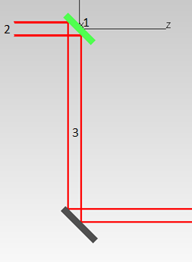

**Figure** **1:** Basic periscopeschematic

The first documented periscope was invented in the fifteenth century to watch over the heads of people in a crowd. In the nineteenth century, the periscope began to be used also for military purposes, which subsequently gained tremendous momentum during World Wars I and II. The rapid progress of camera and wireless transmission soon made the use of such elements negligible. However, the use of such periscopes as secondary viewing systems is still important in some areas where viewing in electrically non-stable environments is necessary. Moreover, conducting natural ambient light to closed places, rooms, and working environments has become attractive, both from mental health considerations and from the standpoint of green energy harvesting. It has been found that fluorescent light or any other artificial light source can reduce the mental and cognitive effectiveness of workers, and, in some cases, can result in depression. The major drawback of the conservative periscope design is that it is very bulky. It requires a space equal to the sighting window and 45 degrees for each curvature to bring light or imaging from outside. In our research, we utilize waveguides to reduce the thickness of the transferring element while preserving the image at the output.

To describe the operation of the new periscope design, we examine the old concept by defining the following, as shown in Figure 1:

periscope axis (1); the horizontal line that exits from the center of the upper mirror

sighting window (2); the aperture through which the light enters the periscope

periscope tube (3); the periscope body, in which the rays propagate after refracting

The above structure has two major drawbacks:

The tube diameter must be at least the size of the incoming beam diameter, which makes the periscope a large and cumbersome tool.

As the length of the tube (Z axis) increases in relation to the length and width (Plane XY) of the entry window, the angle in relation to the periscope axis in which the object is observed becomes smaller, because the rays are reflected from the walls of the tube.

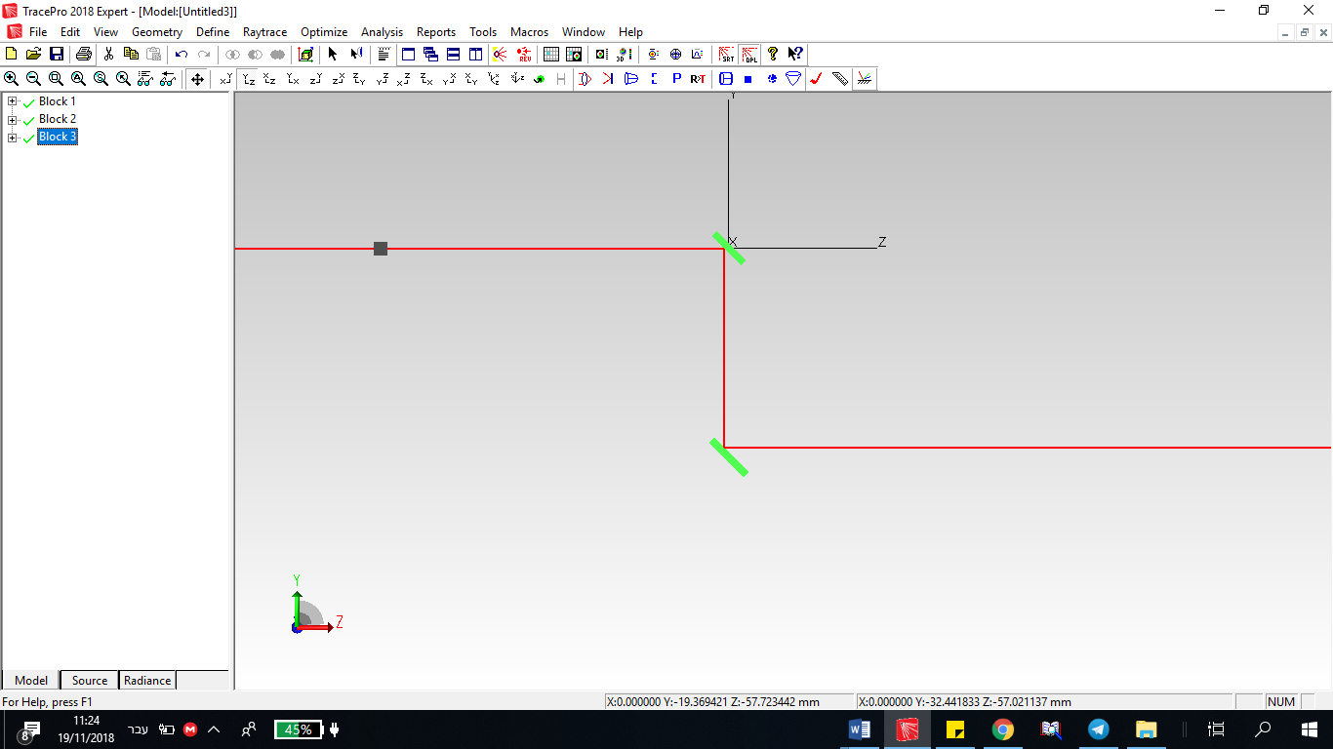 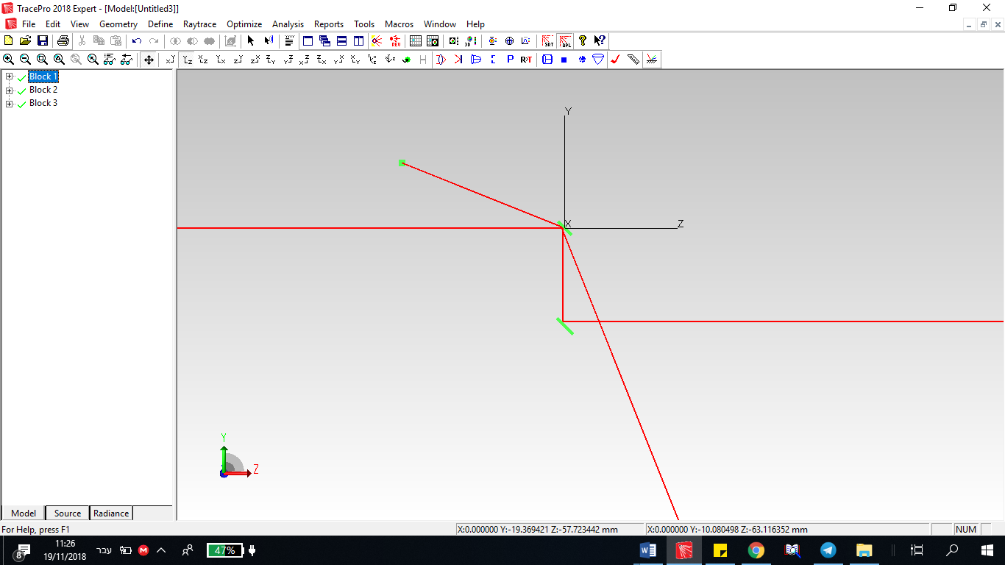

(a) (b)

**Figure 2:** (a) Object on periscope axis (b) Object outside the periscope axis

In modern periscopes, such as the one demonstrated in Figure 3, a telescope and a field lens increase the field of view of the periscope. That increases the system size, adds geometric distortions, and creates constraints on the length of the system and the tube diameter of the periscope**.**

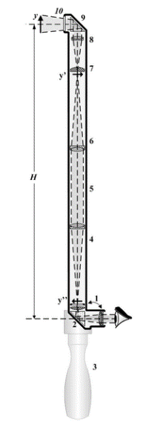

**Figure** **3:** Modern periscope

In this paper, the authors will demonstrate a new development based on the reflective walls of the periscope. The reflective walls allow the light to propagate along the periscope in additional routes rather than in the direct downward path.

That suggested approach allows us to:

use a mirror positioned at an angle different from 45 degrees in relation to the periscope axis,

significantly reduce the periscope dimensions, and

convey the image of an object located far above the viewer or slightly below the optical axis of the periscope.

**2. Various models of the reflective periscope**

The following paragraphs will review the four different models suggested for the new periscope design:

1. the basic model, a mirror tube

2. the basic model with a prism supplement added at the end of the periscope

3. spherical mirrors added at the entrance and exit of the periscope

4. a periscope tube based on a total internal reflection

***2.1 Model 1, basic reflection periscope***

The most basic development is a periscope in which the upper mirror is tilted at an angle greater than 45 degrees with respect to the periscope's axis. The periscope consists of a rectangular tube, in which mirrors serve as front and back walls and the side walls do not reflect light. At the lower edge of the periscope, there is another mirror, parallel to the upper mirror. In this structure, except at the periscope entrance and exit, the periscope thickness can be reduced significantly, as shown in Figures 4 and 5.

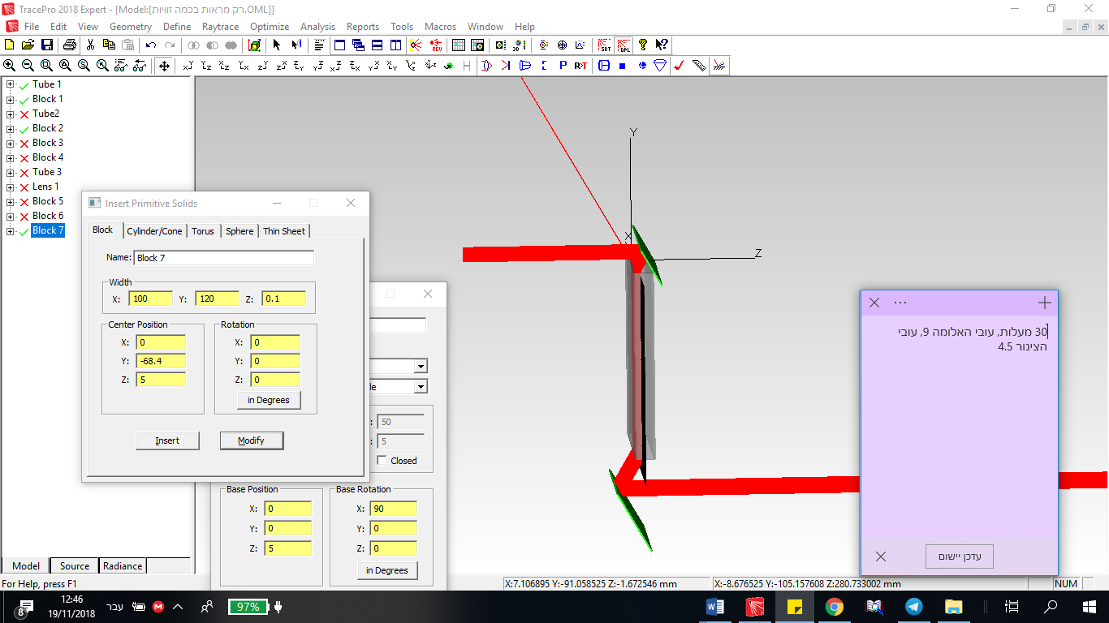

**Figure** **4:** With mirrors tilted at 60 degrees, a beam is delivered in a tube that is half the diameter of the original beam.

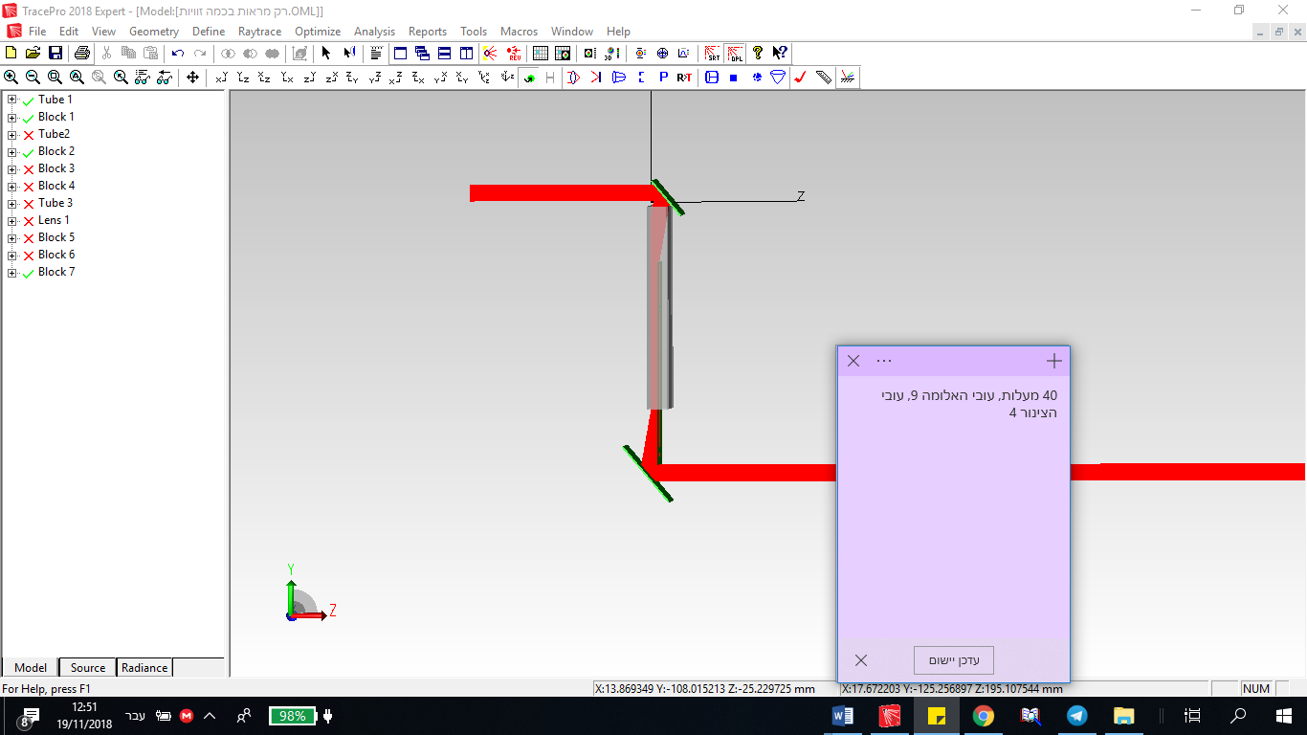

**Figure 5:** With mirrors tilted in 50 degrees, a beam is transmitted by a tube that is 44% of the original beam diameter.

Figures 6 through 8 demonstrate an additional advantage of the system. Objects that are far above the periscope axis may also be imaged by this periscope (Figure 6). (The red line depicts a ray propagating from the object through the periscope.) In figures 7 and 8, one can see rays of light entering at different angles and the way they exit the periscope.

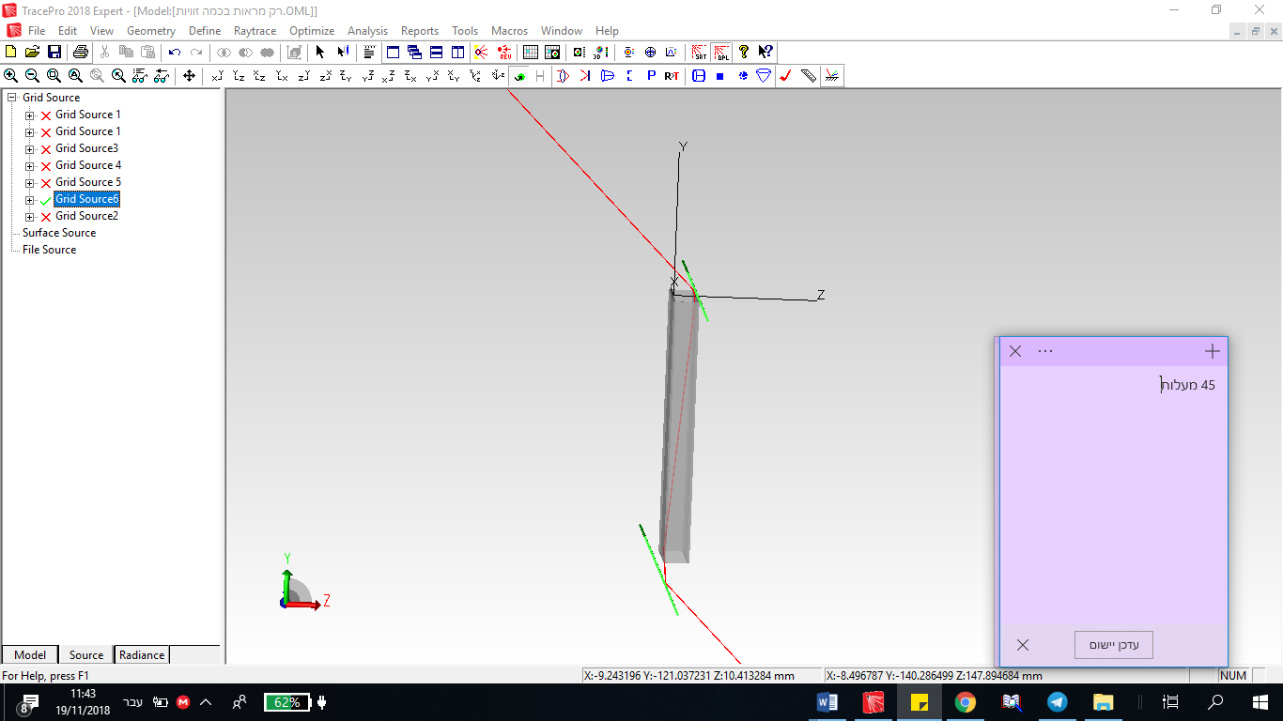.

**Figure** **6:** An object that is at 45 degrees in relation to the optical axis exits the periscope at the angle at which it enters.

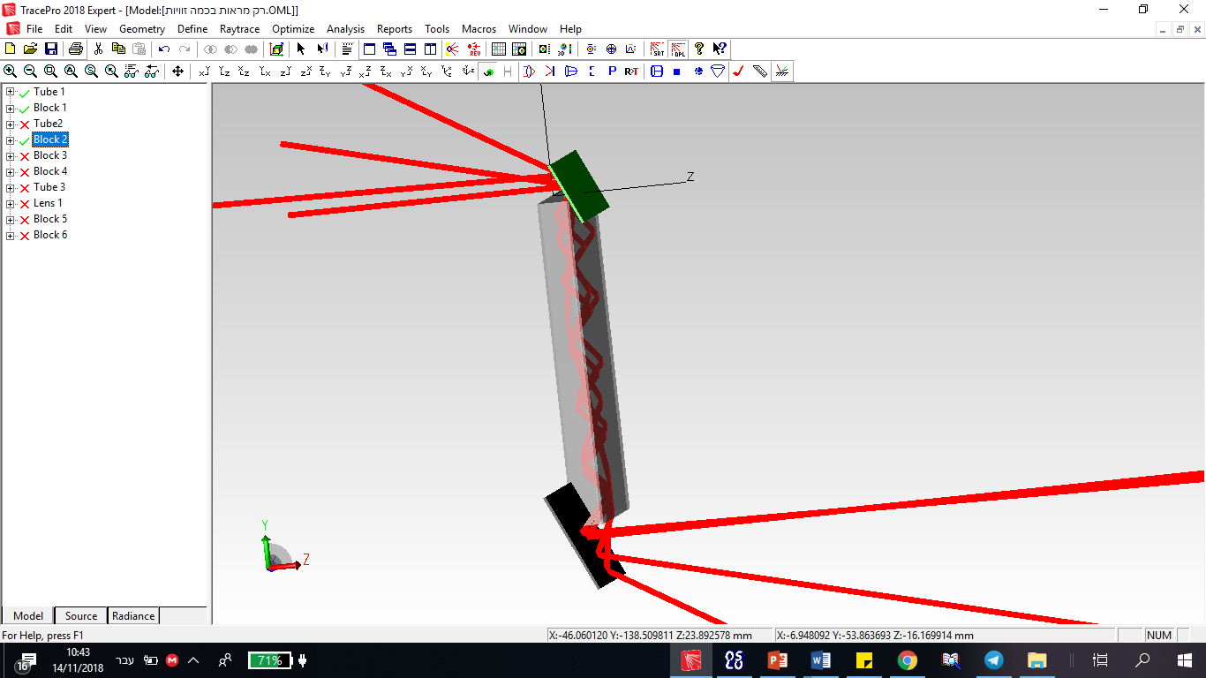

**Figure** **7:** Objects at different angles and how they exit from the periscope

Despite the great advantages of this system, there are some structural problems that require attention:

In the horizontal plane, rays from only a small range of angles can pass through the periscope (depending on the relationship between the periscope’s length and width).

A major disadvantage of this system is the need for relatively large structures at the entrance and exit of the periscope. (The wall opposite the tilting mirror should be at such a distance that a ray hitting the top of the mirror will be reflected to the wall and not above it).

Another problem to consider is a geometrical problem; in a long periscope, there will be a large gap along the periscope between rays at different angles. That may result in some rays not hitting the lower mirror at all or in rays hitting it at the opposite angle with respect to the vertical axis.

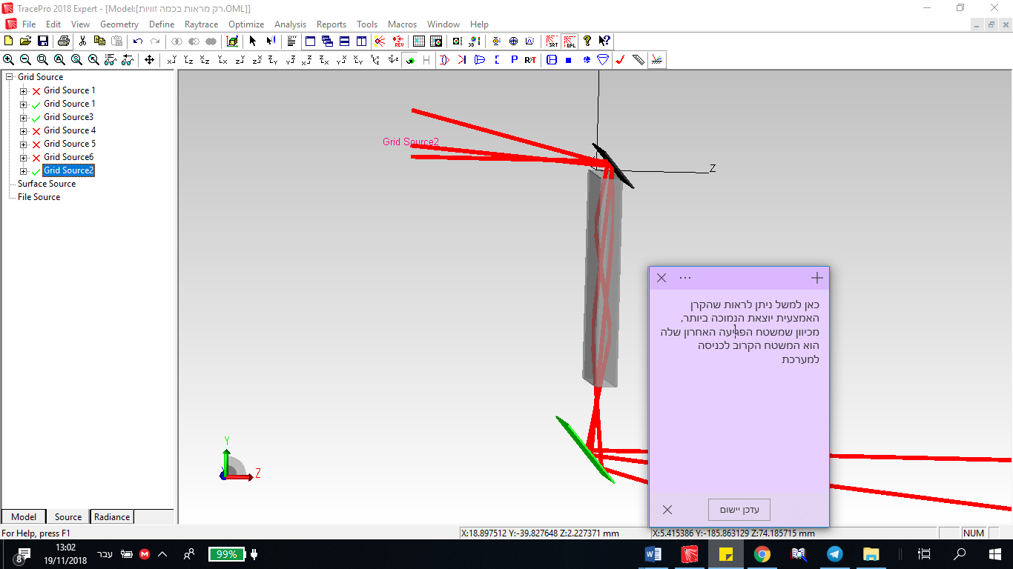

**Figure** **8:** Objects at different angles and how they exit from the periscope

Those problems could possibly be solved by adding a prism at the lower end of the periscope (to be referred to later as Model 2). Below are potential applications and suggested models.

*2.1.1 Transparent sealed materials*

Figure 9 shows that it is possible to create curves along the paths of the rays that can have significance in different applications of the periscope. In the setup shown in Figure 9, the object looks transparent.

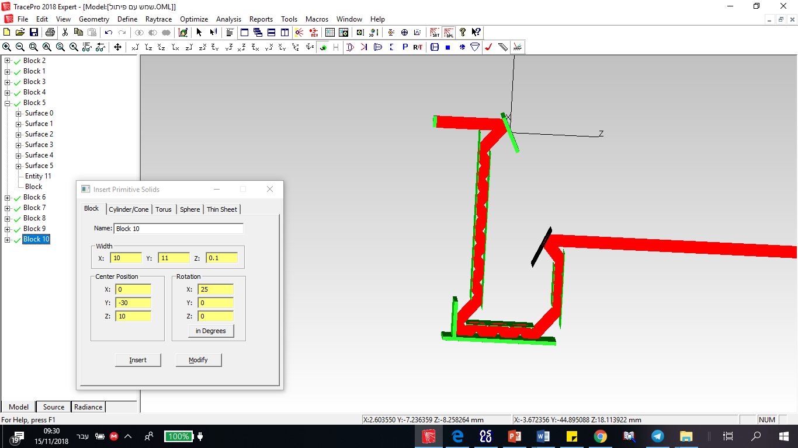

**Figure** **9:** Transparent basic model plus the curve

*2.1.2 Transferring daylight into a room without windows*

Another important application that can be improved with the model we built is the transfer of daylight into a room without a window or adding it to a room and enhancing the light quality, as seen in Figure 10. Although that can also be done by using a standard periscope, our model is much more suitable, due both to the fact it can deliver the actual image as in a real window and to the large range of angles of light collected. Because there is no need for lenses, the cost of the periscope is reduced. In such a system, where precise imaging of a specific object is not required, mirrors can be added to the sides of the periscope, thereby allowing the propagation of a large range of incoming angles through the periscope and by that reducing its width.

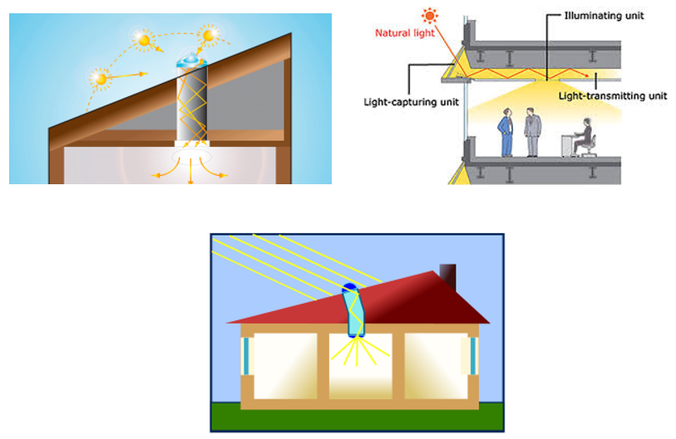

**Figure** **10:** Periscope glass tube transmitting sunlight into buildings without imaging

***2.2 Model 2, reflection periscope, prism addition***

In this model, the authors added a prism (or beam splitter) to the original model, placed at the lower end. That causes rays with large incoming angles to reflect and hit the bottom mirror again, so that all the rays exit the periscope at the same angle at which they entered. This model is built on the principle of total internal reflection from the prism walls. This principle and the conditions for its existence are elaborated in following models.

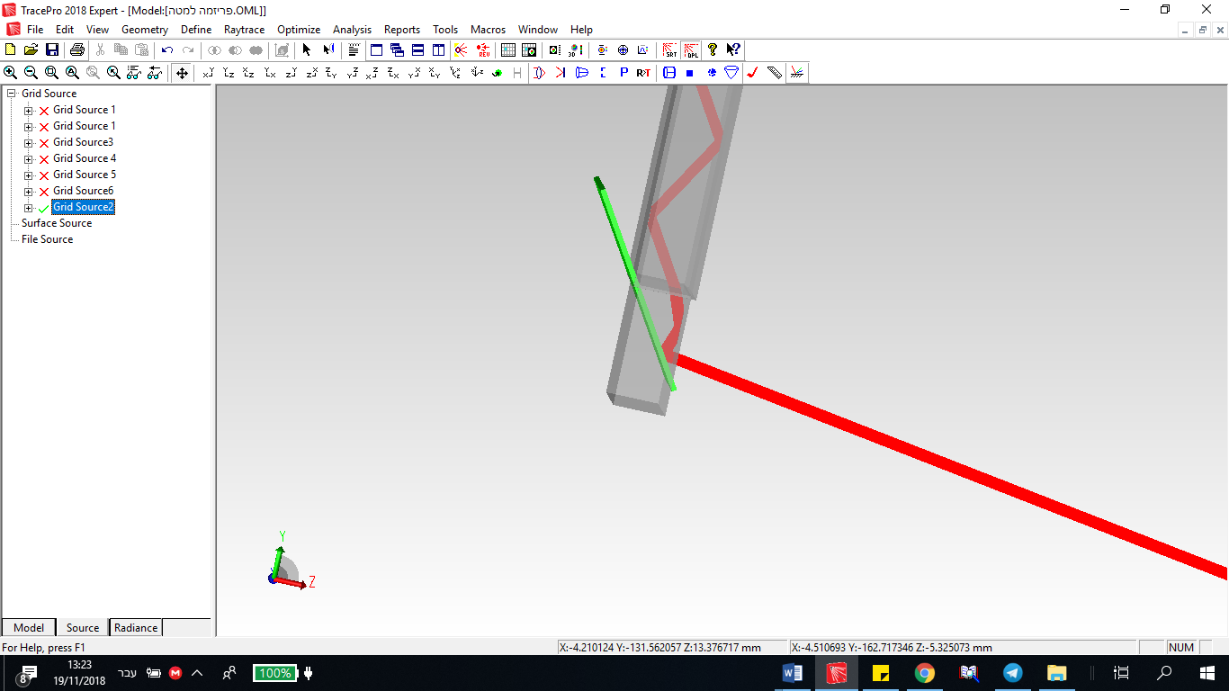

**Figure** **11:** Advantage of adding a prism to the periscope’s end

***2.3 Model 3, reflection periscope, spherical or cylindrical mirrors***

In this model, the upper mirror or the two mirrors, upper and lower, are spherical mirrors. Several benefits may be gained as functions of the curvature of the mirror/mirrors:

the ability to focus the image on a screen without the need for a lens add-on (Figures 12 and 13)

expansion or narrowing of the laser beam (Figure 14)

reducing the beam so that the periscope tube can be further reduced in both depth and width (Figure 14)

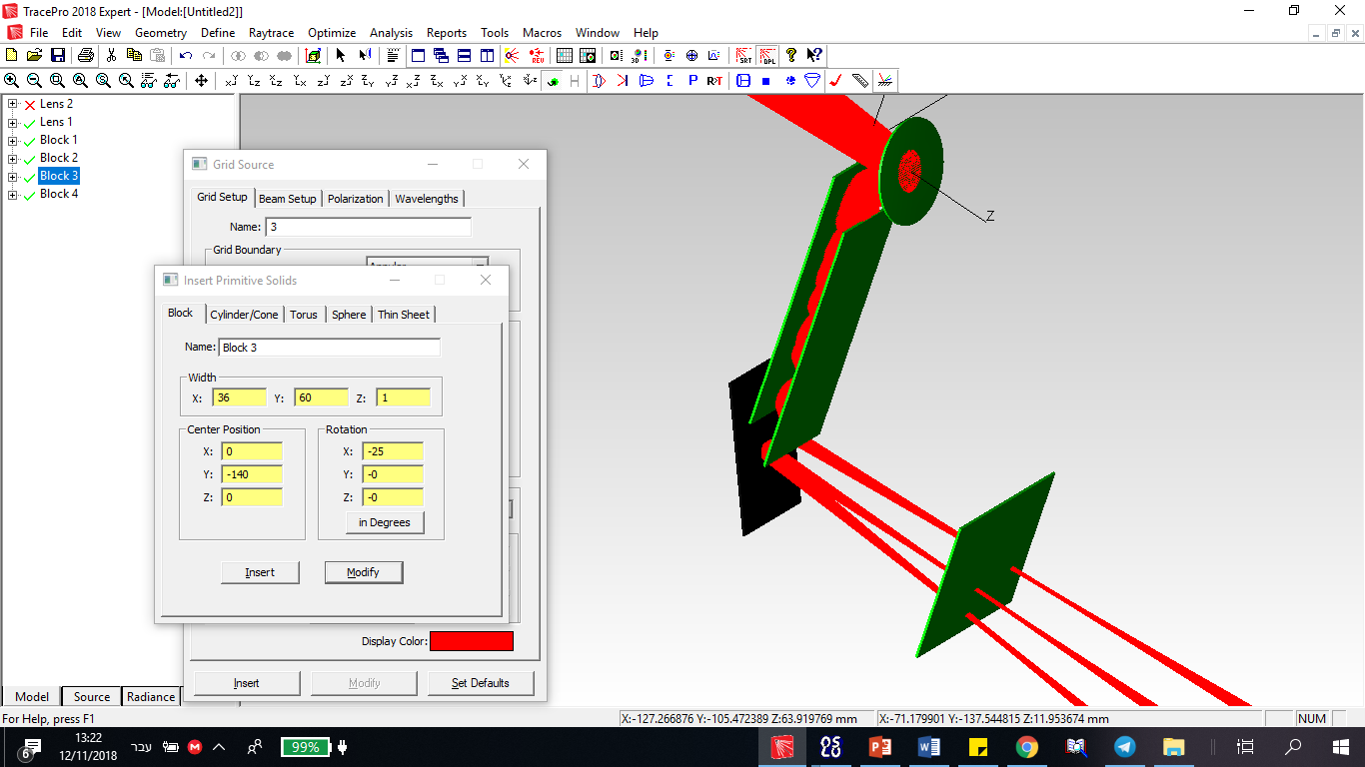

**Figure** **12:** Focusing the image on a screen with a single spherical mirror

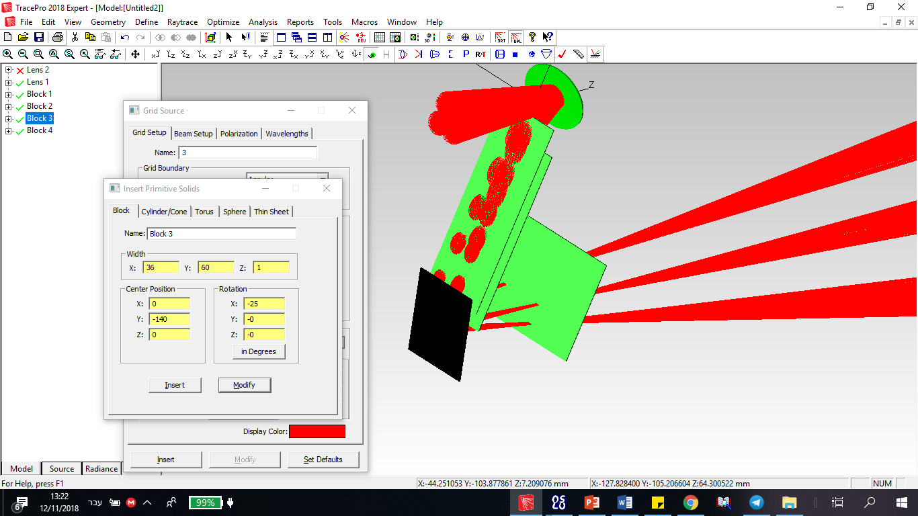

**Figure** **13:** Focusing the image on the screen with a single spherical mirror

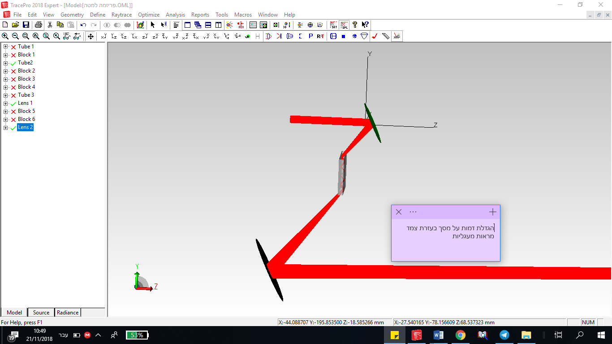

**Figure** **14:** Expansion of the beam with two spherical mirrors

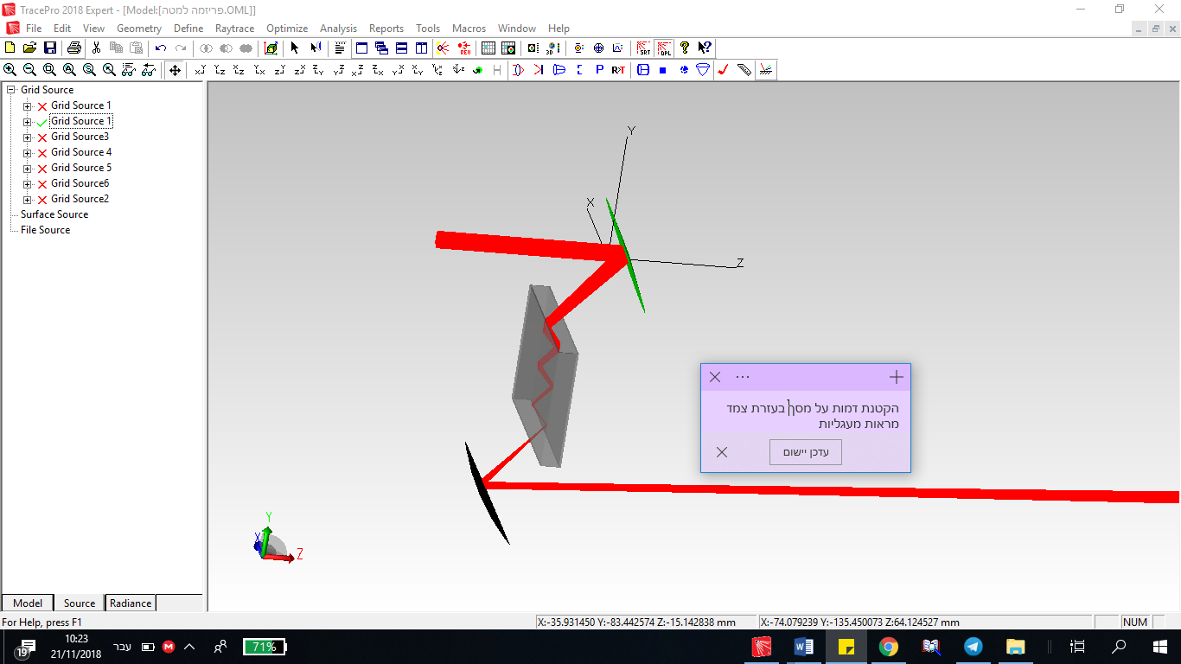

**Figure** **15:** Narrowing the beam with two spherical mirrors

***2.4 Model 4, reflection periscope, transparent material***

In this model, the periscope tube is not filled with air but with a transparent material with a higher refractive index. The principle of this model is based on the total internal reflection principle of Snell's law:

$$n_{1}\sin{θ_{1}}=n_{2}\sin{θ_{2}}$$

According to this principle, in the transition from a high refractive index medium to a low refractive index medium, there is a critical angle in which the ray will not penetrate the lower-indexed medium but would instead be reflected (as in a mirror) to the medium of the higher refractive index. The critical angle is found by placing a 90° angle at the exit angle. To simplify the calculation, suppose that the low refractive element is air. We accept that:

$$θ_{c}=\sin^{-1}{(\frac{1}{n_{1}})}$$

One can determine, for example, that for a refractive index of 1.5, total internal reflection requires an incident angle of 41.81 degrees. The mirror can be tilted up to 69.1 degrees (45 + 41.81÷2) above the periscope axis to enable causing the incoming parallel rays to be reflected within the periscope, (attach a ray diagram). Increasing the refractive index will result in an increase of the range of angles in which the mirror can be tilted.

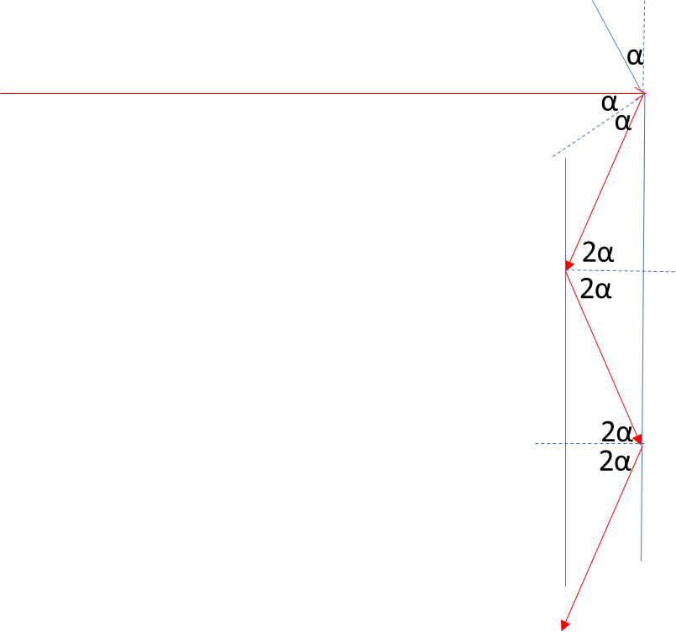

**Figure 16:** Ray diagram with incident and reflected angles

There are several advantages to this model, including:

The mirror-reflected rays can hit the periscope's entrance apperture, yet stay inside the periscope and allow a much narrower structure for the periscope. That comes in addition to the advantages mentioned above for Model 2 at the output of the periscope.

This model enables the incoming rays to have larger angles on the horizontal plane that can propagate through the periscope, because, according to Snell's law, the beam within the periscope propagates at a lower horizontal angle.

**3. The mirror tilting angle as a function of the refraction index**

At this point, we calculate the length-to-width ratio allowed in the basic model.

We examine an incident ray of light that has a vertical angle of zero with respect to the optical axis and a five-degree horizontal angle. The top mirror is tilted at an angle of 65 degrees with respect to the axis. The light hits the right side of the entrance aperture.

The angle of the ray in the vertical axis after hitting the mirror is 50 degrees ((90 - 65) + (90 - 65) = 50). We expect the length of the tube to be 8.79 times greater than its width (sin 50/sin 5).

On the other hand, if the ray passes through glass with a refractive index of 1.8, according to Snell's law, the new angle in which the ray propagates will be 2.77 degrees. That allows the length of the periscope to be 15.85 (sin 50/sin 2.77) times greater than its width.

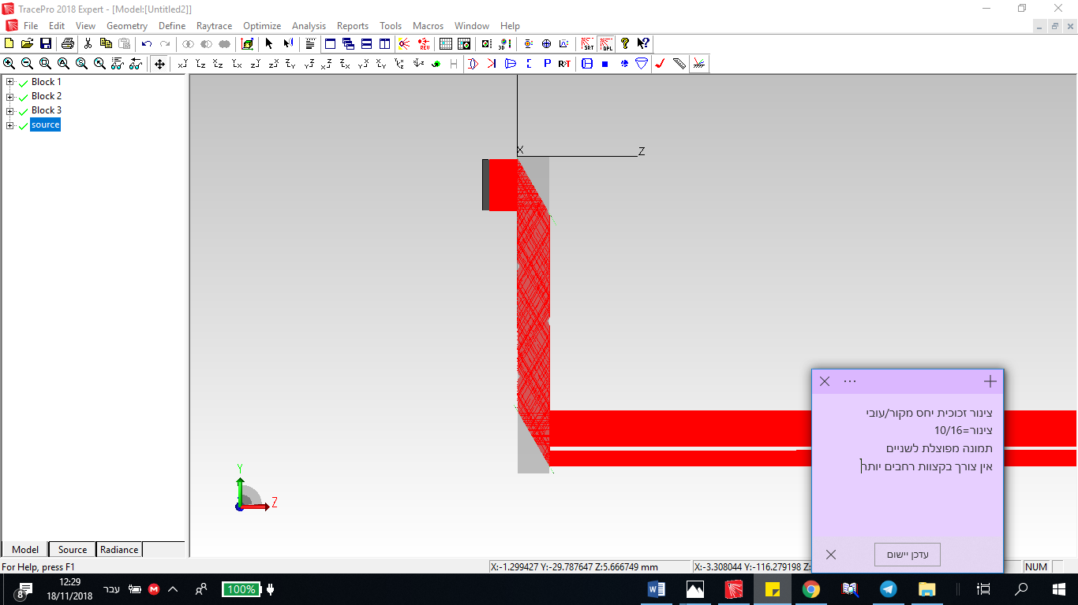

**Figure** **17:** Narrow periscope, glass tube, with ratio of source's radius to tube's radius of 16:10 (The image splits, with the top of the object at the bottom of the image.)

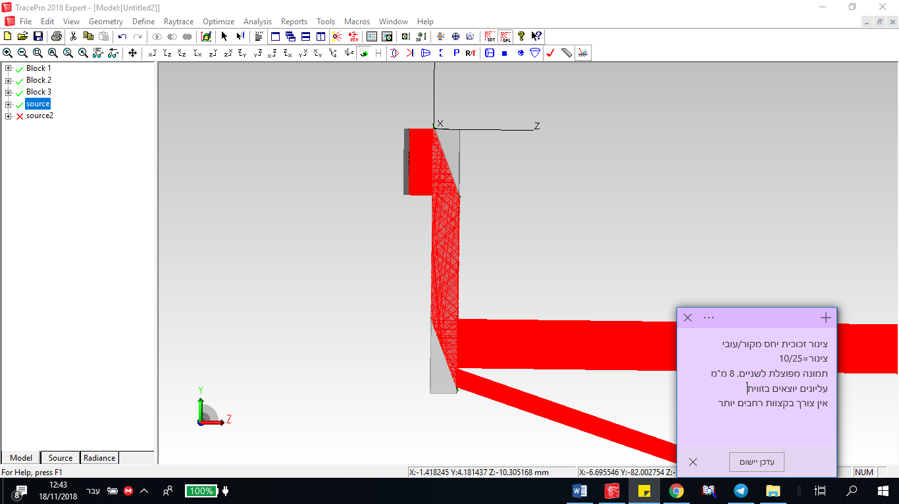

**Figure** **18:** Narrow periscope, glass tube, with ratio of source's radius to tube's radius of 25:10

(8 upper mm exit with a vertical angle (seemingly should have another internal reflection)

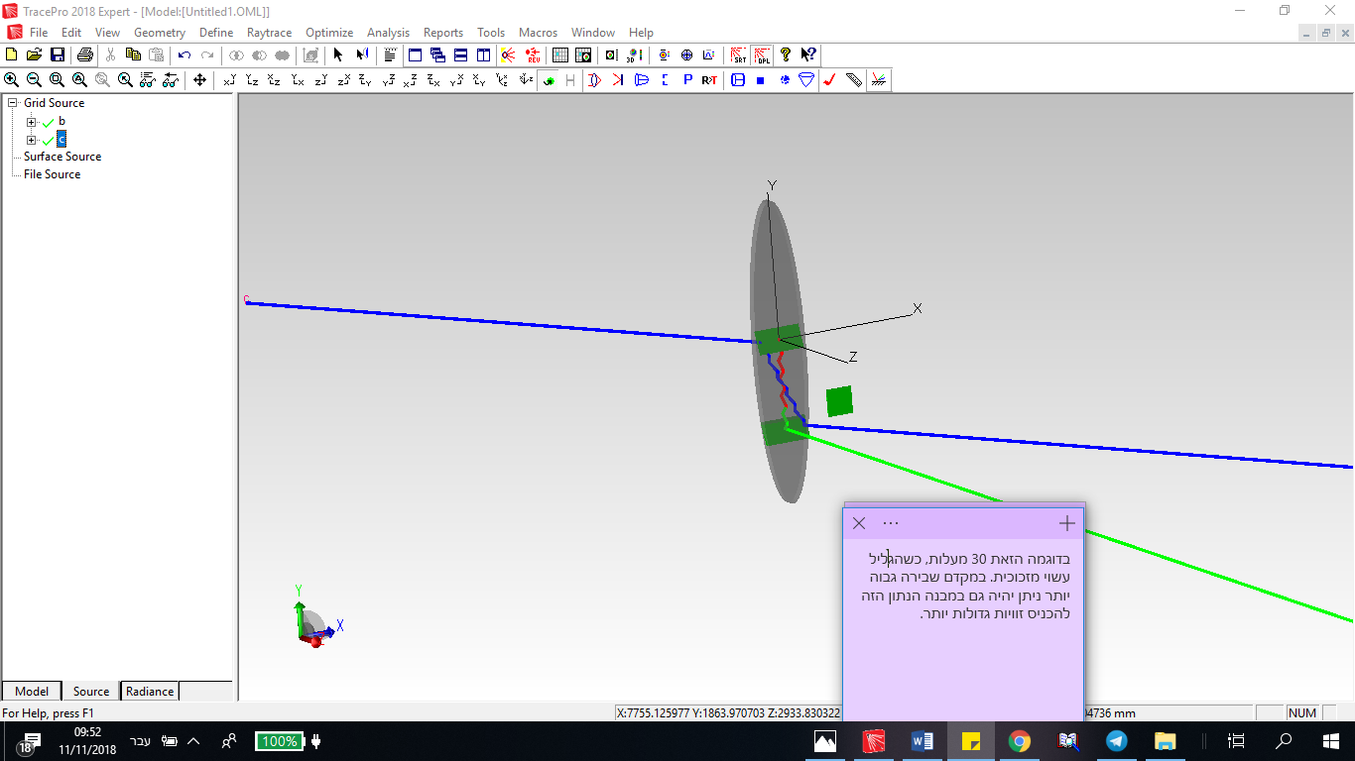

**Figure** **19:** Periscope, glass tube, with the horizontal entrance angle of the blue ray at 30 degrees

**Conclusions and summary:**

The authors examined a variety of periscope models in this work and discussed the advantages and disadvantages of using various materials and elements. This research brings a new approach to the known periscope concept. The standard periscope transfers the image by using mirrors at 45 degrees and a pipe that blocks stray light from the outside. Moreover, the periscopes currently in use are based on lenses or 45-degree prisms. Some companies in the solar energy field use light pipes to transfer sunlight into closed-space rooms, but the pipes need to be close to the ceiling and do not have the ability to transfer images. Our novel approach of transferring images is based on mirror waveguides with suitable angles that reduce the periscope size but preserve the image as in standard periscopes. Future tests will examine the light efficiency of the suggested periscope to ensure an improvement over standard periscopes.

**Bibliography**

1. [K. R. Rao](https://www.google.co.il/search?sa=X&biw=1422&bih=775&tbm=bks&tbm=bks&q=inauthor:%22Kamisetty+Rao%22&ei=qcqcUsPGI8eThgeh3YCADg&ved=0CDoQ9AgwAQ), ‏[D. N. Kim](https://www.google.co.il/search?sa=X&biw=1422&bih=775&tbm=bks&tbm=bks&q=inauthor:%22D.+N.+Kim%22&ei=qcqcUsPGI8eThgeh3YCADg&ved=0CDsQ9AgwAQ), ‏[J. J. Hwang](https://www.google.co.il/search?sa=X&biw=1422&bih=775&tbm=bks&tbm=bks&q=inauthor:%22Jae+Jeong+Hwang%22&ei=qcqcUsPGI8eThgeh3YCADg&ved=0CDwQ9AgwAQ), *Fast Fourier Transform - Algorithms and Application*, Springer-Verlag, New York (2011).
2. K. Obara, A. Ito, S. Kakudate, K. Oka, M. Nakahira, Y. Morita, K. Taguchi, S. Fukatsu, N. Takeda, H. Takahashi, E. Tada, R. Hager, K. Shibanuma, R. Haange, "Development of 15-m-long radiation hard periscope for ITER in-vessel viewing," *Fusion Engineering and Design* 42, 501-509 (1998).
3. P. Stremplewski, K. Komar, K. Palczewski, M. Wojtkowski, and G. Palczewska, "Periscope for noninvasive two-photon imaging of murine retina in vivo," *Biomedical Optics Express* 6 (9), 3352-3361 (2015).
4. J. G. Hay and J. T. Gerot, "Periscope Systems for Recording the Underwater Motions of a Swimmer," *International Journal of Sport Biomechanics* 7 (4), 392-399 (1991).
5. P. R. Yoder, "Opto-Mechanical Designs for Two Special-Purpose Objective Lens Assemblies," *Contemporary Optical Instrument Design, Fabrication, and Testing* 656, 225-230 (1986).
6. D. W. O. Heddle, "An afocal electrostatic lens," *J. Phys. E: Sci. Instrum.* 4 (12), 981 (1971).
7. F. Wakabayashi, "Resolving Spectral Lines with a Periscope-Type DVD Spectroscope," *J. Chem. Educ.* 85 (6), 849-853 (2008).
8. M. O. Lidwell, "Steerable zoom periscope," *SPIE Proc.* 2539*,* *Zoom Lenses* (1995).
9. B. H. Walker, *Design for Visual Systems*, SPIE Press, Chapter 9, Washington (2000).