**Cognitive Reappraisal Reduces the Influence of Negative Emotions on the Desire to Eat**

Gili Barzilay1, Noga Cohen1,2, and Noam Weinbach3

1 Department of Special Education, University of Haifa, Haifa, Israel

2 The Edmond J. Safra Brain Research Center for the Study of Learning Disabilities, University of Haifa, Haifa, Israel

3 School of Psychological Sciences, University of Haifa, Haifa, Israel

Corresponding Author: Noam Weinbach, School of Psychological Sciences, University of Haifa. Abba Khoushy Ave 199, Haifa, Israel, 3498838 Email: [nweinbach@psy.haifa.ac.il](mailto:nweinbach@psy.haifa.ac.il)

Declarations of interest: none

**Abstract**

Accumulating evidence suggests that emotions can modulate eating behaviors. Recent studies further indicate that the way that individuals cope with emotional experiences may be more important for modulating eating than the precise emotion experienced. This study examined whether the use of the adaptive emotion regulation strategy of cognitive reappraisal can influence the effect of threat-provoking stimuli on the desire to eat. We also examined whether this effect is modulated by the emotional eating trait in a sample of 81 women. The participants rated their desire to eat depictions of food viewed after viewing neutral or threat-provoking pictures. In some trials, the participants were asked to reappraise the threat-provoking content by reinterpreting the content to reduce negative feelings. In other trials, they were asked to observe the pictures without trying to change their emotions. Emotional eating was assessed via a self-report questionnaire. The findings showed that the participants’ desire to eat was reduced following the presentation of threat-provoking pictures. However, after participants were instructed to reappraise the threat-provoking stimuli, their desire to eat increased relative to being instructed to watch the pictures without reappraising. Higher levels of self-reported emotional eating were associated with a greater desire to eat when presented with threat-provoking stimuli. This association was eliminated when reappraisal was used. The findings also suggest that reappraisal can reduce the emotional reactivity associated with exposure to threat-provoking stimuli and thus reduce the appetite-inhibitory effects of threat exposure.

**Keywords****:** emotion regulation, cognitive reappraisal, emotional eating, desire to eat.

# **1. Introduction**

Eating is driven by more than physiological needs; multiple socio-cultural and psychological factors, including emotions, play a role in eating behaviors (Macht & Simons, 2000; Torres & Nowson, 2007). In recent years, much has been learned about the relationship between emotions and eating behaviors, but we still know very little of the mechanisms that might influence the relationship between these two sets of phenomena (Devonport et al., 2019; Evers et al., 2018). Moreover, it appears that the ability to regulate emotion inhibits the modulation of eating behaviors (Evers et al., 2018). Work remains to be done to clarify what direct causal effects emotion regulation strategies have on eating.

At a basic level, emotional reactions impact the desire to eat. For example, individuals eat less in response to the perception of an immediate threat (e.g., Torres & Nowson, 2007) because perceived threat induces the release of corticotropin-releasing hormone (CRH) upon exposure to the threat stimulus (George et al., 2010). This has the effect of diverting resources to fight-or-flight mode during acute stress and away from food-seeking behaviors (Sominsky & Spencer, 2014). An ongoing experience of negative emotions, however, may increase eating in individuals who have difficulty in regulating their emotions.

Emotional eating may take the form of overeating or binge eating in response to negative emotions (Cardi et al., 2015; Devonport et al., 2019; Evers et al., 2013). However, it may not be the negative emotion itself that drives emotional eating but rather the presence of maladaptive emotion regulation strategies in the attempt to cope with negative emotions (Evers et al., 2010, 2018; Taut et al., 2012; Vandewalle et al., 2014). This idea is rooted in affect-regulation theories that refer to overeating in response to negative affect as a means of regulating negative emotions in the absence of more adaptive ways of coping (Cardi et al., 2015; Devonport et al., 2019; Evers et al., 2013; Racine & Horvath, 2018).

Emotion regulation is the ability to influence the nature of the emotions we have, the time of their occurrence, and our experience and expression of them (Gross, 1998). Empirical evidence suggests that emotion regulation plays an important role in eating behavior (Evers et al., 2018; Evers et al., 2010; Taut et al., 2012), and difficulties in emotion regulation are associated with symptoms of eating disorders (Prefit & Szentagotai-Tătar, 2018; Sloan et al., 2017; Svaldi et al., 2010, 2012). For example, Evers et al. (2010) showed that people with high levels of emotional eating who use maladaptive emotion regulation strategies, such as suppression (i.e., attempting not to expose their emotions), tend to overeat comfort foods that are rich in sugars and fats.

If maladaptive emotion-regulation strategies result in dysregulated eating, adaptive emotion-regulation strategies may promote better-regulated eating behaviors in the face of negative emotions. The adaptive emotion-regulation strategy of cognitive reappraisal has been extensively studied. Cognitive reappraisal involves assigning a different interpretation or perspective to something unpleasant in order to reduce distress (Gross, 1998). Frequent use of reappraisal is associated with better psychological health, such as greater well-being, better social adjustment, and fewer symptoms of anxiety and depression (Garnefski et al., 2002; Gross & John, 2003; Hopp et al., 2011; Joormann & Gotlib, 2010; Kelley et al., 2019). When participants in laboratory studies are asked to reappraise the content of negative emotional stimuli, these stimuli are rated less negatively than otherwise (Ochsner et al., 2012).

Due to the role that reappraisal plays in reducing negative affect, it may also be beneficial for attenuating emotion-driven eating behaviors. However, findings regarding the causal effect of reappraisal on eating behaviors are mixed (Evers et al., 2010; Taut et al., 2012). For example, Taut et al. )2012) found that healthy women asked to reappraise their emotions in response to negative movie clips began eating later than those who were not instructed to use reappraisal. However, no difference was found between the amount of food consumed by the reappraisal and the control groups. Evers et al. (2010) also found no difference in food consumption between the reappraisal and the control groups. However, the group of participants instructed to suppress their emotions while watching the films ate more than either the reappraisal or the control groups.

The present study investigated the role played by reappraisal in modulating the desire to eat following the experience of negative emotions in a trial-by-trial experimental design. This procedure allowed the direct causal impact of reappraisal on the desire to eat to be assessed. Our assessment used an adaptation of the classic cognitive reappraisal task together with a food-rating task. In some trials (Ochsner et al., 2012), participants were instructed to reappraise the negative emotional stimuli. All participants reported their desire to eat a high- or low-calorie food item depicted in a picture presented to them.

We hypothesized that threat-provoking stimuli (compared to neutral stimuli) would produce a reduced desire to eat and that reappraisal would attenuate this reduction. Moreover, we expected that higher levels of emotional eating would be associated with a greater desire to eat following exposure to threat-provoking stimuli. We also explored whether reappraising threat-provoking content modulates the relationship between emotional eating and the desire to eat.

# **2. Methods**

*2.1 Participants*

The study participants were 82 women aged 19–35 years, with no special dietary preferences (i.e., not vegetarian or vegan). One participant was excluded due to incomplete data, leaving 81 participants with a mean age of 25.6 (*SD =* 3.67) years and a mean body mass index (BMI) of 23.22 (*SD* = 4.3). All participants were native speakers of Hebrew.

*2.2 Procedure*

The study protocol was approved by the local IRB committee (333/20). As is commonly done in studies of this type (e.g., Taut et al., 2012), the participants were asked to avoid eating for 3 hours prior to the study task, which occurred at a time convenient to them, to reduce potential differences related to degree of hunger. After giving consent, the participants received instructions in a remote online meeting with the experimenter conducted using Zoom software (detailed below). Then, they performed the task and completed a self-report questionnaire. Finally, they were debriefed and received a monetary compensation of 40 NIS.

*2.3 Measures*

*2.3.1 Cognitive reappraisal-food rating task*

Each trial within the task began with the presentation of a fixation cross at the center of the screen for 1,000 ms (see a typical trial and sequence of events in Figure 1). Then, a cue appeared for 1,000 ms to indicate to the participant how to respond to the following threat-provoking or neutral picture. One of two instruction cues was used: IMMERSE or RETHINK. IMMERSE trials were control trials, in which participants were asked not to attempt to modify the emotions they were feeling while viewing the picture. They were to imagine what they would see, hear, and feel if they saw the depicted scene in reality (Doré et al., 2018). In RETHINK trials, the participants were asked to change the way they thought about the scene shown in the picture or to modify its meaning for them to reduce their negative emotions. Then, a threat-related or neutral picture appeared for 7,000 ms, allowing the participants to implement the cued instructions. Following the threat-provoking image, a picture of a low or high-calorie food item was presented, and participants were asked to rate their desire to eat the depicted food on a scale from 1 (have no desire to eat) to 5 (very high desire to eat). The food picture remained on the screen until the participant’s response. In all, 120 trials were conducted per participant. Prior to the beginning of the task, the participants received instructions from the experimenter and conducted a practice phase, during which the experimenter explained what to do in response to the reappraisal and immerse cues. Then, they were asked to implement the rethink and immerse instructions on eight images to ensure that they understood the task, after which they were given feedback.

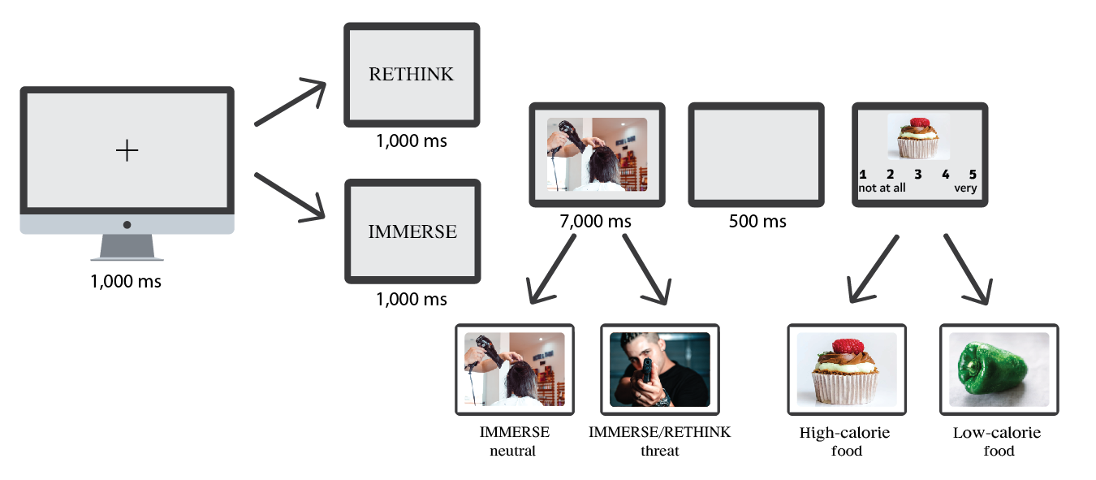

**Figure 1**. A typical trial and sequence of events of the cognitive reappraisal-food task

*2.3.2 Threat-provoking and neutral pictures*

Because stress is a commonly used emotion in studies concerning emotional eating (Bongers & Jansen, 2017), the task included 80 threat-provoking pictures. Half were presented in the IMMERSE condition and half in RETHINK, and 40 neutral pictures appeared only in the IMMERSE condition. All 120 pictures were taken from the International Affective Picture System (IAPS; Lang et al., 1997) and The Nencki Affective Picture System (NAPS; Marchewka et al., 2014). Each picture measured 1024 × 768 pixels. The threat-provoking pictures were chosen for their high fear ratings (Moyal et al., 2018).

*2.3.3 Food pictures*

The food pictures were drawn from a database of food pictures (Blechert et al., 2014). The study contained 60 pictures of high-calorie foods (30 sweet and 30 savory foods) and 60 pictures of low-calorie foods.

*2.3.4 Emotional eating*

Emotional eating was assessed with the Dutch Eating Behavior Questionnaire(DEBQ; Tatjana van Strien et al., 1986), which assesses three distinct eating behaviors: emotional eating, external eating, and restrained eating. It contains 33 items, of which 13 assess emotional eating.

*2.4 Statistical analyses*

The analytical plan was pre-specified, and all data-driven analyses performed are clearly identified and discussed appropriately in this report. To examine the effects of emotion regulation on the desire to eat, we performed an analysis of covariance (ANCOVA) using cue type (RETHINK-threat, IMMERSE-threat, IMMERSE-neutral) and food type (high calorie, low calorie) as within-subject factors and the emotional eating subscale of the DEBQ as a covariate.

# **3. Results**

The ANCOVA showed a main effect for cue type, *F*(1, 79) = 15.48, *p* < .001, ƞ2p = .164, demonstrating a reduced desire to eat in the IMMERSE-threat condition (*M* = 2.32, *SD* = 0.64) relative to the IMMERSE-neutral condition (*M* = 3.08, *SD* = 0.67), *t*(80) = 9.6, *p* < .001. Furthermore, higher desire to eat was observed in the RETHINK-threat (*M* = 2.67, *SD* = 0.52) than in the IMMERSE-threat condition, *t*(80) = 4.41, *p* < .001 (Figure 2), indicating that reappraising the threat-provoking content increased the desire to eat.

The results also showed a main effect of food type, *F*(1, 79) = 11.72, *p* < .005, ƞ2p = .12, indicating that the desire to eat high-calorie food (*M* = 3.34, *SD* = 0.59) was greater than that for low-calorie food (*M* = 2.04, *SD* = 0.65).

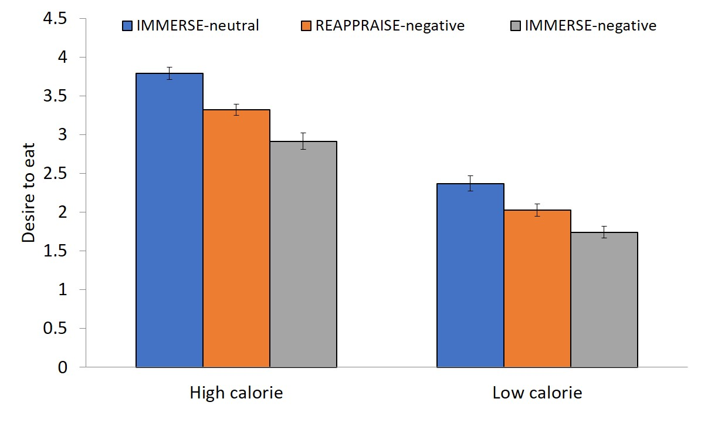

**Figure 2*.*** Desire to eat high- and low-calorie foods in the different task conditions

The three-way interaction between food type, cue type, and emotional eating was not significant, *F*(2, 158) = 1.62, *p* = .20, ƞ2p = .02. However, we did find a significant interaction between cue type and food type, *F*(2, 158) = 4.85, *p* = .009, ƞ2p = .05, indicating that the effects of cue type on the desire to eat were larger for high- than low-calorie foods. In addition, the interaction between food type and emotional eating was also significant, *F*(1,79) = 4.26, *p* = .04, ƞ2p = .05, indicating that levels of emotional eating were differently associated with the desire to consume low-calorie or high-calorie foods. To assess the source of this interaction, we examined the correlation between emotional eating and the desire to eat high- or low-calorie foods. Higher levels of emotional eating were associated with a greater desire to eat high-calorie foods (*r* = .22, *p* = .049) but not low-calorie foods (*r* = 093.-, *p* = .40(.

Furthermore, an interaction was found between cue type and emotional eating, *F*(2, 158) = 3.16, *p* = .04, ƞ2p = .03, indicating that the desire to eat as a function of cue type was modulated by the level of emotional eating. We examined the correlation between emotional eating and the desire to eat for each cue type. It was found that higher levels of emotional eating were associated with a greater desire to eat in the IMMERSE-threat condition (*r* = .228, *p* = .04; Figure 3a).

By contrast, no correlations were found between emotional eating and the desire to eat in the RETHINK-threat (*r* = -.07, *p* = .51; Figure 3b) or IMMERSE-neutral (*r* = -.008, *p* = .94; Figure 3c) condition.

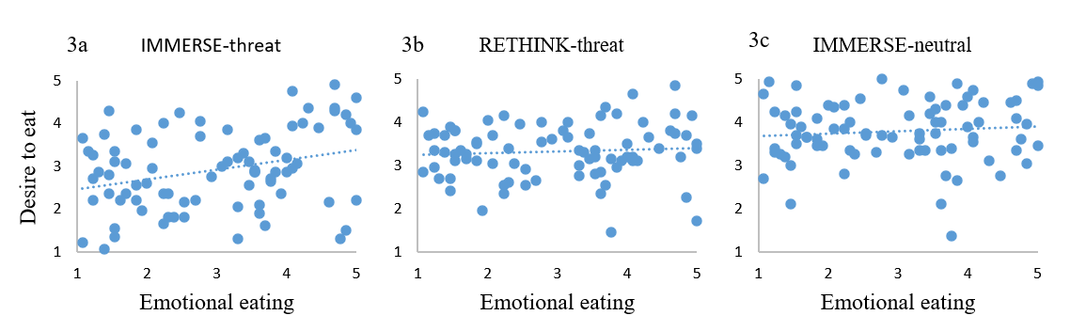

**Figure 3*.*** Correlations between the emotional eating subscale of the DEBQ and the desire to eat after IMMERSE-threat cue (3a), RETHINK-threat cue (3b), and IMMERSE-neutral cue (3c)

**4. Discussion**

This study examined the ways in which reappraisal modulates the effects of threat-provoking stimuli on the desire to eat. and its modulation by level of emotional eating. As hypothesized, it was found that threat-provoking stimuli reduced the desire to eat. However, when reappraisal was used, the influence of threat-provoking stimuli on the desire to eat was reduced. Higher levels of emotional eating were associated with a greater desire to eat when threat-provoking content was observed but not after reappraisal.

Previous studies show that immediate threats elicit an automatic physiological response that reduces appetite (Torres & Nowson, 2007). This phenomenon is considered part of the fight-or-flight set of reactions that occur in response to acute stress (Sominsky & Spencer, 2014). Specifically, CRH, which is released immediately upon exposure to threatening stimuli, affects bodily responses and inhibits the drive to search for food (Torres & Nowson, 2007). Similarly, the present study revealed that exposure to threat-provoking stimuli reduced the desire to eat. This reduction was nonspecific to food type and occurred with both high- and low-calorie foods.

This study also assessed whether using an adaptive emotion regulation strategy, namely, cognitive reappraisal, could attenuate appetite-inhibiting responses prompted by threatening stimuli. It was shown that when participants reappraised the threats presented, the desire to eat increased relative to when reappraisal did not occur. It should be noted that participants were asked to reappraise the threat-provoking content, not the subsequently presented food stimuli. Thus, modulation of the desire to eat should be attributed to the effects of reappraisal on the given emotional reaction.

Only two previous studies examine the influence of reappraising negative content on eating behaviors (Evers et al., 2010; Taut et al., 2012). These studies did not report any influence of negative content on food consumption. However, Taut et al. (2012) did show that eating was delayed following reappraisal. Several methodological differences between those studies and the present research are worth noting. First, in our study, we assessed the desire to eat rather than actual food consumption. Second, both Evers et al. and Taut et al. manipulated participants’ emotional state using mood-induction through video clips. In this study, however, the emotional state and the use of reappraisal were manipulated on a trial-by-trial basis using the presentation of threat-provoking images. A trial-by-trial design may induce the experience of immediate threat, and in this case, the desire to eat is automatically reduced, as we have shown. This assumption is supported by previous work indicating that immediate threat results in reduced eating, while chronic stress results in increased eating (Roberts et al., 2014). It thus may be that when an emotional experience produces appetite inhibition, reappraisal attenuates the emotional effects to increase eating. Conversely, when the emotional experience leads to increased appetite, reappraisal may attenuate this effect and reduce eating. However, this hypothesis should be directly tested in future studies.

This study also assessed the association between individual differences in levels of emotional eating and reported effects. It has been argued that emotional eaters regulate unpleasant emotions with eating (Cardi et al., 2015; Devonport et al., 2019; Evers et al., 2013), especially foods rich in sugars and fats (Jiang et al., 2014). This study supports previous findings that higher levels of emotional eating are associated with a greater desire to eat high-calorie foods when experiencing negative emotions (Wood et al., 2016). Importantly, our results demonstrate an association between the desire to eat and emotional eating only when the participants had observed threat-provoking stimuli but not after reappraising it. This finding strengthens the idea that negative emotions are not what drives emotional eaters to overeat but, rather, the use of maladaptive emotion regulation strategies (Evers et al., 2018).

This study’s results support clinical interventions that seek to treat disordered eating by improving emotion regulation skills (Clyne et al., 2010; Sloan et al., 2017). This study provides a scientific basis for using cognitive reappraisal of negative content to influence attitudes toward food. Furthermore, this study also showed that reappraisal can influence the link between emotional eating and the desire to eat high-calorie foods. These findings contribute to a growing body of evidence indicating that treatments focusing on improving emotion regulation, such as dialectical behavioral therapy, can be useful for treating disordered eating (Hill et al., 2011; Safer et al., 2009, 2018).

Some limitations of the study should be acknowledged. First, the study examined the desire to eat, not actual food consumption, and a gap may exist between the desire to eat and actual eating. Because the experiment was structured on a trial-by-trial basis, the effects reported are necessarily short lived. Thus, no final conclusions can be drawn regarding the long-term effects of reappraisal and exposure to threat-provoking stimuli on disordered eating. For example, it may be that prolonged exposure to threat results in increased, rather than reduced, desire to eat, leading to different effects. Finally, this study assessed the effects of threat-provoking stimuli but not other types of emotional stimuli. A wide range of emotional experiences may influence eating behaviors, and these may also be related to emotional eating. Future studies should seek to clarify the findings of this research by examining the reappraisal of a variety of emotional contents and the desire to eat.

This study demonstrated that while threat-provoking stimuli result in an immediate reduction of the desire to eat, their reappraisal attenuated this effect. The use of reappraisal also eliminated the association between emotional eating and the desire to eat following the experience of threat. Future studies should assess additional ways to utilize cognitive reappraisal, with the aim of ameliorating disordered eating patterns driven by emotional dysregulation.