

**School of Psychological Sciences**

<https://psy.hevra.haifa.ac.il/index.php/en-us/>

**The Herta and Paul Amir Faculty of Social Sciences**

Dear Prof. Swaab,

Please find enclosed our manuscript entitled “Influence of Inhibitory Control on Reappraisal and Experiences of Negative Emotions,” which we hereby submit for publication as a brief article in *Cognition*.

Summary

Previous studies have shown that inhibitory control (IC) plays an important role in emotional processing and regulation. However, such studies have focused on the influence of IC on implicit behavioral measures and neutral or physiological activity. Here, we show for the first time that transient recruitment of IC can modulate experiences of negative emotional content. Specifically, we show that priming IC reduces negativity ratings after exposure to negative emotional images. By contrast, triggering IC increases negativity ratings after exposure to emotionally neutral images. We did not find that IC influenced the use of the adaptive emotion regulation strategy of cognitive reappraisal. We believe that this study contributes to the literature by demonstrating how IC can directly and dynamically influence experiences of emotional content.

Sincerely,

Noam Weinbach, PhD, on behalf of Meital Gil and Noga Cohen

School of Psychological Sciences,

University of Haifa, Israel

**Influence of Inhibitory Control on Reappraisal and Experiences of Negative Emotions**

Meital Gil1, Noga Cohen2, Noam Weinbach1

1 School of Psychological Sciences, University of Haifa, Haifa, Israel

2 Department of Special Education, University of Haifa, Haifa, Israel

Meital Gil, Email: [meitaldavis@gmail.com](mailto:meitaldavis@gmail.com), Address: Department of Special Education, Abba Khoushy Ave 199, Haifa, Israel 3498838

Noga Cohen, Email: [noga.cohen@edu.haifa.ac.il](mailto:noga.cohen@edu.haifa.ac.il), Address: School of Psychological Sciences, Abba Khoushy Ave 199, Haifa, Israel 3498838. E-mail: Nweinbach@psy.haifa.ac.il

Noam Weinbach, Email: [nweinbach@psy.haifa.ac.il](mailto:nweinbach@psy.haifa.ac.il), Address: School of Psychological Sciences, Abba Khoushy Ave 199, Haifa, Israel 3498838. E-mail: Nweinbach@psy.haifa.ac.il

Declaration of interest: none

**Word count:**

Correspondence concerning this article should be addressed to Dr. Noam Weinbach, School of Psychological Sciences, Abba Khoushy Ave 199, Haifa, Israel 3498838. E-mail: Nweinbach@psy.haifa.ac.il

**Abstract**

Inhibitory control (IC) enables goal-directed behavior and reduces the interference of irrelevant information. Studies have shown that IC can downregulate performance-based behavioral and physiological measures of emotional reactivity. This study examined whether transient recruitment of IC can modulate experiences of negative and neutral emotional content by improving the ability to reappraise negative emotional content. A combined flanker and cognitive reappraisal task was performed by 49 participants. The flanker task primed IC before the cognitive reappraisal task of reappraising or observing negative and neutral emotional content. Priming IC prior to exposure to negative emotional content reduced negative reactivity. Higher emotional reactivity was associated with greater self-reported rumination. However, this was only apparent when IC was not primed and reappraisal was not required. Finally, priming IC had no influence on the ability to reappraise negative emotional content. These results illustrate the importance of IC in decreasing emotional reactivity after being exposed to negative content. IC is revealed as a mechanism that modulates emotional reactivity differently in response to context.

**Keywords:** inhibitory control, cognitive control, cognitive reappraisal,emotion regulation, emotional reactivity, flanker task.

**1. Introduction**

Inhibitory control (IC) is the cognitive process of inhibiting the influence of task-irrelevant actions and information in the context of goal-directed behavior (Miyake et al., 2000). Understanding how IC interacts with emotion processing and regulation has been a matter of great interest throughout the years (Cohen & Henik, 2012; Fritz & Dreisbach, 2013; Pourtois et al., 2020). Accumulating evidence indicates a bidirectional relationships between IC and emotion-driven processes.

Studies have shown that negative emotional reactivity can disrupt IC. Specifically, exposure to aversive images impairs the ability to subsequently implement IC among healthy individuals (Kalanthroff et al., 2013; Verbruggen & De Houwer, 2007). Moreover, IC deficits have been argued to play a role in multiple psychological disorders, including major depression (Palmwood et al., 2017). Such deficits may perpetuate depression by failing to inhibit attention to negative emotional content (Joormann & Gotlib, 2010). Thus, IC plays a role in emotion regulation, as indicated by the concurrence of IC deficits and poor emotion regulation in depression and other conditions (Joormann & Stanton, 2016). Furthermore, maladaptive emotion-regulation strategies such as rumination (dwelling on the symptoms, causes, and consequences of distress; Nolen-Hoeksema & Morrow, 1991) are associated with IC deficits (Cohen, Mor, et al., 2015a).

The associations between IC deficits, poor emotion regulation, and psychopathology (Joormann & Gotlib, 2010; Selten et al., 2018; Zetsche et al., 2012) imply that efficient IC may enable improved coping with negative emotions. Experimental studies have shown that recruitment of IC can attenuate emotion-driven interference (Cohen et al., 2012; Straub et al., 2020). For example, exposure to negative emotional stimuli can delay response times (RTs) in a simple discrimination task, a phenomenon termed *emotional interference* (Buodo et al., 2002; Hartikainen et al., 2000). However, this effect is eliminated if IC is experimentally triggered using a cognitive control task (Cohen et al., 2011, 2012; Cohen, Moyal, et al., 2015). Moreover, recruitment of IC downregulates physiological and neural correlates of emotion (Cohen, Moyal, et al., 2015; Cohen et al., 2016).

Efficient IC may also contribute to adaptive emotion regulation strategies, such as cognitive reappraisal (Cohen & Mor, 2018), in which a negative event is reinterpreted to reduce its emotional impact (Gross, 1998). Use of cognitive reappraisal is linked to greater well-being and fewer symptoms of anxiety and depression (e.g., Garnefski et al., 2002; Hopp et al., 2011; Joormann & Gotlib, 2010). Correlations between performance in cognitive reappraisal tasks and IC tasks have been reported at the brain and behavioral levels (Cohen et al., 2014; McRae et al., 2012; Tabibnia et al., 2011). Moreover, the application of transcranial direct current stimulation (tDSC) above brain regions that participate in IC decreases emotional arousal ratings in a reappraisal task (Feeser et al., 2014). Finally, training participants to employ IC while watching negative emotional images leads to an increased propensity to use reappraisal in response to a negative personal event (Cohen & Mor, 2018).

Thus, IC has been demonstrated to influence emotion-driven processes in important ways. However, the role of IC in modulating emotional reactivity and regulation remains uncertain. First, previous work has focused solely on implicit or performance-based measures of emotion processing (e.g., reaction times and physiological or neural activity). It remains unclear whether and how IC can influence experiences of negative emotional content (i.e., how participants experience negative content after IC is recruited). The utility of IC-bolstering manipulations in improving emotional well-being may be limited if IC does not influence how individuals experience emotional content (Beauchamp et al., 2016).

Nonetheless, the influence of IC on experiences of non-emotional stimuli has been examined. In one study, unfamiliar letters were judged by participants as more negative after trials involving the resolution of a conflict that required IC, compared to a no-conflict condition (Fritz & Dreisbach, 2013). IC may act to identify aversive signals and, by doing so, increase negative experiences of emotionally neutral stimuli (Dreisbach & Fischer, 2012; Dreisbach & Fischer, 2015). Nevertheless, it remains unclear how IC influences experiences of negative emotional content. A second question that has received insufficient attention is whether IC can augment the effects of adaptive emotion regulation strategies, such as cognitive reappraisal. It is not yet clear whether a transient recruitment of IC can benefit cognitive reappraisal. Such a finding would establish a direct causal relationship between the two processes.

^The goal of this is to examine how recruitment of IC might influence experiences of emotionally negative or neutral content, as well as the ability to reappraise negative content. Participants completed a combined flanker task (Eriksen & Eriksen, 1974) and cognitive reappraisal task (Ochsner et al., 2012). In the flanker task, the participants were required to overcome the distraction of task-irrelevant information. The cognitive reappraisal task required reappraisal or observation of negative and neutral emotional content, followed by a subjective negativity rating. We hypothesized that IC would downregulate negative emotional reactivity, such that priming IC would reduce subjective negative reactivity. Moreover, if IC and reappraisal shared mental processes, priming IC prior to reappraisal could augment its effects.

**2. Method**

**2.1 Participants:** We recruited 51 participants from the University of Haifa (16 males; mean age was 26.08 years, *SD* = 5.41) in return for monetary reward or course credit. Exclusion criteria included current use of psychotropic medication, diagnosis of attention deficit disorder, or a history of traumatic brain injury. A power analysis using G*Power (Faul et al., 2007) indicated that 43 participants were needed to assess within-factors interactions at a power > 80% and an a priori alpha set at *p* = .05, using an effect size estimate of η2p = 0.06.

**2.2 Measures**

**2.2.1 Flanker-reappraisal task:** Two well-established computerized tasks were combined: the flanker task (Eriksen & Eriksen, 1974) and the cognitive reappraisal task (Ochsner et al., 2002). Figure 1 presents a sample of a typical trial. In the cognitive reappraisal task, participants rated how negative they felt (on a scale from 1 to 5, 5 being most negative) after watching negative or neutral images. Before the images, participants were presented with a “Watch” cue, instructing them to observe the negative or neutral images without trying to change their emotional response, or a “Rethink” cue (reappraisal condition), instructing them to think differently about the negative image to make it feel less negative. Between the instruction cue and the image, the participants performed a flanker task (Eriksen & Eriksen, 1974), in which they indicated whether an arrow in the center of the screen pointed left or right by pressing the Z or M key, respectively. The flanking arrows next to the target were either congruent (i.e., pointing in the same direction; 🡪🡪🡪🡪🡪) or incongruent (i.e., pointing in different directions; 🡪🡪🡨🡪🡪). Incongruent flankers cause a conflict that requires IC resources to resolve (Botvinick et al., 2001). The task consisted of 120 randomly presented trials, divided into two blocks of 60. Eight practice trials were included prior to the task.

**Figure 1**. An example of a typical trial in which a “Rethink” cue is followed by an incongruent flanker condition and a negative image.

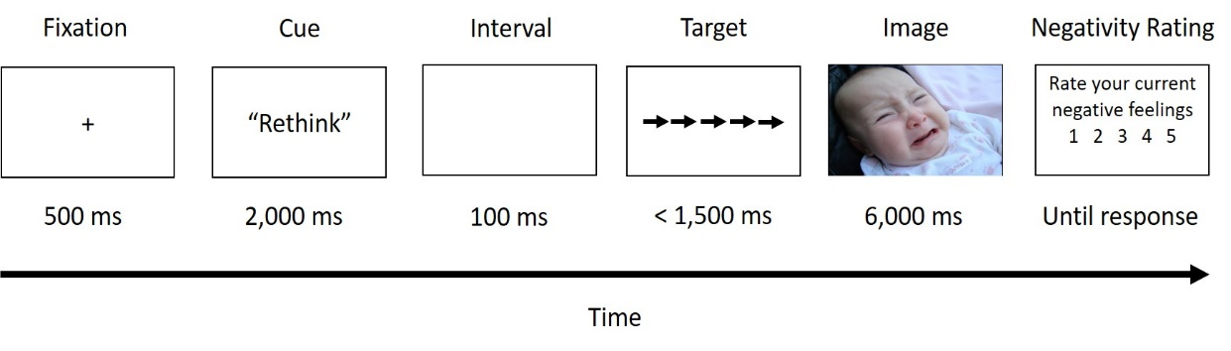

**2.2.2 Emotional images** In all, 80 negative and 40 neutral images from the International Affective Picture System (IAPS; Lang et al., 1997) were used. Negative images were selected for their high arousal and negative valence ratings (mean valence = 2.9; mean arousal = 5.68), whereas neutral images were selected for their low arousal and neutral valence ratings (mean valence = 5.55, mean arousal = 3.47), using normative data. The negative images differed across the “Watch” and “Rethink” conditions; however, the mean valence and arousal ratings, as well as the proportion among the human, animal, and scene images, were kept equal between all conditions. Neutral images were used only in the “Watch” condition because neutral content cannot be reappraised. Each image appeared only once per participant throughout the experiment.

**2.2.3 Self-report questionnaires**

Self-report questionnaires were used to assess the potential associations between clinical measures and task-performance. Anxiety was assessed with the Trait subscale from the State-Trait Anxiety Inventory (STAI; Spielberger, Gorsuch, Lushene, Vagg, & Jacobs, 1983), depressive symptoms using the Major Depression Inventory (MDI; Bech et al., 2001), and emotion regulation using the Ruminative Responses Scale (RRS; Nolen-Hoeksema & Morrow, 1991) for the tendency to ruminate and using the Emotion Regulation Questionnaire (ERQ; Gross & John, 2003) for tendency to use reappraisal and suppression for emotion regulation.

**2.3 Procedure**

The study was approved by the University’s institutional review board (IRB; 411/19). After signing an informed consent form, participants completed the self-report questionnaires. Then, they received detailed instructions from the experimenter regarding the cue types, were given two examples, and were asked to loudly reappraise the content of four negative images in front the experimenter. The experiment was run using OpenSesame (Mathôt et al., 2012).

**3. Results**

Two participants were excluded from the analysis due to low accuracy in the flanker task (above 2.5 standard deviations from the mean). To ensure that the flanker task yielded common effects, we assessed differences in RTs and accuracy rates between the congruent and incongruent conditions using dependent t-tests. Longer RTs were found in the incongruent (*M* = 619.36, *SD* = 112.4) than the congruent condition (*M* = 550.41, *SD* = 98.34), *t*(48) = 12.33, *p* < .001, Cohen’s d = 1.76, as well as lower accuracy for incongruent trials (*M* = 0.95, *SD* = 0.04) than congruent trials (*M* = 0.98, *SD* = 0.01), *t*(48) = 6.23, *p* < .001, Cohen’s d = 0.89. The study’s main hypotheses were examined using a repeated-measures analysis of variance, with flanker congruency (congruent/incongruent) and trial type (reappraisal-negative/watch-negative/watch-neutral) as within-subject factors and negativity ratings as the dependent variable. This analysis was performed only on correct trials in the flanker task (2.77% of the trials were eliminated). It revealed a significant main effect for cue type, *F*(2, 96) = 231.47, *p* < .001, η2p = .82, replicating the classical effects of the cognitive reappraisal task, namely, lower negativity ratings for watch-neutral trials relative to watch-negative trials, *F*(1, 48) = 483.87, *p* < .001, η2p = .89 and for rethink-negative trials compared to watch-negative trials, *F*(1, 48) = 138.41, *p* < .001, η2p = .74. Importantly, the interaction between cue type and flanker congruency was significant, *F*(1, 48) = 7.81, *p* < .001, η2p = .14 (see Figure 2). In line with this hypothesis, negativity ratings in the negative-watch condition were lower after incongruent than congruent flankers, *F*(1, 48) = 10.32, *p* = .002, η2p = 0.17. By contrast, negativity ratings in the neutral-watch condition were higher after incongruent than congruent flankers, *F*(1, 48) = 7.94, *p* = .007, η2p = 0.14. In the rethink-negative condition, no difference was found in negativity ratings between the congruent and incongruent conditions, *F*(1, 48) = 0.74, *p* = .39, η2p = 0.01, which did not support the hypothesis.

Exploratory stepwise linear regression analyses were performed to identify associations between individual characteristics and task performance. Specifically, we assessed the contribution of self-reported depression (MDI), anxiety (STAI), rumination (RRS), suppression (ERQ-S), and reappraisal (ERQ-R) to emotional reactivity (the difference in negativity ratings between the watch-negative and watch-neutral conditions) and the reappraisal effect (the difference in negativity ratings between the negative-rethink and negative-watch conditions). These analyses were carried out separately for the congruent and incongruent conditions. It was found that the model predicting emotional reactivity under the flanker-congruent trials was significant, *F* = (1, 47) = 5.35, *p* = .02, with only levels of rumination serving as a significant predictor, *β* = 0.32, *t* = 2.31, *p* = 0.02.

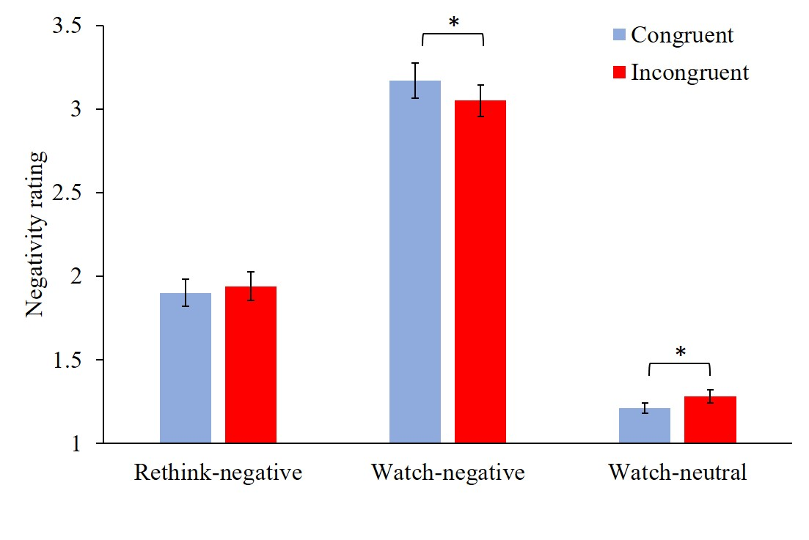

**Figure 2**. The y-axis represents the negativity rating. The x-axis represents the trial type. Blue refers to flanker-congruent trials and red represent flanker-incongruent trials. * < .01.

**4. Discussion**

This study examined how recruitment of IC influences experiences of negative emotional content and the ability to reappraise such content. The results indicated that priming IC before exposure to negative emotional content reduced negativity ratings compared to untriggered IC. By contrast, priming IC increased negativity ratings following exposure to emotionally neutral content. Additionally, rumination level predicted emotional reactivity only when IC was not primed, and reappraisal was not used. Last, in contrast with the a priori hypothesis, recruitment of IC had no impact on ability to reappraise negative emotional content. Reappraisal reduced subjective emotional reactivity, irrespective of whether IC was primed.

This is the first study to expose a direct causal influence of transient recruitment of IC on experiences of negative emotional content. Previous studies have focused on the influence of IC on implicit performance-based measures and neural/physiological correlates of emotion-driven processes (Cohen, Mor, et al., 2015; Cohen, Moyal, et al., 2015; Kalanthroff et al., 2013; Straub et al., 2020; Verbruggen & De Houwer, 2007). Here, we showed that the recruitment of IC prior to the exposure of negative content reduced participants’ subjective negative experience compared to unrecruited IC. A potential alternative explanation of these results could be that successfully overcoming a conflict improved the emotional experiences of participants, buffering against the impact of negative material. However, if this is true, a similar effect should have been observed for emotionally neutral content, but none was. In fact, recruitment of IC increased negativity ratings for non-emotional images. This finding replicates previous results showing that individuals judge unfamiliar neutral stimuli to be more negative after conflict relative to no-conflict trials in an IC task (Fritz & Dreisbach, 2013).

In accounting for the opposite directions in which IC influences experiences of negative and neutral content, it is important to consider the dynamic nature of IC. Implementation of IC may assist in identify aversive signals (Dreisbach & Fischer, 2012; Dreisbach & Fischer, 2015). It could be that when IC identifies an emotional threat, it helps downregulate its harmful influence on performance and thus decreases subjective emotional reactivity. Thus, it promotes the ability to cope with the stressor and secures goal-directed behavior. However, when IC is triggered and no aversive signal is detected, it may increase negative reactivity from the temporary loss of resources. Nevertheless, this hypothesis needs to be tested in future research.

Another noteworthy finding of this study is that a higher level of rumination is associated with higher subjective emotional reactivity. However, this association was evident only when IC is not primed, and reappraisal was not required. Prior studies showed similar results, indicating that the association between rumination and negative mood was abolished in task conditions that involve the frequent pairing of IC with negative emotional images (Cohen, Mor, et al., 2015b). Combined with studies showing that IC deficits are associated with rumination (Joormann & Gotlib, 2010; Joormann & Stanton, 2016), our findings further emphasize the important role played by IC in modulating the link between rumination and heightened negative emotional reactivity. Future studies should investigate ways to utilize IC to reduce rumination and establish a causal relationship between the two processes.

Our hypothesis of an influence of IC on cognitive reappraisal was not supported. This hypothesis was drawn from studies showing that the propensity to use reappraisal and reappraisal success are linked with IC abilities (Cohen & Mor, 2018; McRae et al., 2012). We hypothesized that momentary augmentation of IC could improve the ability to reappraise. However, this was not the case. For a future explanation, it may be relevant here that reappraisal manipulation had a robust effect on decreasing negativity ratings, perhaps masking or overriding any potential additional benefit of IC.

The limitations of this study should be addressed. Among these is its focus on negative and neutral emotions. The lack of positive emotional images limits the ability to understand whether the reported effects are specific to negative emotions or emotional arousal in general. One direction for future research would be to assess whether IC acts to downregulate positive emotional content (Straub et al., 2020). Additionally, this study was conducted in healthy individuals. Any beneficial effect of IC recruitment on reappraisal may be more pronounced among individuals with impaired emotion regulation.

To conclude, the current study found that IC plays a regulatory function in experiences of emotional content and may assist in promoting goal-directed behavior during adverse conditions. Furthermore, we demonstrated that IC can increase subjective negativity ratings of neutral content. this study adds to existing knowledge by demonstrating the ecological nature of IC as a dynamic mechanism that modulates emotional experience as a function of task demands.

**Author contributions**

Meital Gil: Conceptualization; Data curation; Formal analysis; Software; Writing – original draft. Noga Cohen: Formal analysis; Writing – review & editing. Noam Weinbach: Conceptualization; Software; Formal analysis; Writing – review & editing; Supervision.

**Funding**

This work was supported by the Israel Science Foundation (ISF; grant 1313/12)