Survival and extinction of mean-motion resonances in three-body problem and in planetary systems
Ph.D. thesis
Presented by Shuki Koriski, department of Geosciences, Raymond and Beverly Sackler,
Faculty of Exact Sciences, Tel Aviv University
jehoshu1@post.tau.ac.il
January 2017

"טובים השניים מן האחד אשר יש להם שכר בעמלם.
גם אם יפלו האחד יקים את חברו ואלו האחד שיפול ואין שני להקימו. ... ואם יתקפו האחד השניים יעמדו נגדו והחוט המשולש לא במהרה ינתק"
(מתוך קהלת ד')

“Two are better than one; because they have a good reward for their labor.
For if they fall, the one will lift up his fellow: but woe to him that is alone when he falleth; for he hath not another to help him up …
And if one prevails against him, two shall withstand him; and a threefold cord is not quickly broken”

(From Ecclesiastes 4)

Contents

(From Ecclesiastes 4) 2
1 General introduction 7
1.1 Three-body problem and its disturbing function 7
1.2 Mean-motion resonance 24
1.3 Stability and instability of three-body system in mean-motion resonance 30
1.3.1 Causes and origins of instability 30
1.3.2 Chaotic instability 34
1.4 Driven pendulum 43
1.5 Algebraic mapping 50
2 First study: On the ages of planetary systems with mean motion resonances 55
2.1 Sample 57
2.2 Statistical tests 60
2.3 Conclusion 61
3 Second study: Peak-to-Peak distance statistics of energy time-series in periodically driven pendulum 63
3.1 Study Introduction 64
3.1.1 Statistics of Peak-to-Peak Distance 64
3.2 Forced Pendulum 67
3.3 Energy Time Series 68
3.4 Results 71
3.4.1 Peak-to-Peak versus Trough-to-Trough Statistics 71
3.4.2 Dependence of Peak-to-Peak on Mean Energy 73
3.4.3 Peak-to-peak standard deviations 83
3.5 Summary and conclusions 89
4 Third study: From stability to chaos; energy evolution in a driven pendulum and its association with the three-body problem 91
4.1 Methodology 93
4.1.1 Formulating the driving force 94
4.1.2 Running the tests 95
4.2 Results 98
4.2.1 Time-series distribution 98
4.2.2 Mean time of events vs driver-amplitude parameter 110
4.3 Summary, discussion, and conclusions 130
5 REFERENCES 141

Thesis Abstract
We study several aspects of stability, instability, and chaos that coexist in three-body kinetics. The study carries us from the vastness of extrasolar systems to the simple driven pendulum model that mimics the dynamic behavior of celestial systems under resonance.
Our desire for a deeper understanding in this wide and interesting field led us to conduct three related investigations:
- The first investigation is associated with the prevalence of mean-motion resonances (MMRs) in extrasolar systems. In previous work, we investigated the possible effect of elapsing time on the long-term survivability of MMRs (Koriski & Zucker, 2011). In that work, we tested a hypothesis that contends that MMRs tend to suffer evolutionary disruption and are thus destined to be destabilized and disrupted. Under this hypothesis, we expect to see a smaller abundance of MMRs near older stars, so we compared the prevalence of period commensurabilities exhibited in multiplanetary extrasolar systems with published age estimates of host stars from the given systems (derived from the chromospheric activity method).
The results indicate that the typical life expectancy of planetary systems with 2/1 period commensurability, which is the most common MMR among known extrasolar systems, is around 4 Gyr. This age is significantly younger than all other commensurable and non-commensurable extrasolar systems. Therefore, we suggest that, at least, the 2/1 MMR phenomenon is generally not eternal.
Intrigued by these findings we later found that several studies support the hypothesis that MMRs are vulnerable (see, e.g., Thommes, 2008). These studies suggest that disruption of MMR configurations may be the result of cataclysmic events involving close encounters with massive objects or interactions with remnant planetesimals that eventually induced dynamical instability.
These results motivated us to investigate whether the decay of MMRs in planetary systems may also be the mere evolutionary outcome of the physics and dynamic characteristics of the system themselves, without the need of Deus ex machina in the sense of external forces. We suggest that the chaotic nature of three-body systems is a possible cause for MMR disruption.
- The second investigation stemmed from the hypothesis that MMR decay may be related to the chaotic underlying dynamics of three-body systems. The goal of this investigation was to better understand the action patterns of the three-body problem on stable and chaotic motion. To refine and simplify the problem, we investigated these feature by using the periodically driven pendulum, which is a toy model that mimics the behavior of three-body systems in MMRs. We choose the instantaneous energy of the pendulum as a measure of the physical condition of the system. The study produced typical statistical patterns of the distribution of the peak-to-peak and trough-to-trough of the energy-time series generated by the pendulum. These findings provided the tools to continue investigating the effects of chaos on MMR survivability.

- In the third investigation, we exploit the statistical insights from the second investigation to study the probability and the typical time series of the driven pendulum crossing various energy levels that are high enough to disrupt MMRs. This time we subject the pendulum to a unique driving force that we formulate from the general structure of the three-body disturbing function. The results reveal that the series of energy-crossing times per energy level is exponentially distributed. In addition, we show that the averaged time is a function of the driving-force amplitude. These findings indicate that a three-body system that is initially in a stable MMR state can become chaotically unstable and, after sufficient time, may depart from the MMR state. The probability for the departure from MMR and the elapsed time needed for this event to happen depends primarily on the amplitude of perturbation generated by and upon the system masses.
In conclusion, the three studies support our primary hypothesis that the destruction of MMR configurations may be an evolutionary phenomenon that depends completely on the internal features of the three-body problem and does not necessarily rely on external forces or events. This conclusion is also valid for mature three-body planetary systems that are free of significant external primordial forces (e.g., interaction with the protoplanetary gas disk, collision with a remnant planetesimal).

Note: Because of the large amount and variety of information upon which we rely in this study, we elaborate on the scientific information that is relevant to all the studies in the following general introduction. The information that is only relevant to a specific study is embodied within the given study.

General introduction

Three-body problem and its disturbing function
The three-body problem (Fig. 1.1) involves the motion of a point mass under the gravitational influence of two other masses and , where (Murray & Dermott, 1999; Ketchum, Adams & Bloch, 2013).

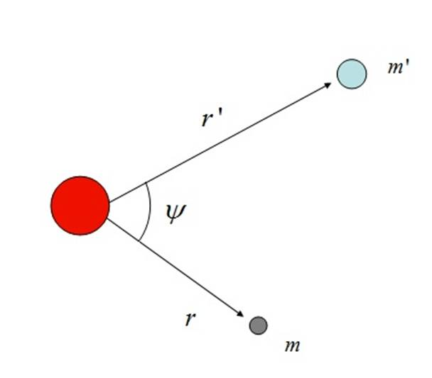
Figure 1.1. The three-body problem.

Unlike the analytical two-body problem in which two bodies rotate in elliptic trajectories about their mutual center of mass, adding an additional body makes the problem nonintegrable and thus with no analytic solution. The problem is commonly approached numerically by separating the system into two binaries, where the inner binary contains the massive body and the inner minor body whereas the outer binary contains the outer minor and the two-body system (i.e., their center of mass). The energy exchange between the inner and outer binaries is described by an argument called the disturbing function, which gives the extra potential energy contributed by one of the secondary masses.
Since our research deals with a mathematical formulation for the pendulum driving force that aims to simulate the Legendre-polynomial expansion of the disturbing function, we provide a comprehensive, step-by-step review of how the expansion is done. This review is mainly based on the book by Murray and Dermott (1999) called “Solar System Dynamics.”

The disturbing function for is
. (1.1.1)

Similarly, the disturbing function for is
, (1.1.2)

where is the gravitational constant, , and.

Applying the cosine rule for the angle (i.e., the angle between the two radial vectors and ) gives

, (1.1.3)
so
. (1.1.4)

Expressing this by a Legendre-polynomial expansion gives

, (1.1.5)

where .

Because , the disturbing function (1.1.1) for the inner body can be written as

, (1.1.6)

and the disturbing function (1.1.2) for the outer body can be written as

. (1.1.7)

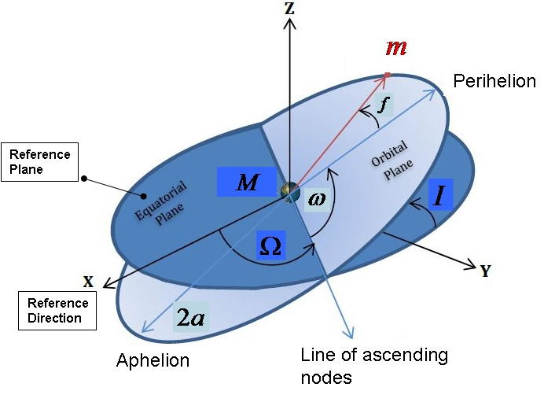
Figure 1.2. Orbital elements , and are, respectively, the true anomaly, argument of periastron, longitude of ascending node, semimajor axis, and inclination.

Because we want to work with the orbital elements (Fig. 1.2), the term is implemented as
, (1.1.8)
where and are the semimajor axis of the inner and outer minor bodies, respectively.
Thus, Eq. (1.1.7) takes the form

. (1.1.9)

To generalize the problem to three dimensions and thus to integrate the inclinations of the external and internal orbits, Murray and Dermott (1999) use the method of Kaula (1961) and Kaula (1962) and write Eq. (1.1.9) in terms of the orbital elements:

(1.1.10)
where
for
and
are the inclination functions
,
(1.1.11)

with

.

The summation goes from k = max to k = min. The quantities S and C are given by

, (1.1.12)

and

(1.1.13)

are the Hansen coefficients,
where
,

with

being the Newcomb operators:
(1.1.14)

Note that, when
,
(1.1.15)
and when
,
(1.1.16)

The disturbing function due to the exterior secondary is given by

(1.1.17)

The above method is one way to fully expand the disturbing function. Another method, which uses the Laplace coefficients, is also widely used.

Furthermore, we can simplify the problem by distinguishing between its direct and indirect parts
(1.1.18)

and
. (1.1.19)

The direct part
(1.1.20)

is derived from the direct term of the disturbing function, so the origin of the coordinate systems is the center of mass

. Conversely, the parts
(1.1.21)

and
(1.1.22)
are derived from the indirect terms of the disturbing function, which are due to the external (E) and internal (I) perturbers, respectively.
These two indirect terms exist only if we choose not to place the origin of the coordinate system at the center of mass.
For simplicity, we assume that the origin lies at the center of mass and so continue only with the direct term.
An expression for as an infinite Taylor series in and by using the Laplace coefficients is given by
(1.1.23)
where
, as in Eq. (1.1.12). Furthermore,
, (1.1.24)
, and are the true longitudes of the inner and outer minor bodies respectively,
and , (1.1.25)
(1.1.26)

The quantities are Laplace coefficients and can be expressed as a uniformly convergent series in for all . They are defined by
. (1.1.27)

To write the disturbing function by using the orbital elements instead of Cartesian coordinates, the following equations are used:

(1.1.28)

(1.1.29)
and
(1.1.30)

In addition,
(1.1.31)
and, similarly,
. (1.1.32)

By using Eqs. (1.1.28) and (1.1.29) we can rewrite Eq. (1.1.24) as
(1.1.30)
where , and are, respectively, the true longitude, mean longitude, longitude of periastron, argument of periastron, longitude of ascending node, true anomaly, semimajor axis, eccentricity, and inclination of the internal and the external orbits.
The full expansion of the direct part of the disturbing function (1.1.23) is infinite. Nevertheless, most studies use only low-order expansions.
The following example is a second-order expansion, so it involves the sum the zeroth, first, and second arguments,
, with
(1.1.31)

(1.1.32)
(1.1.33)
Here, is an arbitrary integer, and denotes a differential operator that acts on the Laplace coefficients,
.
After some algebraic modifications and simplification, the direct part can be written as
(1.1.34)

Finally, Dermott & Murray (1999) formulated a new expression for the disturbing function that has the advantages of Kaula (1961, 1962), Eqs. (1.1.10) and (1.1.17), combined with the Laplace coefficients, Eq. (1.1.23),

(1.1.34)

where the expression

in Eq. (1.1.17) has been simplified and transformed to

,
and where
for ,
(1.1.35)
,

when , (1.1.36)

when, (1.1.37)

, (1.1.38)
(where [∙] means only the integer part of its argument), (1.1.39)

, (1.1.40)

when both are even or odd, (1.1.41)
and
when both are even or odd. (1.1.42)

Thus, the disturbing functions describing the perturbation of the system by one of the minors, in this example by the external mass [i.e., Eq. (1.1.6)], has the general form

, (1.1.43)
where and is a function of the semimajor axes , eccentricities and inclinations of masses and , respectively. As described for Eq. (1.1.34), the general form of each of the infinite number of arguments is a linear combination of all the longitudes of the three-body system:
.

(1.1.44)

Or, in the shorter form,

, (1.1.45)

where

, (1.1.46)

and are integers that obey the d’Alembert relation,
. (1.1.47)

For reasons to be explained in section 1.2, the argument of Eq. (1.1.45) is named the “resonance argument.”

According to Eqs. (1.1.11) and (1.1.16), the lowest orders in the eccentricity and inclination terms are
𝒪,
= 𝒪,
𝒪,
𝒪.
Thus, we can evaluate argument as
, (1.1.49)
where is a function of the Laplace coefficients and can be expressed as a uniformly convergent series in for all.
The argument S is the amplitude of each term in the disturbing function and is often called the “strength” of the function.
It is evident that the lowest power of in a specific term is greater than or equal to the absolute value of the coefficient of . In addition, the lowest power of in a specific term is greater than or equal to the absolute value of the coefficient of . Similarly, the lowest powers of and are, respectively, greater than or equal to the absolute value of the coefficient of and the coefficient of.
Using Eqs. (1.1.17), (1.1.18), (1.1.20), (1.1.23), and (1.1.49), we can now rewrite the lowest order of the expanded disturbing function (1.1.18):
. (1.1.50)
Because , and are all less than unity, researchers tend to neglect high-power terms in the expansion of the disturbing functions and consider only the low-power terms, which are more dominant.
This tendency is clearly demonstrated for the planar, circular, restricted three-body problem where Eq. (1.1.50) reduces to
. (1.1.51)
Because the value of is also the order of the expansion; a higher expansion order corresponds to a lower strength .

In general, the arguments that contain mean longitudes and have short periods and their long-term perturbing effect is minor because they tend to average to zero. Thus, in most cases, the arguments that are more effective are those that contain the secular, low-frequency longitudes, , and .
Nevertheless, cases exist for which the mean longitudes significantly contribute to the perturbation. Such cases occur when the system is exact near MMR, an issue discussed in the next section.

Mean-motion resonance
In general, resonance occurs when two frequencies form a simple numerical ratio. For MMR within the three-body problem, the two minor masses and revolve around the primary mass (Fig. 1.1) with orbital periods that are close to a ratio of two small integers (see, e.g., Beaugé et al., 2008). This ratio is called the period commensurability (PC) and is calculated by

, (1.2.1)
where and are the mean motions of the minors and , respectively (i.e., their average angular velocities), and p and q are integers.
The relevancy of the resonance argument to this situation is that, for MMR, the variations in time of the argument (i.e., ) are very small and, regarding exact resonance,
.
To better understand Eq. (1.2.1) we look at the variation of the resonance argument as given by the derivation of Eq. (1.1.45):

. (1.2.2)

Because , , and the variations of the secular longitudes are relatively small, we can say that, in exact MMR,

. (1.2.3)
Thus, in MMR,

. (1.2.4)

If we consider only the planar, circular, restricted case in which we have no inclination for both secondaries (i.e., ) and a circular orbit for the outer secondary (i.e., ), we can write Eq. (1.2.3) as

. (1.2.5)

By using Eq. (1.1.44) for this case and using the d’Alembert relations,
,
,

.

We can finally write Eq. (1.2.4) as in Eq. (1.2.1):

. (1.2.6)

Spatially, the MMR phenomena force the two orbiting objects to meet repeatedly, on the same orbital longitudes. Thus, the gravitational perturbation generated by and upon the resonating celestial bodies, as reflected by the disturbing function, induces changes in the orbital elements, mostly on the semimajor axis, eccentricity, and inclination. The orbital evolution of the perturbed masses is quantified by the Lagrange planetary equations. These equations depict the variations on each of the six orbital elements: and .
These changes are often small. However, the MMR perturbation due to the frequent conjunctions may sum up coherently and, if the forcing frequency is commensurate or nearly commensurate with the natural frequency of oscillation of the responding elements, the perturbation will produce a large-amplitude, long-period response (de Pater & Lissauer, 2001) that can either provide stability or provoke chaos and destruction. This issue is further discussed in section 1.3.
Although the presence of PC is necessary to the existence of MMR, PC alone is not a sufficient condition for establishing the existence of MMRs and, to constitute a true resonance, one or more of the infinite resonance arguments [Eq. (1.1.45)] in the disturbing function should be fixed or at most undergo small librations. This is because, in inclined and elliptic trajectories, the instantaneous position in space of celestial bodies depends not only on the mean longitudes () but also on the longitudes of periastron and ascending nodes (), which evolve much slower than the mean longitudes and so cause secular variations. In the opposite case, when the system is out of MMR, all arguments circulate (see, e.g. Malhotra, 1998; Adams et al., 2008; Mardling, 2008; Lecoanet et al., 2009; Mustill & Wyatt, 2010).
The order of the resonance and the order of the disturbing-function expansion is the absolute value of the sum of that equals.
For instance, when the ratio of the two secondaries is , the order equals 1 and when, equals 2
This order tells us how many successive conjunctions occur before the two bodies meet again on the same spatial longitudes. Thus, if the orderequals 1, each conjunction occurs at the same longitude, and if the order equals 2 the two bodies meet on the same longitude every second conjunction (Murray and Dermott, 1999).
As mentioned above, the argument is the strength of each individual term in the expansion of the disturbing function.

If we reduce Eq. (1.1.49) (i.e., )
to the simple case of the planar, circular, restricted problem where the body in the external orbit is perturbing an inner minor of negligible mass, the strength of the disturbing function will be
. (1.2.7)
Thus, the strength of the disturbing function depends on the resonance order or, in the more general form, on . Because the eccentricity is usually less than unity, then a lower resonance order leads to a greater strength, and the perturbation is asserted on the inner body.
For MMR, so, because the variations of the secular longitudes,, , and are relatively small, an argument of the form
will result in secular motion, albeit at high frequency of the mean longitudes.

In conclusion, for low-order MMR and especially when the amplitude is large, the total effect of the long-period variations of on the disturbing function is to cause considerable perturbations.

In addition to MMR, planetary systems exhibit other types of resonances; for example:
- Secular resonance. Secular resonance occurs when the frequency of variation of the longitude of periastron () or the longitude of the node () of the perturbed body becomes nearly equal to that of the eigenfrequencies of the perturbing body’s system (Carruba et al., 2005; Murray & Dermott ,1999).
- Spin-orbit resonance. Spin-orbit resonance occurs when the ratio of a satellite’s spin period to its orbital period is an integer or a near integer. In this case, a significant spin-orbit coupling may occur [e.g., the spin-orbit resonance of the earthly moon (Murray & Dermott 1999)].

Although MMRs occupy a relatively small volume of phase space, they are, evidently, a common phenomenon in planetary systems. As shown in figure 2, MMRs appear among planets, moons, and asteroids within our Solar System (see, e.g., Chiang et al., 2007; Malhotra et al., 2008), as well as in extrasolar systems.

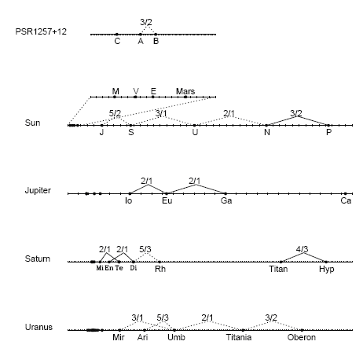
Figure 1.2.1. Mean-motion resonance in Solar System (Malhotra, 1998).

The ongoing effort to detect extrasolar planetary systems yielded over 1300 systems, about 40% of which have multiple planets. Many planets have Jovian masses located relatively close to their stars with orbital periods of 8–10 days. A significant amount of all known multiplanetary systems exhibit period commensurabilities that might indicate the presence of low-order MMRs. The majority of these MMRs are 2/1 and, by descending order, 3/2, 5/2, 3/1, 4/1, and 4/3 [online exoplanet orbit data base (Wright et al., 2011a; Antoniadou, 2016)].
To mention a few of the studies regarding exoplanets in MMRs, Laughlin and Chambers (2001) used N-body integrations of orbital parameters based on a best-fit solution to the data of Keck and Lick. The results show that the two planets orbiting GJ 876 are librating about the 2/1 MMR. In a similar way other systems were found be in MMRs; for example, 55 Cnc in 3/1 (Zhou et al., 2004) and HD82943 (Lee et al., 2006). Wright et al. (2011b) show that the frequency of MMRs in planetary systems (one in three at that time) is too high to be regarded as random. This result suggests that scattering and migration mechanisms, similar to those that generated MMRs in the Solar System, are also relevant for extrasolar systems.
What are the possible origins of MMR configurations?
Protoplanets can migrate into MMR configurations due to large-scale changes in their planetary orbit. According to numerous studies, this change can occur via three basic physical mechanisms:
- Gas-disk migration: According to this model, planets, once embedded in the protoplanetary gas disk, undergo a differential convergent orbital migration as a result of the energy and angular-momentum exchange between the planets and the gas disk (see, e.g., Kley, 2004; Papaloizou & Szuszkiewicz, 2010; Ketchum, Adams & Bloch, 2011). This is considered the main mechanism responsible for instigating a MMR configuration, and especially the 2/1 and 3/1 configurations, before the dissipation of the protoplanetary gas disk (see, e.g., Snellgrove et al., 2001; Lee & Peale, 2002; Lee et al., 2009; Kley et al., 2004, Thommes, 2005; Pierens & Nelson, 2008; Raymond et al., 2008).
- Planetesimal-driven migration: This type of migration becomes effective after the dissipation of the gas disk. It can make planets move into and out of MMR configurations due to their interaction with an outer planetary disk (Fernandez & Ip, 1984; Hahn & Malhotra, 1999; Ida et al., 2000; Gomes et al., 2004, 2005; Thommes et al., 2008; Kirsh et al., 2009).
- Planet-planet scattering: This occurs when an initially unstable system of planets evolves under mutual planet-planet gravitational forces (see, e.g., Raymond et al., 2008). The system evolves chaotically until planets start crossing each other’s orbit and are ejected from the system. The planets that are not ejected migrate closer to the star as a consequence of energy loss (Rasio & Ford, 1996; Weidenschilling & Marzari, 1996; Lin & Ida, 1997) and form MMR configurations.

In addition to these mechanisms, Zhang et al. (2010) suggest a hybrid mechanism of both scattering and collision for the formation of a 2/1 librating-circulating resonant configuration presumably formed in the early stages of the planetary system’s dynamical evolution.

Stability and instability of three-body system in mean-motion resonance

Causes and origins of instability
The stability of a general three-body system depends on the amount of energy exchanged between the orbiting masses. If the energy is high enough, the system becomes unstable in the sense that eventually one of the bodies is diverted and thrown out of the system (Mardling, 2008) or is eliminated after a collision with another body.
Two important stability criteria exist for the circular, restricted, three-body problem (Nakamura & Yoshida, 1992; Deck et al., 2013):
- The Hill stability criterion outlines the region of possible motion, so we can estimate whether the massless particle undergoes a close encounter with one of the major bodies and practically gets captured by it or escape from the system completely. Marchal & Bozis (1980) extended the Hill criterion to the general three-body problem.
- Lagrange stability tells us if the orbit of the massless body will suffer considerable changes due to the repeated gravitational interaction with the other bodies in the system—a change that can eventually lead to a collision or ejection of the negligible mass.

As discussed in the previous section, the gravitational perturbation generated by and upon the three-body masses may be stronger if the system is in MMR. The reason for that phenomenon lies in the fact that, when a system is not in MMR, each conjunction of the two minor bodies occurs around a different celestial longitude, so all resonance arguments of the disturbing function circulate and the gravitational forcing is negligible. The situation differs when a system is in MMR. In this situation, the perturbations may sum coherently and eventually induce major changes in the orbital elements (mostly on the semimajor axis, eccentricity, and inclination) and cause close encounters or even eject the perturbed body out of its current orbit. Koriski & Zuker (2011), in a statistical study based on observations, and Barnes et al. (2015), in a study based upon numerical models, suggest that systems in MMR may be systematically younger than those not in MMR. Thus, generally, MMR may be a passing phenomenon because it provokes instability of celestial systems. In the previous section, we discuss the destabilization potential of MMR due to accumulation of perturbations in repeated conjunctions.

The major aspect of MMR, vis-à-vis this study, is that, by influencing the orbital parameters of planets, it plays an ambiguous role in the long-term evolution of planetary systems. Theoretically, the orbital changes, induced by MMR, can lock a planetary object into a stable quasiperiodic orbit for a substantially long time or, alternatively, distort the object motion and eject it completely out of the system or drive it into the capture zone of one of the other system masses. Thus, MMR is an intriguing phenomenon that can either support the stability of planetary motion and protect it against close encounters and collisions or, conversely, can intensify the gravitational perturbations and induce instability and destruction of orbits (Asghari et al., 2004, Malhorta et al.).

Bois et al (2003) demonstrate this ambiguous function of MMR by presenting the subtleties of the necessary initial configuration conditions under which the extrasolar system HD 160691, with two minors and orbiting star , will stay stable:
- The planets should be in MMRs with a 2/1 commensurability.
- The system should have a MMR configuration of , so the minors and are initially positioned at their apastrons.
This initial spatial configuration combined with the 2/1 MMR ensures that, after one revolution of the inner planet , planet is at its periastron and, after one more revolution, the planets are again near their apastron. Thus, under these terms, the MMR maintains long-term orbital stability by minimizing the magnitude of perturbations exerted on each planet by the others and by reducing the probability of close encounters.
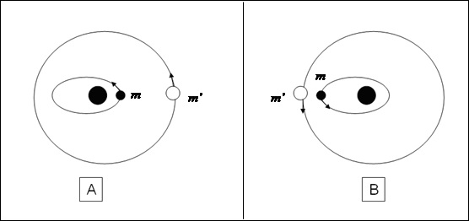
Figure 1.3.1.1. (a) Stable and (b) unstable close encounters in a three-body system.
In conclusion, regarding the system configuration, MMR can provoke instability if it forces the two bodies to pass each other when the inner mass is at its apastron and the outer mass is at its periastron [Fig. 1.3.1.1(b)], a celestial configuration that provides a significant forcing. Nevertheless, in an inverted configuration [Fig. 1.3.1.1(a)], MMR may support stability if it guarantees repeated encounters at the largest possible distance where the gravitational perturbation is minimal.

Once a MMR configuration is established, the planets might be trapped and stay locked in it. The MMR trap usually occurs when the planet’s energy and angular momentum summed by the MMR equals and thus compensates for the energy and angular-momentum loss due to external dissipation. It may even survive the tidal interaction between the planets and the gaseous protoplanetary disk that carried the planets to its current location (Mustill & Wyatt 2010). Nevertheless, mechanisms exist to disrupt the MMR so planets initially locked in resonance might migrate out of their resonance configurations. Studies about stability and evolution of MMR offer various mechanisms that could provoke instabilities and disrupt the resonance.
Adams et al. (2008), followed by Lecoanet et al. (2009), showed that, due to magnetorotational instability, the effects of turbulence in the protoplanetary gas disk could compromise resonant configurations. Thus, if turbulence is present, only a small percentage of the extrasolar systems that produced MMR configurations during their early life will retain their resonances over typical disk lifetimes of 1 Myr.
Hadjidemetriou (2002) studied the issue of stable and unstable resonances. He showed, in particular, that a planetary system in a 2/1 resonance is unstable if the mass of the outer planets is less than that of the inner planet. Others showed that strong stochastic forcing, resulting from turbulences within the protoplanetary disk, can affect and disrupt MMRs (Adams et al., 2008; Leconanet et al., 2009; Rein & Papaloizou, 2009a).
Thommes et al. (2008) and Gomes et al. (2005) raised the possibility that the violent breakup of closely packed, resonantly locked planets is a common evolutionary phenomenon in many planetary systems. Thus, systems currently observed to be in MMRs represent only the survivors of a much larger, primordial, resonance population. They show that interaction with a gas disk may create young planetary systems stabilized by MMRs but, on longer timescales, after the gas with its dumping effect is gone, the gravitational effect of the remnant planetesimal disk pulls these configurations apart, eventually inducing dynamical instability. These instabilities may have caused the late heavy bombardment of asteroids in our Solar System once Jupiter and Saturn crossed there mutual 2/1 MMR.

Chaotic instability
Another phenomenon that provokes instability arises from the chaotic nature of three-body systems (Lecar et al., 2001).
Chaotic behavior is a feature of nonintegrable problems, which includes the three-body problem. It is characterized by an evolution of motion that is extremely sensitive to initial conditions. Thus, no complete analytical solutions to the problem exist and we cannot predict the future state of the system even if we know all the forces currently acting on it. The magnitude of the chaos in the system is frequently determined by the maximum Lyapunov characteristic exponent, a quantitative measure of the rate at which two nearby phase-space trajectories diverge (Murray & Dermott, 1999).
When the motion is chaotic, the evolution of the phase-space distance between the two initially proximate particles at a given time is
, (1.3.2.1)
where is the distance between the trajectories at time and is the maximum Lyapunov characteristic exponent (Fig. 1.3.2.1).

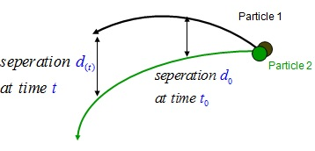
Figure 1.3.2.1. Divergence of two particles in phase space.

The elapsed time for this e-folding separation is called the Lyapunov time .
Chaos in a dynamical system does not imply a disordered system, but rather a deterministic dynamical system that behaves in an irregular manner (Malhotra et al., 2001).
Note also that chaotic behavior does not necessarily imply system instability, so we should not confuse chaos with instability (Bois et al., 2003).
In Poincaré mapping, the meaning of “chaotic” is dynamical behavior that is not quasiperiodic; it does not necessarily mean that the system will eventually disintegrate. Nevertheless, chaos can provoke instability if it induces a change in the orbital parameters that eventually results in significant perturbations due to a close encounter with a massive planet.

In addition to the Lyapunov-time criterion, several analytical tools have been developed to describe chaotic behavior in planetary systems:
- The law (Wisdom, 1980; Duncan et al., 1989) was developed for the circular-planar restricted three-body problem and offers a criterion to determine whether a perturbed test particle is in a chaotic orbit. The law states that a test particle with semimajor axis that satisfies the equation

(1.3.2.2)
will have a chaotic orbit, where is the perturber mass divided by the total mass of the system (primary plus perturber) and is the perturber semimajor axis.
- Lecar et al. (1992a; 1992b) numerically integrate the Solar System polynomial dynamics and provide a relation between the Lyapunov time and the event time . The event time is the time required for a small body (e.g., a main-belt asteroid) to increase its eccentricity until it crosses the orbit of a planet and probably collides with it to be removed from the system. The relation between the two times is
, (1.3.2.3)
where is the orbital period of the main perturbing body and a and b are coefficients obtained from a fit to the particular system.
- Following Lecar et al. (1992a; 1992b), Murray & Holman (1997) developed the following analytical expression to quantify the time it takes a small body in the Solar System to be removed from the system due to a close encounter: , (1.3.2.4)
- where is the removal time, and are system constants, and and are the particle initial and maximal eccentricities in the Hamiltonian form (for low eccentricities ).

The identification of specific orbits as chaotic becomes clear upon observing the Poincaré surface of section map. While the MMR orbits are represented as points along smooth closed curves called “islands” [Fig. 1.3.2.2(a)], chaotic orbits are represented by points that fill the entire area of the phase space [Fig. 1.3.2.2(b)]. A further examination of the Poincaré map reveals that some of the chaotic orbits have a tendency to “stick” to the edges of the MMR islands. This phenomenon demonstrates a fundamental characteristic of chaotic behavior: chaotic orbits might “disguise” themselves as regular orbits over relatively long timescales. In accordance, numerical simulations show that, although planets follow chaotic orbits, they may remain near their current orbits during the entire Solar System lifetime and even much beyond. For instance, the escape time of Uranus out of the Solar System due to chaotic motion is years (Murray & Holman, 1999).

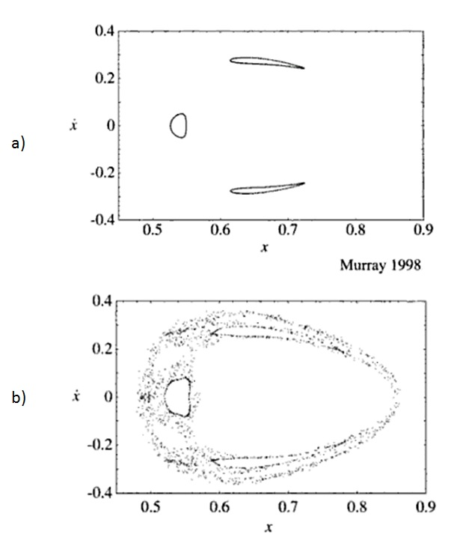
Figure 1.3.2.2. (a) Poincaré surface of section of a third-order MMR shows three smooth curves (islands). The number of islands is equivalent to the order of resonance. ( b) Chaotic trajectories are represented as regions of dots that stick to the resonance islands.

Today, no doubt remains that chaotic behavior exists in our Solar System. Murray & Holman (1999) confronted the analytical theories that earlier claimed that the Solar System is stable and, by using numerical integration, showed that our Solar System is almost certainly chaotic. Indeed, according to numerical integrations, planetary objects in our Solar System exhibit a chaotic behavior (see, e.g., Laskar, 1989; Laskar, 1990; Quinn et al., 1991; Murray & Holman, 1997). The result of integration over 100 Myr of the entire Solar System indicates that the system is chaotic, with a Lyapunov timescale of (Sussman & Wisdom, 1992).
Tsiganis et al. (2005) conclude that of the main-belt objects follow chaotic orbits with Lyapunov times , although many of them are defined as being in a stable chaos. In other words, they have chaotic orbits that, although generating significant changes in orbital parameters, do not result in close approaches between planets and thus do not induce a significant instability.

A three-body system in MMR can undergo large-scale chaos. When in MMR, at least one resonance argument in the disturbing function is librating. If only one resonance argument librates and all others circulate, the system is in a stable resonance. However, if more than one argument librate, they may exert forces on each other in a phenomenon known as resonance overlap, thereby provoking chaotic motion and destabilizing the system (Laskar, 1990; Murray & Dermott, 1999; Mardling, 2008). The extent of chaos depends on the stochasticity parameter , which is a function of the separatrix width divided by the phase-space distance between resonances. For small the chaos is small but for the region close to the MMR zone is primarily chaotic.
An orbit that librates part of the time and rotates the remaining time must cross the separatrix and is thus chaotic. This type of dynamical behavior in which the resonance angle of a planetary system
continuously executes a series of librations and circulation cycles is also known as “nodding.”
Ketchum et al. (2013) studied this type of irregular dynamics regarding exoplanetary systems that orbit in or near MMR.
By using full numerical integrations of the planetary systems and model equations, they showed that these systems can exhibit nodding behavior, which often occurs when a small body is in an external MMR with a larger planet. They conclude that this phenomenon can be important for interpreting observations of transit timing variations, where the existence of smaller bodies is inferred from their effects on larger, observed transiting planets.

The chaotic effects on a three-body system can be relatively slow in case of a phenomenon called “chaotic diffusion.” It exists in celestial systems with high-order MMRs and causes very slow but systematic changes in orbital elements. The elements, and especially the eccentricity and inclination, tend to drift systematically and, eventually, reach substantial values (see, e.g., Morbidelli, 2001; Gozdziewski & Migaszewski, 2009;Tiscareno & Malhotra, 2009).

The notion that planetary particles undergo chaotic diffusion is rather new and was discovered once computers could cope with long-term numerical integrations. Until the 1990s, short-term integrations required for the evolution of small planetary objects (e.g., in the Kuiper Belt) presented either rapid instabilities or stable systems. Long-term integrations ( timescales) tended toward a slow evolution of proper eccentricities and/or inclinations of Solar System bodies caused by overlapping MMRs between the small objects and one or two planets. This slow but consistent drift can eventually eject and remove an object from its orbit (and subsequently from its MMR region) as a result of close encounters with massive planets. This phenomenon may have removed asteroids from the main belt and from the Kuiper Belt and can generate planet-planet scattering in the Solar System and in extrasolar systems.

Tiscareno & Malhotra (2009) ran a numerical integration that showed that chaotic diffusion caused by MMR overlapping forced Kuiper Belt objects out of their MMR region in ~4 Gyr. Wisdom (1987) described the chaotic nature of the gaps in the asteroids’ main belt and showed that the presence of chaos in the 2/1 and 3/1 resonance zones explains the anomaly of the lack of objects in the 2/1 resonance in contrast with the accumulation of objects in the 3/2 resonance (Fig. 1.3.2.3). According to Wisdom (1987), the chaos generates high eccentricities (), which force asteroids orbiting near this region to cross the orbit of Mars and to be ejected out of orbit and out of the resonance zones due to close encounters or collisions. This phenomenon can also explain the continuous delivery of asteroid debris from the asteroid belt to Earth.

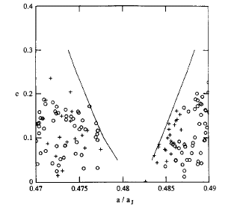
Figure 1.3.2.3. Comparison of actual distribution of asteroids near the 3/1 MMR with outer boundaries of the chaotic zone. Circles denote TRIAD asteroids and crosses denote Palomar–Leiden asteroids (Wisdom 1987).

Tsiganis et al. (2005) present possible chaotic behavior in another part of the Solar System: the Jupiter Trojans. By using the SWIFT package (Levinson & Duncan, 1994) they ran numerical integrations representing the dynamical changes over on a specific Trojan population with chaotic orbits (using Lyapunov time on the order of ). By using the experimental data they showed that 17% of these Trojans exhibit unstable orbits over the Solar System age while 20% undergo stable chaotic motion (i.e., chaotic orbits that do not provoke instability during the of the numerical run).
Most of the studies investigated chaos and chaotic diffusion behavior of small bodies (e.g., asteroids) which could be regarded as test particles. Nevertheless, a first article on the chaotic diffusion of planetary orbits was presented by Laskar (1994). Later, Laskar (2008) statistically analyzed over a thousand different 5 Gyr integrations of the secular equations. For each planet in the Solar System, the paper reported the probability for the eccentricity to obtain large values via chaotic diffusion. The results show that, on a 5 Gyr timescale, the four terrestrial planets might undergo a chaotic diffusive process whereas the outer giant planets do not show significant diffusion.
Chaos is probably most common in extrasolar planets as well. The ever-growing operational and technological effort made in recent years to discover new planetary systems has yielded substantial information about the planets’ dynamical behavior. The accuracy of the data regarding orbital elements enables us, for the first time, to better investigate the coexistence of MMR and chaos in these remote systems.
Antoniadou (2016) used a numerical model of the three-body problem and described a method to find stable, nonchaotic regions in phase space where extrasolar planets in MMR should be hosted to guarantee long-term stability. He applied this process to co-orbital motion and to the systems HD 82943, HD 73526, HD 128311, HD 60532, HD 45364, and HD 108874.
Gayon et al. (2008) used frequency map analysis, mean exponential growth of nearby orbits (MEGNO, Cincotta & Simó 2000), and the SYMBA numerical integrator (Duncan et al. 1998) to show that the five planets orbiting 55 Cnc represent a case of stable chaos.
Bois et al. (2003) applied the MEGNO and fast Lyapunov indicator techniques to find the conditions that ensure dynamical stability for the HD 160691 system (Fig. 1.3.4).
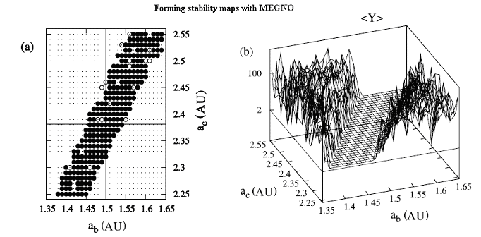
Figure 1.3.2.4. Example of (a) two-dimensional and (b) three-dimensional stability maps for the HD 160691 extrasolar system formed with the MEGNO tool. In panel (a), filled and open circles indicate stable orbits and small dots not surrounded by circles indicate highly unstable orbits. In panel (b), the peaks indicate the magnitude of the instability. The quantity <Y> is the characteristic value of the MEGNO indicator (Bois et al., 2003).

Driven pendulum

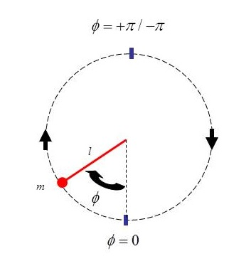
Figure 1.4.1. The simple pendulum.

As mentioned in section 1.3, the behavior of each argument within the disturbance function reveals whether the system is in a MMR state (thus named the “resonance arguments”) (Murray & Dermott, 1999; Mardling, 2008). When at least one of the resonance arguments librates with small amplitude around a specific angle we say that the system is in MMR.
The kinematics of each of the resonance arguments that constitutes the Legendre expansion of the disturbing function can be simulated by a simple pendulum excited by a periodic force.
The simple pendulum consists of a massless rigid rod of length attached to a frictionless pivot point, with a point mass fixed to the end of the rod (Fig. 1.4.1). The motion of the pendulum is described by
, (1.4.1)
where is the angular displacement of the pendulum with respect to its downward equilibrium position and is the small-angle frequency that equals .

We can explain the similarity between the pendulum motion and the resonance-argument motion by deriving the equation of motion of the argument for the planar, circular, restricted problem:
. (1.4.2)
The second time derivative of the resonance argument in Eq. (1.4.2), assuming a negligible change in the mean motion of the perturber (so ), gives
. (1.4.3)
If we neglect the small contribution of and we can write
, (1.4.4)
where
(1.4.5)
and
. (1.4.6)

Therefore,
, (1.4.7)
so
, (1.4.8)
which is identical to the simple-pendulum equation (1.2.1)
when
. (1.4.9)
Note that, for odd-order resonances, the stable motion of the pendulum is around and for even-order resonances, the stable motion is around .
The pendulum obeys conservation of energy, with energy E defined by
. (1.4.10)

The separatrix is the border in phase space that separates the two possible motions of the pendulum: the libratory motion, where the pendulum oscillates with amplitude , and the circulatory motion in which the amplitude moves unbounded
(Murray & Dermott, 1999; Mardling, 2008).
The equation that describes the separatrix in phase space is
. (1.4.11)

For convenience, we choose zero energy to correspond to the separatrix.
Thus, in our study a negative energy implies libration and a positive energy implies circulation (Fig. 1.4.2).

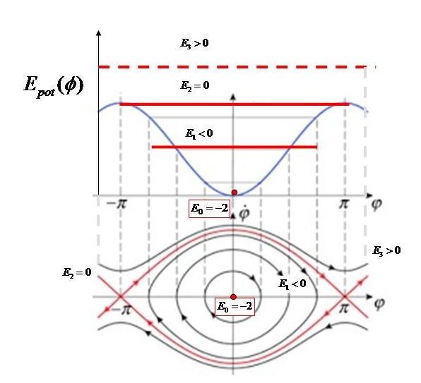
Figure 1.4.2. Lower diagram: Pendulum libratory and circulatory trajectories in phase space () with four corresponding energy values: Pendulum at rest in lower vertical position (), libration (), at the separatrix (), and circulation (). The separatrix is drawn with red lines. The points are hyperbolic fixed points, unstable with respect to small angular displacements, whereas the origin is a fixed point that is stable with respect to small displacements.
Upper diagram: Four potential energies on a graph of energy vs pendulum amplitude .

If we exert a simple driving force on the pendulum, the system will cease to be energy preserving and its energy level and motion will be influenced by the amplitude, frequency, and phase of the driving force. For instance, in our second study (i.e., “Peak-to-Peak Distance Statistics of Energy Time Series in the Periodically Driven Pendulum”), we apply a periodic forcing of the form

, (1.4.12)

where A and are, respectively, the driver amplitude and frequency and is a randomly chosen phase shift.

To demonstrate the evolution of the pendulum motion as a function of its instantaneous energy level, we integrate Eq. (1.4.12) with initial conditions under fixed, arbitrary, driver frequency, amplitude, and phase shift. As shown in Fig. 1.4.3, by changing the driver amplitude A, we regulate the mean energy level in the system.
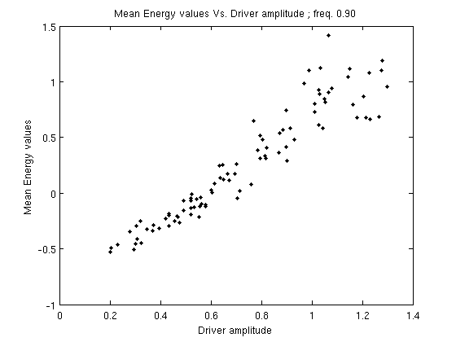
Figure 1.4.3. Mean-energy vs periodic driver amplitude for and randomly drawn pairs of , .

For sufficiently small amplitude, the mean energy of the system remains negative and the pendulum maintains its initial librating state. Upon increasing the driving amplitude, the mean energy of the pendulum also increases and the phase-space trajectories approach the separatrix. This is where the motion becomes irregular (and possibly chaotic).
In this irregular state, the system occasionally crosses the border between negative and positive energy levels. Thus, in this interval, the behavior is more complex and unstable in the sense that it is neither purely librating nor circulating but exhibits a mixed composition of both modes of motion (Fig. 1.4.4). Despite the irregular behavior, this type of motion is not random but deterministic (Chirikov, 1979; Hilborn, 1994; Murray & Dermott, 1999; Gonzalez, Reyes & Suarez, 2002; Mardling, 2008; Celletti 2010).
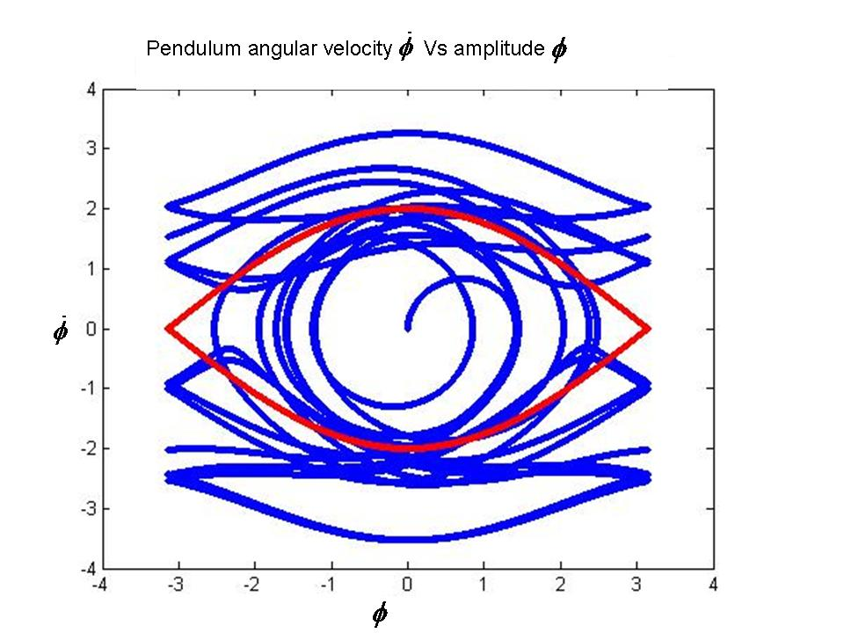
Figure 1.4.4. The blue trajectory displays the chaotic, libratory-circulatory trajectory of a driven pendulum in phase space (angular velocity vs amplitude ). The separatrix is in red. The motion starts at and occasionally crosses the separatrix borders from the libratory to the circulatory region and vice versa.

The evolution described of the argument of the driven pendulum simulates the behavior of a librating resonance argument of a three-body system in MMR when the system is being disturbed by one or more librating resonance arguments with commensurabilities that overlap that of. When an overlap exists, the energy exchange between the two binaries is done efficiently enough to provoke chaos of such magnitude that the resonance is broken and the three-body system is destabilized. Thus, the existence of resonance overlap serves as a diagnostic test and a criterion for strong chaos and instability, which is expressed by the transition of the resonance-angle motion from libration to circulation, indicating chaotic motion (see, e.g., Laskar 1990).
For this reason, driven pendulums are commonly used as toy models to investigate the dynamic behavior and general laws of other, more complex, nonlinear chaotic systems (Butikov, 2002) and, in particular, celestial dynamics phenomena such as the spin-orbit coupling (Celletti, 2007) or the near resonance behavior of three-body celestial systems. The latter issue is discussed in detail in our studies.

Algebraic mapping
Since the driven pendulum and the three-body problem are nonlinear systems, their motion cannot be solved analytically; thus, numerical methods are used. These numerical methods are based on “algebraic mappings” where the continuous motion is divided into time steps and the subsequent state of the system , is mapped from the previous state .
A rather simple, one-dimensional mapping is the “logistic map,” which was originally developed to simulate biological growth of animal populations and was later recognized as an efficient tool for the study of chaos. It takes the form
, (1.4.13)
where, for , the trajectory of the logistic map is stable and periodic but, for , the trajectory becomes chaotically unstable (we come back to the logistic map in the second study).
Another useful mapping is the “standard map,” which is an algebraic mapping of the driven pendulum. Its formulation is as follows:
The Hamiltonian of the simple pendulum is
, (1.4.14)
where and are, respectively, the action and angle variables.
Thus,
(1.4.15)
and
. (1.4.16)
After subjecting the simple pendulum to an oscillating perturbing force, we obtain
(1.4.17)
The approximation of the right-hand side of the equation is achieved by assuming that the cosine term is applied only at discrete intervals.
Applying the Dirac function to simulate an impulse of the exerted force every , we finally obtain the new Hamiltonian
, (1.4.18)

for which the equations of motion are

(1.4.19)
and
. (1.4.20)

Integration of the above equations gives

(1.4.21)
and

. (1.4.22)

Applying time steps of at each iteration, the discrete solutions for the driven pendulum is given by the two-dimensional set (Hilborn, 1994; Murray & Dermott, 1999)

, (1.4.23)

. (1.4.24)

The parameter is called the “perturbing parameter” and measures the nonlinearity of the system.
The standard map was already studied in many works since it was first presented by Chirikov in his famous article “A Universal Instability of Many Dimensional Oscillator Systems” (Chirikov, 1979).
When an agent exerts an external dissipative force on the system the standard map takes the form of the “generalized dissipative standard map,”

, (1.4.25)

, (1.4.26)

where the parameter is called the “dissipative parameter” (i.e., when the system is conservative)
(Celletti, 2007).

To demonstrate the behavior of the standard map we slightly modify Eqs. (1.4.25) and (1.4.26) and integrate the following equations:

, (1.4.28)

. (1.4.29)
Figure 1.5.1 presents the result of the integration for , with initial conditions of , and the dissipation parameter growing from to .
As grows, evolves from stable single-period motion to bifurcation of 2, 4, 8 periods, etc. At , the motion of becomes chaotic.

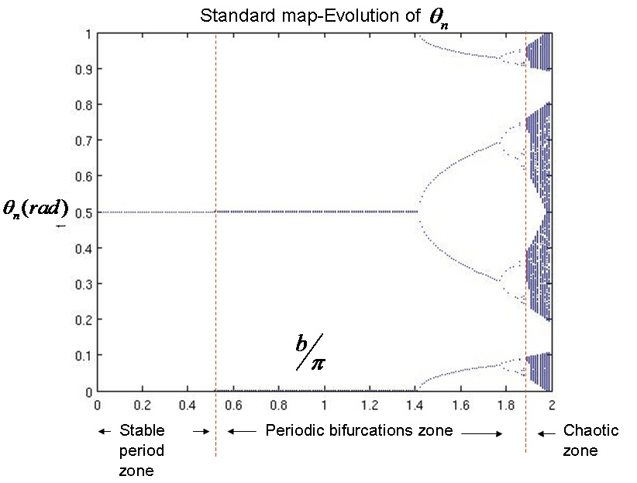
Figure 1.5.1. Evolution of in standard map for initial conditions , . The dissipation parameter grows gradually from to . As grows, moves from stable periodic motion to period bifurcations and, eventually, to chaotic behavior.

First study: On the ages of planetary systems with mean-motion resonances
Shuki Koriski and Shay Zucker
Department of Geophysics sciences, Raymond and Beverly Sackler Faculty of Exact Sciences, Tel Aviv University, Tel Aviv 69978, Israel; jehoshu1@post.tau.ac.il, shayz@post.tau.ac.il
Received 2011 August 11; accepted 2011 September 13; published on the astrophisical journal
on 2011 October 14

Study preface
In this first study the goal was to determine if MMRs are an eternal phenomena or if MMR configurations tend to break down over time, as suggested in several studies (see, e.g., Gomes et al., 2005; Thommes et al., 2008). To check this ambiguity, we measured the average age of systems in MMR against the average age of systems that are not in MMR. If MMR tends to vanish, we would expect to see a shortage of MMRs around older stars. The results indicate that only stars hosting planets with a 2/1 period commensurability are significantly younger statistically. All other PCs do not show such an age correlation; nevertheless, these results provide significant evidence to support the claim that MMRs are not eternal.

Study abstract
We present preliminary but statistically significant evidence that shows that multiplanetary systems that exhibit a 2/1 period commensurability (PC) are in general younger than multiplanetary systems without commensurabilities, and even younger than systems with other commensurabilities. An immediate tentative conclusion is that the 2/1 MMR in planetary systems typically tends to be disrupted after a few Gyr.

Note: For the scientific introduction, please see sections 1.1–1.3 of the general introduction.

Sample
We first built a sample of stars hosting known multiplanet systems by using the publicly available exoplanet orbit database put online by Wright et al. (2011a). To make our sample as homogeneous as possible, we consider only planets that were detected by radial velocities around stars of spectral types F, G, or K. We thus exclude most known transiting planets (except those detected first through radial velocities), pulsar planets, planets detected in direct imaging, planets around M stars, and Solar System planets.
Next, we identified those systems that exhibit PCs. We include in our definition of commensurabilities integer ratios greater than unity and with a denominator less than six (i.e., the ratios 2/1, 3/1, 3/2, 4/1, 4/3, 5/1, 5/2, 5/3, and 5/4). To tag two periods as commensurate, we define a “normalized commensurability proximity” score defined by
, (2.1.1)
where is the actually measured period ratio and is the commensurability ratio against which we compare . We choose to tag as commensurate systems with at least one instance of normalized commensurability proximity .
Next we estimate the ages of the stars in our sample. Stellar age is notoriously difficult to estimate. Soderblom (2010) reviewed and compared several approaches to estimate age. Two approaches dominate the literature: The first uses the stellar activity as estimated by the H and K lines of singly ionized calcium in the stellar spectrum. The second places a star on model isochrones on the Hertzsprung–Russell diagram. Both methods, and the less frequently used methods, are strongly model dependent and suffer many drawbacks and pitfalls.
For the sake of sample homogeneity, we focus purely on a single approach. Furthermore, Figure 8 in the paper by Soderblom (2010) shows that, in addition to a prevailing systematic shift between isochrone age and chromospheric-activity age, the isochrone age might lose its sensitivity for stars younger than about 2 Gyr. Thus, we only use chromospheric-activity age based on the calcium H and K emission lines. To avoid nonuniform interpretation of observations, we extract the chromospheric-activity age only from large published surveys and not from papers that analyze individual stars. Our use of chromospheric-activity ages also provides another reason to exclude M stars from our sample, because M stars are notorious for having variable activity (Soderblom, 2010).
Table 2.1 presents the resulting sample of commensurate planetary systems, including the relevant commensurability ratios and the normalized commensurability proximity. The table also lists the chromospheric-activity ages from the literature and the average age that we computed from these values. Table 2.2 lists the systems that did not satisfy our criterion for PC () and their relevant ages. In both tables, we also include systems for which no chromospheric activity age appears in any large published survey. In total, our sample conveniently includes 15 age estimates for commensurate systems and 15 for noncommensurate systems.

Table 2.1
Sample of commensurate multiplanetary systems.

HD | HIP | Other Names | Commensurabilities | Normalized Commensurability Proximity | Published Ages (Gyr) | Reference | Mean Age (Gyr)
9826 | 7513 | υ And | 5/1 | 0.058 | 6.31, 5.32, 6.23, 7.26 | 1,2,3,4 | 6.28
10180 | 7599 | ... | 4/1, 5/1, 5/2, 3/1, 3/1 | 0.087, 0.022, 0.014, 0.014, 0.055 | 6.46 | 5 | 6.46
37124 | 26381 | GJ 209 | 2/1 | 0.048 | 3.89, 3.33, 4.72 | 1,2,3 | 3.98
40307 | 27887 | GJ 2046 | 2/1, 5/1 | 0.061, 0.052 | ... | ... | ...
45364 | 30579 | ... | 3/2 | 0.007 | 4.87 | 5 | 4.87
60532 | 36795 | GJ 279 | 3/1 | 0.000 | ... | ... | ...
69830 | 40693 | GJ 302 | 4/1 | 0.094 | 4.68, 6.36, 6.43, 6.1 | 1,3,4,6 | 5.89
73526 | 42282 | ... | 2/1 | 0.004 | 5.59 | 2 | 5.59
75732 | 43587 | 55 Cnc | 3/1 | 0.010 | 6.46, 5.5, 6.44, 3.43, 8.7 | 1,2,3,5,6 | 6.11
82943 | 47007 | ... | 2/1 | 0.002 | 4.07, 3.08, 5.10 | 1,2,3 | 4.08
... | ... | BD +20 2457 | 5/3 | 0.021 | ... | ... | ...
90043 | 50887 | 24 Sex | 2/1 | 0.029 | ... | ... | ...
108874 | 61028 | ... | 4/1 | 0.063 | 7.41, 7.26 | 1,2 | 7.33
115617 | 64924 | 61 Vir | 3/1 | 0.075 | 6.31, 5.90, 6.62, 6.1 | 1,3,4,6 | 6.23
128311 | 71395 | GJ 3860 | 2/1 | 0.017 | 0.39, 0.43 | 2,4 | 0.41
155358 | 83949 | ... | 5/2 | 0.084 | 5.32 | 3 | 5.32
160691 | 86796 | μ Ara | 2/1 | 0.035 | 6.41, 3.31, 6.5 | 2,5,6 | 5.41
181433 | 95467 | GJ 756.1 | 5/2 | 0.087 | ... | ... | ...
183263 | 95740 | ... | 5/1 | 0.011 | 8.13, 7.38 | 1,3 | 7.75
200964 | 104202 | ... | 4/3 | 0.008 | ... | ... | ...
202206 | 104903 | ... | 5/1 | 0.076 | 2.04, 2.95 | 2,7 | 2.49

References. (1) Wright et al., 2004; (2) Saffe et al., 2005; (3) Isaacson & Fischer, 2010; (4) Maldonado et al., 2010; (5) Rocha-Pinto & Maciel, 1998; (6) Mamajek & Hillenbrand, 2008; (7) Arriagada, 2011.

Table 2.2
Sample of noncommensurate multiplanetary systems.

HD | HIP | Other Names | Published Ages (Gyr) | Reference | Mean Age (Gyr)
9446 | 7245 | ... | ... | ... | ...
11964 | 9094 | GJ 81.1A | 9.55, 9.56 | 1,2 | 9.55
12661 | 9683 | ... | 7.41, 7.05, 7.05 | 1,2,3 | 7.17
... | 14810 | ... | 7.77 | 3 | 7.77
38529 | 27253 | ... | 4.90, 5.09, 6.73 | 1,2,3 | 5.57
47186 | 31540 | ... | 2.72, 8.13 | 5,7 | 5.43
74156 | 42723 | ... | 7.24, 7.38, 7.54 | 1,2,3 | 7.39
... | 40967 | BD -08 2823 | ... | ... | ...
95128 | 53721 | 47 UMa, GJ 407 | 6.03, 6.03, 6.10, 4.93, 4.4 | 1,2,3,4,6 | 5.50
125612 | 70123 | ... | 4.23 | 3 | 4.23
134987 | 74500 | 23 Lib, GJ 579.4 | 7.76, 7.32, 8.12 | 1,2,3 | 7.73
147018 | 80250 | ... | 3.16 | 7 | 3.16
168443 | 89844 | GJ 4052 | 8.51, 5.90, 8.19 | 1,2,3 | 7.53
169830 | 90485 | ... | 7.24, 4.95 | 1,2 | 6.09
187123 | 97336 | ... | 6.31, 5.33, 6.59 | 1,2,3 | 6.08
190360 | 98767 | GJ 777A | 7.76, 7.09, 8.6 | 1,2,6 | 7.82
215497 | 112441 | ... | ... | ... | ...
217107 | 113421 | ... | 7.41, 7.32, 8.19 | 1,2,3 | 7.64

Note. For references, see Table 1.

Statistical tests
The mean chromospheric-activity age of commensurate systems in our sample is 5.213 Gyr, whereas that of the noncommensurate systems is 6.577 Gyr. This difference of 1.36 Gyr hints that resonant systems tend to be younger on average. To test this hypothesis, we adopted the simplest approach: the permutation test (Good, 1994). Thus, we repeatedly drew a random assignment of the ages from the two samples, effectively destroying any correlation that may have existed between age and commensurability. For each such random assignment we recalculated the mean age difference. We used 106 random assignments, among which 20 650 yielded an age difference larger than 1.36 Gyr. This implies a statistical significance of p = 0.021.
The main advantage of the permutation-test approach is to avoid the need to assume any special assumptions about the distribution of the samples. However, one may still argue that the use of the mean values is prone to strong influence by the extreme values in each sample. An alternative is to use the median instead, which is more robust against extreme values. The median age of the resonant systems is 5.59 Gyr and that of the nonresonant systems is 7.17 Gyr, which gives a difference of 1.58 Gyr. We repeated the permutation test, this time obtaining 17 178 out of 106 values larger than the actual value. Thus, the permutation test for the medians leads to a somewhat more significant result, with a significance of p = 0.017.
These results are only marginally significant. They do seem to point to a tendency of the commensurate systems to be younger than the noncommensurate systems, but their statistical significance is not high. Further examination of the sample shows that the tendency we observe may be attributed only to the 2/1 PC systems. Close examination of Table 1 hints that the subset of the 2/1 PC systems (HD 37124, HD 73526, HD 82943, HD 128311, and μ Ara) seems to possess lower ages. The two additional 2/1 PC systems HD 40307 and 24 Sex do not have an age estimate and thus do not contribute to the statistical significance. Because the number of 2/1 PC systems is much smaller than the total number of PC systems, it is not immediately obvious that this result is statistically significant. We repeated the previous tests, this time dividing the sample into 2/1 PC systems and all the rest. This new division clearly enhances the statistical significance: the “difference in means” test now yields p = 0.007 (6745 out of 106) and the “difference in medians” test gives p = 0.004 (4178 out of 106). The actual age difference is 2.40 Gyr for the difference of means and 2.15 Gyr for the difference of medians.
Further tests that we performed show that the remaining commensurate systems do not exhibit any significant age difference compared with the noncommensurate systems.

Conclusion
The results of this study support the claim that the phenomenon of MMR, which manifests itself as PC, is not generally eternal. The actual numbers we obtain suggest that a typical life expectancy of a 2/1 MMR is around 4 Gyr. For the other families of resonances, we cannot assert at this stage any statistically significant claim, probably because no other category is as populated yet as the 2/1 category.
The above conclusion is extremely simplistic. It does not take into account the details of the orbits involved in the resonance, such as mass ratios or eccentricities. It is also prone to large and significant uncertainties, which are known to plague stellar-age estimates. However, the scarcity of the current data set does not allow for a more detailed and refined analysis.
Our results suggest that the 2/1 resonance stands out among all the resonances. This may very well be the case, as Pierens & Nelson (2008) claim. It might be that the orbital evolutionary history of the 2/1 resonance is unique and different from that of all the other resonances. In fact, Pierens & Nelson (2008) also single out the 3/2 resonance as another preferred outcome of the resonance-trapping scenario. Our analysis may support this because the only 3/2 PC system in the sample (HD 45364) is indeed younger than average (4.87 Gyr). Because only one system is currently in this category, we choose not to include this claim in our tests, even though it would surely improve the statistical significance.
To explain the scarcity of the 2/1 PC among the older systems, some mechanism must be invoked to disrupt them. Thus, our results agree with the claim by Thommes et al. (2008) that breakup (maybe violent) of resonantly locked planets is a common evolutionary step of planetary systems. The fact that non-2/1 resonances seem to survive may hint that their formation is an outcome of a much later stage in the evolution of planetary systems. To test this possibility, it is essential to perform much-longer-term dynamical studies of resonant systems, lasting a few Gyr and more.
To further explore the issue of survivability of MMRs, we also need to refine our knowledge of multiplanetary systems. Specifically, we should compile a more comprehensive data set of stellar ages for multiplanetary systems. Hopefully, with the advent of the recent planet-finding missions, such data will become more abundant.
The results we present in this study constitute only a preliminary attempt to test whether the issue of MMR survival is worth exploring with the tools of stellar-age estimates. Apparently, the existing data partly corroborate the hypothesis presented in section 1, and the 2/1 PC indeed tends to be found in younger systems. This may very well be another window into the understanding of planetary orbital evolution.
This research was supported by the Israel Science Foundation—The Adler Foundation for Space Research (Grant No. 119/07). This research used the Exoplanet Orbit Database and the Exoplanet Data Explorer at http://exoplanets.org.

Second study: Peak-to-Peak distance statistics of energy time-series in periodically driven pendulum
Shuki Koriski and Shay Zucker
Department of Geophysics sciences, Raymond and Beverly Sackler Faculty of Exact Sciences, Tel Aviv University, Tel Aviv 69978, Israel; jehoshu1@post.tau.ac.il, shayz@post.tau.ac.il

Study Preface
We follow up on the first study with the intention to better understand the impact of chaos upon the stability of MMRs in planetary systems. We thus statistically explore the evolution of energy in the driven pendulum while moving from stability to chaos and search for typical patterns that would be useful for exploring the behavior of three-body systems.
Study abstract
We study the statistics of the peak-to-peak (PTP) and trough-to-trough (TTT) distance of energy time series of a periodically driven pendulum during its irregular and chaotic motion near the separatrix.
By controlling the driving-force parameters (i.e., amplitude, frequency, and phase) we force the pendulum trajectories to move near to and, occasionally, to cross the separatrix, moving chaotically between libration and circulation modes of motion. We record the pendulum energy level whenever the driving force completes a full cycle. We measure the distances between every other energy peak and every other energy trough, thus constituting a time series of distances.
We show that a significant difference exists between the standard deviation of the PTP and the TTT distances (i.e., their distributions are different). We further show that the mean PTP and TTT have a typical dependence on the mean-energy levels.
We find that, near the separatrix, the mean PTP and TTT distances reach a minimum of . This value is characteristic of an independent and identically distributed random time series and a logistic map chaotic time series.

Study Introduction
Note: For additional scientific introduction, please see sections 1.1–1.5 of the general introduction.

Statistics of Peak-to-Peak Distance
The peak-to-peak (PTP) distance is a statistical method to find patterns in data sets by investigating the distribution of distances between consecutive peaks in the data. For instance, a long-term study of fox and wolf populations in Canada revealed that the mean distance between adjacent population peaks ranges between 3 and 4 years (Cole, 1951; Newman, 2012).

Newman et al. (2012) studied the PTP distance statistics for several long empirical time-series datasets. Specifically, they prove that the mean PTP in the case of a sequence of independent and identically distributed (i.i.d.) random variables (Fig. 3.1.1.1). They also provide the distribution of the PTP distance m:

, (3.1.1.1)
for integer .
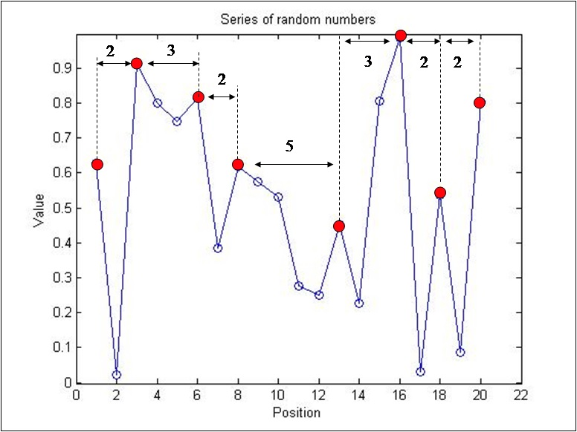
Figure 3.1.1.1. Peak-to-peak distance for a series of 20 i.i.d. random variables. The numbers labelling the horizontal arrows denote the distances between adjacent peaks (red dots).

Besides the case of an i.i.d. sequence, Newman et al. (2012) and Newman (2014) also studied how correlation influences a time series by comparing the i.i.d. PTP statistics with that of a time series generated by a recursion analog of the Langevin equation,

, (3.1.1.2)

where is an i.i.d. random variable and represents the degree of memory or correlation. Newman et al. (2012) and Newman (2014) demonstrate the strong dependence of the mean PTP distance on the memory-related term and show that, between , corresponding to the i.i.d. case, and , corresponding to the Brownian-motion case, an approximately linear rise occurs from to .
Following up on these results, Newman (2012) studied the PTP statistics in the case of the logistic map [Eq. (1.4.13)] in its chaotic configuration () and showed that it has the same mean PTP distance as the i.i.d. sequence (i.e., ) but a completely different distribution:

. (3.1.1.3)

Because there are as many minima as maxima, the mean PTP distance must equal the mean trough-to-trough (TTT) distance. Newman (2012) also suggests that the distribution of the PTP distance should equal the TTT distance in the case of the logistic map at its chaotic state.
Following these previous studies, we study the PTP and TTT statistics for a driven pendulum by focusing on the parameter regime known to invoke irregular behavior.

Forced Pendulum
Here we study a periodically forced pendulum of the form described by Eq. (1.4.1),
,
where and are, respectively, the driver amplitude and frequency and is a phase shift.
Throughout this study, we integrate Eq. (1.4.1) with initial conditions of under fixed, arbitrary driver frequency, amplitude, and phase shift. By changing the driver amplitude we regulate the level of mean energy in the system. For sufficiently small amplitude the mean energy of the system remains negative and the pendulum remains in its initial librating state. Upon increasing the driver amplitude, the mean energy of the pendulum also increases and the phase-space trajectories start approaching the vicinity of the separatrix. This is where the motion becomes irregular (and possibly chaotic), unless the system is periodic or quasiperiodic. In this irregular state, occasionally the system crosses the border between the negative and positive energy levels. Thus, in this interval the behavior is more complex and unstable in the sense that it is neither purely librating nor purely circulating but is a mixed composition of both modes of motion. As mentioned above, the periodically driven pendulum often simulates the behavior of the three-body problem. Thus, this type of dynamical behavior, also referred to as “nodding,” may be prominent among near-MMR extrasolar-planet pairs. There, the resonance angle of the planet pairs will execute several libration cycles, followed by a series of circulations, and then perform a new set of libration cycles (Ketchum, Adams & Bloch, 2013). Despite the irregular behavior, this type of motion is not random but deterministic (Chirikov, 1979; Hilborn, 1994; Murray & Dermott, 1999; Gonzales; Reyes & Suarez, 2002; Mardling, 2008; Celleti, 2010).

Energy Time Series
The angular displacement of the pendulum is a cyclic variable. As such, the local maxima and minima have no meaning for PTP and TTT statistics. Instead, we focus on the instantaneous energy of the pendulum. We use the same definition of energy as used for the simple pendulum, comprising the potential and kinetic energy [Eq. (1.4.10)],
.

To generate these time series, we ran several numerical integrations of the periodically driven pendulum while monitoring the angular displacement and velocity of the system.

For each run we used a Poincaré section of the continuous trajectory by sampling and after every cycle of the driving force and calculating the corresponding energy by using Eq. (1.4.10). Each run comprised cycles of the driving force, and the outcome is a time series of energy values . For each run we define also the mean energy as
. (3.3.1)

We limit our study to an interval of mean-energy levels that are relatively close to the separatrix. This ensures that we witness mixed libration-circulation behavior. We find that an interval of is adequate for this purpose.
Our goal is to study the distribution of PTP and TTT distances and its dependence on the mean energy close to the irregular- and chaotic-behavior zone. Therefore, for each run we randomly choose the driving-force amplitude, thus covering a range of mean-energy levels. We also choose at random the driving-force phase shift while keeping the driver frequency at a fixed value. To remain in near-separatrix trajectories, we follow Mardling (2008) and choose the driver frequencies to be , , and , slightly smaller than the small-angle frequency. For simplicity we choose , so , , and .
Regarding the amplitude of the driving force, we find that, given the selected driving-force frequencies, the amplitudes must be limited to to stay within the desired mean-energy interval . Figure 3.3.1 demonstrates the dependence of mean energy on amplitude for .
We choose the driving-force phase shift at random from within the interval . In total, we performed 100 runs for each of the three fixed driving-force frequencies. Regarding the initial conditions of the pendulum, we learn that changes in initial values of angular displacement and velocity have no long-term effect on our statistics; thus, for simplicity, we start all integrations with .
Altogether we generated 100 runs for each of the three driver frequencies (i.e., 0.90, 0.95, and 0.99), with every run lasting driving-force cycles and being characterized by the randomly selected driving-force amplitude and phase shift. We exclude the very few exceptional runs that fall outside the desired mean-energy interval .

Figure 3.3.1. Mean energy vs driver amplitude A for and randomly drawn pairs of , .

Results

Peak-to-Peak versus Trough-to-Trough Statistics
The mean PTP and TTT distances are known to be equal whenever their distributions are equal simply because peaks and troughs are almost always alternating. We therefore compared their standard deviations and indeed find a noticeable difference, as is apparent in Figs. 3.4.1.1–3.4.1.4. For all three frequencies the standard deviations of the TTT distances tend to be greater than those of the PTP distances.

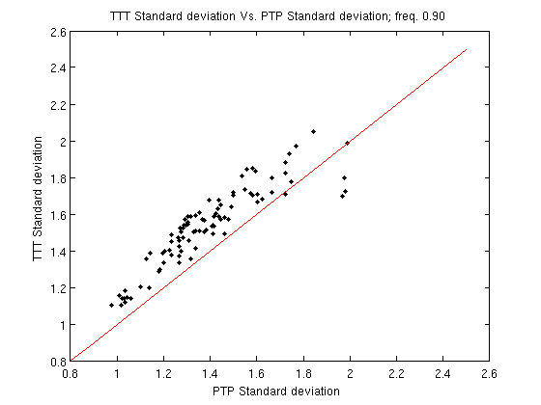
Figure 3.4.1.1. Standard deviation of TTT vs PTP series for .
The line represents .

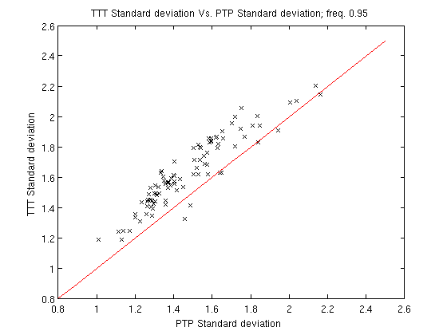
Figure 3.4.1.2. Standard deviation of TTT vs PTP series for .
The line represents .

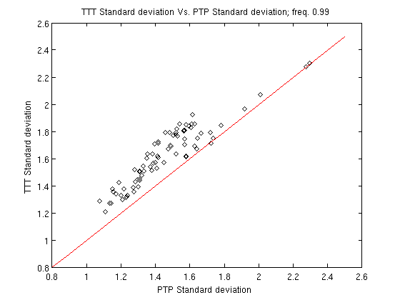
Figure 3.4.1.3. Standard deviation of TTT vs PTP series for .
The line represents.

Dependence of Peak-to-Peak on Mean Energy
Since the mean PTP always equals the corresponding mean TTT, we refer hereinafter to both terms as mean PTP or . Our integrations reveal a similar dependence of mean PTP on mean energy for all three driver frequencies. As the pendulum mean energy increases from negative values toward zero (i.e., the separatrix) the mean values of the PTP decrease and reach a minimum approximately at the separatrix. At higher mean energy they increase again. This behavior repeats for all driver frequencies examined, as can be seen in figures 3.4.2.1–3.4.2.3 for driver frequencies , 0.95, and 0.99, respectively.
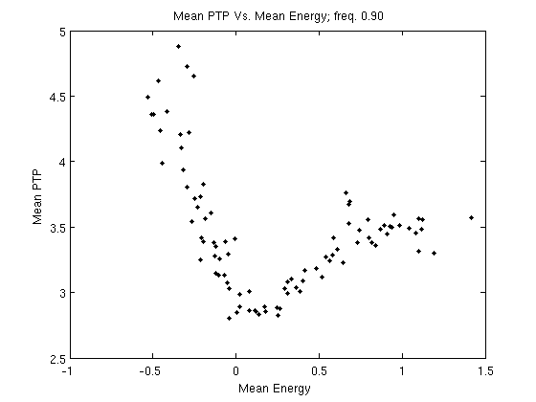
Figure 3.4.2.1. Mean PTP distance () vs mean energy () for and randomly drawn pairs of , .

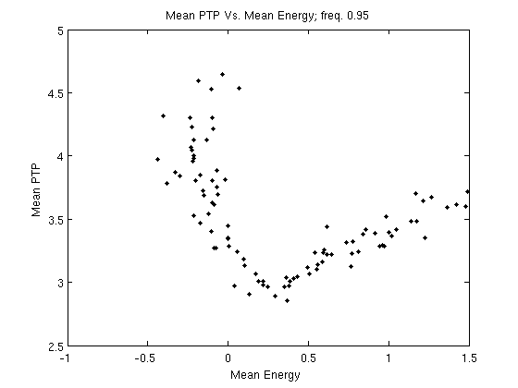
Figure 3.4.2.2. Mean PTP distance () vs mean energy () for and randomly drawn pairs of , .

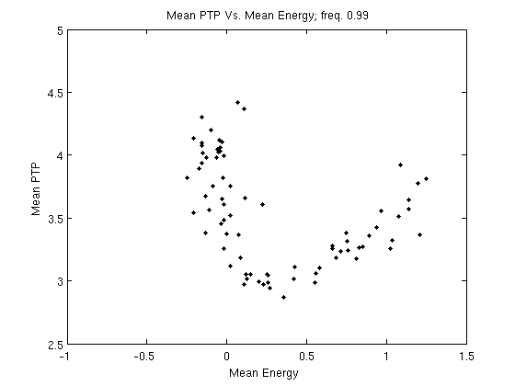
Figure 3.4.2.3 Mean PTP distance () vs mean-energy () for and randomly drawn pairs of , .

We fit the curves with the following rational function that exhibits this qualitative behavior:
. (3.4.2.1)

Figures 3.4.2.4–3.4.2.6 show the best-fit curves for the three driver frequencies. For each frequency, Table 3.4.2.1 lists the corresponding coefficients for Eq. (3.4.2.1), the RMS fit residuals, and the location of the minimum according to the fit.
Table 3.4.2.1. Coefficients, RMS, and minima for the three driver frequencies obtained from fit with Eq. (3.4.2.1).
 |  |  |  |  |  | RMS | Minimum | Fig.
0.9 | 3.945 | 0.6362 | 0.3802 | 0.2847 | 0.1288 | 0.2055 |  | 3.4.2.4
0.95 | 3.802 | −1.259 | 0.4073 | −0.2573 | 0.1139 | 0.2674 |  | 3.4.2.5
0.99 | 3.959 | −2.12 | 0.7068 | −0.4611 | 0.1919 | 0.2795 |  | 3.4.2.6

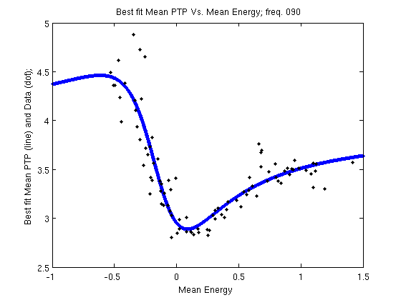
Figure 3.4.2.4. Best-fit curve (solid line) for mean PTP distance () vs mean energy () for and randomly drawn pairs of , .

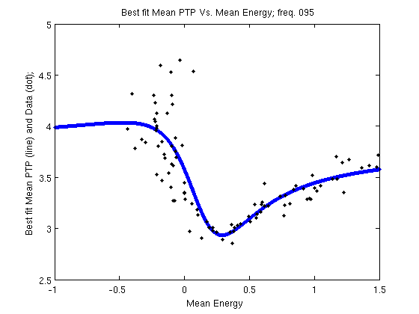
Figure 3.4.2.5. Best-fit curve (solid line) for mean PTP () vs mean energy () for and randomly drawn pairs of , .

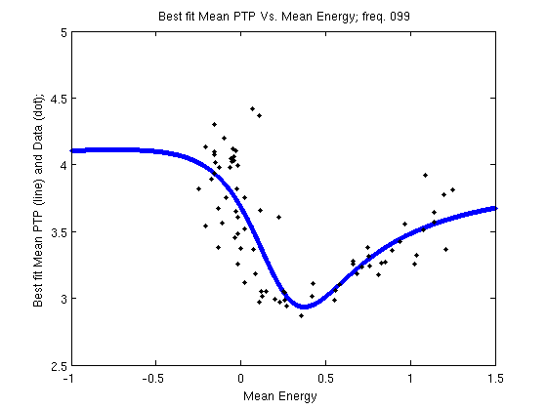
Figure 3.4.2.6. Best-fit curve (solid line) for mean PTP () vs mean energy () for and randomly drawn pairs of , .

The three data sets seem similar enough to assume that the dependence of the mean PTP on the mean energy is common to all driver frequencies. We therefore merged the three datasets and fit a common function:

, (3.4.2.2)

with RMS = 0.2989. This RMS is sufficiently close to the RMS of each of the three frequency-related curves (Table 3.4.2.1), which seems to be consistent with our assumption that the three datasets can be described by a single curve.
The most important feature of the resulting function is that the minimum is obtained close to the separatrix at and (Figure 3.4.2.7). From past studies (Newman et al., 2012; Newman, 2012) we know that both i.i.d. time series and the logistic map chaotic series also present mean peak-to-peak distances of 3.00.
Note that Eq. (3.4.2.2 ) is valid only for mean energy where data are available (i.e., between −0.5 and 1.5). For smaller mean energy, the time series becomes constant and no peaks can be defined. Conversely, some tests that we ran show that this equation is still reasonably accurate for mean energies as high as seven.

.
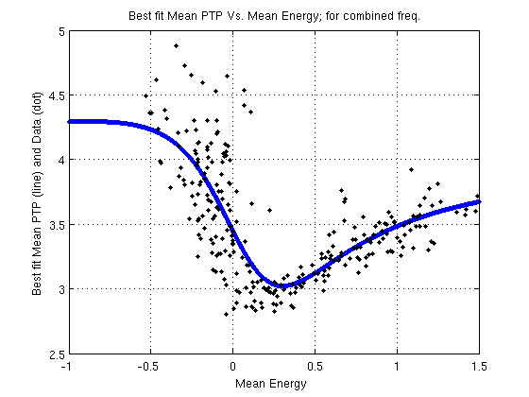
Figure 3.4.2.7. Best-fit curve (solid line) for mean PTP () vs mean energy () for , 0.95, and and randomly drawn pairs of , .

Peak-to-peak standard deviations
As an important part of our attempt to characterize the PTP and TTT distribution we also examined the standard deviations of the resulting distributions. Figures 3.4.3.1–3.4.3.6 present the dependence of the PTP and TTT standard deviation as a function of their means for the three driver frequencies (, 0.95, and ).
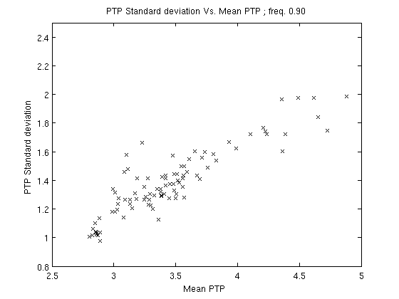
Figure 3.4.3.1. Standard deviation of PTP vs mean PTP () for .
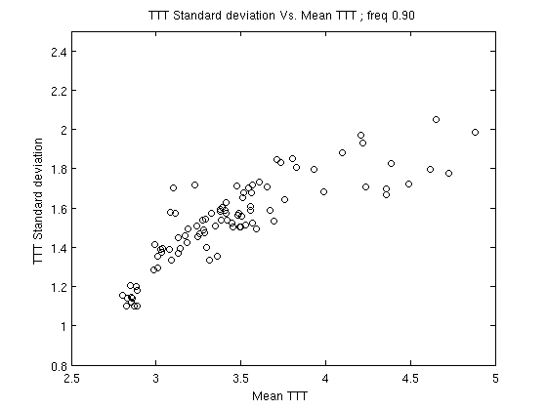
Figure 3.4.3.2. Standard deviation of TTT vs mean TTT () for .

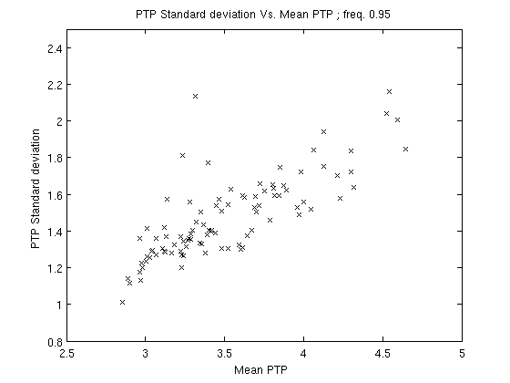
Figure 3.4.3.3. Standard deviation of PTP vs mean PTP () for .
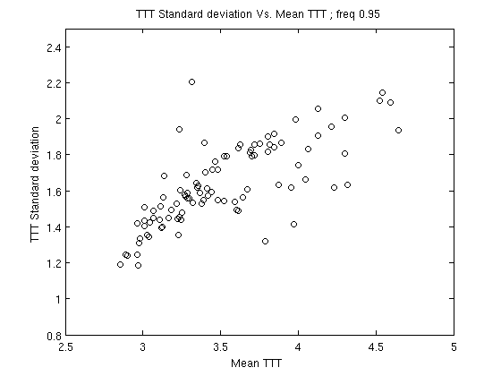
Figure 3.4.3.4. Standard deviation of TTT vs mean TTT () for .

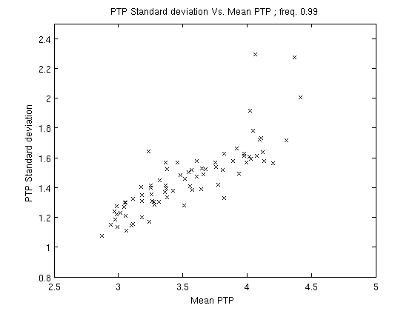
Figure 3.4.3.5. Standard deviation of PTP vs mean PTP () for .

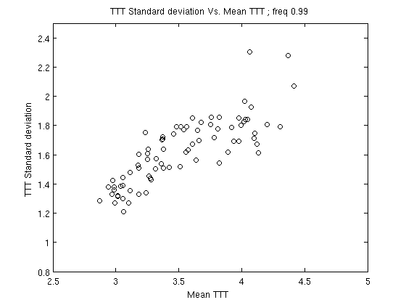
Figure 3.4.3.6. Standard deviation of TTT vs mean TTT () for .

We fit the scattered data in figures 3.4.3.1–3.4.3.6 with a linear function and focus on the irregular zone (i.e., ). The results show PTP standard deviations of for the three driver frequencies, respectively, whereas for the TTT, the standard deviations are .
In comparison, the equivalent PTP standard deviation for an i.i.d. sequence is for a Brownian motion [Eq. (2) with ], , and for the chaotic state of the Logistic map, .

Summary and conclusions
Following Newman et al. (2012, 2014) and Newman (2012) we studied the distribution of the PTP and TTT of energy time series generated by a periodically driven pendulum during its irregular motion near the separatrix.
An important point in this study is the realization that the obvious quantity to study (i.e., the pendulum displacement) is not suitable for analysis by using the PTP and TTT due to its cyclical nature. For this purpose, the energy is more adequate and convenient. As far as we know, this study represents the first attempt to examine the PTP and TTT statistics in a continuous function. We use the Poincaré-section approach for discretization. An interesting additional line of research would be to generalize the PTP and TTT statistics in a more natural and seamless way to the continuous domain in a way that would not require discretization.
One result of this study is the asymmetry between the PTP and TTT statistics, as manifested by the different standard deviations. This is understandable because there is a lower bound for the energy but no upper bound, so it is only natural that the statistics related to peaks differ from statistics related to troughs, as is indeed the case.
We demonstrate that the dependence of the (and therefore the ) on the mean-energy levels follows a typical pattern. In general, the closer we approach a specific mean-energy interval near the separatrix (roughly ) the lower are the values. Specifically, the best-fit model locates the minimum at and . This mean PTP value bears a strong similarity with both the i.i.d. and the chaotic logistic map time series. This behavior reveals another aspect of the chaotic nature of the forced pendulum near the separatrix (see, e.g., Mardling, 2008).

This first application of the PTP and TTT statistics on the solution of a nonlinear differential equation can be elaborated on in many ways. For example, one can discretize it in other ways than the Poincaré-section method (e.g., measuring the intervals between continuous peaks or troughs, or zero crossings). Of course, other nonlinear differential equations can serve as the study subject. The driven pendulum itself can provide other interesting cases, such as different models for the driving force, or the addition of damping. Of course, generalizing this statistics to celestial-mechanics phenomena, namely N-body chaotic systems and planetary systems in resonance, can be very illustrative.

Third study: From stability to chaos; energy evolution in a driven pendulum and its association with the three-body problem

Study Preface
Following our previous studies, we now shed more light on the phenomenon of mean motion resonance (MMR) in the three-body problem and carefully draw possible conclusions about its impact on celestial systems. The first study shows that MMR is, statistically, more prevalent among young celestial system. This result led us to formulate and to further investigate the possibility that resonances in planetary systems tend to diminish with time. Thus, in the second study we use a toy model of the three-body system, the periodically driven pendulum, and study the characteristics of its unstable, chaotic motion by statistically exploring its energy time series. In this third study, we further explore energy time series of the driven pendulum. The results should further our understanding of the ambiguity of strength versus fragility of MMRs in celestial systems. The contribution of the current study to the field of research of which this thesis is part is that this theoretical study significantly supports our assumption that MMRs are not, necessarily, eternal phenomena and their tendency to vanish over time depends primarily on the physical and dynamic structure of the systems themselves, rather than on cataclysmic events that originate outside the system, Deus ex machina.

Study abstract
We use the driven pendulum as a toy model of the three-body problem and study the evolution of its motion from stability to chaos. We use these results to better understand the probability and rate of transition from stable mean-motion resonance (MMR) to unstable, chaotic motion in the three-body problem. We focus on the following main question: when, if ever, does the MMR surrender to growing perturbations and cease to exist? To address this question, we study the typical times over which a driven pendulum (initially at its lowest energy state and thus in stable motion) crosses for the first time several energy levels. Such energy thresholds are chosen from within the energy zone in which the pendulum motion is significantly chaotic and thus unstable. In this model, an unstable motion of the pendulum is analogous to an unstable motion of the resonance argument of the three-body problem, which indicates that the system is out of resonance.
To improve the similarity to gravitational perturbation in the three-body problem, we formulate a parametric driving force that mathematically resembles the disturbing function of the three-body problem when expanded in high-order Legendre polynomials.
We made thousands of tests for various parameters of the driving force and recorded for each test the series of times at which the instantaneous pendulum energy crossed each of the energy thresholds.
We show that, for a wide range of driver parameters, the time-to-energy series for each threshold is exponentially distributed. Thus, the events that cause the system to become unstable occur randomly but at a constant rate. In addition we find that the relation between the mean time of events and the driver-amplitude factor A, which is equivalent to the perturbation level of the system, obeys the power-law , where , c, and are constants.
These results indicate that, for each energy threshold, a specific driving force exists with amplitude , under which the pendulum never crosses the threshold and never departs from its original stable state. For greater driver amplitudes, the probability to attain a specific energy threshold, within any time interval, is greater than zero and, as already mentioned, obeys an exponential probability-density function. Thus, when and given enough time, the pendulum system will eventually become unstable.
Based on our findings regarding the driven pendulum, we suggest that a similar time-to-energy dependence also exists in planetary systems. Thus, for every three-body system, a perturbation threshold exists that depends on the masses and longitudes of the rotating bodies under which the system will stay forever in a stable MMR. For higher perturbations, a system initially in a MMR configuration will depart from its resonance state after a finite time.

Note: For scientific introduction, please refer to sections 1.1–1.4 of the general introduction.

Methodology
Unlike other studies, in this research, and because the survivability of the MMR is our main concern, we use different approaches regarding the terms stability and instability.
First, we explore the stability of the MMR rather than the stability of the system, so our criterion for an unstable system is not when one body escapes to infinity (see, e.g., Mardling, 2008) but rather when the system permanently departs from its previously stable MMR state. Note that such an event is likely to eventually cause the physical destruction of the system as well.
Second, because of the supposedly small effect they have on the evolution of the system, and to reduce computing time, researchers usually tend to neglect terms in the expansion of the disturbing function that are characterized by low order in amplitude (i.e. small strength) and by high frequency of the resonance argument. Nevertheless, since the nature of the motion of the problem is chaotic and thus very sensitive to initial conditions, and in fact unpredicted in the long run, we ask whether the effects of the infinite short-period, small-amplitude perturbation can accumulate and sum up sufficiently to distort the celestial trajectories and break the system resonance.

Our main research objective in the thesis and in this study is to determine the probability that, at a specific time, a three-body system, initially in stable MMR state, will become chaotically unstable in the sense of becoming non-resonating. To reduce time and computation resources we use the toy model that imitates the behavior of the resonance argument in the three-body problem: the driven pendulum.
As a criterion to the disruption of the stable MMR state, we choose the instantaneous pendulum energy.
Note that, for every system there is a specific “destructive energy level” at which the MMR will be disrupted. The energy level is a function of the configuration, dynamics, and physical properties of the system, so we analyze the probability and the timing to attain and cross any possible energy in a region that hosts both stable and chaotic motions. To attain these goals, we had to improve the pendulum model and find an efficient experimental method to cope with probability and timing issues.

Formulating the driving force
We formulate a driving force that simulates a simplified type of Legendre expansion of the disturbing function. For this simplification, we choose the case of a planar, circular, restricted problem. As stated in section 1.1, researchers (e.g., Laskar, 1990; Murray & Dermott, 1999; Deck et al., 2013; Ramos et al., 2015) tend to simplify the three-body problem by neglecting the terms that have short-period arguments and/or low amplitudes and thus consider only the “dominant terms.” These neglected terms are also the low-order terms in the Legendre expansion. Nevertheless, after considerable time, we came to think that the accumulation of minor perturbations may result in significant change in the orbital elements, especially while the system operates in energy domains that are significantly chaotic.
Thus, we expand the driving-force series to high order and investigate numerically how this perturbation impacts the pendulum, which was initially at rest or librating with low amplitude. These modes of motion simulate the resonance argument of a three-body system in exact and near-MMR states.
As described in section 1.4, to destabilize an initially stable, oscillatory motion of a pendulum, it must cross a specific, positive energy threshold above the separatrix and thus in the chaotic zone. Operating at this energy level or above it, the pendulum cannot maintain its initial state of pure libration, so the stable resonance-like state is destroyed. We call this energy the “destructive energy” (). In this study, we choose six arbitrary destructive energies to serve as thresholds. We then sample and analyze the typical times needed to cross these energies and search for possible correlations between the amplitude of the driving force and the time it takes for the pendulum to reach a specific, destructive energy level and thus depart from stable motion and, in the three-body analogy, leave the MMR state.
We choose the simplified form of the disturbing function for the planar, circular, restricted three-body problem, written as a Legendre-polynomial expansion, as in Eq. (1.1.51) and reproduced here for convenience:
.

We then formulate the driving force that resembles the above equation:
, (4.1.1.1)

where
A is the amplitude factor with which we control the average level of the pendulum energy,
has a positive value less than unity,
and
is the natural frequency of the pendulum.
For simplicity, we choose and multiply it by the irrational number in the hope of avoiding harmonics. The quantity
is the integration time step and is determined by the pendulum natural frequency, ,
and is a random number between 0 and .

Thus, is a series of elements on which, for a fixed amplitude A, when the product decreases the frequency, increases.

Running the tests
We ran three separate tests, with each test characterized by a different value of: .
For each test, we integrate the system with the initial conditions , and so with the lowest possible energy level (i.e.,). By augmenting we increase the whole amplitude of the driving force, , and the pendulum gains energy and starts moving from complete rest to oscillate with small amplitude. This state is analogous to a libration of one resonance argument in the three-body problem, and thus leads to a stable MMR. Upon increasing the driver amplitude, the pendulum energy departs the negative region of stable libratory motion and enters the positive-energy region, above the separatrix. At these energies, the motion becomes chaotically unstable in the sense that it shifts continuously and unpredictably between libration and circulation cycles. This state is analogous to a resonance overlap in the three-body problem. As the pendulum gains more and more energy, the circulation-to-libration ratio increases, so the system becomes less and less stable. Examples of the chaotic evolution of the pendulum amplitude and energy level are shown Figures 4.1.2.1 and 4.1.2.2.
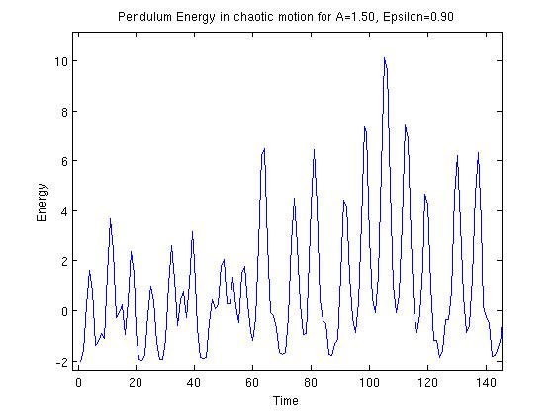
Figure 4.1.2.1. Energy of driven pendulum shifts chaotically between negative (circulation) and positive (libration) levels. Driver parameters are , .

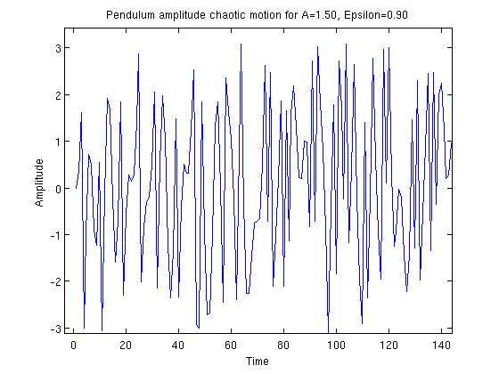
Figure 4.1.2.2. Amplitude of driven pendulum amplitude shifts chaotically during disordered libration-circulation motion. The amplitude shifts unsystematically between the lower position () and the upper vertical position (). Driver parameters are, .

Theoretically, if we continue increasing the pendulum energy well above the separatrix, eventually it attains a specific level where the system libration cycles are so scarce that, in practice, the motion is circular. For a three-body system, this type of motion means that the system is out of MMR. For our statistics, we choose six positive energy thresholds, all above the separatrix, that serve as destructive energies: , and .
Although arbitrary, the thresholds must be higher than the “noisy” level caused by the periodical nature of the driving force that “kicks” the pendulum energy in each driver cycle. In contrast, we want our energy thresholds to be sufficiently low to be crossed by the pendulum energy in a reasonable computing time.
To monitor the instantaneous energy levels of the pendulum and determine the first time that the pendulum crosses each one, we integrate the equation of motion (1.4.1) and use the numeric solutions for and to calculate the instantaneous energy via Eq. (1.4.10).
In total, for each of the three values of (0.90, 0.95, 0.99), we make seven to eight integrations, each one with different value of A. The values of A are selected from within the range, which is chosen to guarantee that, for each integration, all six energy thresholds are crossed by the pendulum. We run each integration 1000 times, with each run requiring 25 000 time steps.

Results

Time-series distribution
Due to the random nature of the phase , each of the integrations give us a series of six times per specific value of A and from , which is the time at which the pendulum crosses , to , which is when it crosses . Out of thousands of integrations we discuss here four examples of energy-crossing events:
Figures 4.2.1.1 and 4.2.1.2 present two separate integrations with driver parameters and , whereas Figs. 4.2.1.3 and 4.2.1.4 have driver parameters and.

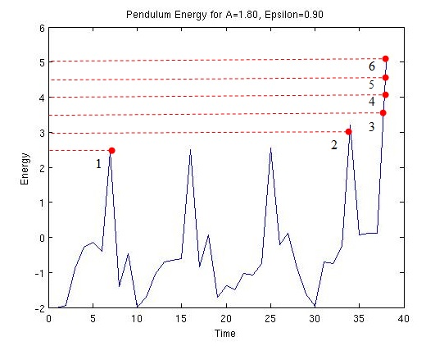
Figure 4.2.1.1. Evolution of pendulum energy for driver parameters
, (first integration). The red dots present indicate the energy- crossing events to .

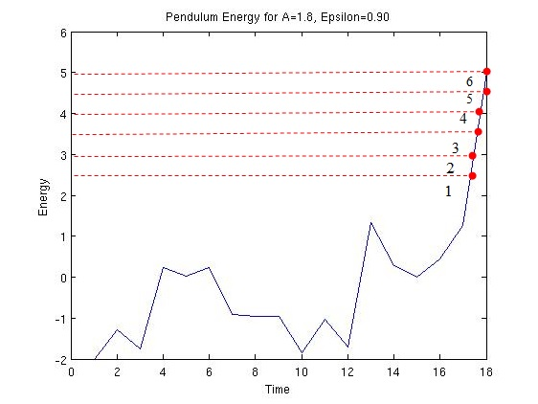
Figure 4.2.1.2. Evolution of pendulum energy for driver parameters
, (second integration). The red dots present indicate the energy- crossing events to .

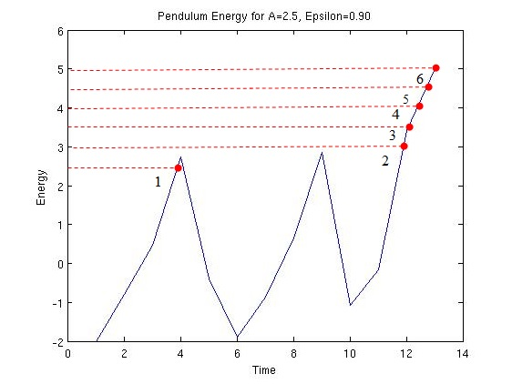
Figure 4.2.1.3. Evolution of pendulum energy for driver parameters
, (first integration). The red dots present indicate the energy- crossing events to .

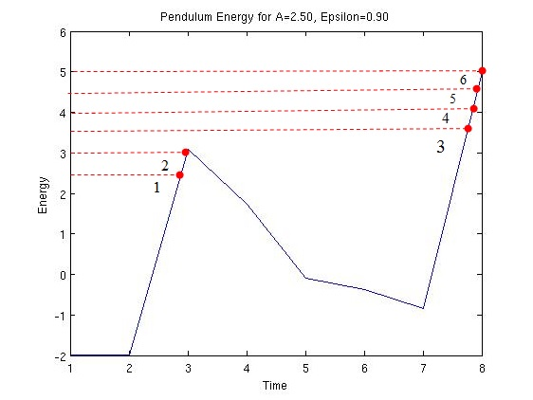
Figure 4.2.1.4. Evolution of pendulum energy for driver parameters
, (second integration). The red dots present indicate the energy- crossing events to .

Each time in the time series corresponds to the first time that the instantaneous energy of the pendulum crosses one of the destructive energies for a given value of the amplitude factor A. Thus the total of 1000 runs yields a sample of 1000 crossing times for each destructive energy to . Figures 4.2.1.5–4.2.1.10 show examples of distribution histograms of the time series samples for driver-amplitude parameter and for.
Each sample is divided into 20-bin histograms where the y axis represents frequency and the x axis represents the first time the given threshold is crossed with the given driving-force parameters.

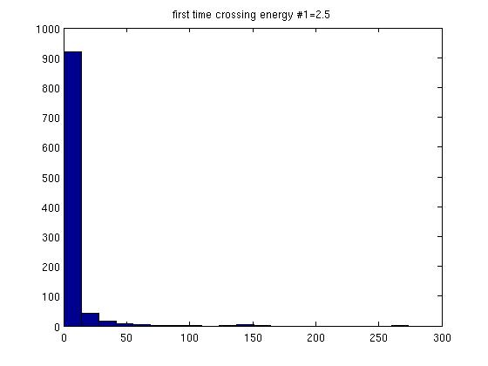
Figure 4.2.1.5. Time series distribution for , , .
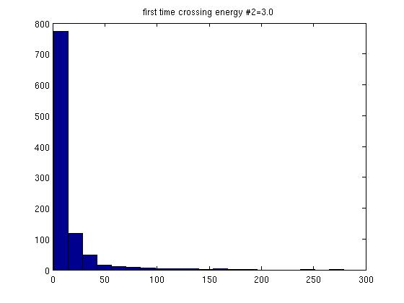
Figure 4.2.1.6. Time series distribution for , , .

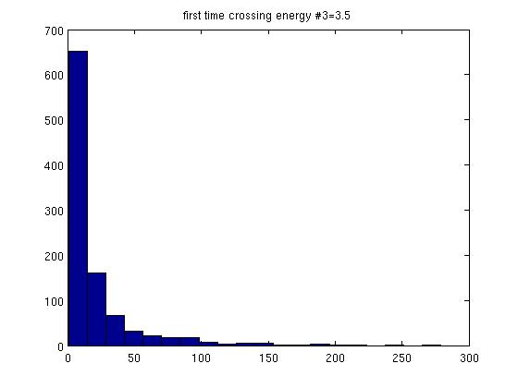
Figure 4.2.1.7. Time series distribution for , , .

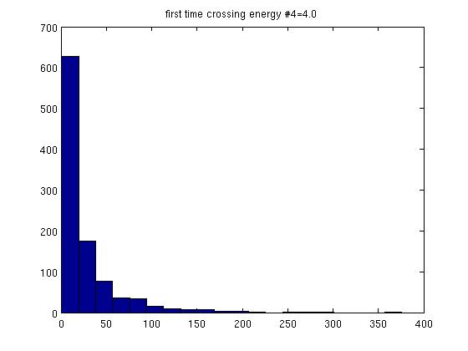
Figure 4.2.1.8. Time series distribution for , , .

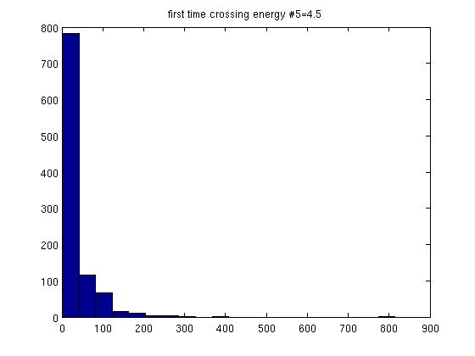
Figure 4.2.1.9. Time series distribution for , , .
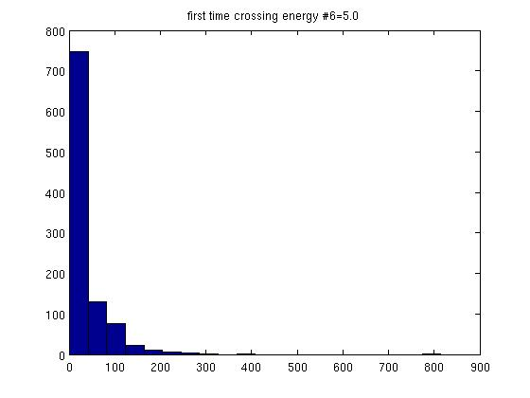
Figure 4.2.1.10. Time series distribution for , , .

We find that the distribution of the time series is exponential and thus has probability density function
, (4.2.1.1)
where is the mean of the time series (which can also be considered as “mean time of events”),
, (4.2.1.2)

and (4.2.1.3)
is the constant event rate.

In this case, “event” is the instant at which an energy threshold is crossed and the pendulum motion becomes unstable.

In the pendulum case, is the minimum time required for the pendulum to reach for the first time the energy threshold, so, for all , the probability function .
Therefore, the following correction to the probability density function in Eq. (4.2.1.1) is necessary:

. (4.2.1.4)

By using the maximum likelihood method, we find that equals the smallest member in the energy time series:

. (4.2.1.5)
Thus, the corrected mean time of events is

(4.2.1.6)

and the corrected event rate is

. (4.2.1.7)

Mean time of events vs driver-amplitude parameter A
To describe the relation between the level of perturbation in the system and the average time to instability, we calculate, for each sample of energy-crossing times, the corrected mean time [Eq. (4.2.1.6)]. We then plot vs the driver-amplitude factor
for to and for each destructive energy to .
We find that the results are best fit by the power law

. (4.2.2.1)

Figures 4.2.2.1–4.2.2.18 show the various best-fit curves, with the data indicated by the blue circles and the fit by the red curves.

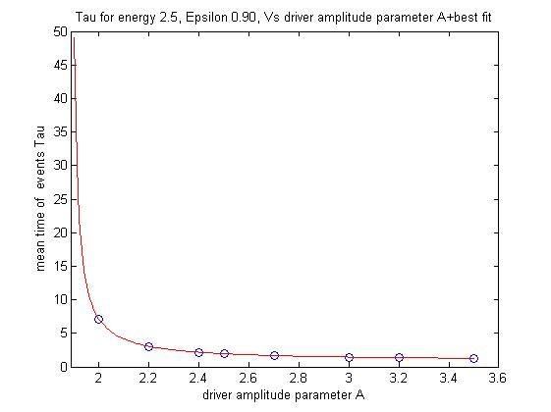
Figure 4.2.2.1. Mean time of events vs driver-amplitude factor A
for , .
The data are shown by the blue circles and the best-fit curve by the red curve.

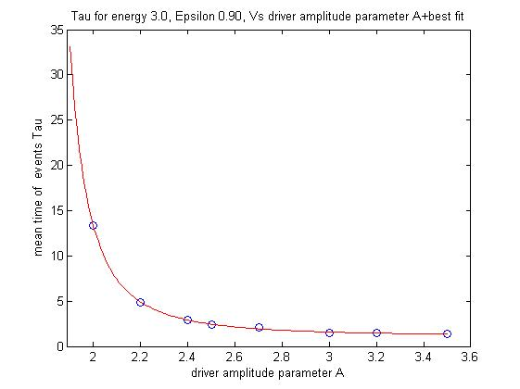
Figure 4.2.2.2. Mean time of events vs driver-amplitude factor A
for , . The data are shown by the blue circles and the best-fit curve by the red curve.

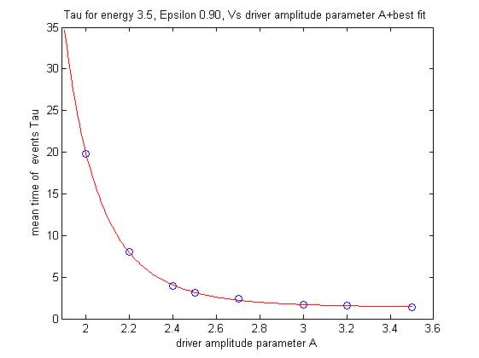
Figure 4.2.2.3. Mean time of events vs driver-amplitude factor A
for, . The data are shown by the blue circles and the best-fit curve by the red curve.

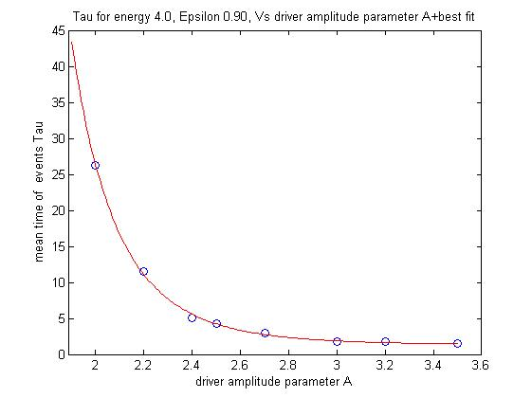
Figure 4.2.2.4. Mean time of events vs driver-amplitude factor A for , . The data are shown by the blue circles and the best-fit curve by the red curve.

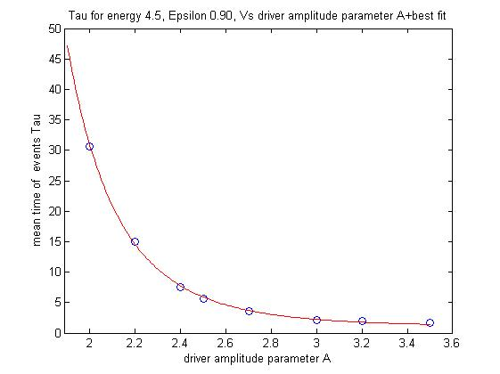
Figure 4.2.2.5. Mean time of events vs driver-amplitude factor A for , . The data are shown by the blue circles and the best-fit curve by the red curve.

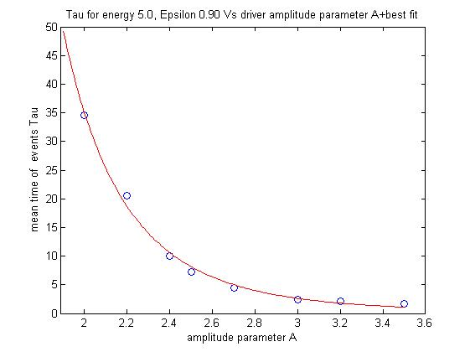
Figure 4.2.2.6. Mean time of events vs driver-amplitude factor A for , . The data are shown by the blue circles and the best-fit curve by the red curve.

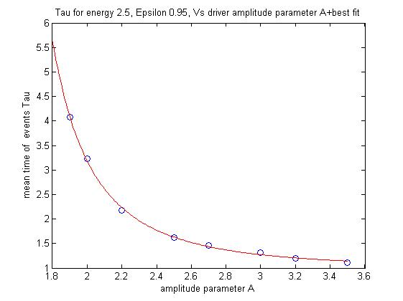
Figure 4.2.2.7. Mean time of events vs driver-amplitude factor A for , . The data are shown by the blue circles and the best-fit curve by the red curve.

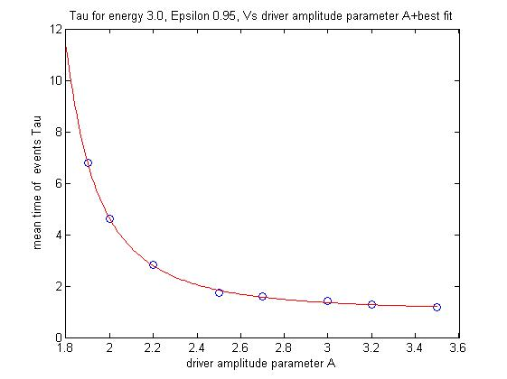
Figure 4.2.2.8. Mean time of events vs driver-amplitude factor A for , . The data are shown by the blue circles and the best-fit curve by the red curve.

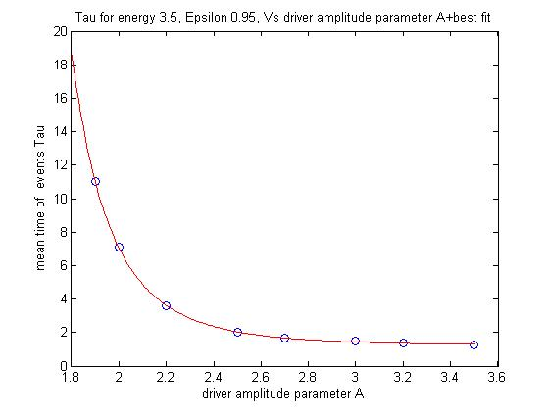
Figure 4.2.2.9. Mean time of events vs. driver-amplitude factor A for , . The data are shown by the blue circles and the best-fit curve by the red curve.

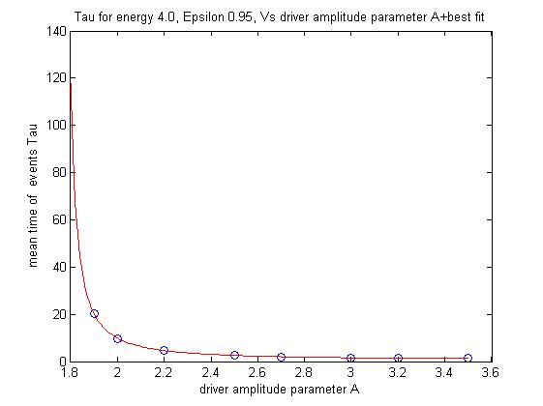
Figure 4.2.2.10. Mean time of events vs driver-amplitude factor A for , . The data are shown by the blue circles and the best-fit curve by the red curve.

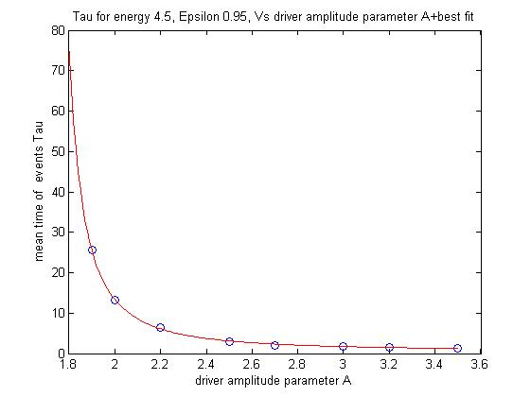

Figure 4.2.2.11. Mean time of events vs driver-amplitude factor A for , . The data are shown by the blue circles and the best-fit curve by the red curve.

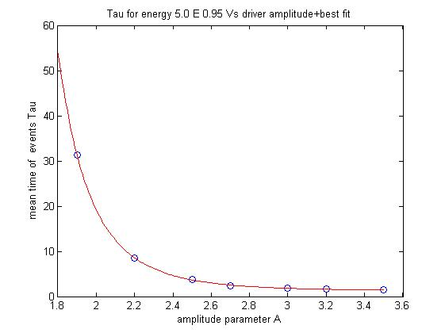
Figure 4.2.2.12. Mean time of events vs driver-amplitude factor A for , . The data are shown by the blue circles and the best-fit curve by the red curve.

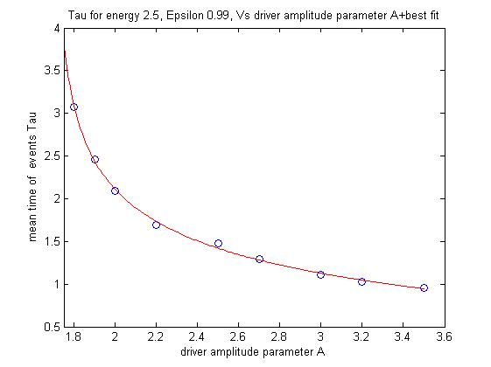
Figure 4.2.2.13. Mean time of events vs driver-amplitude factor A for , . The data are shown by the blue circles and the best-fit curve by the red curve.

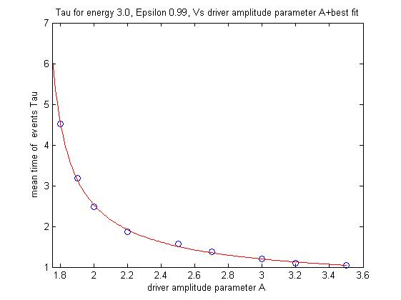
Figure 4.3.2.14. Mean time of events vs driver-amplitude factor A for , . The data are shown by the blue circles and the best-fit curve by the red curve.

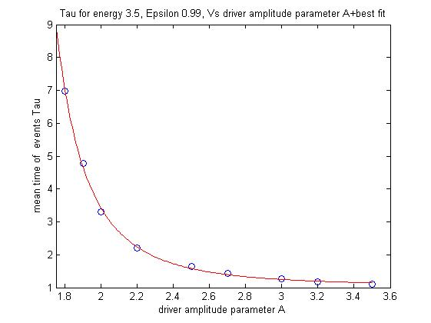
Figure 4.2.2.15. Mean time of events vs driver-amplitude factor A for , . The data are shown by the blue circles and the best-fit curve by the red curve.

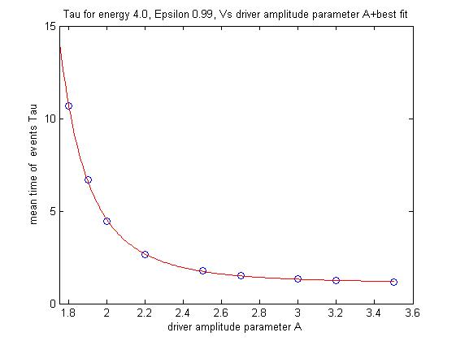
Figure 4.2.2.16. Mean time of events vs driver-amplitude factor A for , . The data are shown by the blue circles and the best-fit curve by the red curve.

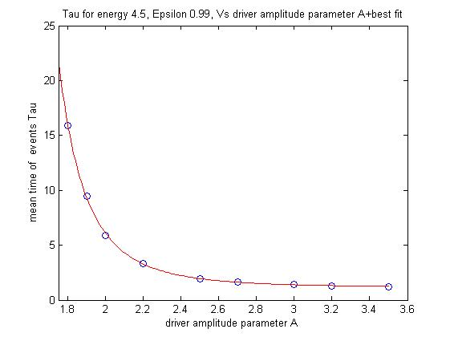
Figure 4.2.2.17. Mean time of events vs driver-amplitude factor A for , . The data are shown by the blue circles and the best-fit curve by the red curve.

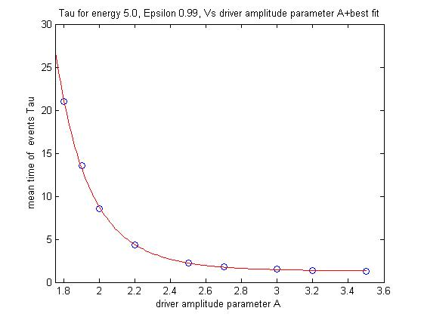
Figure 4.2.2.18. Mean time of events vs driver-amplitude factor A for , . The data are shown by the blue circles and the best-fit curve by the red curve.

Tables 4.2.2.1–4.2.2.3 present the coefficients of Eq. (4.2.2.1) for each value of the parameter and for the six corresponding values of the energy thresholds and the figure with the matching curve.

Table 4.2.2.1. Coefficients of Eq. (4.3.2.1) for
and six different energy thresholds.
 |  |  |  |  | Fig.
 | 0.6365 | 1.883 | 1.062 | 0.8929 | 3.2
 | 0.7664 | 1.724 | 2.147 | 1.128 | 3.3
 | 46.3 | 0.8477 | 6.492 | 1.379 | 3.4
 | 240.6 | 0.6152 | 6.959 | 1.306 | 3.5
 | 367.6 | 0.5086 | 6.289 | 1.047 | 3.6
 | 1,038 | 0.2277 | 5.931 | 0.1661 | 3.7

Table 4.2.2.2. Coefficients of Eq. (4.3.2.1) for
and six different energy thresholds.
 |  |  |  |  | Fig.
 | 1.074 | 1.261 | 2.377 | 0.9834 | 3.8
 | 0.882 | 1.466 | 2.250 | 1.017 | 3.9
 | 4.539 | 1.053 | 4.642 | 1.222 | 3.10
 | 1.291 | 1.765 | 1.360 | 0.618 | 3.11
 | 1.734 | 1.692 | 1.698 | 0.607 | 3.12
 | 26.14 | 0.9261 | 5.267 | 1.252 | 3.13

Table 4.2.2.3. Coefficients of Eq. (4.3.2.1) for
and six different energy thresholds.
 |  |  |  |  | Fig.
 | 2.814 | 1.700 | 0.2147 | -1.534 | 3.14
 | 0.9004 | 1.665 | 0.751 | 0.474 | 3.15
 | 0.956 | 1.271 | 2.869 | 1.049 | 3.16
 | 1.315 | 1.250 | 3.316 | 1.112 | 3.17
 | 1.917 | 1.227 | 3.660 | 1.157 | 3.18
 | 4,500 | 0.005 | 9.277 | 1.292 | 3.19

Summary, discussion, and conclusions
In the current study, we follow our previous works regarding the strength and long-term evolution of MMR in three-body systems. Here, we study the typical times required to destabilize the motion of a driven pendulum that is initially in a stable state of low-amplitude libration. This model is a “refined” analogue of a three-body system, initially in stable MMR, for which we gradually increase its mutual gravitational perturbations, thereby generating significant chaotic motion until its internal resonance is destroyed. The goal is to determine the probability that, at any given time, the stable motion of the pendulum will become significantly chaotic and thus unstable. Based on these results we draw tentative conclusions regarding the survivability of MMR in three-body systems.
For the pendulum driving force we formulate a unique force [Eq. (4.1.1.1)] that is the sum of an infinite time series and is mathematically similar to the Legendre-polynomial expansion of the disturbing function of the three-body problem [Eq. (1.1.51)].
The distinction of an initial MMR state of motion depends, primarily, on the degree of perturbation inflicted on each of the three bodies by its two neighbors. In the three-body problem the perturbation is a result of energy transferred between the three bodies. In the pendulum, the perturbation is caused by energy transferred to the pendulum by the driving force. As we show in our second study (“Peak-to-Peak Distance Statistics of Energy Time Series in the Periodically Driven Pendulum”), when the transferred energy reaches a critical value, the perturbed pendulum cannot maintain its initially stable motion. Thus, we propose as criterion the instantaneous energy of the system to distinguish between the stable state (i.e., a stable resonance in the three-body case and low-amplitude libration in the pendulum case) and the unstable state (i.e., non-resonating state of the three-body system and chaotic libration-circulation motion of the pendulum). Whenever the “destructive energy” level is crossed, we conclude that the pendulum motion or, analogously, the three-body system, has lost its stable motion for good. This level-crossing event may even have cataclysmic results on celestial three-body systems, such as the ejection of one of the minor bodies to infinity or a collision of masses.
Many studies tend to simplify the three-body problem by neglecting short periods and/or small-amplitude terms that allegedly have only marginal effect on the long-term dynamics of the system. In contrast, we include the “minor” terms as well. Our simple logic leads to the conclusion that the cumulative perturbation, amplified by the chaotic nature of the system, may eventually induce significant change in the orbital elements and break the stable motion. Therefore, in our pendulum system, we deliberately expand the driving force series to its twentieth order. By regulating the driving-force-amplitude factor A for fixed values of , we gradually increased the average energy level of the pendulum until it crosses the desired energy. Although we ensure that, for the given parameters, the driving force is strong enough to force the pendulum to the energy threshold, the chaotic nature of the pendulum motion prevents us from estimating when this threshold will be attained. We made 1000 recurring numeric runs for several values of the factor A and for three values of (0.90, 0.95, and 0.99). These runs yielded samples of typical energy-crossing time series, where every series is related to specific values of A, , and to each of the six values of the destructive energy .
These time series are exponentially distributed, each series with its unique average rate of events, . In our study, an “event” defines the crossing of one of the destructive energies, and thus a destruction of the once stable, low-libration motion of the pendulum or, in analogy to the three-body system, the destruction of the MMR.
The exponential distribution of event times indicates that the events occur randomly but at a constant rate. In addition, the process has no memory so, at any given time, the probability of a destructive event to occur does not depend on the elapsed time.

This result may be consistent with our second study (“Peak-to-Peak Distance Statistics of Energy Time Series in the Periodically Driven Pendulum”), where we showed statistical similarity between the pendulum energy time series in the chaotic region, near the separatrix, and i.i.d. random variables.

In addition, we show that, for each value of the driver parameter, to , and for each value of destructive energy to , a nonlinear negative correlation exists between the mean time of events and the driver-amplitude factor A. The typical curve representing this correlation follows the power law .
Most of the values of in Tables 4.2.2.1–4.2.2.3 fall within the range of ~0.5–1.3. These values are merely the time required for the pendulum to move from its rest position (, ), where the energy is at its lowest value, , to cross the energy threshold when the perturbation is infinite, . In the pendulum case the time is depicted in units of the natural period of the pendulum, whereas in the three-body analogue these values indicate the elapsed time between successive conjunctions when the system is in MMR. In any case, we regard the average time to event as infinitesimal, given an infinite perturbation. Note that, if we could calculate the value of the correction constant [Eq. (4.2.1.5)] to the precision required for each run, would probably be zero.

The meaning of asymptote at is that a minimal value exists for the factor A, and, therefore, also for the driver amplitude , below which the pendulum, despite its chaotic motion, never attains the destructive-energy threshold, so it remains in stable motion for all time. If we move from the toy-model pendulum to its three-body analogue we find that the equivalent of A in the disturbing function is the term , where .
It is only logical that a minimum positive value of the ratio exists (i.e., the mass of the exterior secondary divided by its semimajor axis) for which the perturbation effect of the exterior body is negligible and the system remains forever in a stable resonance.
For all , given enough time, the pendulum system will eventually attain the critical energy threshold and, according to our game rules, will become unstable.

In each of Figs. 4.3.1–4.3.6 we display three curves of versus A. Each curve (i.e., blue, red, and green) is assigned to one of the three values of and each figure is for one of the six energy thresholds . Analyzing these figures for each of the destructive energies shows that, the higher is the value of , the faster is the destabilization process and, the higher is the energy, the longer it takes the pendulum to cross it.

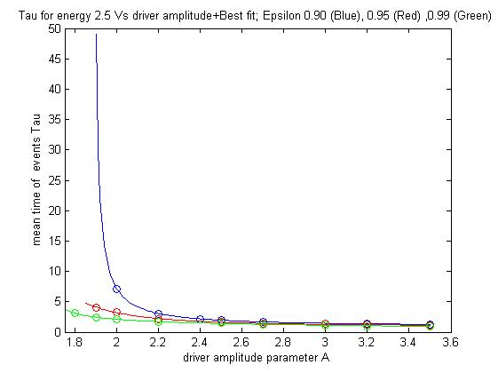
Figure 4.3.1. Mean time of events vs driver-amplitude factor A for and (blue), (red), (green). The data are displayed with circles and the best fit by the continuous curves.

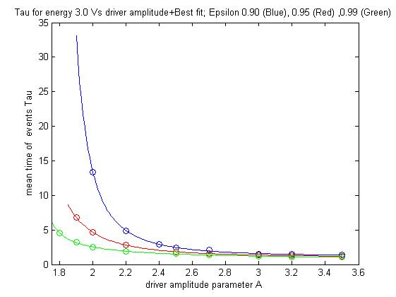
Figure 4.3.2. Mean time of events vs driver-amplitude factor A for and (blue), (red), (green). The data are displayed with circles and the best fit by the continuous curves.

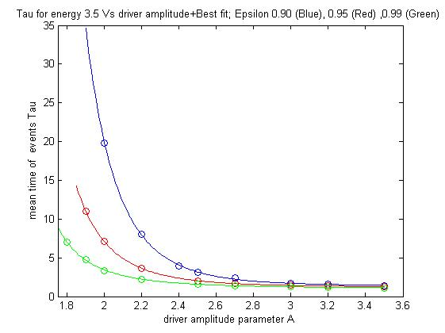
Figure 4.3.3. Mean time of events vs driver-amplitude factor A for and (blue), (red), (green). The data are displayed with circles and the best fit by the continuous curves.

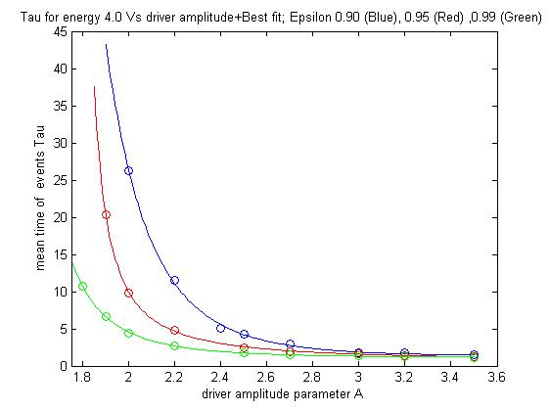
Figure 4.3.4. Mean time of events vs driver-amplitude factor A for and (blue), (red), (green). The data are displayed with circles and the best fit by the continuous curves.

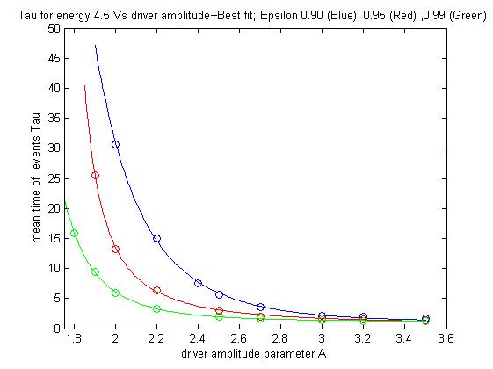
Figure 4.3.5. Mean time of events vs driver-amplitude factor A for and (blue), (red), (green). The data are displayed with circles and the best fit by the continuous curves.

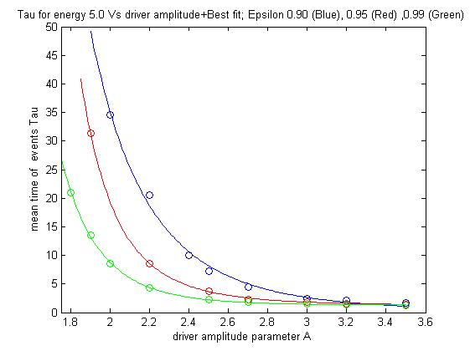
Figure 4.3.6. Mean time of events vs driver-amplitude factor A for and (blue), (red), (green). The data are displayed with circles and the best fit by the continuous curves.

If we carefully compare the pendulum model with the three-body problem in general systems, and in celestial systems in particular, we can say that, even if inspected in relatively old systems, MMR may, in many cases, be only a temporal state that can end at any time. Due to the chaotic nature of its motion, even small gravitational disturbances can accumulate, grow, and eventually drive the system out of resonance and, probably, even destroy the system.

These results are consistent with previous work (Koriski & Zucker, 2011) and with the hypothesis that MMR is not, inevitably, an everlasting phenomenon and its extinction may be the mere result of an evolutionary decay due to the chaotic nature of the three-body problem.

Further studies that apply the energy-time-series method directly to a numerical model of the three-body problem may improve these analytical results and provide an improved diagnostic tool with which to investigate the long-term fate of MMRs in planetary systems.

REFERENCES

- Adams, F. C., Laughlin, G., & Bloch, A. M. 2008, ApJ, 683, 1117
- Antoniadou, K. I., 2016, Eur. Phys. J. Spec. Top., 225, 1001
- Arriagada, P. 2011, ApJ, 734, 70

- Asghari, N. et al. 2004, A&A. 426, 353
- Barnes, R. et al., the Astrophysical Journal, 801:101 (17pp), 2015 March 10

- Beaugé, C., Ferraz-Mello, S., Michtchenko, T. A., & Giuppone, C. A. 2008, Exoplanets: Detection, Formation and Dynamics (IAU Symp. 249), ed. Y.-S. Sun, S. Ferraz-Mello, & J.-L. Zhou (Cambridge: Cambridge Univ. Press), 427 ADS

- Bois, E., Kiseleva-Eggleton, L., Rambaux, N., & Pilat-Lohinger, E. 2003, ApJ, 598, 1312

- Butikov, E. I. 2002, J. Phys. A: Math. Gen., 35, 6209

- Celletti, A., “Weakly Dissipative Systems in Celestial Mechanics “, Lect. Notes Phys. 729, 67-90 (2007)

- Celletti, A., “Stability and Chaos in Celestial Mechanics” (Springer Praxis Books in Astronomy and Planetary Sciences, Chichesterr, UK, 2010)

- Chirikov, B.V., "A Universal Instability of Many Dimensional Oscillator Systems", Phys. Rep. 52, 264-379 (1979)

- Cincotta P., Simó C. 2000, A&AS, 147, 205

- L. Cole, J. Wildlife Manage. 15, 233 (1951)

- Deck K. M., Payne M., Holman M. J., 2013, Astrophys. J. , 774, 129

- de Pater, I., & Lissauer, J. J. 2001, Planetary Sciences, Cambridge, UK: Cambridge University Press, December 2001

- Duncan M. J., Quinn, T., & Tremaine, S. 1989, Icarus, 82, 402

- Duncan M. J., levinson H. F., Lee M. H., 1998, AJ, 116, 2067

- Fernandez, J. A., & Ip, W. H., 1984, Icarus, 58, 109

- Gayon J., Marzari F., Scholl H., 2008, MNRAS, 389, L1

- Gomes, R. S., Morbidelli, A., & Levison, H. F. 2004, Icarus, 170, 492
- Gomes, R., Levison, H. F., Tsiganis, K., & Morbidelli, A. 2005, Nature, 435, 466

- Gonzalez, J. A., Reyes, L., Suarez, J., Guerrero, L., and Gutierrez, G., “A Mechanism for Randomness”, Phys. Lett. A 259, 25-34 (2002)

- Good, P. 1994, Permutation Tests: A Practical Guide to Resampling Methods
for Testing Hypothese (New York: Springer)

- Goździewski, K., & Migaszewski, C. 2009. MNRAS, 397, L16

- Hahn, J. M., & Malhotra, R. 1999, AJ, 117, 3041

- Hilborn, R. C., “Chaos and Nonlinear Dynamics: an Introduction for Scientists and Engineers” (Oxford University Press, New York, 1994)
- Ida, S., Bryden, G., Lin, D. N. C., & Tanaka, H. 2000, ApJ, 534, 428
- Isaacson, H., & Fischer, D. 2010, ApJ, 725, 875

- Kaula, W.M. (1961). Analysis of gravitational and geometric aspects of geodetic utilization of satellites, Geophys. J.5, 104-133

- Ketchum, J. A., Adams, F. C., & Bloch, A. M. 2011, ApJ, 726, 53

- Ketchum, J. A., Adams F. C., and Bloch A. M. 2013, ApJ., 762, 71

- Kirsh, D. R., Duncan, M., Brasser, R., & Levison, H. F. 2009, Icarus, 199, 197

- Koriski, S. & Zucker, S., 2011, ApJL, 741, L23

- Kaula, W.M. (1962). Development of the lunar and solar disturbing functions for a close satellite, Astron. J. 67, 300-303

- Kley, W. et al 2004, A&A, 414,735

- Laskar, J. 1989, Nature, 338, 237

- Laskar, J. 1990, Icarus, 88, 266
- Laskar, J. 1994, A&A, 287, L9
- Laskar, J. 2008, Icarus, 196, 1

- Lecar, M., Franklin, F., & Murison, M. 1992a, AJ, 104, 1230
- Lecar, M., Franklin, F., & Soper, P. 1992b, Icarus, 96, 234

- Lecar, M., Franklin, F. A., Holman, M. J., & Murray, N. J. 2001, ARA&A, 39, 58

- Lecoanet, D., Adams, F.,C., & Bloch A. M. 2009, AJ, 692, 659
- Lee, M. H., & Peale, S. J. 2002, ApJ, 567, 596
- Lee, A. T., Thommes, E. W., Rasio F. A., 2009, ApJ, 691, 1684
- Lin, D.N.C., & Ida, S. 1997, ApJ, 477, 781
- Maldonado, J., Martinez-Arn´aiz, R. M., Eiroa, C., & Montesinos, B.
2010, A&AS, 521, A12

- Malhotra, R. 1998, in ASP Conf. Ser. 149, Solar System Formation and Evolution, ed. D. Lazzaro et al. (San Francisco, CA: ASP), 37

- Malhotra, R., Holman, M. & Ito, T. 2001, Chaos and stability of the solar system. PNAS 8, 12342
- Mamajek, E. E., & Hillenbrand, L. A. 2008, ApJ, 687, 1264

- Marchal, C., & Bozis, G. 1982, Celestial Mechanics, 26, 311

- Mardling, R. A., “Resonance, Chaos and Stability: The Three-Body Problem in Astrophysics”, Lect. Notes Phys. 760, 59-96 (2008)

- Michtchenko, T. A., Beaugé, C., & Ferraz-Mello, S. 2008a, MNRAS, 387, 747

- Michtchenko, T. A., Beaugé, C., & Ferraz-Mello, S. 2008b, MNRAS, 391, 215

- Morbidelli, A. 2001: ``Chaotic diffusion in celestial mechanics'', Reg., Chaot. Dyn. 6, 339

- Murray, C. D. and Dermott, S. F., “Solar System Dynamics” (Cambridge University Press, NY, 1999)

- Murray, N. & Holman, M. 1997, AJ, 114, 1246
- Murray, N. & Holman, M. 1999, Science, 283, 1877
- Mustill, A. J., & Wyatt, W. C., 2010, Proc. of the IAU, 6, 300
- Nakamura, T. & Yoshida, J. Celestial Mech Dyn Astr (1992) 54: 255. doi:10.1007/BF00049560
- Newman W. I., Turcotte D. L., and Malamud B. D., “Emergence of Patterns in Random Processes", Phys. Rev. E 86, 026103 (2012)

- Newman, W. I., “Emergence of Patterns in Random Processes. II", Phys. Rev. E 89, 062113 (2014)

- Newman, W. I., “Logistic Map Peak to Peak Statistics”, Phys. Rev. E, submitted (2015)

- Papaloizou, J. C. B., & Szuszkiewicz, E. 2010, in Extrasolar Planets in Multibody
Systems: Theory and Observations, ed. K. Gozdziewski, A. Niedzielski,
& J. Schneider (EAS Publication Series Vol. 42; Les Ulis: EDP Sciences),
333

- Pierens A., & Nelson, R. P. 2008, A&A, 482, 333

- Quinn, T.R., Tremain, S., Duncan, M. 1991, AJ, 101, 2287
- Rasio, F. A., & Ford, E. B. 1996, Science, 274, 954
- Raymond, S. N., Barnes, R., Armitage, P. J., & Gorelick, N. 2008, ApJ, 687, L107

- Ramos, X.S., Correa-Otto, J.A. & Beaugé, C. Celest Mech Dyn Astr (2015) 123: 453. doi:10.1007/s10569-015-9646-z

- Rocha-Pinto, H. J., & Maciel, W. J. 1998, MNRAS, 298, 332

- Saffe, C., Gómez, M., & Chavero, C. 2005, A&A, 443, 609

- Snellgrove, M. D., Papaloizou, J. C. B., & Nelson, R. P. 2001, A&A, 374, 1092

- Soderblom, D. R. 2010, ARA&A, 48, 581

- Sussman, G., J. & Wisdom, J. 1992, Science, 257, 56

- Thommes, E. W. 2005, ApJ, 626, 1033

- Thommes, E. W., Bryden, G., Wu, Y., & Rasio, F. A. 2008, ApJ, 675, 1538

- Tiscareno, M. S., & Malhotra, R. 2009, ApJ, 138, 827

- Tsiganis, K., Varvoglis, H. & Dvorak, R. 2005, CeMDA, 92, 71

- Voyatzis, G., Kotoulas, T., & Hadjidemetriou, J. D. 2009, MNRAS, 395, 2147

- Weidenschilling, S. J., & Marzari, F. 1996, Nature, 384, 619

- Wisdom, J. 1980, AJ, 85, 1122

- Wisdom, J. 1982, AJ, 87, 5

- Wisdom, J. 1987, Icarus, 72, 241
- Wright, J. T., Marcy, G. W., Butler, R. P., & Vogt, S. S. 2004, ApJS, 152, 261
- Wright, J. T., et al. 2011a, ApJ, 730, 93
- Wright, J. T., et al. 2011b, PASP, 123, 412
- Zhang, N. et al. 2010, MNRAS, 405, 2016

Considering the Hamiltonian of the system, the system is considered integrable when as many constants of motion exist as degrees of freedom (Hilborn 1994). This is not the case in nonitegrable problems such as the three-body problem.
A deterministic dynamical system is described by ordinary differential equations free of external random influences.
A Poincaré map, or Poincaré surface of section in our context, is a method that displays the continuous position of a particle moving in a circular restricted orbit with a given fixed value of the Jacobi constant. The motion is presented as a sequence of points in a two-dimensional plane (Murray & Dermott, 1999). The Poincaé map is a highly efficient method to differentiate between quasiperiodic orbits and chaotic orbits.
To avoid time-consuming calculations, these integrations were done only on truncated secular equations obtained by averaging the equations of motion over the mean longitudes of the planets, i.e., neglecting the chaotic effect of the MMR terms. This method might be inaccurate, mainly in the regions where the gaps between planet orbits are sufficiently close for resonances to overlap and provoke chaotic behavior of mean motions.
The computation of Lyapunov characteristic numbers that measure the chaocity of the system is very time consuming. The MEGNO technique, developed by Cincotta & Simó (2000), is more rapid and gives very good estimates for the Lyapunov characteristic numbers. It investigates both ordered and stochastic components of phase space and provides a clear picture of the resonance structures, the exact location of stable and unstable periodic orbits, and a measure of the rate of divergence of unstable orbits (hyperbolicity). MEGNO has been applied to several exoplanetary systems (Bois et al., 2003).
The fast Lyapunov indicator method was introduced by Froeschle, Lega, & Gonczi (1997) and distinguishes qualitatively between regular and chaotic motion in a dynamical system (Bois et al., 2003).
The system is periodic or quasiperiodic if it can be written as a Fourier series. If the associated frequencies are commensurate, the system is periodic and, if not, the system is quasiperiodic.

