Survival and extinction of mean motion resonances in three-body problem and in planetary system
Ph.D. thesis
Presented by Shuki Koriski, department of Geosciences, Raymond and Beverly Sackler,
Faculty of Exact Sciences, Tel Aviv University
jehoshu1@post.tau.ac.il
January 2017

"טובים השניים מן האחד אשר יש להם שכר בעמלם.
גם אם יפלו האחד יקים את חברו ואלו האחד שיפול ואין שני להקימו. ... ואם יתקפו האחד השניים יעמדו נגדו והחוט המשולש לא במהרה ינתק"
(מתוך קהלת ד')

“Two are better than one; because they have a good reward for their labor.
For if they fall, the one will lift up his fellow: but woe to him that is alone when he falleth; for he hath not another to help him up …
And if one prevails against him, two shall withstand him; and a threefold cord is not quickly broken”

(From Ecclesiastes 4)

Contents

Title and Moto 1
Thesis abstract……………………………………………………………………………………………………………………………5
1 General introduction 7
1.1 The disturbing function of the three-body problem 7
1.2 The mean motion resonance 26
1.3 Stability and instability of a three-body system in MMR 32
1.3.1 Internal and external origins of instability 32
1.3.2 Chaotic instability 36
1.4 The driven pendulum 46
1.5 Algebraic mapping 53
2 The 1st study- On the ages of planetary systems with mean motion resonances 58
Study preface…………………………………………………………………………………………………………………..……….58
Study abstract…………………………………………………………………………………………………………………………..58
2.1 The sample 59
2.2 Statistical tests 62
2.3 Conclusion 63
3 The 2nd study- Peak-to-Peak distance statistics of energy time-series in the periodically driven pendulum 66
Study preface…………………………………………………………………………………………………………………………...66
Study abstract…………………………………………………………………………………………………………………………..66
3.1 Study Introduction 67
3.1.1 Statistics of the Peak-to-Peak distance 67
3.2 The forced pendulum 69
3.3 Energy time-series 70
3.4 Results 74
3.4.1 Peak-to-Peak versus Trough-to-Trough statistics 74
3.4.2 The dependence of PTP on mean-energy 76
3.4.3 The PTP standard deviations 86
3.5 Summary and conclusions 92
4 The 3rd study-From stability to chaos, a study of energy evolution in a driven pendulum with association to the three-body problem 94
Study preface……………………………………………………………………………………………………………………………94
Study abstract…………………………………………………………………………………………………………………………..95
4.1 Methodology 96
4.1.1 Formulating the driving force 97
4.1.2 Running the tests 99
4.2 Results 102
4.2.1 Time series distribution 102
4.2.2 Mean time of events Vs. driver amplitude parameter 114
4.3 Summary, discussion and conclusions 134
5 REFERENCES 145

Thesis Abstract
We studied several aspects of stability, instability, and chaos which coexist in the problem of three-body kinetics. Our study carried us from the vastness of extrasolar systems to the simple driven pendulum model that mimics the dynamic behavior of celestial systems under resonance.
Our desire for a deeper understanding in this wide and interesting field led us to conduct three related investigations:
- The first investigation is associated with the prevalence of mean-motion resonances (MMRs) in extrasolar systems. In Koriski & Zucker (2011), we investigate the possible effect of elapsing time on the long-term survivability of MMRs. In this research, we tested a hypothesis that states that MMRs tend to suffer evolutionary disruption and are thus destined to get destabilized and disrupted. Under this hypothesis, we expect to see a smaller abundance of MMRs near older stars, so we compared the prevalence of period commensurabilities exhibited in multiplanetary extrasolar systems vs. published age estimates of host stars from the given systems (derived by the chromospheric activity method).
The results indicate that the typical life expectancy of planetary systems with 2/1 period commensurability, which is the most common MMR among known extrasolar systems, is around 4 Gyr. This age is significantly younger than all other commensurable and non-commensurable extrasolar systems. Therefore, we suggest that, at least, the 2/1 MMR phenomenon is not generally everlasting.
Intrigued by these findings we later found that several studies support the hypothesis that MMRs are vulnerable (see, e.g., Thommes, 2008). These studies suggest that disruption of MMR configurations may be the result of cataclysmic events involving close encounters with massive objects or interactions with remnant planetesimals that eventually induced dynamical instability.
These results motivated us to investigate whether the decay of MMRs in planetary systems may also be the mere evolutionary outcome of the physics and dynamic characteristics of the system themselves, without the need of “deus ex machina” in the sense of external forces. We suggest the chaotic nature of three-body systems as a possible cause for MMR disruption.
- The second investigation stemmed from the hypothesis that MMR decay may be related to the chaotic underlying dynamics of three-body systems. The goal of this investigation was to better understand the action patterns of the three-body problem on stable and chaotic motion. To refine and simplify the problem, we investigated these feature by using the periodically driven pendulum, which is a toy model that mimics the behavior of three-body systems in MMRs. We chose the instantaneous energy of the pendulum as a measure of the physical condition of the system. The study produced typical statistical patterns of the distribution of the peak-to-peak and trough-to-trough of the energy-time series generated by the pendulum. These findings provided the tools to continue investigating the effects of chaos on MMR survivability.

- In the third investigation, we use the new statistical insights from the second investigation to study the probability and the typical time series of the driven pendulum crossing various energy levels that are high enough to disrupt MMRs. This time we subject the pendulum to a unique driving force that we formulate from the general structure of the three-body disturbing function. The results reveal that the series of energy-crossing times per energy level is exponentially distributed. In addition, we show that the averaged time is a function of the driving-force amplitude. These findings indicate that a three-body system that is initially in a stable MMR state can become chaotically unstable and, after sufficient time, may depart from the MMR state. The probability for the distinction of MMR and the elapsed time needed for this event to happen depends primarily on the amplitude of perturbation generated by and upon the system masses.
In conclusion, the three studies support our primary hypothesis that the destruction of MMR configurations may be an evolutionary phenomenon that depends completely on the internal features of the three-body problem and does not necessarily rely on external forces or events. This conclusion is also valid for mature three-body planetary systems that are free of significant external primordial forces (e.g., interaction with the protoplanetary gas disk, collision with a remnant planetesimal).

Note: Because of the large amount and variety of information upon which we rely in this study, we elaborate on the scientific information that is relevant to all the studies in the following General introduction. The information that is only relevant to a specific study is embodied within the given study.

General introduction

Three-body problem and its disturbing function
The three-body problem (Fig. 1.1) involves the motion of a point mass under the gravitational influence of two other masses and , where (Murray & Dermott 1999, Ketchum, Adams & Bloch 2013).

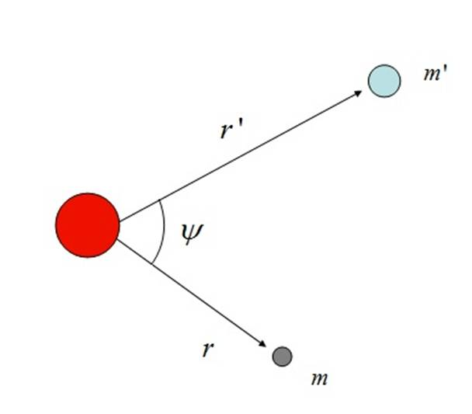
Figure 1.1 The three-body problem.

Unlike the analytical two-body problem in which two bodies rotate about their mutual center of mass in elliptic trajectories, adding an additional body makes the problem nonintegrable and thus with no analytic solution. The problem is commonly approached numerically by separating the system into two binaries, where the inner binary contains the massive body and the inner minor body while the outer binary contains the outer minor and the two-body system (i.e., their center of mass). The energy exchange between the inner and outer binaries is described by an argument called the disturbing function, which gives the extra potential energy contributed by one of the secondary masses.
Since our research deals with a mathematical formulation for the pendulum driving force that aims to simulate the Legendre-polynomial expansion of the disturbing function, we provide a comprehensive, step-by-step review of how the expansion is done. This review is mainly based on the book by Murray and Dermott (1999) called“Solar System Dynamics.”

The disturbing function for is
(1.1.1)

Similarly, the disturbing function for is
(1.1.2)

where is the gravitational constant, , and.

Applying the cosine rule for the angle (i.e., the angle between the two radial vectors and) gives

(1.1.3)
so
(1.1.4)

Expressing this by a Legendre-polynomial expansion gives

(1.1.5)

where ….

Because , the disturbing function (1.1.1) for the inner body can be written as

(1.1.6)

and the disturbing function (1.1.2) for the outer body can be written as

(1.1.7)

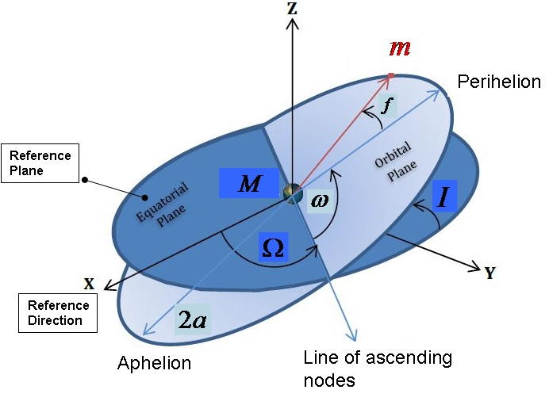
Figure 1.2 Orbital elements , and are, respectively, the true anomaly, argument of periastron, longitude of ascending node, semimajor axis, and inclination.

Since we want to work with the orbital elements (Fig. 1.2), the term is implemented as
(1.1.8)
where and are the semimajor axis of the inner and outer minor bodies, respectively.
Thus, Eq. (1.1.7) takes the form

(1.1.9)

To generalize the problem to three dimensions and thus to integrate the inclinations of the external and internal orbits, Murray and Dermott (1999) use the method of Kaula (1961) and Kaula (1962) and write Eq. (1.1.9) in terms of the orbital elements:

(1.1.10)
where
for
and
are the inclination functions
(1.1.11)

with

,

The summation goes from =max to =min. The quantities S and C are given by

(1.1.12)

and

(1.1.13)

are the Hansen coefficients,
where
,

with

being the Newcomb operators
, (1.1.14)

Note that, when
,
(1.1.15)
and when
,
(1.1.16)

The disturbing function due to the exterior secondary , is given by

(1.1.17)

The above method is one way to fully expand the disturbing function. Nevertheless, another method, which uses the Laplace coefficients, is also widely used.

Furthermore, we can simplify the problem by distinguishing between its direct and indirect parts
(1.1.18)

and
(1.1.19)

The direct part
(1.1.20)

is derived from the direct term of the disturbing function, so the origin of the coordinate systems is at the center of mass

. Conversely, the parts
(1.1.21)

and
(1.1.22)
are derived from the indirect terms of the disturbing function, which are due to the external (E) and internal (I) perturbers, respectively.
These two indirect terms exist only if we choose not to place the origin of the coordinate system at the center of mass.
For simplicity, we assume that the origin lies at the center of mass and so continue only with the direct term.
An expression for as an infinite Taylor series in and by using the Laplace coefficients is given by
(1.1.23)
where
, as in Eq. (1.1.12). Furthermore,
, (1.1.24)
, and are the true longitudes of the inner and outer minor bodies respectively,
and (1.1.25)
(1.1.26)

are Laplace coefficients and can be expressed as a uniformly convergent series in for all . They are defined by
(1.1.27)

To write the disturbing function by using the orbital elements instead of Cartesian coordinates, the following equations are used:

(1.1.28)

and
(1.1.29)
(1.1.30)

In addition,
(1.1.31)
and, similarly,
(1.1.32)

By using Eqs. (1.1.28) and (1.1.29) we can rewrite Eq. (1.1.24) as
(1.1.30)
where , and are, respectively, the true longitude, mean longitude, longitude of periastron, argument of periastron, longitude of ascending node, true anomaly, semimajor axis, eccentricity, and inclination of the internal and the external orbits.
The full expansion of the direct part of the disturbing function (1.1.23) is infinite. Nevertheless, most studies use only low-ordered expansions.
The following example is a second-order expansion, so it involves the sum the zeroth, first, and second arguments,
, with
(1.1.31)

(1.1.32)
(1.1.33)
Here, is an arbitrary integer, and denotes a differential operator that acts on the Laplace coefficients,
After some algebraic modifications and simplification, the direct part can be written as
(1.1.34)

Finally, Dermott & Murray (1999) formulated a new expression for the disturbing function that has the advantages of Kaula (1961, 1962), Eqs. (1.1.10) and (1.1.17), combined with the Laplace coefficients, Eq. (1.1.23),

(1.1.34)

where the expression

in Eq. (1.1.17) has been simplified and transformed here to

,
and where
for ,
(1.1.35)
,

when , (1.1.36)

when, (1.1.37)

(1.1.38)
(where [∙] means only the integer part of its argument) (1.1.39)

(1.1.40)

when both are even or odd, (1.1.41)

when both are even or odd. (1.1.42)

Thus, the disturbing functions describing the perturbation of the system by one of the minors, in this example by the external mass, [i.e., Eq. (1.1.6)], has the general form

(1.1.43)
where and is a function of the semimajor axes (), eccentricities () and inclinations () of masses and , respectively. As described for Eq. (1.1.34), the general form of each of the infinite number of arguments is a linear combination of all the longitudes of the three-body system:

(1.1.44)

Or, in the shorter form,

(1.1.45)

where

(1.1.46)

and are integers that obey the d’Alembert relation,
(1.1.47)

For reasons to be explained in section 1.2, the argument of Eq. (1.1.45) is named the “resonance argument.”

According to Eqs. (1.1.11) and (1.1.16), the lowest orders in the eccentricity and inclination terms are
𝒪
= 𝒪
𝒪
𝒪
Thus, we can evaluate argument as,
(1.1.49)
where is a function of the Laplace coefficients and can be expressed as a uniformly convergent series in for all.
The argument S is the amplitude of each term in the disturbing function and is often called the “strength” of the function.
It is evident that the lowest power of in a specific term is greater than or equal to the absolute value of the coefficient of . In addition, the lowest power of in a specific term is greater than or equal to the absolute value of the coefficient of . Similarly, the lowest powers of and are, respectively, greater than or equal to the absolute value of the coefficient of and the coefficient of.
Using Eqs. (1.1.17), (1.1.18), (1.1.20), (1.1.23), and (1.1.49), we can now rewrite the lowest order of the expanded disturbing function (1.1.18):
(1.1.50)
Because , and are all less then unity, researchers tend to neglect high-power terms in the expansion of the disturbing functions and consider only the low-power terms, which are more dominant.
This tendency is clearly demonstrated for the planar, circular, restricted three-body problem where Eq. (1.1.50) reduces to
(1.1.51)
Because the value of is also the order of the expansion; a higher expansion order corresponds to a lower strength .

In general, the arguments that contain mean longitudes and have short periods and their long-term perturbing effect is minor because they tend to average to zero. Thus, in most cases, the arguments that are more effective are those that contain the secular, low-frequency longitudes, , and .
Nevertheless, cases exist for which the mean longitudes significantly contribute to the perturbation. Such cases occur when the system is exact nearMMR, an issue discussed in the next section.

Mean-motion resonance
In general, resonance occurs when two frequencies form a simple numerical ratio. For MMR within the three-body problem, the two minor masses and revolve around the primary mass (Fig. 1.1) with orbital periods that are close to a ratio of two small integers (see, e.g., Beaugé et al., 2008). This ratio is called period commensurability (PC) and is calculated by

(1.2.1)
Where and are the mean motions of the minors and , respectively (i.e., their average angular velocities), and are integers.
The relevancy of the resonance argument to this situation is that, for MMR, the variations in time of the argument (i.e., ) are very small and, regarding exact resonance,
.
To better understand Eq. (1.2.1) we should look at the variation of the resonance argument as given by the derivation of Eq. (1.1.45):

(1.2.2)

Because , , and the variations of the secular longitudes are relatively small, we can say that, in exact MMR,

(1.2.3)
Thus, in MMR,

(1.2.4)

If we consider only the planar, circular, restricted case in which we have no inclination for both secondaries (i.e., ) and a circular orbit for the outer secondary (i.e., ), we can write Eq. (1.2.3) as

(1.2.5)

By using Eq. (1.1.44) for this case and using the d’Alembert relations,

We can finally write Eq. (1.2.4) as in Eq. (1.2.1):

(1.2.6)

Spatially, the MMR phenomena force the two orbiting objects to meet repeatedly, on the same orbital longitudes. Thus, the gravitational perturbation generated by and upon the resonating celestial bodies, as reflected by the disturbing function, induces changes in the orbital elements, mostly on the semimajor axis, eccentricity, and inclination. The orbital evolution of the perturbed masses is quantified by the Lagrange planetary equations. These equations depict the variations on each of the six orbital elements: and .
These changes are often small. However, the MMR perturbation due to the frequent conjunctions may sum up coherently and, if the forcing frequency is commensurate or nearly commensurate with the natural frequency of oscillation of the responding elements, the perturbation will produce a large-amplitude, long-period response (de Pater & Lissauer, 2001) that can either provide stability or provoke chaos and destruction. This issue is further discussed in section 1.3.
Although the presence of PC is necessary to the existence of MMR, PC alone is not a sufficient condition for establishing the existence of MMRs and, to constitute a true resonance, one or more of the infinite resonance arguments [Eq. (1.1.45)] in the disturbing function should be fixed or at most undergo small librations. This is because, in inclined and elliptic trajectories, the instantaneous position in space of celestial bodies depends not only on the mean longitudes () but also on the longitudes of periastron and ascending nodes (), which evolve much slower than the mean longitudes and so cause secular variations. In the opposite case, when the system is out of MMR, all arguments circulate (see, e.g. Malhotra, 1998; Adams et al., 2008; Mardling, 2008; Lecoanet et al., 2009; Mustill & Wyatt, 2010).
The order of the resonance and the order of the disturbing-function expansion is the absolute value of the sum of that equals.
For instance, when the ratio of the two secondaries is , the order equals 1 and when, equals 2
This order tells us how many successive conjunctions occur before the two bodies meet again on the same spatial longitudes. Thus, if the orderequals 1, each conjunction occurs at the same longitude, and if the order equals 2 the two bodies meet on the same longitude every second conjunction (Murray and Dermott, 1999).
As mentioned above, the argument is the strength of each individual term in the expansion of the disturbing function.

If we reduce Eq. (1.1.49) (i.e., ),
to the simple case of the planar, circular, restricted problem where the body in the external orbit is perturbing an inner minor of negligible mass, the strength of the disturbing function will be
. (1.2.7)
Thus the strength of the disturbing function depends on the resonance order or, in the more general form, on . Because the eccentricity is usually less than unity, then a lower resonance order leads to a greater strength, and the perturbation is asserted on the inner body.
For MMR, so, because the variations of the secular longitudes,, , and are relatively small, an argument of the form
,
will result in secular motion, albeit at high frequency of the mean longitudes.

In conclusion, for low-order MMR and especially when the amplitude is large, the total effect of the long-period variations of on the disturbing function is to cause considerable perturbations.

In addition to MMR, planetary systems exhibit other types of resonances; for example:
- Secular resonance. Secular resonace occurs when the frequency of variation of the longitude of periastron () or the longitude of the node () of the perturbed body becomes nearly equal that of the eigenfrequencies of the perturbing body’s system (Carruba et al., 2005; Murray & Dermott ,1999).
- Spin-orbit resonance. Spin-orbit resonance occurs when the ratio of the spin period of a satellite to its orbital period is an integer or a near integer. In this case, a significant spin-orbit coupling may occur [e.g., the spin-orbit resonance of the earthly moon. (Murray & Dermott 1999)].

Although MMRs occupy a relatively small volume of phase space, they are, evidently, a common phenomenon in planetary systems. As shown in figure 2, MMRs appear among planets, moons, and asteroids within our Solar System (see, e.g., Chiang et al., 2007; Malhotra et al., 2008;), as well as in extrasolar systems.

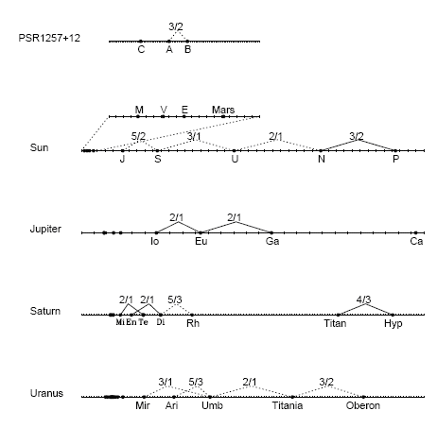
Figure. 1.2.1. Mean-motion resonance in Solar System (Malhotra, 1998).

The ongoing effort to detect extra-solar planetary systems yielded over 1300 systems, about 40% of which have multiple planets. Many planets have Jovian masses located relatively close to their stars with orbital periods of 8–10 days. A significant amount of all known multiplanetary systems exhibit period commensurabilities that might indicate the presence of low-order MMRs. The majority of which are in 2/1 and, by descending order, in 3/2, 5/2, 3/1, 4/1, and 4/3 (online exoplanet orbit data base, Wright et al., 2011a; Antoniadou, 2016).
To mention a few of the studies regarding exoplanets in MMRs, Laughlin and Chambers (2001) used N-body integrations of orbital parameters based on a best-fit solution to Keck and Lick data. The results showed that the two planets orbiting GJ 876 are librating about the 2/1 MMR. In a similar way other systems were found be in MMRs; for example, 55 Cnc in 3/1 (Zhou et al., 2004) and HD82943 in 2/1 (Lee et al., 2006). Wright et al. (2011b) showed that the frequency of MMRs in planetary systems (one in three at that time) is too high to be regarded as random. This result suggests that scattering and migration mechanisms, similar to those that generated MMRs in the Solar System, are also relevant for extrasolar systems.
What are the possible origins of MMR configurations?
Protoplanets can migrate into MMR configurations due to large-scale changes in their planetary orbit. According to numerous studies, this change can occur via three basic physical mechanisms:
- Gas-disk migration: According to this model, planets, once embedded in the protoplanetary gas disk, undergo a differential convergent orbital migration as a result of the energy and angular-momentum exchange between the planets and the gas disk (see, e.g., Kley, 2004; Papaloizou & Szuszkiewicz, 2010; Ketchum, Adams & Bloch, 2011). This is considered the main mechanism responsible for instigating a MMR configuration, and especially the 2/1 and 3/1 configurations, before the dissipation of the protoplanetary gas disk (see, e.g., Snellgrove et al., 2001; Lee & Peale, 2002; Lee et al., 2009; Kley et al., 2004, Thommes, 2005; Pierens & Nelson, 2008; Raymond et al., 2008).
- Planetesimal driven migration: This type of migration becomes effective after the dissipation of the gas disk. It can make planets move into and out of MMR configurations due to their interaction with an outer planetary disk. (Thommes et al., 2008, Fernandez & Ip, 1984; Hahn & Malhotra, 1999; Ida et al., 2000; Gomes et al., 2004, 2005; Kirsh et al., 2009).
- Planet-planet scattering: This occurs when an initially unstable system of planets evolves under mutual planet-planet gravitational forces (see, e.g., Raymond et al., 2008). It will evolve chaotically until planets start crossing each other’s orbit and are ejected from the system. The planets that are not ejected migrate closer to the star as a consequence of energy loss (Rasio & Ford, 1996; Weidenschilling & Marzari, 1996; Lin & Ida, 1997) and form MMR configurations.

In addition to these mechanisms, Zhang et al. (2010) suggest a hybrid mechanism of both scattering and collision for the formation of a 2/1 librating-circulating resonant configuration presumably formed in the early stages of the planetary system’s dynamical evolution.

Stability and instability of three-body system in mean-motion resonance

Causes and origins of instability
The stability of a general three-body system depends on the amount of energy exchanged between the orbiting masses. If the energy is high enough the system becomes unstable in the sense that eventually one of the bodies is diverted and thrown out of the system (Mardling, 2008) or is eliminated after a collision with another body.
Two important stability criteria exist for the circular, restricted, three-body problem (Nakamura & Yoshida, 1992; Deck et al., 2013):
- The Hill Stability criterion outlines the region of possible motion, so we can estimate whether the massless particle undergoes a close encounter with one of the major bodies and practically gets captured by it or escape from the system completely. Marchal & Bozis (1980) extended the Hill criterion to the general three-body problem.
- Lagrange stability tells us if the orbit of the massless body can suffer considerable changes due to the repeated gravitational interaction with the other bodies in the system—a change that can eventually lead to a collision or ejection of the negligible mass

As discussed in the previous section, the gravitational perturbation generated by and upon the three-body masses may be stronger if the system is in MMR. The reason for that phenomenon lies in the fact that, when a system is not in MMR, each conjunction of the two minor bodies occurs around a different celestial longitude, so all resonance arguments of the disturbing function circulate and the gravitational forcing is negligible. The case differs when a system is in MMR. In this situation, the perturbations may sum coherently and eventually induce major changes in the orbital elements (mostly on the semimajor axis, eccentricity, and inclination) and cause close encounters or even eject the perturbed body out of its current orbit. Koriski & Zuker (2011), in a statistical study based on observations, and Barnes et al. (2015), in a study based upon numerical models, suggest that systems in MMR may be systematically younger than those not in MMR. Thus, generally, MMR may be a passing phenomenon because it provokes instability of celestial systems. In the previous section, we discussed the destabilization potential of MMR due to accumulation of perturbations in the repeated conjunctions.

The major aspect of MMR, vis-a-vis this study, is that, by influencing the orbital parameters of planets, it plays an ambiguous role in the long-term evolution of planetary systems. Theoretically, the orbital changes, induced by MMR, can lock a planetary object into a stable quasiperiodic orbit for a substantially long time or, alternatively, distort the object motion and eject it completely out of the system or drive it into the capture zone of one of the other system masses. Thus, MMR is an intriguing phenomenon that can either support the stability of planetary motion and protect it against close encounters and collisions or, conversely, can intensify the gravitational perturbations and induce instability and destruction of orbits (Asghari et al., 2004, Malhorta et al.).

Bois et al (2003) demonstrate this ambiguous function of MMR by presenting the subtleties of the necessary initial configuration conditions under which the extrasolar system HD 160691, with two minors and orbiting star , will stay stable:
- The planets should be in MMRs with a 2/1 commensurability.
- The system should have a MMR configuration of , so the minors and are initially positioned at their apastrons.
This initial spatial configuration combined with the 2/1 MMR ensures that, after one revolution of the inner planet , planet is at its periastron and, after one more revolution, the planets are again near their apastron. Hence, under these terms, the MMR is maintaining long-term orbital stability by minimizing the magnitude of perturbations exerted on each planet by the others and by reducing the probability of close encounters.
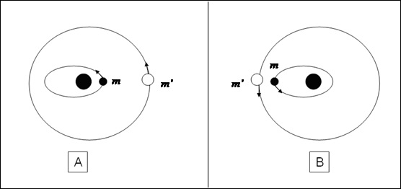
Figure. 1.3.1.1 Stable (A) and unstable (B) close encounters in a three-body system.
In conclusion, regarding the system configuration, MMR can provoke instability if it forces the two bodies to pass each other when the inner mass is at its apastron and the outer mass is at its periastron [Fig. (1.3.1.1 B)], a celestial configuration that provides a significant forcing. Nevertheless, in an inverted configuration [Fig. (1.3.1.1 A)], MMR may support stability if it guarantees repeated encounters at the largest possible distance where the gravitational perturbation is minimal.

Once an MMR configuration is established, the planets might be trapped and stay locked in it. The MMR trap usually occurs when the planet's energy and angular momentum summed by the MMR equals and thus compensates for the energy and angular-momentum loss due to external dissipation. It may even survive the tidal interaction between the planets and the gaseous protoplanetary disk that carried the planets to its current location (Mustill & Wyatt 2010). Nevertheless, mechanisms exist to disrupt the MMR so planets initially locked in resonance might migrate out of their resonance configurations. Studies about stability and evolution of MMR offered different mechanisms that could provoke instabilities and disrupt the resonance.
Adams et al. (2008), followed by Lecoanet et al. (2009), showed that, due to magnetorotational instability, the effects of turbulence in the protoplanetary gas disk could compromise resonant configurations. Thus, if turbulence is present, only a small percentage of the extrasolar systems that produced MMR configurations during their early life will retain their resonances over typical disk lifetimes of 1 Myr.
Hadjidemetriou (2002) studied the issue of stable and unstable resonances. He showed, in particular, that a planetary system in a 2/1 resonance is unstable if the mass of the outer planets is less than that of the inner planet. Others showed that strong stochastic forcing, resulting from turbulences within the protoplanetary disk, can affect and disrupt MMRs (Adams et al., 2008; Leconanet et al., 2009; Rein & Papaloizou, 2009a).
Thommes et al. (2008) and Gomes et al. (2005) raised the possibility that the violent breakup of closely packed, resonantly locked planets is a common evolutionary phenomenon in many planetary systems. Thus systems currently observed to be in MMRs represent only the survivors of a much larger, primordial, resonance population. They showed that interaction with a gas disk may create young planetary systems stabilized by MMRs but, on longer timescales, after the gas with its dumping effect is gone, the gravitational effect of the remnant planetesimal disk pulls these configurations apart, eventually inducing dynamical instability. These instabilities may have caused the late heavy bombardment of asteroids in our Solar System once Jupiter and Saturn crossed there mutual 2/1 MMR.

Chaotic instability
Another phenomenon that provokes instability arises from the chaotic nature of the three-body system (Lecar et al., 2001).
Chaotic behavior is a feature of nonintegrable problems, which includes the three-body problem. It is characterized by evolution of motion that is extremely sensitive to initial conditions. Thus there no complete analytical solutions to the problem exist and we cannot predict the future state of the system even if we know all the forces acting on it now. The magnitude of the chaos in the system is frequently determined by the maximum Lyapunov characteristic exponent, a quantitative measure of the rate at which two nearby phase-space trajectories diverge (Murray & Dermott, 1999).
When the motion is chaotic, the evolution of the phase-space distance between the two initially proximate particles at a given time is
(1.3.2.1)
where is the distance between the trajectories at time and is the maximum Lyapunov characteristic exponent (Fig. 1.3.2.1).

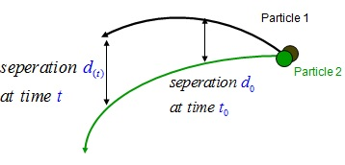
Fig. 1.3.2.1. Divergence of two particles in phase space.

The elapsed time for this e-folding separation is called the Lyapunov time .
Chaos in a dynamical system does not imply that the system is disordered, but rather a deterministic dynamical system that behaves in an irregular manner (Malhotra et al., 2001).
Note also that chaotic behavior does not necessarily imply system instability, so we should not confuse chaos with instability (Bois et al., 2003).
In Poincaré mapping, the meaning of “chaotic” is a dynamical behavior that is not quasi-periodic; it does not necessarily mean that the system will eventually disintegrate. Nevertheless, chaos can provoke instability if it induces a change in the orbital parameters that eventually results in significant perturbations due to a close encounter with a massive planet.

In addition to the Lyapunov-time criterion, several analytical tools have been developed to describe chaotic behavior in planetary systems:
- The law (Wisdom, 1980; Duncan et al., 1989) was developed for the circular-planar restricted three-body problem and offers a criterion to determine whether a perturbed test particle is in a chaotic orbit. The law states that a test particle with semimajor axis that satisfies the equation

(1.3.2.2)
will have a chaotic orbit, where is the perturber mass divided by the total mass of the system (primary plus perturber) and is the perturber semimajor axis.
- Lecar et al. (1992a; 1992b) numerically integrated the Solar System polynomial dynamics and provided a relation between the Lyapunov time and the event time . The event time is the time required for a small body (e.g., a main-belt asteroid) to increase its eccentricity until it crosses the orbit of a planet and probably collides with it to be removed from the system. The relation between the two times is
(1.3.2.3)
where is the orbital period of the main perturbing body and a and b are coefficients obtained from a fit to the particular system.
- Following Lecar et al. (1992a; 1992b) , Murray & Holman (1997) developed the following analytical expression to quantify the time it takes a small body in the Solar System to be removed from the system due to a close encounter: (1.3.2.4)
- where is the removal time, and are system constants, and and are the particle initial and maximal eccentricities in the Hamiltonian form (for low eccentricities ).

The identification of specific orbits as chaotic becomes clear upon observing the Poincaré surface of section map. While the MMR orbits are represented as points along smooth closed curves called “islands,” (Fig. 1.3.2.2.a), chaotic orbits are represented by points that fill the entire area of the phase space (Fig. 1.3.2.2.b). A further examination of the Poincaré map reveals that some of the chaotic orbits have a tendency to “stick” to the edges of the MMR islands. This phenomenon demonstrates a fundamental characteristic of chaotic behavior: chaotic orbits might “disguise” themselves as regular orbits over relatively long timescales. In accordance, numerical simulations show that, although planets follow chaotic orbits, they may remain near their current orbits during the entire Solar System lifetime and even much beyond. For instance, the escape time of Uranus out of the Solar System due to chaotic motion is years (Murray & Holman, 1999).

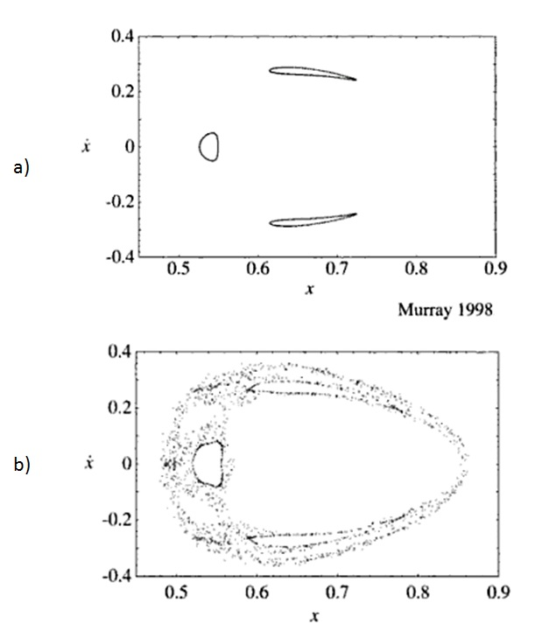
Figure 1.3.2.2. (a) Poincaré surface of section of a third-order MMR shows three smooth curves (islands). The number of islands is equivalent to the order of resonance.( b) Chaotic trajectories are represented as regions of dots that stick to the resonance islands

Today, no doubt remains that chaotic behavior exists in our Solar System. Murray & Holman (1999) confronted the analytical theories that earlier claimed that the Solar System is stable and, by using numerical integration, showed that our Solar System is almost certainly chaotic. Indeed, according to numerical integrations, planetary objects in our Solar System exhibit a chaotic behavior (see, e.g., Murray & Holman, 1997; Laskar, 1989; Laskar, 1990; Quinn et al., 1991). The result of integration over 100 Myr of the entire Solar System indicates that the system is chaotic, with a Lyapunov timescale of (Sussman & Wisdom, 1992).
Tsiganis et al. (2005) concluded that of the main-belt objects follow chaotic orbits with Lyapunov times , although many of them are defined as being in a stable chaos. In other words, they have chaotic orbits that, although generating significant changes in orbital parameters, do not result in close approaches between planets and thus do not induce a significant instability.

A three-body system in MMR can undergo large-scale chaos. When in MMR, at least one resonance argument in the disturbing function is librating. If only one resonance argument librates and all others circulate, the system is at a stable resonance. However, if more than one argument librate, they may force each other in a phenomenon known as resonance overlap, thereby provoking chaotic motion and destabilizing the system (Laskar, 1990; Mardling, 2008; Murray & Dermott, 1999). The extent of chaos depends on the stochasticity parameter , which is a function of the separatrix width divided by the phase space distance between resonances. For small the chaos is small but for the region close to the MMR zone is primarily chaotic.
An orbit that librates part of the time and rotates the remaining time must cross the separatrix and is hence chaotic. This type of dynamical behavior in which the resonance angle of a planetary system
continuously executes a series of librations and circulation cycles is also known as “nodding.”
Ketchum et al. (2013) studied this type of irregular dynamics regarding exoplanetary systems that orbit in or near MMR.
By using full numerical integrations of the planetary systems and model equations, they showed that these systems can exhibit nodding behavior, which often occurs when a small body is in an external MMR with a larger planet. They conclude that this phenomenon can be important for interpreting observations of transit timing variations, where the existence of smaller bodies is inferred from their effects on larger, observed transiting planets.

The chaotic effects on a three-body system can be relatively slow in case of a phenomenon called “chaotic diffusion.” It exists in celestial systems with high-order MMRs and causes very slow but systematic changes in orbital elements. The elements, and especially the eccentricity and inclination, tend to drift systematically and, eventually, reach substantial values (see, e.g., Morbidelli, 2001; Gozdziewski & Migaszewski, 2009;Tiscareno & Malhotra, 2009).

The notion that planetary particles undergo chaotic diffusion is rather new and was discovered once computers could cope with long-term numerical integrations. Until the 1990s, short-term integrations require for the evolution of small planetary objects (e.g., in the Kuiper Belt) presented either rapid instabilities or stable systems. Long-term integrations ( timescales) tended toward a slow evolution of proper eccentricities and/or inclinations of Solar System bodies, caused by overlapping MMRs between the small objects and one or two planets. This slow but consistent drift can eventually eject and remove an object out of its orbit (and subsequently from its MMR region) as a result of close encounters with massive planets. This phenomenon may have removed asteroids from the main belt and from the Kuiper Belt and can generate planet-planet scattering in the Solar System and in extrasolar systems.

Tiscareno & Malhotra (2009) ran a numerical integration that showed that chaotic diffusion caused by MMR overlapping forced Kuiper Belt objects out of their MMR region in . Wisdom (1987) described the chaotic nature of the gaps in the asteroids’ main belt and showed that the presence of chaos in the 2/1 and 3/1 resonance zones explains the anomaly of the lack of objects at the 2/1 resonance in contrast with the accumulation of objects at the 3/2 resonance (Fig. 1.3.2.3). According to Wisdom (1987), the chaos generates high eccentricities () that force asteroids orbiting near this region to cross the orbit of Mars and to be ejected out of orbit and out of the resonance zones due to close encounters or collisions. This phenomenon can also explain the continuous delivery of asteroid debris from the asteroid belt to Earth.

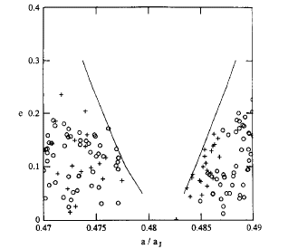
Figure 1.3.2.3. Comparison of actual distribution of asteroids near the 3/1 MMR with outer boundaries of the chaotic zone. Circles denote TRIAD asteroids and crosses denote Palomar–Leiden asteroids (Wisdom 1987).

Tsiganis et al. (2005) present possible chaotic behavior in another part of the Solar System: the Jupiter Trojans. By using the SWIFT package (Levinson & Duncan, 1994) they ran numerical integrations representing the dynamical changes over on a specific Trojan population with chaotic orbits (using Lyapunov time on the order of ). Using the experimental data they showed that 17% of these Trojans exhibit unstable orbits over the Solar System age while 20% undergo stable chaotic motion (i.e., chaotic orbits that do not provoke instability during the of the numerical run).
Most of the studies investigated chaos and chaotic diffusion behavior of small bodies (e.g., asteroids) which could be regarded as test particles. Nevertheless, a first article on the chaotic diffusion of planetary orbits was presented by Laskar (1994). Later, Laskar (2008) statistically analyzed over a thousand different 5 Gyr integrations of the secular equations. For each planet in the Solar System, the paper reported the probability for the eccentricity to obtain large values via chaotic diffusion. The results show that, on a 5 Gyr timescale, the four terrestrial planets might undergo a chaotic diffusive process whereas the outer giant planets do not show significant diffusion.
Chaos is probably most common in extrasolar planets as well. The ever-growing operational and technological effort made in recent years to discover new planetary systems has yielded substantial information about the planets’ dynamical behavior. The accuracy of the data regarding orbital elements enables us, for the first time, to better investigate the coexistence of MMR and chaos in those remote systems.
Antoniadou (2016) used a numerical model of three-body problem and described a method to find stable, nonchaotic regions in phase space where extrasolar planets in MMR should be hosted to guarantee long-term stability. He applied this process to co-orbital motion and to the systems HD 82943, HD 73526, HD 128311, HD 60532, HD 45364, and HD 108874.
Gayon et al. (2008) used frequency map analysis, mean exponential growth of nearby orbits (MEGNO, Cincotta & Simó 2000), and the SYMBA numerical integrator (Duncan et al. 1998) to show that the five planets orbiting 55 Cnc represent a case of stable chaos.
Bois et al. (2003) applied the MEGNO and fast Lyapunov indicator techniques to find the conditions that ensure dynamical stability for the HD 160691 system (Figure 1.3.4).
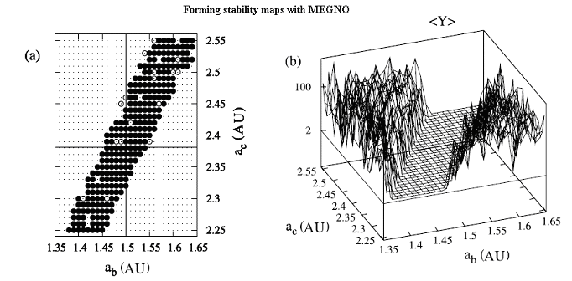
Figure 1.3.2.4. Example of (a) two-dimensional and (b) three-dimensional stability maps for the HD 160691 extrasolar system formed with the MEGNO tool. In panel (a), filled and open circles indicate stable orbits and small dots not surrounded by circles indicate highly unstable orbits. In panel (b), the peaks indicate the magnitude of the instability. The quantity <Y> is the characteristic value of the MEGNO indicator (Bois et al. 2003).

Driven pendulum

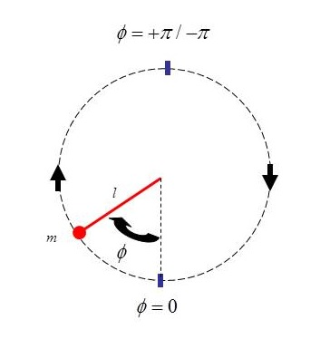
Figure 1.4.1. The simple pendulum.

As mentioned on chapter 1.3, the behavior of each argument within the disturbance function reveals whether the system is in a MMR state (thus named the “resonance arguments”) (Murray & Dermott, 1999; Mardling, 2008). When at least one of the resonance arguments librates with small amplitude around a specific angle we say that the system is in MMR.
The kinematics of each of the resonance arguments that constitutes the Legendre expansion of the disturbing function can be simulated by a simple pendulum excited by a periodic force.
The simple pendulum consists of a massless rigid rod of length attached to a frictionless pivot point, with a point mass fixed to the end of the rod (Fig. 1.4.1). The motion of the pendulum is described by
(1.4.1)
where is the angular displacement of the pendulum with respect to its downward equilibrium position and is the small-angle frequency that equals .

We can explain the similarity between the pendulum motion and the resonance-argument motion by deriving the equation of motion of the argument for a the planar, circular, restricted problem:
(1.4.2)
The second time derivative of the resonance argument in Eq. (1.4.2), assuming a negligible change in the mean motion of the perturber (so ) gives
(1.4.3)
If we neglect the small contribution of and we can write
(1.4.4)
where
(1.4.5)
and
(1.4.6)

Therefore,
(1.4.7)
so
(1.4.8)
which is identical to the simple pendulum equation [i.e., Eq. (1.2.1)]
when
(1.4.9)
Note that, for odd-order resonances, the stable motion of the pendulum is around and for even-order resonances, the stable motion is around .
The pendulum obeys conservation of energy conservation, with energy E defined by
(1.4.10)

The separatrix is the border in phase space that separates the two possible motions of the pendulum: the libratory motion, where the pendulum oscillates with amplitudes , and the circulatory motion in which the amplitude moves unbounded
(Mardling, 2008; Murray & Dermott, 1999).
The equation that describes the separatrix in phase space is
(1.4.11)

For convenience, we choose zero energy to correspond to the separatrix.
Thus, in our study a negative energy implies libration and a positive energy implies circulation (Fig. 1.4.2).

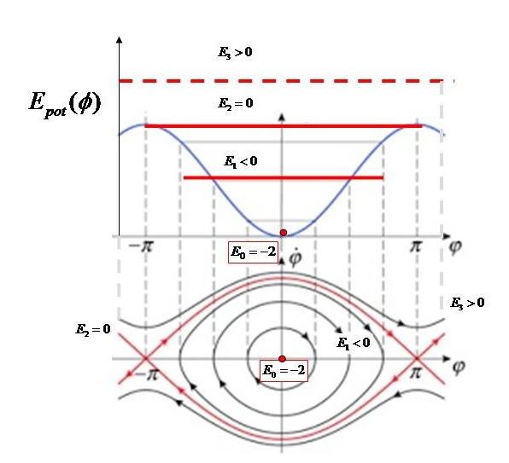
Figure. 1.4.2 Lower diagram: Pendulum libratory and circulatory trajectories in phase space () with four corresponding energy values: Pendulum at rest in lower vertical position (), libration (), at the separatrix (), and circulation (). The separatrix is drawn in red lines. The points are hyperbolic fixed points, unstable with respect to small angular displacements, whereas the origin is a fixed point that is stable with respect to small displacements.
Upper diagram: Four potential energies on a graph of energy versus pendulum amplitude .

If we exert a simple driving force on the pendulum, the system will cease to be energy preserving and its energy level and motion will be influenced by the amplitude, frequency, and phase of the driving force. For instance, in our second study (i.e., “Peak-to-Peak Distance Statistics of Energy Time Series in the Periodically Driven Pendulum”), we applied a periodic forcing of the form

(1.4.12)

where and were, respectively, the driver amplitude and frequency and is a randomly chosen phase shift.

To demonstrate the evolution of the pendulum motion as a function of its instantaneous energy level, we integrated Eq. (1.4.12) with initial conditions under fixed, arbitrary, driver frequency, amplitude, and phase shift. As shown in Fig. 1.4.3, by changing the driver amplitude, we regulate the mean energy level in the system.
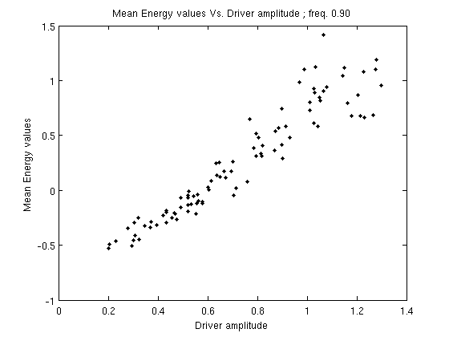
Figure 1.4.3. Mean-energy vs periodic driver amplitude for and randomly drawn pairs of , .

For sufficiently small amplitude, the mean energy of the system remains negative and the pendulum maintains its initial librating state. Upon increasing the driving amplitude, the mean energy of the pendulum also increases and the phase-space trajectories approach the separatrix. This is where the motion becomes irregular (and possibly chaotic).
In this irregular state, the system occasionally crosses the border between negative and positive energy levels. Thus, in this interval, the behavior is more complex and unstable in the sense that it is neither purely librating nor circulating but exhibits a mixed composition of both modes of motion (Fig. 1.4.4). Despite the irregular behavior, this type of motion is not random but deterministic (Chirikov, 1979; Hilborn, 1994; Murray & Dermott, 1999; Gonzalez, Reyes & Suarez, 2002; Mardling, 2008; Celletti 2010).
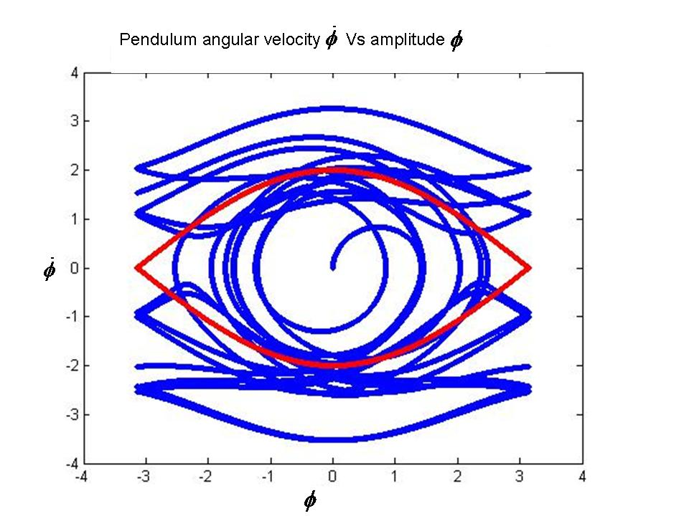
Figure 1.4.4. The blue trajectory displays the chaotic, libratory-circulatory trajectory of a driven pendulum in phase space (angular velocity vs amplitude). The separatrix is in red. The motion starts at and occasionally crosses the separatrix borders from the libratory to the circulatory region and vice versa

The evolution described of the argument of the driven pendulum simulates the behavior of a librating resonance argument of a three-body system in MMR when the system is being disturbed by one or more librating resonance arguments with commensurabilities that overlap that of. When an overlap exists, the energy exchange between the two binaries is done efficiently enough to provoke chaos of such magnitude that the resonance is broken and the three-body system is destabilized. Thus, the existence of resonance overlap serves as a diagnostic test and a criterion for strong chaos and instability, which is expressed by the transition of the resonance-angle motion from libration to circulation, indicating chaotic motion (see, e.g., Laskar 1990).
For this reason, driven pendulums are commonly used as toy models to investigate the dynamic behavior and general laws of other, more complex, nonlinear chaotic systems (Butikov, 2002) and, in particular, celestial dynamics phenomena such as the spin-orbit coupling (Celletti, 2007) or the near resonance behavior of three-body celestial systems. The latter issue is discussed in detail in our studies.

Algebraic mapping
Since the driven pendulum and the three-body problem are nonlinear systems, their motion cannot be solved analytically; thus, numerical methods are used. These numerical methods are based on “algebraic mappings” where the continuous motion is divided into time steps and the subsequent state of the system , is mapped from the previous state .
A rather simple, one-dimensional mapping is the “logistic map,” which was originally developed to simulate biological growth of animal populations and later was recognized as an efficient tool for the study of chaos. It takes the form
(1.4.13)
where, for , the trajectory of the logistic map is stable and periodic but, for , the trajectory becomes chaotically unstable (we come back to the logistic map in the second study).
Another useful mapping is the “standard map,” which is an algebraic mapping of the driven pendulum. Its formulation is as follows:
The Hamiltonian of the simple pendulum is
(1.4.14)
where and are, respectively, the action and angle variables.
Thus,
(1.4.15)
and
(1.4.16)
After subjecting the simple pendulum to an oscillating perturbing force, we obtain
(1.4.17)
The approximation of the right-hand side of the equation is achieved by assuming that the cosine term is applied only at discrete intervals.
Applying the Dirac function to simulate an impulse of the exerted force every , we finally obtain the new Hamiltonian
(1.4.18)

for which the equations of motion are

(1.4.19)
and
(1.4.20)

Integration of the above equations gives

(1.4.21)
and

(1.4.22)

Applying time steps of at each iteration, the discrete solutions for the driven pendulum is given by the two-dimensional set (Hilborn, 1994; Murray & Dermott, 1999)

(1.4.23)

(1.4.24)

The parameter is called the “perturbing parameter” and measures the nonlinearity of the system.
The standard map was already studied in many works since it was first presented by Chirikov in his famous article “A universal Instability of Many Dimensional Oscillator Systems” (Chirikov, 1979).
When an agent exerts an external dissipative force on the system the standard map takes the form of the “generalized dissipative standard map,”

(1.4.25)

(1.4.26)

where the parameter is called the “dissipative parameter” (i.e., when the system is conservative)
(Celletti, 2007).

To demonstrate the behavior of the standard map we slightly modify Eqs. (1.4.25) and (1.4.26) and integrate the following equations:

(1.4.28)

(1.4.29)
Figure 1.5.1 presents the result of the integration for , with initial conditions of , and the dissipation parameter growing from to .
As grows, evolves from stable single-period motion to bifurcation of 2, 4, 8 periods, etc. At the motion of becomes chaotic.

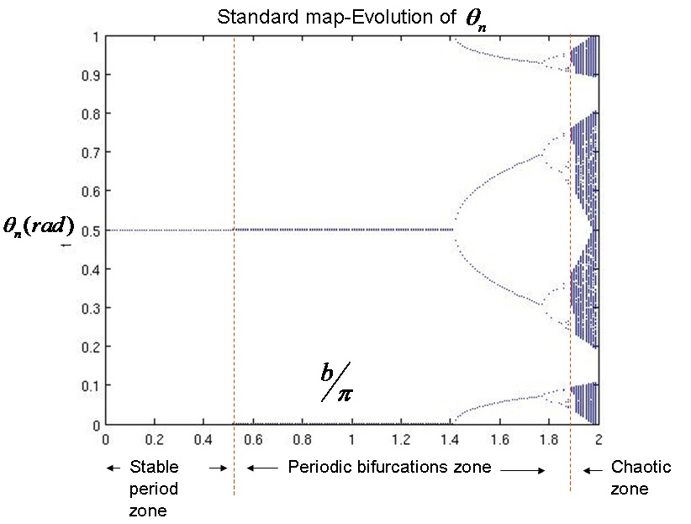
Figure 1.5.1. Evolution of in standard map under initial conditions of , . The dissipation parameter grows gradually from to . As grows, moves from stable periodic motion to period bifurcations and, eventually, to chaotic behavior.

First study: On the ages of planetary systems with mean motion resonances
Shuki Koriski and Shay Zucker
Department of Geophysics sciences, Raymond and Beverly Sackler Faculty of Exact Sciences, Tel Aviv University, Tel Aviv 69978, Israel; jehoshu1@post.tau.ac.il, shayz@post.tau.ac.il
Received 2011 August 11; accepted 2011 September 13; published on the astrophisical journal
on 2011 October 14

Study preface
In this first study we wanted to see if MMRs are an eternal phenomena or whether MMR configurations tend to break down over time, as suggested in several studies (see, e.g., Gomes et al., 2005; Thommes et al., 2008). To check this ambiguity, we measured the average age of systems in MMR against the average ages of systems that are not in MMR. If MMR tends to vanish, we would expect to see a shortage of MMRs around older stars. The results indicate that only stars hosting planets with a 2/1 period commensurability are statistically significantly younger. All other PCs do not show such an age correlation; nevertheless, these results provide significant evidence to support the claim that MMRs are not eternal.

Study abstract
We present preliminary but statistically significant evidence that shows that multiplanetary systems that exhibit a 2/1 period commensurability (PC) are in general younger than multiplanetary systems without commensurabilities, or even younger than systems with other commensurabilities. An immediate tentative conclusion is that the 2/1 MMR in planetary systems typically tends to be disrupted after a few Gyr.

Note: For the scientific introduction, please see chapters 1.1–1.3 of the general introduction.

Sample
We first built a sample of stars hosting known multiplanet systems by using the publicly available exoplanet orbit database put online by Wright et al. (2011a). To make our sample as homogeneous as possible, we consider only planets that were detected by radial velocities around stars of spectral types F, G, or K. We thus exclude most known transiting planets (except those detected first through radial velocities), pulsar planets, planets detected in direct imaging, planets around M stars, and Solar System planets.
Next, we identified those systems that exhibit PCs. We include in our definition of commensurabilities integer ratios greater than unity and with a denominator less than six (i.e., the ratios 2/1, 3/1, 3/2, 4/1, 4/3, 5/1, 5/2, 5/3, and 5/4). To tag two periods as commensurate, we define a “normalized commensurability proximity” score defined by
(2.1.1)
where is the actually measured period ratio and is the commensurability ratio against which we compare . We chose to tag as commensurate systems with at least one instance of normalized commensurability proximity .
Next we estimate the ages of the stars in our sample. Stellar age is notoriously difficult to estimate. Soderblom (2010) reviewed and compared several approaches to estimate age. Two approaches dominate the literature: The first uses the stellar activity as estimated by the H and K lines of singly ionized calcium in the stellar spectrum. The second places a star on model isochrones on the Hertzsprung–Russell diagram. Both methods, and the less frequently used methods, are strongly model dependent and suffer many drawbacks and pitfalls.
For the sake of sample homogeneity, we focus purely on a single approach. Furthermore, Figure 8 in the paper by Soderblom (2010) shows that, in addition to a prevailing systematic shift between isochrone age and chromospheric-activity age, the isochrone age might lose its sensitivity for stars younger than about 2 Gyr. Thus, we only use chromospheric-activity age based on the calcium H and K emission lines. To avoid nonuniform interpretation of observations, we extract the chromospheric-activity age only from large published surveys and not from papers that analyze individual stars. Our use of chromospheric-activity ages also provides another reason to exclude M stars from our sample, because M stars are notorious for having variable activity (Soderblom, 2010).
Table 2.1 presents the resulting sample of commensurate planetary systems, including the relevant commensurability ratios and the normalized commensurability proximity. The table also lists the chromospheric-activity ages from the literature and the average age that we computed from these values. Table 2.2 lists the systems that did not satisfy our criterion for PC () and their relevant ages. In both tables, we also include systems for which no chromospheric activity age appears in any large published survey. In total, our sample conveniently includes 15 age estimates for commensurate systems and 15 for noncommensurate systems.

Table 2.1
Sample of commensurate multiplanetary systems.

HD | HIP | Other Names | Commensurabilities | Normalized Commensurability Proximity | Published Ages (Gyr) | Reference | Mean Age (Gyr)
9826 | 7513 | υ And | 5/1 | 0.058 | 6.31, 5.32, 6.23, 7.26 | 1,2,3,4 | 6.28
10180 | 7599 | ... | 4/1, 5/1, 5/2, 3/1, 3/1 | 0.087, 0.022, 0.014, 0.014, 0.055 | 6.46 | 5 | 6.46
37124 | 26381 | GJ 209 | 2/1 | 0.048 | 3.89, 3.33, 4.72 | 1,2,3 | 3.98
40307 | 27887 | GJ 2046 | 2/1, 5/1 | 0.061, 0.052 | ... | ... | ...
45364 | 30579 | ... | 3/2 | 0.007 | 4.87 | 5 | 4.87
60532 | 36795 | GJ 279 | 3/1 | 0.000 | ... | ... | ...
69830 | 40693 | GJ 302 | 4/1 | 0.094 | 4.68, 6.36, 6.43, 6.1 | 1,3,4,6 | 5.89
73526 | 42282 | ... | 2/1 | 0.004 | 5.59 | 2 | 5.59
75732 | 43587 | 55 Cnc | 3/1 | 0.010 | 6.46, 5.5, 6.44, 3.43, 8.7 | 1,2,3,5,6 | 6.11
82943 | 47007 | ... | 2/1 | 0.002 | 4.07, 3.08, 5.10 | 1,2,3 | 4.08
... | ... | BD +20 2457 | 5/3 | 0.021 | ... | ... | ...
90043 | 50887 | 24 Sex | 2/1 | 0.029 | ... | ... | ...
108874 | 61028 | ... | 4/1 | 0.063 | 7.41, 7.26 | 1,2 | 7.33
115617 | 64924 | 61 Vir | 3/1 | 0.075 | 6.31, 5.90, 6.62, 6.1 | 1,3,4,6 | 6.23
128311 | 71395 | GJ 3860 | 2/1 | 0.017 | 0.39, 0.43 | 2,4 | 0.41
155358 | 83949 | ... | 5/2 | 0.084 | 5.32 | 3 | 5.32
160691 | 86796 | μ Ara | 2/1 | 0.035 | 6.41, 3.31, 6.5 | 2,5,6 | 5.41
181433 | 95467 | GJ 756.1 | 5/2 | 0.087 | ... | ... | ...
183263 | 95740 | ... | 5/1 | 0.011 | 8.13, 7.38 | 1,3 | 7.75
200964 | 104202 | ... | 4/3 | 0.008 | ... | ... | ...
202206 | 104903 | ... | 5/1 | 0.076 | 2.04, 2.95 | 2,7 | 2.49

References. (1) Wright et al., 2004; (2) Saffe et al., 2005; (3) Isaacson & Fischer, 2010; (4) Maldonado et al., 2010; (5) Rocha-Pinto & Maciel, 1998; (6) Mamajek & Hillenbrand, 2008; (7) Arriagada, 2011.

Table 2.2
Sample of noncommensurate multiplanetary systems.

HD | HIP | Other Names | Published Ages (Gyr) | Reference | Mean Age (Gyr)
9446 | 7245 | ... | ... | ... | ...
11964 | 9094 | GJ 81.1A | 9.55, 9.56 | 1,2 | 9.55
12661 | 9683 | ... | 7.41, 7.05, 7.05 | 1,2,3 | 7.17
... | 14810 | ... | 7.77 | 3 | 7.77
38529 | 27253 | ... | 4.90, 5.09, 6.73 | 1,2,3 | 5.57
47186 | 31540 | ... | 2.72, 8.13 | 5,7 | 5.43
74156 | 42723 | ... | 7.24, 7.38, 7.54 | 1,2,3 | 7.39
... | 40967 | BD -08 2823 | ... | ... | ...
95128 | 53721 | 47 UMa, GJ 407 | 6.03, 6.03, 6.10, 4.93, 4.4 | 1,2,3,4,6 | 5.50
125612 | 70123 | ... | 4.23 | 3 | 4.23
134987 | 74500 | 23 Lib, GJ 579.4 | 7.76, 7.32, 8.12 | 1,2,3 | 7.73
147018 | 80250 | ... | 3.16 | 7 | 3.16
168443 | 89844 | GJ 4052 | 8.51, 5.90, 8.19 | 1,2,3 | 7.53
169830 | 90485 | ... | 7.24, 4.95 | 1,2 | 6.09
187123 | 97336 | ... | 6.31, 5.33, 6.59 | 1,2,3 | 6.08
190360 | 98767 | GJ 777A | 7.76, 7.09, 8.6 | 1,2,6 | 7.82
215497 | 112441 | ... | ... | ... | ...
217107 | 113421 | ... | 7.41, 7.32, 8.19 | 1,2,3 | 7.64

Note. For references, see Table 1.

Statistical tests
The mean chromospheric-activity age of commensurate systems in our sample is 5.213 Gyr, whereas that of the noncommensurate systems is 6.577 Gyr. This difference of 1.36 Gyr hints that resonant systems tend to be younger on average. To test this hypothesis, we adopted the simplest approach: the permutation test (Good, 1994). Thus, we repeatedly drew a random assignment of the ages from the two samples, effectively destroying any correlation that may have existed between age and commensurability. For each such random assignment we recalculated the mean age difference. We used 106 random assignments, among which 20 650 yielded an age difference larger than 1.36 Gyr. This implies a statistical significance of p = 0.021.
The main advantage of the permutation-test approach is to avoid the need to assume any special assumptions about the distribution of the samples. However, one may still argue that the use of the mean values is prone to strong influence by the extreme values in each sample. An alternative is to use the median instead, which is more robust against extreme values. The median age of the resonant systems is 5.59 Gyr and that of the nonresonant systems is 7.17 Gyr, which gives a difference of 1.58 Gyr. We repeated the permutation test, this time obtaining 17 178 out of 106 values larger than the actual value. Thus, the permutation test for the medians leads to a somewhat more significant result, with a significance of p = 0.017.
These results are only marginally significant. They do seem to point to a tendency of the commensurate systems to be younger than the noncommensurate systems, but their statistical significance is not high. Further examination of the sample shows that the tendency we observe may be attributed only to the 2/1 PC systems. Close examination of Table 1 hints that the subset of the 2/1 PC systems (HD 37124, HD 73526, HD 82943, HD 128311, and μ Ara) seem to possess lower ages. The two additional 2/1 PC systems HD 40307 and 24 Sex do not have an age estimate and thus do not contribute to the statistical significance. Because the number of 2/1 PC systems is much smaller than the total number of PC systems, it is not immediately obvious that this result is statistically significant. We repeated the previous tests, this time dividing the sample into 2/1 PC systems, and all the rest. This new division clearly enhances the statistical significance: the “difference in means” test now yields p = 0.007 (6745 out of 106) and the “difference in medians” test gives p = 0.004 (4178 out of 106). The actual age difference is 2.40 Gyr for the difference of means and 2.15 Gyr for the difference of medians.
Further tests that we performed show that the remaining commensurate systems do not exhibit any significant age difference compared with the noncommensurate systems.

Conclusion
The results of this study support the claim that the phenomenon of MMR, which manifests itself as PC, is not generally eternal. The actual numbers we obtain suggest that a typical life expectancy of a 2/1 MMR is around 4 Gyr. For the other families of resonances, we cannot assert at this stage any statistically significant claim, probably because no other category is as populated yet as the 2/1 category.
The above conclusion is extremely simplistic. It does not take into account the details of the orbits involved in the resonance, such as mass ratios or eccentricities. It is also prone to large and significant uncertainties, which are known to plague stellar-age estimates. However, the scarcity of the current data set does not allow for a more detailed and refined analysis.
Our results suggest that the 2/1 resonance stands out among all the resonances. This may very well be the case, as Pierens & Nelson (2008) have claimed. It might be that the orbital evolutionary history of the 2/1 resonance is unique and different from that of all the other resonances. In fact, Pierens & Nelson (2008) also singled out the 3/2 resonance as another preferred outcome of the resonance-trapping scenario. Our analysis may support this because the only 3/2 PC system in the sample (HD 45364) is indeed younger than average (4.87 Gyr). Because only one system is currently in this category, we chose to not include this claim in our tests, even though it would surely have improved the statistical significance.
To explain the scarcity of the 2/1 PC among the older systems, some mechanism must be invoked to disrupt them. Thus, our results agree with the claim by Thommes et al. (2008) that breakup (maybe violent) of resonantly locked planets is a common evolutionary step of planetary systems. The fact that non-2/1 resonances seem to survive may hint that their formation is an outcome of a much later stage in the evolution of planetary systems. To test this possibility, it is essential to perform much-longer-term dynamical studies of resonant systems, lasting a few Gyr and more.
To further explore the issue of survivability of MMRs, we also need to refine our knowledge of multiplanetary systems. Specifically, we should compile a more comprehensive data set of stellar ages for multiplanetary systems. Hopefully, with the advent of the recent planet-finding missions, such data will become more abundant.
The results we present in this study constitute only a preliminary attempt to test whether the issue of MMR survival is worth exploring with the tools of stellar-age estimates. Apparently, the existing data partly corroborate the hypothesis presented in Section 1, and the 2/1 PC indeed tends to be found in younger systems. This may very well be another window into the understanding of planetary orbital evolution.
This research was supported by the Israel Science Foundation—The Adler Foundation for Space Research (Grant No. 119/07). This research used the Exoplanet Orbit Database and the Exoplanet Data Explorer at http://exoplanets.org.

Second study: Peak-to-Peak distance statistics of energy time-series in periodically driven pendulum
Shuki Koriski and Shay Zucker
Department of Geophysics sciences, Raymond and Beverly Sackler Faculty of Exact Sciences, Tel Aviv University, Tel Aviv 69978, Israel; jehoshu1@post.tau.ac.il, shayz@post.tau.ac.il

Study Preface
We follow the first study with the intention to better understand the impact of chaos upon the stability of MMRs in planetary systems. We thus decided to statistically explore the evolution of energy in the driven pendulum while moving from stability to chaos and search for typical patterns that would be useful for exploring the behavior of three-body systems.
Study abstract
We study the statistics of the peak-to-peak (PTP) and trough-to-trough (TTT) distance of energy time series of a periodically driven pendulum during its irregular and chaotic motion near the separatrix.
By controlling the driving-force parameters (i.e., amplitude, frequency, and phase) we force the pendulum trajectories to move near to and, occasionally, to cross the separatrix, moving chaotically between libration and circulation modes of motion. We record the pendulum energy level whenever the driving force completes a full cycle. We measure the distances between every other energy peak and every other energy trough, thus constituting a time series of distances.
We show that a significant difference exists between the standard deviation of the PTP and the TTT distances (i.e., their distributions are different). We further show that the mean PTP and TTT have a typical dependence on the mean-energy levels.
We find that, near the separatrix, the mean PTP and TTT distances reach a minimum of . This value is characteristic of an independent and identically distributed random time series and a logistic map chaotic time series.

Study Introduction
Note: For additional scientific introduction, please see chapters 1.1–1.5 of the general introduction.

Statistics of Peak-to-Peak Distance
The peak-to-peak (PTP) distance is a statistical method to find patterns in data sets by investigating the distribution of distances between consecutive peaks in the data. For instance, a long-term study of fox and wolf populations in Canada revealed that the mean distance between adjacent population peaks ranges between 3 and 4 years (Newman, 2012; Cole, 1951).

Newman et al. (2012) studied the PTP distance statistics for several long empirical time-series datasets. Specifically, they prove that the mean PTP in the case of a sequence of independent and identically distributed (i.i.d.) random variables (Fig. 3.1.1.1). They also provide the distribution of the PTP distance m:

(3.1.1.1)
for integer .
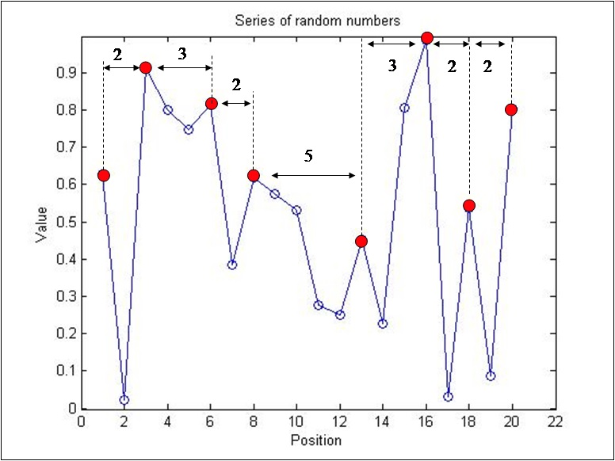
Figure 3.1.1.1 Peak-to-peak distance for a series of 20 i.i.d. random variables. The numbers labelling the horizontal arrows denote the distances between adjacent peaks (red dots).

Besides the case of an i.i.d. sequence., Newman et al. (2012) and Newman (2014) also studied how correlation influences a time series by comparing the i.i.d. PTP statistics with that of a time series generated by a recursion analog of the Langevin equation,

(3.1.1.2)

where is an i.i.d. random variable and represents the degree of memory or correlation. Newman et al. (2012) and Newman (2014) demonstrate the strong dependence of the mean PTP distance on the memory-related term and show that, between , corresponding to the i.i.d. case, and , corresponding to the Brownian-motion case, an approximately linear rise occurs from to .
Following up on those results, Newman (2012) studied the PTP statistics in the case of the logistic map [Eq. (1.4.13)] in its chaotic configuration () and shows that it has the same mean PTP distance as the i.i.d. sequence (i.e., ) but a completely different distribution:

(3.1.1.3)

Because there are as many minima as maxima, the mean PTP distance must equal the mean trough-to-trough (TTT) distance. Newman (2012) also suggests that the distribution of the PTP distance should equal the TTT distance in the case of the logistic map at its chaotic state.
Following these previous studies, we study the PTP and TTT statistics for a driven pendulum by focusing on the parameter regime known to invoke irregular behavior.

Forced Pendulum
Here we study a periodically forced pendulum of the form described by Eq. (1.4.1),
where and are, respectively, the driver amplitude and frequency and is a phase shift.
Throughout this study, we integrate Eq. (1.4.1) with initial conditions of under fixed, arbitrary driver frequency, amplitude, and phase shift. By changing the driver amplitude we regulate the level of mean energy in the system. For sufficiently small amplitude the mean energy of the system remains negative and the pendulum remains in its initial librating state. Upon increasing the driver amplitude, the mean energy of the pendulum also increases and the phase-space trajectories start approaching the vicinity of the separatrix. This is where the motion becomes irregular (and possibly chaotic), unless the system is periodic or quasiperiodic. In this irregular state, occasionally the system crosses the border between the negative and positive energy levels. Thus, in this interval the behavior is more complex and unstable in the sense that it is neither purely librating nor purely circulating but is a mixed composition of both modes of motion. As mentioned above, the periodically driven pendulum often simulates the behavior of the three-body problem. Thus, this type of dynamical behavior, also referred to as “nodding,” may be prominent among near-MMR extrasolar-planet pairs. There, the resonance angle of the planet pairs will execute several libration cycles, followed by a series of circulations, and then perform a new set of libration cycles (Ketchum, Adams & Bloch, 2013). Despite the irregular behavior, this type of motion is not random but deterministic (Chirikov, 1979; Hilborn, 1994; Murray & Dermott, 1999, Gonzales; Reyes & Suarez, 2002; Mardling, 2008; Celleti, 2010).

Energy Time Series
The angular displacement of the pendulum is a cyclic variable. As such, the local maxima and minima have no meaning for PTP and TTT statistics. Instead, we focus on the instantaneous energy of the pendulum. We use the same definition of energy as used for the simple pendulum, comprising the potential and kinetic energy [Eq. (1.4.10)],

To generate these time series, we ran several numerical integrations of the periodically driven pendulum while monitoring the angular displacement and velocity of the system.

For each run we used a Poincaré section of the continuous trajectory by sampling and after every cycle of the driving force and calculating the corresponding energy by using Eq. (1.4.10). Each run comprised cycles of the driving force, and the outcome is a time series of energy values . For each run we define also the mean energy as
(3.3.1)

We limit our study to an interval of mean-energy levels that are relatively close to the separatrix. This ensures that we witness mixed libration-circulation behavior. We find that an interval of is adequate for this purpose.
Our goal is to study the distribution of PTP and TTT distances and its dependence on the mean energy close to the irregular- and chaotic-behavior zone. Therefore, for each run we randomly chose the driving-force amplitude, thus covering a range of mean-energy levels. We also chose at random the driving-force phase shift while keeping the driver frequency at a fixed value. To remain in near-separatrix trajectories, we follow Mardling (2008) and chose the driver frequencies to be , , and , slightly smaller than the small-angle frequency. For simplicity we chose , so , , and .
Regarding the amplitude of the driving force, we find that, given the selected driving-force frequencies, the amplitudes must be limited to to stay within the desired mean-energy interval . Figure 3.3.1 demonstrates the dependence of mean energy on amplitude for .
We chose the driving-force phase shift at random from within the interval . In total, we performed 100 runs for each of the three fixed driving-force frequencies. Regarding the initial conditions of the pendulum, we learned that changes in initial values of angular displacement and velocity have no long-term effect on our statistics; thus, for simplicity, we started all integrations with .
Altogether we generated 100 runs for each of the three driver frequencies (i.e., 0.90, 0.95, and 0.99), with every run lasting driving-force cycles and being characterized by the randomly selected driving-force amplitude and phase shift. We exclude the very few exceptional runs that fall outside the desired mean-energy interval .

Figure 3.3.1. Mean energy vs driver amplitude A for and randomly drawn pairs of , .

Results

Peak-to-Peak versus Trough-to-Trough Statistics
The mean PTP and TTT distances are known to be equal whatever their distributions are equal simply because peaks and troughs are almost always alternating. We therefore compare their standard deviations and indeed find a noticeable difference, as is apparent in Figs. 3.4.1.1–3.4.1.4. For all three frequencies the standard deviations of the TTT distances tend to be greater than those of the PTP distances.

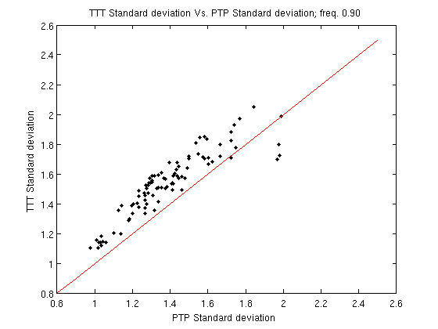
Figure 3.4.1.1. Standard deviation of TTT vs PTP series for .
The line represents .

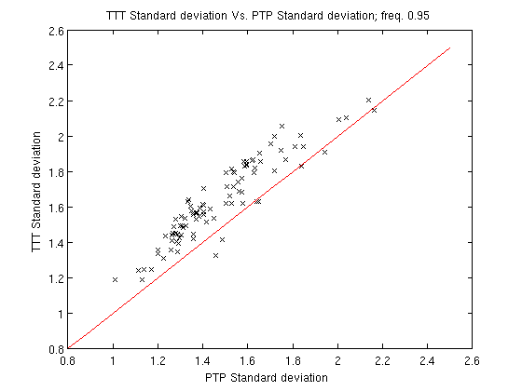
Figure 3.4.1.2. Standard deviation of TTT vs PTP series for .
The line represents .

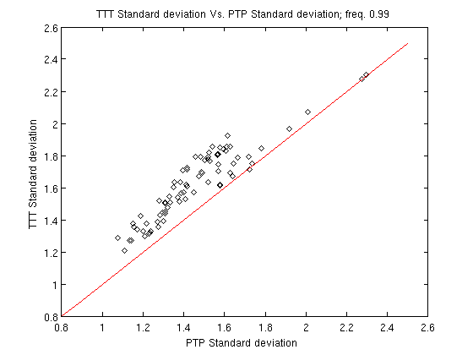
Figure 3.4.1.3. Standard deviation of TTT vs PTP series for .
The line represents.

Dependence of Peak-to-Peak on Mean Energy
Since the mean PTP always equals the corresponding mean TTT we will refer, from now on, to both terms as mean PTP or . Our integrations reveal similar dependence of mean PTP on mean energy for all three driver frequencies. As the pendulum mean energy increases from the negative values toward zero (i.e., the separatrix) the mean values of the PTP decrease, and reach a minimum approximately at the separatrix. At higher mean-energy values they increase again. This behavior repeats for all the driver frequencies we examined, as can be seen in figures 3.4.2.1, 3.4.2.2 and 3.4.2.3 for driver frequency of and 0.99 respectively.
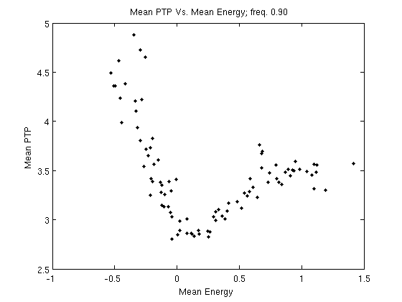
Figure. 3.4.2.1 The mean PTP distance () vs. Mean-energy () for and randomly drawn pairs of , .

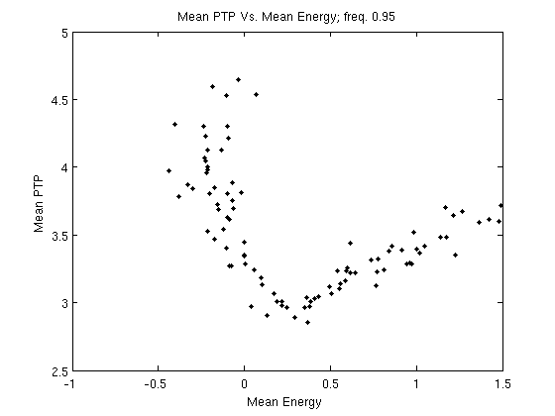
Figure. 3.4.2.2 The mean PTP distance () vs. Mean-energy () for and randomly drawn pairs of , .

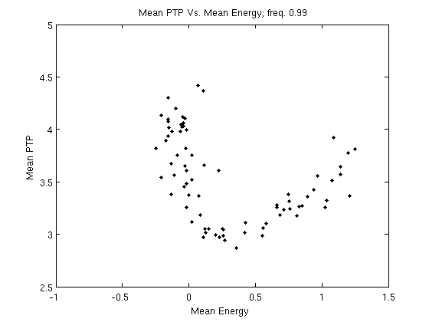
Figure. 3.4.2.3 The mean PTP distance () vs. Mean-energy () for and randomly drawn pairs of , .

We attempted to fit the curves with a rational function that could exhibit this qualitative behavior:
(3.4.2.1)

Figures 3.4.2.4, 3.4.2.5 and 3.4.2.6 show the best fit curves for the three driver frequencies. Table 3.4.2.1 lists, for each frequency, the corresponding coefficients for Eq. (3.4.2.1), the RMS fit residuals and the location of the minimum according to the fit.
Table 3.4.2.1. Eq. (3.4.2.1) coefficients, RMS and minima for the three driver frequencies
 |  |  |  |  |  | RMS | Minimum | Fig.
0.9 | 3.945 | 0.6362 | 0.3802 | 0.2847 | 0.1288 | 0.2055 |  | 3.4.2.4
0.95 | 3.802 | -1.259 | 0.4073 | -0.2573 | 0.1139 | 0.2674 |  | 3.4.2.5
0.99 | 3.959 | -2.12 | 0.7068 | -0.4611 | 0.1919 | 0.2795 |  | 3.4.2.6

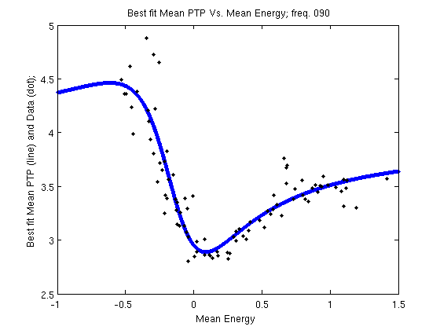
Figure. 3..4.2.4 Best fit curve (solid line) for the mean PTP distance () vs. Mean-energy () for and randomly drawn pairs of , .

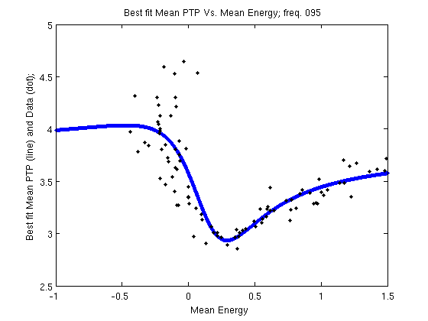
Figure. 3.4.2.5 Best fit curve (solid line) for the mean PTP () vs. Mean-energy () for and randomly drawn pairs of , .

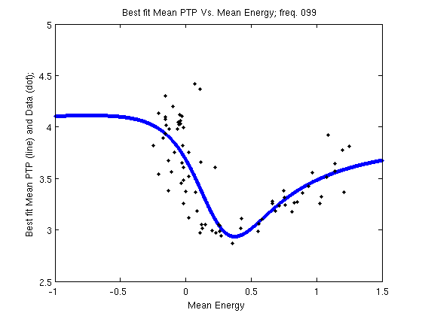
Figure. 3.4.2.6 Best fit curve (solid line) for the mean PTP () vs. Mean-energy () for and randomly drawn pairs of , .

The three data sets seem to be similar enough to assume that the dependence of the mean PTP on the mean energy is common to all driver frequencies. We therefore merged the three datasets and fit a common function:

(3.4.2.2)

With RMS=0.2989. This RMS value is close enough to the RMS value of each of the three frequency related curves (Table 3.4.2.1), which seems to agree with our assumption that the three datasets can be described by a single curve.
The most important feature of the resulting function is that the minimum is obtained close to the separatrix at and (Figure 3.4.2.7). From past studies (Newman et al. 2012, Newman 2012) we know that both i.i.d time series and the logistic map chaotic series also present mean peak-to-peak distances of 3.00.
Obviously, we should note that Eq. (3.4.2.2 ) is valid only on the range of mean-energy values where data is available. i.e., between energy values of -0.5 and 1.5. For smaller values, the time series becomes constant and no peaks can be defined. On the other hand, some tests we ran show that this equation is still reasonably accurate for mean energies as high as 7.

.
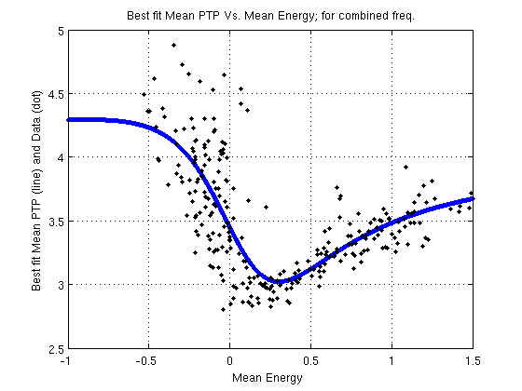
Figure. 3.4.2.7 Best fit curve (solid line) for the mean PTP () vs. Mean-energy () for & and randomly drawn pairs of , .

The PTP standard deviations
As an important part of our attempt to characterize the PTP and TTT distribution we also examined the standard deviations of the resulting distributions. Figures 3.4.3.1-3.4.3.6 present the dependence of the PTP and TTT standard deviation as a function of their means for the three driver frequencies ( & )
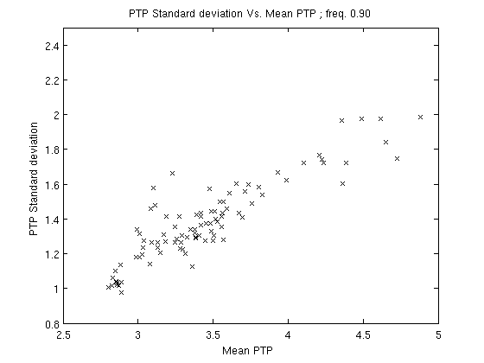
Figure. 3.4.3.1 Standard deviations of PTP against mean PTP () for
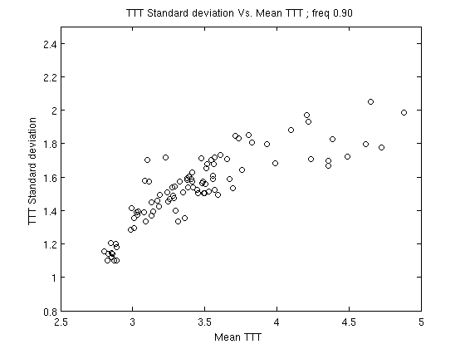
Figure. 3.4.3.2 Standard deviations of TTT against mean TTT () for

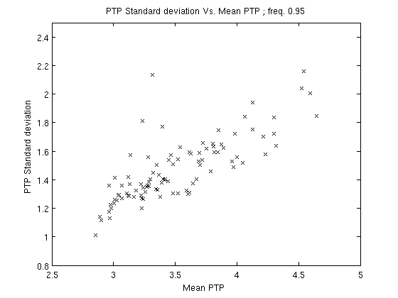
Figure. 3.4.3.3 Standard deviations of PTP against mean PTP () for
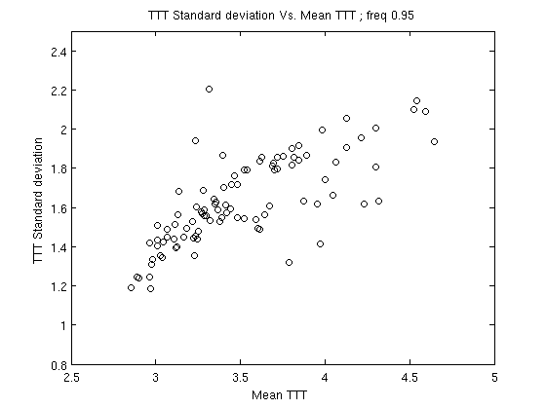
Figure. 3.4.3.4 Standard deviations of TTT against mean TTT () for

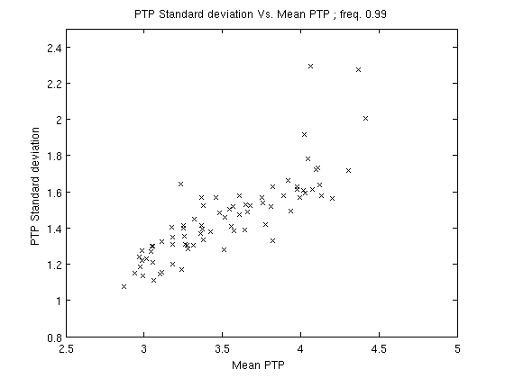
Figure. 3.4.3.5 Standard deviations of PTP against mean PTP () for

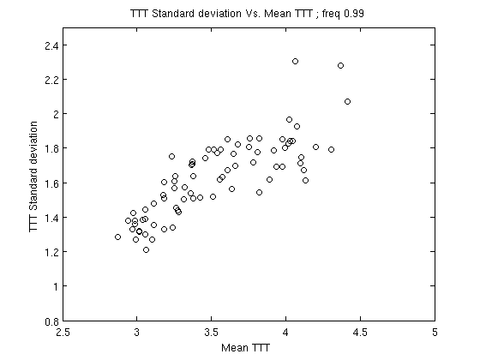
Figure. 3.4.3.6 Standard deviations of TTT against mean TTT () for

We fitted the scattered data in those figures with a linear function and focused on the irregular zone (i.e., ). The results show PTP standard deviations of , for the 3 driver frequencies respectively, while for the TTT, the values are .
In comparison, the equivalent PTP standard deviation for an i.i.d sequence is , for a Brownian motion (Eq.2 with ),, and for the chaotic state of the Logistic map , .

Summary and conclusions
Following Newman et al. (2012, 2014) and Newman (2012) we studied the distribution of the PTP and TTT of energy time series generated by the periodically driven pendulum during its irregular motion near the separatrix.
An important point in this study was the realization that the obvious quantity to study, i.e., the pendulum displacement, was not suitable for analysis using the PTP and TTT, due to its cyclical nature. For this purpose the energy was more adequate and convenient. As far as we know, this study is the first attempt to examine the PTP and TTT statistics in a continuous function. We chose to use the Poincaré section approach for the purpose of discretization. An additional interesting line of research would be to generalize the PTP and TTT statistics in a more natural and seamless way to the continuous domain in a way that would not require discretization.
One obvious result of our study is the asymmetry between the PTP and TTT statistics, as is manifested in the different standard deviations. This is understandable as there is a lower bound for the energy, but no upper bound, and therefore it is only natural that statistics related to peaks will be different from statistics related to troughs, as is indeed the case.
We have demonstrated that there is typical pattern of dependence of the (and therefore the ) on the mean-energy levels. In general, the nearer we are to a specific mean-energy interval near the separatrix (roughly ) the lower are the values. Specifically, our best-fit model locates the minimum at and . This mean PTP value bears strong similarity with both the i.i.d. and the chaotic logistic map time series. This behavior provides another aspect to the chaotic nature of the forced pendulum near the separatrix (e.g. Mardling 2008).

This first application of the PTP and TTT statistics on the solution of a non-linear differential equation can be elaborated on in many ways. Thus, one can achieve the discretization in other ways than the Poincaré section method, e.g., measuring the intervals between the continuous peaks or troughs, or zero-crossings. Of course, other non-linear differential equations can serve as the study subject. The driven pendulum itself can provide other interesting cases, such as different models for the driving force, or the addition of damping. Of course, generalizing this statistics to celestial mechanics phenomena, namely N-body chaotic systems and planetary systems in resonance, can be very illustrative.

The 3rd study-From stability to chaos, a study of energy evolution in a driven pendulum with association to the three-body problem

Study Preface
Following our previous studies, we are shedding some more light on the phenomena of mean motion resonance (MMR) in the three-body problem and to carefully draw possible conclusions on its impact on celestial systems. Our first study showed that MMR is, statistically, more prevalent among young celestial system. This evidence led us to formulate and to further investigate the possibility that resonances, in planetary systems, tend to diminish as time goes by. Hence on our second study we used a toy model of the three-body system, the periodically driven pendulum, and learned the characteristic of its unstable, chaotic motion by statistically exploring its energy time series. In our current, third, study, we further explored energy time sries of the driven pendulum. The results we got may provide further understanding regarding the ambiguity of strength versus fragility of MMRs in celestial systems. The contribution of the current study to our general thesis research is that this theoretical study significantly support our assumption that MMRs are not, neceseraly, an ever lasting phenomena and thiere tendcy to vanish as time goes by depends primarily upon the physical and dynamic structure of the systems themselves, rather than upon cataclysmic events originated outside the system, Deus ex machina.

Study abstract
We used the driven pendulum as a toy model to the three-body problem and studied its evolution of motion, from stability to chaos. We have used these results to better understand the probability and rate of transition from stable mean-motion resonance (MMR) to unstable, chaotic, motion, in the three-body problem. The main question that intrigued us was- if and when does the MMR surrender to growing perturbation and ceases to exist. For that, we studied the typical times on which a driven pendulum, initially at its lowest energy state hence stable motion, crosses for the first time several energy levels. Those energy thresholds were chosen from within the energy zone in which the pendulum motion is significantly chaotic hence unstable. In our model, an unstable motion of the pendulum is analogous to an unstable mtion of the resonance argument of the three-body problem which indicates that the system is out of resonance.
To achieve a better similarity to the gravitational perturbation in the three-body problem, we formulated a parametric driving force with mathematical resemblance to the disturbing function of the three-body problem when written in high order Legendre-polynomials expansion.
We made thousands of tests, for various parameters of the driving force; on every test we recorded the series of times on which the instantaneous pendulum energy crossed each of the energy thresholds.
We show that, for a wide range of driver parameters, the time-to-energy series for each threshold are exponentially distributed. Hence the events on which the system becomes unstable occur randomly but on a constant rate. In addition we found that the relation between meant time of events and the driver amplitude factor , that is equivalent to the level of perturbation in the system, obeys a power low function, where , c and are constants.
These results indicate that for each energy threshold there is specific driving force amplitude, under which the pendulum will never cross the threshold and will never lose its original stable state. For higher driver amplitudes, the probability to attain specific energy threshold, within any time interval, is greater than zero and, as said, obeys an exponential probability density function. Hence, when and given enough time, the pendulum system will eventually become unstable.
Trying to make a deduction from our findings regarding the driven pendulum, we suggest that a similar time-to-energy dependence also exists in planetary systems. Hence for every three-body system, there is a perturbation threshold that depends upon the masses and longitudes of the rotating bodies, under which the system will stay forever in a stable MMR. For higher perturbations, a system, initially in a MMR configuration, will lose its resonance state after finite time.

Note: for scientific introduction, please refer to chapters 1.1-1.4 of the General introduction

Methodology
Unlike other studies, in our current research, and since the survivability of the MMR is our main concern, we use different approaches regarding the terms stability and instability.
Firstly, we explore the stability of the MMR rather then the stability of the system hence our criterion for unstable system is not when one body escapes to infinity (e.g. Mardling 2008) but rather when the system is getting permanantly out of its previously stable MMR state. We should note that it is probable that such an event may, eventually, cause the physical destruction of the systen as well.
Secondly, because of their supposedly small effect on the evolution of the system, and to reduce computing time, researchers usually tend to neglect terms, in the expansion of the disturbing function, that are characterized by low order in amplitude (i.e. small strength) and by high frequency of the resonance argument. Nevertheless, since the nature of motion of the problem is chaotic, hence very sensitive to initial conditions, and in fact, unpredicted in the long run, we ask the question whether the effects of the infinite short-period, small-amplitude perturbation can accumulate and add up sufficiently to distort the celestial trajectories and break the system resonance.

Our main research question on the thesis and on this study, was to figure out the probability that at a specific time, a three-body system, initially in stable state of MMR, will become chaotically unstable in the sense of becoming non-resonating. To reduce time and computation resources we utilize the toy-model that imitates the behavior of the resonance argument in the three-body problem, the driven pendulum.
As a criterion to the disruption of the stable MMR state, we chose the instantaneous pendulum energy.
It is but obvious that for every system there is a specific “destructive energy level” under which the MMR will be disrupted. The level of energy is a function of the configuration, dynamics and physical properties of the system; hence we should analyze the probability and the timing to attain and cross any possible energy in a region that hosts both stable and chaotic motions. To follow our goals, we had to improve our model, the pendulum and to find an efficient experimental method to cope with the probability and timing issues.

Formulating the driving force
In our research, we formulated a driving force that simulates a simplified type of the Legendre expansion of the disturbing function. For simplification purpose, we chose the case of the planar, circular, restricted problem. As said in chapter 1.1, researchers (e.g. Laskar 1990; Murray & Dermott 1999; Deck et al. 2013; Ramos et al. 2015) tend to simplify the three-body problem by neglecting the terms that have short period arguments and/or low amplitudes hence consider only the “dominant terms”. These terms are also the low order terms in the Legendre expansion. Nevertheless, we thought that, after considerable time, the accumulation of minor perturbations may result in significant change of the orbital elements, especially while we operate the system in energy domains that are significantly chaotic.
Hence, we expanded the driving force series to high order and investigated, numerically, its perturbation impact upon the pendulum that was, initially, at rest or librating with low amplitude. These modes of motion simulate the resonance argument of a three-body system in exact and near MMR state.
As described in chapter 1.4, to destabilize an initially stable, oscillatory, motion of a pendulum it must cross a specific, positive, energy threshold, above the separatrix hence in the chaotic zone. Operating in this energy level or above it, the pendulum cannot maintain its initial state of pure librations hence the stable resonance-like state is destructed. We named this energy “destructive energy”, (). In our study, we arbitrary chose six destructive energy values that served us as thresholds. We than sampled and analyzed the typical times needed to cross these energies to find a possible correlation between the amplitude of the driving force and the time it takes the pendulum to reach a specific, destructive, energy level hence to leave the stable motion and, in the three-body analogy, to leave the MMR state.
We chose the simplified form of the disturbing function for the planar, circular, restricted three-body problem, written in the Legendre-polynomials expansion, as in Eq. (1.1.51),
i.e., .

We then formulated the driving force, that resembles the above equation,
(4.1.1.1)

where,
, is the amplitude factor with which we control the average level of the pendulum energy.
, has a positive value lower than 1
and,
is the natural frequency of the pendulum.
For simplicity, we chose and multiplied it by the irrational number, trying to avoid harmonics.
is the integration time-step determined by the pendulum natural frequency,,
and, is a random number between.

Hence is a series of elements on which, for a fixed value of the amplitude, when the product,, decreases the frequency,, increases.

Running the tests
We ran 3 separate tests. Each one characterized with a different value of,
On each test, we integrate the system with initial conditions of hence with the lowest possible energy level (i.e.). By augmenting the value of we increase the whole amplitude of the driving force, and the pendulum gains energy and start moving from complete rest to oscillate with small amplitude. This state is analogous to a libration of one resonance argument in the three-body problem hence a stable MMR. Increasing the driver amplitude, the pendulum energy moves out of the negative region of stable libratory motion into the positive energy region, above the separatrix. On this level of energy, the motion becomes chaotically unstable in a sense that it shifts continuously and unpredictably between libration and circulation cycles. This state is analogous to a resonance overlap in the three-body problem. As the pendulum gains more and more energy, the circulation to libration ratio becomes higher hence the system becomes less and less stable. Examples of the chaotic evolution of the pendulum amplitude and energy level are shown Figures 4.1.2.1 & 4.1.2.2.
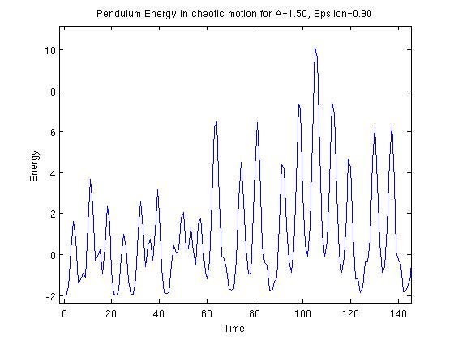
Figure. 4.1.2.1 The driven pendulum momentary energy shifts chaotically between negative (circulation) and positive (libration) levels. The driver parameters:,

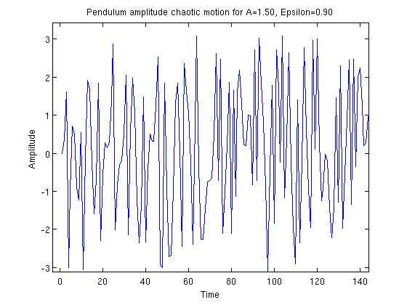
Figure. 4.1.2.2 The driven pendulum amplitude moves chaotically during in a disordered libration-circulation motion. Its amplitude shifts unsystematically between the lower position () and the upper vertical position (). The driver parameters:,

Theoretically, if we go on increasing the pendulum energy well above the separatrix, eventually it will attain a specific level, where the system libration cycles are so scarce that we can say that, in practice, the motion is circular. For a three-body system, this type of motion means that the system is out of MMR. For our statistics, we chose six positive energy thresholds, all above the separatrix, that will serve as the destructive energies: and.
Though arbitrary, the thresholds had to be higher than the “noisy” level caused by the periodical nature of the driving force that gives a “kick” to the pendulum energy on each driver cycle. In contrast, we wanted our energy thresholds to be sufficiently low to be crossed by the pendulum energy in reasonable computing time.
To monitor the pendulum instantaneous energy levels and determine the first time that the pendulum crossed each energy threshold, we integrated the equation of motion, Eq. (1.4.1) and used the numeric solutions of and to calculate the instantaneous energy via Eq. (1.4.10).
In total, for each of the 3 values of (0.90, 0.95, 0.99), we made 7-8 integrations, each one with different value of. The values of were selected within the range. This range was chosen to guarantee that on each integration, all the six energy thresholds are crossed by the pendulum. We repeatedly ran each integration 1,000 times; each run took 25,000 time steps.

Results

Time series distribution
Due to the random nature of the phase each of the integrations, per specific values of and, gave us a series of 6 times, from, the time the pendulum crossed, to, when it crossed . Out of thousands of integrations we chose four examples of energy crossing events:
Fig.4.2.1.1 and 4.2.1.2 present two separate integrations with driver parameters values of and while Fig. 4.2.1.3 and 4.2.1.4 are for and.

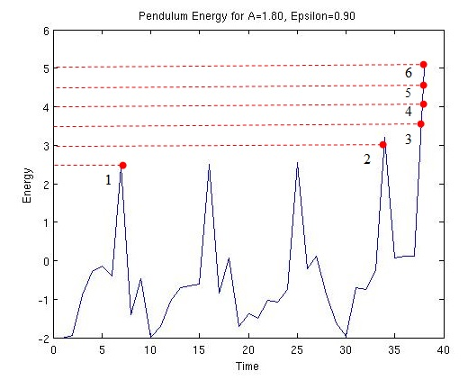
Figure. 4.2.1.1 Pendulum energy evolution for driver parameters
, , 1st. integration
The red dots present the energy crossing events to

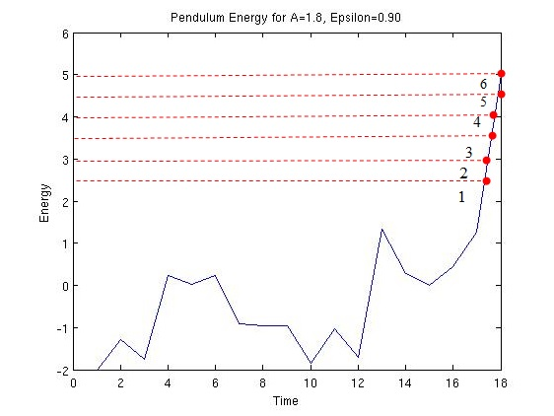
Figure. 4.2.1.2 Pendulum energy evolution for driver parameters
, , 2nd. integration
The red dots present the energy crossing events to

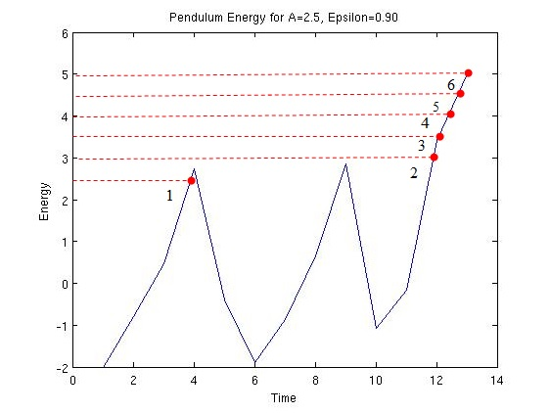
Figure. 4.2.1.3 Pendulum energy evolution for driver parameters
, , 1st. integration
The red dots present the energy crossing events to

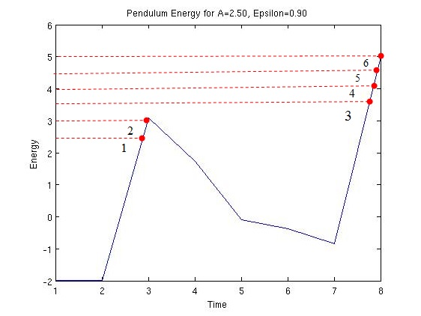
Figure. 4.2.1.4 Pendulum energy evolution for driver parameters
, , 2nd. integration
The red dots present the energy crossing events to

Each time in the time series corresponds to the first time that the instantaneous energy of the pendulum crossed one of the destructive energies under specific value of the amplitude factor. Hence the total of 1,000 runs yielded a sample of 1,000 crossing times for each destructive energy, to . An example of the distribution histograms of the time series samples, for driver amplitude parameter and for, is shown on Figures 4.2.1.5-4.2.1.10.
Each sample is divided into 20 bins histograms where the y-axis represents the frequency and the x-axis represents the first time on which the specific threshold was crossed under those driving force parameters.

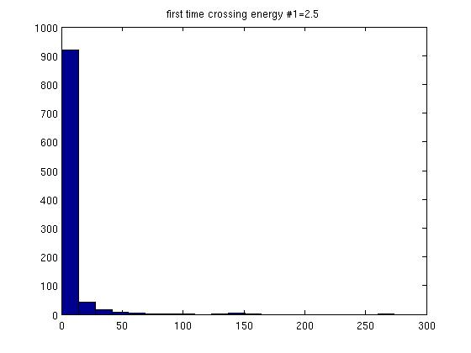
Figure. 4.2.1.5 Time series distribution for,,
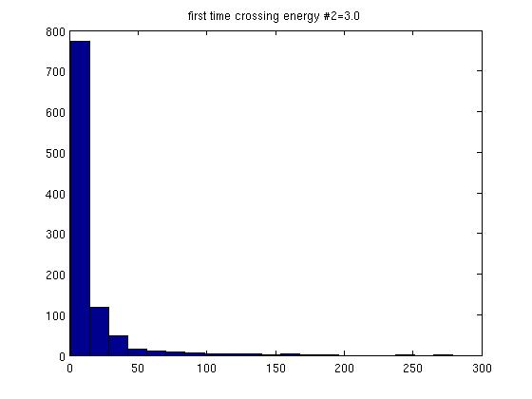
Figure. 4.2.1.6 Time series distribution for,,

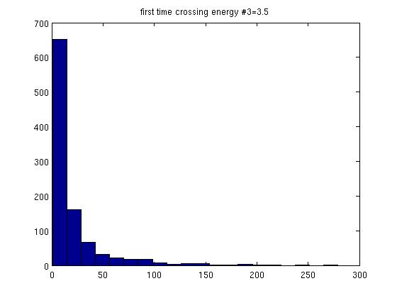
Figure. 4.2.1.7 Time series distribution for,,

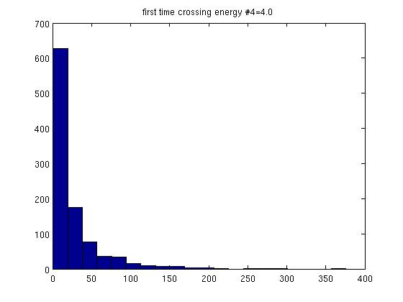
Figure. 4.2.1.8 Time series distribution for,,

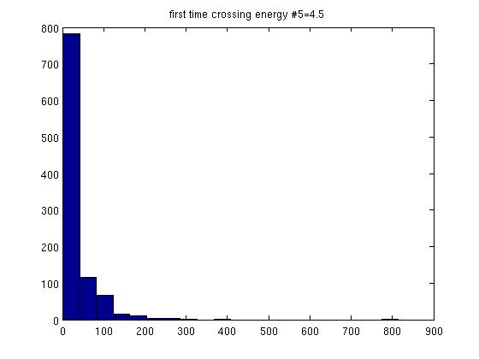
Figure. 4.2.1.9 Time series distribution for,,
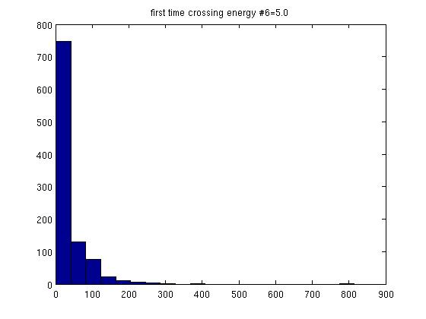
Figure. 4.2.1.10 Time series distribution for,,

We found that the distribution of the time series, is exponential hence with probability density function (PDF),
(4.2.1.1)
Where is the mean of the time series which can also be considered as “mean time of events”
(4.2.1.2)

and , (4.2.1.3)
is the constant event rate.

In our case, “event” is the instant on which an energy threshold was crossed and the pendulum motion became unstable.

In the pendulum case, there is a minimum time which takes the pendulum to reach, for the first time, the energy threshold, hence for all, the probability function .
Therefore, we should make a necessary correction to the PDF in Eq. (4.2.1.1),

(4.2.1.4)

Using the maximum likelihood method, we found that the value of should be equal to the smallest member in the energy time series hence,

(4.2.1.5)
Hence the corrected mean time of events is,

(4.2.1.6)

and the corrected event rate,

(4.2.1.7)

Mean time of events Vs. driver amplitude parameter
To describe the relation between the level of perturbation in the system and the average time to instability, we calculated, for each sample of the energy crossing times, the value of the corrected mean time (Eq.4.2.1.6). We then ploted the different values of vs. the corresponding values of the driver amplitude factor .
A plot was depicted for each of the values to and for each distructive energy to.
We found that our results are best fitted with a curve of the following power function,

(4.2.2.1)

The various best fit curves are shown on figures Figures 4.2.2.1-4.2.2.18 where the data appears in Blue bullets and the fitted curve is the red, continuous line.

For
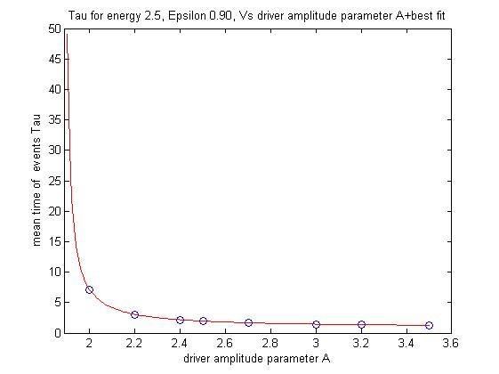
Figure. 4.2.2.1 Mean time of events vs. driver amplitude factor
for ,.
The data presented by blue circles and the best fit curve by continuous red line

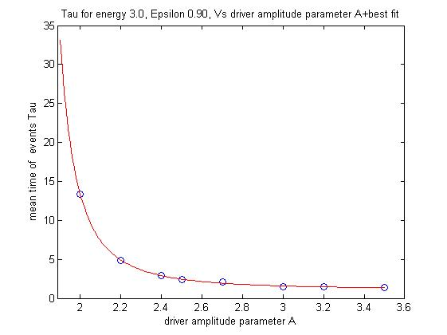
Figure. 4.2.2.2 Mean time of events vs. driver amplitude factor
for , .
The data presented by blue circles and the best fit curve by continuous red line

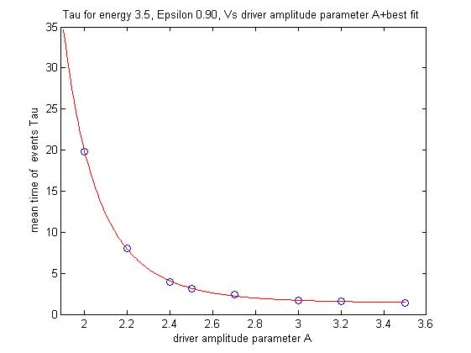
Figure. 4.2.2.3 Mean time of events vs. driver amplitude factor
for,
The data presented by blue circles and the best fit curve by continuous red line

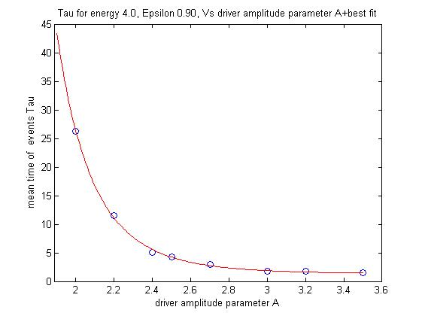
Figure. 4.2.2.4 Mean time of events vs. driver amplitude factor for,.
The data presented by blue circles and the best fit curve by continuous red line

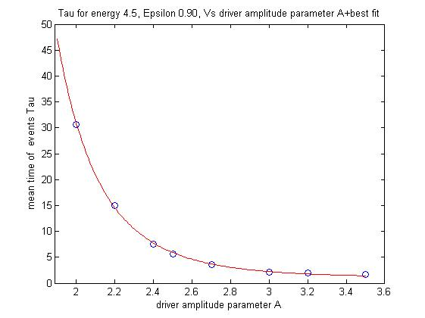
Figure. 4.2.2.5 Mean time of events vs. driver amplitude factor for,.
The data presented by blue circles and the best fit curve by continuous red line

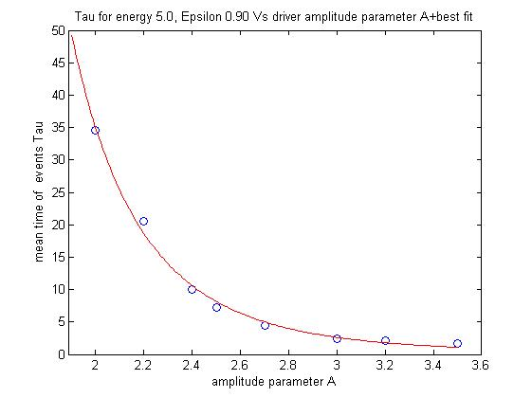
Figure. 4.2.2.6 Mean time of events vs. driver amplitude factor for,.
The data presented by blue circles and the best fit curve by continuous red line

For
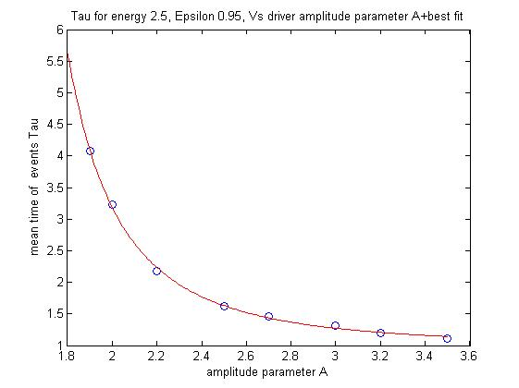
Figure. 4.2.2.7 Mean time of events vs. driver amplitude factor for,.
The data presented by blue circles and the best fit curve by continuous red line

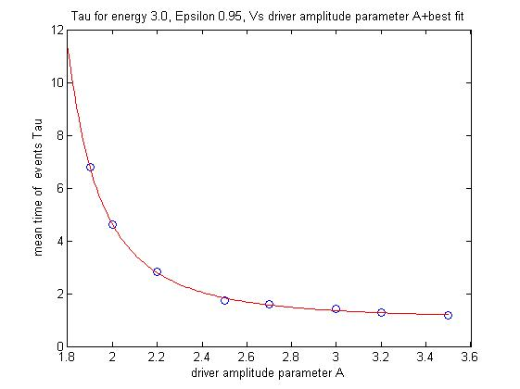
Figure. 4.2.2.8 Mean time of events vs. driver amplitude factor for,.
The data presented by blue circles and the best fit curve by continuous red line

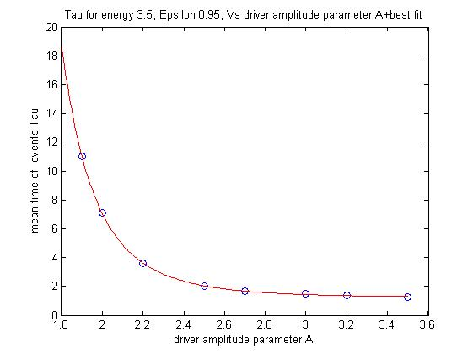
Figure. 4.2.2.9 Mean time of events vs. driver amplitude factor for,.
The data presented by blue circles and the best fit curve by continuous red line

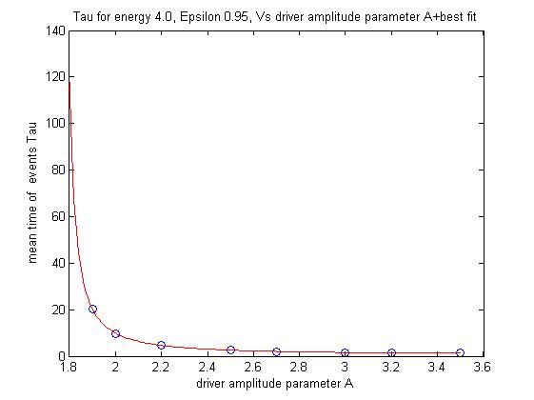
Figure. 4.2.2.10 Mean time of events vs. driver amplitude factor for,.
The data presented by blue circles and the best fit curve by continuous red line

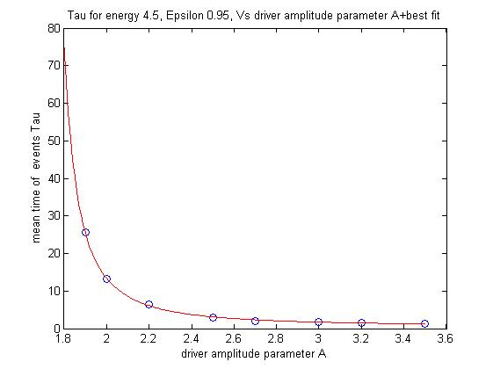

Figure. 4.2.2.11 Mean time of events vs. driver amplitude factor for,.
The data presented by blue circles and the best fit curve by continuous red line

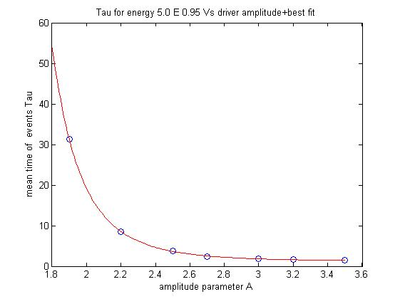
Figure. 4.2.2.12 Mean time of events vs. driver amplitude factor for,.
The data presented by blue circles and the best fit curve by continuous red line

For
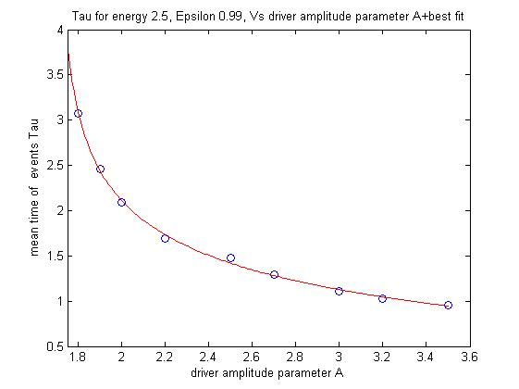
Figure. 4.2.2.13 Mean time of events vs. driver amplitude factor for,.
The data presented by blue circles and the best fit curve by continuous red line

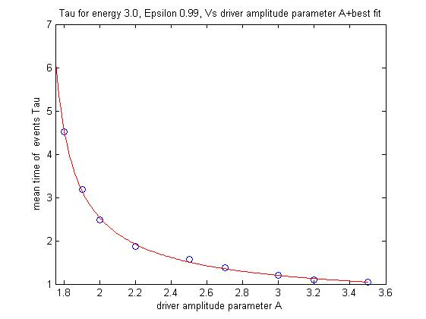
Figure. 4.3.2.14 Mean time of events vs. driver amplitude factor for,.
The data presented by blue circles and the best fit curve by continuous red line

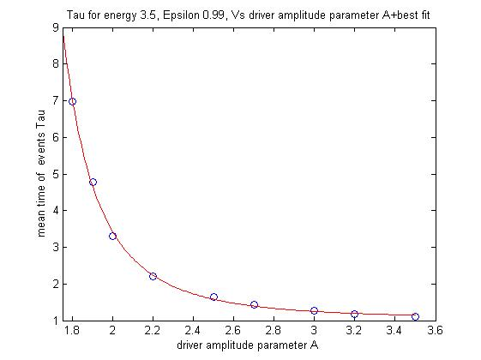
Figure. 4.2.2.15 Mean time of events vs. driver amplitude factor for,
The data presented by blue circles and the best fit curve by continuous red line

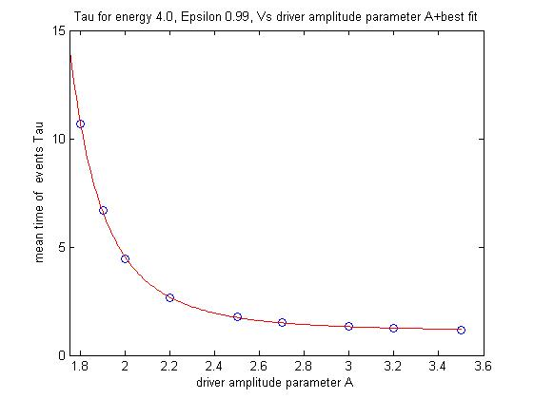
Figure. 4.2.2.16 Mean time of events vs. driver amplitude factor for,.
The data presented by blue circles and the best fit curve by continuous red line

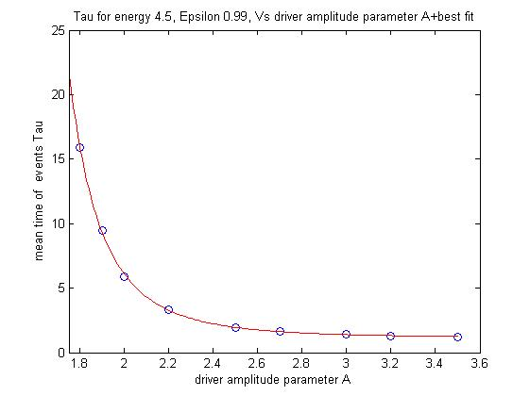
Figure. 4.2.2.17 Mean time of events vs. driver amplitude factor for,.
The data presented by blue circles and the best fit curve by continuous red line

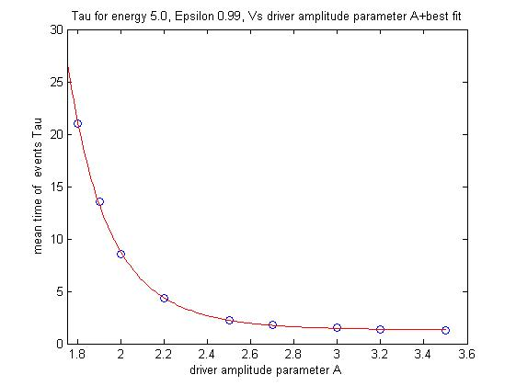
Figure. 4.2.2.18 Mean time of events vs. driver amplitude factor for,.
The data presented by blue circles and the best fit curve by continuous red line

Tables 4.2.2.1-4.2.2.3 present the coefficients of Eq. 4.2.2.1 for each value of the parameter in correspondence to the six values of the energy thresholds and the figure of the matching curve,

Table. 4.2.2.1 The coefficients of Eq.4. 3.2.1 for,
in correspondence to the six energy thresholds
 |  |  |  |  | Fig.
 | 0.6365 | 1.883 | 1.062 | 0.8929 | 3.2
 | 0.7664 | 1.724 | 2.147 | 1.128 | 3.3
 | 46.3 | 0.8477 | 6.492 | 1.379 | 3.4
 | 240.6 | 0.6152 | 6.959 | 1.306 | 3.5
 | 367.6 | 0.5086 | 6.289 | 1.047 | 3.6
 | 1,038 | 0.2277 | 5.931 | 0.1661 | 3.7

Table. 4.2.2.2 The coefficients of Eq.4. 3.2.1 for,
in correspondence to the six energy thresholds
 |  |  |  |  | Fig.
 | 1.074 | 1.261 | 2.377 | 0.9834 | 3.8
 | 0.882 | 1.466 | 2.250 | 1.017 | 3.9
 | 4.539 | 1.053 | 4.642 | 1.222 | 3.10
 | 1.291 | 1.765 | 1.360 | 0.618 | 3.11
 | 1.734 | 1.692 | 1.698 | 0.607 | 3.12
 | 26.14 | 0.9261 | 5.267 | 1.252 | 3.13

Table. 4. 2.2.3 The coefficients of Eq.4. 3.2.1 for,
in correspondence to the six energy thresholds
 |  |  |  |  | Fig.
 | 2.814 | 1.700 | 0.2147 | -1.534 | 3.14
 | 0.9004 | 1.665 | 0.751 | 0.474 | 3.15
 | 0.956 | 1.271 | 2.869 | 1.049 | 3.16
 | 1.315 | 1.250 | 3.316 | 1.112 | 3.17
 | 1.917 | 1.227 | 3.660 | 1.157 | 3.18
 | 4,500 | 0.005 | 9.277 | 1.292 | 3.19

Summary, discussion and conclusions
In the current study, we followed our previous works regarding the strength and long-term evolution of MMR in three-body systems. Here, we studied the typical times needed to destabilize the motion of a driven pendulum, initially in stable state of low amplitude libration. This model is a “refined” analogue, to a three-body system, initially in stable MMR, that we gradually increasing its mutual gravitational perturbations and generating significant chaotic motion until its internal resonance is destroyed. Our goal was to figure out the probability that at any given time the stable motion of the pendulum will become significantly chaotic hence unstable. Based on these results we aimed to draw possible conclusions regarding survivability of MMR in the three-body system.
For the pendulum driving force we formulated a unique force, Eq. (4.1.1.1), that is the sum of infinite time series and is mathematically similar to the Legendre-polynomials expansion of the three-body problem disturbing function, Eq. (1.1.51).
The distinction of an initial MMR state of motion depends, primarily, on the degree of perturbation inflicted on each of the three bodies by its two neighbors. In the three-body problem the perturbation is a result of the energy transferred between the three bodies. In the pendulum, the perturbation is caused by the energy transferred to the pendulum by the driving force. As we showed on our 2nd. Study (“Peak-to-Peak Distance Statistics of Energy Time Series in the Periodically Driven Pendulum”), when the transferred energy reaches a critical value, the perturbed pendulum cannot maintain its initially stable motion. Hence, we proposed the system instantaneous energy as criterion to distinguish between the stable state (i.e. stable resonance in the three-body case and low amplitude libration in the pendulum case) and the unstable state (i.e. non-resonating state of the three-body system and chaotic libration-circulation motion of the pendulum). Whenever an event of crossing the “destructive energy” level occurs, we can conclude that the pendulum motion or, in analogue, the three-body system, lost its stable motion for good. This event may even have cataclysmic results upon the celestial three-body system such as an ejection of one of the minor bodies to infinity or a collision of masses.
Many studies tend to simplify the three-body problem by neglecting short periods and/or small amplitude terms that allegedly have only marginal affect on the long-run of the system. We chose to consider and include the “minor” terms as well. Our simple logic led us to believe that their cumulative perturbation, amplified by the chaotic nature of the system, may eventually induce significant changes upon the orbital elements and break the stable motion. Therefore, in our pendulum system, we deliberately expanded the driving force series to its 20th Order. By regulating the driving force amplitude factor under fixed values of, we gradually increased the pendulum averaged energy level until the desired energy has been crossed. Although we made sure that, under the specific parameters, the driving force is strong enough to force the pendulum to the energy threshold, the chaotic nature of the pendulum motion made it impossible to estimate when this threshold will be attained. We made 1,000 recurring numeric runs for several values of the factor under the three values of (0.90, 0.95, and 0.99). These runs yielded samples of typical energy-crossing time series, where every series is related to specific value of, and to each of the six values of the destructive energy,.
These time series are exponentially distributed, each series with its unique average rate of events,. In our study, an “event” defines the crossing of one of the destructive energies hence a destruction of the once stable, low libration motion of the pendulum or, in analogy to the three-body system, the destruction of the MMR.
The exponential distribution of event times indicates that the events occur randomly but with a constant rate. In addition, the process has no memory hence the probability of a destructive event to occur, at any given time, does not depend upon the elapsed time.

This result may be consistent with our 2nd. research, (i.e. “Peak-to-Peak Distance Statistics of Energy Time Series in the Periodically Driven Pendulum”), where we showed statistical similiarity between the behaviour of pendulum energy time series in the chaotic region, near the separatrix, and independent and identically distributed random variables (i.i.d.).

In addition, we showed that for each value of the driver parameter, to , and for each of the distructive energies to there is a non linear negative correlation between mean time of events and the driver amplitude factor . This correlation has a typical curve pattern that obeys the power function, .
Looking at the values of on tables 4.2.2.1-4.2.2.3, we notice that most of them fall in the range of ~0.5-1.3. These values are merely the time it takes the pendulum to move from its rest position (,), where the energy is at its lowest value,, and cross the energy threshold when the perturbation is infinite, . In the pendulum case the time is depicted in units of the pendulum natural period while in the three-body analogue these values indicate the elapsing time between successive conjunctions when the system is in MMR. In any case, we can regard the average time to event,, as infinitesimal, given infinite perturbation. We should note that if we could calculate the value of the correction constant , (Eq.4.2.1.5), in the required precision for each run, should probably equal zero.

The meaning of asymptothe at is that there is a minimal value for the factor , and, therefore, also for the driver amplitude , bellow which the pendulum, despite its chaotic motion, will never attain the destructive energy threshold hence will stay in a stable motion for all times. If we move from the toy-model to its three-body analogue we find that the equivalent of in the disturbing function is the term , where.
It is but logic that there is a minimum positive value to the ratio, (i.e. the mass of the exterior secondary divided by its semimajor axis), under which the perturbation effect of the exterior body is negligible and the system will remain forever in a stable resonance.
For all values, given enaugh time, the pendulum system will eventually attain the critic energy threshold, and according to our game rules will become unstable.

On each of the figures 4.3.1-4.3.6 we display three curves of versus. Each curve (i.e. Blue, Red, and Green) is assigned to one of the three values of and each figure is related to one of the six energy thresholds, . Analyzing those figures for each of the destructive energies, the higher is the value of , the faster is the destabilization process and, obviously, the higher is the energy, the longer it takes the pendulum to cross it.

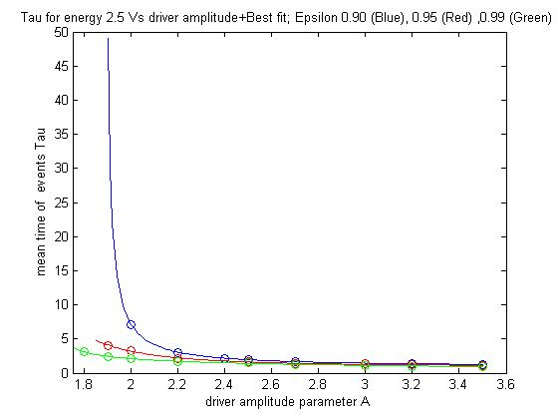
Figure. 4.3.1 Mean time of events vs. driver amplitude factor for and (Blue), (Red), (Green); the data is displayed with circles and the best fit with a continuous curve

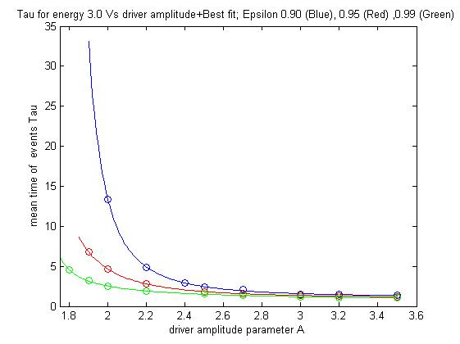
Figure. 4.3.2 Mean time of events Vs. driver amplitude factor for and (Blue), (Red), (Green); The data is displayed with circles and the best fit with a continuous curve

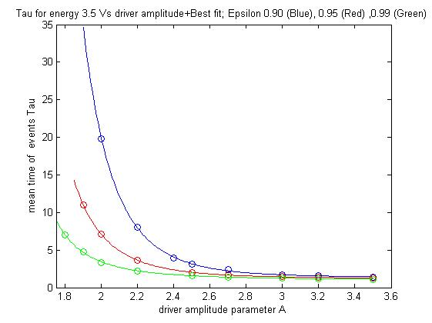
Figure. 4.3.3 Mean time of events vs. driver amplitude factor for and (Blue), (Red), (Green); the data is displayed with circles and the best fit with a continuous curve

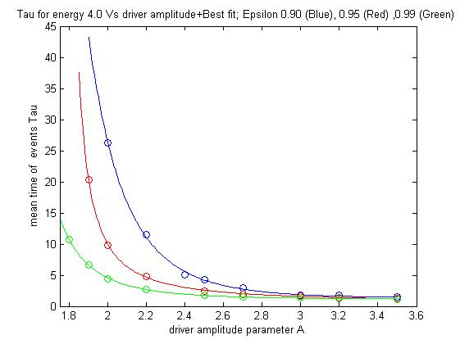
Figure. 4.3.4 Mean time of events vs. driver amplitude factor for and (Blue), (Red), (Green); the data is displayed with circles and the best fit with a continuous curve

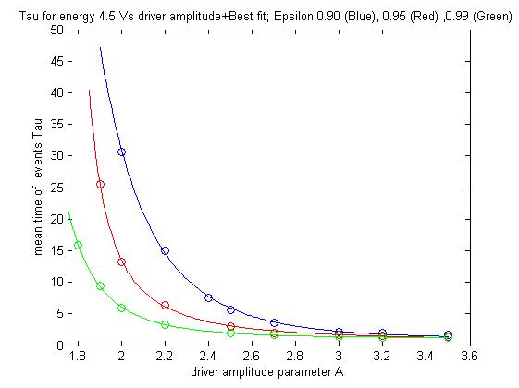
Figure. 4.3.5 Mean time of events vs. driver amplitude factor for and (Blue), (Red), (Green); the data is displayed with circles and the best fit with a continuous curve

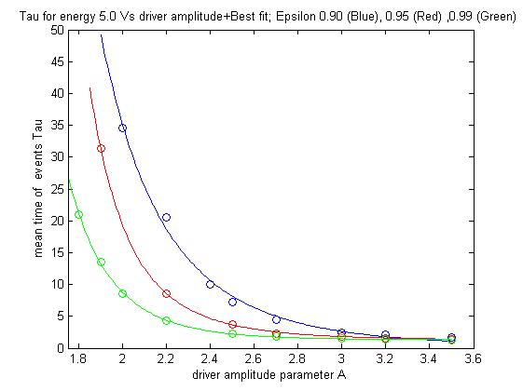
Figure. 4.3.6 Mean time of events Vs. driver amplitude factor for and (Blue), (Red), (Green); The data is displayed with circles and the best fit with a continuous curve

If we cautiossely compare between the pendulum model and the three-body problem in general and celestial systems in particular, we can say that even if inspected in relatively old systems, MMR may, in many cases, be only a temporal state that will end anytime. Due to the chaotic nature of its motion, even small gravitational disturbances can accumulate, grow and, eventually drive the system out of resonance and, probably, even destroy the system.

Our results supports our former study (Koriski & Zucker 2011) as well as the hypothesis that MMR is not, inevitably, an ever lasting phenomenon and its extinction may be the mere result of an evolutionary decay due to the chotic nature of the three-body problem.

Further studies that will apply the energy time series method directly upon a numeric model of the three-body problem may improve our analytic results and supply an improved diagnostic tool to investigate the long-term fate of MMRs in planetary systems.

REFERENCES

- Adams, F. C., Laughlin, G., & Bloch, A. M. 2008, ApJ, 683, 1117
- Antoniadou, K. I., 2016, Eur. Phys. J. Spec. Top., 225, 1001
- Arriagada, P. 2011, ApJ, 734, 70

- Asghari, N. et al. 2004, A&A. 426, 353
- Barnes, R. et al., the Astrophysical Journal, 801:101 (17pp), 2015 March 10

- Beaugé, C., Ferraz-Mello, S., Michtchenko, T. A., & Giuppone, C. A. 2008, Exoplanets: Detection, Formation and Dynamics (IAU Symp. 249), ed. Y.-S. Sun, S. Ferraz-Mello, & J.-L. Zhou (Cambridge: Cambridge Univ. Press), 427 ADS

- Bois, E., Kiseleva-Eggleton, L., Rambaux, N., & Pilat-Lohinger, E. 2003, ApJ, 598, 1312

- Butikov, E. I. 2002, J. Phys. A: Math. Gen., 35, 6209

- Celletti, A., “Weakly Dissipative Systems in Celestial Mechanics “, Lect. Notes Phys. 729, 67-90 (2007)

- Celletti, A., “Stability and Chaos in Celestial Mechanics” (Springer Praxis Books in Astronomy and Planetary Sciences, Chichesterr, UK, 2010)

- Chirikov, B.V., "A Universal Instability of Many Dimensional Oscillator Systems", Phys. Rep. 52, 264-379 (1979)

- Cincotta P., Simó C. 2000, A&AS, 147, 205

- L. Cole, J. Wildlife Manage. 15, 233 (1951)

- Deck K. M., Payne M., Holman M. J., 2013, Astrophys. J. , 774, 129

- de Pater, I., & Lissauer, J. J. 2001, Planetary Sciences, Cambridge, UK: Cambridge University Press, December 2001

- Duncan M. J., Quinn, T., & Tremaine, S. 1989, Icarus, 82, 402

- Duncan M. J., levinson H. F., Lee M. H., 1998, AJ, 116, 2067

- Fernandez, J. A., & Ip, W. H., 1984, Icarus, 58, 109

- Gayon J., Marzari F., Scholl H., 2008, MNRAS, 389, L1

- Gomes, R. S., Morbidelli, A., & Levison, H. F. 2004, Icarus, 170, 492
- Gomes, R., Levison, H. F., Tsiganis, K., & Morbidelli, A. 2005, Nature, 435, 466

- Gonzalez, J. A., Reyes, L., Suarez, J., Guerrero, L., and Gutierrez, G., “A Mechanism for Randomness”, Phys. Lett. A 259, 25-34 (2002)

- Good, P. 1994, Permutation Tests: A Practical Guide to Resampling Methods
for Testing Hypothese (New York: Springer)

- Goździewski, K., & Migaszewski, C. 2009. MNRAS, 397, L16

- Hahn, J. M., & Malhotra, R. 1999, AJ, 117, 3041

- Hilborn, R. C., “Chaos and Nonlinear Dynamics: an Introduction for Scientists and Engineers” (Oxford University Press, New York, 1994)
- Ida, S., Bryden, G., Lin, D. N. C., & Tanaka, H. 2000, ApJ, 534, 428
- Isaacson, H., & Fischer, D. 2010, ApJ, 725, 875

- Kaula, W.M. (1961). Analysis of gravitational and geometric aspects of geodetic utilization of satellites, Geophys. J.5, 104-133

- Ketchum, J. A., Adams, F. C., & Bloch, A. M. 2011, ApJ, 726, 53

- Ketchum, J. A., Adams F. C., and Bloch A. M. 2013, ApJ., 762, 71

- Kirsh, D. R., Duncan, M., Brasser, R., & Levison, H. F. 2009, Icarus, 199, 197

- Koriski, S. & Zucker, S., 2011, ApJL, 741, L23

- Kaula, W.M. (1962). Development of the lunar and solar disturbing functions for a close satellite, Astron. J. 67, 300-303

- Kley, W. et al 2004, A&A, 414,735

- Laskar, J. 1989, Nature, 338, 237

- Laskar, J. 1990, Icarus, 88, 266
- Laskar, J. 1994, A&A, 287, L9
- Laskar, J. 2008, Icarus, 196, 1

- Lecar, M., Franklin, F., & Murison, M. 1992a, AJ, 104, 1230
- Lecar, M., Franklin, F., & Soper, P. 1992b, Icarus, 96, 234

- Lecar, M., Franklin, F. A., Holman, M. J., & Murray, N. J. 2001, ARA&A, 39, 58

- Lecoanet, D., Adams, F.,C., & Bloch A. M. 2009, AJ, 692, 659
- Lee, M. H., & Peale, S. J. 2002, ApJ, 567, 596
- Lee, A. T., Thommes, E. W., Rasio F. A., 2009, ApJ, 691, 1684
- Lin, D.N.C., & Ida, S. 1997, ApJ, 477, 781
- Maldonado, J., Martinez-Arn´aiz, R. M., Eiroa, C., & Montesinos, B.
2010, A&AS, 521, A12

- Malhotra, R. 1998, in ASP Conf. Ser. 149, Solar System Formation and Evolution, ed. D. Lazzaro et al. (San Francisco, CA: ASP), 37

- Malhotra, R., Holman, M. & Ito, T. 2001, Chaos and stability of the solar system. PNAS 8, 12342
- Mamajek, E. E., & Hillenbrand, L. A. 2008, ApJ, 687, 1264

- Marchal, C., & Bozis, G. 1982, Celestial Mechanics, 26, 311

- Mardling, R. A., “Resonance, Chaos and Stability: The Three-Body Problem in Astrophysics”, Lect. Notes Phys. 760, 59-96 (2008)

- Michtchenko, T. A., Beaugé, C., & Ferraz-Mello, S. 2008a, MNRAS, 387, 747

- Michtchenko, T. A., Beaugé, C., & Ferraz-Mello, S. 2008b, MNRAS, 391, 215

- Morbidelli, A. 2001: ``Chaotic diffusion in celestial mechanics'', Reg., Chaot. Dyn. 6, 339

- Murray, C. D. and Dermott, S. F., “Solar System Dynamics” (Cambridge University Press, NY, 1999)

- Murray, N. & Holman, M. 1997, AJ, 114, 1246
- Murray, N. & Holman, M. 1999, Science, 283, 1877
- Mustill, A. J., & Wyatt, W. C., 2010, Proc. of the IAU, 6, 300
- Nakamura, T. & Yoshida, J. Celestial Mech Dyn Astr (1992) 54: 255. doi:10.1007/BF00049560
- Newman W. I., Turcotte D. L., and Malamud B. D., “Emergence of Patterns in Random Processes", Phys. Rev. E 86, 026103 (2012)

- Newman, W. I., “Emergence of Patterns in Random Processes. II", Phys. Rev. E 89, 062113 (2014)

- Newman, W. I., “Logistic Map Peak to Peak Statistics”, Phys. Rev. E, submitted (2015)

- Papaloizou, J. C. B., & Szuszkiewicz, E. 2010, in Extrasolar Planets in Multibody
Systems: Theory and Observations, ed. K. Gozdziewski, A. Niedzielski,
& J. Schneider (EAS Publication Series Vol. 42; Les Ulis: EDP Sciences),
333

- Pierens A., & Nelson, R. P. 2008, A&A, 482, 333

- Quinn, T.R., Tremain, S., Duncan, M. 1991, AJ, 101, 2287
- Rasio, F. A., & Ford, E. B. 1996, Science, 274, 954
- Raymond, S. N., Barnes, R., Armitage, P. J., & Gorelick, N. 2008, ApJ, 687, L107

- Ramos, X.S., Correa-Otto, J.A. & Beaugé, C. Celest Mech Dyn Astr (2015) 123: 453. doi:10.1007/s10569-015-9646-z

- Rocha-Pinto, H. J., & Maciel, W. J. 1998, MNRAS, 298, 332

- Saffe, C., Gómez, M., & Chavero, C. 2005, A&A, 443, 609

- Snellgrove, M. D., Papaloizou, J. C. B., & Nelson, R. P. 2001, A&A, 374, 1092

- Soderblom, D. R. 2010, ARA&A, 48, 581

- Sussman, G., J. & Wisdom, J. 1992, Science, 257, 56

- Thommes, E. W. 2005, ApJ, 626, 1033

- Thommes, E. W., Bryden, G., Wu, Y., & Rasio, F. A. 2008, ApJ, 675, 1538

- Tiscareno, M. S., & Malhotra, R. 2009, ApJ, 138, 827

- Tsiganis, K., Varvoglis, H. & Dvorak, R. 2005, CeMDA, 92, 71

- Voyatzis, G., Kotoulas, T., & Hadjidemetriou, J. D. 2009, MNRAS, 395, 2147

- Weidenschilling, S. J., & Marzari, F. 1996, Nature, 384, 619

- Wisdom, J. 1980, AJ, 85, 1122

- Wisdom, J. 1982, AJ, 87, 5

- Wisdom, J. 1987, Icarus, 72, 241
- Wright, J. T., Marcy, G. W., Butler, R. P., & Vogt, S. S. 2004, ApJS, 152, 261
- Wright, J. T., et al. 2011a, ApJ, 730, 93
- Wright, J. T., et al. 2011b, PASP, 123, 412
- Zhang, N. et al. 2010, MNRAS, 405, 2016

Considering the Hamiltonian of the system, the system is considered integrable when as many constants of motion exist as degrees of freedom (Hilborn 1994). This is not the case in nonitegrable problems such as the three-body problem.
A deterministic dynamical system is described by ordinary differential equations free of external random influences.
A Poincaré map, or Poincaré surface of section in our context, is a method that displays the continuous position of a particle moving in a circular restricted orbit with a given fixed value of the Jacobi constant. The motion is presented as a sequence of points in a two-dimensional plane (Murray & Dermott, 1999). The Poincaé map is a highly efficient method to differentiate betwee quasiperiodic orbits and chaotic orbits.
To avoid time-consuming calculations, these integrations were done only on truncated secular equations obtained by averaging the equations of motion over the mean longitudes of the planets, i.e., neglecting the chaotic effect of the MMR terms. This method might be inaccurate, mainly in the regions where the gaps between planet orbits are sufficiently close for resonances to overlap and provoke chaotic behavior of mean motions.
The computation of Lyapunov characteristic numbers that measure the chaocity of the system is very time consuming. The MEGNO technique, developed by Cincotta & Simó 2000, is more rapid and gives very good estimates for the Lyapunov characteristic numbers. It investigates both ordered and stochastic components of phase space and provides a clear picture of the resonance structures, the exact location of stable and unstable periodic orbits, and a measure of the rate of divergence of unstable orbits (hyperbolicity). MEGNO has been applied to several exoplanetary systems (Bois et al.2003).
The fast Lyapunov indicator method was introduced by Froeschle, Lega, & Gonczi (1997) and distinguishes qualitatively between regular and chaotic motion in a dynamical system (Bois et al. 2003).
The system is periodic or quasiperiodic if it can be written as a Fourier series. If the associated frequencies are commensurate, the system is periodic and, if not, the system is quasiperiodic.

