**FIRST- AND SECOND-GRADE PROSPECTIVE TEACHERS RE CONSTRUCTING DEFINITIONS OF POLYGON DIAGONALS**

Concept definition and concept image are considered essential for acquiring mathematical concepts. The current study aimed to examine how prospective mathematics teachers of first and second grades define the polygon diagonals concept, how they reconstruct their definition, and how their concept image developed over time which is in line with the concept definition. For this end a 23 prospective teachers participated in the study, they need to analyses mathematical events that presented a conflict relevant to diagonal concept, which could be resolved through a precise mathematical definition of diagonal. The data were collected from pre- and post-questionnaires and observations. The study findings indicated that prior to the intervention, all participants provided incorrect definitions in the pre-questionnaire and struggled to connect formal definitions to non-prototypical examples of diagonals in the initial learning process. However, engaging in the analysis of mathematical events helped participants reconstruct the definition of polygon diagonals and identify the critical attributes of this concept which contribute to extending their concept's image related to polygon diagonals. The participants' improved understanding was evident in the significant improvement in the post-questionnaire.

**INTRODUCTION**

Acquiring geometrical concepts needs two main components based on the model proposed by Vinner & Hershkowitz (1980) and later by Tall and Vinner (1981) regarding overall mathematical concepts: the concept definition and the concept image. The concept definition is the verbal-mathematical description of the concept, while the concept image is the cognitive structure that represents the concept in the learner's mind. When the concept image matches the concept definition, the concept is learned. However, a mismatch between these two components can negatively impact students' ability to identify examples, construct examples, and engage in proving processes (Haj-Yahya & Hershkowitz, 2013; Fujita & Jones, 2007; Marchis, 2012). Understanding mathematical definitions of concepts are essential to identifying critical features of geometric shapes and developing geometrical understanding (Haj-Yahya et al., 2022).

Early-grades teachers are responsible for laying the foundation for future learning in mathematics; research has consistently shown that teachers who have a strong understanding of the mathematical concepts they teach are better able to support their students in developing their understanding and skills (e.g., Sherstha, 2022; Hill et al., 2005). Specifically, knowledge of geometry and teachers' geometric thinking level affect their students' geometric thinking levels (Pavlovičová et al., 2022). Despite this importance, teachers' knowledge of geometry is limited; Tsamir et al. (2014) reported that only a small percentage of all early-year teachers in their defining geometric concepts. The same direction we can find in other researches conducted later (Haj-Yahya, 2019; Haj-Yahya et al., 2019). Shahbari's (2022) study revealed a low level of knowledge in geometry compared to the other mathematics fields among practicing and prospective first- and second-grade mathematics teachers. Other previous studies also indicated limited mathematical content and pedagogical knowledge among first- and second-grade mathematics teachers; for example, Shaieb and Tabach (2020) half of the first-grade teachers in their study had difficulty identifying the non-typical examples of the pyramid. Malzahn (2002) reportes that close to fifty percent of the second-grade math teachers in the study expressed a perceived requirement for a greater level of content knowledge in the subjects they teach. Additionally, half of these teachers emphasized the significance of enhancing their comprehension and understanding of student thought processes. Therefore, there is a need to develop first- and second-grade mathematics teachers' knowledge. A useful tool for helping teachers better understand mathematical ideas is engaging in mathematical events analyses (Stockero et al., 2019). Analyses of mathematical events might allow for the creation of a community of learners and the opportunity for discussion and argumentation around mathematical concepts. The process of argumentation, in which claims are presented, evaluated, and either accepted or rejected, is considered as a way to build up a whole class understanding (Toulmin, 2003). In the current study we aimed to examine whether analysis of mathematical events related to geometrical definitions will affect prospictive teachers defining processes.

**GEOMETRIC THINKING AND DEFINITIONS**

Van Hiele and Van Hiele (1958) proposed a theory on the development of geometric thinking that involves five levels, which follow a sequential and hierarchical order. At level 2, students can list properties of a figure but don't see relationships between them or recognize that some imply others. They use informal analysis of parts and attributes to reason about geometric concepts. Necessary properties are established, but there's no formal organization of properties yet. Level 3 is characterized by the students' ability to recognize logical structure among properties of the figure, in addition students can provide meaningful definitions and informal arguments. Level 4 marks the stage where students can construct proofs, comprehend the role of axioms and definitions, and discern the meaning of necessary and sufficient conditions. The hierarchy in Van Hiele and Van Hiele's theory emphasizes the significance and roles of definitions within the formal geometrical system. Mathematical definitions are essential for understanding the meanings of mathematical concepts and for solving problems such as constructing theorems and proofs (e.g., Haj-Yahya et al., 2022).

In Vinner's (1991) study on the significance of definitions, he made five assumptions. The first assumption was that learners acquire concepts through their definitions. The second assumption was that students employ definitions to resolve problems and proving processes. Zaslavsky and Shir (2005) mentioned the imperative mathematical definitions. The imperative includes the absence of any inherent contradiction between the concept attributes; the absence of ambiguity; the absence of any changes under one or another representation of the concept; hierarchical (based on previous concepts) formulation, and noncircularity. Regarding the logical structure of the mathematical definition, one is that mathematicians and mathematical educators use arbitrary definitions that are equivalent to each other definitions of the same concept, one statement is chosen from a set of logically equivalent statement to define the concept, and each statement in the set used as legitimate definition for particular concept (Harel et al., 2006; Usiskin et al., 2008; Vinner, 1991). The most controversial optional feature is the requirement that a mathematical definition be minimal. A definition is considered to be minimal if it is with no superfluous conditions. Mathematical educators discussed the tendency to list the long lists of the attributes of the concept as a definition of the concept, although its mathematically correct, but some educators don't prefer it, one can omit some of these attributes, because we conclude these attributes from other listed attributes (e.g., Leikin & Winicky-Landman, 2001; Linchevsky et al., 1992; Vinner, 1991; Zaslavsky & Shir, 2005).

However, numerous studies have identified difficulties that both students and teachers face when they are demanded to define mathematical concepts and to make reflection about the structure and meaning of these definitions (e.g., Haj-Yahya, 2021; Haj-Yahya et al., 2019). Teachers struggled with using "uneconomical definitions", "incorrect definitions", or rejecting equivalent definitions of geometrical concepts, for many participants the essence and the nature of the geometrical concept is more important than the essence of the definition, teachers reject geometrical definition although it classify examples and non-examples, because it did not emphasise the essence of the concept (Haj-Yahya, 2019; Haj-Yahya et al., 2019). A minimal definition is one that includes the necessary and sufficient attributes to deduce the remaining attributes of a concept, on the other hand, an uneconomical definition lists all the attributes of a concept, some of which can be omitted and deduced from others. Although these lengthy descriptive definitions may be accurate, many mathematics educators prefer minimal definitions. An incorrect definition includes either non-necessary attributes or insufficient attributes. For instance, defining a kite as a quadrilateral with perpendicular diagonals includes insufficient attributes, while defining a trapezium as a quadrilateral with perpendicular diagonals includes non-necessary attributes (Choi et al., 2008; Markovic & Romano, 2013; de Villiers et al., 2009 ;Zaslavsky & Shir, 2005).

The difficulties in understanding the definitions often arise from the relationship between the concept image and the concept definition, especially in cases where the concept image is limited and inaccurate (Fujita & Jones, 2007; Vinner, 1991). When there is a disconnect between an individual's personal mental image and the definitions of geometric concepts derived from both practical experience and formal knowledge, difficulties can arise (Seah et al., 2016). A personal concept definition can diverge from a formal concept definition, with the latter being the definition accepted by the broader mathematical community. The personal understanding of a concept is susceptible to interpretations and individual perspectives, which can influence its deviation from the formally accepted definition (Tall & Vinner, 1981). In a study involving 40 prospective teachers who were asked to write the definitions of a rectangle and a rhombus, the results revealed the effects of the prototypical concept image, more than half of the subjects thought that a rectangle must have two sides that are longer than the other sides (Pickreign, 2007).

In the current study, we focused on polygon diagonals, which has been identified as an essential but difficult concept. Previous research has found that students often struggle with understanding polygon diagonals. For example, Wilson and Schmidt (2005) found that high school students had misconceptions about polygon diagonals, such as the belief that the number of diagonals equals the number of sides in the polygon. Regarding other segment in the shapes (Triangles), a study conducted by Gutiérrez and Jaime (1999), pre-service teachers were given the definition of the concept of altitude, and the subjects were asked to draw an altitude from a given vertex. It was found that pre-service teachers ignored the given definition and were unable to identify and build exterior elevations, coalescing with one of the sides (right-angled triangles), and it was easy for them to build an altitudes inside the triangle when the position is from top to bottom, that is, the "internal" features that distinguish the limited concept image exclusive to prototypical examples of segments. .

Vinner (1991) suggests using activities that present learners with a conflict that can be resolved through a precise mathematical definition. This helps students understand the precision and importance of definitions as a tool for effective mathematical communication. The current study adopts mathematical event analyses to answer Vinner’s recommendation.

**Mathematical events**

Mathematical events refer to cases and problems that arise in the mathematics classroom, to which the teacher responds (Markowitz, 2003). The use of analyses of events as a pedagogical tool is common in various fields, including law, business management, medicine, and education. This approach enables learners to explore critical issues and situations relevant to theory and practice (Walen & Williams, 2000). In teacher training, events are regarded as an essential tool, and researchers have used them for many years (Tirosh et al., 2019; Herbst et al., 2017; Shulman, 1992). Participating in analyses of mathematical events helps teachers to gain insight into students' diverse ways of thinking and responding (Markowitz, 2003). This approach fosters critical thinking and enhances teachers' understanding of theory, preparing them to be reflective practitioners (Richardson, 1991). The events database becomes a repository of precedents, which the teacher can draw upon in their classroom practice (Shulman, 1992). The significance of the events lies in the discussion that takes place around them, creating a community of learners (Richardson, 1991). The ensuing debate is based on an argumentative discourse (Toulmin, 1969; 2003), where learners explain their reasoning, listen to other's perspectives, and agree or disagree with the arguments put forward.

Moreover, the role of the learner changes from being a marginal participant in the mathematical discourse to a more central one, contributing to knowledge construction (Lave & Wenger, 1991). Analyses of mathematical events provide an opportunity to build on learners' mathematical thinking, helping them understand crucial mathematical concepts (Stockero et al., 2019). Therefore, the incidents should be rich and substantial, allowing for multiple levels of analysis and interpretation to capture the complexity of teaching mathematics in different contexts (Levin, 1995). It is important to monitor the mathematical progress of a class at the whole class level rather than focusing on the individual thinking of each participant. This allows for an understanding of the accepted mathematical meanings within a class community when the class is treated as its own entity (Toulmin, 1969; 2003). **Research questions**

The current study examined how participants' understanding of polygon diagonals evolved into a more whole class understanding as they participated in the analyses of mathematical events related to the definition of polygon diagonals and engaged in discussion and argumentation with their peers. This may have included examining how participants' definitions of polygon diagonals developed and how they used evidence and reasoning to support their ideas. Following the purpose of the study and according to the theoretical background, we formulated the following questions:

1. how do first- and second-grade prospective mathematics teachers define the polygon diagonals concept? To what extent are their concept images of polygon diagonals related to the polygon diagonals definition?
2. how do first- and second-grade prospective teachers reconstruct their definition through analyses of mathematical events related to the definition of polygon diagonals?, and how their concept image developed over time which is in line with the concept definition?

**METHOD**

**Research context**

The study was conducted at the College for Arabic Speakers for Teacher Training as a part of a geometry teaching course designed for individuals looking to expand their teaching certification in first and second grades. The course consisted of 14 sessions, each lasting 90 minutes, and focused on four key areas of geometric thinking: properties of shapes, place and space relations, transformations and symmetry, and visualization. The course contents were developed based on the American National Council of Teachers of Mathematics - National Council for Teachers of Mathematics [NCTM] (2000) standards for geometry education in children from kindergarten to second grade. These standards outlined the expected achievements of students in geometry and provided teachers with a framework for age-appropriate instruction. The research took place over two sessions and focused on polygons. The teaching-learning process was based on discussions in mathematical events, emphasizing various ways of thinking and misconceptions students make when working with polygons. The two main events, each consisting of several sections, were developed based on previous studies, such as Tsamir et al., 2008, and the researchers' experience teaching geometry and extracting relevant information from previous research (see Figure 1 as an example of one event). The first researcher conducted the course and was accompanied by other researchers. She presented events that encouraged students to build knowledge of polygon definitions. Her role was to facilitate learning, guide and motivate students to learn, develop, and build their knowledge on their own while providing opportunities for them to examine ways of justification and analyze and discuss events.

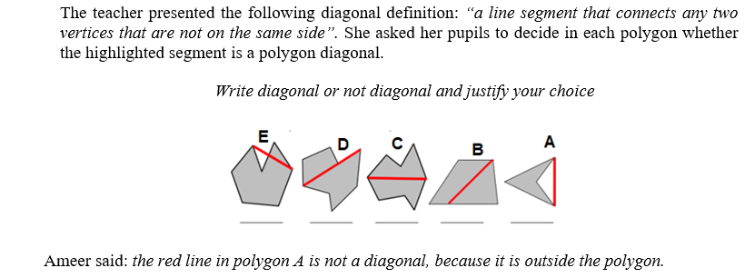

Figure 1: an example of a diagonal event presented during the meeting

**Participants**

The present study was conducted with 23 prospective teachers who were studying for their teaching certification for first and second grades at a college for teacher training in the Arab community in Israel. The participants are fourth-year students who have completed three years of studies. This course is typically considered a second course and falls under the mathematics education component alongside a calculus teaching course for first and second grades. The participants were chosen using a convenience sampling method.

**Data sources and procedure**

The data for this study were collected from three sources: 1) pre-questionnaire, which included two parts: One part focused on the definition task of polygon diagonals and a separate part focused on the identification of prototypical and non-prototypical examples of polygon diagonals (see appendix 1). 2) Postquestionnaire included two parts: the first is the same part of the pre-questionnaire and a separate part consisting of two items: the first requested participants to draw polygon diagonals according to instructions. The second was a mathematical event based on students' misconceptions about a polygon diagonal definition (see Appendix 2). 3) observations of class discussions were recorded by video and transcribed word for word by the first researcher. At the course's first meeting, the pre-questionnaire was administered to participants; they were once again required to fill in the post-questionnaire at the end of the course.

**Data analyses**

*The pre-and-post questionnaires data*. Were analyzed using thematic content analysis (Braun & Clarke, 2006). Considering the categories identified in Tsamir et al.'s (2015) research on the definition of geometric concepts, we did that. We found three categories consistent with Tsamir et al.'s (2015) categories: a.1) minimal correct definitions, a.2) Correct definitions which consist of non-minimal definitions. b.1) Incorrect definitions consist of Insufficient (missing critical attribute/s). We found a fourth new category, b.2) incorrect definitions based on on-critical attribute/s (see Table 1). We counted the frequencies of each category. For the correct definition of a polygon, we considered “a line segment that connects any two non-adjacent vertices.” according to the Ministry of Education's website (https://retro.education.gov.il/tochniyot_limudim/math/metzolaim.htm#cm6).

*The observations.* The researchers decided that a Toulmin model would afford the best representation of the ideas that emerged during the discussion. Therefore, they started by documenting the observation using Toulmin’s model (1969, 2003) by creating an argumentation log (see Table 3). Then they constructed the core of the argument, which consisted of three parts: data, claim, and warrant. More parts would be added to these parts according to the participants’ responses, such as backings, qualifiers, and rebuttals. The claim is the statement that is being argued for or against. The data are the evidence or reasons that support the claim. The warrant is the principle or rule that connects the data to the claim. The backing is additional evidence or support for the warrant. The qualifier is a statement that limits the degree to which the claim is true. The rebuttal is a counterargument or counterclaim. The meaning of the components of Toulmin's model (1969) of arguments is that in every argument, the speaker presents a claim; If it were challenging, evidence or data could be presented to support it. However, one of the listeners/learners from the class community does not understand how the data relates to the speaker's conclusion. In that case, it should ask the presenter (the claim) to clarify why and how the data leads to the conclusion. In other words, the authority/credibility of the justification can be challenged, and the speaker must provide backup to explain why the justification and the core of the argument are valid. Therefore, the Toulmin model examined the participation contribution patterns, argument structure, and key ideas development related to the concept image and concept definition of polygon diagonal.

**FINDINGS**

In this section, we present prospective teachers' results of pre and post-questionnaires to illuminate the individuals’ understanding and reconstruct diagonal concept definition and their advances in the identification of polygon diagonals. Toulmin’s model represents the argumentation and key concepts raised in the class discussion by reconstructing the polygon diagonals definition. Mainly, two episodes from the transcript are presented to further illuminate the prospective teachers' discussion about the polygon diagonal definition.

**Definition and identification of the polygon diagonals: before and after event analysis**

The results of the prospective teachers’ written definitions that emerged from the pre-and post-questionnaires in terms of correctness and mention of critical attributes of polygon diagonals based on using mathematical language with representative examples are presented in Table 1.

Table 1: Correct and incorrect polygon diagonal definitions

|  |  |  |  |  |
| --- | --- | --- | --- | --- |
|  |  | Frequency | | Examples: a polygon diagonal is… |
|  |  | Pre | Post |
| Correct definitions | Minimal | - | 13 (57%) | * A line segment that connects two non-adjacent vertices * A line segment that connects any two non-adjacent vertices |
| Non-minimal | - | 7 (30%) | * A line segment that connects any two non-adjacent vertices. The diagonal is completely external or internal, or partly internal and partly external   ● A straight line connecting any two non-adjacent vertices. It can be inside or outside the polygon or part inside and part outside |
| Incorrect definitions | Insufficient (missing critical attribute/s) | 13 (57%) | 2 (9%) | A line segment inside the polygon  A line segment that connects two vertices  A line segment that connects a vertex to a parallel vertex  A straight line that connects a vertex to a parallel vertex |
| Based on non-critical attribute/s | 10 (43%) | 1 (4%) | * A straight line that divides a shape into two equal parts * The diagonal crosses the polygon * Straight line that connects any two angles * A straight line connecting the sides * The length of the line |

We can see from Table 1 that all participants provided incorrect definitions in pre-questionnaire. 57% of the participants wrote an incorrect, insufficient definition that was missing critical attributes when the vast majority mentioned only the critical attribute of “a line segment” or “straight line” without mentioning the non-adjacent vertex. 43% of the participants added non-critical attributes in the diagonal concept definition, such as using the attributes “Inside the polygon,” “crosses the polygon,” and “divided into two equal parts.” These non-critical attributes indicated a limited concept image of a diagonal being just inside the polygon.

Furthermore, the definition findings of the post-questionnaire show that most participants improved their correct definitions. 87% of the participants wrote the correct definition (minimal or non-minimal), and 57% of the participants gave a minimal definition that included necessary and sufficient attributes, critical attributes of “a line segment,” in addition to “non-adjacent vertices.” 30% of the participants gave a non-minimal definition which includes attributes focused on the diagonal location targeted to expand the concept image, such as “Completely or partly internal.” These additional attributes indicate that their concept image of a diagonal was developed. In addition, results obtained from the post-questionnaire (see Appendix 2) showed that all participants could notice the students' possible misconceptions relevant to a polygon diagonal definition based on students drawing of polygon diagonals.

The pre-questionnaire Identification findings indicated that all participants identified the prototypical example presented. All incorrect identifications related to claiming that a non-prototypical example is a non-example of a polygon diagonal. All did not identify the concave polygon diagonals as an example. When a diagonal is completely external, or partly internal and partly external, the polygon. This means these diagonals are not part of the concept image of polygon diagonals. The polygon diagonals concept image was limited before event analysis. However, the findings obtained from the post-questionnaire indicated that participants’ concept image of the diagonal has developed. All of them succeeded to drew non-prototype examples such as partly internal and partly or completely external polygon and across one polygon side (see Fig 2 below). In addition, the participants in the same questionnaire recognized that two students presented in a mathematical event had a common misconception about the polygon diagonal definition. All participants (23) recognized that they were both aware that the diagonal connects two non-adjacent vertices and must be entirely inside the polygon. Furthermore, most of the participants (21) discovered the difference between the two students, the first knows that the diagonal is *a segment,* but the second student knows that the diagonal is *a line* (straight or curved).

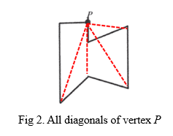

We can summarize and emphasize the importance of the mutual relationship between concept image and concept definition, especially in cases where the concept image is limited and inaccurate.

**Definition development and the relationship with a concept image**

The discussions in analyses of events based on non-prototypical examples of diagonals contributed to understanding the concept definition of diagonals, which caused various arguments in **Table 3** related to the diagonal definition. The arguments that emerged from participants show that although the minimal diagonal definition was presented throughout the meeting, they were not always aware of the gap between the prototype example of the diagonal and the analytical aspect arising from the definition. However, during the argumentative discourse, the participants identified which critical attributes the diagonal has and which others should not be considered. The evidence for this finding is the last argument in the meeting, which refers to the need to check all the critical attributes found in the diagonal definition. Such a process is the relationship between the concept image and its definition.

Table 3: Arguments that emerged during participants’ diagonal events

|  |  |
| --- | --- |
| **NO.** | **Arguments title** |
| 1 | The diagonal definition is incomplete |
| 2 | The diagonal definition is complete (counter-argument to argument 1) |
| 3 | The line segment that connects two vertices in a polygon which is entirely outside the polygon is not a diagonal |
| 4 | Number of diagonals in a concave quadrilateral is two (detailed below, episode 1) |
| 5 | Number of adjacent vertices in a concave quadrilateral is four (detailed below, episode 1) |
| 6 | Eight diagonals adjacent vertices in a concave quadrilateral (detailed below, episode 1)  (counter-argument to argument 5) |
| 7 | Locations of all diagonals in a concave octagon |
| 8 | The line segment that connects a vertex to a side is not a diagonal |
| 9 | The line segment that connects two vertices and is entirely contained in the polygon is a diagonal |
| 10 | The line segment that intersects the side isn’t a diagonal (detailed below, episode 2) |
| 11 | The line segment that intersects the side is a diagonal (detailed below, episode 2)  (counter-argument to argument 10) |
| 12 | The line segment that goes partially inside the polygon and partially outside it is called a diagonal |
| 13 | The line segment direction that connects two adjacent vertices in a polygon is not a critical attribute of diagonal |

Due to space constraints, only two episodes were chosen. A selection of rows from the first episode is shown in episode 1 below:

***Episode 1:The diagonals number in a concave square***

|  |  |  |  |
| --- | --- | --- | --- |
| 1 | Instructor: | How many diagonals does the polygon in front of you have 1234? |  |
| 2 | Sina: | There is another diagonal in the middle. From vertex 1 to vertex 4 |  |
| 3 | Instructor: | So, how many diagonals does a polygon have? |  |
| 4 | Riwaa: | There is only one diagonal |  |
| 5 | Instructor: | Why? |  |
| 6 | Riwaa: | According to the definition? |  |
| 7 | Instructor: | What did you infer from the definition? |  |
| 8 | Riwaa: | The only diagonal is the one connecting vertex 1 and vertex 4 | [She only meant those vertices] |
| 24 | Instructor: | What are the numbers of adjacent vertices in the polygon? |  |
| 25 | Riwaa: | 2 and 4…..4 and 3 | [She did not explicitly say the number of vertices. But, she mentioned the symbol of each vertex by its number in the image] |
| 26 | Instructor: | Are these just the adjacent vertices? |  |
| 27 | All participants: | No... | [They mean that there are more adjacent vertices] |
| 28 | Instructor: | Riwaa please.. |  |
| 29 | Riwaa: | Ahhh…..2 and 4, 4 and 3, 2 and 1, 1 and 3 |  |
| 30 | Instructor: | What do you conclude about vertices 1 and 4? Are they adjacent vertices? |  |
| 31 | Riwaa: | No. are not adjacent |  |
| 32 | Instructor: | And what about vertices 2 and 3 |  |
| 33 | Riwaa: | are not adjacent. I can connect a diagonal between them |  |
| 34 | Instructor: | Are you convinced that the red segment is a diagonal? |  |
| 35 | Riwaa: | Yes, of course. The red segment is a diagonal |  |

The discussion related to this episode began with a question regarding How many diagonals does the polygon in front of you have? [1]. The Claim was made by Riwaa [4]. In terms of Toulman’s Model, Riwaa’s Claim can be broken down as follows:

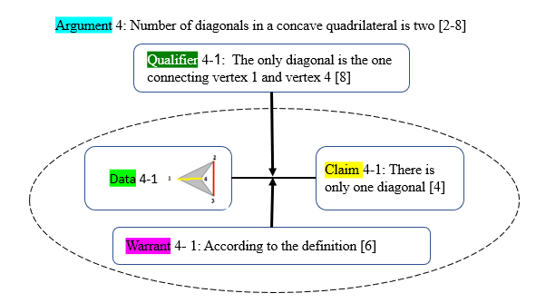

According to argument-4 above, we can see that the diagonal concept image that Riwaa has is completely external. She does not accept the external diagonal and declares that this polygon has only one diagonal which is the prototypical one.

Later, the next Argument about the number of diagonals adjacent vertices in a concave quadrilateral that made by the same teacher, Riwaa:

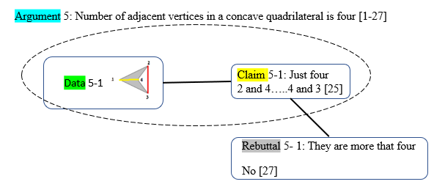

According to argument-5 above, we can also conclude that Riwaa does not understand the critical attribute of the diagonal definition that is relevant to non-adjacent vertices. Therefore, it fails to detect all non-adjacent vertices. Immediately, the following argument made by the same teacher, Riwaa, which is counter-argument to the previous argument:

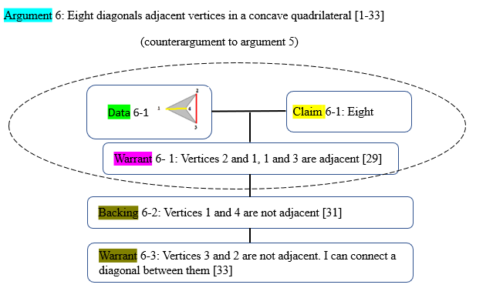

According to the first argument above (argument-4) it can be seen that the concept image of polygon diagonal that Riwaa has, did not match its definition. Although she looked at the definition and read it, she could not identify the diagonal outside the polygon. She eliminated the example from examples space for the concept. But, during the discussion, especially in the second argument, it became clear that the Riwaa did not recognize the concept of "adjacent vertices." As a result, she excluded the external diagonal from all diagonals of the displayed polygon. The evidence is that when she knew all adjacent vertices, she understood the definition well, especially the critical attributes of the diagonal definition. After Argument-6 was made, several teachers agreed with everything that Riwaa said [33]. This broad consensus is a sign of normative agreement that we believe strengthens the teachers’ utterances in the context of Argument-6.

***Episode 2: The diagonals in an octagonal polygon***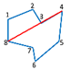

1 Instructor: Is the red segment diagonal or not?

2 Tamir: No…I do not know... not sure because the segment is above the polygon side. Also, it passes through it.

3 Participants: [noise]

4 Sower: I think that the red segment is a diagonal, regardless of its position relative to the side of the polygon. The most important factor in determining whether a segment is a diagonal is whether it connects two vertices that are not adjacent; in other words, both vertices are not on the same side. For instance, if the segment connects vertices 3 and 4, it would not be considered a diagonal.

5 Tamir: Ahh...the diagonal is between 4 and 8

6 Sower: Exactly. If the segment is congruent or across the side that connects vertexes 3 and 4, it cannot be considered a diagonal. Because the two vertices are on the same side. So, it is considered a side, not a diagonal.

7 Sajil: Right. It is a side.

8 Sower: The question refers to the segment connecting vertices 4 and 8, not the segment connecting 3 and 4.

9 Instructor: Is it a diagonal, in your opinion?

10 Sower: Yes. It fulfils the definition conditions.

11 Participants: Yeah, right. The segment connects two non-adjacent vertices.

12 Instructor: Is what Tamir said at the beginning true? Can the segment be cancelled from the list of given polygon diagonals if it is congruent with one of its sides? Is the attribute that the segment covers a side part or a whole side critical?

13 Participants: No. This is not critical.

14 Sower: This is how we agreed before: that the segment's location is not essential and is not a critical attribute. Whether internal or external, or even if it covers or intersects the side.

During the discussion, the instructor asked: Is the red segment diagonal or not? [1]. The claim was made by Tamir [4]. In terms of Toulmin's Model, Tamir's claim can be broken down as follows:

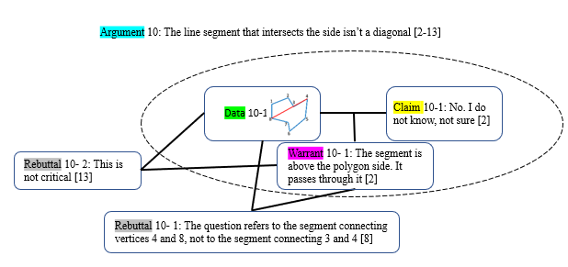

Immediately, the following argument made by Sower, which is a counter-argument to the previous argument:

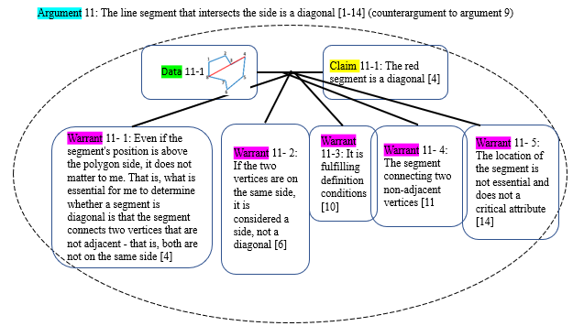

Based on argument-10, it appears that Tamir's understanding of the concept image of a polygon diagonal did not align with its definition. Tamir could not identify a diagonal that intersects the side of the polygon and eliminated that example from the examples space for the concept. However, Sower immediately rebutted Tamir's argument. As a result, Sower presented counter-claims to Tamir's claim and contributed data and part of the warrants, with assistance from Sajal and other participants. This led to a claim collaboratively constructed by Sower and all participants, stating that the segment in question matched the definition of a diagonal. All participants agreed on a critical attribute in the definition and disagreed that the segment location was not a critical attribute for a diagonal defintion.

**Tracking participants' development process about polygon diagonal definition**

The results obtained from the pre-and post-questionnaires, besides those obtained from observation, indicated developments in participants' definition and identification of the polygon diagonal. In order to illustrate the development process of the participants, the researchers chose to review one participant, *Rewaa*. The criterion for selecting *Rewaa* is relevant to her pre- and post-questionnaire knowledge and her active participation in the argumentative discourse during the event presented analysis. Figure 2 shows the track development in *Rewaa*'s knowledge about polygon diagonals.

A polygon diagonal has two critical attributes: a line segment and two non-adjacent vertices. According to the figure below, it can be seen that Riwaa’s pre-questionnaire findings relevant to a diagonal-polygon definition were inaccurate. The definition that she has and wrote was “A straight line that connects a vertex to another vertex”. It was missing the full critical attribute of the polygon diagonal. She didn't mention the exact critical attributes such as non-adjacent vertices or segments. This may not be surprising that Rewaa did not correctly identify examples and non-examples of diagonals in the second part of the pre-questionnaire. In addition, Rewaa’s reliance on her concept images did not always lead to correct identifications. At the beginning of the class discussion (see Episode 1), it was obvious that Rewaa didn't differentiate between sufficient critical attributes which is connecting two non-adjacent vertices and Insufficient critical attributes which was connecting one vertex to another one. Post-questionnaire findings show that Rewaa wrote a minimal definition which was “A line segment that connects two non-adjacent vertices”, she knew the total number of diagonals, and drew it. This is evidence of other participants' contributions and role in a polygon diagonal definition reconstruction.

Fig 5. Rewaa (case study) definition development process

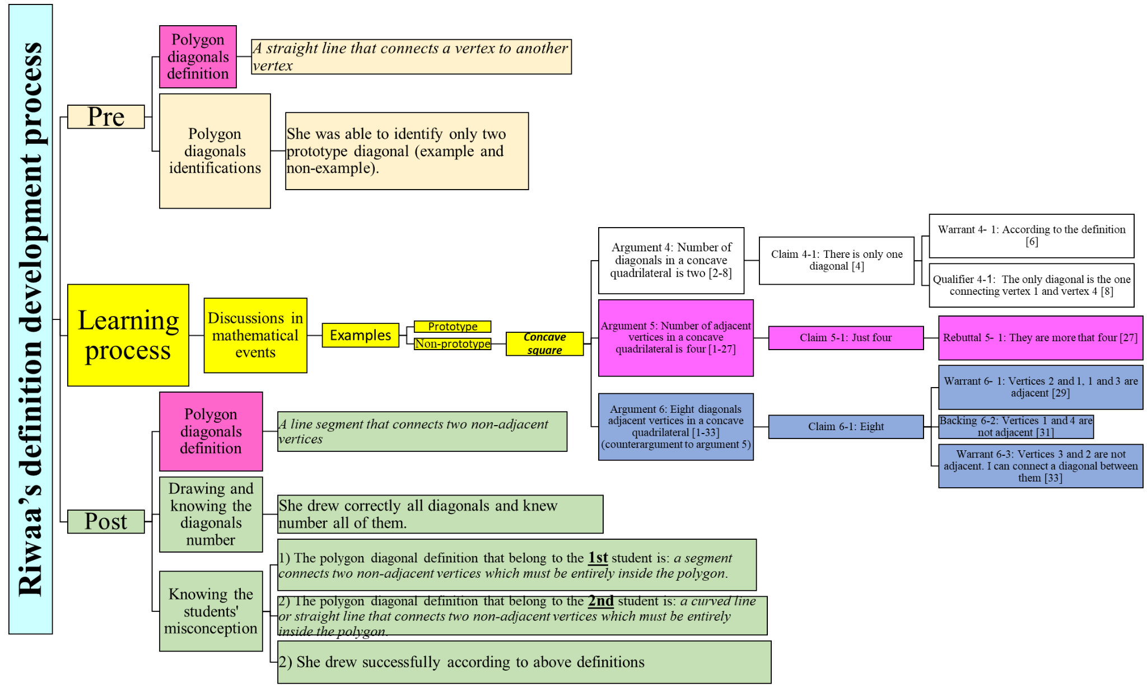

**DISCUSSION**

The current study aimed to examine how prospective mathematics teachers of first and second grades define the polygon diagonals concept, how they reconstruct their definition through analyses of mathematical events, and how their concept image developed over time which is in line with the concept definition. The study's results show that before engagement in events analyses, prospective teachers were able to identify prototypical examples of polygon diagonals and they had difficulties in identifying non-prototypical examples of polygon diagonals. These results point about the influence of the non-critical attribute of the diagonal concept, the diagonal is completely drawn inside the shape, this finding is consistent with previous studies that show the same findings regarding section like altitude (Gutiérrez & Jaime, 1999; Haj-Yahya, 2020; Haj-Yahya et al., 2016). Regarding the diagonal concept definition, most participants provided incorrect definitions in the pre-questionnaire; they did not recall the correct definition of polygon diagonal, when mentioning non-critical attributes such as “divide the shape” or “cross the polygon” or not mentioning sufficient critical attributes of polygon diagonal such as “adjacent vertex”. This means it may be that prospective teachers relied on definition that has insufficient conditions, which is called non-sufficient definition, that can fit some examples of the concept. This result is consistent with previous research (e.g., Berenger, 2018; Haj-Yahya, 2021; Tsamir et al., 2014). However, there was a significant improvement in the post-questionnaire, with more participants providing correct definitions (see Table 2) and correct identifications. When a mathematical event involves the analysis of non-prototypical examples and triggers the concept image of the diagonal, the personal concept definition tends to align more closely with the formal concept definition (Tall & Vinner, 1981).

During the mathematical events analyses and discussions around the attributes of polygons’ diagonal, participants' geometrical thinking is influenced by the interconnections and interplay between mathematical ideas, which results in their ideas moving from the second level of Van Hiele's (1958) geometric thinking to the third level, which means that participants recognized logical structure among attributes of the polygon diagonals and make connections between them innovatively, which ultimately enhances their understanding of the polygon diagonals definition. This was clear in the differences between the pre- and post-questionnaires. In the pre-questionnaire, about 40% of the participants included non-critical attributes incorrectly. However, this tendency dropped drastically in the post-questionnaire. These results are in the same direction as other studies which emphasised the interplay between the concept image and the concept definition (Fujita & Jones, 2007; Vinner, 1991). In the current study, we can see that making the concept image more accurate might help the learners or teachers to be more accurate when they asked to define a geometric concept.

In the post test more participants mentioned non-minimal definitions which include attributes exclusive to non-prototypical examples, such as being external to the polygon or being partly external or internal to the polygone (Vinner & Hershkowitz, 1980). This result is a novelty, in one side it is aligned with the claim about the interaction between the concept definition and the concept image (Avcu, 2022; Haj-Yahya & Harshkowitz, 2013; Seah & Berenger, 2016; Vinner, 1991), and in the other side they noticed the possible misconceptions their future students might face and include attributes which might minimise these misconceptions. The arguments that emerged during the mathematical events analysis strengthen the quantitative results (see Table 2). Here the tendency to list the long lists of the attributes of the concept as a definition of the concept (Leikin & Winicky-Landman, 2001; Linchevsky et al., 1992; Vinner, 1991; Zaslavsky & Shir, 2005), has a positive factor which might help learners to develop a more accurate concept image.

The results that emerged in the current study are in the same direction as other studies (e.g., Conner, 2011; Pang, 2011) that emphasized the effectiveness of engagement with analyses of mathematical events in the teaching process. In addition, the results in similar to other studies (e.g., Moore-Russoet al., 2011), emphasized the effectiveness of applying Tulman’s model (2003) analysis, which involves identifying the claims being made, the evidence supporting the claims and the reasoning connecting the claims and the evidence. It was possible to monitor the participants’ understanding of how they were developing their definition of polygon diagonals. The use of the Toulmin model reveals the incorrect arguments (contains incomplete claim and/or insufficient warrant) from certain participants, which characterised in missing critical attribute/s in the participants’ definition and the definition that is based on non-critical attribute/s; it also reveals their limited concept image of polygon diagonals and disconnection between the concept image and concept definition (see arguments: 4 and 5). The use of the model reveals the positive impact of shared mathematical ideas in whole class discussions; by the counterarguments (see argument 6) that followed incorrect arguments that was made by other participants who questioned in correct argument (rebuttal) and would immediately raise a counter-argument based on using critical attribute/s of minimal definition that were presented at the beginning of the discussion. Such a process led other participants to think deeply and reconstruct diagonal definition and promote diagonal concept images of them, and always maintain the relationship between the two. This highlights the process of understanding and identifying, and correcting misconceptions and how participants refine their concept images and develop a more accurate understanding of the definition of polygon diagonals.

In conclusion, the engagement in mathematical events of polygon diagonal was a fruitful exercise in promoting learning among the prospective teachers involved. By sharing their ideas and reasoning processes, they might be able to deepen their understanding of this mathematical concept and develop new insights into how it could be taught effectively in the classroom. Given these findings, it is recommended that future research focus on analyzing mathematical events related to the definition of other geometric concepts. We recommend that practicing and prospective teachers be exposed to the findings of this study to raise their awareness of specific strategies and help to minimize teachers' geometrical difficulties. More research is necessary to gain a deeper understanding of how prospective teachers develop their concepts’ definitions in geometry and mathematics. Conducting additional studies exposing these prospective teachers to various geometric and mathematical scenarios would be beneficial.

**Limitation**

The generalizability of our findings may be constrained due to the lack of a more representative research population in this study. Additionally, it is important to acknowledge another limitation in this study, by considering these aspects, we can enhance the clarity and robustness of our results.

**Data Availability**

The data that support the findings of this study are available on request from the corresponding authors.

**References**

Avcu, R. (2022). Pre-service middle school mathematics teachers’ personal concept definitions of special quadrilaterals. *Mathematics Education Research Journal*, 1-46.‏

Berenger, A. (2018). Changes in Students' Mathematical Discourse When Describing a Square. *Mathematics Education Research Group of Australasia*.‏

Braun, V., & Clarke, V. (2006). Using thematic analysis in psychology. *Qualitative Research in Psychology, 3*(2), 77–101

Conner, A., Wilson, P. S., & Kim, H. J. (2011). Building on mathematical events in the classroom. *ZDM*, *43*, 979-992.‏

Choi, K., & Oh, S. Kyoung. (2008). Teachers’ conceptual errors related to the definitions in the area of geometry of elementary school mathematics. *Journal of the Korean Society of Mathematical Education. Series A. The Mathematical Education*, *47*(2), 197–219.

De Villiers, M., Govender, R., & Patterson, N. (2009). Defining in Geometry. In T. Craine & R. Rubinstein (Eds.), *Seventy-first NCTM yearbook: Understanding Geometry for a changing world* (pp. 189–203). Reston, VA: NCTM.

Gutiérrez, A., & Jaime, A. (1999). Preservice primary teachers’ understanding of the concept of altitude of a triangle. *Journal of Mathematics Teacher Education, 2*(3), 253–275.

Haj-Yahya, A. (2020). Do prototypical constructions and self-attributes of presented drawings affect the construction and validation of proofs?. *Mathematics Education Research Journal*, *32*, 685-718.‏

Haj-Yahya, A. (2021). Students' conceptions of the definitions of congruent and similar triangles. *International Journal of Mathematical Education in Science and Technology*, 1-25.‏

Haj-Yahya, A. (2019). Can Classification Criteria Constitute a Correct Mathematical Definition? Preservice and In-Service Teachers' Perspectives. *International Journal of Research in Education and Science*, *5*(1), 88-101.‏

Haj-Yahya, A., Daher, W., & Swidan, O. (2019). In-service teachers' conceptions of parallelogram definitions. In *Eleventh Congress of the European Society for Research in Mathematics Education* (No. 12). Freudenthal Group; Freudenthal Institute; ERME.‏

Haj-Yahya, A., Hershkowitz, R., & Dreyfus, T. (2016). Impacts of students’ difficulties in constructing geometric concepts on their proof’s understanding and proving processes. In *Proceedings of the 40th Conference of the International Group for the Psychology of Mathematics Education: PME 40* (Vol. 2, pp. 345-352).‏

Haj-Yahya, A., Hershkowitz, R., & Dreyfus, T. (2022). Investigating students' geometrical proofs through the lens of students definitions. *Mathematics Education Research Journal (MERJ)*. 1-27.

Harel, G., Selden, A., & Selden, J. (2006). Advanced mathematical thinking: Some PME perspectives. In A. Gutiérrez & P. Boero (Eds.), *Handbook of research on the psychology of mathematics education: Past, present and future* (pp. 147–172). Sense.

Hill, C. H., Rowan, B., & Ball, D. L. (2005). Effects of teachers’ mathematical knowledge for teaching on student achievement. *American Educational Research Journal, 42*(2), 371-406.

Leikin, R., & Winicky-Landman, G. (2001). Defining as a vehicle for professional development of secondary school mathematics teachers. *Mathematics Teacher Education and Development,* *3,* 62–73.

Linchevsky, L., Vinner, S., & Karsenty, R. (1992). To be or not to be minimal? Student teachers views about definitions in geometry. In W. Geeslin & K. Graham (Eds.), *Proceedings of the Conference of the International*

Marchis, I. (2012). Preservice primary school teachers' elementary geometry knowledge. *Acta Didactica Napocensia*, *5*(2), 33-40.

Markovic, Z., & Romano, D. A. (2013). Gaining insight of how elementary school students conceptualize geometric shape of parallelogram*. Open Mathematical Education Notes*, *3*, 31–41.

Malzahn, K. A. (2002). The 2000 national survey of science and mathematics education: Status of elementary school mathematics teaching. Chapel Hill, NC: Horizon Research, Inc.

Moore-Russo, D., Conner, A., & Rugg, K. I. (2011). Can slope be negative in 3-space? Studying concept image of slope through collective definition construction. *Educational studies in Mathematics*, *76*, 3-21.‏

Pang, J. (2011). Case-based pedagogy for prospective teachers to learn how to teach elementary mathematics in Korea. *ZDM*, *43*, 777-789

Pickreign, J. (2007). Rectangles and rhombi: How well do pre-service teachers know them? *Issues in the Undergraduate Mathematics Preparation of School Teachers*, 1.

Seah, R., Horne, M., & Berenger, A. (2016). High school students' knowledge of a square as a basis for developing a geometric learning progression'. In B. White, M. Chinnappan & S. Trenholm (Eds.), *Proceedings of the 39th Annual conference of the Mathematics Education Research Group of Australasia (MERGA) Opening Up Mathematics Education Research* (pp. 584-591). Adelaide, Australia.

Shahbari, J. A. (2022). Investigation of mathematical-pedagogical knowledge among prospective teachers in the early childhood program at the college for Arabic speakers. In A. Rasslan, & D. Hasidov (Eds.), *Special issues in early childhood mathematics education research* (pp 246-265). Leiden, The Netherlands: Brill.

Shrestha, R. (2022). Teachersʼ Content Knowledge and Pedagogical Content Knowledge for Teaching: As Preconditions to Develop Studentsʼ Mathematical Thinking at Grade 1-3 in Nepal. *NUE Journal of International Educational Cooperation, 15*, 123-132.

Stockero, S. L., Leatham, K. R., Ochieng, M. A., Zoest, L. R., & Peterson, B. E. (2019).Teachers’ orientations toward using student mathematical thinking as a resource during whole‑class discussion*. Journal of Mathematics Teacher Education*, 1-31.

Tall, D., & Vinner, S. (1981). Concept image and concept definition in mathematics with particular reference to limits and continuity. *Educational studies in mathematics*, *12*(2), 151-169.‏

Tirosh, D., Tsamir, P., Levenson, E. S., & Barkai, R. (2019). Using theories and research to analyze a case: learning about example use. *Journal of Mathematics Teacher Education*, *22*(2), 205-225.

Toulmin, S. (2003). *The Uses of Argument* (2nd ed.). Cambridge: Cambridge University Press. doi:10.1017/CBO9780511840005

Tsamir, P., Tirosh, D., Levenson, E., Barkai, R. & Tabach, M., (2014). Early-years teachers' concept image and concept definition: triangles, circles and cylinders. *ZDM mathematics Education, 47*(3), 1-13.

Usiskin, Z., Griffin, J., Witonsky, D., & Willmore, E. (2008). *The classification of quadrilaterals: A study of definition*. Information Age Publishing.

van Hiele, P. M., & van Hiele, D. (1958). A method of initiation into geometry. In H. Freudenthal (Ed.), *Report on methods of initiation into geometry* (pp. 67–80). Groningen, Netherlands: Walters.

Vinner, S. (1991). The role of definitions in the teaching and learning of mathematics. In D. Tall (Ed.), *Advanced mathematical thinking* (pp. 65–81). Kluwer Academic Publishers.

Vinner, S., & Hershkowitz, R. (1980). Concept image and common cognitive paths in the development of some simple geometrical concepts. In R. Karplus (Ed.), *Proceedings of the Conference of the International Group for Psychology of Mathematics Education* (pp. 177-184). University of California, Berkeley, California.

Wilson, J.C., & Schmidt, S.L. (2005). Diagnosing and Remedying Students' Misconceptions about Polygon Diagonals. Journal for Research in Mathematics Education, 36(4), 270-303.

Zaslavsky, O., & Shir, K. (2005). Students’ conceptions of a mathematical definition. *Journal of Research in Mathematics Education,* *36*(4), 317–346.

Appendix 1: Is the highlighted segment a polygon diagonal? (pre-questionnaire)

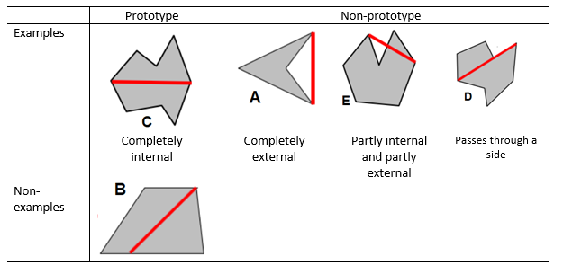

Appendix 2: Identification students' misconception (post-questionnaire)

|  |  |  |  |
| --- | --- | --- | --- |
| Item | Detail | |  |
| *First* | Write an accepted mathematical definition of polygon diagonal concept. | |  |
| *Second* | Given the following polygon:    **Question** (1): What is the number of all diagonals from vertex *P*?  **Question** (2): Draw all of them. | |  |
| *Third* | The following task was given to the students related to polygon diagonal:  *Different polygons are shown below.*  *For each polygon, draw all diagonals from vertex A.*    The answers for two students were as follows: | |  |
|  | First student | Second student |  |
|  |  |  |  |
|  | **Question** (1): According to the two answers above, analyze what each student understands about the polygon diagonal concept. In other words, write down the definition they both obtained for the polygon diagonal.  **Question** (2): Shown below are two polygons. Draw all the diagonals from *vertex* A according to what the two students understood about the diagonal concept. | |  |