**The Bologna Fragments of *Halakhot Gedolot* and their Relation to the Italian Textual Tradition of the Book**

Roni Shweka, University of Haifa

**The two versions of *Halakhot Gedolot***

*Halakhot Gedolot* by R. Simeon Qayyara (hereafter: *HG*) is one of the most important halakhic books composed in the Geonic period. It was enormously popular during that period and is the Geonic book quoted most often in medieval rabbinic literature.[1] Different versions of it were known in medieval Europe, and medieval rabbinic authorities in France and Germany occasionally referred to ‘*HG of Aspamia*’ (Spain) in contrast to ‘*Our HG*’ or ‘*HG of Babylonia*’. Until the end of the 19th century, only the *editio princeps* version of *HG*, Venice 1548, was known. During the years 1888-1892, Azriel Hildesheimer published a totally different version of *HG,* based on Ms. Vatican ebr. 142, probably a North-African manuscript from the 11th century.[2] Besides the many textual variants from the *editio princeps*, the order of the chapters in this version is quite different, as is the compilationof some of the chapters, mostly at the beginning and end of the book. Another remarkable difference is that Hildesheimer’s Berlin edition contains numerous Geonic responsa, as well as late interpretations and marginal notes that found their way into the text.

In a comprehensive study of these versions, A. Epstein argued that the *editio princeps* presents the original version of *Halakhot Gedolot*, which was composed in the academy of Sura at the beginning of the ninth century, while the Berlin edition presents an augmented recension compiled in Qayrawan around the year 900. He also identified the Berlin edition version of the text with the ‘Spanish’ *Halakhot Gedolot*.[3] Epstein’s theory has been challenged by some scholars, who based their arguments on additional manuscripts and many Genizah fragments of *Halakhot Gedolot* thathave been discovered since his study.[4] Between 1972 and 1987, Azriel Hildesheimer, the grandson and namesake of the above-mentioned Hildesheimer, published a variorum edition of *HG*. As the base text of his edition, he chose an Italian manuscript dated to around the year 1400 from the Ambrosiana Library in Milan. The version of the text in this manuscript is very similar to that of the Berlin edition. Hildesheimer argued, contra Epstein, that if one excludes the sections that were added to this text (that appear mainly in the Berlin edition), this manuscript presents the version of *HG* most faithful to theoriginal. The later Hildesheimer, besides referring to the Venice edition (V), the Berlin edition (B) and the Milan manuscript (M), recorded in his edition variants from two additional manuscripts: an almost complete manuscript found in the Vatican Library written in Ashkenazic script from the mid-thirteen century (R), and a partial manuscript found in the Bibliothèque Nationale de France, Paris (P).[5] This is an early eastern manuscript, not later than the 11th century.

In my study of *HG,* I reexamined all the textual witnesses of the book, including two additional partial Ashkenazic manuscripts found in the Firkovich collections, and no less than four hundred Genizah fragments.[6] Besides constructing a stemma of the main manuscripts, I dedicated a large part of the work to identifying the special characteristics of the B-M version of the text. Following Epstein’s earlier suggestion, I concluded that this version is the product of a complex and sophisticated project which took place in the last part of the ninth century and involved compiling and then revising a new recension of *HG* not too long after it was published. Ostensibly, the two most notable features of this recension are the different order of the chapters and the addition of Geonic responsa to the book. However, the order of chapters in the B-M recension is no less authentic than that of V or R. In fact it is closer to the original setting of the book as reflected in P and other sources. The addition of Geonic responsa should also not be considered the primary feature of this recension. These additions are mostly found in B and are less common in the other textual witnesses of this recension. Rather, the most significant feature of this recension is the rearranging of the small units within a given chapter or in-between chapters, and the massive editing of the running text, which in some sections can be detected in nearly every sentence. This characteristic of the B-M recension, although it is not always very evident at first glance, indicates that it was a well-planned and comprehensive project to rewrite *HG* from beginning to end that took place at a specific place and time. This characteristic of the B-M recension distinguishes it from all other versions of *HG* that are found in a variety of manuscripts. The differences between these other versions can be explained as sporadic adaptations and modifications made by local scribes and scholars, but do not represent a systematic effort to rewrite the book completely.

**The Italian tradition of *HG***

As I mentioned above, Epstein suggested, based on the responsa that were included in the B-M recension, that it was compiled in Qayrawan around 900. This is a reasonable speculation, and it certainly fits Beit-Arie’s evaluation that the script (and the provenance?) of B is North African.[7] However, the purchase statement at the end of the manuscript apparently states that the manuscript was produced in Fustat and Cairo. In any case, the manuscript was purchased in Cairo by Isaac b. Saul from Ferrara, who presumably brought the manuscript to Italy.[8] The presence of B in Italy could explain the close relationship between B and the later Italian manuscript M, but there is no real need to assume a direct relationship between these manuscripts. The characteristics of B-M that indicate its being product of a systematic recension also appear in many Genizah fragments. Most of these fragments are written in Oriental script and some of them can be assumed to be from as early as the tenth century. However, there are also fragments from two different manuscripts written in Italian script. Edna Engel dated one of them to around 1100, and the other to around 1200. All together, they make up about thirty-five fragments.[9] These early Italian manuscripts found in the Cairo Genizah present the same recension presented by B-M and thus confirm that this recension reached Italy by the eleventh century, and certainly before manuscript B was brought to Italy by Isaac b. Saul. In another place, I have shown that these Genizah manuscripts share some unique textual variants with manuscript M, in contrast to all other manuscripts, including B.[10] It can therefore be concluded that the textual tradition found in the relatively late manuscript M is not based solely on B, which was brought to Italy from Cairo, but represents an Italian tradition of *HG* which can be traced to the beginning of the second millennium in early Italian manuscripts found in the Cairo Genizah. This textual tradition reflects the reworked recension found in B-M, and it may well be that this recension arrived in Italy directly from Qayrawan, where it had been created. The connections between the Italian Jewish communities (especially those of the south, particularly Sicily) and North Africa are attested to both by merchants traveling from North Africa to Italy and by Italian scholars and students who immigrated to North Africa, particularly to the academy of Qayrawan.[11] One famous example of this immigration is R. Hushiel and his son R. Elhanan’s move from Bari to Qayrawan at the beginning of the eleventh century, which eventually became part of the basis of the legend of the four captives found in Ibn Daud.[12] Be that as it may, the textual evidence is clear enough: in Italy, the common version of *HG* was the recension presented in B-M. This is also the conclusion reached by Epstein, based on quotations from *HG* by Italian scholars.

The textual evidence from Germany and France indicates that the common version of *HG* in these regions was the original one instead of the reworked recension. All of the three Ashkenazic manuscripts (R and the two partial manuscripts in the Firkovich collections) present the original version of the book. It goes without saying that none of the manuscripts should be considered to be identical to the original. Rather, each is the result of various adaptions and modifications which occurred through the transmission of the text. Nevertheless, none of them present the reworked recension found by B-M. This textual evidence supports Epstein’s conclusion, which is based on quotations from *HG* made by German and French rabbinic authorities.

**The Bologna Fragment**

The Bologna fragment of *HG* consists of two not continuous folios. One side of each folio is completely erased and does not contain any legible characters. The other side is beautifully clear and easy to read. The inner margins of each folio are cut, and a few letters at the end of the lines on the first folio and the beginning of the lines on the second folio are missing.[13] One page contains the text between p. 97 l. 75 and p. 99 l. 17 of *Hilkhot Yibum we-Halitza* in the Hildesheimer (Jerusalem) edition. The other contains the text between p. 118 l. 44 and p. 120 l. 83 of *Hilkhot Me’un* in the same edition. Since *Hilkhot Yibum we-Halitza* precedes *Hilkhot Me’un* in all known versions of *HG,* we can assume that this is the case also in this manuscript. The two folios are most probably not parts of one bifolio. As the text of each page occupies approximately 40 lines in the Hildesheimer edition, and the text in the gap between the two folios occupies 400 lines in the Hildesheimer edition, one may conclude that approximately ten missing pages separate the two surviving pages. These would make an odd number of five folios, that do not correlate to a certain number of bifolios. Unless the manuscript had significant and unique lacuna or addenda in these chapters, we should conclude that the two pages survived from two different bifolios.

The overall quality of the text in the Bologna fragment is not particularly good. Besides the variant readings and typographical errors that are common in most manuscripts, the short text in the fragment contains obvious scribal mistakes that are not typographical errors and do not occur in other manuscripts. In two places, the scribe wrote ‘מים שאין להן סוף’ in places where it is clear from the context that the text should read ‘מים שיש להן סוף.’[14] In the first instance where this occurs, the error led to another one, in which the scribe changed the wording ‘אבל ודאי מים שאין להן סוף’ in the next line, which was meant to contrast with the previous case, to ‘מאי טע' אמרינן מים שאין להן סוף’, so that it will make sense with the erroneous wording at the beginning of the sentence. In another case, *HG* quotes *Mishnah Niddah* 6, 12 ‘שתי שערות האמורות בפרה ובנגעים’, while the fragment reads: ‘שתי שערות האמורות בפעוטות ובנגעים’, an erroneous reading that is not found elsewhere.[15] That being said, the fragment also preserves some original readings which in other manuscripts are replaced with more common forms, e.g., the idiom ‘קטן פרח’ in the fragment instead of ‘קטן פורח’ found in other manuscripts.[16] A more interesting question is the position of this fragment in the stemma of *HG* textual witnesses. Elsewhere I have shown that the early Italian fragments of *HG* from the Genizah share a common textual tradition with the much later Milan manuscript, containing some unique variants which occur only in these manuscripts.[17] Unfortunately, I cannot repeat the same argument here and present a variant which is shared by M and the Bologna fragment only, as the short text in concern does not present an example in which M has a significant and distinct reading from all other witnesses, including B. Still, the fragment can be attributed to the B-M recension by one clear evidence.

The dictum and subsequent comment “תנו רבנן פדחת בלא פרצוף פנים ופרצוף פנים בלא פדחת אין מעידין עליו עד שיהו שניהן עם החוטם. אמר אביי ואיתימא רב כהנא מאי קראה הכרת פניהם ענתה בם” (Hild. ed. p. 98 l. 83-86) appear in the fragment (p. 1 l. 6-8) in the same place that they appear in the B-M recension,[18] while in V and R they appear later, after “שנים אומרים מת ואחד אומר לא מת אף על פי שלא נישאת תינשא” (Hild. ed. p. 98 l. 99). The different position of these phrases in the text is caused by the fact that they were not in the original text of *HG* in this context, and were transferred to this chapter from an early addenda section originally located in the last part of *HG*, very far from this chapter.[19] Most probably, these phrases were copied from their original place in the addenda at the end of the book to the margins of this chapter in one of the earliest manuscripts of the book. The different locations of these phrases in this chapter as they appear in the two versions of *HG* reflect different interpretations with regard to the exact place where this marginal note should be inserted. The agreement of the Bologna fragment with B-M here, in contrast to V and R, clearly places the fragment within the textual tradition of the B-M recension.

The phenomenon of small textual units which are transferred from early addenda sections to different parts of the book is one of the most distinctive and significant characteristics of the various versions of *HG*, and particularly the B-M recension.[20] J.N. Epstein already drew attention to the fact that at the end of some chapters of *HG,* one can find series of paragraphs, mainly Talmudic quotations, which are not connected to one another and do not seem to relate to the chapter topic at all.[21] These sections are titled in some textual witnesses as *‘tosefta’*, i.e., addenda, additional textual units that were not part of the original book (not to be confused with the Tannaitic compilation with the same name). These *tosefta* sections were preserved in their original format mainly in P and R, while in the B-M recension all these paragraphs were removed from their original addenda sections and integrated into the different chapters, in accordance with their content. In some cases, the editors of B-M could not find an appropriate place in which to insert the addenda, and instead created new secondary *tosefta* sections at the end of other chapters, collecting all the addenda on the same topic in one place. This process of reediting the *tosefta* sections and transferring paragraphs from one part of the book to another serves as further evidence for both the posteriority of the B-M edition and for the fact that this edition is the result of an intentional and well-planned process, an observation that is supported by other evidence as well.

The agreement of the Bologna fragment with the B-M recension is by no means a surprise and is what we would expect with an Italian manuscript, as I argued above. Still, this agreement presents us with a great riddle that I do not yet know how to solve.

**The Leipzig fragments**

As Perani has demonstrated convincingly, fragments of the same manuscript of which the Bologna fragment is a part are found in Leipzig.[22] The Leipzig fragments contain a much larger portion of the manuscript and include no less than nine bifolios, that is, eighteen folios. These folios come from many different chapters of *HG*: *Hilkhot Me’un, Ketubot, Nedarim, Gittin, Kiddushin, Bava Kama, Niduy, Halva’ah,* and *Bava Batra*. In some cases, we can determine the order of these chapters in the manuscript. To my great surprise, I discovered that the chapter order in the Leipzig fragments is identical to that of R, and diverges from the order of chapters found in all other textual witnesses, including that of B-M. The chapter order in the Leipzig fragments is *Me’un* followed by *Ketubot* as in R and V, whereas in B, M, and P, *Ketubot* is at the end of *Seder Nashim,* after *Kiddushin*.[23] Likewise, the chapter order of the Leipzig fragments has *Nedarim* before *Gittin*. It has long been observed that B and M do not include the chapter of *Nedarim*, and it has been argued that this chapter was not part of the original *HG*. I have argued otherwise elsewhere, and I noted there that there is no positive evidence for the absence of *Nedarim* in B, as the last pages of *Seder Nashim* are missing from this manuscript.[24] In any case, while other textual witnesses place *Nedarim* at the end of *Seder Nashim*, the order of *Nedarim* before *Gittin* is found only in V and R![25] This is the case also with the three chapters *Niduy, Halva’ah,* and *Bava Batra* – so is the order in the Leipzig fragments, and this is the order in R. Although the chapters of *Niduy* and *Halva’ah* are missing in P, it is probable that in this case R and P share the same tradition. However, in B-M and V, the order is *Bava Batra, Niduy, Nahalot,* and *Halva’ah*.[26] To sum up, in all three of the cases for which there is evidence of chapter order in the Leipzig fragments, these fragments exactly match R in contrast to other manuscripts. Most significantly, the order is different from B-M in all three cases!

**Conclusion**

Here is the problem we are facing: If the Bologna fragment is an Italian manuscript, one would expect that it would be associated with the B-M recension. In fact, despite the short text of the fragment, this association has been successfully established through one clear and satisfying piece of evidence. On the other hand, if the Bologna fragment and the Leipzig fragments are parts of the same manuscript, which I do not doubt, then how do we explain the fact that the order of chapters in the Leipzig fragments is identical to that of the Ashkenazic manuscript R and diverges completely from B-M? Perani identified the script of the manuscript that is the source of both fragments as a ‘typical Italian script of the 12th c.,’ and revealed most amazingly the journey of the folios from Bologna to Leipzig. The Italian origin and provenance of the manuscript are therefore beyond any doubt. However, the specific textual tradition of the manuscript as a whole is still dubious and should be determined only after a further comprehensive study of the Leipzig fragments, a study which I hope to accomplish in the future.

**The text of the Bologna fragment**

**הלכות גדולות הלכות יבום וחליצה, עמ' 97-99**

1. [יבמה] יבא עליה ביאה גומרת בה ואין כסף ושטר גומרין בה. וקונה את עצמה בחליצה
2. [מנ]א לן [ד]כת' ונקרא שמו ביש' בית חלוץ הנעל כיון שחלצה נעל הותרה לכל יש'. נפל
3. [במים] שאין להן סוף ודאי בשני עדים ודיי מימת מיית ולגבי ממון יורשין יורדין[27] לנכסיו ולגבי
4. [אש]ה אחמ[י]רו בה רבנן עד דאמרין עדים סימנין שלו פדחתו וחוטמו ושאר סימנים שלו
5. [אם] כן ניסת בעד אחד תצא אקילו בה רבנן כל היכא דאיכא עד אחד וודאי איכא עד
6. [אח]ר בהדיה אלא איתרמויי דלא מתרמי בהדדי הדדי. תנו רבנ'[28] פדחת בלא פרצוף
7. [פנים] ופרצוף פנים בלא פדחת אין מעידין עליו עד שיהו שניהן עם החוטם. אמ' אביי
8. [ואית]ימא רב כהנא מהאי קרא הכרת פניהם ענתה בם. בעי מיניה מרב ששת עד אחד
9. [ביבמ]ה לשוק מהוא אמ' להו תניתוה אמרו לה מת בעליך ואחר כך מת בנה וניסית וקא מוקים
10. [לה ר]ב ששת בעד אחד ואפעלגב דקא מדחי ליה רבנן למתניתין רב ששת בעד אחד מוקים
11. [לה ו]להיתירא קא פשיט דקאמ[רינ]ן והכא[29] נמי להיתירא קא פשיט דקאמרינן רבא אמ'
12. [קל ו]חומר א'ס'ו'ר' לאיסור כרת היתרתה לאיסור לאו לא כל שכן ואפעלגב דאמ' ליה ההוא
13. [מרב]נן לרבא[30] הא קאמ' להיתירא וקמו להו רב ששת ורבא בחדא שיטתא להיתירא וקמ'
14. [...]רב' ששת שמע מינה עד אחד ביבמה לשוק כשר והשתא דאמרת עד אחד כשר
15. [דשו]יוה רבנן כאשה שהולך בעלה למדינת הים כאשה לכולה מילתא וקתני גבי אשה
16. [הוחז]קו להיות משיאין עד מפי עד עד מפי אשה אשה מפי עבד ומפי שפחה והדא יבמה
17. [...] שריא לאינסובי. הכל נאמין להעידה חוץ מחמותה ובת חמותה צרתה ויבמתה
18. [ובת ב]עלה ומה בין גט למיתה כתב מוכיח עד אחד אומ' מת וניסית ובא אחר ואמ' לא מת
19. [הרי זו] לא תצא עד אחד אומ' מת ושנים אומ' לא מת אפעלפי שניסית תצא שנים אומ' מת
20. [ועד] אומ' לא מת אפעלפי שלא ניסית תינשא. והיכא דאתו בתרי סהדי או אפי[לו]
21. [חד ס]הדא ואמ' חזיתיה לגברא פלו' דטבע במים שאין[31] להן סוף ושהאי כשיעור מיפ[ק]
22. [נשמת]יה ולא סליק לאלתר שרינן לה לאיתתיה מאי טע' אמרינן[32] מים שאין להם סוף אפיל[ו]
23. [...] משהיי לי טובא ולא סליק לא שרינן ליה לאיתתיה מאי טע' גנדרוה מיא מיא
24. [וסליק] בדוכתא אחריתי הני מילי לכתחילה אבל עבר ואינסיב לא מפקינן לה ולא שנ[א]
25. [גברא] קמא חשוב הוה ולא שנא שאינו חשוב היכא דעבר ונסיב לא מפקינן לה ולכתח[ילה]
26. [לא ש]רינן לה. תנו רבנ' נפל למים בין שיש להן סוף ובין שאין להם סוף אשתו אסורה
27. [דברי ר'] מאיר וחכמ' אומ' מים שאין להן סוף אשתו אסורה ושיש להן סוף אשתו מותרת
28. [היכי ד]אמי מים שאין[33] להן סוף אמ' אביי כל שעומד ורואה אותו מארבע רוחותיו. תנו [רבנן]
29. [יש חול]ץ לאמו מיספק יש חולץ לבתו מספק יש חולץ לאחותו מספק. אמו מספק כיצ[ד]
30. [אמו וא]שה אחרת ילדו שני זכרים במחבא ובא בנה שלזה ונשא אמו שלזה ובא בנה של[זה]
31. [ונשא א]מו שלזה ומתו בלא בנים זה חולץ לאמו וזה חולץ לאמו מספק. בתו מספק כיצד
32. [...] אשתו ואשה אחרת ילדו שתי נקבות במחבא ובאו אחי אביהן ונשאום ומתו בלא
33. [בנים ז]ה חולץ לבתו מספק וזה חולץ לבתו מספק. אחותו מספק כיצד אחותו[34] ואשה
34. [אחרת] ילדו שתי נקבות במחבא ובאו אחיהן ונשאום ומתו בלא בנים זה חולץ אחותו
35. [מספק] וזה חולץ אחותו מספק. מי שמת והניח אשתו מעוברת ומת וולד בן יום

**הלכות גדולות הלכות מיאון, עמ' 118-120**

1. זבינה זביני במקרקעי הויא עדותו עדות במקרקעי [אל]א אינו נבדק ולמטל[טלי לא]
2. [ה]ויא עדותו עדות בעידנא דהוו זביניה זביני במטלטלי דאילו זביני דמטלטלי פ[עוטות]
3. כבר שית כבר שבע כבר תמני כבר תשע כבר עשר כל חד וחד[35] לפי[36] חורפיה ואילו [לענין]
4. עדות אפילו מטלטלי עד שיהא בן שלש עשרה שנה ויום אחד משום דכת' ו[עמדו שני]
5. האנשים. ולהשלם לתפילה ולברכת המזון קטן פרח[37] מצטרף היכא דאתחיל ל[יה לאתויי]
6. שתי שערות ואכתי לא אייתי ההוא קטן פרח ודווקא ליה דעייל ליה בתליסרי וד[וקא]
7. דידע למי מברכין. והיל' קטן שקידש אין קידושיו קידושין ואם נשא אשה [והוליד]
8. בנים ועדיין לא הגיע לשלש עשרה שנה ויום אחד[38] אין קידושיו קידושין [ואין כתובתו]
9. כתובה אבל בניו כשרין [ה]ם ונקראין על שמו ואם בא לה[וצי]א אין צריך ליתן גט [ולכשיגיע]
10. לשלוש עשרה שנה ויום אחד [יחזו]ר ויקדיש ויכת[ו]ב כתובה אחרת ואסור לשה[ות את]
11. אשתו בלא כתובה וקידושין לאחר שלוש עשרה שנה ויום אחד מפני שכתובה [ראשונה]
12. אין משתעבדין בה נכסיו ואם בא עליה לאחר שלש[39] עשרה שנה ויום אחד אפע[לפי שלא]
13. קידש ושלא כתב כתובה אחרת ומבקש לגרשה צריכה הימנו גט שאין אדם עוש[ה בעילתו]
14. בעילת זנות. בא סימן התחתון עד שלא יבא סימן העליון או חולצת או מ[תייבמת]
15. דכולי עלמא מיהא אתחתון סמכינן מנהני מילי אמ' רב יהודה אמ' רב כדתנא[40] ד[בי ר']
16. ישמעא' אמ' קרא איש או אשה כי יעשו מכל חטאות האדם הישוה הכת' אשה [לאיש]
17. לכל ענשין שבתורה מה איש [בס]ימן אחד [א]ף אשה בסימן אחד אימא כי האי[41] [..כאיש]
18. מה איש תחתון ולא עליון אף אשה תחתון ולא עליון. תניא נמי הכי אמ' ר' אלע[זר בר']
19. יצחק[42] כך היו מפרשין ביבנה כיון שבא תחתון שוב אין משגיחין על העליון. תניא [רבן]
20. ש[מ]עון בן גמל' אומ' בנות כרכין תחתון ממהר לבוא מפני שרגילות במרחצאות בנו[ת כפרים]
21. עליון ממהר לבוא מפני שטוחנות בריחים. ר' שמעון בן אלעזר אומ' בנות עשירים [צד]
22. ימין ממהר לבוא מפני שנישוף באפיקרסותן בנות עניים צד שמאול ממהר לבוא [מפני]
23. ששואבות עליו כדי מים. דב' אח' מפני שנושאות אחיהן על גיססיהן. תנו [רבנן כל]
24. הנבדקות נבדקות על פי שנים[43] וכן היה ר' אליעזר מוסר לאשתו ור' ישמעאל[44] מוסר לא[מו ר']
25. יהודה אומ' לפני הפרק ולאחר הפרק נשים בודקות אותן תוך הפרק אין הנשים בודק[ות]
26. אותן שאין משיאין ספיקות על פי נשים ר' שמעון אומ' אף תוך הפרק הנשים בודקות [אותן]
27. ונאמנת אשה להחמיר אבל לא להקל כאי זה צד גדולה היא שלא תמאן קטנה ה[יא שלא]
28. תחלוץ אבל אין נאמנת לומר קטנה היא שתמאן גדולה היא שתחלוץ. שתי ש[ערות]
29. האמורות בפעוטות[45] ובנגעים והאמורות בכל מקום כמה שיעורן כדי לכוף ראשן [לעיקרן]
30. דברי ר' ישמעאל ר' אליעזר אומ' [כד]י לקרוץ בציפורן ר' עקיבה אומ' כדי שיהו ניטלי[ן בזוג]
31. אמ' רב חסדא אמ' מר עוקבא הלכ' כדברי כולן להחמיר. תינוקת שהביאה שת[י]
32. שערות חייבת בכל מצוות האמורות[46] או חולצת או מתיבמ'. תינוקת שהביאה שתי [שערות]
33. אינה יכולה למאן. אמ' ר' חלבו אמ' רב הונא שתי שערות שאמרו צריך שיהא בעי[קרן ..]
34. גומות. אמ' רב מילכיו אמ' רב אדה בר אהבה גומות אפעלפי שאין שערות ואפעל[פי]
35. שתי שערות בגומא אחת. והיכא דאיכא גומות אי איפשר לגומות בלא שערות

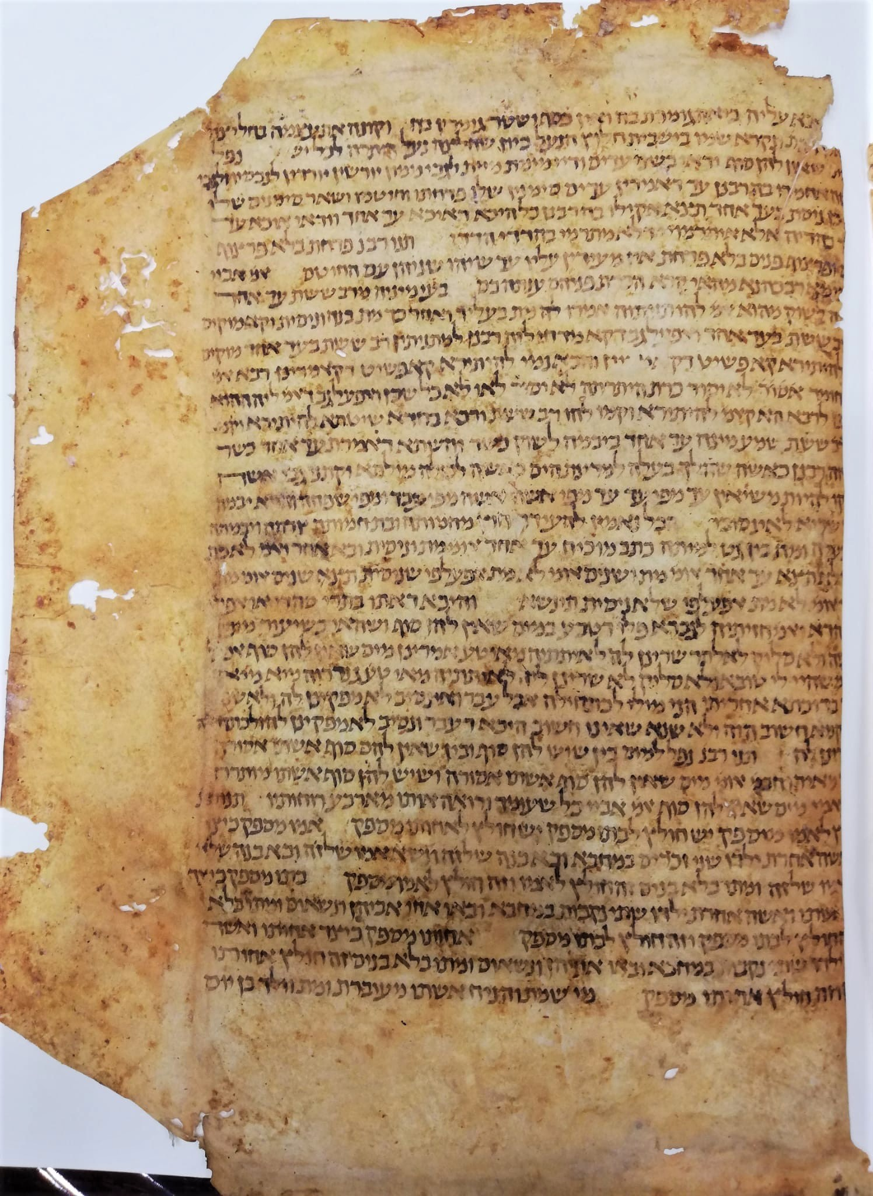

Fig. 1 – Bologna, Archivio di Stato, folio 1 containing *Halakhot Gedolot*, *Hilkhot Me’un*.

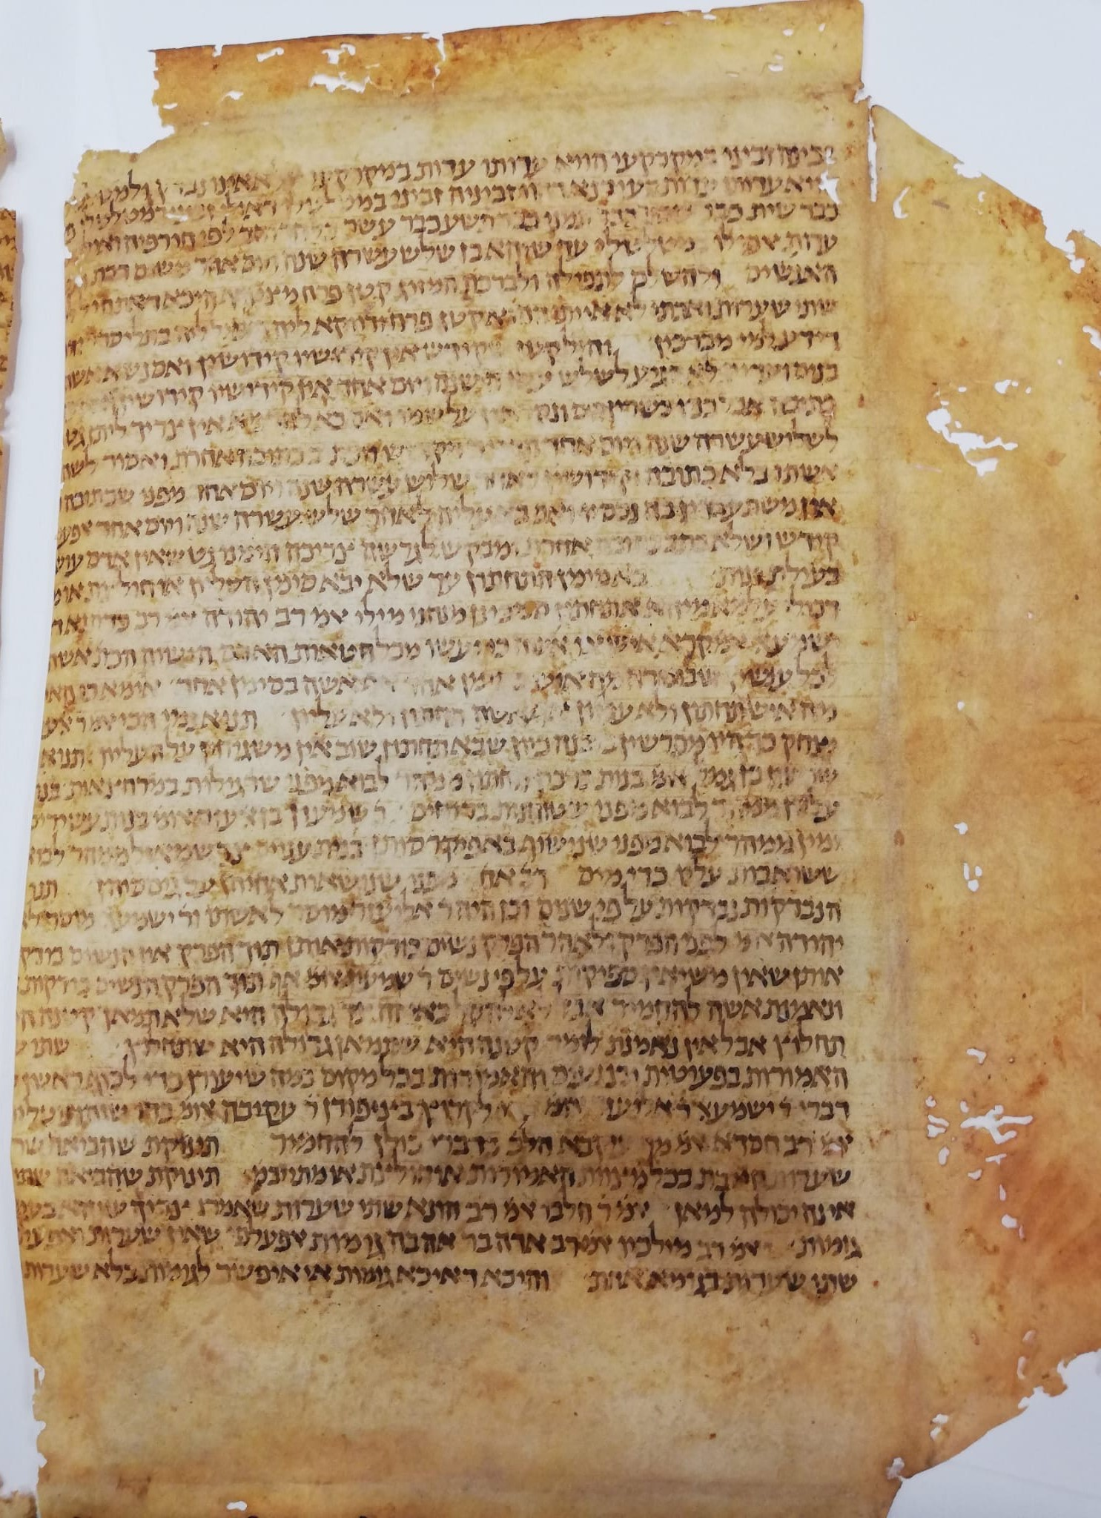

Fig. 2 – Bologna, Archivio di Stato, folio 1 containing *Halakhot Gedolot*,

*Hilkhot Yibum we-Halitza*.

1. For general information on *HG* see R. Brody, *The Geonim of Babylonia and the Shaping of Medieval Jewish Culture*, New Haven and London 1998, pp. 223-230; Id., *Zion Between the Tigris and the Euphrates: The World of the Babylonian Geonim*, Jerusalem 2015, pp. 379-386 (Hebrew).
2. J. Hildesheimer, *Halachot Gedolot*, Berlin 1888-1892.
3. A. Epstein, *Mi-Qadmoniyyot ha-Yehudim: Mehqarim u-Reshimot*, edited by A. M. Habermann = *The Literary Works of Abraham Epstein*, vol. 2, Jerusalem 1957, pp. 378-409.
4. See in particular N. Danzig, “*Teshuvot haGeonim beQeta min haGenizah veYahasan leHalakhot Gedolot*,” *Proceedings of the American Academy for Jewish Research*, vol. 54, 1987, pp. 13–57; idem, *Introduction to Halakhot Pesuqot* (Hebrew), 2nd ed., New York and Jerusalem 1999, pp. 186-191.
5. The sigla in the manuscripts match the sigla used in Hildesheimer variorum edition.
6. R. Shweka, Studies in *Halakhot Gedolot*: Text and Recension (Hebrew), Doctoral Dissertation, The Hebrew University, 2009.
7. B. Richler (ed., Paleographical and Codicological Descriptions by M. Beit-Arie in collaboration with N. Pasternak), *Hebrew manuscripts in the Vatican Library*, Città del Vaticano 2008, p. 99-100.
8. Another note in Latin records the purchase of the manuscript on 12 November 1542 for four and a half ducats (f. 1r).
9. Shweka, *Halakhot Gedolot*, pp. 35-36 (manuscripts G4 and G5 there).
10. An unpublished paper given at Oxford, February 2011. See for now R. Shweka, “Genizah Fragments of Geonic Halakhic Codes,” *Report of the Oxford Centre for Hebrew and Jewish Studies*, 2010-2011, pp. 95-96.
11. M. Ben Sasson, “Italy and Ifriqia from the Ninth to the Eleventh Century,” in J. L. Miege (ed.), *Les relations intercommunautaires juives en méditerranée occidentale. XIIIe-XXe siècles.*Paris 1984, pp. 34-50.
12. G. D. Cohen, “The Story of the Four Captives,” *Proceedings of the American Academy for Jewish Research*, vol. 29 (1960), pp. 55-131. On R. Hushiel and his son in Qayrawan see M. Ben Sasson, *The Emergence of the Local Jewish Community in the Muslim World: Qayrawan, 800-1057*, Jerusalem 1996, pp. 221-229.
13. For full codicological description see M. Perani, “Juridical Books bound in 16th c. Bologna with folios from a 12th c. manuscript of *Halakhot Gedolot*, and donated, in the 19th c., to the Leipzig University Library,” in this volume pp. 00-00.
14. p. 1 l. 21, l. 28
15. p. 2 l. 29.
16. The meaning of ‘קטן פרח’ is probably related to the meaning of ‘a young boy who is not a child, an apprentice;’ as in ‘פרחי כהונה’ (*Mishnah Yoma* 1, 7). This reading is found in two genizah fragments of *Bavli Berakhot* 47a, Cambridge T-S F1(1).106 and T-S F1(1).113, instead of the form ‘קטן פורח’found in all other manuscripts. This is also the form in some geonic authorities, among them *Halakhot Pesukot*, p. 154 and *Sefer ha-bagrut le-Rav Shmuel ben Hofni Gaon*, ed. by T. Meacham, Jerusalem 1999, p. 164.
17. See n. 10.
18. The same also in Genizah fragment Cambridge University Library, T-S AS 77.139, which belongs to a manuscript that present the B-M recension (Shweka, *Halakhot Gedolot*, p. 50 [G40] and p. 138).
19. Shweka, *Halakhot Gedolot*, p. 161.
20. Shweka, *Halakhot Gedolot*, pp. 143-146.
21. J. N. Epstein, *Studies in Talmudic Literature and Semitic Languages* (edited by E. Z. Melamed), vol 1, Jerusalem 1983, pp. 270-273 (=*MGWJ* 61 (1917), pp. 127-132).
22. Perani (above, n. 13).
23. Shweka, *Halakhot Gedolot*, pp. 113-114.
24. R. Shweka, “Concerning The Chapters Nedarim and Nazir in *Halakhot Gedolot*,” *Tarbiz* 74 (2005), pp. 305-312 (Hebrew).
25. Shweka, *Halakhot Gedolot*, pp. 117-119.
26. Shweka, *Halakhot Gedolot*, pp. 124-125.
27. [ יורשין יורדין B, M, V, R: נחתין יורשין (Aramaic)
28. תנו רבנ'... ענתה בם ] so also in B, M and T-S AS 77.139; in VR missing here and found after אעלפי שלא ניסית תינשא (l. 20)
29. והכא] read ורבא, so R and T-S AS 77.139; B, M, V missing דקאמרינן ורבא נמי להיתירא קא פשיט (homeoteleuton)
30. B, M, V and T-S AS 77.139 correctly: לרבא רבא
31. B, M, V, R correctly: שיש
32. מאי טע' אמרינן ] B, M, V, R correctly:אבל ודאי
33. B, M, V, R correctly: שיש
34. אחותו ] so also B, M, R and this is an ancient mistake; V: אמו
35. חד וחד ] so B, M, V; R missing וחד
36. לפי ] so B; M (contra Hild. ed.!), R, V: לפום
37. קטן פרח ] other Mss.: קטן פורח; the same for the second occurrence on the next line.
38. ויום אחד ] R missing in all occurrences (l. 8, 10, 11,12)
39. So in all Mss. including M, but in Hild. ed. שתים!
40. כדתנא ] B, M, V, R: וכן תנא
41. כי האי ] so R; B, M, V: אי האי אי האי
42. יצחק ] B, M, V, R correctly: צדוק
43. שנים ] read נשים
44. ישמעאל ] so M (contra Hild. ed.!), R, V; B: יהושע
45. בפעוטות ] B, M, R, V and T-S F10.65: בפרה
46. האמורות ] B, M, R, V: האמורות בתורה