**Background:** Transcranial direct current stimulation (tDCS) is an evolving neurostimulation therapy for multiple neurological and psychiatric indications such as major depression, stroke, Parkinson's disease, and others 1–9. It entails the delivery of a weak direct current (DC) to the brain via the scalp 10–13. tDCS advantages are that it is noninvasive, portable, simple to use, cheap, and with minimal side effects 14,15. However, despite the growing use of tDCS, its overall therapeutic efficacy is not yet clear, and even encouraging studies called for further optimization 16–18. One of the most significant barriers to tDCS optimization is that its underlying mechanisms are not fully clear 17,19–25. The basic dogma for tDCS is that it generates an electrical field that modulates the neuronal intrinsic and extrinsic properties 26. Besides neurons, tDCS has been shown to affect other brain cells, like astrocytes and glial cells27–31. Yet, it is unclear whether the effect of tDCS on non-neuronal cells is a direct consequence of the electrical current or an indirect effect due to the modulation of neuronal properties. Modeling studies and indirect measurements posited that an electrical field, parallel to the dendro-axonic axis, generates incremental membrane polarization, which gradually maximizes at the distal subcellular compartments 26,32–36. Nonetheless, these models predicted that the terminal polarization is too small even under optimal conditions to generate significant physiological effects 34,35. Using an *ex-vivo* model for tDCS, where direct current stimulation (**DCS**) was applied to brain slices via submerged wires in the recording bath, we performed direct measurements that confirmed the maximal polarization at the terminal compartments and showed that the resultant polarization is much larger than the one predicted by the models 35. We further showed that the models based on the cable model took into consideration only the passive membrane properties, while modulation of ion channels conductance amplifies the terminal membrane polarization 37,38. These results lay the theoretical ground to explain the non-linearity of tDCS' dose-response as indicated by numerous studies 39–42. Despite this knowledge of the cellular processes that take place in tDCS, the resultant molecular processes that lead to the long-term effects of tDCS are still unclear.

Angelman syndrome (AS) is a genetic neurodevelopmental disorder manifested by severe cognitive and motor impairments 43–47. Its prevalence is estimated to be between 1:10,000-1:40,000 44,48. Typically, the life expectancy of most AS subjects is normal, although subjects with AS cannot function independently at any stage of their life 49,50. AS is caused by the loss of function of the Ube3a protein in the brain, usually due to the deletion of small portions of the maternal chromosome 15(q11-13) that contains the UBE3A gene 51–54. Knockout of this gene in mice recapitulates many features of AS (e.g., motor dysfunction, aberrant behavior, and cognitive deficits), making this model an efficient tool for investigating the disease 55–58. Using this model, we and others showed that brain regions implicated in AS deficits correlate with aberrant cellular excitability 59–68, and mostly but not always 60, the recovery of the excitability aberrations correlates with the rescue of the behavioral deficits 59,62,64,66. However, the mechanism that is responsible for this phenomenon is unclear. The loss of UBE3A expression in AS occurs in almost all neurons of the central nervous system (REF DINDOT JUSTIN2010xx). However, the effects of UBE3A loss on cellular excitability differ between brain regions (e.g., hippocampus, cortex, and cerebellum). For example, while the cellular excitability of layer-5 pyramidal neurons in the infra-limbic prefrontal cortex of AS mice is enhanced 69, at the visual cortex, the loss of Ube3a led to an increased pyramidal neuron intrinsic excitability alongside a decrease in the excitatory and inhibitory drive onto layer-2/3 pyramidal neurons 70,61, and we showed that in the dorsal hippocampus there is an increased inhibitory GABAergic tone, which its alleviation restores LTP 71.

tDCS can be delivered as an anodal or as a cathodal stimulation. Simply put, anodal stimulation excites neuronal activity, while cathodal stimulation inhibits neuronal activity. For this reason, we hypothesized that applying anodal tDCS stimulation over the dorsal hippocampus of AS mice might correct the aberrant cellular excitability, leading to normalizing AS hippocampal-dependent deficits. In an initial set of experiments that were designed to examine this hypothesis. Electrodes were surgically fixed over the skull above the dorsal hippocampi, and mice were treated with sham or tDCS before each training session (Fig 1A,B). Based on those experiments, we concluded that tDCS treatment rescued spatial memory deficits of AS mice (Fig 1C-E). However, the treatment did not affect motor functioning (Fig 1F), which is reasonable because this electrode position is unsuitable for motor effects. Furthermore, a small pilot study showed that tDCS enhanced object location memory (OLM) for the displaced object in both WT and AS mice littermates (Fig 2). All of the above indicated that tDCS has the potential to evolve into a novel, noninvasive, therapeutic approach for Angelman syndrome patients. However, before this therapeutic approach can be applied, we must understand how dose the tDCS stimuli affect the cellular mechanism in targeted parts of the brain, evaluate the effect of stimuli on overall behavior, and determine the impact of the treatment on the short and prolonged effects on the neuronal metabolism, cellular homeostasis, and excitability and determine the duration of the treatment effect.

The excitability of neurons is defined as the ability to generate a significant, rapid change of membrane voltage in response to a stimulus. Homeostatic regulation of neuronal excitability provides stability to the neural network, which is essential for maintaining normal brain functions. Any dysregulation in the homeostatic regulation of neuronal excitability could lead to neuropsychiatric disorders, such as epilepsy, depression, autism, and schizophrenia. Previous studies performed by others72 and us73,74, showed that alteration in the expression level of UBE3A leads to mitochondrial abnormalities that can affect various glucose metabolic pathways, cellular homeostasis, calcium homeostasis, apoptosis, and accumulation of ROS. Furthermore, It has been previously shown that AS adult mice models, which display endophenotypes consistent with the human disorder, exhibit mitochondrial dysfunction and altered mitochondrial morphology in the hippocampus 75 76. Neurons consume ~15% of the body's resting energy to sustain action potential, neurotransmitter release, cytoskeletal dynamics, and gene expression. Despite the significant energy demands, neurons do not store energy but rather instantly and locally synthesize it in the form of ATP. Therefore, it is not surprising that metabolic insults, including acute ischemia, mitochondrial poisons, hypoglycemia, or even minor neuronal energy homeostasis disruptions, cause a rapid decline in nervous system function.

tDCS is a safe method for modulating neuronal excitability77. Interestingly, data which was generated in our lab show that direct current stimulation modulates neuronal excitability on the single-cell level as well as the circuit level and, at the same time, has the potential to alter the metabolic state of neurons and modify the expression of various metabolites which serve as signaling molecules and neurotransmitters78–80. These attributes of tDCS might serve as a therapeutic strategy for treating neurodevelopmental disorders, similar to AS. And indeed, as we previously showed (Fig 1), tDCS treatment was able to rescue some of the behavioral aberrations associated with AS.

Anodal tDCS treatment has been shown to increase neuronal excitability8182, and some of its excitability alterations are long-lasting. Despite multiple studies, the mechanisms, especially the long-lasting effects, are still obscure. We hypothesize that tDCS, like other types of neurostimulation, alters the metabolic state of the neurons and thus modulates neuronal excitability via modulation of the neuronal metabolic pathways and cellular homeostasis. Support for this hypothesis can be found in an experiment in which we treated WT rats with anodal tDCS for five consecutive days and analyzed the adenosine level in the rat cortex and hippocampus. We found that upon tDCS stimulation, adenosine level was up-regulated in the hippocampus, which was targeted by the tDCS stimuli, and the prefrontal cortex (Fig. 3). Adenosine serves as a neurotransmitter and neuromodulator in the central nervous system, its plays a role in modulating neuronal plasticity, astrocytic activity, learning and memory, motor function, feeding, control of sleep and aging. Adenosine is also an essential component of energy production that can be produced during the catabolism of adenosine triphosphate (ATP)83.

It has been previously shown that anodal tDCS in the MPTP-induced PD mouse model decreases mitochondrial damage84 and reduces the oxidative stress level85. This finding is particularly interesting since we previously found elevated Reactive oxygen species (ROS) levels in the hippocampus of adult AS mice86. Moreover, Rae et al. reported that anodal tDCS treatment in human subjects exhibited an increased demand for adenosine triphosphate (ATP) and an increased pH, which affected creatine kinase steady-state equilibrium created by hydrolysis of PCr due to demand for ATP 87. All of the above indicate that tDCS can affect the mitochondria and the capability of the mitochondria to produce cellular energy through the electron transport chain, affecting the overall mitochondrial dynamics. Additionally, tDCS has the potential to induce other metabolic effects that are not directly related to the mitochondria, such as changes in levels of neurotransmitter-related metabolites. Taken together, we posit that the loss of Ube3a in AS alters the neuronal metabolism and that tDCS has the potential to modulate their aberrant metabolism that will rescue their neuronal excitability, culminating in rescuing the cognitive and behavioral deficits.

Angelman syndrome shares the same pathophysiological mechanisms as various autistic disorders like Rett Syndrome, Pitt-Hopkins, and other86. Furthermore, some of the cellular properties associated with AS (like elevated levels of ROS and mitochondrial abortions) are also known to play a significant role in the pathophysiological of other neurodegeneration diseases like Alzheimer's. Therefore, unveiling the effect tDCS treatment has on the cellular homeostasis of the central nervous system will benefit Angelman syndrome patients and potentially evolve to brode rang treatment for multiple types of neurodegeneration and neurodevelopmental diseases.

**Hypothesis or Objective:** Angelman syndrome is a genetic condition that affects the nervous system and causes severe learning and behavioral disabilities. AS has also been associated with aberrant cellular metabolism, calcium metabolism, and mitochondrial abnormalities. Our preliminary studies concluded that tDCS could improve the learning capabilities of AS mice and even WT mice (Fig 2 and 3). However, while tDCS appears to have an overall beneficiary effect on learning capabilities, the cellular mechanism governed by tDCS and the duration of the tDCS effect are still unknown. For this reason, the objective of this proposal is three-fold: **A.** to delineate the effect of tDCS on different brain regions in AS mics and study the behavioral outcome of those treatments. **B.** to study the metabolic effect tDCS has on the treated areas. **C.** to determine the effective treatment duration on both the behavioral and metabolism of the treated areas

**Specific Aims:**

1. To delineate the effects of tDCS on behavioral phenotypes of wild-type and Angelman syndrome model mice.

2. To examine the metabolic effects of tDCS on wild-type and Angelman syndrome model mice.

3. To correlate the metabolic effects of tDCS with its effects on intrinsic and extrinsic excitability.

**The expected significance** of the proposed study is fourfold: **1)** a better understanding of the cellular mechanisms underlying tDCS will enable an efficient treatment regimen, thus optimizing its use for any application; **2)** Understanding tDCS-mediated cellular mechanisms will facilitate the use of pharmacological agents that augment tDCS efficiency; **3)** Due to critical developmental time-points, genetic manipulations rescue only some of AS deficits. Although tDCS will not cure AS patients, any functional improvement will significantly enhance their independence and quality of life; **4)** The test case of AS will support further studies for other neurodevelopmental disorders. Therefore, strategies that directly modify cellular functioning, brain region connectivity, or excitability, such as tDCS, may offer a more practical approach to treating AS and healthy individuals seeking to improve their learning capabilities.

**Preliminary results :**

**Figure 1:** tDCS alleviates the spatial navigation memory deficits in AS mice.

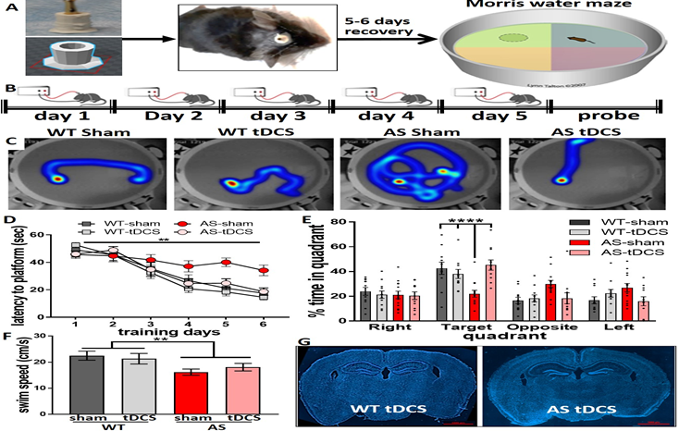

**Fig 1**. MWM study shows that 20 min of tDCS over the parietal cortex and dorsal hippocampus, ending 5min before training, alleviates the spatial navigation memory deficits in AS mice. The center of anodal electrode was -1.5mm posterior to bregma, and the return electrode was over the thorax using a Velcro corset. A. experimental procedure layout. B. stimulation protocol during MWM training period. C. representative heat-maps of mice in the probe test. D. latency to reach the platform [F(15,210)=2.6, p<0.01 in RM-2way-ANOVA for interaction group*time]. E. time in target quadrant in the probe test [F(3,42)=9.7, p<0.0001 in ANOVA for target quadrant]. F. swim speed is affected by genotype but not by tDCS [F(1,42)=8.9, p<0.01 and F(1,42)=0.06, p=0.82 for genotype and treatment, respectively; in 2way-ANOVA]. G. histological analysis of brains after the end of experimetns did not show any tDCS-induced damage at the end of the experimental protocol. Data presented as means ± SEM as error bars. Dots represent individual mice. Mice Numbers: WT sham (11), WT tDCS (11), AS sham (13), AS tDCS (11). **p<0.01; ****p<0.0001.

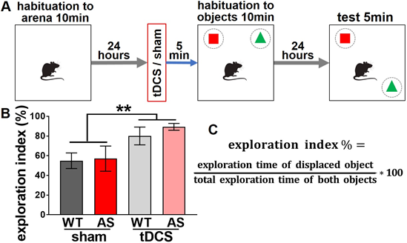**Figure 2: tDCS enhance object location memory in WT and AS mice.**

**Fig 2**. A pilot study shows that tDCS enhances object location memory in both WT and AS mice.

tDCS electrode position same as for MWM.

Stimulation parameters 150A for 20 min. **A.** OLM experimental scheme. **B.** tDCS increases test phase exploration index in WT and AS mice

[F(1,14)=9.1, p<0.01 for treatment effect in 2 way-ANOVA]. No differences are found between WT and AS.

**C.** Equation for calculating exploration index %.

N=5 mice for WT sham and AS sham each group.

N=4 mice for WT tDCS and AS tDCS each group.

**Figure 3:**

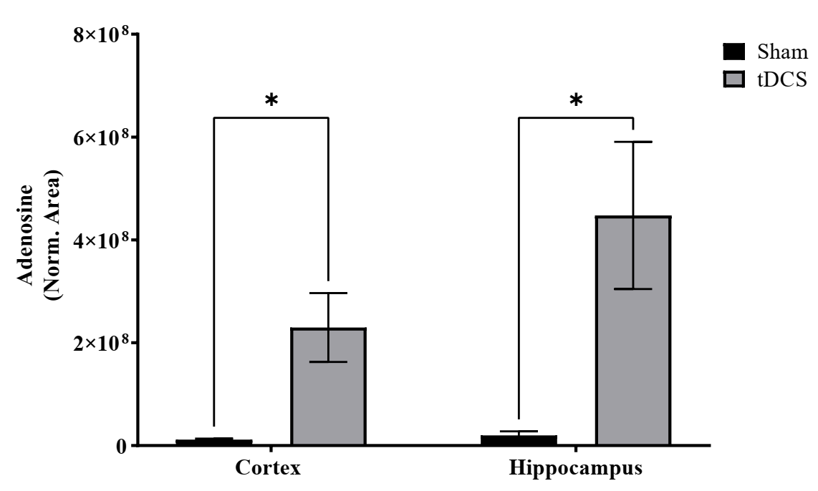

**Fig 3**. tDCS elvates the adenosine level in WT rats following tDCS treatment in the cortex and hippocampus of rats. Adenosine levels in the cortex and hippocampus after tDCS treatment in rats. Adenosine were measured by LS/MS in the rat cortex and hippocampus after 5 days of consecutive tDCS stimulation (intensity set at 150 μA for 20 min). Data are mean ± SEM from three different samples. * p < 0.05 is significantly n=3.

**Figure 4:**

**Fig 4**. 1H NMR metabolisim of

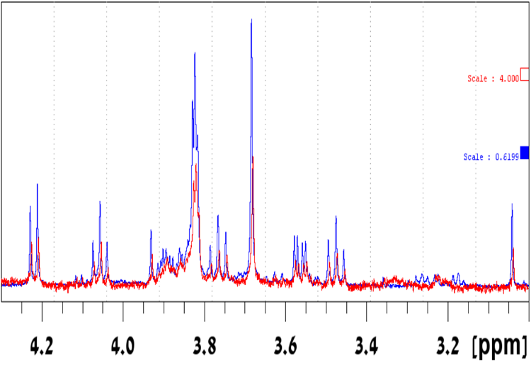

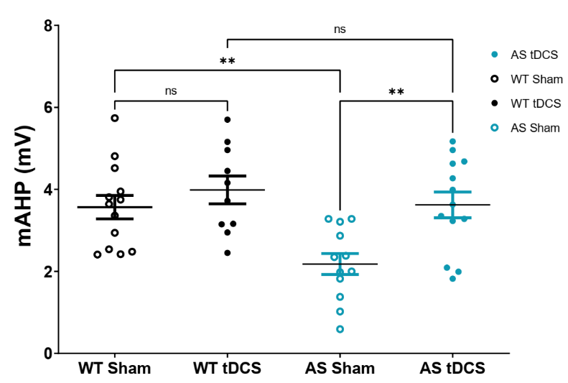**Figure 5:**

**Fig 5**. Medium afterhyperpolarizing potential (mAHP) is normalized in AS mice following tDCS treatment. mAHP in CA1 Pyramidal neurons with 5 consecutive days of either sham treatment or tDCS stimulation (150 μA for 20 min). The mAHP was measured using prolonged (3s), high-amplitude (3 nA) somatic current injections to initiate time-locked AP trains of 50 Hz frequency and duration (10–50 Hz, 1 or 3 s) in pyramidal cells. mAHP was measured from the equipotential point of resting potential to the anti-peak of the same spike. Data is presented as mean ± SEM. ** p < 0.01 is significantly. WT Sham: N=2, n= 10; WT tDCS: N=2, n= 9; AS Sham: N= 2, n= 10; WT tDCS: N=2, n= 11.

**Research Strategy:** (Partnering PI Option: Describe how the research project is supported and strengthened by the proposed synergistic collaboration. If the project is multi-organizational, describe plans for communication between investigators at each organization)

**Graphical representation of the experimental design** :

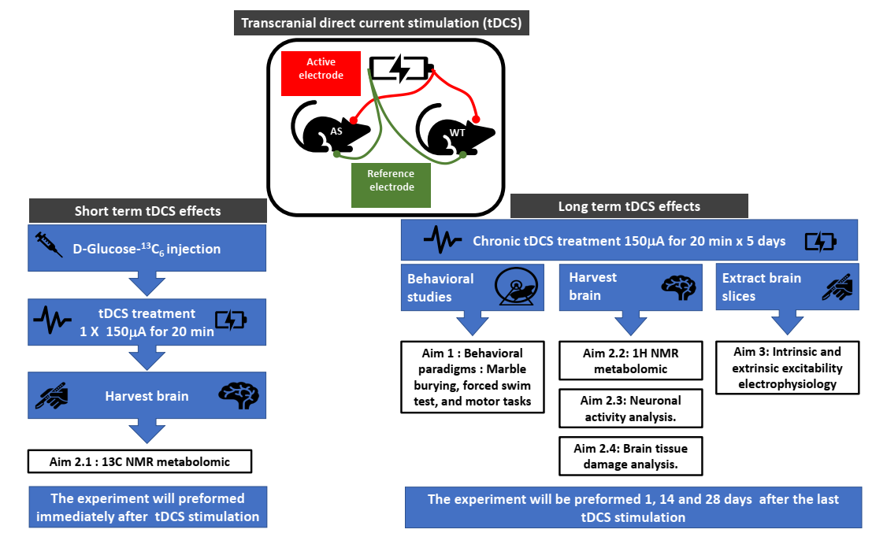

**Aim-1 To delineate the effects of tDCS on behavioral phenotypes of wild-type and Angelman syndrome model mice:**

***Rationale:*** Many AS deficits correlate with aberrant excitability in corresponding brain regions, including the cerebellum, cortex, and hippocampus 59–67. Despite one study 60, we and others showed a correlation between the recovery of the excitability and rescue of AS behavioral deficits 59,62,64,66. One of these robust deficits is the spatial memory impairment in AS mice, demonstrated in the Morris water maze (MWM) 57,66,88–90. MWM is a task dependent on the dorsal hippocampus 91–95 and the parietal cortex 96–99. Using a tDCS device we designed for mice (Fig 1a), we demonstrated that applying tDCS above these regions successfully rescues the AS mice deficit in MWM (Fig 1).

Furthermore, 20 min of tDCS just prior to habituation to an arena with two objects enhanced the hippocampal-dependent 100 novel object location memory (OLM) in both WT and AS mice (Fig 2). ***Therefore, we posit that modifying the excitability of distinct brain regions in AS mice, using tDCS, will alleviate cognitive/behavioral deficits.*** In this aim, we will apply tDCS over relevant brain regions of WT and AS littermates and test performance in corresponding behavioral tasks. We expect that tDCS over distinct brain regions will modify regional brain activity and surpass developmental deficits, thus rescuing some AS deficits. We will also examine the long-lasting effect of tDCS treatment on AS behavioral characteristics by repeating the behavioral paradigms exams at a few points post the tDCS treatment.

**Aim-1** **experimental design*:*** We will surgically implant a custom-made hollow dome-shaped tDCS electrode (base internal diameter = 4mm), filled with a sterile conductive gel contacted with a protruding copper wire (Fig 1a). Mice will be anesthetized with isoflurane using a Somnosuite apparatus (Kent scientific). The mouse scalp is cut to reveal the skull, and the electrode is tightly attached using a Metabond adhesive cement (Parkell). The scalp skin is sutured above the baseplate of the electrode, and mice will receive postoperative antibiotics and analgesics for the following 3 days. The electrode will be positioned over the relevant brain structures (**Specific Methods**). Mice will recover after the surgery for 5-6 days. After that, we will treat the mice with anodal/cathodal tDCS or sham for five consecutive days, before each training session. In tests that do not include training and are performed once (forced swim test 101, marble burying 102), we will stimulate for 5 consecutive days before the test. Stimulation intensity will be 150 μA (current density of 11.93μA/mm2). The mice tolerate these stimulation parameters without any observed pain or stress and without inducing any cellular damage to the brain tissue underneath the electrodes, as observed in histological preparations (Fig. 1G).

**Behavioral paradigms:** Marble burying, forced swim test, and the motor tasks of rotarod and beam crossing will be used to assess tDCS effects, as we and others previously described 58,89. The neuronal circuitry of marble burying is not fully elucidated, but the dorsal hippocampus is likely to be involved 102–104. The neural region related to the forced swim test is the medial prefrontal cortex (PFC) 105–111. The neural region responsible for motor deficits are to some extent the motor cortex 112,113 and even the medial PFC 114, and not necessarily the cerebellum 115. All of these regions were shown to have altered excitability in AS mice 59,60,64–66,90,116. IL-PFC was shown to entail enhanced excitability in AS 59,60, therefore cathodal stimulation will also be examined. The behavioral paradigms, forced swim test, marble burying, rotarod and beam crossing, were previously described in details by us and others 58,89,90,117,118. We will examine males and females, and compare between the sexes. The tracking of behavior is executed by the automatic tracking system EthoVision XT 12 software (Noldus).

**Aim-2 To examine the metabolic effects of tDCS on wild-type and Angelman syndrome model mice.**

**Rationale:** In the early 1950th, it was demonstrated that the application of electric currents to brain cortical tissue could affect brain metabolism119. A later study from 2013 demonstrated that tDCS is associated with an induced metabolic workload, with induction in ATP synthesis and an increase in brain pH120 . Recent studies showed that when tDCS was applied to the MPTP-induced neurotoxic mouse model, it suppressed excessive mitophagy and balanced mitochondrial dynamics121. Mitochondria are cell organelles that play a vital role in maintaining cellular homeostasis. They are involved in numerous functions and signaling pathways such as energy metabolism, calcium homeostasis, apoptosis, etc. Mitochondria are not static but dynamic organelles involved in adaptation to changes in the metabolic environment of cells. Altered mitochondrial function and oxidative stress are well-described pathophysiological mechanisms in neurodegenerative and autistic disorders, including Angelman syndrome122. Previous studies performed by others72 and us73,74, showed that alteration in the expression level of UBE3A leads to mitochondrial abnormalities that can affect various glucose metabolic pathways and cellular homeostasis. Brain bioenergetics are known to be sensitive to brain workload and are known to be altered in some psychiatric disorders. In this aim, we wish to determine whether brain bioenergetics and metabolism changed during tDCS treatment, delineate these changes, and determine the duration of those effects. For this aim, we will utilize high-throughput NMR metabolomics to assess the effect of the tDCS on brain metabolism. 1H NMR will be used to detect alterations in metabolites and their linkage to metabolic processes83. For example, N-acetylaspartate (NAA) has been used as a neuronal biomarker to reflect neuronal function and density [11] and it is implicated in many metabolic processes, such as myelination and oxidative metabolism. 13C NMR technique is an approach for detecting metabolic kinetics. This approach can measure the composition of metabolites, detect changes in the metabolic rate of energy sources and reflect the dynamics of neurotransmitter transmission [8]. For this reason this metabolomic aproch will allow us to study the dynamics of molecular metabolisms, which may play a crucial role in brain function and are afeted be the tDCS tratmnent.

**Aim-2 experimental design:** WT and AS mice, which were surgically implanted with the tDCS electrode (as described in aim 1), will be treated with anodal tDCS or sham for either one or five consecutive days. Upon completion of the behavioral test, different brain regions will be harvested and subjected to 1H or 13C NMR metabolomics.

**Short-term effect of the tDCS on the brain metabolic flux**: The short-term effect of the tDCS on glucose, glucose-derived metabolites (like lactate and pyruvate), and different mitochondrial metabolite levels will be measured using glucose labeled with carbon-13 NMR pre/post tDCS in the cerebral cortex, hippocampus, and other brain regions. The WT and AS mice will be injected with D-Glucose-13C6 via the tail vein 20 minutes before the tDCS stimulation flowing 20 minutes of anodal tDCS stimulation with the intensity of 150 μA. Upon completion of the stimulation, different brain regions will be harvested immediately after the application of the tDCS to the mice. The hippocampus, cerebral cortex, and xxx will be processed for 13C NMR metabolism as described by Guo et al. 123.

**Long-term effect of the tDCS on the brain metabolic homeostasis:** tDCS treatment affects the brain bioenergetics and metabolism at different time points after tDCS treatment. The effects of tDCS on brain energy levels will be evaluated by measuring metabolites like Phosphocreatinine, adenosinetriphosphates, adenosinediphosphates, and inorganic phosphate levels in different brain regions. We will also evaluate the long-term effect on neurotransmitters like GABA. and Glu, as well as other metabolites such as N-acetylaspartate (NAA)123, which can be used as a neuronal biomarker that reflects neuronal function and is implicated in many metabolic processes, such as oxidative metabolism124. Similarly, metabolites variations related to energy metabolisms, like lactate, creatine, acetone, 3-hydroxybutyrate, and nicotinamide-adenine dinucleotide (NAD)125, will also be studied. To this end, WT and AS mice will be treated with anodal tDCS or sham for five consecutive days. Upon completion of the behavioral test, different brain regions will be harvested at different time points as described in aim 1 and subjected to 1H NMR metabolomics as previously described by Hongyu et al. 125 and Zheng et al. 123.

**AIM-3 To correlate the metabolic effects of tDCS with its effects on intrinsic and extrinsic excitability.**

***Rationale:*** As aforementioned, many of the AS deficits correlate with aberrant excitability in corresponding brain regions, including the cerebellum, cortex, and hippocampus 59–67, and despite a single study 60, manipulations that rescued AS behavioral deficits correlated to the recovery of the excitability 59,62,64,66. ***Therefore, we posit that the alleviation of cognitive/behavioral deficits would correlate to long-lasting excitability modifications in the relevant distinct brain regions in AS mice, following tDCS.*** Delineation of these long-lasting excitability changes alongside the detailed information regarding the metabolic changes that are ignited by tDCS will shed light on the processes by which acute tDCS effects are being translated into long-term beneficial cellular changes. This knowledge has the potential to enable the optimization of tDCS as a therapeutic tool and suggest augmentation strategies, such as pharmacological interventions alongside the tDCS treatment.

**Aim-3 experimental design*:*** After administering the abovementioned tDCS protocol for behavioral testing in WT and AS mice, brains will be extracted at the end of the experiments. Half of the brain (one hemisphere) will be taken for metabolic examination, and the other half of the brain will be taken for the production of viable brain slices for electrophysiological recordings. In addition, we will also produce brain slices from brains that went through different stages of tDCS protocol. We will extract brains an hour after a single session and an hour after the last stimulation of 5 daily consecutive stimulation sessions. We will perform recordings of intrinsic properties as well as inhibitory and excitatory extrinsic activity, by recording spontaneous excitatory postsynaptic currents (sEPSCs) and inhibitory postsynaptic currents (sIPSCs). These recordings are regularly performed in the lab and have been described by us multiple times 90 126,127.

**Statistical Plan**

In general, we will examine eight groups, two genotypes (WT and AS) of which each group will receive either sham or tDCS treatment, and all of the studied mice will be divided into two sexes, males and females. This will result in overall 8 groups [2 genotypes (WT and AS) x 2 treatment types (sham and tDCS) x 2 sexes (males and females)].

Given normal distribution is anticipated (will be examined), comparisons of results will be performed using 2way-ANOVA between each genotype and treatment within the same sex. Similarly, comparisons of the treatment versus sham will be performed between the sexes within the same genotype. If sex-dependent differences will not be observed, males and females will be pooled. Multiple comparisons will be corrected by using Bonferroni post hoc correction method. Time lapse studies, as in the C13-labeled glucose we will use 2way-repeated measures ANOVA.

With regard to sample size according to power analysis. Given that we will perform each study separately for each sex, we will have a total of 4 groups. Considering a reasonable a reasonable effect size of 0.4, an  of 0.05 and a  of 0.8, and given a 2x2 design which yields a numerator df of 1, the total sample size is 52, meaning 13 mice per group, per each sex, per each type of experiment. These values are true for the behavioral, the metabolic and the electrophysiological studies. In the electrophysiological studies we can push two timepoints, because we can record multiple cells from each mouse. Since we will perform the study on both males and females, we will need per each experiment a total of 104 mice. Taking into consideration that each electrode implantation has a risk of falling off or postoperative complications of approximately 20%, we will take 128 mice per each experiment, 64 males and 64 females; in each sex 32 WT and 32 AS. Given that we will perform 3 major experiments (for each aim) we will require 384 mice half males, half females. In addition, there will be the short experiments for C13-labeled glucose, which will require another batch of 128 mice. Altogether 512 mice, for the 3 years period.

Specific Methods

***Mice:*** Mice are bred, as we previously described 35,89,90,128. For behavioral experiments (aim-1), WT and AS littermates will be used. Furthermore, experiments will include males and females, and tDCS will be examined for sex-dependent differences.

***Data analysis and statistics:*** For all experimental methods (behavior, electrophysiology and imaging), students who are blind to the experimental conditions, will do the raw data analysis and the statistical analysis.

***In-vivo animal behavior tDCS studies:*** *In-vivo* tDCS application is detailed in the experimental design sections. For dorsal hippocampus/parietal cortex, the center of electrode is -1.5mm posterior to bregma and the return electrode over the thorax. For medial-PFC, the center of electrode will be +1.7mm anterior to bregma and the return electrode over the two sides of the neck. These electrode positions will direct the dispersion of the electrical field also via the medial-PFC. The IL-PFC was suggested to correspond to the human Brodmann area 25 129. tDCS contraption is printed using a 3D-printer. Behavioral methods are displayed in brief in the experimental design section, and were previously described by us in details 64,66,89,90,117.

References

1. Bennabi, D. & Haffen, E. Transcranial Direct Current Stimulation (tDCS): A Promising Treatment for Major Depressive Disorder? *Brain Sci.* **8**, 81 (2018).

2. Palm, U. *et al.* Treatment of major depression with a two-step tDCS protocol add-on to SSRI: Results from a naturalistic study. *Brain Stimul.* **12**, 195–197 (2019).

3. Vaz, P. G. *et al.* Noninvasive brain stimulation combined with other therapies improves gait speed after stroke: a systematic review and meta-analysis. *Top. Stroke Rehabil.* **26**, 1–13 (2019).

4. Feil, J. & Zangen, A. Brain stimulation in the study and treatment of addiction. *Neurosci. Biobehav. Rev.* **34**, 559–574 (2010).

5. Duarte, D., Castelo-Branco, L. E. C., Uygur Kucukseymen, E. & Fregni, F. Developing an optimized strategy with transcranial direct current stimulation to enhance the endogenous pain control system in fibromyalgia. *Expert Rev. Med. Devices* **15**, 863–873 (2018).

6. Costa, B., Ferreira, I., Trevizol, A., Thibaut, A. & Fregni, F. Emerging targets and uses of neuromodulation for pain. *Expert Rev. Neurother.* **19**, 109–118 (2019).

7. Dagan, M. *et al.* Multitarget transcranial direct current stimulation for freezing of gait in Parkinson’s disease. *Mov. Disord.* **33**, 642–646 (2018).

8. Yang, F. *et al.* Effects and potential mechanisms of transcranial direct current stimulation (tDCS) on auditory hallucinations: A meta-analysis. *Psychiatry Res.* **273**, 343–349 (2019).

9. Kim, J. *et al.* A meta-analysis of transcranial direct current stimulation for schizophrenia: “Is more better?” *J. Psychiatr. Res.* **110**, 117–126 (2019).

10. Dmochowski, J. P., Datta, A., Bikson, M., Su, Y. & Parra, L. C. Optimized multi-electrode stimulation increases focality and intensity at target. *J Neural Eng* **8**, 46011 (2011).

11. Kessler, S. K. *et al.* Dosage considerations for transcranial direct current stimulation in children: a computational modeling study. *PLoS One* **8**, e76112 (2013).

12. Truong, D. Q., Magerowski, G., Blackburn, G. L., Bikson, M. & Alonso-Alonso, M. Computational modeling of transcranial direct current stimulation (tDCS) in obesity: Impact of head fat and dose guidelines. *NeuroImage Clin.* **2**, 759–766 (2013).

13. Huang, Y. *et al.* Correction: Measurements and models of electric fields in the \textit{in vivo} human brain during transcranial electric stimulation. *Elife* **7**, e35178 (2018).

14. Bikson, M. *et al.* Safety of Transcranial Direct Current Stimulation: Evidence Based Update 2016. *Brain Stimul.* **9**, 641–661 (2016).

15. Woods, A. J. *et al.* A technical guide to tDCS, and related non-invasive brain stimulation tools. *Clin. Neurophysiol.* **127**, 1031–1048 (2015).

16. Borrione, L., Moffa, A. H., Martin, D., Loo, C. K. & Brunoni, A. R. Transcranial Direct Current Stimulation in the Acute Depressive Episode. *J. ECT* **34**, 1 (2018).

17. Terranova, C. *et al.* Is There a Future for Non-invasive Brain Stimulation as a Therapeutic Tool? *Front. Neurol.* **9**, 1146 (2019).

18. Brunoni, A. R. *et al.* Noninvasive brain stimulation in psychiatric disorders: a primer. *Brazilian J. Psychiatry* **41**, 70–81 (2018).

19. Lefaucheur, J.-P. *et al.* Evidence-based guidelines on the therapeutic use of transcranial direct current stimulation (tDCS). *Clin. Neurophysiol.* **128**, 56–92 (2017).

20. Antal, A. *et al.* Low intensity transcranial electric stimulation: Safety, ethical, legal regulatory and application guidelines. *Clin. Neurophysiol.* **128**, 1774–1809 (2017).

21. Lafon, B., Rahman, A., Bikson, M. & Parra, L. C. Direct Current Stimulation Alters Neuronal Input/Output Function. *Brain Stimul.* **10**, (2017).

22. Rahman, A., Lafon, B., Parra, L. C. & Bikson, M. Direct current stimulation boosts synaptic gain and cooperativity *in vitro*. *J. Physiol.* **595**, 3535–3547 (2017).

23. Yu, T.-H., Wu, Y.-J., Chien, M.-E. & Hsu, K.-S. Transcranial direct current stimulation induces hippocampal metaplasticity mediated by brain-derived neurotrophic factor. *Neuropharmacology* **144**, 358–367 (2019).

24. Stagg, C. J., Antal, A. & Nitsche, M. A. Physiology of Transcranial Direct Current Stimulation. *J. ECT* **34**, 1 (2018).

25. Sánchez-León, C. A. *et al.* Exploring new transcranial electrical stimulation strategies to modulate brain function in animal models. *Curr. Opin. Biomed. Eng.* **8**, 7–13 (2018).

26. Rahman, A. *et al.* Cellular effects of acute direct current stimulation: somatic and synaptic terminal effects. *J Physiol* **591**, 2563–2578 (2013).

27. Ruohonen, J. & Karhu, J. TDCS possibly stimulates glial cells. *Clin. Neurophysiol.* **123**, 2006–2009 (2012).

28. Monai, H. *et al.* Calcium imaging reveals glial involvement in transcranial direct current stimulation-induced plasticity in mouse brain. *Nat. Commun.* **7**, 11100 (2016).

29. Monai, H. & Hirase, H. Astrocytes as a target of transcranial direct current stimulation (tDCS) to treat depression. *Neurosci. Res.* **126**, 15–21 (2018).

30. Mishima, T. *et al.* Transcranial Direct Current Stimulation (tDCS) Induces Adrenergic Receptor-Dependent Microglial Morphological Changes in Mice. *eneuro* **6**, ENEURO.0204-19.2019 (2019).

31. Ma, Z. *et al.* Cortical Plasticity Induced by Anodal Transcranial Pulsed Current Stimulation Investigated by Combining Two-Photon Imaging and Electrophysiological Recording. *Front. Cell. Neurosci.* **13**, 400 (2019).

32. Radman, T., Datta, A., Ramos, R. L., Brumberg, J. C. & Bikson, M. One-dimensional representation of a neuron in a uniform electric field. *Conf Proc IEEE Eng Med Biol Soc* **2009**, 6481–6484 (2009).

33. Bikson, M., Rahman, A. & Datta, A. Computational Models of Transcranial Direct Current Stimulation. *Clin. EEG Neurosci.* **43**, 176–183 (2012).

34. Arlotti, M., Rahman, A., Minhas, P. & Bikson, M. Axon terminal polarization induced by weak uniform DC electric fields: a modeling study. *Conf Proc IEEE Eng Med Biol Soc* **2012**, 4575–4578 (2012).

35. Chakraborty, D., Truong, D. Q., Bikson, M. & Kaphzan, H. Neuromodulation of Axon Terminals. *Cereb. cortex* **28**, 2786–2794 (2018).

36. Bikson, M. *et al.* Effects of uniform extracellular DC electric fields on excitability in rat hippocampal slices in vitro. *J. Physiol.* **557**, 175–190 (2004).

37. Vasu, S. O. & Kaphzan, H. Calcium channels control tDCS-induced spontaneous vesicle release from axon terminals. *Brain Stimul.* **15**, 270–282 (2022).

38. Vasu, S. O. & Kaphzan, H. The role of axonal voltage-gated potassium channels in tDCS. *Brain Stimul.* **15**, 861–869 (2022).

39. Giordano, J. *et al.* Mechanisms and Effects of Transcranial Direct Current Stimulation. *Dose. Response.* **15**, 1559325816685467.

40. Batsikadze, G., Moliadze, V., Paulus, W., Kuo, M.-F. & Nitsche, M. A. Partially non-linear stimulation intensity-dependent effects of direct current stimulation on motor cortex excitability in humans. *J. Physiol.* **591**, 1987–2000 (2013).

41. Goldsworthy, M. R. & Hordacre, B. Dose dependency of transcranial direct current stimulation: implications for neuroplasticity induction in health and disease. *J. Physiol.* **595**, 3265–3266 (2017).

42. Esmaeilpour, Z. *et al.* Incomplete evidence that increasing current intensity of tDCS boosts outcomes. *Brain Stimul.* **11**, 310–321 (2018).

43. Angelman, H. ‘Puppet’ Children A Report on Three Cases. *Dev. Med. Child Neurol.* **7**, 681–688 (2008).

44. Williams, C. A. *et al.* Angelman syndrome 2005: updated consensus for diagnostic criteria. *Am J Med Genet A* **140**, 413–418 (2006).

45. Peters, S. U., Beaudet, A. L., Madduri, N. & Bacino, C. A. Autism in Angelman syndrome: implications for autism research. *Clin Genet* **66**, 530–536 (2004).

46. Williams, C. A. Neurological aspects of the Angelman syndrome. *Brain Dev* **27**, 88–94 (2005).

47. Summers, J. A., Allison, D. B., Lynch, P. S. & Sandier, L. Behaviour problems in Angelman syndrome. *J. Intellect. Disabil. Res.* **39**, 97–106 (1995).

48. Dan, B. Angelman syndrome: current understanding and research prospects. *Epilepsia* **50**, 2331–2339 (2009).

49. Buntinx, I. M. *et al.* Clinical profile of Angelman syndrome at different ages. *Am. J. Med. Genet.* **56**, 176–83 (1995).

50. Laan, L. A., den Boer, A. T., Hennekam, R. C., Renier, W. O. & Brouwer, O. F. Angelman syndrome in adulthood. *Am. J. Med. Genet.* **66**, 356–60 (1996).

51. Kishino, T., Lalande, M. & Wagstaff, J. UBE3A/E6-AP mutations cause Angelman syndrome. *Nat Genet* **15**, 70–73 (1997).

52. Matsuura, T. *et al.* De novo truncating mutations in E6-AP ubiquitin-protein ligase gene (UBE3A) in Angelman syndrome. *Nat Genet* **15**, 74–77 (1997).

53. Knoll, J. H. M. *et al.* Angelman and Prader-Willi syndromes share a common chromosome 15 deletion but differ in parental origin of the deletion. *Am J Med Genet* **32**, 285–290 (1989).

54. Gustin, R. M. *et al.* Tissue-specific variation of Ube3a protein expression in rodents and in a mouse model of Angelman syndrome. *Neurobiol. Dis.* **39**, 283–291 (2010).

55. Jiang, Y. *et al.* Mutation of the Angelman Ubiquitin Ligase in Mice Causes Increased Cytoplasmic p53 and Deficits of Contextual Learning and Long-Term Potentiation. *Neuron* **21**, 799–811 (1998).

56. Miura, K. *et al.* Neurobehavioral and electroencephalographic abnormalities in Ube3a maternal-deficient mice. *Neurobiol Dis* **9**, 149–159 (2002).

57. van Woerden, G. M. *et al.* Rescue of neurological deficits in a mouse model for Angelman syndrome by reduction of alphaCaMKII inhibitory phosphorylation. *Nat Neurosci* **10**, 280–282 (2007).

58. Sonzogni, M. *et al.* A behavioral test battery for mouse models of Angelman syndrome: A powerful tool for testing drugs and novel Ube3a mutants. *Mol. Autism* **9**, 1–19 (2018).

59. Sidorov, M. S. *et al.* Enhanced Operant Extinction and Prefrontal Excitability in a Mouse Model of Angelman Syndrome. *J. Neurosci.* **38**, 2671–2682 (2018).

60. Rotaru, D. C., van Woerden, G. M., Wallaard, I. & Elgersma, Y. Adult Ube3a Gene Reinstatement Restores the Electrophysiological Deficits of Prefrontal Cortex Layer 5 Neurons in a Mouse Model of Angelman Syndrome. *J. Neurosci.* **38**, 8011–8030 (2018).

61. Wallace, M. L., Burette, A. C., Weinberg, R. J. & Philpot, B. D. Maternal loss of Ube3a produces an excitatory/inhibitory imbalance through neuron type-specific synaptic defects. *Neuron* **74**, 793–800 (2012).

62. Gu, B. *et al.* Ube3a reinstatement mitigates epileptogenesis in Angelman syndrome model mice. *J. Clin. Invest.* **129**, 163–168 (2019).

63. Judson, M. C. *et al.* GABAergic Neuron-Specific Loss of Ube3a Causes Angelman Syndrome-Like EEG Abnormalities and Enhances Seizure Susceptibility. *Neuron* **90**, 56–69 (2016).

64. Kaphzan, H. *et al.* Reversal of impaired hippocampal long-term potentiation and contextual fear memory deficits in angelman syndrome model mice by ErbB inhibitors. *Biol. Psychiatry* **72**, 182–190 (2012).

65. Kaphzan, H., Buffington, S. A., Jung, J. I., Rasband, M. N. & Klann, E. Alterations in intrinsic membrane properties and the axon initial segment in a mouse model of Angelman syndrome. *J. Neurosci.* **31**, 17637–17648 (2011).

66. Kaphzan, H. *et al.* Genetic reduction of the α1 Subunit of Na/K-ATPase corrects multiple hippocampal phenotypes in angelman syndrome. *Cell Rep.* **4**, 405–412 (2013).

67. Egawa, K. *et al.* Decreased tonic inhibition in cerebellar granule cells causes motor dysfunction in a mouse model of Angelman syndrome. *Sci Transl Med* **4**, 163ra157 (2012).

68. Wang, T., van Woerden, G. M., Elgersma, Y. & Borst, J. G. G. Enhanced Transmission at the Calyx of Held Synapse in a Mouse Model for Angelman Syndrome. *Front. Cell. Neurosci.* **11**, 1–19 (2018).

69. Sidorov, M. S. *et al.* Enhanced Operant Extinction and Prefrontal Excitability in a Mouse Model of Angelman Syndrome. *J. Neurosci.* **38**, 2671–2682 (2018).

70. Wallace, M. L., Van Woerden, G. M., Elgersma, Y., Smith, S. L. & Philpot, B. D. Ube3a loss increases excitability and blunts orientation tuning in the visual cortex of angelman syndrome model mice. *J. Neurophysiol.* **118**, 634–646 (2017).

71. Kaphzan, H. *et al.* Reversal of impaired hippocampal long-term potentiation and contextual fear memory deficits in Angelman syndrome model mice by ErbB inhibitors. *Biol. Psychiatry* **72**, 182–190 (2012).

72. Su, H. *et al.* Mitochondrial dysfunction in CA1 hippocampal neurons of the UBE3A deficient mouse model for Angelman syndrome. *Neurosci. Lett.* **487**, 129–133 (2011).

73. Simchi, L., Panov, J., Morsy, O., Feuermann, Y. & Kaphzan, H. Novel Insights into the Role of UBE3A in Regulating Apoptosis and Proliferation. *J. Clin. Med.* **9**, 1573 (2020).

74. Panov, J., Simchi, L., Feuermann, Y. & Kaphzan, H. Bioinformatics analyses of the transcriptome reveal Ube3a-dependent effects on mitochondrial-related pathways. *Int. J. Mol. Sci.* **21**, 1–21 (2020).

75. Su, H. *et al.* Mitochondrial dysfunction in CA1 hippocampal neurons of the UBE3A deficient mouse model for Angelman syndrome. *Neurosci. Lett.* **487**, 129–133 (2011).

76. Rotaru, D. C., Mientjes, E. J. & Elgersma, Y. Angelman Syndrome: From Mouse Models to Therapy. *Neuroscience* **445**, 172–189 (2020).

77. Anderson, A. J., Jackson, T. D., Stroud, D. A. & Stojanovski, D. Mitochondria-hubs for regulating cellular biochemistry: emerging concepts and networks. *Open Biol.* **9**, (2019).

78. Chakraborty, D., Truong, D. Q., Bikson, M. & Kaphzan, H. Neuromodulation of Axon Terminals. *Cereb. Cortex* **28**, 2786–2794 (2018).

79. Vasu, S. O. & Kaphzan, H. The role of sodium channels in direct current stimulation-axonal perspective. *Cell Rep.* **37**, (2021).

80. Vasu, S. O. & Kaphzan, H. Calcium channels control tDCS-induced spontaneous vesicle release from axon terminals. *Brain Stimul.* **15**, 270–282 (2022).

81. Sczesny-Kaiser, M. *et al.* Repetitive Transcranial Direct Current Stimulation Induced Excitability Changes of Primary Visual Cortex and Visual Learning Effects—A Pilot Study. *Front. Behav. Neurosci.* **10**, (2016).

82. Romero Lauro, L. J. *et al.* TDCS increases cortical excitability: Direct evidence from TMS–EEG. *Cortex* **58**, 99–111 (2014).

83. Garcia-Gil, M., Camici, M., Allegrini, S., Pesi, R. & Tozzi, M. G. Metabolic Aspects of Adenosine Functions in the Brain. *Front. Pharmacol.* **12**, (2021).

84. Lee, S. Bin, Youn, J., Jang, W. & Yang, H. O. Neuroprotective effect of anodal transcranial direct current stimulation on 1-methyl-4-phenyl-1,2,3,6-tetrahydropyridine (MPTP)-induced neurotoxicity in mice through modulating mitochondrial dynamics. *Neurochem. Int.* **129**, 104491 (2019).

85. Li, X. *et al.* Transcranial Direct Current Stimulation Ameliorates Behavioral Deficits and Reduces Oxidative Stress in 1-Methyl-4-Phenyl-1,2,3,6-Tetrahydropyridine-Induced Mouse Model of Parkinson’s Disease. *Neuromodulation Technol. Neural Interface* **18**, 442–447 (2015).

86. Santini, E. *et al.* Mitochondrial Superoxide Contributes to Hippocampal Synaptic Dysfunction and Memory Deficits in Angelman Syndrome Model Mice. *J. Neurosci.* **35**, 16213–16220 (2015).

87. Rae, C. D., Lee, V. H. C., Ordidge, R. J., Alonzo, A. & Loo, C. Anodal transcranial direct current stimulation increases brain intracellular pH and modulates bioenergetics. *Int. J. Neuropsychopharmacol.* **16**, 1695–1706 (2013).

88. Margolis, S. S., Sell, G. L., Zbinden, M. A. & Bird, L. M. Angelman Syndrome. *Neurotherapeutics* **12**, 641–650 (2015).

89. Koyavski, L. *et al.* Sex-Dependent Sensory Phenotypes and Related Transcriptomic Expression Profiles Are Differentially Affected by Angelman Syndrome. **15**, (2019).

90. Rayi, P. R., Koyavski, L., Chakraborty, D., Bagrov, A. & Kaphzan, H. α1-Na/K-ATPase inhibition rescues aberrant dendritic calcium dynamics and memory deficits in the hippocampus of an Angelman syndrome mouse model. *Prog. Neurobiol.* 101676 (2019) doi:10.1016/j.pneurobio.2019.101676.

91. Ulivi, A. F. *et al.* Longitudinal Two-Photon Imaging of Dorsal Hippocampal CA1 in Live Mice. *J. Vis. Exp.* (2019) doi:10.3791/59598.

92. Takahashi, S. The Hippocampal Ensemble Code for Spatial Navigation and Episodic Memory. in 49–70 (2018). doi:10.1007/978-3-319-94593-4_3.

93. Moser, M. B., Moser, E. I., Forrest, E., Andersen, P. & Morris, R. G. Spatial learning with a minislab in the dorsal hippocampus. *Proc. Natl. Acad. Sci.* **92**, 9697–9701 (1995).

94. Dong, H.-W., Swanson, L. W., Chen, L., Fanselow, M. S. & Toga, A. W. Genomic-anatomic evidence for distinct functional domains in hippocampal field CA1. *Proc. Natl. Acad. Sci. U. S. A.* **106**, 11794–9 (2009).

95. Fanselow, M. S. & Dong, H.-W. Are the Dorsal and Ventral Hippocampus Functionally Distinct Structures? *Neuron* **65**, 7–19 (2010).

96. Saito, K. & Watanabe, S. Spatial memory activation of the parietal cortex measured with near-infrared spectroscopic imaging in the finger-maze of the Morris water maze analogue for humans. *Rev. Neurosci.* **17**, 227–38 (2006).

97. DiMattia, B. D. & Kesner, R. P. Spatial cognitive maps: differential role of parietal cortex and hippocampal formation. *Behav. Neurosci.* **102**, 471–80 (1988).

98. Krumin, M., Lee, J. J., Harris, K. D. & Carandini, M. Decision and navigation in mouse parietal cortex. *Elife* **7**, (2018).

99. Driscoll, L. N., Pettit, N. L., Minderer, M., Chettih, S. N. & Harvey, C. D. Dynamic Reorganization of Neuronal Activity Patterns in Parietal Cortex. *Cell* **170**, 986-999.e16 (2017).

100. Barker, G. R. I. & Warburton, E. C. When is the hippocampus involved in recognition memory? *J. Neurosci.* **31**, 10721–10731 (2011).

101. Castagné, V., Moser, P., Roux, S. & Porsolt, R. D. Rodent Models of Depression: Forced Swim and Tail Suspension Behavioral Despair Tests in Rats and Mice. in *Current Protocols in Neuroscience* vol. Chapter 8 Unit 8.10A (John Wiley & Sons, Inc., 2011).

102. Deacon, R. M. J. J. & Rawlins, J. N. P. Hippocampal lesions, species-typical behaviours and anxiety in mice. *Behav. Brain Res.* **156**, 241–9 (2005).

103. Gray, D. S., Terlecki, L. J., Treit, D. & Pinel, J. P. Effect of septal lesions on conditioned defensive burying. *Physiol. Behav.* **27**, 1051–6 (1981).

104. Dringenberg, H. C., Levine, Y. & Menard, J. L. Electrical stimulation of dorsal, but not ventral hippocampus reduces behavioral defense in the elevated plus maze and shock-probe burying test in rats. *Behav. Brain Res.* **186**, 143–7 (2008).

105. Choi, S. H. *et al.* Changes in c-Fos expression in the forced swimming test: Common and distinct modulation in rat brain by desipramine and citalopram. *Korean J. Physiol. Pharmacol.* **17**, 321–329 (2013).

106. Duncan, G. E., Knapp, D. J., Johnson, K. B. & Breese, G. R. Functional classification of antidepressants based on antagonism of swim stress-induced fos-like immunoreactivity. *J. Pharmacol. Exp. Ther.* **277**, 1076–89 (1996).

107. Hamani, C. & Nóbrega, J. N. Deep brain stimulation in clinical trials and animal models of depression. *Eur. J. Neurosci.* **32**, 1109–17 (2010).

108. Rea, E. *et al.* Anti-anhedonic effect of deep brain stimulation of the prefrontal cortex and the dopaminergic reward system in a genetic rat model of depression: an intracranial self-stimulation paradigm study. *Brain Stimul.* **7**, 21–8 (2014).

109. Silva, M., Aguiar, D. C., Diniz, C. R. A., Guimarães, F. S. & Joca, S. R. L. Neuronal NOS inhibitor and conventional antidepressant drugs attenuate stress-induced fos expression in overlapping brain regions. *Cell. Mol. Neurobiol.* **32**, 443–53 (2012).

110. Bambico, F. R. *et al.* Neuroplasticity-dependent and -independent mechanisms of chronic deep brain stimulation in stressed rats. *Transl. Psychiatry* **5**, e674 (2015).

111. Bilang-Bleuel, A., Rech, J., De Carli, S., Holsboer, F. & Reul, J. M. H. M. Forced swimming evokes a biphasic response in CREB phosphorylation in extrahypothalamic limbic and neocortical brain structures in the rat. *Eur. J. Neurosci.* **15**, 1048–60 (2002).

112. Rattray, I. *et al.* Correlations of Behavioral Deficits with Brain Pathology Assessed through Longitudinal MRI and Histopathology in the R6/2 Mouse Model of HD. *PLoS One* **8**, e60012 (2013).

113. Scholz, J., Niibori, Y., W Frankland, P. & P Lerch, J. Rotarod training in mice is associated with changes in brain structure observable with multimodal MRI. *Neuroimage* **107**, 182–189 (2015).

114. Kupferschmidt, D. A., Juczewski, K., Cui, G., Johnson, K. A. & Lovinger, D. M. Parallel, but Dissociable, Processing in Discrete Corticostriatal Inputs Encodes Skill Learning. *Neuron* **96**, 476-489.e5 (2017).

115. Bruinsma, C. F. *et al.* Dissociation of locomotor and cerebellar deficits in a murine Angelman syndrome model. *J. Clin. Invest.* **125**, 4305–4315 (2015).

116. Avagliano Trezza, R. *et al.* Loss of nuclear UBE3A causes electrophysiological and behavioral deficits in mice and is associated with Angelman syndrome. *Nat. Neurosci.* **22**, 1235–1247 (2019).

117. Santini, E. *et al.* Mitochondrial Superoxide Contributes to Hippocampal Synaptic Dysfunction and Memory Deficits in Angelman Syndrome Model Mice. *J. Neurosci.* **35**, 16213–20 (2015).

118. Silva-Santos, S. *et al.* Ube3a reinstatement identifies distinct developmental windows in a murine Angelman syndrome model. *J. Clin. Invest.* **125**, 2069–2076 (2015).

119. McILWAIN, H. Glucose level, metabolism, and response to electrical impulses in cerebral tissues from man and laboratory animals. *Biochem. J.* **55**, 618–624 (1953).

120. Rae, C. D., Lee, V. H. C., Ordidge, R. J., Alonzo, A. & Loo, C. Anodal transcranial direct current stimulation increases brain intracellular pH and modulates bioenergetics. *Int. J. Neuropsychopharmacol.* **16**, 1695–1706 (2013).

121. Lee, S. Bin, Youn, J., Jang, W. & Yang, H. O. Neuroprotective effect of anodal transcranial direct current stimulation on 1-methyl-4-phenyl-1,2,3,6-tetrahydropyridine (MPTP)-induced neurotoxicity in mice through modulating mitochondrial dynamics. *Neurochem. Int.* **129**, (2019).

122. Santini, E. *et al.* Mitochondrial superoxide contributes to hippocampal synaptic dysfunction and memory deficits in Angelman syndrome model mice. *J. Neurosci.* **35**, 16213–16220 (2015).

123. Zheng, H. *et al.* NMR-based metabolomics reveals brain region-specific metabolic alterations in streptozotocin-induced diabetic rats with cognitive dysfunction. *Metab. Brain Dis.* **32**, 585–593 (2017).

124. Guo, M. *et al.* Investigation of metabolic kinetics in different brain regions of awake rats using the [1H-13C]-NMR technique. *J. Pharm. Biomed. Anal.* **204**, 114240 (2021).

125. Li, H. *et al.* 1H-Nuclear magnetic resonance-based metabolomic analysis of brain in mice with nicotine treatment. *BMC Neurosci.* **15**, 32 (2014).

126. Rayi, P. R., Bagrov, A. Y. & Kaphzan, H. Chronic α1-Na/K-ATPase inhibition reverses the elongation of the axon initial segment of the hippocampal CA1 pyramidal neurons in Angelman syndrome model mice. *Neuropsychopharmacology* **46**, 654–664 (2021).

127. Rayi, P. R. & Kaphzan, H. Electrophysiological Characterization of Regular and Burst Firing Pyramidal Neurons of the Dorsal Subiculum in an Angelman Syndrome Mouse Model. *Front. Cell. Neurosci.* **15**, (2021).

128. Chakraborty, D., Fedorova, O. V., Bagrov, A. Y. & Kaphzan, H. Selective ligands for Na+/K+ ATPase α isoforms differentially and cooperatively regulate excitability of pyramidal neurons in distinct brain regions. *Neuropharmacology* **117**, 338–351 (2017).

129. Laubach, M., Amarante, L. M., Swanson, K. & White, S. R. What, If Anything, Is Rodent Prefrontal Cortex? *eNeuro* **5**, ENEURO.0315-18.2018 (2018).