A Flipped Classroom in High-School Science Education: is it Beneficial and Rewarding?

**Abstract**

The flipped classroom approach integrates distance learning and face-to-face meetings. It flips the traditional approach: the teacher’s lecture is delivered through online videos, while exercises and problem-solving take place in the classroom in small groups, with guidance from the teacher. The purpose of the case study presented here is to implement this innovative strategy in high-school chemistry education and examine the students’ overall satisfaction. Furthermore, it investigates the impact of the flipped classroom on in-class group work, in-class social interaction, and students' achievement, all in comparison with the traditional approach. Both qualitative and quantitative methods were applied. A high level of satisfaction, advantages, and disadvantages were reported. Positive and significant differences were found for all the variables tested except for student achievement, for which a positive but insignificant effect was noted. Correlations between self-efficacy, in-class group activities, in-class social interaction, and satisfaction variables were checked and found to be positive.

**Keywords**: flipped classroom, self-efficacy, in-class social interaction, satisfaction, student achievement.

# Introduction

The flipped classroom (FC) is a blended learning-teaching strategy which consists of two parts (Figure 1): online video lectures as distance learning; and in-class face-to-face activities (Bishop and Verleger, 2013). In a comparison between the FC and the traditional classroom (TC), we can see that the FC flips the TC: the teacher’s lecture is delivered through online videos, which students watch at home independently. This requires lower-order thinking skills: remembering and understanding, according to Bloom’s taxonomy (1956). Exercises and problem-solving take place in the classroom in small groups, with guidance from the teacher. Such exercises require higher-order thinking skills: applying, analyzing, creating, and evaluating.

Figure 1. Flipped classroom as a blended learning approach

The FC is valuable since it has many advantages over the TC: it provides for self-paced learning; it frees up class time for teacher-guided small-group activities instead of lectures; it is more interesting; it is unlimited in terms of time or place; it enables students to repeat and re-watch the video lectures; it results in higher student engagement; and it speaks the language of today's students by integrating technology as a flexible and appropriate learning tool for the twenty-first century (Bergmann & Sams, 2012; Herreid & Schiller, 2013; Gilboy et al., 2015). The FC allows for more student-student and student-teacher interaction since it relies on small-group work (Chen, 2016). This social interaction contributes to the zone of proximal development (ZPD), as defined by Vygotsky (1978).

Various empirical comparative studies have showed FCs having a different impact on student achievement than TCs: higher achievement (Thai et al., 2017; Peterson, 2016); no change in achievement (Clark, 2015); and lower achievement (Gundlach et al., 2015). However, comparative studies have showed higher overall student satisfaction with the FC approach as compared to the TC approach (Peterson, 2016; Stockwell et al., 2015). Moreover, Chou (2017) found a positive correlation between self-efficacy and student satisfaction with FCs, and Thai et al. (2017) found that the FC approach had a positive impact on self-efficacy beliefs. Notably, the FC approach requires students to develop strategies for self-regulated learning (Sletten, 2017).

Alongside the many benefits of FCs, there are also disadvantages, fears, and challenges regarding them: they might increase students’ screen time; students might show resistance to this approach, especially if they have not experienced it before; it is hard for teachers to find good and suitable videos on the internet or record their own videos; some students might not watch the pre-class video lectures; and students cannot ask questions immediately after watching the video lectures (Herreid & Schiller, 2013; Chen, 2016). The development of TPACK by teachers is essential to ensure effective teaching with technology. The complex interaction between three bodies of knowledge – content, pedagogy, and technology (Figure 2) – produces the types of flexible knowledge needed to successfully integrate technology use into teaching, which is considered as a challenge for teachers (Koehler, 2009).

Figure 2. TPACK: Technological, Pedagogical, and Content Knowledge

# The study

The study was conducted in a private Arab high school in Israel in spring 2017. Two groups of students participated in the research: a control group (22 students), who learned through a TC approach; and an experimental group (27 students), who learned through a FC approach. Both groups were eleventh-grade students; they learned the same materials on the chemistry of food, studied the subject over the same period of time (five weeks), had six face-to-face lessons per week, and took the same examination at the end of the unit. The TC lessons included teaching and delivering all the required content and sometimes group work in the time remaining (if any). In the intervention unit of the FC, each week included one asynchronous lesson as an online video lecture, and six face-to-face lessons including interactive activities in small groups accompanied and guided by the teacher. In the FC, all the content was delivered through online videos, and all the face-to-face meetings were used for small-group work. Very important considerations went into the development of the intervention unit: the students were given verbal and written explanations of the FC approach as well as its definition; student-teacher communication was opened up to allow students to express themselves and for the teacher to provide support; the teacher recorded short videos (four–thirteen minutes long); when recording the videos, the teacher talked to the students as if they were present; a weekly ‘Kahoot’ game was held at the beginning of each face-to-face class the day after the students had watched a video; and no homework was set except for watching the videos. These considerations are similar to some of the recommendations and guidelines proposed by Lo and Hew (2017).

# Research questions

The researchers formulated and investigated three main research questions:

1. How does the FC approach affect the following:
2. in-class group activities
3. in-class social interaction
4. students' achievement

all in comparison with the TC approach?

1. How does the FC approach affect students’ overall satisfaction?
2. What kind of correlations, if any, exist between self-efficacy, in-class group activities, in-class social interaction, and student satisfaction?

# Methodology

The research included the use of both qualitative and quantitative methods: an online questionnaire, and free feedback written by the students. The questionnaire consisted of five-point Likert scale questions grouped into four parts. It was delivered at the end of the unit as a Google Doc and was filled out anonymously by the students. The experimental group was asked to fill out all four parts of the questionnaire, while the control group was asked to fill out the first three parts only. The results were analyzed by an SPSS program using a t-test and the Pearson correlation. Cronbach’s alpha was calculated separately by the SPSS program for each part of the questionnaire: Part 1, self-efficacy, α=0.97; Part 2, small-group activities, α=0.949; Part 3, social interaction, α=0.892; and Part 4, satisfaction, α=0.907. The feedback written by the students was read, coded, and categorized by the first researcher.

# Findings

All the variables tested scored higher in the FC group than in the TC group (Table 1). Moreover, the results showed that the FC had a positive effect on in-class group activities (p<0.001), in-class social interaction (p<0.001), and student achievement in comparison with the TC. Significant differences were found on the t-tests for some of the factors. Students’ self-efficacy was also checked and found to be higher in the FC group (p<0.01) (Figure 3).

Table 1. Findings: FC versus TC

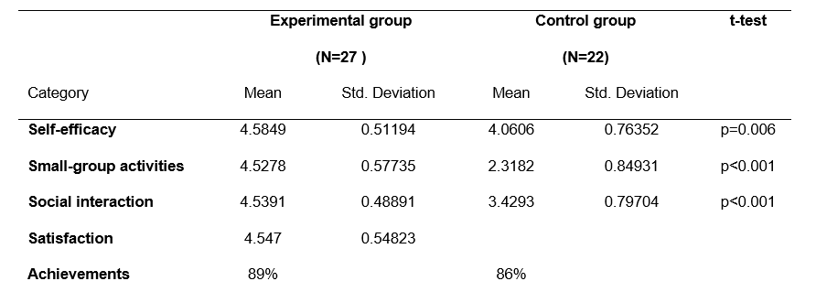

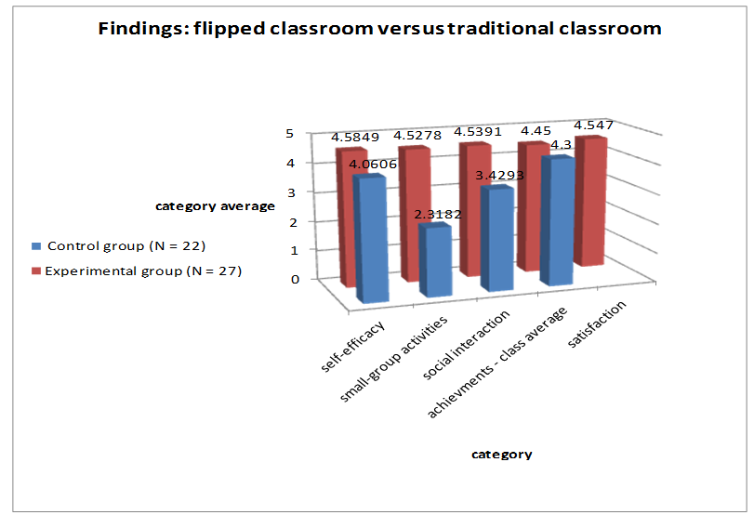

Figure 3. Findings: FC versus TC

The students’ overall satisfaction with the FC was high, as calculated from the results of the questionnaire: 4.547/5. The written feedback was read, coded, and categorized into five categories: category 1 (Table 2) contains general advantages of the FC, while categories 2-5 contain advantages and disadvantages of both the distance learning (watching online video lectures) and face-to-face (small-group activities) components (Table 3). The written feedback also included recommendations and suggestions by the students such as: a forum for discussion is definitely required, and this approach needs to be implemented for other subjects.

Table 2. Category 1

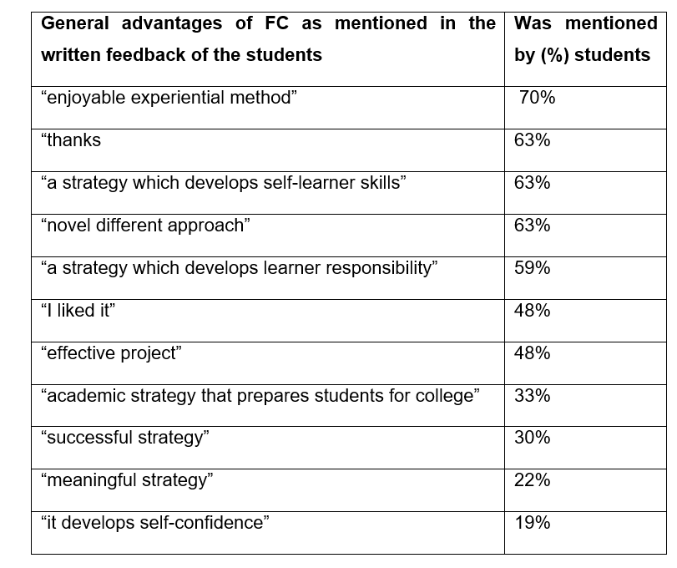

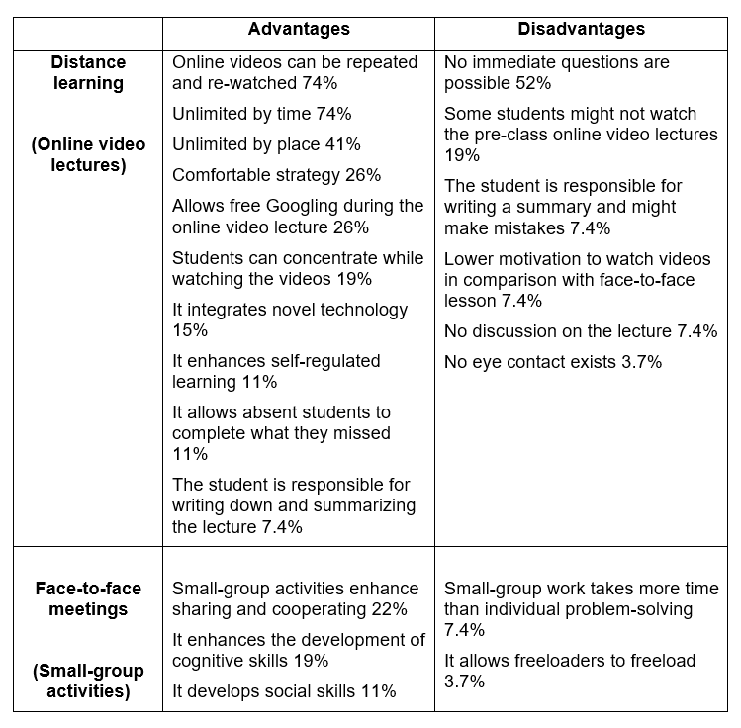Table 3. Categories 2-5

Correlations were tested using the Pearson correlation (Table 4): a medium-strong positive correlation was found between the integration of small-group activities and social interaction (*r*=0.669, *p*<0.01); a strong positive correlation was found between self-efficacy and social interaction (*r*=0.706, *p*<0.01); and a medium positive correlation was found between self-efficacy and satisfaction (*r*=0.367, *p*>0.05).

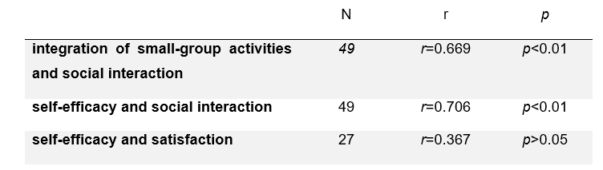Table 4. Correlations

# Discussion

Similarly to previous studies, the current findings showed that the FC had a positive impact. In comparison with the TC, the FC resulted in: (i) an increase in in-class group activities (Bergmann & Sams, 2012); (ii) an increase in in-class social interaction (Chen, 2016); and (iii) higher student achievement (Thai et al., 2017; Peterson, 2016). Some of the differences in comparison with the TC were significant. Furthermore, it was found that the students’ overall satisfaction with the FC was high, as referred to in the research literature (Stockwell et al., 2015). Consequently, we highly recommend integrating the flipped approach into high-school education in general, and into high-school science education in particular.

Positive correlations were found between different variables. A positive correlation was found between integrating small-group activities and social interaction, as referred to by Vygotsky (1978). Further positive correlations were noted between self-efficacy and overall student satisfaction, as referred to by Chou (2017), and between self-efficacy and social interaction, as found by Shea and Bidjerano (2010).

Most of the advantages and disadvantages mentioned in the students’ feedback were also mentioned by Bergmann and Sams (2012) and Herreid and Schiller (2013), and it seems that some of the disadvantages are unavoidable.

There were several limitations in the research: the number of participants was small; there was no pre-questionnaire for the participant groups; the students’ satisfaction with the TC was not checked; and the different groups were taught by different teachers.

# Recommendations

The findings of this study provide effective advice and suggestions to educators incorporating such an instructional method into their teaching, and offer researchers insights into the value of this instructional model. We highly recommend using discussion forums for distance learning, as was recommended by the students, a short quiz after each online video lecture, and an LMS for supervision. Future research could investigate the impact of the FC on self-efficacy beliefs.

# References

Bergmann, J., & Sams, A. (2012). *Flip your classroom: Reach every student in every class every day*. Virginia: ISTE.

‏Bishop, J. L., & Verleger, M. A. (2013, June). The flipped classroom: A survey of the research. In ASEE National Conference Proceedings, Atlanta, GA (Vol. 30, No. 9, pp. 1-18).

Bloom, B. S. (1956). Taxonomy of educational objectives. Vol. 1: Cognitive domain.  *New York: McKay*, 20-24.‏

Chen, L. L. (2016). Impacts of flipped classroom in high school health education.  *Journal of Educational Technology Systems, 44*(4), 411-420.‏

Chou, L. Y. (2017, July). The Effect of Flipped Classroom on Self-efficacy and Satisfaction of Computer Auditing. In International Conference on Innovative Mobile and Internet Services in Ubiquitous Computing (pp. 841-845). Springer, Cham.‏

Clark, K. R. (2015). The effects of the flipped model of instruction on student engagement and performance in the secondary mathematics classroom. *Journal of Educators Online, 12*(1), 91-115.‏

‏Gilboy, M. B., Heinerichs, S., & Pazzaglia, G. (2015). Enhancing student engagement using the flipped classroom. *Journal of nutrition education and behavior, 47*(1), 109-114.‏

Gundlach, E., Richards, K. A. R., Nelson, D., & Levesque-Bristol, C. (2015). A comparison of student attitudes, statistical reasoning, performance, and perceptions for web-augmented traditional, fully online, and flipped sections of a statistical literacy class. *Journal of Statistics Education, 23*(1), 1-33.‏

Herreid, C. F., & Schiller, N. A. (2013). Case studies and the flipped classroom*. Journal of College Science Teaching, 42*(5), 62-66.

Koehler, M., & Mishra, P. (2009). What is technological pedagogical content knowledge (TPACK)?. *Contemporary issues in technology and teacher education*, *9*(1), 60-70.‏

Lo, C. K., & Hew, K. F. (2017). A critical review of flipped classroom challenges in K-12 education: possible solutions and recommendations for future research. *Research and Practice in Technology Enhanced Learning, 12*(1), 4

Peterson, D. J. (2016). The flipped classroom improves student achievement and course satisfaction in a statistics course: A quasi-experimental study. *Teaching of Psychology, 43*(1), 10-15.‏

Shea, P., & Bidjerano, T. (2010). Learning presence: Towards a theory of self-efficacy, self-regulation, and the development of a communities of inquiry in online and blended learning environments. *Computers & Education, 55*(4), 1721-1731.

Sletten, S. R. (2017). Investigating Flipped Learning: Student Self-Regulated Learning, Perceptions, and Achievement in an Introductory Biology Course. *Journal of Science Education and Technology, 26*(3), 347-358.‏

Stockwell, B. R., Stockwell, M. S., Cennamo, M., & Jiang, E. (2015). Blended learning improves science education. *Cell, 162*(5), 933-936.‏

Thai, N. T. T., De Wever, B., & Valcke, M. (2017). The impact of a flipped classroom design on learning performance in higher education: Looking for the best “blend” of lectures and guiding questions with feedback. *Computers & Education, 107*, 113-126.‏

Vygotsky, L. (1978). Interaction between learning and development. *Readings on the development of children, 23*(3), 34-41.‏