**Highlights**

* Venture Capital funds and technological incubators act as substitute investors in Israel
* Compared to technological incubators in Israel, Venture Capital funds are more prone to be affected by financial crises
* Startups that are incubated during financial crises show poor performance compared to startups incubated during other times
* During financial crises, Israeli entrepreneurs choose to delay new venture operations over approaching technological incubators as alternative investors
* Israel's technological incubator program is missing its public policy objective during financial crises by financing higher than desired risk

**Abstract**

During financial crises, investors find difficulties in raising investment funds, especially from Venture Capital funds (VCs) which are more prone to economic changes in the private sector compared to governmental programs such as the Israeli Technological Incubator Program. Incubators and VCs in Israel are substitute financing tools for certain startups since each is a relevant investor for early stage companies. The goal of this research is to determine whether the negative effect of economic crises on the ability of VCs to invest in startups is affecting the incubator program's performance as a substitute financing tool.

The research question was examined on startups incubated in Israel between 1998 and 2011 (n=1096), and by comparing the performance of incubator graduates incubated during financial crises to the performance of graduates incubated during other times.

The researchers suggest an explanation: startups that fail to raise VC investments during financial crises place the blame on the economy, even though some of them would have failed to obtain those investments in a different economic environment as well, due to their high risk level. These startups prefer to postpone business launch until the economic environment stabilizes instead of approaching incubators as alternative investors. Other self-aware high-risk startups, which would normally be rejected by incubators due to their high risk level, are the only ones to approach incubators; due to low incubation competition, these are then incubated.

**Keywords**

entrepreneurship, financial crisis, venture capital, technological incubators, innovation finance, Israel

**Introduction**

In times of financial crisis, investors find it difficult to raise money for investment in startup companies, as they are largely dependent upon the institutional market, which tends to become more conservative and often to even freeze up during such times; this could be a response to a recession or to economic changes that appear with it ~~(for example revenue loss**, the ability to issue stocks and bonds, revenue**, liquidity, and even expectation, in particular on the part of investors, of precautionary measures)~~ (Block and Sandner 2009). Consequently, startups encountering difficulty raising investment must decide whether to delay the start of their entrepreneurial activity or to seek alternative sources of financing. Widening the search for financing sources may involve approaching investors they would not have considered had there not been a crisis, including technological incubators; these are perceived as a financing source inferior to venture capital funds due to R&D Law limitations (which imposes restrictions in exporting know-how and on the sale of the business), the limited budget size obtainable from incubators, the bureaucratic process necessary for obtaining investments from incubators, as well as added value[1] ('smart money') not typically obtainable from incubators.

The hypothesis drawn from this is that during times of crisis in the VC industry, technological incubators benefit from a growth in deal flow, and thus have the opportunity to invest in startups of a lower risk level than in non-crisis times.

The technological incubator program acts as a rational investor, aiming for maximum return on investment. Thus, the expectation would be that just like any other rational investor, incubators would also tend to take advantage of crisis times in order to invest in lower-risk startups. In other words, we hypothesize that at times of crisis, promising companies (those with lower risk and/or expectation of higher return at the same risk level), which would not have approached incubators were it not for the crisis in the VC market, would push aside the less promising companies, which could have successfully raised fund from incubators in the past (that is, not in times of crisis).

This study will examine whether technological incubators invested in lower-risk ventures during periods of crisis in the VC industry compared to other periods. It will be studied by examining the success of companies that have graduated from the incubator program in relation to the economic environment at the time they entered the technological incubator program.

The objective of the study is to provide insight into changes that may be necessary in investment policy of the technological incubator program for a changing economic environment. The results of the study may then be used as a basis for defining operational strategies for the technological incubator program in times of VC sector crisis; these could then resolve market failure during crisis periods as well -- perhaps even primarily so. Policy conclusions will help answer the question of whether during crisis times the effectiveness of the incubator program as a tool to solving market failure in entrepreneurship is preserved, and will also help examine whether it is necessary to increase the number of deals in the technological incubator program (and, correspondingly, the program budget), in order to maintain the same risk level. (as in non-crises times)

**Literature Survey**

1. Market failure in innovation financing and government support as a solution

A naturally functioning economy gives rise to insufficient investment in R&D, especially its later stages, compared to the level desirable for social benefit[2]. The desired level of R&D investment -- the kind that will lead to growth and boost the economy through technological innovation -- could not be maintained without government support, because of market failure caused by various uncertainty factors[3]; first and foremost of these is the fact that knowledge is, in its very essence, a public good (Stiglitz 1999). Free market principles, too, dictate that clear evidence of the lack of proportionate investment in R&D justifies government intervention in the private market (Martin and Scott 2000).

Hausman and Johnston (2014) address the link between government and entrepreneurial processes; in particular, government activity has a substantial effect on economic opportunities and establishment of conditions ripe for growth in entrepreneurship. They indicate that technological startups as well as small and mid-size tech companies (startups that have grown) are among the central contributors to economic growth, with the Israeli high tech industry particularly so. These companies make a significant contribution to the economy and play a central role in the innovation process and the effect of its outcome.

This is visible in Israel as well, where government policy in the years 1960 through 1990 was a significant component in development and stimulation of the local high tech industry. Broad and systematic public support for innovation was a critical component in a process that essentially triggered construction of scientific-technological infrastructure and protection for intellectual property (Frenkel et al. 2005; Roper 1999; Pugatch et al. 2010; Avnimelech and Teubal 2004).

1. Technological incubators and venture capital funds in Israel as substitute investors

VC funds are active in Israel primarily in early stage financing and are less active at more advanced stages (Mayer et al. 2005). According to Frenkel et al. (2005), the technological incubator program in Israel, too, is active at the early stage, providing a solution to market failure in financing of R&D and innovation. The MoneyTree report by Kesselman & Kesselman (PwC) which summarized VC activity in Israel quarterly, points to an overlap in investment policy: between 2010 and 2014 VC funds in Israel carried out an average of 7% of their total investments in seed stage financing and about 42% in early stage financing. We thus establish that funds and incubators in Israel invest in identical stages -- or at least very similar ones -- in the life of startups, and in effect represent substitute financing tools.

Crisis environments boost the relationship among substitute financing tools: McCahery and Vermeulen (2010) point out that in times of financial crisis, VC funds tend to decrease new investments, and suggest to startups that they look for other sources of investment, such as Corporate Venture Capital (CVC). Block et al. (2010) also propose that ventures looking for investment during crisis explore alternative investment channels.

1. The effect of economic crises on the VC industry, on government support programs and on the ability of startups to raise investment

Gompers and Lerner (1998) explain that there exists a relationship between exogenous macroeconomic variables and the VC market's ability to raise capital for investment; alternative return on investment (other market opportunities) and the degree of economic health affect investors' commitments to invest in VC funds[4]. Lerner (2011) states that risk-averse investors were hesitant to make new financial commitments in the period adjacent to the 2008 crisis. The effect of crises on innovation financing is marked (a record drop of 4.5% in business expenditure on R&D in OECD nations in 2009 [with the exception of Korea and France]), in particular in VC fund activity (a 42% drop in activity of US VC funds and a 19% drop in VC funds outside the US after the 2000 and 2008 crisis), in addition to the drop in syndicated investment[5] of funds (Block et al. 2010).

On the other hand, according to the OECD report Innovation in the Crisis and Beyond (OECD 2012), government support programs were barely affected by the 2008 crisis. The US and EU nations actually increased their budgets targeted to innovation and entrepreneurship during crisis periods. This was the case in Israel as well; following the crisis of 2000 and the decline in the sector investing in startups, a government seed fund was established in 2002, with the objective of assisting startups in raising financing for seed stage and early stage activity. This is an expression of a renewed need for continued government involvement in the area, and a justification for continuing the incubator program's public activity (Frenkel et al. 2005).

Evidence has shown that crisis has a detrimental effect on raising investment: The OECD Science, Technology and Industry Outlook (OECD 2012) claims that raising investment for new ventures (startups) was nearly impossible after the 2008 crisis; US internet-related startups in advanced stages of fundraising (e.g. Round B) obtained 80% of the investment they could have gotten in the period preceding the crisis, while the volume of investment in new and young companies was unaffected (Block and Sander 2009); between 2009 and 2010 there was a dramatic drop in Israel of 24% in raising follow-up investment by companies that had graduated from the incubator program, according to the meeting protocol of the Knesset Subcommittee for the Advancement of Science Intensive Industries (Knesset 2011).

1. Economic crisis trends in the VC industry

The slumps of the global VC industry are visible in the figure below: in 2002-2004 as a result of the crisis of 2000, and in 2009-2010 from the 2008 crisis.

Figure 1: Worldwide venture capital investments: number of deals and total value (in $M) -- a multi-year comparison

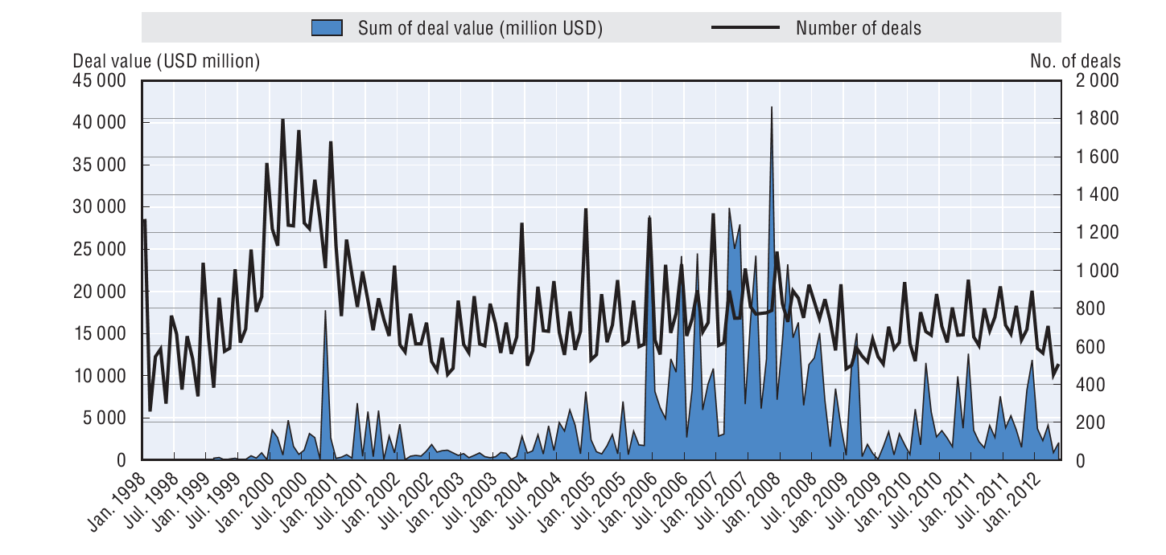Source: Innovation in the Crisis and Beyond (OECD 2012)

2008 crisis

2000 crisis

The MoneyTree report[6] allows a close look at the effect of the crisis in Israel; note that there is a decline in the number of companies in which Israeli VC invested and in total investment, in the years that follow the financial crisis. Figures 5 and 6 show that manifestations of the VC industry financial crisis appear immediately at the tail of the global crisis -- in 2002-2004, and in 2009-2010.

Figure 2: Annual investment by VC funds in Israel (in $M): a multi-year comparison[7]

2008 crisis

2000 crisis

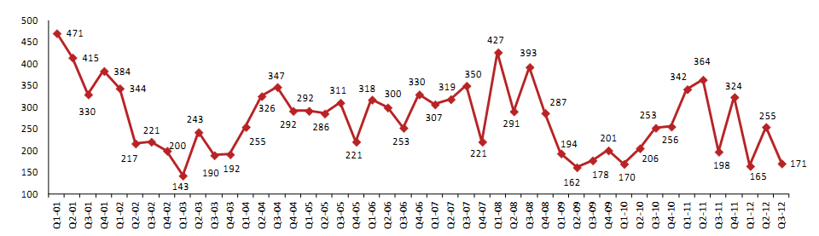Source: MoneyTree Q3 2012 Report (PwC)

Figure 3: Average investment per company (in $M) by VC funds in Israel: a multi-year comparison[8]

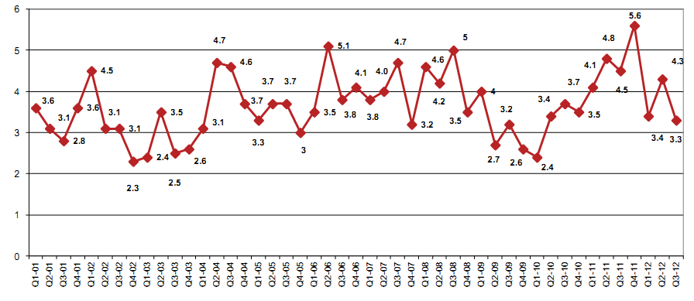Source: MoneyTree Q3 2012 Report (PwC)

2008 crisis

2000 crisis

1. Fiscal expansion as a means of coping with economic crises and transforming them to growth opportunities

Governments and companies investing in innovation during times of crisis increase their competitive advantage and strengthen their position as market leaders; they are then the first to enjoy crisis recovery (Hausman and Johnston 2014). They claim that the known positive correlation between financial stability and continuity of innovation is one of the reasons that innovation is preferred by many as a means of recovery from financial crisis.

An example of this is the way Finland and South Korea successfully handled the crisis of 2000, from which they recovered due to their increase in public support of R&D and innovation. More recent examples include the activity of OECD nations in 2009, in which they explicitly and directly provided incentive and stimulation of R&D and innovation to small and mid-sized businesses, as a step in grappling with the 2008 crisis (Guellec and Wunsch-Vincent 2009); changes in research and innovation budgets in the US, Japan, China, Holland, Finland and Germany after the 2008 crisis (Pagels-Fick 2009); changes in government budget appropriations or outlays for R&D and innovation (GBAORD[9]) in OECD nations (OECD 2012); and innovation-support readiness steps taken by OECD governments to grapple with the effects of crisis on science, technology and innovation (STI): in the years 2008 through 2011 in which effects of the crisis were greatest, GBAORD budgets rose sharply in 2009 and temporarily in most OECD nations by an average of about 9%[10]. Only in 5 nations[11] did budgets remain virtually constant, including in Israel, with a negligible increase of 0.9% in GBOARD budget in 2009, and no change in 2010[12].

In budgeting the incubator program, Israel did not exercise fiscal expansion as a step to grapple with the crisis: other than a slight rise of 1.6% in 2008, real program budgeting dropped significantly[13] during the years the economy was affected by crisis[14] (OCS 2013). The figure below presents the percent of real budget change in the years the economy was affected by crisis, and it shows that fiscal expansion is not in the budgetary plan for either the 2000 or the 2008 crisis.

Figure 4: Technological incubator program budget, permission to commit (in millions of NIS): a multi-year comparison

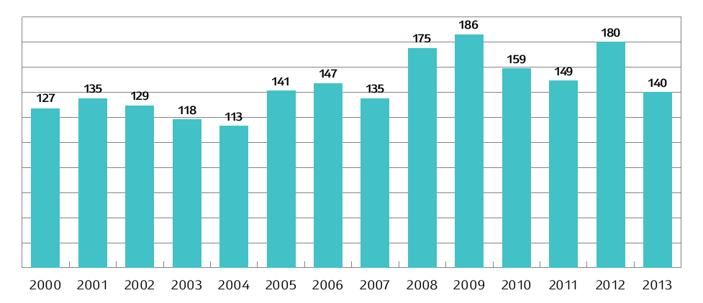

2008 crisis

2000 crisis

**-5.5% -13% -5% +1.6% -17.2%**

Source: Office of the Chief Scientist Program Guide for 2013 (OCS 2013)

1. Research question

When VC fund investment ability diminishes and entrepreneurial ventures have difficulty finding investors, it is advisable to turn to alternative investors (Block et al. 2010, McCahery and Vermeulen 2010). In times of VC industry crisis, it would thus be expected that the supply of entrepreneurial ventures applying to the incubator program would rise and would naturally comprise higher quality candidates, which would not have turned to the technological incubator program if not for the crisis-causing drop in VC investments. Hence, incubator program deal flow would be expected to increase in times of crisis, and thus to include relatively more promising companies.

On the other hand, and based on earlier research of Block et al. (2009), it is possible that the reverse may be true, whereby entrepreneurs would tend to wait for market recovery in times of crisis. This would bring about the opposite effect; a drop in the number of applications to incubators in times of crisis could bring to the incubation of companies of below-average quality in the technological incubator program.

One way or another, a crisis environment is likely to lead to a situation whereby the incubator program misses its original mark: stimulating high-risk companies -- in particular due to the fact that spurring innovation and investing in R&D are tools for coping with economic crisis. This study will examine whether in times of VC crisis, there was a change in technological incubator investment patterns in their support of lower-risk ventures (on the assumption that they behave like rational investors[15]) compared to other periods, or conversely.

The research topic will be explored by examining the success of companies graduated from the incubator program in relation to the economic environment at their time of operation. Examining the relationship between economic environment and success of technological incubator program graduates will provide insight into adapting technological incubator program investment policy to a changing economic environment. We seek to lay the groundwork for a discussion on the question of whether mechanisms of support and/or aid to technological ventures should adapt themselves to versatile market conditions in order to achieve their objectives. The discussion on the outcome of the study will address the need for changing operational strategies for the technological incubator program in times of VC sector crisis; these could then resolve market failure also during crisis periods -- and perhaps primarily so.

The researchers assume that during economic crisis periods, technological incubators accept lower-risk companies into their program in comparison with those accepted in other times -- companies that exhibit higher performance (lifespan, employees, revenue, capital raising, market value, financing rounds, life cycle stage, exit progress) than in other periods, on the assumption that better performance indicates a more promising company.

The research hypotheses therefore assume that 'graduated companies' that had been accepted into incubators during VC crisis periods, compared with 'graduated companies' of other periods, would present better business performance expressed in average lifespan (H1), employees (H2), revenues (H3), follow-up capital raising (H4), market value (H5), financing rounds (H6), life cycle stage (H7) and number of exits (H8).

**Methodology**

The study will make use of the database of the Technological Incubator Administration, a government entity that manages and supervises technological incubator activity in Israel. We will supplement the database with up-to-date data on incubator graduates (years of activity, employees, volume of investment, financing rounds, company life cycle stage, type of exit) from the database of Israel Venture Capital (IVC) Research Center[16], which monitors and analyzes the high tech industry in Israel.

All companies active in the technological incubator program in Israel between 1998 and 2011 were sampled in the study (N=1096). Only those that were still active in 2014 (N=452) were selected in order to remove confounder variables not examined as part of this study. The study compares performance of companies that began activity in years of economic crisis, during which VC fund investment activity was cut back in Israel ("the 2000 crisis" between 2002 and 2004, and the "2008 crisis" between 2009 and 2010 -- as presented by the MoneyTree report in Figures 2 and 3), to companies accepted to the incubator program in other periods.

Performance of incubator graduated companies are measured in lifespan, follow-up capital raising (volume and number of rounds), activity expansion (stage advancement, hiring, revenue generation), exits (mergers, acquisitions, sale of intellectual property and/or IPO), sales revenue and market value.

A regression model will be used to perform statistical tests and predictions.

**Findings**

Table 3 below presents the distribution of the sample of incubator companies by year, where crisis years are indicated in bold. Note that 59 companies (about 5%) were disqualified from the sample because we were unable to obtaining crucial data.

Table 3: Descriptive statistics for incubated companies in the data sample

|  |  |  |  |  |  |  |  |  |  |  |
| --- | --- | --- | --- | --- | --- | --- | --- | --- | --- | --- |
| **Year** | **Number of incubated companies** |  | **Companies disqualified from sample** | |  | **Inactive companies** | |  | **Active companies** | |
|  | **Quantity** | **%** |  | **Quantity** | **%** |  | **Quantity** | **%** |
| 1998 | 84 |  | 8 | 9.5% |  | 70 | 83.3% |  | 6 | 7.1% |
| 1999 | 115 |  | 13 | 11.3% |  | 83 | 72.2% |  | 19 | 16.5% |
| 2000 | 79 |  | 9 | 11.4% |  | 55 | 69.6% |  | 15 | 19.0% |
| 2001 | 75 |  | 1 | 1.3% |  | 54 | 72.0% |  | 20 | 26.7% |
| **2002** | **92** |  | **6** | **6.5%** |  | **61** | **66.3%** |  | **25** | **27.2%** |
| **2003** | **75** |  | **1** | **1.3%** |  | **46** | **61.3%** |  | **28** | **37.3%** |
| **2004** | **87** |  | **0** | **0.0%** |  | **50** | **57.5%** |  | **37** | **42.5%** |
| 2005 | 46 |  | 3 | 6.5% |  | 27 | 58.7% |  | 16 | 34.8% |
| 2006 | 72 |  | 3 | 4.2% |  | 32 | 44.4% |  | 37 | 51.4% |
| 2007 | 69 |  | 1 | 1.4% |  | 32 | 46.4% |  | 36 | 52.2% |
| 2008 | 78 |  | 0 | 0.0% |  | 33 | 42.3% |  | 45 | 57.7% |
| **2009** | **78** |  | **3** | **3.8%** |  | **22** | **28.2%** |  | **53** | **67.9%** |
| **2010** | **86** |  | **1** | **1.2%** |  | **17** | **19.8%** |  | **68** | **79.1%** |
| 2011 | 60 |  | 5 | 8.3% |  | 8 | 13.3% |  | 47 | 78.3% |
|  |  |  |  |  |  |  |  |  |  |  |
| Total | 1096 |  | 54 | 4.9% |  | 590 | 53.8% |  | 452 | 41.2% |

Table 4: Descriptive statistical analysis for incubated companies in the data sample

|  |  |  |  |  |  |  |
| --- | --- | --- | --- | --- | --- | --- |
| **Variable** | **Quantity (N)** | **% companies that did not develop beyond the incubator[17]** | **Total** | **Average** | **SD** | **Range** |
| Lifespan (years) | 1042 | 16% | N/A | 5.69 | 3.46 | 2-16 |
| Life cycle stage[18] | 1038 | 25% | N/A | 0.98 (R&D) | 0.7  (as a single stage) | N/A |
| Employees (job positions) | 1006 | N/A | 7,994 | 7.95 | 13.99 | 1-300 |
| Capital raised ($M) | 1042 | 50% | 2,350 | 2.26 | 8.314 | 0-132 |
| Financing rounds[19] | 1042 | 57% | N/A | 2.03  (extended seed) | 1.522  (1.5 rounds) | N/A |
| revenue ($M) | 41 | N/A | 304 | 7.41 | 16.607 | 0-100 |
| EBITDA profit ($M) | 1 | N/A | N/A | N/A | N/A | N/A |
| market value ($M) | 125 | N/A | 3,800 | 30.4 | 77.042 | 0-606 |
| Exits[20] | 80 | N/A | N/A | 1.39 (A&M) | 0.755 | N/A |
| raised in IPO ($M) | 10 | N/A | 248 | 24.79 | 20.753 | 2-64 |

A descriptive analysis of the sample data in Table 4 above shows a number of interesting facts about the activity of the companies in the sample.

* The average lifespan of incubator companies is about 5.7 years with a relatively high standard deviation of about 3.5 years.
* The average stage in incubator company life cycle is the R&D stage. Standard deviation is about a single stage.
* Incubator companies in the period studied are responsible for 7,994 jobs in the market, where each company creates an average of nearly 8 jobs in its lifespan. The standard deviation here is large -- about 14 jobs. The largest company as far as jobs are concerned employed 300 people.
* Incubator companies in the period studied raised $2.35 million, where the average was $2.26 million with a relatively high standard deviation of about $8.3 million. The largest financing was $132 million for a single company.
* On the average, incubator companies reach the second financing stage -- the extended seed stage. This data item has a standard deviation of about 1.5 financing rounds.
* The limited data available on revenue of incubator companies in the sample -- only 41 observations -- shows that the total revenue of these companies was $304 million, while average revenue per company was $7.4 million with a large standard deviation of about $16.6 million. The highest revenue was $100 million.
* The limited data available on market value of incubator companies in the sample -- 125 observations only -- shows that their value was $3.8 billion, while the average value of a company at $30.4 million with a standard deviation of about $77 million. The highest market value was $606 million.
* The 10 observations of capital raised by IPO shows a total of $248 million raised by IPO, with the largest IPO being $64 million, and the smallest -- $2 million. The average IPO raised about $24.8 million with a large standard deviation of $20.7 million.

Additional data from the sample:

* A large majority of the 80 companies that carried out an exit did so by merger and/or acquisition (77.5%, which are 62 cases). Only 16.2% (13 companies) performed IPOs, while 6.2% (5 companies) sold their intellectual property.
* As far as geographic distribution of activity of the incubator company sample, we observe that most companies operated in northern Israel (516 companies) compared to a lower volume of activity, but almost uniform, of companies in other regions (189 in the central region, 197 in the south, and 194 in the Jerusalem region).
* In the distribution of companies by sector shown in Figure 5 below, we see the largest number of companies operating in medical devices followed closely by companies in computing, software and communications.

Figure 5: Sample company sectors

Hypothesis H1 examining graduated company survival is the only one tested on the entire sample (N=1096); the remainder of the hypotheses were tested on the sample of companies active in 2014 (N=452), as we could not determine the reason they shut down earlier and the degree to which it was related to other measures of success that we examined. Below is the summary of statistical test results for the research hypotheses (hypotheses 1-5 in T-tests for independent variables; hypotheses 6-8 in Mann-Whitney tests):

Table 5: T-test comparing graduated incubator companies accepted during crisis period with those accepted during non-crisis period

|  |  |  |  |
| --- | --- | --- | --- |
| **Assumption** | **Test significance** | **Test value** | **Significance of the finding (for companies incubated in a crisis year, compared to other companies)** |
| H1a | p=.010 | t=2.563 | on the average about one year less |
| H1b | p=.000 | t=4.496 |
| H2 | p=.009 | t=2.633 | employed an average of about 4.1 fewer workers |
| 3H | p=.032[21] | t=26.872 | average sales revenue lower by about 8.7 million NIS |
| 4H | p=.024 | t=449.708 | raised investments lower by about 2.23 million NIS on the average |
| 5H | N/A | N/A | no significant correlation found between acceptance to technological incubator during crisis years and company market value |
| 6H | p=.002 | U=20,089 | reached lower investment stages |
| 7H | p=.072[22] | U=22,054.5 | reached lower company life cycle stage |
| 8H | N/A | N/A | no significant correlation was found between acceptance to technological incubator during crisis years and the fact that a company carried out an exit |

In addition to these findings, the data indicates that the performance of high tech companies[23] was more severely affected than low-tech companies: high tech companies were active for a shorter period (t=5.236, p=.000), employed fewer workers (p=.007, t=2.700), reached lower sales revenues (p=.05940, t=2.011), raised less investment capital (p=.014, t=2.477), had lower market value (p=.077[24], t=1.800), participated in fewer financing rounds (p=.001, U=11,921.5), and reached lower life cycle stages (p=.015, U=13,105.5), than companies incubated in other periods.

The findings indicate that in times of crisis, companies incubated are of higher risk than the average company typically accepted into the incubator program. In order to establish this assumption, we examined whether companies accepted into the incubator program immediately at the end of the crisis period show better performance than other companies. We explored whether companies entering the program in 2004-2005 -- the years of recovery immediately following the 2000 crisis -- showed performance different from those entering the incubator program in other periods.

1. A T-test of the independent variables shows a statistically significant relationship between being accepted into a technological incubator during the period of recovery from the 2000 crisis with company lifespan (p=.000, t=-3.588), and with investment capital raised (p=.029, t=-2.208): the **lifespan of these companies was longer by an average of 1.5 years and they raised about $2 million more in investment capital** than the others.
2. A Mann-Whitney U-test of the independent variables shows a statistically significant relationship between being accepted into a technological incubator during the recovery period from the 2000 crisis with life cycle stage (p=.001, U=49,132), with the investment stage the company completed (p=.007, U=51,495), and with exits (p=.013, U=55,632) -- in all of these parameters **these companies exhibited better performance** than the other companies.

Regression model

Table 5 presents the correlations among the collected variables --

Table 5: Results of Spearman and Pearson tests for correlation of variables in the study

|  |  |  |  |  |  |  |  |  |  |  |
| --- | --- | --- | --- | --- | --- | --- | --- | --- | --- | --- |
| **dependent variables** | **Years of activity** | **Life cycle stage** | **Employees** | **Capital raised** | **Financing rounds** | **Profit** | **EBITDA** | **Market value** | **Exit (binary)** | **IPO** |
| Years of activity | 1 | .558** | .292** | .301** | .495** | .254* | - | .316** | .389** | .452 |
| Life cycle stage | .558** | 1 | .422** | .466** | .472** | .534** | - | .476** | .225** | -.067 |
| Employees | .292** | .422** | 1 | .466** | .534** | .542** | - | .650** | .452** | .742** |
| Capital raised | .301** | .466** | .466** | 1 | .894** | .601** | - | .818** | .707** | **.984 |
| Financing rounds | .495** | .472** | .534** | .902** | 1 | .462** | - | .658** | .505** | - |
| Profit | .254* | .534** | .542** | .601** | .462** | 1 | - | .873** | .655 | **1.0 |
| EBITDA | - | - | - | - | - | - | 1 | - | - | - |
| Market value | .316** | .476** | .650** | .818** | .658** | .873** | - | 1 | .858 | **.844 |
| Exit (binary) | .389** | .225** | .452** | .707** | .505** | .655 | - | .858 | 1 | - |
| IPO | .452 | -.067 | **.742 | **.984 | - | **1.0 | - | **.844 | - | 1 |

*p<0.10, **p<0.05

Significant relationships were among between certain variables.

* **IPO** to profit, employees, volume raised and market value -- strong relationship
* **Market value** to volume of capital raised and profit -- strong relationship; to financing rounds and employees -- medium-strong relationship
* **Volume raised** to profit and exit -- medium-strong relationship

In order to avoid multicollinearity, the variables 'IPO' and 'market value' are not included in the construction of the regression model. In addition, the variable 'profit' is not included in the model because it has only 41 observations.

Regression model variables:

* Dependent variable: Y(X) - 'activity of incubated company' (in years)
* Independent variables: R -- 'financing stage'; S -- 'stage in company life cycle'; T-- 'years before outbreak of economic crisis'
* The model neutralizes the effect of raising capital by the company and its advancement in the company's life cycle by controlling these as independent variables in the model.

First a regression model was run (Column 1 in Table 6) comparing companies that began their activity in times that are not characteristic of crisis, between 2005 and 2006, to those which began their activity in the second crisis period, between 2009 and 2010 (N=272). The model and regression variables were found significant, and the regression equation explains 37% of the variance. We thus find that the number of years of activity of incubated companies is positively explained by the financing stage and the life cycle stage of the company, and negatively explained by years before outbreak of economic crisis (variable values are negative in this case because the crisis is in the future, so that companies founded before crisis outbreak are expected to survive for a longer period).

Second, and in order to verify that the above does not stem from the fact that the companies were founded later but rather from the crisis itself, we compared (Column 2 in Table 6) those companies that began their activity during the crisis between 2005 and 2006, and those that began their activity during the first crisis, between 2002 and 2004 (N=359). The model and regression variables were found significant and the regression equation explains 44% of the variance. Here, too, years of activity of incubated company is positively explained by investment stage and life cycle stage, and negatively explained by years before outbreak of economic crisis (variable values are positive in this case because the crisis was in the past, so that companies founded after the crisis are expected to survive for a longer period). In this case too, although the companies that were established between 2002 and 2004 were theoretically supposed to last at least a year longer as they were founded later, in practice they survived less than companies established after them, between 2005 and 2006.

We also ran the opposite regression model with the following regression variables:

* Dependent variable: Y(X) -- 'financing stage'
* Independent variables: ~~R variables~~ L -- 'activity of incubated company' (years); E -- 'employees'; T -- 'years before outbreak of economic crisis'; S -- 'stage in company life cycle'.

This model was found significant when comparing among companies that began their activity in times not characterized by crisis, between 2005 and 2006, with those that began their activity during the second crisis, between 2009 and 2010 (N=272) -- Column 3. This was also the case when comparing those same companies (that began their activity in non-crisis times, 2005-2006) with those that began their activity during the first crisis, between 2002 and 2004 (N=359) -- Column 4.

Finally, we also ran the opposite model with the following regression model variables:

* Dependent variable: Y(X) -- 'stage in company life cycle'
* Independent variables~~: R variables~~ L -- 'activity of incubated company' (years); E -- 'employees'; T -- 'years before outbreak of economic crisis'; R -- 'financing stage' ~~(R)~~

This model was also found significant when comparing companies that began their activity during times not characterized by crisis, between 2005 and 2006, with those that began their activity during the second crisis, between 2009 and 2010 (N=272) -- Column 5. This was also the case when comparing those same companies (those that began their activity in times not characterized by crisis, between 2005 and 2006) with those that began their activity during the first crisis, between 2002 and 2004 (N=359) -- Column 6.

From statistically significant models 3 through 6 we understand that even when predicting success parameters other than lifespan, there exists a confounder variable that causes companies established during crisis period to survive for less. Our conclusion is that the confounder variable is the economic crisis, and it is powerful enough to explain the fact that companies that were established during the crisis survive less than others -- both ones established before crisis, and ones established after crisis.

|  |  |  |  |  |  |  |
| --- | --- | --- | --- | --- | --- | --- |
| **Financing round** | | **Life cycle stage** | | **Lifespan** | | **Dep. var.** |
| **6** | **5** | **4** | **3** | **2** | **1** | **Model** |
|  |  | 0.62***  (0.21) | 0.093**  (0.28) | 0.645***  (0.086) | 0.44***  (0.23) | Financing round |
| 0.405***  (0.134) | 0.415**  (0.192) |  |  | 1.949***  (0.219) | 1.142***  (0.083) | Life cycle stage |
| 0.155***  (0.051) | -0.063*  (0.038) | 0.037***  (0.02) | 0.041*  (0.18) | -0.455***  (0.091) | -0.188**  (0.055) | Time to turndown |
| 0.193***  (0.027) | 0.196***  (0.039) | 0.089***  (0.01) | 0.115***  (0.018) |  |  | Lifespan |
| 0.04***  (0.006) | 0.032***  (0.006) | 0.012***  (0.002) | 0.012***  (0.003) |  |  | Employees |
| 0.178  (0.178) | 0.315  (0.192) | 0.264***  (0.069) | 0.281**  (0.09) | 3.227***  (0.272) | 2.704***  (0.23) | Constant |
| 0.43 | 0.38 | 0.42 | 0.36 | 0.44 | 0.37 | R² |
| 359 | 272 | 359 | 272 | 359 | 272 | Observations |

Table 6: Linear regression models

Standard errors in parentheses

*p<0.10, **p<0.05, ***p<0.01

**Conclusions and discussion**

This study sought to resolve the issue of the effect of economic crises on early stage companies in Israel. Two different hypotheses existed for the issue under examination, based on studies that focused on the effect of the 2008 economic crisis on financing entrepreneurial ventures. The first, a study by Block and Sandner (2009) found that entrepreneurs in times of crisis will delay new business launch and will engage in looking for alternative sources of employment until the financial arena stabilizes. Another study of Block's also supported by McCahery and Vermeulen, on the other hand, recommended to entrepreneurs seeking investment in times of crisis to explore alternative investments channels (Block et al. 2010, McCahery and Vermeulen 2010). The current study hypothesized that the latter would be the case: that Israeli entrepreneurs in crisis times will approach technological incubators as an alternative financing channel -- which would then manifest itself with better performance of incubator companies in crisis years.

All hypotheses of this study were rejected, but not because there was no significant variance between the incubated companies under study, but rather the findings indicate a situation that is the opposite of the research hypotheses. The results of this study prove that companies accepted into the technological incubator program in times characterized by economic crisis in the VC market exhibit poorer performance than companies accepted into technological incubator program in other years. This is expressed in lower lifespan, number of employees, revenue, financing, investment rounds, market value and life cycle stage. The regression model proves this as well: lifespan of companies that began activity in crisis times was shorter -- this was the case compared to companies that began activity before or after crisis. Similarly, it appears that high tech venture activity is negatively affected across the board, while more traditional business ventures are not affected by the consequences of the crisis. This is consistent with the findings of Block et al. (2010), who found that the biotech, medical devices, and internet sectors were harmed more than others in the 2008 crisis.

The conjecture drawn from this is that the hypothesis of Block and Sanders (2009) whereby entrepreneurs prefer to delay business launch in times of crisis and seek alternative sources of occupation, exists in practice in Israel. Furthermore, the great difference in performance of companies incubated during crisis times may point to something much more problematic, as Poposka and Mihajloska (2016) point out -- a situation in which an economic crisis causes postponement of new ventures and causes only those ventures which are forced or need to operate (and not out of opportunity -- 'entrepreneurs out of necessity' (Poschke 2012)) do in fact do so; as a result, only inferior ventures, with very high risk levels, make use of the incubator tool during those times. Specifically, control of the independent variables proves that even the activity of good 'entrepreneurs out of necessity' (that is, those that have succeeded in raising capital and reaching various company life cycle stages) gives rise to companies good enough to raise capital but not to achieve success in other parameters.

Consequently, and considering lower competition for government investment capital, companies that would not have been accepted into the incubator program in general have the opportunity to take part in it, in the shadow of the crisis. Although the incubator program is intended to carry higher risk than other investors, and thus in the first place attracts ventures that are not as good; the fact is, however, that the quality of 'entrepreneurs out of necessity' accepted to the program during crisis declines, together with an increase in the risk level of the companies, as reflected by performance of companies incubated during those periods. In Figure 6 below, we attempt to describe the change in behavior of startups during crisis.

Figure 6: Behavior of entrepreneurs and startups compared with investors in different periods

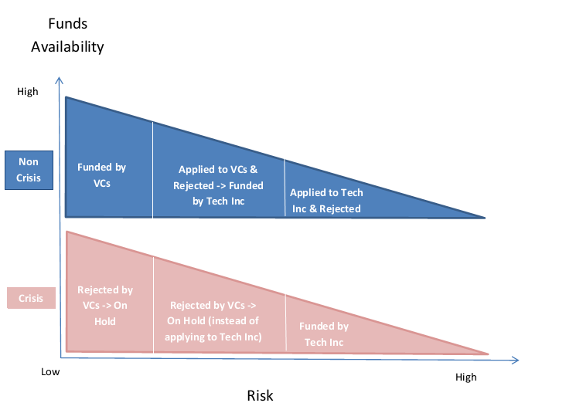

Tech Incubator

Tech Incubator

The figure describes two global scenarios: a non-crisis economic environment with high availability of capital for investment (in blue) and a crisis economic environment with lower availability of capital for investment (in red).

1. In the first scenario, the non-crisis environment, we assume that low-risk ventures obtain financing from private investors, while medium-risk ventures approach private investors and are rejected (because they represent too high a risk for the private investor market); they then apply to technological incubators as an alternative financing channel. High-risk companies are rejected by the incubator program due to excessive risk.
2. In the second scenario, during economic crisis, we assume that medium and high-risk ventures are rejected by private investors; these ventures attribute the fundraising difficulties to the economic crisis. Thus, after being rejected by the private investors, they prefer to wait for economic recovery rather than turn to alternative financing channels. Medium-risk ventures delay launch of their businesses because they do not know that in effect they would have been rejected without a crisis as well; this is sending them into standby mode. Based on the results of our study we assume that the incubators tend to invest in companies of excessive risk that would not have been accepted into the program had there not been a crisis, and this is because only the high-risk ventures are applying to the incubator program, and are being accepted by it because of low competition for the program resources in times of crisis.

Insight for policymakers

A question arising from the research findings is whether there exists a qualitative threshold or risk threshold above which entrepreneurs and companies choose to "sit on the fence" instead of turning to alternative investment channels, and whether companies below that threshold -- those having higher risk than the average incubator company -- are the only competitors for available investment resources during times of crisis. If so, then as the research indicates, this fact creates a situation whereby in times of crisis incubators are forced to take on even worse companies that would not have been accepted even by an incubator were it not for the crisis. The proposed characterization is further supported by the performance of companies entering the incubator at times of economic recovery. These companies exhibit better performance and indicate a change in entrepreneurial behavior -- from a 'wait' status during the crisis period to a situation where rejection by private investors pushes medium-risk companies to the incubator programs during non-crisis periods.

It is important to assimilate this market and entrepreneurial behavior in order to formulate dynamic policy -- the kind that adapts itself to the environment in which it is operating. Research conclusions about these behavioral changes have consequences on government policy for financing innovation as a solution to market failure; a concerted effort should be made to engage ventures "sitting on the fence" during crisis periods as an opportunity to support favorable projects for the incubator program. The findings point out that during crisis periods government budgets in this area do not achieve the kinds of results they achieve in other years. In effect, during these periods, the budget finances higher risk levels than those that policymakers had in mind -- excessive risk levels that have a significantly detrimental effect on the incubator program. It is evident that incubator budgets must be increased during those times, where the increases are to be used to attract those favorable businesses that have chosen to sit on the fence during the crisis period; at the same time, of course, it must be assured that the increased budget will not be used to finance excessive risk through high-risk companies during times of crisis. This is to be achieved by positioning the incubator program as an alternative investor in the eyes of the entrepreneurs, especially during those periods. The way to do this is by making the program more attractive through provisional changes relevant to those times, such as easing regulation and the R&D Law; entering into more classic investment sectors of VC funds; improving conditions for incubation and ownership distribution; more aggressive marketing in order to engage entrepreneurs who are sitting on the fence, positioning the incubator program as an opportunity to gain competitive advantage as an alternative to delaying venture activity, etc. The objective of the proposed actions is to engage the better companies by making the incubator program accessible to a new audience who is entrenched in the belief that they should not give up on private investment funds. It is precisely in times of crisis that there is an opportunity to draw in entrepreneurs in a different way than in other periods -- through temporary adaptation of regulation and perhaps even of the bureaucracy required for applying.

Proposals for follow-up study

In the context of our study we observed a phenomenon that was not part of our research objective, and that is, that the degree to which the crisis influences company performance is significantly related to the company's location: the effect of the crisis on companies incubated in central Israel and in the periphery[25] was further-reaching compared to companies in the Jerusalem region. More specifically, companies incubated in central Israel during the crisis operated one and a half years less (~~36~~p=.057, t=1.934), employed 9.5 fewer employees (p=.059, t=55.404~~36~~), raised $5 million less in investments (p=.012, t=54.437) and reached a less advanced stage in the business life cycle (p=.049, U=376) on the average compared to other companies during non-crisis periods in the same region. This was also the case for companies incubated in peripheral incubators during the crisis: these operated two years less (p=.000, t=4.575), employed 3 fewer employees (p=.039, t=2.073), raised $2.4 million less in investment (p=0.94, t=297.489) and reached a less advanced stage in the business life cycle (p=.008, U=8877.5) on the average, compared to other companies during non-crisis periods in the same region. On the other hand, companies operating in the Jerusalem region during crisis exhibited a life cycle shorter by "only" two years (p=.037, t=2.125) compared to companies incubated in the same region during other periods.

As several open questions remain, we propose follow-up research to address the following:

1. Study the differences in company performance by geographic location -- findings suggest that the effects of crisis are not uniform for all incubators: effect on central and peripheral businesses was further-reaching than on those in the Jerusalem region. Studying the variance of business performance by these subgroups will allow for delineation of the extent of crisis effect and demarcation of the risk subgroups. The findings of the follow-up study will contribute to the knowledge base ~~on the subject of how the incubator program functions in times of crisis,~~ and may suggest ~~relevant~~ region and sector adjustments ~~modifications to public pol~~icy~~, adapted by region~~ ~~and sector.~~
2. Study entrepreneurial behavior during times of crisis -- with the goal of understanding the reason that entrepreneurs in Israel prefer to delay the launch of their activity despite the fact that the incubator program serves as a financial alternative. Identification of motives will offer an explanation for this behavior, which past research has not been able to provide. Studying the motives of this behavior will also facilitate in structuring a solution and defining the opportunity inherent in crisis periods, for the incubator program.
3. Examine risk level of businesses that turn to the incubator program -- such a follow-up study could construct a profile of the average incubator business, thereby defining a risk level of the typical incubator company. Such a profile could be used as a benchmark for filtering and evaluating incubator program candidates, and thus effectively providing a key to be used for containing the risk level the incubator program is willing to carry, both in normal times and in times of crisis.

**Bibliography**

* דן קאופמן ועוז גורה, 2009. הערכה מקדמית של תכנית החממות הטכנולוגיות בישראל. מכון ירושלים לחקר ישראל
* ~~הועדה לעידוד תעשיות עתירות-ידע ולקידום מיומנויות מקצועיות באזורי הפריפריה, "ועדת גבאי", 1996.~~
* ~~Israel Venture Capital Research Center מאגר מידע מקיף לנושאי הון סיכון - ומיזמים טכנולוגיים בישראל.~~

1. Avnimelech, G., Schwartz, D., & Bar-El, R. (2007). Entrepreneurial high-tech cluster development: Israel's experience with venture capital and technological incubators. *European Planning Studies*, 15(9), 1181-1198.
2. Avnimelech, G., & Teubal, M. (2004). Venture capital start-up co-evolution and the emergence & development of Israel's new high tech cluster: Part 1: Macro-background and industry analysis. *Economics of Innovation and New Technology*,13(1), 33-60.
3. Block, J.H., de Vries, G., & Sandner, P. (2010). Venture capital and the financial crisis: An empirical study across industries and countries. In Cumming D. (Ed.), *The Oxford handbook of venture capital* (pp. 37-60). New York: Oxford University Press.
4. Block, J.H., & Sandner, P. (2009). What is the effect of the current financial crisis on venture capital-financing? Empirical evidence from US internet start-ups. *Venture Capital*, 11(4), 295-309. doi: http://dx.doi.org/10.1080/13691060903184803
5. de Vries, G., & Block, J. H. (2011). Venture capital syndication in times of economic crisis. *Venture Capital*, 13(3), pp. 195-213. doi: http://dx.doi.org/10.1080/13691066.2011.600278
6. ~~Fairlie, R. W. (2013). Entrepreneurship, economic conditions, and the great recession.~~ *~~Journal of Economics & Management Strategy~~*~~, 22(2), 207-231.~~
7. Frenkel, A., Miller, M., & Shefer, D. (2005). *The technological incubators in Israel: Technological policy in an era of privatization.* Haifa: The Center for Urban and Regional Studies, Israel Institute of Technology.
8. Gompers, P., & Lerner, J., (1998). What drives venture capital fundraising?. Brookings Papers on Economic Activity. *Microeconomics* (July 1998): 149–192.
9. Gompers, P., & Lerner, J. (2001). The venture capital revolution. *Journal of Economic Perspectives* 15(2). 145-168.
10. Guellec, D., & Wunsch-Vincent, S. (2009). Policy responses to the economic crisis: Investing in innovation for long-term growth, In *OECD Digital Economy Papers*, No. 159, Paris: OECD Publishing. http://www.oecd-ilibrary.org/science-and-technology/policy-responses-to-the-economic-crisis_222138024482
11. Hausman, A., & Johnston, W. J. (2014). The role of innovation in driving the economy: Lessons from the global financial crisis. *Journal of Business Research*, 67(1), 2720-2726.
12. Jeng, L. A., & Wells, P. C. (2000). The determinants of venture capital funding: evidence across countries. *Journal of Corporate Finance*, 6(3), 241-289.
13. Kahneman, D., & Tversky, A. (1979). Prospect theory: An analysis of decision under risk. *Econometrica: Journal of the econometric society*, 263-291.‏
14. Kaufmann, D., and Schwartz, D. (2008). Networking: The “missing link” in public R&D support schemes. *European Planning Studies*, 16(3), 429-440.
15. Knesset (2011). The ongoing decline of follow-up financing for incubator graduates. In Knesset Subcommittee for the Advancement of Science Intensive Industries meeting protocol. https://oknesset.org/committee/meeting/4742/
16. Lerner, J., Sorensen, M., & Strömberg, P. (2011). Private equity and long‐run investment: The case of innovation. *The Journal of Finance*, 66(2), 445-477.
17. Martin, S., & Scott, J. T. (2000). The nature of innovation market failure and the design of public support for private innovation. *Research Policy*, 29(4), 437-447.
18. McCahery, J. A., & Vermeulen, E. P. (2010). Venture capital beyond the financial crisis: how corporate venturing boosts new entrepreneurial clusters (and assists governments in their innovation efforts). *Capital Markets Law Journal*, 5(4), 471-500. https://doi.org/10.1093/cmlj/kmq018
19. Mayer, C., Schoors, K., & Yafeh, Y. (2005). Sources of funds and investment activities of venture capital funds: evidence from Germany, Israel, Japan and the United Kingdom. *Journal of Corporate Finance*, 11(3), 586-608.‏
20. PWC (2017-2014). MoneyTreeTM Quarterly Reports, 2007-2014. PWC Israel. http://www.pwc.com/il/en/venture-capital-israel/moneytree-home.jhtml
21. OCS (2013). *Office of the Chief Scientist Program Guide for 2013*. Office of the Chief Scientist in the Ministry of Economy (Israel). http://www.economy.gov.il/Publications/Publications/DocLib/chief-scientist-programs-2013.pdf
22. OECD (2012). Innovation in the crisis and beyond. In *OECD Science, Technology and Industry Outlook 2012*. OECD Publishing.http://www.oecd-ilibrary.org/science-and-technology/oecd-science-technology-and-industry-outlook-2012_sti_outlook-2012-en
23. Pagels–Fick, G. (2009). *Fight the crisis with research and innovation? Additional public investment in research and innovation for sustainable recovery from the crisis*. Sweden: VINNOVA Analysis VA, 14. http://www2.vinnova.se/en/Publications-and-events/Publications/Products/Fight-the-Crisis-with-Research-and-Innovation/
24. Poposka, K., & Mihajloska, E., (2016). The implications and aftermath effects of the financial crisis on startups in EU. *Economic Development* (*Ekonomiski Razvoj*),18(3).
25. Poschke, M. (2012). ‘Entrepreneurs out of necessity’: a snapshot. *Applied Economics Letters*, 20(7), 658-663.
26. Pugatch, M., Teubal, M., & Zlotnick, O. (2010). Israel’s high tech catch up process: The role of IPR and other policies. In Odagiri, H. (Ed.), *Intellectual property rights, development, and catch up: An international comparative study*. Oxford University Press. doi:10.1093/acprof:oso/9780199574759.003.0007
27. Roper, S. (1999). Israel's technology incubators: Repeatable success or costly failure?. *Regional Studies*, 33(2), 175-184.
28. Stiglitz, J. E. (1999). Knowledge as a global public good.In Kaul I., Grunberg I., Stern M. (Ed.) *Global public goods: International cooperation in the 21st century*, (pp. 308-325). New York: Oxford University Press.
29. ~~Vanacker, T., Deloof, M., (2014). The financial and real effects of credit availability for startup firms: Evidence from the recent financial crisis.~~ *~~European Financial Management Association~~*~~.http://www.efmaefm.org/0EFMAMEETINGS/EFMA%20ANNUAL%20MEETINGS/2014-Rome/papers/EFMA2014_0231_fullpaper.pdf~~
30. ~~Von Burg, U., & Kenney, M. (2000). Venture capital and the birth of the local area networking industry.~~ *~~Research Policy~~*~~, 29(9). pp. 1135–1155. https://doi.org/10.1016/S0048-7333(99)00072-4.~~

1. The added value of venture capital funds -- earning them the name 'smart money' -- is composed of often non-quantifiable non-economic advantages; these include a network of contacts in the relevant industry, experience in the branch, accumulated experience in business development of young companies, etc.
2. Social benefit may be expressed in growth, job creation, as a catalyst for broad technological change, etc.
3. Cost of required investment, technological and business risk, absence of precise information and flow of know-how to competitors
4. The researchers point out that investor willingness to invest in funds is affected by economic growth rate, changes in GNP, interest rates, variance in return on security investments and growth/decline in R&D expenditures.
5. Researchers offer several explanations for the fact that syndicated investment, a tool for risk distribution pertinent for coping with crisis, has been found to drop particularly during financial crises.
6. MoneyTree Q3 2012 Report From the website: http://www.pwc.com/il/en/venture-capital-israel/moneytree-home.jhtml
7. http://www.pwc.com/il/en/venture-capital-israel/moneytree-home.jhtml
8. http://www.pwc.com/il/en/venture-capital-israel/moneytree-home.jhtml
9. Government budget appropriations or outlays for research and development
10. According to a survey that included 26 OECD nations, with the exception of Italy and Romania
11. Belgium, Israel, Spain, Ireland and Great Britain
12. Note that the OECD's GBAORD declined by about 4% in 2010
13. In the 2002 budget there was a real decline of about 5.5%; about 13% in 2003, and about 5% in 2005. In effect, the 2002 budget was nearly identical to the 2000 budget in real terms, while the 2003 and 2004 budget was even lower than that of 2000 and 2001. The 2009 budget grew negligibly in real terms, by about 1.6%, while in 2010 there was a dramatic drop of about 17%.
14. Published by the Office of the Chief Scientist of the Israel Ministry of Economy
15. According to Kahneman and Amos Tversky's prospect theory (1979), the natural tendency toward risk aversion explains the rational person's preference to choose minimizing risk over expectation for high returns. The technological incubator program, therefore, as a rational investor and in general, would prefer to invest in low-risk companies over those that offer the expectation of high returns. This explains why in those times of crisis, incubators would be expected to prefer investing in lower risk companies then those they ordinarily invest in, and to take on companies that are relatively more promising.
16. http://www.ivc-online.com
17. Companies that were not active beyond the two year mark, did not get past seed stage, raised less than $100K and did not progress to a later stage financing after seed
18. seed, R&D, earliest revenues, growth
19. seed, extended seed, first, extended first, second, extended second, third, extended third, fourth, extended fourth, fifth, IPO/PIPE
20. merger and/or acquisition, intellectual property sale, public offering (IPO) or private investment in public equity (PIPE)
21. with a statistical error of 10%
22. with a statistical error of 10%
23. engaging in one of the areas of high technology (biotech, medical devices, computing/software/communications, in contrast to companies engaging in more traditional areas (electronics/mechanics, environmental technology or other technology categorized as "other")
24. with a statistical error of 10%
25. Incubators in the northern or southern regions not located in the Jerusalem or Dan regions