1. **References.** I did not change your numbering because it appears to be linked to a reference manager. I moved the reference information from the comments and hyperlinked them in the text for your convenience. Additional references are also hyperlinked in the text – these do not currently appear in your reference list.
2. **Hypothesis.** I recommend taking a stronger stance with your hypothesis. As it stands, the proposal is observational. I think there are opportunities to interpret your preliminary data with more confidence as you approach the aims. For example, your preliminary data show changes in cytokine expression. Is there published information about miRNA regulation of these cytokines or the significance of the cytokines in relation to the behavioral phenotype? I would add some interpretation to your preliminary findings to further strengthen the model you've developed.
3. **MicroRNAs.** In the section with the header "MicroRNA-mediated effects of CBD, I would focus this on the effects of CBD that you will be measuring specifically. In each statement, try to be more definitive in describing the effects observed in each study cited. I also recommend focusing this paragraph on inflammatory markers only. Because you don't consider cell cycle arrest in the proposal, for example, the information is not needed. You can use the space to describe in a bit more detail what happens with T cells in the setting of major depression. If you're running out of space, the paragraph can be omitted completely. It would be sufficient to jump right to the second paragraph of this section. In the second paragraph, I'd add a concluding sentence to remind the reader that these cytokines are related to psychiatric disorders. Finally, the call for proposals alludes to the fact that they are seeking information about the possible negative effects of cannabinoids during development. The paragraph seems to focus on protective effects of CBD. Is there information to the contrary that could be added to raise the question of whether CBD is protective or not in the setting of a fetus?
4. **Length**. The text is about one page over the limit at this point, but we can edit it down once the content is finalized.
5. **Sex differences.** The proposal background could benefit from a paragraph on sex differences in microRNA expression related to psychiatric disorders and sexually dimorphic effects of CBD. This is a strength of your proposal, so I'd emphasize the involvement of both sexes in the background section.
6. **Preliminary data.** I recommend moving the yellow highlighted text and figures 3 and 4 out of the aims and into the section with the header "Preliminary supporting data." Reviewers will expect to see it there and the data will help convince the reviewers that you have firmly established your model. In this way, your aims can be succinct and uninterrupted.
7. **Figure legends.** When your figures are finalized, be sure to include a short figured legend.
8. **Summary table.** I recommend adding a short table that summarizes the aims. I would include information about the model, experimental approach, and physiological response measured. It can help guide your reviewer through your text and will save space in your text. The behavior tests are currently occupying a decent amount of space that could be reduced by a table. This is an example:

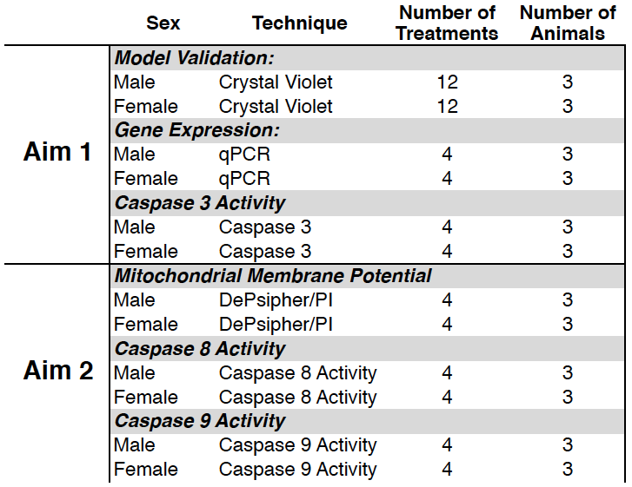

Alternatively, if you like the schematic that you already have, I would change this into a proper timeline with the ages that are above the line incorporated into the line itself. You can then used perpendicular arrows to point indicate where along the timeline different interventions or experiments will be performed. [BioRender](https://www.biorender.com/) is an excellent tool for this type of schematic. They have many templated timelines that could work well. Below is an example of a template.

1. **Scoring**. I inserted, where appropriate, the scoring information. It's likely that these items are on a score sheet that reviewers will use to rate your proposal. When writing your specific aims, try to address each of these as definitively as you can so the relevance of the proposal to their Notice of Special Action is strong.
2. **Innovation**. I recommend adding information that states why your lab is uniquely qualified to perform the research. Can you emphasize (again) previously published work or expertise that demonstrates why your lab is the best one to perform this study?
3. **Aims**. The aims should be written in future tense; there was a mix of tenses so I made it consistent. I recommend using the headers: rationale, experimental design, and anticipated results and potential problems.
   1. **Experimental design**. You can remove most of the details about the experimental approach and leave only the information that might be specific to your experiments. For example, I removed some of the detail about real time PCR and instead. You can add information about why gene expression is useful for the aim and how your approach might be different/build on work from other labs. Try to begin the description of each approach with the question the experiment seeks to answer. Then provide a brief description of the approach and include the details that are important the answering the question. Include the specific miRNAs that will be measured and remind the reviewer very briefly why these were selected.
   2. **Potential problems.** This section will need to be expanded. Once all of the preliminary data are included and edits are made, we can revisit this and devise alternative experiments that could be performed to lead your researchers to the second aim if aim 1 doesn't work out as expected. Because Aim 1 is descriptive and you and others have presented data to support the hypothesis, you can remind the reviewer that problems are not anticipated.
   3. **Aims.** I recommend using the preliminary data to build the aims. In other words, I would put all of the preliminary data together and when you introduce the experimental design for the aims, you can refer back to the preliminary data and present the experiments as extensions of what you already started. This will also cover you in the potential problems section because you can remind the reviewer that you have demonstrated feasibility. In this way, you can hopefully detract from the fact that Aim 2 relies on the success of Aim 1.