The Future of Science Laboratories

Muhamad Hugerat* and Avi Hofstein**

*The Academic Arab College for Education, Haifa, Israel

**The Weizmann Institute of Science, Rehovot, Israel

**Introduction**

**The Science Laboratory**

It was only in the nineteenth century that schools first began to teach science systematically. It was then that the laboratory became a characteristic element of science education (Edgeworth & Edgeworth, 1811 cited by Rosen, 1954). While scientific knowledge increased rapidly after the First World War, scientific laboratories in schools continued to be used primarily to confirm and reinforce information that had already been taught in a lecture or from a In the 1960s, scientific education underwent major reforms in both the United States and the United Kingdom, with a new commitment to teaching science by directly engaging students in scientific activities. As students became involved in investigating, discovering, inquiring, and problem-solving, the laboratory became the core of science instruction and the scientific learning process. .

Scientific laboratories have been the site of extensive and comprehensive research, resulting in the publication of countless research papers and doctoral dissertations throughout the world (Hofstein & Lunetta, 2004; Lazarowitz & Tamir, 1994; Lunetta, Hofstein, & Clogh, 2007). While scientific laboratories have flourished as centers of practical work, they have also been subject to serious questions and challenges over their efficiency and benefits (Hodson, 1993; Hofstein & Lunetta, 2004; Millar, 1989). One criticism levelled is that many educators and, often, curriculum developers, fail to consider “creative” aspect of laboratory work, and have students perform routine, programmed activities that do not call for the mental engagement that true scientific research requires. According to recent literature, scientific education should ideally be encouraging open-ended inquiries, where students can hypothesise, plan an experiment, ask questions, , and plan an experiment again to verify or reject their hypotheses. However, experts contend that this process rarely takes place in educational laboratories. Much attention has been given to the learning outcomes in those limited instances when genuine scientific inquiry does take place in the laboratory.

It should be emphasized that the issue of what is involved in practical scientific laboratory work is not a static one, having evolved gradually over the years and continuing to unfold. The debate over the role of the laboratory is affected by changes in goals for science education, advances in understanding about science education,, changing views and understanding of scientific inquiry, and more recent breakthroughs in educational technologies. In order to explore these issues, this paper begins with an historical review, examining the nature of practical scientific research over the last 50 years, during the periods of: (1) the 1960s to the mid-1980s; (2) the mid-1980s to the mid-1990s; and (3) the last 15 years.

**50 Years of Laboratory Work, Research and Practice: An Historical Overview**

***The 1960s to the Mid-1980s: Unfulfilled Ideals***

During the period of the 1960s to the 1980s, numerous new curriculum projects were developed and introduced with the aim of improving and advancing science education. These efforts actually began in the late 1950s, as educators sought to update and reorganize the aspect of knowledge content of the science curricula. However, educational reformers soon focused on the *science process* rather than knowledge as the main aim and organizing principle of science education. As Sunee Klainin (1988) in Thailand explained:

Many science educators and philosophers of science education (e.g. in the USA: Schwab, 1962; Rutherford & Gardner, 1970) regarded science education as a process of thought and action, as a means of acquiring new knowledge, and a means of understanding the natural world. (p. 171)

This new emphasis on the processes rather than the products of science reflected the thinking of many different parties, and was fuelled by numerous initiatives. For example, some educators, convinced that the earlier reform projects had placed too much emphasis on subject knowledge, sought to shift to a more student-oriented pedagogy. For other educators, placing the science process at the center of science education served as a solution to the rapid development of knowledge in science and technology. For these educators, mastering science processes and concepts would provide students with more enduring skills, and thus better prepare them for the unforeseeable challenges of the future. Significantly, this shift in the goals of scientific education was accompanied and supported by developments in cognitive psychology at the time, which were highlighting the importance of reasoning processes and scientific thinking. Psychologists such as Jean Piaget, Jerome Bruner, and Robert Gagné helped explain the nature of the thinking involved in the science process and supported the proposition that science teaching could help advance what they considered the worthy goal of developing this type of thinking in young people.

The review of Lazarowitz and Tamir (1994) of laboratory work clearly demonstrates the interest in the element of practical work in science education and research during this period They identified 37 reviews of laboratory issues in the context of science education (Bryce & Robertson), all of which reflected strong support for the beneficial potential of practical work in the curriculum. However, these studies also recognized significant difficulties in obtaining convincing data on the educational effectiveness of such teaching. According to the studies, the only area that could be identified in which laboratory work showed a genuine advantage in comparison o to non-practical learning methods was that of acquiring and developing practical laboratory working skills. However, they could identify very few or no differences between laboratory-based and other scientific learning methods with respect conceptual understanding, critical thinking, and an understanding of the nature of science.

Lazarowitz and Tamir (1994) suggested that one reason for these results could be that the assessment and research procedures used in the studies under review were inadequate. Although quantitative research methods were not adequate or appropriate for research purposes in this area, at that time, qualitative research methods were generally not taken seriously in the science education community. Hofstein (2004) identified several methodological shortcomings in research designs of studies about science education during this period: insufficient control over laboratory procedures, including laboratory manuals, teacher behavior, and assessment of students’ achievement and progress in the laboratory; inappropriate samples; and the use of measures that were not sensitive or relevant to laboratory processes and procedures.

Not only was there insufficient evidence of the advantages of process-based science education in laboratories during this period, but actual teaching practices in the laboratory were slow to change, and teachers did not embrace the shift to the open-ended style of teaching as recommended by the curriculum projects. Instead, teachers continued to prefer a safer, more formulaic approach to science education (Tamir & Lunetta, 1981).

***Mid-1980s to Mid-1990s: The Constructivist Approach***

The support for practical work in the laboratory as part of the scientific curriculum faced a two-pronged challenged during the period from the mid-1980s to the mid-1990s. First, science education researchers were becoming increasingly aware of the failure to truly incorporate and execute the pedagogical reforms proposed during the previous period. Indeed, Robert Yager (1984), reported that laboratory work in schools continued to tend to focus on following instructions, arriving at the right answer, or handling equipment. It was found that students failed to gain the conceptual and procedural understandings that the reformers had intended to inculcate.. Frequently, students were unable to understand the relationship between the purpose of the investigation or the research question and the design of the experiments (Lunetta et al., 2007).

The second line of criticism of the earlier approach encouraging practical laboratory work arose from the fact that there was little evidence that students had been provided with adequate time and opportunities to learn or think about the nature of science and understand the connection between science and laboratory work. Students were seldom aware of the discrepancies between their own concepts, their peers’ concepts and the concepts of the science community (Eylon & Linn, 1988; Tobin, 1990). In essence, for students, practical work in the laboratory did not have anything to do with creating and exploring ideas. Rather, it meant working with and manipulating equipment and materials, with no thoughtful content.

During the 1980s, influenced by the philosophical and sociological issues associated with constructivism, which recognized that students’ experiences prior to entering school influenced their understanding and knowledge, researchers began questioning both the practice and the theoretical justifications for emphasizing practical, process-centered science education in the laboratory(Millar & Driver, 1987). They contended thatthe entire science education community had been misled by a naïve empiricist view of science, referred to by Robin Millar (1989) as the Standard Science Education (SSE) view.

***The Period after the 1990s: A New Era of Change***

During the last 20 years, science education has undergone major changes, implemented, in part, in response to globalisation and rapid technological development over the last decades. In order to remain competitive and to develop the knowledge and skills needed to operate successfully in a world characterized by constant and fast-paced innovation, educational systems must offer the highest level of science education. Developments in the United States regarding standards for science education (NRC, 2005) clearly support teaching both scientific content and higher-order learning skills. The latter demand a laboratory environment where students can learn to plan an experiment, observe, ask relevant questions, hypothesise, and analyse experimental results (Bybee, 2000). Throughout the world, there have been intense efforts to reform scientific curricula in schools, with an emphasis on better adapting and tailoring science education to mrry the needs of all citizens (AAAS, 1989).

***Looking Towards the Future: The Next 50 Years***

With schools and educational systems under increasing pressure to improve the performance of their diverse student bodies in science, it is more imperative and urgent than ever toed carefully define the role and goals of high school science laboratories and to measure progress toward attaining those goals. However, these same schools and educational systems are also under constant pressure to cut costs, thus forcing them to make painful choices about the more expensive and specialized features of education.

The efforts to improve students’ experiences in the laboratory in the 21st standard have been impeded by weaknesses and ambiguities in definitions, research and policies. Even at the most basic level, historically, researchers studying laboratory experiences have not been able to agree on a precise definition of "laboratory" or about the purpose of the laboratory, which has made it challenging to identify evidence that could lead to improvements in laboratory education. Reaching precise conclusions on the optimal approaches to laboratory teaching and learning has been very difficult, given the gaps in the research, particularly researchers’ inability to determine and draw on the knowledge of expert science teachers. In addition, educators, policy makers and researchers today have disparate opinions about the role and goals of high school laboratory experiences. As a result of this disunity in research, policy and practice, the research, development, e realization and dissemination of improved laboratory experiences have not been able to advance in a meaningful manner. ., Many questions related to learning in and from science still remain only partially answered. The following are a list of issues that require additional research and development and more diverse approaches.

1. *Assessment of student learning in laboratory experiences:* Researchers need to determine the specific learning outcomes of laboratory experiences. In order to do so, they must ascertain the best methods for measuring these outcomes, both in the classroom and in large-scale assessments.
2. *Effective teaching and learning in laboratory experiences:* Research must be undertaken to identify what kinds of laboratory experiences are most effective in advancing the sought-after learning outcomes of laboratory experiences. The different kinds of curricula that can support teachers and students in reaching for and ultimately achieving these learning outcomes need to be explored and clarified.
3. *Diverse populations of learners:* Researchers need to examine through which teaching and learning processes laboratory experiences contribute to particular learning outcomes for specific and diverse student populations.
4. *School organization for effective laboratory teaching:* Professionals and academics need to determine those organisational arrangements, such as state and district policy, funding priorities, resource allocation, professional enrichment, textbooks, emerging technologies and school and district leadership most effectively and efficiently facilitate high-quality laboratory experiences most efficiently and effectively. The most effective ways of implementing such organisational arrangements also need to be clarified.
5. *Continuing learning about laboratory experiences:* Among the issues to be explored here are in what ways teachers and administrators can learn to design and implement effective curricula that incorporate laboratory experiences for diverse and underrepresented students. Together with this, researchers need to find the most effective professional enrichment methods for helping teachers and administrators create and use such curricula. Finally, it should be determined when professional laboratory enrichment should be introduced or continued during a teacher’s career, from pre-service to expert teachers.

Serious and sustained attention to the above issues is essential in order to improve the quality of laboratory experiences available to U.S. high school students and thereby advance important educational goals. However, even now, science educators can begin to integrate laboratory experiences more effectively into the science curriculum by applying the principles of instructional design now emerging from ongoing research,. This paper seeks to offer definitions goals, design principles and findings which can help an organizing framework for tackling the challenging task of designing laboratory experiences for the 21st century.

To keep up with rapid technological advances, school laboratories must undergo profound changes. The school laboratory of the future will differ significantly from those to which we have become accustomed in terms of their space, equipment, and materials, as well as they goals which they will be required to meet. The future school lab needs to:

* Be connected to everyday life and be "more relevant" to today’s students;
* Protect and sustain the environment and use renewable and clean energy;
* Use small amounts of chemicals and move from macro to micro and nano materials;.
* Become a supportive environment for understanding the new technological concepts and methods being taught;

Link our planet and the greater universe while developing a better understanding of how scientific processes work in both realms. Some of the following actual examples from The Academic Arab College for Education in Haifa, Israel can offer some insights on how to achieve these goals.

1. **How learning chemistry laboratory activities can be made more relevant to students.**

Science teachers, particularly chemistry teachers, are urged to make science education, in this case, chemistry education, “more relevant” in order to get their students interested in science and motivated to pursue these studies ( Hugerat et al., 2015; Hugerat et al., 2018; Stuckey et al., 2013).

The Academic Arab College of Education decided to adopt a new model, whereby students play an active role in the teaching process. In the“General Chemistry Lab” and “Methods for Teaching Chemistry” courses, students were required to create and apply an active, dynamic, and meaningful inter-disciplinary learning and teaching process. Students in the “The General Chemistry Lab” course planned a number of simple experiments. These were not carried out as part of the course itself, but were presented within the college environment. First, the students from the course distributed an explanation to all the College’s students about the experiment to be performed and its connection to everyday life, which usually involved the home particularly the kitchen. Other students from the College observed the experiment during their break periods. We observed that the students expressed a lot of interest, asking many questions. These questions were met with explanations at a variety of levels.

**1.1. Presenting laboratory activities during break periods as a means of improving teaching**

Based on the results of this experience, we believe that every teacher, especially those of very young children should learn to engage in this kind of activity. An interesting example is provided by a student training to teach Arabic. Following the presentation of the course participants’ experiments during the break periods, this student asked to use the school laboratory. With the help of lab technician and the chemistry teacher, this student wanted to prepare an experiment taken from everyday life that would be relevant to his students. He then planned to ask the students from his course in fluent Literary Arabic to compose a report on what they had witnessed.. Given this reaction to just one presentation, it is possible conclude that trainee teachers need science and chemistry courses that are relevant to everyday life, and that such courses can have a significant effect on the way these subjects are then taught in schools.

Students from the “Methods for Teaching Chemistry” course were asked to write several lesson plans on a wide variety of topics (Table 1). They were required to think creatively, both “out of the box” as well as “”ut of the book". Books, it must be stressed, are a necessary but not sufficient element in science education.

**Table 1: Chemistry Laboratory Activities Relevant for Teaching**

|  |  |  |  |
| --- | --- | --- | --- |
|  | **Laboratory Activity** | **Description of the Activity** | **Relevance to Everyday Life** |
| 1 | Electrostatic Attraction | Moving a tin can using a balloon without the balloon touching the can to prove the existence of particles in matter | * Static electricity can be felt by everyone; * Using familiar materials from everyday life |
| 2 | Preparing a Polymer (large molecule) | Preparing polymers from common domestic products: glucose, soda, detergent, glue, etc. | Using common domestic materials to produce a new material, a plastic that is ubiquitous in our lives |
| 3 | Boiling by Cooling | Boiling water using cold tap water | * Pressure cooker, * Cooking time * Interpretation of recognizable objects, such as space suits * Boiling temperature as a function of altitude and atmospheric pressure |
| 4 | Lowering the Freezing Point | Mixing ice with cooking salt | * Making ice cream * , Spreading salt on icy roads * Quick cooling on trips |
| 5 | Packaged Fuel | Mixing alcohol with calcium acetate to produce a volatile gel. | * Igniting coal * Preparing a hot drink when no gas is available or when on a trip * Manufacturing a product |
| 6 | Extraction of Colours | Extracting colours from flowers; Extracting chlorophyll;,  Painting on Styrofoam and adding ethanol; Mixing egg and chalk | * Preparing paints using the traditional method * Producing writing that will last centuries * Cycles of materials, perfumes, etc. |
| 7 | Acid-based Experiments | Various experiments on acids and bases | * Removing limescale from a kettle * Detergents * Acidosis * Acid rain * Production of vinegar, etc. |
| 8 | Chemistry Works | Adding hydrogen peroxide to iodide;  Extracting silver from silver nitrate (AgNO3);  Producing iron rust | * Processes of corrosion, * Making vessels shine * Extracting magnesium from the Dead Sea * Polishing jewellery * Using platinum in the body * Dangers of mixing cleaners, etc. |
| 9 | Experiments with Eggs | Adding cola to an egg; Adding a salt solution | * Cola: healthy or not? * Making pickles |
| 10 | Chemical Cake | Creating a basic cake | * Making pastry, thick cakes, holes in cakes * Ming a new cake |

1. **Using the Laboratory to Teach Students to Value Solar Energy**

In a study conducted at The Academic Arab College of Education,, it was found that teaching science by the project-based learning (PBL) method significantly improved student-teacher relationships and enhanced students’ enjoyment of the course (Hugerat, 2016).The results of this study can be applied to teaching students about solar energy.

School laboratories are ideal sites for using and promoting the use solar energy, especially because any changes and improvements at schools are highly visible and closely followed. In a project that we designed at The Academic Arab College of Education, the students built a working model of a solar village inside the school (Hugerat et al., 2004; 2011), which uses only solar energy (Fig. 1).

Using a photocell instead of a conventional battery reduces environmental pollution. Over the course of the year, the laboratory uses numerous different devices, which would require a great deal of conventional battery current to operate. Conventional battery use would be much more expensive than using one photocell that can last for a long time. In fact, if maintained in good condition, a photocell can last nearly forever.

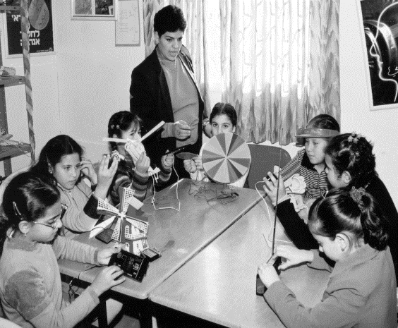 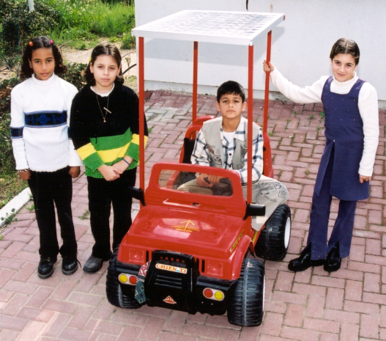

Fig.1: In laboratory activities with a study group, the pupils are exposed to the scientific, technological and social aspects of solar energy. In addition, the pupils build different systems utilizing solar energy inside the school courtyard.

**2.1. An example of a laboratory activity**

Electrolysis refers to a process whereby chemical change, especially decomposition, occurs when an electrical current flows through an electrolyte. Students in this activity used solar electric panels to produce hydrogen and oxygen gases through water electrolysis (Fig. 2). They then ran tests for the presence of flammable gases, after which they had to propose an experiments to balance a chemical reaction for the process of the electrolysis of water (Hugerat et al., 2003).

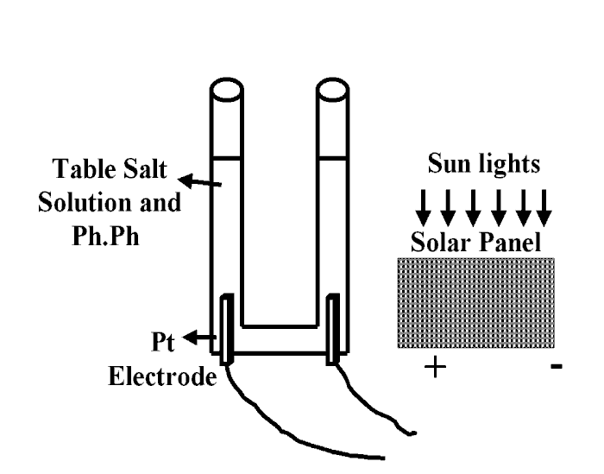 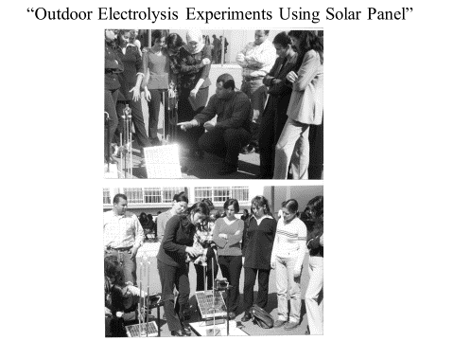

Fig. 2: Students use solar electric panels to produce hydrogen and oxygen gases from the electrolysis of water.

1. **Micro-Scale Laboratory Activities Using Disposable Materials**

Strategies for teaching and learning chemistry through work in a laboratory need to change in light of increased concerns about protecting the environment from chemical pollution as well as rising laboratory costs. An example of a creative response to this challenge is an interesting project initiated at The Academic Arab College of Education for developing educational materials while focusing on miniaturizing laboratories for sustainability purposes. In the course of creating multi-disciplinary learning materials for a variety of ages in the field of education, project participants miniaturized an environmental laboratory and tools in order to protect the immediate and more distant environments. Building a miniaturized research laboratory at the school provided an active learning environment for all students during the year and even drew in members of the community outside the college (Hugerat, 2008; 2009; Hugerat et al., 2010). Presumably, this project can encourage teachers to actually build a miniature laboratory in the future by successfully demonstrating that it is possible to:

* 1. Minimise the use of resources and production of polluting residues;
  2. Lower risks by minimising exposure;
  3. Minimise energy use; and
  4. Design laboratory activities using minimal or no toxic substances.

**3.1 Constructing micro-scale volumetric water analysis devices with disposable materials**

In another project for miniaturizing laboratory equipment, students at The Academic Arab College of Education constructed miniature devices for water electrolysis. Many methods for volumetric water analysis have been developed since the German chemist A. W. von Hofmann (1803–1892) first constructed his apparatus for the electrolysis of water. In this project at The Academic Arab College of Education, Hugerat et al. introduced MCE appliances for the electrolysis of brine (Hugerat, 2008; Hugerat & Schwarz, 2008). Using used disposable plastic pipettes, needles, pencil leads, and neutral electrolytes, teaching students at the College designed different micro-scale models of the Hofmann apparatus. Hugerat et al. (Hugerat, 2008; Hugerat & Schwarz, 2008; Hugerat et al., 2013) also developed a project to construct galvanic and electrolytic cells from pieces of a cola can, pencil leads, 1ml blisters, 2 ml injection bottles and cheap plastic containers to make electrolysis water with a 2ml plastic pipette pierced by two hypodermic needles and a 9 Volt battery (Fig. 3).

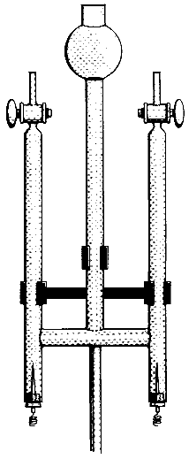 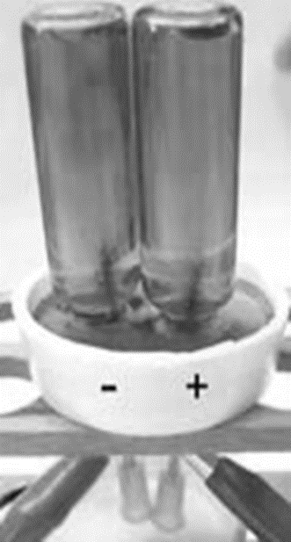 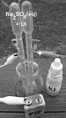

Fig 3: On the right, traditional glass for the Hofmann apparatus (200ml).The middle figure shows a micro-scale glass Hofmann apparatus (10 ml) constructed from disposable materials. On the left is a plastic Hofmann apparatus (5 ml) constructed from plastic syringes designed by Hugerat et al. (2013).

**3.2 Constructing micro-scale solvated electrons using disposable materials**

There has long been speculation about the existence of solvated electrons. The earliest known example of an established electron excess in a liquid was from alkali metals that produced stable blue solutions as a result of the presence of solvated electrons in liquid NH3 (ammoniated electrons).



Fig 4: A simple experiment to produce solvated electrons using disposable materials

At The Academic Arab College of Education, college we devised a simple experiment to produce solvated electrons using materials commonly available in undergraduate laboratories (Fig. 4), such as lithium metal from a small battery and computer-cleaning fluid. These materials interact in a reasonably safe manner and pose none of the dangers associated with the use of solid Na or K metals, such as intense reactions or explosions.. Not only were the experimental materials relatively safe, but the use of a simple and inexpensive source for a metal alkali and the production of liquid ammonia were also interesting from an educational perspective (Ibanez et al., 2011).

1. **Nano-Laboratory**

Nanoparticles are a significant element in the energy and mass budgets of our planet. However, the role of nanoparticles is rarely incorporated into studies of the Earth’s history and processes. Because nanoscience is basically overlooked in the teaching of the Earth, Space, and Environmental Sciences, the subject is is largely absent in school curricula in these subjects (Abu-Much & Hugerat, 2015; Dege et al., 2015).

A study conducted at The Academic Arab College of Education investigated the awareness of and attitudes toward nanotechnology among science teachers and secondary school students from the Arab sector in Israel. The results revealed low awareness, albeit positive attitudes (Abu-Much et al., 2019).

**4.1 Nano experiments: An example from** The Academic Arab College of Education

At The Academic Arab College of Education, we conducted an unusual lab experiment in which for participants were exposed to the terms “Nanosystems” and “drug delivery” in a unqiue manner. (Abu-Much et al., 2017). Aqueous solutions of liposome structures were prepared using a simple method and were then used as a model for exploring cell membrane structures and drug carriers. Solutions of the drugs Acamol®and Optalgin® were prepared, colored with food dye and then inserted into the hydrophilic interior part of the liposome structures. In the second step of the experiment, the participants could minimise the size of the drug-infused liposome structures from micro-scale to nanometre scale (400 nm, 100 nm) using an inexpensive and simple apparatus called a Mini-Extruder(Fig. 5 and Fig. 6).

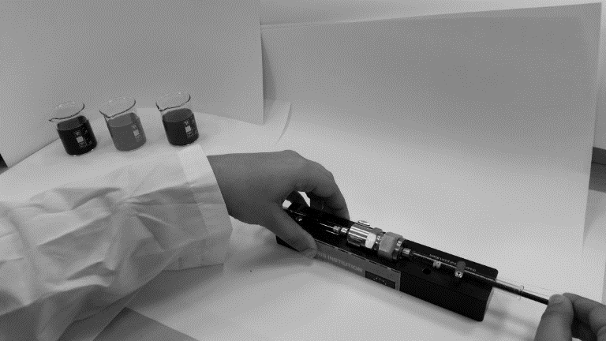

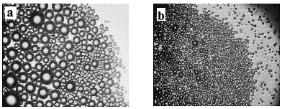Fig. 5: Mini Extruder apparatus, passing drug-infused liposomes through its membranes.

Fig. 6: Optical microscope images (X100) of:

1. Micro-scale liposomes infused with Acamol® solution
2. Nano-scale liposomes infused with Acamo®l solution

A group of 25 teaching students from the Academic Arab College for Education in Haifa, Israel, participated in this laboratory project as part of the course “Chemistry in the Lab”. In the project, liposome structures and their chemical characteristics were used as a teaching model, enabling the students to compare the chemical structure of cell membranes and that of the liposomes. This project offered an inexpensive, simple, and interesting way to introduce students to new, modern science fields like nanotechnology and to teach them about the field’s impact on our everyday life (Abu-Much et al., 2017).

We believe that engaging in such laboratory activities has a significant impact on student attitudes to chemistry and encourages them to undertake these important laboratory activities when they do their own teaching in the future. This result could lead to meaningful changes in how the subjects of nano liposomes and drug vehicle transport" are taught and understood in chemistry classes.

1. **The Laboratory as a Tool for Argumentative Skills Development**

The laboratory provides support for higher-order learning of inquiry skills that include observing, planning an exper­iment, asking relevant questions, hypothesising and analysing the experi­mental results (Hofstein, Shore, & Kipnis, 2004). Argumentation is the most important discourse process in scientific inquiry; therefore, it must be taught and learned in science classes as part of scientific investigation and literacy (Erduran, Ozdem, & Park, 2015).

For the purpose of constructing a well-founded and reasoned argument, many studies (Erduran, Simon, & Osborne, 2004; Katchevich et al., 2013; 2014) have utilized Toulmin's (1958) use of a model, according to which an argument contains the following components: claim, data and warrant, the latter constituting a connection between the former two.

In our college, the instruction aims at encouraging classroom discourse and the argument-construction process among pre-service teachers while they conduct laboratory activities, both in the discourse that takes place during the laboratory activity itself and in the subsequent classroom discussion on topics that arose during the laboratory activity. Twelve students specialising in chemistry in college, who were second-year students studying to be teachers in middle school, conducted it (Hugerat, Najami, & Hofstein, 2020).

We found that for the research groups that we observed, the laboratory could function as a platform for argument-construction without any intervention, owing to this learning environment's unique features: working in small groups, which made it possible to develop a discourse and an environment that provided students with time and a platform. In addition, we found that when students obtain unexpected results in a laboratory activity that they planned, the developing discourse contains more arguments, as well as rebuttals (Hugerat, Najami, & Hofstein, 2020).

1. **Space laboratories**

The Spacelab is important to all of us. It has expanded the Shuttle's ability to conduct science on-orbit many fold. It has provided a marvellous opportunity and serves as an example of a large international joint venture involving government, industry and science. Scientific research on the [International Space Station](https://en.wikipedia.org/wiki/International_Space_Station" \o "International Space Station) is a collection of experiments that require one or more of the unusual conditions present in [low Earth orbit](https://en.wikipedia.org/wiki/Low_Earth_orbit" \o "Low Earth orbit) (Buckey, 2006; NASA, 2005).

As of 2006, data on bone loss and muscular atrophy suggest that there would be a significant risk of fractures and movement problems if astronauts landed on a planet after a lengthy interplanetary cruise (such as the six-month journey time required to [fly to Mars](https://en.wikipedia.org/wiki/Manned_mission_to_Mars" \o "Manned mission to Mars)). It is anticipated that remotely guided ultrasound scans would have applications on Earth in emergency and rural care situations where access to a trained physician is difficult. Researchers are investigating the effect of the station's near-weightless environment on the evolution, development, growth and internal processes of plants and animals (Buckey, 2006; NASA, 2005).

Future plans are for the researchers to examine [aerosols](https://en.wikipedia.org/wiki/Aerosol" \o "Aerosol), [ozone](https://en.wikipedia.org/wiki/Ozone" \o "Ozone), [water vapor](https://en.wikipedia.org/wiki/Water_vapor" \o "Water vapor) and [oxides](https://en.wikipedia.org/wiki/Oxide" \o "Oxide) in the Earth's atmosphere, as well as [cosmic rays](https://en.wikipedia.org/wiki/Cosmic_ray" \o "Cosmic ray), [cosmic dust](https://en.wikipedia.org/wiki/Cosmic_dust" \o "Cosmic dust), [antimatter](https://en.wikipedia.org/wiki/Antimatter" \o "Antimatter) and [dark matter](https://en.wikipedia.org/wiki/Dark_matter" \o "Dark matter) in the universe.

**6.1 Candles in space**

Burning is a rapid (chemical reaction) process involving flame-forming material exposed to oxygen. It appears in almost all chemistry textbooks in the elementary school lab and in middle and high school. This experiment is the students' first encounter with chemistry in the laboratory.

In light of this, astronauts have examined how a candle burns at the International Space Station, which has very weak gravity (Fig. 7). Foreman Williams, a professor of physics at the University of California, San Diego, explained that a burning candle in space creates a kind of sphere around it. In the absence of gravity, combustion occurs mainly in a narrow area on the outside of the spherical flame, in the area where the wax vapors come in contact with oxygen, and not necessarily in the top as on Earth. In fact, a burning candle in space is much simpler because its wax and combustion vaporization occurs on a more limited surface. In addition, because there is no air flow near the burning candle in space, combustion of the wax fumes is more complete and less soot particles are emitted from the flame. As a result, the flame of the burning candle in space is much bluer than that of the burning candle on Earth (Buckey, 2006; NASA, 2005).

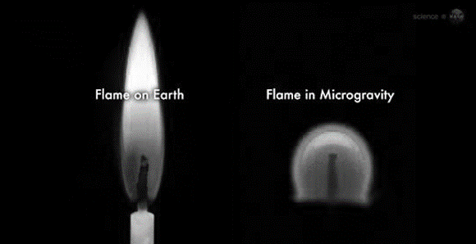

Fig. 7: Gravity plays an important role in shaping the flame. A Flame Candle on Earth (Left) and in the Space Station (Right) | Source: NASA

Taking this into consideration, one of the experiments deals with flames in space: creating fireballs that fly inside a special combustion chamber from flammable material injected into the cell and in flames that provide stability for very long periods. The purpose of the experiment is to test fire-extinguishing methods both in space and on Earth, using water vapor instead of various chemicals that may cause air pollution

**6.2 Examples from Israel**

1. A high school in Nahariya (a city in northern Israel) has designed an experiment that explores how microgravity affects the rate of kidney stones and kidney formation, with the aim of optimising dialysis treatment here on earth.
2. The "chemical garden" experiment was conducted by the first Israeli astronaut in space, Ilan Ramon, on the "Columbia" space shuttle. The "Chemical Garden" experiment was presented to Ilan Ramon in 2003 (Fig. 7) by a group of high school students and was performed by him about six hours after the shuttle took off. The purpose of the experiment was to examine the mechanism of crystalline growth in a "glass water" solution under gravity conditions in space (Fig. 8).

High school students, along with science teachers from the schools, built all of these experiments launched for the International Space Station.

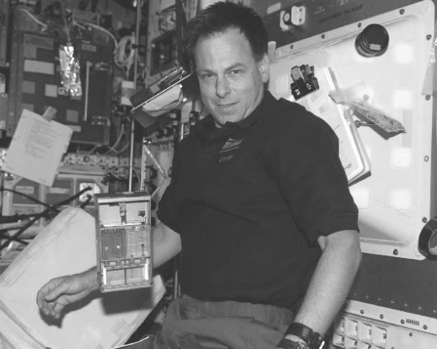

Fig.7: Israeli astronaut Ilan Ramon and the Chemical Garden Experiment on the Columbia Space Shuttle

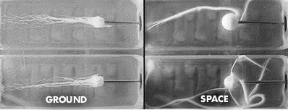

Fig. 8: Results of the "Chemical Garden" experiment with calcium chloride crystals on Earth and in space.

**6.3 The future of space laboratories**

However, conducting experiments in space is very expensive. Therefore, many companies have developed a tiny lab that is big as a shoebox, which is launched into space and allows remote experiments. Service customers are states, universities, large health agencies and research institutes that purchase a slot in the lab, such as we purchase an airline ticket or rent a car from a rental company.

The experiments conducted in this space laboratory are controlled from the ground up. Using a simple smartphone app, the researcher can see the metrics in real time, run the experiment, see the reaction and, if necessary, remove everything and restart - as if playing Angry Birds. The experiments can be used to develop drugs, cosmetics, advanced materials, crystals and more.

**Summary**

In this chapter, related to practical work, we tried to visualize and determine the content, curriculum and pedagogy of the science laboratory. We used examples from chemistry education. However, the key problem is that every 20-30 years the goals for practical work change. The question regarding experimentation for whom and how still remains open. In order to understand the dilemma, we could go back 30 years regarding ICT.

In the 1980s and 1990s, nobody around the world had a clear idea about the influence of computers on our lives in general, and on learning in particular.

In the past, laboratories were rooms (in schools) in which students' manipulated materials and equipment. In the future, we will provide students with opportunities to explore the world, space and the environment in which they learn science. We hope that these opportunities will extend students' abilities and skills to become literate citizens who are able to better control and be aware of their future experiences.

**References**

AAAS (1989). *Project 2061: Science for all Americans*: Washington, DC: American Association for the Advancement of Science.

Abu-Much, R., & Hugerat, M. (2015). The Fabrication of Electrical Conductive Thin Films made of Silver Nanoparticles - A Case Study of Its Implementation with freshman Students*. Journal of Nano Education. 7,* 1-8.

Abu-Much, R., Basheer, A., Zahaika, S., & Hugerat, M. (2019). Nanotechnology among Teachers and Students in the Arab Sector in Israel: Awareness and Attitudes. *Creative Education, 10*, 1140-1154. <https://doi.org/10.4236/ce.2019.106086>

Abu-Much, R., Najami, N., Hugerat, S., & Hugerat, M. (2017). Simple Method for the Demonstration of Drug-Loaded Nano-Liposomes. *International journal of Chemical Science, 15*(4), 209.

Bryce, T. G. K., & Robertson, I. J. (1985). What can they do? A review of practical assessment in science. *Studies in Science Education*, *12*, 1-24. *School Science Review*, *56*, 737-740.

Buckey, J. (2006). Space Physiology*.* NY: Oxford University Press.

Bybee, R. (2000). Teaching science as inquiry. In J. Minstrel & E. H. Van Zee (Eds.), *Inquiring into inquiry learning and teaching in science* (pp. 20-46). Washington, DC: American Association for the Advancement of Science.

Dege, J., Waitz, T., Haffer, S., Pietzner, V., Abu-Much, R., Hugerat, M., & Wilke, T. (2015). TiO2 Nanoparticles in Sunscreen-A Course Design Introducing Nanotechnology to Upper Secondary Chemistry Classes. *Journal of Nano Education. 7*, 1-11.

Erduran, S., Ozdem, Y., & Park, J. Y. (2015). Research trends on argumentation in science education: a journal content analysis from 1998-2014. *International Journal of STEM Education*, *2*(5), 1-12.

Erduran, S., Simon, S., & Osborne, J. (2004). TAPping into argumentation: Developments in the application of Toulmin`s argument pattern for studying science discourse. *Science Education*, *88*(6), 915-933.

Eylon, B., & Linn, M. C. (1988). Learning and instruction: An examination of four research perspectives in science education. *Review of Educational Research*, *58*, 251-301.

Hodson, D. (1993). Re-thinking old ways: Toward a more critical approach to practical work in school science. *Studies in Science Education*, *22*, 85-142.

Hofstein, A. (2004). The laboratory in chemistry education: Thirty years of experience with developments, implementation, and research. *Chemistry Education Research and Practice*, *5*, 247-264.

Hofstein, A., & Lunetta, V. N. (2004). The laboratory in science education: Foundation for the 21st century. *Science Education*, *88*, 28-54.

Hofstein, A., Shore, R., & Kipnis, M. (2004). Providing high school chemistry students with opportunities to develop learning skills in an inquiry-type labo­ratory: A case study. *International Journal of Science Education, 26*, 47-62.

Hugerat, M. (2008). New Inexpensive Apparatus for Electrolysis. *Chemical Education Journal (CEJ), 10*(2). Retrieved from: URL=<http://www.juen.ac.jp/scien/cssj/cejrnlE.html>;

Hugerat, M. (2009). Electrolysis of water using accessible materials: a case study of its implementation with middle and high school teachers*. Journal of Science Education, 2*(10), 115-118.

Hugerat, M. (2016). How teaching science using project-based learning strategies affect classroom learning environment and educational achievement; Learning Environment Research. *Learning Environmental Research, 19*(3), 383-395.

Hugerat, M., & Schwarz, P. (2008). Microscale Electrolysis Using Disposable Materials. *The Chemical Educator, 13*, 1-4.

Hugerat, M., Basheer, A. & Kortam, N. (2013). Usefulness of Plastic Hoffman Apparatus in Chemistry Classes: A Case Study of Its Implementation with High School Teachers. *Creative Education*, *4*, 446-451. doi: 10.4236/ce.2013.47064.

Hugerat, M., Basheer, A., Abu-Much, R., & Basheer, S. (2010). Using inexpensive to free materials to do chemistry experiments with all school ages. *Chemical Education Journal (CEJ), 13*(2).

Hugerat, M., Ilaiyan, S., Abu-Rayya, M., & Basheer, S. (2003). Acid-Base Demonstration through Electrolysis of Water Solution Using a Solar Panel. *Journal of Science Education, 2*(4), 96-97.

Hugerat, M., Ilaiyan, S., Zadik, R., Zidani, S., Zidan, R., & Toren, Z. (2004). The Impact of Implementing an Educational Project, The Solar Village, on Pupils, Teachers, and Parents. *Journal of Science Education and Technology, 13*(2), 277-284.

Hugerat, M., Mamlok-Naaman, R., Eilks, I., Hofstein, A. (2015). Professional development of chemistry teachers for relevant chemistry education. In I. Eilks, & A. Hofstein (Eds.), A. Relevant Chemistry Education - From Theory to Practice (pp. 369-386). Rotterdam: Sense Publishers.

Hugerat, M., Najami, N., & Hofstein, A. (2020). The Laboratory as a Vehicle for Argumentation Enhancement among Pre-Service Teachers of Science Education*. Science & Education, accepted for publication.*

Hugerat, M., Najami, N., Abu-Much, R., Khatib, W., & Hofstein, A. (2018). Making the Learning of Acid-Base Concepts More Relevant - A Research Study*. Journal of Laboratory Chemical Education*, 6(2), 36-45. DOI: 10.5923/j.jlce.20180602.04

Hugerat, M., Saker, S., Odeh, S. & Agbaria, A. (2011). Teaching Children to Value Solar Energy. *US-China Education Review, 1*(6), 804-818.

Ibanez, G. J., Guerra-Milan, F. J., Hugerat, M., Vazquez-Olavarrieta, J. L., Basheer, A., & Abu-Much, R. (2011). Readily Made Solvated Electrons*. Journal of Chemical Education, 88*, 670-672.

Katchevich, D., Mamlok-Naaman, R., & Hofstein, A. (2013). Argumentation in the chemistry laboratory: Inquiry and confirmatory experiments*. Research in Science Education, 43*(1), 317-345.

Katchevich, D., Mamlok-Naaman, R., & Hofstein, A. (2014). The characteristics of open-ended inquiry-type chemistry experiments that enable argumentative discourse. *Journal of education, 2*(2), 74-99.

Klainin, S. (1988). Practical work and science education I. In P. Fensham (Ed.), *Developments and dilemmas in science education* (pp. 169-188). London: The Falmer Press.

Lazarowitz, R., & Tamir, P. (1994). Research on using laboratory instruction in science. In D. L. Gabel (Ed.), *Handbook of research on science teaching and learning* (pp. 94-130). New York: MacMillan.

Lunetta, V. N., Hofstein, A., & Clogh, M. P. (2007). Learning and teaching in the school science laboratory: An analysis of research, theory, and practice. In S. K. Abell & Lederman N. G. (Eds.), *Handbook of research on science education* (pp. 393-441). Mahwah, NJ: Lawrence Erlbaum.

Millar, R. (1989). A means to an end: The role of process in science education. In B. Woolnough (Ed.), *Practical Science* (pp. 43-52). Milton Keynes, UK: Open University Press.

Millar, R., & Driver, R. (1987). Beyond process. *Studies in Science Education*, *14*, 33-62.

NASA Authorization Act of 2005 Pub. L. NO. 109-155-DEC. 30, 2005 119 Stat. 2895 (2005). Retrieved 6 March 2009. From: <https://www.govinfo.gov/content/pkg/PLAW-109publ155/pdf/PLAW-109publ155.pdf>

National Research Council. (2005). *National science education standards*. Retrieved May 29, 2006, from: [http://www.nap.edu/readingroom/books/nses/ html/index.html](http://www.nap.edu/readingroom/books/nses/%20html/index.html)

Rosen, S. A. (1954). History of the physics laboratory in American public schools (to 1910). *American Journal of Physics*, *22*, 194-204.

Stuckey, M., Mamlok-Naaman, R., Hofstein, A., Eilks, I. (2013). The Meaning of ‘Relevance’ in Science Education and its Implications for the Science Curriculum. *Studies in Science Education*, *49*, 1-34.

Tamir, P., & Lunetta, V. N. (1981). Inquiry related tasks in high school science laboratory handbooks. *Science Education*, *65*, 477-484.

Tobin, K. G. (1990). Research on science laboratory activities: In pursuit of better questions and answers to improve learning. *School Science and Mathematics*, *90*, 403-418.

Toulmin, S. (1958). *The uses of argument*. Cambridge, UK: Cambridge University Press.

Yager, R. E. (1984). The major crisis in science education. *School Science and Mathematics*, *84*, 189-198.