Application Number: 2427/20

Yossi Yagil

Changes in Execution Probability Function Over the Recent Decade:

Evidence from the Tel Aviv Stock Exchange

**Research Program**

1. **Scientific Background**

Many stock exchanges around the world are making major investments to improve their trading environments in order to increase asset tradability (Amihud, Mendelson and Lauterbach,1997). In the past decade, the Tel Aviv Stock Exchange (TASE) has introduced several structural amendments, including: the transition from three to five orders in the order book (2014); adding the FOK (Fill or Kill) and IOC (Immediately or Cancel) commands (2012); changing the trading hours in order to correspond with the NYSE trading hours (2013); and increasing the number of stocks included in the main stock index from the 25 to the 35 biggest companies (2017). In addition, the TASE underwent technological changes in the trading environment, especially with respect to internet speed.

Of interest is the question of whether investments actually improve the trading mechanisms. In keeping with market microstructure research, we will investigate how the relationship between execution probability and the order price has changed over different trading environments. The execution probability and the tradability of the market have a dual impact. On the one hand, high tradability increases the likelihood that there will be a trader willing to trade with the order. On the other hand, a trading environment with high execution will probability be attractive to market traders, which consequently can raise the tradability level.

Several empirical studies of limit order markets have analyzed the impact of different structural regulation changes on limit order books (LOBs). Huang, Rosenbaum and Saliba (2019), for example, investigated the European regulation, "Markets in Financial Instruments Directive II" (MiFID II). This regulation’s reform changed the tick size regime. Taking data from the Paris Stock Exchange, the researchers explored the limit order book of some 14 assets three months both before MiFID II went into effect and after three months operating under MiFID II. Comparing these two periods, they found that the constrained bid-ask spread was equal to the sum of the tick value and the intrinsic bid-ask spread corresponding to the case of a vanishing tick size, which also enabled them to value quantitatively the queue position of a limit order in the book. Laruelle, Rosenbaum and Savku (2019), also investigated MiFID II regulation and analyzed the change in the transaction cost paid by investors. By comparing the tick size changes of 269 assets traded on Euronext in the periods before and after MiFID II took effect, they found that MiFID II reduced the transaction cost and clearly produced an improvement in market quality. Our model will employ a similar method of comparing the market's parameters of the periods before and after implementation of the regulation and will attempt to test the impact of other structural amendments on execution probability.

During trading days in capital markets, traders send their open interests to a queuing system. These orders include quantity and the maximum or minimum price traders wish to buy or sell (respectively). The queuing system tries to match the offers according to "first in, first out" queue positions at each possible price. The buy or sell order would be denied if there are no sell or buy orders at that price, or if there is not a sufficient supply or demand quantity at that price. Otherwise, the order will be fully or partially executed, and all or part of the amount of the order will change hands. This structure creates a tradeoff between the order price, the execution probability and the winner's curse risk, which is defined in the literature as execution cost.

The objective of this research is to characterize the sale and buy probability function of different financial assets traded on the TASE. By examining documentation of the the sale and buy orders that were fulfilled, partially fulfilled or not fulfilled at all over the past ten years, we seek to define the relationships between the sale probability and the level of the sale or buy order prices for given market conditions.

Most of the research on book orders focuses only on orders that have been executed. Using a theoretical dynamic model, Foucault, Kadan and Kandel (2005) show how traders with different liquid preferences minimize their trading costs by choosing their limit orders level. Ainsworth and Lee (2014) empirically tested the waiting cost in the ex-day period on the Australian Securities Exchange. In those two studies, the trading cost is represented by the waiting time between the submission and the execution. In our study, we will also refer to orders that were not executed, distinguishing them from the orders that were partial fulfilled. Such a distinction will allow for a more representative examination of the execution cost.

There are many studies that examine the evidence of different stock exchanges order books in various countries. Using an empirical model, Hollifield, Miller and Sandas (2004) analyzed the execution probability-order price tradeoff. Performing a three-month follow-up of the order book of Ericsson stocks traded on the Stockholm Stock Exchange, they found evidence counterindicating the monotonicity of the estimated relationship. In the present study, we expand the existing body of research by including more stocks and examining longer time periods having different characteristics. This research will try to determine how the execution function is influenced by parameters both related to the asset (quality, firm size, asset value, tradability and intensity), and parameters related to the book order and market price tendency (bull or bear).

There are several theoretical studies (Chang, 2012; Guerrieri and Shimer, 2014; et al.) that show how markets overcome the adverse selection problem by adding an additional trade element of the sale probability, which is defined as the ratio of the number of transactions made at a particular price divided by the number of sale orders made at the same price of a certain asset. In these studies, the sale probability is endogenously determinate in equilibrium. This creates a tradeoff between the price level and the sale probability, which allows for the trading of different quality assets in different markets rather than in only one market (a pooling equilibrium, as in Akerlof’s models). By choosing a market with low sale probability and high price level, the seller signals that the seller holds a high quality asset. Sellers with lower quality assets will be prepared to increase the probability of selling their assets by choosing a market with lower prices. Paradoxically, in this environment, high quality assets may be associated with a low sale probability. Intuitively, it is common to assume that high quality assets will be more tradable. By studying longer time periods, we will explore whether and how the quality of the asset influences the execution probability function under different trade conditions.

1. **Research Objectives & Expected Significance**

Using advanced econometric methods, we will formulate the execution probability function, which depends on a wide range of parameters. By using hypothesis tests, we will explore how the execution probability has changed over the past decade due to changes in trading conditions. In addition, we will conduct a similar analysis of execution probabilities in the London Stock Exchange (LSE) and the New York Stock Exchange (NYSE). Finally, we will conduct a comparison of dually listed assets within both these markets. These comparisons may identify the differences of the execution probability function in different markets.

The significance of this research lies in its anticipated ability to provide policy makers with tools to test the structural amendments that have already been enacted, and to suggest recommendations for appropriate future structural amendments.

The execution probability function may also be useful for individual investors who wish to minimize their execution costs due to liquidity preferences. An expected execution probability may be an important indicator for investors’ investment strategies.

1. **Detailed Description of the Proposed Research**

This study is based on data from the documentation of quotes, orders and transactions in the TASE, LSE and NYSE between the years 2010–2019. This dataset contains all order placements and cancellations, making it possible to reconstruct the limit order book and other parameters at any point of time. To reduce the variability of the orders, we will not include orders that were cancelled after 10 minutes or less. The execution probability orders would be defined by those quantities or parts of the orders that were executed.

* 1. **Working Hypotheses**

Hypothesis 1: High quality assets will be more tradable, and their execution probability will be higher.

Hypothesis 2: Under adverse selection conditions, the relationship between the quality of the asset and the execution probability will reverse.

Hypothesis 3: Tradability and execution affect one another. When structural amendments influence execution probability positively, the increase in assets tradability will be greater.

Hypothesis 4: Dually listed assets may have different execution probability functions in different markets.

* 1. **Research Design & Methods**

**Analysis methods**:

In order to analyze the data and be able to predict the execution probability, we will use an ordered logit model. The dependent variable of the supply or demand function will be divided into four categories according to the level of success of the sell or buy order. The independent variables will be financial and market indicators. Thus, given the market data, we will be able to predict the optimal sell or buy order price.

In order to test the effect of regulations on execution probabilities function, following Huang, Rosenbaum and Saliba (2019) and Laruelle, Rosenbaum and Savku (2019), we will compare the estimated function at three months before the regulation and after three months under the regulation.

In recent years, applications of neural network architectures are used for financial predictions. Basing our analysis in part on Huang, Capretz and Ho (2019), we will construct a feed-forward neural network (FNN) based on fundamental analysis in order to classify stocks according to tendency prediction.

* 1. **Preliminary Results**

Our preliminary results are based on data of the first week of January 2016.

**Result 1:** Presenting two ordered logit models that analyze the effect of market and stock indicators on the execution probabilities of a TA25 call option.

The supply equation assesses the effect of the following variables: order sell price; most recent transection price; tendency; volatility; order submission time; the percentile of the order price relative to the available five sell orders in the order book; the percentile of the order price relative to the available five buy orders in the order book; and on-sell execution probability. Table 1 presents our results of the ordered logit estimation, where the dependent variable is divided into two categories: the first, where neither one of the call options were sold; and the second, where all the call options were sold.

The demand equation assesses the effect of the following variables: order buy price; most recent transection price; volume; volatility; order submission time; the percentile of the order price relative to the available five sell orders in the order book; the percentile of the order price relative to the available five buy orders in the order book; on-sell execution probability. Table 2 presents our results of the ordered logit estimation.

In both models, the coefficients are significant. These results provide us with a benchmark model that will be tested for different trading environments to identify the effect of regulations on traders’ behavior.

**Result 2:** Presenting an ordered logit model that analyzes the effect of market and stock indicators on the execution probabilities of Leumi bank stock.

The supply equation assesses the effect of the following variables: order sell price; tendency; volatility; order submission time; TA25 call option tendency; TA25 call option volatility; and on-sell execution probability. Table 3 presents our results of the ordered logit estimation.

**Result 3:** Presenting an ordered logit model that analyzes the effect of market and stock indicators on the execution probabilities of Mizrahi Tefahot bank stock.

The supply equation assesses the effect of the following variables: order sell price; tendency; volatility; volume; order submission time; TA25 call option tendency; TA25 call option volatility; TA25 call option volume; and on-sell execution probability. Table 4 presents our results of the ordered logit estimation.

A comparison of results 3 and 4 shows that high quality assets have higher execution probabilities. Bank Leumi, the second biggest bank in Israel, is considered to be a higher quality stock in comparison to Bank Mizrahi Tefahot, the fourth biggest bank in Israel. This result supports Hypothesis 1. This research will analyze the effect of unexpected shocks on the execution probabilities of stocks with different quality levels.[1]

* 1. **Manpower and Infrastructure**

For this type of extensive research, we expect to utilize a very large data base. For example, the expected amount of orders on an average day in the TASE for an average stock from the Tae Aviv 25 Stocks Index (TA25) is around 10,000. Because we plan to explore several assets over a decade, we need the following resources, among others: access to the above-mentioned and other data resources; highly advanced computers; specialized software; and research assistants for processing the data.

* 1. **Expected Results**

By using innovative estimation methods, we expect to find a statistically significant relationship between the execution probability and the other parameters under examination, especially the structural amendments enacted over the recent decade. By studying the execution probability, we expect to provide tools to market makers and policy makers for inducing improvements in market quality.

**Figures**

**Table 1:** TA25 Call Option Sell Execution Probability Equation

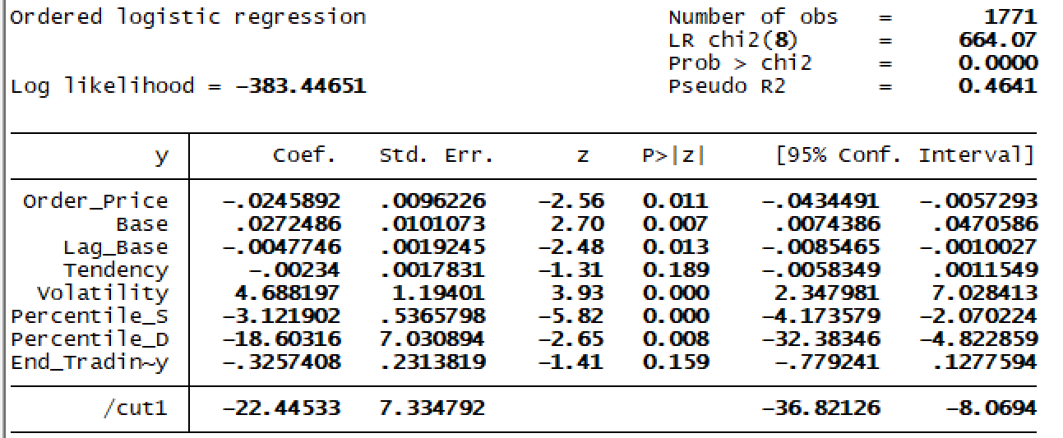

**Table 2:** TA25 Call Option Buy Execution Probability Equation

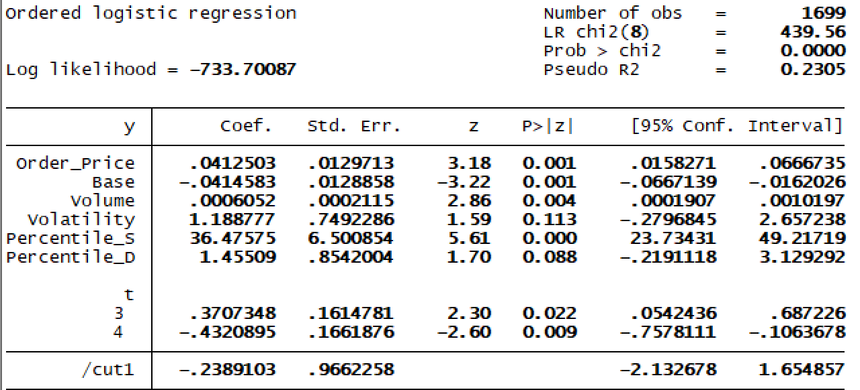

**Table 3:** Leumi Bank Sell Execution Probability Equation

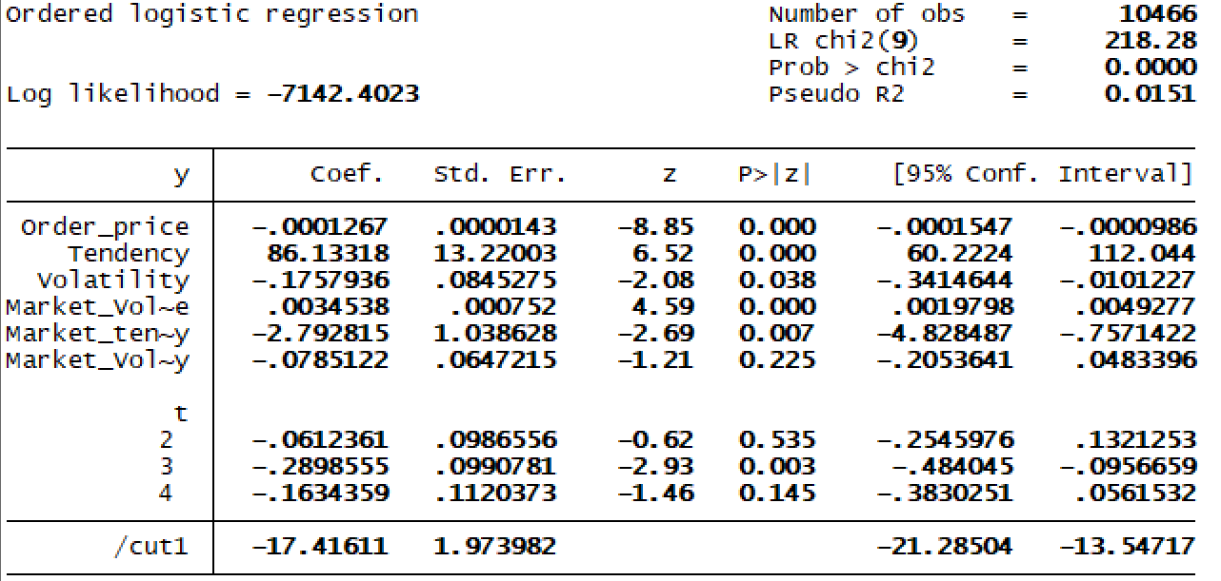

**Table 4:** Mizrahi Tefahot Bank Sell Execution Probability Equation

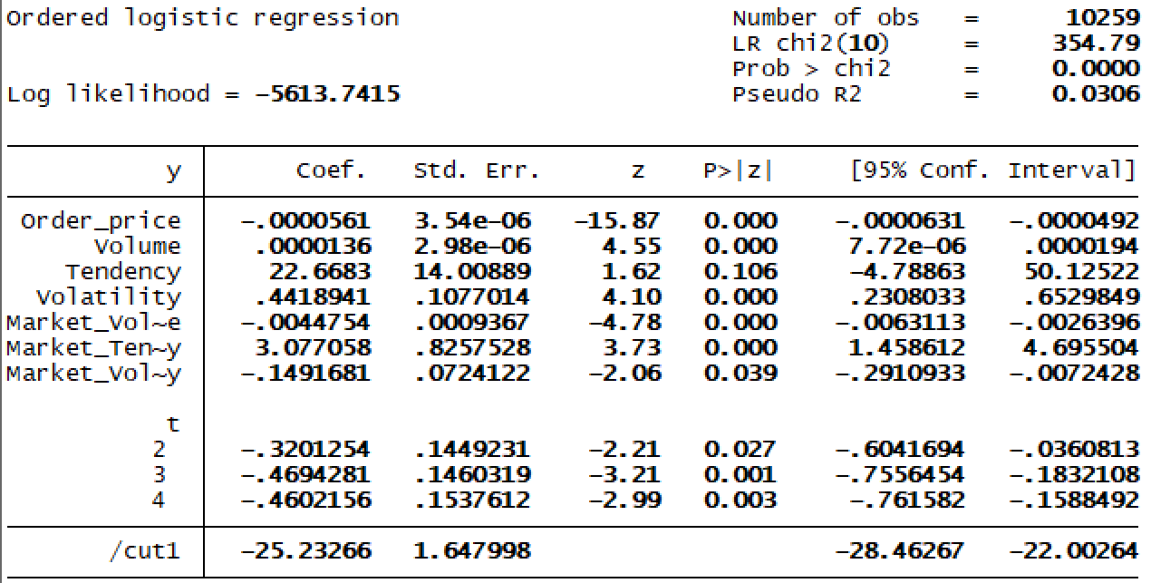

**Bibliography**

1. Ahn, H.J., Cai, J., Hamao, Y. and Ho, R.Y., 2002. The components of the bid–ask spread in a limit-order market: Evidence from the Tokyo Stock Exchange. *Journal of Empirical Finance*, *9*(4), pp.399–430.
2. Ainsworth, A. and Lee, A.D., 2014. Waiting costs and limit order book liquidity: Evidence from the ex-dividend deadline in Australia. *Journal of Financial Markets*, *20*, pp.101–128.
3. Akerlof George A. (1970): "The Market for "Lemons": Quality Uncertainty and the Market Mechanism", *Quarterly Journal of Economics*, *84*(3), 488–500.
4. Amihud, Y., Mendelson, H. and Lauterbach, B., 1997. Market microstructure and securities values: Evidence from the Tel Aviv Stock Exchange. *Journal of Financial Economics*, *45*(3), pp.365–390.
5. Bloomfield, R., O’Hara, M. and Saar, G., 2005. The “make or take” decision in an electronic market: Evidence on the evolution of liquidity. *Journal of Financial Economics*, *75*(1), pp.165–99.
6. Chang, B., 2017. Adverse selection and liquidity distortion. *The Review of Economic Studies*, *85*(1), pp.275–306.
7. Foucault, T., Kadan, O. and Kandel, E., 2005. Limit order book as a market for liquidity. *Review of Financial Studies*, *18*(4), pp.1171–1217.
8. Guéant, O., Lehalle, C.A. and Fernandez-Tapia, J., 2012. Optimal portfolio liquidation with limit orders. *SIAM Journal on Financial Mathematics*, *3*(1), pp.740–76.
9. Guerrieri, V. and Shimer, R., 2014. Dynamic adverse selection: A theory of illiquidity, fire sales, and flight to quality. *American Economic Review*, *104*(7), pp.1875–19.
10. Hollifield, B., Miller, R.A. and Sandås, P., 2004. Empirical analysis of limit order markets. *The Review of Economic Studies*, *71*(4), pp.1027–106.
11. Huang, W., Lehalle, C.A. and Rosenbaum, M., 2015. Simulating and analyzing order book data: The queue-reactive model. *Journal of the American Statistical Association*, *110*(509), pp.107–122.
12. Huang, W., Rosenbaum, M. and Saliba, P., 2019. From Glosten-Milgrom to the whole limit order book and applications to financial regulation. *Available at SSRN 3343779*.*
13. Huang, Y., Capretz, L.F. and Ho, D., 2019. Neural Network Models for Stock Selection Based on Fundamental Analysis. *arXiv preprint arXiv:1906.05327*.*
14. Kaufman, P.J., 2013. *Trading Systems and Methods,+ Website* (Vol. 591). Hoboken, NJ: John Wiley & Sons.
15. Laruelle, S., Rosenbaum, M. and Savku, E., 2018. Assessing MiFID 2 Regulation on Tick Sizes: A Transaction Costs Analysis Viewpoint. *Available at SSRN 3256453*.*
16. Lehalle, C.A. and Mounjid, O., 2017. Limit order strategic placement with adverse selection risk and the role of latency. *Market Microstructure and Liquidity*, *3*(01), p.1750009.

* These three unpublished papers will be available upon request from the Israel Science Foundation.

1. See Hypothesis 2.